**IN THE DISPUTE RESOLUTION PANEL AT MELBOURNE**

**(Constituted for a determination as to compensation under rule 226 of the National Gas Rules)**

**BETWEEN**

**IPOWER 2 Pty Limited & IPOWER Pty Limited**

(trading as **Simply Energy**)(ABN 67 269 241 237) (**Simply Energy**) &

# AETV Pty Ltd (ABN 29 123 391 613) (AETV)

# APA Facilities Management Pty Limted (ABN 76 140 898 424) (APA)

# Red Energy Pty Ltd (ABN 60 107 479 372) (Red Energy)

# Lumo Energy Australia Pty Ltd (ABN 69 100 528 327) (Lumo)

# M2 Energy Pty Ltd (trading as Dodo Power & Gas) (ABN 15 123 155 840) (Dodo)

(together the “**Participants**”)

and

**Australian Energy Market Operator Limited** (ABN 94 072 010 327) (**AEMO**)

**JOINT SUBMISSION TO THE DISPUTE RESOLUTION PANEL**

A. Glossary and National Gas Rules

1. A number of terms and acronyms are used throughout this submission.

2. Many of the terms used in these submissions are defined in the National Gas Rules (**NGR**). For ease of reference these terms are italicised. Unless the context dictates otherwise, terms defined in the NGR have the same meaning in this submission as in the NGR.

3. A reference to a ‘rule’ followed by a number means a provision in the NGR.

4. Version 29 of the NGR applied on 1 October 2016. The amendments made to the NGR since Version 29 do not alter the effect of the provisions cited in this submission in a manner that is material to the matters relevant to the DRP's determination of compensation as a result of the *unintended scheduling result*.

B. Application

4. Australian Energy Market Operator Limited (**AEMO**) was requested by a Market

Participant to investigate whether an *unintended scheduling result* occurred on 1 October 2016 in accordance with rule 218(1)(a) and AEMO has determined that it did so occur. Compensation may be payable from the *Participant compensation fund* (**PCF**) as a consequence of this *unintended scheduling result*.

5. The Participants are and were, at all material times, registered in the Victorian wholesale gas market as *Market Participants*.

6. Under rule 218(4)*,* the Participants may apply to the Dispute Resolution Panel **(DRP**) for a determination as to compensation as a consequence of the *unintended scheduling result*.

7. If an unintended scheduling result occurs and its occurrence is confirmed under subrule 226(2), the matters to be determined by the DRP are:

(a) which *Market Participants* are to receive compensation from the *Participant compensation fund* for that *unintended scheduling result*; and

(b) the amount of compensation to be paid to each *Market Participant*; and

(c) the manner and timing of payment from the *Participant compensation fund*.[1]

C. AEMO and the Victorian Wholesale Gas Market

8. The Victorian wholesale gas market started in March 1999 and was designed to:

* manage gas supply, demand and linepack of the Victorian Declared Transmission System (**DTS**);
* allow Market Participants to buy and sell gas; and
* set a daily gas price (ex post) for all trades.

9. The Victorian wholesale gas market was redesigned to an ex-ante market commencing February 2007 where gas prices are set at 6am, 10am, 2pm, 6pm and 10 pm.

10. The Victorian wholesale gas market covers the DTS, which is depicted in Figure 1.

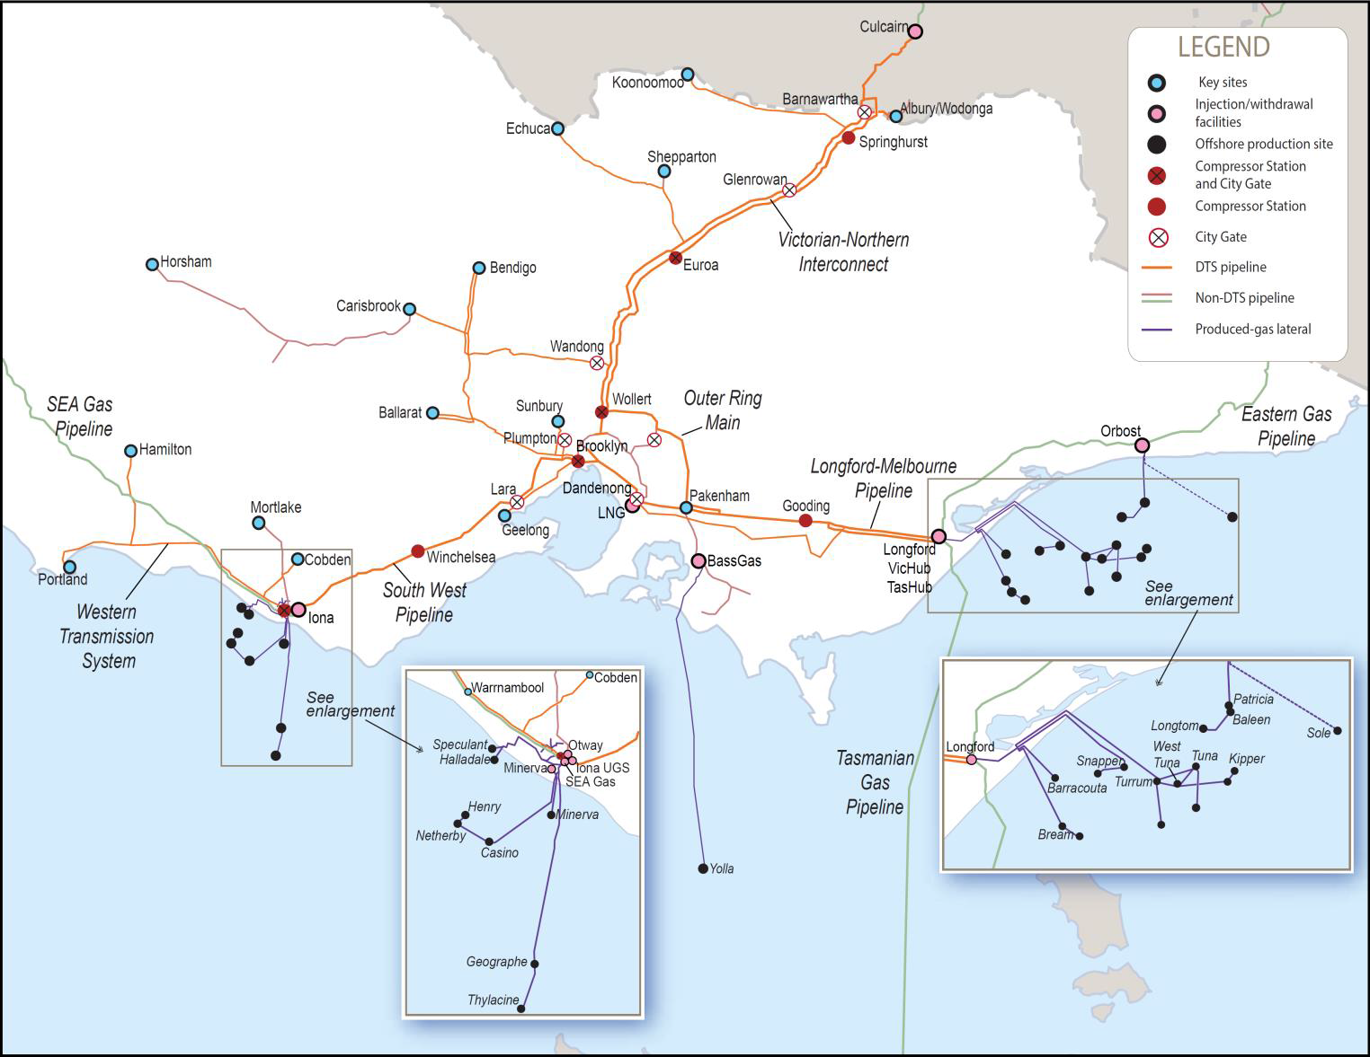**Figure 1: Declared Transmission System**

11. AEMO performs a number of functions in the Victorian wholesale gas market, including the following:

* operate the DTS and operate and administer the market in accordance with the National Gas Law and the NGR;
* establish and update system security standards for the DTS; and
* operate the DTS so as to minimise the threats to system security.

D. The Regulatory Framework

12. The NGR governs access to natural gas pipeline services and broader elements of natural gas markets. As applied in Victoria, this includes the operation of the Victorian wholesale gas market.

13. The NGR:

* facilitates an efficient, competitive and reliable market;
* regulates the operation and administration of the market;
* regulates activities of participants in the market; and
* provides for access to the DTS in a way that ensures its security.

14. Participants can be directly or indirectly involved in the Victorian wholesale gas market. Those who are registered to trade gas, that is, to inject gas into, or withdraw gas from, the DTS are called *Market Participants*.

E. Operation of the Victorian Wholesale Gas Market

15. On any given gas day, *Market Participants* trade in the Victorian wholesale gas market based on the imbalances in the gas withdrawn by their respective customer loads and the gas injected into the DTS by each of them.

16. Gas scheduling is a process that AEMO conducts a number of times each gas day to provide hourly injection schedules for each *Market Participant* and schedules for any controllable withdrawals. The market clearing algorithm (also known as the “Market Clearing Engine” or “**MCE**”) is optimisation software that determines operating schedules and pricing schedules. For each operating schedule it minimises the cost of supplying gas to meet the forecast gas demand within the pipeline system security limits.

17. Figure 2 depicts the key steps in the gas scheduling process, which link the data inputs from *Market Participants* and AEMO to the scheduling process. A different process is followed depending on whether or not the system is in a normal operating state.[2]

**Figure 2: Gas Scheduling Process**

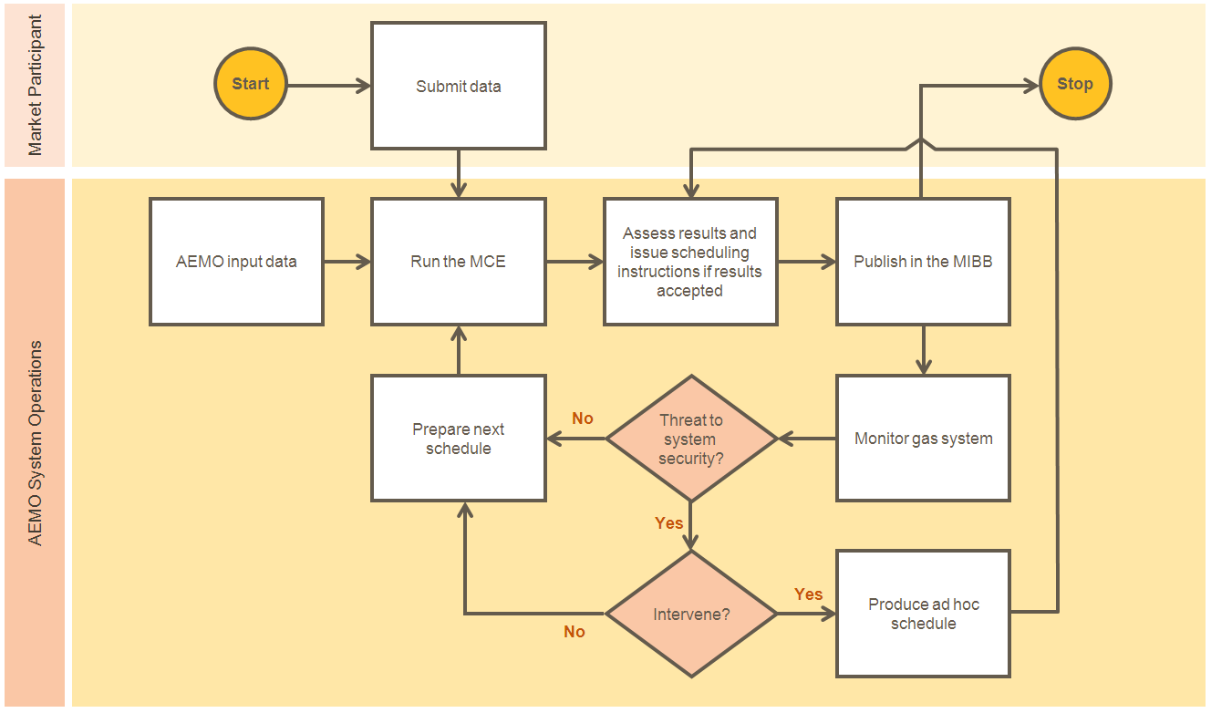

18. When the DTS is in a normal operating state, AEMO performs the following tasks each time it prepares, runs, and issues an operating schedule:

* + - AEMO collates the input data from *Market Participants*, including forecast demand and injection and withdrawal bids, prepares its own input data and demand forecasts, and, if required, overrides demand forecasts from *Market Participants*.
    - AEMO runs the MCE based on the input data to produce the schedules and assesses those schedules.
    - AEMO issues pricing and operating schedules if the MCE results are accepted or reassesses the input data and repeats the process.
    - Five standard schedules for the current gas day are issued at 6 AM,10 AM, 2 PM, 6PM, and 10 PM

19. A threat to system security may eventuate if a normal operating state cannot be maintained. Monitoring system security is an integral part of the process that determines if and when AEMO needs to take actions in case of threats to system security. Threats to system security can be caused by:

* + - Unplanned producer or transmission system equipment outages
    - Gas demand exceeding transmission system capacity or available supply
    - Ongoing injections of off-specification gas

20. In the event of a system security threat, AEMO will:

* Notify participants of the potential or existing system threat.
* If time is available, seek advice from participants and *Market Participants* on corrective actions that will mitigate the risk or threat.
* If necessary, intervene in the market by issuing an ad hoc operating schedule.
* In the case of persistent off-specification gas, take steps in accordance with the Gas Quality Guidelines to mitigate or remove the threat.
* Notify participants and *Market Participants* when the threat is removed and conditions return to a normal operating state.

F. Events of 1 October 2016

21. At 04:26 AEST on 1 October 2016, there was an unplanned total shutdown of the Esso Longford gas production facility (‘Longford plant’), which ceased injections into the DTS. Longford injections recommenced at approximately at 04:52, however, injections ceased again at 05:36. Longford plant operators subsequently requested AEMO constrain down Longford hourly injections to 0 TJ/h for the first three hours of the gas day. At this stage there was no threat to system security.

22. At 08:32 Longford plant operators advised AEMO that the Longford plant would be unable to begin injections until around 11:00. AEMO modelling of the DTS indicated that minimum operating pressures near Sale in the Longford to Melbourne Pipeline would be breached around 10:00.

23. At 08:40, AEMO provided *Market Participants* with a notice of threat to system security. In accordance with rule 215(4), AEMO subsequently intervened in the market by publishing an operating schedule at 09:03, outside the standard times specified in rule 215(3) (referred to as the ad hoc operating schedule).[3]

24. AEMO constrained VicHub[4] to zero flow for the remainder of that gas day by applying a directional flow point constraint (DFPC) in the ad hoc operating schedule, and each operating schedule and pricing schedule for the reminder of that gas day in accordance with rule 343 and section 3.8B of the Wholesale Market Gas Scheduling Procedures (Victoria).

25. AEMO may apply DFPCs to *system injection points* and *system withdrawal points[5]* to reflect contractual, physical and operating constraints for facilities that are external to the DTS. These are applied to both pricing schedules and operating schedules. The DFPC is a constraint that pairs an injection and withdrawal meter so that the net flow of those meters is constrained or, as applied on the 1 October, the flow in either direction was constrained to zero.

26. AEMO determined that the threat to system security was effective until after the 2pm operating schedule.

27. At approximately 14:30, Jemena updated the EGP linepack capacity adequacy flag on the Natural Gas Services Bulletin Board (GasBB) to red indicating involuntary curtailment of ‘firm’ load is likely or happening on the gas day. This flag remained red until the following gas day. At approximately 17:00, Longford ceased injections into the EGP due to a gas quality issue and did not begin injections again until around 19:40. Accordingly, AEMO did not remove the constraint at VicHub in any of the subsequent schedules issued on that gas day.

28. AEMO investigated these events at the request of a *Market Participant* in accordance with rule 218(1)(a). The request referred to an alleged *unintended scheduling result* in respect of injections at the VicHub injection point for the 10am schedule on 1 October 2016 and all subsequent schedules on that gas day. AEMO prepared a detailed report titled **'DWGM – Compliance report and Investigation into USR following event on 1 October 2016**’. A copy of the report is reproduced in Schedule 1 of this submission. An update to the report relating to issues with notification of the threat to system security was published on 1 March 2017 but the update is not relevant to the determination of the issues under this submission.

29. AEMO determined that the ad hoc operating schedule and the 10am and 2pm operating schedules are not *unintended scheduling results* as they are covered by the exceptions set out in rules 217(2)(a)(i), 217(2)(a)(ii) and 217(2)(a)(x) (as a result of the threat to system security being effective until after the 2pm operating schedule).

30. AEMO determined that the 6pm operating schedule is not an *unintended scheduling result* as it is covered by the exception set out in rule 217(2)(a)(x). Although the threat to system security is considered to have ceased by the 6pm operating schedule, the application of the DFPC in the 6pm operating schedule was considered reasonable in the circumstances as a result of Longford ceasing injection into the EGP at approximately 17.00.

31. AEMO considers that, although the linepack adequacy flag on the GasBB for the EGP was still red, the DFPC on VicHub should have been able to be reduced or removed from the 10pm schedule once Longford had begun injecting back into the EGP. Prior to the 10pm schedule, AEMO considers that the DFPC was reasonable in the circumstances (low levels of linepack in the EGP, and Longford injections into the EGP did not stabilise until after 19:40).

32. AEMO determined that none of the exceptions in rule 217(2) apply to the 10pm operating schedule. As a result, AEMO determined that an *unintended scheduling result* occurred on 1 October 2016 with financial impacts in respect of the 10pm operating schedule.

G. Participant Compensation Fund

33. AEMO is not liable for an *unintended scheduling result.* In accordance with rule 227(2), compensation for affected *Market Participants* is paid out of the PCF.

34. AEMO is required to maintain the PCF under rule 225. The purpose of the PCF is to compensate *Market Participants* following an *unintended scheduling result.*

35. AEMO is required to replenish the PCF with fees collected from *Market Participants* in accordance with rules 225(3)-(6). For each *financial year[6]*, the funding requirement for the PCF is the lesser of:

* $500,000; and
* $1,000,000 minus the amount AEMO reasonably expects to be the balance at the end of the relevant *financial year*.[7]

36. The current balance in the PCF is $3,189,229.81

37. In making a determination as to compensation, a DRP must take into account the matters detailed in rule 226(1), which are:

* which *Market Participant* is to receive compensation;
* the amount of the compensation for each *Market Participant*; and
* the manner and timing of payments from the PCF.

H. Liability to pay Compensation

38. Rule 226 requires that the occurrence of an *unintended scheduling result* be confirmed either by agreement or determination in accordance with the dispute resolution processes in the NGR.

39. The parties submit that the *unintended scheduling result* has occurred in respect of *scheduling instructions* issued by AEMO based on the 10pm *operating schedule* as a result of the application of rule 217(1)(f), namely, that a *scheduling instruction* is not issued in accordance with the *gas scheduling procedures*, in that, contrary to the *gas scheduling procedures*, a DFPC was applied to the 10pm *operating schedule* in circumstances that did not require a DFPC.

40. The parties also submit that none of the exceptions in rule 217(2) apply to the 10pm *operating schedule*.

41. The exceptions in rule 217(2)(a) provide for expected impacts on schedules and market outcomes arising from physical or contractual constraints on gas flows and other matters. Such constraints are routinely applied in the scheduling and operations processes and no compensation is applicable.

42. Rule 217(2)(b) does not apply as no *Market Participant* has been paid compensation for this event.

43. Rule 217(3) is not relevant because no error was made in determining the market price on the day. The pricing schedule process worked correctly without error.

44. The affected *Market Participants* that have made claims for compensation are the Participants.

I. Calculation of Estimated Financial Effect

45. Rule 217(4) states that a result specified in subrule 217(1) will not be an *unintended scheduling result* unless its estimated financial effect on *Market Participants* exceeds either:

(a) for an individual *Market Participant*, $20,000, adjusted to reflect the change in the Consumer Price Index in accordance with subrule (5); or

(b) for all affected *Market Participants*, an aggregate of $50,000, adjusted to reflect the change in the Consumer Price Index in accordance with subrule (5).

46. Pursuant to Rule 217(5), the amounts referred to in subrule 217(4) are to be adjusted by multiplying the relevant amount by a number determined using a formulae to reflect the Consumer Price Index for the financial year ended 30 June 2008 (being 161.4) and the Consumer Price Index (All Groups, weighted average of eight capital cities) for the most recent financial year published by the Australian Bureau of Statistics before the issue of the relevant operating schedule.[8]

47. The Consumer Price Index (All Groups, weighted average of eight capital cities) for the most recent financial year published by the Australian Bureau of Statistics before the issue of the relevant operating schedule on 1 October 2016 was 108.3 for the 2015-2016 financial year.

48. After adjustment for CPI in accordance with Rule 217(5), the amount in Rule 217(4)(a) $24,120.27 and the amount in Rule 217(4)(b) is $60,300.67.

49. The meaning of estimated financial effect and the manner in which estimated financial effect is to be determined is not defined or prescribed in the NGR.

50. For the purpose of estimating the financial effect on *Market Participants*, AEMO has calculated the lost *Market* revenue of the Participants based on a ‘what if’ scenario as if the USR had not occurred for the 10pm *operating schedule*.

51. The manner in which AEMO applied the ‘what’ if scenario is contained in Schedule 2.

52. Based on a ‘what if’ scenario, the amount of the lost *Market* revenue:

(a) of Simply Energy as a result of this *unintended scheduling result* is $12,279.14 (GST inclusive);

(b) of AETV as a result of this *unintended scheduling result* is $93,552.68 (GST inclusive);

(c) of APA as a result of this *unintended scheduling result* is $2,514.00 (GST inclusive);

(d) of Red Energy as a result of this *unintended scheduling result* is $3,716.39 (GST inclusive);

(e) of Lumo as a result of this *unintended scheduling result* is $2,158.48 (GST inclusive); and

(f) of Dodo as a result of this *unintended scheduling result* is $2,273.40 (GST inclusive);

53. Detailed calculations of the lost *Market* revenue of the Participants have been provided in confidential supplementary submissions.

54. As the total lost *Market* revenue of the Participants based on the ‘what if’ scenario is $116,494.09, the estimated financial effect of this *unintended scheduling result* for all affected *Market Participants* exceeds $60,300.67 under Rule 217(4) (b) (as adjusted in accordance with Rule 217(5)) and therefore Rule 217(4) does not apply.

J. Calculation of Compensation

55. If an *unintended scheduling result* occurs and its occurrence is confirmed under subrule 226(2), the matters to be determined by the DRP are:

(a) which *Market Participants* are to receive compensation from the *Participant compensation fund* for that *unintended scheduling result*; and

(b) the amount of compensation to be paid to each *Market Participant*; and

(c) the manner and timing of payment from the *Participant compensation fund*.[9]

56. Therefore, the meaning of compensation is relevant to the determination of the DRP as to which *Market Participants* are to receive compensation from the *participant compensation fund* for that *unintended scheduling result* under subrule 226(1)(a), not just the determination of the DRP as to the amount of compensation to be paid under subrule 226(1)(b).

57. The meaning of compensation and the manner in which compensation is to be determined is not defined or prescribed in the NGR.

58. As Rule 226 uses the term compensation and not estimated financial effect, it is submitted that compensation for the purposes of Rule 226 does not mean the same as estimated financial effect for the purpose of Rule 217(4).

59. Therefore, it is submitted that, even if there has been an estimated financial effect on a *Market Participant*, the DRP may determine that compensation is not payable to that *Market Participant*.

60. AEMO submits that, although there is an estimated financial effect for a *Market Participant* based on the application of the NGR for settlement of the *Market*, the DRP should consider the purpose of the compensation under the NGR for *unintended scheduling results* and whether financial loss or lost opportunity has actually been suffered by a *Market Participant*.

K. Payment of Compensation

61. Rule 227(1) also requires that the aggregate amount of compensation paid each year from the PCF must not exceed the balance that would have been available at the end of that year had no compensation payments been made that year and therefore the DRP must, when making a determination, take into account the following requirements:

(a) the aggregate amount of compensation determined under rule 226 must not exceed the balance of the PCF at the time the determination is made, less any amount not yet paid from the PCF in respect of any previous determinations; and

(b) the aggregate amount of compensation payable from the PCF at any time is limited to its balance.

62. Since the commencement of the Market there have been a total of three claims made from the PCF resulting in payments totalling $98,381.65

63. There are no other claims made or anticipated to be made against the PCF.

64. The Adviser issued a notice on 10 April 2017 to the Dispute Management Contacts (DMC) contacts regarding the receipt of a claim against the PCF in respect of this unintended scheduling result. No further claims were notified.

65. If the compensation was paid for the full amount of –the Participant’s claims, the balance in the Participant compensation fund would be $3,072,735.72 (GST inclusive).

66. Accordingly, if the DRP determines that the Participants are to be paid compensation and the amount of compensation payable is the amounts claimed by the Participants, full payment of the Participant’s claims would comply with Rule 227 taking into account the current balance of the Participant compensation fund and the low likelihood of any further actual liabilities being incurred this financial year.

L. Interest

67. The Participants do not seek payment of interest on their claimed amounts as part of this application.

M. Costs

68. The parties submit that the costs of this process (other than the legal costs of the parties) should be borne by the Participants in proportion to the amount of the compensation to be paid to each of them and that each of the parties should bear its own legal costs. It is submitted that the DRP should not exercise any discretion it may have under rule 135JA to allocate costs on a different basis as the Participants and AEMO, have not unreasonably prolonged or escalated a dispute or otherwise increased the costs of the DRP proceedings.

**DATED:** ………………………………..

**IPOWER 2 Pty Limited & IPOWER Pty Limited** (trading as **Simply Energy)**

# AETV Pty Ltd (ABN 29 123 391 613) (AETV)

# APA Facilities Management Pty Limted (ABN 76 140 898 424) (APA)

# Red Energy Pty Ltd (ABN 60 107 479 372) (Red Energy)

# Lumo Energy Australia Pty Ltd (ABN 69 100 528 327) (Lumo)

# M2 Energy Pty Ltd (trading as Dodo Power & Gas) (ABN 15 123 155 840) (Dodo)

**Australian Energy Market Operator Ltd**

**SCHEDULE 1**

Report titled **'DWGM – Compliance report and Investigation into USR following event on 1 October 2016’**

**SCHEDULE 2**

**Approach in calculating lost Market revenue**

AEMO calculated the lost *Market* revenue as if the USR had not occurred for the 10pm operating schedule (the ‘what if’ scenario).

The steps AEMO followed to produce the ‘what if the USR had not occurred’ outcomes are follows:

1. In order to produce the ‘what-if’ scheduling results, AEMO removed the Directional Flow Point Constraint at VicHub for the 10PM schedule and re-ran the 10PM schedule in a Pre-production environment.

The lower priced gas injected at VicHub resulted a number of other injection points being de-scheduled in the ‘what-if’ scenario. The ‘what-if’ 10PM market price of $9.9745 was lower compared to the ‘actual’ 10PM market price of $12.2849.

1. AEMO calculated the ‘what-if’ allocation data based on the ‘what-if’ scheduling results, taking into account the difference between the ‘actual’ scheduled quantity and the actual’ allocated quantity for each participant and for each biddable meter.

Only injection bids were rescheduled (i.e. increases at VicHub and decreases at other injection sources). ‘Actual’ final allocations were proportionally adjusted for the ‘what if’ scenario to reflect what the ‘what if’ allocation would have been.

1. AEMO passed through the ‘what-if’ results to AEMO’s settlement system to calculate the ‘what-if’ settlement outcomes, including imbalance payments/charges, deviation payments/charges, linepack account, ancillary payments and uplift payments. This was then compared with the results in the ‘actual’ system.

The ‘what if’ settlement outcomes accounted for likely allocations. Jemena EGP who is the allocation agent for VicHub advised that not all parties scheduled at VicHub had gas available to be injected at the 10PM schedule. Accordingly, that shortfall in the ‘what if’ deliveries has been taken into account and resulted in a ‘what if’ market price of $2.7600 (up from the actual market price of $2.5000) for the 6AM schedule on 2 October which was used to determine the ‘what if’ deviation charges for the 10PM schedule on 1 October (in accordance with rule 235(6)). Companies with the same ABN have been grouped and a nett impact has been calculated.

The settlement process includes numerous sub-processes where AEMO determines for each schedule and each *Market Participant*:

* Imbalance quantities and payments
* Deviation quantities and payments
* Linepack account quantities and payments
* Ancillary quantities and payments
* Uplift quantities and payments
* Market fees

The USR had an impact on imbalances and deviations, and the linepack account.

*Market Participants* are paid or pay the costs for the imbalance quantities based on their scheduled amounts and the market price. Since the ‘what if’ 10PM price was lower due to lower priced VicHub gas replacing more expensive gas from other sources, those participants that were rescheduled had changes to their injection imbalance payments and charges.

The differences between a *Market Participant’s* scheduled and actual behaviour is accounted for with deviation payments or charges. Since the next day’s ‘what if’ 6AM price was higher than the actual 6AM price as a result of under deliveries at VicHub, any *Market Participant* under delivering faced a higher deviation charge and those over delivering had higher deviation payments than the charges and payments that actually applied.

Since the ‘what if’ scenario resulted in changes to price, imbalances and deviations, this had a flow on impact to the linepack account. When *Market Participants* deviate from their schedules, the gas is either removed from or added to the system linepack. AEMO purchases or sells this gas at the market price of the current schedule through the linepack account. In the next schedule, AEMO resells or repurchases the change in linepack gas that occurred in the previous schedule at the market price of the current schedule. Because the prices at which linepack is purchased and sold are usually different, these balancing transactions can build up a surplus or deficit of funds in the linepack account. This surplus or deficit is cleared daily by apportioning the surplus or deficit to *Market Participant’s* based on their total actual withdrawals for the day. The linepack account for each schedule is the sum of all *Market Participant’s’* imbalance and deviation payments for that schedule.

1. Rule 226(1)
2. See section 3 of the Wholesale Market System Security Procedures (Victoria) for the conditions for when the DTS is in a normal operating state, which includes when there is no threat to public safety, no threat to the supply of gas to customers, breaches of gas quality specifications do not require intervention by AEMO and system pressures and flows are within, and forecast to remain within, operating limits.
3. Under rule 215(3)(c), the standard times for publication of operating schedules by AEMO on a gas day are 6am, 10am, 2pm, 6pm and 10pm.
4. VicHub is an interconnect facility situated at the Longford Compressor Station and enables gas to flow bi-directionally between the Eastern Gas Pipeline and the DTS.
5. *System injection points* and *system withdrawal points* are connection points on the DTS that permit gas to flow into or out of the DTS.
6. Financial year is defined as a period commencing on 1 July and terminating on the following 30 June.
7. Rule 225(2)
8. From the September quarter 2012, all index numbers are calculated on a new index reference period of 2011-12. This resulted in the index numbers for each index series being reset to 100.0 for the financial year 2011-12. The value of 161.4 as prescribed in the NGR was the average of the four quarters prior to this change being implemented.

   For the purpose of calculating the CPI increase the average of the four quarters for the 2015-16 financial year (being 108.3) has been divided by the average of the four quarters for the 2007-08 financial year (being 89.8).
9. Rule 226(1)