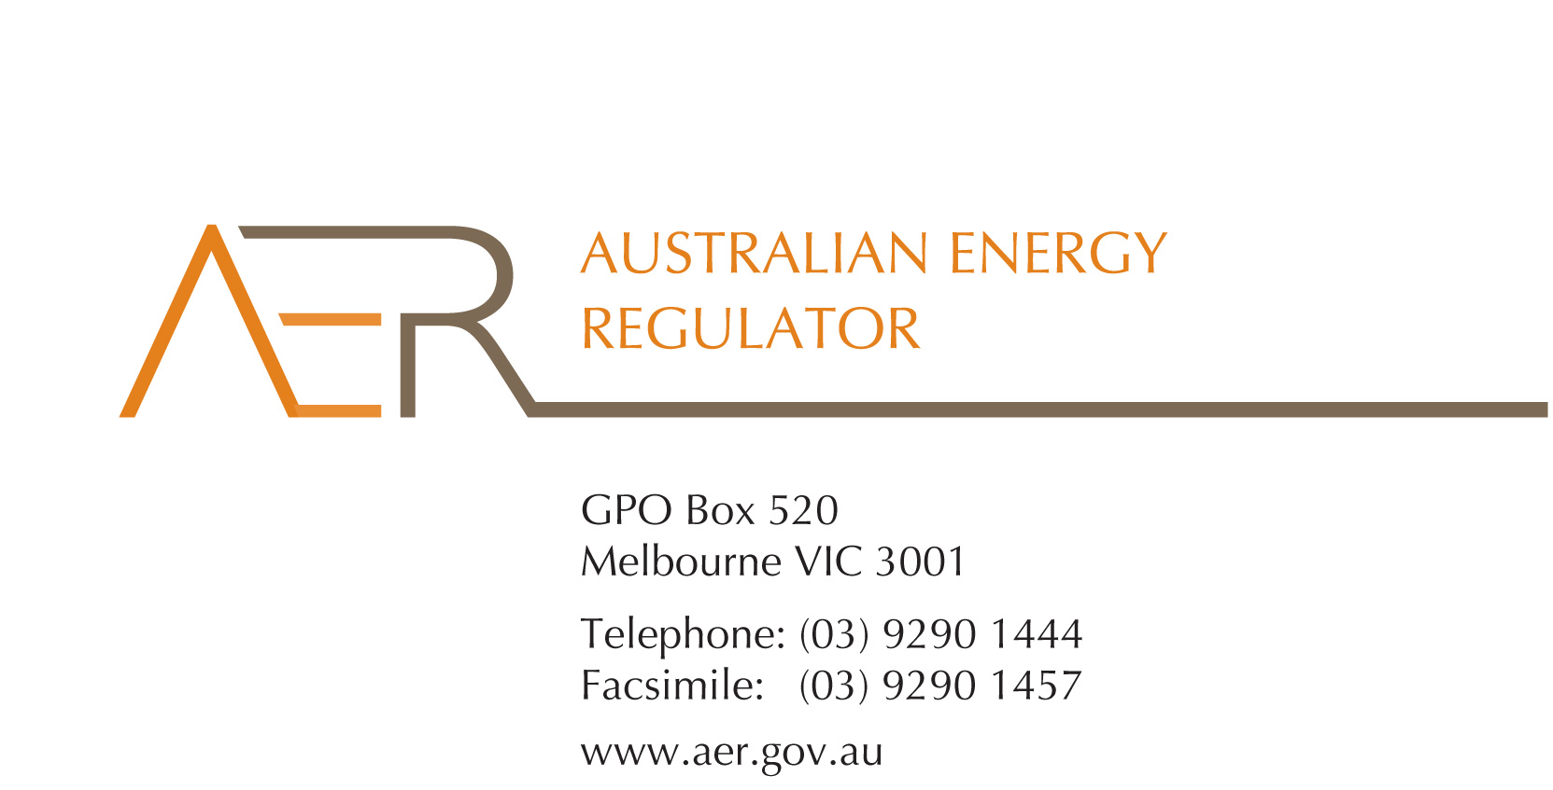

Our Ref: 56121-D16/80627

Contact Officer: Fiona Walker

Contact Phone: (03) 9290 1440

6 July 2016

Mr John Pierce

Chairman

Australian Energy Market Commission

PO Box A2449

SYDNEY SOUTH NSW 1235

Dear Mr Pierce,

**Submission on National Electricity Amendment (Market Participant Suspension Framework) Rule 2016**

Thank you for the opportunity to comment on the AEMC’s consultation paper on the National Electricity Amendment (Market Participant Suspension Framework) Rule 2016. The AER supports the rule changes to clarify the market suspension provisions in the rules for participants under external administration. However we consider that the consequences where these participants do not comply with conditions imposed by AEMO require further clarification.

We do not consider that AEMO’s discretion in deciding whether to suspend or partially suspend a market participant should be subject to further conditions or limitations. These decisions are complex, nuanced and involve unpredictable scenarios. The changes proposed by the COAG Energy Council balance prescription and discretion, and no further factors or considerations should be prescribed in the rules.

AEMO should not be required to consult with the AER or any other entity when making a decision on whether to suspend (or partially suspend) a market participant under external administration. These decisions need to be taken without delay, and are not conducive to mandated consultation. AEMO and the AER have protocols in place to ensure timely notification of AEMO decisions in the lead up to suspension, including a Retailer of Last Resort Event Communication Protocol. These protocols have worked well to date.

We consider that decisions by AEMO not to suspend a market participant under external administration should not be subject to time limitations or AER approval for any extension beyond the time limit. This option would conflate the respective roles of the market operator as prudential regulator and the AER’s regulatory roles such as retailer of last resort functions.

**Incentivising compliance by participants under external administration**

The AER supports the changes proposed by the COAG Energy Council to allow AEMO to impose conditions in any decision not to suspend a market participant under external administration. The risk of non-compliance by a market participant under external administration and subject to a non-suspension decision is sufficiently high to justify the imposition of conditions. Such conditions might include, as noted in the paper, regular reporting to the AER. Reporting requirements could address matters such as resourcing, technical capability and the expected duration of external administration.

As currently drafted, the consequence of non-compliance with these conditions is unclear. The rules should make it clear that AEMO may proceed with full suspension if a participant under administration that is subject to a non-suspension or partial suspension decision by AEMO does not comply with the conditions imposed on it.

The framework should also allow for a participant subject to a non-suspension or partial suspension decision to be suspended for a broader range of reasons than those set out in the payment default procedure in rule 3.15.21 of the Electricity Rules, such as significant non-compliance with the Electricity Rules or energy laws. This would maintain incentives on the participant to comply with the market rules irrespective of whether AEMO has imposed specific conditions on them.

**Interaction with the National Energy Retail Law RoLR provisions**

Entry by a retail entity into external administration triggers a retailer of last resort (RoLR) event under section 122 of the National Energy Retail Law. Any non-suspension decisions taken to allow for a retail entity under external administration to continue to participate in the market would conflict with the RoLR process. If the rule changes proposed by the COAG Energy Council are implemented, consequential changes to the RoLR framework may be required. The AER will raise this issue with the COAG Energy Council’s Retail Policy Working Group.

If you have any queries about the issues raised in this letter, please contact Fiona Walker ((03) 9290 1440; [fiona.walker@aer.gov.au](mailto:fiona.walker@aer.gov.au)).

Yours sincerely

James Cox

Acting Chair

Australian Energy Regulator