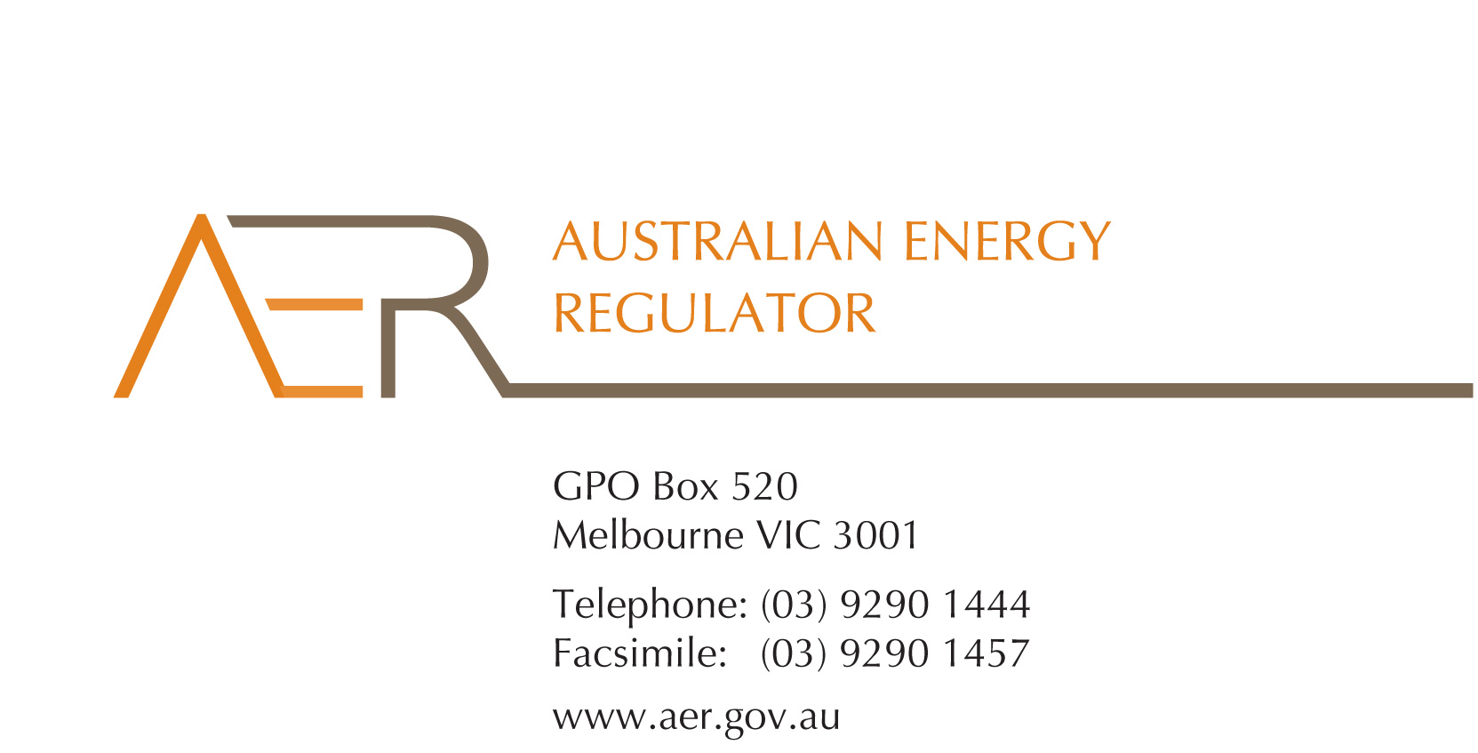

Our Ref: 56121-D16/139585

Contact Officer: Fiona Walker

Contact Phone: (03) 9290 1440

14 October 2016

Mr John Pierce

Chairman

Australian Energy Market Commission

PO Box A2449

SYDNEY SOUTH NSW 1235

**Submission on National Electricity Amendment (Market Participant Suspension Framework) Rule 2016 – Draft Determination**

Thank you for the opportunity to comment on the AEMC’s draft rule determination on the *National Electricity Amendment (Market Participant Suspension Framework) Rule 2016*. The AER supports changes to clarify the market suspension provisions in the rules for participants under external administration.

The AER strongly endorses the provisions in the draft rule which would enable AEMO to make a non-suspension decision that is conditional on the defaulting market participant continuing to satisfy specified obligations including compliance with the rules. We also support the clarification in the draft rule that any conditions imposed by AEMO in a non-suspension decision must be satisfied in order for the decision to remain in effect.

As we noted in our submission on the AEMC’s consultation paper, it is important to ensure that the prudential role undertaken by AEMO remains separate from the AER’s retailer of last resort functions. The draft rule preserves this separation.

The AER considers that AEMO should not be limited to making a non-suspension decision only where clause 3.15.21(c2) has been satisfied. We remain of the view that the rules should provide AEMO with broad discretion to manage the diverse and unpredictable scenarios which may arise in future. As currently drafted, clause 3.15.21(c2) significantly constrains AEMO’s discretion. We suggest that the word ‘only’ in clause 3.15.21(c2) should be removed, and that the matters specified in clause 3.15.21(c2)(1)-(2) should be matters to which AEMO may have regard when making a non-suspension decision, without further constraints on its decision-making.

If you have any queries about the issues raised in this letter, please contact Fiona Walker ((03) 9290 1440; [fiona.walker@aer.gov.au](mailto:fiona.walker@aer.gov.au)).

Yours sincerely

Paula Conboy

Chair

Australian Energy Regulator