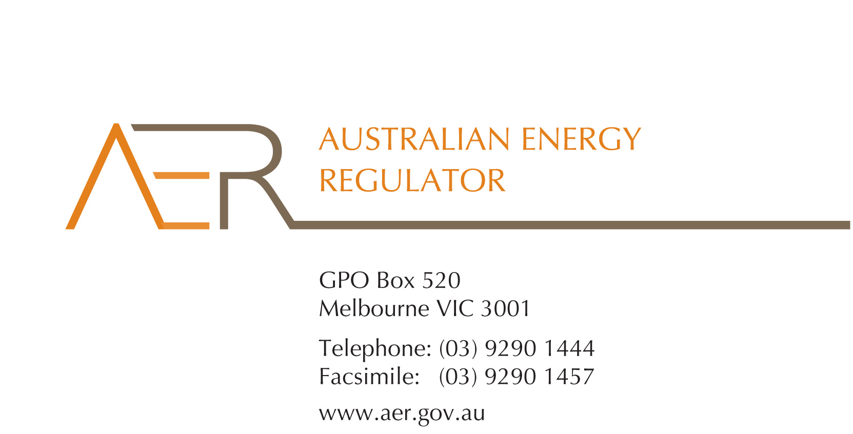

Our Ref: 52160

Your Ref:

Contact Officer: Susan Faulbaum

Contact Phone: (08) 8213 3643

2 January 2014

Donghua Wang

Managing Director

Express Power Australia

12/62-66 Newton Road

Wetherill Park NSW 2164

Dear Mr Wang

**Express Solar** **application for an individual exemption from the requirement to hold an electricity retailer authorisation**

I refer to your letter dated 29 September 2013, which attached an application for an individual exemption in accordance with s.110 of the National Energy Retail Law (Retail Law) by Express Solar Pty Ltd (ACN 154 342 97) (Express Solar).

I am writing to inform you that the Australian Energy Regulator (AER) has decided to grant Express Solar’s application for an individual exemption in accordance with s.110 of the Retail Law.

In accordance with the National Electricity Retail Rules, the AER has published the application on its website, and sought submissions from interested parties.[1] The AER received two submissions in response to Express Solar’s application, which it has considered in deciding whether to grant Express Solar an individual exemption.

The AER has also considered the policy principles relating to exempt selling, in s. 114 of the Retail Law, being:

1. regulatory arrangements for exempt sellers should not unnecessarily diverge from those applying to retailers,
2. exempt customers, should, as far as practicable, be afforded the right to a choice of retailer in the same way comparable retail customers in the same jurisdiction have that right,
3. exempt customers, should, as far as practicable, not be denied customer protections afforded to retail customers under this Law and Rules.

In making its decision the AER is also guided by the objective of the Retail Law[2], the exempt seller factors,[3] and the customer related factors.[4] The AER’s decision is also informed by the assessment approach outlined in the *Exempt Selling Guideline*.

On 20 December 2013, the AER considered Express Solar’s application for an individual exemption, considering and having regard to the matters above.

The AER is satisfied that Express Solar should be exempt from the requirement to hold a national retailer authorisation, having regard to the above considerations. This individual exemption is subject to acceptance of the conditions[5] set out at Schedule 1 to this letter.

Please be aware that the AER may vary conditions attached to an individual exemption at any time in accordance with rule 158 of the National Energy Retail Rules (Retail Rules).

Express Solar must advise the AER in writing, by **24 January 2014,** whether it accepts these conditions.

If you have any further queries, or would like to discuss this further, please contact Susan Faulbaum on (08) 8213 3463.

Yours sincerely

Andrew Reeves

Chairman

Australian Energy Regulator

**Schedule 1: Instrument of exemption**

**INDIVIDUAL EXEMPTION FROM THE REQUIREMENT TO HOLD A RETAIL AUTHORISATION**

The Australian Energy Regulator on 20 December 2013, decided pursuant to section 110 of the National Energy Retail Law, to grant Express Solar Pty Ltd (ACN 154 342 97, trading as Express Solar ) (the exempt person) an exemption from the requirement to hold a retailer authorisation under section 88 of the National Energy Retail Law, subject to the following conditions.

**Condition 1 - Information provision**

The exempt seller must provide the customer in writing a plain English notice explaining that the contract is covered by Australian consumer protection laws and is separate to the customer’s contract with their retailer and distributor which are covered under the National Energy Retail Law.

1. r. 155(3) and 156, National Energy Retail Rules .
2. The National Energy Retail Law objective is to “promote efficient investment in and efficient operation and use of energy services for the long term interests of energy consumers with respect to price, quality, safety, reliability and security of supply of energy”. (s. 13, Retail Law)
3. s. 115, Retail Law.
4. s. 116, Retail Law.
5. r. 158 (1), Retail Rules.