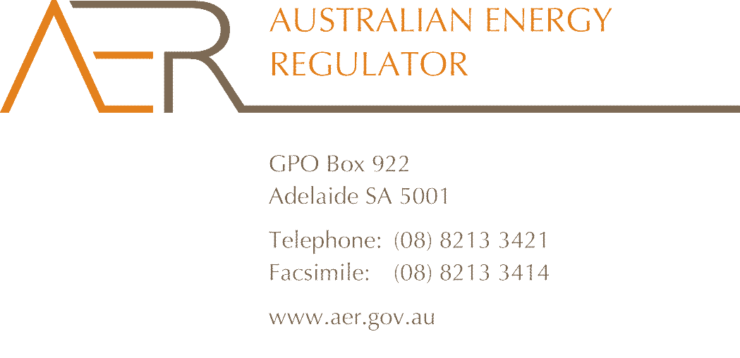

**Forum Attendees**

**Meeting:** AER draft decision on Powerlink transmission revenue proposal for 2017–22 – Public forum

**Location:** Australian Energy Regulator, Level 24,

400 George St, Brisbane 4000

**Date:**  Wednesday 19 October 2016, 9.30am - 12.00pm

| **Name** | **Organisation** |
| --- | --- |
| James Cox | AER |
| Moston Neck | AER |
| Georgina Duas | Qld Farmers’ Federation |
| Claire Tune | Qld Department of Energy and Water |
| Garry Mulhain | Powerlink |
| Dan Martin | University of Qld |
| Henry Wattenberg | Brisbane City Council |
| Merryn York | Powerlink |
| Jenny Harris | Powerlink |
| Thomas Smolkee | Reinhavon Australia |
| Mark Grenning | Energy Users’ Association of Australia |
| Rimu Nelson | Qld Treasury |
| Gerard Reilly | Powerlink |
| Lynne Gallagher | Energy Consumers’ Australia |
| Hugh Grant | AER Consumer Challenge Panel |
| David Headberry | AER Consumer Challenge Panel |
| Jo de Silva | AER Consumer Challenge Panel |
| Kevin Fincham | AER |
| Adam Young | AER |