

Consultation Paper

Demand management incentive scheme early implementation rule change

Electricity distribution network service providers

August 2017

© Commonwealth of Australia 2017

This work is copyright. In addition to any use permitted under the Copyright Act 1968, all material contained within this work is provided under a Creative Commons Attributions 3.0 Australia licence, with the exception of:

* the Commonwealth Coat of Arms
* the ACCC and AER logos
* any illustration, diagram, photograph or graphic over which the Australian Competition and Consumer Commission does not hold copyright, but which may be part of or contained within this publication. The details of the relevant licence conditions are available on the Creative Commons website, as is the full legal code for the CC BY 3.0 AU licence.

Requests and inquiries concerning reproduction and rights should be addressed to the:

Director, Corporate Communications  
Australian Competition and Consumer Commission   
GPO Box 4141, Canberra ACT 2601

or publishing.unit@accc.gov.au.

Inquiries about this publication should be addressed to:

Australian Energy Regulator  
GPO Box 520  
Melbourne Vic 3001

Tel: (03) 9290 1444  
Fax: (03) 9290 1457

Email: [DM@aer.gov.au](mailto:DM@aer.gov.au)

AER reference: 58882

Request for submissions

The Australian Energy Regulator (AER) invites interested parties to make written submissions regarding this paper by the close of business 12 October 2017.

Interested parties should send submissions electronically to: [DM@aer.gov.au](mailto:DM@aer.gov.au).

Alternatively, people can mail submissions to:

Mr Warwick Anderson

General Manager, Network Finance and Reporting

Australian Energy Regulator

GPO Box 3131

Canberra ACT 2601

We prefer that all submissions be publicly available to facilitate an informed and transparent consultative process. We will treat submissions as public documents unless otherwise requested.

We request parties wishing to submit confidential information to:

* Clearly identify the information that is the subject of the confidentiality claim.
* Provide a non-confidential version of the submission in a form suitable for publication.

We will place all non-confidential submissions on our website at www.aer.gov.au. For further information regarding our use and disclosure of information provided to us, see the ACCC/AER Information Policy, June 2014 available on our website.

Please direct enquiries about this paper, or about lodging submissions, to [DM@aer.gov.au](mailto:DM@aer.gov.au) or to Lisa Beckmann on (02) 9230 9164.

Shortened forms and glossary

| Shortened form | Extended form |
| --- | --- |
| AEMC | Australian Energy Market Commission |
| AER | Australian Energy Regulator |
| capex | capital expenditure |
| CESS | Capital Expenditure Sharing Scheme |
| COAG Energy Council | Council of Australian Governments Energy Council |
| distributor | Distribution network service provider |
| EBSS | Efficiency Benefit Sharing Scheme |
| Mechanism | Demand Management Innovation Allowance Mechanism |
| NEO | National Electricity Objective |
| NER | National Electricity Rules |
| opex | operating expenditure |
| RIT-D | Regulatory Investment Test for Distribution |
| Scheme | Demand Management Incentive Scheme |
| the Scheme Objective | The Demand Management Incentive Scheme objective |
| STPIS | Service Target Performance Incentive Scheme |

Contents

Request for submissions 3

Shortened forms and glossary 4

Contents 5

1 Introduction 6

2 Background to the new Scheme 8

2.1 The design of the new Scheme 9

3 Feedback from stakeholders 11

4 Nature and scope of the rule change proposal 13

4.1 Prior AER view about the scope of the rule 15

4.1.1 Why we are not providing STPIS exemptions 15

4.1.2 Why we are providing CESS and EBSS exemptions 16

4.1.3 Conclusion 16

5 Achieving the National Electricity Objective 17

5.1 A bridge to a better framework 17

5.2 Effect of the rule 18

6 Costs and benefits of the proposed rule 19

A The draft rule 21

# ****Introduction****

We are proposing a rule change to the National Electricity Rules (NER) to allow eligible distribution network service providers (distributors) to request approval to apply the demand management incentive scheme (the new Scheme) mid-way through an existing regulatory control period. Without the proposed rule, we would not be able to apply the new Scheme to a distributor until the commencement of its next regulatory control period.

Early application will benefit consumers by providing them with access to the efficient demand management projects that the new Scheme incentivises more quickly. This will help to achieve the new Scheme Objective, which in turn will help give effect to the National Electricity Objective (NEO).

Under the NER, we may, from time to time and in accordance with the distribution consultation procedures amend, or replace the Scheme.[1] However, no such amendment or replacement can change the application of the Scheme to a distributor in respect of a regulatory control period that has already commenced. Therefore, this proposed rule change is necessary to allow us to be able to apply the new Scheme before the remaking of a distribution determination.

The rule change is proposed as a new rule in the savings and transitional provisions of Chapter 11 of the NER. The proposed rule change is a 'one-off'. That is, it does not apply to any future revised Scheme, only the new Scheme to be finalised by December 2017.

This Consultation Paper discusses the elements of the proposed rule change. It explains the nature and scope of the rule change, how it contributes to achieving the NEO and the costs and benefits of the proposed rule change. A draft of the proposed rule is included as an Attachment to this paper. We consider that this information, taken together, should provide stakeholders with an opportunity to respond to us with a good understanding of the merits of the proposed rule change.

We are also proposing to request that the Australian Energy Market Commission (AEMC) expedite the rule change as non-controversial under section 96 of the National Electricity Law. As such, we have published this Consultation Paper alongside our draft of the new Scheme and its Explanatory Statement, and we welcome stakeholders' comments on the nature and content of our proposed rule change.

The proposed rule does not require any amendments to the distribution determinations of businesses that choose to participate. This is because, under the new Scheme, there will be a two-year period between the first accrual of an incentive under the new Scheme and the first inclusion of that incentive as allowed revenue in a particular regulatory year.

This means that the rule effectively has no revenue impact until we assess the applicable regulatory proposals at the time of writing the regulatory determination. However, it provides certainty to distributors as they commit projects prior to the remaking of their next distribution determinations.

In addition to this Consultation Paper, we have had extensive consultation with stakeholders in developing this Scheme. Section 3 of this Consultation Paper contains a summary of our stakeholder engagement.

The proposed rule is set out in appendix A.

# Background to the new Scheme

Chapters 5 and 6 of the NER govern the parts of the regulatory framework that contain provisions relating to demand management incentives and obligations for distributors. This framework encourages distributors to generate outcomes that consumers need, want and are willing to pay for, and to do so efficiently in line with jurisdictional reliability standards.

For the purpose of the new Scheme, demand management refers to network demand management. This is the act of modifying the drivers of network demand to remove a network constraint. Many stakeholders see demand management as vital to ensuring the grid remains responsive to innovative and new technologies, such as Distributed Energy Resources and Internet of Things devices.[2]

In 2015, the AEMC amended the NER in response to two separate rule change proposals ― submitted by COAG Energy Council and the Total Environment Centre.

In making this rule change, the AEMC considered that the previous arrangements had created an insufficient incentive for distributors to engage in demand management. The new Scheme Objective is to ‘provide distribution businesses with an incentive to undertake efficient expenditure on relevant non-network options relating to demand management’.[3]

A key objective of the AEMC's 2015 rule change was to help us balance the incentives for distributors seeking to engage in demand management against network options. The rule change aimed to accomplish this by strengthening the pre-existing rules pertaining to the current Scheme. The AEMC considered that this was best achieved by providing greater clarity regarding the new Scheme's aims and allowing us the flexibility to implement it appropriately.

The AEMC acknowledged in its final determination that changes in market conditions had an effect on the uptake of demand management projects. It also noted other forthcoming regulatory reforms that aim to redress the reward for non-network expenditure.[4] However, the AEMC ultimately considered that there was a bias against non-network solutions and that a principles-based approach would help distributors to redress this imbalance.[5]

Under clause 6.6.3 of the NER, we must develop a Scheme that is consistent with the Scheme Objective in clause 6.6.3(b) which is to provide distributors with an incentive to undertake efficient expenditure on relevant non-network options relating to demand management. We must also develop and apply the Scheme taking into account the following:[6]

1. the Scheme should be applied in a manner that contributes to the achievement of the Scheme Objective;
2. the Scheme should reward distributors for implementing relevant non-network options that deliver net cost savings to retail customers;
3. the Scheme should balance the incentives between expenditure on network options and non-network options relating to demand management. In doing so, we may take into account net economic benefits to all those who produce, consume and transport electricity to the market associated with implementing the relevant non-network option;
4. the level of the incentive:
   * 1. should be reasonable, considering the long term benefit to retail customers;
     2. should not include costs that are otherwise recovered from any other source, including under a relevant distribution determination; and
     3. may vary by distributor and over time;
5. penalties should not be imposed on distributors under any Scheme;
6. the incentive should not be limited by the length of a regulatory control period, if such limitation would not contribute to the achievement of the Scheme Objective;
7. the possible interaction between the Scheme and:
   * 1. any other incentive available to the distributor in relation to undertaking efficient expenditure on, or implementation of, relevant non-network options;
     2. particular control mechanisms and their effect on a distributor's available incentives referred to above; and
     3. meeting any regulatory obligation or requirements.

## The design of the new Scheme

The new Scheme provides an uplift on the costs of demand management projects that have been assessed as efficient. In the new Scheme, we are proposing to set this uplift at 50 per cent. Projects must be assessed as efficient, either through conducting a regulatory investment test for distribution (RIT-D) or through following alternative requirements specified in the Scheme. We consider that this will provide distributors with a suitable incentive to invest in demand management, but only where it is efficient and in the long-term interests of consumers.

The incentive is subject to two caps:

* The project cap - this stipulates that the total incentive payable cannot exceed the expected net benefits of the project. This cap aims to have every project that receives the incentive deliver either a positive or a neutral benefit to retail electricity customers ex-ante.
* The overall cap - this cap prevents a distributor's total incentive for a regulatory year from exceeding 1.0 per cent of maximum allowable revenue for that year.

Overall, we consider this new Scheme addresses the requirements contained in the NER and will serve to achieve the Scheme's stated objective. The Explanatory Statement accompanying the draft new Scheme, published alongside this paper, explains our proposal for the new Scheme in detail.

# Feedback from stakeholders

To date there has been a large amount of stakeholder interest and engagement on the new Scheme. A number of stakeholders have shared their view throughout the Scheme development process. For instance:

* Prior to the Issues Day, 57 stakeholders responded to a pre-workshop survey by submitting to us their top three issues concerning network demand management and the development of the new Scheme and new demand management innovation allowance mechanism (Mechanism).
* 68 stakeholders attended our demand management Issues Day on 20 September 2016. Eight key stakeholders gave presentations and all participants actively brainstormed views and solutions around key issues during 'breakout sessions'.
* 28 stakeholders lodged detailed submissions on a Consultation Paper with published on 4 January 2017.
* 42 stakeholders actively participated in a round table discussion at our demand management Options Day on 6 April 2017.
* 12 stakeholders that attended the Options Day lodged supplementary submissions following the Options Day.
* 51 stakeholders attended a Directions Forum videoconference on 29 June 2017.

Where possible, we have made the material that stakeholders provided to us publicly available on our website.[7]

We raised this rule change proposal at our Directions Forum videoconference on 29 June 2017. The proposal received general support, with some stakeholders wanting clarification on the details surrounding the legal mechanism for early implementation.[8]

In addition to this, the AEMC's consultation process on the 2015 rule change included discussion on early implementation of the Scheme. We note the following two submissions:

* The Public Interest Advocacy Centre submitted that it believed the benefits of mid regulatory control period commencement would outweigh the costs of early implementation. It argued that customers have waited a long time for this rule change and further delay would be unnecessary.[9]
* Total Environment Centre submitted that if we advise distributors on the likely Scheme design during our consultation process, transitional arrangements could come into force earlier rather than later.[10]

In our own submission on the AEMC's 2015 proposed rule change, we raised a number of concerns regarding the early implementation of the new Scheme. We address these concerns in section 4 of this Consultation Paper.

# Nature and scope of the rule change proposal

The objective of the proposed rule is to allow eligible distributors to apply to us for approval to apply the new Scheme mid-way through an existing regulatory control period. Without the proposed rule, we would not be able to apply the new Scheme to a distributor until the commencement of its next regulatory control period.

We consider that with a rule change, distributors could have the new Scheme apply from as early as 2019. In some cases, this avoids a three-year delay. Determinations made after publication of the final version of the new Scheme (December 2017) would apply the new Scheme.

The proposed rule has a narrow scope and is confined to permitting distributors to seek early application of the Scheme only. The proposed rule does not include any proposed changes to the NER provisions in relation to the Service Target Performance Incentive Scheme (STPIS), Capital Expenditure Sharing Scheme (CESS) or the Efficiency Benefit Sharing Scheme (EBSS).

Table : When the next distribution determinations apply from

|  |  |
| --- | --- |
| Date | Determinations Remade |
| 1 July 2019 | Tasmania, New South Wales, ACT, Northern Territory, |
| 1 July 2020 | South Australia, Queensland |
| 1 January 2021 | Victoria |

Table 1 sets out when the next electricity distribution determinations would apply from. Without the rule change, we would apply the new Scheme to distributors from their next distribution determination. This means that distributors will need to wait until the start of the next regulatory control period to have certainty that they are eligible for the incentive payment.

The rule change will provide distributors with the confidence to undertake eligible projects once the rule is made and effective, and we have made a decision to apply the Scheme to that distributor during its current regulatory control period.[11] Once we make this decision, distributors can with confidence start to immediately identify and commit to efficient eligible projects. This certainty is consistent with the objective of incentivising efficient demand management in the long-term interest of consumers. Moreover, to the extent that the bias towards capital expenditure (capex) and any imbalance in incentives affect efficient network investment, the early application of the new Scheme will drive efficient outcomes.

This rule will not require re-opening any existing distribution determination because the Scheme design results in revenue recovery from consumers only two years after the year in which eligible demand management costs are contracted. This time lag is set out in more detail in the new Scheme. Essentially, the lag ensures proper reporting and compliance with the new Scheme by the distributors prior to the recovery of the incentive from consumers. Figure 1 and table 2 illustrate this.

Figure : Process for passing through the total financial incentive in regulatory year t

Table : How the rule change will affect distributors in NSW and VIC

|  |  |  |  |  |
| --- | --- | --- | --- | --- |
| Distributor | 2018/19 | 2019/20 | 2020/21 | 2021/22 |
| New South Wales without rule change | No application of the scheme | Can commit Eligible Projects | Can commit Eligible Projects | Can recover incentive for projects committed in 2019 |
| New South Wales with rule change | No application of the scheme | Can commit Eligible Projects | Can commit Eligible Projects | Can recover incentive for projects committed in 2019 |
| Victoria without rule change* | No application of the scheme | No application of the scheme | No application of the scheme | Can commit eligible projects |
| Victoria with rule change* | No application of the scheme | Can commit Eligible Projects | Can commit Eligible Projects | Can recover incentive for projects committed in 2019 |

*Victorian distributors operate on a calendar year basis

While the rule change is significant, in that it is consistent with a rule change that allows for the re-opening of an existing distribution determination, it has no financial impact until we assess the next regulatory proposals. This is due to the time lag noted above.

We therefore consider that this rule change should be expedited under s96 of the NER as it is non-controversial in nature.

## Prior AER view about the scope of the rule

We are not proposing to exempt or exclude projects using the new Scheme from any existing incentive scheme that applies to distributors. During the 2015 rule change process, we considered the potential for exempting demand management projects from other incentive schemes to remove distributors' disincentives to undertake demand management. We raised the challenges associated with this approach in our submissions during the AEMC's 2015 rule change proposal.[12]

We considered that potential exemptions could expand the scope of this proposed rule change, as they would require us to amend a number of elements of the distribution determination. We explored this option in our September 2016 demand management consultation paper.[13] However, we have decided to adopt a Scheme design that does not pose implementation challenges associated with providing project exemptions.

We discuss in more detail below the impact of our chosen design on a distribution determination.

### Why we are not providing STPIS exemptions

In our view, exempting projects from the STPIS would negatively affect consumers in two ways.

Firstly, not applying the STPIS to demand management solutions would transfer the risk of solution failure onto consumers, who have little opportunity to mitigate that risk. Distributors are best placed to evaluate and mitigate such risks. Therefore, subjecting demand management projects to the same targets as other projects should promote investment signals that encourage prudent and efficient decisions.

Additionally, we consider that exempting demand management solutions from performance targets may increase the perception that demand management is less reliable than network solutions, furthering any potential cultural bias against demand management. This would not serve to further the Scheme Objective of promoting efficient investment in demand management solutions.

### Why we are providing CESS and EBSS exemptions

We currently operate two incentive schemes designed to encourage efficient decision making by distributors―the CESS and EBSS.

These operate symmetrically to better balance incentives between capex and operating expenditure (opex), by sharing the savings and risks of each kind of expenditure between distributors and consumers.

We expect the new Scheme will encourage distributors to undertake more demand management where it is efficient. Since demand management typically consists of opex rather than capex, the Scheme might result in distributors receiving higher penalties or lower rewards under the EBSS.

However, since the new Scheme only incentives efficient demand management projects, these projects should result in a commensurate or greater decrease in capex. This should deliver commensurate or greater rewards under the CESS. Therefore, we consider it is prudent and effective to continue applying the CESS and EBSS, without providing exemptions relating to demand management.

### Conclusion

In light of the considerations outlined above, we are not proposing to alter the way we apply other incentive schemes to projects utilising the Scheme. As such, when we apply the Scheme, there will be no need to re-examine the assumptions and decisions made in relation to these other elements of the distribution determination. This means that the process of applying the new Scheme is likely to be relatively simple and its scope will remain narrow.

Question 1

What will be the effect of the proposed rule?

# Achieving the National Electricity Objective

We consider that the proposed rule will contribute to the achievement of the National Electricity Objective (NEO) because it will promote non-network investment that is in the long-term interests of consumers in terms of both price and reliability. The NEO is:

…to promote efficient investment in, and efficient operation and use of, electricity services for the long-term interests of consumers of electricity with respect to—

(a) price, quality, safety, reliability and security of supply of electricity; and

(b) the reliability, safety and security of the national electricity system. [14]

## A bridge to a better framework

The current Scheme is effectively a modest innovation allowance. It aims to encourage distributors to fund innovative demand management projects, rather than aiming to reward efficient expenditure on broader implementations of demand management. In its 2015 rule change, the AEMC chose to retain an innovation allowance as a feature of the regulatory framework. The AEMC chose to supplement this allowance by requiring that we separately develop the Scheme.

We consider the new Scheme, paired with a slightly modified innovation allowance (the Mechanism), will have a greater ability to contribute towards the NEO. It would therefore be in consumers’ long-term interests to transition to the new Scheme sooner, particularly as there is little cost to allowing eligible distributors to apply for its early application.

We acknowledge that there are ongoing reform efforts that aim to improve the broader regulatory framework. These include our ongoing implementation of cost reflective tariffs, metering competition and ring fencing guidelines. The AEMC is also currently consulting on similar questions following network contestability rule change requests from the COAG Energy Council and Australian Energy Council,[15] and the review of the Distribution Market Model.[16] These reviews will necessarily undergo robust analysis and consultative processes, which will take time to produce results.

The new Scheme, along with the Mechanism we are developing in tandem, will encourage efficient investment decisions, serving as a bridge to a regulatory framework based on more cost-reflective pricing.

This bridge is beneficial, in part, because it will encourage distributors to make the most of technological innovations, such as decentralised generation and smart energy management, which are influencing the broader market at an increasing speed. These innovations have increased the potential efficiency gains from deferred expenditure initiatives. Without a sufficient incentive to undertake efficient demand management, distributors may bypass these opportunities, making their chosen network capex solutions relatively more inefficient and costly to consumers.[17] Therefore, early application of the new Scheme will help achieve the NEO by assisting us in better encouraging efficient investments in both the short and mid-term.

This rule will also promote concurrent application across jurisdictions. Without the proposed rule change, some distributors will have access to the Scheme in 2019, while others will have to wait until 2021.

## Effect of the rule

Without the proposed rule, the new Scheme could not be applied until the start of the next regulatory control period, which in some cases commences in 2021.

This delay will not significantly affect distributors in the Northern Territory, New South Wales, the ACT and Tasmania, as these next regulatory control periods will commence in July 2019. However, Victorian customers will benefit from this rule change, as the next regulatory control period for Victorian distributors will not commence until January 2021. This rule may also affect the determinations we will make in July 2020, for distributors in Queensland and South Australia.

This delay would defer the opportunity for customers across the different jurisdictions to benefit from efficient demand management solutions. We consider the removal of this delay is in the long-term interest of electricity consumers.

We are not proposing to implement the Mechanism early, as it is a modest change to the current demand management innovation allowance (current DMIA) under which we have already provided an ex ante allowance to distributors. Therefore, commencing it prior to the next regulatory period would have little effect and serve to create greater administrative costs than any benefit that might be gained. The current DMIA will continue to operate as normal until the distribution determinations are remade on the current schedule.

Question 2

Will the proposed rule contribute to the National Electricity Objective?

# Costs and benefits of the proposed rule

The benefit of this proposed rule is that it will promote efficient investment, ultimately reducing costs to consumers. This is because the new Scheme only allows distributors to access a cost uplift on efficient demand management projects that deliver an expected net benefit to electricity consumers.

Incentive payments will be borne by the customers. However, they also receive the benefits from demand management as a more efficient network is in their long term interest. We have also reduced the risk of consumers receiving a net-cost from the Scheme by:

* applying the project cap, meaning that the incentive cannot exceed the project's expected net benefit;
* applying the total cap, meaning that incentive payments made under the Scheme cannot exceed 1.0 per cent of total allowed revenue, and
* retaining the ability to adjust the Scheme via the control mechanism (as briefly explained in section 2.2).

The design of the new Scheme limits the costs of implementation. In our submission on the draft of the National Electricity Amendment (Demand Management Incentive Scheme) Rule 2015, we considered that the application of the Scheme midway through a regulatory control period might require significant alterations to the distribution determinations. Such changes to determinations may impose considerable costs on distributors and us. However, we have designed the Scheme to operate without affecting other elements of the determination as discussed in section 4 and therefore no longer consider this an undue burden.

Additionally no mid-regulatory control period change to control mechanisms in existing distribution determinations will be necessary. While the Scheme will need to be included in all distribution determinations, there is a two-year period between first applying the Scheme and the pass through of incentives to consumers. Distributors can commit projects that are eligible for funding under the Scheme during their current regulatory control periods, but will not receive the increased revenue through their annual pricing proposal. This means that, if we apply the Scheme in the 2019 regulatory year, the revenue will not pass through to consumers until the 2021 regulatory year. By this time all distribution determinations will have been remade, on the current schedule as outlined in table 1, to include the Scheme. Therefore, there is no need to alter the control mechanisms in current determinations. This also means that there is little financial impact caused by early implementation, as no pass through of revenue will occur before the Scheme is included through a full distribution determination process.

The availability of the incentive payment allows distributors to make investment decisions based on a cost–benefit analysis. As they would conduct such analysis regardless of the incentive, we consider the extra cost to be insignificant, compared with the benefit offered by the incentive. The administrative costs to us are relatively minor, given that we do not need to reconsider other elements of the distribution determination or alter our determination process.

We do not consider that there will be undue costs to distributors caused by this rule change. While there may be some burden in adhering to compliance and reporting requirements under the Scheme, these will be minor when compared to the benefits available from the incentive itself.

The new Scheme only incentivises projects that have the highest expected net benefit across the National Electricity Market. Under this design, we also cap the incentive to allow consumers to receive value (an expected net benefit) from every project. In light of this and the low administrative burden, we consider that the benefits of having an early application of the Scheme will outweigh the costs associated with its early implementation.

Question 3

Do the benefits of early implementation outweigh the costs?

# A The draft rule

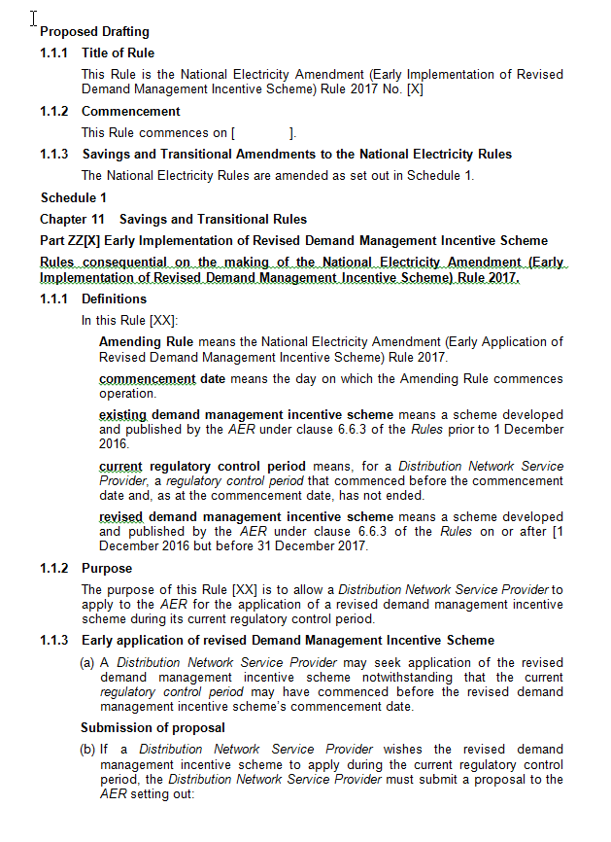

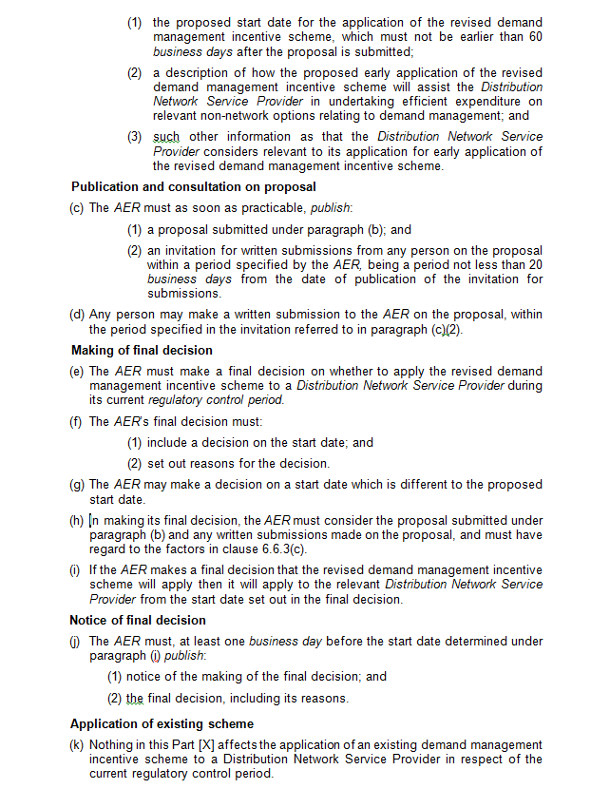

1. NER 6.6.3(d)(2).
2. Institute for Sustainable Futures, Additional Submission following our Demand Management Options Day, 8 May 2017, p.1. Examples of these technologies include rooftop solar, battery storage, smartphone control of household appliances, and Demand Response Enabling Devices.
3. NER 6.6.3(b).
4. AEMC, Rule Determination, National Electricity Amendment (Demand Management Incentive Scheme) Rule 2015, August 2015, p 23.
5. AEMC, Rule Determination, National Electricity Amendment (Demand Management Incentive Scheme) Rule 2015, August 2015, p 38.
6. NER rr.6.6.3(c)(1)-(7).
7. All submissions are available at: <https://www.aer.gov.au/networks-pipelines/guidelines-schemes-models-reviews/demand-management-incentive-scheme-and-innovation-allowance-mechanism/initiation>.
8. AER, Summary of Demand Management Options Day, 29 June 2017, Available at: https://www.aer.gov.au/networks-pipelines/guidelines-schemes-models-reviews/demand-management-incentive-scheme-and-innovation-allowance-mechanism/initiation.
9. Public Interest Advocacy Centre, Submission on the Draft National Electricity Amendment (Demand Management Incentive Scheme) Rule 2015, July 2015, p. 1.
10. Total Environment Centre, Submission on the Draft National Electricity Amendment (Demand Management Incentive Scheme) Rule 2015, July 2015, p .4.
11. The AER will make a decision to apply the Scheme during a distributor's regulatory control period after the distributor has submitted a proposal to the AER requesting early application by a requested start that is no earlier than 60 business days after it submits the proposal.
12. AER, Submission on the AEMC Draft National Electricity Amendment (Demand Management Incentive Scheme) Rule 2015, p. 4.
13. AER, Demand Management Incentive Scheme and Innovation Allowance Consultation Paper, January 2017, Available at: <https://www.aer.gov.au/networks-pipelines/guidelines-schemes-models-reviews/demand-management-incentive-scheme-and-innovation-allowance-mechanism>>.
14. National Electricity Law, Section 7.
15. More information about this process is available at;< http://www.aemc.gov.au/Rule-Changes/Contestability-of-energy-services-demand-response>.
16. More information about this project is available at; http://www.aemc.gov.au/Markets-Reviews-Advice/Distribution-Market-Model>.
17. ISF, Submission on AER's demand management consultation paper, 27 February 2017, 19.