

Better regulation

Consumer reference group subgroup guide

March 2013
Introduction
The Australian Energy Regulator (AER) has undertaken the ‘Better regulation’ program to deliver an improved regulatory framework focused on promoting the long term interests of electricity consumers. As part of this program we have put together a consumer reference group (CRG) which seeks to encourage input from consumers.
This document provides context for the CRG subgroups (by giving an overview of the AER’s Better regulation program and the CRG), as well as the specific purpose and role of the AER’s CRG subgroups.
Context
The ‘Better regulation’ program
We have commenced the Better regulation program to deliver an improved regulatory framework focused on promoting the long term interests of electricity consumers. This follows from changes to the National Electricity and Gas Rules that were published by the Australian Energy Market Commission on 29 November 2012.
The Better regulation program includes seven work streams. The final outcome of each work stream is the development of a new guideline for that area. We are keen for consumers and their representatives to participate in the development of these new guidelines.
The consumer reference group
The CRG is a key forum for the AER to get consumer input as we develop new guidelines, as part of the Better regulation program, on how we regulate network service providers (NSPs) in the NEM.
The intention of the CRG is to make it easier for consumer representative groups to have input into the ‘Better regulation’ consultative process without necessarily writing formal submissions. CRG members are able to distil key issues and information to constituents for consideration, consult and report back to the AER. This will provide a mechanism for co-ordinated and informed input from a cross-section of consumer groups. The CRG will also give guidance on where consumer representative groups can invest their limited resources to most effectively contribute to future regulatory processes.
The CRG subgroups are a part of this process.
Purpose
We are adopting a dual approach to consultation through the CRG. Accordingly, we have organised:
- monthly CRG meetings
- monthly subgroup meetings.
We anticipate that the monthly CRG meetings will provide a general overview of all work streams in the Better regulation program. The purpose of the subgroups is to engage in a more in-depth discussion than can be achieved in the monthly CRG meetings.
The CRG subgroups are made up of various consumer representatives from the CRG who have nominated to participate in the subgroups. Participation in CRG subgroups will allow members to target their contribution to specific areas that are of particular interest to their organisation.
Members of the subgroups are not expected to have a detailed knowledge of the subgroup that they are a member of. However, we hope subgroup members have an interest in finding out more and providing a customer perspective over the coming year.
Subgroup meetings will be facilitated by us. We will provide key discussion points ahead of the subgroup meetings.
The subgroups are complements to the Better regulation working groups. The working groups are a broad forum for any interested parties but tend to be a more technical discussion. In comparison, the subgroups are for consumers, and will be less technical. Both input from the working groups and the subgroups will be taken into account as the AER establishes new guidelines later this year. Figure 1 shows the relationship between the AER working groups and the customer reference group and subgroups.
Figure 1: Better regulation program
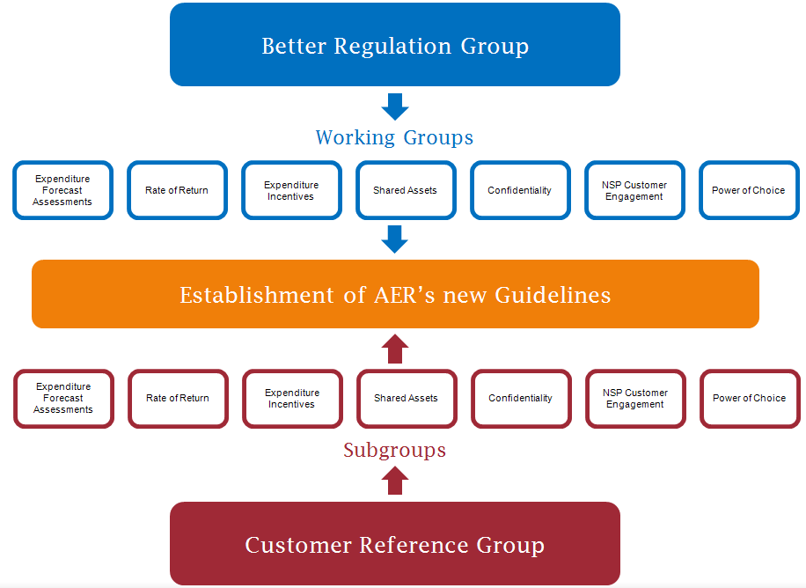

Roles and logistics

Each subgroup will consist of a spokesperson and general members from the CRG who have nominated to participate in that subgroup. In addition, we will make available the AER director responsible for that work stream and an AER contact to assist by providing expertise on the specific work stream.

Here are some guidelines of what we would like to see from different participants in the subgroup meetings. We acknowledge that there are many demands on your time so we appreciate that may not always be possible.

Spokesperson
The role of the subgroup spokesperson is to ensure that a summary of subgroup meetings is recorded, in particular action items. The spokesperson will liaise with the AER secretariat and subgroup members to ensure that action items are followed up. The spokesperson may be asked to report at the CRG on the discussions of the subgroup—the AER secretariat can assist with this. The spokesperson may ask another subgroup member to provide the report.

We will organise and facilitate the meetings of the subgroups. However, we envisage that the AER secretariat will liaise, in the first instance, with the spokesperson to ensure that the subgroup meetings occur at appropriate times. The spokesperson may consider that more meetings are required and may work with the AER secretariat to organise this.

Importantly, the spokesperson does not speak ‘on behalf of’ the subgroup. Rather, the spokesperson should report to the CRG the range of viewpoints presented at the subgroup meetings.

Subgroup members
Subgroup members should try to attend the subgroup meetings and participate where possible. To assist with this, the AER secretariat will provide information, including summaries of previous meeting and issues papers. Subgroup members are encouraged to present the views and opinions of themselves and their organisations at subgroup meetings.

AER contact
We have nominated an AER contact for each work stream who will be available to assist the subgroups as much as required. The AER contact will be available to provide technical guidance on the content being discussed in a particular subgroup. The AER contact could be available to follow up on action items and provide more in depth information as required. The AER contact Subgroup members should feel free to direct questions about the work stream to the AER contact. We expect that the AER contact will attend most subgroup meetings. Generally, the AER secretariat will also seek to be involved in the CRG subgroup meetings.

The AER contact and details are provided in Attachment 1.

AER director
We have assigned responsibility for each work stream within the Better regulation program to an AER director. The director will provide a report to the subgroup of any working group meetings. We envisage that the AER director will attend every CRG subgroup meeting.

Importantly, directors provide the link that ensures that both customer and business perspectives are accounted for in the development of the final guidelines.

Timeframes

Subgroups are expected to meet at least once between CRG meetings but can meet more frequently should they choose to. This will be largely dependent on the timetable of work stream. The AER secretariat will organise appropriate meeting times with the subgroup. The AER secretariat will likely engage with the spokesperson in the first instance.

We anticipate that most subgroup meetings will use teleconference facilities. The AER secretariat has organised for the following numbers to be used for teleconferences. This can be used for all subgroup meetings.

Dial in number: 1800766715
Conference Code: 361472

(note: you may be prompted to press # or *).

Subgroup meetings will be scheduled to run for approximately one or two hours (depending on the analysis required and the stage of the process).

Secretariat contacts

The following are contacts details for the AER CRG as at January 2013. In the first instance:

CRG Secretariat: Tanja Warre
Director
Tel: (02) 6243 1103
Email: tanja.warre@aer.gov.au

CRG General Enquiries: Kurt Stevens
Senior analyst
Tel: (02) 6243 1329
Email: kurt.stevens@aer.gov.au

All correspondence should be provided to: customerreferencegroup@aer.gov.au

Alternatively, correspondence can be mailed to:

Customer Reference Group
Australian Energy Regulator
GPO Box 3131
Canberra ACT 2601

Attachment 1—Details: members, directors and contacts
 | Expenditure Forecast Assessment | Rate of Return | Expenditure Incentives | Shared Assets | Confidentiality | NSP Customer Engagement | Power of Choice
CRG Spokesperson | Tennant Reed | Mark Henley | David Headberry | Tennant Reed | Graham Mawer | Carolyn Hodge | Katrina Lee
CRG Members | Mark Henley  David Headberry  Jonathan Pavetto  Janine Rayner  Angus Nardi  Bruce Mountain | David Headberry  Jonathan Pavetto  Carolyn Hodge  Janine Rayner  Bruce Mountain | Mark Henley  David Headberry  Heather l’Anson  Jonathan Pavetto  Dr Siwei Goo  Bruce Mountain | Mark Henley  David Headberry  Heather l’Anson  Bruce Mountain | Mark Henley  David Headberry  Heather I’Anson  Deanna Foong  Bruce Mountain | Mark Henley  David Headberry  Dr Siwei Goo  Carly Allen  Belinda Crivelli / Matt Helme  Carolyn Hodge  Alexandra Geddes  Jonathan Pavetto  Sue Fraser  Ro Evans  Heather l’Anson  Deanna Foong  Angus Nardi  Bruce Mountain | Mark Henley  David Headberry  Carly Allen  Belinda Crivelli / Matt Helme  Carolyn Hodge  Damian Sullivan  Heather l’Anson  Ro Evans  Tennant Reed  Carly Allen  Deanna Foong  Bruce Mountain
AER Contact | Lawrence Irlam  lawrence.irlam@aer.gov.au  03 9290 1438 | Sajjad Minhas  Sajjad.minhas@aer.gov.au  02 9320 3815 | Anne Sastro  Anne.sastro @aer.gov.au  02 9320 9109 | Dale Johansen  Dale.johansen@aer.gov.au  07 3835 4679 | Shalini Prasad  Shalini.prasad@aer.gov.au  02 9320 3829 | Robyn Lowien  Robyn.lowien@aer.gov.au  07 3835 4659 | Shalini Prasad  Shalini.prasad@aer.gov.au  02 9320 3829
AER Director | Lawrence Irlam (see above for contact details) | Craig Madden  Craig.madden@aer.gov.au 03 9290 6927 | Blair Burkitt  blair.burkitt@aer.gov.au  03 9290 1442 | Moston Neck  Moston.neck@aer.gov.au  07 3835 4669 | Adam Petersen  Adam.petersen@aer.gov.au  08 8213 3458 | Moston Neck  Moston.neck@aer.gov.au  07 3835 4669 | John Skinner  John.skinner@aer.gov.au  02 9320 3855

