

DRAFT DECISION

APA VTS Australia

Gas access arrangement

2018 to 2022

Overview

July 2017

© Commonwealth of Australia 2017

This work is copyright. In addition to any use permitted under the Copyright Act 1968, all material contained within this work is provided under a Creative Commons Attributions 3.0 Australia licence, with the exception of:

* the Commonwealth Coat of Arms
* the ACCC and AER logos
* any illustration, diagram, photograph or graphic over which the Australian Competition and Consumer Commission does not hold copyright, but which may be part of or contained within this publication. The details of the relevant licence conditions are available on the Creative Commons website, as is the full legal code for the CC BY 3.0 AU licence.

Requests and inquiries concerning reproduction and rights should be addressed to the:

Director, Corporate Communications  
Australian Competition and Consumer Commission   
GPO Box 4141, Canberra ACT 2601

or publishing.unit@accc.gov.au.

Inquiries about this publication should be addressed to:

Australian Energy Regulator  
GPO Box 520  
Melbourne Vic 3001

Tel: 1300 585 165  
Email: [AERInquiry@aer.gov.au](mailto:AERInquiry@aer.gov.au)

Invitation for submissions

This is our draft decision on APA's access arrangement for the Victorian Transmission System for 1 January 2018 to 31 December 2022. APA will submit a revised proposal in response to this draft decision by 14 August 2017. Interested parties are invited to make submissions on both our draft decision and APA's revised proposal by 15 September 2017.

We will consider and respond to all submissions received by that date in our final decision.

Submissions should be sent to: VicGAAR2018-22@aer.gov.au.

Alternatively, submissions can be sent to:

Mr Chris Pattas  
General Manager  
Australian Energy Regulator  
GPO Box 520  
Melbourne VIC 3001

Submissions should be in Microsoft Word or another text readable document format.

We prefer that all submissions be publicly available to facilitate an informed and transparent consultative process. Submissions will be treated as public documents unless otherwise requested. Parties wishing to submit confidential information should:

1. clearly identify the information that is the subject of the confidentiality claim
2. provide a non-confidential version of the submission in a form suitable for publication.

All non-confidential submissions will be placed on our website. For further information regarding our use and disclosure of information provided to us, see the ACCC/AER Information Policy (June 2014), which is available on our website.[1]

1. Note
2. This overview forms part of the AER's draft decision on the access arrangement for APA VTS Australia for 2018–22. It should be read with all other parts of the draft decision.
3. The draft decision includes the following documents:
4. Overview

Attachment 1 - Services covered by the access arrangement

Attachment 2 - Capital base

Attachment 3 - Rate of return

Attachment 4 - Value of imputation credits

Attachment 5 - Regulatory depreciation

Attachment 6 - Capital expenditure

Attachment 7 - Operating expenditure

Attachment 8 - Corporate income tax

Attachment 9 - Opex incentive mechanism

Attachment 10 - Reference tariff setting

Attachment 11 - Reference tariff variation mechanism

Attachment 12 - Non-tariff components

Attachment 13 - Demand

1. Contents

Invitation for submissions 2

Note 3

Contents 4

Shortened forms 6

1 Introduction 8

1.1 Structure of this overview 9

2 Draft decision 10

2.1 What is driving proposed revenue? 10

2.2 Key differences between our draft decision and APA's proposal 12

2.3 Impact of our draft decision on gas bills 13

3 Reference tariffs, demand and efficiency benefit sharing mechanism 16

3.1 Services covered by the access arrangement 16

3.2 Reference tariff setting and the reference tariff variation mechanism 16

3.3 Forecast Demand 17

4 Total revenue requirement 19

4.1 The building block approach 19

4.2 Draft decision 20

4.3 Total revenue 21

4.4 Revenue smoothing and tariffs 22

5 Key elements of decision on revenue 26

5.1 Capital base 26

5.2 Rate of return (return on capital) 28

5.3 Value of imputation credits (gamma) 32

5.4 Regulatory depreciation (return of capital) 34

5.5 Capital expenditure 35

5.5.1 Conforming capex for 2013–17 36

5.5.2 Conforming capex for the 2018–22 access arrangement period 37

5.6 Operating expenditure 40

5.7 Opex incentive mechanism 41

5.8 Corporate income tax 42

6 Non-tariff components 45

7 Understanding the NGO 46

7.1 Achieving the NGO to the greatest degree 49

7.1.1 Interrelationships between individual components 50

8 Consultation 51

8.1 APA's engagement with customers 51

A List of submissions 53

1. Shortened forms

|  |  |
| --- | --- |
| 1. Shortened form | 1. Extended form |
| 1. AER | 1. Australian Energy Regulator |
| 1. ATO | Australian Tax Office |
| 1. capex | 1. capital expenditure |
| 1. CAPM | 1. capital asset pricing model |
| 1. CPI | 1. consumer price index |
| 1. DRP | 1. debt risk premium |
| 1. ECM | (Opex) Efficiency Carryover Mechanism |
| 1. ERP | 1. equity risk premium |
| 1. Expenditure Guideline | Expenditure Forecast Assessment Guideline |
| 1. gamma | Value of Imputation Credits |
| 1. MRP | 1. market risk premium |
| 1. NGL | 1. National Gas Law |
| 1. NGO | 1. national gas objective |
| 1. NGR | 1. National Gas Rules |
| 1. NPV | net present value |
| 1. opex | 1. operating expenditure |
| 1. PTRM | 1. post-tax revenue model |
| 1. RBA | 1. Reserve Bank of Australia |
| 1. RFM | 1. roll forward model |
| 1. RIN | 1. regulatory information notice |
| 1. RPP | 1. revenue and pricing principles |
| 1. SLCAPM | 1. Sharpe-Lintner capital asset pricing model |
| 1. STTM | Short Term Trading Market |
| 1. TAB | Tax asset base |
| 1. UAFG | Unaccounted for gas |
| 1. WACC | 1. weighted average cost of capital |
| 1. WPI | Wage Price Index |

|  |
| --- |
| Background to our draft decision |

|  |
| --- |
| Background to our draft decision |

Since APA submitted its original proposal for the 2018-22 access arrangement period on 3 January 2017, a number of market developments occurred that increased uncertainty in relation to gas supply and demand, particularly for gas powered generation (GPG). These developments included:

* electricity and gas supply issues, and resulting government intervention in the market
* Federal Government responses including a new power to limit gas exports under certain conditions
* closure of the Hazelwood generator
* a threat to system security identified and issued by the Australian Energy Market Operator (AEMO) on 10 March 2017[2] following the publication of the 2017 Victorian Gas Planning Report (VGPR).[3]

Submissions on APA's original proposal, from a number of APA's users and AEMO, expressed the need for additional investment in the Victorian Transmission System (VTS) above that proposed by APA. In particular, submissions supported additional augmentation to address forecast tightening of the gas supply/demand balance in Victoria, South Australia and NSW.

In response to gas market developments and submissions, APA submitted what likely solutions might look like, specifically submitting a full business case for bringing forward construction of the Western Outer Ring Main (the WORM), the need for which had been anticipated by APA in the 2023–2027 period. Further consultation with AEMO indicated that construction of the WORM would meet their requirements to alleviate security issues related to the balance of supply and demand in the VTS. We also sought the advice of the AER's Consumer Challenge Panel (CCP11) on whether this expenditure would serve the long-term interests of consumers.

This draft decision address issues raised in submissions and includes additional capital expenditure not contemplated in APA's January proposal.

Our approval of additional capex for the construction of the WORM also has consequential impacts on opex, overall revenue and tariffs. Our draft decision shares these additional costs between those using withdrawal zones that use the new flow path incorporating the WORM.

As part of our consultation on this draft decision we seek stakeholder views on whether APA's WORM proposal addresses their concerns.

# Introduction

The Australian Energy Regulator (AER) regulates energy markets and networks under national energy market legislation and rules. Our network regulatory functions, which relate to energy networks in all Australian states and territories, except Western Australia, include setting the amount of revenue that monopoly network businesses can recover from customers for using networks (electricity poles and wires and gas pipelines) that transport energy.

The National Gas Law and Rules (NGL and NGR) provide the regulatory framework governing gas networks. Our work under this framework is guided by the National Gas Objective (NGO):[4]

…to promote efficient investment in, and efficient operation and use of, natural gas services for the long term interests of consumers of natural gas with respect to price, quality, safety, reliability and security of supply of natural gas.

APA VTS Australia (Operations) Pty Ltd and APA VTS Australia (NSW) Pty Ltd (APA) own the Victorian Transmission System (VTS)[5], which is the primary transmission system for the delivery of gas throughout Victoria. Gas pipelines that are subject to full regulation—like the VTS—are regulated by the AER under an approved access arrangement. [6] An access arrangement specifies certain pipeline services (reference services), and the price and non-price terms and conditions on which those reference services will be offered over the next five years (2018–2022).

To approve an access arrangement, we make decisions on the revenue that APA can recover from users of its reference services. For this draft decision, our assessment is based on the proposal submitted by APA for the VTS on 3 January 2017 amended to incorporate the updated WORM forecast expenditure. APA's proposal sets out its view of its expected costs, demand and required revenues for the period 1 January 2018 to 31 December 2022.

This Overview, together with its attachments, constitutes our draft decision on APA's access arrangement proposal for the VTS. This draft decision is one of the key steps in reaching our final decision. APA will have the opportunity to submit a revised proposal in response to this draft decision. Stakeholders will then have the opportunity to make submissions to us on both our draft decision and APA's revised proposal. Subject to stakeholder interest, we will also consider holding a public forum following submission of APA's revised proposal.

Following receipt of the revised proposal and submissions, we will then make our final decision taking into account the revised proposal, submissions and any other relevant information. Table 1‑1 lists key dates and consultation deadlines for this review.

Table ‑ Key dates and consultation timelines

|  |  |
| --- | --- |
| Task | Date |
| Access arrangement revision proposal submitted to the AER | 3 January 2017 |
| Public forum | 1 February 2017 |
| Submissions on access arrangement proposal closed | 3 March 2017 |
| AER draft decision published | 6 July 2017 |
| Revised proposal due | 14 August 2017 |
| Submissions on draft decision and revised proposal close | 15 September 2017 |
| AER final decision published* | 29 November 2017 |

* This date is indicative only.

## Structure of this overview

This overview provides a summary of our draft decision and its individual components:

* Section 2 provides a high level summary of our draft decision
* Section 3 sets out our draft decision on the reference services that will be covered by the access arrangement, and the mechanism for setting and varying reference tariffs.
* Section 4 sets out our draft decision on the total revenue requirement
* Section 5 provides a break-down of our revenue decision into its key components
* Section 6 sets out our draft decision on the non-tariff components of APA's access arrangement proposal
* Section 7 explains our views on the regulatory framework and the NGO
* Section 8 outlines the consultation process we undertook in reaching our draft decision
* Appendix A lists the stakeholder submissions received on APA's proposal.

In our attachments to this overview we set out detailed analysis of the constituent components that make up our draft decision.

# Draft decision

Our draft decision is to approve a forecast revenue requirement of $555.4 million   
($ nominal, smoothed) for APA over the 2018–22 access arrangement period. This is a 24.2 per cent reduction from APA's proposed revenue requirement of $732.3 million   
($ nominal, smoothed). Our draft decision would allow APA to recover 12.9 per cent more revenue than its 2013–17 allowance of $492.0 million ($ nominal, smoothed).

Figure 2‑1 compares our draft decision on APA's total revenue requirement for   
2018–22 to its proposed revenue requirement, and to the revenue allowed and recovered during the two previous access arrangement periods of 2013–17 and   
2008–12. The effect of this draft decision will be to hold APA's revenues relatively constant in real dollar terms.

Figure ‑ APA's past total revenue, proposed total revenue and AER draft decision total revenue ($ million, 2017)

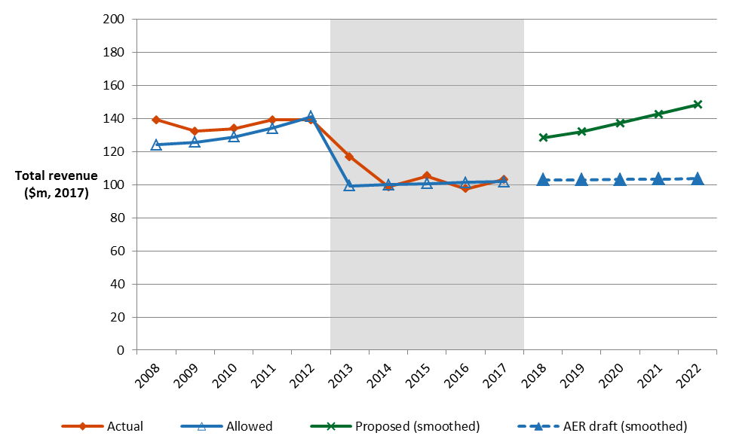

Source: AER analysis

## What is driving proposed revenue?

The impact of inflation makes it difficult to compare revenue across different time periods on a like-for-like basis. We therefore use real values based on a common year, which have been adjusted for the impact of inflation, to compare revenue from one access arrangement period to the next. In real dollar terms, our draft decision approves revenues for the 2018–22 access arrangement period that are $12.5 million ($ 2017)—or 2.5 per cent—higher than was approved in our decision for 2013–17.[7]

Figure 2‑2 compares our draft decision for the 2018–22 access arrangement period to APA's allowed revenue for the current period, broken down by the various building block components that make up the forecast revenue allowance.

Figure ‑ AER's draft decision for the 2018–22 access arrangement period and APA's 2013–17 allowed average annual building block costs ($ million, 2017)

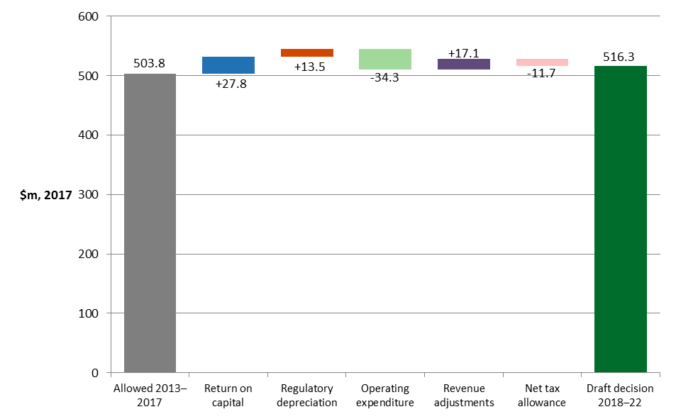

Source: AER analysis

The return on capital and regulatory depreciation are key drivers of the increase in real revenue from the current period to the 2018–22 access arrangement period. This is driven by significant growth in APA's capital base, which increased by 40 per cent, in real terms, over the current period and is expected to increase by a further 2.4 per cent over 2018–22. The impact of this growth in the capital base is offset to an extent by the lower rate of return that will apply in 2018–22: 5.75 per cent compared to 7.22 per cent in the current period.

The increases in the return on and of capital are largely offset by operating efficiencies gained by APA in the current period and passed through to customers in the form of a lower opex forecast in the 2018–22 access arrangement period.

## Key differences between our draft decision and APA's proposal

Figure 2‑3 compares the building block revenue from our draft decision to that proposed by APA for the 2018–22 access arrangement period, and to the approved amount for the 2013–17 period. These are total amounts based on building block costs over the five year access arrangement period.

Figure ‑ AER's draft decision on components of total revenue ($ million, 2017)

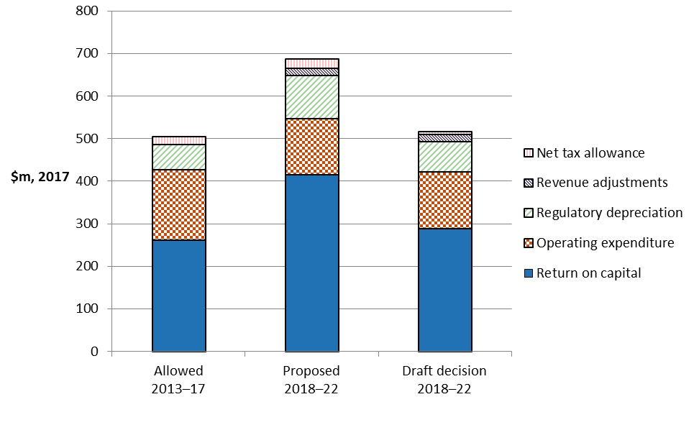

Source: AER analysis

APA's proposed total revenue requirement of $732.3 million ($ nominal) for 2018–22 was primarily driven by a proposed rate of return of 7.88 per cent (nominal, vanilla) on a capital base which included higher than anticipated capex in the current period to meet increased demand for the northern flow of gas from Victoria.[8] The rate of return allowed in our final decision for the current period was 7.22 per cent.

Our draft decision allows APA to recover $176.9 million ($ nominal) or 24.2 per cent less revenue than its proposed forecast revenue requirement of $732.3 million ($ nominal). A lower approved return on capital is the primary driver of the difference between APA's proposed revenue requirement and that approved in our draft decision. Key differences between our draft decision and APA's proposal include:

* a nominal vanilla rate of return of 5.75 per cent, compared to 7.88 per cent in APA's proposal
* an imputation credits (gamma) value of 0.4 per cent, compared to APA’s proposed 0.25, resulting in a lower corporate income tax allowance.
* a reduction of 27.3 per cent to APA’s proposed regulatory depreciation allowance, due to our decision to update APA’s calculation of the remaining asset lives as at 1 January 2018 and our decision to reduce APA’s forecast capex. Our draft decision on expected inflation has also reduced the allowance for regulatory depreciation.
* while our draft decision approves additional capex for the full construction of the WORM that was not contemplated in its January proposal, we have not accepted all of APA's forecast total net capex which has been reduced by 16 per cent. The majority of the reduction arises from our draft decision that APA has not justified its proposed forecast capex for its slabbing program which appears premature, given the available information about the when urban development is likely to proceed. The approval for this expenditure can be deferred closer to the time when urban development is actually likely to proceed.

APA will have the opportunity to address these differences in its revised proposal.

## Impact of our draft decision on gas bills

The annual gas bill for customers in Victoria will reflect the combined cost of all the gas supply chain components. Changes in gas bills over time reflect movements in one or more of the components of the bill. The main components are:

* the cost of producing gas (the wholesale gas generation cost);
* the cost of the pipelines used to transport the gas (the transmission and distribution networks) and other infrastructure such as metering costs; and
* the retailers costs and profit margin.

Our draft decision for APA affects transmission charges, which represent approximately 2.1 per cent on average of a Victorian customer's annual gas bill. This small percentage largely explains the relatively modest impact that this draft decision is likely to have on average annual gas bills.

We estimate the expected bill impact by varying the transmission charges in accordance with our draft decision, while holding other components of the bill constant.[9] Our estimates are in nominal terms (taking into account expected future inflation to determine what the nominal price levels will be in future periods) because it will be nominal amounts that consumers will be paying. Based on this approach, we expect that our draft decision will result in an increase to the transmission component of the average annual gas bills for residential customers in Victoria over the 2018–22 access arrangement period. The transmission component of the average annual residential gas bill in 2018 is expected to be about $1 lower than the current, 2017 level. By the end of the 2018–22 access arrangement, the transmission component of the average annual bill is expected to be about $4 ($ nominal) above the 2017 level. Similarly, the transmission component of the average small business gas bill in 2018 is expected to be about $1 lower than in 2017, and about $36 above the current 2017 level by 2022.

Table 2‑1 shows our estimated impact of this draft decision on average annual gas bills for residential and commercial customers over the 2018–22 access arrangement period compared to APA's proposal. These impacts are indicative only, and individual customers' actual bills will also depend on their usage patterns and the structure of their chosen retail tariff offering.

Table ‑ AER's estimated impact of our draft decision and APA's proposal on average annual gas bills for the 2018–22 access arrangement period

|  |  |  |  |  |  |  |
| --- | --- | --- | --- | --- | --- | --- |
|  | 2017 | 2018 | 2019 | 2020 | 2021 | 2022 |
| **AER draft decision** |  |  |  |  |  |  |
| Residential annual gas bill | 1271a | 1270 | 1272 | 1273 | 1274 | 1275 |
| Annual changec |  | –1 (–0%) | 2 (0.1%) | 1 (0.1%) | 1 (0.1%) | 1 (0.1%) |
| Small business annual gas bill | 7775b | 7774 | 7785 | 7794 | 7802 | 7811 |
| Annual changec |  | –1 (–0%) | 11 (0.1%) | 9 (0.1%) | 8 (0.1%) | 9 (0.1%) |
| **APA proposal** |  |  |  |  |  |  |
| Residential annual gas bill | 1271a | 1277 | 1280 | 1282 | 1285 | 1288 |
| Annual changec |  | 6 (0.5%) | 3 (0.2%) | 2 (0.2%) | 3 (0.2%) | 3 (0.2%) |
| Small business annual gas bill | 7775b | 7829 | 7850 | 7871 | 7893 | 7916 |
| Annual changec |  | 54 (0.7%) | 21 (0.3%) | 21 (0.3%) | 22 (0.3%) | 23 (0.3%) |

Source: AER analysis. APA, B1 - RIN templates - 20170103

(a) Based on transmission charges accounting for 2.1 per cent of the average residential gas bill.

(b) Based on transmission charges accounting for 2.8 per cent of the average small business gas bill.

(c) Annual change amounts and percentages are indicative. They are derived by varying the transmission component of 2017 bill amounts by the nominal weighted average expected change in tariffs. Actual bill impacts will vary depending on consumption and tariff class.

We do not expect transmission charges flowing from this draft decision will be a large contributor to overall gas bill changes.

While our approach isolates the effect of our decision on gas prices, it does not imply that other components of the bill will remain unchanged across the access arrangement period. Wholesale gas costs make-up a smaller percentage of the retail gas prices paid by energy consumers. AEMO’s modelling forecasts retail prices to rise on average by 2.1 per cent per annum (in real dollar terms) for residential customers, driven mainly by wholesale prices.[10] Modelling by AEMO projects that the delivered wholesale cost of gas in Australia will increase by 48 per cent by 2036.[11]

Bill impacts for customers connected directly to the VTS, including gas fired power stations and large industrial manufacturers, will be different to impacts for retail customers. Directly connected customers don't pay distribution network charges, so the transmission component of their gas bill is a larger proportion of their total bill. More generally, bill impacts for directly connected customers are a magnified version of bill impacts estimated for retail customers.

# Reference tariffs, demand and efficiency benefit sharing mechanism

## Services covered by the access arrangement

An access arrangement sets out at least one service likely to be sought by a significant part of the market (reference services). For each reference service, the access arrangement specifies the reference tariff and the other terms and conditions on which the reference service will be provided.[12]

Our draft decision is to approve APA's proposal to continue to offer the Tariffed Transmission Service, the same primary reference service, in the 2018–22 access arrangement period as it has in the current period. We considered and approved this service in our final decision on APA's 2013–17 access arrangement, and remain of the view that it is appropriate.

We also accept APA’s proposal to remove its Authorised Maximum Daily Quantity Credit Certificates (AMDQ CC) reference service, which we had required it to include in its 2013–17 access arrangement. This change reflects changes to the NGR that took effect during the current period.

## Reference tariff setting and the reference tariff variation mechanism

Our draft decision on APA's proposed access arrangement includes decisions on the structure of its reference tariffs and the mechanism by which those tariffs will be determined from year to year (the annual reference tariff variation mechanism).

The proposed reference tariff variation mechanism includes:

* an annual reference tariff variation mechanism, and
* a cost pass through mechanism, including a number of cost pass through events.

The AER accepts the fundamental features of APA's proposed reference tariffs, including the tariff design, the zonal structure, the basis for charging users, and the general approach to allocating costs.

The reference tariff includes:

* Injection tariffs–the charge payable for injecting gas into the VTS
* Withdrawal tariffs–the charge for withdrawing gas from the VTS

A zonal tariff structure is proposed to continue to apply. This is where users pay for the use of the VTS transmission system depending on the length of the pipeline they use within certain zones, and for the injection and or withdrawal of gas from the pipeline. Non-system costs, such as the return of and on capital and corporate overheads are allocated to customers on a postage stamp basis.

For example, VNI expenditure will be recovered during the 2018–22 access arrangement from those using the interconnector to take gas from Victoria to New South Wales and Queensland (shippers and retailers) to supply markets outside Victoria. These customers take their gas supply via the Culcairn withdrawal tariff and this gas is not used by Victorian customers. However, the VNI will result in larger throughput on the Victorian network delivering some benefits for Victorian customers in the form of a reduction in shared network costs.

Likewise, we approve APA's proposal that costs associated with the WORM are allocated to users based on their use of the WORM. This means that costs directly attributable to supplying the users are allocated to those users. In summary, the impact of the WORM on VTS tariffs is immaterial. Some injection and withdrawal tariffs increase slightly and others drop a little. The approach we have taken is consistent with APA's standard cost allocation methodology. Approval of capex on the WORM proposal results in an increase in annual direct costs to be recovered through tariffs, from approximately $760,000 to $7.6 million.

In this draft decision we are amending the existing cross system tariff such that users who ship gas from Longford or Culcairn into Iona storage and then take it out for export to South Australia (via the Sea Gas pipeline) are charged the cross-system tariff in addition to the current storage refill tariff.

APA proposed that the previous reference tariff variation mechanisms continue to apply for the 2018–22 access arrangement subject to annual updates of the return on debt, which alter the rate of return each year.

The two existing reference tariff variation mechanisms are:

* a scheduled reference tariff variation mechanism - which applies in respect of each year of the access arrangement period; and
* a cost pass-through reference tariff variation mechanism - under which APA may seek to vary the reference tariffs as a result of a cost pass through event.

We approve the reference tariff variation mechanisms proposed by APA as per the formulas set out in attachment 11.

## Forecast Demand

Demand is an important input into the derivation of APA's reference tariffs. In simple terms, tariffs are determined by dividing cost (as reflected in forecast revenue) by total demand (GJ/day), so that an increase in forecast demand has the effect of reducing the tariff price and vice versa.

Our draft decision is to not accept APA's proposed total VTS withdrawal volumes for the 2018–22 access arrangement period. While we are satisfied that APA's overall methodology to forecast total VTS withdrawal volumes is consistent with rule 74(2) of the NGR, we have not accepted the forecasts for Tariff V and storage refill demand—components of total withdrawal volumes. We have updated the Tariff V forecast to reflect the changes we have made to the three Victorian gas distributors' demand forecasts. We also forecast a higher volume of gas flowing into Iona Underground Storage. These changes result in a small (0.56 per cent) increase to APA's forecast of withdrawal volumes of gas from the VTS.

We accept APA's proposed forecast of Tariff D demand (large commercial and industrial), gas powered generation (GPG) demand and interstate transfers.

The forecasts from our draft decision mean:

* a decrease in Tariff V gas demand of around -0.35 per cent per year over 2018–22 access arrangement period. The relatively flat demand reflects population growth being offset by improving appliance efficiency and improving quality of insulation in Victoria's housing stock.[13]
* a decrease in Tariff D demand of -2.0 per cent per year over the 2018–22 access arrangement period. This decline reflects an ongoing decline in industrial demand observed since 2007, owing to reduced economic activity in that sector.[14]
* a decline in GPG demand over the 2018–22 access arrangement period, following a short-term spike in GPG generation in 2017 as gas-fired power generators replace electricity supply lost through the closure of the Hazelwood power station. GPG demand is forecast to fall to below a third of the pre-2017 level by 2022, following an increase in renewable generation in response to the Victorian Renewable Energy Target.
* annual gas flows from the VTS through Culcairn into the NSW transmission system is forecast to remain at the estimated 2017 level over the 2018–22 access arrangement period.

Further detail on our draft decision in regards to APA's demand forecast is set out in attachment 13.

# Total revenue requirement

1. The total revenue requirement is a forecast of the efficient cost of providing gas transmission services over the access arrangement period. We determine annual revenue—and the total revenue requirement—in nominal terms because it will be in nominal amounts that consumers will be paying. To do this, we take into account expected future inflation to determine what the nominal price levels will be in future periods. Our draft decision uses 10 year inflation expectations on average to convert revenues to nominal values.
2. The total revenue requirement set out in this draft decision has been determined by assessing each building block cost of APA's access arrangement proposal. We have assessed whether these building block costs are consistent with the costs that would be incurred by an efficient provider of gas transmission services.
3. Tariffs are derived from the total revenue requirement after consideration of demand for each tariff category. APA operates under a control mechanism that takes the form of an average revenue yield. It is a price control formula that adjusts for the effect of differences between actual and forecast volumes over the access arrangement. The tariffs we determine, (including the means of varying the tariffs from year to year) are the binding constraint across the 2018–22 access arrangement period, rather than the total revenue requirement set out in our decision.[15] Tariffs are adjusted each year using the 'X factors'. X factors are percentage changes in real weighted average tariffs from year to year. The process of determining X factors is discussed in section 4.4.

## The building block approach

1. We have employed the building block approach to determine APA's total revenue requirement—that is, we based the total revenue requirement on our estimate of the efficient costs that APA is likely to incur in providing its reference service. The building block costs, as shown in Figure 4‑1, include:[16]

* return on the projected capital base (return on capital)
* depreciation of the projected capital base (return of capital)
* the estimated cost of corporate income tax
* revenue increments or decrements resulting from incentive mechanisms such as the benefit sharing allowance
* forecast opex.

1. Our assessment of capex directly affects the size of the capital base and therefore, the revenue generated from the return on capital and depreciation building blocks.

Figure ‑ ****The building block approach for determining total revenue****

Return on capital (forecast capital base × cost of capital)

Regulatory depreciation (depreciation net of indexation applied to capital base)

Corporate income tax (net of value of imputation credits)

Capital costs

Operating expenditure (opex)

Incentive mechanisms (increment or decrement)

Total revenue

## Draft decision

We do not approve APA's proposed total revenue requirement (smoothed) of $732.3 million ($ nominal) for reference services over the 2018–22 access arrangement period.[17] Our draft decision is to approve a total revenue requirement (smoothed) of $555.4 million ($ nominal) for APA over the 2018–22 access arrangement period. This is 24.2 per cent lower than APA's proposal.[18]

We do not approve APA's proposed 2018 tariffs, which included a weighted average increase in real tariffs of 23.8 per cent.[19] We also do not approve APA's proposed   
2019–22 tariff path, which was for a weighted average increase in real tariffs of 3.3 per cent per year.[20] As a result of our lower total revenue requirement, our draft decision is for a real decrease in weighted average tariffs of 0.25 per cent for 2018, and real increase of 0.2 per cent in the remaining years of the 2018–22 access arrangement period.[21] Our decision aims to balance APA's ability to recover revenues and recognises the potential for stable prices over the access arrangement period. Approved building block revenues (unsmoothed) are expected to increase over the access arrangement period. Section 4.4 discusses our approach to revenue smoothing and tariffs.

Table 4‑1 sets out our draft decision on APA's total revenue requirement, by building block, for each year of the 2018–22 access arrangement period, the total revenue after equalisation (smoothing) and the X factors for use in the tariff variation mechanism.

Table ‑ AER's draft decision on APA's smoothed total revenue and X factors for the 2018–22 access arrangement period ($ million, nominal)

|  |  |  |  |  |  |  |
| --- | --- | --- | --- | --- | --- | --- |
| Building block | 2018 | 2019 | 2020 | 2021 | 2022 | Total |
| Return on capital | 56.7 | 59.7 | 62.4 | 66.0 | 65.8 | 310.5 |
| Regulatory depreciation | 11.6 | 14.2 | 15.8 | 19.5 | 17.0 | 78.1 |
| Operating expenditure | 26.6 | 27.3 | 28.0 | 29.8 | 30.8 | 142.6 |
| Revenue adjustments | 7.1 | 4.7 | 3.9 | 2.4 | 0.0 | 18.0 |
| Net tax allowance | 1.3 | 1.5 | 1.9 | 1.4 | 0.5 | 6.5 |
| **Building block revenue - unsmoothed** | **103.3** | **107.4** | **112.0** | **119.0** | **114.0** | **555.7** |
| **Building block revenue - smoothed** | **105.5** | **108.1** | **111.0** | **113.9** | **117.0** | **555.4** |
| X factors | 0.25% | –0.07% | –0.17% | –0.16% | –0.27% | n/a |

Source: AER analysis.

n/a: not applicable.

(a) Under the CPI–X form of control, a positive X factor is a decrease in price (and therefore in revenue).

The X factor for 2018 is indicative only. The draft decision establishes 2018 tariffs directly, rather than referencing a change from 2017 tariffs.

## Total revenue

1. Figure 4‑2 shows the effect of our draft decision adjustments on APA's proposed building blocks for the 2018–22 access arrangement period. It shows the reductions to APA's proposed return on capital, depreciation and tax building blocks.

Figure ‑ AER’s draft decision and APA's proposed building block revenue (unsmoothed) ($ million, nominal)

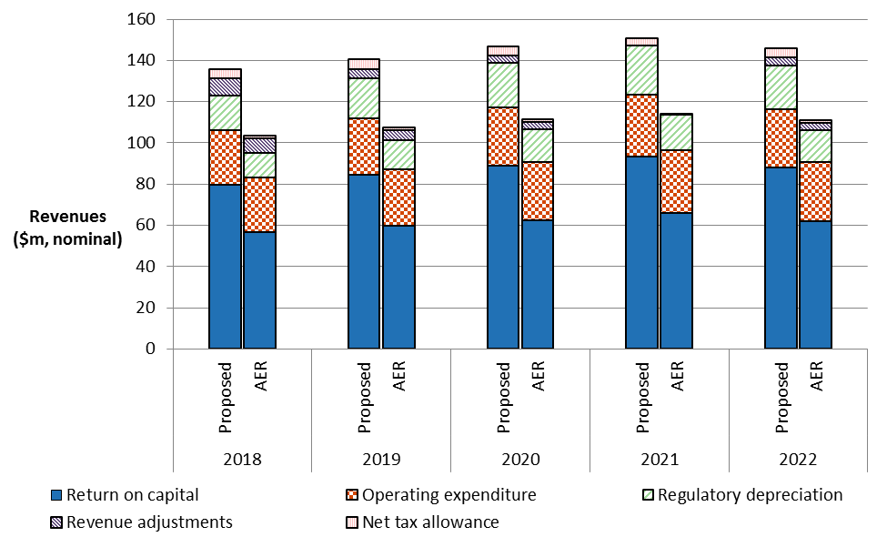

Source: AER analysis.

## Revenue smoothing and tariffs

After our assessment of APA's total building block revenue (unsmoothed revenue), we determined the smoothed revenue profile across the 2018–22 access arrangement period. [22] APA has operated under largely the same reference tariff control mechanism since the first access arrangement. It is a price control formula that adjusts for the effect of differences between actual and forecast volumes over the access arrangement, to ensure that the net present value of building block revenues equals the revenues forecast to be achieved in the current regulatory year and future regulatory years of the 2018–22 access arrangement. The control mechanism takes the form of an average revenue yield.[23]

This weighted average tariff change is labelled the 'X factor'. The X factors that we determine must ensure that the sum of the smoothed revenues across the period equals the unsmoothed building block revenue in net present value (NPV) terms.

The X factors represent the weighted average real change in tariffs. As part of the annual reference tariff variation process, we combine the X factors we have determined in our decision with actual inflation to create reference tariffs for the coming year. This means that the prices paid by consumers, and therefore the revenues received by the networks, change with actual inflation, but (ignoring other non-inflation factors) are constant in real terms.

1. The mechanics of the tariff variation mechanism are addressed in attachment 11.
2. Table 4‑2 presents our draft decision X factors, and compares them to the APA proposal.

Table ‑ Weighted average tariff change across the access arrangement period (X factors) — comparison of APA's proposal and AER's draft decision (per cent)

|  |  |  |  |  |  |
| --- | --- | --- | --- | --- | --- |
|  | 2018 | 2019 | 2020 | 2021 | 2022 |
| **AER draft decision** |  |  |  |  |  |
| X factora | 0.25% | –0.07% | –0.17% | –0.16% | –0.27% |
| Nominal price change | 2.19% | 2.53% | 2.63% | 2.61% | 2.73% |
| **APA's proposal** |  |  |  |  |  |
| X factora | –23.79% | –2.48% | –3.44% | –3.50% | –3.63% |
| Nominal price changeb | 26.83% | 4.99% | 5.97% | 6.04% | 6.17% |

Source: APA, Proposed supplementary capital expenditure submission PTRM, May 2017; AER analysis.

(a) Under the CPI–X form of control, a positive X factor is a decrease in price (and therefore in revenue). For example, an X factor of –3.5 per cent in 2021 proposed by APA means a real price increase of 3.5 per cent that year. After consideration of inflation (assumed at 2.45 per cent) this becomes a nominal price increase of 6.04 per cent.

(b) For comparison purposes the nominal price changes are derived from the real price changes for APA adjusted by AER's draft decision forecast inflation of 2.45 per cent.

1. Figure 4‑3 shows indicative tariff paths for APA's reference services across the   
   2018–22 period. It compares APA's proposed tariff path with that approved in the 2013–17 access arrangement, and with this draft decision.[24] This provides a broad overall indication of the average movement across this period.

Figure ‑ Indicative reference tariff paths for APA's reference services from 2013 to 2022 (nominal index)

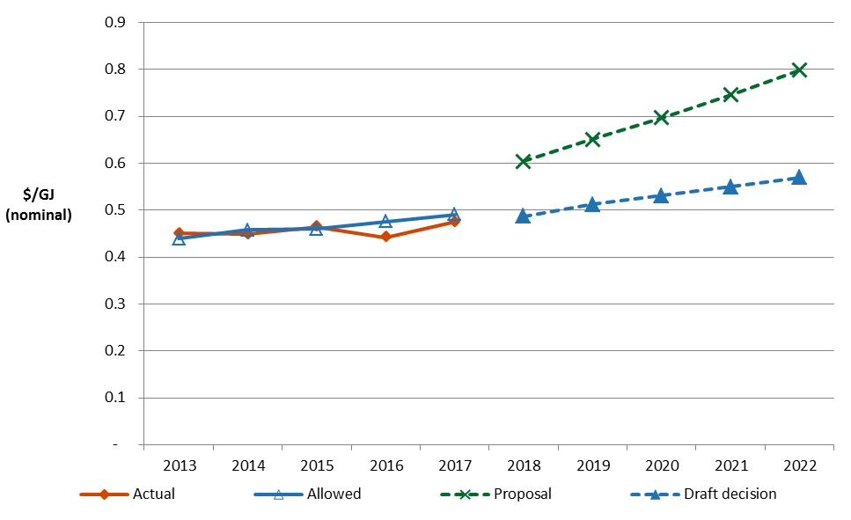

Source: AER analysis; [APA, B4 - APA Post Tax Revenue Model revised with WORM (includes 3 March 2017 updates for inflation in response to AER information request IR003), 16 May 2017](https://www.aer.gov.au/system/files/APA%20VTS-B4-APA%20Post%20Tax%20Revenue%20Model%20revised%20with%20WORM-20170516%20-Public.xlsm). APA, B5 - Tariff Model revised with WORM, Confidential, 16 May 2017.

1. APA's proposed tariff path suggested an increase of 27.2 per cent (in nominal terms) in 2018, followed by tariffs that increase at an average of 7.2 per cent per year for the remaining years of the 2018–22 access arrangement period. Our draft decision provides for lower total smoothed revenue than APA's proposal, in line with our reductions to total unsmoothed revenue. Our draft decision tariff path shows an increase of 3.7 per cent in tariffs (in nominal terms) on average over the 2018–22 access arrangement period.

In choosing the smoothing profile for this draft decision we have balanced a number of competing objectives:

* Equalising (in NPV terms) unsmoothed and smoothed revenue
* Providing price signals that reflect the underlying efficient costs
* Minimising tariff variability from 2017 and within the 2018–22 access arrangement period
* Minimising the likelihood of variability in tariffs at the start of the 2023–27 access arrangement period.

Each of these points is discussed in turn.

First, we are satisfied that our draft decision tariff path for APA's 2018–22 access arrangement period achieves revenue equalisation as required by rule 92(2) of the NGR.[25] As set out above, we have made substantial reductions to the unsmoothed revenue proposed by APA. Accordingly, we set the tariff path so that it adjusts the smoothed revenue downward to better reflect the unsmoothed building block costs.

Second, but closely related to the first point, our smoothing allows closer alignment of tariffs and costs. This aids the achievement of the NGO and the revenue and pricing principles, including through providing a price signal that facilitates efficient use of natural gas services.[26] Our draft decision tariff path shows consistent decreases across the 2018–22 access arrangement period. This reflects the lower unsmoothed building block costs and increasing demand in the later years of the access arrangement period that would generally result in lower tariffs, all things being equal.

Third, in setting the tariff path, we aim to minimise tariff volatility from 2017 to 2018 and within the 2018–22 access arrangement period. Our chosen tariff path reflects this objective, but also reflects the consideration we must give to other competing objectives. For instance, setting a flat tariff path from 2017 would better minimise volatility within the 2018–22 access arrangement period, but would not achieve revenue equalisation.

Fourth, in setting the tariff path, we also aim to minimise the likelihood of tariff volatility between this access arrangement period and the next. We do not know with certainty what APA's efficient costs will be in 2023, or across the 2023–27 access arrangement period more generally. The unsmoothed building block costs for 2022 (the last year of APA's 2018–22 access arrangement period) are the best available proxy. Hence, this objective requires minimising the divergence between the smoothed and unsmoothed revenues for the last year of the access arrangement period. If there were no significant changes in forecast costs from 2022 to 2023, this final year divergence gives us an estimate of the size of the tariff change at the start of the 2023–27 access arrangement period.

For this draft decision, this final year divergence is 2.6 per cent.

We note that if there are significant changes in costs at the start of the 2023–27 access arrangement period, this might increase or decrease the required tariff change at that time.

We are satisfied that our draft decision tariff path reflects our balanced consideration of these competing objectives. We will review this smoothing profile for the final decision if necessary.

# Key elements of decision on revenue

The components of our draft decision include the building blocks we use to determine the revenue that APA may recover from its users. The following sections summarise our revenue decision by building block. The attachments to this draft decision provide a more detailed explanation of our analysis and findings.

## Capital base

The capital base roll forward accounts for the value of APA's regulated assets over the access arrangement period. The opening capital base value for a regulatory year within the access arrangement period is rolled forward by indexing it for inflation, adding any conforming capex, and subtracting depreciation and other possible factors (for example, disposals or customer contributions).[27] Following this process, we arrive at a closing value of the capital base at the end of each year of the access arrangement period. The opening value of the capital base is used to determine the return of capital (regulatory depreciation) and return on capital building block allowances.

We do not approve APA's proposed opening capital base of $1008.5 million ($ nominal) as at 1 January 2018. This is because:

* we do not accept APA's proposal to use forecast inflation as an input to roll forward the capital base over the 2013–17 access arrangement period
* we have made several amendments to other proposed inputs for the roll forward model (RFM)
* we have substituted our latest version of the RFM to correct a number of errors in APA's proposed RFM.

We determine an opening capital base of $985.5 million ($nominal) as at   
1 January 2018, which is $23.0 million ($ nominal) lower than that proposed by APA, a reduction of 2.3 per cent.

Table 5‑1 summarises our draft decision on the roll forward of APA's capital base during the 2013–17 access arrangement period.

Table ‑ AER draft decision on APA's capital base roll forward for the 2013–17 access arrangement period ($ million, nominal)

|  |  |  |  |  |  |  |
| --- | --- | --- | --- | --- | --- | --- |
|  | 2013 | 2014 | 2015 | 2016 | 2017 | |
| Opening capital base | 634.0 | 649.8 | 762.5 | 842.7 | | 931.7 | |
| Net capex | 15.9 | 127.9 | 97.4 | 108.1 | 65.0 | | |
| Indexation of capital base | 12.3 | 11.2 | 12.9 | 12.4 | 18.6 | | |
| Less: straight-line depreciation | 12.4 | 26.4 | 30.2 | 31.6 | 29.8 | | |
| Closing capital base | 649.8 | 762.5 | 842.7 | 931.7 | 985.5 | | |
| **Opening capital base as at 1 January 2018** |  |  |  |  | **985.5** | | |

Source: AER analysis.

We do not approve APA's proposed roll forward of its projected capital base across the 2018–22 access arrangement period, and do not approve its closing capital base at 31 December 2022 of $1176.8 million ($ nominal). This is because:

* we amended APA's proposed inputs to the projected capital base roll forward, specifically the opening capital base, forecast depreciation (attachment 5), expected inflation (attachment 3), and forecast capex (attachment 6)
* we do not accept APA's proposal to use lagged actual inflation (annually updated) in the roll forward of its projected capital base (attachment 3).

Based on our revised amounts for these inputs, we determine a projected closing capital base of $ 1138.7 million ($ nominal) as at 31 December 2022. This is $38.2 million ($ nominal) less than that proposed by APA, a reduction of 3.2 per cent.

Table 5‑2 sets out the projected roll forward of the capital base during the 2018–22 access arrangement period.

Table ‑ AER's draft decision on APA's projected capital base roll forward for the 2018–22 access arrangement period ($ million, nominal)

|  |  |  |  |  |  |
| --- | --- | --- | --- | --- | --- |
|  | 2018 | 2019 | 2020 | 2021 | 2022 |
| Opening capital base | 985.5 | 1037.6 | 1084.1 | 1147.3 | 1143.2 |
| Net capex | 63.6 | 60.7 | 79.0 | 15.4 | 12.5 |
| Indexation of capital base | 24.1 | 25.4 | 26.6 | 28.1 | 28.0 |
| Less: straight-line depreciation | 35.7 | 39.6 | 42.4 | 47.6 | 45.0 |
| **Closing capital base** | **1037.6** | **1084.1** | **1147.3** | **1143.2** | **1138.7** |

Source: AER analysis.

As set out above, APA proposed to change the treatment of inflation for both the historical roll forward of the capital base (in the 2013–17 RFM) and the projected roll forward of the capital base (in the 2018–22 PTRM). Each of these changes was proposed to address the same underlying issue—an inflation 'mismatch' that APA submitted resulted in under compensation for the service provider across the 2013–17 access arrangement period, and increased the likelihood of under or over recovery in future access arrangement periods. We do not consider that APA has set out the correct framework for assessing over or under recovery when inflation outcomes differ from expected inflation. Given the information currently available to us, we do not agree with APA that there is an inflation 'mismatch'. Accordingly, we do not accept either of the proposed changes to inflation treatment in the regulatory models and have instead applied the AER's standard approach.

Further detail on our draft decision in regards to APA's capital base is set out in attachment 2.

Figure 5‑1 compares our draft decision on APA's forecast capital base to APA's proposal and actual capital base in real dollar terms.

Figure ‑ APA's actual, proposed forecast and draft decision forecast capital base ($ million, 2017)

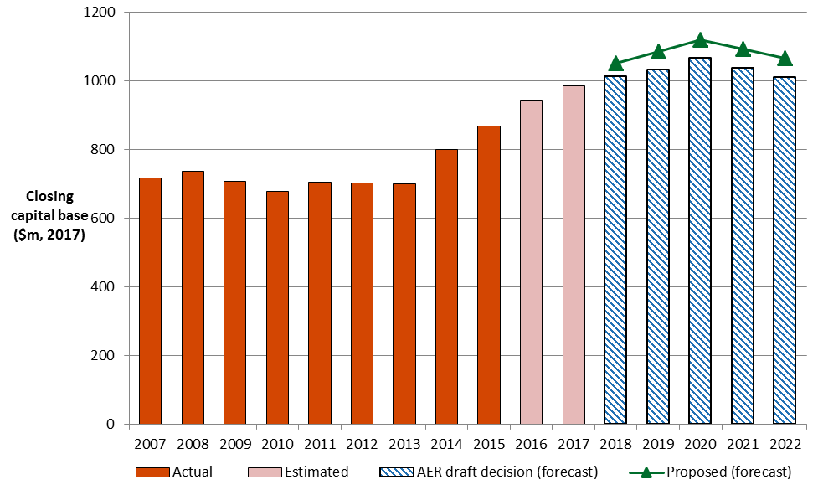

Source: AER analysis.

## Rate of return (return on capital)

The allowed rate of return provides a service provider a return on capital to service the interest on its loans and give a return on equity to investors. The return on capital building block is calculated as a product of the rate of return and the value of the RAB.

We are satisfied that the allowed rate of return of 5.75 per cent (nominal vanilla) we determined contributes to the achievement of the NGO, and achieves the allowed rate of return objective (ARORO) set out in the NGR.[28] That is, we are satisfied that this allowed rate of return is commensurate with the efficient financing costs of a benchmark efficient entity with a similar degree of risk as that which applies to APA in providing reference services.[29] We are not satisfied that APA's proposed (indicative) per cent rate of return for 2018 will achieve the ARORO.[30]

Table 5‑3 sets out our rate of return and APA's proposed rate of return.

Table ‑ Draft decision on APA's rate of return (% nominal)

|  |  |  |  |  |
| --- | --- | --- | --- | --- |
|  | Previous allowed return (2013-17) | APA's proposal (2018-22) | AER draft decision (2018) | Allowed return over 2018 regulatory control period |
| Return on equity (nominal post–tax) | 8.02% | 8.45% | 7.2% | Constant (7.2% |
| Return on debt (nominal pre–tax) | 6.68% | 7.47% | 4.79% | Updated annually |
| Gearing | 60 | 60 | 60 | Constant (60%) |
| Nominal vanilla WACC | 7.22% | 7.88% | 5.75% | Updated annually for return on debt |
| Forecast inflation | 2.5% | 2% | 2.45% | Constant (%) |

Source: AER analysis; APA, Victorian transmission system access arrangement submission, 3 January 2017.

Our return on equity estimate for this draft decision is 7.2 per cent. We derived this estimate by applying the foundation model approach (as set out in the Guideline) used to determine the allowed return on equity in our most recent decisions.[31] This is a six step process, where we have regard to a considerable amount of relevant information, including various equity models.

Our return on equity point estimate and the parameter inputs are set out in the table below. APA proposed departing from the approach in the Guideline for the market risk premium and equity beta parameters. We are not satisfied that APA's proposal would result in an outcome that better achieves the ARORO.[32]

Table ‑ Draft decision on APA's return on equity (% nominal)

|  |  |  |  |
| --- | --- | --- | --- |
|  | AER previous decision (2013–17) | APA's proposal (2018–22) | AER draft decision (2017-18) |
| Nominal risk free rate (return on equity only) | 3.22% | 2.24%a | 2.6%b |
| Equity risk premium | 4.8% | 6.76% | 4.55% |
| Market risk premium | 6 | 8.45% | 6.5% |
| Equity beta | 0.8 | 0.8 | 0.7 |
| Nominal post–tax return on equity | 8.02% | 8.45% | 7.2% |

Source: AER analysis; APA, Victorian transmission system access arrangement submission, 3 January 2017

a Based on APA's indicative averaging period adopted for its proposal of 20 business days to 31 October 2016.

b Calculated with a placeholder averaging period of 20 business days up to 28 April 2017.

Our return on debt estimate is based on a gradual transition from the ‘on-the-day’ approach we used in the past to the ‘trailing average’ approach we proposed in the Guideline. The trailing average approach reflects the return on debt that a network business would face if it raised debt annually in equal parcels. Our return on debt approach incorporates a transition to the new approach.

Our decision is also to update the return on debt annually. Therefore, our estimate in this decision is for the first year of the regulatory period. Due to this, we update our rate of return annually.

We commence the trailing average with an initial estimation of the return on debt that is then progressively updated over the regulatory period. In practice, this means that for new debt that is issued (10 per cent of the initial estimate each year) we apply an estimate of the observed return on debt immediately. For existing debt issued before the commencement of the trailing average approach, we will continue to apply the on-the-day approach for the portion that has not been updated. Consequently, at the end of 10 years the total debt portfolio will have been updated and incorporated into the trailing average.

Our return on debt estimate is developed on the basis that a benchmark efficient entity issues debt with a 10 year term and has a BBB+ credit rating. To estimate the yield on this debt, we use an independent third party data service provider. We have reviewed the recent draft proposals and decided to adopt a simple average of the data series provided by the Reserve Bank of Australia and Bloomberg.

Our estimation procedure allows the service provider to propose a period between 10 business days and 12 months in length before the start of each regulatory year, over which the observed rates are averaged to estimate the return on debt. This results in service providers proposing an averaging period consistent with its debt practices and therefore, our return on debt estimate is different for different service providers.

Our return on debt estimate for the first year of APA's access arrangement period in this draft decision is 4.79 per cent. This return on debt number will be updated annually during the regulatory period to partially reflect prevailing interest rates. Our approach and estimation procedures are consistent with the Guideline. We note that APA in its current draft proposal proposed to depart from our return on debt approach as set out in the Guideline and adopted an immediate transition to the trailing average approach. It proposed a return on debt of 7.47 per cent.

Our estimate of expected inflation is estimated as the geometric average of 10 annual expected inflation rates. We use the RBA's forecasts of inflation for the first two annual rates and the mid-point of the RBA's inflation target band for the remaining eight annual rates.

APA proposed that the inflation rate in its revenue model be calculated as the year-on-year change in June-quarter Consumer Price Index (CPI) for the previous year. APA's proposal requires an estimate of expected inflation that is:

* time varying, compared to our current approach of a single inflation estimate reflecting an annual average over a ten-year investment horizon; and
* updated annually, as the CPI data required to calculate the estimates for years 2 through 5 would not be available at the time of our final determination.[33]

We do not accept APA's proposal. The effect of the annual adjustments is to effectively remove the forecast inflation used in the revenue model and apply actual inflation each year. APA proposed this approach to address 'mismatch' between the regulatory deprecation calculations at different stages in the regulatory process.[34] APA submitted that this resulted in under-compensation for the service provider across the 2013–17 access arrangement period, and increased the likelihood of under or over recovery in future access arrangement periods. We do not consider that APA has set out the correct framework for assessing over or under recovery when inflation outcomes differ from expected inflation. Given the information currently available to us, we do not agree with APA that there is an inflation 'mismatch'. We therefore do not accept APA's proposed approach. APA's proposed revenue model may also materially alter the risk profile of APA and allocation of risk between APA and consumers, with consequences for determining a rate of return that is commensurate with these risks. APA's proposal does not address this issue at all.

It is important to note that we are currently conducting a broader industry-wide review of our method for estimating expected inflation and the treatment of inflation in our regulatory models. That review is yet to be finalised and so findings from the review cannot therefore be included in this decision. That said, for the purposes of this determination, on the basis of the information currently available to us, we consider the treatment of inflation in our regulatory models will contribute to the achievement of the National Gas Objective and allowed rate of return objective.

Further detail on our draft decision in regards to APA's rate of return is set out in attachment 3.

## Value of imputation credits (gamma)

Under the Australian imputation tax system, investors can receive an imputation credit for income tax paid at the company level.[35] These are received after company income tax is paid, but before personal income tax is paid. For eligible investors, this credit offsets their Australian income tax liabilities. If the amount of imputation credits received exceeds an investor's tax liability, that investor can receive a cash refund for the balance. Imputation credits are therefore valuable to investors and are a benefit to investors in addition to any cash dividend or capital gains they receive from owning shares.

However, the estimation of the return on equity does not take imputation credits into account. Therefore, an adjustment for the value of imputation credits is required. This adjustment could take the form of a decrease in the estimated return on equity itself. An alternative but equivalent form of adjustment, which is employed under the NER, is via the revenue granted to a service provider to cover its expected tax liability. Specifically, the NER requires that the estimated cost of corporate income tax be determined in accordance with a formula that reduces the estimated cost of corporate tax by the 'value of imputation credits' (represented by the Greek letter, γ, 'gamma'). This form of adjustment recognises that it is the payment of corporate tax which is the source of the imputation credit return to investors.

Our draft decision adopts a value of imputation credits of 0.4. We do not accept APA's proposed value of imputation credits (or gamma) of 0.25. We consider that a value for imputation credits of 0.4 will result in equity investors in the benchmark efficient entity receiving an ex ante total return (inclusive of the value of imputation credits) commensurate with the efficient equity financing costs of a benchmark efficient entity.

In coming to a value of imputation credits of 0.4:

* We adopt a conceptual approach consistent with the Officer framework, which we consider best promotes the objectives and requirements of the NER/NGR. This approach considers the value of imputation credits is a post-tax value before the impact of personal taxes and transaction costs.[36] As such, we view the value of imputation credits as the proportion of company tax returned to investors through the utilisation of imputation credits.[37]
* We consider our conceptual approach allows for the value of imputation credits to be estimated on a consistent basis with the allowed rate of return and allowed revenues under the post-tax framework in the NER/NGR.[38]
* We use the widely accepted approach of estimating the value of imputation credits as the product of two sub-parameters: the 'distribution rate' and the 'utilisation rate'. Our definition of, and estimation approach for, these sub-parameters is set out in Table 5‑5.

Table ‑5 Gamma sub-parameters: definition and estimation approach

|  |  |  |
| --- | --- | --- |
| 1. Sub-parameter | 1. Definition | 1. Estimation approach |
| Distribution rate (or payout ratio) | The proportion of imputation credits generated that is distributed to investors. | Primary reliance placed on the widely accepted cumulative payout ratio approach. Some regard is also given to Lally's estimate for listed equity from financial reports of the 20 largest listed firms. |
| Utilisation rate (or theta) | The utilisation value to investors in the market per dollar of imputation credits distributed.[39] | A range of approaches, with due regard to the merit of each approach:  equity ownership approach  tax statistics  implied market value studies. |

Source: AER analysis.

Overall, the evidence suggests a range of estimates for the value of imputation credits might be reasonable. With regard to the merits of the evidence before us, we choose a value of imputation credits of 0.4 from within a range of 0.3 to 0.5.

In considering the evidence on the distribution and utilisation rates, we have broadly maintained the approach set out in the Rate of Return Guideline (the Guideline), but have re-examined the relevant evidence and estimates. This re-examination, and new evidence and advice considered since the Guideline, led us to depart from the 0.5 value of imputation credits we proposed in the Guideline.

1. Further detail on our draft decision in regards to the value of APA's imputation credits is set out in attachment 4.

## Regulatory depreciation (return of capital)

When determining the total revenue for APA, we include an allowance for the depreciation of the projected capital base (otherwise referred to as ‘return of capital’).[40] Regulatory depreciation is used to model the nominal asset values over the 2018–22 access arrangement period and the depreciation allowance in the total revenue requirement.[41]

We accept APA’s proposal to use the real straight-line method to calculate the regulatory depreciation allowance. However, we do not approve APA’s proposed regulatory depreciation allowance of $107.4 million ($ nominal) for the 2018–22 access arrangement period. This is mainly because of our decision to update APA's calculation of the remaining asset lives as at 1 January 2018, and due to the effect of our determinations on other components of APA’s proposal. Discussed in other attachments, these determinations include the opening capital base (attachment 2), and the forecast capex (attachment 6).

We approve APA’s proposed asset classes and the standard asset lives assigned to each of its asset classes for the 2018–22 access arrangement period, which are consistent with the approved standard asset lives for the current period. They are also broadly comparable with the standard asset lives approved in our previous decisions for this and other APA pipelines.[42]

We accept APA’s proposed weighted average method to calculate the remaining asset lives as at 1 January 2018.[43] In accepting the weighted average method, we have updated the proposed remaining asset lives as at 1 January 2018 due to the input changes we made to APA’s proposed roll forward model (RFM). These input changes affect the remaining asset lives calculation and are discussed in attachment 5

Our draft decision on APA’s regulatory depreciation allowance is $78.1 million ($ nominal) in total for the 2018–22 access arrangement period as set out in Table 5‑6.

Table ‑ AER’s draft decision on APA’s regulatory depreciation allowance for the 2018–22 access arrangement period ($ million, nominal)

|  |  |  |  |  |  |  |
| --- | --- | --- | --- | --- | --- | --- |
|  | 2018 | 2019 | 2020 | 2021 | 2022 | Total |
| Straight-line depreciation | 35.7 | 39.6 | 42.4 | 47.6 | 45.0 | 210.3 |
| Less: indexation on capital base | 24.1 | 25.4 | 26.6 | 28.1 | 28.0 | 132.2 |
| **Regulatory depreciation** | **11.6** | **14.2** | **15.8** | **19.5** | **17.0** | **78.1** |

Source: AER analysis.

Further detail on our draft decision in regards to APA's regulatory depreciation is set out in attachment 5.

## Capital expenditure

Capital expenditure (capex) refers to the capital costs and expenditure incurred in the provision of pipeline services.[44] This investment mostly relates to assets with long lives. APA recovers the costs of these assets through the return on capital and depreciation building blocks that form part of its total revenue. In this way APA recovers the financing cost and depreciation associated with these assets over the expected life of these assets.

Our draft decision includes an assessment of APA's actual capex in the current period, which forms part of its opening capital base.[45] It also includes an assessment of APA's forecast capex for the 2018–22 access arrangement period, which forms part of its projected capital base.[46]

Figure 5‑2 compares APA's past and proposed forecast capex, and the forecasts we have approved in our previous decision for 2013–17 and this draft decision for   
2018–22.

Figure ‑ AER draft decision compared to APA's past and proposed capex ($ million, 2017)

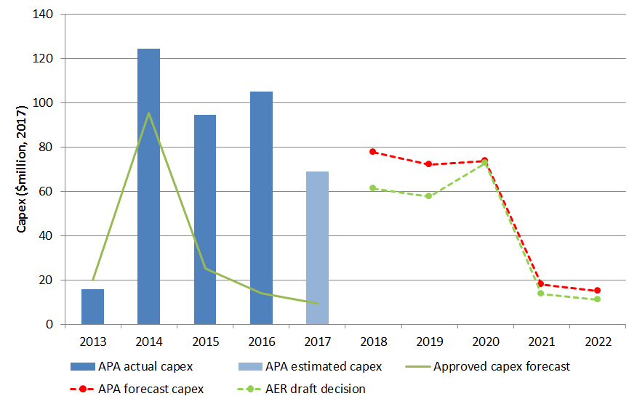

Source: AER analysis.

### Conforming capex for 2013–17

1. APA's actual capex in the current period was $244.6 million ($ 2017) higher than contemplated in our last decision. The key driver of this increase was augmentation capex, which included additional investment in the Victorian Northern Interconnector Expansion (VNIE) and South West Pipeline (SWP) to Anglesea Pipeline projects. These investments were required to meet significant changes in the east coast gas market that APA did not anticipate until after finalisation of the access arrangement. The effect of these changes resulted in increased demand for the northern flow of gas from Victoria.[47]
2. We have approved the additional capex for the VNIE on the basis that:

* APA has demonstrated that significant changes in the east coast gas market, since the finalisation of the current access arrangement, have led to increased demand for gas to flow north from Victoria. APA has confirmed that it has contracts with NSW shippers reflecting this increased demand.[48]
* the present value of the incremental revenue to be generated as a result of the expenditure exceeds the present value of the capital expenditure. [49]
* taking advice from Sleeman Consulting into account, we are satisfied that the $339.2 million is prudent, in accordance with good industry practice and achieves the lowest sustainable cost of providing services.

Further, given the tight supply/demand balance in Victoria, the VNIE also provides system security benefits for Victorian customers.

1. Table 5‑7 sets out our draft decision on approved capex for the current period.

Table ‑ Approved capex, 2013 to 2017 ($ million)

|  |  |  |  |  |  |  |
| --- | --- | --- | --- | --- | --- | --- |
| Category | 2013 | 2014 | 2015 | 2016 | 2017 | Total  (2013–17) |
| Augmentation | 12.3 | 112.4 | 74.6 | 92.1 | 52.3 | **343.8** |
| Replacement & Upgrade | 1.6 | 7.5 | 14.2 | 10.5 | 2.1 | **35.9** |
| Non-System | 1.7 | 4.2 | 5.7 | 2.3 | 8.6 | **22.6** |
| **TOTAL CAPEX** | **15.6** | **124.2** | **94.5** | **105.0** | **63.0** | **402.3** |

Source: AER analysis

1. Our approved capex includes actual capital expenditure on the major capital works projects of the VNIE and SWP and other expenditure on replacement and upgrades as well as non-system capex.

However, we have not approved $6.0 million of APA’s estimated capex for pigging projects to be undertaken during 2017. On the information before us APA's estimated cost of these works does not appear consistent with the costs of works on similar projects in the current period.[50] APA did not provide sufficient explanation to assist our understanding as to why they should be different.

### Conforming capex for the 2018–22 access arrangement period

The proposal APA submitted in January 2017 set out the capex it considered it would require over the 2018–22 access arrangement period. It forecast $168.4 million ($2017, real) which included $26.7 million ($2017, real) for procurement of the WORM easement. Submissions on that proposal from a number of APA's users and AEMO—the operator of the VTS—suggested that additional capex would be necessary to address system security concerns. These views were supported by AEMO's Victorian Gas Planning Report,[51] and Gas Statement of Opportunities,[52] (both released in late March 2017) and in its system security notices.[53]

In response, APA provided additional information on the capex required to address the tightening of the supply/demand balance in the VTS forecast by AEMO in March 2017.[54] Specifically, APA proposed to include $126.7 million ($ 2017) to undertake construction of the entire WORM project during the 2018–22 access arrangement period.[55]

This increased its total forecast net capex for the 2018–22 access arrangement period from $168.4 million ($2017) to $256.1 million, an increase of $87.7 million or 52.1 per cent from its initial proposal. APA proposed preparatory works, including planning, design and purchasing the WORM easement, to occur in 2018 and 2019, with construction to begin in 2020 and the WORM to be operational by the end of 2020.

Our draft decision considers this updated information together with the other capex items included in APA's January proposal. To inform our assessment of this new information, we sought advice from AEMO on how well APA's proposal would address its concerns. AEMO offered strong support, indicating that construction of the WORM would meet their requirements to alleviate security issues related to the balance of supply and demand in the VTS.

CCP11 accepted that the proposal is conforming capex due to it being necessary to maintain the safety and integrity of services and to maintain capacity to meet demand that exists at the time the capital expenditure is incurred.[56] However, they raised concerns about the extent to which the WORM is directed at augmenting the Iona storage facility and meeting the demands of consumers other than Victorian consumers.[57]

We have undertaken our own assessment of the proposal, which includes advice from Sleeman Consulting on the reasonableness of the cost estimates for building the WORM. Sleeman Consulting have advised that APA’s estimated cost of $126.7 million for the WORM is reasonable using current data and assumptions.[58] This, along with our own assessment, leads us to conclude that the proposed $126.7 million ($ 2017) expenditure on the WORM is conforming capex.[59]

Our draft decision is to approve $215.0 million ($ 2017) of APA's proposed   
$256.1 million ($ 2017) total net capex for the 2018–22 access arrangement period as conforming capex.[60] While this includes additional capex from APA's January proposal for full construction of the WORM, it is $41.1 million, or 16 per cent, less than the total net capex proposed by APA.

We show approved capex by category for the 2018–22 access arrangement period in

Table 5‑8.

Table ‑ AER approved capex by category over the 2018–22 access arrangement period ($ million, 2017)

| Category | 2018 | 2019 | 2020 | 2021 | 2022 | Total |
| --- | --- | --- | --- | --- | --- | --- |
| Augmentation | 44.4 | 46.8 | 59.8 | - | - | **151.0** |
| Replacement and Upgrade | 12.5 | 6.5 | 9.3 | 10.2 | 8.6 | **47.1** |
| Non-System | 4.2 | 3.6 | 3.3 | 3.6 | 2.3 | **16.9** |
| **TOTAL CAPEX** | **61.1** | **56.9** | **72.3** | **13.7** | **10.9** | **215.0** |

Source: AER analysis. Totals may not add due to rounding.

1. The key differences between our draft decision and APA's proposal are:

* APA’s proposal to undertake all of the slabbing program (Safety Management, High Consequence Areas - $24.2 million) in 2018 and 2019 does not appear prudent or efficient, as there are likely to be substantial economic benefits from deferring much of this work until closer to the time of when urban development is actually likely to proceed. We recognise that some slabbing is necessary in the 2018-22 access arrangement period, particularly along sections of the pipeline where land development is imminent. We invite APA to respond with an alternative slabbing program that is more consistent with the rate of urban development.
* proposed expenditure of $6.7 million ($2017) for pipe integrity, particularly modifying pipelines at James Street, Tyres to Maryvale and Truganina to Plumpton to enable inline inspection, is not prudent as APA have not shown it is cost-beneficial on short sections of pipeline
* Wollert Compressor station Turbine Overhauls ($4.7 million) are routine maintenance activities that APA can prioritise within its existing base opex forecast
* our estimation that the costs on the Warragul Lateral Expansion are overestimated by around 105 per cent or $3.8 million
* the Coogee pipeline decommissioning ($1.8 million) in the 2018–22 access arrangement period appears premature, given the future of the methanol plant it supports is yet to be decided.[61]

Further detail on our draft decision in regards to APA's capex is set out in attachment 6.

## Operating expenditure

Operating expenditure (opex) is the operating, maintenance and other non-capital expenses, incurred in the provision of reference services for a pipeline. Forecast opex is one of the building blocks we use to determine a service provider's total revenue requirement.

Our draft decision is to accept APA’s opex proposal of $132.4 million ($2017) over the 2018–22 access arrangement period, as set out in Table 5‑9.[62] Our draft decision represents a 2.5 per cent increase from APA's actual opex in the 2013–17 access arrangement period and a reduction of 19.9 per cent from opex forecast approved in our final decision for the 2013–17 access arrangement period.[63]

Table 5‑9 sets out the total opex approved in this draft decision.

Table ‑ Our draft decision on total opex ($ million, 2017)

|  |  |  |  |  |  |  |
| --- | --- | --- | --- | --- | --- | --- |
|  | 2018 | 2019 | 2020 | 2021 | 2022 | Total |
| APA's revised proposal and our draft decision | 26.0 | 26.1 | 26.1 | 27.1 | 27.3 | 132.4 |

Source: APA, B4 - APA Post Tax Revenue Model revised with WORM (includes 3 March 2017 updates for inflation in response to AER information request IR#03), 16 May 2017.

As we explained above, in response to stakeholders' submissions on APA's initial proposal APA provided information on the additional capex that would be required to complete construction of the WORM. This additional capex has consequences for the opex APA requires, and our draft decision accepts the consequential increase in APA’s total opex forecast from $131.5 million ($2017) to $132.4 million ($2017).[64]

Using our base–step–trend approach and taking into account the new information, we developed an alternative total opex estimate of $134.9 million ($2017).[65] This is not materially different from APA's updated proposal of $132.4 million ($2017). So we are satisfied APA's proposal reasonably reflects the opex criteria.

Figure 5‑3 shows our draft decision compared to APA's proposal, its past allowances and past actual expenditure.

Figure ‑ Our draft decision compared to APA's past and proposed opex ($ million, 2017)



Source: APA, B.1 - RIN templates - Redacted, January 2017; APA, B2 - Operating expenditure model revised with WORM, 15 May 2017; AER analysis.

Note: Includes debt raising costs.

Further detail on our draft decision in regards to APA's opex is set out in attachment 7.

## Opex incentive mechanism

The opex incentive mechanism in APA's access arrangement provides an additional incentive to that provided under an incentive based regime for APA to pursue efficiency improvements in its opex over an access arrangement period. It does this by allowing APA to retain efficiency savings achieved within a particular period for a longer period of time.

Our draft decision is to approve a benefit sharing allowance of $17.1 million ($2017) from the application of the opex incentive mechanism in the 2013–17 access arrangement period. This is $1.5 million ($2017) less than APA's proposal. The primary reason for this difference is we did not adopt APA's adjustment to its allowed opex forecast, associated with un-forecast extensions and expansions it undertook in the current period. The costs it identified were not additional operating and maintenance costs associated with extensions and expansions. APA added allowances for linepack and spare fittings inventories instead.

Table 5‑10 shows our draft decision on APA's proposed benefit sharing allowance.

Table ‑ AER’s draft decision on APA's benefit sharing allowance   
($ million, 2017)

|  |  |  |  |  |  |  |
| --- | --- | --- | --- | --- | --- | --- |
|  | 2018 | 2019 | 2020 | 2021 | 2022 | Total |
| APA's proposed benefit sharing allowance | 8.4 | 4.6 | 3.5 | 2.1 | – | 18.6 |
| Draft decision | 6.9 | 4.5 | 3.6 | 2.1 | – | 17.1 |
| **Difference** | **–1.5** | **–0.1** | **0.1** | **0.0** | **–** | **–1.5** |

Source: APA, VTS Revision Proposal submission, 20170103 - Public, p. 208; AER analysis.

Note: Numbers may not add up due to rounding.

We accept APA’s proposal to retain an opex incentive mechanism for the 2018–22 access arrangement period. However, for the 2018–22 access arrangement period we have amended APA’s proposed opex incentive mechanism to reflect improvements included in the efficiency benefit sharing scheme (EBSS) we released in November 2013 for electricity service providers.[66] Importantly, the amendments give APA more flexibility in the choice of base year it uses to forecast opex in the following period.

Further detail on our draft decision on APA's opex incentive mechanism is set out in attachment 9.

## Corporate income tax

When determining the total revenue for APA, we include an estimate of APA’s cost of corporate income tax.[67] APA has adopted the post-tax framework to derive its revenue requirement for the 2018–22 access arrangement period.[68] Under the post-tax framework, a separate corporate income tax allowance is calculated as part of the building blocks assessment.

We accept APA’s proposed approach to calculating its forecast corporate income tax allowance. APA's proposed approach is consistent with our post-tax revenue model (PTRM) for electricity service providers and the approach previously approved in gas access arrangement decisions. However, we do not approve APA’s proposed corporate income tax allowance of $22.9 million ($ nominal) for the 2018–22 access arrangement period. Our draft decision on APA’s corporate income tax allowance over the 2018–22 access arrangement period is $6.5 million ($ nominal). This represents a reduction of $16.3 million ($ nominal) or 71.4 per cent compared to APA’s proposed forecast corporate income tax allowance.

The reduction reflects our amendments to APA's proposed inputs for forecasting the cost of corporate income tax, including:

* the opening tax asset base (TAB) (section 8.4.1, attachment 8)
* remaining tax asset lives (section 8.4.3, attachment 8)
* the value of imputation credits (gamma) (attachment 4).

Our adjustments to the following building blocks - return on capital (attachments 2 and 3), regulatory depreciation (attachment 5), forecast capex (attachment 6) and forecast opex (attachment 7) - affects revenues, which in turn impacts the tax calculation.[69]

We do not approve the proposed opening TAB of $543.2 million ($ nominal) as at 1 January 2018. We instead determined an opening TAB of $512.7 million ($ nominal). This is because we do not approve APA’s proposal to use 'as-incurred' actual capex and forecast tax depreciation to roll forward the TAB for the 2013–17 access arrangement period.[70]

Our draft decision is to use 'as-commissioned' actual capex and actual tax depreciation to roll forward the TAB for the 2013–17 access arrangement period.

We approve APA’s proposed standard tax asset lives for the 2018–22 access arrangement period. They are consistent with the provisions of the Income Tax Assessment Act 1997 (Cth) and the standard tax asset lives prescribed in the Tax Ruling 2016/1.[71] They are also consistent with the approved standard tax asset lives in the 2013–17 access arrangement.

We accept APA’s proposed weighted average method to calculate the remaining tax asset lives as at 1 January 2018. In accepting the weighted average method, we have updated APA’s proposed remaining tax asset lives as at 1 January 2018. This is due to changes we have made to the roll forward of the opening TAB for the 2013–17 access arrangement period and other inputs that affect the calculation of the remaining tax asset lives in APA’s proposed RFM.

Table 5‑11 sets out our draft decision on the estimated cost of corporate income tax allowance for APA over the 2018–22 access arrangement period.

Table ‑ AER’s draft decision on corporate income tax allowance for APA ($ million, nominal)

|  |  |  |  |  |  |  |
| --- | --- | --- | --- | --- | --- | --- |
|  | 2018 | 2019 | 2020 | 2021 | 2022 | Total |
| Tax payable | 2.2 | 2.5 | 3.1 | 2.3 | 0.8 | 10.9 |
| Less: value of imputation credits | 0.9 | 1.0 | 1.2 | 0.9 | 0.3 | 4.4 |
| **Net corporate income tax allowance** | **1.3** | **1.5** | **1.9** | **1.4** | **0.5** | **6.5** |

Source: AER analysis.

Further detail on our draft decision in regards to APA's corporate income tax is set out in attachment 8.

# Non-tariff components

The non-tariff components of an access arrangement include:

* the terms and conditions for supply of the reference service
* queuing requirements—a process or mechanism for establishing an order of priority between prospective users of spare and/or developable capacity
* extension and expansion requirements—the method for determining whether an extension or expansion is a part of the covered pipeline and the effect this will have on tariffs
* capacity trading requirements—how users may assign contracted capacity and change delivery and receipt points
* provision for receipt and delivery point changes, and
* a review submission date and a revision commencement date.

APA has proposed only very minor changes to the access arrangement in respect of non-tariff components. APA notes that substantive revisions were approved for the last access arrangement, and submits that limiting the scope of revisions is desirable for stability, particularly in light of possible changes to the operation of the Declared Wholesale Gas Market (DWGM) during the access arrangement period.[72]

Our draft decision is to accept all of APA's non-tariff components without revision or amendment.

However, in relation to the review submission date, we note that AGN has proposed a review submission date of 1 December 2021, and AusNet has indicated it is also prepared to adopt this earlier date. We welcome this approach as it will avoid the administrative difficulties of receiving review submissions in the middle of the holiday season. We encourage APA to also bring forward its review submission date by one month to 1 December 2021.

Further detail on our draft decision in regards to APA's non-tariff components is set out in attachment 12.

# Understanding the NGO

1. The NGO is the central feature of the regulatory framework. The NGO is

to promote efficient investment in, and efficient operation and use of, natural gas services for the long term interests of consumers of natural gas with respect to price, quality, safety, reliability and security of supply of natural gas.[73]

1. Energy Ministers have provided us with a substantial body of explanatory material that guides our understanding of the NGO.[74] The long term interests of consumers are not delivered by any one of the NGO's factors in isolation, but rather by balancing them in reaching a regulatory decision.[75]

In general, we consider that we will achieve this balance and, therefore, contribute to the achievement of the NGO, where consumers are provided a reasonable level of safe and reliable service that they value at least cost in the long run.[76] We have also considered the quality and reliability of services provided to consumers. For example, the opex allowance and pass through mechanism approved in this draft decision has been set so that APA can meet existing and new regulatory requirements. Our approved capex forecast includes expenditure to replace assets that are aged or in unacceptable condition.

1. The nature of decisions under the NGR is such that there may be a range of economically efficient decisions, with different implications for the long term interests of consumers.[77] At the same time, however, there are a range of outcomes that are unlikely to advance the NGO, or not advance the NGO to the degree that others would.
2. For example, we do not consider that the NGO would be advanced if allowed revenues encourage overinvestment and result in prices so high that consumers are unwilling or unable to efficiently use the network.[78] This could have significant longer term pricing implications for those consumers who continue to use network services.
3. Equally, we do not consider the NGO would be advanced if allowed revenues result in prices so low that investors are unwilling to invest as required to adequately maintain the appropriate quality and level of service, and where customers are making more use of the network than is sustainable. This could create longer term problems in the network[79] and could have adverse consequences for safety, security and reliability of the network.

The NGL also includes the revenue and pricing principles (RPP), which support the NGO.[80] As the NGL requires,[81] we have taken the RPPs into account throughout our analysis under the NGR. The RPPs are:

A service provider should be provided with a reasonable opportunity to recover at least the efficient costs the service provider incurs in—

* providing reference services; and
* complying with a regulatory obligation or requirement or making a regulatory payment.

A service provider should be provided with effective incentives in order to promote economic efficiency with respect to reference services the service provider provides. The economic efficiency that should be promoted includes—

* efficient investment in, or in connection with, a pipeline with which the service provider provides reference services; and
* the efficient provision of pipeline services; and
* the efficient use of the pipeline.

Regard should be had to the capital base with respect to a pipeline adopted—

* in any previous—
* full access arrangement; or
* decision of a relevant regulator under section 2 of the Gas Code; or
* in the Rules.

A reference tariff should allow for a return commensurate with the regulatory and commercial risks involved in providing the reference service to which that tariff relates.

Regard should be had to the economic costs and risks of the potential for under and over investment by a service provider in a pipeline with which the service provider provides pipeline services.

Regard should be had to the economic costs and risks of the potential for under and over utilisation of a pipeline with which a service provider provides pipeline services.

1. Consistent with Energy Ministers' views, we set the amount of revenue that service providers can recover from customers to balance all of the elements of the NGO and consider each of the RPPs.[82] For example:

* In determining forecast opex and capex that reasonably reflects the opex and capex criteria, we take into account the revenue and pricing principle that we should provide APA with a reasonable opportunity to recover at least efficient costs (refer to capex attachment 6 and opex attachment 7).
* We take into account the economic costs and risks of the potential for under and over investment by a service provider in our assessment of APA’s forecast capex and opex proposals (refer to capex attachment 6 and opex attachment 7).
* We consider the economic costs and risks of the potential for under and over utilisation of APA’s network in our decisions on demand forecasting and forecast augmentation capex (refer to capex attachment 6 and demand attachment 13).
* The benefit sharing allowance for opex in this decision provides APA with effective incentives which we consider will promote economic efficiency with respect to the reference service that APA provides throughout the access arrangement period (refer to opex incentive mechanism attachment 9).
* We have determined APA’s opening capital base taking into account the capital adopted in the previous access arrangement (refer to capital base attachment 2).
* The allowed rate of return objective reflects the revenue and pricing principle in s. 24(5). We have determined a rate of return that we consider will provide APA with a return commensurate with the regulatory and commercial risks involved in providing pipeline services (refer to rate of return attachment 3).
* Our financing determinations provide APA with a reasonable opportunity to recover at least the efficient costs of accessing debt and capital (refer to rate of return attachment 3).

In some cases, our approach to a particular component (or part thereof) results in an outcome towards the end of the range of options that results in higher revenue than another option. Some of these decisions include:

* selecting at the top of the range for the equity beta
* setting the return on debt by reference to data for a BBB broad band credit rating, when the benchmark is BBB+
* the cash flow timing assumptions in the post-tax revenue model.

We take into account the RPPs when exercising discretion about an appropriate estimate. The legislative framework recognises the complexity of this task by providing us with significant discretion in many aspects of the decision-making process to make judgements on these matters.

1. Part 9 of the NGR provides specifically for the economic regulation of covered pipelines. It includes detailed rules about the individual components of our decisions. These are intended to contribute to the achievement of the NGO.

## Achieving the NGO to the greatest degree

1. An access arrangement decision is complex. In most instances, the provisions of the NGR do not point to a single answer, either for our decision as a whole or in respect of particular components. They require us to exercise our regulatory judgment. For example, Part 9 of the NGR requires us to prepare forecasts, which are predictions about unknown future circumstances. There may be more than one plausible forecast. There is substantial debate amongst stakeholders about the costs we must forecast, with both sides often supported by expert opinion. As a result, for certain components of our decision there may be several plausible answers or several plausible point estimates.
2. We approach this from a practical perspective, accepting that it is not possible to consider every permutation specifically. Where there are choices to be made among several plausible alternatives each of which would result in an overall decision that contributes to the achievement of the NGO, we have selected what we are satisfied would result in an overall decision that contributes to the achievement of the NGO to the greatest degree. [83]

In reaching this draft decision we have considered APA’s proposal and examined each of the building block components of the forecast revenue requirement, and the incentive mechanisms that should apply across the next access arrangement period. We have considered submissions we received in regard to APA’s proposal. We have conducted our own analysis and engaged expert consultants to help us better understand if and how APA’s proposal contributes to the achievement of the NGO. We have also considered how the individual components of our decision relate to each other, the impact that particular components of our decision have on others, and have described these interrelationships in this draft decision. We have had regard to and weighed up all of the information assembled before us in making this draft decision, and have made as much of this information publicly available as practicable for the purposes of consultation.

Therefore, we are satisfied that among the options before us, our draft decision on APA’s access arrangement for the 2018–22 access arrangement period contributes to achieving the NGO to the greatest degree.

### Interrelationships between individual components

Considering individual components in isolation ignores the importance of interrelationships between components of the overall decision, and would not contribute to the achievement of the NGO. As outlined by Energy Ministers, considering the elements in isolation has resulted in regulatory failures in the past.[84] Interrelationships can take various forms, including:

* underlying drivers and context which are likely to affect many constituent components of our decision. For example, forecast demand affects the forecasts of efficient levels of capex and opex in the access arrangement period (see attachments 6, 7 and 13).
* direct mathematical links between different components of a decision. For example, the value of imputation credits (gamma) has an impact on the appropriate tax allowance; the benchmark efficient entity's debt to equity ratio has a direct effect on the cost of equity, the cost of debt, and the overall vanilla rate of return (see attachments 3, 4 and 8).
* trade-offs between different components of revenue. For example, undertaking a particular capex project may affect the need for opex and vice versa (see attachments 6 and 7).
* trade-offs between forecast and actual regulatory measures. The reasons supporting one part of a proposal may have impacts on other parts of a proposal. For example, completion of forecast augmentation (capex) to the network will mean the service provider has more assets to maintain, leading to higher opex requirements (see attachments 6 and 7).
* the service provider's approach to managing its network. The service provider's governance arrangements and its approach to risk management will influence most aspects of the proposal, including capex/opex trade-offs (see attachments 6 and 7).

We have considered interrelationships, including those above, in our analysis of the individual components of our draft decision. These considerations are explored in the relevant attachments.

# Consultation

Stakeholder participation is important to informed decision making under the NGL and NGR. It allows us to take a range of views into account when considering how a proposal or decision contributes to the NGO. Effective consultation and engagement provide confidence in our processes and are good regulatory practice. This is reflected in the consultation process set out in the NGR, under which we have:

* published APA's access arrangement revision proposal and the material APA provided in support of that proposal
* invited and had regard to submissions on APA's proposal
* consulted directly with APA in relation to submissions received from APA's stakeholders including AEMO, the operator of the VTS
* held a public forum on APA's proposal
* published this draft decision and reasoning
* invited written submissions on this draft decision.

We have also consulted on our approaches to these reviews: our 2013 Better Regulation Program brought a wide range of views to our development of assessment tools and techniques and our approaches to decision making. More recently, we have commenced consultation on approaches to forecasting inflation for the purposes of modelling regulated revenues. Our continued engagement on these processes enables us to identify and reflect stakeholder priorities and will result in decisions that will or are likely to contribute to the achievement of the NGO to the greatest degree.

## APA's engagement with customers

Other than a brief discussion in its proposal,[85] APA has not provided evidence that it undertook engagement with its users in developing its access arrangement proposal. CCP11 made particular note of this. In their submission CCP11 was unable to establish whether APA had addressed feedback from stakeholders within its proposal. Prior to submission of its proposal, CCP11 offered assistance to APA in providing feedback on their stakeholder engagement plan; however this offer was not taken up. We consider that consumer engagement is important in regulatory processes as it supports regulatory outcomes that better align with consumers' long term interests.

The AER's Consumer Engagement Guideline for Network Service Providers (guideline) sets out how we expect service providers to engage with their consumers. As noted in our guideline, stronger consumer engagement can help us test service providers' expenditure proposals, and can raise alternative views on matters such as service priorities, capex proposals, and price structures. Although our guideline is not binding, we have stated that we expect all service providers to adopt the guideline and demonstrate a commitment to ongoing and genuine consumer engagement.[86]

Our own consultation on APA's proposal has shown that there is considerable stakeholder interest in APA's capex program as well as pricing tariffs on withdrawals at Culcairn. We consider that APA's access arrangement proposal would have benefited from stakeholder engagement on these matters at an early stage. APA's proposal notes that it has developed the first phase of its Consumer Engagement Plan which is focused on identifying relevant consumer stakeholders and potential approaches for engagement.[87] We recommend that APA undertake more rigorous engagement from this point, including in the development of its revised proposal, to build confidence between APA, AEMO and its users that its proposal addresses their concerns and is supported.

1. List of submissions

|  |  |
| --- | --- |
| Submission from | Date received |
| Australian Energy Market Operator | 3 March 2017, 16 May 2017* |
| Consortium of Gas Market Participants | 3 March 2017 |
| Consumer Challenge Panel (CCP11) | 3 March 2017, 6 June 2017* |
| Energy Australia | 3 March 2017 |
| Tasmanian Gas Pipeline Pty Ltd | 3 March 2017 |
| Powershop Australia | 6 March 2017 |
| Lochard Energy | 8 March 2017 |
| Origin Energy | 8 March 2017 |
| Beverly Hughson | 22 March 2017 |
| Visy Industries Australia | 30 March 2017 |
| Lily D'Ambrosio MP | 26 May 2017 |

* To assist our assessment of additional capex required to address stakeholder concerns raised in submissions, we sought targeted advice from AEMO and CCP11.

1. https://www.aer.gov.au/publications/corporate-documents/accc-and-aer-information-policy-collection-and-disclosure-of-information
2. <https://www.aemo.com.au/-/media/Files/Gas/DWGM/2017/Threat-to-System-Security-Notice---SWP-to-Port-Campbell-constraint.pdf>
3. https://www.aemo.com.au/Gas/National-planning-and-forecasting/Victorian-Gas-Planning-Report
4. NGL, s. 23.
5. APA VTS, VTS Revision Proposal submission, 20170103 - Public, p. 7.
6. The NGL provides for different types of regulation to apply to gas pipelines, based on competition and significance criteria. A 'full regulation' pipeline must periodically submit an access arrangement to the AER, setting out pricing for a reference service sought by a significant part of the market (see section 3 of this Overview). 'Light regulation' pipelines are not subject to upfront price regulation. The light regulation model is more a negotiate-arbitrate approach, placing greater emphasis on commercial negotiation and information disclosure. The AER plays a role only if dispute resolution mechanisms are triggered.
7. The comparison of revenues between the 2018–22 and 2013–17 access arrangement periods is based on smoothed revenues. In nominal dollar terms, our draft decision revenues for the 2018–22 access arrangement period are about $62.8 million (or 12.8 per cent) higher than the average annual revenues approved for the 2013–17 access arrangement period.
8. APA, Proposed supplementary capital expenditure submission, May 2017, p. 41.
9. We vary the transmission charges based on the nominal weighted average expected change in tariffs. The weighted average change tariffs is calculated based on smoothed revenues with the assumption that there is no volume forecast error.
10. AEMO, National Gas Forecasting Report for Eastern and Southern Australia, December 2016, p. 26.
11. AEMO, National Gas Forecasting Report for Eastern and Southern Australia, December 2016, p. 7
12. NGR, r. 48.
13. APA VTS, VTS access arrangement revision submission 2018–22, January 2017, p. 4.
14. APA VTS, VTS access arrangement revision submission 2018–22, January 2017, pp. 4–5.
15. Where actual demand across the 2017–22 access arrangement period varies from the demand forecast in the access arrangement, APA's actual revenue will vary from the revenue allowance determined in our decision. In general, if actual demand is above forecast demand, APA's actual revenue will be above forecast revenue, and vice versa.
16. NGR, r. 76.
17. APA, Proposed supplementary capital expenditure submission, May 2017, p. 41.
18. This is calculated by smoothing the unsmoothed building block revenue for the 2017–22 access arrangement period as set in this draft decision.
19. The change in weighted average increase in real tariff is calculated based on the smoothed revenues proposed by APA and our draft decision forecast CPI. APA, Proposed supplementary capital expenditure submission, May 2017, p. 41.
20. APA, Proposed supplementary capital expenditure submission, May 2017, p. 41.
21. This is calculated based on smoothed revenues with the assumption that there is no volume forecast error.
22. This process of smoothing revenues is described in the NGR as 'revenue equalisation'. NGR, r. 92.
23. The average revenue yield shares characteristics with both a revenue and a price cap. Like a price cap, the business is exposed to the risk that demand may be greater or less than forecast. If actual demand is greater than forecast, the NSP earns higher revenues than forecast and vice versa if actual demand is less than forecast.
24. The tariff path for 2012–22 uses actual inflation outcomes for the 2012–16 period, and forecast inflation for 2017–22.
25. The revenue equalisation occurs in NPV terms, discounting the yearly cash flows at the rate of return to reflect the time value of money.
26. NGL, rr. 23, 24.
27. The term 'rolled forward' means the process of carrying over the value of the capital base form one regulatory year to the next.
28. NGR, cl. 87(2).
29. NGR r. 87(3).
30. APA VTS, Victorian transmission system access arrangement submission, 3 January 2017, p. 163.
31. For example, see AER, Final decision: AusNet Services determination 2015 -16 to 2019–20, Attachment 3―Rate of return, May 2016.
32. NGR, cl. 87(18)
33. APA did not state which inflation estimates for years 2-5 it proposed to use as placeholder values, but used an estimate of 2 per cent for all five years in its proposed post-tax revenue model.
34. APA, VTS Revision Proposal submission, 3 January 2017, pp. 118–119.
35. Income Tax Assessment Act 1997, parts 3–6.
36. Post-tax refers to after company tax and before personal tax.
37. This means one dollar of claimed imputation credits has a post (company) tax value of one dollar to investors before personal taxes and personal transaction costs.
38. In finance, the consistency principle requires that the definition of the cash flows in the numerator of a net present value (NPV) calculation must match the definition of the discount rate (or rate of return / cost of capital) in the denominator of the calculation (see Peirson, Brown, Easton, Howard, Pinder, Business Finance, McGraw-Hill, Ed. 10, 2009, p. 427). By maintaining this consistency principle, we provide a benchmark efficient entity with an ex ante total return (inclusive of the value of imputation credits) commensurate with the efficient financing costs of a benchmark efficient entity.
39. In this decision we use the terms theta, utilisation value and utilisation rate interchangeably to mean the same thing.
40. NGR, r. 76(b).
41. Regulatory depreciation allowance is the net total of the straight-line depreciation (negative) and the annual inflation indexation (positive) on the projected capital base.
42. For example, AER: Access arrangement final decision APA GasNet Australia (Operations) Pty Ltd 2013–17 Part 2: Attachments, March 2013, p. 149; AER: Final decision Amadeus Gas Pipeline access arrangement attachment 5 — Regulatory depreciation, May 2016, p. 9.
43. We note that the capex determined in this draft decision for 2016 and 2017 are estimates. As part of the final decision, we expect the estimate of capex for 2016 to be replaced by actuals and the estimate of capex for 2017 may be revised based on more up to date information by APA in its revised proposal. The capex values are used to calculate the weighted average remaining asset lives. Therefore, we may recalculate APA’s remaining asset lives using the method approved in this draft decision to reflect revisions to the 2016 and 2017 capex values for the final decision.
44. NGR, r. 69.
45. NGR, r. 77.
46. NGR, r. 78(b)
47. APA VTS, VTS Revision Proposal submission, 20170103 - Public, p. 63.
48. APA, Response to Information Request AER APA VTS 007, 3 April 2017, p.2 (APA Response to AER Information Request 007).
49. NGR, rr. 79(1)(b), 79(2)(b).
50. We note the estimate of 2017 capex in APA’s initial proposal may be updated with more recent information in the revised proposal it submits in August.
51. AEMO, Victorian Gas Planning Report: Declared Transmission System Planning for Victoria, March 2017.
52. AEMO, Gas Statement of Opportunities: For Eastern and South-Eastern Australia, March 2017.
53. AEMO, Notice of a Threat to System Security – Seeking a Market Response, 10 March 2017 < <https://www.aemo.com.au/-/media/Files/Gas/DWGM/2017/Threat-to-System-Security-Notice---SWP-to-Port-Campbell-constraint.pdf>>, AEMO, Notice of a Threat to System Security, 10 March 2017 < <https://www.aemo.com.au/-/media/Files/Gas/DWGM/2017/Threat-to-System-Security-Notice---Warragul.pdf>>.
54. AEMO, Victorian Gas Planning Report: Declared Transmission System Planning for Victoria, March 2017, p. 55, AEMO, Gas Statement of Opportunities: For Eastern and South-Eastern Australia, March 2017.
55. APA Revised Access Arrangement Submission (WORM).

    APA, Business Case 506 - Western Outer Ring Main (WORM) Project, 21 April 2017
56. NGR, r 79(2)(c)
57. [Consumer Challenge Panel (CCP11) - Advice to the AER regarding APA VTS proposal to complete the WORM in the 2018-22 access arrangement period - 6 June 2017](https://www.aer.gov.au/system/files/Consumer%20Challenge%20Panel%20%28CCP11%29%20-%20Advice%20to%20the%20AER%20regarding%20APA%20VTS%20proposal%20to%20complete%20the%20WORM%20in%20the%202018-22%20access%20arrangement%20period%20-%206%20June%202017.pdf), p. 4.
58. Sleeman Consulting, Western Outer Ring Main Project Capex Related Considerations, May 2017, p. 3 (Sleeman Consulting WORM Report).
59. NGR, r. 79(1)(a).
60. NGR, r. 79(1).
61. NGR, r. 69.
62. APA VTS, B2 - Operating expenditure model revised with WORM, 15 May 2017. Includes debt raising costs.
63. AER, Access arrangement final decision - APA GasNet - Part 1, March 2013.
64. Including debt raising costs.
65. Including debt raising costs.
66. AER, Efficiency Benefit Sharing Scheme for Electricity Network Service Providers, November 2013, pp. 7–9.
67. NGR, r. 76(c).
68. APA VTS, VTS Revision Proposal submission - 20170103 - Public, p. 213.
69. The changes affecting revenues are discussed in the overview.
70. The TAB is roll forward by adding capex and subtracting tax depreciation over the 2013–17 access arrangement period. There are two ways to recognise capex. The as-incurred capex approach recognises capex in any one year based on expenditure incurred in that year regardless of whether the asset related to that expenditure has been commissioned or not, while the as-commissioned capex approach recognises expenditure at the time when the asset related to that expenditure has been commissioned.
71. ITAA 1997, s. 40.102(5); Australian Taxation Office, Taxation Ruling (TR 2016/1) Income Tax: effective life of depreciating assets (applicable from 1 July 2016).
72. APA VTS Submission p. 16.
73. NGL, s. 23.
74. Hansard, SA House of Assembly, 9 February 2005, pp. 1451–1460.

    Hansard, SA House of Assembly, 27 September 2007, pp. 963–972.

    Hansard, SA House of Assembly, 26 September 2013, pp. 7171–7176.
75. Hansard, SA House of Assembly, 26 September 2013, p. 7173.
76. Hansard, SA House of Assembly, 9 February 2005, p. 1452.
77. Re Michael: Ex parte Epic Energy [2002] WASCA 231 at [143].

    Energy Ministers also accept this view – see Hansard, SA House of Assembly, 26 September 2013 p. 7172.

    AEMC, Rule Determination National Electricity Amendment (Economic Regulation of Transmission Services) Rule 2006 No. 18, p. 50.
78. NGL, s. 24(7).
79. NGL, s. 24(6).
80. NGL, s. 24.
81. NGL, s. 28(2).
82. Hansard, SA House of Assembly, 27 September 2007 pp. 965, Hansard, SA House of Assembly, 9 April 2008 p. 2886, Hansard, SA House of Assembly, 26 September 2013, p. 7173.
83. NGL, s. 28(1)(b)(iii).
84. SCER, Regulation Impact Statement: Limited Merits Review of Decision-Making in the Electricity and Gas Regulatory Frameworks – Decision Paper, 6 June 2013 p. 6.
85. APA VTS, VTS Revision Proposal submission, 20170103 - Public, pp. 2-3.
86. AER, [Consumer engagement guideline for network service providers](https://www.aer.gov.au/networks-pipelines/guidelines-schemes-models-reviews/consumer-engagement-guideline-for-network-service-providers), August 2013 p. 5
87. APA VTS, VTS Revision Proposal submission, 20170103 - Public, p. 3; APA VTS, A4 - Consumer Engagement Plan , 20170103 - public