

DRAFT DECISION

Multinet Gas

Access arrangement

2018 to 2022

Attachment 5 – Regulatory depreciation

July 2017

© Commonwealth of Australia 2017

This work is copyright. In addition to any use permitted under the Copyright Act 1968, all material contained within this work is provided under a Creative Commons Attributions 3.0 Australia licence, with the exception of:

* the Commonwealth Coat of Arms
* the ACCC and AER logos
* any illustration, diagram, photograph or graphic over which the Australian Competition and Consumer Commission does not hold copyright, but which may be part of or contained within this publication. The details of the relevant licence conditions are available on the Creative Commons website, as is the full legal code for the CC BY 3.0 AU licence.

Requests and inquiries concerning reproduction and rights should be addressed to the:

Director, Corporate Communications  
Australian Competition and Consumer Commission   
GPO Box 4141, Canberra ACT 2601

or publishing.unit@accc.gov.au.

Inquiries about this publication should be addressed to:

Australian Energy Regulator  
GPO Box 520  
Melbourne Vic 3001

Tel: 1300 585 165

Email: [AERInquiry@aer.gov.au](mailto:AERInquiry@aer.gov.au)

1. Note
2. This attachment forms part of the AER's draft decision on the access arrangement for Multinet for 2018‑22. It should be read with all other parts of the draft decision.
3. The draft decision includes the following documents:
4. Overview

Attachment 1 - Services covered by the access arrangement

Attachment 2 - Capital base

Attachment 3 - Rate of return

Attachment 4 - Value of imputation credits

Attachment 5 - Regulatory depreciation

Attachment 6 - Capital expenditure

Attachment 7 - Operating expenditure

Attachment 8 - Corporate income tax

Attachment 9 - Efficiency carryover mechanism

Attachment 10 - Reference tariff setting

Attachment 11 - Reference tariff variation mechanism

Attachment 12 - Non-tariff components

Attachment 13 - Demand

Attachment 14 - Other incentive schemes

1. Contents

Note 5-2

Contents 5-3

Shortened forms 5-4

5 Regulatory depreciation 5-5

5.1 Draft decision 5-5

5.2 Multinet’s proposal 5-6

5.3 Assessment approach 5-7

5.3.1 Interrelationships 5-9

5.4 Reasons for draft decision 5-12

5.4.1 Year-by-year tracking 5-12

5.4.2 Accelerated depreciation 5-13

5.4.3 Standard asset lives 5-14

5.4.4 Application of the forecast depreciation approach 5-18

5.5 Revisions 5-18

1. Shortened forms

|  |  |
| --- | --- |
| 1. Shortened form | 1. Extended form |
| 1. AER | 1. Australian Energy Regulator |
| 1. ATO | Australian Tax Office |
| 1. capex | 1. capital expenditure |
| 1. CAPM | 1. capital asset pricing model |
| 1. CESS | 1. Capital Expenditure Sharing Scheme |
| 1. CPI | 1. consumer price index |
| 1. DRP | 1. debt risk premium |
| 1. ECM | (Opex) Efficiency Carryover Mechanism |
| 1. ERP | 1. equity risk premium |
| 1. Expenditure Guideline | Expenditure Forecast Assessment Guideline |
| 1. gamma | Value of Imputation Credits |
| 1. MRP | 1. market risk premium |
| 1. NGL | 1. National Gas Law |
| 1. NGO | 1. national gas objective |
| 1. NGR | 1. National Gas Rules |
| 1. NPV | net present value |
| 1. opex | 1. operating expenditure |
| 1. PTRM | 1. post-tax revenue model |
| 1. RBA | 1. Reserve Bank of Australia |
| 1. RFM | 1. roll forward model |
| 1. RIN | 1. regulatory information notice |
| 1. RPP | 1. revenue and pricing principles |
| 1. SLCAPM | 1. Sharpe-Lintner capital asset pricing model |
| 1. STTM | Short Term Trading Market |
| 1. TAB | Tax asset base |
| 1. UAFG | Unaccounted for gas |
| 1. WACC | 1. weighted average cost of capital |
| 1. WPI | Wage Price Index |

# Regulatory depreciation

When determining the total revenue for Multinet, we include an allowance for the depreciation of the projected capital base (otherwise referred to as ‘return of capital’).[1] Regulatory depreciation is used to model the nominal asset values over the 2018–22 access arrangement period and the depreciation allowance in the total revenue requirement.[2]

This attachment outlines our draft decision on Multinet’s annual regulatory depreciation allowance for the 2018–22 access arrangement period. Our consideration of specific matters that affect the estimate of regulatory depreciation is also outlined in this attachment. These include:

* the standard asset lives for depreciating new assets associated with forecast capex[3]
* the year-by-year tracking approach to depreciating assets in the capital base.

We also discuss the prospect of accelerated depreciation for mains assets that are replaced.

## Draft decision

We approve Multinet’s proposal to use the real straight-line method to calculate the regulatory depreciation allowance. However, we do not approve Multinet’s proposed regulatory depreciation allowance of $250.8 million ($nominal) for the 2018–22 access arrangement period. This is mainly because of our draft decision to update changes in amounts allowed for accelerated depreciation and its application. We also made draft decisions on other components of Multinet's proposal which impact on the regulatory depreciation allowance. Discussed in other attachments, these determinations include the opening capital base (attachment 2), expected inflation (attachment 2) and the forecast capex (attachment 6). We also corrected some errors in modelling.

We accept all of the standard asset lives proposed by Multinet other than for the 'Buildings' asset class. Besides the 'Buildings' asset class, the standard asset lives for all other asset classes are broadly comparable with the standard asset lives approved in our recent decisions for other gas service providers.[4] Multinet did not provide a standard asset life for equity raising costs. We have determined this asset life for the draft decision. We accept Multinet's revision to its 'Meters' asset class lives, though we do not accept Multinet's proposal to reduce the asset lives of all existing meters to 5 years.

We accept Multinet's proposed year-by-year tracking approach for depreciating its capital base. Our assessment is presented in section 5.4.1.

We also accept Multinet's proposed accelerated depreciation of mains and services to be replaced over the 2018–22 access arrangement period subject to adjustments made to the approved length of mains to be replaced over the 2018–22 access arrangement period, as discussed in attachment 6. We have also extended the proposed remaining asset lives of the residual older mains and services by seven years to align with our assessment that the mains replacement program will not be completed until 2040.

Our draft decision on Multinet’s regulatory depreciation allowance is $182.4 million ($nominal) in total for the 2018–22 access arrangement period as set out in table 5.1.

Table 5.1 AER’s draft decision on Multinet’s regulatory depreciation allowance for the 2018–22 access arrangement period ($million, nominal)

|  |  |  |  |  |  |  |
| --- | --- | --- | --- | --- | --- | --- |
|  | 2018 | 2019 | 2020 | 2021 | 2022 | Total |
| Straight-line depreciation | 60.3 | 63.6 | 67.9 | 71.8 | 76.0 | 339.6 |
| Less: indexation on capital base | 29.2 | 30.5 | 31.6 | 32.5 | 33.4 | 157.3 |
| **Regulatory depreciation** | **31.1** | **33.1** | **36.4** | **39.3** | **42.6** | **182.4** |

Source: AER analysis.

## Multinet’s proposal

Multinet used the AER's post-tax revenue model (PTRM) to calculate the forecast depreciation for the 2018–22 access arrangement period. Its proposed regulatory depreciation for the 2018–22 access arrangement period is set out in table 5.2.

Multinet proposed the year-by-year tracking approach to depreciation, which implements the straight-line method.[5] It proposed accelerated depreciation of its mains and services assets (distribution pipelines) it plans to replace, including both those pipes to be replaced over the 2018–22 access arrangement period and those pipes to be replaced in future periods.[6] Multinet proposed new asset classes associated with its proposed replacement program and a new 'Meters' asset class for applying the accelerated depreciation.[7] It also proposed reducing the standard asset lives for the 'Meters' and 'Buildings' asset classes and scaled down the remaining asset lives of buildings proportionately.[8]

The proposed regulatory depreciation allowance is also significantly affected by the expected inflation rate. Multinet has proposed a change to the way this is estimated. This is discussed in attachment 3.

Table 5.2 Multinet’s proposed regulatory depreciation for the 2018–22 access arrangement period ($million, nominal)

|  |  |  |  |  |  |  |
| --- | --- | --- | --- | --- | --- | --- |
|  | 2018 | 2019 | 2020 | 2021 | 2022 | Total |
| Straight-line depreciation | 66.6 | 69.3 | 70.5 | 74.7 | 79.1 | 360.1 |
| Less: indexation on capital base | 20.0 | 21.1 | 21.9 | 22.7 | 23.6 | 109.3 |
| **Regulatory depreciation** | **46.5** | **48.2** | **48.6** | **52.0** | **55.5** | **250.8** |

Source: Multinet Gas - 0.1 - Access Arrangement Review Pricing Model - 20161221 - PUBLIC.

## Assessment approach

In its access arrangement proposal, Multinet must provide a forecast of depreciation for the 2018–22 access arrangement period, including a demonstration of how the forecast is derived on the basis of the proposed depreciation method.[9]

The depreciation schedule sets out the basis on which the pipeline assets constituting the capital base are to be depreciated for the purpose of determining a reference tariff. The depreciation schedule may consist of a number of separate schedules, each relating to a particular asset or class of asset.[10] In making a decision on the proposed depreciation schedule, we assess the compliance of the proposed depreciation schedule with the depreciation criteria set out in the NGR.[11] We must also take into account the NGO and the revenue and pricing principles.[12]

Our discretion under the depreciation criteria is limited.[13] The depreciation criteria state that the depreciation schedule should be designed:

* so that reference tariffs will vary, over time, in a way that promotes efficient growth in the market for reference services[14]
* so that each asset or group of assets is depreciated over the economic life of that asset or group of assets[15]
* so as to allow, as far as reasonably practicable, for adjustment reflecting changes in the expected economic life of a particular asset, or a particular group of assets[16]
* so that (subject to the rules about capital redundancy), an asset is depreciated only once[17]
* so as to allow for the service provider's reasonable needs for cash flow to meet financing, non-capital and other costs.[18]

The depreciation criteria also provide that a substantial amount of depreciation may be deferred.[19]

The rules also require that any forecast must be arrived at on a reasonable basis and must represent the best forecast or estimate possible in the circumstances.[20]

The regulatory depreciation allowance is the net total of the real straight-line depreciation (less the annual inflation indexation on the projected capital base. Our standard approach is to employ a straight-line method for calculating depreciation. We consider that the straight-line method satisfies the NGR’s depreciation criteria.[21] This is because the straight-line method smooths changes in the reference tariffs, promotes efficient growth of the market, allows assets to be depreciated only once and over its economic life, and allows for a service provider's reasonable needs for cash flow.

In assessing Multinet’s proposed regulatory depreciation allowance, we have analysed Multinet’s proposed inputs to the PTRM for calculating depreciation for the 2018–22 access arrangement period. These inputs include:

* the depreciation associated with the opening capital base as at 1 January 2018—calculated in a separate year-by-year tracking depreciation model
* the forecast net capex in the 2018–22 access arrangement period
* the standard asset life for each asset class—used for calculating the depreciation of new assets associated with forecast net capex in the 2018–22 access arrangement period
* the indexation adjustment—based on the forecast capital base and expected inflation rate for the 2018–22 access arrangement period.

Our decisions on the opening and forecast capital base (attachment 2), expected inflation (attachment 3) and forecast net capex (attachment 6) are set out elsewhere. Our decision on the required amendments to Multinet’s proposed regulatory depreciation allowance reflects our determinations on these building block components. Our assessment approach on the remaining inputs in the above list is set out below.

In general, we consider that consistency in the standard asset life for each asset class across access arrangement periods will allow reference tariffs to vary smoothly over time. This will promote efficient growth in the market for reference services.[22] We usually depreciate a service provider's existing assets in the PTRM by using remaining asset lives at the start of an access arrangement period. Our standard method for determining the remaining asset lives is the weighted average method.[23] The weighted average method rolls forward the remaining asset life for an asset class from the beginning of the earlier access arrangement period. This method reflects the mix of assets within that asset class. It also reflects when the assets were acquired over that period and the remaining asset lives of existing assets at the end of that period. The remaining values of all assets are used as weights at the end of the period.[24] Multinet's proposal, however, has adopted the year-by-year tracking method to calculate depreciation. We have assessed whether this change of approach would meet the depreciation criteria of the NGR, as discussed in section 5.4.

### Interrelationships

The regulatory depreciation allowance is a building block component of the annual building block revenue requirement.[25] Higher (or quicker) depreciation leads to higher revenues over the access arrangement period. It also causes the capital base to reduce more quickly (assuming no further capex). This reduces the return on capital allowance, although this impact is usually smaller that the increased depreciation allowance in the short to medium term.[26]

Ultimately, however, a service provider can only recover the capex it has incurred on assets once. The depreciation allowance reflects how quickly the capital base is being recovered and is based on the remaining and standard asset lives used in the depreciation calculation. It also depends on the level of the opening capital base and the forecast capex. Any increase in these factors also increases the depreciation allowance.

Our standard approach is to maintain the capital base in real terms, meaning the capital base is indexed for expected inflation. The return on capital building block has to be calculated using a nominal rate of return (WACC) applied to the opening capital base.[27] The total revenue requirement is calculated by adding up the return on capital, depreciation, opex, and tax building blocks. Because inflation on the capital base is accounted for in both the return on capital—based on a nominal rate—and the depreciation calculations—based on an indexed capital base—an adjustment must be made to the revenue requirement to prevent compensating twice for inflation.

To avoid this double compensation, we make an adjustment by subtracting the annual indexation gain on the capital base from the calculation of total revenue. Our approach is to subtract the indexation of the opening capital base—the opening capital base multiplied by the expected inflation for the year—from the capital base depreciation. The net result of this calculation is referred to as regulatory depreciation.[28] Regulatory depreciation is the amount used in the building block calculation of total revenue to ensure that the revenue equation is consistent with the use of a capital base, which is indexed for inflation annually.

This approach produces the same total revenue requirement and capital base as if a real rate of return had been used in combination with an indexed capital base. Under an alternative approach where a nominal rate of return was used in combination with an un-indexed (historical cost) capital base, no adjustment to the depreciation calculation of total revenue would be required. This alternative approach produces a different time path of total revenue compared to our standard approach. In particular, overall revenues would be higher early in the asset's life (as a result of more depreciation being returned to the service provider) and lower in the future—producing a steeper downward sloping profile of total revenue.[29] Under both approaches, the total revenues being recovered are in present value neutral terms—that is, returning the initial cost of the capital base.

Figure 5.1 shows the recovery of revenue under both approaches using a simplified example.[30] Indexation of the capital base and the offsetting adjustment made to depreciation results in smoother revenue recovery profile over the life of an asset than if the capital base was un-indexed.

The relative size of the inflation indexation and straight-line depreciation, and their impact on the capital base using Multinet’s proposal is shown in the capital base attachment 2. A ten per cent increase in the straight-line depreciation causes revenues to increase by about 3.1 per cent.

Figure 5.1 Revenue path example – indexed vs un-indexed capital base ($ nominal)

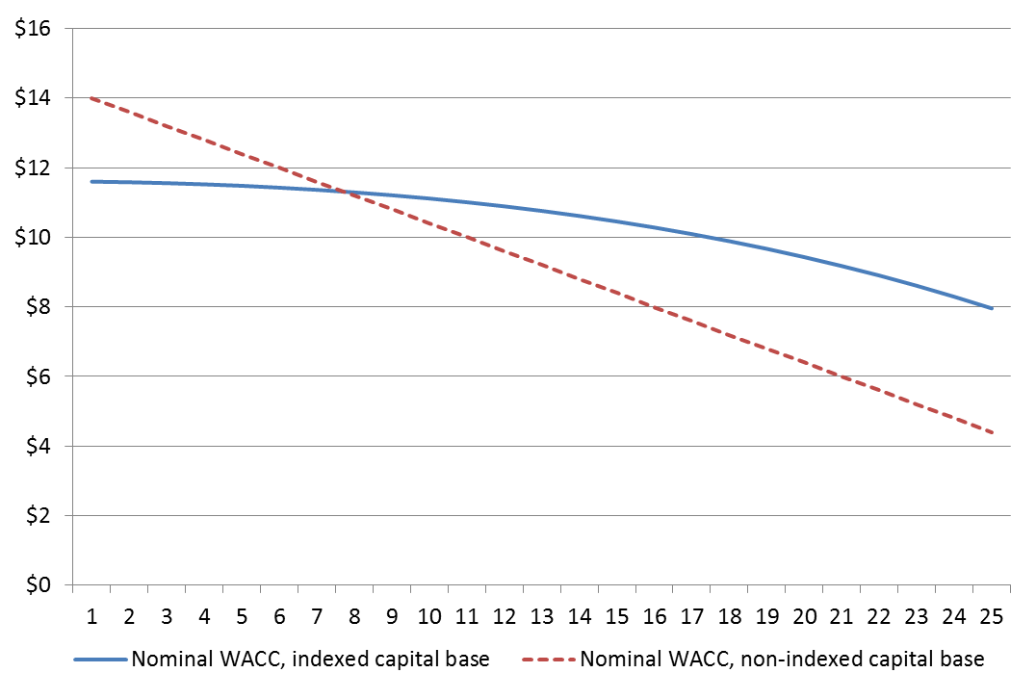

Source: AER analysis.

## Reasons for draft decision

In our assessment of Multinet's proposal, we focused on the following aspects:

* year-by-year tracking of depreciation
* accelerated depreciation of replaced mains and services
* changes to some standard asset lives.
* application of forecast depreciation approach.

Each of these is discussed in turn in the following subsections.

### Year-by-year tracking

Multinet proposed the year-by-year tracking approach to implement straight-line depreciation.[31] This represents a change from the current approach to determining remaining asset lives at the end of each access arrangement period. Multinet stated the year-by-year tracking approach is the AER's preferred option.[32] This statement is incorrect. Our preferred option (as noted above) is a weighted average remaining life (WARL) approach. We consider that year-by-year tracking is administratively more complex and costly than a WARL approach and can increase revenue fluctuations as depreciation depends more on when individual assets expire.[33] The change of approach can also cause revenue (and price spikes) which may not be helpful to efficient development in the market for reference services.

We accept that the year-by-year tracking approach can meet the criterion of having the depreciation schedule reflect the asset's economic life, where it tracks the asset's technical life. However, we must also assess the approach against the other criteria in the NGR, in particular, whether the approach leads to efficient development in the market for reference services. Under this criterion we also need to consider the impact of the change in the long run and any significant disruption in the short to medium term from a change in previous practice. The proposed change to year-by year tracking does increase depreciation (and prices) over short to medium term, other things being equal. The Consumer Challenge Panel (CCP11) also raised this potential impact as a concern in its submission.[34] However, our analysis suggests the impact in this case to be modest and therefore unlikely to have a significant impact on the efficient growth in the market for reference services. We therefore accept Multinet's proposal in this regard.

### Accelerated depreciation

Multinet proposed accelerated depreciation over five years on assets to be replaced through its mains replacement programs over the 2018–22 access arrangement period. We accept the accelerated depreciation on these assets subject to adjustments made to the approved length of mains to be replaced over the 2018–22 access arrangement period, as discussed in attachment 6. The reduction in the expected kilometres of mains to be replaced by 36.6 per cent resulted in a proportional reduction in the amount of accelerated depreciation allowed over the next five years in this draft decision.

Multinet also proposed accelerated depreciation of fifteen years on assets to be replaced between 2022 and 2033, by which time Multinet submitted that it will have replaced all old low pressure mains and services. As discussed in attachment 6, we consider the mains replacement program will not be completed until 2040—that is, seven years later than Multinet forecasts. Accordingly, we have extended the remaining asset lives of the residual older mains and services to 22 years from 15 years.

We have corrected two errors which we identified in Multinet's proposed application of accelerated depreciation. The proposal effectively double counted one accelerated depreciation adjustment and failed to count another at all. The two errors almost offset each other in terms of their impact on the proposed revenues. We have corrected these errors in the draft decision.

Multinet proposed to accelerate depreciation of existing meters over five years. In doing so, it did not apply year-by-year tracking of depreciation for this asset class. It submitted the existing meters only had a remaining asset life of 6.3 years and reducing it to 5 years would simplify the capital base. However, this remaining asset life was calculated using an average depreciation approach that the AER has previously rejected as it results in remaining asset lives that are too short.[35] We consider that year-by-year tracking should be applied to this asset class, as it is proposed for all other asset classes. However, we have scaled back the remaining asset lives to reflect the new standard asset life for meters of 15 years proposed by Multinet (and which we accept, as discussed below). To take a single year example, we consider a meter acquired in the final year of the 2013–17 access arrangement period (which has had no depreciation applied against it) should have a remaining asset life of 15 years (equal in this case to the new standard asset life). This compares to the 5 year life Multinet proposed and the 30 years that would have applied under year-by-year tracking if the old standard asset life of 30 years was used. This change reduces Multinet's regulatory depreciation allowance by $10.7 million ($ 2017). Our draft decision addresses CCP11's concern that this aspect of the proposal did not appear to be 'in the interests of consumers' with Multinet instead emphasising simplification of the capital base.[36]

### Standard asset lives

Multinet has proposed most of the same standard asset lives be applied to new conforming capex made during the 2013–17 access arrangement, which we accept. The exceptions are for the 'Buildings' and 'Meters' asset classes, which are discussed below. Multinet also did not provide a standard asset life for equity raising costs. This is also discussed below.

#### Buildings

Multinet proposed to reduce the standard asset life of the 'Buildings' asset class to 35 years from 50 years. It submitted that this is consistent with tax law.

We accept that consistency with tax law is appropriate for the tax asset base and accept its use for this purpose. However, we do not agree that an asset's economic life necessarily matches the life provided for under tax law. It is the economic life of the asset that is to be used for depreciation of the capital base under the NGR. CCP11 also submitted that consistency with tax law is not compelling enough to justify the impact of higher revenue requirement on consumers.[37]

'Buildings' is an asset class used by most electricity and gas service providers that we regulate.[38] Figure 5.2 shows the range of standard asset lives we have approved in various decisions across electricity and gas distribution and transmission. Multinet's proposed standard asset life for buildings is lower than all businesses we regulate except one.

We have reviewed the data across the businesses we regulate and consider that a reasonable range for the standard asset life of buildings is 40 to 60 years.[39] Longer lived buildings are likely to be more robust system buildings, while 40 years we consider is a reasonable minimum life for commercial buildings.[40] We do not accept Multinet's proposal as it is outside this range. We consider Multinet's estimate is not consistent with the economic life of the asset, and was not arrived at on a reasonable basis and does not provide the best possible estimate in the circumstances. For our draft decision, we have taken the view that the buildings Multinet acquires in the future are likely to be a mix of both system and commercial buildings. We therefore have decided to continue with the standard asset life of 50 years used for buildings during the 2013–17 access arrangement. CCP11 also noted that Multinet had been satisfied with the 50 year standard asset life of its building for many years, and had not shown that these building fail to last 50 years.[41]

Multinet's proposal went against developing consistency in standard asset lives across businesses over time. This concern has been raised by the CCP in a number of submissions in recent times. The standard asset lives for different asset classes used in many cases were developed by previous jurisdictional regulators, and generally have not changed over several access arrangement periods. Some asset classes can also reflect a mix of assets (or high level of aggregation), such as the mix of different types of buildings that can be allocated to a single high level 'buildings' asset class. This can lead to reasonable differences in the standard asset life of seemingly similar asset classes across regulated businesses. We will continue to develop greater consistency across businesses when it is not reasonable for a different asset life to be used.

Figure 5.2 Approved standard asset lives of buildings

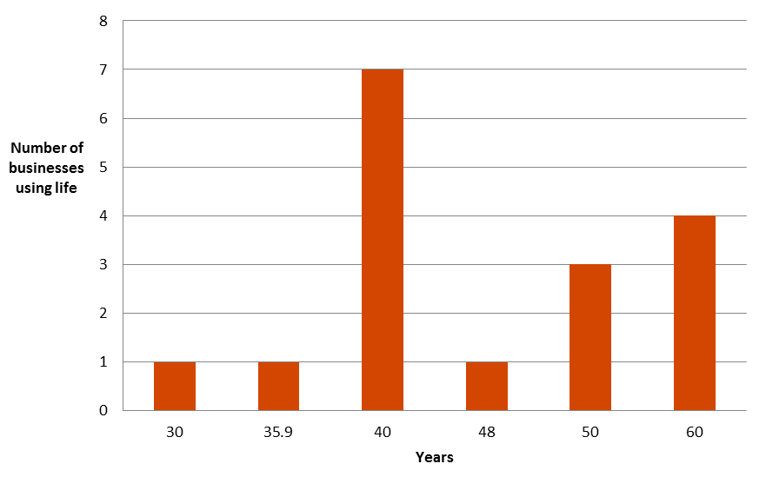

Source: AER analysis.

Notwithstanding the analysis above, Multinet proposed a relatively small amount of forecast capex on buildings.[42] We sought further information from Multinet as to these amounts and the relative mix of assets. Multinet advised the capex related to office fittings. It proposed that the forecast capex be moved from the 'Buildings' asset class to the 'Other' asset class, which has a standard asset life of 10 years.[43] We agree that an error was made in the proposal in classifying office fittings as 'Buildings'. We also consider that given the nature of the assets a 10 year standard asset life is reasonable in these circumstances. We have amended the models accordingly. The impact of this change on Multinet' revenues is not material.

#### Meters

Multinet proposed reducing the standard asset life of the 'Meters' asset class to 15 years from 30 years. It stated that this revised standard asset life would be consistent with tax law and previous AER decisions.[44] As noted above, we consider consistency with tax law to be appropriate for the tax asset base. However, we do not accept that this is a sufficient reason to apply the economic life to the capital base.

Nonetheless, the proposed standard asset life is consistent with previous AER decisions regarding meters. Given that the meters used by Multinet are likely to be similar to those used by other businesses, we accept this proposal. CCP11 raised a concern as to the revenue impact of this proposed change. However, our assessment revealed this to be insignificant.[45]

#### Equity raising costs

Multinet did not provide a standard asset life for equity raising costs. We have determined this asset life for the draft decision based on our standard approach of using the weighted average standard asset lives of the opening capital base.

#### Summary of standard asset lives

We have considered Multinet's proposal and are satisfied the standard asset lives approved in this draft decision reflect the requirements of r. 89(1) of the NGR. Table 5.3 sets out our draft decision on the standard asset lives for the Multinet over the 2018–22 access arrangement period.

Table . AER's draft decision on Multinet’s standard asset lives (years)

|  | Standard asset life |
| --- | --- |
| Transmission and distribution | 50 |
| Services | 50 |
| Cathodic protection | 50 |
| Supply regs/valve stations | 50 |
| Meters | 15 |
| Buildings | 50 |
| IT | 5 |
| SCADA | 15 |
| Other | 10 |
| Equity raising costs | 47 |

Source: AER analysis.

### Application of the forecast depreciation approach

Multinet's capital base must be rolled forward using forecast depreciation (adjusted for actual inflation) over the 2013–17 access arrangement period. This requirement was set out in the 2013–17 access arrangement and ensures that the business does not over or under recover on depreciation due to forecasting errors in the capex allowance. There are various ways forecast depreciation can be applied in practice.

Multinet's proposed year-by-year tracking depreciation model used actual capex as the basis for determining depreciation. This ensures that the profile of future depreciation reflects the profile of actual capex that was incurred. Multinet then also made an adjustment to the opening capital base to account for the difference between the forecast depreciation allowance from the last access arrangement review and actual depreciation over the 2013–17 access arrangement period. This adjustment is needed so the value of the opening capital base reflects the forecast depreciation allowance from the last access arrangement review. However, Multinet failed to make a similar adjustment for depreciation of these assets into the future. Therefore, while the opening capital base is correct, the forecast depreciation allowance on those assets for the 2018–22 access arrangement period will be in error as it is based on actual capex in the past with no forecast depreciation adjustment.[46] The error means Multinet would over or under recover on depreciation at the asset class level going forward. We have corrected this in Multinet's depreciation model.

## Revisions

We require the following revisions to make the access arrangement proposal acceptable:

|  |  |
| --- | --- |
|  |  |
| Revision 5.1: | Make all necessary amendments to reflect this draft decision on the regulatory depreciation allowance for the 2018–22 access arrangement period, as set out in Table 5.1. |
| Revision 5.2: | Make all necessary amendments to reflect this draft decision on the standard asset lives, as set out in Table 5.3. |
| Revision 5.3: | Make all necessary amendments to reflect this draft decision on the accelerated depreciation, as set out in section 5.4.2. |

1. NGR, r. 76(b).
2. Regulatory depreciation allowance is the net total of the straight-line depreciation (negative) and the annual inflation indexation (positive) on the projected capital base.
3. The term ‘standard asset life’ may also be referred to as ‘standard economic life’, ‘asset life’, ‘economic asset life’ or ‘economic life’.
4. For example, AER: Access arrangement final decision APA GasNet Australia (Operations) Pty Ltd 2013–17 Part 2: Attachments, March 2013, p. 149; AER: Final decision Amadeus Gas Pipeline access arrangement attachment 5 — Regulatory depreciation, May 2016, p. 9. Final Decision Australian Gas Networks Access Arrangement 2016 to 2021 Attachment 5 – Regulatory depreciation, May 2016, p.28. Final decision, Jemena Gas Networks (NSW) Ltd Access Arrangement 2015-20 Attachment 5 − Regulatory depreciation, June 2015, p10.
5. Multinet Gas, 2018–22 Access arrangement information, December 2016, p. 120.
6. Multinet Gas, 2018–22 Access arrangement information, December 2016, pp. 120–123.
7. Multinet Gas, 2018–22 Access arrangement information, December 2016, pp. 118–119.
8. Multinet Gas, 2018–22 Access arrangement information, December 2016, pp. 119 & 125.
9. NGR, r. 72(1)(c)(ii).
10. NGR, rr. 88(1), 88(2).
11. NGR, r. 89.
12. NGL, s 28; NGR r. 100(1). The NGO is set out in NGL, s. 23. The revenue and pricing principles are set out in NGL, s. 24.
13. NGR, rr. 89(3) and 40(2). The example provided in r. 40(2) states: The AER has limited discretion under r. 89. Rule 89 governs the design of a depreciation schedule. In dealing with a full access arrangement submitted for its approval, the AER cannot, in its draft decision, insist on change to an aspect of a depreciation schedule governed by r. 89 unless the AER considers the change is necessary to correct non-compliance with a provision of the Law or an inconsistency between the depreciation schedule and the applicable criteria. Even though the AER might consider change desirable to achieve more complete conformity between the depreciation schedule and the principles and objectives of the Law, it would not be entitled to give effect to that view in the decision making process.
14. NGR, r. 89(1)(a).
15. NGR, r. 89(1)(b).
16. NGR, r. 89(1)(c).
17. NGR, r. 89(1)(d).
18. NGR, r. 89(1)(e).
19. NGR, r. 89(2).
20. NGR, r. 74(2).
21. NGR, r. 89.
22. NGR, r. 89(1)(a).
23. We consider this depreciation method to be a generally superior approach. The reasons are outlined in our decision on the roll forward model for electricity transmission network service providers. See AER, Explanatory statement, Proposed amendment, Electricity transmission network service providers, Roll forward model, August 2010, pp. 5–6.
24. See AER, Final decision - amended transmission roll forward model, December 2010, pp. 5–6 for further explanation.
25. Under our standard approach, the distinction is made between straight-line depreciation and regulatory depreciation. The difference being that regulatory depreciation is the straight-line depreciation minus the indexation adjustment.
26. This is generally the case because the reduction in the capital base amount feeds into the higher depreciation building block, whereas the reduced return on capital building block is proportionate to the lower capital base multiplied by the WACC.
27. NGR, cl. 87(4)(b).
28. If the asset lives are extremely long, such that the capital base depreciation rate is lower than the inflation rate, then negative regulatory depreciation can emerge. The indexation adjustment is greater than the capital base depreciation in such circumstances
29. A change of approach from an indexed capital base to an un-indexed capital base would result in an initial step change increase in revenues to preserve NPV neutrality.
30. The example is based on the initial cost of an asset of $100, a standard economic life of 25 years, a real WACC of 7.32%, expected inflation of 2.5% and nominal WACC of 10%. Other building block components such as opex, tax and capex are ignored for simplicity as they would affect both approaches equally.
31. However, it did not apply the approach to existing mains and services, and existing meters, which it proposed for accelerated depreciation.
32. Multinet Gas, 2018–2022 Access arrangement information, December 2016, p. 115.
33. There is also greater scope for error in non-standardised models. For example, our RFM makes sure forecast depreciation is correctly accounted for. Multinet's separate year-by-year tracking model for depreciation has made an error in applying this approach as discussed below.
34. Consumer Challenge Panel (CCP 11) - Response to proposals from AGN, AusNet and Multinet for the 2018-2022 Access Arrangements - 3 March 2017, p.53.
35. For example, imagine an asset class with two assets. Asset one worth $1 million with one year life left. Asset two worth $1 million but with fifty years of life left. Under the average depreciation approach the remaining asset life for the asset class as a whole would be 1.96 years ($2m divided by the depreciation expected next year of $1.02 million – asset one depreciation of $1 million plus asset two depreciation of $0.02 million ($1m divided by 50 years)). In contrast, a weighted average remaining life in this case would be 25.5 years ((1+50)/2 given the weights of $1 million are identical). For further discussion refer to section 5.4.2 of the SA Power Networks draft decision. AER - Preliminary decision, SA Power Networks determination 2015−16 to 2019−20, Attachment 5 − Regulatory depreciation, April 2015.
36.
37. Consumer Challenge Panel (CCP 11) - Response to proposals from AGN, AusNet and Multinet for the 2018-2022 Access Arrangements - 3 March 2017
38. The labels may be somewhat different across businesses. The term 'buildings' is used predominantly, but some also use terms such as system buildings, commercial buildings, and houses.
39. The two businesses with standard asset lives for buildings below this range will be reviewed at their next resets.
40. For example, Energex has both commercial buildings and system buildings. The former has a standard asset life of 40 years. The latter has a standard asset life of 60 years.
41. Consumer Challenge Panel (CCP 11) - Response to proposals from AGN, AusNet and Multinet for the 2018-2022 Access Arrangements - 3 March 2017, p. 54.
42. Multinet Gas proposed to spend $0.9 million of capex allocated to this asset class over the next 5 years in total.
43. Multinet Gas, Email RE: AER–Multinet Gas–IR #16–Standard asset life of Buildings, 27 March 2017.
44. Multinet Gas, 2018–2022 Access arrangement information, December 2016, p. 125.
45. Consumer Challenge Panel (CCP 11) - Response to proposals from AGN, AusNet and Multinet for the 2018-2022 Access Arrangements - 3 March 2017, p. 54.
46. For example, consider if at the last access arrangement review that $5 million forecast capex was approved with associated forecast depreciation of $1 million. If actual capex was $10 million, then the opening value for these assets at the next access arrangement review should be $9 million ($10 million actual capex – $1 million forecast depreciation). Actual depreciation in this case would be $2 million, other things being equal. Multinet's capital base roll forward correctly recognised that the opening value of this asset at the next access arrangement should be $9 million. However, in determining future depreciation on these assets its approach incorrectly calculates that $2 million depreciation has already been recovered. It results in the sum of tracked depreciation for this capex being $8 million instead of the $9 million of the opening capital base. Multinet would therefore under recover by $1 million in the future. Our correction ensures that future depreciation equals the correct opening capital base value.