Draft decision:

Powerlink electricity transmission 2017–22



Overview

The Australian Energy Regulator (AER) regulates the revenues of Powerlink by setting the annual revenue requirement it may recover from its customers.

Our draft decision allows Powerlink to recover $3720.8 million ($nominal) from its customers over five years commencing 1 July 2017. If we had accepted Powerlink’s proposal, it would have been permitted to recover $4017.2 million ($nominal) over the 2017−22 regulatory control period. Our draft decision is for 7.4 per cent less revenue than Powerlink proposed.

The figure below shows the difference between Powerlink’s proposed revenue, and what we have allowed for each year of the regulatory period.

Powerlink’s past and proposed total revenue and AER draft decision revenue allowance ($million, 2016–17)

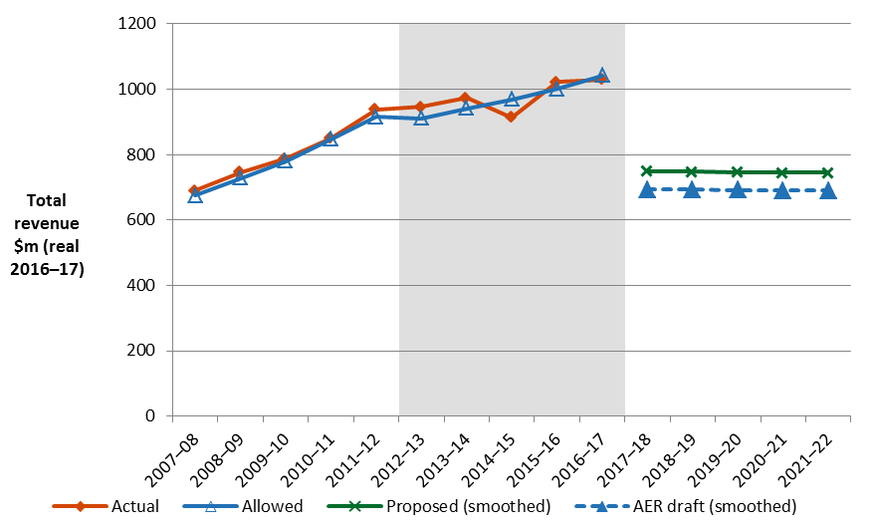

The revenue we determine affects the transmission component of a customer’s electricity bill. Transmission charges may make up approximately 9.3 per cent of the bill for one of Queensland’s typical residential customers.

Other components of customer bills include the cost of generation, distribution, network charges and retailer costs. The AER regulates the transmission and distribution components only, it does not influence the cost of generation or set retail prices. 

**Estimated impact on customer bills**

As a result of the reductions proposed in our draft decision, we expect that the transmission component of the average annual residential electricity bill in 2021–22 would reduce by about $40 below the 2016–17 level.

We also expect the transmission component of small business’ electricity bills would reduce. For small business customers with annual consumption of 10 000 kWh, the transmission component of the bill would be $75 lower than in 2016–17.

These are only estimates, and are based on the data we have about how much energy customers in Queensland use. There are a number of other factors that also affect a customers electricity bill, such as the wholesale price of electricity. You can read more about what makes up the energy process on customers’ bills on our website: http://www.aer.gov.au/Consumers .

**Key elements of our decision**

We based our assessment of Powerlink’s proposed revenue on a number of components. These include expenditures to maintain and operate the network, and the return to shareholders on their investment. Together, these determine

the revenue Powerlink may recover from its customers.

Two components of our draft decision drive most of the difference between Powerlink’s proposed revenue and our draft decision: rate of return, and allowed capital expenditure.

We discuss each of these below.

**Rate of return**

Significant investment is required to build a transmission network. The return Powerlink must pay lenders and investors is referred to as the rate of return. Even a small difference in the rate of return can have a big impact on revenues.

We set out our approach to determining the rate of return in the Rate of Return Guideline (Guideline) we published in December 2013. In its proposal, Powerlink proposed to use the methodology set out in our guideline. We have accepted the approach proposed by Powerlink for calculating the rate of return, however, this approach requires us to consider prevailing market conditions.

Prevailing market conditions for debt and equity are subject to change and heavily influence the rate of return. Financial market conditions have changed since Powerlink submitted its proposal. Interest rates are lower, meaning that the cost of debt and the returns required to attract equity are lower. These factors result in a rate of return lower than Powerlink proposed in its draft decision.

Our draft decision sets the allowed rate of return (or ‘cost of capital’) at 5.48 per cent for 2017–18. This compares with Powerlink’s proposed 6.04 per cent in its regulatory proposal. This difference is due to movements in market rates for the risk free rate and return on debt since Powerlink submitted its proposal.

In our final decision we will update the rate of return again, having regard to the prevailing market conditions at the time we make our final decision and by reference to the averaging periods that Powerlink nominated in its proposal.

Allowed capital expenditure

Capital expenditure (capex) refers to the capital expenses incurred in the provision of network services. We are not satisfied that Powerlink's proposed total forecast capex of $959.7 million ($2016-17) for the 2017–22 regulatory control period reasonably reflects the capex criteria. We have substituted it with our estimate of Powerlink's total forecast capex for the 2017–22 regulatory control period. We are satisfied that our substitute estimate of $775.2 million ($2016–17) reasonably reflects the capex criteria.

The key reason for the difference between our draft decision on capex and Powerlink’s proposal is a reduction in Powerlink's forecast replacement capital expenditure (repex). We are not satisfied that Powerlink's forecast asset replacement lives used in its repex modelling are realistic and likely to result in a forecast of asset replacement capex requirements which is prudent and efficient and reflects the capex objectives.

Along with analysing Powerlink’s forecast using our internal technical and engineering expertise, we engaged consultants, EMCa, to review Powerlink's capex forecast and in particular to assess the efficiency of the replacement lives used in the repex model. Our analysis found, and EMCa also concluded that, the asset lives proposed by Powerlink were shorter than efficient lives.

**More information about our consultation process**

Powerlink may submit a revised proposal in response to our draft decision by 1 December 2016. Stakeholders may make written submissions on our draft decision by the same date,   
1 December 2016. Stakeholders may also file submissions on Powerlink’s revised proposal by 23 December 2016. Our final decision is due for release by the end of April 2017.

More information on Powerlink’s proposal, our draft decision and how to make a submission is on our website: [www.aer.gov.au](http://www.aer.gov.au).