

DRAFT DECISION

TasNetworks distribution determination

2017−18 to 2018−19

Attachment 2 – Regulatory asset base

September 2016

© Commonwealth of Australia 2016

This work is copyright. In addition to any use permitted under the Copyright Act 1968, all material contained within this work is provided under a Creative Commons Attributions 3.0 Australia licence, with the exception of:

* the Commonwealth Coat of Arms
* the ACCC and AER logos
* any illustration, diagram, photograph or graphic over which the Australian Competition and Consumer Commission does not hold copyright, but which may be part of or contained within this publication. The details of the relevant licence conditions are available on the Creative Commons website, as is the full legal code for the CC BY 3.0 AU licence.

Requests and inquiries concerning reproduction and rights should be addressed to the:

Director, Corporate Communications  
Australian Competition and Consumer Commission   
GPO Box 4141, Canberra ACT 2601

or publishing.unit@accc.gov.au.

Inquiries about this publication should be addressed to:

Australian Energy Regulator  
GPO Box 520  
Melbourne Vic 3001

Tel: 1300 585 165  
Email: [AERInquiry@aer.gov.au](mailto:AERInquiry@aer.gov.au)

1. Note
2. This attachment forms part of the AER's draft decision on TasNetworks' distribution determination for 2017–19. It should be read with all other parts of the draft decision.
3. The draft decision includes the following documents:
4. Overview
5. Attachment 1 – Annual revenue requirement
6. Attachment 2 – Regulatory asset base
7. Attachment 3 – Rate of return
8. Attachment 4 – Value of imputation credits
9. Attachment 5 – Regulatory depreciation
10. Attachment 6 – Capital expenditure
11. Attachment 7 – Operating expenditure
12. Attachment 8 – Corporate income tax
13. Attachment 9 – Efficiency benefit sharing scheme
14. Attachment 10 – Capital expenditure sharing scheme
15. Attachment 11 – Service target performance incentive scheme
16. Attachment 12 – Demand management incentive scheme
17. Attachment 13 – Classification of services
18. Attachment 14 – Control mechanisms
19. Attachment 15 – Pass through events
20. Attachment 16 – Alternative control services
21. Attachment 17 – Negotiated services framework and criteria
22. Attachment 18 – Connection policy
23. Attachment 19 – Tariff structure statement

1. Contents

Note 2-2

Contents 2-3

Shortened forms 2-4

2 Regulatory asset base 2-6

2.1 Draft decision 2-6

2.2 TasNetworks' proposal 2-8

2.3 Assessment approach 2-9

2.3.1 Interrelationships 2-11

2.4 Reasons for draft decision 2-14

2.4.1 Opening RAB as at 1 July 2017 2-14

2.4.2 Forecast closing RAB as at 30 June 2019 2-16

2.4.3 Application of depreciation approach in RAB roll forward for next reset 2-17

1. Shortened forms

| Shortened form | Extended form |
| --- | --- |
| AEMC | Australian Energy Market Commission |
| AEMO | Australian Energy Market Operator |
| AER | Australian Energy Regulator |
| augex | augmentation expenditure |
| capex | capital expenditure |
| CCP | Consumer Challenge Panel |
| CESS | capital expenditure sharing scheme |
| CPI | consumer price index |
| DRP | debt risk premium |
| DMIA | demand management innovation allowance |
| DMIS | demand management incentive scheme |
| distributor | distribution network service provider |
| DUoS | distribution use of system |
| EBSS | efficiency benefit sharing scheme |
| ERP | equity risk premium |
| Expenditure Assessment Guideline | Expenditure Forecast Assessment Guideline for Electricity Distribution |
| F&A | framework and approach |
| MRP | market risk premium |
| NEL | national electricity law |
| NEM | national electricity market |
| NEO | national electricity objective |
| NER | national electricity rules |
| NSP | network service provider |
| opex | operating expenditure |
| PPI | partial performance indicators |
| PTRM | post-tax revenue model |
| RAB | regulatory asset base |
| RBA | Reserve Bank of Australia |
| repex | replacement expenditure |
| RFM | roll forward model |
| RIN | regulatory information notice |
| RPP | revenue and pricing principles |
| SAIDI | system average interruption duration index |
| SAIFI | system average interruption frequency index |
| SLCAPM | Sharpe-Lintner capital asset pricing model |
| STPIS | service target performance incentive scheme |
| WACC | weighted average cost of capital |

# Regulatory asset base

As part of our distribution determination, we make a decision on TasNetworks' opening regulatory asset base (RAB) as at 1 July 2017.[1] We use the RAB at the start of each regulatory year to determine the return of capital (regulatory depreciation) and return on capital building block allowances. This attachment presents our draft decision on the opening RAB value as at 1 July 2017 for TasNetworks and roll forward of the forecast RAB over the 2017–19 regulatory control period.

## Draft decision

We determine an opening RAB value of $1629.4 million ($ nominal) as at 1 July 2017 for TasNetworks. This value is $17.4 million (or 1.1 per cent) lower than TasNetworks' proposed opening RAB of $1646.7 million ($ nominal) as at 1 July 2017.[2] This is because we have updated the 2015–16 inflation rate with actual CPI for indexation in the RAB roll forward.

1. To determine the opening RAB as at 1 July 2017, we have rolled forward the RAB over the 2012–17 regulatory control period to determine a closing RAB value at 30 June 2017. This roll forward includes an adjustment at the end of the 2012–17 regulatory control period to account for the difference between actual 2011–12 capex and the estimate approved at the 2012–17 determination.[3]
2. We determine a forecast closing RAB value at 30 June 2019 of $1753.9 million ($ nominal). This is $9.4 million (or 0.5 per cent) lower than the amount of $1763.2 million ($ nominal) proposed by TasNetworks. Our draft decision on the forecast closing RAB reflects the updated opening RAB as at 1 July 2017, and our draft decisions on the expected inflation rate (attachment 3), forecast depreciation (attachment 5) and forecast capex (attachment 6).
3. Table 2.2 sets out our draft decision on the forecast RAB values for TasNetworks over the 2017–19 regulatory control period.
4. Table 2.1 sets out our draft decision on the roll forward of the RAB values for TasNetworks over the 2012–17 regulatory control period.
5. We determine a forecast closing RAB value at 30 June 2019 of $1753.9 million ($ nominal). This is $9.4 million (or 0.5 per cent) lower than the amount of $1763.2 million ($ nominal) proposed by TasNetworks.[4] Our draft decision on the forecast closing RAB reflects the updated opening RAB as at 1 July 2017, and our draft decisions on the expected inflation rate (attachment 3), forecast depreciation (attachment 5) and forecast capex (attachment 6).
6. Table 2.2 sets out our draft decision on the forecast RAB values for TasNetworks over the 2017–19 regulatory control period.

Table .1 AER's draft decision on TasNetworks' RAB for the 2012–17 regulatory control period ($ million, nominal)

|  | 2012–13 | 2013–14 | 2014–15 | 2015–16a | 2016–17b |
| --- | --- | --- | --- | --- | --- |
| Opening RAB | 1445.2 | 1486.9 | 1539.3 | 1557.0 | 1606.3 |
| Capital expenditurec | 89.3 | 99.8 | 89.2 | 114.9 | 125.7 |
| Inflation indexation on opening RABd | 36.2 | 43.6 | 20.4 | 20.4 | 40.2 |
| Less: straight-line depreciatione | 83.8 | 90.9 | 91.9 | 85.4 | 87.6 |
| Closing RAB | 1486.9 | 1539.3 | 1557.0 | 1606.3 | 1684.5 |
| Difference between estimated and actual 2011–12 capex (1 July 2011 to 30 June 2012) |  |  |  |  | –38.0 |
| Return on difference for 2011–12 capex |  |  |  |  | –17.2 |
| **Closing RAB as at 30 June 2017** |  |  |  |  | **1629.4** |

1. Source: AER analysis.
2. (a) Based on estimated capex. We will update the RAB roll forward for actual capex in the final decision.
3. (b) Based on estimated capex provided by TasNetworks. We expect to update the RAB roll forward with a revised capex estimate in the final decision, and true-up the RAB for actual capex at the next reset.
4. (c) Net of disposals and capital contributions, and adjusted for actual CPI.

(d) We will update the RAB roll forward for actual CPI for 2016–17 in the final decision.

(e) Adjusted for actual CPI. Based on actual as-incurred capex.

Table .2 AER's draft decision on TasNetworks' RAB for the 2017–19 regulatory control period ($ million, nominal)

|  |  |  |
| --- | --- | --- |
|  | 2017–18 | 2018–19 |
| Opening RAB | 1629.4 | 1705.7 |
| Capital expenditurea | 115.9 | 107.2 |
| Inflation indexation on opening RAB | 39.9 | 41.8 |
| Less: straight-line depreciation | 79.5 | 100.8 |
| Closing RAB | 1705.7 | 1753.9 |

Source: AER analysis.

(a) Net of forecast disposals and capital contributions. In accordance with the timing assumptions of the post-tax revenue model (PTRM), the capex includes a half-WACC allowance to compensate for the six month period before capex is added to the RAB for revenue modelling.

We accept TasNetworks' proposal that the forecast depreciation approach (instead of an actual depreciation approach) is to be used to establish the opening RAB at the commencement of the 2019–24 regulatory control period.[5] We consider this approach will provide sufficient incentives for TasNetworks to achieve capex efficiency gains over the 2017–19 regulatory control period.

## TasNetworks' proposal

1. TasNetworks used our roll forward model (RFM) to establish an opening RAB as at 1 July 2017 and our post-tax revenue model (PTRM) to roll forward the RAB over the 2017–19 regulatory control period.
2. TasNetworks proposed an opening RAB value as at 1 July 2012 of $1445.2 million ($ nominal).[6] Rolling forward this RAB and using depreciation based on actual capex, TasNetworks proposed a closing RAB as at 30 June 2017 of $1646.7 million ($ nominal). It has also adjusted the capex for 2011–12 and 2012–17 regulatory control period for movements in capitalised provisions.[7] Table 2.3 presents TasNetworks' proposed roll forward of its RAB during the 2012–17 regulatory control period.

Table .3 TasNetworks' proposed RAB for the 2012–17 regulatory control period ($million, nominal)

|  |  |  |  |  |  |  |  |  |
| --- | --- | --- | --- | --- | --- | --- | --- | --- |
|  | 2012–13 | 2013–14 | | 2014–15 | | 2015–16a | | 2016–17a |
| Opening RAB | 1445.2 | 1486.9 | | 1539.3 | | 1557.0 | | 1625.5 |
| Capital expenditureb | 89.3 | 99.8 | | 89.2 | | 114.9 | | 125.7 |
| Inflation indexation on opening RAB | 36.2 | 43.6 | | 20.4 | | 38.9 | | 40.6 |
| Less: straight-line depreciationc | 83.8 | 90.9 | | 91.9 | | 85.4 | | 88.6 |
| Closing RAB | 1486.9 | 1539.3 | | 1557.0 | | 1625.5 | | 1703.1 |
| Difference between estimated and actual 2011–12 capex (1 July 2011 to 30 June 2012) |  | | | | –38.4 | | | |
| Return on difference for 2011–12 capex |  | |  | |  | | –18.0 | |
| **Closing RAB as at 30 June 2017** |  |  | |  | |  | | **1646.7** |

Source: TasNetworks, Regulatory proposal, January 2016, RFM.

(a) Based on estimated capex.

(b) Net of disposals and capital contributions, and adjusted for CPI.

(c) Adjusted for actual CPI. Based on actual as-incurred capex.

1. TasNetworks proposed a closing forecast RAB as at 30 June 2019 of $1763.2 million ($ nominal). This value reflects its proposed opening RAB, forecast capex, expected inflation, and depreciation (based on forecast capex) over the 2017–19 regulatory control period. Its projected RAB over the 2017–19 regulatory control period is shown in Table 2.4.

Table .4 TasNetworks' proposed RAB for the 2017–19 regulatory control period ($million, nominal)

|  | 2017–18 | 2018–19 |
| --- | --- | --- |
| Opening RAB | 1646.7 | 1713.2 |
| Capital expenditurea | 116.2 | 107.6 |
| Inflation indexation on opening RAB | 41.2 | 42.8 |
| Less: straight-line depreciation | 90.8 | 100.4 |
| Closing RAB | 1713.2 | 1763.2 |

Source: TasNetworks, Regulatory proposal, January 2016, PTRM.

(a) Net of forecast disposals and capital contributions. Inclusive of equity raising costs and the half-WACC to account for the timing assumptions in the PTRM.

1. TasNetworks proposed to apply a forecast depreciation approach to establish the RAB at the commencement of the 2019–24 regulatory control period, consistent with the approach set out in our Framework and approach paper.[8]

## Assessment approach

1. We roll forward the distributor's RAB during the 2012–17 regulatory control period to establish the opening RAB at 1 July 2017. This value can be adjusted for any differences in the forecast and actual capex, disposals and capital contributions. It may also be adjusted to reflect any changes in the use of the assets, with only assets used in the provision of standard control services to be included in the RAB.[9]
2. To determine the opening RAB, we developed an asset base RFM that a service provider must use the RFM in preparing its regulatory proposal.[10] The RFM rolls forward the RAB from the beginning of the final year of the 2007–12 regulatory control period,[11] through the 2012–17 regulatory control period, to the beginning of the 2017–19 regulatory control period. The roll forward occurs for each year by:

* Adding an inflation (indexation) adjustment to the opening RAB for the relevant year. This adjustment is consistent with the inflation factor used in the control mechanism.[12]
* Adding actual or estimated capex to the RAB for the relevant year.[13] We review a distributor's past capex and may exclude past capex from being rolled into the RAB where total capex exceeds the regulatory allowance.[14] The details of our assessment approach for capex overspending are set out in the Capital expenditure incentive guideline.[15] We note that under the transitional rules, our review of past capex does not apply to TasNetworks prior to 1 July 2014.[16] Also, the review of past capex does not include the last two years of the 2012–17 regulatory control period—these will instead be reviewed at the next reset.[17] We check actual capex amounts against audited annual reporting RIN data and generally accept the capex reported in those RINs in rolling forward the RAB.[18] However, there may be instances where adjustments are required to the annual reporting RIN data.[19]
* Subtracting depreciation from the RAB for the relevant year, calculated in accordance with the relevant distribution determination for that year.[20] Depreciation based on forecast or actual capex can be used to roll forward the RAB.[21] For this draft decision, we use depreciation based on actual capex for rolling forward TasNetworks' RAB values over the 2012–17 regulatory control period.[22] However, depreciation based on forecast capex will be used for the 2017–19 regulatory control period at the next reset.[23]
* Subtracting any gross proceeds for asset disposals for the relevant year, by way of netting from capex to be added to the RAB.[24] We check these amounts against audited annual reporting RIN data.

These annual adjustments give the closing RAB for any particular year, which then becomes the opening RAB for the following year. Through this process the RFM rolls forward the RAB to the end of the 2012–17 regulatory control period. The PTRM used to calculate the annual revenue requirement for the 2017–19 regulatory control period generally adopts the same RAB roll forward approach as the RFM, although the annual adjustments to the RAB are based on forecasts, rather than actual amounts.

1. We also decide whether depreciation for establishing the distributor's RAB as at the commencement of the 2019–24 regulatory control period is to be based on actual or forecast capex.[25]
2. The opening RAB for the 2019–24 regulatory control period can be determined using depreciation based either on forecast or actual capex incurred during the 2017–19 regulatory control period. To roll forward the RAB using depreciation based on forecast capex, we would use the forecast depreciation contained in the PTRM for the 2017–19 regulatory control period, adjusted for actual inflation. If the approach to roll forward the RAB using depreciation based on actual capex was adopted, we would recalculate the depreciation based on actual capex incurred during the 2017–19 regulatory control period.
3. Our decision on whether to use actual or forecast depreciation must be consistent with the capex incentive objective. We must have regard to:[26]

* the incentives the service provider has to undertake efficient capex
* substitution possibilities between assets with different lives and the relative benefits of each
* the extent of overspending and inefficient overspending relative to the allowed forecast
* the capex incentive guideline
* the capital expenditure factors.

### Interrelationships

1. The RAB is an input into the determination of the return on capital and depreciation (return of capital) building block allowances.[27] Factors that influence the RAB will therefore flow through to these building block components and the annual revenue requirement. Other things being equal, a higher RAB increases both the return on capital and depreciation allowances.
2. The RAB is determined by various factors, including:

* the opening RAB (meaning the value of existing assets at the beginning of the regulatory control period)
* net capex[28]
* depreciation
* indexation adjustment – so the RAB is presented in nominal terms, consistent with the rate of return.

The opening RAB depends on the value of existing assets and will depend on actual net capex, actual inflation outcomes and depreciation in the past.

The RAB when projected to the end of the regulatory control period increases due to both forecast new capex and the indexation adjustment. The size of the indexation adjustment depends on expected inflation (which also affects the nominal rate of return or WACC) and the size of the RAB at the start of each year.

1. Depreciation reduces the RAB. The depreciation allowance depends on the size of the opening RAB, the forecast net capex and depreciation schedules applied to the assets. By convention, the indexation adjustment is also offset against depreciation to prevent double counting of inflation in the RAB and WACC, which are both presented in nominal terms. This reduces the depreciation building block that feeds into the annual revenue requirement.

We maintain the RAB in real terms by indexing for inflation.[29] A nominal rate of return (WACC) is multiplied by the opening RAB to produce the return on capital building block.[30] To prevent the double counting of inflation through the nominal WACC and indexed RAB,[31] the regulatory depreciation building block has an offsetting reduction for indexation of the RAB.[32] Indexation of the RAB and the offsetting adjustment made to depreciation results in smoother revenue recovery profile over the life of an asset than if the RAB was un-indexed. If the RAB was un-indexed, there would be no need for an offsetting adjustment to the depreciation calculation of total revenue. This alternative approach provides for overall revenues being higher early in the asset's life (as a result of more depreciation being returned to the distributor) and lower in the future—producing a steeper downward sloping profile of total revenue.[33] The implications of an un-indexed RAB are discussed further in attachment 5.

Figure 2.1 shows the key drivers of the change in the RAB over the 2017–19 regulatory control period as proposed by TasNetworks. Overall, the closing RAB at the end of the 2017–19 regulatory control period would be 7.1 per cent higher than the opening RAB at the start of that period based on the proposal, in nominal terms. The proposed forecast net capex increases the RAB by about 13.6 per cent, while expected inflation increases it by about 5.1 per cent. Forecast depreciation, on the other hand, reduces the RAB by about 11.6 per cent.

Figure .1 Key drivers of changes in the RAB ($ million, nominal)

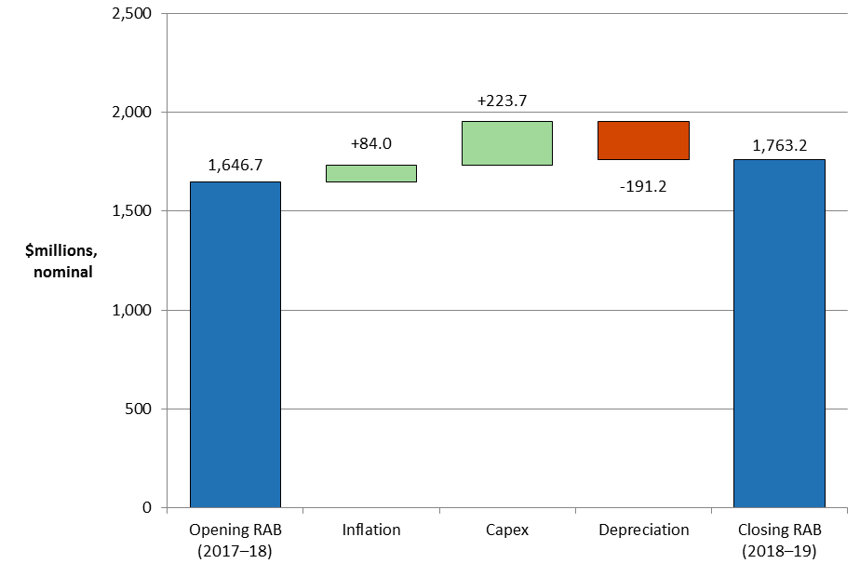

Source: TasNetworks, Regulatory proposal, April 2015, Attachment CP 2016-20 PTRM.

1. TasNetworks forecast depreciation of $191.2 million ($ nominal). We have largely accepted TasNetworks' depreciation proposal, subject to some input updates and modelling corrections, as it satisfies the requirements of the NER in terms of the assigned standard asset lives. This is discussed in attachment 5. The depreciation amount largely depends on the opening RAB (which in turn depends on capex in the past). Forecast net capex is a significant driver of the increase in the RAB. We are also satisfied TasNetworks' proposed total forecast capex of $213.4 million ($ 2016–17)[34] for the 2017–19 regulatory control period reasonably reflects the capex criteria. We have therefore accepted TasNetworks' proposed total forecast capex for the 2017–19 regulatory control period.[35] Refer to attachment 6 for the discussion on forecast capex.
2. A ten per cent increase in the opening RAB causes revenues to increase by about 7.0 per cent. However, the impact on revenues of the annual change in RAB depends on the source of the RAB change, as some drivers affect more than one building block cost.[36]

## Reasons for draft decision

We determine an opening RAB value for TasNetworks of $1629.4 million ($ nominal) as at 1 July 2017, a reduction of $17.4 million ($ nominal) or 1.1 per cent from the proposed value. We forecast a closing RAB value of $1753.9 million by 30 June 2019. This represents a reduction of $9.4 million or 0.5 per cent compared to TasNetworks' proposal. The reasons for our draft decision are discussed below.

### Opening RAB as at 1 July 2017

We determine an opening RAB value of $1629.4 million ($ nominal) as at 1 July 2017 for TasNetworks. This value is $17.4 million (or 1.1 per cent) lower than TasNetworks' proposed opening RAB of $1646.7 million ($ nominal) as at 1 July 2017.[37] This is because we updated the inflation input for 2015–16 using the actual March 2016 consumer price index (CPI) published by the Australian Bureau of Statistics.[38]

To determine the opening RAB as at 1 July 2017 we have rolled forward the RAB over the 2012–17 regulatory control period to determine a closing RAB value as at 30 June 2017. In doing so we reviewed the key inputs of TasNetworks' proposed RFM, such as asset lives, actual gross capex values, asset disposal values, capital contribution values, actual inflation and rate of return. We found these were generally correct and they reconcile with relevant data sources such as annual reporting RIN data and the 2012–17 decision models.[39] However, we consider TasNetworks' proposed RFM input should be updated for 2015–16 actual CPI as it is now available.[40]

We also consider the extent to which our roll forward of the RAB to 1 July 2017 contributes to the achievement of the capital expenditure incentive objective.[41] We note that under the transitional rules, in making this distribution determination, the review of past capex does not apply to TasNetworks prior to 1 July 2014.[42] Given this, the review period for this distribution determination is limited to 2014–15 capex.[43] TasNetworks' actual capex incurred in 2014–15 is below the forecast allowance set at the previous distribution determination. Therefore, the overspending requirement for an efficiency review of past capex is not satisfied.[44] Accordingly, the capex incurred in that year is regarded as prudent and efficient, and included in the RAB—this is discussed further in appendix D of capex attachment 6.

Further, for the purposes of this draft decision, we have included TasNetworks' estimated capex in 2015–16 and 2016–17 in the RAB roll forward to 1 July 2017. At the next reset, the 2015–16 and 2016–17 capex will form part of the review period for whether past capex should be excluded for inefficiency reasons.[45] Our RAB roll forward applies the incentive framework approved in the previous distribution determination, which included the use of an actual depreciation approach.[46] As such, we consider that the 2012–17 RAB roll forward contributes to an opening RAB (as at 1 July 2017) that includes capex that reflects prudent and efficient costs, in accordance with the capital expenditure criteria.[47]

CCP member David Headberry made a submission that noted the importance of new capex on the growth of the RAB over time.[48] In this draft decision (as discussed in attachment 6), we are satisfied TasNetworks' proposed total forecast capex of $213.4 million ($ 2016–17) for the 2017–19 regulatory control period reasonably reflects the capex criteria. We have therefore accepted TasNetworks' proposed total forecast capex for the 2017–19 regulatory control period.

### Forecast closing RAB as at 30 June 2019

We forecast a closing RAB value of $1753.9 million ($ nominal) by 30 June 2019 for TasNetworks. This represents a reduction of $9.4 million or 0.5 per cent to TasNetworks' proposal. This reduction reflects our draft decision on the inputs for determining the forecast RAB in the PTRM. To determine the forecast RAB value for TasNetworks, we amended the following PTRM inputs:

* We reduced TasNetworks's proposed opening RAB as at 1 July 2017 by $17.4 million or 1.1 per cent ($ nominal) (section 2.4.1).
* We reduced TasNetworks' proposed expected inflation rate of 2.50 per cent per annum to 2.45 per cent per annum (attachment 3). This results in a decrease to the indexation of the RAB component for the 2017–19 regulatory control period by $1.7 million or 2.0 per cent ($ nominal), all else being equal.
* We reduced TasNetworks' proposed forecast depreciation for the 2017–19 regulatory control period by $10.9 million or 5.7 per cent ($ nominal) (attachment 5).

Figure 2.2 shows the key drivers of the change in TasNetworks' RAB over the 2017–19 regulatory control period for this draft decision. Overall, the closing RAB at the end of the 2017–19 regulatory control period is forecast to be 7.6 per cent higher than the opening RAB at the start of that period, in nominal terms. The approved forecast net capex increases the RAB by about 13.7 per cent, while expected inflation increases it by about 5.0 per cent. Forecast depreciation, on the other hand, reduces the RAB by about 11.1 per cent.

Figure .2 Key drivers of changes in the RAB ($ million, nominal)

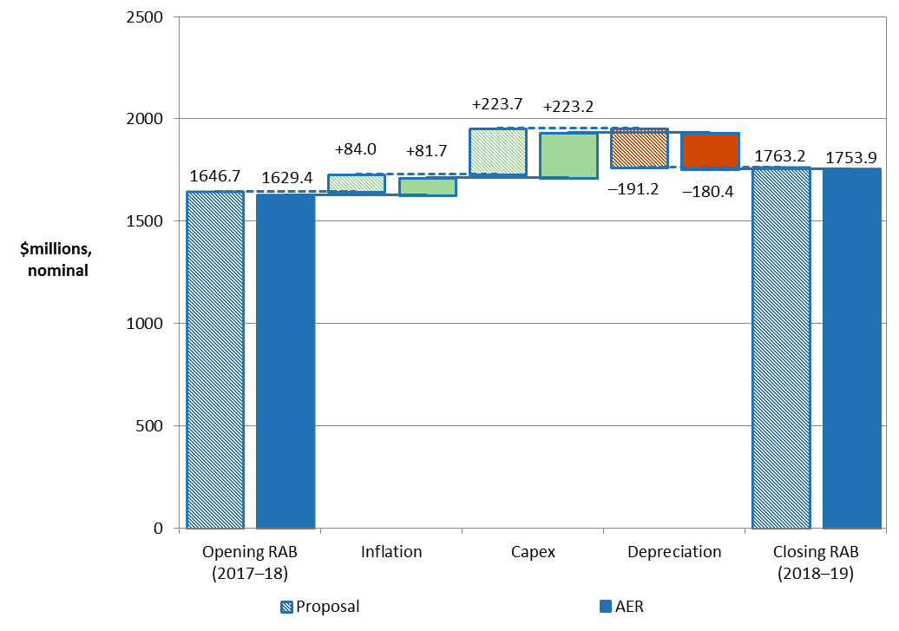

Source: AER analysis.

### Application of depreciation approach in RAB roll forward for next reset

TasNetworks proposed to use the forecast depreciation approach to roll forward the RAB for the commencement of its 2019–24 regulatory control period, consistent with our Framework and approach.[49]

We accept TasNetworks' forecast depreciation approach to roll forward the RAB for the commencement of its 2019–24 regulatory control period.[50] This approach was signalled in the AER's Framework and approach. As discussed in attachment 10, TasNetworks is not currently subject to a capital expenditure sharing scheme (CESS) but we will apply the CESS to TasNetworks over the 2017–19 regulatory control period. We consider this scheme will provide sufficient incentives for TasNetworks to achieve capex efficiency gains over that period. We are satisfied that the use of a forecast depreciation approach in combination with the application of the CESS and our other ex post capex measures are sufficient to achieve the capex incentive objective.[51]

1. NER, cl. 6.12.1(6).
2. TasNetworks, Regulatory proposal 2017–19, January 2016, p. 108, Table 9–1.
3. The end of period adjustment will be positive (negative) if actual capex is higher (lower) than the estimate approved at the 2012–17 determination.
4. TasNetworks, Regulatory proposal 2017–19, January 2016, p.109, Table 9–2.
5. NER, cl. 6.12.1(18).
6. TasNetworks, Regulatory proposal 2017–19, January 2016, p.108, Table 9–1.
7. TasNetworks, Regulatory proposal, January 2016, RFM.
8. TasNetworks, Regulatory proposal, January 2016, p.113.
9. NER, cl. S6.2.1.
10. NER, cll. 6.5.1(b), 6.5.1(e), S6.1.3(7).
11. The roll forward commences in the final year of the 2007–12 regulatory control period to allow us to adjust for the difference between actual 2011–12 capex and the estimated 2011–12 capex used in our 2012 distribution determination. See NER, cl. S6.2.1(e)(3).
12. NER, cl. 6.5.1(e)(3).
13. NER, cl. S6.2.1(e).
14. NER, cl. S6.2.2A.
15. AER, Capital expenditure incentive guideline, November 2013, pp. 12–20.

    Under the NER, cl S6.2.2A(b), the exclusion of inefficient capex could only come from three areas: overspend in capex, margin paid to third party and capitalisation of opex as defined in cll. S6.2.2A (c), (d) and (e) of the NER.
16. NER, cl.11.62.
17. NER, cl. S6.2.2(a1). The two year lag ensures that actual capex (instead of estimated capex) is available when the review of past capex commences.
18. We will update any estimated capex with actual capex at the time of the next reset.
19. For example, we make adjustment for movements in provisions if the actual capex amounts reported in the RIN include capitalised provisions.
20. NER, cl. S6.2.1(e)(5).
21. NER, cl. 6.12.1(18).
22. The use of actual depreciation is consistent with the depreciation approach established in the 2012 distribution determination for TasNetworks. See AER, Final distribution determination: Aurora Energy 2012–17, April 2012, p. 106.
23. Refer to section 2.4.3 for the reasons.
24. NER, cl. S6.2.1(e)(6).
25. NER, cl. S6.2.2B.
26. NER, cl. S6.2.2B(c).
27. The size of the RAB also impacts the benchmark debt raising cost allowance. However, this amount is usually relatively small and therefore not a significant determinant of revenues overall.
28. Net capex is gross capex less disposals and capital contributions. The rate of return or WACC also influences the size of the capex. This is because the capex is not depreciated in the year it is first incurred, but added to the RAB at the end of the year. Instead, the capex amount is escalated by half a WACC to arrive at an end of year value. It then begins depreciating the following year.
29. NER, cll. 6.3.2(a)(2) and 6.5.1(e)(3).
30. NER, cll. 6.5.2(a) and 6.5.2(d)(2).
31. NER, cl. 6.4.3(b)(1)(ii).
32. If the asset lives are extremely long, such that the RAB depreciation rate is lower than the inflation rate, then negative regulatory depreciation can emerge. The indexation adjustment is greater than the RAB depreciation in such circumstances. Please also refer to section 5.3.1 of attachment 5 of this draft decision for further explanation of the offsetting adjustment to the depreciation.
33. A change of approach from an indexed RAB to an un-indexed RAB would result in an initial step change increase in revenues to preserve NPV neutrality.
34. This amount includes customer contributions and excludes equity raising costs and half WACC adjustment.
35. We have included a half-WACC adjustment to take the values to end of year terms for the purposes of RAB roll forward.
36. If capex causes the RAB increase, return on capital, depreciation, and debt raising costs all increase too. If a reduction in depreciation causes the RAB increase, revenue could increase or decrease. In this case, the higher return on capital is offset (perhaps more than offset) by the reduction in depreciation allowance. Inflation naturally increases the RAB in nominal terms.
37. TasNetworks, Regulatory proposal 2017–19, January 2016, p. 108.
38. The March quarter CPI is used as a proxy for the June financial year in the 2012–17 regulatory control period. As discussed in attachment 14, the December quarter CPI will be used as a proxy for the June financial year for the 2017–19 regulatory control period.
39. At the time of this draft decision, the roll forward of TasNetworks's RAB includes estimated capex values for 2015–16 and 2016–17. We will update the 2015–16 estimated capex with actuals in the final decision. We may also update the 2016–17 estimated capex with a revised estimate in the final decision.
40. In our final decision we will update the estimate for 2016–17 expected inflation with actual CPI.
41. NER, cl. 6.12.2(b).
42. NER, cl. 11.62.
43. NER, cl. S6.2.2A(a1).
44. NER, cl. S6.2.2A(c).
45. Here, 'inefficiency' of past capex refers to three specific assessments (labelled the overspending, margin and capitalisation requirements) detailed in NER, cl. S6.2.2A. The details of our ex post assessment approach for capex are set out in AER, Capital expenditure incentive guideline, November 2013, pp. 12–20.
46. AER, Final distribution determination: Aurora Energy 2012–17, April 2012, p. 106.
47. NER, cll. 6.4A(a), 65.7(a), 6.5.7(c) and 6.12.2(b).
48. CCP (David Headberry), Submission to the AER, Response to the proposal from Tasmania's electricity distribution network service provider (TasNetworks - TND) for a revenue reset for the 2017–19 regulatory period, 4 May 2016, p. 12.
49. AER, Framework and approach for TasNetworks Distribution for the regulatory control period commencing 1 July 2017, July 2015, p. 17.
50. TasNetworks, Regulatory proposal, January 2016, p.113.
51. Our ex post capex measures are set out in the capex incentives guideline, AER, Capital expenditure incentive guideline for electricity network service providers, November 2013, pp. 13–19, 20–21. The guideline also sets out how all our capex incentive measures are consistent with the capex incentive objective.