

DRAFT DECISION

TasNetworks distribution determination

2017−18 to 2018−19

Attachment 6 – Capital expenditure

September 2016

© Commonwealth of Australia 2016

This work is copyright. In addition to any use permitted under the Copyright Act 1968, all material contained within this work is provided under a Creative Commons Attributions 3.0 Australia licence, with the exception of:

* the Commonwealth Coat of Arms
* the ACCC and AER logos
* any illustration, diagram, photograph or graphic over which the Australian Competition and Consumer Commission does not hold copyright, but which may be part of or contained within this publication. The details of the relevant licence conditions are available on the Creative Commons website, as is the full legal code for the CC BY 3.0 AU licence.

Requests and inquiries concerning reproduction and rights should be addressed to the:

Director, Corporate Communications  
Australian Competition and Consumer Commission   
GPO Box 4141, Canberra ACT 2601

or publishing.unit@accc.gov.au.

Inquiries about this publication should be addressed to:

Australian Energy Regulator  
GPO Box 520  
Melbourne Vic 3001

Tel: 1300 585 165  
Email: [AERInquiry@aer.gov.au](mailto:AERInquiry@aer.gov.au)

1. Note
2. This attachment forms part of the AER's draft decision on TasNetworks' distribution determination for 2017–19. It should be read with all other parts of the draft decision.
3. The draft decision includes the following documents:
4. Overview
5. Attachment 1 – Annual revenue requirement
6. Attachment 2 – Regulatory asset base
7. Attachment 3 – Rate of return
8. Attachment 4 – Value of imputation credits
9. Attachment 5 – Regulatory depreciation
10. Attachment 6 – Capital expenditure
11. Attachment 7 – Operating expenditure
12. Attachment 8 – Corporate income tax
13. Attachment 9 – Efficiency benefit sharing scheme
14. Attachment 10 – Capital expenditure sharing scheme
15. Attachment 11 – Service target performance incentive scheme
16. Attachment 12 – Demand management incentive scheme
17. Attachment 13 – Classification of services
18. Attachment 14 – Control mechanisms
19. Attachment 15 – Pass through events
20. Attachment 16 – Alternative control services
21. Attachment 17 – Negotiated services framework and criteria
22. Attachment 18 – Connection policy
23. Attachment 19 – Tariff Structure Statement

1. Contents

Note 6-2

Contents 6-3

Shortened forms 6-5

6 Capital expenditure 6-7

6.1 Draft decision 6-7

6.2 TasNetworks' proposal 6-9

6.3 AER’s assessment approach 6-10

6.3.1 Building an alternative estimate of total forecast capex 6-13

6.3.2 Comparing the distributor's proposal with our alternative estimate 6-15

6.4 Reasons for draft decision 6-16

6.4.1 Key assumptions 6-17

6.4.2 Forecasting methodology 6-17

6.4.3 Interaction with the STPIS 6-18

6.4.4 TasNetworks' capex performance 6-18

6.4.5 Interrelationships 6-22

6.4.6 Consideration of the capex factors 6-23

6.4.7 Submissions on TasNetworks' proposal 6-24

A Assessment techniques 6-26

A.1 Economic benchmarking 6-26

A.2 Trend analysis 6-27

A.3 Category analysis 6-28

A.4 Predictive modelling 6-28

A.5 Engineering review 6-29

B Assessment of capex drivers 6-30

B.6 Forecast augex 6-30

B.6.1 Capacity augex 6-30

B.6.2 Reliability augex 6-32

B.6.3 Power quality augex 6-33

B.7 Forecast customer connections capex 6-33

B.7.1 Trend analysis 6-34

B.7.2 Forecasting methodology 6-35

B.8 Forecast repex 6-39

B.8.1 Position 6-39

B.8.2 TasNetworks' proposal 6-40

B.8.3 AER approach 6-40

B.8.4 AER repex findings 6-42

B.9 Forecast non-network capex 6-54

B.9.1 Position 6-54

B.9.2 ICT capex 6-57

B.9.3 Fleet capex 6-58

B.9.4 Land and buildings 6-60

C Maximum demand 6-63

D Ex post review – 2014-15 capex 6-66

D.9.1 Position 6-66

D.9.2 AER approach 6-66

D.9.3 AER assessment 6-67

1. Shortened forms

| Shortened form | Extended form |
| --- | --- |
| AEMC | Australian Energy Market Commission |
| AEMO | Australian Energy Market Operator |
| AER | Australian Energy Regulator |
| augex | augmentation expenditure |
| capex | capital expenditure |
| CCP | Consumer Challenge Panel |
| CESS | capital expenditure sharing scheme |
| CPI | consumer price index |
| DRP | debt risk premium |
| DMIA | demand management innovation allowance |
| DMIS | demand management incentive scheme |
| distributor | distribution network service provider |
| DUoS | distribution use of system |
| EBSS | efficiency benefit sharing scheme |
| ERP | equity risk premium |
| Expenditure Assessment Guideline | Expenditure Forecast Assessment Guideline for Electricity Distribution |
| F&A | framework and approach |
| MRP | market risk premium |
| NEL | national electricity law |
| NEM | national electricity market |
| NEO | national electricity objective |
| NER | national electricity rules |
| NSP | network service provider |
| opex | operating expenditure |
| PPI | partial performance indicators |
| PTRM | post-tax revenue model |
| RAB | regulatory asset base |
| RBA | Reserve Bank of Australia |
| repex | replacement expenditure |
| RFM | roll forward model |
| RIN | regulatory information notice |
| RPP | revenue and pricing principles |
| SAIDI | system average interruption duration index |
| SAIFI | system average interruption frequency index |
| SLCAPM | Sharpe-Lintner capital asset pricing model |
| STPIS | service target performance incentive scheme |
| WACC | weighted average cost of capital |

# Capital expenditure

Capital expenditure (capex) refers to the investment made in the network to provide standard control services. This investment mostly relates to assets with long lives (30-50 years is typical) and these costs are recovered over several regulatory periods. On an annual basis, however, the financing cost and depreciation associated with these assets are recovered (return of and on capital) as part of the building blocks that form part of TasNetworks' total revenue requirement.[1]

This attachment sets out our draft decision on TasNetworks' total forecast capex. Further detailed analysis is in the following appendices:

* Appendix A - Assessment techniques
* Appendix B - Assessment of capex drivers
* Appendix C - Maximum demand
* Appendix D - Ex post review – 2014-15 capex

## Draft decision

We are satisfied TasNetworks' proposed total forecast capex of $213.4 million ($2016–17) reasonably reflects the capex criteria. We have accepted TasNetworks' forecast as the total forecast capex for the 2017–19 regulatory control period. Table 6.1 outlines our draft decision.

Table 6.1 Our draft decision on TasNetworks' total forecast capex ($million, 2016–17)

|  |  |  |
| --- | --- | --- |
|  | 2017-18 | 2018-19 |
| TasNetworks' proposal | 112.0 | 101.4 |
| AER draft decision | 112.0 | 101.4 |
| Difference | 0 | 0 |
| Percentage difference (%) | 0 | 0 |

Source: AER analysis.

TasNetworks' proposal includes $18.5 million ($2016–17) for the continuation of the replacement of TasNetworks' legacy asset management system. This project was initiated by TasNetworks' predecessors, Transend and Aurora, during the current regulatory control period. This asset management system capex is in line with our previous decision on TasNetworks (transmission) and has been supported by a thorough business case. We have approved this expenditure in this draft decision.

Table 6.2 summarises our findings and the reasons for our draft decision.

In the table we present our reasons by ‘capex driver’ (for example, augmentation, replacement and connections). This reflects the way in which we tested TasNetworks' total forecast capex. Our testing used techniques tailored to the different capex drivers, taking into account the best available evidence. Through our techniques, we found all aspects of TasNetworks' proposal, such as repex, satisfied the requirements of the NER.

Our findings on the capex drivers are part of our broader analysis and should not be considered in isolation. Our draft decision concerns TasNetworks' total forecast capex for the 2017–19 regulatory control period. We do not approve an amount of forecast expenditure for each capex driver. However, we use our findings on the different capex drivers to arrive at a draft decision for total capex.

Table 6.2 Summary of AER reasons and findings

| Issue | Reasons and findings |
| --- | --- |
| Total capex forecast | TasNetworks proposed a total capex forecast of $213.4million ($2016–17) in its proposal. We are satisfied this forecast reasonably reflects the capex criteria.  The reasons for this draft decision are summarised in this table and detailed in the remainder of this attachment. |
| Forecasting methodology, key assumptions and past capex performance | We consider TasNetworks' key assumptions and forecasting methodology are generally reasonable. Where we identified specific areas of concern, we discuss these in the appendices to this capex attachment and section 6.4.2. |
| Augmentation capex | We accept TasNetworks' forecast augex of $18.7 million ($2016–17). We accept that TasNetworks' forecast for augex reasonably reflects the required expenditure for this category. However, we did not accept TasNetworks' demand forecast because it shows a higher forecast growth rate for future demand than that independently forecasted by the Australian Energy Market Operator (AEMO) for the same period. We discuss these in section B.6 and appendix C. |
| Customer connections capex | We accept TasNetworks' forecast customer connections capex of $15.9 million ($2016–17). We accept that TasNetworks' forecast for customer connections capex reasonably reflects the required expenditure for this category. In particular, we note that TasNetworks' forecast is consistent with the underlying expenditure trend and macroeconomic drivers of new connections activities in Tasmania. We discuss this in section B.7. |
| Replacement capex (repex) | We accept TasNetworks' forecast repex of $98.4 million ($2016–17). We accept that TasNetworks' forecast for repex reasonably reflects the required expenditure for this category. In particular, we note that TasNetworks' repex is lower than our estimation of business as usual repex, and closer to our observation of a benchmark service provider. |
| Non-network capex | We accept TasNetworks' forecast non-network capex of $35.4 million ($2016–17), including $25.9 million for ICT. We accept that TasNetworks' forecast for non-network capex reasonably reflects the required expenditure for this category. In particular, we note that the reduction in forecast expenditure for each category of non-network capex is likely to reasonably reflect efficient costs. |
| Real cost escalators | TasNetworks has not proposed to apply real cost escalation for labour or materials in its capex forecast. We have accepted this approach. |

Source: AER analysis.

We consider that our overall capex forecast satisfies the revenue and pricing principles. In particular, we consider our overall capex forecast provides TasNetworks a reasonable opportunity to recover at least the efficient costs it incurs in:

* providing direct control network services; and
* complying with its regulatory obligations and requirements.[2]

As set out in appendix B, we are satisfied that the approved capex forecast is consistent with the national electricity objective (NEO). We consider our decision promotes efficient investment in, and efficient operation and use of, electricity services for the long term interests of consumers of electricity.

We also consider that overall, the approved capex forecast achieves the capital expenditure objectives.[3] In making our draft decision, we specifically considered the impact our decision will have on the safety and reliability of TasNetworks' network. We consider this capex forecast should be sufficient for a prudent and efficient service provider in TasNetworks' circumstances to be able to maintain the safety, service quality, security and reliability of its network consistent with its current obligations.

## TasNetworks' proposal

TasNetworks proposed forecast capex of $213.4 million ($2016–17) for the 2017–19 regulatory period. Figure 6.1 shows TasNetworks' proposal for the 2017–19 regulatory control period compared to the actual capex that it spent during 2012–17.

Figure 6.1 TasNetworks' total actual and forecast capex 2008–2019

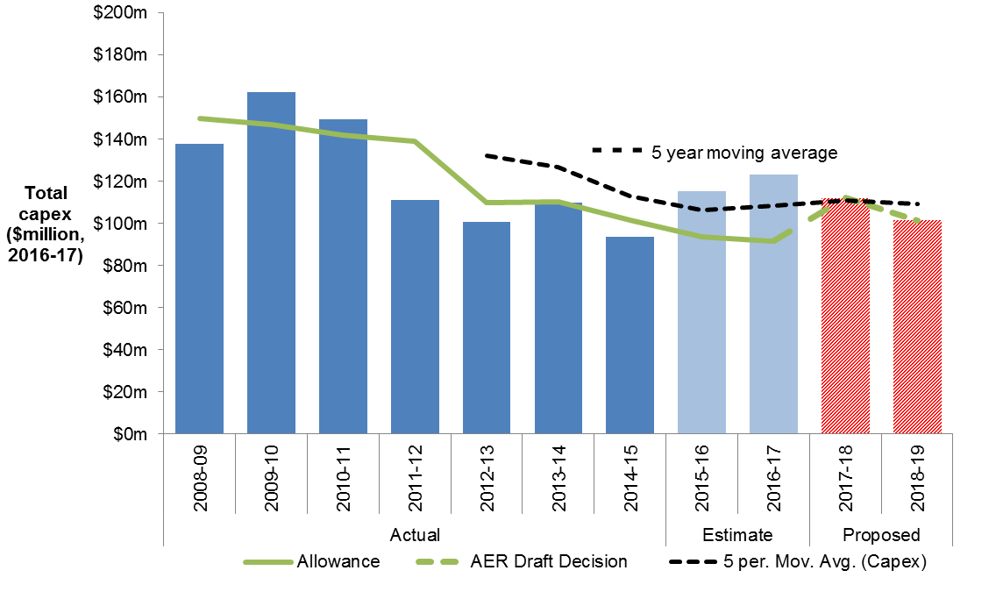

Source: AER analysis.

In its regulatory proposal, TasNetworks forecast reductions in capex for development, Information Technology (IT) and communications, operational support and non-network capex. TasNetworks forecast increases in expenditure for renewal and enhancement.[4] Our assessment of these capex drivers is found in appendix B to this attachment.

## AER’s assessment approach

1. This section outlines our approach to capex assessments. It sets out the relevant legislative and rule requirements, and outlines our assessment techniques. It also explains how we derive an alternative estimate of total forecast capex against which we compare the distributor's total forecast capex. The information TasNetworks provided in its regulatory proposal, including its response to our RIN, is a vital part of our assessment. We also took into account information that TasNetworks provided in response to our information requests, and submissions from other stakeholders.
2. Our assessment approach involves the following steps:

* Our starting point for building an alternative estimate is the distributor's regulatory proposal.[5] We apply our various assessment techniques, both qualitative and quantitative, to assess the different elements of the distributor's proposal. This analysis informs our view on whether the distributor's proposal reasonably reflects the capex criteria in the NER at the total capex level.[6] It also provides us with an alternative forecast that we consider reasonably reflects the criteria. In arriving at our alternative estimate, we weight the various techniques we used in our assessment. We give more weight to techniques we consider are more robust in the particular circumstances of the assessment.
* Having established our alternative estimate of the total forecast capex, we can test the distributor's total forecast capex. This includes comparing our alternative estimate total with the distributor's total forecast capex and what the reasons for any differences are. If there is a difference between the two, we may need to exercise our judgement as to what is a reasonable margin of difference.
* If we are satisfied the distributor's proposal reasonably reflects each of the capex criteria in achieving the capex objectives, we will accept it. The capital expenditure objectives (capex objectives) are to:[7]
* meet or manage the expected demand for standard control services over the period
* comply with all regulatory obligations or requirements associated with the provision of standard control services
* to the extent that there are no such obligations or requirements, maintain service quality, reliability and security of supply of standard control services and maintain the reliability and security of the distribution system
* maintain the safety of the distribution system through the supply of standard control services.
* If we are not satisfied, the NER requires us to put in place a substitute estimate that we are satisfied reasonably reflects the capex criteria.[8] Where we have done this, our substitute estimate is based on our alternative estimate.
* The capex criteria are:[9]
* the efficient costs of achieving the capital expenditure objectives
* the costs that a prudent operator would require to achieve the capital expenditure objectives
* a realistic expectation of the demand forecast and cost inputs required to achieve the capital expenditure objectives.

1. The AEMC noted '[t]hese criteria broadly reflect the NEO [National Electricity Objective]'.[10]
2. Importantly, we approve a total capex forecast and not particular categories, projects or programs in the capex forecast. Our review of particular categories or projects informs our assessment of the total capex forecast. The AEMC stated:[11]

It should be noted here that what the AER approves in this context is expenditure allowances, not projects.

1. In deciding whether we are satisfied that TasNetworks' proposed total forecast capex reasonably reflects the capex criteria, we have regard to the capex factors.[12] In taking the capex factors into account, the AEMC noted:[13]

…this does not mean that every factor will be relevant to every aspect of every regulatory determination the AER makes. The AER may decide that certain factors are not relevant in certain cases once it has considered them.

1. Table 6.5 summarises how we had regard to the capex factors.

More broadly, we note that in exercising our discretion, we take into account the revenue and pricing principles set out in the NEL.[14] In particular, we take into account whether our overall capex forecast provides TasNetworks a reasonable opportunity to recover at least the efficient costs it incurs in:

* providing direct control network services; and
* complying with its regulatory obligations and requirements.[15]

Expenditure Assessment Guideline

1. The rule changes the AEMC made in November 2012 required us to make and publish an Expenditure Forecast Assessment Guideline for electricity distribution (Guideline).[16] We released our Guideline in November 2013.[17] The Guideline sets out our proposed general approach to assessing capex (and opex) forecasts. The rule changes also require us to set out our approach to assessing capex in the relevant framework and approach paper. For TasNetworks, our framework and approach paper stated that we would apply the Guideline, including the assessment techniques outlined in it.[18] We may depart from our Guideline approach and if we do so, we need to provide reasons. In this determination, we have not departed from the approach set out in our Guideline.
2. We note that RIN data form part of a distributor's regulatory proposal.[19] In our Guideline we stated we would "require all the data that facilitate the application of our assessment approach and assessment techniques". We also stated that the RIN we issue in advance of a distributor lodging its regulatory proposal would specify the exact information we require.[20] Our Guideline made clear our intention to rely upon RIN data during distribution determinations.

### Building an alternative estimate of total forecast capex

The following section sets out the approach we apply to arrive at an alternative estimate of total forecast capex.

Our starting point for building an alternative estimate is the distributor’s proposal.[21] We review the proposed forecast methodology and the key assumptions that underlie the distributor's forecast. We also consider the distributor's performance in the previous regulatory control period to inform our alternative estimate.

We then apply our specific assessment techniques to develop an estimate and assess the economic justifications that the distributor puts forward. Many of our techniques encompass the capex factors that we are required to take into account. Appendix A contains further details on each of these techniques.

Some of these techniques focus on total capex; others focus on high level, standardised sub-categories of capex. Importantly, while we may consider certain projects and programs in forming a view on the total capex forecast, we do not determine which projects or programs the distributor should or should not undertake. This is consistent with the regulatory framework and the AEMC's statement that the AER does not approve specific projects. Rather, we approve an overall revenue requirement that includes an assessment of what we find to be an efficient total capex forecast.[22]

We determine total revenue by reference to our analysis of the proposed capex and the various building blocks. Once we approve total revenue, the distributor is able to prioritise its capex program given its circumstances over the course of the regulatory control period. The distributor may need to undertake projects or programs it did not anticipate during the distribution determination. The distributor may also not require some of the projects or programs it proposed for the regulatory control period. We consider a prudent and efficient distributor would consider the changing environment throughout the regulatory control period in its decision-making.

As we explained in our Guideline:[23]

Our assessment techniques may complement each other in terms of the information they provide. This holistic approach gives us the ability to use all of these techniques, and refine them over time. The extent to which we use each technique will vary depending on the expenditure proposal we are assessing, but we intend to consider the inter-connections between our assessment techniques when determining total capex … forecasts. We typically would not infer the findings of an assessment technique in isolation from other techniques.

In arriving at our estimate, we weight the various techniques we used in our assessment. We weight these techniques on a case by case basis using our judgement. Broadly, we give more weight to techniques we consider are more robust in the particular circumstances of the assessment. By relying on a number of techniques, we ensure we consider a wide variety of information and can take a holistic approach to assessing the distributor’s capex forecast.

Where our techniques involve the use of a consultant, we consider their reports as one of the inputs to arriving at our draft decision on overall capex. Our draft decision clearly sets out the extent to which we accept our consultants' findings. Where we apply our consultants’ findings, we do so only after carefully reviewing their analysis and conclusions, and evaluating these against outcomes of our other techniques and our examination of TasNetworks' proposal.

We also take into account the various interrelationships between the total forecast capex and other components of a distributor's distribution determination. The other components that directly affect the total forecast capex include:

* forecast opex
* forecast demand
* the service target performance incentive scheme
* the capital expenditure sharing scheme
* real cost escalation
* contingent projects.

We discuss how these components impact the total forecast capex in Table 6.4.

Underlying our approach are two general assumptions:

* the capex criteria relating to a prudent operator and efficient costs are complementary. Prudent and efficient expenditure reflects the lowest long-term cost to consumers for the most appropriate investment or activity required to achieve the expenditure objectives[24]
* past expenditure was sufficient for the distributor to manage and operate its network in past periods, in a manner that achieved the capex objectives.[25]

### Comparing the distributor's proposal with our alternative estimate

Having established our estimate of the total forecast capex, we can test the distributor's proposed total forecast capex. This includes comparing our alternative estimate of forecast total capex with the distributor's proposal. The distributor's forecast methodology and its key assumptions may explain any differences between our alternative estimate and its proposal.

As the AEMC foreshadowed, we may need to exercise our judgement in determining whether any 'margin of difference' is reasonable:[26]

The AER could be expected to approach the assessment of a NSP's expenditure (capex or opex) forecast by determining its own forecast of expenditure based on the material before it. Presumably this will never match exactly the amount proposed by the NSP. However there will be a certain margin of difference between the AER's forecast and that of the NSP within which the AER could say that the NSP's forecast is reasonable. What the margin is in a particular case, and therefore what the AER will accept as reasonable, is a matter for the AER exercising its regulatory judgment.

As noted above, we draw on a range of techniques, as well as our assessment of elements that impact upon capex such as demand and real cost escalators.

Our decision on the total forecast capex does not strictly limit a distributor’s actual spending. A distributor might spend more on capex than the total forecast capex amount specified in our decision in response to unanticipated expenditure needs.

The regulatory framework has a number of mechanisms to deal with such circumstances. Importantly, a distributor does not bear the full cost where unexpected events lead to an overspend of the approved capex forecast. Under the capital expenditure sharing scheme (CESS), the distributor bears 30 per cent of this cost if the expenditure is subsequently found to be prudent and efficient. Further, the pass through provisions provide a means for a distributor to pass on significant unexpected capex to customers, where appropriate.[27] Similarly, a distributor may spend less than the capex forecast because they have been more efficient than expected. In this case the distributor will keep on average 30 per cent of this reduction over time.

We set our alternative estimate at the level where the distributor has a reasonable opportunity to recover efficient costs. The regulatory framework allows the distributor to respond to any unanticipated issues that arise during the regulatory control period. In the event that this leads to the approved total revenue underestimating the total capex required, the distributor should have sufficient flexibility to allow it to meet its safety and reliability obligations by reallocating its budget. Conversely, if there is an overestimation, the stronger incentives the AEMC put in place in 2012 should result in the distributor only spending what is efficient. As noted, the distributor and consumers share the benefits of the underspend and the costs of an overspend under the regulatory regime.

## Reasons for draft decision

We applied the assessment approach set out in section 6.3 to TasNetworks' capex proposal. In this draft decision, we are satisfied TasNetworks' total forecast capex reasonably reflects the capex criteria. Our assessment techniques are outlined in Appendix A. Appendix B sets out the capex amounts by driver that we included as TasNetworks' total forecast capex for the 2017–19 period regulatory control period.

Table 6.3 Our assessment of required capex by capex driver 2017–19 ($million, 2016–17)

|  |  |  |  |
| --- | --- | --- | --- |
| Category | 2017-18 | 2018-19 | Total |
| Augmentation | 10.06 | 8.65 | 18.71 |
| Connections | 19.07 | 19.05 | 38.12 |
| Replacement | 52.69 | 45.69 | 98.38 |
| Non-Network | 18.6 | 16.8 | 35.4 |
| Capitalised overheads | 22.76 | 22.24 | 45.00 |
| Labour and materials escalation adjustment | - | - | - |
| **Gross Capex (includes capital contributions)** | **123.14** | **112.48** | **235.62** |
| Capital Contributions | 11.17 | 11.05 | 22.22 |
| **Net Capex (excluding capital contributions)** | **111.97** | **101.43** | **213.4** |

Source: AER analysis.

Note: Numbers may not add up due to rounding.

We discuss our assessment of TasNetworks' forecasting methodology, key assumptions and past capex performance in the sections below.

Our assessment of the individual capex drivers is in appendices A and B. These appendices set out the application of our assessment techniques to the capex drivers, and the weighting we gave to particular techniques.

### Key assumptions

The NER requires TasNetworks to include in its regulatory proposal the key assumptions that underlie its proposed forecast capex and a certification by its Directors that those key assumptions are reasonable.[28]

TasNetworks submitted that the key assumptions which underpin its capex forecasts are reasonable. TasNetworks supported this claim with a certification by its Directors.[29] On review, we consider TasNetworks' underlying capex assumptions are reasonable.

### Forecasting methodology

The NER requires TasNetworks to inform us about the methodology it proposes to use to prepare its forecast capex allowance before it submits its regulatory proposal.[30] TasNetworks must include this information in its regulatory proposal.[31]

TasNetworks submitted that different forecasting methodologies were used for each capex category so that they are tailored to the relevant capex drivers. TasNetworks:[32]

* Considered growth in customer connections and maximum demand to form its capex forecast;
* Considered safety, asset condition, performance and risk to form its forecast for renewal and enhancement capex.

We consider TasNetworks' forecasting methodology is generally reasonable. Where we identified specific areas of concern, we discuss these in the appendices to this draft decision.

### Interaction with the STPIS

We consider that our approved capex forecast is consistent with the setting of targets under the STPIS. In particular, we consider that the capex allowance should not be set such that it would lead to TasNetworks systemically under or over performing against its STPIS targets. We consider our approved capex forecast is sufficient to allow a prudent and efficient TasNetworks to maintain performance at the targets set under the STPIS. As such, it is appropriate to apply the STPIS as set out in attachment 11.

In making our draft decision, we have specifically considered the impact our decision will have on the safety and reliability of TasNetworks' network.

We consider the approved capex forecast is sufficient for TasNetworks to maintain the safety, service quality and reliability of its network consistent with its obligations. Our provision of a total capex forecast does not constrain a distributor's actual spending – either as a cap or as a requirement that the forecast be spent on specific projects or activities. It is conceivable that a distributor might wish to expend particular capex differently or in excess of the total capex forecast set out in our decision. However, such additional expenditure is not included in our assessment of expenditure forecasts as it is not required to meet the capex objectives. We consider the STPIS is the appropriate mechanism to provide distributors with the incentive to improve reliability performance where such improvements reflect value to the energy customer.

Under our analysis of specific capex drivers, we have explained how our analysis and certain assessment techniques factor in safety and reliability obligations and requirements.

### TasNetworks' capex performance

We have looked at a number of historical metrics of TasNetworks' capex performance against that of other distributors in the NEM. We also compare TasNetworks' proposed forecast capex allowance against historical trends. These metrics are largely based on outputs of the annual benchmarking report and other analysis undertaken using data provided by the distributors for the annual benchmarking report. The report includes TasNetworks' relative partial and multilateral total factor productivity (MTFP) performance, total cost per customer and maximum demand, and TasNetworks' historic capex trend.

The NER sets out that we must have regard to our annual benchmarking report.[33] This section shows how we have taken it into account. We consider this high level benchmarking at the overall capex level is suitable to gain an overall understanding of TasNetworks' proposal in a broader context. However, in our capex assessment we have not relied on our high level benchmarking metrics set out below other than to gain a high level insight into TasNetworks' proposal. We have not used this analysis deterministically in our capex assessment.

Partial factor productivity of capital and multilateral total factor productivity

Figure 6.2 shows a measure of partial factor productivity of capital taken from our benchmarking report. This measure incorporated the productivity of transformers, overhead lines and underground cables.

Figure 6.2 Partial factor productivity of capital (transformers, overhead and underground lines)



Source: AER, Electricity distribution network service providers: Annual benchmarking report, November 2014, p. 11.

TasNetworks does not appear to perform well compared to the other distributors we regulate. However, as we explain in our Annual Benchmarking report, TasNetworks can be considered an outlier compared to its peers in terms of system structure, which influences its productivity score.[34] TasNetworks operates substantially less high voltage subtransmission assets and has a comparatively high proportion of lower voltage lines. Therefore, some caution is required in interpreting TasNetworks capital productivity score, given its comparatively unusual system structure.

Figure 6.3 shows how TasNetworks ranks on total factor productivity. MTFP measures how efficient a business is in terms of its inputs (costs) and outputs (energy delivered, customer numbers, ratcheted maximum demand, reliability and circuit line length). Given TasNetworks' unusual system structure, TasNetworks also performs poorly on MTFP. Therefore, some caution is required in interpreting TasNetworks’ MTFP score.

Figure 6.3 Multilateral total factor productivity



Source: AER, Distribution network service providers: Annual benchmarking report, November 2015, p. 8.

#### Relative capex efficiency metrics

1. We consider capex to be an asset cost, which indicates the amount that consumers are charged annually for the asset inputs of the distributors. Figure 6.4 shows asset cost per megawatt of maximum demand, against customer density. It shows that TasNetworks performed reasonably well compared to other distributors.

Figure 6.4 Total cost per MW of maximum demand (000s, $2013–14), against customer density (average 2010–14)

1. 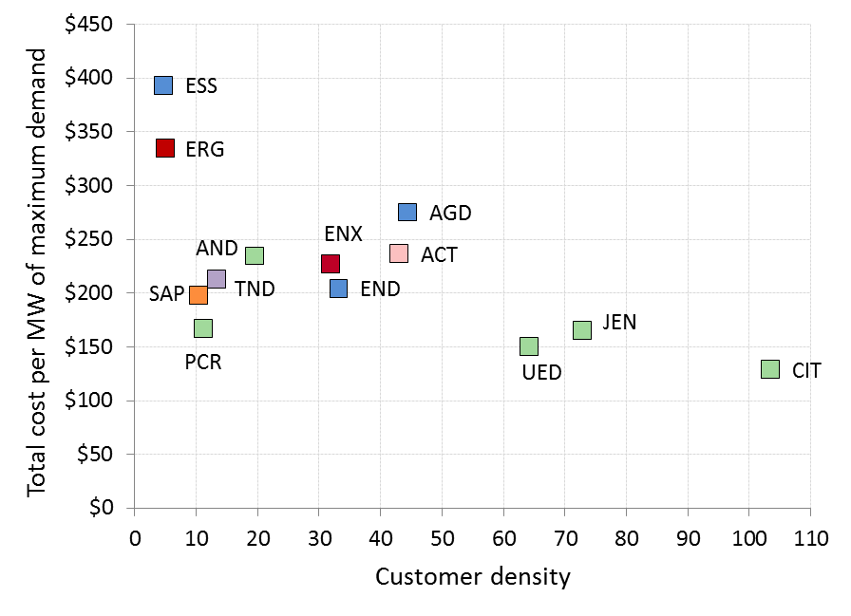

Source: AER, Distribution network service providers: Annual benchmarking report, November 2015, p. 26.

Appendix B details our assessment of TasNetworks' capex categories. This assessment, along with the high level analysis in this section 6.4.4, were inputs into our draft decision on TasNetworks' total capex for the 2017–19 regulatory control period.

TasNetworks' historic capex trends

We compared TasNetworks' capex proposal for the 2017–19 regulatory control period against the long term historical trend in capex levels.

Figure 6.5 shows actual historic capex and proposed capex between 2003 and 2019. This figure shows that TasNetworks' forecast is consistent with actual spend incurred during the 2012–17 regulatory control period. We note that TasNetworks forecasts show falling capex during the 2017–19 regulatory control period.

Our detailed assessment in appendix B examines whether the increase in capex is reasonably reflective of the capex criteria.

Figure 6.5 TasNetworks total capex – historical and forecast for 2003–2019

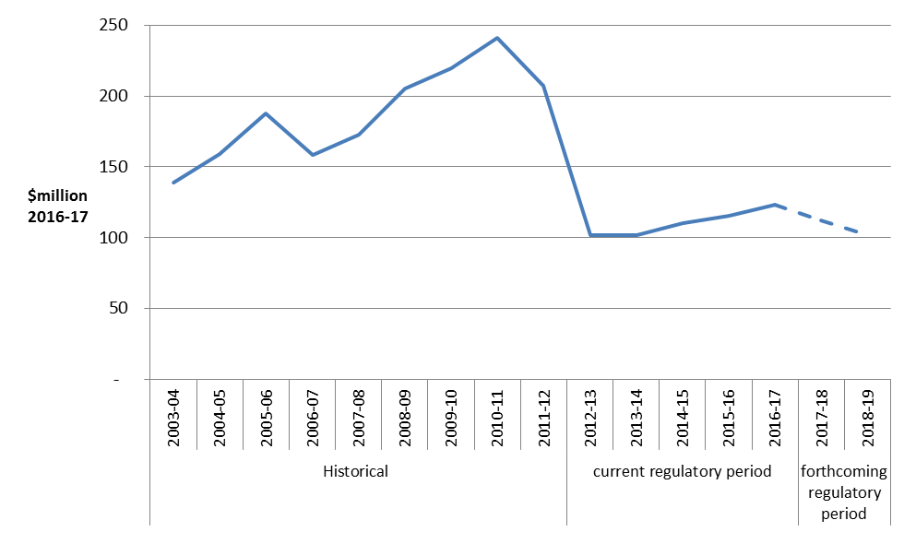

Source: AER analysis.

### Interrelationships

There are a number of interrelationships between TasNetworks' total forecast capex for the 2017–19 regulatory control period and other components of its distribution determination (see Table 6.4). We considered these interrelationships in coming to our draft decision on total forecast capex.

Table 6.4 Interrelationships between total forecast capex and other components

| 1. Other component | 1. Interrelationships with total forecast capex |
| --- | --- |
| Total forecast opex | There are elements of TasNetworks' total forecast opex that are specifically related to its total forecast capex. These include the forecast labour price growth that we included in our opex forecast in Attachment 7. This is because the price of labour affects both total forecast capex and total forecast opex.  More generally, we note our total opex forecast will provide TasNetworks with sufficient opex to maintain the reliability of its network. Although we do not approve opex on specific categories of opex such as maintenance, the total opex we approve will in part influence the repex TasNetworks needs to spend during the 2017–19 regulatory control period. |
| Forecast demand | Forecast demand is related to TasNetworks' total forecast capex. Growth driven capex, which includes augex and customer connections capex, is typically triggered by a need to build or upgrade a network to address changes in demand or to comply with quality, reliability and security of supply requirements. Hence, the main driver of growth-related capex is maximum demand and its effect on network utilisation and reliability. |
| Capital Expenditure Sharing Scheme (CESS) | The CESS is related to TasNetworks' total forecast capex. In particular, the effective application of the CESS is contingent on the approved total forecast capex being efficient, and that it reasonably reflects the capex criteria. As we note in the capex criteria table below, this is because any efficiency gains or losses are measured against the approved total forecast capex. In addition, in future distribution determinations we will be required to undertake an ex post review of the efficiency and prudency of capex, with the option to exclude any inefficient capex in excess of the approved total forecast capex from TasNetworks' regulatory asset base. In particular, the CESS will ensure that TasNetworks bears at least 30 per cent of any overspend against the capex allowance. Similarly, if TasNetworks can fulfil their objectives without spending the full capex allowance, it will be able to retain 30 per cent of the benefit of this. In addition, if an overspend is found to be inefficient through the ex post review, TasNetworks risks having to bear the entire overspend. |
| Service Target Performance Incentive Scheme (STPIS) | The STPIS is interrelated to TasNetworks' total forecast capex, in so far as it is important that it does not include any expenditure for the purposes of improving supply reliability during the 2017–19 regulatory control period. This is because such expenditure should be offset by rewards provided through the application of the STPIS.  Further, the forecast capex should be sufficient to allow TasNetworks to maintain performance at the targets set under the STPIS. The capex allowance should not be set such that there is an expectation that it will lead to TasNetworks systematically under or over performing against its targets. |

Source: AER analysis.

### Consideration of the capex factors

As we discussed in section 6.3, we had regard to the capex factors when assessing whether we are satisfied that TasNetworks' total capex forecast reasonably reflects each of the capex criteria.[35] Table 6.5 summarises how we have taken into account the capex factors.

Where relevant, we also had regard to the capex factors in assessing the forecast capex associated with its underlying capex drivers such as repex, augex and so on (see appendix B).

Table 6.5 AER consideration of the capex factors

| Capex factor | AER consideration |
| --- | --- |
| The most recent annual benchmarking report and benchmarking capex that would be incurred by an efficient distributor over the relevant regulatory control period | We had regard to our most recent benchmarking report in the metrics we used in our assessment of TasNetworks' capex performance. |
| The actual and expected capex of TasNetworks during any preceding regulatory control periods | We had regard to TasNetworks' actual and expected capex during the 2012–17 and preceding regulatory control periods in our assessment of TasNetworks' capex performance and our assessment of the forecast capex associated with the capex drivers that underlie TasNetworks' total forecast capex.  For some elements of non-network, augex and connections capex, we rely on trend analysis to arrive at an estimate that reasonably reflects the capex criteria. |
| The extent to which the capex forecast includes expenditure to address concerns of electricity consumers as identified by TasNetworks in the course of its engagement with electricity consumers | TasNetworks has undertaken engagement with its customers and presented high level findings regarding its customer preferences in its regulatory proposal. |
| The relative prices of operating and capital inputs | We had regard to the relative prices of operating and capital inputs in the context that TasNetworks has not proposed real cost escalation factors. |
| The substitution possibilities between operating and capital expenditure | The regard we had to the interrelationships between TasNetworks' total forecast capex and total forecast opex is discussed in Table 6.4 above. |
| Whether the capex forecast is consistent with any incentive scheme or schemes that apply to TasNetworks | The regard we had to the interrelationships between TasNetworks' total forecast capex and the application of the CESS and the STPIS is discussed in Table 6.4 above. |
| The extent to which the capex forecast is referable to arrangements with a person other than the distributor that do not reflect arm's length terms | We do not have any evidence to indicate that any of TasNetworks' arrangements do not reflect arm’s length terms. |
| Whether the capex forecast includes an amount relating to a project that should more appropriately be included as a contingent project | We did not identify any amounts that should more appropriately be included as a contingent project. |
| The extent to which TasNetworks has considered and made provision for efficient and prudent non-network alternatives | We had regard to the extent to which TasNetworks made provision for efficient and prudent non-network alternatives as part of our assessment of the capex drivers in Appendix B. |
| Any other factor the AER considers relevant and which the AER has notified TasNetworks in writing, prior to the submission of its revised regulatory proposal, is a capex factor | We did not identify any other capex factor that we consider relevant. |

Source: AER analysis.

### Submissions on TasNetworks' proposal

We received four submissions which commented on TasNetworks' proposed capex. Jo De Silva from the CCP sub-panel 4 recommended that the AER undertakes detailed analysis about business cases and allowances for each of the capex programs.[36]

The Tasmanian Council of Social Services welcomed the proposed reductions in capex, but noted the significant ongoing expenditure on IT systems, SCADA and network included in this forecast. [37]

David Headberry CCP Sub-panel 4 expressed concern at the continuing growth in the RAB and noted great care is needed to ensure that capex allowed is efficient and does not result in the RAB further increasing. [38] Mr Headberry also noted that category analysis is a key element for providing useful input into capex forecasting.[39] Mr Headberry expressed concerns that TasNetworks is forecasting a significant increase in capex for the last two years of the current regulatory control period compared to the capex actually used in the first 3 years of the current period.[40]

The Tasmanian Small Business Council (TSBC) welcomed the reduction in actual spending in capex when compared to the AER’s allowance for the current regulatory control period. The TSBC also welcomed TasNetworks’ forecast capex. The TSBC sought assurance that the capex proposal reflects the minimum level of capex needed.[41]

1. Assessment techniques
2. This appendix describes the assessment approaches we applied in assessing TasNetworks' proposed forecast capex. We used a variety of techniques to determine whether TasNetworks' total forecast capex reasonably reflects the capex criteria. Appendix B sets out in greater detail the extent to which we relied on each of the assessment techniques.
3. The assessment techniques that we apply in capex are necessarily different from those we apply in the assessment of opex. This is reflective of differences in the nature of the expenditure we are assessing. As such, we use some assessment techniques in our capex assessment that are not suitable for assessing opex and vice versa. We set this out in our expenditure assessment guideline, where we stated:[42]

Past actual expenditure may not be an appropriate starting point for capex given it is largely non-recurrent or 'lumpy', and so past expenditures or work volumes may not be indicative of future volumes. For non-recurrent expenditure, we will attempt to normalise for work volumes and examine per unit costs (including through benchmarking across distributors) when forming a view on forecast unit costs.

Other drivers of capex (such as replacement expenditure and connections works) may be recurrent. For such expenditure, we will attempt to identify trends in revealed volumes and costs as an indicator of forecast requirements.

1. Below we set out the assessment techniques we used to asses TasNetworks' capex.
   1. Economic benchmarking
2. Economic benchmarking is one of the key outputs of our annual benchmarking report. The NER requires us to consider the annual benchmarking report as it is one of the capex factors.[43] Economic benchmarking applies economic theory to measure the efficiency of a distributor's use of inputs to produce outputs, having regard to environmental factors.[44] It allows us to compare the performance of a distributor against its own past performance, and the performance of other distributors. Economic benchmarking helps us to assess whether a distributor's capex forecast represents efficient costs.[45] As the AEMC stated, 'benchmarking is a critical exercise in assessing the efficiency of a NSP'.[46]
3. A number of economic benchmarks from the annual benchmarking report are relevant to our assessment of capex. These include measures of total cost efficiency and overall capex efficiency. In general, these measures calculate a distributor's efficiency with consideration given to its inputs, outputs and its operating environment. We considered each distributor's operating environment in so far as there are factors outside of a distributor's control that affect its ability to convert inputs into outputs.[47] Once such exogenous factors are taken into account, we expect distributors to operate at similar levels of efficiency. One example of an exogenous factor we took into account is customer density. For more on how we derived these measures, see our annual benchmarking report.[48]
4. In addition to the measures in the annual benchmarking report, we considered how distributors performed on a number of overall capex metrics, including capex per customer, and capex per maximum demand. We calculated these economic benchmarks using actual data from the previous regulatory control period.
5. The results from economic benchmarking give an indication of the relative efficiency of each of the distributors, and how this has changed over time.
   1. Trend analysis
6. We considered past trends in actual and forecast capex as this is one of the capex factors under the NER.[49]
7. Trend analysis involves comparing a distributor's forecast capex and work volumes against historical levels. Where forecast capex and volumes are materially different to historical levels, we seek to understand the reasons for these differences. In doing so, we consider the reasons the distributor provides in its proposal, as well as changes in the circumstances of the distributor.
8. In considering whether the total forecast capex reasonably reflects the capex criteria, we need to consider whether the forecast will allow the distributor to meet expected demand, and comply with relevant regulatory obligations.[50] Demand and regulatory obligations (specifically, service standards) are key drivers of capex. More onerous standards will increase capex, as will growth in maximum demand. Conversely, reduced service obligations or a decline in demand will likely cause a reduction in the amount of capex the distributor requires.
9. Maximum demand is a key driver of augmentation or demand driven expenditure. Augmentation often needs to occur prior to demand growth being realised. Hence, forecast rather than actual demand is relevant when a business is deciding the augmentation projects it will require in an upcoming regulatory control period. To the extent actual demand differs from forecast, however, a business should reassess the need for the projects. Growth in a business' network will also drive connections related capex. For these reasons it is important to consider how trends in capex (in particular, augex and connections) compare with trends in demand (and customer numbers).
10. For service standards, there is generally a lag between when capex is undertaken (or not) and when the service improves (or declines). This is important when considering the expected impact of an increase or decrease in capex on service levels. It is also relevant to consider when service standards have changed and how this has affected the distributor's capex requirements.
11. We looked at trends in capex across a range of levels including at the total capex level, and the category level (such as growth related capex, and repex) as relevant. We also compared these with trends in demand and changes in service standards over time.
    1. Category analysis
12. Expenditure category analysis allows us to compare expenditure across NSPs, and over time, for various levels of capex. The comparisons we perform include:

* overall costs within each category of capex
* unit costs, across a range of activities
* volumes, across a range of activities
* asset lives, across a range of asset classes which we use in assessing repex.

1. Using standardised reporting templates, we collected data on augex, repex, connections, non-network capex, overheads and demand forecasts for all distributors in the NEM. The use of standardised category data allows us to make direct comparisons across distributors. Standardised category data also allows us to identify and scrutinise different operating and environmental factors that affect the amount and cost of works performed by distributors, and how these factors may change over time.
   1. Predictive modelling
2. Predictive modelling uses statistical analysis to determine the expected efficient costs over the regulatory control period associated with the demand for electricity services for different categories of works. We have two predictive models:

* the repex model
* the augex model (used in a qualitative sense )

1. The use of the repex and augex models is directly relevant to assessing whether a distributor's capex forecast reasonably reflects the capex criteria.[51] The models draw on actual capex the distributor incurred during the preceding regulatory control period. This past capex is a factor that we must take into account.[52]
2. The repex model is a high-level probability based model that forecasts asset replacement capex (repex) for various asset categories based on their condition (using age as a proxy), and unit costs. If we consider a distributor's proposed repex does not conform to the capex criteria, we use the repex model (in combination with other techniques where appropriate) to generate a substitute forecast.
3. The augex model compares utilisation thresholds with forecasts of maximum demand to identify the parts of a network segment that may require augmentation.[53] The model then uses capacity factors to calculate required augmentation, and unit costs to derive an augex forecast for the distributor over a given period.[54] In this way, the augex model accounts for the main internal drivers of augex that may differ between distributors, namely peak demand growth and its impact on asset utilisation. We can use the augex model to identify general trends in asset utilisation over time as well as to identify outliers in a distributor's augex forecast.[55]
4. For our draft decision we have relied on input data for the augex model to review forecast utilisation of individual zone substations to assess whether augmentation may be necessary to alleviate capacity constraints. We use this analysis both as a starting point for our further detailed evaluation, and as a cross-check on our overall augex estimate. We have not otherwise used the augex model in our assessment of TasNetworks' augex forecast.
   1. Engineering review
5. We drew on engineering and other technical expertise within the AER to assist with our review of TasNetworks' capex proposal.[56] Appendix B discusses in detail our consideration of these reviews in our assessment of TasNetworks' capex forecast.
6. Assessment of capex drivers
   1. Forecast augex

Augmentation capex (augex) is driven by a service provider's need to build or augment its network. The main driver of augex is maximum demand and its effect on the utilisation of network capacity. It can also be triggered by the need to upgrade the network to comply with quality, safety, reliability and security of supply requirements.

TasNetworks proposes $18.7 million ($2016–17) in forecast augex for the 2017–19 regulatory control period (excluding overheads). TasNetworks forecast is primarily comprised of three programs:

* capacity augmentation ($9.23 million ($2016–17))
* network reliability obligations ($5.18 million ($2016–17)), and
* power quality upgrades ($3.25 million ($2016–17)).

We accept that the total augex forecast reasonably reflects the capex criteria and we have included it in our alternative capex estimate. In reaching this position, we reviewed each of three programs that comprise the augex forecast.

* + 1. Capacity augex

TasNetworks proposed $9.23 million ($2016–17) to augment network capacity over the 2017–19 period (excluding overheads). TasNetworks' capacity-related augex forecast is 20 per cent lower than the average annual augex between 2012–13 and 2016–17, and 75 per cent less than the prior regulatory period. This reduction is from declining maximum demand since 2008.

Historically, a key driver of the forecast augex is demand constraints and capacity risks on parts of the network. However, TasNetworks submitted that the forecast augex is not directly driven by the forecast maximum demand.[57] The forecast augex is instead a continuation of the historical volumes and expenditures in this area, based on addressing existing capacity constraints and risks identified in high-voltage network.[58] Unlike previous regulatory control periods, TasNetworks does not require any new zone substations or additional zone substation transformers over the 2017-19 period (and currently does not plan additional zone substation upgrades over the next ten years).[59]

We examined the existing capacity utilisation of TasNetworks' high-voltage network feeders.[60] Figure 6.6 shows TasNetworks' high-voltage feeder utilisation between 2011–12 and 2015–16.[61] While feeder utilisation decreased between 2011–12 and 2015–16 (as represented by the downward shift between the blue and red lines), TasNetworks has some highly utilised feeders on its network (represented by capacity utilised above approximately 70 per cent). These utilisation results support TasNetworks' forecast to the need to augment capacity on some feeders.

Figure 6.6 TasNetworks zone substation utilisation between 2011-12 and 2015-16

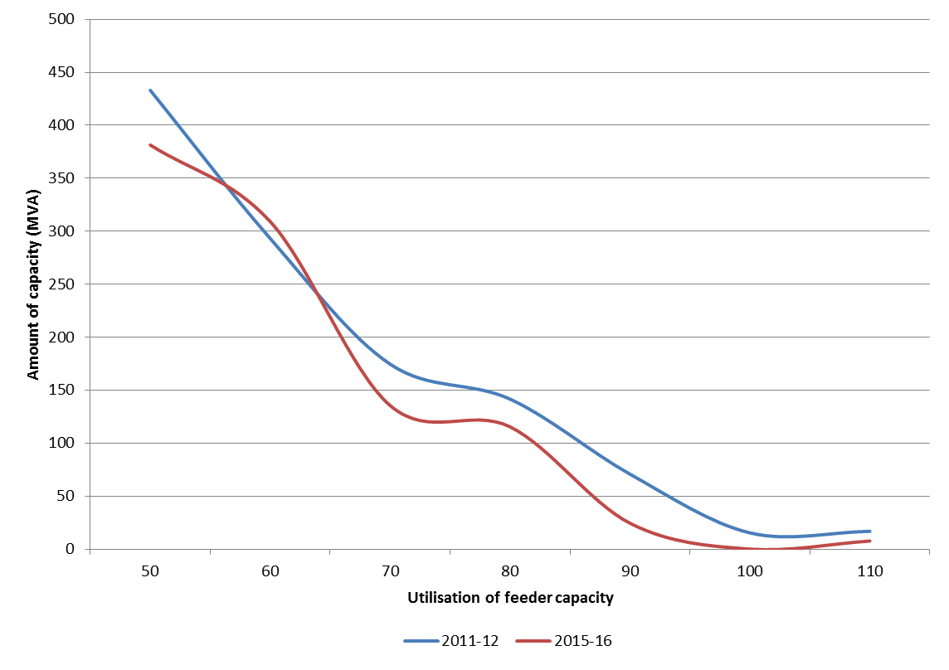

Source: AER analysis, TasNetworks' reset RIN.

Note: Utilisation in this figure is based on actual weather corrected 50% POE maximum demand and the thermal rating of each feeder.

The submission from the CCP sub-panel 4 noted that the utilisation of TasNetworks’ assets is falling considerably, implying there is little need for augmentation of the network.[62] We agree that TasNetworks' overall network utilisation has declined and this is represented by lower amounts of average utilisation at TasNetworks' zone substations. However, our analysis shows that network constraints exist on some parts of TasNetworks' high voltage network.

* + 1. Reliability augex

TasNetworks faces reliability standards contained within the Tasmanian Electricity Code. These standards require TasNetworks to use 'reasonable endeavour' to comply with targets for the average annual number and duration of planned and unplanned interruptions on the network. TasNetworks proposes $5.18 million ($2016–17) in augex over 2017–18 to 2018–19 to improve the reliability performance of its seven worst feeders where reliability performance is presently underperforming against its standards. [63]

TasNetworks has historically met the reliability levels prescribed in the Tasmanian Electricity Code.[64] However, in 2013–14 and 2014–15 the average duration of network outages experienced by TasNetworks' customers was longer than levels required within the Tasmanian Electricity Code.[65]

We analysed historical reliability data provided by TasNetworks to find out the key drivers of the outages which occurred on each of seven worst feeders.[66] Our analysis shows that the drivers of outages on the seven worst feeders related to weather, vegetation and unknown factors which are non-recurrent and outside of a network operator's control. We found that it is not clear whether there is a growing systemic problem of asset failure that contributed to the exceedance of the reliability standards on the seven worst feeders. In such cases, augmentation may not prevent further outages on the feeders.

In addition, the information provided by TasNetworks highlights that planned interruptions contributed to the breaching of the standards. If TasNetworks were to reduce the number of planned interruptions, this would also reduce the overall probability that these feeders would breach the standards in the future.

Nonetheless, we accept that the reliability performance of the seven feeders has been poor and well below the average reliability across the network. This may support feeder augmentation as a 'reasonable endeavour' to ensure that TasNetworks satisfies its minimum reliability standards. On this basis, we accept TasNetworks proposed $5.18 million ($2016–17) in augex over 2017–18 to 2018–19 in our draft decision.

The submission from the CCP sub-panel 4 and the Tasmanian Council of Social Services (TasCOSS) raised issues with the way reliability is discussed by TasNetworks in its workshops and surveys. We agree with these submissions that TasNetworks should better consider the views of the customers directly impacted by its worst performing feeders and their willingness to pay for reliability improvements. Alongside this, we encourage TasNetworks to also consider the influence of weather and other non-recurrent drivers on the reliability performance of these feeders. The combination of greater driver analysis and customer consultation may alter the need for capex augmentation.

* + 1. Power quality augex

TasNetworks proposed $3.26 million ($2016–17) (excluding overheads) to address quality of supply constraints on its network. This primarily relates to addressing concerns regarding quality of supply issues such as voltage flicker and waveform distortion associated with electrical loading of the network. The proposed program will include the uptake of solar PV embedded generation and expenditure to address compliance issues in relation to quality of supply.[67]

TasNetworks’ forecast is based on historical spending trend in this category, modestly incremented to account for a predicted increase in PV uptake. We consider a forecast of $3.26 million ($2016–17) for power quality to be reasonable on the basis that TasNetworks has shown this forecast to be the lowest cost option and that this forecast was made based on historical expenditure trend. Therefore, we will include an amount of $3.26 million ($2016–17) in our total capex.

* 1. Forecast customer connections capex

Connections capex is incurred by TasNetworks to connect new customers to its network and, where necessary, augment the shared network to ensure there is sufficient capacity to meet demand from new customers.

TasNetworks proposes $38.12 million ($2016–17) (excluding overheads) in forecast connections capex for the 2017–19 regulatory control period. Of this forecast, TasNetworks estimates $22.22 million ($2016–17) of customer contributions.

We accept both TasNetworks' net connections capex forecast and customer contributions forecast and have included these in our alternative estimate of capex. In reaching this view, we considered that:

* TasNetworks' forecast is consistent with the underlying expenditure trend and macroeconomic drivers of new connections activities in Tasmania
* TasNetworks' forecasting methodology for calculating its forecast is reasonable and likely to produce a prudent and efficient forecast.
  + 1. Trend analysis

Figure 6.7 shows the trend in TasNetworks' actual and forecast gross connections capex by both net connections capex and customer contributions. This shows that the forecast connections capex and customers are consistent with the historical level of spending over the 2012–17 period.

Figure 6.7 TasNetworks connections and customer contributions 2008-09 to 2018-19 ($million, 2016–17, excluding overheads)

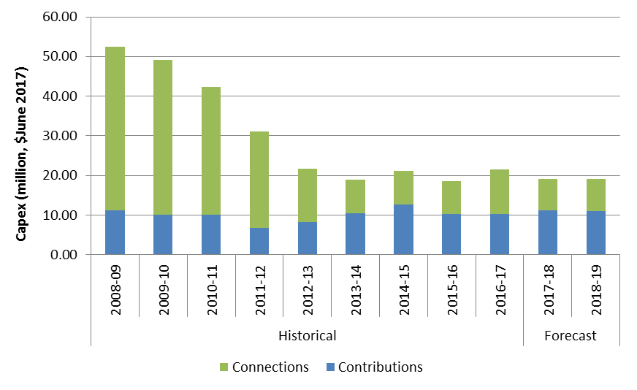

Source: TasNetworks reset RIN

Note: The figures for 2015-16 and 2016-17 are TasNetworks' estimates.

TasNetworks' overall forecast is consistent with some of the macroeconomic drivers of customer connections:

* TasNetworks showed that the trend of declining customer connections from 2009–10 onwards is consistent with the observed decline in the gross state product since 2009–10. TasNetworks submitted that this is directly related to the global economic decline caused by the Global Financial Crisis (GFC). [68]
* TasNetworks also submitted that the decline in customer connections from 2009–10 is also consistent with the decline in residential and non-residential construction activities recorded by the Australian Bureau of Statistics (ABS).[69]
* The Tasmanian Treasury forecasts that the Tasmanian Government's First Home Owner Grant will increase business and dwelling investments in 2015–16 and 2017–18. This will contribute towards the Tasmanian economy, which is expected to grow at around 2.25 per cent per annum during the 2015–17 period.[70] The Tasmanian Treasury also forecasts the state's population to grow slightly at 0.6 per cent in 2016–17 which it considers will improve the economic and employment opportunities in Tasmania. [71]
* TasNetworks' forecast of connection expenditure at a level similar to the 2015–17 period likely reflects the continued impact of the First Home Owners Grant and the slight growth in the state's population.
  + 1. Forecasting methodology

TasNetworks' forecast consists of a series of activity based connection type forecasts. These activity forecasts correspond to each standard control customer connection service that we classify, such as residential, residential sub-divisions, commercial and embedded generation. TasNetworks separately forecasts connections capex for each connection type.

TasNetworks calculates its connections capex forecast by first estimating the volumes of new customer connections for each customer class and then multiplying these volumes by unit rates for each connection type. We have separately assessed TasNetworks' forecast volumes and unit costs and found that:

* TasNetworks’ forecast connections volumes are reasonable and unbiased ,
* TasNetworks' average forecast unit rates likely represent efficient amounts
* TasNetworks' forecast of customer contribution is reasonable.

We address each below.

Volume forecasts

TasNetworks' forecasts the volumes of new customer connections by applying an econometric methodology that estimates a statistical relationship between the number of new connections and the underlying drivers that influence the number of new connections.[72] This was developed by economic consultant National Institute of Economic and Industry Research (NIEIR). NIEIR found that Tasmania's gross state product (which reflects the state economic performance) is the best predictor of new residential and commercial customer connections.

Figure 6.8 shows TasNetworks' historical and the forecast volumes rates for residential and sub-division connections and commercial connections. We compared these volumes against forecasts of residential dwelling data for Tasmania published by the Housing Institute of Australia (HIA). This provides an independent comparison against TasNetworks' residential and residential sub-division forecasts.[73] This chart shows that TasNetworks' forecast volumes are consistent with the HIA's independent forecast of residential construction in Tasmania. This lends support to TasNetworks' forecast because it shows that TasNetworks' forecasts are likely not to be biased or overly inflated.

Figure 6.8 TasNetworks' connections volumes

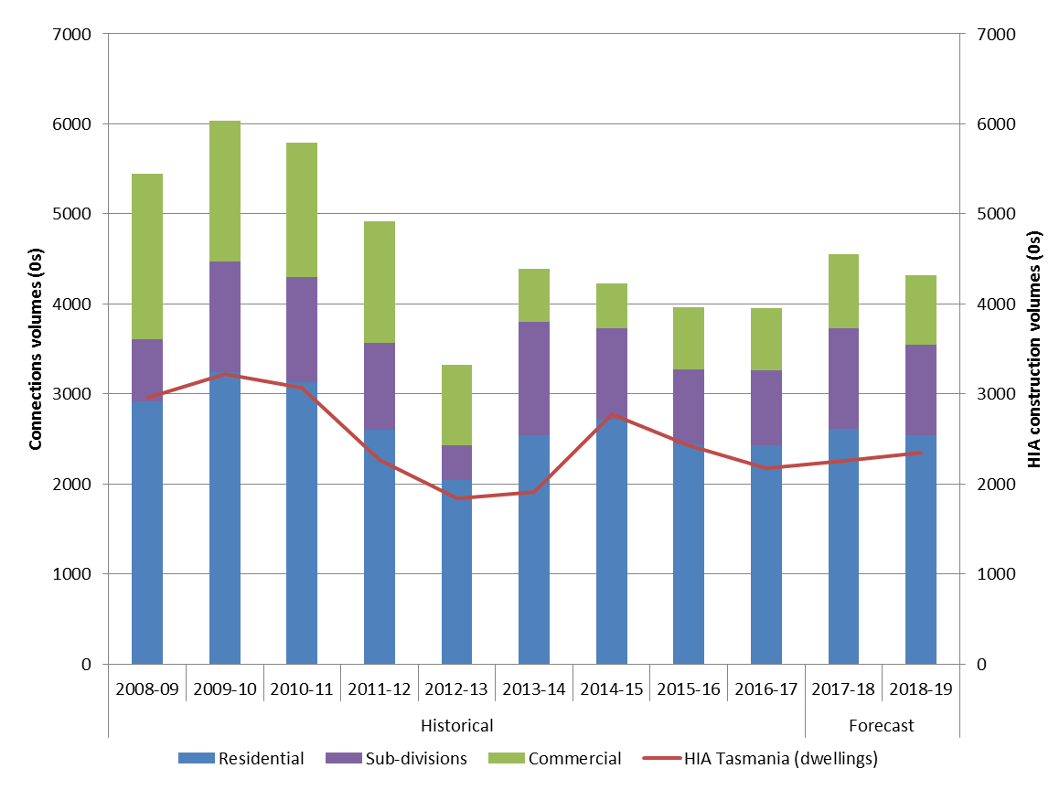

Source: TasNetworks reset RIN, HIA data.

Note: The figures for 2015-16 and 2016-17 are TasNetworks' estimates.

TasNetworks also 'back-cast' its residential connections volumes using NIEIR's statistical model and historical movements in gross state product to check the historical accuracy of its forecasting methodology. The modelled results closely match the historical volumes of connections between 2007–08 and 2013–14 (with an accuracy error of between -4.0 per cent to 1.7 per cent).[74] This further suggests that this methodology is capable of producing a realistic and unbiased forecast of residential connections volumes.

Unit rates

In determining their forecast, TasNetworks relies on a series of internally derived unit costs. These unit costs are broken down by connection activities based on the characteristics of the type of customer served and the capacity of the connection.

TasNetworks derives a unit rate for each connection activity based on a sample of historical data from 2012 to 2015, from which a minimum value is found.[75] TasNetworks also submitted that it applies top down constraints to limit the capital expenditure forecast. The top down constraint on capital expenditure forecast reduces the unit rates applied.[76]

We found that the average forecast 2017–19 unit rates (after applying the top-down adjustment) are much lower than the average unit rates across 2012–15. This provides a degree of comfort that TasNetworks has reduced its expenditure across all categories of connections costs in deriving its forecast for the 2017–19 regulatory period. This suggests TasNetworks unit rates are likely at or close to an efficient level.

Customer Contributions

The mix between net capex and customer contributions is important as it determines from whom and when TasNetworks recovers revenue associated with the capex investment. For works involving a customer contribution, TasNetworks recovers revenue directly from the customer who initiates the work at the time the work is undertaken.

1. TasNetworks showed that its customer contribution forecast is based on its proposed connection charge guideline which includes a continuation of current arrangements. Examples of these arrangements include 22 percent upfront contribution by new irrigation connections, and exemption of transformers costs for customers with standard customer projects.[77]

We compared customer contributions for the 2012–17 period with TasNetworks' forecast for the 2017–19 regulatory control period. As shown in Figure 6.7 previously, the customer contribution forecast is consistent with the historical actual contributions received during the 2012–17 period. The level of customer contributions as a proportion of total connections capex has significantly increased since 2008–09. This may be driven by changes in TasNetworks' customer contributions charging policy over this period.

1. We consider the proposed customer contributions to be reasonable on the basis that it is consistent with actual customer contributions for 2012–17 and that this cost continues current connections policy arrangements for new connections.

The submission from CCP sub-panel 4 noted that the customer initiated capex seems excessive given the forecast new customer rate is a quarter of the current period’s rate, yet the costs are about two thirds of the current cost.[78] We took into account the CCP's submission. However, TasNetworks informed us that the proposed customer contributions costs have taken into account the Government's request for TasNetworks to continue the current concession for irrigation connection projects.[79]

* 1. Forecast repex

Replacement capital expenditure (repex) occurs for a variety of reasons, including when:

* an asset fails while in service, or presents a real risk of imminent failure
* a condition assessment of the asset[80] determines that it is likely to fail soon (or degrade in performance, such that it does not meet its service requirement) and replacement is the most economic option
* the asset does not meet the relevant jurisdictional safety regulations, and can no longer be safely operated on the network
* the risk of using the asset exceeds the benefit of continuing to operate it on the network.

Most network assets remain in use for far longer than a single five year regulatory control period (many network assets have economic lives of 50 years or more). As a consequence, a distributor only needs to replace a portion of its network assets in each regulatory control period. Our assessment of repex seeks to establish the portion of TasNetworks' assets that will likely require replacement over the 2017–19 regulatory control period and the associated capital expenditure.

* + 1. Position

We accept TasNetworks' proposed repex of $98.4 million ($2016–17), excluding overheads, and have included this amount in our alternative estimate of overall total capex for repex. We are satisfied that this amount forms part of a total forecast capex that reasonably reflects the capex criteria.

Key aspects of our draft decision on repex include:

* $77 million ($2016–17) for replacement of poles, overhead conductor, underground cable, service lines, switchgear and transformers which is more in line with the benchmarked average asset replacement lives and unit costs of service providers in the NEM and is less than expected based on TasNetworks recent asset replacement practices.
* $15.7 million ($2016–17) for implementing changes to its asset management system (AMS), which it shares with its transmission business. TasNetworks provided a positive business case in support of its forecast capex. We reviewed this business case, and consider that:
* the need for the investment has been previously identified in the current regulatory control period
* the options analysis was sufficiently granular in identifying the range of feasible options
* project costs were subject to an open tender process, such that we are reasonably satisfied that TasNetworks’ proposed costs are prudent and efficient
* the lowest cost feasible option was selected.
* $4.5 million ($2016–17) for the replacement of pole top structures, SCADA, network control and protection systems, which is not materially higher than historical trends.
  + 1. TasNetworks' proposal

TasNetworks' forecast repex is $98.4 million ($2016–17).[81] TasNetworks' submitted that this expenditure is driven by: [82]

* satisfying its regulatory obligations, including the requirement to maintain the safety of the distribution system; and
* maintaining network reliability in accordance with its customers’ preferences.

We address TasNetworks' proposal as part of our assessment below.

* + 1. AER approach

We applied several assessment techniques to assess TasNetworks' forecast of repex. These techniques were:

* analysis of TasNetworks' long term total repex trends
* predictive modelling of repex based on TasNetworks' assets in commission
* consideration of various asset health indicators.

We primarily use our predictive modelling to assess approximately 79 per cent of TasNetworks' proposed repex. For the remaining categories of expenditure, we do not use our predictive modelling but rely instead on the analysis of historical expenditure trends and a review of business cases where relevant. We explain the reasons for this approach in the “other repex categories” section below.

We also had regard to asset health indicators as part of our assessment process. Our findings regarding asset health are consistent with our overall conclusion.

Trend analysis

We have used trend analysis (historical expenditure) to draw general observations in relation to the modelled categories of repex, and to assist our analysis of other un-modelled categories of repex. We recognise the limitations of expenditure trends, especially in circumstances where replacement needs may change over time (e.g. a distributor may have a lumpy asset age profile or legislative obligations may change over time). For this reason we typically place more weight on predictive modelling than historical trends. In some cases, however, predictive modelling is not feasible because of data limitations. In these circumstances we use historical levels of expenditure as an input into our assessment of TasNetworks' forecast of repex or to determine our alternative estimate.

Repex modelling

Our predictive model for replacement expenditure, known as the 'repex model', can be used to estimate the amount of repex TasNetworks would require if it maintained its current risk profile for condition-based replacement into the next regulatory control period. As part of the 'Better Regulation' process we undertook extensive consultation with service providers on the repex model and its inputs. The repex model we developed through this consultation process is well-established and has been applied as a standard assessment tool for all distribution service providers in the NEM.[83] TasNetworks also used repex modelling in support of its forecast repex.[84]

The repex model estimates future repex by allowing TasNetworks the opportunity to continue its current replacement practices in the next regulatory control period. These replacement practices represent the approach that TasNetworks has undertaken to maintain the safety and reliability of its network and meet the capex objectives in the recent past. As noted in our Expenditure Guideline, we assume that past expenditure was sufficient for TasNetworks to manage and operate its network in past periods in a manner that achieved the capex objectives.[85]

It can also be used to predict the amount of repex TasNetworks would require if it adopted the practices of other service providers (under benchmarked input scenarios, which are detailed later in this appendix), rather than continuing its own replacement practices.

In our modelling, we found that TasNetworks' forecast for the modelled categories was significantly lower than the repex model estimate derived from its past replacement practices, and is closer to (though slightly higher than) a benchmark derived from other service providers. This is described in detail in section B.8.4 below.

Asset health indicators

We have used a number of asset health indicators with a view to observing asset health. These provide context for our decision, and are used in conjunction with our other techniques above to form a view on the overall repex proposal. However, these indicators are not used in isolation to either reject TasNetworks' proposed repex or in the formation of an alternative estimate. Rather, they act as a cross-check on our other assessment techniques.

* + 1. AER repex findings

Trends in historical and forecast repex

We have conducted a trend analysis of repex. The NER requires that we consider the actual and expected capital expenditure during any preceding regulatory control period.[86] Our use of trend analysis is to gauge how TasNetworks' historical actual repex compares to its expected repex for the 2017–19 regulatory control period.

Figure B‑9 shows TasNetworks' repex spend has varied across time, and is forecast to increase above historical levels for the first year of the 2017–19 regulatory control period.

Figure B‑9 TasNetworks repex trend (including asset management repex)



Source: AER Category analysis and Reset RINs

CCP sub-panel 4 noted that, on a long term trend basis, forecast repex is significantly higher than it needs to be and that repex allowed for the current period would retain the average age of the assets at the current acceptable level. CCP sub-panel 4 also commented that the repex forecast for the two year regulatory period is much higher than in the three years following.[87]

When considering the above trend we acknowledge there are limitations in long term year-on-year comparisons of replacement expenditure. In particular we are mindful that during the last regulatory control period, TasNetworks distribution has implemented a new asset management system (AMS) (in conjunction with TasNetworks transmission). The implementation of this AMS has largely driven the higher trend in repex over the final two years of the last regulatory control period, and is also driving higher repex in the first year of the 2017–19 regulatory control period. As shown by Figure B‑9 (where the AMS capex is shown in red), if this expenditure is excluded, TasNetworks' repex trend is expected to peak in 2018–19 and then reduce over the remaining forecast period. TasNetworks' repex trend over the forecast period is also expected to be similar to 2014–15 levels (pre AMS expenditure). Forecast repex (without AMS) does not exhibit the step change increase that can be observed in total forecast repex (including AMS) over the forecast period.

TasNetworks' has submitted that its repex over the 2017–19 regulatory control period is driven by:

* safety and environmental performance and compliance requirements;
* asset condition and risk;
* asset performance;
* spares availability and product support;
* technical obsolescence; and
* physical security.[88]

We have been mindful of the above trends and the reasons TasNetworks has provided in assessing the repex allowance required for the 2016–20 regulatory control period.

An increasing or decreasing trend does not, in and of itself, indicate that a service provider has proposed total repex that is likely to reflect or not reflect the capex criteria. In the case of TasNetworks, which has proposed an increase in repex from the last regulatory control period, we must consider whether it has sufficiently justified that this increase is required to reflect the capex criteria. We use repex modelling, the views of stakeholders and the material put forward by TasNetworks in support of its forecast, to help us form a view on whether TasNetworks has sufficiently justified that its repex reasonably reflects the capex criteria.

Repex modelling

We use repex modelling to estimate how much repex TasNetworks is expected to need in future, given how old its current networks assets are, and based on when it is likely to replace these assets.

We modelled six asset groups using the repex model. These asset groups included poles, overhead conductors, underground cables, service lines, transformers and switchgear. To ensure comparability across different service providers, these asset groups have also been split into various asset sub categories. We have modelled these categories as we have sufficient replacement volume, cost and asset age data at a granular level.[89] In total, the assets in these six modelled categories represent 79 per cent of TasNetworks' proposed repex.

The Tasmanian Small Business Council[90] supported our use of the repex model, however, it encouraged us to also use other techniques given that TasNetworks' repex was forecast to increase over the regulatory control period and modelling carried out by TasNetworks' consultant provided outcomes higher than TasNetworks' proposal.[91]

In total for all six modelled categories we have accepted the amount of $77 million ($2016–17) in our alternative estimate of total forecast capex, which reflects TasNetworks' forecast for the modelled categories.

TasNetworks proposed $21.4 million for repex categorised as supervisory control and data acquisition (SCADA), network control and protection (which, we collectively refer to as secondary systems); pole top structures; and "other" in TasNetworks' RIN response were not included in the repex model. While we have considered secondary systems and pole top structure replacement as part of the repex model in some recent decisions, we do not have suitable age data from TasNetworks to carry out modelling in this instance. Instead we have compared the forecasts with historical repex trends and information provided by the service provider. The remaining expenditure is related to TasNetworks asset management system capex. Our assessment of this capex is considered later in this section.

The repex model

The repex model and the functions that underlie it are described in detail in our Guide to the repex model.[92] In general, the repex model estimates the probability of each network asset being replaced, based on various inputs, in order to forecast future replacement volumes and expenditure. The repex model can be run using a series of different input scenarios. The model inputs, outputs and scenarios are described below.

The repex model uses three inputs:

* the asset age profile input, which is the number of assets in commission and when each one was installed
* the replacement life input, which includes the mean replacement life and standard deviation (i.e. on average, how old assets are when they are replaced)
* the unit cost input, which is the cost of replacing a single unit of an asset (i.e. on average, how much each asset costs to replace).

The repex model has two main outputs which will differ based on the model inputs:

* a twenty year estimate of replacement volumes for each modelled asset category (which is estimated based on the age profile and the replacement life inputs)
* a twenty year estimate of replacement expenditure for each modelled asset category (this is calculated by multiplying the volume estimate by the replacement unit cost).

The repex model can be applied in a number of ways, based on the input scenario chosen. Changing the inputs used in the repex model will change the output of the model in relatively predictable ways. For example, if a shorter asset replacement mean is used, the model will predict that a service provider will need to replace its assets sooner, and estimate a greater volume of replacement. Conversely, if a lower unit cost is used, the cost of replacing each asset will be lower, so the model will estimate lower repex.[93]

In recent regulatory decisions we have given more weight to repex modelling inputs that were based on the service provider's recent replacement practices (usually the last five years of asset replacement volumes).[94] We refer to this as a calibrated input scenario. The estimate provided from this input scenario is referred to a business as usual estimate. This is because the estimate represents a continuation of past replacement practices, as it is based on a service providers past replacement behaviour.

We also have regard to other repex model scenarios, most notably the average asset replacement life and unit cost inputs from all service providers (benchmarked input scenarios). To date, this modelling has been used as a cross-check on the calibrated input scenario, as it has allowed us to compare the replacement practices of a single service provider with all other service providers in the NEM.

We will consider on a case‑by‑case basis whether this input scenario should be used in place of the calibrated input scenario. For example, it may be more appropriate to use a benchmarked input scenario where a service provider's recent replacement practices are found to be inefficient (for example, where it has replaced a large cohort of assets well before the end of their economic life).

Repex model outcomes

Calibrated input scenario

As noted above, the calibrated input scenario derives unit cost and replacement life inputs from TasNetworks' recent past replacement practices (for unit costs, we also derive a unit cost from TasNetworks' future repex forecasts). We modelled the calibrated replacement lives using two unit cost assumptions:

* TasNetworks' own historical unit costs from the current regulatory control period. These reflect the unit costs TasNetworks has incurred over the last five years.
* TasNetworks' own forecast unit costs for the next regulatory control period. These reflect the unit costs TasNetworks expects to incur over the next two years.

Under this input scenario, the repex model estimates $126 million of repex when using TasNetworks' historical unit costs, and $115 million using forecast unit costs. Both of these outcomes are above TasNetworks' forecast of $77 million for the six modelled asset categories. This indicates that TasNetworks' unit cost and forecast volume are lower than would be expected given their recent past replacement practices.

Benchmarked input scenario

The benchmarked input scenario has been developed using repex model outcomes from all distribution service providers in the NEM. We have used average benchmarked asset replacement lives and unit costs to estimate an alternative amount of repex to test TasNetworks' proposal.

The repex model under this input scenario estimates $68 million of repex. This demonstrates that TasNetworks' forecast of $77 million for the modelled asset categories is more in line with the benchmarked average asset replacement lives of service providers in the NEM than what would be expected based on their recent past replacement practices.

In addition, TasNetworks expects repex to fall over the next five years. TasNetworks' forecasts will be lower than our repex benchmarks by the end of the five year forecast period. This is consistent with the improvements in asset management that TasNetworks expects to be realised from its proposed expenditure on asset management systems, and is consistent with continued improvements in asset performance. Therefore we are satisfied TasNetworks’ forecast for the modelled categories of repex reasonably reflects the capex criteria and we have included this amount in our alternative estimate of total forecast capex.

Other repex categories

1. As noted above, repex categorised as supervisory control and data acquisition (SCADA), network control and protection (which, for simplicity, we collectively refer to as secondary systems); pole top structures; and 'other' in TasNetworks' RIN response were not included in the repex model. Where we are unable to directly use repex modelling for pole top structures we have placed more weight on an analysis of historical repex, trends, and information provided by TasNetworks in relation to these categories. TasNetworks has submitted that its proposed expenditure of pole top structures is to reduce the risk of fire starts, harm to the public, and to maintain network reliability,[95] while its expenditure on secondary system is related to life-cycle replacement and some non-recurrent needs.[96]
2. Our analysis of secondary systems and pole top structures is discussed below.

For un-modelled categories of forecast repex we have compared historical expenditure with forecast repex as an indicator of the efficiency of the proposed expenditure. Where past expenditure was sufficient to reasonably reflect the capex criteria it can be a good indicator of whether forecast repex reasonably reflects the capex criteria. This is due to the more predictable and recurrent nature of repex relative to other drivers of capex (e.g. augex is less predictable given demand can be relatively volatile and unpredictable over time).[97] For un-modelled asset categories we consider that if the forecast expenditure for the next regulatory control period is similar (the same or not materially higher) or lower than the expenditure in the last regulatory control period, the distributor’s forecast is likely to reasonably reflect the capex criteria. In circumstances where forecast repex materially exceeds historical expenditure, we would expect the distributor to sufficiently justify this increase.

We have accepted TasNetworks' proposed repex for pole top structures of $2 million, and its proposed repex for secondary systems of $2.5 million. While, these amounts are higher than TasNetworks' recent historical levels of repex, ($1.2 million and $1.9 million for pole top structures and for secondary systems, respectively) we do not consider this difference to be material.

Other repex

1. TasNetworks has proposed $16.5 million of 'other' repex for the 2017–19 regulatory control period, which represents around 20 per cent of its forecast repex.[98] This amount is lower than its recent expenditure on this category (approximately $31 million in 2015–17, though significantly higher than its actual expenditure trend ('other' repex for 2013–15 was around $3 million).
2. TasNetworks' proposed 'other' repex forecast predominately reflects changes to its asset management system (AMS), which it shares with its transmission business. The increase in this asset category in 2015–17 coincides with the commencement of this project.

Asset Management Systems

TasNetworks forecast $20 million of capex for implementing asset management systems (AMS capex). TasNetworks submitted that AMS is used for asset information gathering, asset information management and asset information analysis. AMS capex includes the replacement, installation and maintenance of asset management business processes, business systems, and associated tools and software.[99]

The AMS capex has been allocated between repex ($15.7 million) and non-network capex ($4.3 million).[100] Our analysis of TasNetworks’ total proposed AMS capex is set out in this section of our draft decision.

TasNetworks has identified its AMS capex as:

* Ajilis – project to replace a range of unsupported asset management and delivery platforms, and implement new asset management processes ($11.3 million).
* Asset Management Information System (AMIS) and Geographic Information Systems (GIS) ($8.7 million).

Figure B‑10 shows AMS capex from the financial year 2015–16 to 2021–22. The red columns represent forecast capex in the 2017–19 regulatory control period.

Figure B‑10 TasNetworks’ historical and forecast AMS capex



TasNetworks’ AMS capex significantly varied over the 2012–17 regulatory control period, with relatively low expenditure in the first three years, and a significant increase in the last two years. This increase was driven by TasNetworks’ business transformation project (AMS project). The significant growth (and subsequent decline) in TasNetworks’ AMS capex observed in Figure B‑10 can be attributed to the AMS project. TasNetworks forecasts AMS capex to fall significantly in 2018–19, following the completion of its AMS project.

TasNetworks’ AMS project is a combination of similar transformation projects proposed by its predecessor businesses, Aurora (distribution) and Transend (transmission). Aurora and Transend had each separately identified the need for capex to renew their AMS and corporate IT. We considered these proposals in our previous decisions for Aurora[101] and Transend[102]. Expenditure on business transformation was included as part of our alternative estimate of efficient capex in those decisions.

Following the merger of Aurora and Transend, TasNetworks delayed the commencement of the separate business transformation projects to consider the benefits of a joint implementation.[103] TasNetworks developed a business case in support of a joint implementation, and commenced the AMS project in 2015–16. We have assessed this business case as part of our review of AMS capex (and note that the AMS project is also partly funded by TasNetworks’ transmission business as part of its last regulatory determination).

TasNetworks considers that the key benefits of it forecast AMS capex are:

* reducing the risk of asset failure
* maintaining overall network performance
* ensuring compliance with regulatory and governance requirements
* effective collection and management of asset knowledge
* effective resource utilisation
* optimum infrastructure investment.[104]

A number of stakeholders provided submissions on TasNetworks’ AMS capex. David Headberry from CCP sub-panel 4 supported the proposal for this expenditure, but expressed reservations about its benefits to consumers and noted that TasNetworks should demonstrate the consumer benefit of the proposed expenditure.[105] TasCOSS also noted TasNetworks’ increase in expenditure on AMS capex in recent years, and noted that it would like to see evidence that this level of spending will either result in direct and immediate cost savings or prevent an escalation of costs over time.[106] Jo De Silva from CCP sub-panel 4 noted the increase and recommended that we undertake an individual project review.[107]

The business case provided in support of the AMS project included a number of different operating scenarios:

* maintaining the status quo
* upgrading some of its systems
* upgrading most of its systems or
* moving to an integrated business solution to replace the various different systems.[108]
* TasNetworks carried out an open tender process to determine availability of solutions and their cost. It engaged KPMG to review its assessment of the various options, and provide advice on which option was most viable.[109]

TasNetworks considered that the status quo or only updating a small subset of systems was not viable, as a number of operational applications were at end of life and were unsupported by their vendors. It noted that the age, complexity and highly customised nature of the existing applications, which presented a likely risk that one or many of the applications may experience a major outage. [110] KPMG considered this to be a reasonable conclusion.[111] KPMG assessed the costings of the various options put forward by TasNetworks. KPMG did not agree that TasNetworks’ costing of the upgrade path was necessarily accurate. Despite this KPMG agreed the integrated business solution was still a lower cost option than upgrading TasNetworks’ current systems.[112] On the basis of this business case, TasNetworks commenced the AMS project in 2015.

We are satisfied that TasNetworks’ proposed AMS capex is prudent and efficient. TasNetworks provided a positive business case in support of its forecast capex. We have reviewed this business case, and consider that:

* the need for the investment has been previously identified in the current regulatory control period
* the options analysis was sufficiently granular in identifying the range of feasible options
* project costs were subject to an open tender process, such that we are reasonably satisfied that TasNetworks’ proposed costs are prudent and efficient
* the lowest cost feasible option was selected.

1. In addition, we also note that the majority of this project will have been completed before the start of the 2017–19 regulatory control period and there are likely to be benefits associated with a joint implementation (cost sharing and business synergies) across transmission and distribution networks. We also note that TasNetworks' is forecasting repex to decline over the forecast period to 2022. This expenditure profile appears to be consistent with the benefits of the AMS project identified by TasNetworks. Further, The AMS project is also partly funded by TasNetworks’ transmission business as part of its last regulatory determination.

Network health indicators

As noted above, we have looked at network health indicators to form high level observations about whether TasNetworks’ past replacement practices have allowed it to meet the capex objectives. In summary we observed that:

* the measures of reliability and asset failures show that outages on TasNetworks’ network have been stable across time
* measures of TasNetworks’ network assets residual service lives and age show that the overall age of the network is being maintained. Using age as a high level proxy for condition, this suggests that historical replacement expenditures have been sufficient to maintain the condition of the network (refer below to trends in the remaining service life and age of network assets).

Further, the value of customer reliability has recently fallen. Other things being equal, this fall should result in the deferral of repex as the value customers place on reliability for replacement projects has fallen.

The above indicators generally suggest that replacement expenditure in the past period has been sufficient to allow TasNetworks to meet the capex objectives. The asset health indicators are discussed in more detail below.

Trends in reliability and asset failure

Asset failure is a significant contributor to the volume of sustained interruptions on TasNetworks’ network. Table B‑1 shows that, over the 2009–15 period 20 per cent of total interruptions per customer on TasNetworks’ network were caused by the failure of assets.[113] Table B‑1 indicates that over time these interruptions have been relatively stable, albeit with a significant reduction in 2015.

Table B‑1 TasNetworks - contribution of asset failures to non-excluded sustained interruptions (per cent)

|  |  |  |  |  |  |  |  |
| --- | --- | --- | --- | --- | --- | --- | --- |
|  | 2009 | 2010 | 2011 | 2012 | 2013 | 2014 | 2015 |
| Sustained interruptions caused by asset failures | 23.0% | 20.3% | 24.1% | 23.2% | 19.7% | 20.5% | 10.7% |

Source: TasNetworks- CA RIN – 6.3 Sustained Interruptions.

Figure B‑11 compares sustained interruptions caused by asset failure with the System Average Interruption Frequency Index (SAIFI), which is an aggregate measure of the frequency of sustained interruptions on the network.[114]

Figure B‑11 Relationship between system wide SAIFI and non-excluded interruptions caused by asset failures

* 

Source: TasNetworks- CA RIN – 6.3 Sustained Interruptions and EBT RIN - Whole of network unplanned SAIFI.

We note that Figure B‑11 shows TasNetworks’ SAIFI has generally been flat across time, even in the event of recent increases in the number of non-excluded sustained interruptions caused by asset failures. We note that the substantial increase in the number of interruptions may be due to data inconsistencies as we would not expect asset condition leading to failures to change as significantly between years. Relevantly, this indicates that TasNetworks' replacement practices from the last period have maintained a relatively stable level in the frequency of outages on its network per customer. Though the recent increases in the number of interruptions caused by asset failures may suggest that some deterioration in asset performance going forward in some areas of the network. We expect TasNetworks to clarify as to whether the outage performance in 2014 and 2015 reflects data inconsistencies.

Trends in the remaining service life and age of network assets

Another factor which we have considered when assessing TasNetworks’ repex requirements for the 2017–19 regulatory control period is the trend in TasNetworks’ residual asset life across time. We have used residual service life as a high-level proxy for asset condition. Asset condition is a key driver of replacement expenditure.

Figure B‑12 shows that TasNetworks’ residual asset lives for some assets (underground assets and overhead assets >33kv) have been declining over time and are projected to continue declining, while the trend is stable or increasing for other asset categories. On average, the age of TasNetworks’ overhead network assets are increasing over the forecast period (with the exception of assets <33kv).

Figure B‑12 TasNetworks estimated residual service life network assets



Source: TasNetworks EBT RIN - 4. Assets (RAB) - Table 4.4.2 Asset Lives – estimated residual service life

* 1. Forecast non-network capex

TasNetworks' non-network capex includes expenditure on information and communications technology (ICT), motor vehicles, land and buildings, and other capex. TasNetworks proposed average annual capex of $17.7 million ($2016–17) for non-network capex, compared to $22.9 million in the 2012–17 regulatory control period. It proposed average annual capex of $13.0 million for ICT capex, compared to $14.7 million in the previous period. It has also proposed average annual capex of $4.7 million for the other non-network capex categories, compared to $8.2 million in the previous period.

* + 1. Position

As part of our estimate of the total capex required for the 2017–19 regulatory control period, we accept that TasNetworks' forecast for non-network capex of $35.4 million ($2016–17) is a reasonable estimate of the efficient costs that a prudent operator would require for this capex category. We have included it in our estimate of total capex for the 2017–19 regulatory control period.

Figure 6.13 shows TasNetworks' actual and expected non-network capex for the period from 2003 to 2017, and forecast capex for the 2017–19 regulatory control period.

Figure 6. TasNetworks' non-network capex 2003 to 2019 ($million, 2016–17)



Source: TasNetworks, Regulatory information notice, template 2.6; TasNetworks, Category Analysis RIN 2014-15, template 2.6; TasNetworks, Category Analysis RIN 2013-14, template 2.6; Aurora Energy, Category Analysis RIN 2008-2013, template 2.6; Aurora Energy, RIN response for 2012­–2017 regulatory control period, template 3.1; AER analysis.

TasNetworks' forecast non-network capex for the 2017–19 regulatory control period is on average 23 per cent lower than actual and expected annual capex in the 2012–17 regulatory control period.

Our analysis of longer term trends in non-network capex suggests that TasNetworks has forecast capex for this category at historically low levels. Non-network capex for the 2017–19 regulatory control period is forecast to be lower than the average expenditure in each of the preceding three regulatory control periods. TasNetworks' forecast non-network capex continues the declining trend in expenditure in this category evident since the peak in 2005–06. In our view, this suggests that TasNetworks' forecast of non-network capex requirements in the 2017–19 regulatory control period is likely to be reasonable having regard to past expenditure.[115]

We have also assessed forecast expenditure in each category of non-network capex. Analysis at this level has been used to inform our view of whether forecast capex is reasonable relative to historical rates of expenditure in each category, and to identify trends in the different category forecasts which may warrant specific investigation. Figure 6.14 shows TasNetworks' actual and forecast non-network capex by category for the period from 2008–09 to 2018–19.

Figure 6. TasNetworks' non-network capex by category ($million, 2016–17)



Source: TasNetworks, Regulatory information notice, template 2.6; TasNetworks, Category Analysis RIN 2014-15, template 2.6; TasNetworks, Category Analysis RIN 2013-14, template 2.6; Aurora Energy, Category Analysis RIN 2008-2013, template 2.6; AER analysis.

TasNetworks has forecast substantial reductions in the various categories of non-network capex in the 2017­–19 regulatory control period, ranging from a decline of 12 per cent for ICT capex up to 46 per cent for other non-network capex. Forecast expenditure for other non-network capex, which includes motor vehicles, land and buildings expenditure, is at historically low levels in the 2017–19 regulatory control period. ICT capex is forecast to decline from the peaks experienced in the 2012–17 regulatory control period, but will remain in line with the long term historical average.

Given the forecast decline in non-network capex in the 2017–19 regulatory control period, we have considered whether TasNetworks' forecast reduction in non-network capex reflects the substitution possibilities between opex and capex for this category of expenditure.[116] For example, to some extent it is possible to substitute building or motor vehicle asset replacement capex with increased opex for ongoing asset maintenance. However, despite the significant reductions in forecast non-network capex, TasNetworks' non-network opex is also forecast to decrease by approximately 5 per cent in real terms compared to the 2012–17 regulatory control period. Taking this into account, we are satisfied that TasNetworks' forecast reduction in non-network capex does not simply reflect a reallocation of expenditure from capex to opex.

Our review of the different categories of non-network capex is set out in more detail below. In summary, we are satisfied that the reduction in forecast expenditure for each category of non-network capex reflects the high level drivers of expenditure in these categories and is therefore likely to reasonably reflects efficient costs. Having considered TasNetworks' regulatory proposal and having had regard to the capex factors and submissions from interested parties,[117] we are satisfied that total capex which reasonably reflects the capex criteria should include a forecast of $35.4 million for non-network capex, excluding overheads. Our estimate of total capex for the 2017–19 regulatory control period reflects this conclusion.

* + 1. ICT capex

TasNetworks has proposed ICT capex of $25.9 million for the 2017–19 regulatory control period, an average of $13 million per year. This is a 12 per cent decrease from the average annual ICT capex of $14.7 million for the previous regulatory control period (2011–15).[118] TasNetworks’ ICT capex is forecast to decline from the peaks experienced in the 2012–17 regulatory control period. We accept TasNetworks’ forecast of ICT capex for the reasons below.

TasNetworks submitted that its ICT capex contains both recurrent and non-recurrent cost components which are in line with its corporate IT strategy.[119] TasNetworks’ proposed ICT capex includes $4.3 million for the replacement of its asset management system (with the majority of this Ajilis project ($18.2 million) included in the repex forecast) and $4.1 million for the metering rule change.[120] Both the asset management system and metering rule change expenditure are only in the first year of the period and are for completing projects that were started in the previous period.

We received several submissions on TasNetworks’ ICT expenditure for metering competition. TasCOSS submitted that more evidence of the benefit to consumers should be obtained to justify further capital IT works proposed required because of the ‘competition in metering rule change’.[121]

The Tasmanian Small Business council also commented on TasNetworks implementing Full Retail Competition (FRC) and a Rule change to make metering services competitive. It expressed concern about the usefulness of metering services and the lack of retail competition in Tasmania.[122] We consider that TasNetworks spending on metering competition is justified as necessary to comply with regulatory requirements.[123]

CCP sub-panel 4 submitted that it was concerned about the significant increase in ICT expenditure compared to its allowance for the last regulatory period and recommended that the AER assess ICT capex using both trend analysis and business cases, especially for the Ajilis project.[124] A second submission from the CPP questioned TasNetworks’ need to continually update network systems and submitted that the high costs were likely delivering modest benefits to consumers, including no reduced opex or capex costs elsewhere in the allowances.[125] We consider that TasNetworks’ proposed ICT capex is justified by the material provided in its regulatory proposal. This is discussed in the repex section B.8 above. We note that the proposed ICT capex is lower than the actual capex for the last regulatory period.

We are satisfied that the forecast reduction in non-network capex reflects the underlying drivers of expenditure in this category. When the amounts designated to ongoing projects have been considered, ICT capex is significantly lower than previous periods. We consider that this is a reasonable estimate of the efficient costs that a prudent operator would require for this capex category.

* + 1. Fleet capex

TasNetworks has proposed motor vehicle fleet capex of $4.9 million ($2016–17) for the 2017-19 regulatory control period.[126] This is, on an average annual expenditure basis, 31 per cent less than TasNetworks' actual and estimated fleet capex for the 2012-17 regulatory control period.[127] TasNetworks submitted that its fleet expenditure needs are determined in accordance with the fleet management strategy and that the forecast is based on both a bottom up view and top down approach with regard to the replacement and investment needs of its vehicle fleet. The forecast is based on an assessment of TasNetworks' fleet age and kilometres travelled, condition assessment of useful life, fleet size and the resourcing requirements of the business.[128]

TasNetworks submitted two supporting documents relevant to its proposed fleet capex for the 2017-19 regulatory control period: the Operational Fleet Strategy and Operational Fleet Management Plan.[129] The Operational Fleet Strategy document provides details on the following characteristics of TasNetworks' fleet management services and functions:

* service provision (to maintain cost-effective and timely processes for procurement, maintenance, management and disposal of the operational vehicle fleet)
* vehicle acquisition (to identify and meet the operational fleet assets needs of TasNetworks for operational services)
* operational fleet asset replacement (to maintain an efficient and effective whole of life vehicle fleet, ensuring vehicles are replaced in accordance with optimal replacement cycles, in line with replacement criteria)
* industry standards (to review developments and opportunities in industry practices to maintain best practice fleet services)
* environment (to protect and minimise the environmental impact of operational fleet vehicles and encourage the purchase of fuel efficient and electric vehicles)
* performance monitoring (to continue to develop relationships and communicate with service providers to maximise contractual arrangements)
* collaboration (to extend opportunities for collaboration and communication between departments for the benefit of TasNetworks); and
* resource management (to provide a framework for delivering fleet services activities and utilise information system capability).

TasNetworks' Operational Fleet Management Plan aligns with TasNetworks' Operational Fleet Strategy and provides details of:

* TasNetworks' approach to asset management as reflected through its legislative and regulatory obligations and strategic plans
* the key projects and programs underpinning its fleet; and
* the basis upon which TasNetworks' fleet capex is derived.

TasNetworks' Operational Fleet Management Plan also provides information on the number of assets, their capital value and age profile for each fleet asset category.

We have reviewed TasNetworks' forecast fleet capex for the 2017–19 regulatory control period and consider that TasNetworks' forecast fleet capex of $4.9 million reasonably reflects the efficient costs that a prudent operator would require to achieve the capex objectives.[130] We have come to this conclusion on the basis that:

* TasNetworks' proposed fleet capex is 31 per cent less than its actual and estimated fleet capex for the 2012–17 regulatory control period, reflecting the resourcing strategy required to deliver its proposed network program.
* TasNetworks' Operational Fleet Strategy and Operational Fleet Management Plan show that TasNetworks manages its fleet in a prudent and efficient manner, in particular:
* the average capital value for each fleet asset category appears reasonable[131]
* the routine and non-routine fleet maintenance management strategies to maintain TasNetworks' fleet assets appear reasonable[132]
* TasNetworks' fleet replacement criteria based on age and kilometres travelled are consistent with the efficient benchmarks of other Australian electricity service providers[133]
* TasNetworks' Standardised Operational Fleet fit up and modifications strategy appears prudent and efficient[134].
  + 1. Land and buildings

TasNetworks has proposed land and buildings capex of $2.5 million ($2016–17) for the 2017–19 regulatory control period.[135] This is, on an average annual expenditure basis, 44 per cent less than TasNetworks' actual and estimated land and buildings capex in the 2012–17 regulatory control period.[136] TasNetworks submitted that its land and buildings capex requirements are based on its corporate facilities and property strategy. This approach identifies the land and property requirements to support the accommodation of staff and the overall property strategy. TasNetworks stated that its property needs are aligned to its facility requirements to support the efficient delivery of services.[137]

TasNetworks submitted two supporting documents relevant to its proposed land and buildings capex for the 2017–19 regulatory control period: the Operational Facilities Strategy and Facilities Management Plan.[138] The Operational Facilities Strategy provides details on the following characteristics of TasNetworks' facilities strategy:

* minimum standards (to ensure all facilities will meet or exceed the established minimum standards)
* centralised responsibility for TasNetworks' properties (to maintain cost‐effective and timely processes for administration, maintenance and management of facilities)
* facilities are fit for purpose, compliant with Australian Standards, safe and secure (to establish systems to ensure that all facilities are compliant with Australian Standards)
* security
* sustainability (to work with Health Safety, Quality and Environment Department to develop a sustainability strategy to future proof TasNetworks' facilities in the most efficient manner)
* asbestos (develop a program of works to remove asbestos from all facilities by 2020)
* ensure property mix aligns with business needs (to work closely with key stakeholders to ensure facilities are located to meet operational needs and ensure TasNetworks' facilities are optimised)

TasNetworks' Facilities Management Plan aligns with TasNetworks' Operational Facilities Strategy and provides details of:

* TasNetworks' approach to facility asset management, as reflected through its legislative and regulatory obligations and strategic plans
* the key facilities projects and programs underpinning its activities
* forecast capex and opex spending, including the basis upon which these forecasts are derived.

We have reviewed TasNetworks' submission in respect of its proposed land and buildings capex for the 2017–19 regulatory control period and consider that TasNetworks' forecast land and buildings capex of $2.5 million ($2016–17) reasonably reflects the efficient costs that a prudent operator would require to achieve the capex objectives.[139] We have come to this conclusion on the basis that:

* TasNetworks' proposed land and buildings capex is 44 per cent less than its actual and estimated land and buildings capex for the 2012–17 regulatory control period and reflects the associated resourcing strategy required to deliver its proposed network program.
* TasNetworks' Operational Facilities Strategy and Facilities Management Plan show that TasNetworks manages its land and buildings expenditure in a prudent and efficient manner, in particular:
* processes, including the controlled removal of asbestos, are in place to ensure TasNetworks meets legislative requirements and standards for buildings and property[140]
* TasNetworks ensures facilities are optimised in respect to design and resource utilisation prior to seeking out alternative outside accommodation[141]
* TasNetworks' on-going physical asset costs in respect to maintenance repair and running costs appear reasonable.[142]

1. Maximum demand
2. This attachment sets out our views on TasNetworks’ forecast network maximum demand for the 2017–19 regulatory control period. Maximum demand forecasts are typically important to a distributor's forecast capex and opex, and to our assessment of that forecast expenditure. However, TasNetworks submitted that its forecast demand is not a direct driver of its capital expenditure program over the 2017–19 period (as discussed in section B.6.1).

TasNetworks proposed approximately 1.4 per cent annual growth in maximum demand across the 2017–19 period. For the reasons set out in this Appendix, we consider that TasNetworks' demand forecast may not reflect a realistic expectation of demand. However, the impact of this view on our assessment of the forecast capacity augex is negligible since the forecast augex is not directly driven by the forecast maximum demand.

While our views on TasNetworks' demand forecast does not have a direct bearing on its capex forecast for 2017–19, it is important that TasNetworks adopts a methodology that leads to realistic forecasts over the longer term.

In forming our view on TasNetworks' demand forecast, we have had regard to the following factors:

* Demand has been decreasing in Tasmania over the past five years, and has only has only picked up in the final year of the current regulatory period. TasNetworks forecast continues the most recent upwards trend in demand.
* Independent demand forecast from the Australian Energy Market Operator (AEMO) showed flatter demand growth over the 2017–19 period than TasNetworks.
* Both TasNetworks and AEMO's demand forecasts take into account forecast growth in Tasmanian gross state product, suggesting that the difference between the forecasts is primarily methodological.

Figure 15 shows that the path of the actual weather adjusted maximum demand on TasNetworks grew from 2006 to 2008, but steadily declined for the next five years (from 2008 to 2012). The demand then increased from 2013 to 2015, but has not returned to the level previously observed in 2008. As also shown further in Figure 15, TasNetworks forecasts that demand will increase for the 2017–19 period. This contrasts with AEMO’s Connection Point Forecasts, published in February 2016, which forecasts little or no growth in connection point demand on TasNetworks for this period.[143]

Figure 15 Comparison of peak demand forecasts of TasNetworks and AEMO (MW, non-coincident, summated connection point forecasts)

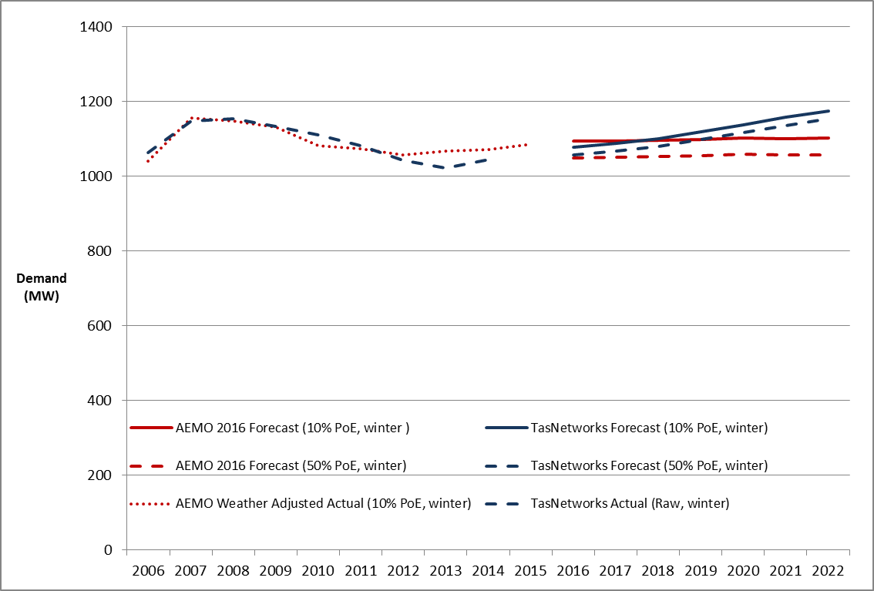

Source: TasNetworks regulatory proposal, AER analysis using AEMO data on transmission connection point forecasts; reset RIN; economic benchmarking RIN 2006–14.

Note: Actual weather adjusted demand over the 2006 to 2014 period reflects non-coincident winter peak demand data with probability of exceedance (POE) of 10 percent and has been weather adjusted and summated at the transmission connection point level.

We sought TasNetworks’ reasons for forecasting a reversal of trend from steady decline in demand to forecast growth. In its response, TasNetworks submitted that it considers that there will be a reversal of recent trend of declining maximum demand because economic conditions in the state will facilitate a slow level of growth. TasNetworks considers that its growth forecast is subdued when compared with the growth in demand seen in the period prior to 2008. TasNetworks considers that maximum demand in 2015 was higher than 2014 maximum demand, and therefore supports its analysis.[144]

We note the increase in actual weather adjusted demand in 2015. Despite this, the question of whether demand will continue to increase in the future still remains given the continued reduction in demand during 2008–2012. There also remains a question of whether demand will return to pre-2008 levels in the context of generally declining demand across the NEM.

In addition, TasNetworks’ demand forecast appears to be high when compared to AEMO’s 2016 independent connection point demand forecast. AEMO forecasts demand to grow at an average rate of 0.2 per cent per annum over the 2017–19 period. This appears to reflect the uncertainty in the future path of demand within the context of changing demand pattern observed over the past 10 years.

We sought TasNetworks’ views on the reasons for the difference between its forecast and AEMO’s, including the underlying forecasting methodology.[145] In its response, TasNetworks singled out the difference in treatment of the forecast Gross State Product (GSP) as the key driver of the difference between its forecast and AEMO’s. TasNetworks considers that AEMO’s model does not use GSP as a primary driver of demand growth, whereas its model does. TasNetworks submitted that its modelling shows that forecast demand growth is likely to return in line with growth in GSP forecasts.[146]

We have not examined the different economic assumptions adopted by TasNetworks and AEMO for their demand forecasts. However, we note that AEMO’s forecasting methodology is robust and has been developed and evolved over several years. In addition, AEMO’s demand forecast is consistent with actual weather adjusted demand trend observed for TasNetworks. This is shown in Figure 15.

Given the differences in demand growth rates between AEMO and TasNetworks, and the divergence of TasNetworks’ forecast from the historical demand trend, we consider that TasNetworks’ forecast may not provide a realistic forecast of demand. Having said that, the impact of TasNetworks' demand forecast on the capex forecast is low (this is discussed in section B.6.1 capacity augex).

1. Ex post review – 2014-15 capex

We are required to provide a statement on whether the roll forward of the regulatory asset base from the previous period contributes to the achievement of the capital expenditure incentive objective.[147] The capital expenditure incentive objective is to ensure that where the regulatory asset base is subject to adjustment in accordance with the NER, only expenditure that reasonably reflects the capex criteria is included in any increase in value of the regulatory asset base.[148]

The NER requires that the last two years of the previous regulatory control period (for the purposes of this decision, the 2012–17 regulatory control period) are excluded from the ex-post assessment of past capex.[149] Further, the review period does not include the regulatory year in which the first Capital Expenditure Incentive Guideline was published (2013–14) or any regulatory year that precedes that regulatory year.[150] Accordingly, our ex-post assessment only applies to the 2014–15 regulatory year.

We may exclude capex from being rolled into the RAB in three circumstances:[151]

1. Where the service provider has spent more than its capex allowance;
2. Where the service provider has incurred capex that represents a margin paid by the service provider, where the margin refers to arrangements that do not reflect arm's length terms; and
3. Where the service provider's capex includes expenditure that should have been classified as opex as part of a service provider’s capitalisation policy.
   * 1. Position

We are satisfied that TasNetworks' capex in the 2014–15 regulatory year should be rolled into the RAB.

* + 1. AER approach

We have conducted our assessment of the efficiency of past capex consistent with the approach set out in our Capital Expenditure Incentive Guideline (the Guideline). In our Guideline we outlined a two stage process for undertaking an ex-post assessment of capital expenditure:[152]

* Stage one - initial consideration of capex performance;
* Stage two - detailed assessment of capex projects and project management planning processes.

The first stage considers whether the service provider has overspent against its allowance and past capex performance.

In accordance with our Guideline we would only proceed to a more detailed assessment (stage two), if a service provider had overspent against its allowance, the overspend was significant and its capex performance covered by the period of our ex-post assessment suggests that levels of capex may not be efficient or do not compare favourably to other service providers.

* + 1. AER assessment

We have reviewed TasNetworks' capex performance for the 2014–15 regulatory year. This assessment has considered TasNetworks' capex relative to its approved capex forecast for 2014–15. Given TasNetworks has underspent against its regulatory allowance in the 2014–15 regulatory year, the overspending requirement for an efficiency review is not satisfied. Accordingly, this supports the view that this expenditure is consistent with the capital expenditure incentive objective.

1. NER, cl. 6.4.3(a).
2. NEL, s. 7A.
3. NER, cl. 6.5.7(a).
4. TasNetworks, Regulatory proposal, January 2016, p. 73.
5. AER, Better regulation: Explanatory statement: *Expenditure forecast assessment guideline,* November 2013, p. 7; see also AEMC, *Final rule determination: National electricity amendment (Economic regulation of network service providers) Rule 2012,* 29 November 2012, pp. 111 and 112.
6. NER, cl. 6.5.7(c).
7. NER, cl. 6.5.7(a).
8. NER, cl. 6.12.1(3)(ii).
9. NER, cl. 6.5.7(c).
10. AEMC, *Final rule determination: National electricity amendment (Economic regulation of network service providers) Rule 2012,* 29 November 2012, p. 113.
11. AEMC, *Final rule determination: National electricity amendment (Economic regulation of network service providers) Rule 2012,* 29 November 2012, p. vii.
12. NER, cl. 6.5.7(e).
13. AEMC, *Final rule determination: National electricity amendment (Economic regulation of network service providers) Rule 2012,* 29 November 2012, p. 115.
14. NEL, ss. 7A and 16(2).
15. NEL, s. 7A.
16. AEMC, *Final rule determination: National electricity amendment (Economic regulation of network service providers) Rule 2012,* 29 November 2012, p. 114.
17. AER, *Better regulation: Expenditure forecast assessment guideline for electricity distribution*, November 2013.
18. AER, Final Framework and approach for TasNetworks Distribution for the Regulatory control period commencing 1 July 2017, July 2015, p. 76.
19. NER, cll. 6.8.2(c2) and (d).
20. AER, *Better regulation: Expenditure forecast assessment guideline for electricity distribution*, November 2013, p. 25.
21. AER, Better regulation: Explanatory statement: *Expenditure forecast assessment guideline,* November 2013, p. 7; AEMC, *Final rule determination: National electricity amendment (Economic regulation of network service providers) Rule 2012,* 29 November 2012, pp. 111 and 112.
22. AEMC, *Final rule determination: National electricity amendment (Economic regulation of network service providers) Rule 2012,* 29 November 2012, p. vii.
23. AER, *Better regulation: Expenditure forecast assessment guideline for electricity distribution*, November 2013, p. 17.
24. AER, *Better regulation: Expenditure forecast assessment guideline for electricity distribution*, November 2013, pp. 8 and 9. The Australian Competition Tribunal has previously endorsed this approach: see : Application by Ergon Energy Corporation Limited (Non-system property capital expenditure) (No 4) [2010] ACompT 12; Application by EnergyAustralia and Others [2009] ACompT 8; Application by Ergon Energy Corporation Limited (Labour Cost Escalators) (No 3) [2010] ACompT 11; Application by DBNGP (WA) Transmission Pty Ltd (No 3) [2012] ACompT 14; Application by United Energy Distribution Pty Limited [2012] ACompT 1; Re: Application by ElectraNet Pty Limited (No 3) [2008] ACompT 3; Application by DBNGP (WA).
25. AER, *Better regulation: Expenditure forecast assessment guideline for electricity distribution*, November 2013, p. 9.
26. AEMC, *Final rule determination: National electricity amendment (Economic regulation of network service providers) Rule 2012,* 29 November 2012, p. 112.
27. NER, r. 6.6.
28. NER, cll. S6.1.1(2), (4) and (5).
29. TasNetworks, Regulatory proposal 2017–19, January 2016, p.68; TasNetworks, Regulatory proposal 2017–19, TN002, Directors Certification of key assumptions for regulatory proposal, distribution, January 2016.
30. NER, cll. 6.8.1A and 11.60.3(c).
31. NER, cl. S6.1.1(2).
32. TasNetworks, Regulatory proposal 2017–19, January 2016, p. 67.
33. NER, cl. 6.5.7(e).
34. AER, Distribution network service providers: Annual benchmarking report, November 2015
35. NER, cl. 6.5.7(c), (d) and (e).
36. Jo De Silva (Consumer Challenge Panel), *Submission to the Australian Energy Regulator on TasNetworks’ distribution Regulatory Proposal 2017–19*, April 2016, p. 10.
37. Tasmanian Council of Social Service, Submission on AER issues paper regarding TasNetworks' regulatory proposal, p. 1.
38. David Headberry (Consumer Challenge Panel, Sub-panel 4), *Submission on TasNetworks’ Regulatory Proposal*, May 2016, p.29.
39. David Headberry (Consumer Challenge Panel, Sub-panel 4), *Submission on TasNetworks’ Regulatory Proposal*, May 2016, p.29.
40. David Headberry (Consumer Challenge Panel, Sub-panel 4), *Submission on TasNetworks’ Regulatory Proposal*, May 2016, p.30.
41. Tasmanian Small Business Council, Submission on TasNetworks’ regulatory proposal, May 2016, p.24.
42. AER, *Better regulation: Expenditure forecast assessment guideline for electricity distribution*, November 2013, p. 8.
43. NER, cl. 6.5.7(e)(4).
44. AER, Better regulation: *Explanatory statement: Expenditure forecasting assessment guidelines,* November 2013.
45. NER, cl. 6.5.7(c).
46. AEMC, *Final rule determination: National electricity amendment (Economic regulation of network service providers) Rule 2012,* 29 November 2012, p. 25.
47. AEMC, *Final rule determination: National electricity amendment (Economic regulation of network service providers) Rule 2012,* 29 November 2012, p. 113. Exogenous factors could include geographic factors, customer factors, network factors and jurisdictional factors.
48. AER, Electricity distribution network service providers: Annual benchmarking report, November 2014.
49. NER, cl. 6.5.7(e)(5).
50. NER, cl. 6.5.7(a)(3).
51. NER, cl. 6.5.7(c).
52. NER, cl. 6.5.7(e)(5).
53. Asset utilisation is the proportion of the asset's capability under use during peak demand conditions.
54. For more information, see: AER, *Guidance document: AER augmentation model handbook,* November 2013.
55. AER, *'Meeting summary – distributor replacement and augmentation capex', Workshop 4: Category analysis work-stream – Replacement and demand driven augmentation (Distribution),* 8 March 2013, p. 1.
56. AER, Better regulation: Explanatory statement: Expenditure forecast assessment guideline, November 2013, p. 86.
57. As set out in Appendix C, we have found that TasNetworks' forecast of maximum demand likely does not reasonably reflect a realistic expectation of demand over the 2017–19 period. The available evidence suggests that maximum demand will remain generally flat over the 2017–19 period, which is consistent with the Australian Energy Market Operator's (AEMO) independent forecasts for TasNetworks. However, the impact of this finding on our assessment of the forecast capacity augex is negligible since the forecast augex is not directly driven by the forecast maximum demand.
58. TasNetworks, Response to AER request #012, demand augex, 4 July 2016, pp.7-9.
59. TasNetworks, Regulatory Proposal 1 July 2017 to 30 June 2019, 29 January 2016, p. 76; TasNetworks, Network Development Management Plan, October 2015, p. 24.
60. Network capacity utilisation is a measure of the installed network capacity that is in use. Where utilisation rates decline over time (such as from a decline in maximum demand), it is expected that total augex requirements would similarly fall.
61. This chart does not include forecast utilisation of high voltage feeders. This is because forecast demand for each feeder is not available to us. We rely on historical utilisation data provided in TasNetworks' reset RIN.
62. David Headberry (Consumer Challenge Panel, Sub-panel 4), Submission on TasNetworks’ Regulatory Proposal, May 2016, p. 33.
63. TasNetworks, Regulatory Proposal 1 July 2017 to 30 June 2019, 29 January 2016, p. 76.
64. Office of the Tasmanian Economic Regulator, Energy in Tasmania – Performance Report 2014-15, January 2016, pp. 82-84.
65. Office of the Tasmanian Economic Regulator, Energy in Tasmania – Performance Report 2014-15, January 2016, pp. 81-84.
66. We analysed annual feeder reliability information that TasNetworks reports in its regulatory information notices, which includes the length and cause of each individual outage.
67. TasNetworks, Regulatory Proposal 1 July 2017 to 30 June 2019, 29 January 2016, p. 64.
68. TasNetworks, Regulatory Proposal, January 2016, TN022, Customer Connection Forecasts 2015, January 2016, p.14.
69. TasNetworks, Regulatory Proposal, January 2016, TN022, Customer Connection Forecasts 2015, January 2016, p.14.
70. The Tasmanian Government's Department of Treasury and Finance, 2016–17 Budget Paper No. 1, Chapter 2 -Tasmanian Economy, May 2016, p.26.
71. The Tasmanian Government's Department of Treasury and Finance, 2016–17 Budget Paper No. 1, Chapter 2 -Tasmanian Economy, May 2016, p.26.
72. TN022 Customer Connections Forecasts 2015, p. 12.
73. HIA data is a reasonably well accepted industry standard indicator of residential connection activity. HIA is a private-sector industry association comprising mainly house construction contractors, and has been used by the industry since 1984. See Mills, Anthony and Harris, David and Skitmore, Martin R, The Accuracy of Housing Forecasting in Australia, Engineering Construction and Architectural, Management 10(4), 2003, pp. 245-253. Accessed from: <http://eprints.qut.edu.au/archive/00004441/>
74. TN022 Customer Connections Forecasts 2015, p. 32-33.
75. TasNetworks, Response to AER information request #006, TasNetworks response to questions raised by the AER, p. 10.
76. TasNetworks, Response to AER information request #006, TasNetworks response to questions raised by the AER, p. 10.
77. TasNetworks, response to AER information request #011, Connections Costs, pp. 9-10.
78. David Headberry (Consumer Challenge Panel, Sub-panel 4), Submission on TasNetworks’ Regulatory Proposal, May 2016, p.33.
79. TasNetworks, Response to AER Information Request#011, 27 June 2016, p.10.
80. A condition assessment may relate to assessment of a single asset or a population of similar assets. High value/low volume assets are more likely to be monitored on an individual basis, while low value/high volume assets are more likely to be considered from an asset category wide perspective.
81. TasNetworks' regulatory proposal used different capex categorisations than those set out within the AER's Expenditure Forecast Assessment Guideline (EFAG). However, the information provided in the reset RIN conformed to our specified categories (e.g. augex, repex, non-networks and connections). Consistent with the EFAG, we have assessed TasNetworks' proposal by capex category specified in the RIN, rather than the categorisations put forward by TasNetworks.
82. TasNetworks, Regulatory Proposal 2017–2019, January 2016, p. 78.
83. We recognise that predictive modelling cannot perfectly predict TasNetworks’ necessary replacement volumes and expenditure over the next regulatory period, in the same way that no prediction of future needs will be absolutely precise. However, we consider the repex model is suitable for providing a reasonable statistical estimate of replacement volumes and expenditure for certain types of assets, where we are satisfied we have the necessary data. We note that TasNetworks relies on similar predictive modelling to support their forecast amount for repex.
84. Nuttall Consulting, Assessing TasNetworks’ replacement forecast, January 2016.
85. AER, Better regulation: Expenditure forecast assessment guideline for electricity transmission, November 2013, p.9.
86. NER, cl. 6.5.7(e)(5).
87. David Headberry (Consumer Challenge Panel, Sub-panel 4), Submission on TasNetworks’ Regulatory Proposal, May 2016, p.34.
88. TasNetworks, Regulatory Proposal 1 July 2017 to 30 June 2019, 29 January 2016, p. 78.
89. For other categories, we do not necessarily have sufficient data to allow such comparison. For example, we do not have an age profile for some asset categories, which prevents us from using the repex model for these assets. For assets that are not modelled, we rely more heavily on other assessment techniques such as trend analysis, business cases and project/program justifications put forward by the service providers.
90. Tasmanian Small Business Council, Submission on TasNetworks’ regulatory proposal, May 2016, p. 26.
91. Nuttall Consulting, Assessing TasNetworks’ replacement forecast, January 2016.
92. AER, Replacement expenditure model handbook, November 2013.
93. While the asset replacement age and unit cost can be considered under different scenarios, the asset age profile is a fixed input, and does not change under different scenarios.
94. See, for example, the AER’s final distribution determinations for the Victorian electricity distribution businesses, May 2016
95. TasNetworks, Regulatory Proposal 1 July 2017 to 30 June 2019, 29 January 2016, p. 79.
96. TasNetworks, Regulatory Proposal 1 July 2017 to 30 June 2019, 29 January 2016, p. 80.
97. AER, Expenditure Forecast Assessment Guideline for Electricity Distribution, November 2013, pp. 7–9.
98. TasNetworks included $19 million of other in reset RIN template 2.2. However, this occurred because it counted its secondary systems repex twice, once in the prescribed "SCADA, network control and protection" category, and also in the "other" category. As we have already addressed secondary systems earlier in this section, we have removed this expenditure from the "other" category.
99. TasNetworks, Regulatory Proposal 1 July 2017 to 30 June 2019, 29 January 2016, p. 81.
100. TasNetworks, Response to AER information request #002, April 2016.
101. AER, Aurora Energy Final distribution determination 2012–17, April 2012.
102. AER, TasNetworks Final decision, transmission determination 2015–19, April 2015.
103. TasNetworks, TasNetworks Integrated Business Solution, October 2015, p. 1.
104. TasNetworks, Regulatory Proposal 1 July 2017 to 30 June 2019, 29 January 2016, p. 83.
105. David Headberry (Consumer Challenge Panel, Sub-panel 4), Submission on TasNetworks’ Regulatory Proposal, May 2016, p.38.
106. TasCOSS, TasCOSS submission to AER re TasNetworks revenue proposal 2017-19, 28 April 2016, p. 1.
107. Jo De Silva (Consumer Challenge Panel, Sub-panel 4), Submission on TasNetworks’ Regulatory Proposal, April 2016, p. 9.
108. TasNetworks, TasNetworks Integrated Business Solution, October 2015, p. 1.
109. TasNetworks, TasNetworks Integrated Business Solution, October 2015, p. 8.
110. TasNetworks, TasNetworks Integrated Business Solution, October 2015, p. 1, 8.
111. TasNetworks, TasNetworks Integrated Business Solution, appendix H, October 2015, p. 8.
112. TasNetworks, TasNetworks Integrated Business Solution, appendix H, October 2015, p. 3.
113. These measures do not include planned outages, momentary outages, major event days and excluded events.
114. SAIFI: The total number of unplanned sustained customer interruptions divided by the total number of distribution customers. Unplanned SAIFI excludes momentary interruptions (one minute or less). SAIFI is expressed per 0.01 interruptions.
115. NER, cl. 6.5.7(e)(5).
116. NER, cl. 6.5.7(e)(7).
117. Most relevantly, NER, cll. 6.5.7(e)(5) and 6.5.7(e)(7).
118. TasNetworks, *Regulatory Proposal*, 29 January 2016, p. 84.
119. TasNetworks, *Regulatory Proposal*, 29 January 2016, p. 85.
120. TasNetworks, *Regulatory Proposal*, 29 January 2016, p. 85.
121. TasCOSS, *TasCOSS submission to AER re TasNetworks revenue proposal* 2017-19, 28 April 2016, p. 1.
122. Tasmanian Small Business Council, *Submission on TasNetworks regulatory proposal*, May 2016, p.6.
123. TasNetworks, *Regulatory Proposal*, 29 January 2016, p.138.
124. Consumer Challenge Panel ( Jo de Silva), *Submission to the Australian Energy Regulator on TasNetworks’ Distribution Regulatory Proposal 2017-19*, April 2016, p.8-9.
125. Consumer Challenge Panel (David Headberry), *Submission to the Australian Energy Regulator,* 4 May 2016, p.37.
126. TasNetworks, Regulatory proposal 2017–22, 29 January 2016, p. 84.
127. TasNetworks, Regulatory proposal 2017–22, 29 January 2016, p. 84.
128. TasNetworks, Regulatory proposal 2017–22, 29 January 2016, p. 84.
129. TasNetworks, Regulatory proposal 2017–22, Operational Fleet Management Plan 2015-2020 and Asset Management Plan - Operational Fleet Strategy 2015-20, July 2015.
130. NER, cl. 6.5.7(c)(1).
131. TasNetworks, Regulatory proposal 2017–22, Operational Fleet Management Plan 2015-2020, July 2015, p. 9.
132. TasNetworks, Regulatory proposal 2017–22, Operational Fleet Management Plan 2015-2020, July 2015, p. 14.
133. TasNetworks, Regulatory proposal 2017–22, Operational Fleet Management Plan 2015-2020, July 2015, p. 18.
134. TasNetworks, Regulatory proposal 2017–22, Operational Fleet Management Plan 2015-2020, July 2015, pp. 18-19.
135. TasNetworks, Regulatory proposal 2017–22, 29 January 2016, p. 84.
136. TasNetworks, Regulatory proposal 2017–22, 29 January 2016, p. 84.
137. TasNetworks, Regulatory proposal 2017–22, 29 January 2016, p. 84.
138. TasNetworks, Regulatory proposal 2017–22, Operational Facilities Strategy and Asset Management Plan - Facilities Management Plan 2015-20, July 2015.
139. NER, cl. 6.5.7(c)(1).
140. TasNetworks, Regulatory proposal 2017–22, Operational Facilities Strategy 2015-2020, July 2015, pp. 5-8.
141. TasNetworks, Regulatory proposal 2017–22, Operational Facilities Strategy 2015-2020, July 2015, p. 8.
142. TasNetworks, Regulatory proposal 2017–22, Facilities Management Plan 2015-2020, July 2015, p. 15.
143. AEMO, Transmission Connection Point Forecasting Report for Tasmania, February 2016, p. 10.
144. TasNetworks , Response to AER information request #006, 10 May 2016, p. 13.
145. AER, Information Request to TasNetworks #006, 3 May 2016.
146. TasNetworks , Response to AER information request #006, 10 May 2016, p. 13.
147. NER, cl. 6.12.2(b).
148. NER, cl. 6.4A(a).
149. NER, cl. S6.2.2A(a1).
150. NER, cl. 11.58.5(a).
151. NER, cl. S6.2.2A(b).
152. AER, Capital Expenditure Incentive Guideline, November 2013, pp. 19–22.