

DRAFT DECISION

Amadeus Gas Pipeline  
Access Arrangement

2016 to 2021

Attachment 7 – Operating expenditure

November 2015

© Commonwealth of Australia 2015

This work is copyright. In addition to any use permitted under the Copyright Act 1968, all material contained within this work is provided under a Creative Commons Attributions 3.0 Australia licence, with the exception of:

* the Commonwealth Coat of Arms
* the ACCC and AER logos
* any illustration, diagram, photograph or graphic over which the Australian Competition and Consumer Commission does not hold copyright, but which may be part of or contained within this publication. The details of the relevant licence conditions are available on the Creative Commons website, as is the full legal code for the CC BY 3.0 AU licence.

Requests and inquiries concerning reproduction and rights should be addressed to the:

Director, Corporate Communications  
Australian Competition and Consumer Commission   
GPO Box 4141, Canberra ACT 2601

or publishing.unit@accc.gov.au.

Inquiries about this publication should be addressed to:

Australian Energy Regulator  
GPO Box 520  
Melbourne Vic 3001

Tel: (03) 9290 1444  
Fax: (03) 9290 1457

Email: [AERInquiry@aer.gov.au](mailto:AERInquiry@aer.gov.au)

1. Note
2. This attachment forms part of the AER's draft decision on the access arrangement for the Amadeus Gas Pipeline for 2016–21. It should be read with all other parts of the draft decision.
3. The draft decision includes the following documents:
4. Overview

Attachment 1 - Services covered by the access arrangement

Attachment 2 - Capital base

Attachment 3 - Rate of return

Attachment 4 - Value of imputation credits

Attachment 5 - Regulatory depreciation

Attachment 6 - Capital expenditure

Attachment 7 - Operating expenditure

Attachment 8 - Corporate income tax

Attachment 9 - Efficiency carryover mechanism

Attachment 10 - Reference tariff setting

Attachment 11 - Reference tariff variation mechanism

Attachment 12 - Non-tariff components

Attachment 13 - Demand

1. Contents

Note 7-2

Contents 7-3

Shortened forms 7-4

7 Operating expenditure 7-6

7.1 Draft decision 7-6

7.2 APTNT’s proposal 7-6

7.3 AER’s assessment approach 7-8

7.3.1 Building an alternative estimate of total forecast opex 7-8

7.3.2 Interrelationships 7-11

7.4 Reasons for draft decision 7-11

7.4.1 Forecasting method 7-12

7.4.2 Selection of base year 7-13

7.4.3 Step changes 7-16

7.4.4 Rate of change 7-16

7.4.5 Category specific forecasts 7-20

1. Shortened forms

| 1. Shortened form | 1. Extended form |
| --- | --- |
| 1. AA | Access Arrangement |
| 1. AAI | Access Arrangement Information |
| 1. AER | 1. Australian Energy Regulator |
| 1. AGP | Amadeus Gas Pipeline |
| 1. ATO | Australian Tax Office |
| 1. capex | 1. capital expenditure |
| 1. CAPM | 1. capital asset pricing model |
| 1. CESS | 1. Capital Expenditure Sharing Scheme |
| 1. CPI | 1. consumer price index |
| 1. DRP | 1. debt risk premium |
| 1. EBSS | Efficiency Benefit Sharing Scheme |
| 1. ERP | 1. equity risk premium |
| 1. Expenditure Guideline | Expenditure Forecast Assessment Guideline |
| 1. gamma | Value of Imputation Credits |
| 1. GSL | Guaranteed Service Level |
| 1. MRP | 1. market risk premium |
| 1. NEGI | 1. north eastern gas interconnector |
| 1. NGL | 1. national gas law |
| 1. NGO | 1. national gas objective |
| 1. NGR | 1. national gas rules |
| 1. NPV | net present value |
| 1. opex | 1. operating expenditure |
| 1. PFP | partial factor productivity |
| 1. PPI | 1. partial performance indicators |
| 1. PTRM | 1. post-tax revenue model |
| 1. RBA | 1. Reserve Bank of Australia |
| 1. RFM | 1. roll forward model |
| 1. RIN | 1. regulatory information notice |
| 1. RPP | 1. revenue and pricing principles |
| 1. SLCAPM | 1. Sharpe-Lintner capital asset pricing model |
| 1. TAB | Tax asset base |
| 1. UAFG | Unaccounted for gas |
| 1. WACC | 1. weighted average cost of capital |
| 1. WPI | Wage Price Index |

# Operating expenditure

Forecast operating expenditure (opex) is the forecast operating, maintenance and other non-capital costs incurred in the provision of reference services for a pipeline. It includes labour costs and other non-capital costs that a prudent service provider is likely to require during an access arrangement period for the efficient operation of its pipeline.

## Draft decision

We are satisfied that the forecast of total opex APTNT proposed complies with the opex criteria, and satisfies the criteria for forecasts and estimates.[1] We therefore accept the forecast of opex APTNT included in its access arrangement proposal. APTNT’s proposed total opex and our draft decision on opex for the 2016–21 access arrangement period are in Table 7.1.

Table 7.1 AER draft decision on APTNT’s total opex ($million, 2015–16)

|  |  |  |  |  |  |  |
| --- | --- | --- | --- | --- | --- | --- |
|  | 2016–17 | 2017–18 | 2018–19 | 2019–20 | 2020–21 | Total |
| APTNT's proposal | 11.9 | 12.9 | 13.9 | 11.8 | 12.3 | 62.8 |
| AER draft decision | 11.9 | 12.9 | 13.9 | 11.8 | 12.3 | 62.8 |
| Difference | – | – | – | – | – | – |

Source: APTNT, 2016-21 Access arrangement information, August 2015 – Opex model; AER analysis.

## APTNT’s proposal

APTNT proposed total opex of $63 million for the 2016–21 access arrangement period.[2] This is an 8 per cent real increase in actual expenditure compared to the 2011–16 period.

Figure 7.1 APTNT’s historical and forecast opex ($million, 2015–16)

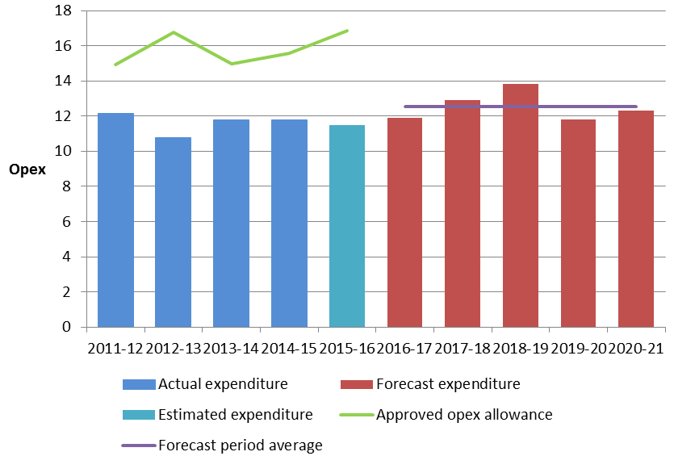

Source: APTNT, 2016-21 Access Arrangement Information, August 2015 – Opex model; APTNT, RIN response, August 2015.

APTNT forecast most of its opex using 2014–15 opex as a base and trending it forward by applying a forecast rate of change, which incorporated changes in labour costs. It then added a specific category forecast for intelligent pigging[3] to derive its total opex forecast. Table 7.2 disaggregates APTNT’s forecast into its separate components.

Table 7.2 APTNT’s forecast opex ($ million, 2015–16)

|  |  |  |  |  |  |  |
| --- | --- | --- | --- | --- | --- | --- |
|  | 2016–17 | 2017–18 | 2018–19 | 2019–20 | 2020–21 | Total |
| Base opex | 11.4 | 11.4 | 11.4 | 11.4 | 11.4 | 57.1 |
| Escalation | 0.1 | 0.3 | 0.4 | 0.4 | 0.5 | 1.7 |
| Intelligent pigging | 0.4 | 1.2 | 2.1 | 0 | 0.4 | 4.1 |
| Debt raising |  |  |  |  |  | 0.04 |
| Total opex | 11.9 | 12.9 | 13.9 | 11.8 | 12.3 | 62.8 |

Source: APTNT, 2016-21 Access Arrangement Information, August 2015 – Opex model.

Numbers may not add due to rounding.

## AER’s assessment approach

We decide whether or not to accept a service provider's total forecast opex proposal. We approve the service provider's forecast opex if we are satisfied that it is consistent with the criteria governing operating expenditure (the opex criteria).[4]

Criteria governing operating expenditure

Operating expenditure must be as such as would be incurred by a prudent service provider acting efficiently to provide the lowest sustainable cost of delivering pipeline services.

In determining whether forecast opex is consistent with the opex criteria we have regard to the criteria for forecasts and estimates.[5]

Forecasts and estimates

(1) Information in the nature of a forecast or estimate must be supported by a statement on the basis of the forecast or estimate.

(2) A forecast or estimate:

(a) must be arrived at on a reasonable basis; and

(b) must represent the best forecast or estimate possible in the   
 circumstances.

Our approach is to compare the service provider's total forecast opex with our alternative estimate of total opex. By doing this, we form a view on the service provider's proposal. If we are not satisfied that the proposal complies with the opex criteria we use our alternative opex estimate as a substitute.

Our estimate is unlikely to exactly match the service provider's forecast because the service provider may adopt a different forecasting method to us. However, if the service provider's inputs and assumptions are reasonable, its method should produce a forecast close to our estimate. Accordingly, part of our approach is to assess the service provider's forecasting method as well as the inputs and assumptions it used to form its opex forecast.

### Building an alternative estimate of total forecast opex

Our approach to building an alternative estimate of opex involves five key steps:

1. We typically use the service provider's actual opex in a single year as the starting point for our assessment. While categories of opex can vary from year to year, total opex is relatively recurrent.
2. We assess whether opex in that base year complies with the opex criteria. If necessary, we make an adjustment to the base year expenditure to ensure that it complies with the opex criteria.
3. As opex tends to change over time due to price, output and productivity changes, we trend the adjusted base year opex forward over the access arrangement period to take account of these changes. We refer to this as the rate of change.
4. We then adjust the base year expenditure to account for any other forecast cost changes that would meet the opex criteria. This may be due to new regulatory obligations and efficient capex/opex trade-offs. We call these step changes.
5. Finally we add any additional opex components which have not been forecast using this approach. For instance, we forecast debt raising costs based on the costs incurred by a benchmark efficient service provider. If we removed a category of opex from the selected base year, we will need to consider what additional opex is needed for this category of opex in forecasting total opex.

We have used this general approach in our past decisions. It is a well-regarded top down forecasting model that has been employed by a number of Australian regulators over the last fifteen years. We have sometimes referred to it as the base-step-trend method in our past regulatory decisions.

We set out more detail about each of the steps we follow in constructing our forecast below.

Step 1 – Starting point - base year expenditure

When we choose the base year, we aim to use a year that is most representative of efficient, recurrent expenditure. Typically, we start with the service provider's revealed actual expenditure in the second last year of the current access arrangement period. Actual expenditure in the second last year is usually the most recent available at the time we conduct our assessment. Accordingly, to the extent expenditure drivers change over time, it is likely to best reflect the forecast period. However, if this year does not represent efficient, recurrent costs, we may consider another year.

In choosing a base year, we need to make a decision as to whether any categories of opex incurred in the base year should be removed. For instance:

* If a material cost was incurred in the base year that is unrepresentative of a service provider's future opex we may remove it from the base year in undertaking our assessment.
* Rather than use all opex in the base year, service providers also often forecast specific categories of opex using different methods. We must also assess these methods in deciding what the starting point should be. If we agree that these categories of opex should be forecast separately, we will also remove them from the base year.

Step 2 - Assessing base year expenditure

Regardless of the base year we choose, we must test the view that 'revealed expenditure' is the appropriate starting point because the service provider's actual expenditure may not be efficient. We will use all techniques available to us to do this. If we determine that a service provider's revealed expenditure is not efficient, we will not use it as our starting point for our estimate of total forecast opex.

Step 3 - Rate of change

Once we have chosen an efficient starting point, we apply an annual escalator to take account of the likely ongoing changes to efficient opex over the forecast access arrangement period. Efficient opex in the forecast access arrangement period could reasonably differ from the efficient starting point due to changes in:

* prices
* outputs
* productivity.

We estimate the change by adding expected changes in prices (such as the cost of labour and materials) and outputs (such as changes in customer numbers and demand). We then incorporate reasonable estimates of changes in productivity.

Step 4 - Step changes

We then consider if there is other opex needed to satisfy the opex criteria in the forecast period. We refer to these as ‘step changes’. Step changes may be for new, changed or discontinued obligations for the service provider in the upcoming access arrangement period. They may also account for efficient capex/opex trade-offs, or other reasons why a service provider would need different opex to that incurred in the base year. We will typically compensate a service provider for step changes only if efficient base year opex and the rate of change in opex of an efficient service provider do not already compensate for the proposed costs.

Step 5 - Other costs that are not included in the base year

In our final step, we make any further adjustments we need for our opex forecast to satisfy the opex criteria. For instance, our approach is to forecast debt raising costs based on a benchmarking approach rather than a service provider’s actual costs. This is to be consistent the forecast cost of debt in the rate of return building block.

After applying these five steps, we arrive at our total opex forecast.

Comparing our opex forecast to the service provider's opex forecast

If a service provider's total forecast opex is different to our estimate, we will examine potential reasons for the difference. If there is no satisfactory explanation for this difference, we may form the view that the service provider's forecast does not comply with the opex criteria. Conversely, if our estimate demonstrates that the service provider's forecast is consistent with the opex criteria, we will accept the forecast. Whether or not we accept a service provider's forecast, we will provide the reasons for our decision.

### Interrelationships

There are interrelationships between the opex forecast and other elements of APTNT’s access arrangement proposal. In assessing APTNT’s proposed total opex we also took into account:

* forecast changes in demand
* capex/opex trade-offs
* the possible impact of the connection of the Amadeus Gas Pipeline to south eastern gas markets.

## Reasons for draft decision

1. In accordance with the method set out in this chapter we derived an alternative forecast of total opex. We have assessed APTNT’s opex forecast against our alternative estimate of opex. Differences between our forecast and the total opex forecast proposed by APTNT arise due to:

* substitution of rate of change forecast to reflect alternative input price forecasts and an alternative weighting of labour and non-labour inputs
* correction of a minor error in APTNT’s opex model.

Table 7.3 compares our forecast total opex to that proposed by APTNT.

Table 7.3 Comparison of total opex forecasts* ($million 2015–16)

|  |  |  |  |  |  |  |
| --- | --- | --- | --- | --- | --- | --- |
|  | 2016–17 | 2017–18 | 2018–19 | 2019–20 | 2020–21 | Total 2016–21 |
| APTNT proposed | 11.92 | 12.90 | 13.85 | 11.80 | 12.29 | 62.76 |
| AER alternative | 11.84 | 12.78 | 13.68 | 11.65 | 12.14 | 62.09 |
| Difference | –0.08 | –0.12 | –0.17 | –0.15 | –0.16 | –0.67 (1.1%) |

Source: APA Group, Amadeus Gas Pipeline, Access Arrangement Revision Proposal, Submission, 1 July 2016 to 30 June 2021, August 2015, Opex model; AER analysis.

* Excludes debt raising costs.

We are satisfied that APTNT's forecast opex for the 2016–21 access arrangement period complies with the opex criteria and criteria for forecast and estimates. We discuss each element of APTNT's forecast opex in more detail in sections 7.4.2–7.4.5 of this attachment. Debt raising costs are discussed in Attachment 3.

### Forecasting method

We have assessed APTNT’s forecasting method to determine if it explains the difference between our forecast opex and that proposed by APTNT. We are satisfied the forecasting method is not a key driver of the difference. APTNT describes its forecasting method as involving:[6]

* identification of an efficient base year and base year costs
* adjustment for step and scope changes, including removal from the base year of costs that are not indicative of future requirements and adding costs for new expenditures not experienced in the past or embedded in base year costs
* escalation of costs for expected changes in input costs.

APTNT’s forecasting method reflects our preferred method, applying a rate of change to base year opex, as well developing category specific forecasts for a limited component of the opex forecast. The expenditure impact of APTNT’s forecasting method is shown in Figure 7.2. It shows the drivers of change between a forecast derived using APTNT’s allowed opex in 2014–15 and its proposed opex for 2016–21.

Figure 7.2 APTNT’s forecasting method impacts ($million, 2015–16)

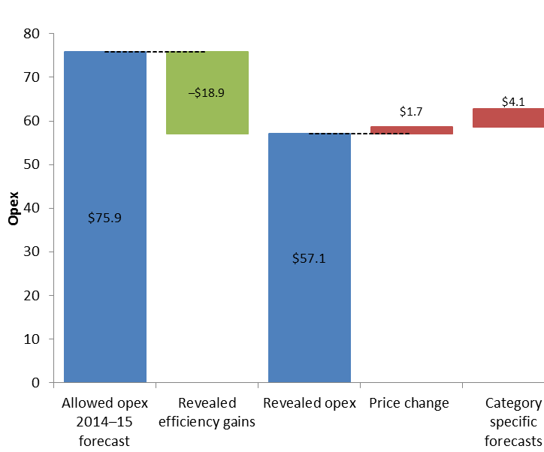

Source: AER analysis.

* APTNT used revealed actual expenditure for 2014–15 as its base opex to forecast total opex for the 2016–21 period. This resulted in its forecast opex being $18.9 million lower than total opex forecast using the 2014–15 opex allowed under the 2011–16 access arrangement. We have assessed APTNT’s base opex in sections 7.4.2.
* APTNT accounted for price changes by applying forecast changes in labour prices to internal and external labour elements of its forecast opex. The application of these forecast price changes increased APTNT’s opex forecast by $1.7 million. We have assessed price changes in section 7.4.4.
* APTNT did not incorporate any changes in output, productivity or step changes to its forecast opex.
* APTNT developed a category specific forecast for its pigging costs of $4.1 million in the 2016–21 period. We generally prefer not to incorporate category specific forecasts into opex forecasts[7] but in this instance we are satisfied APTNT’s forecasting approach does not produce opex forecasts that exceed the efficient level of total opex required by APTNT to meet the opex criteria.

### Selection of base year

APTNT used revealed expenditure for 2014–15 as its base opex, and stated:[8]

* it is the most recent complete regulatory year for expenditure and is therefore the most indicative of the current operating expenditure of the business; and
* it is in line with operating expenditure in previous years of the period.

We consider APTNT’s proposed base year is a reasonable base year for forecasting opex because:

* Most opex is recurrent in nature and actual expenditure in 2014–15 is likely to be a good indicator for the efficient expenditure in the 2016–21 period.
* 2014–15 is the second last year of the 2011–16 period, and is the most recent year for which certified actual data is be available. To the extent expenditure drivers do not change over time, this year is likely to best reflect future expenditure.
* APTNT’s actual opex is relatively stable in the 2011–16 period, and there is no evidence to suggest opex has been inflated in the base year to try and increase its opex forecast for the 2016–21 period.
* We did not identify any non-recurrent opex in the base year data, except for the pigging costs identified and removed by APTNT.
* APTNT’s opex in 2014–15 was slightly below the expected average opex for the 2011–16 period, after adjustments for non-recurrent expenditure (Figure 7.3).

Figure 7.3 APTNT’s opex 2011–16 period ($million, 2015–16)

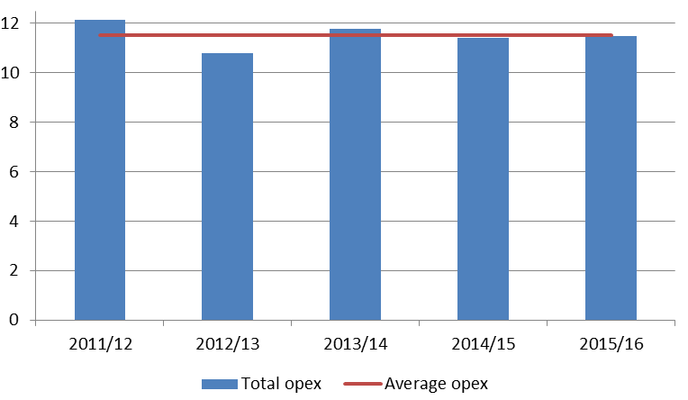

Source: APA Group, Amadeus Gas Pipeline, Access Arrangement Revision Proposal, Submission, 1 July 2016 to 30 June 2021, August 2015, Opex model; AER analysis.

Based on our assessment we are satisfied APTNT’s proposed base year (2014–15) is not biased and is a reasonable base year for forecasting opex.

Efficiency of base year

APTNT was not subject to an incentive mechanism, such as an efficiency carryover mechanism, on its opex in the 2011–16 period. Without such a mechanism in place APTNT has an incentive to increase its base year opex, in order to drive up forecast opex for the 2016–21 period.[9] Given this, we have assessed whether the proposed base year opex includes any increases or one-off costs, that do not reflect recurrent efficient opex. We consider the removal of pigging costs from opex is appropriate, and we found no evidence of other one-off or non-recurrent expenditure in the base year.

We do not have standardised data for the gas network service providers in order to do our own economic benchmarking or category analysis review to assess the efficiency of the revealed base year. Instead, we rely on analysis of APTNT's historical trends. We note APTNT has underspent its opex allowance in all years of the 2011–16 period, and attributed this to:[10]

* lower labour costs associated with integration with the APA Group structure
* efficiencies associated with business wide initiatives such as consolidation of engineering and financing resources
* difficulties in filling some positions in the NT, reducing overall labour costs
* delays and deferrals to its pigging schedule.

With the exception of the deferred pigging costs, all of these opex savings are reflected in the base year opex. All pigging costs have been removed from base year opex and are separately forecast. We note APTNT’s 2014–15 opex is just below average opex for the 2011–16 period, and well below the highest opex incurred in 2011–12. We consider APTNT’s opex in 2014–15 also captures the benefits of cost savings and efficiencies implemented by APTNT in the 2011–16 period. We consider there is no evidence to suggest that APTNT's revealed costs in its proposed base year are materially inefficient.

North eastern gas interconnector

APTNT has noted that during the 2016–21 period a gas interconnector between the Amadeus Gas Pipeline and the south eastern gas markets—the North Eastern Gas Interconnector (NEGI)—may be developed. However, as the timing, route and impact of the NEGI is unknown, APTNT has not factored any potential impact on demand, or changes in pipeline operations and maintenance into its opex forecast.[11]

We consider that in the event NEGI becomes operational in the 2016–21 access arrangement period, there may be an impact on many of the factors that underlie the proposed access arrangement, including demand, reference tariffs, and opex requirements. We propose to treat the interconnection to the south eastern gas markets as a re-opener event, and will review the efficient opex requirements for APTNT to take into account the new operating environment it is facing at that time.[12] We discuss proposed revisions to the access arrangement to address the likely impact of NEGI in attachment 12.

We have not incorporated any specific opex forecast for NEGI in our alternative forecast of total opex.

### Step changes

APTNT did not include any step changes in its opex forecast for the 2016–21 access arrangement period.

We have not identified any step changes in our alternative opex forecast.

### Rate of change

Once we have determined the efficient base level of opex in the 2011–16 access arrangement period we apply a forecast annual rate of change to forecast opex for the 2016–21 access arrangement period. The rate of change is forecast as:

∆Opex= ∆price + ∆output - ∆productivity

Where ∆ denotes the proportional change in a variable.

The rate of change captures the year on year change in efficient expenditure. Specifically it accounts for forecast changes in outputs, prices and productivity. These three opex drivers should explain changes in efficient opex.[13] The output and productivity change variables capture the forecast change in the volume of inputs required to produce a given output. The real price change variable captures the forecast change in the prices of those inputs.

APTNT used a rate of change methodology for estimating its forecast total opex. We have therefore assessed the inputs applied by APTNT in forecasting its rate of change.

APTNT proposed forecast changes in labour costs to develop its rate of change factor. It applied the rate of change to the labour component of its opex forecast. It has not incorporated any real price changes to materials, or output or productivity rates of change.

We have used the rate of change method set out in our expenditure forecast assessment guideline to review the rate of change proposed by APTNT.[14]

Price growth

APTNT used forecast labour cost escalators derived by Deloitte Access Economics (DAE) for the NT Utilities Commission’s 2014 price review of the Power and Water Corporation. APTNT stated its real price escalators were appropriate as they had been prepared for a regulated business that operated in the Northern Territory, and were previously accepted by the jurisdictional regulator.[15] APTNT’s labour cost escalators are shown in Table 7.4.

Table 7.4 APTNT’s forecast real input price escalators

|  |  |  |  |  |  |  |
| --- | --- | --- | --- | --- | --- | --- |
|  | 2015–16 | 2016–17 | 2017–18 | 2018–19 | 2019–20 | 2020–21 |
| Internal labour | 1.0 | 0.6 | 0.9 | 1.0 | 0.9 | 0.9 |
| External labour | 1.1 | 0.9 | 1.0 | 1.1 | 0.9 | 0.9 |

Source: APA Group, *Amadeus Gas Pipeline,* *Access Arrangement Revision Proposal, Submission*, Opex model, August 2015.

Internal and external labour costs

APTNT has forecast its opex using separate price escalators for internal and external labour. It advised that internal labour costs refer to employees of APTNT, and external labour costs refer to contractor labour costs. However, to develop our alternative forecast of total opex we do not differentiate between internal and external labour. We escalate gas related labour by the Electricity Gas Water and Waste Services (EGWWS) sector.

***Comparison of input price escalators***

To assess input price (labour cost) escalators we compared APTNT’s proposed escalators to recent forecast labour costs in the Northern Territory.[16] Differences between the two sets of forecasts arise as APTNT used a composite escalator from a number of industries to estimate its labour cost forecasts and an average of earlier years to derive forecasts for 2019–20 and 2020–21.

The internal labour index proposed by APTNT is a composite index that was applied by the NT Utilities Commission for Power and Water Corporation’s 2014 price review. It weights labour cost forecasts for three industry sectors: Utilities, Administrative, and Other services. As the EGWWS sector includes pipeline labour and general labour we do not consider it is necessary to apply labour escalation based on other sectors of the economy to opex forecasts. Therefore, our labour cost escalator is based only on the EGWWS sector and we have applied it to all labour. We also do not consider it appropriate to use out of date estimates where updated forecasts are now available. The labour cost forecasts that we have applied are based on June 2015 analysis by DAE.[17] We will update the labour cost forecasts prior to our final access arrangement decision.

APTNT’s labour cost forecasts for 2019–20 and 2020–21 are based on forecasts made in 2013, and are an average of the forecasts from 2013-14 to 2018–19. We consider the DAE 2015 updated labour cost forecasts, which extend to 2020–21, take into account new information about the economic environment in the Northern Territory and are a better indicator of future labour costs.

Opex price weightings

We weight the forecast input price growth to account for the proportion of opex that is labour and non-labour. Labour and non-labour inputs are necessary to undertake opex-related functions and activities. The forecast input price change is weighted by the proportion of opex that is labour and non-labour.

APTNT has allocated its base year opex costs to categories of labour (internal and external) and non‑labour (materials).[18] Consistent with our recent decision for Jemena Gas Networks we have adopted a 62 per cent weighting for labour and 38 per cent for non‑labour in forecasting input price changes in our alternative opex forecast.[19]

Our preferred input price escalators are set out in Table 7.5.

Table 7.5 AER preferred forecast real input price escalators

|  |  |  |  |  |  |  |
| --- | --- | --- | --- | --- | --- | --- |
|  | 2015–16 | 2016–17 | 2017–18 | 2018–19 | 2019–20 | 2020–21 |
| Labour | 0.9 | 0.0 | 0.8 | 0.7 | 1.0 | 1.0 |
| Non- labour | 0.0 | 0.0 | 0.0 | 0.0 | 0.0 | 0.0 |

Source: DAE, *Forecast growth in labour costs in NEM regions of Australia*, Report prepared for the AER, 15 June 2015, pp. 77–85.

Output growth

APTNT has not escalated its opex forecast by an output growth rate of change.

We note that the Amadeus Gas Pipeline is characterised by a stable operating environment (in the absence of NEGI). There is no expected change in pipeline length or customer numbers, and demand growth of 1.7 per cent per annum is forecast in the 2016–21 access arrangement period. In developing an alternative opex forecast we have applied APTNT’s proposed zero output escalation, reflecting the absence of pipeline expansion, stable customer numbers and low demand growth.

Productivity growth

APTNT did not identify any productivity growth in developing its forecast opex for the 2016–21 access arrangement period.

Productivity growth can result from economies of scale and technological change. To forecast productivity growth for electricity distribution and transmission service providers we relied on Economic Benchmarking data from 2006–13. However, we do not have an equivalent data set from which to estimate productivity growth for APTNT.

In the absence of data from which to estimate APTNT’s specific productivity growth, we considered applying recent productivity estimates derived for the gas distribution sector or electricity transmission sector.[20] The estimates range from 0.7 to 0.86 per cent (average per annum). However, doing so would result in a productivity rate of change that did not take into account the specific circumstances of APTNT, as set out in the expenditure assessment guideline.[21] We also note that these productivity measures capture specific circumstances unique to the gas distribution and electricity transmission sectors which may not be applicable to gas transmission.

In the absence of appropriate data from which to derive an accurate productivity growth forecast, we have applied a productivity growth forecast of zero. In applying a productivity growth forecast of zero, we have also taken into account the offsetting impact of output growth and productivity on opex forecasts. In this regard, we note that APTNT has forecast output growth of zero, even though it has forecast moderate demand growth for the 2016–21 access arrangement period.

Overall rate of change

The overall rate of change applied to the base year opex is shown in Table 7.6.

Table 7.6 AER draft decision - rate of change

|  |  |  |  |  |  |  |
| --- | --- | --- | --- | --- | --- | --- |
|  | 2015–16 | 2016–17 | 2017–18 | 2018–19 | 2019–20 | 2020–21 |
| Labour | 0.9 | 0.0 | 0.8 | 0.7 | 1.0 | 1.0 |
| Non- labour | 0.0 | 0.0 | 0.0 | 0.0 | 0.0 | 0.0 |
| Output growth | 0.0 | 0.0 | 0.0 | 0.0 | 0.0 | 0.0 |
| Productivity | 0.0 | 0.0 | 0.0 | 0.0 | 0.0 | 0.0 |
| Total rate of change (%) | 0.56 | 0.0 | 0.50 | 0.43 | 0.62 | 0.62 |

Source: AER analysis.

### Category specific forecasts

Intelligent pigging

Intelligent pigging is treated as opex by APTNT but was removed from the base year opex used for forecasting. APTNT separately forecast its pigging costs, noting expenditure on this activity is lumpy and not suited to the base year forecasting approach.[22]

Pigging is scheduled to be undertaken 7 or 10 year cycles for different sections of the Amadeus Gas Pipeline. Actual pigging costs in any specific year are not a good predictor of future pigging costs. Pigging costs in the base year are around three per cent of total opex, and range from zero to 15 per cent of opex in the 2016–21 period. In such circumstances we consider a specific cost forecast is appropriate for pigging costs as the alternative of retaining pigging costs in base year forecast is not likely to result in an efficient forecast of total opex.

APTNT has provided information on its pigging program in its Pipeline Integrity Management Program. The forecast pigging costs align with the cycle of the proposed work program, which in turn aligns with the documented pigging cycles.[23]

APTNT has also described the process it used to determine forecast pigging costs.[24] The forecasts are based on existing contract costs, where the existing contracts have arisen from competitive supply arrangements. Forecasts for each section of the pipeline are prepared separately allowing for variations in the pipeline specifications, pig tool configuration and operational conditions.

We consider forecasting pigging costs using the outcomes of recent competitive supply contracts is likely to result in efficient forecasts. We also note the cost forecasts reflect the planned pigging activities documented in the Pipeline Integrity Asset Management Plan. We have incorporated forecast pigging expenditure into our total opex forecast.

Debt raising costs

Our assessment of debt raising costs is set out at Attachment 3 of this draft decision.

1. NGR, rr. 74, 91(1).
2. Unless otherwise indicated, all dollar amounts are specified in $million, 2015-16 throughout this attachment.
3. Pigging refers to the practice of inserting devices into pipelines to clean (and maintain) the pipelines. Intelligent pigging uses devices that can also monitor pipeline condition, such as the thickness of the pipe walls.
4. NGR, r. 91(1).
5. NGR, r. 74.
6. APA Group, *Amadeus Gas Pipeline,* *Access Arrangement Revision Proposal, Submission, 1 July 2016 to 30 June 2021*, August 2015, p. 160.
7. Generally it is best to use the same forecasting approach for all cost categories of opex as hybrid forecasting approaches may produce biased opex forecasts inconsistent with the opex criteria. Using one approach for some cost categories can invalidate the use of another approach for the other categories. For example, the forecast of total opex will systematically exceed the efficient level of opex if a bottom up forecasting approach is used to forecast opex categories with low expenditure in the base year, or with a greater rate of change than total opex.
8. APA Group, *Amadeus Gas Pipeline,* *Access Arrangement Revision Proposal, Submission, 1 July 2016 to 30 June 2021*, August 2015, p. 161.
9. We note APTNT has claimed the regulatory regime and its commercial arrangements provide it with a strong incentive to reduce opex, even in the absence of a specific opex incentive mechanism. APA Group, *Amadeus Gas Pipeline,* *Access Arrangement Revision Proposal, Submission, 1 July 2016 to 30 June 2021*, August 2015, p. 161.
10. APA Group, *Amadeus Gas Pipeline,* *Access Arrangement Revision Proposal, Submission, 1 July 2016 to 30 June 2021*, August 2015, p. 158.
11. APA Group, *Amadeus Gas Pipeline,* *Access Arrangement Revision Proposal, Submission, 1 July 2016 to 30 June 2021*, August 2015, pp. 21–22.
12. NGR, r. 51.
13. Additional changes in efficient opex are due to changes in obligations facing the regulated business that require an increase or decrease in expenditure. These changes are classified as step changes. APTNT has not forecast any step changes.
14. AER, *Better regulation – Explanatory Statement, Expenditure forecast assessment guideline*, November 2013, pp. 98–99.
15. APA Group, *Amadeus Gas Pipeline,* *Access Arrangement Revision Proposal, Submission, 1 July 2016 to 30 June 2021*, August 2015, p. 163.
16. DAE, *Forecast growth in labour costs in NEM regions of Australia*, Report prepared for the AER, 15 June 2015.
17. DAE, *Forecast growth in labour costs in NEM regions of Australia*, Report prepared for the AER, 15 June 2015, pp. 77–85.
18. APTNT categories of external labour and other have been aggregated to the category non-labour. APA Group, *Amadeus Gas Pipeline,* *Access Arrangement Revision Proposal, Submission, 1 July 2016 to 30 June 2021*, August 2015, Opex Model.
19. AER, Final decision, Jemena Gas Networks (NSW) Ltd, Access arrangement 2015-20, Attachment 7: Operating expenditure, pp. 7-17 –7-18.
20. See AER, Final decision, Jemena Gas Networks (NSW) Ltd, Access arrangement 2015-20, Attachment 7: Operating expenditure, pp. 7-14–15; and AER, Final decision, TransGrid transmission determination 2015–16 to 2017–18, Attachment 7: Operating expenditure, p. 7-27.
21. AER, *Better regulation – Explanatory Statement, Expenditure forecast assessment guideline*, November 2013, p. 105.
22. APA Group, *Amadeus Gas Pipeline,* *Access Arrangement Revision Proposal, Submission, 1 July 2016 to 30 June 2021*, August 2015, p. 161.
23. APA Group, *Pipeline Management System, Pipeline Integrity Management Plan, Northern Territory APA Group Assets*, pp. 10–18.
24. APTNT, Response to information request No. 1, 20 August 2015.