

DRAFT DECISION

Amadeus Gas Pipeline  
Access Arrangement

2016 to 2021

Overview

November 2015

© Commonwealth of Australia 2015

This work is copyright. In addition to any use permitted under the Copyright Act 1968, all material contained within this work is provided under a Creative Commons Attributions 3.0 Australia licence, with the exception of:

* the Commonwealth Coat of Arms
* the ACCC and AER logos
* any illustration, diagram, photograph or graphic over which the Australian Competition and Consumer Commission does not hold copyright, but which may be part of or contained within this publication. The details of the relevant licence conditions are available on the Creative Commons website, as is the full legal code for the CC BY 3.0 AU licence.

Requests and inquiries concerning reproduction and rights should be addressed to the:

Director, Corporate Communications  
Australian Competition and Consumer Commission   
GPO Box 4141, Canberra ACT 2601

or publishing.unit@accc.gov.au.

Inquiries about this publication should be addressed to:

Australian Energy Regulator  
GPO Box 520  
Melbourne Vic 3001

Tel: (03) 9290 1444  
Fax: (03) 9290 1457

Email: [AERInquiry@aer.gov.au](mailto:AERInquiry@aer.gov.au)

Invitation for submissions

Interested parties are invited to make submissions on our draft decision and the revised proposal APTNT will submit on 6 January 2016. Submissions are due by 4 February 2016.

We will consider and respond to submissions in our final decision in late April 2016.

We prefer that all submissions are in Microsoft Word or another text readable document format. Submissions on the draft decision and revised proposal should be sent to: [Amadeus2015GAAR@aer.gov.au](mailto:Amadeus2015GAAR@aer.gov.au).

Alternatively, submissions can be sent to:

Mr Warwick Anderson  
General Manager  
Australian Energy Regulator  
GPO Box 3131

Canberra ACT 2601

We prefer that all submissions be publicly available to facilitate an informed and transparent consultative process. Submissions will be treated as public documents unless otherwise requested. Parties wishing to submit confidential information should:

1. clearly identify the information that is the subject of the confidentiality claim
2. provide a non-confidential version of the submission in a form suitable for publication.

All non-confidential submissions will be placed on our website. For further information regarding our use and disclosure of information provided to us, see the ACCC/AER Information Policy (June 2014), which is available on our website.

1. Note
2. This attachment forms part of the AER's draft decision on the access arrangement for the Amadeus Gas Pipeline for 2016–21. It should be read with all other parts of the draft decision.
3. The draft decision includes the following documents:
4. Overview

Attachment 1 - Services covered by the access arrangement

Attachment 2 - Capital base

Attachment 3 - Rate of return

Attachment 4 - Value of imputation credits

Attachment 5 - Regulatory depreciation

Attachment 6 - Capital expenditure

Attachment 7 - Operating expenditure

Attachment 8 - Corporate income tax

Attachment 9 - Efficiency carryover mechanism

Attachment 10 - Reference tariff setting

Attachment 11 - Reference tariff variation mechanism

Attachment 12 - Non-tariff components

Attachment 13 - Demand

1. Contents

Invitation for submissions 2

Note 3

Contents 4

Shortened forms 6

1 Introduction 7

1.1 Structure of overview 8

2 Draft decision 9

2.1 Snapshot of draft decision 10

2.2 Key aspects of our draft decision 11

2.2.1 Network funding costs are lower 12

2.2.2 Demand remains steady 13

2.2.3 Approved operating expenditure in line with current levels 14

2.2.4 Capital expenditure lower than previous periods 14

3 Total revenue requirement 15

3.1.1 The building block approach 15

3.1.2 Draft decision 16

3.1.3 Total revenue 17

3.1.4 Revenue equalisation (smoothing) and tariffs 18

4 Key elements of decision on APTNT’s revenue 23

4.1 Capital base 23

4.2 Rate of return (return on capital) 25

4.3 Value of imputation credits (gamma) 29

4.4 Regulatory depreciation (return of capital) 31

4.5 Capital expenditure 32

4.6 Operating expenditure 35

4.7 Corporate income tax 36

5 Demand, reference tariffs and incentive schemes 38

5.1 Demand 38

5.2 Services covered by the access arrangement 38

5.3 Reference tariff setting 39

5.4 Reference tariff variation mechanism 39

5.5 Efficiency carryover mechanism 40

6 Non-tariff components 41

6.1 Acceleration of review submission date 41

7 Understanding the NGO 43

7.1 Achieving the NGO to the greatest degree 46

7.1.1 Interrelationships between individual components 47

1. Shortened forms

| 1. Shortened form | 1. Extended form |
| --- | --- |
| 1. AA | Access Arrangement |
| 1. AAI | Access Arrangement Information |
| 1. AER | 1. Australian Energy Regulator |
| 1. ATO | Australian Tax Office |
| 1. capex | 1. capital expenditure |
| 1. CAPM | 1. capital asset pricing model |
| 1. CPI | 1. consumer price index |
| 1. DRP | 1. debt risk premium |
| 1. EBSS | Efficiency Benefit Sharing Scheme |
| 1. ERP | 1. equity risk premium |
| 1. Expenditure Guideline | Expenditure Forecast Assessment Guideline |
| 1. gamma | Value of Imputation Credits |
| 1. GTA | gas transport services agreement |
| 1. MRP | 1. market risk premium |
| 1. NEGI | 1. north eastern gas interconnector |
| 1. NGL | 1. national gas law |
| 1. NGO | 1. national gas objective |
| 1. NGR | 1. national gas rules |
| 1. NPV | net present value |
| 1. opex | 1. operating expenditure |
| 1. PTRM | 1. post-tax revenue model |
| 1. RBA | 1. Reserve Bank of Australia |
| 1. RFM | 1. roll forward model |
| 1. RIN | 1. regulatory information notice |
| 1. RPP | 1. revenue and pricing principles |
| 1. SLCAPM | 1. Sharpe-Lintner capital asset pricing model |
| 1. TAB | Tax asset base |
| 1. UAFG | Unaccounted for gas |
| 1. WACC | 1. weighted average cost of capital |
| 1. WPI | Wage Price Index |

# Introduction

We, the Australian Energy Regulator (AER), are responsible for the economic regulation of covered gas pipelines[1] in all states and territories in Australia except for Western Australia.

1. APT Pipelines (NT) Pty Limited (APTNT) operates the Amadeus Gas Pipeline (AGP), which provides transmission services to customers in the Northern Territory. As with other covered pipelines, we regulate APTNT's reference tariffs, and through this, its revenue.
2. APTNT submitted its access arrangement revision proposal on 4 August 2015, for the 2016–21 access arrangement period.
3. The National Gas Law (NGL) and National Gas Rules (NGR) provide the regulatory framework governing gas networks. In regulating APTNT, we are guided by the National Gas Objective (NGO), as set out in the NGL. The NGO is to promote efficient investment in, and efficient operation and use of, natural gas services for the long term interests of consumers of natural gas with respect to price, quality, safety, reliability and security of supply of natural gas.[2]
4. We apply incentive regulation in making our decision on APTNT's forecast revenue requirement.[3] Incentive regulation encourages service providers to spend efficiently and to share the benefits of efficiency gains with consumers.[4]
5. While we approve an overall revenue requirement for APTNT, this does not bind the business to a particular operating budget. We determine an overall revenue requirement that is based on a forecast of capital and operating expenditures, such as would be incurred by a prudent service provider acting efficiently, in accordance with accepted good industry practice, to achieve the lowest sustainable cost of providing services. The regime provides incentives for APTNT to outperform those forecasts, while delivering safe, reliable and secure services to its customers.
6. If in assessing APTNT's proposal we do not accept that its forecast revenue complies with the requirements of the NGR, we must indicate the nature of amendments required in order to make the proposal acceptable to us, including an alternative amount of revenue that we are satisfied does comply. In doing so, we must undertake this assessment and make this decision in a manner that will or is likely to contribute to the achievement of the NGO and, where there are two or more possible decisions that will do so, make the decision that we are satisfied will contribute to the greatest degree (see section 7 of this overview).
7. The purpose of this draft decision is to set out our draft findings based on the information APTNT has provided us, the analysis we have done and the stakeholder submissions we received. Our final decision will be issued in April 2016 and will take into account any new information submitted by APTNT in its revised proposal, additional analysis and stakeholder submissions. There are several areas in this draft decision where we have indicated that APTNT needs to provide further information to support its proposal. To the extent that new information, analysis or submissions cause us to depart from this draft decision, the final decision will deliver a different total revenue requirement and therefore a different impact on reference tariffs.
8. This overview, together with its attachments, constitutes our draft decision on APTNT's access arrangement for 2016–21.

## Structure of overview

This overview provides a summary of our draft decision and its individual components. It is structured as follows:

* Section 2 provides a high-level summary of our draft decision and the key issues.
* Section 3 sets out our draft decision on APTNT's total revenue requirement.
* Section 4 provides a break-down of our revenue decision into its key components. We determine revenue using the building block approach and this section details the approved amount for each building block.
* Section 5 sets out our draft decision on demand, APTNT's reference service, reference tariff setting and the reference tariff variation mechanism that will apply to APTNT. It also sets out our draft decision on the incentive schemes to apply to APTNT.
* Section 6 sets out our draft decision on non-tariff components.
* Section 7 explains our views on the regulatory framework and the NGO.

In our attachments we set out detailed analysis of the individual components that make up APTNT's proposal and our draft decision on each of them.

# Draft decision

Our draft decision is to approve a forecast revenue requirement of $110.7 million ($nominal) for APTNT over the 2016–21 access arrangement period, which begins on 1 July 2016 as shown in Figure 1. This is a 21.1 per cent reduction to APTNT’s proposed revenue of $140.3 million ($nominal), and 24.5 per cent lower than the forecast revenue requirement used to determine reference tariffs in the current, 2011–16 access arrangement period.

Figure 1 APTNT's past total revenue, proposed total revenue and AER's total revenue allowance ($million, 2015–16)

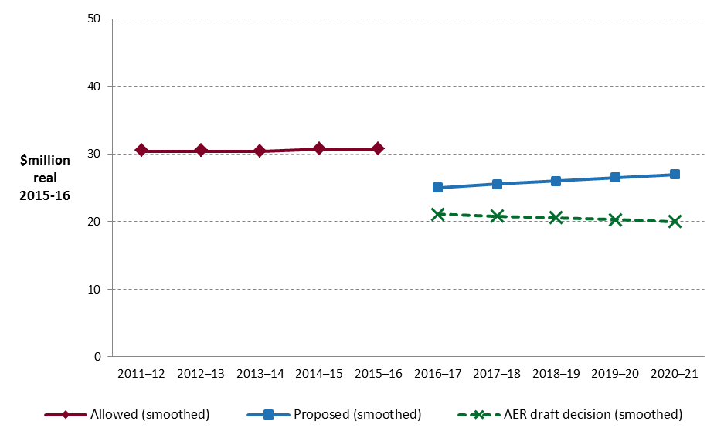

Source: AER analysis.

Note: APTNT did not receive any revenue from reference services in the 2011–16 access arrangement period. Its actual revenue in that period is entirely related to contractual arrangements for a non-reference service. The revenue earned under these contracts is confidential (see: APTNT, Response to AER information request No 12, 12 October 2015).

1. We are satisfied that the forecast revenue requirement set in our draft decision is sufficient for APTNT, acting prudently and efficiently, to recover the costs of investment in, and efficient operation and use of, natural gas services for the long term interests of consumers of natural gas with respect to price, quality, safety, reliability and security of supply of natural gas.[5]

In this section, we provide a snapshot of our draft decision and highlight key issues considered as part of this review (section 2.2). Further discussion of the components that make up our draft decision follows in sections 3 to 6.

Next steps

Our draft decision sets out the nature of the amendments required to make APTNT’s proposal acceptable to us, and provides APTNT with direction where further evidence is required in support of its proposal. APTNT may respond to these in a revised proposal no later than 6 January 2016.

We have made our draft decision with regard to submissions from stakeholders on APTNT’s proposal,[6] and encourage stakeholders to make further submissions on this draft decision, and on APTNT’s revised proposal, by 4 February 2016. Details on how to make a submission are provided at the start of this overview.

## Snapshot of draft decision

Figure 2 and Figure 3 compare our draft decision to APTNT’s proposal, broken down by the building block components that make up the forecast revenue requirement. They highlight that the allowed rate of return—which feeds into the return on capital—is the key difference between our draft decision and APTNT’s proposal.

Figure 2 AER’s draft decision and APTNT’s proposed annual building block costs ($million, 2015–16)

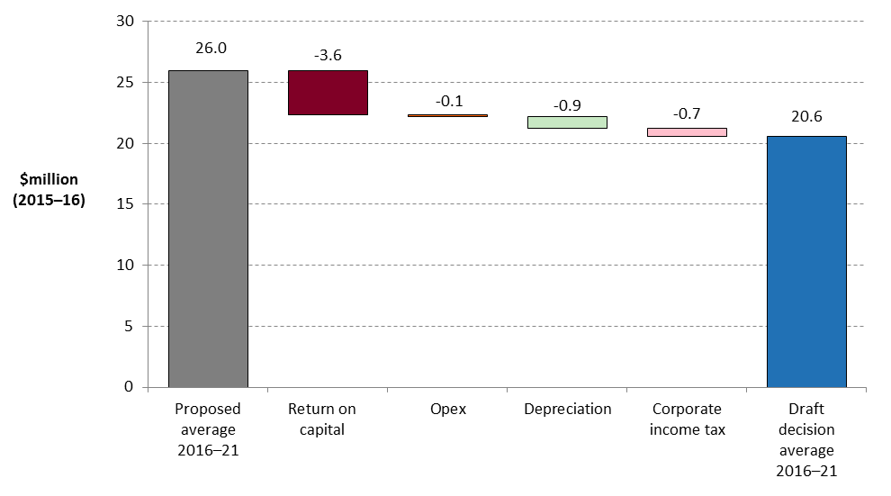

Source: AER analysis.

Figure 3 AER’s draft decision average annual revenue (unsmoothed) compared with APTNT's proposed average annual revenue and approved average annual revenue for 2011–16 ($million, 2015–16)

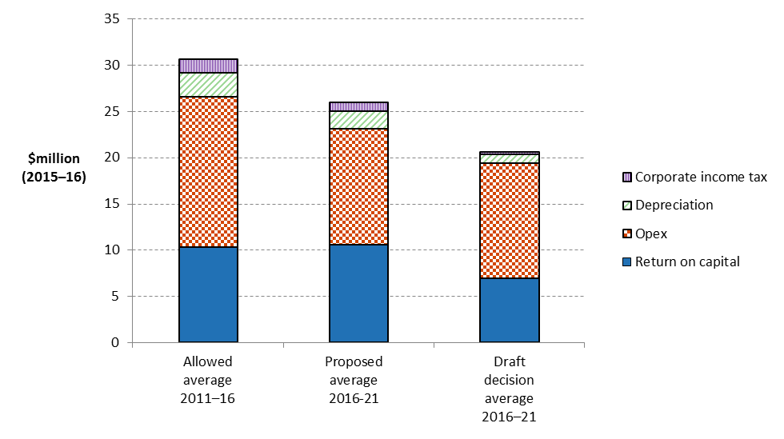

Source: AER analysis; APTNT, Access arrangement revision submission, August 2015, p. 168.

## Key aspects of our draft decision

APTNT has characterised its current and previous access arrangement periods as periods of significant operational changes. It described its proposal for 2016–21 as reflecting a transition to more stable operating and commercial conditions, where most of the necessary integrity works for the AGP are now complete and contractual arrangements for the pipeline are well established. The exception to this—as APTNT has noted—is the anticipated connection of the new North East Gas Interconnector (NEGI) to the AGP, which will link northern gas fields to the Eastern gas market via the AGP.[7]

At the time APTNT submitted its proposal there were a number of uncertainties around what this will mean for the AGP in terms of demand, APTNT’s expenditure requirements, and what this might mean for reference tariffs. These uncertainties remain as we release this draft decision, and are unlikely to be sufficiently resolved before our final decision is made in April 2016. This means we do not have sufficient information on the potential impact of the NEGI on APTNT's costs of operating the AGP to address this in our decision.

Rather than speculate—at the possible expense of APTNT or its users—our draft decision therefore requires APTNT to amend its access arrangement to include a trigger event for acceleration of the review submission date should it become clear that the implications of the NEGI for this access arrangement are substantial. The effect of accelerating the review submission date in this way is to trigger a review of the access arrangement as a whole, at a point when better information is available about the impact connection of the NEGI will have on the operation of the AGP. This will allow us to make a more informed decision on what revisions to the access arrangement may be required.

The total revenue requirement in our draft decision reflects a number of factors:

* the investment environment has improved compared to the previous access arrangement period, which translates to lower financing costs necessary to attract efficient investment (section 2.2.1).
* demand remains steady, with slightly lower growth forecast for 2016–21 than in the current period (section 2.2.2).
* cost savings and efficiencies following APTNT’s integration into the APA Group structure have balanced other increases in operating costs (opex) to keep costs broadly in line with current levels (section 2.2.3).
* after a period of higher capital investment, forecast capex is expected to fall to lower, business-as-usual levels (section 2.2.4).

### Network funding costs are lower

The rate of return provides APTNT with revenue to service the interest on its loans and to give a return on equity to shareholders. The allowed rate of return is a key determinant of the total revenue requirement. The difference between the rate of return we determine and that proposed by APTNT may appear small—a percentage point or two. However, even a small difference can have a big impact on revenues. This is because APTNT has raised large amounts of funds from lenders and other investors in the past, which is to be expected given the capital intensive nature of the sector. These fund raisings have to continue to be financed, as well as financing of any new capital spending.

The rate of return must be commensurate with the efficient financing costs of a benchmark efficient entity with a similar degree of risk to the service provider in respect of the provision of services. The NGR refer to this requirement as the ‘allowed rate of return objective’.

Prevailing market conditions for debt and equity heavily influence the rate of return. Financial conditions have changed since our last decision for APTNT in July 2011, which covered the 2011–16 access arrangement period. This is reflected in a lower rate of return in this draft decision. Interest rates are lower and financial market conditions are more stable. This means that the cost of debt and the returns required to attract equity are lower. These factors are reflected in the rate of return.

Our draft decision is for a rate of return of 6.02 per cent (for 2016–17)[8]—compared to 9.73 per cent in the 2011–16 access arrangement period.

We set out our approach to determining the rate of return in the Rate of Return Guideline (Guideline) we published in December 2013.[9] We undertook extensive consultation in developing the Guideline. Although it is not binding, a service provider must provide reasons to justify any departure from the Guideline.

APTNT proposed a rate of return of 8.30 per cent. It proposed that we depart from the Guideline. We have considered APTNT's arguments and supporting information, but we do not consider that there are reasons for us to depart from the Guideline.

This draft decision on rate of return is consistent with our mid-2015 final decisions for the New South Wales and ACT electricity distribution and transmission, and New South Wales gas distribution, network businesses. Some of these network businesses have appealed many aspects of our rate of return decisions to the Australian Competition Tribunal. The Australian Competition Tribunal’s process had not been finalised at the time of this draft decision.

### Demand remains steady

Demand is an important input to the derivation of APTNT’s reference tariff. This tariff is determined by dividing APTNT's costs (the total revenue requirement approved in this decision), by total demand. An increase in forecast demand has the effect of reducing the tariff price, and vice versa. Our draft decision approves demand forecasts that APTNT has based on historic trends in gas volumes and maximum demand for each delivery point on the AGP, and the drivers for demand at those delivery points. The resulting forecast of approximately 1.7 per cent growth in total demand per annum over the 2016–21 access arrangement period is slightly lower than in the current access arrangement period.

Submissions—from AGL, Jemena and Santos[10]—raised concerns that APTNT’s demand forecasts did not take into account the impact connection of the NEGI to the AGP will have on demand, and therefore the reference tariff for the AGP. This is not something we can reliably predict at this stage. As noted above, our draft decision therefore requires a trigger for acceleration of the review submission date, which will allow APTNT, stakeholders and us to consider the implications of the NEGI for the access arrangement as a whole if necessary.

Demand forecasts also affect forecast opex and capex linked to increased network capacity. APTNT has not proposed to increase the capacity of the AGP during the access arrangement period, and this draft decision does not include expenditure for this purpose.

### Approved operating expenditure in line with current levels

We approve $62.8 million ($2015–16) in opex for the 2016–21 access arrangement period. Our draft decision accepts APTNT's proposed opex forecast, which—but for 'lumpier' expenditure on pigging, which varies from year to year—is for a relatively constant annual expenditure profile. We consider this forecast provides for opex such as would be incurred by a prudent operator acting efficiently, in accordance with accepted good industry practice, to achieve the lowest sustainable cost of providing pipeline services.[11]

In our forecast for 2016–21, past savings from the integration of APTNT into the APA Group and a number of business-wide initiatives have been passed through in a lower, base level of recurrent opex. These savings are offset, however, by expected changes in labour costs and by forecast pigging costs. This results in an eight per cent real increase from APTNT’s actual opex in the current access arrangement period.

### Capital expenditure lower than previous periods

In the current 2011–16 access arrangement period APTNT spent $44.4 million ($2015–16) in capex. This was a significant increase relative to the forecast we approved in 2011, which reflects late changes in APTNT's capex program that were not included on our decision for that access arrangement period.

Our draft decision on total forecast capex for 2016–21, which is an 11.4 per cent reduction from APTNT’s proposal, reflects the reduction in the capex APTNT will require going forward, given the return to more stable operating conditions. We have approved total net forecast capex of $26.5 million ($2015/16), falling from around $9 million in 2016/17 to a stable average of around $4.5 million per annum thereafter until the end of the access arrangement period.

As noted above, steady demand means that APTNT has not proposed to increase the capacity of the AGP during the access arrangement period, and the total forecast capex in this draft decision does not include forecast expenditure for this purpose. Around 70 per cent of our approved forecast capex relates to replacement of system assets. We have also included forecast expenditure for replacement or refurbishment of non-system assets such as motor vehicles, buildings and information technology. Together, we consider our draft decision reflects a forecast of capex such as would be incurred by a prudent operator acting efficiently, in accordance with good industry practice, to maintain the safety, reliability and integrity of the AGP at the lowest sustainable cost.[12]

# Total revenue requirement

1. The total revenue requirement is a forecast of the efficient cost of providing gas transmission services over the access arrangement period. The total revenue set out in this draft decision has been determined by assessing each building block cost of APTNT's access arrangement proposal. We have assessed whether these building block costs are consistent with the costs that would be incurred by an efficient provider of gas transmission services.
2. APTNT's reference tariffs are derived from the total revenue requirement after consideration of demand. APTNT operates under an average tariff cap. This means that the tariff we determine (including the means of varying the tariff from year to year) is the binding constraint across the 2016–21 access arrangement period, rather than the total revenue requirement set in our decision.[13]
3. We note that APTNT’s pipeline is fully committed to a single customer which has negotiated a contract price for the supply of gas.[14] APTNT’s proposed tariff path reflects a 2.5 per cent decrease in tariffs (in nominal terms) in 2016–17 followed by an increase of 2.5 per cent for each subsequent year of the 2016–21 access arrangement period. Our draft decision tariff path produces lower total smoothed revenue than APTNT's proposal, in line with our reductions to total unsmoothed revenue. Our draft decision tariff path provides for a decrease of 18.0 per cent in tariffs (in nominal terms) in 2016–17 and a further decrease of 0.7 per cent for each subsequent year of the 2016–21 access arrangement period.

### The building block approach

1. We have employed the building block approach to determine APTNT's total revenue—that is, we based the total revenue on our estimate of the efficient costs that APTNT is likely to incur in providing gas transmission network services. The building block costs, as shown in Figure 4, include:[15]

* return on the projected capital base (return on capital)
* depreciation of the projected capital base (return of capital)
* the estimated cost of corporate income tax
* forecast opex.

1. Our assessment of capex directly affects the size of the capital base and therefore, the revenue generated from the return on capital and depreciation building blocks.

Figure 4 ****The building block approach for determining total revenue****

Return on capital (forecast capital base × cost of capital)

Regulatory depreciation (depreciation net of indexation applied to capital base)

Corporate income tax (net of value of imputation credits)

Capital costs

Operating expenditure (opex)

Total revenue

### Draft decision

We accept that some aspects of APTNT's proposal are consistent with the requirements of the NGR. However, we have not approved all elements, and as such, have not approved APTNT's access arrangement proposal as a whole.[16]

We do not approve APTNT's proposed total revenue requirement (smoothed) of $140.3 million ($nominal) for reference services over the 2016–21 access arrangement period. Based on our assessment of the building block costs, we determine a total revenue requirement (smoothed) of $110.7 million ($nominal) for APTNT over the 2016–21 access arrangement period. Our draft decision on total revenue has been determined using the building block approach set out in rule 76 of the NGR. This total smoothed revenue requirement is $29.6 million (or 21.1 per cent) lower than APTNT's proposal.

We do not approve APTNT's proposed 2016–21 tariff path, which provides for a real reduction of 4.9 per cent in 2016–17 but then no change in real tariffs over the remaining years of the 2016–21 access arrangement period.[17] As a result of our lower total revenue requirement and accepted demand forecast, our draft decision results in a real tariff decrease of 20.0 per cent in 2016–17, and then further real decreases of 3.1 per cent for each subsequent year of the 2016–21 access arrangement period.

Table 1 sets out our draft decision on APTNT's revenue requirement by building block costs for each year of the 2016–21 access arrangement period, the total revenue after equalisation (smoothing) and the X factors for use in the tariff variation mechanism.

Table 1 AER's draft decision on APTNT's smoothed total revenue and X factors for the 2016–21 access arrangement period ($million, nominal)

|  |  |  |  |  |  |  |
| --- | --- | --- | --- | --- | --- | --- |
| Building block | 2016–17 | 2017–18 | 2018–19 | 2019–20 | 2020–21 | Total |
| Return on capital | 6.7 | 7.3 | 7.5 | 7.7 | 7.9 | 37.2 |
| Regulatory depreciation | 0.7 | 0.9 | 1.0 | 1.2 | 1.4 | 5.2 |
| Operating expenditure | 12.2 | 13.5 | 14.7 | 12.9 | 13.7 | 67.0 |
| Corporate income tax | 0.3 | 0.3 | 0.3 | 0.3 | 0.3 | 1.6 |
| Building block revenue – unsmoothed | 20.0 | 21.9 | 23.6 | 22.1 | 23.4 | 110.9 |
| **Building block revenue – smoothed** | **21.6** | **21.9** | **22.1** | **22.4** | **22.7** | **110.7** |
| X factora | 19.98% | 3.09% | 3.09% | 3.09% | 3.09% | n/a |
| Inflation forecast | 2.50% | 2.50% | 2.50% | 2.50% | 2.50% | n/a |
| Nominal price change | –17.98% | –0.67% | –0.67% | –0.67% | –0.67% | n/a |

Source: AER analysis.

n/a: not applicable.

(a) Under the CPI–X form of control, a positive X factor is a decrease in price (and therefore in revenue).

The X factor for 2016–17 is indicative only. The draft decision establishes 2016–17 tariffs directly, rather than referencing a change from 2015–16 tariffs.

### Total revenue

1. Figure 5 shows the effect of our draft decision adjustments on APTNT's proposed building blocks for the 2016–21 access arrangement period. It shows the reductions to APTNT's proposed return on capital, opex, depreciation and tax building blocks.

Figure 5 AER’s draft decision and APTNT's proposed building block revenue (unsmoothed) ($million, nominal)

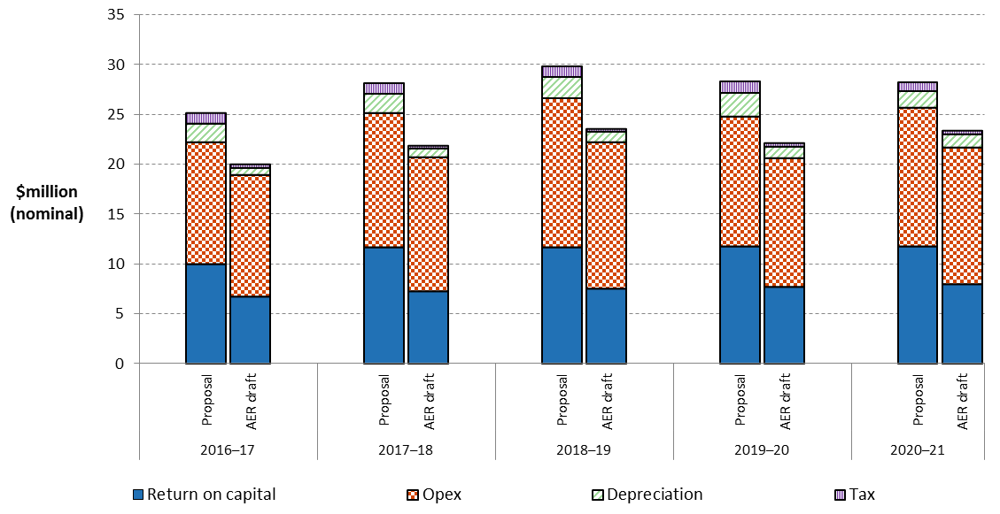

Source: AER analysis.

### Revenue equalisation (smoothing) and tariffs

1. After our assessment of APTNT’s total building block revenue (unsmoothed revenue), we need to determine the smoothed revenue profile across the 2016–21 access arrangement period. APTNT operates under an average tariff cap[18] as its tariff variation mechanism. This means we determine the average tariff change each year such that the net present value (NPV) of unsmoothed and smoothed revenue is equal across the entire period. This average tariff change is labelled the 'X factor'. The mechanics of the tariff variation mechanism are addressed in attachment 11.
2. Table 2 presents our draft decision X factors, and compares them to APTNT’s proposal.

Table 2 Average tariff change across the access arrangement period (X factors) — comparison of APTNT's proposal and AER's draft decision (per cent)

|  |  |  |  |  |  |
| --- | --- | --- | --- | --- | --- |
|  | 2016–17 | 2017–18 | 2018–19 | 2019–20 | 2020–21 |
| **AER draft decision** |  |  |  |  |  |
| X factora | 19.98% | 3.09% | 3.09% | 3.09% | 3.09% |
| Nominal price change | –17.98% | –0.67% | –0.67% | –0.67% | –0.67% |
| **APTNT proposal** |  |  |  |  |  |
| X factor | 4.92% | 0.00% | 0.00% | 0.00% | 0.00% |
| Nominal price change | –2.54% | 2.50% | 2.50% | 2.50% | 2.50% |

Source: APTNT, Proposed PTRM, August 2015; AER analysis.

(a) Under the CPI–X form of control, a positive X factor is a decrease in price (and therefore in revenue). For example, an X factor of 3.09 per cent in 2017–18 means a real price decrease of 3.09 per cent that year. After consideration of inflation (assumed at 2.5 per cent) this becomes a nominal price decrease of 0.67 per cent. The X factor for 2016–17 is indicative only. The draft decision establishes 2016–17 tariffs directly, rather than referencing a change from 2015–16 tariffs.

1. Figure 6 shows indicative tariff paths for APTNT's reference services across the 2011–21 period. It compares APTNT's proposed tariff path with that approved in the 2011–16 access arrangement, and with this draft decision.[19] This provides a broad overall indication of the average movement across this period.
2. Table 3 shows the indicative tariffs for APTNT's reference services across the 2016–21 access arrangement period. It compares the proposed tariffs with those approved for this draft decision.

Figure 6 Indicative reference tariff paths for APTNT's reference services from 2011 to 2021 (nominal index)

1. 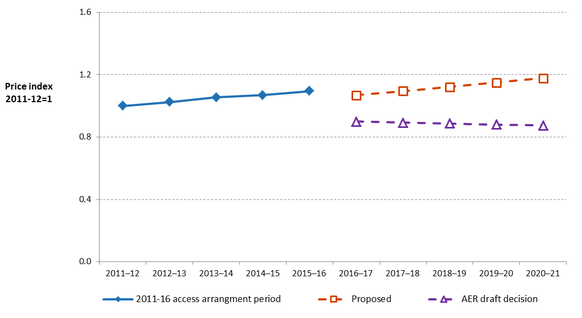

Source: AER analysis.

Table 3 Indicative reference tariffs across the access arrangement period — comparison of APTNT's proposal and AER's draft decision ($/GJ)

|  |  |  |  |  |  |  |
| --- | --- | --- | --- | --- | --- | --- |
|  | 2015–16 | 2016–17 | 2017–18 | 2018–19 | 2019–20 | 2020–21 |
| **AER draft decision** |  |  |  |  |  |  |
| Reference tariff | 0.7076 | 0.5804 | 0.5765 | 0.5726 | 0.5688 | 0.5650 |
| Nominal change |  | –17.98% | –0.67% | –0.67% | –0.67% | –0.67% |
| **APTNT proposal** |  |  |  |  |  |  |
| Reference tariff | 0.7076 | 0.6896 | 0.7068 | 0.7245 | 0.7426 | 0.7612 |
| Nominal change |  | –2.54% | 2.50% | 2.50% | 2.50% | 2.50% |

1. Source: APTNT, Proposed PTRM, August 2015; AER analysis.

(a) Approved reference tariff for 2015–16 (see: AER, Approval letter: Amadeus Pipeline annual tariff variation 2015–16, 20 May 2015).

1. APTNT’s proposed tariff path reflected a decrease of 2.5 per cent in tariffs (in nominal terms) in 2016–17, followed by an increase of 2.5 per cent for each subsequent year of the 2016–21 access arrangement period. Our draft decision provides for lower total smoothed revenue than APTNT's proposal, in line with our reductions to total unsmoothed revenue. As such, a decrease to the tariff path is required over the 2016–21 access arrangement period to reflect the lower smoothed revenue than provided for in the 2011–16 access arrangement period. Our draft decision tariff path shows a decrease of 18.0 per cent in tariffs (in nominal terms) in 2016–17 and a further decrease of 0.7 per cent for each subsequent year of the 2016–17 access arrangement period.

In choosing the smoothing profile for this draft decision we have balanced a number of competing objectives:

* Equalising (in NPV terms) unsmoothed and smoothed revenue
* Providing price signals that reflect the underlying efficient costs
* Minimising variability in tariffs in 2015–16 and within the 2016–21 access arrangement period
* Minimising the likelihood of variability in tariffs at the start of the 2021–26 access arrangement period.

Each of these points is discussed in turn.

First, we are satisfied that our draft decision tariff path for APTNT's 2016–21 access arrangement period achieves revenue equalisation as required by rule 92(2) of the NGR.[20] As set out above, we have made substantial reductions to the unsmoothed revenue proposed by APTNT. Accordingly, we set the tariff path so that it adjusts the smoothed revenue downward to better reflect the unsmoothed building block costs.

Second, but closely related to the first point, our smoothing allows closer alignment of tariffs and costs. This aids the achievement of the NGO and the revenue and pricing principles, including through providing a price signal that facilitates efficient use of natural gas services.[21] Our draft decision tariff path shows a large decrease in the first year of the 2016–21 access arrangement period reflecting the lower unsmoothed building block costs.

Third, in setting the tariff path, we aim to minimise tariff volatility in 2015–16 and within the 2016–21 access arrangement period. Our chosen tariff path reflects this objective, but also reflects the consideration we must give to other competing objectives. For instance, setting a flat tariff path from 2015–16 would better minimise within-period volatility, but would not achieve revenue equalisation.

Fourth, in setting the tariff path, we also aim to minimise the likelihood of tariff volatility between this access arrangement period and the next. We do not know with certainty what APTNT's efficient costs will be in 2021–22, or across the 2021–26 access arrangement period more generally. The unsmoothed building block costs for 2020–21 (the last year of the 2016–21 access arrangement period) are the best available proxy. Hence, this objective requires minimising the divergence between the smoothed and unsmoothed revenues for the last year of the access arrangement period—for APTNT, this is 2020–21. If there were no significant changes in forecast costs from 2020–21 to 2021–22, this final year divergence gives us an estimate of the size of the tariff change at the start of the 2021–26 access arrangement period. For this draft decision, this final year divergence is 3 per cent, which is consistent with our usual target. We note that if there are significant changes in costs at the start of the 2021–26 access arrangement period, this might increase or decrease the required tariff change at that time.

We are satisfied that our draft decision tariff path reflects our balanced consideration of these competing objectives. We will review this smoothing profile for the final decision if necessary.

# Key elements of decision on APTNT’s revenue

The components of our decision include the building blocks we use to determine the revenue APTNT may recover from its customers.

In setting our overall total revenue requirement for APTNT of $110.9 million ($nominal, unsmoothed) for the 2016–21 access arrangement period we:

* apply relevant tests under the NGR, the assessment methods and tools developed as part of our Better Regulation guidelines.[22] We considered information provided by APTNT, consultants and stakeholder submissions.
* consider our overall revenue decision against section 23 of the NGL, including the individual components and relationships we discuss in section 7.

The following section summarises our decision by building block and provides a summary of our reasons and analysis. The attachments to this draft decision provide the detailed explanation of our analysis and findings.

## Capital base

We are required to make a decision on APTNT's opening capital base as at 1 July 2016 for the 2016–21 access arrangement period. We are also required to make a decision on APTNT's projected capital base for the 2016–21 access arrangement period.

The capital base roll forward accounts for the value of APTNT's regulated assets over the access arrangement period. The level of the capital base substantially impacts the service provider's revenue and the price that users ultimately pay. It is an input into the determination of the return on capital and depreciation (return of capital).[23] Other things being equal, a higher capital base increases both the return on capital and depreciation allowances. In turn, it increases the service provider's revenue, and prices for its services.

We do not approve APTNT's proposed opening capital base of $120.6 million ($nominal) as at 1 July 2016. We determine an opening capital base of $112.2 million ($nominal) as at 1 July 2016, which is $8.4 million ($nominal) or 7.0 per cent less than that proposed by APTNT. This is because we have made several amendments to APTNT’s proposed roll forward model (RFM) to correct some input errors. We also updated the conforming capex input in line with our draft decision on APTNT’s conforming capex for 2011–16 (discussed below in section 4.5).

Table 4 summarises our draft decision on the roll forward of APTNT's capital base during the 2011–16 access arrangement period.

Table 4 AER's draft decision on APTNT's capital base roll forward for the 2011–16 access arrangement period ($million, nominal)

|  | 2011–12 | 2012–13 | 2013–14 | 2014–15 | 2015–16 |
| --- | --- | --- | --- | --- | --- |
| Opening capital base | 92.1 | 92.7 | 106.1 | 107.6 | 107.4 |
| Net capex | 4.3 | 16.5 | 4.0 | 4.2 | 8.2 |
| Indexation of capital base | 1.5 | 2.3 | 3.1 | 1.4 | 2.7 |
| Depreciation | –5.1 | –5.4 | –5.6 | –5.9 | –3.4 |
| Closing capital base | 92.7 | 106.1 | 107.6 | 107.4 | 114.9 |
| Adjustment for difference between estimated and actual capital expenditure in 2010–11 |  |  |  |  | –2.7 |
| **Opening capital base at 1 July 2016** |  |  |  |  | 112.2 |

Source: AER analysis.

We also do not approve APTNT’s proposed projected capital base of $142.6 million ($nominal) as at 30 June 2021. We instead determine a closing capital base of $135.8 million ($nominal) as at 30 June 2021, a reduction of $6.8 million or 4.8 per cent from the proposed value. The main reasons for the reduction are our adjustments—also reductions—to APTNT's opening capital base as at 1 July 2016 (discussed above), forecast net capex (see section 4.5) and depreciation (see section 4.4).

Table 5 sets out the projected roll forward of the capital base during the 2016–21 access arrangement period.

Table 5 AER's draft decision on projected capital base roll forward for the 2016–21 access arrangement period ($million, nominal)

|  | 2016–17 | 2017–18 | 2018–19 | 2019–20 | 2020–21 |
| --- | --- | --- | --- | --- | --- |
| Opening capital base | 112.2 | 120.7 | 124.7 | 128.4 | 132.1 |
| Net capex | 9.3 | 4.9 | 4.7 | 4.9 | 5.1 |
| Indexation of capital base | 2.8 | 3.0 | 3.1 | 3.2 | 3.3 |
| Depreciation | –3.5 | –3.9 | –4.1 | –4.4 | –4.7 |
| Closing capital base | 120.7 | 124.7 | 128.4 | 132.1 | 135.8 |

Source: AER analysis.

The capital base at the commencement of the 2021–26 access arrangement period will be subject to adjustments consistent with the NGR.[24] The adjustments include (but are not limited to) actual inflation and approved depreciation over the 2016–21 access arrangement period. We accept APTNT’s proposal to use forecast depreciation for the 2016–21 access arrangement period to establish APTNT’s opening capital base as at 1 July 2021

## Rate of return (return on capital)

1. The return on capital provides APTNT with revenue to service the interest on its loans and give a return on equity to shareholders. The return on capital building block is calculated as a product of the rate of return and the value of the capital base.[25]
2. The NGR set out that the allowed rate of return must be commensurate with the efficient financing costs of a benchmark efficient entity with a similar degree of risk as that which applies to the distributor in respect of the provision of distribution services. The NGR refer to this requirement as the 'allowed rate of return objective'.[26]
3. We have determined an allowed rate of return of 6.02 per cent (for 2016–17, nominal vanilla).[27] We have not accepted APTNT’s proposed 8.30 per cent rate of return. In accordance with the Rate of Return Guideline, we will update the rate of return annually.[28] Table 6 sets out the parameters we have used to determine the rate of return.

Table 6 AER's draft decision on APTNT’s rate of return (nominal)

|  |  |  |  |  |
| --- | --- | --- | --- | --- |
|  | AER previous decision  (2011–16) | APTNT proposal  (2016–17)(a) | AER draft decision  (2016–17) | Return over  2016–21 access arrangement period |
| Return on equity (nominal post–tax) | 10.33% | 9.20% | 7.3% | Remains constant (7.3%) |
| Return on debt (nominal pre–tax) | 9.33% | 7.70% | 5.16% | Updated annually |
| Gearing | 60% | 60% | 60% | Remains constant (60%)(b) |
| Nominal vanilla WACC | 9.73% | 8.30% | 6.02% | Updated annually as return on debt is updated |
| Forecast inflation | 2.55% | 2.50% | 2.50% | Remains constant (2.50%) |

Source: AER analysis; APTNT, Amadeus Gas Pipeline Access Arrangement Information Effective 1 July 2016 - 30 June 2021, August 2015, p. 34; AER, Final decision - Public: N.T. Gas Access Arrangement Proposal for the Amadeus Gas Pipeline 1 August 2011 to 30 June 2016, July 2011, p. 80.

(a) APTNT's revised proposal uses values derived from the placeholder averaging periods for risk free rate and rate on debt.

(b) This rate will be updated in the final decision because our draft decision rate is based on a placeholder averaging period. However, after the rate is updated for the final decision it will then 'remain constant' for the access arrangement period and will not be updated each regulatory year.

1. Our approach
2. All NGR requirements relating to the rate of return are subject to the overall rate of return achieving the allowed rate of return objective.[29] The NGR recognise that there may be several plausible answers that could achieve the allowed rate of return objective. We agree with stakeholders that predictability and consistency in our approach to rate of return issues, consistent with prevailing market conditions, materially benefits the long term interests of consumers and also benefits investors.[30]

We developed our approach prior to the submission of APTNT’s proposal. As required by the rate of return framework, in December 2013 we published the Guideline.[31] The Guideline was developed through extensive consultation and involved effective and inclusive stakeholder participation.[32]

Return on debt

Previously, we used an on-the-day approach to determine the return on debt.[33] This is the approach that several Australian regulators continue to use. We have determined a return on debt estimate that gradually transitions from an on-the-day approach to a trailing average approach.[34] This is consistent with the approach most stakeholders supported during the Guideline development process.

In its proposal, APTNT proposed a hybrid transition from the on–the–day to trailing average approach. We have not accepted APTNT’s proposal, because we consider it is backward looking and produces a biased estimate of the return on debt. We discuss this more extensively in attachment 3 ─ rate of return.

Return on equity

1. Our approach to determining the return on equity involves considering all of the information before us, through a six step process as set out in the Rate of Return Guideline (foundation model approach). This includes detailed consideration of a number of financial models for determining the return on equity.[35] Considering all of this material helps inform a return on equity estimate that contributes to the achievement of the allowed rate of return objective.
2. Notwithstanding the approach set out in the guideline, APTNT proposed a multi-model approach to calculating the return on equity.
3. We consider that the Sharpe–Lintner capital asset pricing model (SLCAPM) is the superior financial model in terms of estimating expected equity returns. We have therefore adopted this model as our foundation model. We are persuaded by the evidence before us that also indicates that, on balance, employing our foundation model approach and using the SLCAPM as the foundation model is expected to lead to a rate of return that achieves the allowed rate of return objective.[36]

We also evaluated our point estimate from the SLCAPM against other information. The critical allowance for an equity investor in a benchmark efficient entity is the allowed equity risk premium (ERP) over and above the estimated risk free rate at any given time.[37] Our estimate of the ERP for the benchmark efficient entity is 4.55 per cent which is within the range of other information available to inform the return on equity (see Figure 7). A detailed explanation of our findings on return on equity and this figure can be found attachment 3 ─ Rate of return.

Figure 7 Other information comparisons with the AER allowed equity risk premium

Source: AER analysis and various submissions and reports.

Notes: The AER foundation model equity risk premium (ERP) range uses the range and point estimate for MRP and equity beta as set out in step three. The calculation of the Wright approach, debt premium, brokers, and other regulators ranges is outlined in Attachment 3, Appendices E.1, E.2, E.4, and E.5 respectively.

Grant Samuel's final WACC range included an uplift above an initial SLCAPM range. The lower bound of the Grant Samuel range shown above excludes the uplift while the upper bound includes the uplift and is on the basis that it is an uplift to return on equity. Grant Samuel made no explicit allowance for the impact of Australia's dividend imputation system. We are uncertain as to the extent of any dividend imputation adjustment that should be applied to estimates from other market practitioners. Accordingly, the upper bound of the range shown above includes an adjustment for dividend imputation, while the lower bound does not. The upper shaded portion of the range includes the entirety of the uplift on return on equity and a full dividend imputation adjustment.[38]

The service provider proposals range is based on the proposals from businesses for which we are making final or preliminary/draft decisions in October-November 2015.[39] Equity risk premiums were calculated as the proposed return on equity less the risk free rate utilised in the service provider's proposed estimation approach.

The CCP/stakeholder range is based on submissions made (not including service providers) in relation to our final or preliminary/draft decisions in October-November 2015. The lower bound is based on the Alliance of Electricity Consumers submission on Energex and Ergon Energy revised proposals. The upper bound is based on Origin Energy’s submission on the preliminary decision for SA Power Networks.[40]

## Value of imputation credits (gamma)

1. Under the Australian imputation tax system, investors can receive an imputation credit for income tax paid at the company level.[41] These are received after company income tax is paid, but before personal income tax is paid. For eligible investors, this credit offsets their Australian income tax liabilities. If the amount of imputation credits received exceeds an investor's tax liability, that investor can receive a cash refund for the balance. Imputation credits are therefore a benefit to investors in addition to any cash dividend or capital gains they receive from owning shares.
2. In determining a service provider's total revenue, the NGR require that the estimated cost of corporate income tax be estimated in accordance with a formula that reduces the estimated cost by the 'value of imputation credits'.[42] That is, the revenue a service provider recovers from customers in respect of its expected tax liability must be reduced in a manner consistent with the value of imputation credits.

Our draft decision is to adopt a value of imputation credits of 0.4. This differs from APTNT’s proposed value of imputation credits of 0.25.

1. Although we have broadly maintained the approach to determining the value of imputation credits set out in the Rate of Return Guideline, we have re-examined the relevant evidence and estimates since publishing our Guideline. This re-examination, and new evidence and advice considered since the Guideline was published, led us to depart from the value of 0.5 in the Guideline. Most notably, our updated consideration of the relevant advice and evidence led us to generally lower estimates of the ‘utilisation rate’ from the 0.7 estimate in the Guideline.
2. Estimating the value of imputation credits is a complex and somewhat imprecise task. There is no consensus among experts on the appropriate value or estimation techniques to use.
3. Consistent with the relevant academic literature, we estimate the value of imputation credits as the product of the distribution rate and the utilisation rate. While there is a widely accepted approach to estimating the distribution rate, there is no single accepted approach to estimating the utilisation rate. There is a range of evidence relevant to the utilisation rate:

* the proportion of Australian equity held by domestic investors (the 'equity ownership approach')
* the reported value of credits utilised by investors in Australian Taxation Office (ATO) statistics ('tax statistics')
* implied market value studies—there is no separate market in which imputation credits are traded, and therefore there is no observable market price for imputation credits.

1. In estimating the utilisation rate, we place:

* significant reliance upon the equity ownership approach
* some reliance upon tax statistics
* less reliance upon implied market value studies.

1. Overall, the evidence on the distribution rate and the utilisation rate suggests that a reasonable estimate of the value of imputation credits is within the range of 0.3 to 0.5. From within this range, we choose a value of 0.4. This is because:

* the equity ownership approach, on which we have placed the most reliance, suggests a value between 0.40 and 0.47 when applied to all equity and between 0.29 and 0.42 when applied to only listed equity. Therefore, the overlap of the evidence from the equity ownership approach suggests a value between 0.40 and 0.42.
* the evidence from tax statistics suggests the value could be lower than 0.4. Therefore, with regard to this evidence and the less reliance we place on it, we choose a value at the lower end of the range suggested by the overlap of evidence from the equity ownership approach (that is, 0.4).
* an estimate of 0.4 is reasonable in light of both higher and lower estimates from implied market value studies and the lesser degree of reliance we place on these studies. The service providers submitted evidence to support placing more reliance on SFG’s dividend drop off study relative to other implied market value studies. However, we consider that neither the difference from 0.4 of the estimate from this study (0.31) nor any increased reliance we might place on it relative to other implied market value studies are sufficient to warrant an estimate lower than 0.4.

## Regulatory depreciation (return of capital)

Regulatory depreciation is a building block component of the annual building block revenue requirement.[43] When determining the total revenue for APTNT, we must decide on the depreciation for the projected capital base (otherwise referred to as ‘return of capital’).[44] Regulatory depreciation is used to model the nominal asset values over the 2016–21 access arrangement period and the depreciation forecast in the total revenue requirement.[45]

Ultimately, a service provider can only recover the capex it has incurred on assets once. The depreciation forecast reflects how quickly the capital base is being recovered, and is based on the remaining and standard asset lives used in the depreciation calculation. Higher (or quicker) depreciation leads to higher revenues over the access arrangement period. It also causes the capital base to reduce more quickly (assuming no further capex). This reduces the return on capital building block, although this impact is usually less than that of the increased depreciation forecast.

In making a decision on the proposed depreciation schedule, we assess the compliance of the proposed depreciation schedule with the depreciation criteria set out in the NGR.[46] We must also take into account the NGO and the revenue and pricing principles.[47] If a proposed depreciation schedule complies with the NGR, we must approve it.

Our draft decision is to approve APTNT’s proposal to use the real straight-line method to calculate the regulatory depreciation allowance. However, we do not approve APTNT’s proposed regulatory depreciation forecast of $10.2 million ($nominal) for the 2016–21 access arrangement period. Our draft decision on APTNT’s regulatory depreciation forecast is $5.2 million ($nominal) over the 2016–21 access arrangement period, a reduction of $5.0 million ($nominal) or 49.1 per cent compared to the proposed amount. This is set out in Table 7.

Table 7 AER’s draft decision on APTNT’s regulatory depreciation for the 2016–21 access arrangement period ($million, nominal)

|  |  |  |  |  |  |  |
| --- | --- | --- | --- | --- | --- | --- |
|  | 2016–17 | 2017–18 | 2018–19 | 2019–20 | 2020–21 | Total |
| Straight-line depreciation | 3.5 | 3.9 | 4.1 | 4.4 | 4.7 | 20.6 |
| Less: indexation on capital base | 2.8 | 3.0 | 3.1 | 3.2 | 3.3 | 15.5 |
| **Regulatory depreciation** | **0.7** | **0.9** | **1.0** | **1.2** | **1.4** | **5.2** |

Source: AER analysis.

This reduction to APTNT's proposal is required because of:

* our required updates to the proposed remaining asset lives as at 1 July 2016
* our draft decision to not depreciate forecast land and easement capex. Land assets (and easement related purchases) do not depreciate and therefore should not have a standard asset life for depreciation purposes. This approach is consistent with Australian accounting standards and the ATO's treatment for such assets.[48]
* our draft decision on other components of APTNT’s proposal, which also affect the calculation of forecast regulatory depreciation. These include our reductions to forecast capex (see section 4.5) and APTNT's opening capital base (see section 4.1).

## Capital expenditure

Capital expenditure (capex) refers to the capital expenses incurred in the provision of pipeline services. The return on and of forecast capex for reference services are two of the building blocks we use to determine a service provider's total revenue requirement.

We must make two decisions regarding APTNT’s capex. First, we are required to assess past capex and determine whether it meets the criteria set out in the NGR to be added to the starting capital base.[49] Where capex meets these criteria, it is referred to as "conforming capex".[50] Secondly, we are required to assess APTNT’s forecast of required capex for the 2016–21 access arrangement period to determine whether it is conforming capex. Figure 8 compares APTNT’s actual/estimated capex for the current access arrangement period and its forecast capex for 2016–21 to our draft decision on conforming capex.

Figure 8 APTNT actual, estimated and forecast capex and AER draft decision conforming capex ($2015-16)



Source: AER analysis; APTNT, Attachment B-6 Supporting model – Capital expenditure, August 2015.

APTNT submitted $44.4 million ($2015–16) of capex from the current period, and a forecast of $29.9 million ($2015–16) for 2016–21. Our draft decision approves $37.4 million ($2015-16) for the 2011–16 access arrangement period and total net capex of $26.5 million for 2016–21.

The reasons for the difference between APTNT’s proposal and our draft decision are:

* We have redistributed $7.0 million of APTNT’s estimated capex for belowground station pipework recoating project in the final year of the current period (2015–16), by reallocating it across forecast capex for the 2016–21 access arrangement period.
* We are not satisfied that APTNT’s forecast capex of $10.9 million ($2015–16) for the Channel Island bridge project is such as would be incurred by a prudent service provider acting efficiently to achieve the lowest sustainable cost of providing services. We consider that forecast capex of $1.1 million is a reasonable estimate of conforming capex for this project.
* APTNT’s forecast capex has not accounted for the proceeds from expected disposals of motor vehicle assets in the 2016–21 access arrangement period. Our approved forecast deducts this amount ($0.7 million, $2015–16) from total forecast capex.
* We have not accepted APTNT’s forecast of real labour cost escalation, and have substituted a lower forecast. This reduces total forecast capex by another $0.2 million ($2015–16).

Table 8 sets out our draft decision on APTNT’s forecast capex, a reduction of 11.4 per cent from its proposal.

Table 8 Comparison of AER approved and APTNT’s proposed capital expenditure over the 2016–21 access arrangement period ($million, 2015-16)

| Category | Proposed | Approved(a) | Difference ($millions) | Difference (%) |
| --- | --- | --- | --- | --- |
| Expansion | - | - | - | - |
| Replacement | 21.2 | 18.5 | -2.7 | -13% |
| Non-system | 8.7 | 8.7 | -0.1 | -1% |
| GROSS TOTAL CAPITAL EXPENDITURE | 29.9 | 27.2 | -2.8 | -9% |
| Contributions | - | - | - | - |
| Asset disposals | - | 0.7 | 0.7 | N/A |
| NET TOTAL CAPITAL EXPENDITURE | 29.9 | 26.5 | -3.4 | -11% |

Source: AER analysis.

Note: (a) Including AER labour escalation adjustments.

We have set out our reasons for our draft decision on confirming capex for 2011–16 and 2016–21 in attachment 6.

## Operating expenditure

We accept APTNT’s total forecast opex of $62.8 million ($2015–16) for the 2016–21 access arrangement period. Table 9 shows our approved opex forecast—which we consider is such as would be incurred by a prudent service provider acting efficiently, in accordance with accepted good industry practice, to achieve the lowest sustainable cost of delivering pipeline services.[51]

Table 9 AER draft decision on total opex—APTNT ($million, 2015–16)

|  | 2016–17 | 2017–18 | 2018–19 | 2019–20 | 2020–21 | Total |
| --- | --- | --- | --- | --- | --- | --- |
| APTNT's proposal | 11.9 | 12.9 | 13.9 | 11.8 | 12.3 | 62.8 |
| AER draft decision | 11.9 | 12.9 | 13.9 | 11.8 | 12.3 | 62.8 |
| Difference | – | – | – | – | – | – |

Source: APTNT, 2016-21 Access arrangement information, August 2015 – Opex model; AER analysis.

This allows an eight per cent real increase from APTNT’s actual opex in the current access arrangement period. APTNT underspent relative to its opex forecast in 2011–16. Savings—in labour costs associated with integration into the APA Group structure, and efficiencies associated with business wide initiatives such as consolidation of engineering and finance resources—are reflected in the base year from which opex for 2016–21 has been forecast. However, these are offset by the following factors, which necessitate an increase from the current period to accommodate:

* Forecast changes in labour costs (but no real price changes to materials)
* Pigging costs, including for delays and deferrals to the pigging schedule from the current access arrangement period to 2016–21.

Figure 9 compares forecast opex for the 2016–21 period to APTNT’s allowed and actual opex in 2011–16.

Figure 9 APTNT’s historical and forecast opex ($million, 2015–16)

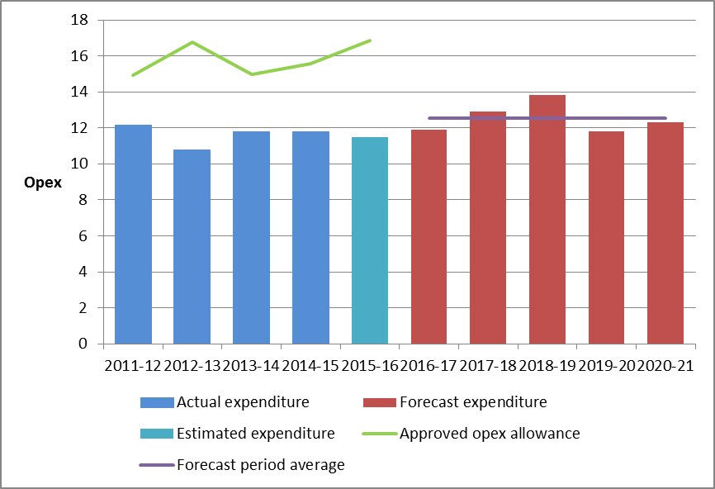

Source: APTNT, 2016-21 Access arrangement information, August 2015 – Opex model; APTNT, RIN response, August 2015.

## Corporate income tax

When determining the total revenue for APTNT, we must estimate APTNT’s cost of corporate income tax.[52] APTNT has adopted the post-tax framework to derive its total revenue requirement for the 2016–21 access arrangement period.[53] Under the post-tax framework, a separate corporate income tax building block is calculated, based on the estimated cost of corporate income tax less the value of imputation credits. The corporate income tax building block feeds directly into the annual revenue requirement.

Our draft decision on APTNT’s corporate income tax building block over the 2016–21 access arrangement period is $1.6 million ($nominal), as set out in Table 10. This represents a reduction of $3.6 million ($nominal) or 69 per cent of APTNT’s proposed corporate income tax building block.

Table 10 AER’s draft decision on the corporate income tax building block for APTNT for the 2016–21 access arrangement period ($million, nominal)

|  |  |  |  |  |  |  |
| --- | --- | --- | --- | --- | --- | --- |
|  | 2016–17 | 2017–18 | 2018–19 | 2019–20 | 2020–21 | Total |
| Tax payable | 0.5 | 0.5 | 0.5 | 0.5 | 0.5 | 2.7 |
| Less: value of imputation credits | 0.2 | 0.2 | 0.2 | 0.2 | 0.2 | 1.1 |
| **Net corporate income tax building block** | **0.3** | **0.3** | **0.3** | **0.3** | **0.3** | **1.6** |

Source: AER analysis.

We accept APTNT’s proposed approach to calculating the corporate income tax building block. The difference between our draft decision and APTNT’s proposal is mainly a consequence of our adjustments to:

* the opening tax asset base as at 1 July 2016, from APTNT’s proposed $37.2 million ($nominal) as at 1 July 2016 to $35.5 million ($nominal)
* remaining tax asset lives as at 1 July 2016, and the addition of the new asset class for ‘Land and easement’ (see section 4.4)
* the value of gamma, from 0.25 to 0.40 (see section 4.3)
* other building block components, including reductions made in this draft decision to the rate of return, forecast capex and forecast opex (see sections 0, 4.5 and 4.6, respectively).[54]

# Demand, reference tariffs and incentive schemes

## Demand

Demand is an important input to the derivation of APTNT’s reference tariffs. Tariff prices depend on estimates of total demand (GJ/day). Changes in these forecasts will translate into changed tariff prices. In simple terms, tariff prices are determined by cost divided by total demand (GJ/day), such that an increase in forecast demand has the effect of reducing the tariff price and vice versa.

Demand forecasts also affect capex and opex linked to increased network capacity. However, APTNT has not proposed to increase the capacity of the AGP during the access arrangement period.

APTNT proposed demand forecasts based on historic trends in gas volumes and maximum demand for each delivery point on the AGP, and the drivers for demand at those delivery points. Our draft decision approves APTNT's demand forecasts per annum over the 2016–21 access arrangement period. We consider APTNT has arrived at this forecast on a reasonable basis, and are satisfied that it represents the best forecast or estimate possible in the circumstances.

Submissions from AGL, Santos and Jemena raised concerns that APTNT’s demand forecasts do not take into account the impact connection of the NEGI to the AGP will have on demand. We agree with APTNT that there is not sufficient information to reliably forecast the impact of the NEGI on the demand forecasts at this time. We do, however, consider there is merit in providing for a further review of the access arrangement when the implications of the NEGI for services provided on the AGP are more certain. As discussed in section 2 of this overview (and further in attachment 12), our draft decision therefore requires a trigger for acceleration of the review submission date, which will allow APTNT, stakeholders and us to consider the implications of the NEGI for the access arrangement as a whole, when sufficient information becomes available.

## Services covered by the access arrangement

Our draft decision accepts the services APTNT proposes to offer on its network over the 2016–21 access arrangement period:

* the firm service as the only reference service
* the non‑reference services:
* interruptible service
* negotiated services.[55]

We accept APTNT’s proposed reference service (the firm service) as we consider it will be sought by a significant part of the market.[56] This means it must be covered by the access arrangement.

We agree with APTNT that the interruptible service and negotiated service are non‑reference services as they are not likely to be sought by a significant part of the market and should not be specified as reference services.[57]

The reasons for our draft decision are set out in attachment 1.

## Reference tariff setting

Our draft decision accepts APTNT’s proposed reference tariff structure for the 2016–21 access arrangement period. We are satisfied the proposed structure of the reference tariffs complies with the requirements of the NGR. [58] The tariff structure is consistent with that applied in the current access arrangement. However, we consider the quantum of the proposed reference tariff must be amended to reflect the revised revenue allowance based on this draft decision.

The reasons for our draft decision are set out in attachment 10.

## Reference tariff variation mechanism

The reference tariff variation mechanism:

* permits building block revenues to be recovered smoothly over the access arrangement period, subject to any differences between forecast and actual demand
* accounts for actual inflation
* accommodates other reference tariff variation adjustments that may be required, such as approved cost pass through events, and
* sets administrative procedures for the approval of any proposed changes to reference tariffs.

Our draft decision does not accept APTNT’s proposed reference tariff mechanism for the 2016–21 access arrangement period.

* We do not accept the proposed initial reference tariff and X factors must be revised to reflect the changes to the forecast total revenue.
* We do not accept APTNT’s proposed approach for the annual update of return on debt under the tariff variation mechanism.
* We have amended the tariff variation mechanism to include an adjustment factor to accommodate adjustments for an approved pass through event.
* We accept APTNT’s proposed tax change event, but require amendments to its proposed definitions of the regulatory change event, service standard event, terrorism event, natural disaster event, insurer credit risk event and insurance cap event.

The reasons for our draft decision are set out in attachment 11.

## Efficiency carryover mechanism

A full access arrangement, such as APTNT’s, may include (and we may require it to include) one or more incentive mechanisms to encourage efficiency in the provision of services by the service provider.[59]

APTNT’s current access arrangement for the AGP does not include an efficiency carryover mechanism, and did not propose one for 2016–21. For the 2016–21 access arrangement period, our draft decision is to introduce this mechanism. This will provide additional incentives for APTNT to pursue efficiency improvements in its opex.

The efficiency carryover mechanism is an integral component of the base-step-trend (revealed cost) forecasting method we use to assess opex forecasts. This method relies on identifying an efficient opex amount in the base year (the ‘revealed costs’ of the service provider), from which to develop a total opex forecast. In this context, the inclusion of an efficiency carryover mechanism in the access arrangement for the AGP will serve two important functions:

* to provide a continuous incentive for APTNT to pursue efficiency improvements across the access arrangement period
* to reduce the incentive for APTNT to inflate its costs in the expected base year in order to increase its opex forecast for the next access arrangement period.

The application of an efficiency carryover mechanism is consistent with our approach to other regulated service providers where we use the base-step-trend forecasting method to forecast opex.

# Non-tariff components

APTNT’s proposed access arrangement sets out terms and conditions on which it offers to provide its firm (reference) service. These describe the relationship between APTNT and users of the firm service, including respective obligations and liabilities.

APTNT proposed limited changes to its current non-price terms and conditions. We are satisfied that most of the proposed terms and conditions are consistent with the NGO, the NGR and the Procedures as in force when the terms and conditions of the access arrangement are determined or revised. However, our draft decision requires APTNT to make a number of revisions to terms and conditions relating to termination for default, liabilities and indemnities and confidentiality. We have also corrected some minor drafting errors in the terms and conditions, which we confirmed with APTNT.

The access arrangement also includes specific provisions around:

* Extension and expansion requirements
* Capacity trading requirements
* Provisions for changing receipt and delivery points
* The review submission and revision commencement dates for our next review of the access arrangement.

We have approved APTNT’s proposed extension and expansion and capacity trading requirements, and the proposed provisions for changing receipt and delivery points. We have not accepted APTNT’s proposed review submission and revision commencement dates. These set out the date by which APTNT must submit its proposal for the next access arrangement period, and the date on which approved revisions under that proposal are intended to commence. The NGR require APTNT to specify single dates for each of these, and not alternative dates as APTNT has proposed. Our draft decision nominates a review submission date of 1 July 2020, and a revision commencement date of 1 July 2021. However, as discussed in section 6.1, these dates will be subject to a trigger for early review so that we can—if necessary—update APTNT’s access arrangement to accommodate the connection of the AGP to the NEGI.

## Acceleration of review submission date

As discussed in section 2 above, the installation of the NEGI and its connection to the AGP may occur within the 2016–21 access arrangement period. This has potential implications for this access arrangement, in particular for the forecast demand used to calculate reference tariffs. There will not be sufficient certainty as to what—and how material—these implications might be for them to be properly considered in revisions commencing 1 July 2016.

Submissions recognised the difficulty of including an informed assessment of the implications of the NEGI—in terms of forecast expenditure and demand—in APTNT’s proposal and reference tariffs at this time. APTNT has not sought to include forecast expenditure or demand associated with the NEGI in its forecast revenue requirement. The implications the NEGI may have for these and other elements of the access arrangement are unclear, and cannot be reliably forecast at this time. For these reasons we do not consider it possible to account for the impact of the NEGI in the forecast revenue requirement and reference tariffs approved in this review.

We do, however, consider there is merit in providing for a further review of the access arrangement when the implications of the NEGI for services provided on the AGP are more certain.

Under the NGR, APTNT may, but is not required to, submit revisions to its access arrangement prior to the approved review commencement date.[60] It would be open to APTNT to do so at an appropriate point, so that the impact of the NEGI could be reflected in a revised access arrangement. Where warranted, however, the NGR allow an access arrangement to specify particular trigger events, the occurrence of which would require early submission.[61] The NGR allow us to insist on the inclusion of trigger events in an access arrangement, and we may specify the nature of trigger events to be included.[62] We consider the certainty that this would provide is preferable to leaving early submission of revisions to APTNT’s discretion.

We therefore require APTNT to amend its access arrangement to include a trigger event for acceleration of the review submission date should it become clear that the implications of the NEGI for this access arrangement are substantial. The effect of accelerating the review submission date in this way is to trigger a review of the access arrangement as a whole.

# Understanding the NGO

1. The NGO is the central feature of the regulatory framework. The NGO is

to promote efficient investment in, and efficient operation and use of, natural gas services for the long term interests of consumers of natural gas with respect to price, quality, safety, reliability and security of supply of natural gas. [63]

1. Energy Ministers have provided us with a substantial body of explanatory material that guides our understanding of the NGO.[64] The long term interests of consumers are not delivered by any one of the NGO's factors in isolation, but rather by balancing them in reaching a regulatory decision.[65]

In general, we consider that we will achieve this balance and, therefore, contribute to the achievement of the NGO, where consumers are provided a reasonable level of safe and reliable service that they value at least cost in the long run.[66] We have also considered the quality and reliability of services provided to consumers. For example, the opex allowance and pass through mechanism approved in this draft decision has been set so that APTNT can meet existing and new regulatory requirements. Our approved capex forecast includes expenditure to replace assets that are aged or in unacceptable condition.

1. The nature of decisions under the NGR is such that there may be a range of economically efficient decisions, with different implications for the long term interests of consumers.[67] At the same time, however, there are a range of outcomes that are unlikely to advance the NGO, or advance the NGO to the degree that others would.
2. For example, we do not consider that the NGO would be advanced if allowed revenues encourage overinvestment and result in prices so high that consumers are unwilling or unable to efficiently use the network.[68] This could have significant longer term pricing implications for those consumers who continue to use network services.
3. Equally, we do not consider the NGO would be advanced if allowed revenues result in prices so low that investors are unwilling to invest as required to adequately maintain the appropriate quality and level of service, and where customers are making more use of the network than is sustainable. This could create longer term problems in the network[69] and could have adverse consequences for safety, security and reliability of the network.

The NGL also includes the revenue and pricing principles (RPP), which support the NGO.[70] As the NGL requires,[71] we have taken the RPPs into account throughout our analysis. The RPPs are:

A service provider should be provided with a reasonable opportunity to recover at least the efficient costs the service provider incurs in—

* providing reference services; and
* complying with a regulatory obligation or requirement or making a regulatory payment.

A service provider should be provided with effective incentives in order to promote economic efficiency with respect to reference services the service provider provides. The economic efficiency that should be promoted includes—

* efficient investment in, or in connection with, a pipeline with which the service provider provides reference services; and
* the efficient provision of pipeline services; and
* the efficient use of the pipeline.

Regard should be had to the capital base with respect to a pipeline adopted—

* in any previous—
  + full access arrangement; or
  + decision of a relevant regulator under section 2 of the Gas Code; or
* in the Rules.

A reference tariff should allow for a return commensurate with the regulatory and commercial risks involved in providing the reference service to which that tariff relates.

Regard should be had to the economic costs and risks of the potential for under and over investment by a service provider in a pipeline with which the service provider provides pipeline services.

Regard should be had to the economic costs and risks of the potential for under and over utilisation of a pipeline with which a service provider provides pipeline services.

1. Consistent with Energy Ministers' views, we set the amount of revenue that service providers can recover from customers to balance all of the elements of the NGO and consider each of the RPPs.[72] For example:

* In determining forecast opex and capex that reasonably reflects the opex and capex criteria, we take into account the revenue and pricing principle that we should provide APTNT with a reasonable opportunity to recover at least efficient costs. (Refer to capex attachment 6 and opex attachment 7).
* We take into account the economic costs and risks of the potential for under and over investment by a service provider in our assessment of APTNT’s forecast capex and opex proposals. (Refer to capex attachment 6 and opex attachment 7).
* We consider the economic costs and risks of the potential for under and over utilisation of APTNT’s network in our decisions on demand forecasting and forecast augmentation capex (Refer to capex attachment 6 and demand attachment 13).
* Our introduction of the efficiency carryover mechanism in this decision provides APTNT with effective incentives which we consider will promote economic efficiency with respect to the reference service that APTNT provides throughout the access arrangement period. (Refer to attachment 9).
* We have determined APTNT’s opening capital base taking into account the capital adopted in the previous access arrangement. (Refer to attachment 2, capital base).
* The allowed rate of return objective reflects the revenue and pricing principle in s. 24(5). We have determined a rate of return that we consider will provide APTNT with a return commensurate with the regulatory and commercial risks involved in providing pipeline services. (Refer to attachment 3, rate of return).
* Our financing determinations provide APTNT with a reasonable opportunity to recover at least the efficient costs of accessing debt and capital. (Refer to attachment 3, rate of return).

In some cases, our approach to a particular component (or part thereof) results in an outcome towards the end of the range of options that may be favourable to the businesses, for example, our choice of equity beta. Some of these decisions include:

* selecting at the top of the range for the equity beta
* setting the return on debt by reference to data for a BBB broad band credit rating, when the benchmark is BBB+
* the cash flow timing assumptions in the post-tax revenue model.

We take into account the RPPs when exercising discretion about an appropriate estimate. This requires recognition that for the long term interests of consumers, the risk of under compensation for, or underinvestment by, a service provider may be less desirable than the risk of overcompensation or overinvestment. However, we are also conscious of the risk of introducing an inherent bias towards higher amounts where estimates throughout the different components of the forecast revenue requirement are each set too conservatively.[73] The legislative framework recognises the complexity of this task by providing us with significant discretion in many aspects of the decision-making process to make judgements on these matters.

1. Part 9 of the NGR provides specifically for the economic regulation of covered pipelines. It includes detailed rules about the individual components of our decisions. These are intended to contribute to the achievement of the NGO.

## Achieving the NGO to the greatest degree

1. An access arrangement decision is complex and must be considered as such. In most instances, the provisions of the NGR do not point to a single answer, either for our decision as a whole or in respect of particular components. They require us to exercise our regulatory judgment. For example, Part 9 of the NGR requires us to prepare forecasts, which are predictions about unknown future circumstances. As a result, there will likely always be more than one plausible forecast. There is substantial debate amongst stakeholders about the costs we must forecast, with both sides often supported by expert opinion. As a result, for certain components of our decision there may be several plausible answers or several plausible point estimates.
2. When the components of our decision are considered together, this means there will almost always be several potential, overall decisions. More than one of these may contribute to the achievement of the NGO. Where this is the case, our role is to make an overall decision that we are satisfied contributes to the achievement of the NGO to the greatest degree.[74]
3. We approach this from a practical perspective, accepting that it is not possible to consider every permutation specifically. Where there are choices to be made among several plausible alternatives each of which would result in an overall decision that contributes to the achievement of the NGO, we have selected what we are satisfied would result in an overall decision that contributes to the achievement of the NGO to the greatest degree.

Also, in coming to this draft decision we have considered APTNT’s proposal. We have examined each of the building block components of the forecast revenue requirement, and the incentive mechanisms that should apply across the next access arrangement period. We have considered submissions we received in regard to APTNT’s proposal. We have conducted our own analysis and engaged expert consultants to help us better understand if and how APTNT’s proposal contributes to the achievement of the NGO. We have also considered how the individual components of our decision relate to each other, the impact that particular components of our decision have on others, and have described these interrelationships in this draft decision. We have had regard to and weighed up all of the information assembled before us in making this draft decision, and have made as much of this information publicly available as practicable for the purposes of consultation.

Therefore, we are satisfied that among the options before us, our draft decision on APTNT’s access arrangement for the 2016–21 access arrangement period contributes to achieving the NGO to the greatest degree.

### Interrelationships between individual components

Considering individual components in isolation ignores the importance of interrelationships between components of the overall decision, and would not contribute to the achievement of the NGO. As outlined by Energy Ministers, considering the elements in isolation has resulted in regulatory failures in the past.[75] Interrelationships can take various forms, including:

* underlying drivers and context which are likely to affect many constituent components of our decision. For example, forecast demand affects the forecasts of efficient levels of capex and opex in the access arrangement period (see attachment 6, 7 and 13).
* direct mathematical links between different components of a decision. For example, the value of imputation credits (gamma) has an impact on the appropriate tax allowance; the benchmark efficient entity's debt to equity ratio has a direct effect on the cost of equity, the cost of debt, and the overall vanilla rate of return (see attachments 3, 4 and 8).
* trade-offs between different components of revenue. For example, undertaking a particular capex project may affect the need for opex and vice versa (see attachments 6 and 7).
* trade-offs between forecast and actual regulatory measures. The reasons for one part of a proposal may have impacts on other parts of a proposal. For example, completion of forecast augmentation (capex) to the network will mean the service provider has more assets to maintain, leading to higher opex requirements (see attachments 6 and 7).
* the service provider's approach to managing its network. The service provider's governance arrangements and its approach to risk management will influence most aspects of the proposal, including capex/opex trade-offs (see attachments 6 and 7).

We have considered interrelationships, including those above, in our analysis of the individual components of our decision. These considerations are explored in the relevant attachments.

1. List of submissions

|  |  |
| --- | --- |
| Submission from | Date received |
| AGL | 2 September 2015 |
| Jemena Limited | 31 August 2015 |
| Santos Ltd | 2 September 2015 |

1. Pipeline 'coverage' under the NGL determines the level of regulation that applies to a particular pipeline or network. The AGP is a covered pipeline. Under section 132 of the NGL, APTNT (as the service provider for the AGP), must therefore submit for our approval an access arrangement for the services it provides through the AGP.
2. NGL, s. 23.
3. The revenue and pricing principles (RPPs) state a regulated network service provider should be provided with effective incentives in order to promote economic efficiency with respect to reference services the service provider provides.
4. AEMC, Consultation paper: National Electricity Amendment (Demand Management Incentive Scheme) Rule 2015, February 2015, p. 3.
5. NGL, s. 23.
6. A list of submissions on APTNT’s proposal is provided in Appendix A.
7. APTNT, Amadeus Gas Pipeline Access Arrangement Revision Proposal: Submission (August 2015), p. 5.
8. For the remaining years of the access arrangement period, we will update the rate of return annually.
9. AER, Rate of Return Guideline, December 2013; <http://www.aer.gov.au/networks-pipelines/guidelines-schemes-models-reviews/rate-of-return-guideline>.
10. All submissions are available on our website: <http://www.aer.gov.au/networks-pipelines/determinations-access-arrangements/amadeus-gas-pipeline-access-arrangement-2016-21/proposal>.
11. NGR, r. 91.
12. NGR, rr. 79(1)(a), 79(2)(c).
13. Where actual demand across the 2016–21 access arrangement period varies from the demand forecast in the access arrangement, APTNT's actual revenue will vary from the revenue allowance determined in our decision. In general, if actual demand is above forecast demand, APTNT's actual revenue will be above forecast revenue, and vice versa.
14. AER, *APTNT response to information request No.12,* 7 October 2015; APTNT, *Amadeus Gas Pipeline access arrangement revision proposal submission,* August 2015.
15. NGR r. 76.
16. NGR, r. 41(2).
17. APTNT, Amadeus Gas Pipeline access arrangement revision proposal submission, August 2015, p. 7.
18. An average tariff cap is where the total revenue is divided by forecast energy capacity to establish the average tariff. For 2016–17 the established average tariff becomes the reference tariff which forms the starting point for adjusting the price path under the CPI–X tariff variation mechanism.
19. The tariff path for 2011–21 uses actual inflation figures for 2011–15, and estimated inflation for 2015–21.
20. The revenue equalisation occurs in NPV terms, discounting the yearly cash flows at the rate of return to reflect the time value of money.
21. NGL, ss. 23, 24.
22. <http://www.aer.gov.au/networks-pipelines/better-regulation>.
23. The size of the capital base also impacts the benchmark debt raising cost allowance. However, this amount is usually relatively small and therefore not a significant determinant of revenues overall.
24. NGR, r. 77(2).
25. NGR, r. 87(1).
26. NGR, r. 87(3).
27. The nominal vanilla rate of return formula combines a post-tax return on equity and pre-tax return on debt, for consistency with other building blocks.
28. NGR, r. 87(9)(b); AER, Rate of Return Guideline, December 2013.
29. NGR, r. 87(2).
30. ENA, Response to the Draft Rate of Return Guideline of the AER, 11 October 2013, p. 1; AER, Better regulation: Explanatory statement Rate of Return Guideline, Appendices, December 2013, Appendix I, Table I.4, pp. 185−186.
31. NGR, r. 87(13).
32. See AER website: <http://www.aer.gov.au/node/18859>.
33. This involved determining the return on debt by reference to the return on BBB+ rated bonds over a 10-40 business day averaging period that occurred as close as practicable to the start of the access arrangement period.
34. In broad terms, this means that the return on debt for any year will represent the average return on debt over the previous ten years.
35. NGR, r. 87(5)(a).
36. McKenzie & Partington, Part A: Return on equity, Report to the AER, October 2014, p. 13; John Handley, Advice on return on equity, Report prepared for the AER, October 2014, p. 3.
37. Our task is to determine the efficient financing costs commensurate with the risk of providing regulated network service by an efficient benchmark entity (allowed rate of return objective). Risks in this context are those which are compensated via the return on equity (systematic risks).
38. Grant Samuel, Envestra: Financial services guide and independent expert’s report, March 2014, Appendix 3.
39. ActewAGL, Ausgrid, Directlink, Endeavour Energy, Energex, Ergon Energy, Essential Energy, Jemena Gas Networks, SA Power Networks, TasNetworks, and TransGrid. Jemena Gas Networks' revised proposal contained an indicative return on equity based on an indicative risk free rate averaging period. On 27 March 2015 JGN provided submissions that updated its approach using values derived from its proposed averaging periods. We have shown the 27 March 2015 updates.
40. Alliance of Electricity Consumers, Submission to the Australian Energy Regulator's Preliminary Decision (Queensland), July 2015, p. 29; Origin Energy, Submission to AER Preliminary Decision SA Power Networks, July 2015, p. 9.
41. Income Tax Assessment Act 1997, parts 3–6.
42. NGR, rr. 76(c), 87A.
43. Under our standard approach, the distinction is made between straight-line depreciation and regulatory depreciation. The difference being that regulatory depreciation is the straight-line depreciation minus the indexation adjustment.
44. NGR, r. 76(b).
45. Regulatory depreciation is the net total of the straight-line depreciation (negative) and the annual inflation indexation (positive) on the projected capital base.
46. NGR, r. 89.
47. NGL, s 28; NGR r. 100(1). The NGO is set out in NGL, s. 23. The revenue and pricing principles are set out in NGL, s. 24.
48. Australian accounting standard board, Accounting standard AASB1021: Depreciation, August 1997, pp. 10-11; ATO, Guide to depreciating assets 2011, 2011, p. 3.
49. NGR, r. 77(2)(b).
50. NGR, r. 79.
51. NGR, r. 91.
52. NGR, r. 76(c).
53. APTNT, Amadeus Gas Pipeline access arrangement revision proposal submission, August 2015, p. 168.
54. NGR, r. 87A.
55. APTNT, Access arrangement for the Amadeus Gas Pipeline: 1 July 2016 to 30 June 2021, August 2015, clause 2; APTNT, *Amadeus Gas Pipeline access arrangement revision proposal submission,* August 2015, pp. 23–24.
56. NGR, r. 101(2).
57. APTNT, *Amadeus Gas Pipeline access arrangement revision proposal submission,* August 2015, p. 24.
58. NGR, rr. 93 and 94.
59. NGR, r.98(1).
60. NGR, r. 65.
61. NGR, r. 51(1).
62. NGR, r. 51(3).
63. NGL, s. 23.
64. Hansard, SA House of Assembly, 9 February 2005, pp. 1451–1460.

    Hansard, SA House of Assembly, 27 September 2007, pp. 963–972.

    Hansard, SA House of Assembly, 26 September 2013, pp. 7171–7176.
65. Hansard, SA House of Assembly, 26 September 2013, p. 7173.
66. Hansard, SA House of Assembly, 9 February 2005, p. 1452.
67. Re Michael: Ex parte Epic Energy [2002] WASCA 231 at [143].

    Energy Ministers also accept this view – see Hansard, SA House of Assembly, 26 September 2013 p. 7172.

    AEMC, Rule Determination National Electricity Amendment (Economic Regulation of Transmission Services) Rule 2006 No. 18, p. 50.
68. NGL, s. 24(7).
69. NGL, s. 24(6).
70. NGL, s. 24.
71. NGL, s. 28(2).
72. Hansard, SA House of Assembly, 27 September 2007 pp. 965, Hansard, SA House of Assembly, 9 April 2008 p. 2886, Hansard, SA House of Assembly, 26 September 2013, p. 7173.
73. : AEMC, Rule Determination, National Electricity Amendment (Economic Regulation of Transmission Services) Rule 2006 No. 18, 16 November 2016, p. 52.
74. NGL, s. 28(1)(b)(iii).
75. SCER, Regulation Impact Statement: Limited Merits Review of Decision-Making in the Electricity and Gas Regulatory Frameworks – Decision Paper, 6 June 2013 p. 6.