Draft decision:

Jemena Gas Networks (distribution) 2015–20



We have made a draft decision for the major gas distribution network operator in NSW, Jemena Gas Networks (NSW) Ltd (JGN). Our draft decision allows JGN to recover $2,477 million ($ nominal) from its customers over five years commencing 1 July 2015.

Overview

JGN is the principal gas distribution network operator in New South Wales (NSW), and is Australia’s largest gas distribution network. It owns and operates the pipelines that deliver natural gas to homes and businesses in NSW. We, the Australian Energy Regulator (AER), regulate the revenues of JGN and other major gas networks in eastern and southern Australia under the National Gas Law (NGL) and National Gas Rules (NGR).

Our draft decision allows JGN to recover $2,477.3 million ($ nominal) from its customers over five years commencing 1 July 2015. As a result of our forecast of lower total revenue and higher demand, we expect a real decrease in JGN’s weighted average tariffs of 23 per cent in 2015-16, and then real decreases of about 2 per cent each subsequent year.

We regulate gas networks by reviewing access arrangement revisions periodically (typically every five years), and determining the total revenue and tariffs that the service provider can derive from pipeline services. If we had accepted JGN’s proposal, it would recover $2,933.3 million ($ nominal) over the 2015-20 access arrangement period. The difference between JGN’s revenue from the previous access arrangement period 2010-15, its proposed revenue, and what we have allowed in our draft decision are shown below.

JGN’s’ past total revenue, proposed total revenue and AER draft decision revenue allowance ($ million, $2014–15)

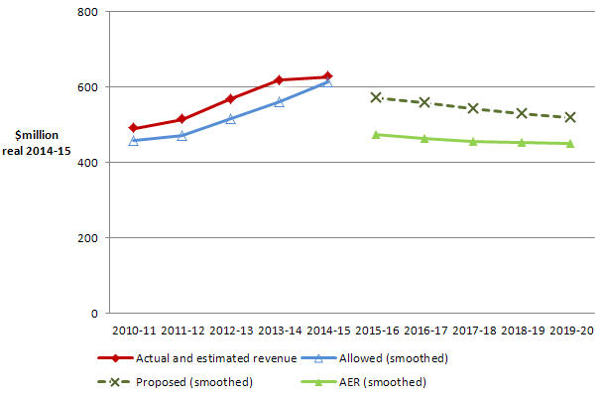

The revenue we determined in this draft decision affects the distribution component of a customer’s final gas bill. Distribution charges are only one component of the customer’s gas bill, which also includes wholesale, transmission and retail costs.

**Our assessment**

Most Australian distribution networks are subject to full regulation, which requires the service provider to submit an initial access arrangement to the regulator for approval, and revise it periodically. An access arrangement sets out the terms and conditions under which third parties can use a pipeline. It must specify at least one reference service likely to be sought by a significant part of the market, and a reference tariff for that service.

Our assessment process includes a building block approach to determine total network revenues and derive reference tariffs.

Together, the building blocks add up to the total revenue JGN can earn through levying reference tariffs on customers. In this way, it should recover no more than the efficient cost of providing pipeline services to its customers.

**AER draft decision: building blocks 2015-20 ($ nominal)**

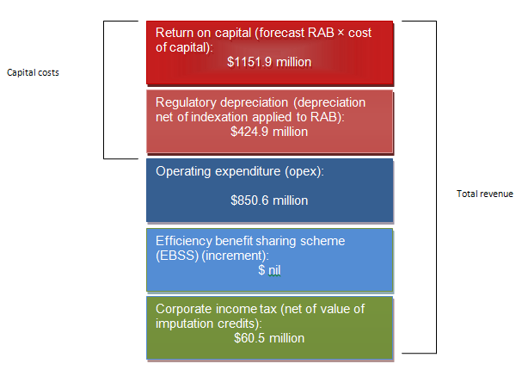

**$ million 2013-14**

**Capital expenditure**

We did not accept JGN’s proposed forecast capital expenditure (capex) of $1130.4 million ($2014-15). We estimated a substitute forecast of $918.6 million ($2014-15).

Most of our capital expenditure adjustments are to JGN’s meter replacement program and the cost of new residential connections. Our alternative forecast capex helps to maintain reliable gas supply to JGN’s customers.

Capex refers to the cost of building new facilities or replacing existing infrastructure. Factors that influence the required level of capex include the age and condition of existing assets.

**AER draft decision compared to JGN’s past and proposed capex ($million, $2014-15)**



Operating expenditure

We did not accept JGN’s proposed operating expenditure (opex) of $789.3 million ($2014-15) and have instead allowed an opex forecast of $779.7 million ($2014-15). This is mainly due to our lower forecast growth in input prices and not including a step change for regulatory reporting.

Opex refers to the non-capital cost of running a business. It includes controllable and non-controllable costs.

**AER draft decision compared to JGN’s past and proposed opex ($million, $2014-15)**

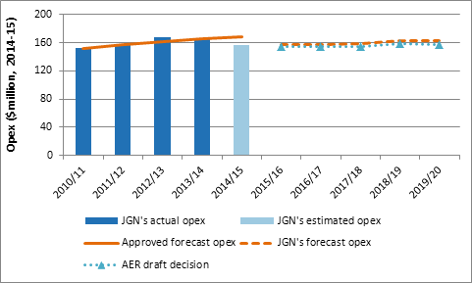

**Rate of return**

Our draft decision sets the allowed rate of return (or ‘cost of capital’) for JGN at 6.80 per cent (nominal vanilla). In comparison, it was 10.43 per cent during the previous regulatory control period.

The investment environment has improved since our previous decision, which was made during the height of uncertainty surrounding the global financial crisis. The lower rate of return in this decision will reduce JGN’s total revenue requirement compared to the past. This should help reduce gas prices for consumers in the forthcoming access arrangement period.

JGN requires significant investment to build and maintain a gas distribution network. The return JGN must pay lenders and investors is referred to as the rate of return. Even a small difference in the rate of return can have a big impact on revenues.

**More information about our consultation process**

JGN may submit a revised proposal in response to our draft decision, no later than 27 February 2015. Stakeholders will also be able to make submissions on our draft decision and JGN’s revised proposal by 27 March 2015.

More information on JGN’s proposal, our draft decision, and how to make a submission is on our website: [www.aer.gov.au](http://www.aer.gov.au).