Draft decision:

APA VTS 2018–22



Overview

The Australian Energy Regulator (AER) approves access arrangements for APA VTS Australia (APA) and other major gas networks in most of Australia under the National Gas Law (NGL) and National Gas Rules (NGR). APA is the owner of the Victorian Transmission System (VTS), which is the primary transmission system for the delivery of gas throughout Victoria.

Our draft decision is to approve a forecast revenue requirement of $555.4 million ($ nominal, smoothed) for APA over the 2018–22 access arrangement period. This is a   
24.2 per cent reduction from APA's proposed revenue requirement of $732.3 million ($ nominal, smoothed). In real terms, our draft decision would allow APA to recover 2.5 per cent more revenue than its 2013-17 allowance.

The figure below shows the difference between APA’s proposed revenue, and what we have allowed for each year of the access arrangement period.

APA’s past and proposed total revenue and AER draft decision revenue allowance ($million, 2017)

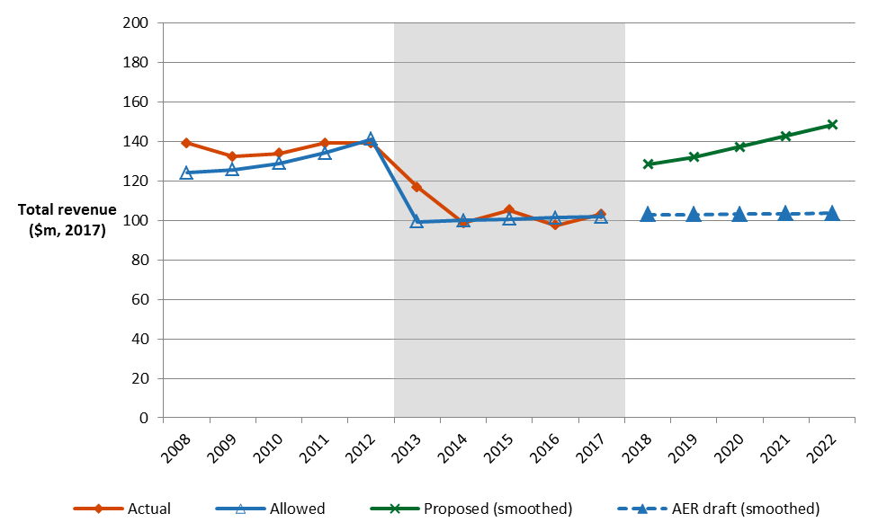

Our draft decision for APA affects transmission charges, which represent approximately 2.1 per cent on average of a Victorian residential customer's annual gas bill. This small percentage largely explains the relatively modest impact that this draft decision is likely to have on average annual gas bills. 

Other components of customer bills include the cost of sourcing the gas, distribution network charges and retailer costs. The AER does not set retail prices.

**Estimated impact on customer bills**

If implemented, we expect that our draft decision will result in an increase to the transmission component of the average annual gas bills for residential customers in Victoria over the 2018–22 access arrangement period.

The transmission component of the average annual residential gas bill in 2018 is expected to be about $1 below the current, 2017 level. By the end of the 2018–22 access arrangement, the transmission component of the average annual bill is expected to be about $4 ($nominal) above the 2017 level.

The transmission component of the average small business gas bill in 2018 is expected to be about $1 lower than in 2017, and about $36 above the current 2017 level by 2022.

**Key elements of our decision**

We based our assessment of APA’s proposed revenue on a number of components. These include expenditure to build, maintain and operate the system, and the return to shareholders on their investment. Together, these determine the revenue that APA may recover from its customers.

The return on capital and regulatory depreciation are key drivers of the increase in real revenue from the current period to the 2018–22 access arrangement period. This is driven by significant growth in APA's capital base, which increased by 40 per cent, in real terms, over the current period and is expected to increase by a further 2.4 per cent over 2018–22.The impact of this growth in the capital base is offset to an extent by the lower rate of return that will apply in 2018–22: 5.75 per cent compared to 7.22 per cent in the current period (and 7.88 in APA’s proposal).

These increases in the return on capital and regulatory depreciation are partly offset by operating efficiencies gained by APA in the current period and passed through to customers in the form of an opex forecast for 2018-22 that is around 19.9 per cent lower than the current period.

Capital expenditure

Capital expenditure (capex) refers to the capital costs and expenditure incurred in the provision of pipeline services. The figure below compares APA's past and proposed forecast capex, and the forecasts we have approved in our previous decision for 2013–17 and this draft decision for   
2018–22.

**AER draft decision compared to APA's past and proposed capex ($ million, 2017)**

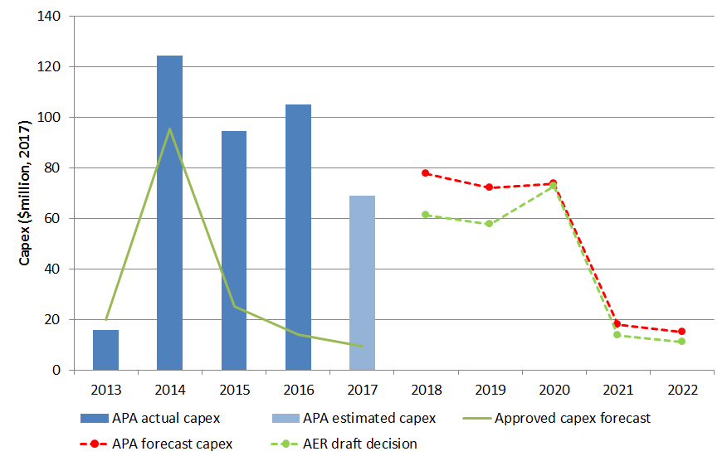

Capital Expenditure in the current period

APA's actual capex in the current period was $244.6 million ($ 2017) higher than contemplated in our last decision. The key driver of this increase was augmentation capex, which included additional investment in the Victorian Northern Interconnector Expansion (VNIE) and South West Pipeline (SWP) to Anglesea Pipeline projects. These investments were required to meet significant changes in the east coast gas market that APA did not anticipate until after finalisation of the access arrangement. The effect of these changes resulted in increased demand for the northern flow of gas from Victoria.

Our draft decision approves the additional capex for the VNIE. We are satisfied that APA has demonstrated that significant changes in the east coast gas market, since the finalisation of the current access arrangement, have led to increased demand for gas to flow north from Victoria. We are satisfied that the $339.2 million is prudent, in accordance with good industry practice and achieves the lowest sustainable cost of providing services. Further, given the tight supply demand balance in Victoria, the VNIE also provides system security benefits for Victorian customers.

VNI expenditure will be recovered during the 2018–22 access arrangement from those using the interconnector to take gas from Victoria to New South Wales and Queensland (shippers and retailers) to supply markets outside Victoria. These customers take their gas supply via the Culcairn withdrawal tariff and this gas is not used by Victorian customers. However, the VNI will result in larger throughput on the Victorian network delivering some benefits for Victorian customers in the form of a reduction in shared network costs

Forecast capital expenditure for 2018-22

Our draft decision approves $215.0 million ($2017) of APA's proposed $256.1 million ($2017) total net capex for the 2018–22 access arrangement period. While this includes additional capex from APA's January proposal for full construction of the Western Outer Ring Main (WORM), it is $41.1 million, or 16 per cent, less than the total net capex proposed by APA.

The proposal APA submitted in January 2017 set out the capex it considered it would require over the 2018–22 access arrangement period. It forecast $168.4 million ($2017, real) which included $26.7 million ($2017, real) for procurement of the WORM easement.

Since APA submitted its original proposal on 3 January 2017, a number of market developments occurred that increased uncertainty in relation to gas supply and demand, particularly for gas powered generation (GPG). These developments included:

* electricity and gas supply issues, and resulting government intervention in the market
* Federal Government responses including a new power to limit gas exports under certain conditions
* closure of the Hazelwood generator
* a threat to system security identified and issued by the Australian Energy Market Operator (AEMO) on 10 March 2017 following the publication of the 2017 Victorian Gas Planning Report (VGPR).

Submissions from a number of APA's users and AEMO, expressed the need for additional investment in the Victorian Transmission System (VTS) above that proposed by APA. In particular, submissions supported additional augmentation to address forecast tightening of the gas supply demand balance in Victoria, South Australia and NSW.

In response, APA provided additional information on the capex required to address the tightening of the supply/demand balance in the VTS forecast by AEMO in March 2017. Specifically, APA proposed to include $126.7 million ($ 2017) to undertake construction of the entire WORM project during the 2018–22 access arrangement period.

This increased its total forecast net capex for the 2018–22 access arrangement period from $168.4 million ($2017) to $256.1 million, an increase of $87.7 million or 52.1 per cent from its initial proposal.

Our draft decision approves $126.7 million ($2017) to undertake the entire WORM construction project during the 2018–22 access arrangement period.

Our draft decision also approves APA's proposal that costs associated with the WORM are allocated to users based on their use of the WORM. This means that costs directly attributable to supplying the users are allocated to those users. In summary, the impact of the WORM on VTS tariffs is immaterial. Some injection and withdrawal tariffs increase slightly and others drop a little. The approach we have taken is consistent with APA's standard cost allocation methodology.

More information about our consultation process

APA may submit a revised proposal in response to our draft decision by 14 August 2017. Interested parties are invited to make submissions on both our draft decision and APA's revised proposal by 15 September 2017. More information on APA’s proposal, our draft decision and how to make a submission is on our website: <www.aer.gov.au>