

Draft decision

Victorian transmission determination for the

Australian Energy Market Operator

December 2013

© Commonwealth of Australia 2013

This work is copyright. Apart from any use permitted by the Copyright Act 1968, no part may be reproduced without permission of the Australian Competition and Consumer Commission. Requests and inquiries concerning reproduction and rights should be addressed to the Director Publishing, Australian Competition and Consumer Commission, GPO Box 3131, Canberra ACT 2601.

Inquiries about this document should be addressed to:

Australian Energy Regulator

GPO Box 520

Melbourne Vic 3001

Tel: (03) 9290 1444

Fax: (03) 9290 1457

Email: [AERInquiry@aer.gov.au](mailto:AERInquiry@aer.gov.au)

AER reference: 52117

1. Contents

Contents 3

Shortened forms 4

1 Overview 5

1.1 Draft decision 5

1.2 Rule requirements 5

1.3 Victorian transmission arrangements 6

2 Pricing methodology 9

2.1 Draft decision 9

2.2 AEMO's proposal 9

2.3 Assessment approach 9

2.4 Reasons for draft decision 10

3 Negotiated services 17

3.1 Draft decision 17

3.2 AEMO's proposal 17

3.3 Assessment approach 17

3.4 Reasons for draft decision 17

3.5 Negotiated transmission service criteria 19

1. Shortened forms

|  |  |
| --- | --- |
|  |  |
| 1. AARR | 1. Aggregate Annual Revenue Requirement |
| 1. AER | 1. Australian Energy Regulator |
| 1. AEMO | 1. Australian Energy Market Operator |
| 1. ASRR | 1. Annual Service Revenue Requirement |
| 1. DNSP | 1. Distribution Network Service Provider |
| 1. NEL | 1. National Electricity Law |
| 1. NER | 1. National Electricity Rules |
| 1. NTSC | 1. Negotiated Transmission Service Criteria |
| 1. TNSP | 1. Transmission Network Service Provider |
| 1. TUOS | 1. Transmission Use of System |

# Overview

1. We, the Australian Energy Regulator (AER), regulate the economic activities of transmission network service providers (TNSPs) in the national electricity market (NEM). We regulate TNSPs in accordance with the National Electricity Law (NEL) and the National Electricity Rules (NER).
2. The Australian Energy Market Operator (AEMO) manages energy markets and systems and provides network planning advice. It does this in each region of the NEM, which incorporates the Eastern and Southern states of Australia. Additionally, in Victoria AEMO provides prescribed and negotiated transmission services.[1] Victoria is the only region where AEMO provides transmission services.
3. We are required to make a transmission determination for AEMO for its next regulatory control period commencing 1 July 2014 to 30 June 2019. Our transmission determination relates to AEMO's role in providing transmission services in Victoria and must consist of a pricing methodology, negotiating framework, and negotiated transmission service criteria (NTSC). We are not required to make a revenue determination for AEMO.
4. AEMO may submit a revised proposal in response to our draft decision by 21 February 2014. We also invite interested stakeholders to make written submissions on our draft decision and the revised proposal on or before 21 February 2014. We will host a predetermination conference at our Melbourne offices on 4 February 2014. The predetermination conference is an opportunity for the AER to explain its draft decision and answer queries from stakeholders. Those wishing to attend the public forum are required to register by 20 January 2014. The following link provides more information including on how stakeholders wishing to attend the public forum can register their attendance: <http://www.aer.gov.au/node/22265>.

## Draft decision

1. AEMO has been consulting with stakeholders about its proposed pricing methodology and proposed negotiating framework. In response to its engagement with stakeholders, AEMO has raised the possibility of amending the pricing methodology it originally proposed to us. Our draft decision, therefore, does not approve AEMO’s proposed pricing methodology. This facilitates its resubmission by AEMO and also allows stakeholders to make submissions according to the processes set out in the NER. The negotiating framework AEMO proposed is approved, and our draft decision is that the NTSC we published on 16 October 2013 will be the NTSC that applies to AEMO in the 2014–17 regulatory control period.

## Rule requirements

1. The economic regulation of transmission services in the NEM is set out in Chapter 6A of the NER. For the purposes of this Chapter, AEMO is regarded as a TNSP.[2] It is required to submit to us a proposed pricing methodology and proposed negotiating framework.[3] Derogations in the NER, however, provide that AEMO is not required to submit a revenue proposal to us.[4] Instead, AEMO is required to consult with stakeholders and formulate its own revenue methodology, which is not subject to our approval.[5]

## Victorian transmission arrangements

Under the Victorian transmission arrangements, AEMO is responsible for providing shared transmission services. These consist of TUOS services and common TUOS services.[6] SP AusNet is the principal TNSP in Victoria. It provides connection services consisting of prescribed entry and prescribed exit services.

AEMO does not own any element of the transmission network.[7] Rather, it 'procures, through contracts, individual services from network and non-network asset owners and provides bundled system services to network users through agreements'.[8] SP AusNet is the main source from which AEMO procures transmission services under contract. Figure 1.1 provides a basic overview of the Victorian transmission arrangements.

Figure 1.1 Overview of the Victorian transmission arrangements

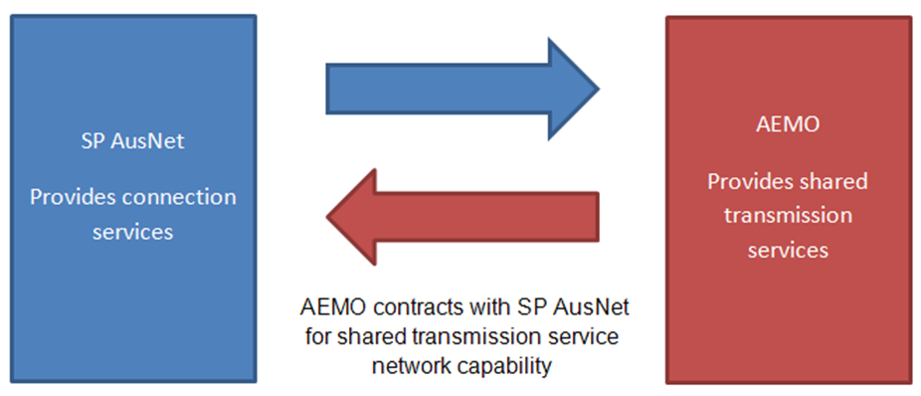

Source: AER analysis

In addition to SP AusNet and AEMO, Murraylink provides transmission services in Victoria. Where there are multiple TNSPs in a region, those providers must appoint a coordinating network service provider responsible for allocating all the AER-determined regulated revenue in that region.[9] Both SP AusNet and Murraylink have appointed AEMO as the co-ordinating network service provider for Victoria.

AEMO operates on a cost recovery basis as a corporate entity limited by guarantee under the Corporations Act 2001 (Cth). AEMO fully recovers its operating costs through fees paid by market participants. AEMO’s ownership structure is split between government and industry representatives across the eastern states of Australia with membership comprising 60% Commonwealth and state government and 40% industry including generators, transmission companies, distribution businesses, resource companies and investment companies.

### Transmission services

1. Transmission services can be "prescribed" or "negotiated". Figure 1.2 provides an overview of how AEMO charges each service. Most charges for prescribed transmission services are allocated to distribution network service providers (DNSPs) with some allocated to large customers directly connected to the transmission system. Negotiated services, by contrast, are dedicated to an individual or small group of users. In these cases any charges associated with those services are recovered from that user.[10]

Figure 1.2 AEMO's Victorian transmission charging components

1. 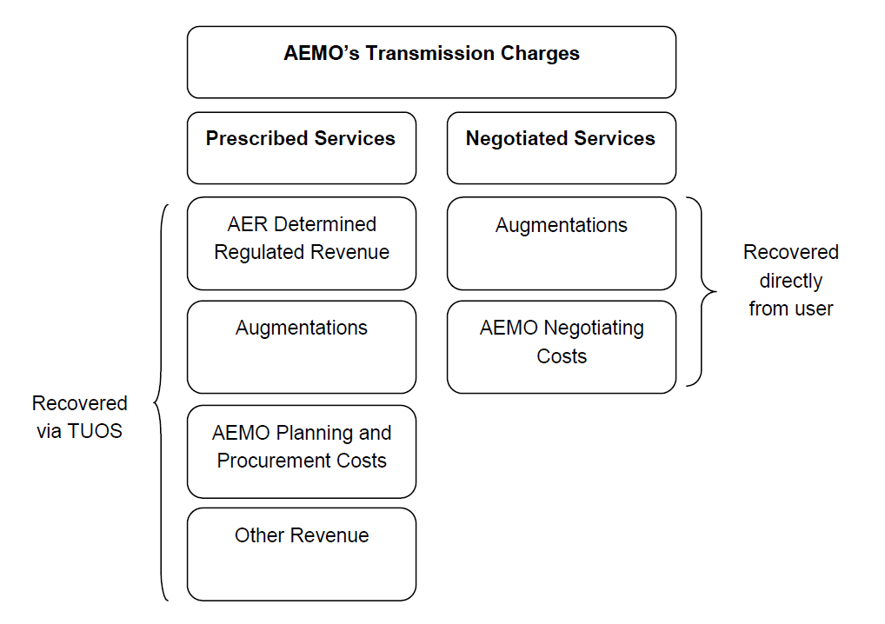

Source: AEMO, Revenue Methodology for Victoria's electricity transmission system, 1 July 2011, p. 5.

### How AEMO calculates its revenue requirement

1. The revenue AEMO recovers comprises three main components. They are AER regulated revenue for Victoria, contestable augmentations, and AEMO's planning and procurement costs.

Under the Victorian transmission arrangements, AEMO collects the regulated revenues of SP AusNet and Murraylink. It then passes the revenues on to the TNSPs under long term contracts.

The cost of new augmentation forms part of AEMO's revenue in certain circumstances. Under the Victorian planning arrangements, there is an opportunity for multiple parties to build, own and operate elements of the transmission system. This contestable process will occur if the capital cost of the augmentation is reasonably expected to exceed $10 million and it can be provided as a distinct and definable service.[11] Where this competitive tendering process is used to procure a new service, the cost of the augmentation is charged to AEMO under contract. The terms of these contracts are typically 30 years or in line with the technical life of the asset involved. The charges largely reflect the annual cost of the service being provided.

In the case of an augmentation being provided by an asset owner who is subject to our regulation (SP AusNet or Murraylink), the asset may be rolled into their regulated asset base (RAB) at the commencement of the next regulatory control period.[12] Alternatively it can continue to be charged under contract.

AEMO performs numerous energy market functions. The costs that AEMO incurs in planning the Victorian transmission network and procuring network investment are passed onto transmission customers. Those costs form part of the revenue that AEMO recovers.

# Pricing methodology

1. As part of our transmission determination we must specify a pricing methodology for AEMO.[13] This methodology establishes a tariff structure for the TNSP, and describes how it allocates its revenue to its prescribed transmission services and connection points.[14] AEMO's proposed pricing methodology addresses only the pricing matters for which it has responsibility—that is, prescribed TUOS services and prescribed common transmission services. AEMO is also the co-ordinating network service provider in Victoria. It is therefore responsible for allocating the aggregate annual revenue requirement (AARR) for all TNSPs in the region including SP AusNet and Murraylink.[15]

## Draft decision

1. We do not approve the pricing methodology AEMO proposed for the 2014–19 regulatory control period. In response to stakeholder engagement, AEMO has raised two different approaches to calculating the price of locational TUOS services. Therefore, we require AEMO to propose a clear pricing structure for each category of its prescribed transmission services in its revised proposal, as required by the NER clause 6A.23.4(b) & (e).[16] We also require minor amendments to the proposed pricing methodology regarding the extent to which AEMO may offer prudent discounts.

## AEMO's proposal

1. In August 2013, AEMO submitted its proposed pricing methodology. On 25 November 2013, AEMO then made a submission to us seeking to revise its proposal. It stated that in response to stakeholder comments at our public forum on 28 October 2013 and a subsequent public forum that AEMO hosted on 15 November 2013, AEMO wished to revise how it calculates locational TUOS prices and charges.[17]

## Assessment approach

1. We must approve a proposed pricing methodology if we are satisfied that it:

* gives effect to, and complies with, the pricing principles for prescribed transmission services[18]
* complies with the information requirements of the pricing methodology guidelines.[19]

The Transmission Pricing Principles are contained in Chapter 6A of the NER. They provide 'a principles-based regulatory framework where the implementation elements of the regime are left to the guided discretion of TNSPs and the AER'.[20] The AER's Pricing Methodology Guidelines elaborate on the Transmission Pricing Principles by, among other things, specifying the information that must accompany a proposed pricing methodology.[21]

Locational TUOS prices

Our assessment has included an evaluation of the way in which AEMO proposes to calculate locational TUOS prices and charges in the 2014–19 regulatory control period.

There are four categories of prescribed transmission services. These are entry services, exit services, transmission common services, and TUOS services. Out of these, TUOS constitutes the majority of a TNSP's costs in providing prescribed transmission services. In accordance with the NER, the cost of providing TUOS services is divided (approximately 50/50 split) into locational and non-locational components.[22]

The price of non-locational TUOS services must be postage stamped meaning that it is the same price for every transmission customer irrespective of their network utilisation or location. In contrast, the NER provides that the prices for recovering the locational component of prescribed TUOS services must be based on demand at times of greatest network utilisation.[23] The NER does not, however, specify the measure of demand that a TNSP is required to use.

It is left to the AER’s Pricing Methodology Guidelines to establish the permitted pricing structures for the recovery of the locational component of providing prescribed TUOS services. Two options are given in our guidelines:[24]

* The current contract agreed maximum demand (prevailing at the time transmission prices are published) as negotiated in a transmission customer’s connection agreement or the transmission customer’s maximum demand in the previous 12 months if the transmission customer has exceeded its current contract agreed maximum demand, expressed as $/MW/day.
* The average of the transmission customer’s half-hourly maximum demand recorded at a connection point on the 10 weekdays when system demand was highest between the hours of 11:00 and 19:00 in the local time zone during the previous 12 months.

The AER's Pricing Methodology Guidelines states that TNSP's can develop an alternative pricing structure if the TNSP clearly shows that it gives effect to the Transmission Pricing Principles.[25] The alternative must also improve on the permitted pricing structures outlined in the AER's Pricing Methodology Guidelines and contribute to the NEM objective.[26]

## Reasons for draft decision

1. We do not approve the pricing methodology AEMO proposed because:

* AEMO has not proposed a clear pricing structure for locational TUOS services
* The pricing methodology AEMO proposed made an error in restating the extent to which the NER allows TNSPs to offer prudent discounts to transmission customers.

### Locational TUOS services

1. AEMO has raised two different approaches to calculating the price and charge of locational TUOS services. The first approach was in the proposed pricing methodology AEMO submitted to us on 16 August 2013 (original approach). The second approach was set out in a submission AEMO made to us on 25 November 2013 (amended approach).
2. Both of the approaches that AEMO has raised are consistent with one of the two permissible pricing structures in the AER's Pricing Methodology Guidelines.[27] That is, AEMO has not raised an alternative pricing structure. In particular, both approaches are variations of the option in the AER's Pricing Methodology Guidelines in which the locational TUOS price is based on:[28]

The average of the transmission customer’s half-hourly maximum demand recorded at a connection point on the 10 weekdays when system demand was highest between the hours of 11:00 and 19:00 in the local time zone during the previous 12 months (emphasis added).

The original and amended approaches differ with respect to the time period from which the "10 weekdays" are taken to occur. The original approach involved AEMO using the average maximum demand that occurred in the 10 weekdays in the most recently completed financial year.[29] This is how other TNSPs in the NEM calculate locational TUOS prices on an historical basis.

The revised approach calculates locational TUOS prices using more recent data. It uses the average maximum demand from the 10 weekday in the most recently completed 12 month period. For ease of reference, we call this time period "t – 1" where "t" is the year in which the new prices and charges will be incurred. AEMO referred to its original approach as "t – 2".

Figure 2.1 shows how the two approaches would differ in relation to the calculation of locational TUOS prices for the 2014–15 financial year. It assumes that the 10 weekdays when system demand is highest occurs in December and that AEMO calculates new locational TUOS prices in May.

Figure 2.1 The initially and revised approaches to locational TUOS prices/charges

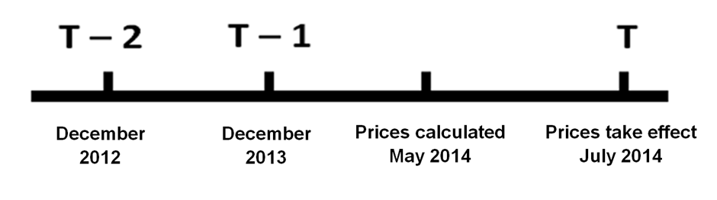

Under the original approach AEMO would use the average of the 10 weekdays when demand was highest in December 2012 to calculate locational TUOS prices for the 2014–15 regulatory control period. Under the amended approach, however, AEMO would use more recent data. It would use the average of the 10 weekdays when demand was highest in December 2013.

1. In its submission to the AER dated 25 November 2013, AEMO stated that it considered the amended approach to offer improved outcomes for transmission customers. AEMO's submission noted that consumer representatives had raised concerns about setting the prices and charges for locational TUOS services using the average maximum demand from the most recently completed financial year (t – 2). These concerns were first raised at the AER public forum on 28 October 2013 and again at a public forum AEMO hosted at its offices on 15 November 2013. Specifically, consumer representatives were concerned about using historical demand from the most recently completed financial year (t – 2) given that there is trend towards declining electricity consumption.[30]
2. In response, AEMO made its submission to us. It raised the possibility of calculating locational TUOS prices and charges on the basis of historical average maximum demand from the mostly recent 12 month period (t – 1). This is most likely to be the period 1 March to 28 February.[31] AEMO stated this amended approach satisfies the concerns of consumer representatives because it uses more recent data.
3. We received a submission from the Energy Users Coalition of Victoria (EUCV) on the pricing methodology AEMO proposed. In general, the EUCV submission supported the original approach AEMO proposed for pricing locational TUOS services. The EUCV submitted that when prices are based on the 10 weekdays when network usage is highest, ‘those causing the network to be sized to serve the peak demands would be exposed to the costs they impose’.[32]
4. While the EUCV supported the "10 weekdays" approach to calculating locational TUOS prices, it raised concerns about using historical data to select when those weekdays occurred. It submitted that using historical data leads to a reduction in cost reflectivity. This is because the locational TUOS prices that are calculated could be 'many months (even years) out of date'.[33] The EUCV submitted that this would affect a transmission customer's ability to engage in efficient demand side management and, therefore, it does not comply with the recommendations in the AEMC's Power of Choice report.[34]
5. We understand that the amended approach AEMO submitted to us on 25 November 2013 attempts to address the EUCV's concerns. Though AEMO would still use historical data, the amended approach would use data that is more recent. This could alleviate most of the EUCV's concerns. Its submission in fact stated that 'as a minimum, AEMO must use 12 month data that is the most up to date possible for the development of prices'.[35]
6. EUCV submission, in essence, raises the issue of how to best achieve the objectives of the pricing principles in the NER. Following on from this draft decision, AEMO will have an opportunity to submit a revised pricing methodology. We expect that in doing so AEMO will clearly set out its proposed pricing structure for locational TUOS. We will then make our final decision after considering any further stakeholder submissions on AEMO's revised pricing methodology.

### Prudent discounts

1. The pricing methodology AEMO proposed does not accurately reflect the availability of prudent discounts in the NER. We consider that this could cause confusion or mislead some stakeholders.

The pricing methodology AEMO proposed states that AEMO may provide prudent discounts on the prices for the non-locational component of prescribed transmissions services. In accordance with revision 2.1 in this draft decision, we consider that AEMO's pricing methodology should be amended to state that prudent discounts may be offered on the prices of non-locational and locational TUOS services. This would reflect the NER.[36]

### Assessment against the pricing principles

In considering AEMO's proposed pricing methodology against the requirements of the pricing principles, we addressed only those principles that are relevant to AEMO's transmission pricing responsibilities. We consider this approach is appropriate, because the pricing principles are intended to provide scope for TNSPs to develop pricing arrangements that address their operating circumstances.[37]

Calculation and allocation of annual revenue

1. We assessed how AEMO's proposed pricing methodology calculates and allocates its AARR. The AARR is derived from an adjustment that a TNSP makes to the MAR that we approve in AEMO's transmission determination. That adjustment must accord with the method prescribed under clause 6A.3.2 of the NER. Table 2.1 summarises our assessment which found that AEMO's original proposal satisfactorily addresses the pricing principles in respect of calculation and allocation of revenue.

Table 2.1 AER's assessment of AEMO's proposed calculation and allocation of the AARR

|  |  |
| --- | --- |
| 1. NER requirements | 1. AER assessment |
| 1. Requirement for the AARR to be calculated as defined in the NER—clause 6A.22.1 | 1. Section 3.3 of AEMO's proposed pricing methodology satisfies this requirement. |
| 1. Requirement for the AARR to be allocated to each category of prescribed transmission services in accordance with the attributable cost share for each such category of service—clause 6A.23.2(a) | 1. Section 3.3 of AEMO's proposed pricing methodology satisfies this requirement |
| 1. Requirement for every portion of the AARR to be allocated and for the same portion of AARR to be allocated more than once—clause 6A.23.2(c) | 1. Section 3.3 of AEMO's proposed pricing methodology satisfies this requirement |
| 1. Subject to clause 11.6.11 of the NER, requirement for adjusting the attributable cost share and priority ordering approach to asset costs that would otherwise be attributed to the provision of more than one other category of prescribed transmission service—clause 6A.23.2(d) | 1. Section 3.3 of AEMO's proposed pricing methodology satisfies this requirement |

Allocation of annual service revenue to network connection points

1. We assessed how AEMO's proposed pricing methodology allocates the annual service revenue requirement (ASRR). The ASRR is derived from allocating a TNSP's AARR to each category of prescribed transmission services in accordance with each category's attributable cost share.[38]   
   Table 2.2 summarises our assessment which found that AEMO's proposal satisfactorily addresses the pricing principles.

Table 2.2 AER's assessment of AEMO's proposed allocation of the ASRR

|  |  |
| --- | --- |
| 1. NER requirements | 1. AER assessment |
| 1. Requirement for the whole ASRR for prescribed entry services to be allocated to transmission network connection points in accordance with the attributable connection point cost share for prescribed entry services that are provided by the TNSP at that connection point—clause 6A.23.3(a) | 1. Not applicable |
| 1. Requirement for the whole ASRR prescribed exit services to be allocated to transmission network connection points in accordance with the attributable connection point cost share for prescribed exit services that are provided by the TNSP at that connection point—clause 6A.23.3(b) | 1. Not applicable |
| 1. Requirement for the ASRR to be allocated for prescribed TUOS services locational components and pre-adjusted non locational components—clause 6A.23.3(c) | 1. Section 3.4 of AEMO's proposed pricing methodology satisfies this requirement |
| 1. Requirement for adjusting attributable cost share and priority ordering approach to asset costs that would otherwise be attributed to the provision of more than on category of prescribed transmission services—clause 6A.23.2(d) | 1. Section 3.4 of AEMO's proposed pricing methodology satisfies this requirement |
| 1. Requirement for the recovery of the ASRR for prescribed common transmission services and the operating and maintenance costs incurred in the provision of those services to be recovered through prices charged to transmission customers and network service provider transmission connection points set in accordance with price structure principles set out in clause 6A.23.4—clause 6A.23.3(f) | 1. Section 3.5.3 of AEMO's proposed pricing methodology satisfies this requirement |

Note: Clauses 6A.23.3(a) and (b) are "not applicable" because they relate to services (prescribed entry services and prescribed exit services) that AEMO is not responsible for providing under the Victorian transmission arrangements.

Development of price structure

1. AEMO's proposed pricing methodology must develop different prices for recovering the ASRR. We are not satisfied that AEMO has met this requirement for the reasons given in section 2.3.1.
2. Table 2.3 summarises our assessment against the pricing principles.

Table 2.3 AER's assessment of AEMO's proposed pricing structure

|  |  |
| --- | --- |
| 1. NER requirements | 1. AER assessment |
| 1. Requirement for separate prices for each category of prescribed transmission services—clause 6A.23.4(b) | More clarity required regarding the pricing structure for locational TUOS services |
| 1. Requirement for fixed annual amount prices for prescribed entry and exit services—clause 6A.23.4(c) | 1. Not applicable |
| 1. Requirement for postage stamped prices for prescribed common transmission services—clause 6A.23.4(d) | 1. Section 3.5.3 of AEMO's proposed pricing methodology satisfies this requirement |
| 1. Requirement for prices for locational component of prescribed TUOS services to be based on demand at times of greatest use of the transmission network and for which network investment is most likely to be contemplated—clause 6A.23.4(e) | 1. More clarity required regarding the pricing structure for locational TUOS services |
| 1. Requirement for prices for the locational component of the ASRR for prescribed TUOS services not to change by more than 2 per cent per year compared with the load weighted average price for this component for the relevant region—clauses 6A.23.4– 6A.23.4(f) | 1. Section 3.5.1 of AEMO's proposed pricing methodology satisfies this requirement |
| 1. Requirement for prices for the adjusted non locational component of prescribed TUOS services to be on a postage stamped basis—clause 6A.23.4(j) | 1. Section 3.5.2 of AEMO's proposed pricing methodology satisfies this requirement |

### Assessment against the pricing methodology guidelines

1. We are satisfied AEMO's proposed pricing method complies with the information requirements of the pricing methodology guidelines except for the requirements relating to permitted (locational) pricing structures for the reasons discussed in section 2.3.1.
2. Features of the proposal that reflect the guideline requirements include:

* acknowledging AEMO is the coordinating network service in Victoria
* using the priority ordering approach under clause 6A.23.3(d) of the NER to implement priority ordering
* describing how asset costs that may be attributable to both prescribed entry services and prescribed exit services will be allocated at a connection point
* describing billing arrangements as in clause 6A.27 of the NER
* describing prudential requirements as in clause 6A.28 of the NER
* including hypothetical examples
* describing how AEMO intends to monitor and develop records of its compliance with its approved pricing methodology.

Revision 2.1

Provide clarity regarding how AEMO will calculate locational TUOS prices and charges consistent with NER clause 6A. 23.4 (b) & (e) and the AER's Pricing methodology Guideline section 2.2.

Revision 2.2

Amend the first sentence in section 4, on page 12, of AEMO's proposed pricing methodology to read (with amendments in bold font):

"AEMO may, but is not required to, agree with a transmission customer to charge lower prices for the locational and non-locational component of prescribed TUOS services and prescribed common transmission services than the prices determined in accordance with this proposed pricing methodology".

# Negotiated services

1. Our transmission determination imposes control over revenues that a TNSP can recover from its provision of prescribed transmission services. But we do not determine the terms and conditions of negotiated transmission services. Under the NER, negotiated services are provided under an agreement or as a result of a determination of a commercial arbitrator. These processes are facilitated by:

* a negotiating framework
* NTSC

1. A TNSP must prepare a negotiating framework that sets out procedures for negotiating the terms and conditions of access to a negotiated transmission service. The NTSC set out criteria that a TNSP must apply in negotiating those terms and conditions, including the prices and access charges for negotiated transmission services. They also contain the criteria that a commercial arbitrator must apply to resolve disputes about such terms and conditions and/or access charges.

## Draft decision

1. We approve AEMO's proposed negotiating framework because it meets the requirements in the NER.[39] Further, our draft decision is that the NTSC we published in October 2013 will apply to AEMO in the 2014–19 regulatory control period, because those criteria give effect to the negotiated transmission service principles.[40]

## AEMO's proposal

1. The negotiating framework that AEMO proposed is the same negotiating framework which we accepted in our draft decision for SP AusNet's 2014–17 regulatory control period.

## Assessment approach

1. To be approved, a proposed negotiating framework must specify each requirement in clause 6A.9.5(c) of the NER. We examined whether AEMO's proposed negotiating framework met these requirements.
2. We consider the NTSC that adopts the negotiated transmission service principles would satisfy the NER requirements. We thus assessed whether our proposed NTSC reflect the negotiating transmission service principles in clause 6A.9.1 of the NER.

## Reasons for draft decision

1. We approve AEMO's proposed negotiating framework because it specifies the minimum requirements in the NER.[41] The negotiating framework that AEMO proposed is the same negotiating framework which we accepted in our draft decision for SP AusNet's 2014–17 regulatory control period. We accept that benefits arise from AEMO and SP AusNet having a common negotiating framework. When AEMO receives an application to connect to the Victorian Transmission Network, that service applicant must also negotiate with SP AusNet for connection services. For this reason, a common negotiating framework that both AEMO and SP AusNet apply during their negotiations with service applicants would be useful.

Table 3.1 summarises our findings on AEMO's proposed negotiating framework. It shows that each of the requirements under the NER for a negotiating framework is satisfactorily addressed.

Table 3. AER’s assessment of AEMO's proposed negotiating framework

|  |  |
| --- | --- |
| 1. NER requirements | 1. AER assessment |
| Requirement for AEMO and the applicant of a negotiated transmission service to negotiate in good faith—clause 6A.9.5(c)(1) | Section 4 of AEMO's proposed negotiating framework satisfies this requirement. |
| Requirement for AEMO to provide all such commercial information reasonably required to enable the applicant of a negotiated transmission service to engage in effective negotiations—clause 6A.9.5(c)(2) | Section 8 of AEMO's proposed negotiating framework satisfies this requirement. |
| Requirement for AEMO to identify and inform the negotiated transmission service applicant of the reasonable costs of providing the negotiated service; and demonstrate that charges reflect costs—clause 6A.9.5(c)(3) | Section 8 of AEMO's proposed negotiating framework satisfies this requirement. |
| Requirement for a negotiated transmission service applicant to provide all such commercial information reasonably required to enable AEMO to engage in effective negotiation—clause 6A.9.5(c)(4) | Section 8 of AEMO's proposed negotiating framework satisfies this requirement. |
| Requirement to specify a reasonable period of time for commencing, progressing and finalising negotiations; and a requirement for each party to use their reasonable endeavours to adhere to those time periods during the negotiation—clause 6A.9.5(c)(5) | Section 5 of AEMO's proposed negotiating framework satisfies this requirement. |
| Requirement to specify a process for disputes to be dealt with in accordance with the relevant provisions for dispute resolution[42]—clause 6A.9.5(c)(6) | Section 10 of AEMO's proposed negotiating framework satisfies this requirement. |
| Requirement to specify arrangements for the payment of AEMO's reasonable direct expenses incurred in processing the application to provide the negotiated transmission service—clause 6A.9.5(c)(7) | Section 6 of AEMO's proposed negotiating framework satisfies this requirement. |
| Requirement for AEMO to determine the potential impact of the provision of a negotiated transmission service on other network users—clause 6A.9.5(c)(8) | Section 11 of AEMO's proposed negotiating framework satisfies this requirement. |
| Requirement for AEMO to notify and consult with any affected network user and ensure the negotiated transmission service does not result in noncompliance with obligations in relation to other network users under the NER—clause 6A.9.5(c)(9) | Section 11 of AEMO's proposed negotiating framework satisfies this requirement. |

## Negotiated transmission service criteria

1. In October 2013, we published an invitation for submissions on the draft NTSC for AEMO. Our draft decision is that the NTSC which we published with that invitation (reproduced in section 3.5.1) should apply to AEMO's 2014–17 regulatory control period. This is because it adopts the negotiated transmission service principles as its criteria. We did not receive stakeholder submissions on the NTSC.

### The NTSC

National electricity objective

* 1. The terms and conditions of access for a negotiated transmission service, including the price that is to be charged for the provision of that service and any access charges, should promote the achievement of the National Electricity Objective.

Criteria for terms and conditions of access

Terms and conditions of access

* 1. The terms and conditions of access for a negotiated transmission service must be fair, reasonable and consistent with the safe and reliable operation of the power system in accordance with the NER.
  2. The terms and conditions of access for negotiated transmission services, particularly any exclusions and limitations of liability and indemnities, must not be unreasonably onerous. Relevant considerations include the allocation of risk between the TNSP and the other party, the price for the negotiated transmission service and the cost to the TNSP of providing the negotiated service.
  3. The terms and conditions of access for a negotiated transmission service must take into account the need for the service to be provided in a manner that does not adversely affect the safe and reliable operation of the power system in accordance with the NER.

Prices of services

* 1. The price of a negotiated transmission service must reflect the cost that the TNSP has incurred or incurs in providing that service, and must be determined in accordance with the principles and policies set out in the Cost Allocation Methodology.
  2. Subject to criteria 7 and 8, the price for a negotiated transmission service must be at least equal to the avoided cost of providing that service but no more than the cost of providing it on a stand alone basis.
  3. If the negotiated transmission service is a shared transmission service that:
     1. exceeds any network performance requirements which it is required to meet under any relevant electricity legislation; or
     2. exceeds the network performance requirements set out in schedule 5.1a and 5.1 of the NER
  4. then the difference between the price for that service and the price for the shared transmission service which meets network performance requirements must reflect the TNSP’s incremental cost of providing that service (as appropriate).
  5. For shared transmission services, the difference in price between a negotiated transmission service that does not meet or exceed network performance requirements and a service that meets those requirements should reflect the TNSP’s avoided costs. Schedule 5.1a and 5.1 of the NER or any relevant electricity legislation must be considered in determining whether any network service performance requirements have not been met or exceeded.
  6. The price for a negotiated transmission service must be the same for all Transmission Network Users. The exception is if there is a material difference in the costs of providing the negotiated transmission service to different Transmission Network Users or classes of Transmission Network Users.
  7. The price for a negotiated transmission service must be subject to adjustment over time to the extent that the assets used to provide that service are subsequently used to provide services to another person. In such cases the adjustment must reflect the extent to which the costs of that asset are being recovered through charges to that other person.
  8. The price for a negotiated transmission service must be such as to enable the TNSP to recover the efficient costs of complying with all regulatory obligations associated with the provision of the negotiated transmission service.

Criteria for access charges

Access charges

* 1. Any access charges must be based on the costs reasonably incurred by the TNSP in providing Transmission Network User access. This includes the compensation for forgone revenue referred to in clause 5.4A(h) to (j) of the NER and the costs that are likely to be incurred by a person referred to in clause 5.4A(h) to (j) of the NER (as appropriate).



1. NER, S6A.4.1(a)
2. NER, clause S6A.4.1(a)
3. NER, S6A.4.2(f)(1)(a)
4. NER, S6A.4.2(c)(1)
5. NER, S6A.4.2(c)(1)–(3)
6. NER, S6A.4.1
7. AEMO, Revenue methodology for Victoria's electricity transmission system, 1 July 2011, p. 5.
8. AEMO, Revenue methodology for Victoria's electricity transmission system, 1 July 2011, p. 5.
9. NER, clause 6A.29.1(a).
10. AEMO, Revenue methodology for Victoria's electricity transmission system, 1 July 2011, p. 5.
11. AEMO, Revenue methodology for Victoria's electricity transmission system,1 July 2011, p. 7.
12. AEMO, Revenue methodology for Victoria's electricity transmission system,1 July 2011, p. 7.
13. NER, clause 6A.2.2(4).
14. NER, clause 6A.24.1(b)(1) and (2).
15. NER, clause 6A.29.1.
16. NER, clause 6A.23.4(b) and (e).
17. AEMO, Submission to the AER, 25 November 2013, p. 1.
18. NER, clause 6A.14.3(g)(1).
19. NER, clause 6A.14.3(g)(2).
20. AEMC, Transmission pricing for prescribed transmission services: Rule proposal report, Proposed national electricity amendment (Pricing of prescribed transmission services) rule 2006, 24 August 2006, p. 1.
21. NER, clause 6A.25.2.
22. NER, clause 6A.23.3(d)(1).
23. NER, clause 6A.23.4(e).
24. AER, Pricing methodology guidelines, October 2007, section 2.2(c), p. 6.
25. AER, Pricing methodology guidelines, October 2007, section 2.2(e), p. 6–7.
26. AER, Pricing methodology guidelines, October 2007, section 2.2(e), p. 6–7.
27. AER, Pricing methodology guidelines, October 2007, section 2.2(c), p. 6.
28. AER, Pricing methodology guidelines, October 2007, section 2.2(c), p. 6.
29. AEMO, Proposed pricing methodology for prescribed shared transmission services, 16 August 2013
30. AEMO, Submission to the AER, 25 November 2013, p. 1.
31. AEMO, Submission to the AER, 25 November 2013, p. 1.
32. EUCV, Submission to the AER, 24 November 2013, p. 6.
33. EUCV, Submission to the AER, 24 November 2013, p. 4.
34. AEMC, Power of Choice, 30 November 2012.
35. EUCV, Submission to the AER, 24 November, p. 8.
36. NER, clause 6A.26.1(b).
37. AEMC, Rule Determination: National Electricity Amendment (Pricing of Prescribed Transmission Services) Rule 2006 No. 22, 21 December 2006, pp. 27–8.
38. NER, clause 6A.22.3.
39. NER, clause 6A.9.5(c).
40. NER, clause 6A.9.1.
41. NER, clause 6A.9.5(c).
42. The relevant provisions for dispute resolution are set out in part K of chapter 6A of the NER.