

Issues Paper

ElectraNet

electricity transmission revenue proposal

1 July 2018 to 30 June 2023

May 2017

© Commonwealth of Australia 2017

This work is copyright. In addition to any use permitted under the Copyright Act 1968, all material contained within this work is provided under a Creative Commons Attributions 3.0 Australia licence, with the exception of:

* the Commonwealth Coat of Arms
* the ACCC and AER logos
* any illustration, diagram, photograph or graphic over which the Australian Competition and Consumer Commission does not hold copyright, but which may be part of or contained within this publication. The details of the relevant licence conditions are available on the Creative Commons website, as is the full legal code for the CC BY 3.0 AU licence.

Requests and inquiries concerning reproduction and rights should be addressed to:

Director, Corporate Communications  
Australian Competition and Consumer Commission   
GPO Box 4141, Canberra ACT 2601

or

publishing.unit@accc.gov.au.

Inquiries about this publication should be addressed to:

Australian Energy Regulator  
GPO Box 520  
Melbourne Vic 3001

Tel: (03) 9290 1444  
Fax: (03) 9290 1457

Email: [ElectraNet2018@aer.gov.au](mailto:AERInquiry@aer.gov.au)

Request for submissions

Energy consumers and other interested parties are invited to make submissions on the ElectraNet electricity transmission revenue proposal by COB Friday 7 July 2017. The proposal is available on the AER’s website [www.aer.gov.au](http://www.aer.gov.au)

We will consider and respond to submissions in our draft determination.

We prefer that all submissions are in Microsoft Word or another text readable document format. Submissions should be sent to: [ElectraNet2018@aer.gov.au](mailto:TransGrid2018@aer.gov.au)

Alternatively, submissions can be sent to:

Mr Sebastian Roberts  
General Manager  
Australian Energy Regulator  
GPO Box 520  
Melbourne Vic 3001

We prefer that all submissions be publicly available to facilitate an informed and transparent consultative process. Submissions will be treated as public documents unless otherwise requested. Parties wishing to submit confidential information should:

* clearly identify the information that is the subject of the confidentiality claim
* provide a non-confidential version of the submission in a form suitable for publication.

All non-confidential submissions will be placed on our website. For further information regarding our use and disclosure of information provided to us, see the ACCC/AER Information Policy (June 2014), which is available on our website [ACCC and AER information policy](https://www.aer.gov.au/publications/corporate-documents/accc-and-aer-information-policy-collection-and-disclosure-of-information).

If interested parties have any enquires about this Issues Paper, or about lodging submissions, please send an email to: [ElectraNet2018@aer.gov.au](mailto:TransGrid2018@aer.gov.au)

Contents

1 Introduction 1

2 Overview of ElectraNet's proposal 5

2.1 Regulatory asset base 7

2.2 Capital expenditure 8

2.2.1 Contingent projects 9

2.3 Operating expenditure 10

2.4 Return on investment 10

3 Effect of demand on prices 12

3.1 Demand for energy 12

3.2 Demand and prices 14

4 Capital expenditure 16

4.1 How we assess capital expenditure 16

4.2 Key drivers of ElectraNet's capital expenditure proposal 16

5 Contingent projects 19

5.1 How we assess contingent projects 19

5.2 ElectraNet's contingent projects 20

6 Value of imputation credits 22

6.1.1 How we have calculated the value of imputation credits 22

6.2 ElectraNet's proposed value of imputation credits 22

7 Inflation 24

8 Consumer engagement 25

8.1 Consumer engagement in the NER 25

8.2 Our consumer engagement guideline 26

8.3 ElectraNet’s consumer engagement strategy 26

Appendix A: Background to our assessment 28

8.4 Who are we? 28

8.5 AER Guidelines and schemes 30

Expenditure forecast assessment guideline 30

Rate of return guideline 30

Capital expenditure incentive guideline 30

Efficiency benefit sharing scheme 30

Consumer engagement guideline for network service providers 30

Shared asset guideline 30

Service target performance incentive scheme 30

Confidentiality guideline 31

8.6 Our framework and approach paper 31

Shortened forms

|  |  |
| --- | --- |
| Shortened form | Extended form |
| AEMC | Australian Energy Market Commission |
| AEMO | Australian Energy Market Operator |
| AER | Australian Energy Regulator |
| capex | capital expenditure |
| EBSS | efficiency benefit sharing scheme |
| kW | kilowatt |
| MAR | maximum allowed revenue |
| MW | megawatt |
| MWh | megawatt hour |
| NEL | National Electricity Law |
| NEM | National Electricity Market |
| NEO | National Electricity Objective |
| NER | National Electricity Rules |
| opex | operating expenditure |
| RAB | regulatory asset base |
| RIT-T | Regulatory Investment Test for Transmission |
| RPPs | Revenue and pricing principles |
| STPIS | service target performance incentive scheme |
| TUoS | transmission use of system |
| VCR | Value of Customer Reliability |
| WACC | weighted average cost of capital |

# Introduction

Households and businesses consume electricity that is supplied through an electricity network of 'poles and wires'. The electricity network is divided into two parts:

* a transmission network, which carries electricity at high voltages from large generators to the major load centres
* a distribution network, which carries electricity from the points of connection with the transmission network to virtually every building, house and apartment in South Australia (SA).

The transmission and distribution networks charge their customers for transmitting electricity across their networks. These 'network charges' do not appear directly on most customers’ electricity bills, which are sent by the retail businesses. Nevertheless, the network charges are important as they account for a significant component of each customer's final bill.

ElectraNet operates and maintains the South Australian electricity transmission network. On 28 March 2017, ElectraNet submitted its electricity transmission revenue proposal for the regulatory control period from 1 July 2018 to 30 June 2023 (2018–23 regulatory control period). This proposal sets out how much ElectraNet proposes to charge its customers over the five year period.

We, the Australian Energy Regulator (AER), regulate the revenues of electricity network businesses by setting the annual revenues they may recover from customers. For electricity transmission businesses, this annual revenue is called the maximum allowed revenue, and directly impacts the network charges ElectraNet can recover from customers as part of their electricity bills.

Although our decision influences the total revenue ElectraNet can recover from its transmission customers (such as SA Power Networks and large customers connected directly to the transmission network), we do not set transmission charges for each customer or the retail prices that end consumers pay. Retail prices are set by electricity retailers and include the costs associated with transmission, distribution, generation, and the costs incurred by retailers in selling the electricity.

We have started the process of reviewing ElectraNet's revenue proposal for the 2018–23 regulatory period. This involves examining ElectraNet's proposal to ensure that consumers pay no more than necessary for the safe and reliable delivery of electricity.

We determine an overall revenue allowance based on a forecast of the efficient costs required by ElectraNet to prudently provide transmission services and fulfil its obligations. The regime provides incentives for ElectraNet to outperform our forecast while delivering safe, reliable and secure services to its customers. If ElectraNet incurs costs greater than what we deem to be efficient, ElectraNet bears those costs.

Timing

This issues paper will be followed by a draft decision, and then we must make a final decision by April 2018.

We provided ElectraNet with an eight-week extension to submit its proposal to address the whole network outage that occurred on 28 September 2016, which has compressed the timeframe for our review of ElectraNet's proposal. The adjusted timeline in Table 1 provides stakeholders with the requisite time to prepare submissions as required under the NER including allowing any person to make a written submission on our issues paper within a period of no less than 30 business days after the publication of the issues paper.[1] After we make our draft decision, we must allow written submissions on the draft decision to be made within a period of no less than 45 business days after the draft decision.[2] We may also invite written submissions on ElectraNet's revised revenue proposal.[3]

We aim to release our draft decision by the end of October 2017 instead of the end of September due to the eight-week extension we gave to ElectraNet. This affords us one less month to prepare our draft decision and one less month to prepare our final decision. Given that we are releasing the draft decision one month later, the due date for submissions on the draft decision will be 2 January 2018.

We recognise that the compressed timeline presents challenges and welcome submissions on the timeline.

Table Key dates for the ElectraNet transmission pricing review

| Step | Date |
| --- | --- |
| AER published Framework & Approach paper for ElectraNet | 28 July 2016 |
| ElectraNet submitted revenue proposal to AER | 28 March 2017 |
| AER publishes issues paper | 25 May 2017 |
| AER to hold public forum on issues paper | 7 June 2017 |
| Submissions on revenue proposal close | 7 July 2017 |
| AER to publish draft transmission determination | end October 2017* |
| AER to hold public forum on draft transmission determination | November 2017 |
| ElectraNet to submit revised revenue proposal to AER | 2 January 2018* |
| Submissions on draft determination close | 2 January 2018* |
| Submissions on revised revenue proposal close | 29 January 2018* |
| AER to publish final transmission determination | 30 April 2018 |

Source: NER, chapter 6A, Part E  
* Note this is our expected timeframe and actual dates may differ.

Consumer Views

Consumer engagement is not only something we must have regard to when making our revenue determinations[4] but is desired by us. When consumer views are incorporated into TNSP proposals, our review process is strengthened. When we receive submissions from stakeholders that address issues in the proposal and provide evidence and analysis, our decision-making process is strengthened.

Consumers can get involved in this review in a number of ways. Consumers can participate in any engagement activities ElectraNet decides to undertake, and thereby influence ElectraNet's subsequent proposal to us. We will host public forums during which consumers can ask us and ElectraNet questions. And consumers can make submissions on this issues paper, ElectraNet's proposal, and our draft determination.

As part of our 'Better Regulation Program' and to ensure that consumers have a say in our decision making process, we established the Consumer Challenge Panel (CCP). The purpose of the CCP is to assist us in making better regulatory decisions by advising us on issues that are important to consumers. Panel members will present their views and analysis at our public forums, which will help consumers understand the issues and be better able to have a say.

Submissions

The purpose of this issues paper is to help consumers and other stakeholders understand ElectraNet's proposal, and to alert them to issues we would particularly like feedback on based on our initial review of the proposal.

We are most interested in receiving submissions on ElectraNet's proposed approach to customer engagement, capital expenditure (capex) and contingent projects, and the expected rate of return. That does not preclude you making submissions on any other significant aspect of the proposal.

Keeping in mind that we are required to put out an Issues Paper, we also welcome submissions on the usefulness of this approach, and whether it would have been helpful for you to have seen more or less information or analysis in this paper.

When making submissions, it is useful to keep in mind that our jurisdiction in reviewing ElectraNet's proposal is set out in the National Electricity Law (NEL) and National Electricity Rules (NER). The objective of the regulatory framework is to promote the efficient investment in, and efficient operation and use of, electricity services for the long term interests of consumers of electricity. Under the NER, we assess the business' proposed expenditure forecasts to determine whether they are required to meet this objective.

Submissions will be of greater value to us if they address specific issues, supported by evidence and analysis.

If you consider a certain aspect of the revenue proposal is not justified, you should tell us why. It is useful to us if you also state what further information you consider ElectraNet should provide to justify that aspect of its proposal. Likewise, if you consider a certain aspect of the proposal is justified, you should tell us why.

Submissions on ElectraNet's proposal and this issues paper are due by 7 July 2017.

****Public forum****

We will hold a public forum on ElectraNet's proposal at the Ibis Hotel, 122 Grenfell Street, Adelaide, South Australia on 7 June 2017. The public forum will commence at 10:15 am and conclude by 12:15 pm. To attend, please email us by close of business **31 May 2017** at: [ElectraNet2018@aer.gov.au](mailto:ElectraNet2018@aer.gov.au)

# Overview of ElectraNet's proposal

ElectraNet's revenue proposal sets out the revenue that ElectraNet proposes to recover from consumers over the next regulatory control period. This section discusses ElectraNet's revenue proposal in total.

ElectraNet has proposed a total revenue requirement of $1,637 million (smoothed, real $ June 2018) over the 2018–23 regulatory control period.[5][6] This represents a 0.3 per cent real decrease compared to the revenue we allowed ElectraNet to recover over the 2013–18 regulatory control period.[7]

ElectraNet's actual, expected and forecast revenue are shown in Figure 1 below. ElectraNet propose a significant drop in revenue at the start of the next period (12.4 per cent (real $ June 2018)) followed by increases in annual revenue (3.3 per cent per annual in real terms).

Figure 1 ElectraNet total revenue requirement ($m, June 2018)

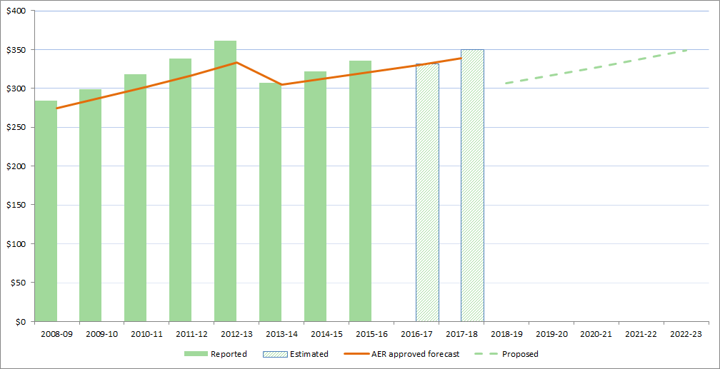

Source: AER, Economic Benchmarking RIN accounts; AER, Final decision PTRM for ElectraNet 2013–18, April 2013; ElectraNet, Revenue Proposal 2018-–23, March 2017; AER analysis.

In accordance with the methodology required by the NER, ElectraNet's revenue requirement is the sum of a number of "building blocks", as follows:

* a return on the regulatory asset base (RAB) (return on capital)
* depreciation of the RAB (return of capital)
* forecast operating expenditure (opex)
* increments or decrements resulting from the application of incentive schemes
* the estimated cost of corporate income tax.

Our assessment of capex directly affects the size of the RAB and therefore the return on capital and return of capital building blocks.

Our assessment of ElectraNet's proposal will consider each of the building blocks shown in Figure 2. However, we must decide ElectraNet's revenue as a whole and describe how the component parts of the decision relate to each other.

Figure ****The building block approach to determining maximum allowed revenue****

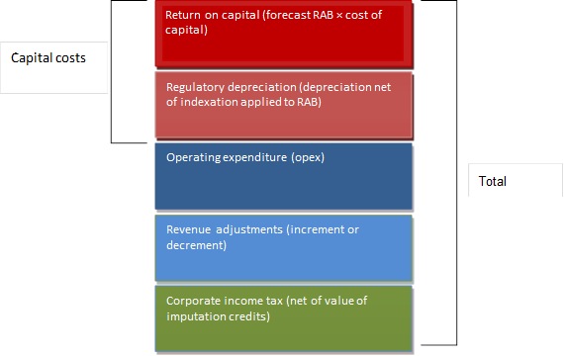

To assist consumers to understand the key drivers of the increase in ElectraNet's proposed total revenue requirement, we have separated out the various building block elements. In the figure below we show the impact of these changes as if all occurred in one year.

Figure 3 shows that ElectraNet's forecast return on capital and opex building blocks decrease. However, this decrease is offset by increases to the regulatory depreciation, revenue adjustments from incentive schemes and tax building blocks.[8] ElectraNet's forecast capital expenditure and lower expected inflation estimate are the key drivers of the increase in forecast depreciation allowance, and its proposal for a lower value of imputation credits (gamma) is the main driver of the increase to corporate income tax.

Figure ElectraNet – change in 2013–18 average annual revenue to proposed average annual revenue for 2018–23 – by revenue component ($m, June 2018)

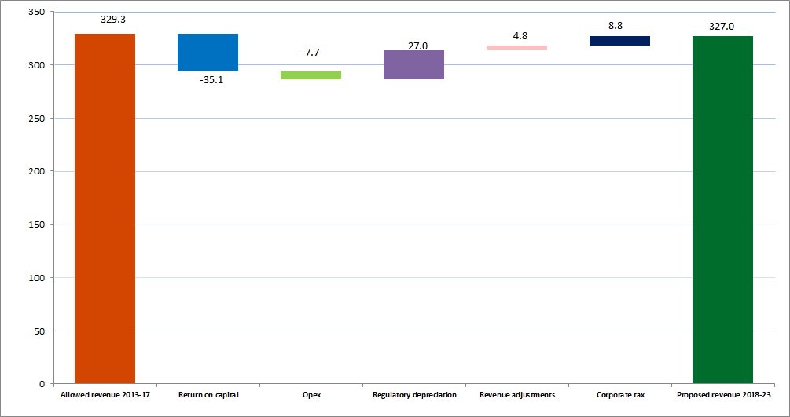

Source: AER, Final decision PTRM for ElectraNet 2014–18, April 2013; ElectraNet, Revenue Proposal 2018–23, March 2017; AER analysis.

## Regulatory asset base

The RAB is the value of the assets used by ElectraNet to provide prescribed transmission services. From the proposed opening value of the RAB on 1 July 2018, it will be adjusted for each year of the 2018–23 regulatory control period by:

* adding an inflation adjustment
* adding actual or estimated capital expenditure
* subtracting depreciation, calculated according to a straight-line depreciation approach
* subtracting gross proceeds from any asset disposals.

These annual adjustments give the closing RAB for any particular year, which then becomes the opening RAB for the following year, and this process rolls forward the RAB to the end of the 2018–23 regulatory control period.

Figure 4 ElectraNet historical and forecast RAB ($m, nominal)



Source:   AER, Final decision PTRM for ElectraNet 2013–18, 30 April 2013; AER, Final decision RFM for ElectraNet 2013–18, 30 April 2013; ElectraNet, Revenue Proposal 2018–2023, 28 March 2017.

As shown in Figure 4, ElectraNet proposed an opening RAB value of $2,552 million ($nominal) as at 1 July 2018, and of $2,694 million ($nominal) as at 1 July 2023. The closing forecast RAB is $2,670 million ($nominal) as at 30 June 2023.

## Capital expenditure

ElectraNet's capex increases the size of its RAB and, in turn, ElectraNet's revenues. ElectraNet's network assets are long-lived and will typically remain in service for several decades. This means that ElectraNet's capex will influence the revenues that it will earn well beyond the 2018–23 regulatory period.

ElectraNet has proposed forecast capex of $458 million ($2017-18) over the forthcoming regulatory period, representing a 39 per cent reduction on actual and estimated expenditure over the current period.[9] ElectraNet's historical and forecast capex is shown in Figure 5.

Figure 5 ElectraNet's historical and forecast capital expenditure ($m, real June 2018)



Source: AER, Category Analysis RIN accounts; AER, Final decision PTRM for ElectraNet 2013–18, 30 April 2013; ElectraNet, Revenue Proposal 2018–2023, 28 March 2017; AER analysis.

Most of ElectraNet's capex forecast relates to network capex ($405 million, or 88 per cent) compared to non-network ($53 million, or 12 per cent). A significant part of the network capex forecast (80 per cent) is for network replacement and refurbishment. Augmentation to the transmission system makes up only a relatively minor 5 per cent of the forecast network capex.[10]

ElectraNet has proposed a number of targeted asset replacement programs for various asset types such as line insulators, protection systems and isolators. ElectraNet has also proposed a significant project for the replacement of sections of transmission line on the Eyre Peninsula, at a forecast cost of $73.8 million ($2017-18). The Eyre Peninsula is also the subject of a contingent project for the full replacement of these lines, subject to the outcome of a separate RIT-T process.[11]

See section of this paper for further details.

### Contingent projects

Contingent projects are significant capex projects that may be required in the forecast period. However, unlike other capex projects, the need for the project and the associated costs are not sufficiently certain. Consequently, expenditure for such projects does not form a part of our assessment of the total forecast capex that we approve in this determination.

Instead we consider the appropriate 'trigger event' to justify commencing contingent projects in the next period. In that period, if we are satisfied the trigger event has occurred, we would then determine the efficient incremental revenue which is likely to be required in each remaining year of the regulatory control period as a result of the contingent project, and amend the revenue determination accordingly.

ElectraNet proposed five contingent projects, costing in total between $630 million and $950 million. See section of this paper for further details.

## Operating expenditure

ElectraNet proposed total operating expenditure of $436 million ($ June 2018) for the 2018–23 regulatory control period.[12] This is 1 per cent less than ElectraNet's estimated actual opex for the 2013–18 regulatory control period.[13] We have not identified any aspects of ElectraNet's opex proposal we consider to be an issue for discussion in this paper but consumers are welcome to comment on the proposal, if they either agree or disagree with it.

Figure ElectraNet's opex ($m, June 2018)

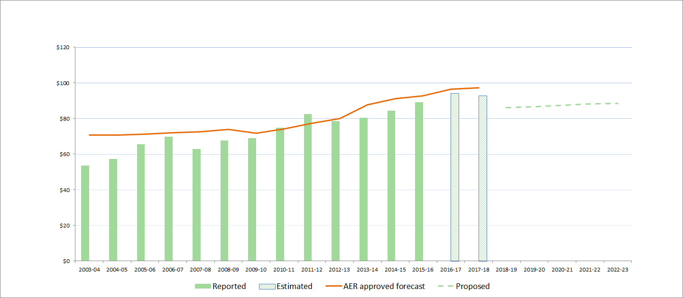

Source: AER, Benchmarking RIN accounts; AER, Final decision PTRM for ElectraNet 2013–18, 30 April 2013; ElectraNet, Revenue Proposal 2018–2023, 28 March 2017; AER analysis.

## Return on investment

The allowed rate of return is the forecast of the cost of funds a network business requires to attract investment in the network. We allow ElectraNet to earn a return on its investments, by applying a rate of return to the RAB.

We published our Rate of Return guideline in December 2013.[14] It sets out the method we propose to use to estimate the allowed rate of return for electricity and gas network businesses.

There are several components to ElectraNet's forecast return on investment. These are set out in Table 2 below. ElectraNet has calculated its rate of return consistent with our rate of return guideline, with the exception of the value of imputation credits (gamma).[15] We consider this aspect in further detail in section 6 of this paper.

We are also reviewing our method for estimating expected inflation.[16] See section 7 of this paper for further details.

Table ElectraNet's proposed rate of return

|  |  |  |
| --- | --- | --- |
| Parameter | Approach | Proposed value |
| Risk free rate | AER guideline approach | 2.83% |
| Equity beta | AER guideline approach | 0.7 |
| MRP | AER guideline approach | 6.5% |
| ROE | AER guideline approach | 7.4% |
| Return on debt | AER guideline approach | 5.1% |
| WACC | (60% gearing) | 6.02% |
| Gamma | Based on market value estimate | 0.25 |
| Inflation | Market based (break-even) | 1.97% |

Source: ElectraNet revenue proposal 2018-23, Attachment 3 Rate of Return, 28 March 2017, p. 6.

# Effect of demand on prices

We will apply a cap on the revenues that ElectraNet can earn in the next regulatory period. Where a revenue cap applies, prices are sensitive to demand, that is, the prices required to recover the revenue will depend on demand. For instance, where demand is falling, prices per unit of energy would need to increase. Energy delivered by ElectraNet has been declining in the current period and has been lower than we forecast for this period. This means that ElectraNet will have needed to increase its prices in order to recover its revenue allowance.

The Australian Energy Market Operator (AEMO) forecasts that demand on ElectraNet's network in the next period will continue to decline. This means that, all other things being equal, ElectraNet will need to increase its prices further in order to match its revenue cap.

ElectraNet has proposed to reduce its total revenue in the next period moderately (by 0.3 per cent). This will mitigate the effect of declining demand on prices to a small extent. Further, ElectraNet has proposed a 12 per cent reduction in revenue in the first year of the next regulatory period. However, this is offset by annual revenue increases of 3.3 per cent per annum in real terms in the following years.[17]

In the next sections, we consider the actual and forecast demand for electricity in South Australia, and the effect of demand on prices.

## Demand for energy

Energy delivered through ElectraNet's network peaked in 2011 and has declined since then (though ElectraNet has experienced a moderate increase in demand in 2016). Figure 7 shows ElectraNet's total energy delivered.

Figure Electricity delivered by ElectraNet (GWh)



Source: AER, Economic Benchmarking RIN accounts; Energy delivered (excluding energy delivered to other transmission networks)

AEMO forecasts that demand on ElectraNet's network will continue to decline at 0.5 per cent annually over the next 20 years, driven by high levels of growth in rooftop PV, which continues to be at a rate higher than seen in other regions [18] Figure 8 shows the actual and forecast energy consumption in South Australia broken down by category.

Figure AEMO South Australian annual consumption forecast (GWh)

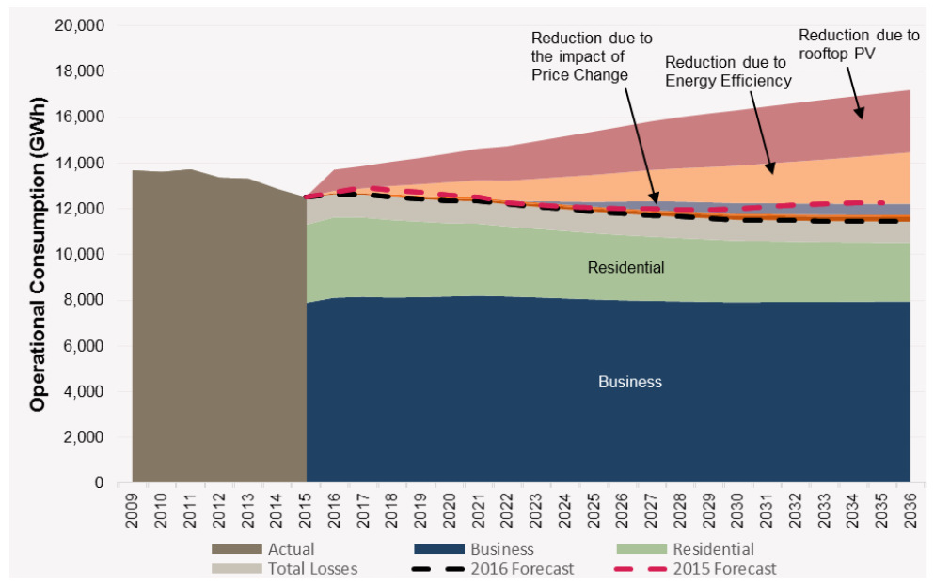

Source: AEMO, 2016 National Electricity Forecasting Report Chart Pack, 2016, slide 23.

## Demand and prices

We cannot specify the precise effect ElectraNet's proposal will have on transmission prices because the transmission prices ElectraNet sets will differ depending on the customer. However, we can provide an indication of how the proposal could affect prices by considering revenue per MWh of electricity delivered.

ElectraNet's proposed revenue, if accepted, would translate to an increase in revenue per MWh of electricity delivered of 1.4 per cent in comparison to the current period.[19]

Figure 9 shows the indicative average price path (in real terms) derived from ElectraNet's revenue proposal, in terms of the revenue per MWh of energy delivered. The solid lines represent actual (up to 2015–16) and approved (up to 2017–18) average prices. The dotted line represents the average price path proposed by ElectraNet over the next regulatory control period. From 2008–09 to 2015–16, ElectraNet’s actual price path, on average, has been higher by 5.7 per cent than the approved average price because actual demand was lower than our demand forecast.

Figure 9 ElectraNet – Revenue per MWh 2008–09 to 2022–23 ($ June 2018/MWh)



Source: AER, Economic Benchmarking RIN accounts; AER, Final decision PTRM for ElectraNet 2013–18, April 2013; ElectraNet, Revenue Proposal 2018–23, March 2017; AEMO, Electricity Annual Consumption Operational, 2017, <http://forecasting.aemo.com.au/Electricity/AnnualConsumption/Operational> .

Figure 9 also shows that at the start of the next period ElectraNet proposes to reduce its revenue per MWh significantly. However, under ElectraNet's proposal, revenue per MWh will then increase in each subsequent year of the next period.

# Capital expenditure

Capital expenditure (capex) refers to expenditure on assets that provide services over a number of years. The most significant elements of total capex are generally asset replacement expenditure (repex), augmentation expenditure (augex), and connections.

Capex is added to the RAB, and so forms part of the capital costs in the building blocks used to determine total required revenue. Under the NER, we must accept a proposed forecast of total capex if we are satisfied it reasonably reflects the capital expenditure criteria (capex criteria) set out in the NER.[20] The capex criteria relate to the efficient costs incurred by a prudent operator in light of realistic demand forecasts and cost inputs. We must also have regard to the capex factors set out in the NER when making that decision.[21]

## How we assess capital expenditure

We assess forecast capex proposals through a combination of top down and bottom up assessments. Our focus is typically on determining the prudent and efficient level of forecast capex. We will generally assess forecast capex by assessing the need for the expenditure and the efficiency of the proposed projects and related expenditure to meet any justified expenditure need. This is likely to include consideration of the timing, scope, scale and level of expenditure associated with proposed projects. Where businesses do not provide sufficient economic justification for their proposed expenditure, we will determine what we consider to be the efficient and prudent level of forecast capex. In assessing forecasts and determining what we consider to be efficient and prudent forecasts we may use a variety of analytical techniques to reach our views.

Our assessment approaches for capex and opex differ. We use revealed costs for opex to a greater extent than for capex because we consider opex is largely recurrent. Past actual expenditure may not be an appropriate starting point for capex given it is largely non-recurrent or 'lumpy', and so past expenditure or work volumes may not be indicative of future expenditure or volumes. Further, transmission network service providers (TNSPs) tend to propose a smaller number of large, high-cost projects which we may need to consider on a case-by-case basis.

## Key drivers of ElectraNet's capital expenditure proposal

ElectraNet has proposed forecast capex of $458 million ($2017-18) over the forthcoming regulatory period, a 39 per cent reduction compared to actual and estimated expenditure over the current period.[22]

ElectraNet's investment program for the forthcoming period is driven by:[23]

* targeted measures to improve network security and the ability of the network to withstand extreme weather events
* replacing assets whose condition signals they are at the end of their useful lives
* refurbishing assets in order to drive the network harder and longer.

Figure 10 shows the breakdown of forecast capex into driver categories.

Figure 10 ElectraNet's capex forecast by driver categories

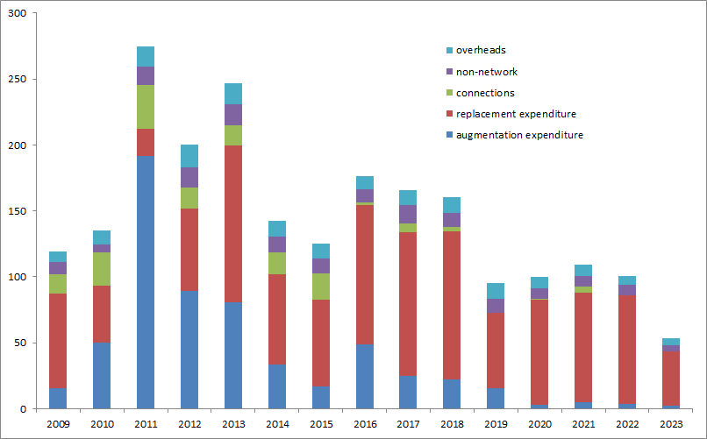

Source: AER analysis; ElectraNet annual regulatory accounts; ElectraNet, Revenue Proposal 2018-23, 28 March 2017.

Note: Overheads for network and non-network have been aggregated.

A significant majority of ElectraNet's forecast capex (71 per cent) is for the replacement or refurbishment of existing network assets. ElectraNet has proposed a number of targeted asset replacement programs for various asset types such as line insulators, protection systems and isolators. ElectraNet's asset replacement and refurbishment expenditure is supported by a risk assessment approach which quantifies the costs associated with asset failures to justify the need for asset replacement or refurbishment.

Given growth in electricity demand in South Australia has decreased, and is projected to fall further in the forthcoming period, ElectraNet has proposed minimal load driven capex (augex) for the 2018–2023 regulatory control period.

The largest single project in ElectraNet's capex forecast relates to the replacement of major components of the transmission line supplying the Eyre Peninsula, at a forecast cost of $73.8 million ($2017-18). This is the minimum level of expenditure that ElectraNet considers will be required in the 2018–23 regulatory control period to maintain the existing line. However, ElectraNet is also considering whether alternative approaches such as full line replacement or duplication deliver greater net benefits through improved reliability and avoided network support costs. ElectraNet is currently considering a range of options for delivering reliable electricity supply to the Eyre Peninsula through a formal RIT-T process.

ElectraNet has proposed $46 million ($2017-18) for capex driven by security and compliance requirements. Specifically, ElectraNet submitted that it had identified a number of targeted measures to improve the ability of the transmission network to withstand the impact of extreme weather events, and improve the security of the network. These projects include:[24]

* implementing a special protection scheme to maintain system security and protect against islanding of the South Australian power system
* providing diesel generator supplies to critical substations to enable quicker restoration of the network under system black conditions
* upgrading access track conditions at vulnerable tower locations
* reviewing and updating the transmission line design manual
* replacing control systems to improve network security and management of interconnector flows
* installation of additional equipment to maintain voltages under more complex power flows
* installation of additional equipment at Torrens Island North substation to facilitate a faster and more reliable black start.

The total forecast cost of these measures to address network security risk is approximately $32 million. The need for and justification of these projects to enhance transmission network security will be one focus of our review.

We are looking for responses to the following questions, but also welcome submissions on other aspects if you think they are important.

**Capex questions**

1. Do you consider that ElectraNet has adequately justified the need for the proposed investment in measures to improve network security and the ability of the network to withstand the impact of extreme weather events?

2. Do you consider that ElectraNet's approach in proposing an ex ante capex project to refurbish transmission lines on the Eyre Peninsula, while at the same time exploring alternative options through a formal RIT-T process is reasonable?

3. Do you consider that ElectraNet's risk assessment methodology and its application support its proposed replacement and refurbishment capex against the capex criteria?

# Contingent projects

Generally, contingent projects are significant network augmentation projects that are reasonably required to be undertaken in order to achieve the capex objectives. However, unlike other proposed capex projects, the need for the project within the regulatory period and the associated costs are not sufficiently certain. Consequently, expenditure for such projects does not form a part of the total forecast capex that we approve in this determination. Such projects are linked to unique investment drivers (rather than general investment drivers such as expectations of load growth in a region) and are triggered by defined ‘trigger events’. The occurrence of the trigger event must be probable during the relevant regulatory control period.[25]

If, during the regulatory control period, ElectraNet considers that the trigger event for an approved contingent project has occurred, then it may apply to us. At that time, we will assess whether the trigger event has occurred and the project meets the threshold. If satisfied of both, we would determine the efficient incremental revenue which is likely to be required in each remaining year of the regulatory control period as a result of the contingent project, and amend the revenue determination accordingly.[26]

## How we assess contingent projects

We will review each of ElectraNet's proposed contingent projects against the assessment criteria in the NER.[27] We will consider whether:

* the proposed contingent project is reasonably required to be undertaken in order to achieve any of the capex objectives;[28]
* the proposed contingent project capital expenditure is not otherwise provided for in the capex proposal;[29]
* the proposed contingent project capital expenditure reasonably reflects the capex criteria, taking into account the capex factors;[30]
* the proposed contingent project capital expenditure exceeds the defined threshold;[31] and
* the trigger events in relation to the proposed contingent project are appropriate.[32]

We will also consider whether the proposed trigger events for each project are appropriate. This includes having regard to the need for the trigger event:

* to be reasonably specific and capable of objective verification;[33]
* to be a condition or event which, if it occurs, makes the project reasonably necessary in order to achieve any of the capex objectives;[34]
* to be a condition or event that generates increased costs or categories of costs that relate to a specific location rather than a condition or event that affects the transmission network as a whole;[35]
* is described in such terms that it is all that is required for the revenue determination to be amended;[36] and
* is probable during the 2018–23 period but the inclusion of capex in relation to it (in the total forecast capex) is not appropriate because either it is not sufficiently certain that the event or condition will occur during the regulatory control period or if it may occur after that period or not at all; or (and assuming it meets the threshold) the costs associated with the event or condition are not sufficiently certain.[37]

## ElectraNet's contingent projects

ElectraNet proposed between $630 million and $950 million for five contingent projects for the 2018–23 regulatory control period.[38] ElectraNet submitted it is probable or plausible the proposed projects would need to occur by 2023.[39]

The five proposed contingent projects are:[40]

* Eyre Peninsula Reinforcement ($200 million)
* South Australian Energy Transformation ($200-500 million)
* Upper North-East Line Reinforcement ($60 million)
* Upper North-West Line Reinforcement ($110 million)
* Main Grid System Strength Support ($60-80 million)

ElectraNet submitted that the proposed Eyre Peninsula Reinforcement project may deliver sufficient benefits to customers to outweigh the additional costs by improving supply reliability to customers in the region, avoiding the ongoing annual costs of network support at Port Lincoln and reducing network losses.[41]

ElectraNet identified the following needs in respect to the South Australian Energy Transformation project:[42]

* facilitating greater competition in the wholesale electricity market, to lower dispatch costs and consequently wholesale electricity prices, particularly in South Australia (market need)
* providing appropriate security of supply, including inertia, frequency response and system strength services in South Australia (security need); and
* facilitating the transition to lower carbon emissions and the adoption of new technologies (emissions need).

In respect to the two-load related projects (Upper North-East and Upper North-West Line Reinforcement), ElectraNet submit that the proposed contingent projects would be reasonably required to meet the NER capital expenditure objectives to efficiently meet expected demand for prescribed transmission services and to comply with all applicable regulatory obligations.[43]

ElectraNet submitted that the requirement for the Main Grid System Strength Support project is to maintain minimum fault levels in South Australia for foreseeable operating conditions above a level that is sufficient to ensure that:

* power electronic interfaced devices such as wind turbines and static Var compensators can remain stable
* protection systems can adequately function; and
* voltage can be maintained during normal system and market operations including switching transformers, transmission lines and reactive plant, transformer tap changing and routine variations in load or generation.[44]

ElectraNet's proposal on contingent projects will be a particular focus in our review. We are looking for responses to the following questions, but also welcome submissions on other aspects if you think they are important.

Contingent projects questions

1. Do you consider that the trigger event proposed by ElectraNet for each proposed contingent project is probable during the 2018-23 regulatory control period? If not, why?

2. With respect to the Upper North-East and Upper North-West Line Reinforcement load-driven contingent projects, can you provide any evidence of investments which may increase demand for electricity such that ElectraNet's current load limits for these two regions are likely to be exceeded during the 2018-23 regulatory control period?

# Value of imputation credits

In the building block model, we provide an allowance for the estimated tax paid by the benchmark firm. In Australia, companies typically pay tax at the rate of 30 per cent on their profit. However, under the Australian taxation system, investors can receive an 'imputation credit' for income tax paid at the company level. For investors that meet certain eligibility criteria, this credit can be used to offset their tax liabilities. If the amount of imputation credits received exceeds an investor’s tax liability, that investor can receive a cash refund for the balance. Imputation credits are a benefit to investors in addition to any cash dividend or capital gains from owning shares.

The NER recognises that a service provider's allowed revenue does not need to include the value of imputation credits. Under the NER, service providers are able to recover revenue that compensates them for their efficient costs in providing regulated services. This includes, among other things, a return to be provided to investors (return on equity) that is required to promote efficient levels of investment. The more that imputation credits are valued, the less return that investors require from dividends and capital gains. We adjust the revenue granted to a service provider to cover its expected tax liability to account for imputation credits.

### How we have calculated the value of imputation credits

The rate of return guideline proposes that the value of imputation credits would be estimated as a market-wide parameter, rather than estimating this on an industry or business-specific basis. Under the guideline, the value of imputation credits is accounted for by gamma which is determined as the product of:

* a distribution rate (referred to in our guideline as the 'payout ratio'), which represents the proportion of imputation credits generated by the benchmark entity that is distributed to investors; and
* a utilisation rate, which is the extent to which investors can use the imputation credits they receive to reduce their tax or to get a refund.

In the guideline, our assessment of this evidence produced an estimate of 0.7 for the utilisation rate and 0.7 for the distribution rate. The guideline therefore proposed a gamma estimate of 0.5. However, in the recent determinations we re-examined the evidence and clarified our understanding of the utilisation rate as the utilisation value to investors in the market per dollar of imputation credits distributed. This re-examination, in addition to new evidence and advice considered since the guideline, led us to depart from the 0.5 value of gamma we proposed in the guideline. Instead, we chose a value of 0.4 for gamma from within a range of 0.3 to 0.5.

## ElectraNet's proposed value of imputation credits

ElectraNet has proposed a gamma of 0.25. The reason for the difference between ElectraNet's proposal and our recent decisions is primarily a disagreement on the interpretation of the utilisation rate. We define the utilisation rate as the value to investors in the market per dollar of imputation credits distributed, which reflects the extent to which investors can utilise the imputation credits they receive to reduce their tax or obtain a refund. ElectraNet argues that the rules define gamma as the value of imputation credits and value must be defined as worth to investors. Therefore, it considers the utilisation rate is the amount that investors would be prepared to buy an imputation credit for. It considers this is a market value concept and must be estimated as such.[45]

Our recent decisions on the value of gamma have been the focus of reviews of our decisions at the Tribunal and Full Federal Court. A number of these decisions are currently reserved. The Full Federal Court handed down its judgement on our appeal of the Tribunal's decision for the NSW and ACT electricity distribution networks on 24 May 2017. We are currently considering this judgement and at this stage, we are not in a position to comment on its implications for our decision. Subject to our required decision making timeframes and processes under the NEL, we will consider any Tribunal or Federal Court decisions on the value of gamma handed down in making our future decisions on the value of gamma. The outcomes of these legal cases may affect our future decisions on the value of gamma.

Gamma question

1. Do you agree with ElectraNet's proposal to use a gamma value of 0.25 in valuing imputation credits, and if so, why?

# Inflation

Recently, the method for estimating expected inflation has been the subject of debate in our regulatory determinations. Expected inflation is an important parameter for modelling future revenues in both electricity and gas regulatory determinations and is applied uniformly across both sectors.

Our method for estimating expected inflation is set out in the Post-Tax Revenue Model. The rules require us to use the method that is set out in the current version of the model. To fully consider inflation-related issues that have been raised with us, we have instituted an industry-wide consultation and review. The first step of this consultation and review is to seek written submissions on our regulatory treatment of inflation in our determination of revenue and prices for electricity and gas network services.

On 18 April 2017, we published our discussion paper on the regulatory treatment of inflation.[46] The discussion paper is informed by ACCC working paper no. 11 on the best estimates of expected inflation, which can be found under ACCC working & discussion papers.[47] Interested parties are invited to make submissions on our discussion paper by close of business on Thursday 29 June 2017.

# Consumer engagement

This section summarises the consumer engagement strategies and activities described by ElectraNet in its revenue proposal, to give consumers and stakeholders a sense of ElectraNet’s consumer engagement approaches. However, we also encourage you to review the consumer engagement material contained in the revenue proposal when making submissions.

When assessing the revenue proposal we will have regard to how a business engaged with its consumers and accounted for their long term interests.

## Consumer engagement in the NER

Under the NER, consumer engagement is a factor we must consider when making our revenue determinations.[48] We will examine whether and how well a transmission business considered and responded to consumer views, equipped consumers to participate in consultation, made issues tangible and obtained a cross-section of views. We will make our assessment on a case-by-case basis, considering whether it would have been reasonable to engage on a particular issue. We will monitor consumer engagement activities through our Consumer Challenge Panel and by our ongoing engagement with stakeholders. We may publicly comment on any shortcomings in a business' consumer engagement that we identify from a regulatory proposal.

Our obligation to have regard to the extent to which a transmission business' forecast includes expenditure to address the concerns of consumers forms part of our overall task of determining whether the transmission business' proposed forecasts reasonably reflect the efficient and prudent costs of achieving the capex (or opex) objectives.[49] Therefore, if proposed expenditure is not required to achieve one or more of the capex (or opex) objectives, even with evidence of consumer support we will not be satisfied that the proposed expenditure reasonably reflects the capex and opex criteria.

Furthermore, the extent to which the proposed forecasts include expenditure to address the concerns of consumers during the course of the business' engagement with consumers is only one of nine or more factors that we must have regard to in determining whether we are satisfied that the proposed capex (or opex) reasonably reflects the capex (or opex) criteria.[50] In this sense, the factor relating to consumer engagement alone is not determinative.[51]

If a TNSP submits that particular expenditure programs will address the concerns of consumers identified through its consumer engagement, we will consider whether such claims are supported by solid evidence of the preferences of affected consumers. This may include consideration of whether the engagement was sufficient to identify key areas of consumer concern, whether consumers have been adequately informed of relevant price implications, and how the expenditure proposed would address those customer concerns.

## Our consumer engagement guideline

Our consumer engagement guideline sets out a framework for electricity and gas network service providers to better engage with consumers. It aims to help the businesses develop strategies to engage systematically, consistently and strategically with consumers on issues that are significant to both parties. The guideline sets out our expectations when considering service provider consumer engagement activities:

**Priorities**—we expect service providers to identify consumer cohorts, and the current views of those cohorts and their service provider; outline their engagement objectives; and discuss the processes to best achieve those objectives.

**Delivery**—we expect service providers to address the identified priorities via robust and thorough consumer engagement.

**Results**—we expect service providers to articulate the outcomes of their consumer engagement processes and how they measure the success of those processes reporting back to us, their business and consumers

**Evaluation and review**—we expect service providers to periodically evaluate and review the effectiveness of their consumer engagement processes.

## ElectraNet’s consumer engagement strategy

ElectraNet commenced its consumer engagement activities in December 2015, in advance of the submission of its revenue proposal, with the establishment of a Consumer Advisory Panel (CAP).[52]

The primary objective of the early engagement approach was to ensure that the Revenue Proposal submitted to the AER was thoroughly tested by stakeholders and focused on the needs of customers. This engagement was not intended to replace the formal revenue determination process but rather to improve and better inform it through a collaborative approach to develop a more fully tested and understood set of proposals, with the aim of ensuring a more effective and efficient review process built on a level of shared understanding with stakeholders.[53]

ElectraNet's early engagement process was designed to deliver a key number of benefits to customers and ElectraNet. This was supported by ElectraNet's CAP and us, which included[54]:

* Improved shared understanding of network challenges and customer concerns
* More targeted expenditure plans that better reflect customer preferences
* Greater trust and confidence in regulatory outcomes increased certainty in regulatory outcomes with 'no surprises'
* Reduced resources engaged in the current regulatory process.

It is important to emphasise, as ElectraNet acknowledges, that these early engagement activities do not replace or dilute the formal decision making process required for a revenue determination under the NER.

ElectraNet's pre-lodgement process included public consultation on a preliminary revenue proposal and the use of in depth technical workshops[55] with consumer representatives, the CCP and us.

We have observed ElectraNet being upfront and open about its network plans, costs and impacts on consumers, including the early presentation of a number of business cases that make up key components of the capital expenditure contained in its revenue proposal.

Material on ElectraNet's consultation activities can be found on its CAP resources webpage.[56]

In its proposal, ElectraNet has provided a summary of feedback received from stakeholders on the preliminary revenue proposal. This summary includes responses and actions taken in its revenue proposal.[57]

We are keen to understand consumer views on ElectraNet's consumer engagement process. We are looking for responses to the following questions, but also welcome submissions on other aspects if you think they are important.

**Consumer engagement questions**

1. How far has ElectraNet's early engagement process gone towards achieving its intended benefits?

2. Has the early engagement process enhanced the regulatory process?

3. If you have been involved with other TNSP reviews, are there any aspects of ElectraNet's process so far that are better or less well developed than other TNSP consumer engagement processes?

4. Is ElectraNet's process likely to have improved its understanding of customer concerns and taken these into account in determining its revenue proposal for the long term interest of consumers?

Appendix A: Background to our assessment

This section provides information about the AER and ElectraNet.

The NEL and NER set out the regulatory framework for the National Electricity Market (NEM). Chapter 6A of the NER contains timelines and processes for the regulation of transmission businesses. It provides that regulated transmission businesses must periodically apply to us to assess their revenue requirements. Typically, this happens every five years. The revenue proposal as submitted by each business starts a process often referred to as a pricing review or 'revenue reset'.

## Who are we?

We are Australia's energy market regulator for the National Electricity Market (NEM).[58] Our functions are set out in NEM legislation and rules. These functions include:

* setting the revenues that network businesses can recover from their customers for using energy networks (electricity poles and wires and gas pipelines) to transport energy to customers
* monitoring wholesale electricity and gas markets so suppliers comply with the legislation and rules, and taking enforcement action where necessary
* publishing information on energy markets, including the annual State of the Energy Market report and more detailed market and compliance reporting, to assist participants and the wider community
* assisting the Australian Competition and Consumer Commission with energy-related issues arising under the Competition and Consumer Act, including enforcement, mergers and authorisations.

The NEL and NER set out the regulatory framework under which we operate.

We exercise our functions in a manner that will advance the National Electricity Objective (NEO). The NEO in turn is supported through the revenue and pricing principles and the various objectives, criteria and elements within the rules. The NEO is:

…to promote efficient investment in, and efficient operation and use of, electricity services for the long term interests of consumers of electricity with respect to—

(a) price, quality, safety, reliability and security of supply of electricity; and

(b) the reliability, safety and security of the national electricity system.

Energy Ministers have provided us with a substantial body of explanatory material that guides our understanding of the NEO. [59] The long term interests of consumers are not delivered by any one of the NEO's factors in isolation, but rather by balancing them in reaching a regulatory decision. [60]

In general, we consider that we will achieve this balance and, therefore, contribute to the achievement of the NEO, where consumers are provided a reasonable level of safe and reliable service that they value at least cost in the long run.[61] In most industries, competition creates this outcome. Competition drives suppliers to develop their offerings to attract customers. Where a supplier’s offering is not attractive it risks being displaced by other suppliers.

However, in the energy networks industry the usual competitive disciplines do not apply. Electricity transmission businesses such as ElectraNet are largely natural monopolies.[62] In addition, many of the products they offer are essential services for most consumers. Consequently, in an uncompetitive environment, consumers have little choice but to accept the quality, reliability and prices the network service provider offers.

The NEL and NER aim to remedy the absence of competition by providing that we, as the regulator, make decisions that are in the long term interests of consumers. For example, we might require a transmission business to offer its services at a different cost than they would choose themselves. By its nature, this process will involve exercising regulatory judgement to balance the NEO's various factors.

It is important to recognise that there are a number of plausible outcomes that may contribute to the achievement of the NEO. The nature of decisions under the NER is such that there may be a range of economically efficient decisions, with different implications for the long term interests of consumers.[63] At the same time, however, there are a range of outcomes that are unlikely to advance the NEO to a satisfactory extent. For example, we do not consider that the NEO would be advanced if allowed revenues encouraged overinvestment and resulted in prices so high that consumers are unwilling or unable to efficiently use the network.[64] This could have significant longer term cost implications for those consumers who continue to use network services.

Equally, we do not consider the NEO would be advanced if the revenue recoverable from customers results in prices so low that investors are unwilling to invest as required to adequately maintain the appropriate quality and level of service, and where customers make more use of the network than is sustainable. This could create longer term problems and have adverse consequences for safety, security and reliability of the network.[65]

## AER Guidelines and schemes

During our 2013 Better Regulation program we developed, through an extensive consultation process, a number of guidelines and schemes. The result was a suite of guidelines that accommodated changes to the NEL and NER and set out approaches we consider are most likely to advance the NEO.

Below is a list and brief description of each of our guidelines and schemes. These guidelines and schemes are available on our website and include:[66]

****Expenditure forecast assessment guideline****

This guideline sets out how we go about assessing the operating and capital expenditure proposals from businesses.

****Rate of return guideline****

This guideline sets out how we go about determining the allowed rate of return businesses earn on their investments.

****Capital expenditure incentive guideline****

Our capital expenditure incentive guideline provides network businesses with an incentive to spend capital expenditure efficiently and share the benefits of efficiencies with consumers.

****Efficiency benefit sharing scheme****

Our efficiency benefit sharing scheme provides network businesses with a continuous incentive to spend operating expenditure efficiently and share efficiencies with consumers.

****Consumer engagement guideline for network service providers****

This guideline looks at our expectations of what the businesses should consider in implementing consumer engagement strategies that are effective for all stakeholders.

****Shared asset guideline****

This guideline explains how revenue the networks earn from shared assets is shared with consumers.

Service target performance incentive scheme

The purpose of the STPIS is to provide incentives to TNSPs to improve or maintain a high level of service for the benefit of participants in the National Electricity Market (NEM) and end users of electricity.

****Confidentiality guideline****

This guideline sets out how we manage confidential information claims within the regulatory determination process.

We consulted extensively in developing these guidelines. This consultation process was very important for testing our views and hearing from a range of interested parties. In particular, we made a special effort to engage consumers in the process through our Consumer Reference Group. The guidelines provide a solid foundation for our decision making and provide predictability in how we will exercise our discretion. Predictability provides confidence to both investors and consumers.

## Our framework and approach paper

We released our Framework and Approach (F&A) paper for ElectraNet on July 2016.[67]The F&A paper is the first step in the regulatory process and determines the broad nature of any regulatory arrangements that will apply in this process. It also facilitates early public consultation and assists network service providers to prepare revenue proposals.

The F&A is not binding on ElectraNet or us.[68] This means it is open to ElectraNet or us to propose a different approach to that set out in our F&A for the regulatory control period.

1. NER, cl. 6A.11.3(c).
2. NER, cl. 6A.12.2(c).
3. NER, cl. 6A.12.3(g).
4. NER, cl. 6A.6.6(e)(5A), cl. 6A.6.7(e)(5A).
5. All dollar values in this report are expressed in real June 2018 terms unless otherwise stated.
6. Revenues are smoothed to reduce revenue fluctuations between years. To calculate the smoothed revenues, the annual building block revenue requirements (the sum of the various building block costs) for all five years are smoothed across the regulatory control period. The smoothed and unsmoothed revenues across this period are equal in net present value terms.
7. AER analysis.
8. Regulatory depreciation is the net amount of the straight-line depreciation allowance and the forecast inflation indexation of the regulatory asset base.
9. Capex for 2013-14 to 2015-16 is actual; capex for 2016–17 and 2017–18 is estimated because actual data is not available yet.
10. ElectraNet, Revenue Proposal 2019–23 - Attachment 6: Capital Expenditure, 28 March 2017, p.43.
11. ElectraNet, Revenue Proposal 2019–23 - Attachment 6: Capital Expenditure, 28 March 2017, pp. 18-19 and 44.
12. ElectraNet, Revenue Proposal 2019 – 2023 - Attachment 7: Operating Expenditure, 28 March 2017, p. 28.
13. Opex for 2013-14 to 2015-16 is actual; opex for 2016–17 and 2017–18 is estimated because actual data is not available yet.
14. The rate of return guideline is available on our website, here: https://www.aer.gov.au/networks-pipelines/guidelines-schemes-models-reviews/rate-of-return-guideline
15. ElectraNet, Revenue Proposal 2019 – 2023 - Revenue Proposal Overview, 28 March 2017, p. 66.
16. Our method for estimating expected inflation is set out in the Post-Tax Revenue Model. It is an important parameter for modelling future revenues in both electricity and gas regulatory determinations and is applied uniformly across both sectors. See https://www.aer.gov.au/networks-pipelines/guidelines-schemes-models-reviews/review-of-expected-inflation-2017.
17. ElectraNet - Post Tax Revenue Model - March 2017 - Public, 'Revenue Summary' Tab'.
18. AEMO, National Electricity Forecasting Report, 2016, p. 23.
19. AER analysis.
20. NER, cl.6A.6.7(c).
21. NER, cl.6A.6.7(e).
22. Capex for 2013-14 to 2015-16 is actual; capex for 2016–17 and 2017–18 is estimated.
23. ElectraNet, Revenue proposal 2018–23: Attachment 6 - Capital Expenditure, 28 March 2017, p. 20.
24. ElectraNet, Revenue proposal 2018–23: Attachment 6 - Capital Expenditure, 28 March 2017, pp. 45-46.
25. NER, cl. 6A.8.1(c)(5).
26. NER, cl. 6A.8.2.
27. NER, cl. 6A.8.1.
28. NER, cl. 6A.8.1(b)(1).
29. NER, cl. 6A.8.1(b)(2)(i). Relevantly, a TNSP must include forecast capex in its revenue proposal which it considers is required in order to meet or manage expected demand for prescribed transmission services over the regulatory control period (see NER, cl. 6A.6.7(a)(1)).
30. NER, cl. 6A.8.1(b)(2)(ii).
31. NER, cl. 6A.8.1(b)(2).
32. NER, cl. 6A.8.1(b)(4).
33. NER, cl. 6A.8.1(c)(1).
34. NER, cl. 6A.8.1(c)(2).
35. NER, cl. 6A.8.1(c)(3).
36. NER, cl. 6A.8.1(c)(4).
37. NER, cl. 6A.8.1(c)(5).
38. ElectraNet, Revenue Proposal 2019–23 - Attachment 6: Capital Expenditure, 28 March 2017, pp. 47-48.
39. ElectraNet, Revenue Proposal 2019–23 - Attachment 6 - Appendix B: Contingent Projects, 28 March 2017.
40. ElectraNet, Revenue Proposal 2019–23 - Attachment 6 - Appendix B: Contingent Projects, 28 March 2017.
41. ElectraNet, Revenue Proposal 2019–23 - Attachment 6 - Appendix B: Contingent Projects, 28 March 2017, p. 4.
42. ElectraNet, Revenue Proposal 2019–23 - Attachment 6 - Appendix B: Contingent Projects, 28 March 2017, p. 8.
43. ElectraNet, Revenue Proposal 2019–23 - Attachment 6 - Appendix B: Contingent Projects, 28 March 2017, p. 11 and 14.
44. ElectraNet, Revenue Proposal 2019–23 - Attachment 6 - Appendix B: Contingent Projects, 28 March 2017, p. 17.
45. ElectraNet, Revenue Proposal 2018/19 – 2022/23, January 2017, pp. 190.
46. We have published this on our website, here: <https://www.aer.gov.au/node/51171> .
47. This paper has been published here: <https://www.aer.gov.au/node/51171> .
48. NER, cl. 6A.6.6(e)(5A), cl. 6A.6.7(e)(5A).
49. NER, cl. 6A.6.6(e)(5A).
50. NER, cl. 6A.6.6(e)(5A).
51. NER, cl. 6A.6.6(e)(5A).
52. ElectraNet, Revenue Proposal 2018–2023, Customer Engagement Outcomes Report, 28 March 2017, p. 10–11.
53. ElectraNet, Revenue Proposal 2018–2023, Customer Engagement Outcomes Report, 28 March 2017, p. 8.
54. ElectraNet, Revenue Proposal 2018–2023, Customer Engagement Outcomes Report, 28 March 2017, p. 9.
55. ElectraNet, Revenue Proposal 2018–2023, Revenue Proposal Overview, 28 March 2017, p. 35
56. <https://www.electranet.com.au/resource-categories/consumer-advisory-panel>
57. ElectraNet, Revenue Proposal 2018–2023, Customer Engagement Outcomes Report, 28 March 2017, Appendix D, p. 34..
58. The NEM connects electricity customers to electricity generators across all states and Territories with the exception of the Northern Territory and Western Australia. We are responsible for regulating electricity networks in every state and territory other than Western Australia.
59. Hansard, SA House of Assembly, 9 February 2005 pp. 1451–1460.

    Hansard, SA House of Assembly, 27 September 2007 pp. 963–972.

    Hansard, SA House of Assembly, 26 September 2013 pp. 7171–7176.
60. Hansard, SA House of Assembly, 26 September 2013 p. 7173.
61. Hansard, SA House of Assembly, 9 February 2005 p. 1452.
62. A natural monopoly is a distinct type of monopoly that may arise when there are extremely high fixed costs of distribution, such as exist when large-scale infrastructure is required to ensure supply. Examples of infrastructure include cables and grids for electricity supply, pipelines for gas and water supply.
63. Re Michael: Ex parte Epic Energy [2002] WASCA 231 at [143].

    Energy Ministers also accept this view – see Hansard, SA House of Assembly, 26 September 2013 p. 7172.

    AEMC, Rule Determination National Electricity Amendment (Economic Regulation of Transmission Services) Rule 2006 No. 18, p. 50.
64. NEL, s. 7A(7).
65. NEL, s. 7A(6).
66. http://www.aer.gov.au/Better-regulation-reform-program
67. The ElectraNet F&A can be found on our website at: [http://www.aer.gov.au/system/files/AER%20-%20ElectraNet%20final%20framework%20%26%20approach%202018-23%20-%20July%202016.pdf](http://www.aer.gov.au/system/files/AER%20-%20TransGrid%20final%20framework%20%26%20approach%202018-23%20-%20July%202016.pdf)
68. NER, cl. 6A.10.1A(f).