Ergon Energy provided further supporting information which we have not published on our website due to the number of documents provided. However, if you wish to obtain a copy of this material, please email [Qldelectricity2015@aer.gov.au](mailto:Qldelectricity2015@aer.gov.au).

We have listed below the documents submitted by Ergon Energy but not published on our website.

**0.A.02 Other references and documentation**

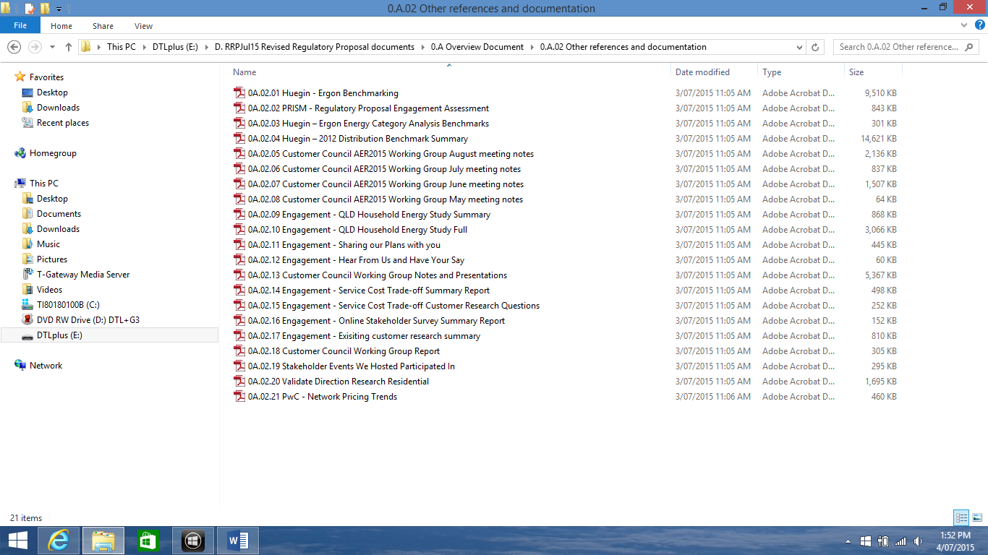

**01.02 Introduction - Other references and supporting documentation**

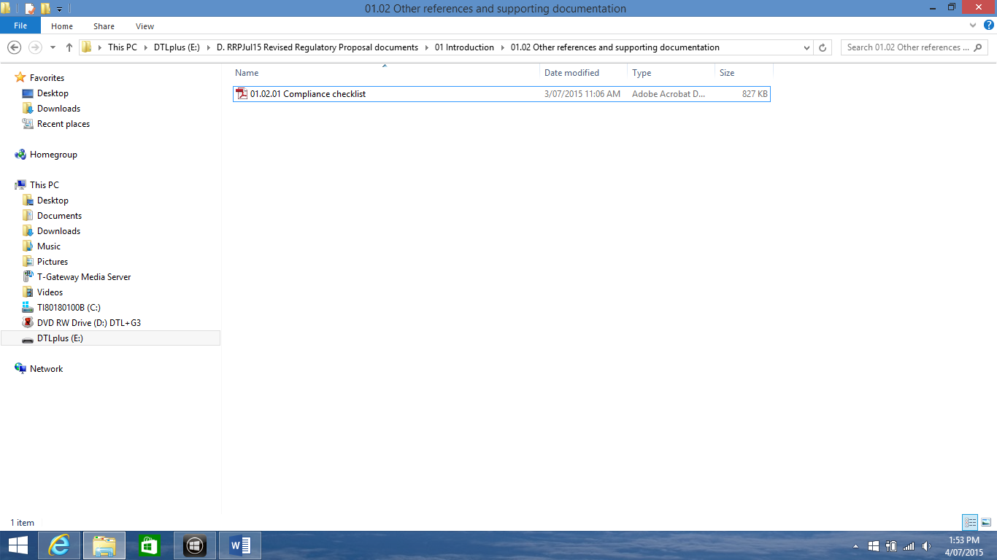

**03 Revenue building blocks for Standard Control Services**

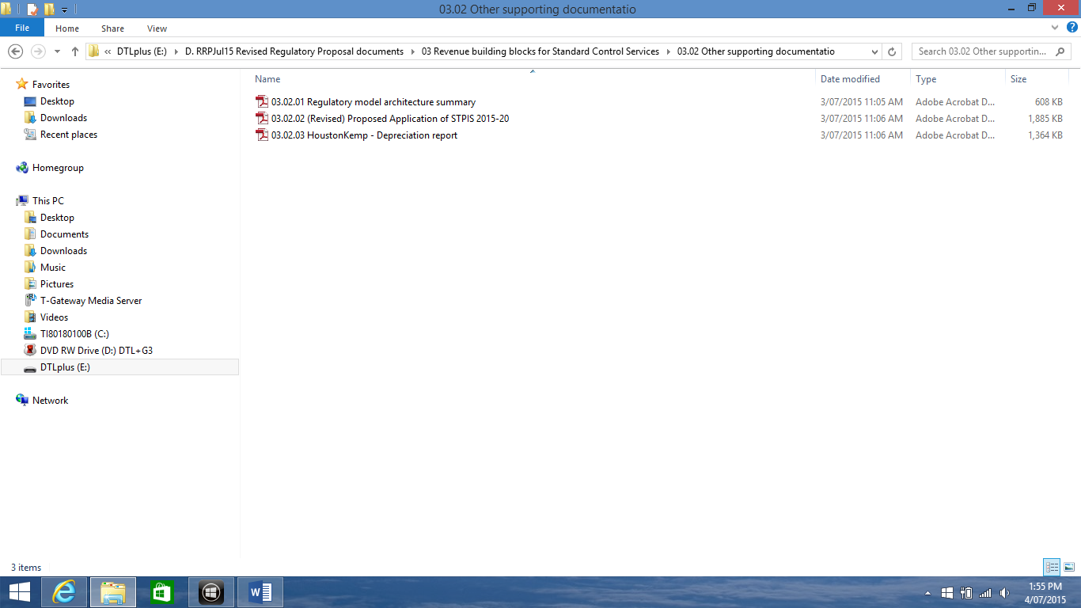

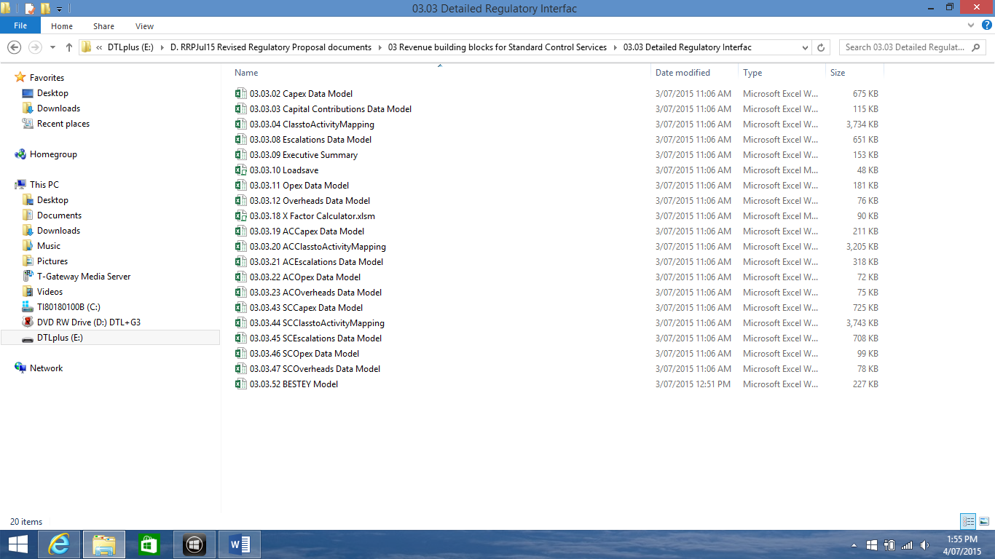

**04 Controls on revenue and prices for Standard Control Services**

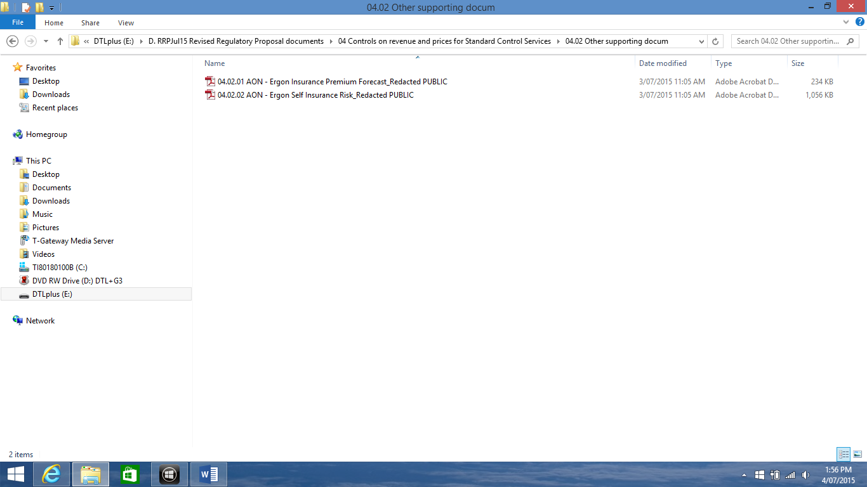

**05 Alternative Control Services**

05.02 Public lighting supporting documentation and reference material

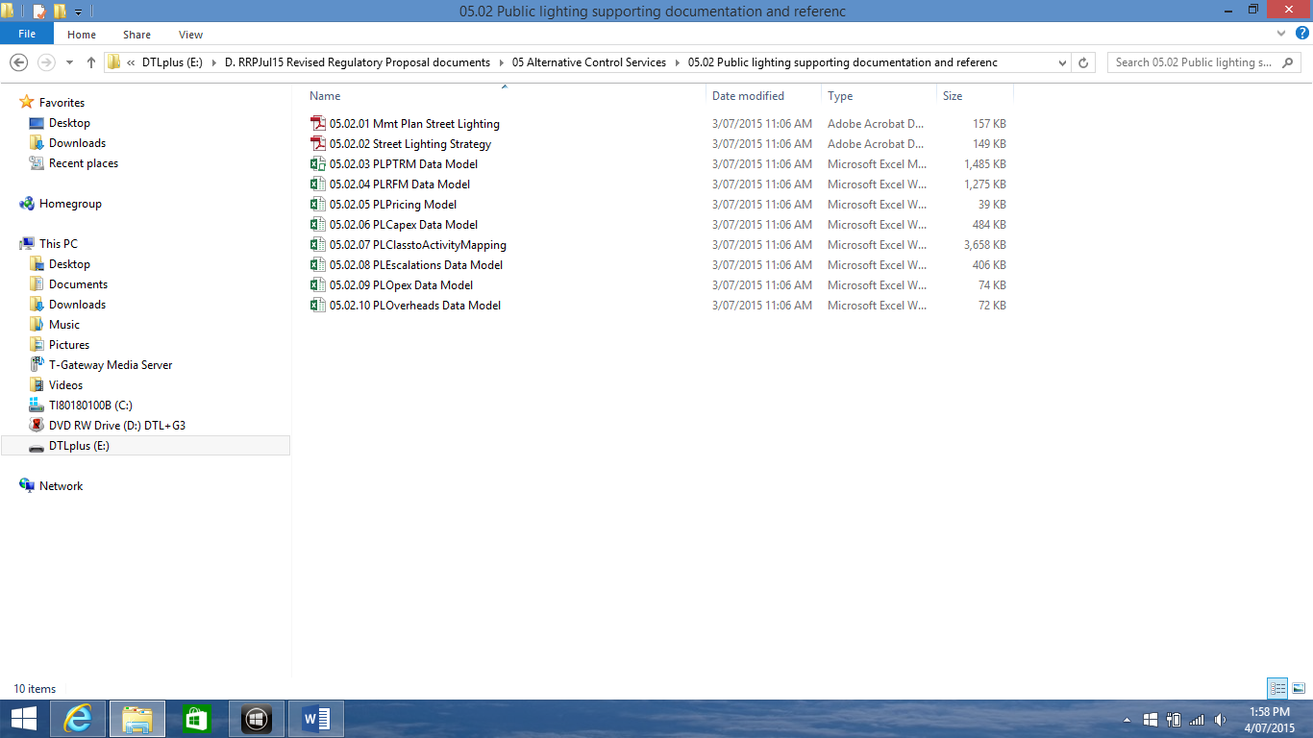

05.04 Default Metering Service supporting documentation

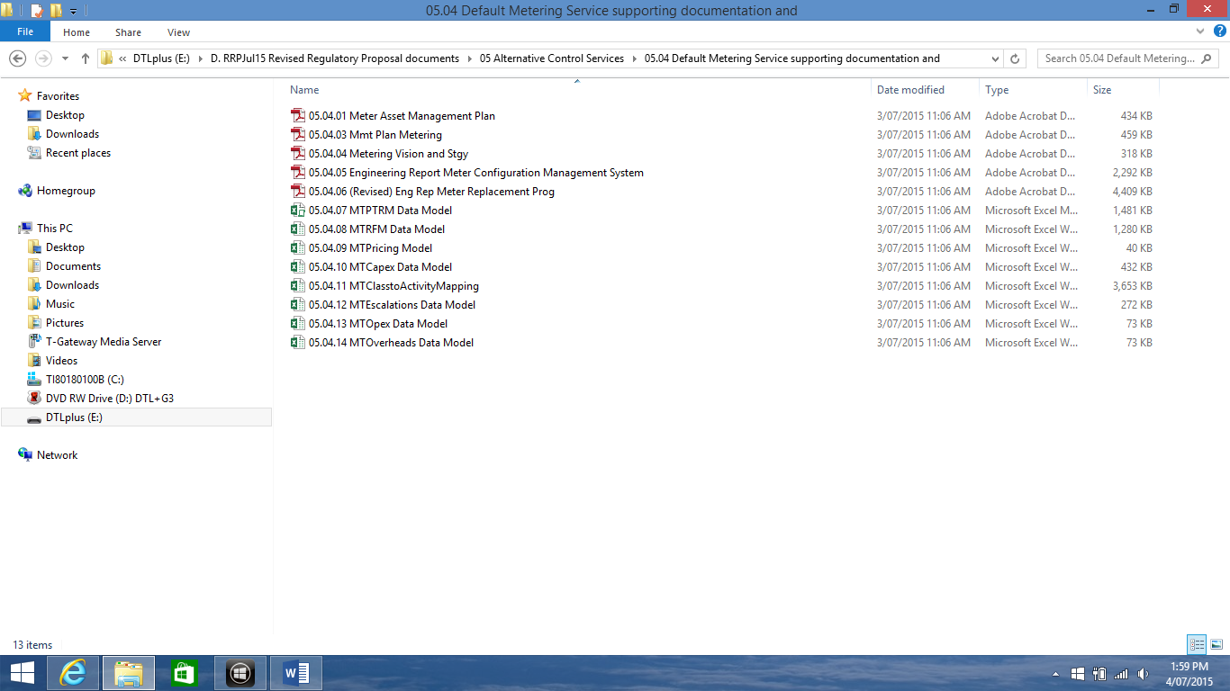

05.05 Other Alternative Control Services Key Documents

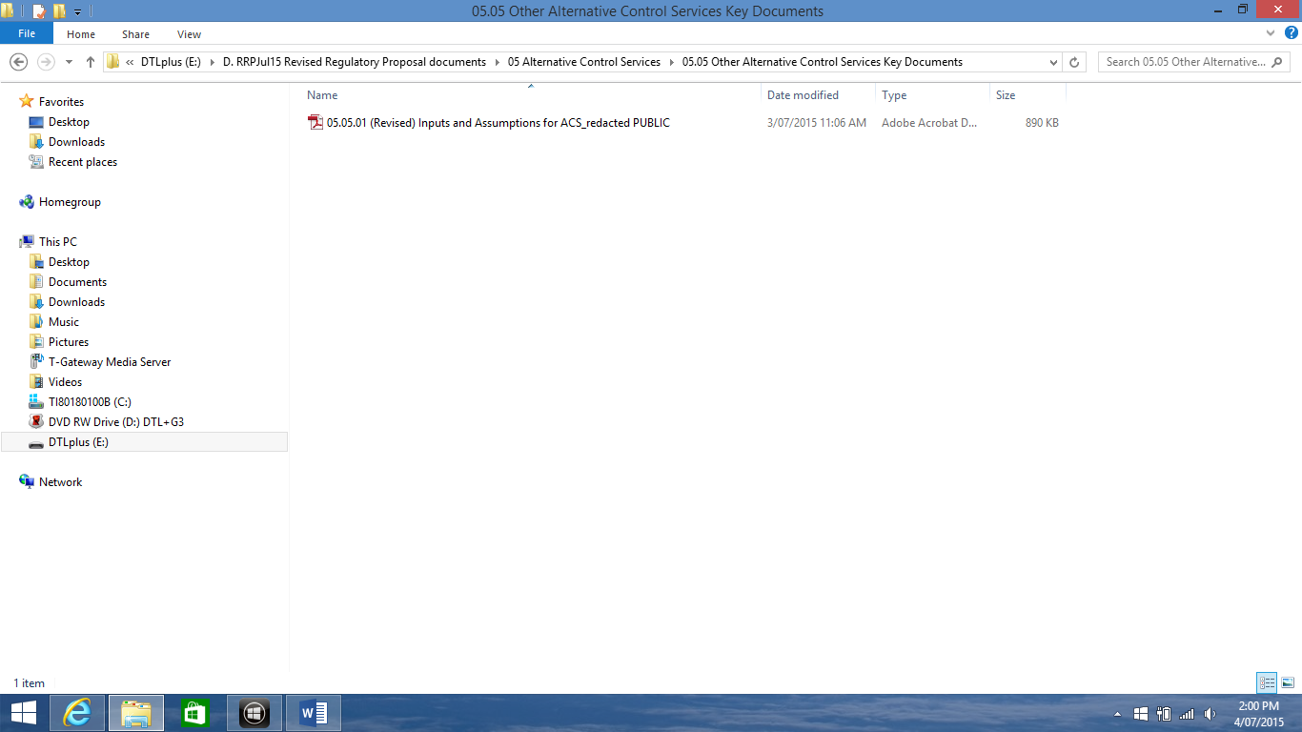

05.06 Other Alternative Control supporting documentation

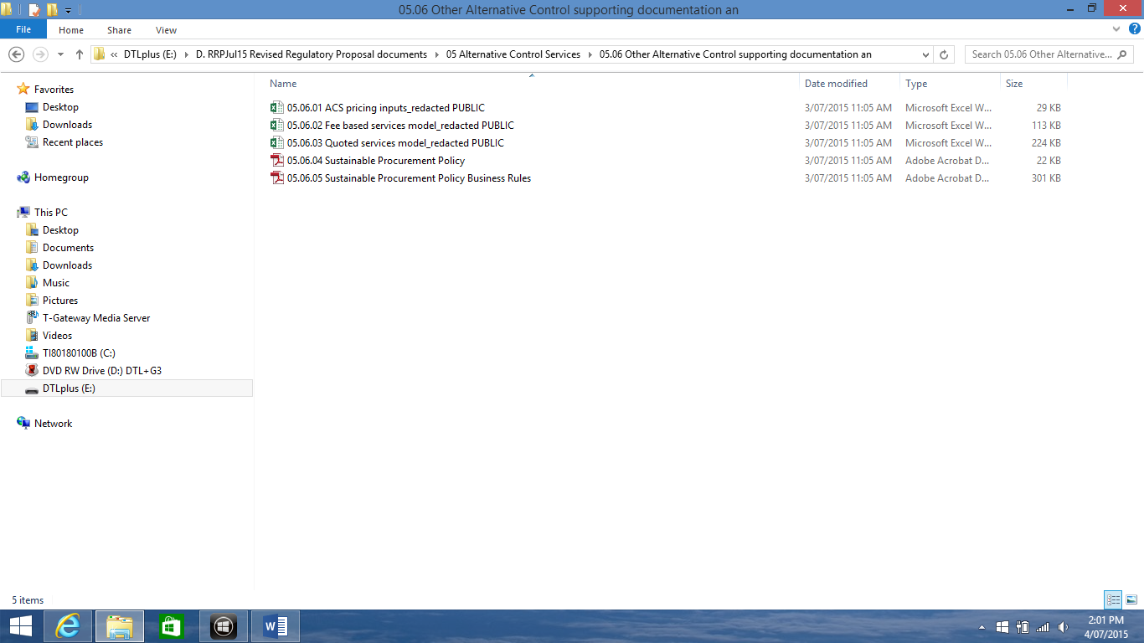

**06 Operating expenditure forecast for Standard Control Services**

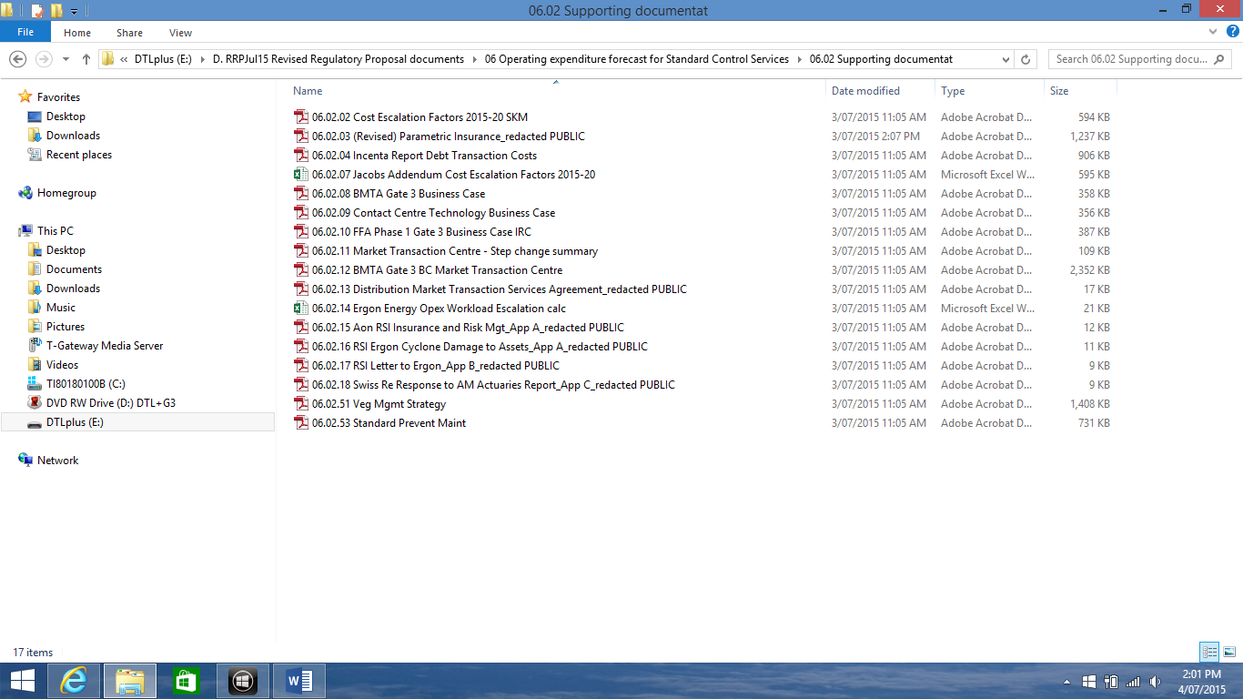

**07 Capital expenditure forecasts for Standard Control Services**

07.00 Key Supporting Documents

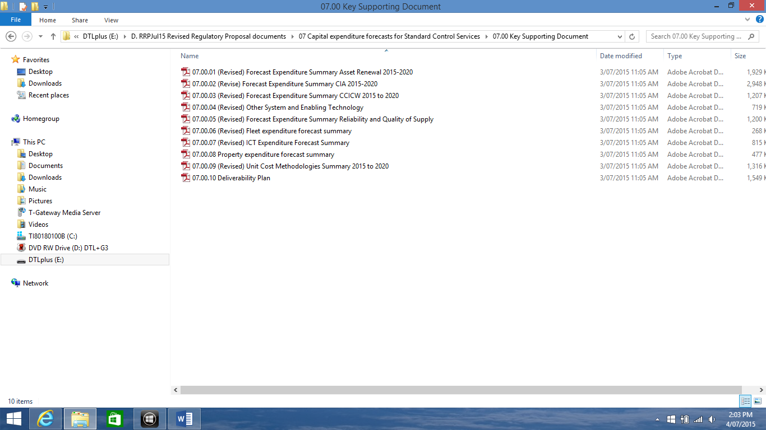

07.01 Asset Renewal Supporting documents

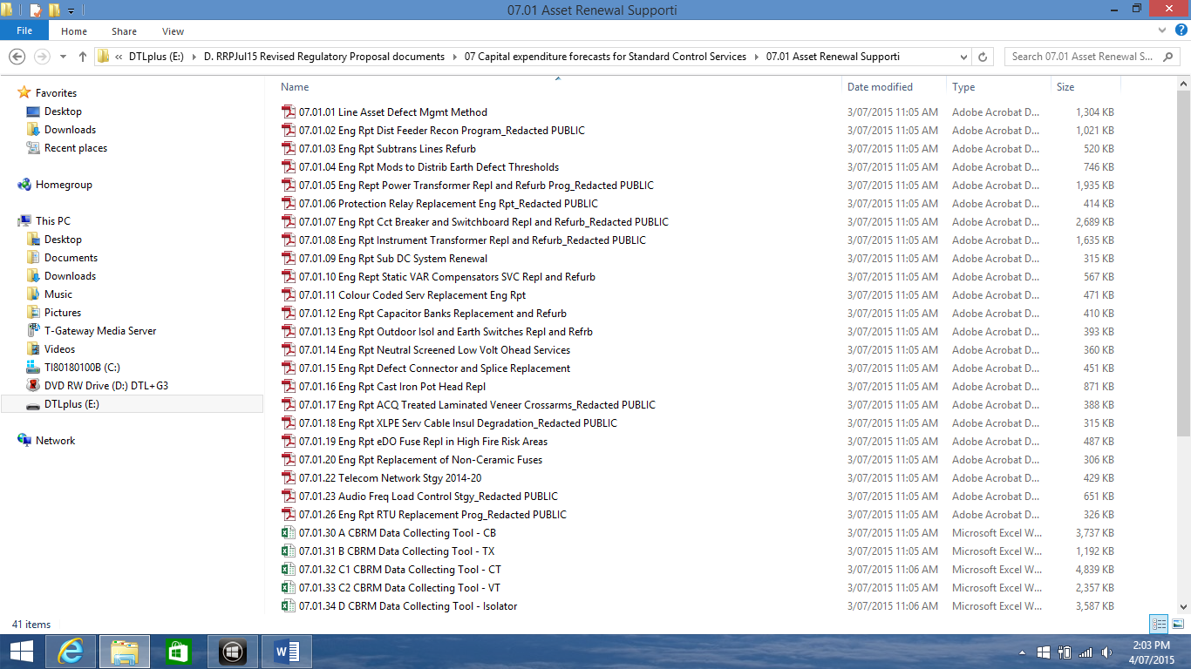

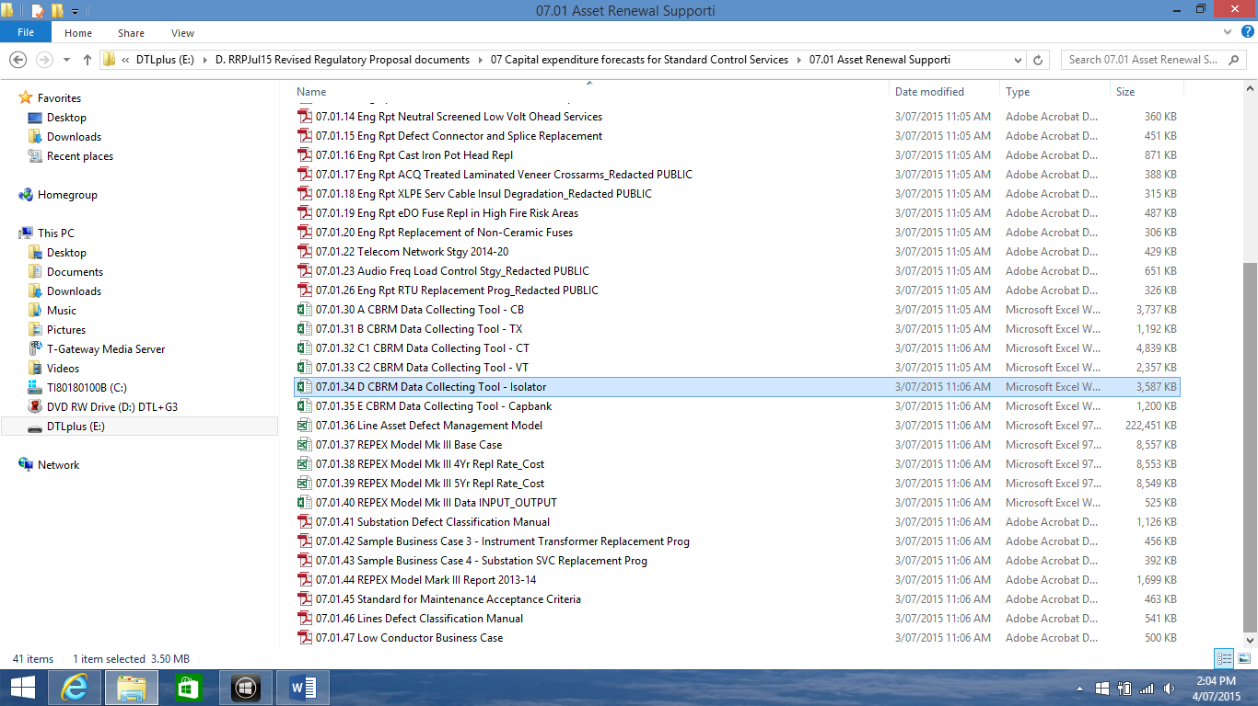

07.02 CIA Supporting Documents

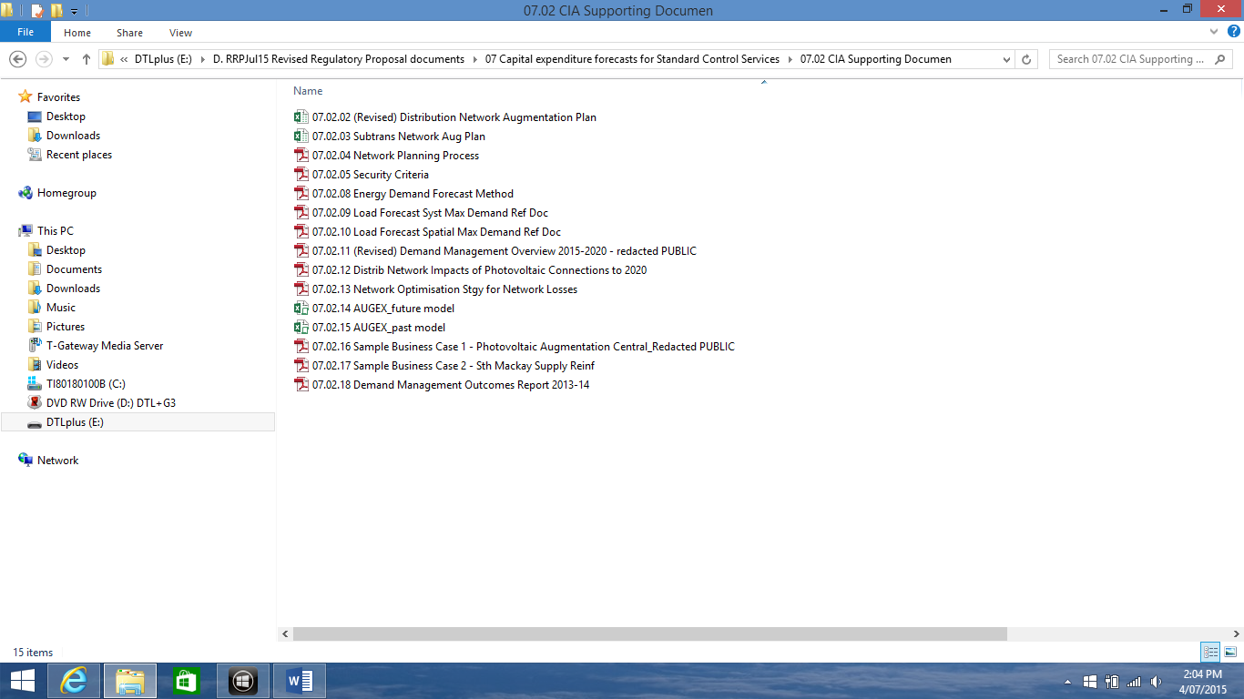

07.03 CICW Supporting Documents

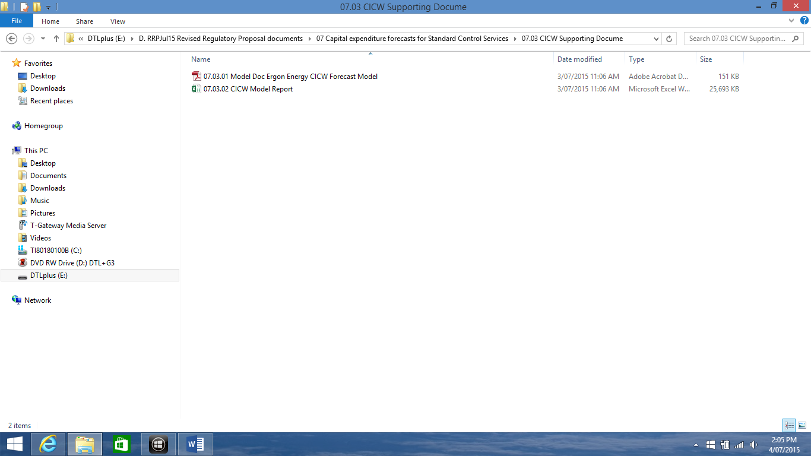

07.04 Other System and Enabling

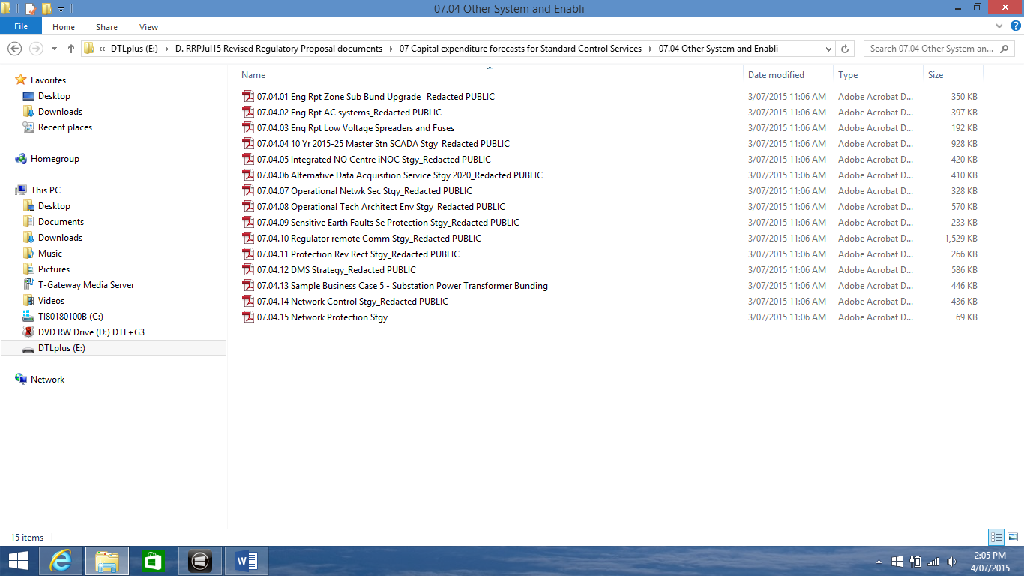

07.05 Network Reliability

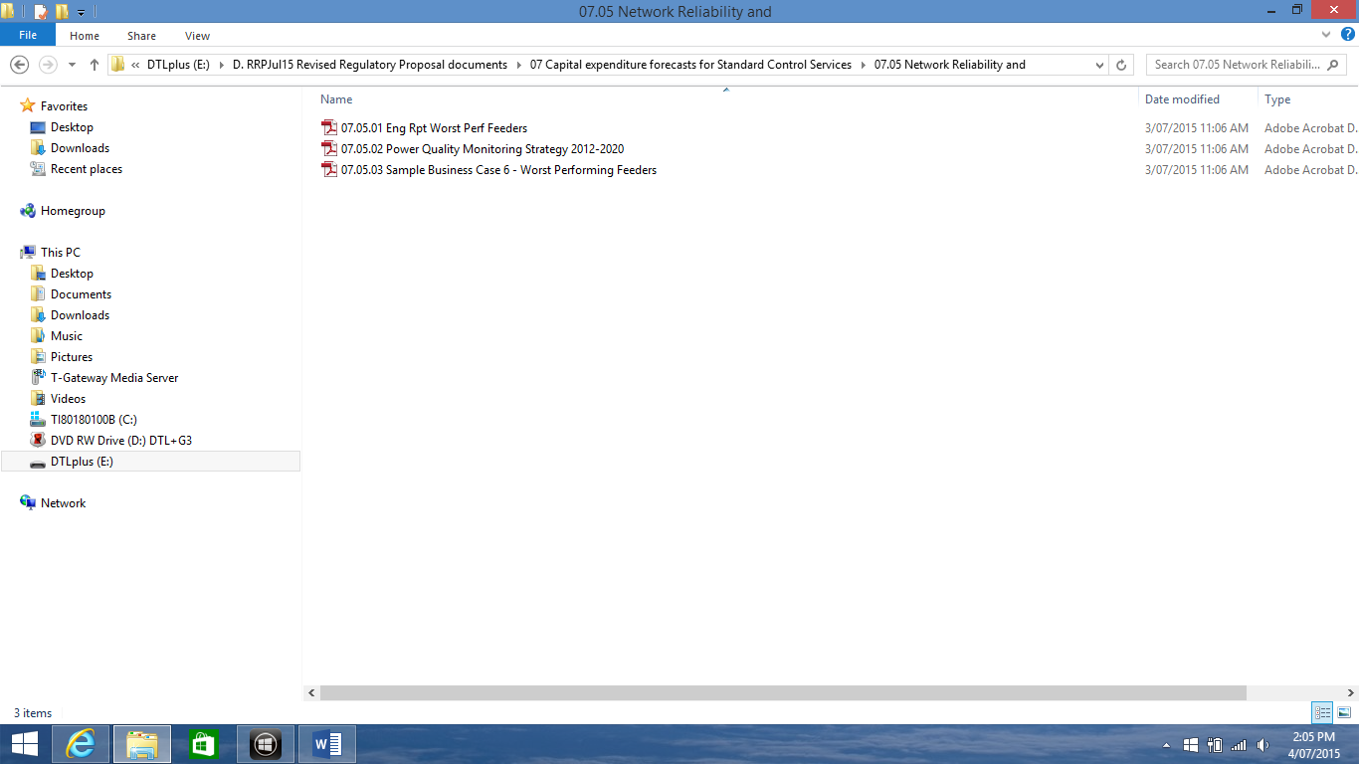

07.06 Fleet Supporting Documents

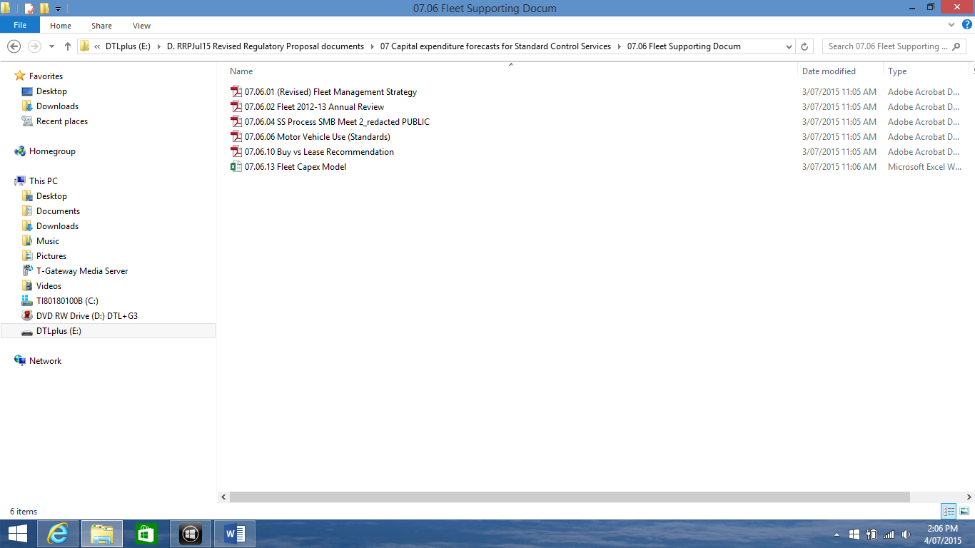

07.07 ICT Supporting Document

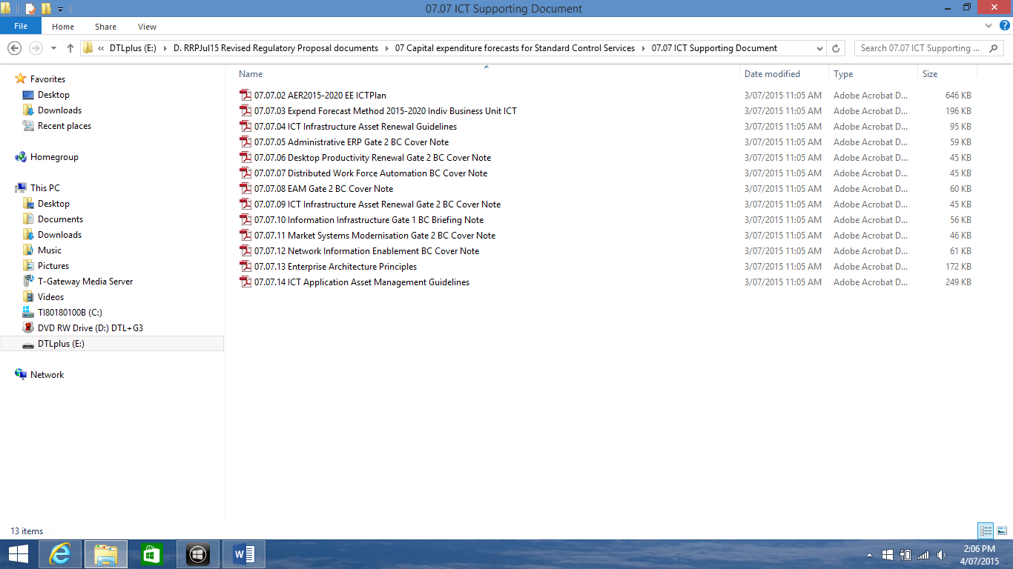

07.08 Property and Supporting

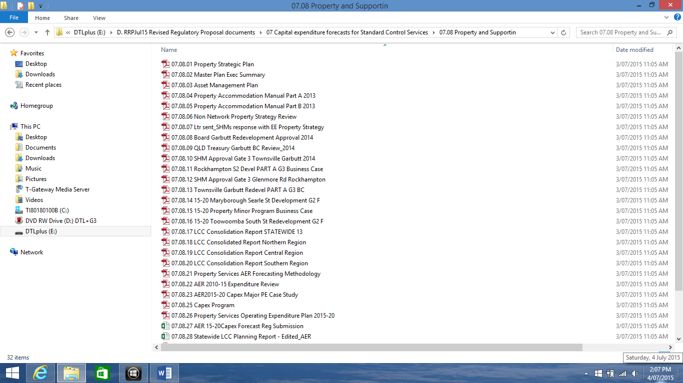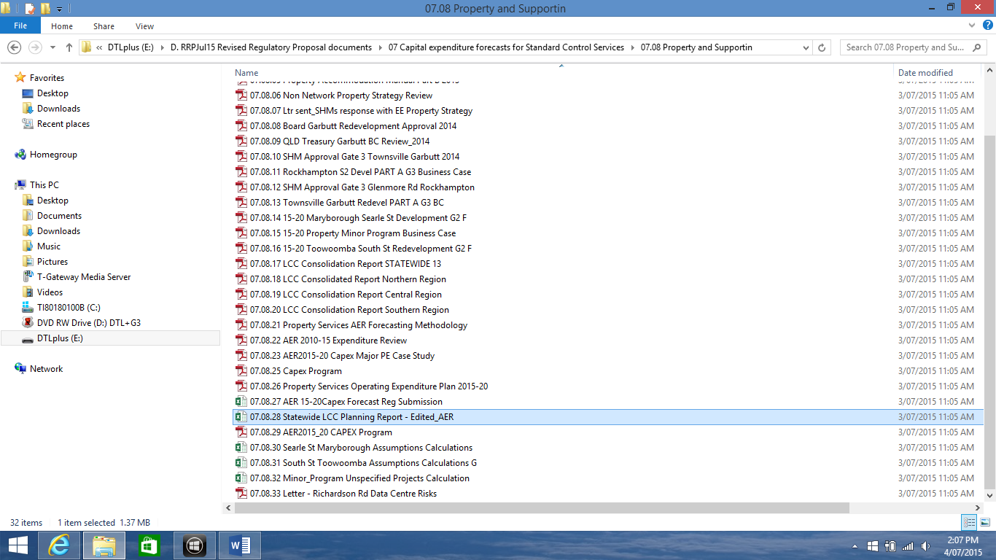

07.09 Capex Supporting Documents

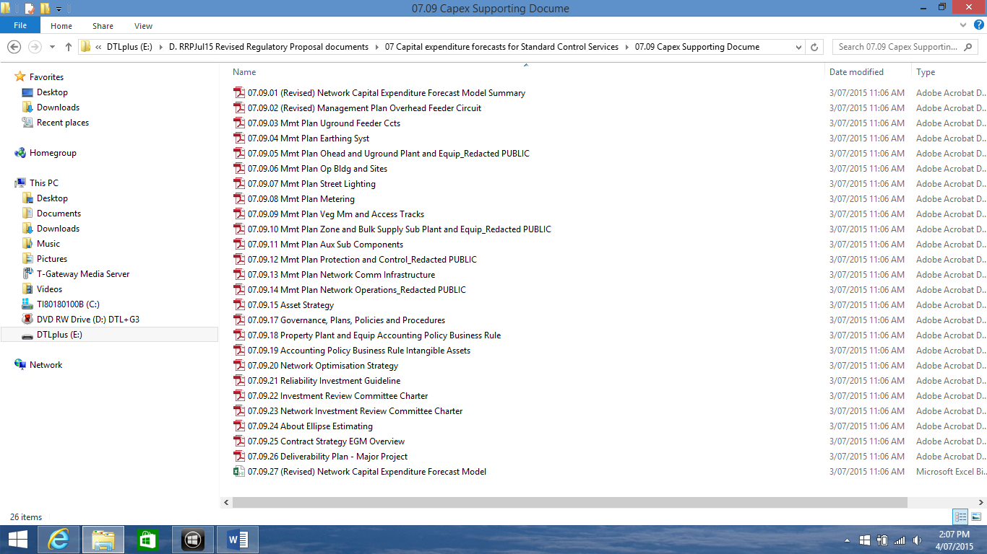

**C. SUBMIT15 Submission in response to AER determination**

EXP Consultant Reports

