We have made a final decision on the access arrangement for ActewAGL Distribution (ActewAGL). ActewAGL's gas distribution network provides services to customers in the Australian Capital Territory (ACT). Its network also extends into NSW where it supplies gas to Queanbeyan and the Palerang Shire. Our final decision allows ActewAGL to recover $301.4 million ($nominal) from its customers over five years commencing 1 July 2016.

Final decision:

ActewAGL Distribution access arrangement 2016–21



Overview

The Australian Energy Regulator (AER) approves access arrangements for ActewAGL and other major gas networks in eastern and southern Australia under the National Gas Law (NGL) and National Gas Rules (NGR).

Our final decision allows ActewAGL to recover $301.4 million ($nominal) from its customers over five years commencing 1 July 2016. If we had accepted ActewAGL’s revised proposal, it would have been permitted to recover $382.6 million ($nominal) over the 2016−21 access arrangement period. Our final decision is for 21.2 per cent less revenue than ActewAGL’s revised proposal.

The figure below shows the difference between ActewAGL’s proposed revenue and our final decision.

ActewAGL’s past and proposed total revenue and AER final decision revenue allowance ($million, 2014–15)

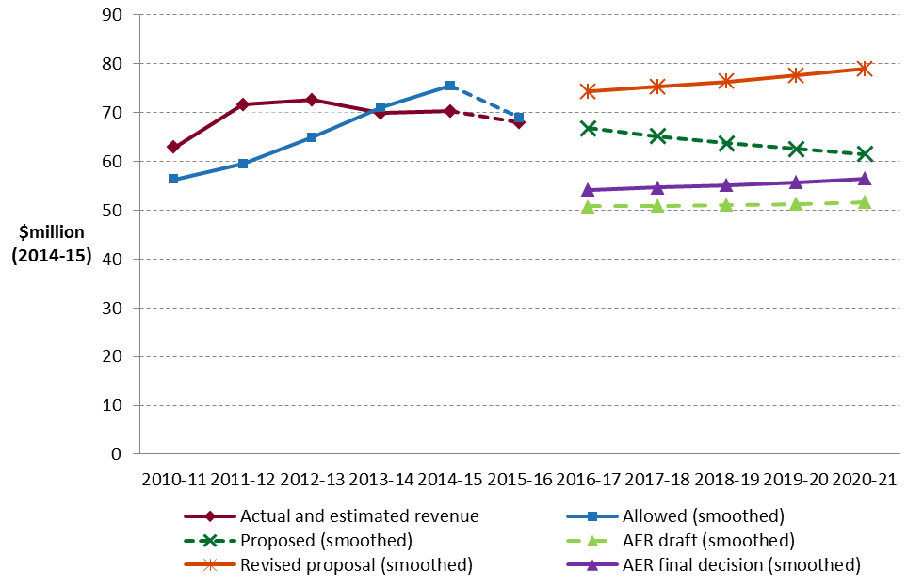

**Key elements of our decision**

As a covered pipeline ActewAGL’s gas distribution network is subject to full regulation, which requires the service provider to submit an initial access arrangement to the regulator for approval, and revise it periodically. An access arrangement sets out the terms and conditions under which third parties can use a pipeline. It must specify at least one reference service likely to be sought by a significant part of the market, and a reference tariff for that service.

We based our assessment of ActewAGL’s proposed revenue for its reference service on a number of components. These include expenditures to maintain and operate the network, and the return to shareholders on their investment. Together, these determine the revenue ActewAGL may recover from its customers.

We discuss each of these below.

**Rate of return**

Significant investment is required to build and maintain a gas distribution network. The return ActewAGL must pay lenders and investors is referred to as the rate of return. Even a small difference in the rate of return can have a big impact on revenues.

Our final decision sets the allowed rate of return (or ‘cost of capital’) at 6.01 per cent for 2015-16. We have not accepted ActewAGL’s revised proposed rate of return of 8.64 per cent.

The investment environment has improved since our previous decision, which was made during the period of uncertainty surrounding the global financial crisis. This improved investment environment translates to lower financing costs necessary to attract efficient investment. We consider that ActewAGL has sought a rate of return that is higher than necessary given the current investment environment.

We have not accepted the methodology proposed by ActewAGL to set its rate of return. Instead, we have used the methodology we developed through extensive consultation during our Better Regulation program in 2013. We consider that our approach provides for a rate of return that better reflects the allowed rate of return objective.

The lower rate of return in this decision will reduce ActewAGL’s average annual revenue requirement compared to the previous access arrangement period.

Operating expenditure

Opex includes forecast operating, maintenance and other non-capital costs incurred in the provision of gas distribution services. It includes labour and other non-capital costs that ActewAGL is likely to require during the 2016−21 access arrangement period for the efficient operation of its network.

We must be satisfied that the level of opex reflects costs that would be incurred by a prudent service provider acting efficiently, in accordance with accepted good industry practice, to achieve the lowest sustainable cost of delivering pipeline services.

Our final decision allows ActewAGL to recover $156.9 million ($2015–16) for opex. This is 3 per cent lower than the $162.2 million ActewAGL proposed. This difference is primarily driven by our decision to reject a number of ActewAGL’s proposed step changes.

**AER final decision compared to ActewAGL’s past and proposed opex ($million, 2015–16)**

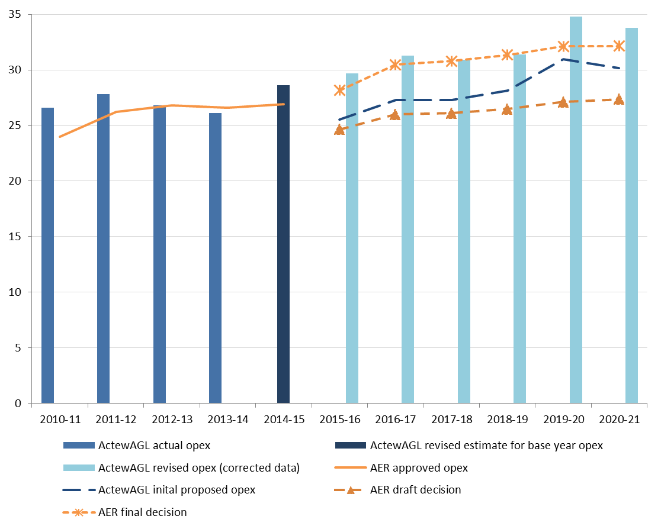

**Capital expenditure**

Capex refers to the cost of building new facilities or replacing existing infrastructure. Factors that influence our required level of capex include expected growth in the network, and the age and condition of existing assets.

We must be satisfied that the level of capex proposed by ActewAGL is justified, and reflects costs that would be incurred by a prudent service provider acting efficiently, in accordance with accepted good industry practice, to achieve the lowest sustainable cost of delivering pipeline services.

We have estimated total forecast net capex of $80.7 million ($2015–16) for ActewAGL’s 2016−21 access arrangement period. This is 13.5 per cent lower than the $93.2 million ActewAGL proposed.

The key difference between our substitute capex forecast and ActewAGL’s revised proposal is augmentation capex—a reduction of $8.4 million (or 58.3 per cent) to ActewAGL's proposed $14.4 million. Our final decision is that a prudent operator, acting efficiently, would not require ActewAGL's forecast capex associated with the Molonglo Primary and Molonglo Secondary network expansions during the 2016–21 access arrangement period.

**AER final decision compared to ActewAGL’s past and proposed capex ($million, 2015–16)**



**For more information:**

More information on our final decision can be found on our website: [www.aer.gov.au](http://www.aer.gov.au).