We have made a final decision on Endeavour Energy’s distribution determination. Endeavour Energy is one of three electricity distributors in NSW. Our final decision allows Endeavour Energy to recover $3182.8 million ($nominal) from its customers over the 2015–19 regulatory control period.[1]

Final decision: Endeavour Energy (distribution) 2015–19



Overview

The Australian Energy Regulator (AER) regulates Endeavour Energy by setting the annual revenue requirement it may recover from customers through distribution network charges.

Our final decision allows Endeavour Energy to recover $3182.8 million ($nominal) from its customers over the 2015–19 regulatory control period. If we had accepted Endeavour Energy’s proposal, it would have recovered $4441.3 million ($ nominal) over the 2015-19 regulatory control period. Our final decision is for 28 per cent less revenue than Endeavour Energy’s proposal.

The figure below shows the difference between Endeavour Energy’s proposed revenue, and what we have allowed for each year of the final decision.

Endeavour Energy's past total revenue, proposed total revenue and AER final decision revenue allowance ($ million, 2013–14)



The revenue we determine affects the distribution component of a customer’s electricity bill. Distribution charges make up about 39 per cent of the bill for one of Endeavour Energy’s typical residential customers.

Other components in consumer bills include the cost of generation, transmission network charges, and retailer costs. The AER does not set retail prices.

**Estimated bill impact**

Based on the lower distribution charges from our final decision being passed through to customers, we expect average annual electricity bills for residential customers to reduce by $106 (or 5.3 per cent) in 2015–16 and remain relatively stable over the rest of the period covered by this decision.

For small business customers, we expect reductions of $152 (5.3 per cent) in 2015-16 and relatively stable bills over the rest of the period covered by this decision.

These are only estimates, and are based on the data we have about how much energy customers in NSW use. There are a number of other factors that also affect a customer’s electricity bill, such as the wholesale price of electricity. You can read more about what makes up the energy prices on customers’ bills on our website: <http://www.aer.gov.au/Consumers>.

Key elements of our decision

Our assessment of Endeavour Energy’s proposed revenue is based on a number of components. These components include expenditure to maintain and operate the network, and the return to investors on their investment. Together, these determine the revenue Endeavour Energy may recover from its customers.

Two components of our final decision drive most of the difference between Endeavour Energy’s proposed revenue and our final decision: rate of return and operating expenditure. We discuss each of these below.

Rate of return

Significant investment is required to build a distribution network. The return Endeavour Energy must pay lenders and investors is referred to as the rate of return. Even a small difference in the rate of return can have a big impact on revenues.

Our final decision sets the allowed rate of return (or ‘cost of capital’) at 6.68 per cent in 2015–16. We have not accepted Endeavour Energy’s proposal for a rate of return of 8.85 per cent.[2]

The investment environment has improved since our previous decision, which was made during the height of uncertainty surrounding the global financial crisis. This improved investment environment translates to lower financing costs necessary to attract efficient investment. We consider that Endeavour Energy has sought a rate of return that is higher than necessary given the current investment environment.

In our final decision we did not accept the methodology proposed by Endeavour Energy to set its rate of return. Instead, we have used our methodology developed with extensive consultation during our Better Regulation program in 2013. We consider that our approach provides for a rate of return that better reflects the allowed rate of return objective.

The lower rate of return in this decision will reduce Endeavour Energy’s average annual revenue requirements compared to the past.

Operating expenditure

Operating expenditure (opex) includes forecast operating, maintenance and other non-capital costs incurred in the provision of network services.

It includes labour costs, maintenance costs, and other non-capital costs that Endeavour Energy is likely to require during the 2014–19 period for the efficient operation of its network.

We did not accept Endeavour Energy’s proposed $1465.6 million ($2013–14) opex forecast. Our final decision allows $1218.3 million ($2013–14). This is 16.9 per cent less than Endeavour Energy’s proposal.

**AER final decision compared to Endeavour Energy's past and proposed opex ($million, 2013-14)**

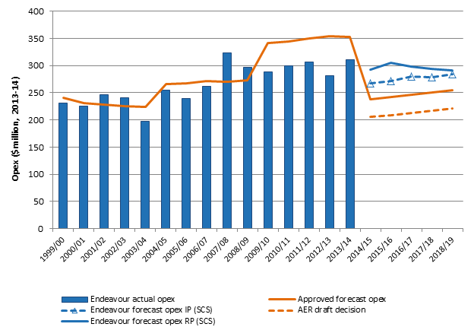

We must be satisfied that the level of opex reflects costs that a prudent operator—with efficient costs and a realistic expectation of demand and cost inputs—would need to operate its network safely and comply with its obligations and service standards.

In our final decision we have relied on Endeavour Energy’s revealed opex as a starting point for forecasting future opex. However, the key issue driving the difference between our final decision and Endeavour Energy’s revised opex forecast is our decision not to include a step change for increased vegetation management costs.

**Capital expenditure**

Capital expenditure (capex) refers to the cost of building new facilities or replacing existing infrastructure. Factors that influence the required level of capex include the age and condition of existing assets.

Capex is another key component of our final decision. We must be satisfied that the level of capex proposed by Endeavour Energy reflects the capex criteria: the costs that a prudent operator—with efficient costs and a realistic expectation of demand and cost inputs—would need to operate its network safely and comply with its obligations and service standards.

We accept Endeavour Energy’s proposed total forecast capex of $1595.8 million ($2013–14). We are satisfied that Endeavour Energy’s revised total capex forecast reasonably reflects the capex criteria.

**AER final decision compared to Endeavour Energy's past and proposed capex ($million, 2013-14)**



**For more information:**

More information on our final decision can be found on our website: [www.aer.gov.au](http://www.aer.gov.au).

1. In November 2012 major changes were introduced to the regulation of distributors under the National Electricity Rules. Endeavour Energy’s distribution determination was due to commence on 1 July 2014, and apply for a period of five years. So that the new rules could be applied to this decision, transitional rules required two regulatory control periods: a transitional regulatory control period from 1 July 2014 to 30 June 2015; and a subsequent regulatory control period commencing 1 July 2015. We made a fast-tracked placeholder determination for 2014-15. That determination has been adjusted (or ‘trued up’) in this final decision. Endeavour Energy’s approved revenue for the combined 2014-19 period is $4132.3 million ($nominal).
2. The rate of return that Endeavour Energy included in its proposal is an indicative value. Its proposal includes provision for the AER to adjust this value based on updated information that was not available when Endeavour Energy submitted its revised proposal. More information on the rate of return can be found in our Rate of Return Fact Sheet.