

FINAL DECISION

Ergon Energy determination 2015−16 to 2019−20

Attachment 1 − Annual revenue requirement

October 2015

© Commonwealth of Australia 2015

This work is copyright. In addition to any use permitted under the Copyright Act 1968, all material contained within this work is provided under a Creative Commons Attributions 3.0 Australia licence, with the exception of:

* the Commonwealth Coat of Arms
* the ACCC and AER logos
* any illustration, diagram, photograph or graphic over which the Australian Competition and Consumer Commission does not hold copyright, but which may be part of or contained within this publication. The details of the relevant licence conditions are available on the Creative Commons website, as is the full legal code for the CC BY 3.0 AU licence.

Requests and inquiries concerning reproduction and rights should be addressed to the Director, Corporate Communications,  
Australian Competition and Consumer Commission,   
GPO Box 4141, Canberra ACT 2601  
or publishing.unit@accc.gov.au.

Inquiries about this publication should be addressed to:

Australian Energy Regulator  
GPO Box 520  
Melbourne Vic 3001

Tel: (03) 9290 1444  
Fax: (03) 9290 1457

Email: [AERInquiry@aer.gov.au](mailto:AERInquiry@aer.gov.au)

1. Note
2. This attachment forms part of the AER's final decision on Ergon Energy's 2015–20 distribution determination. It should be read with all other parts of the final decision.
3. The final decision includes the following documents:
4. Overview
5. Attachment 1 – Annual revenue requirement
6. Attachment 2 – Regulatory asset base
7. Attachment 3 – Rate of return
8. Attachment 4 – Value of imputation credits
9. Attachment 5 – Regulatory depreciation
10. Attachment 6 – Capital expenditure
11. Attachment 7 – Operating expenditure
12. Attachment 8 – Corporate income tax
13. Attachment 9 – Efficiency benefit sharing scheme
14. Attachment 10 – Capital expenditure sharing scheme
15. Attachment 11 – Service target performance incentive scheme
16. Attachment 12 – Demand management incentive scheme
17. Attachment 13 – Classification of services
18. Attachment 14 – Control mechanism
19. Attachment 15 – Pass through events
20. Attachment 16 – Alternative control services
21. Attachment 17 – Negotiated services framework and criteria
22. Attachment 18 – Connection policy
23. Contents

Note 1-2

Contents 1-3

Shortened forms 1-4

1 Annual revenue requirement 1-6

1.1 Final decision 1-6

1.2 Ergon Energy's revised proposal 1-8

1.3 AER’s assessment approach 1-9

1.4 Reasons for final decision 1-9

1.4.1 Revenue true-up for 2015–16 1-10

1.4.2 Revenue smoothing 1-11

1.4.3 Revenue increments or decrements 1-14

1.4.4 Indicative average distribution price impact 1-18

1. Shortened forms

| Shortened form | Extended form |
| --- | --- |
| AEMC | Australian Energy Market Commission |
| AEMO | Australian Energy Market Operator |
| AER | Australian Energy Regulator |
| augex | augmentation expenditure |
| capex | capital expenditure |
| CCP | Consumer Challenge Panel |
| CESS | capital expenditure sharing scheme |
| CPI | consumer price index |
| DRP | debt risk premium |
| DMIA | demand management innovation allowance |
| DMIS | demand management incentive scheme |
| distributor | distribution network service provider |
| DUoS | distribution use of system |
| EBSS | efficiency benefit sharing scheme |
| ERP | equity risk premium |
| Expenditure Assessment Guideline | Expenditure Forecast Assessment Guideline for electricity distribution |
| F&A | framework and approach |
| MRP | market risk premium |
| NEL | national electricity law |
| NEM | national electricity market |
| NEO | national electricity objective |
| NER | national electricity rules |
| NSP | network service provider |
| opex | operating expenditure |
| PPI | partial performance indicators |
| PTRM | post-tax revenue model |
| RAB | regulatory asset base |
| RBA | Reserve Bank of Australia |
| repex | replacement expenditure |
| RFM | roll forward model |
| RIN | regulatory information notice |
| RPP | revenue and pricing principles |
| SAIDI | system average interruption duration index |
| SAIFI | system average interruption frequency index |
| SLCAPM | Sharpe-Lintner capital asset pricing model |
| STPIS | service target performance incentive scheme |
| WACC | weighted average cost of capital |

# Annual revenue requirement

The annual revenue requirement (ARR) is the sum of the various building block costs for each year of the regulatory control period before smoothing. The ARRs are smoothed across the period to reduce fluctuations between years and to determine expected revenues for each year. The expected revenues are the amounts that Ergon Energy will target for annual pricing purposes and recover from customers for the provision of standard control services for each year of the regulatory control period. This attachment sets out our final decision on Ergon Energy's ARRs and expected revenues for the 2015–20 regulatory control period.

## Final decision

1. We do not accept Ergon Energy's revised proposed total revenue requirements of $7728.4 million over the 2015–20 regulatory control period. This is because we have not accepted the building block costs in Ergon Energy's revised proposal. We determine a total revenue requirement (excluding additionals)[1] of $6266.0 million ($ nominal) for Ergon Energy for the 2015–20 regulatory control period, reflecting our final decision on the various building block costs. This is a reduction of $1462.4 million ($ nominal) or 18.9 per cent to Ergon Energy's proposal.
2. We approved in our preliminary decision the expected revenue for 2015–16 of $1137.7 million for Ergon Energy.[2] Under the transitional rules, we are required to determine the ARR for 2015–16 as part of this final decision process and adjust for the difference between the preliminary decision revenue and the ARR for 2015–16. We have now determined the ARR for 2015–16 of $1267.4 million for Ergon Energy. The difference is therefore $129.7 million. We have applied this difference as part of the smoothing process to establish the annual expected revenue for the remaining four years of the 2015–20 regulatory control period.
3. As a result of our smoothing of the ARRs, our final decision on the annual expected revenue and X factor for each regulatory year of the 2015–20 regulatory control period is set out in table 1.1. Our final decision is to approve total expected revenues (excluding additionals) of $6295.4 million ($ nominal) for the 2015–20 regulatory control period.
4. Figure 1.1 shows the difference between Ergon Energy's revised proposal and our decision (preliminary and final).
5. Table 1.1 shows our final decision on the building block costs, the ARR, annual expected revenue and X factor for each year of the 2015–20 regulatory control period.

Figure 1.1 AER's final decision on Ergon Energy's revenues for the 2015–20 regulatory control period ($million, nominal)

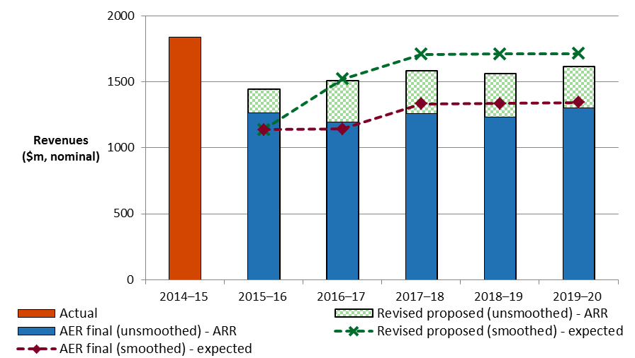

1. Source: AER analysis. Ergon Energy, Revised regulatory proposal, July 2015, Attachment 03.01.04 SCPTRM data model.

Table 1.1 AER's final decision on Ergon Energy's revenues for the 2015–20 regulatory control period ($million, nominal)

|  |  |  |  |  |  |  |
| --- | --- | --- | --- | --- | --- | --- |
|  | 2015–16 | 2016–17 | 2017–18 | 2018–19 | 2019–20 | Total |
| Return on capital | 593.2 | 622.9 | 652.9 | 680.8 | 706.5 | 3256.4 |
| Regulatory depreciation | 192.3 | 136.1 | 133.7 | 141.2 | 147.9 | 751.2 |
| Operating expenditure | 347.7 | 362.5 | 377.8 | 395.2 | 412.7 | 1896.0 |
| Revenue adjustmentsa | 90.5 | 46.3 | 66.8 | -18.0 | -2.9 | 182.8 |
| Net tax allowance | 43.7 | 30.6 | 29.0 | 36.2 | 40.0 | 179.6 |
| Annual revenue requirement (unsmoothed) | 1267.4 | 1198.4 | 1260.3 | 1235.5 | 1304.4 | 6266.0 |
| **Annual expected revenue  (exc. additionals)** | **1137.7** | **1142.6** | **1335.1** | **1337.0** | **1343.0** | **6295.4** |
| X factorb | n/ad | 2.02% | –14.00% | 2.30% | 2.00% | n/a |
| Additional amounts in DUoSc | 420.6 | 341.6 | 114.3 | 114.0 | 113.8 | 1104.3 |
| **Annual expected revenue  (smoothed – inc. additionals)** | **1558.3** | **1484.2** | **1449.4** | **1451.0** | **1456.8** | **7399.7** |
| Annual change in revenue (inc. additionals) | n/a | –4.8% | –2.3% | 0.1% | 0.4% | n/a |

Source: AER analysis.

(a) Revenue adjustments include efficiency benefit sharing scheme carry-overs, forecast DMIA, DUoS under-recoveries and shared asset adjustments.

(b) The X factors from 2016–17 to 2019–20 will be revised to reflect the annual return on debt update. Under the CPI–X framework, the X factor measures the real rate of change in annual expected revenue from one year to the next. A negative X factor represents a real increase in revenue. Conversely, a positive X factor represents a real decrease in revenue.

(c) Additional amounts in DUoS include solar bonus scheme forecasts (jurisdictional scheme obligation for FiT) for 2015–20, estimated solar bonus scheme pass throughs for 2015–16 and 2016–17 relating to under-recoveries in 2013–14 and 2014–15, estimated DUoS under-recovery for 2013–14, transitional capital contribution and shared assets under/over recovery from 2010–15, STPIS allowance from 2010–15 and DMIA over-recovery from 2010–15.

(d) In our preliminary decision, we determined the expected revenue and associated X factor for 2015–16. In this final decision to update the 2015–16 revenue for our assessment of efficient costs, we maintained the preliminary decision expected revenue for 2015–16 and determined X factors for the final four years of the 2015–20 regulatory control period. This is to adjust Ergon Energy's total expected revenue requirement for the remaining four years in the 2015–20 regulatory control period for the difference between the preliminary decision revenue and our final decision on Ergon Energy's efficient costs for 2015–16.

## Ergon Energy's revised proposal

Ergon Energy's revised proposal included a total expected revenue (excluding additionals) of $7728.4 million ($ nominal) for the 2015–20 regulatory control period.

Table 1.2 shows Ergon Energy's revised proposed building block costs, the ARR, expected revenue and X factor for each year of the 2015–20 regulatory control period.

Table 1.2 Ergon Energy's revised proposed revenues for the 2015–20 regulatory control period ($million, nominal)

|  |  |  |  |  |  |  |
| --- | --- | --- | --- | --- | --- | --- |
|  | 2015–16 | 2016–17 | 2017–18 | 2018–19 | 2019–20 | Total |
| Return on capital | 744.9 | 790.8 | 831.6 | 870.4 | 907.6 | 4145.4 |
| Regulatory depreciationa | 162.3 | 179.2 | 168.0 | 171.1 | 148.5 | 829.1 |
| Operating expenditure | 354.7 | 377.4 | 399.9 | 418.9 | 439.4 | 1990.4 |
| Revenue adjustmentsb | 87.5 | 44.6 | 62.8 | –26.4 | –6.3 | 162.2 |
| Net tax allowance | 96.2 | 119.1 | 126.0 | 132.4 | 127.6 | 601.3 |
| Annual revenue requirement (unsmoothed) | 1445.6 | 1511.0 | 1588.4 | 1566.5 | 1616.9 | 7728.4 |
| **Annual expected revenue  (exc. additionals)** | **1137.7**c | **1522.3** | **1709.1** | **1712.7** | **1716.3** | **7798.2** |
| X factor | n/a | –30.48% | –9.48% | 2.28% | 2.28% | n/a |
| Additional amounts in DUoSd | 420.6 | 341.6 | 114.3 | 114.0 | 113.8 | 1104.3 |
| **Annual expected revenue  (inc. additionals)** | **1562.0** | **1854.0** | **1814.0** | **1814.8** | **1815.5** | **8860.4** |
| Annual change in revenue (inc. additionals) | n/a | 18.7% | –2.2% | 0.0% | 0.0% | n/a |

Source: Ergon Energy, Regulatory revised proposal, July 2015, Attachment 03.01.04 SCPTRM data model; AER analysis.

(a) Regulatory depreciation is straight-line depreciation net of the inflation indexation on the opening RAB.

(b) Revenue adjustments include proposed efficiency benefit sharing scheme carry-over, forecast DMIA, DUoS under-recoveries and shared asset adjustments.

(c) Ergon Energy's revised proposal conducted a true-up for the difference between the preliminary decision revenue and its revised proposal revenue for 2015–16 by holding the 2015–16 preliminary decision revenue constant. This results in the difference being adjusted for in the expected revenue (via the X factor) for the remaining four years of the 2015–20 regulatory control period.

(d) These amounts have been included based on information provided in Ergon Energy's revised proposal. Ergon Energy did not smooth its revised proposed revenue having regard to these amounts. In contrast, while the amounts are not in the underlying building block, we have had regard to their impact on total revenue while smoothing expected revenues.

## AER’s assessment approach

We have not changed our assessment approach for the ARR from our preliminary decision. Section 1.3 of our preliminary decision details that approach.[3] We have reviewed our revenue path for the final decision in light of the requirement to perform an adjustment for 2015–16 and this is discussed further in section 1.4.1.

## Reasons for final decision

1. For this final decision, we determine a total revenue requirement of $6266.0 million ($ nominal) over the 2015–20 regulatory control period for Ergon Energy. This is $1462.4 million ($ nominal) or 18.9 per cent below Ergon Energy's revised proposal. This reflects the impact of our final decision on the various building block costs.
2. Figure 1.2 shows our preliminary decision and the difference between Ergon Energy's revised proposed ARRs and our final decision.
3. The most significant changes to Ergon Energy's revised proposal include: a reduction in the return on capital allowance of 21.4 per cent (attachments 2 and 3), a reduction in the capex allowance of 14.1 per cent (attachment 6), and a reduction in the opex allowance of 4.7 per cent (attachment 7).

Figure 1.2 AER's preliminary and final decisions and Ergon Energy's revised proposed annual revenue requirements ($million, nominal)

1. 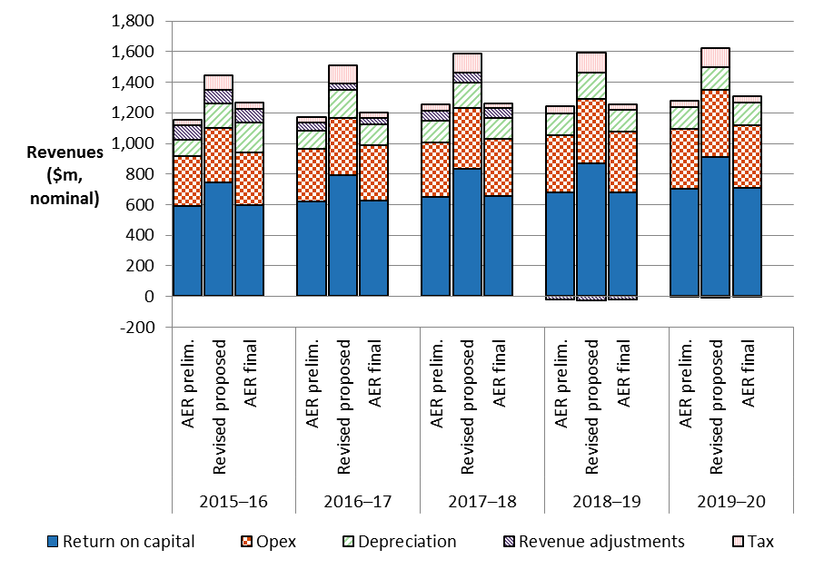

Source: AER analysis; Ergon Energy, Revised regulatory proposal, July 2015, Attachment 03.01.04 SCPTRM data model.

### Revenue true-up for 2015–16

1. In April 2015, as required under the transitional rules, we made our preliminary decision on Ergon Energy's proposed revenue requirement for the 2015–20 regulatory control period.[4] We determined the expected revenue for 2015–16 of $1137.7 million for Ergon Energy in the preliminary decision.[5]
2. For this final decision, we are required to revoke and substitute the preliminary decision for the ARRs over the 2015–20 regulatory control period. As part of this, we are to determine ARRs for each year of the 2015–20 regulatory control period and use a net present value (NPV) neutral adjustment mechanism to account for any difference between:[6]

* the expected revenue for 2015–16 approved in the preliminary decision, and
* the ARR for 2015–16 that is established through this final determination process.

1. Our final decision approves the 2015–16 ARR of $1267.4 million for Ergon Energy. To give effect to the adjustment, we have set Ergon Energy's first year expected revenue in the post-tax revenue model (PTRM) equal to our preliminary decision revenue for 2015–16 of $1137.7 million. This is the only practical option as prices were set for 2015–16 based on this approved preliminary decision amount. This approach means that the difference in the revenues for 2015–16 between the preliminary and final decisions is accounted for in the remaining four years of the 2015–20 regulatory control period. That is, the expected revenue for 2015–16 established from the preliminary decision provides a base from which the expected revenues (excluding additionals) for the remaining four years of the 2015–20 regulatory control period are calculated. This is done through the determination of the X factors for each of the remaining years in that period.[7] This gives effect to the adjustment requirements under the NER and ensures that the difference of $129.7 million is returned to Ergon Energy over the remaining four years of the 2015–20 regulatory control period (adjusted for the time value of money).
2. Ergon Energy's revised proposal adopted this approach for the adjustment.

### Revenue smoothing

We have determined our smoothed revenue path having regard to major drivers of total network revenues (distribution use of system—DUoS—charges), which are elements that do not fit in the building blocks.[8] In particular, Ergon Energy has forecast large revenue recovery associated with the under-recovery of the solar bonus scheme (feed-in tariffs) in 2013–15. It has also forecast solar bonus scheme payments throughout the 2015–20 regulatory control period. In the determination for the 2010–15 regulatory control period, we included the forecast solar bonus scheme payments in the opex allowance. We included a pass-through mechanism for any difference to be applied two years later during the annual pricing proposal processes. As a result of this mechanism, the expected under-recoveries from 2013–14 and 2014–15 will be recovered in 2015–16 and 2016–17. Based on Ergon Energy's revised proposal, these amount to $135.0 million and $125.5 million ($ nominal) respectively. Then, in the 2015–20 regulatory control period, there is no solar bonus scheme forecasts included in the opex allowance. Instead, these amounts will be recovered through a jurisdictional scheme obligation, which will feed into DUoS as part of the annual pricing approval process.

Other annual revenue adjustments are also significant. In particular, Ergon Energy expects to under-recover its 2013–14 DUoS target by $67.1 million, which will be recovered in 2015–16. It also expects to seek pass throughs for under-recovered capital contributions in 2013–14 ($85.1 million) and 2014–15 ($114.7 million), which will be recovered in 2015–16 and 2016-17 respectively.

Accordingly, we have smoothed the expected revenue for standard control services over the 2015–20 regulatory control period by allowing for these additional forecast revenue impacts. This approach was initially proposed by Energex and adopted by us for both Energex and Ergon Energy's preliminary decisions. Ergon Energy's revised proposal did not agree with this approach and submitted the amounts associated with the feed-in tariffs should not be included as part of the 'additionals' for smoothing purposes. Given the size of the feed-in tariffs and they make up the bulk of the additionals, we consider there is merit in accommodating these amounts in the smoothing process. We also consider that it is preferable a consistent approach for smoothing of the additional amounts is undertaken for both Queensland service providers. Overall, we are satisfied this approach will contribute to a smoother final revenue path for customers and the service providers.

1. In practice, we would normally set the path of X factors to result in a smooth expected revenue path. That is, these X factors would result in the desired smoothed path of the annual expected revenues through the regulatory control period. However, due to the sizeable factors outside of the building blocks that will affect total DUoS revenue, we have adopted a different approach outlined above. Specifically, when determining the X factors that set the path for smoothed expected revenue, we have considered the additional impact of these additional factors. As a result, the smoothed expected revenue does not produce a desirable path for revenue in isolation. However, the total DUoS revenue to be faced by customers including the additional factors will be smoothed overall. Further, we note that our profile of X factors results in an expected revenue in the last year of the regulatory control period that is as close as reasonably possible to the ARR for that year.[9]

Figure 1.3 shows the revenue path of our final decision smoothed revenues including the additional revenue amounts. This is the expected revenue path that includes additional amounts that Ergon Energy is able to recover from network customers. Figure 1.4 shows the expected revenues excluding the additional amounts. Neither Ergon Energy nor the AER are able to influence these additional revenues going forward as they emerge from either separate Government schemes or in truing up outcomes from previous years.

Figure 1.3 Smoothed revenue path including additional amounts ($ million, 2014–15)

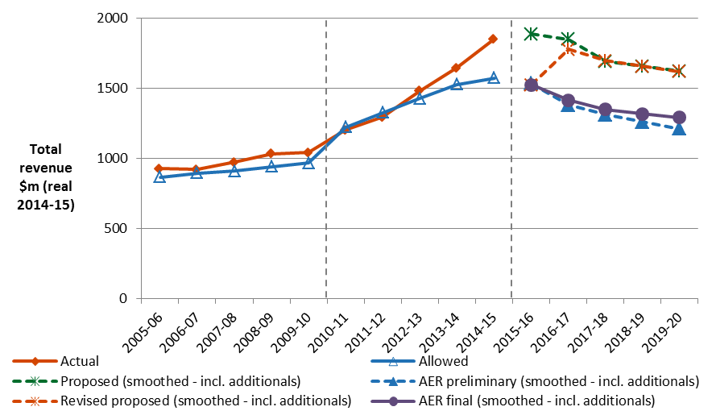

Source: AER analysis.

Notes: 'Additionals' in DUoS include solar bonus scheme forecasts (jurisdictional scheme obligation for FiT) for 2015–20, estimated solar bonus scheme pass throughs for 2015–16 and 2016–17 relating to under-recoveries in 2013–14 and 2014–15, estimated DUoS under recovery for 2013–14, transitional capital contribution and shared assets under/over recovery from 2010–15, STPIS allowance from 2010–15 and DMIA over recovery from 2010–15. The ‘Allowed’ 2014–15 data point is the amount allowed in the AER final decision excluding additionals. The ‘Actual’ 2014–15 data point is an updated forecast of the amount Ergon Energy actually expects to recover, including additionals, as submitted in its reset RIN.

Figure 1.4 Smoothed revenue path excluding additional amounts ($ million, 2014–15)

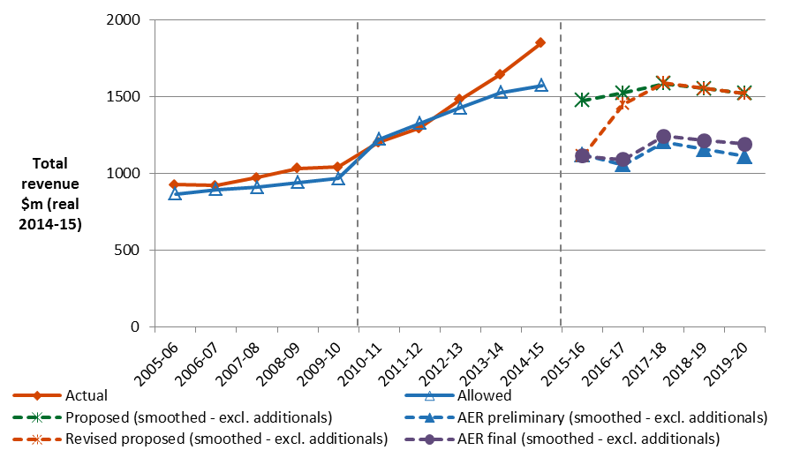

Source: AER analysis.

In its submission to the preliminary decision, the Alliance of Energy Consumers stated that we should identify the additional revenues Ergon Energy is expected to receive over the remaining years of the regulatory control period.[10] We have done so above and in the final decision PTRM, although we note that these amounts are in some cases estimates and the actual outcomes may differ somewhat. The annual pricing proposals of the distributors—that are approved by us and then released on our website­—explain in detail the actual outcomes in relation to these annual adjustments to revenues. These pricing proposals also show the evolution of the distributor's unders and overs account. That is, whether prices and demand were such that the distributor achieved its revenue targets in previous years and what further adjustments for past under or over recoveries may be necessary.

### Revenue increments or decrements

Revenue increments or decrements arising from the operation of a control mechanism or schemes, also known as 'carry-overs', may have a sizeable impact in addition to our approved annual revenue requirements for the 2015–20 regulatory control period.[11] The revenue increment and decrement amounts are shown in table 1.3.

Table 1.3 Revenue increments or decrements ($million, nominal)

|  |  |  |  |  |  |  |
| --- | --- | --- | --- | --- | --- | --- |
|  | 2015–16 | 2016–17 | 2017–18 | 2018–19 | 2019–20 | Total |
| EBSS | 34.6 | 48.9 | 69.6 | –15.2 | 0.0 | 137.9 |
| DMIA | 1.0 | 1.1 | 1.1 | 1.1 | 1.1 | 5.4 |
| Closing balance of DUoS unders/overs account as at 30 June 2015. | 58.5 | n/a | n/a | n/a | n/a | 58.5 |
| Shared assets | –3.6 | –3.7 | –3.8 | –3.9 | –4.0 | –19.0 |
| **Total** | **90.5** | **46.3** | **66.8** | **–18.0** | **–2.9** | **182.8** |

Source: AER analysis.

This section explains how these revenue increments or decrements arose.

Over the 2010–15 regulatory control period, we regulated Ergon Energy under a revenue cap form of control. Under this form of control, service providers recover no more or less than the total allowed revenue, which usually includes:

* Building block expected revenue set in the determination.
* Under or over-recovery in the expected revenue from two years prior—these amounts are for two years prior because the full amount of any under/over-recovery is not known until the end of a pricing year, but the pricing approval process must take place in advance of the pricing year. Therefore, there is a two-year lag between when the pricing year finishes and when revenue under/over-recoveries can be included in the future revenue target.
* Any change in the balance of the unders and overs account. A balance may emerge in the unders and overs account where an under or over-recovery from an earlier year has not been fully recovered two years later. The residual then needs to be recovered in subsequent years. We generally target a zero balance for the unders and overs account, but in Queensland circumstances prevented this as discussed below.
* Jurisdictional scheme obligation amounts—these are amounts that the service provider is required to collect under legislation and which we are not required to assess.
* Pass through amounts—these are amounts that the service provider has applied for under the pass through provisions in its determination and we have subsequently approved. Often, this relates to events with unforeseeable likelihood and or timing, such as damage due to storms or regulatory changes.
* Other factors—this category includes applicable incentive scheme amounts, such as the S-factor for STPIS, and transitional capital contributions and shared asset amounts.

Ergon Energy has accumulated a large under-recovery balance in its unders and overs account due to:

* revenue cap under-recoveries
* pass through of feed-in tariffs under-recoveries.

These are amounts that Ergon Energy was allowed to recover as revenues over the 2010–15 regulatory control period, but did not do so. In particular, these amounts accumulated due to three main factors:

* Throughout the 2010–15 regulatory control period, consumption of electricity on Ergon Energy's network decreased at a faster rate than was projected in pricing forecasts. Approved prices are set annually to recover the target revenue based on estimated units of consumption, customer numbers and other factors where relevant. Holding all else constant, if any of these units is overestimated:
* prices are relatively lower than they should have been, since the same revenue amount is shared across a larger number of units
* revenue is therefore lower than it should have been, since it is the product of a lower-than-forecast actual number of units multiplied by a relatively lower price.
* Uptake of the solar bonus scheme (feed-in tariffs) was greater than forecast. Annual estimates of the feed-in tariffs were included in Ergon Energy's opex allowance over the 2010–15 regulatory control period. However, since this was a new jurisdictional policy and hence difficult to forecast, we approved a specific overs/unders factor to account for the difference between forecast and actual. As the take-up of the scheme was much greater than forecast, this led to a large under-recovery balance.
* These in combination led to a triggering of the under-recovery threshold. In the 2010 determination, we set a 5 per cent over/under threshold for accumulated under or over-recovery balances. On meeting this threshold, Ergon Energy submitted a plan to clear the balance over several years, rather than in a single or two years.[12] Part of this plan included the recovery of some of the revenue in the 2015–20 regulatory control period. This was designed to prevent larger increase in prices over the 2010–15 regulatory control period.

Shared assets

1. Our final decision is to maintain our position set out in the preliminary decision on the shared asset adjustments for Ergon Energy.
2. Service providers, such as Ergon Energy, may use assets to provide both standard control services we regulate and unregulated services. These assets are called 'shared assets'.[13] Of the unregulated revenues a service provider earns from shared assets, 10 per cent will be used to reduce the service provider's prices for standard control services.[14]
3. Shared asset price reductions are subject to a materiality threshold. Unregulated use of shared assets is material when a service provider's unregulated revenues from shared assets in a specific regulatory year are expected to be greater than 1 per cent of its total expected revenue for that regulatory year.[15]
4. In the preliminary decision, we accepted Ergon Energy's updated proposed shared asset revenue adjustments.[16] Ergon Energy also proposed to adjust its total revenue for alternative control service assets that it retained in its RAB for standard control services. However, we did not accept Ergon Energy's proposed revenue reductions for alternative control services provided by assets retained in its RAB. This was because we had removed these assets providing alternative control services from the RAB for standard control services.
5. Ergon's Energy's revised proposal did not adopt our preliminary decision on its shared assets. It submitted that the AER's approach of removing the value of asset providing alternative control services was not appropriate under the NER.[17]
6. Consistent with the preliminary decision, we note that Ergon Energy's proposed approach is the same approach as applied for the 2010 determination, which in turn was based on that determined by the Queensland Competition Authority. Under transitional provisions of the NER, Ergon Energy was permitted to continue this approach during the 2010–15 regulatory control period. These transitional arrangements cease at the end of the 2010–15 regulatory control period. From the beginning of the 2015–20 regulatory control period, Ergon Energy's RAB must be determined under the NER.
7. We consider that, under the NER, Ergon Energy's RAB should reflect only the value of assets providing standard control services.[18] Following an information request, Ergon Energy provided updated shared asset revenue adjustments that exclude revenue reductions for alternative control services provided by assets that are no longer in the RAB for standard control services.[19]
8. Ergon Energy's updated proposed revenue adjustments are set out in table 1.4. Our final decision adopts these amounts for adjustments to the ARR—that is, the revenue decrements under clause 6.4.3(a)(6A) of the NER.

Table 1.4 Ergon Energy's proposed shared asset revenue adjustments ($ million, 2014–15)

|  |  |  |  |  |  |  |
| --- | --- | --- | --- | --- | --- | --- |
|  | 2015–16 | 2016–17 | 2017–18 | 2018–19 | 2019–20 | Total |
| Adjustment for shared assets | –3.5 | –3.5 | –3.5 | –3.5 | –3.5 | –17.7 |

Source: Ergon Energy, Response to Information Request 'AER Ergon 098', 30 September 2015, Revised SCPTRM Data Model.

### Indicative average distribution price impact

1. Our bill impact calculations adopt the network charges in our final decision for Energex.[20] This is because retail electricity prices in Ergon Energy's distribution area are determined under the Queensland Government's uniform tariff policy. The policy results in regulated retail electricity prices in Ergon Energy's distribution area being matched to those in Energex's area.
2. We estimate that based on the distribution charges from our final decision passing through to customers, we would expect the average annual electricity bill for residential customers to reduce by $25 or 1.7 per cent in 2015–16. This would be followed by reductions of about $18 or 1.2 per cent ($ nominal) per annum from 2016–17 to 2019–20. By comparison, had we accepted the revised proposal, the average annual electricity bill for residential customers would increase by approximately $23 (1.6 per cent) per annum between 2016–17 and 2019–20.
3. Our estimate of the potential impact our final decision will have for Ergon Energy's residential customers is based on the typical annual electricity usage of 4100 kWh per annum for a residential customer in Queensland.[21] Therefore, customers with different usage will experience different changes in their bills. We also note that there are other factors, such as transmission network costs, wholesale and retail costs, which affect electricity bills.
4. Similarly, for an average small business customer in Queensland that uses approximately 10 MWh of electricity per annum, our final decision is expected to lead to lower average annual electricity bills. We estimate that based on the distribution charges from our final decision passing through to customers, we would expect the average annual electricity bill for small business customers to reduce by $51 or 1.7 per cent in 2015–16. This would be followed by decreases of about $36 or 1.2 per cent ($ nominal) per annum from 2016–17 to 2019–20. By comparison, had we accepted the revised proposal, the average annual electricity bill for small business customers would increase by approximately $48 (1.6 per cent) per annum between 2016–17 and 2019–20. These amounts include additional revenues Energex can also recover of the types discussed above for Ergon Energy.
5. Table 1.5 shows the estimated annual average impact of our final decision for the 2015–20 regulatory control period on the average residential and small business customers' annual electricity bills. These amounts include additional revenues Energex can also recover of the types discussed above for Ergon Energy.

Table 1.5 Estimated impact of AER's final decision on annual electricity bills for the 2015–20 regulatory control period ($ nominal)

|  | 2014−15 | 2015−16 | 2016−17 | 2017−18 | 2018−19 | 2019–20 |
| --- | --- | --- | --- | --- | --- | --- |
| **AER final decision** | | | | | | |
| Residential annual billb | 1470 | 1445 | 1428 | 1406 | 1389 | 1375 |
| Annual changed |  | –25 (–1.7%) | –17 (–1.2%) | –21 (–1.5%) | –17 (–1.2%) | –14 (–1.0%) |
| Small business annual billc | 3036 | 2985 | 2949 | 2905 | 2869 | 2840 |
| Annual changed |  | –51 (–1.7%) | –36 (–1.2%) | –44 (–1.5%) | –36 (–1.2%) | –30 (–1.0%) |
| **Energex revised proposal**a | | | | | | |
| Residential annual billb | 1470 | 1445 | 1473 | 1496 | 1518 | 1539 |
| Annual changed |  | –25 (–1.7%) | 28 (1.9%) | 23 (1.6%) | 23 (1.5%) | 21 (1.4%) |
| Small business annual billc | 3036 | 2985 | 3042 | 3089 | 3136 | 3178 |
| Annual changed |  | –51 (–1.7%) | 57 (1.9%) | 47 (1.6%) | 47 (1.5%) | 43 (1.4%) |

Source: AER analysis; Energy Made Easy, [www.energymadeeasy.gov.au](http://www.energymadeeasy.gov.au); QCA, Final determination, Regulated retail electricity prices 2014–15, May 2014, p.4.

(a) Energex's bill impacts are used for this table.

(b) Based on annual bill for typical consumption of 4100 kWh per year during the period 1 July 2014 to 30 June 2015.

(c) Based on the annual bill sourced from Energy Made Easy for a typical consumption of 10000 kWh per year during the period 1 July 2014 to 30 June 2015.

(d) Annual change amounts and percentages are indicative. They are derived by varying 2014–15 bill amounts in proportion with total annual regulated revenue divided by forecast demand. Actual bill impacts will vary depending on electricity consumption, tariff class and other variables.

1. The additionals are amounts relating to other factors that will be recovered as part of DUoS but not within the building block revenue, such as the Solar Bonus Scheme feed-in tariff (FiT).
2. AER, Preliminary decision, Ergon Energy determination 2015–16 to 2019–20 – Attachment 1 – Annual revenue requirement, April 2015, p. 7.
3. AER, Preliminary decision, Ergon Energy determination 2015–16 to 2019–20 – Attachment 1 – Annual revenue requirement, April 2015, pp. 9–11.
4. NER, cl. 11.60.3.
5. AER, Preliminary decision, Ergon Energy determination 2015–16 to 2019–20 – Attachment 1 – Annual revenue requirement, April 2015, p. 7.
6. NER, cll. 11.60.4(d)(1) and (e).
7. The X factors represent the rate of change in the real revenue path over the 2015–20 regulatory control period under the CPI–X framework. They must equalise (in net present value terms) the total expected revenues to be earned by the service provider with the total revenue requirement for that period.
8. AER, Preliminary decision, Ergon Energy determination 2015–16 to 2019–20 – Attachment 1 – Annual revenue requirement, April 2015, Table 1.3.
9. In the present circumstances, based on the X factors we have determined for Ergon Energy, this divergence is around 3.0 per cent.
10. Alliance of Energy Consumers, Submission to the AER's preliminary decision (Queensland), 3 July 2015, p. 32.
11. NER, cll. 6.4.3(a)(5), (6), (6A).
12. Balances of the unders and overs account of less than 2 per cent were to be recovered in one year, while balances between 2 to 5 per cent were to be recovered over two years.
13. NER, cl. 6.4.4.
14. AER, Shared asset guideline, November 2013.
15. AER, Shared asset guideline, November 2013, p. 8.
16. AER, Preliminary decision, Ergon Energy determination 2015–16 to 2019–20 – Attachment 1 – Annual revenue requirement, April 2015, pp. 16–18.
17. Ergon Energy, Submission to the AER on its preliminary determination – SCS building blocks, control mechanism and pricing, October 2015, p. 13.
18. NER, cl. 6.5.1(a).
19. Ergon Energy, response to AER Ergon 098 received by the AER on 30 September 2015.
20. Distribution charges represent approximately 42 per cent on average of Energex's typical customer's annual electricity bill.
21. QCA, Final determination: Regulated retail electricity prices 2014-15, May 2014, p. 116.