

FINAL DECISION

Essential Energy distribution determination

2015−16 to 2018−19

Attachment 17 – Negotiated services framework and criteria

April 2015

© Commonwealth of Australia 2015

This work is copyright. In addition to any use permitted under the Copyright Act 1968, all material contained within this work is provided under a Creative Commons Attributions 3.0 Australia licence, with the exception of:

* the Commonwealth Coat of Arms
* the ACCC and AER logos
* any illustration, diagram, photograph or graphic over which the Australian Competition and Consumer Commission does not hold copyright, but which may be part of or contained within this publication. The details of the relevant licence conditions are available on the Creative Commons website, as is the full legal code for the CC BY 3.0 AU licence.

Requests and inquiries concerning reproduction and rights should be addressed to the:

Director, Corporate Communications  
Australian Competition and Consumer Commission   
GPO Box 4141, Canberra ACT 2601

or publishing.unit@accc.gov.au.

Inquiries about this publication should be addressed to:

Australian Energy Regulator  
GPO Box 520  
Melbourne Vic 3001

Tel: (03) 9290 1444  
Fax: (03) 9290 1457

Email: [AERInquiry@aer.gov.au](mailto:AERInquiry@aer.gov.au)

AER reference: 54419

1. Note
2. This attachment forms part of the AER's final decision on Essential Energy’s revenue proposal 2015–19. It should be read with all other parts of the final decision.
3. The final decision includes the following documents:
4. Overview

Attachment 1 - Annual revenue requirement

Attachment 2 - Regulatory asset base

Attachment 3 - Rate of return

Attachment 4 - Value of imputation credits

Attachment 5 - Regulatory depreciation

Attachment 6 - Capital expenditure

Attachment 7 - Operating expenditure

Attachment 8 - Corporate income tax

Attachment 9 - Efficiency benefit sharing scheme

Attachment 10 - Capital expenditure sharing scheme

Attachment 11 - Service target performance incentive scheme

Attachment 12 - Demand management incentive scheme

Attachment 13 - Classification of services

Attachment 14 - Control mechanism

Attachment 15 - Pass through events

Attachment 16 - Alternative control services

Attachment 17 - Negotiated services framework and criteria

Attachment 18 - Connection methodology

Attachment 19 - Analysis of Financial Viability

1. Contents

Note 17-2

Contents 17-3

Shortened forms 17-4

17 Negotiated services framework and criteria 17-6

17.1 Final decision 17-6

Negotiating framework 17-6

Negotiated distribution service criteria 17-6

17.2 Essential Energy’s revised proposal 17-7

17.3 AER’s assessment approach 17-7

Negotiating framework 17-7

Negotiated distribution service criteria 17-7

17.4 Reasons for final decision 17-7

Negotiating framework 17-7

Negotiated distribution services criteria 17-9

A Essential Energy's negotiating framework 17-11

1. Shortened forms

| 1. Shortened form | 1. Extended form |
| --- | --- |
| 1. AEMC | 1. Australian Energy Market Commission |
| 1. AEMO | 1. Australian Energy Market Operator |
| 1. AER | 1. Australian Energy Regulator |
| 1. augex | 1. augmentation expenditure |
| 1. capex | 1. capital expenditure |
| 1. CCP | 1. Consumer Challenge Panel |
| 1. CESS | 1. capital expenditure sharing scheme |
| 1. CPI | 1. consumer price index |
| 1. DRP | 1. debt risk premium |
| 1. DMIA | 1. demand management innovation allowance |
| 1. DMIS | 1. demand management incentive scheme |
| 1. distributor | 1. distribution network service provider |
| 1. DUoS | 1. distribution use of system |
| 1. EBSS | 1. efficiency benefit sharing scheme |
| 1. ERP | 1. equity risk premium |
| 1. Expenditure Assessment Guideline | 1. expenditure forecast assessment Guideline for electricity distribution |
| 1. F&A | 1. framework and approach |
| 1. MRP | 1. market risk premium |
| 1. NEL | 1. national electricity law |
| 1. NEM | 1. national electricity market |
| 1. NEO | 1. national electricity objective |
| 1. NER | 1. national electricity rules |
| 1. NSP | 1. network service provider |
| 1. opex | 1. operating expenditure |
| 1. PPI | 1. partial performance indicators |
| 1. PTRM | 1. post-tax revenue model |
| 1. RAB | 1. regulatory asset base |
| 1. RBA | 1. Reserve Bank of Australia |
| 1. repex | 1. replacement expenditure |
| 1. RFM | 1. roll forward model |
| 1. RIN | 1. regulatory information notice |
| 1. RPP | 1. revenue and pricing principles |
| 1. SAIDI | 1. system average interruption duration index |
| 1. SAIFI | 1. system average interruption frequency index |
| 1. SLCAPM | 1. Sharpe-Lintner capital asset pricing model |
| 1. STPIS | 1. service target performance incentive scheme |
| 1. WACC | 1. weighted average cost of capital |

# Negotiated services framework and criteria

1. The NER requires us to make constituent decisions on:

* the negotiating framework that is to apply to Essential Energy (which may be as proposed by the distributor, some variant of it, or a framework substituted by us),[1] and
* a decision on the negotiated distribution service criteria (NDSC) for the distributor.[2]

While our final decision is not to classify any distribution services as negotiated distribution services, the NER require us to set out these matters irrespective of our classification decisions. Essential Energy did not submit a negotiating framework with its regulatory proposal.[3] However, as part of its revised regulatory proposal Essential Energy submitted a negotiating framework for our consideration.[4]

The NDSC set out criteria that a distributor must apply in negotiating terms and conditions including the prices for negotiated distribution services. They also contain the criteria that a commercial arbitrator must apply to resolve disputes about such terms and conditions and/or prices. This section sets out our final decision on Essential Energy's negotiating framework and NDSC.

## Final decision

1. Negotiating framework

Our final decision it to approve Essential Energy's proposed negotiating framework as it meets the requirements of the NER.[5] Therefore, our final decision is to accept the negotiating framework submitted by Essential Energy as part of its revised proposal for the 2015–19 regulatory control period.[6]

1. Negotiated distribution service criteria

Our final decision is to retain the NDSC that we published Essential Energy in June 2014[7] for the 2015–19 regulatory control period. The NDSC give effect to the negotiated distribution service principles.[8]

## Essential Energy’s revised proposal

Essential Energy submitted a negotiating framework as part of its revised proposal which proposed some minor modifications to the framework we proposed in our draft decision.[9] We discuss Essential Energy's negotiating framework below.

Essential Energy's revised proposal did not comment on our proposed NDSC.

## AER’s assessment approach

1. Negotiating framework
2. To be approved, a proposed negotiating framework must specify the obligations in clause 6.7.5(c) of the NER. We examined whether Essential Energy's proposed negotiating framework had done that.
3. Negotiated distribution service criteria

We consider NDSC that reflect the negotiated distribution service principles would satisfy the NER. Therefore we assessed whether our proposed NDSC reflect the negotiated distribution service principles in clause 6.7.1 of the NER.

## Reasons for final decision

1. Negotiating framework

We approve Essential Energy's proposed negotiating framework because it specifies the minimum requirements of the NER.[10] Those requirements include, among other things, a statement that a distributor will negotiate in good faith and a description for dealing with disputes.

Table 17.1 summarises our assessment of Essential Energy's proposed negotiating framework. It shows that each of the NER requirements for a negotiated framework is satisfactorily addressed.

Table . AER's assessment of negotiating framework to apply to Essential Energy

| NER requirements | AER assessment of framework for Essential Energy |
| --- | --- |
| 1. Requirement for a distributor and applicant[11] to negotiate in good faith— cl. 6.7.5(c)(1) | 1. Section 4 of negotiating framework |
| 1. Requirement for a distributor to provide all such commercial information reasonably required to enable the applicant of a negotiated distribution service to engage in effective negotiations— cl. 6.7.5(c)(2) | 1. Section 8 of negotiating framework |
| 1. Requirement for a distributor to identify and inform the applicant of the reasonable costs of providing the negotiated service; demonstrate the charges reflect costs and have appropriate arrangements for assessment and review of the charges and the basis on which they are made— cl. 6.7.5(c)(3) | 1. Section 8.1.3 of negotiating framework |
| 1. Requirement for the applicant to provide all such commercial information reasonably required for a distributor to engage in effective negotiation— cl. 6.7.5(c)(4) | 1. Section 6 of negotiating framework |
| 1. Requirement to specify a reasonable period of time for commencing, progressing and finalising negotiations; and a requirement for each party to use their reasonable endeavours to adhere to those time periods during the negotiation— cl. 6.7.5(c)(5) | 1. Section 5 of negotiating framework |
| 1. Requirement to specify a process for dispute resolution in accordance with the relevant provisions for dispute resolution— cl. 6.7.5(c)(6) | 1. Section 12 of negotiating framework |
| 1. Requirements to specify arrangements for the payment of a distributor's reasonable direct expenses incurred in processing the application to provide the negotiated distribution service— cl. 6.7.5(c)(7) | 1. Section 13 of negotiating framework |
| 1. Requirement for a distributor to determine the potential impact of the provision of a negotiated distribution service on other distribution network users— cl. 6.7.5(c)(8) | 1. Section 10.1 of negotiating framework |
| 1. Requirement for a distributor to notify and consult with any affected distribution network user and ensure that the provision of the negotiation distribution service does not result in noncompliance with obligations in relation to other network users under the NER— cl. 6.7.5(c)(9) | 1. Section 10.2 of negotiating framework |
| 1. Requirement that the distributor publish the results of negotiations on its website − cl. 6.7.5(c)(10) | 1. Section 5.7 of negotiating framework |

Source: AER analysis.

1. A copy of Essential Energy's framework is at appendix A.
2. Negotiated distribution services criteria
3. In June 2014, we published an invitation for submissions on our proposed NDSC for Essential Energy. We did not receive any submissions in response to our proposed NDSC. The NDSC we have decided to apply to Essential Energy follow:
4. National Electricity Objective
   1. The terms and conditions of access for a negotiated distribution service, including the price that is to be charged for the provision of that service and any access charges, should promote the achievement of the national electricity objective.

Criteria for terms and conditions of access

Terms and Conditions of Access

* 1. The terms and conditions of access for a negotiated distribution service must be fair and reasonable and consistent with the safe and reliable operation of the power system in accordance with the NER.
  2. The terms and conditions of access for a negotiated distribution service (including in particular, any exclusions and limitations of liability and indemnities) must not be unreasonably onerous taking into account the allocation of risk between a distributor and any other party, the price for the negotiated distribution service and the costs to a distributor of providing the negotiated distribution service.
  3. The terms and conditions of access for a negotiated distribution service must take into account the need for the service to be provided in a manner that does not adversely affect the safe and reliable operation of the power system in accordance with the NER.

Price of Services

* 1. The price for a negotiated distribution service must reflect the costs that a distributor has incurred or incurs in providing that service, and must be determined in accordance with the principles and policies set out in the relevant Cost Allocation Method.
  2. Subject to criteria 7 and 8, the price for a negotiated distribution service must be at least equal to the cost that would be avoided by not providing that service but no more than the cost of providing it on a stand-alone basis.
  3. If a negotiated distribution service is a shared distribution service that:
     + 1. exceeds any network performance requirements which it is required to meet under any relevant electricity legislation: or
       2. exceeds the network performance requirements set out in schedule 5.1a and 5.1 of the NER,

then the difference between the price for that service and the price for the shared distribution service which meets network performance requirements must reflect a distributor’s incremental cost of providing that service (as appropriate).

* 1. If a negotiated distribution service is the provision of a shared distribution service that does not meet or exceed the network performance requirements, the difference between the price for that service and the price for the shared distribution service which meets, but does not exceed, the network performance requirements should reflect the cost a distributor would avoid by not providing that service (as appropriate).
  2. The price for a negotiated distribution service must be the same for all Distribution Network Users unless there is a material difference in the costs of providing the negotiated distribution service to different Distribution Network Users or classes of Distribution Network Users.
  3. The price for a negotiated distribution service must be subject to adjustment over time to the extent that the assets used to provide that service are subsequently used to provide services to another person, in which case such adjustment must reflect the extent to which the costs of that asset are being recovered through charges to that other person.
  4. The price for a negotiated distribution service must be such as to enable a distributor to recover the efficient costs of complying with all regulatory obligations or requirements associated with the provision of the negotiated service.

Criteria for access charges

Access Charges

* 1. Any charges must be based on costs reasonably incurred by a distributor in providing distribution network user access, and, in the case of compensation referred to in clauses 5.5(f)(4)(ii) and (iii) of the NER, on the revenue that is likely to be foregone and the costs that are likely to be incurred by a person referred to in those provisions where an event referred to in those provisions occurs (as appropriate).
  2. Any charges must be based on costs reasonably incurred by a distributor in providing transmission network user access to services deemed to be negotiated distribution services by clause 6.24.2(c) of the NER, and, in the case of compensation referred to in clauses 5.4A(h) to (j) of the NER, on the revenue that is likely to be foregone and the costs that are likely to be incurred by a person referred to in those provisions where an event referred to in those provisions occurs (as appropriate).

1. The above therefore constitutes our constituent decisions on the negotiating framework and NDSC to apply to Essential Energy for the 2015–19 regulatory control period.
2. Essential Energy's negotiating framework

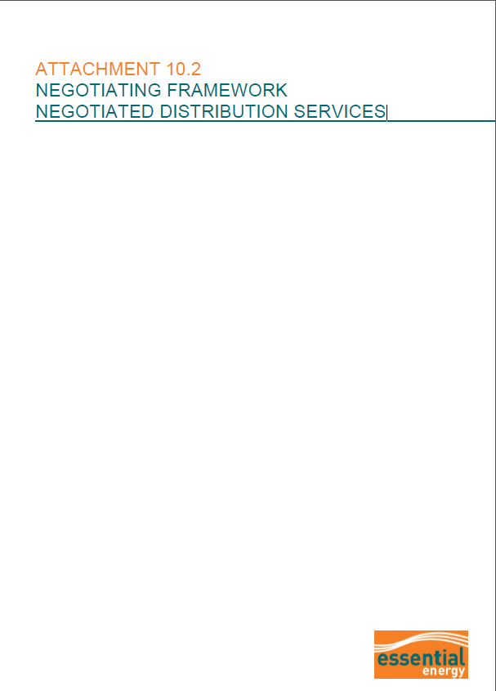

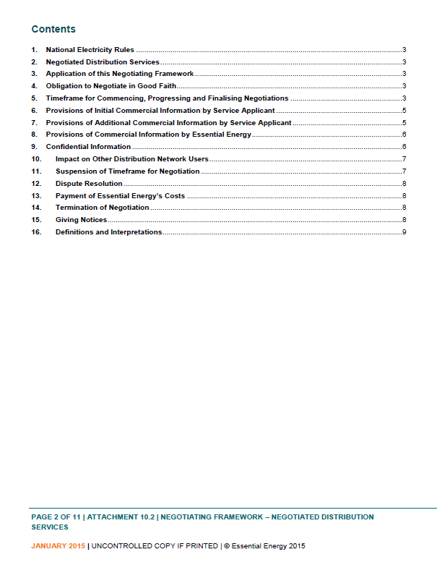

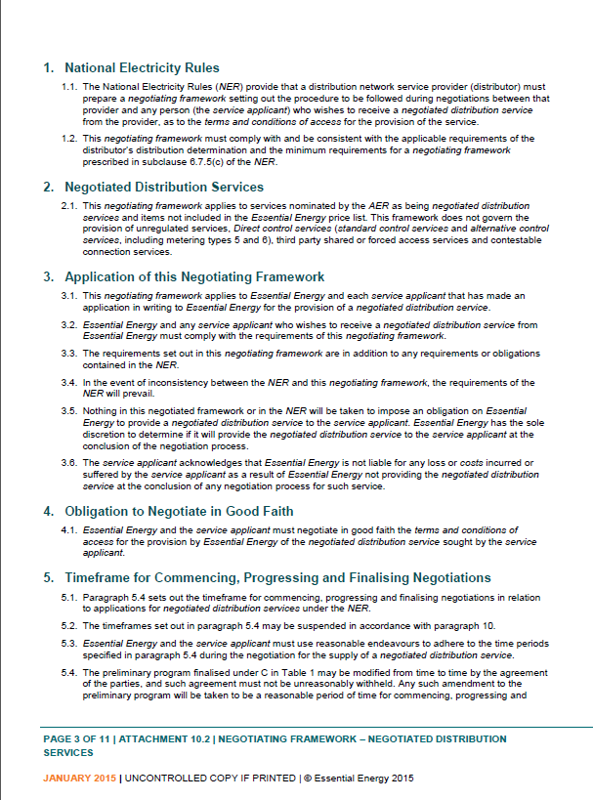

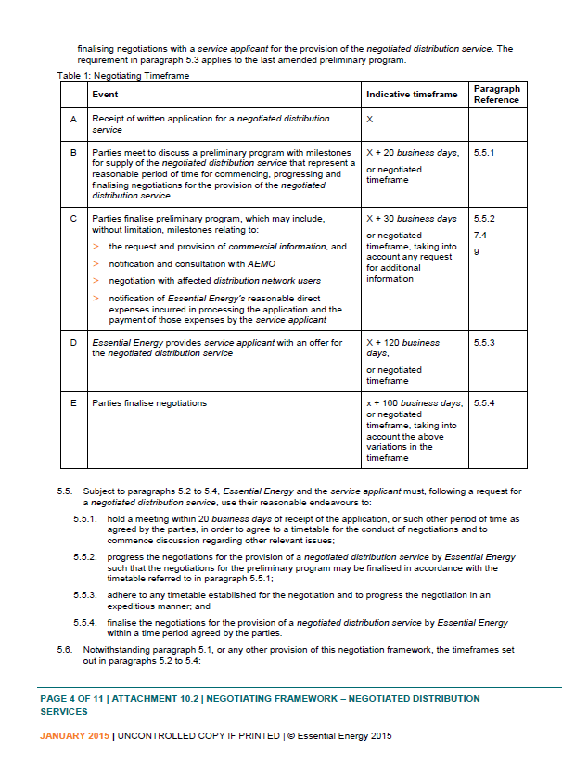

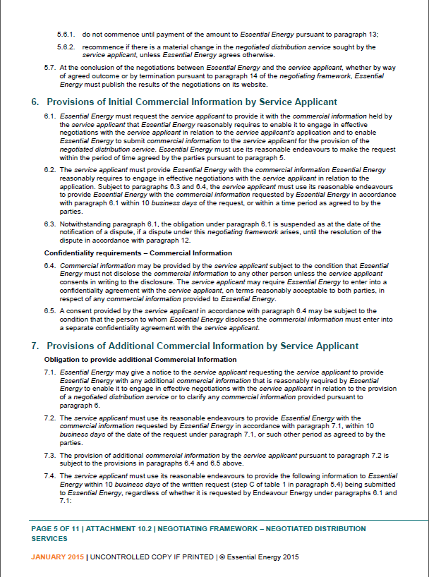

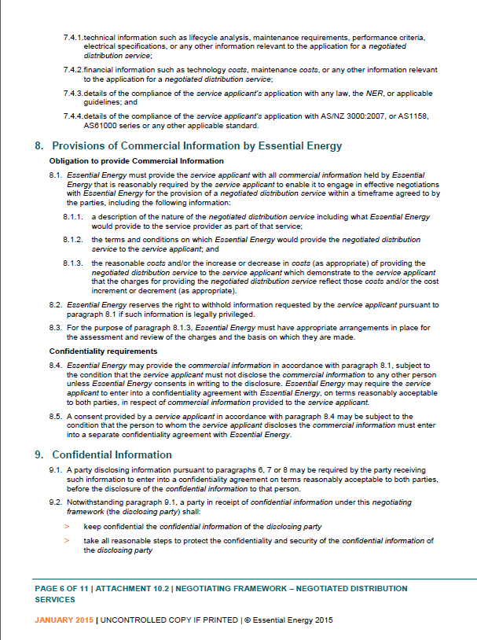

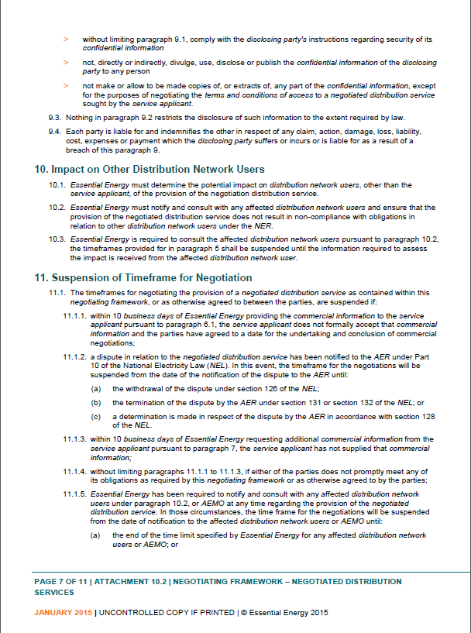

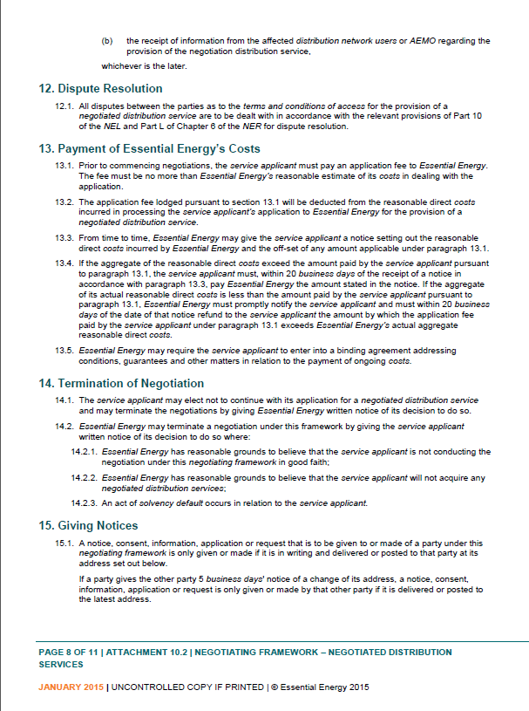

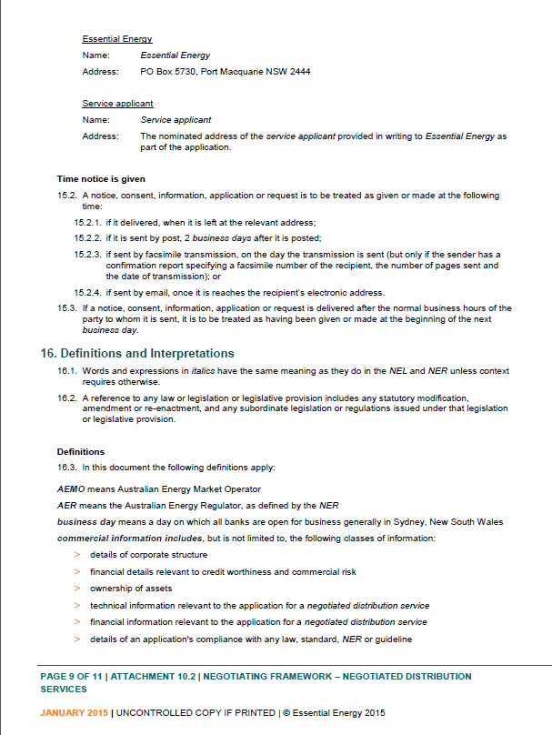

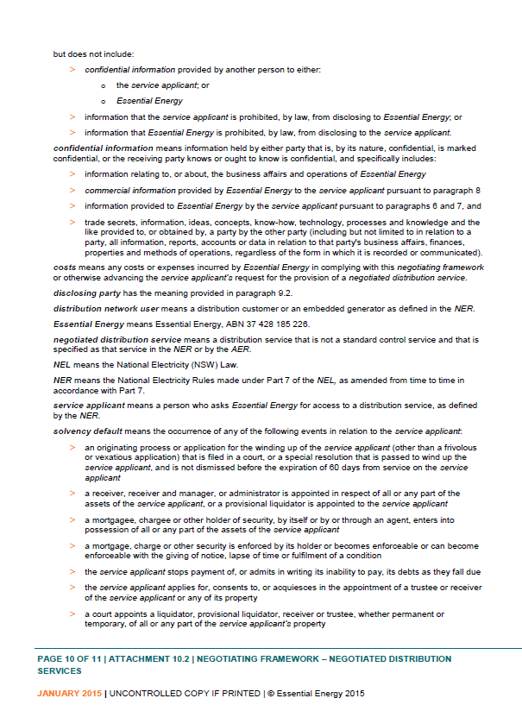

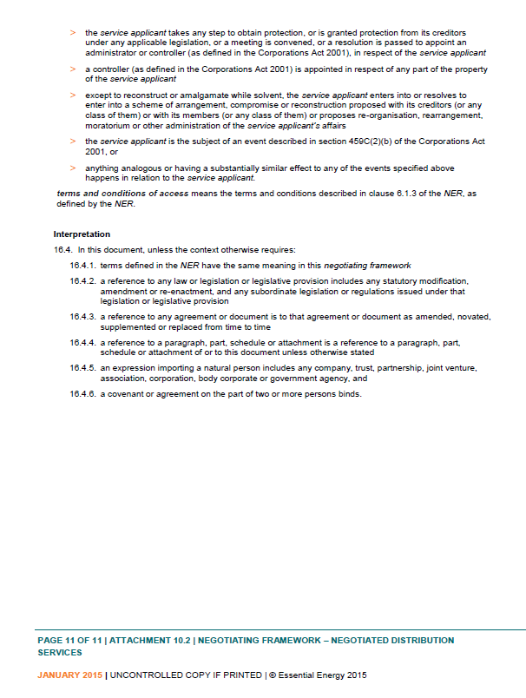

1. NER, cl. 6.12.1(15).
2. NER, cl. 6.12.1(16).
3. Essential Energy, Regulatory proposal, May 2014, p. 130.
4. Essential Energy, Revised regulatory proposal, January 2015, p. 264 and Attachment 10.2.
5. NER, cl. 6.7.5.
6. NER, cl. 6.12.1(15).
7. AER, Proposed Negotiated Distribution Service Criteria for Essential Energy – period commencing 1 July 2014, June 2014.
8. NER, cl. 6.7.1.
9. Essential Energy, Revised regulatory proposal, January 2015, p. 264.
10. NER, cl. 6.7.5(c).
11. An applicant or service applicant is the person who wishes to receive a negotiated distribution service. NER, ch. 10.