

FINAL DECISION

SA Power Networks determination 2015−16 to 2019−20

Attachment 1 − Annual revenue requirement

October 2015

© Commonwealth of Australia 2015

This work is copyright. In addition to any use permitted under the Copyright Act 1968, all material contained within this work is provided under a Creative Commons Attributions 3.0 Australia licence, with the exception of:

* the Commonwealth Coat of Arms
* the ACCC and AER logos
* any illustration, diagram, photograph or graphic over which the Australian Competition and Consumer Commission does not hold copyright, but which may be part of or contained within this publication. The details of the relevant licence conditions are available on the Creative Commons website, as is the full legal code for the CC BY 3.0 AU licence.

Requests and inquiries concerning reproduction and rights should be addressed to the Director, Corporate Communications,  
Australian Competition and Consumer Commission,   
GPO Box 4141, Canberra ACT 2601  
or publishing.unit@accc.gov.au.

Inquiries about this publication should be addressed to:

Australian Energy Regulator  
GPO Box 520  
Melbourne Vic 3001

Tel: (03) 9290 1444  
Fax: (03) 9290 1457

Email: [AERInquiry@aer.gov.au](mailto:AERInquiry@aer.gov.au)

1. Note
2. This attachment forms part of the AER's final decision on SA Power Networks' 2015–20 distribution determination. It should be read with all other parts of the final decision.
3. The final decision includes the following documents:
4. Overview
5. Attachment 1 – Annual revenue requirement
6. Attachment 2 – Regulatory asset base
7. Attachment 3 – Rate of return
8. Attachment 4 – Value of imputation credits
9. Attachment 5 – Regulatory depreciation
10. Attachment 6 – Capital expenditure
11. Attachment 7 – Operating expenditure
12. Attachment 8 – Corporate income tax
13. Attachment 9 – Efficiency benefit sharing scheme
14. Attachment 10 – Capital expenditure sharing scheme
15. Attachment 11 – Service target performance incentive scheme
16. Attachment 12 – Demand management incentive scheme
17. Attachment 13 – Classification of services
18. Attachment 14 – Control mechanism
19. Attachment 15 – Pass through events
20. Attachment 16 – Alternative control services
21. Attachment 17 – Negotiated services framework and criteria
22. Attachment 18 – Connection policy
23. Contents

Note 2

Contents 3

Shortened forms 4

1 Annual revenue requirement 6

1.1 Final decision 6

1.2 SA Power Networks' revised proposal 8

1.3 AER’s assessment approach 9

1.4 Reasons for final decision 9

1.4.1 Revenue true-up for 2015–16 10

1.4.2 Revenue smoothing 11

1.4.3 Shared assets 11

1.4.4 Indicative average distribution price impact 12

1. Shortened forms

| Shortened form | Extended form |
| --- | --- |
| AEMC | Australian Energy Market Commission |
| AEMO | Australian Energy Market Operator |
| AER | Australian Energy Regulator |
| augex | augmentation expenditure |
| capex | capital expenditure |
| CCP | Consumer Challenge Panel |
| CESS | capital expenditure sharing scheme |
| CPI | consumer price index |
| DRP | debt risk premium |
| DMIA | demand management innovation allowance |
| DMIS | demand management incentive scheme |
| distributor | distribution network service provider |
| DUoS | distribution use of system |
| EBSS | efficiency benefit sharing scheme |
| ERP | equity risk premium |
| Expenditure Assessment Guideline | Expenditure Forecast Assessment Guideline for electricity distribution |
| F&A | framework and approach |
| MRP | market risk premium |
| NEL | national electricity law |
| NEM | national electricity market |
| NEO | national electricity objective |
| NER | national electricity rules |
| NSP | network service provider |
| opex | operating expenditure |
| PPI | partial performance indicators |
| PTRM | post-tax revenue model |
| RAB | regulatory asset base |
| RBA | Reserve Bank of Australia |
| repex | replacement expenditure |
| RFM | roll forward model |
| RIN | regulatory information notice |
| RPP | revenue and pricing principles |
| SAIDI | system average interruption duration index |
| SAIFI | system average interruption frequency index |
| SLCAPM | Sharpe-Lintner capital asset pricing model |
| STPIS | service target performance incentive scheme |
| WACC | weighted average cost of capital |

# Annual revenue requirement

The annual revenue requirement (ARR) is the sum of the various building block costs for each year of the regulatory control period before smoothing. The ARRs are smoothed across the period to reduce fluctuations between years and to determine expected revenues for each year. The expected revenues are the amounts that SA Power Networks will target for annual pricing purposes and recover from customers for the provision of standard control services for each year of the regulatory control period. This attachment sets out our final decision on SA Power Networks' ARRs and expected revenues for the 2015–20 regulatory control period.

## Final decision

1. We do not accept SA Power Networks' revised proposed total revenue requirements of $4519.3 million over the 2015–20 regulatory control period. This is because we have not accepted the building block costs in SA Power Networks' revised proposal. We determine a total revenue requirement of $3846.9 million ($ nominal) for SA Power Networks for the 2015–20 regulatory control period, reflecting our final decision on the various building block costs. This is a reduction of $672.6 million ($ nominal) or 14.9 per cent to SA Power Networks' revised proposal.
2. We approved in our preliminary decision the expected revenue for 2015–16 of $682.0 million for SA Power Networks.[1] Under the transitional rules, we are required to determine the ARR for 2015–16 as part of this final determination process and adjust for the difference between the preliminary decision revenue and the ARR for 2015–16. We have now determined the ARR for 2015–16 of $ 638.2 million for SA Power Networks. The difference is therefore $43.8 million. We have applied this difference as part of the smoothing process to establish the annual expected revenue for the remaining four years of the 2015–20 regulatory control period.
3. As a result of our smoothing of the ARRs, our final decision on the annual expected revenue and X factor for each regulatory year of the 2015–20 regulatory control period is set out in table 1.1. Our final decision is to approve total expected revenues of $3837.5 million ($ nominal) for the 2015–20 regulatory control period.
4. Figure 1.1 shows the difference between SA Power Networks' revised proposal and our decision (preliminary and final).
5. Table 1.1 shows our final decision on the building block costs, the ARR, annual expected revenue and X factor for each year of the 2015–20 regulatory control period.

Figure 1.1 AER's final decision on SA Power Networks' revenues for the 2015–20 regulatory control period ($million, nominal)

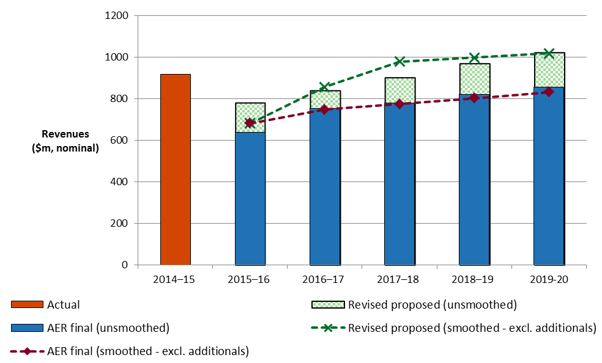

1. Source: AER analysis. SA Power Networks, Revised regulatory proposal, July 2015, Attachment P.1 revised PTRM.

Table 1.1 AER's final decision on SA Power Networks' revenues for the 2015–20 regulatory control period ($million, nominal)

|  |  |  |  |  |  |  |
| --- | --- | --- | --- | --- | --- | --- |
|  | 2015–16 | 2016–17 | 2017–18 | 2018–19 | 2019–20 | Total |
| Return on capital | 233.0 | 250.7 | 263.9 | 276.5 | 288.7 | 1312.9 |
| Regulatory depreciation | 116.9 | 188.8 | 194.0 | 202.5 | 215.0 | 917.2 |
| Operating expenditure | 249.5 | 265.0 | 271.5 | 281.9 | 292.4 | 1360.3 |
| Revenue adjustmentsa | –0.1 | –4.8 | –2.3 | 5.4 | –0.1 | –1.9 |
| Net tax allowance | 38.9 | 52.4 | 51.9 | 54.5 | 60.6 | 258.3 |
| Annual revenue requirement (unsmoothed) | 638.2 | 752.1 | 779.1 | 820.8 | 856.7 | 3846.9 |
| **Annual expected revenue (smoothed)** | **682.0** | **748.2** | **774.5** | **801.9** | **830.9** | **3837.5** |
| X factorb | n/ac | –7.02% | –1.00% | –1.00% | –1.10% | n/a |
| Annual change in revenue (smoothed) | n/a | 9.7% | 3.5% | 3.5% | 3.6% | n/a |

Source: AER analysis.

(a) Revenue adjustments include efficiency benefit sharing scheme carry-overs, forecast DMIA and shared asset adjustments.

(b) The X factors from 2016–17 to 2019–20 will be revised to reflect the annual return on debt update. Under the CPI–X framework, the X factor measures the real rate of change in annual expected revenue from one year to the next. A negative X factor represents a real increase in revenue. Conversely, a positive X factor represents a real decrease in revenue.

(c) In our preliminary decision, we determined the expected revenue and associated X factor for 2015–16. In this final decision to update the 2015–16 revenue for our assessment of efficient costs, we maintained the preliminary decision expected revenue and determined X factors for the final four years of the 2015–20 regulatory control period. This is to adjust SA Power Networks' total expected revenue requirement for the remaining four years in the 2015–20 regulatory control period for the difference between the preliminary decision revenue and our final decision on SA Power Networks' efficient costs for 2015–16.

## SA Power Networks' revised proposal

SA Power Networks' revised proposal included a total expected revenue of $4519.5 million ($ nominal) for the 2015–20 regulatory control period.

Table 1.2 shows SA Power Networks' revised proposed building block costs, the ARR, expected revenue and X factor for each year of the 2015–20 regulatory control period.

Table 1.2 SA Power Networks' revised proposed revenues for the   
2015–20 regulatory control period ($million, nominal)

|  |  |  |  |  |  |  |
| --- | --- | --- | --- | --- | --- | --- |
|  | 2015–16 | 2016–17 | 2017–18 | 2018–19 | 2019–20 | Total |
| Return on capital | 268.0 | 287.8 | 308.4 | 326.2 | 341.9 | 1532.4 |
| Regulatory depreciationa | 157.3 | 181.8 | 208.1 | 233.6 | 258.7 | 1039.5 |
| Operating expenditure | 277.2 | 294.8 | 305.0 | 317.8 | 329.6 | 1524.4 |
| Revenue adjustmentsb | –1.0 | –5.4 | –2.2 | 4.7 | 0.7 | –3.2 |
| Net tax allowance | 80.1 | 81.8 | 84.6 | 88.3 | 91.8 | 426.5 |
| Annual revenue requirement (unsmoothed) | 781.7 | 840.8 | 903.7 | 970.6 | 1022.7 | 4519.5 |
| **Annual expected revenue (smoothed)** | **682.0** | **856.1** | **978.5** | **998.6** | **1019.2** | **4534.5** |
| X factor | n/ac | –23.00% | –11.98% | 0.00% | 0.00% | n/a |
| Annual change in expected revenue (smoothed) | n/a | 25.5% | 14.3% | 2.1% | 2.1% | n/a |

Source: SA Power Networks, Regulatory revised proposal, July 2015, Attachment P.1, revised PTRM; AER analysis.

(a) Regulatory depreciation is straight-line depreciation net of the inflation indexation on the opening RAB.

(b) Revenue adjustments include proposed efficiency benefit sharing scheme carry-over, forecast DMIA and shared asset adjustments.

(c) SA Power Networks revised proposal conducted an adjustment for the difference between the preliminary decision revenue and its revised proposal revenue for 2015–16 by holding the 2015–16 preliminary decision revenue constant. This results in the difference being adjusted for in the expected revenue (via the X factor) for the remaining four years of the 2015–20 regulatory control period.

## AER’s assessment approach

We have not changed our assessment approach for the ARR from our preliminary decision. Section 1.3 of our preliminary decision details that approach.[2] We have reviewed our revenue path for the final decision in light of the requirement to do an adjustment for 2015–16 and this is discussed further in section 1.4.1.

## Reasons for final decision

1. For this final decision, we determine a total revenue requirement of $3846.9 million ($ nominal) over the 2015–20 regulatory control period for SA Power Networks. This is $672.6 million ($ nominal) or 14.9 per cent below SA Power Networks' revised proposal. This reflects the impact of our final decision on the various building block costs.
2. Figure 1.2 shows our preliminary decision and the difference between SA Power Networks' revised proposed ARRs and our final decision.

Figure 1.2 AER's preliminary and final decisions and SA Power Networks' revised proposed annual revenue requirements ($million, nominal)

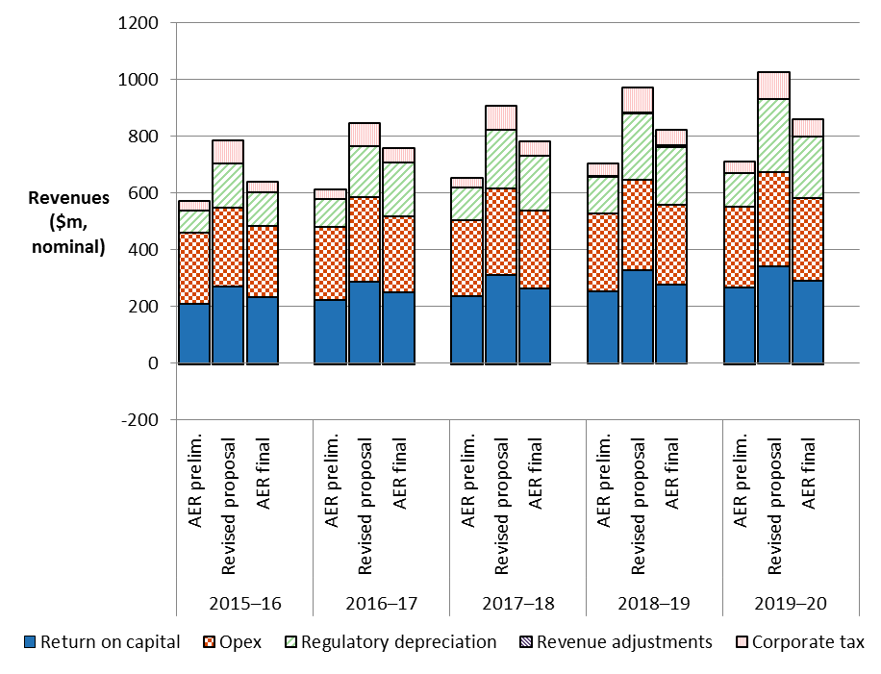

Source: AER analysis; SA Power Networks, Revised regulatory proposal, July 2015, Attachment P.1 revised PTRM.

The most significant changes to SA Power Networks' revised proposal include: a reduction in the return on capital allowance of 14.3 per cent (attachments 2 and 3), a reduction in the capex allowance of 10.2 per cent (attachment 6), and a reduction in the opex allowance of 10.8 per cent (attachment 7).

### Revenue true-up for 2015–16

1. In April 2015, as required under the transitional rules, we made our preliminary decision on SA Power Networks' proposed revenue requirement for the 2015–20 regulatory control period.[3] We determined the expected revenue for 2015–16 of $682.0 million for SA Power Networks in the preliminary decision.[4]
2. For this final decision, we are required to revoke and substitute the preliminary decision for the ARRs over the 2015–20 regulatory control period. As part of this, we are to determine ARRs for each year of the 2015–20 regulatory control period and use a net present value (NPV) neutral adjustment mechanism to account for any difference between:[5]

* the expected revenue for 2015–16 approved in the preliminary decision, and
* the ARR for 2015–16 that is established through this final determination process.

1. Our final decision approves the 2015–16 ARR of $638.2 million for SA Power Networks. To give effect to the true-up, we have set SA Power Networks' first year expected revenue in the post-tax revenue model (PTRM) equal to our preliminary decision revenue for 2015–16 of $682.0 million. This is the only practical option as prices were set for 2015–16 based on this approved preliminary decision amount. This approach means that the difference in the revenues for 2015–16 between the preliminary and final decisions is accounted for in the remaining four years of the 2015–20 regulatory control period. That is, the expected revenue for 2015–16 established from the preliminary decision provides a base from which the expected revenues for the remaining four years of the 2015–20 regulatory control period are calculated. This is done through the determination of the X factors for each of the remaining years in that period.[6] This gives effect to the true-up requirements under the NER and ensures that the difference of $43.8 million is returned to customers over the remaining four years of the 2015–20 regulatory control period (adjusted for the time value of money).
2. SA Power Networks' revised proposal adopted this approach for the adjustment.

### Revenue smoothing

We have taken the building block costs determined in this decision and smoothed them to determine the expected revenues for SA Power Networks over the 2015–20 regulatory control period. In doing so and for the reasons discussed in section 1.4.1, we first set the expected revenue for the first regulatory year (2015–16) at $682.0 million ($ nominal). This is higher than the 2015–16 ARR (unsmoothed) we have now determined, which is $638.2.0 million ($ nominal). We then applied a profile of X factors to determine the expected revenue in subsequent years.

1. We consider that our profile of X factors is reasonable in the circumstances. Revenues determined for this final decision are significantly higher than expected in the preliminary decision due to various changes to the building blocks.[7] Accordingly, expected revenues (smoothed) will increase in the remaining years of the 2015–20 regulatory control period, rather than decrease as anticipated in the preliminary decision. We have mitigated the revenue increase for 2016–17 somewhat by spreading the increases over the remaining four years of the regulatory control period. We have limited the difference between smoothed and unsmoothed revenues in the last year of the 2015–20 regulatory control period to three per cent. This mitigates the potential for any step changes in revenues at the end of the regulatory control period.[8]

### Shared assets

1. Our final decision is to maintain our position set out in the preliminary decision on the shared asset adjustments for SA Power Networks.
2. Service providers, such as SA Power Networks, may use assets to provide both standard control services we regulate and unregulated services. These assets are called 'shared assets'.[9] Of the unregulated revenues a service provider earns from shared assets, 10 per cent will be used to reduce the service provider's prices for standard control services.[10]
3. Shared asset price reductions are subject to a materiality threshold. Unregulated use of shared assets is material when a service provider's unregulated revenues from shared assets in a specific regulatory year are expected to be greater than 1 per cent of its total expected revenue for that regulatory year.[11]
4. In the preliminary decision, we accepted SA Power Networks' proposed shared asset revenue adjustments using updated assessment of materiality threshold based on the preliminary decision revenues.[12] SA Power Networks' revised proposal updated the shared asset revenue adjustments based on its revised proposal revenues and CPI forecast. SA Power Networks submitted that its shared asset unregulated revenues will meet the shared asset threshold in the first two years of the 2015–20 regulatory control period, but will be below the threshold for the final three years of that period. However, SA Power Networks' forecast unregulated revenues must be compared to the total regulated revenues we determine, rather than the total revenue proposed by SA Power Networks. On that basis, we consider SA Power Networks' unregulated revenues are between 1.1 and 1.4 per cent of its total expected revenue in each regulatory year of the 2015–20 regulatory control period.
5. We are satisfied SA Power Networks' shared asset unregulated revenues meet the threshold for revenue adjustments in each year of the 2015–20 regulatory control period. SA Power Networks submitted that it expects to earn a consistent amount of unregulated revenue from its shared assets in each year of the period.[13] Our final decision is therefore to reduce SA Power Networks' annual revenue requirement for shared assets in each year of the 2015–20 regulatory control period as shown in table 1.4.[14]

Table 1.4 SA Power Networks' proposed shared asset revenue adjustments ($ million, 2014–15)

|  |  |  |  |  |  |  |
| --- | --- | --- | --- | --- | --- | --- |
|  | 2015–16 | 2016–17 | 2017–18 | 2018–19 | 2019–20 | Total |
| Adjustment for shared assets | –0.8 | –0.8 | –0.8 | –0.7 | –0.7 | –3.8 |

Source: AER analysis.

### Indicative average distribution price impact

1. Our final decision on SA Power Networks' expected revenues ultimately affects the prices consumers pay for electricity. There are several steps required in translating our revenue decision to a price impact.
2. We regulate SA Power Networks' standard control services under a revenue cap form of control. This means our final decision on SA Power Networks' expected revenues do not directly translate to price impacts. This is because SA Power Networks' revenue is fixed under the revenue cap form of control, so changes in the consumption of electricity will affect the prices ultimately charged to consumers. We are not required to establish the distribution prices for SA Power Networks as part of this determination. However, we will assess SA Power Networks' annual pricing proposals before the commencement of each regulatory year for the 2015–20 regulatory control period to administer the pricing requirements in this distribution determination.
3. For this final decision, we have estimated some indicative average distribution price impacts flowing from our determination on the expected revenues for SA Power Networks over the 2015–20 regulatory control period.
4. Figure 1.4 shows SA Power Networks' indicative price path based on the expected revenues established in our final decision compared to its revised proposal. We estimated average prices by dividing expected revenue by total forecast energy consumed (MWh) in SA Power Networks' distribution network to determine the movement in overall prices.[15] For presentational purposes, the prices are scaled so that the price index begins at 1.0 in 2014–15. The index provides a simple overall measure of the relative movement in expected distribution prices over the 2015–20 regulatory control period.

Figure 1.4 AER's final decision and SA Power Networks' revised proposed indicative price paths (nominal price index)

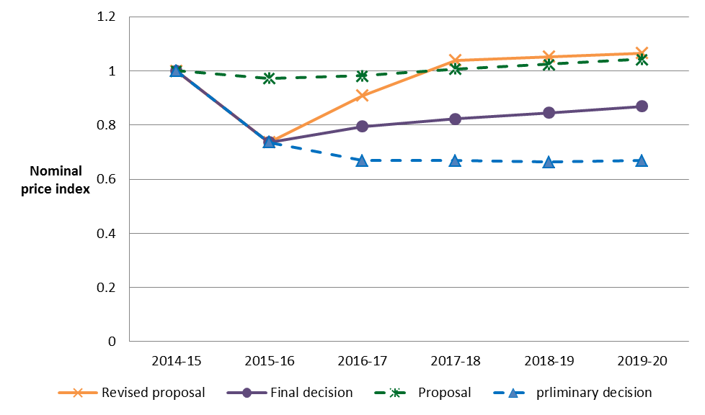

Source: AER analysis.

Notes: The nominal price index is calculated by the AER based on the energy consumption forecast submitted by SA Power Networks in its revised proposal, and adjusting for the change in overall revenue substituted by the AER.

1. We estimate that our final decision on SA Power Networks' annual expected revenue will result in a decrease to average distribution charges by about 1.9 per cent per annum over the 2015–20 regulatory control period in nominal terms. This compares to the nominal average increase of approximately 2.8 per cent per annum proposed by SA Power Networks over the 2015–20 regulatory control period. This amount includes a forecast inflation rate of 2.5 per cent per annum. In real terms we estimate average distribution charges to decline by 4.3 per cent per annum, compared to an increase of 0.3 per cent proposed by SA Power Networks.
2. Table 1.5 displays the comparison of the price impacts of SA Power Networks' revised proposal and our final decision revenue allowance.

Table 1.5 Comparison of revenue and price impacts of SA Power Networks' revised proposal and the AER's final decision

|  |  |  |  |  |  |  |
| --- | --- | --- | --- | --- | --- | --- |
|  | 2014–15 | 2015–16 | 2016–17 | 2017–18 | 2018–19 | 2019–20 |
| **AER final decision** |  |  |  |  |  |  |
| Revenue ($m, nominal) | 918.7 | 682.0 | 748.2 | 774.5 | 801.9 | 830.9 |
| Price path (nominal index) | 1.00 | 0.74 | 0.79 | 0.82 | 0.84 | 0.87 |
| Revenue (change %) |  | –25.8% | 9.7% | 3.5% | 3.5% | 3.6% |
| Price path (change %) |  | –26.4% | 7.9% | 3.5% | 2.7% | 2.8% |
| **SA Power Networks revised proposal** |  |  |  |  |  |  |
| Revenue ($m, nominal) | 918.7 | 682.0 | 856.1 | 978.5 | 998.6 | 1019.2 |
| Price path (nominal index) | 1.00 | 0.74 | 0.91 | 1.04 | 1.05 | 1.07 |
| Revenue (change %) |  | –25.8% | 25.5% | 14.3% | 2.1% | 2.1% |
| Price path (change %) |  | –26.4% | 23.5% | 14.3% | 1.3% | 1.3% |

Source: AER analysis.

Distribution charges represent approximately 38 per cent on average of SA Power Networks' typical customer's annual electricity bill.[16] We expect that our final decision, holding all other components of the bill constant, will result in the average residential customer's annual electricity bill for 2015–16 to 2019–20 to remain below the bill paid in 2014─15. This is because we estimate that our final decision will result in lower distribution charges on average over the 2015–20 regulatory control period compared to SA Power Networks' revised proposal as discussed above.

1. We estimate that based on the distribution charges from our final decision passing through to customers, we would expect the average annual electricity bill for residential customers to reduce by $203 or 10.1 per cent in 2015–16. This would be followed by increases of about $26 or 1.4 per cent ($ nominal) per annum from 2016–17 to 2019–20. By comparison, had we accepted the revised proposal, the average annual electricity bill for residential customers would increase by approximately $64 (3.4 per cent) per annum between 2016–17 and 2019–20.
2. Our estimate of the potential impact our final decision will have for SA Power Networks' residential customers is based on the typical annual electricity usage of 5000 kWh per annum for a residential customer in South Australia.[17] Therefore, customers with different usage will experience different changes in their bills. We also note that there are other factors, such as transmission network costs, wholesale and retail costs, which affect electricity bills.
3. Similarly, for an average small business customer in SA that uses approximately 10 MWh[18] of electricity per annum, our final decision for SA Power Networks is expected to result in their average annual electricity bill for 2015–16 to 2019–20 to remain below the bill paid in 2014–15. We estimate that based on the distribution charges from our final decision passing through to customers, we would expect the average annual electricity bill for small business customers to reduce by $392 or 10.1 per cent in 2015–16. This would be followed by increases of about $49 or 1.4 per cent ($ nominal) per annum from 2016–17 to 2019–20. By comparison, had we accepted the revised proposal, the average annual electricity bill for small business customers would increase by approximately $122 (3.4 per cent) per annum between 2016–17 and 2019–20.
4. Table 1.6 shows the estimated annual average impact of our final decision for the 2015–20 regulatory control period and SA Power Networks' revised proposal on the average residential and small business customers' annual electricity bills.

Table 1.6 Estimated impact of SA Power Networks' revised proposal and AER's final decision on annual electricity bills for the 2015–20 regulatory control period ($ nominal)a

|  | 2014−15 | 2015−16 | 2016−17 | 2017−18 | 2018−19 | 2019–20 |
| --- | --- | --- | --- | --- | --- | --- |
| **AER final decision** | | | | | | |
| Residential annual billa | 2007 | 1803 | 1848 | 1870 | 1887 | 1905 |
| Annual changec |  | –203 (–10.1%) | 45 (2.5%) | 22 (1.2%) | 17 (0.9%) | 19 (1.0%) |
| Small business annual billb | 3867 | 3475 | 3562 | 3603 | 3637 | 3673 |
| Annual changec |  | –392 (–10.1%) | 87 (2.5%) | 42 (1.2%) | 33 (0.9%) | 36 (1.0%) |
| **SA Power Networks revised proposal** | | | | | | |
| Residential annual billa | 2007 | 1803 | 1936 | 2036 | 2047 | 2057 |
| Annual changec |  | –203 (–10.1%) | 133 (7.4%) | 100 (5.2%) | 10 (0.5%) | 10 (0.5%) |
| Small business annual billb | 3867 | 3475 | 3732 | 3925 | 3945 | 3965 |
| Annual changec |  | –392 (–10.1%) | 257 (7.4%) | 193 (5.2%) | 20 (0.5%) | 20 (0.5%) |

Source: AER analysis; AER, Energy Made Easy, [www.energymadeeasy.gov.au](http://www.energymadeeasy.gov.au); ESCoSA, South Australian Energy Retail Prices Ministerial Pricing Report 2014, August 2014.

(a) Based on annual bill for typical consumption of 5000 kWh per year during the period 1 July 2014 to 30 June 2015. Sample postcode: 5015.

(b) Based on the annual bill sourced from Energy Made Easy for a typical consumption of 10000 kWh per year during the period 1 July 2014 to 30 June 2015. Sample postcode: 5015.

(c) Annual change amounts and percentages are indicative. They are derived by varying 2014–15 bill amounts in proportion with total annual regulated revenue divided by forecast demand. Actual bill impacts will vary depending on electricity consumption, tariff class and other variables.

1. AER, Preliminary decision, SA Power Networks determination 2015–16 to 2019–20 – Attachment 1 – Annual revenue requirement, April 2015, p. 7.
2. AER, Preliminary decision, SA Power Networks determination 2015–16 to 2019–20 – Attachment 1 – Annual revenue requirement, April 2015, pp. 8–10.
3. NER, cl. 11.60.3.
4. AER, Preliminary decision, SA Power Networks determination 2015–16 to 2019–20 – Attachment 1 – Annual revenue requirement, April 2015, p. 7.
5. NER, cll. 11.60.4(d)(1) and (e).
6. The X factors represent the rate of change in the real revenue path over the 2015–20 regulatory control period under the CPI–X framework. They must equalise (in net present value terms) the total expected revenues to be earned by the service provider with the total revenue requirement for that period.
7. In particular, the change in position on the remaining asset lives (depreciation) of existing assets from the preliminary decision means SA Power Networks recover significantly higher regulatory depreciation than in the preliminary decision. This is discussed in attachment 5.
8. In the preliminary decision, the divergence in the smoothed and unsmoothed revenues was 10 per cent at the end of the regulatory control period.
9. NER, cl. 6.4.4.
10. AER, Shared asset guideline, November 2013.
11. AER, Shared asset guideline, November 2013, p. 8.
12. AER, Preliminary decision, SA Power Networks determination 2015–16 to 2019–20 – Attachment 1 – Annual revenue requirement, April 2015, pp. 16–18.
13. SA Power Networks, Revised regulatory proposal, July 2015, table 11.3, p. 320.
14. It should be noted that the unregulated revenue and shared asset adjustment amounts are reported in nominal terms in table 11.3 and table 11.4 of the SA Power Networks' revised proposal, while the shared asset revenue adjustment amounts reported in table 1.4 of this final decision are in real 2014–15 dollar terms. We also amended the CPI forecast used in the share asset adjustment calculation for the 2015–20 regulatory period t to 2.5 per cent, consistent with our final decision for CPI forecast as set out in attachment 3.
15. We have used the energy consumption forecast reported in table 6.1 of SA Power Networks' revised proposal to calculate the indicative average prices.
16. SA Power Networks, Regulatory proposal, October 2014.
17. Based on ESCoSA, South Australian Energy Retail Prices Ministerial Pricing Report 2014, August 2014, p. 9.
18. Based on ESCoSA, South Australian Energy Retail Prices Ministerial Pricing Report 2014, August 2014, p. 9.