

Issues Paper

TransGrid

electricity transmission revenue proposal

1 July 2018 to 30 June 2023

March 2017

© Commonwealth of Australia 2017

This work is copyright. In addition to any use permitted under the Copyright Act 1968, all material contained within this work is provided under a Creative Commons Attributions 3.0 Australia licence, with the exception of:

* the Commonwealth Coat of Arms
* the ACCC and AER logos
* any illustration, diagram, photograph or graphic over which the Australian Competition and Consumer Commission does not hold copyright, but which may be part of or contained within this publication. The details of the relevant licence conditions are available on the Creative Commons website, as is the full legal code for the CC BY 3.0 AU licence.

Requests and inquiries concerning reproduction and rights should be addressed to:

Director, Corporate Communications  
Australian Competition and Consumer Commission   
GPO Box 4141, Canberra ACT 2601

or

publishing.unit@accc.gov.au.

Inquiries about this publication should be addressed to:

Australian Energy Regulator  
GPO Box 520  
Melbourne Vic 3001

Tel: (03) 9290 1444  
Fax: (03) 9290 1457

Email: [AERInquiry@aer.gov.au](mailto:AERInquiry@aer.gov.au)

Request for submissions

Energy consumers and other interested parties are invited to make submissions on the TransGrid electricity transmission revenue proposal by COB Friday 12 May 2017. The proposal is available on the AER’s website [www.aer.gov.au](http://www.aer.gov.au)

We will consider and respond to submissions in our draft determination in September 2017.

We prefer that all submissions are in Microsoft Word or another text readable document format. Submissions should be sent to: [TransGrid2018@aer.gov.au](mailto:TransGrid2018@aer.gov.au)

Alternatively, submissions can be sent to:

Mr Sebastian Roberts  
General Manager  
Australian Energy Regulator  
GPO Box 520  
Melbourne Vic 3001

We prefer that all submissions be publicly available to facilitate an informed and transparent consultative process. Submissions will be treated as public documents unless otherwise requested. Parties wishing to submit confidential information should:

* clearly identify the information that is the subject of the confidentiality claim
* provide a non-confidential version of the submission in a form suitable for publication.

All non-confidential submissions will be placed on our website. For further information regarding our use and disclosure of information provided to us, see the ACCC/AER Information Policy (June 2014), which is available on our website [ACCC and AER information policy](https://www.aer.gov.au/publications/corporate-documents/accc-and-aer-information-policy-collection-and-disclosure-of-information).

If interested parties have any enquires about this Issues Paper, or about lodging submissions, please send an email to: [TransGrid2018@aer.gov.au](mailto:TransGrid2018@aer.gov.au)

Contents

1 Introduction 1

2 Our initial observations 4

2.1 Total revenue 4

2.2 Capital expenditure 6

2.3 Regulatory asset base 7

2.4 Operating expenditure 8

2.5 Rate of return 8

3 Background to our assessment 9

3.1 Who we are 9

3.2 Who is TransGrid and what does it do? 11

3.3 AER Guidelines 11

3.4 Our framework and approach paper 12

3.5 Maximum allowed revenue to be recovered from consumers 13

4 Capital expenditure 15

4.1 How we assess capex expenditure 15

4.2 TransGrid's capex proposal 16

4.3 Key drivers of TransGrid's capital expenditure proposal 17

5 Operating expenditure 21

5.1 How we assess operating expenditure 21

5.2 TransGrid's operating expenditure proposal 23

5.2.1 TransGrid's opex forecasting approach 24

6 Rate of return 29

6.1 How we calculate the rate of return 29

6.1.1 Return on equity 29

6.1.2 Return on debt 30

6.2 TransGrid's proposed overall rate of return 31

7 Value of imputation credits 33

7.1.1 How we have calculated the value of imputation credits 33

7.2 TransGrid's proposed value of imputation credits 33

8 Consumer engagement 35

8.1 Consumer engagement in the NER 35

8.2 Our consumer engagement guideline 36

8.3 TransGrid’s consumer engagement strategy 36

Shortened forms

|  |  |
| --- | --- |
| Shortened form | Extended form |
| AEMC | Australian Energy Market Commission |
| AEMO | Australian Energy Market Operator |
| AER | Australian Energy Regulator |
| capex | capital expenditure |
| EBSS | efficiency benefit sharing scheme |
| kW | kilowatt |
| MAR | maximum allowed revenue |
| MW | megawatt |
| MWh | megawatt hour |
| NEL | National Electricity Law |
| NEM | National Electricity Market |
| NEO | National Electricity Objective |
| NER | National Electricity Rules |
| opex | operating expenditure |
| RAB | regulatory asset base |
| RIT-T | Regulatory Investment Test for Transmission |
| RPPs | Revenue and pricing principles |
| STPIS | service target performance incentive scheme |
| TUoS | transmission use of system |
| VCR | Value of Customer Reliability |
| WACC | weighted average cost of capital |

# Introduction

Households and businesses consume electricity, which is supplied through an electricity network of 'poles and wires'. The electricity network in is divided into two parts:

* a transmission network, which carries electricity from the large generators to the major load centres
* a distribution network, which carries electricity from the points of connection with the transmission network to virtually every building, house and apartment in NSW.

The transmission and distribution networks charge their customers for transmitting electricity across their networks. These 'network charges' do not appear directly on most customers’ electricity bills, which are sent by the retail businesses. Nevertheless, the network charges are important as they account for a significant component of each customer's final bill.

TransGrid (NSW Electricity Networks Operations Pty Limited) operates and maintains the NSW electricity transmission network assets.[1] On 31 January 2017 TransGrid submitted its electricity transmission revenue proposal for its regulatory control period from 1 July 2018 to 30 June 2023 (2018–23 regulatory control period). This revenue proposal sets out how much TransGrid proposes to charge its customers over the five year period.

We, the Australian Energy Regulator (AER), regulate the revenues of electricity network businesses by setting the annual revenues they may recover from customers. For electricity transmission businesses, this annual revenue is called the maximum allowed revenue, and directly impacts the network charges TransGrid can recover from customers as part of their electricity bills.

Although our decision influences the total revenue TransGrid can recover from its transmission customers (such as the NSW distributors and large customers connected directly to the transmission network), we do not set transmission charges for each customer or the retail prices that end consumers pay. Retail prices are set by electricity retailers and include the costs associated with transmission, distribution, generation, and the costs incurred by retailers in selling the electricity.

We are just starting the process of reviewing TransGrid's revenue proposal for the 2018–23 regulatory control period. This involves examining TransGrid's proposal to ensure that consumers pay no more than necessary for the safe and reliable delivery of electricity.

We determine an overall revenue allowance based on a forecast of the efficient costs required by TransGrid to prudently provide transmission services and fulfil its obligations. The regime provides incentives for TransGrid to outperform our forecast, while delivering safe, reliable and secure services to its customers. If TransGrid incurs costs that are greater than what we deem to be efficient, TransGrid bears those costs.

The purpose of this issues paper is to help consumers and other stakeholders understand TransGrid's proposal. This issues paper will be followed by a draft decision in September 2017 and a final decision by April 2018.

Table 1 lists the key dates of the review.

Table Key dates for the TransGrid transmission pricing review

| Step | Date |
| --- | --- |
| AER published Framework & Approach paper for TransGrid | 28 July 2016 |
| TransGrid submitted revenue proposal to AER | 31 January 2017 |
| AER publishes issues paper | 28 March 2017 |
| AER to hold public forum on issues paper | 11 April 2017 |
| Submissions on revenue proposal close | 12 May 2017 |
| AER to publish draft transmission determination | 29 September 2017* |
| AER to hold public forum on draft transmission determination | 10 October 2017* |
| TransGrid to submit revised revenue proposal to AER | 1 December 2017* |
| Submissions on draft determination close | 1 December 2017* |
| Submissions on revised revenue proposal close | 5 January 2018* |
| AER to publish final transmission determination | 30 April 2018 |

Source: NER, chapter 6A, Part E  
* Expected timeframe

Under the NER, consumer engagement is a factor we can consider when making our revenue determinations.[2] Consumers can get involved in our review process in a number of ways. We will host public forums during which consumers can ask us and TransGrid questions. Consumers can make submissions on TransGrid's proposal, this issues paper, and our draft determination.

As part of our 'Better Regulation Program' and to ensure that consumers have a say in our decision making process, we established the Consumer Challenge Panel (CCP). The purpose of the CCP is to assist us in making better regulatory decisions by advising us on issues that are important to consumers. Panel members will present their views and analysis at our public forums, which will help consumers understand the issues and be better able to have a say.

Submissions

Submissions on TransGrid's proposal and this issues paper are due by **12 May 2017**.

Your submission will be of greater value to us if it is supported by evidence and analysis. Submissions that address specific issues, supported by evidence and analysis, can be very useful.

If you consider a certain aspect of the revenue proposal is not justified, you should state why you consider it is not justified. You should also state what further information you consider TransGrid should provide to justify that aspect of its proposal. Likewise, if you consider a certain aspect of the proposal is justified, you should state why.

When considering the questions on which we would like feedback, it is useful to keep in mind that our jurisdiction in reviewing the proposal is set out in the National Electricity Law (NEL) and National Electricity Rules (NER). The objective of the regulatory framework is to promote the efficient investment in, and efficient operation and use of, electricity services for the long term interests of consumers of electricity. Under the NER, we assess the business' proposed expenditure forecasts to determine whether they are required to meet this objective.

We are most interested in receiving submissions on TransGrid's proposed approach to customer engagement, operating expenditure (opex), capital expenditure (capex) and the expected rate of return. However, we welcome submissions on all aspects of the proposal.

**Public forum**

We will hold a public forum on TransGrid's revenue proposal at the University of Technology Sydney Aerial Function Centre on 11 April 2017. The public forum will commence at 2 pm and conclude by 4.15 pm. To attend, please email us by COB Tuesday **4 April 2017** at: [TransGrid2018@aer.gov.au](mailto:TransGrid2018@aer.gov.au)

# Our initial observations

This section sets out our initial observations on TransGrid's revenue proposal.

## Total revenue

TransGrid's revenue proposal covers many issues relevant to our responsibilities as an economic regulator. Primarily though, the revenue proposal sets out the revenue that TransGrid proposes to recover from consumers over the next regulatory control period. This section discusses TransGrid's revenue proposal in total.

TransGrid has proposed a total revenue requirement of $3,973 million (smoothed, real $ June 2018) over the 2018–23 regulatory control period.[3] This represents a 2.3 per cent increase compared to the average annual revenue TransGrid was allowed to recover from customers over the 2014–18 regulatory control period.[4]

TransGrid's actual, expected and forecast revenue are outlined in Figure 1 below.

Figure TransGrid total revenue requirement ($m, June 2018)

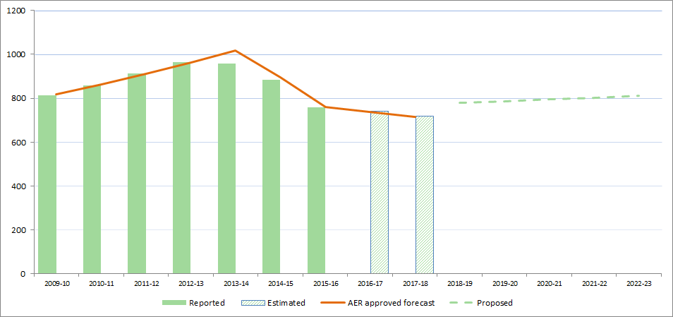

Source: AER, Economic Benchmarking RIN accounts; AER, Final decision PTRM for TransGrid 2014–18, 3 July 2015; TransGrid, Revenue Proposal 2018/19 – 2022/23, January 2017; AER analysis.

Revenue impact by building block revenue component

To assist consumers to understand the drivers of the increase in TransGrid's proposed total revenue requirement we have separated TransGrid's proposed changes in revenue into the various building block elements.

In the figure below we show the impact of these changes as if all of these were to occur in the first year. By doing so, we can see more clearly the key drivers of TransGrid's proposed revenue increase.

Figure 2 shows that the regulatory depreciation, corporate tax and opex building blocks are the key drivers of the proposed increase in revenues in the 2018–23 regulatory control period. This increase is offset by a forecast lower return on capital.

Figure TransGrid – change in 2014–18 average revenue to proposed average revenue for 2018–23 – by revenue component ($m, June 2018)

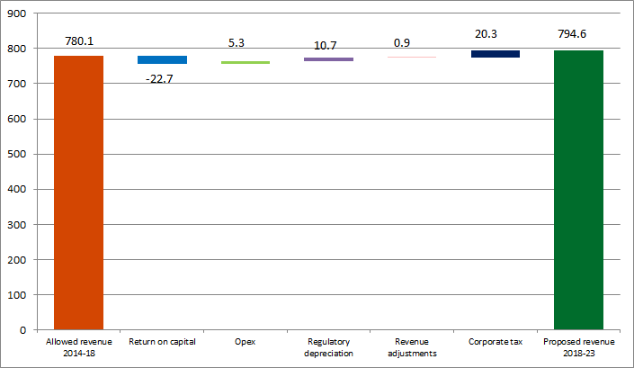

Source: AER, Final decision PTRM for TransGrid 2014–18, 3 July 2015; TransGrid, Revenue Proposal 2018/19 – 2022/23, January 2017; AER analysis.

Impact on transmission prices

TransGrid's proposed revenue, if accepted, would translate to annual transmission price increases for NSW consumers of 8.5 per cent, compared to the approved average prices in the current regulatory control period.[5]

Figure 3 shows the indicative average price path derived from TransGrid's revenue proposal. The solid lines represent actual (up to 2015–16) and approved (up to 2017–18) average prices. The dotted line represents the average price path proposed by TransGrid over the next regulatory control period. From 2009–10 to 2015–16, TransGrid’s actual price path, on average, has been lower than approved.

In the current regulatory control period,[6] average annual prices have increased from the previous regulatory control period.

TransGrid's proposal is for increases in the average price path over the 2018–23 regulatory control period.

Figure TransGrid – indicative transmission price path from 2009–10 to 2022–23 ($/MWh, nominal)

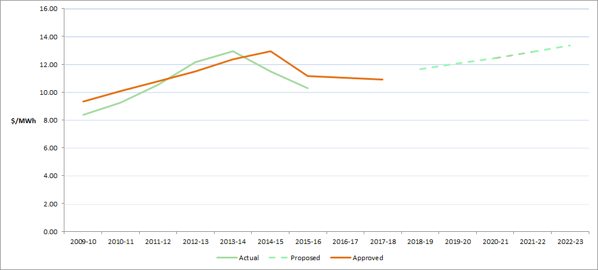

Source: AER, Economic Benchmarking RIN accounts; AER, Final decision PTRM for TransGrid 2014–18, 3 July 2015; TransGrid, Revenue Proposal 2018/19 – 2022/23, January 2017; AER analysis.

Note: The indicative average price path is calculated using total revenue and dividing by forecast energy consumption for each year of the regulatory control period.

## Capital expenditure

TransGrid has proposed forecast capex of $1 612.3 million ($June 2018) over the forthcoming regulatory period. This represents an average increase of approximately 36 per cent compared to actual and expected expenditure over the current period.[7]

TransGrid submitted that most of the capex forecast is related to network capex ($1 453.3 million, or 90 per cent) compared to non-network ($159 million, or 10 per cent). A significant part of the network capex forecast (56 per cent) is for network replacement. Augmentation to the transmission system also makes up 30 per cent of the capex.[8]

TransGrid has also proposed a significant project for the replacement of a number of cables into the inner Sydney electricity network. This project is known as Powering Sydney's Future and has a forecast cost of $330.9 million ($June 2018).[9] This is currently the subject of a separate RIT-T process under the rules.

See section 4 of this paper for further details.

## Regulatory asset base

The regulatory asset base (RAB) is the value of the assets used by TransGrid to provide prescribed transmission services. From the proposed opening value of the RAB on 1 July 2018, the RAB will be adjusted for each year of the 2018–23 regulatory control period by:

* adding an inflation adjustment to the opening RAB
* adding actual or estimated capital expenditure to the RAB
* subtracting depreciation from the RAB, calculated according to a straight-line depreciation approach
* subtracting gross proceeds from any asset disposals.

These annual adjustments give the closing RAB for any particular year, which then becomes the opening RAB for the following year, and this process rolls forward the RAB to the end of the 2018–23 regulatory control period.

Figure 4 TransGrid historical and forecast RAB ($m, nominal)

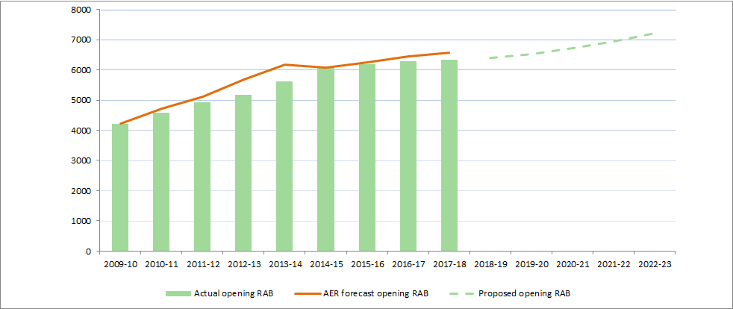

Source:   AER, Final decision PTRM for TransGrid 2014–18, 3 July 2015; AER, Final decision RFM for TransGrid 2014–18, April 2015; AER, Final decision PTRM for TransGrid 2009-14, 25 November 2009; TransGrid, Revenue Proposal 2018/19 – 2022/23, January 2017.

As shown in Figure 4, TransGrid proposed an opening RAB value of $6,406 million ($nominal) as at 1 July 2018 and a closing forecast RAB of $7,512 million ($nominal) as at 30 June 2023. This closing forecast RAB reflects the proposed opening RAB, forecast capex, expected inflation, and depreciation over the 2018–23 regulatory control period.

Figure 5 shows what is driving the change in TransGrid's RAB. As can be seen from the figure, the increase in TransGrid's RAB is predominantly attributable to asset replacement expenditure (repex), asset augmentation expenditure (augex) and inflation. These drivers outweigh the depreciation of the asset base.

Figure Drivers of RAB change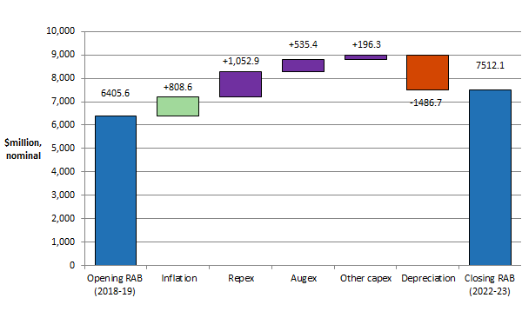

Note:   The inflation, repex, augex, other capex, and depreciation values reflect the sum of nominal values over the 2018–23 regulatory control period as sourced from TransGrid's proposed PTRM.

## Operating expenditure

TransGrid proposed total operating expenditure of $907.6 million ($June 2018) for the 2018–23 regulatory control period.[10] This is 4.1 per cent more than TransGrid's actual and estimated opex for the 2014–18 regulatory control period on an annual average basis.[11]

See section 5 of this paper for further details.

## Rate of return

In its revenue proposal, TransGrid proposed a rate of return of 6.6 per cent. This comprises:

* 7.49 per cent return on equity; calculated using:
* A (placeholder) risk free rate estimate of 2.24 per cent
* A equity beta of 0.7; and
* A market risk premium of 7.5 per cent
* A (placeholder) 6.1 per cent return on debt; and
* 60 per cent gearing (proportion of debt financing).

We consider TransGrid's proposed rate of return in further detail in section 6 of this paper.

# Background to our assessment

This section provides information about the AER and TransGrid. If you are familiar with the AER's pricing review process, then refer straight to section 4.

The NEL and NER set out the regulatory framework for the National Electricity Market (NEM). Chapter 6A of the NER contains timelines and processes for the regulation of transmission businesses. It provides that regulated transmission businesses must periodically apply to us to assess their revenue requirements. Typically, this happens every five years. The revenue proposal as submitted by each business starts a process often referred to as a pricing review or 'revenue reset'.

## Who we are

We are Australia's energy market regulator for the National Electricity Market (NEM).[12] Our functions are set out in NEM legislation and rules. These functions include:

* setting the revenues that network businesses can recover from their customers for using energy networks (electricity poles and wires and gas pipelines) to transport energy to customers
* monitoring wholesale electricity and gas markets so suppliers comply with the legislation and rules, and taking enforcement action where necessary
* publishing information on energy markets, including the annual State of the Energy Market report and more detailed market and compliance reporting, to assist participants and the wider community
* assisting the Australian Competition and Consumer Commission with energy-related issues arising under the Competition and Consumer Act, including enforcement, mergers and authorisations.

The NEL and NER set out the regulatory framework under which we operate.

We exercise our functions in a manner that will advance the National Electricity Objective (NEO). The NEO in turn is supported through the revenue and pricing principles and the various objectives, criteria and elements within the rules. The NEO is:

…to promote efficient investment in, and efficient operation and use of, electricity services for the long term interests of consumers of electricity with respect to—

(a) price, quality, safety, reliability and security of supply of electricity; and

(b) the reliability, safety and security of the national electricity system.

Energy Ministers have provided us with a substantial body of explanatory material that guides our understanding of the NEO. [13] The long term interests of consumers are not delivered by any one of the NEO's factors in isolation, but rather by balancing them in reaching a regulatory decision. [14]

In general, we consider that we will achieve this balance and, therefore, contribute to the achievement of the NEO, where consumers are provided a reasonable level of safe and reliable service that they value at least cost in the long run.[15] In most industries, competition creates this outcome. Competition drives suppliers to develop their offerings to attract customers. Where a supplier’s offering is not attractive it risks being displaced by other suppliers.

However, in the energy networks industry the usual competitive disciplines do not apply. Electricity transmission businesses such as TransGrid are largely natural monopolies.[16] In addition, many of the products they offer are essential services for most consumers. Consequently, in an uncompetitive environment, consumers have little choice but to accept the quality, reliability and prices the network service provider offers.

The NEL and NER aim to remedy the absence of competition by providing that we, as the regulator, make decisions that are in the long term interests of consumers. For example, we might require a transmission business to offer its services at a different cost than they would choose themselves. By its nature, this process will involve exercising regulatory judgement to balance the NEO's various factors.

It is important to recognise that there are a number of plausible outcomes that may contribute to the achievement of the NEO. The nature of decisions under the NER is such that there may be a range of economically efficient decisions, with different implications for the long term interests of consumers.[17] At the same time, however, there are a range of outcomes that are unlikely to advance the NEO to a satisfactory extent. For example, we do not consider that the NEO would be advanced if allowed revenues encouraged overinvestment and resulted in prices so high that consumers are unwilling or unable to efficiently use the network.[18] This could have significant longer term cost implications for those consumers who continue to use network services.

Equally, we do not consider the NEO would be advanced if the revenue recoverable from customers results in prices so low that investors are unwilling to invest as required to adequately maintain the appropriate quality and level of service, and where customers make more use of the network than is sustainable. This could create longer term problems and have adverse consequences for safety, security and reliability of the network.[19]

## Who is TransGrid and what does it do?

TransGrid is the operator and manager of the main high voltage electricity transmission network in NSW and ACT, connecting generators, distribution networks and major end users. TransGrid’s network stretches along the east coast of Australia from Queensland to Victoria, then inland to Broken Hill NSW. Its network connects major generation sources in the Central Coast, Hunter Valley, Lithgow area and Snowy Mountains in NSW, and is interconnected with the Victorian and Queensland networks. TransGrid’s network also connects to four electricity distribution networks in NSW and ACT. TransGrid operates more than 13,000 kilometres of high voltage overhead transmission lines and underground cabling, along with 99 substations and switching stations.[20]

In December 2015, the consortium NSW Electricity Networks was successful in its bid to take on the 99 year lease of TransGrid from the NSW State Government.[21]

## AER Guidelines and schemes

During our 2013 Better Regulation program we developed, through an extensive consultation process, a number of guidelines and schemes. The result was a suite of guidelines that accommodated changes to the NEL and NER and set out approaches we consider are most likely to advance the NEO.

Below is a list and brief description of each of our guidelines and schemes. These guidelines and schemes are available on our website and include:[22]

****Expenditure forecast assessment guideline****

This guideline sets out how we go about assessing the operating and capital expenditure proposals from businesses.

****Rate of return guideline****

This guideline sets out how we go about determining the allowed rate of return businesses earn on their investments.

****Capital expenditure incentive guideline****

Our capital expenditure incentive guideline provides network businesses with an incentive to spend capital expenditure efficiently and share the benefits of efficiencies with consumers.

****Efficiency benefit sharing scheme****

Our efficiency benefit sharing scheme provides network businesses with a continuous incentive to spend operating expenditure efficiently and share efficiencies with consumers.

****Consumer engagement guideline for network service providers****

This guideline looks at our expectations of what the businesses should consider in implementing consumer engagement strategies that are effective for all stakeholders.

****Shared asset guideline****

This guideline explains how revenue the networks earn from shared assets is shared with consumers.

Service target performance incentive scheme

The purpose of the STPIS is to provide incentives to TNSPs to improve or maintain a high level of service for the benefit of participants in the National Electricity Market (NEM) and end users of electricity.

****Confidentiality guideline****

This guideline sets out how we manage confidential information claims within the regulatory determination process.

We consulted extensively in developing these guidelines. This consultation process was very important for testing our views and hearing from a range of interested parties. In particular, we made a special effort to engage consumers in the process through our Consumer Reference Group. The guidelines provide a solid foundation for our decision making and provide predictability in how we will exercise our discretion. Predictability provides confidence to both investors and consumers.

## Our framework and approach paper

We released our Framework and Approach (F&A) paper for TransGrid on July 2016.[23]The F&A paper is the first step in the regulatory process and determines the broad nature of any regulatory arrangements that will apply in this process. It also facilitates early public consultation and assists network service providers to prepare revenue proposals.

The F&A is not binding on TransGrid or us.[24] This means it is open to TransGrid or us to propose a different approach to that set out in our F&A for the regulatory control period.

## Maximum allowed revenue to be recovered from consumers

A transmission business recovers revenue from its customers via network charges. A pricing methodology prescribes the way the business recovers this revenue. To determine the transmission business' revenue for the next regulatory control period, we assess the total revenue required to provide prescribed transmission services for each year of the period.

In accordance with the NER, we use the building block approach to determine the total revenue required by the business. That revenue requirement is determined by estimating the efficient costs that the business is likely to incur in providing prescribed transmission services. The underlying cost elements include:

* a return on the regulatory asset base (RAB) (return on capital)
* depreciation of the regulatory asset base (return of capital)
* forecast operating expenditure (opex)
* increments or decrements resulting from the application of incentive schemes
* the estimated cost of corporate income tax.

Our assessment of capex directly affects the size of the RAB and therefore the return on capital and return of capital building blocks.

Our assessment of TransGrid's proposal will consider each of the building blocks shown in Figure 6. However, we must decide TransGrid's revenue as a whole and describe how the component parts of the decision relate to each other.

Figure **The building block approach to determining maximum allowed revenue**

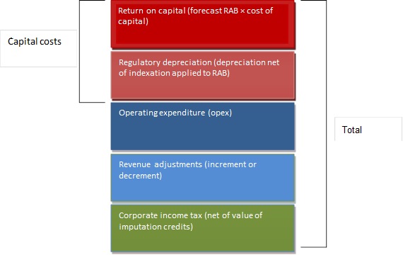

The key drivers of these cost elements in the revenue proposal are discussed in sections 4 to 7 of this paper.

# Capital expenditure

Capital expenditure (capex) refers to the capital expenditure incurred in the provision of network services. The most significant elements of total capex are generally network augmentation expenditure (augex), asset replacement expenditure (repex) and connections.

Capex is added to the regulatory asset base (RAB) and so forms part of the capital costs of the building blocks used to determine total required revenue. Under the rules, we must accept the proposed forecasts of total capex if we are satisfied they reasonably reflect the capital expenditure criteria (capex criteria) set out in the NER.[25] The capex criteria relate to the efficient costs incurred by a prudent operator in light of realistic demand forecasts and cost inputs. We must have regard to the capex factors in the NER when making that decision.[26]

## How we assess capex expenditure

Our approach is to compare the service provider's total capex forecast with an alternative estimate that we are satisfied reasonably reflects the capex criteria. Having established our alternative estimate of the total forecast capex, we can test the service provider's proposed total forecast capex. This includes comparing our alternative estimate total with the service provider's proposal total. If there is a difference between the two, we may need to exercise our judgement as to what is a reasonable margin of difference.

If we are satisfied that the service provider's proposal reasonably reflects the capex criteria, we accept it. If we are not satisfied, the rules require us to put in place a substitute estimate which we are satisfied reasonably reflects the capex criteria taking into account the capex factors.[27] Where we have done this, our substitute estimate is based on our alternative estimate.

We assess forecast capex proposals through a combination of top down and bottom up assessments. Our focus is typically on determining the prudent and efficient level of forecast capex. We will generally assess forecast capex through assessing: the need for the expenditure; and the efficiency of the proposed projects and related expenditure to meet any justified expenditure need. This is likely to include consideration of the timing, scope, scale and level of expenditure associated with proposed projects. Where businesses do not provide sufficient economic justification for their proposed expenditure, we will determine what we consider to be the efficient and prudent level of forecast capex. In assessing forecasts and determining what we consider to be efficient and prudent forecasts we may use a variety of analysis techniques to reach our views.

Our assessment approaches for capex and opex differ. We use revealed costs for opex to a greater extent than for capex because we consider opex is largely recurrent. Past actual expenditure may not be an appropriate starting point for capex given it is largely non-recurrent or 'lumpy', and so past expenditures or work volumes may not be indicative of future volumes. Further, TNSPs will tend to propose smaller volumes of large, high cost projects which we may need to consider on a case by case basis.

The assessment techniques that we may adopt to assess TransGrid' forecasts of total capex are outlined in our expenditure forecast assessment guideline.

## TransGrid's capex proposal

TransGrid has proposed forecast capex of $1 612.3 million ($June 2018) over the forthcoming regulatory period. This represents an average increase of approximately 36 per cent compared to actual and expected expenditure over the current period.[28]

TransGrid submitted that most of the proposed capex forecast is related to network capex ($1 453.3 million, or 90 per cent) compared to non-network ($159 million, or 10 per cent). A significant part of the network capex forecast (56 per cent) is for network replacement. Augmentation to the transmission system also makes up 30 per cent of the capex.[29]

Figure 7 outlines TransGrid' proposed capex forecasts, compared to historic levels and capex allowances. Over the current 2014–18 period, capex was considerably reduced compared to the previous 2009–14 period.

Figure 7 TransGrid historical and forecast capital expenditure ($m, real June 2018)

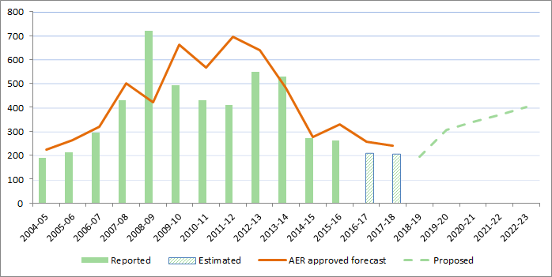

Source: AER, Category Analysis RIN accounts; AER, Final decision PTRM for TransGrid 2014–18, 3 July 2015; TransGrid, Revenue Proposal 2018/19 – 2022/23, January 2017; AER analysis.

## Key drivers of TransGrid's capital expenditure proposal

TransGrid's submitted that its capex forecast is driven predominately by higher:

* asset replacement (including security and compliance) at a forecast cost of $961 million ($June 2018), based upon asset risk assessments which have identified the need to replace assets or otherwise manage risks, where a large proportion of risks related to transmission lines and secondary systems [30]
* augmentation expenditure, due to the inclusion of the Powering Sydney's Future project at a forecast cost of $332 million. This reflects two thirds of the total augmentation forecast of $491.7 million ($June 2018).[31]

Figure 8 shows the breakdown of capex forecast into driver categories.

Figure TransGrid breakdown of capex forecast into driver categories



Source: TransGrid, Regulatory proposal 2018–23, January 2017, p. xx.

Table 2 sets out in detail the drivers of TransGrid's capex forecast. Our assessment of TransGrid's regulatory proposal will focus on these drivers. There are a number of specific projects that contribute to TransGrid's forecast capex including the Powering Sydney's Future project.

Table TransGrid ‑ Drivers of capex forecast ($ 2017)

| Cost driver | Description |
| --- | --- |
| Augmentation related expenditure (demand related) | * TransGrid has proposed $491 million of augmentation capex of which $331m driven by the reliability of TransGrid and Ausgrid cables that supply inner Sydney (including the CBD) and the need to augment the network to meet forecast increases in peak demand. TransGrid has also commenced a RIT-T process and has sought expression of interest regarding non-network solutions to address or partly address the identified need. * TransGrid has proposed $56 million related to demand driven augmentation expenditure to meet localised demand. This expenditure is higher than in the previous regulatory control period and is driven by an anticipated increase in the connection of new large industrial mining loads and localised demand in the connected distribution networks. TransGrid considers that the potential for the connection of these new large industrial and mining loads are unlikely to be included in the AEMO or DNSP forecasts. TransGrid has adopted a probabilistic planning approach in support of the majority of this expenditure. |
| Augmentation related expenditure (market benefits related) | TransGrid has proposed $64 million of projects it considers will provide economic benefits. These identified benefits include improving power quality, reductions in load restoration times, improved network resilience during extreme weather events and improved ability to respond to grid emergencies. |
| Augmentation related expenditure (reliability related) | TransGrid has proposed $41 million to comply with reliability obligations in the Australian Capital Territory and in relation to meeting the updated reliability standards prescribed by the NSW Government. |
| Asset replacement capex | TransGrid has proposed replacement expenditure of $961 million or $192 million on an average annual basis. This is higher than the average annual amount of $179 million over the current regulatory control period. TransGrid's replacement program is driven by:   * Transmission line renewals (including pole/tower related expenditure) ($389 million) * Substation renewals (including transformers) $234 million) * Secondary system renewals (includes SCADA and protection systems) ($173 million) * Network communications upgrades ($65 million) * Security and compliance ($54 million). |
| Non-network | TransGrid has proposed $159 million for non-network expenditure. This includes expenditure on information technology, motor vehicles, property and plant and equipment. Information technology related expenditure represents 65 per cent of the forecast. |
| Labour escalation | TransGrid forecasts real increases in labour costs above inflation (CPI). This amounts to $26 million over the regulatory control period. The figures in this table for each cost driver are inclusive of these real labour escalation costs. |
| Contingent projects | The regulatory framework allows a transmission business to propose projects above a defined financial threshold, but here there is significant uncertainty as to the need and timing of these projects such that these projects are not included in the proposed initial revenue allowance (and prices). However, pre-defined events or circumstances (e.g. unexpected growth in load) that would trigger the need for this project during the regulatory control period may be included in our decisions. In the event that these projects are subsequently required during the regulatory control period (subject to AER approval), the transmission business is allowed to recover these additional investments within the regulatory control period. TransGrid have proposed the following contingent projects:   * New South Wales to South Australia Interconnector (NSI): this project has an estimated cost between $279 million and $1,084 million. ElectraNet is currently undertaking a RIT-T related to this project and the draft RIT-T is expected to be published in mid-2017. * Reinforcement of the Northern Network (Queensland NSW Interconnect upgrade): this project has an estimated cost of $63 million to $142 million. * Reinforcement of the Southern Network: this project has an estimated cost between $60 million and $397 million. * Support South Western NSW for Renewables; this project has an estimated cost of $89 million to $473 million. |

Table 2 shows that the largest components of TransGrid's forecast capex are replacement expenditure and augmentation expenditure. TransGrid has applied a risk assessment methodology to develop its forecast of replacement expenditure. One focus of our review will be this risk assessment methodology and we are interested in stakeholder feedback on the methodology. Table 2 also shows that the Powering Sydney's Future project makes up the bulk of TransGrid's forecast augmentation expenditure. This project will be another focus of our review.

**Capex questions**

1. Do you consider that TransGrid's risk assessment methodology and its application have been sufficiently detailed to support its proposed replacement capex against the capex criteria? If not please identify any issues that may be relevant to an assessment of the proposed capex.

2. Do you consider that TransGrid has adequately outlined the need for the proposed investment in relation to the inner supply to Sydney, including the CBD and has sufficiently considered customer views in developing its proposed network solution?

# Operating expenditure

Opex refers to the operating, maintenance and other non-capital expenditure incurred in the provision of network services. It includes labour costs and other non-capital costs that a prudent service provider is likely to require for the efficient operation of its network.

Opex is one of the building blocks used to determine TransGrid's total revenue requirement.

## How we assess operating expenditure

Our role is to form a view about whether a business' forecast of total opex is reasonable. Specifically, we must form a view about whether a business' forecast of total opex 'reasonably reflects the opex criteria'.[32] In doing so we must have regard to each of the opex factors specified in the NER.[33]

If we are satisfied the business' forecast reasonably reflects the criteria, we accept the forecast.[34] If we are not satisfied, we substitute the business' forecast with an alternative estimate that we are satisfied reasonably reflects the opex criteria.[35] In making this decision, we take into account the reasons for the difference between our alternative estimate and the business' proposal and materiality of the difference. Further, we consider interrelationships with the other building block components of our decision.[36]

After conducting an extensive consultation process with service providers, users, consumers and other stakeholders, we published the Expenditure forecast assessment guideline (the guideline) together with an explanatory statement in November 2013.[37] The guideline sets out our intended approach to assessing opex in accordance with the NER.[38] While the guideline provides greater regulatory predictability, transparency and consistency, it is not binding. If we depart from the approach set out in the guideline we must set out explicit reasons that warrant a departure.[39]

We apply the assessment approach outlined in the guideline to develop our estimate of the business' total opex requirements (our alternative estimate). Our alternative estimate serves two purposes. First, it provides a basis for assessing whether the business' proposal is reasonable. Second, it can be used as a substitute forecast if we determine the business' proposal does not reasonably reflect the opex criteria.

Our guideline approach is a base-step-trend forecasting approach—a top-down model—to develop our alternative estimate. There are three broad stages to the base-step-trend approach as its name suggests, as summarised in Figure 9.

Figure Our opex assessment approach



## TransGrid's operating expenditure proposal

TransGrid proposed total operating expenditure of $907.6 million ($June 2018) for the   
2018–23 regulatory control period.[40] This is 4.1 per cent more than TransGrid's actual and estimated opex for the 2014–18 regulatory control period on an annual average basis (Figure 10).[41]

Figure 10 TransGrid historical and forecast operating expenditure ($m, June 2018)

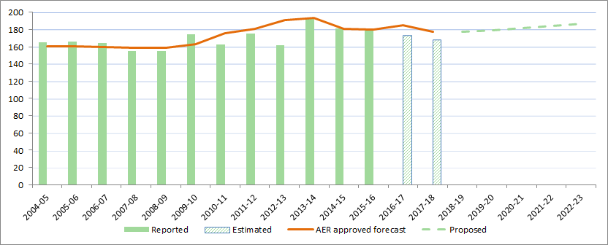

Source: AER, Economic Benchmarking RIN accounts; AER, Final decision PTRM for TransGrid 2014–18, 3 July 2015; TransGrid, Revenue Proposal 2018/19 – 2022/23, January 2017; AER analysis.

TransGrid adopted a 'base–step–trend' approach to forecast its opex for the 2018–23 regulatory control period. The key elements of its proposed opex are:

* TransGrid used estimated opex for 2016–17 as the base to forecast opex for the   
  2018–23 regulatory control period.[42] Its estimated expenditure for 2016–17 would lead to base opex of $868.7 million ($June 2018) over the 2018–23 regulatory control period.[43]
* To forecast the increase in opex between the base year and the last year of the current regulatory control period (i.e. 2016–17 and 2017–18), TransGrid:
* made an efficiency adjustment to the base year of –$6.6 million
* applied the rate of change for price growth and small amount of output growth.

This decreased TransGrid's total opex forecast by $26.6 million ($, June 2018).

* TransGrid proposed a small amount of output growth. This increased its total opex forecast by $2.2 million ($June 2018).
* TransGrid proposed labour price increases, which increased its total opex forecast by $26.0 million ($June 2018).
* TransGrid did not explicitly account for forecast growth in productivity. However, it applied economies of scale to its output growth.
* TransGrid proposed one step change for easement risk management of $7.5 million for each year of the regulatory control period. This increased its total opex forecast by $37.3 million ($June 2018).

These resulted in total opex forecast of $907.6 million ($June 2018) for the 2018–23 regulatory control period.

TransGrid also included debt raising costs of $40.2 million ($June 2018) in its proposed PTRM. TransGrid did not adopt our method of recognising only the transaction costs of issuing bonds and excluding refinancing and liquidity costs.[44]

### TransGrid's opex forecasting approach

TransGrid applied a base–step–trend approach to forecast opex, but did not adopt our guideline approach for all components of its forecasts.

Two key issues in our assessment of TransGrid's opex proposal are the forecast starting point (section 5.2.1.1) and a step change to reduce fire risks from trees that are outside TransGrid's easements (section 5.2.1.2).

We will consider them in making our draft decision, so it is helpful for stakeholders to engage with us on these matters. We acknowledge that these issues are inherently complex and require a good understanding of our assessment approach. We expect some stakeholders are better placed to make submissions on these issues than others. Nevertheless, it is not just about the technical analysis. It is important for us to gain consumer perspectives and observations more broadly to help us understand if a regulatory proposal is consistent with the long term interests of consumers. We welcome any feedback on TransGrid's proposed opex forecast.

It is noted that TransGrid has also adopted an alternative approach to forecasting the rate of change (trend) component of the base–step–trend, which we will also consider in our draft decision. However, this issue is less material, so we have not sought to explain it in detail for the purposes of this issues paper.

#### Forecast starting point (base opex)

Under our guideline approach, we calculate base opex in the following way:[45]

* We use a business’ actual opex from a year that reflects the efficient level of ongoing opex as ‘base opex’. Typically this is the most recent year for which we have audited data. If benchmarking shows the business to be materially inefficient we may make an efficiency adjustment to base opex.
* Given our regulatory processes are generally completed before the start of the new regulatory period, we do not usually have audited data for the final year of the current regulatory control period. So, we need to estimate final year opex.
* We estimate final year opex by adding the difference between our allowances for the base year and the final year to actual reported opex for the base year. We also add back (or subtract) any non-recurrent efficiency gains (or losses) we identify in the base year.[46]
* We use the same approach to estimate final year opex when we calculate EBSS rewards. This consistency ensures the business is rewarded (or penalised) for any efficiency gains (or losses) it makes in the final year the same as it would for gains or losses made in other years.[47]
* We use this estimate of final year opex as the starting point for our forecast of total opex in the upcoming regulatory period.

We then apply the forecast rate of change to this estimate of final year opex and add or subtract any step changes to forecast our alternative estimate of total opex in the upcoming regulatory period.

TransGrid has proposed estimated opex for 2016–17 as the forecast starting point. It stated that the full year audited financials for 2016–17 are expected by the end of August 2017 and will be available in time for the AER’s draft decision.[48] TransGrid has not adopted our guideline approach to estimate opex for the final year of the current regulatory control period (2017–18). Instead it applied its latest forecast of the rate of change to estimated opex for   
2016–17. TransGrid stated that its proposed approach improves forecast accuracy.[49] TransGrid submitted advice from Frontier Economics and Herbert Smith Freehills to support its approach to forecasting opex for 2017–18 and the 2018–23 regulatory control period.[50] However, in calculating its EBSS reward it used a different (lower) estimate of opex for 2017–18.

One of the factors that we have to consider in reviewing TransGrid's opex forecast is whether it is consistent with the EBSS.[51] The EBSS reward in the current period is intrinsically linked to our opex forecasting approach for 2018–23. As we note above, the level of opex used as the starting point to forecast opex (the final year of the current period) needs to be the same as the level of opex used to forecast the EBSS carryover. Otherwise, it is possible the EBSS reward would be based on a lower level of opex than the business uses to forecast opex. In this scenario, the business would receive a reward for efficiency gains that were not passed on to the consumer through a lower opex forecast—creating a windfall gain to the business.

Additionally, in deciding whether TransGrid's proposal justifies a departure from our guideline approach, we will consider whether TransGrid's proposal to 'update' the rate of change forecast for the current regulatory period is consistent with both the principles of an ex ante incentive-base regulatory framework, and other aspects of the opex forecast.

Proposed step change

TransGrid included a single step change in its forecast of $37 million ($June 2018). It stated that this step change is driven by a re-interpretation of safety compliance obligations, to reduce fire risks from trees that are outside TransGrid's easements but that could touch its conductors if they fell.[52]

Our guideline approach is to apply step changes for any costs not captured in base opex or the rate of change that are required for forecast opex to meet the opex criteria.[53] These costs would form part of base opex in future resets and they are subject to the EBSS.

Under our guideline approach, step changes should not double count costs included in other elements of the total opex forecast.[54] As explained in the guideline, the costs of increased volume or scale may have been compensated through the output growth component in the rate of change and should not become a step change.[55] Also, forecast productivity growth may account for the cost of increased regulatory obligations over time.[56] Therefore, only new costs that do not reflect the historic 'average' change accounted for in the productivity growth forecast would be considered as step changes.

Our guideline position is that only exceptional events are likely to require explicit compensation as step changes, as stated in our guideline.[57] Two typical examples of 'events' that may require explicit compensation are:

* a material change in the business' regulatory obligations
* an efficient and prudent capex/opex substitution opportunity.

Consistent with our guideline, we may accept a step change when a material 'step up' or 'step down' in expenditure is required by a network business to prudently and efficiently comply with a new, binding regulatory obligation that is not reflected in the productivity growth forecast.[58] Usually when a new regulatory obligation is imposed on a service provider, it has little choice but to incur the additional expenditure required to comply. The business may be expected to continue to incur such costs associated with the new regulatory obligation into future regulatory periods; hence an increase of its opex allowance could be warranted.

In the absence of a change to regulatory obligations or legitimate capex/opex trade-off opportunity, our guideline approach is to only accept a step change under limited circumstances. We would likely consider whether the costs associated with the step change are unavoidable and material—such that base opex, trended forward by the forecast rate of change, would be insufficient for the business to recover its efficient and prudent costs.

A network business may experience fluctuations in particular categories of opex and the composition of its opex may vary from year-to-year. There are generally some offsetting effects of these variations and to the extent the opex categories do not offset each other, we expect the network business would continually re-prioritise its work program. Therefore, total opex is relatively stable. We base our opex forecast on the network business' total opex, and not the specific costs it has identified in the forecast period. Once total revenue is set, it is for the network business to decide what opex projects are required to service its customers while meeting its regulatory obligations.

To increase its maximum allowable revenue, a regulated business has an incentive to identify new costs not reflected in base opex or increasing costs within base opex, but has no corresponding incentive to identify those costs that are decreasing or non-recurrent. Information asymmetries make it difficult for us to identify those future diminishing costs. Further, we consider opex projects designed to improve the operation of the business would be sufficiently funded by base opex (with the rate of change), together with the savings or increased revenue that the efficiency gains generate.

Therefore, simply demonstrating that a new cost will be incurred—that is, a cost that was not incurred in the base year—is not sufficient justification for a step change to base opex or for a category specific forecast. There is a risk that including such costs would upwardly bias the total opex forecast.

TransGrid states that its requirements were reviewed when the safety regulator changed from NSW Department of Trade and Investment to IPART and clearer, more stringent compliance requirements were published. As a result, TransGrid states, there is now an additional need to manage the risk presented by off-easement trees.[59] The regulation is not new and TransGrid 'has always managed vegetation within easement corridors to maximise network reliability and public safety and to minimise bush fire risk.'[60]

TransGrid states an operating expenditure step change is needed to manage off-easement tree risks as:

* it is the result from a change in regulator and its new compliance regime and audit guidelines
* there has been a significant increase in the number of off-easement tree events in 2016
* TransGrid’s re-assessment of the regulations is supported by independent legal advice
* TransGrid needs time to correctly develop and efficiently implement appropriate risk management controls so cost cannot be forecast using the 2016–17 base year.[61]

In making our draft decision, we will consider whether:

* IPART's new compliance framework amounts to a change in regulatory requirements relating to off-easement vegetation management, including whether the new compliance framework is different to any compliance guidelines produced by the previous safety regulator, the NSW Department of Trade and Investment
* any cost estimates incorporated in the relevant Regulatory Impact Statement (RIS) for increased off-easement vegetation management are consistent with TransGrid's proposal—assuming IPART's new compliance framework creates a change in regulatory requirements that imposes an 'appreciable burden' on the business
* the additional $37 million spending for off-easement risk management is unavoidable or discretionary
* increased costs identified by TransGrid are reasonably funded by the existing regulatory allowances or from other elements of the expenditure forecasts, such as the productivity forecast
* there is a risk that allowing this step change would upwardly bias the total opex forecast
* TransGrid has identified all reasonable options to meet the change in regulatory obligations it perceived, and if TransGrid's proposed step change is the most efficient option
* proposed costs associated with the off-easement risk management are prudent and efficient.

# Rate of return

The rate of return is the return that we allow TransGrid to earn on its investments. Significant investment is required to sustain a transmission network. To provide the owners of transmission networks with an incentive to invest in their networks we must provide them with an appropriate return on their investments. If this rate is too low, there is a risk that they will underinvest. Conversely, if the return is too high, there is a risk of overinvestment.

We published our Rate of Return guideline in December 2013.[62] It sets out the method we propose to use to estimate the allowed rate of return for electricity and gas network businesses. The Rate of Return guideline is not binding, but if a business seeks to depart from this, the business must include reasons in its proposal for doing so. Also, if we seek to depart from its guideline when making our draft or final decision, we must also include reasons for doing so.

Transmission networks must submit their regulatory proposals 15 months in advance of our final decisions. This means that financial information that is relevant to determining the rate of return may not be available at the time that they submit their proposals. As such, transmission networks often submit a method for determining certain WACC parameters once data is available.

## How we calculate the rate of return

To estimate the rate of return, we consider the cost of the two sources of funds for investments – equity and debt. The return on equity is the return shareholders of the business require to attract new investment. The return on debt is the interest rate the business pays when it borrows money to invest. We consider that efficient transmission network businesses would fund their investments by borrowing 60 per cent of the required funds, while raising the remaining 40 per cent from equity.

For both the return on debt and return on equity, we estimate the efficient financing costs of a benchmark efficient entity, rather than the actual financing costs or circumstances of the service provider to which a determination relates.

Below we set out how we estimate the return on debt and the return on equity and the value of imputation credits.

### Return on equity

We apply the 'foundation model' approach to estimate the return on equity as set out in our rate of return guideline and applied in regulatory determinations for NSW network businesses. This approach has been considered and upheld by the Australian Competition Tribunal (Tribunal).[63]

Our starting point is the Sharpe Linter Capital Asset Pricing model (SL CAPM)—our ‘foundation model.’ We use the SL CAPM because it is widely accepted and is the current standard asset pricing model of modern finance, both in theory and practice.

Under the SL CAPM, the return on equity for a network business depends on the returns on a risk-free asset (the risk free rate), the returns to the broader market (the MRP) and the extent to which returns to equity for network businesses vary with market conditions in general (the equity beta).

The risk free rate is determined by observing the return on ten-year Commonwealth Government Securities over a short period close to the start of the next regulatory period.

We consider information from a range of relevant evidence when estimating the MRP and equity beta. We assign a role to each piece of evidence based on an assessment of their relative merits and suitability for our regulatory task. And we select point estimates of the MRP and equity beta having regard to the role assigned to each piece of evidence. In recent determinations, we have estimated the equity beta and MRP to be 0.7 and 6.5 per cent respectively.

We then cross-check the resulting estimates against those from other relevant sources of relevant information to inform the reasonableness of the foundation model return on equity estimate. In recent determinations, we have cross-checked at the equity risk premium (that is, multiplying the equity beta by the MRP).

### Return on debt

The return on debt is the interest rate the network business pays when it borrows money to invest. When lending money, investors require a risk premium which differs depending on how risky they perceive the borrower to be. To estimate the risk premium of Australian Energy Networks we use the yields on Australian 10-year broad BBB-rated corporate bonds. We measure this as the mid-point of RBA and Bloomberg estimates of the yield on Australian 10-year broad BBB-rated bonds.

Our approach to the return on debt is to consider the average interest rate that a network business would face if it raised debt annually in ten equal parcels. This is referred to as the trailing average portfolio approach. This approach assumes that every year, one-tenth of the debt of a network business is re-financed. As the return on debt is an average of the interest rates over a period of ten years, this approach leads to a relatively stable estimate over time.

This method for estimating the return on debt differs to the approach that we applied prior to publishing our rate of return guideline. Previously we applied an "on-the-day" estimate of the return on debt based on prevailing interest rates around the start of the regulatory period. To implement the new approach, we are transitioning the benchmark business gradually. We start the transition by setting the return on debt allowance in a way similar to the previous regime. From there we update the regulatory allowance every year until it is reflective of the debt financing costs of a benchmark business that refinances one-tenth of its debt portfolio annually.

## TransGrid's proposed overall rate of return

In its revenue proposal, TransGrid proposed a rate of return of 6.6 per cent. This comprises:

* 7.49 per cent return on equity; calculated using:
* A (placeholder) risk free rate estimate of 2.24 per cent
* A equity beta of 0.7; and
* A market risk premium of 7.5 per cent
* A (placeholder) 6.1 per cent return on debt; and
* 60 per cent gearing (proportion of debt financing).

We set out TransGrid's approach to calculating the return on debt and return on equity below.

TransGrid has adopted our guideline approach to forecast the cost of debt. TransGrid has estimated cost of debt using on a benchmark credit rating of BBB and 10 year term to maturity. TransGrid has taken the mid-point of estimates provided by the Reserve Bank of Australia and Bloomberg for 10-year Australian BBB-rated corporate bonds.[64] TransGrid also accepts our approach to transition to the trailing average approach.[65]

TransGrid's proposed return on equity of 7.49 per cent is higher than the 7.1 per cent from our previous decision for TransGrid.[66] It has adopted the use of the Sharpe-Lintner CAPM for estimating the return on equity and the yield on 10 year Commonwealth Government Securities for estimating the risk-free rate. Both align with our guideline approach.[67]

TransGrid adopted an equity beta of 0.7 which is consistent with the point estimate in our guideline and recent determinations. However, TransGrid considers this conservatively low and submitted material indicating that the equity beta has increased since the publication of our guideline. TransGrid also submits that our estimate does not fully correct for low-beta bias and does not consider unregulated infrastructure firms that operate in competitive markets.[68]

TransGrid has adopted a market risk premium of 7.5 per cent[69] which is higher than the market risk premium of 6.5 per cent in our guideline and in our recent determinations. TransGrid justifies its estimate of the MRP by:

* Applying TransGrid's interpretation of the weight placed on the different pieces of information before the AER
* Citing recent studies (using the dividend growth model and Wright approach) indicate that the market risk premium has increased since 2013[70]
* Citing estimates of the market risk premium made by other regulators, central banks and other entities[71]

Question

Do you consider TransGrid's approach to estimating the market risk premium appropriate?

# Value of imputation credits

In the building block model, we provide an allowance for the estimated tax paid by the benchmark firm. In Australia companies typically pay tax at the rate of 30 per cent on their profit. However, under the Australian taxation system, investors can receive an 'imputation credit' for income tax paid at the company level. For investors that meet certain eligibility criteria, this credit can be used to offset their tax liabilities. If the amount of imputation credits received exceeds an investor’s tax liability, that investor can receive a cash refund for the balance. Imputation credits are a benefit to investors in addition to any cash dividend or capital gains from owning shares.

The NER recognises that a service provider's allowed revenue does not need to include the value of imputation credits. Under the NER, service providers are able to recover revenue that compensates them for their efficient costs in providing regulated services. This includes, among other things, a return to be provided to investors (return on equity) that is required to promote efficient levels of investment. The more that imputation credits are valuable, the less return that investors require from dividends and capital gains. We adjust the revenue granted to a service provider to cover its expected tax liability to account for imputation credits.

### How we have calculated the value of imputation credits

The rate of return guideline proposes that the value of imputation credits would be estimated as a market-wide parameter, rather than estimating this on an industry or business specific basis. Under the guideline, the value of imputation credits is accounted for by gamma which is determined as the product of:

* a distribution rate (referred to in our guideline as the 'payout ratio'), which represents the proportion of imputation credits generated by the benchmark entity that is distributed to investors
* a utilisation rate, which is the extent to which investors can use the imputation credits they receive to reduce their tax or to get a refund.

In the guideline, our assessment of this evidence produced an estimate of 0.7 for the utilisation rate and 0.7 for the distribution rate. The guideline therefore proposed a gamma estimate of 0.5. However, in the recent determinations we re-examined the evidence and clarified our understanding of the utilisation rate as the utilisation value to investors in the market per dollar of imputation credits distributed. This re-examination, in addition to new evidence and advice considered since the guideline, led us to depart from the 0.5 value of gamma we proposed in the guideline. Instead, we chose a value of 0.4 for gamma from within a range of 0.3 to 0.5.

## TransGrid's proposed value of imputation credits

TransGrid has proposed a gamma of 0.25. The reason for the difference between TransGrid's proposal and our recent decisions is primarily a disagreement on the interpretation of the utilisation rate. We define the utilisation rate as the value to investors in the market per dollar of imputation credits distributed, which reflects the extent to which investors can utilise the imputation credits they receive to reduce their tax or obtain a refund. TransGrid argues that the rules define gamma as the value of imputation credits and value must be defined as worth to investors. Therefore, it considers the utilisation rate is the amount that investors would be prepared to buy an imputation credit for. It considers this is a market value concept and must be estimated as such.[72]

Our recent decisions on the value of gamma have been the focus of reviews of our decisions at the Tribunal and Full Federal Court. A number of these decisions are currently reserved. Subject to our required decision making timeframes and processes under the NEL, we will consider any Tribunal or Federal Court decisions on the value of gamma handed down in making our future decisions on the value of gamma. The outcomes of these legal cases may affect our future decisions on the value of gamma.

Questions

Do you agree with TransGrid's proposal to use a gamma value of 0.25 in valuing imputation credits?

# Consumer engagement

This section summarises the consumer engagement strategies and activities described by TransGrid in its revenue proposal. We consider this is a valuable resource for readers to get a sense of TransGrid’s consumer engagement approaches. However, we also encourage consumers to review the consumer engagement material contained in the revenue proposal and make submissions.

When assessing the revenue proposal we will have regard to how a business engaged with its consumers and accounted for their long term interests.

## Consumer engagement in the NER

Under the NER, consumer engagement is a factor we can consider when making our revenue determinations.[73] We will examine whether and how well a transmission business considered and responded to consumer views, equipped consumers to participate in consultation, made issues tangible and obtained a cross-section of views. We will make our assessment on a case-by-case basis, considering whether it would have been reasonable to engage on a particular issue. We will monitor consumer engagement activities through our consumer challenge panel and by our ongoing engagement with stakeholders. We may publicly comment on any shortcomings in a businesses' consumer engagement that we identify from a regulatory proposal.

Our obligation to have regard to the extent to which a transmission business' forecast includes expenditure to address the concerns of consumers forms part of our overall task of determining whether the transmission business' proposed forecasts reasonably reflect the efficient and prudent costs of achieving the capex (or opex) objectives.[74] Therefore, if proposed expenditure is not required to achieve one or more of the capex (or opex) objectives, even with evidence of consumer support we will not be satisfied that the proposed expenditure reasonably reflects the capex and opex criteria.

Furthermore, the extent to which the proposed forecasts include expenditure to address the concerns of consumers during the course of its engagement with consumers is only one of nine or more factors that we must have regard to in determining whether we are satisfied that the proposed capex (or opex) reasonably reflects the capex (or opex) criteria.[75] In this sense, the factor relating to consumer engagement alone is not determinative.[76]

If a transmission business submits that particular expenditure programs will address the concerns of consumers identified through its consumer engagement, we will consider whether such claims are supported by solid evidence of the preferences of affected consumers. This may include consideration of whether the engagement was sufficient to identify key areas of consumer concern, whether consumers have been adequately informed of relevant price implications, and how the expenditure proposed would address those customer concerns.

## Our consumer engagement guideline

Our consumer engagement guideline sets out a framework for electricity and gas network service providers to better engage with consumers. It aims to help the businesses develop strategies to engage systematically, consistently and strategically with consumers on issues that are significant to both parties. The guideline sets out our expectations when considering service provider consumer engagement activities:

**Priorities**—we expect service providers to identify consumer cohorts, and the current views of those cohorts and their service provider; outline their engagement objectives; and discuss the processes to best achieve those objectives.

**Delivery**—we expect service providers to address the identified priorities via robust and thorough consumer engagement.

**Results**—we expect service providers to articulate the outcomes of their consumer engagement processes and how they measure the success of those processes reporting back to us, their business and consumers

**Evaluation and review**—we expect service providers to periodically evaluate and review the effectiveness of their consumer engagement processes.

Below, we summarise the TransGrid's submitted approach to consumer engagement but we encourage readers to review the revenue proposals and supporting documentation. As a guide, we have referenced below where TransGrid has included consumer engagement content in their revenue proposal package of materials.

## TransGrid’s consumer engagement strategy

In its revenue proposal, TransGrid submitted that it values the needs and views of its customers and electricity consumers and has been actively engaged with a range of stakeholders in the development of its business plans and priorities and has enhanced its engagement program through the establishment of the TransGrid Advisory Council (TAC).[77]

The TAC represents a cross section of consumer representatives, customers and stakeholders. Engagement on TransGrid's revenue proposal took place through TAC's establishment of a revenue proposal working group. TransGrid submitted that this was to ensure interested parties had an opportunity to understand and influence TransGrid's approach to the revenue proposal.[78] In addition, TransGrid also ran a number of other engagement activities. These included amongst others, the NSW Energy Forum regarding a low carbon future and the grid, as well as a forum, with Ausgrid on Powering Sydney's Future. A majority of stakeholder consultation occurred in the lead up to the submission of TransGrid's regulatory proposal in 2016.[79]

Material on TransGrid's consultation activities can be found on its 'Let's Connect' webpage.[80]

In its proposal, TransGrid has provided a summary of feedback received from stakeholders participating in the revenue proposal working group, the transmission pricing engagement, reliability standards engagement and the NSW Energy Forum. This summary includes responses and actions taken in its revenue proposal.[81]

1. TransGrid, Revenue Proposal 2018/19 – 2022/23, January 2017, p. 19. The relevant licenced entity is TransGrid Pty Ltd (ABN 70 250 995 390).
2. NER, cl. 6A.6.6(e)(5A), cl. 6A.6.7(e)(5A).
3. Revenues are smoothed to reduce revenue fluctuations between years. To calculate the smoothed revenues, the annual building block revenue requirements (the sum of the various building block costs) for all five years are smoothed across the regulatory control period. The smoothed and unsmoothed revenues across this period are equal in net present value terms.
4. AER analysis.
5. AER analysis.
6. Actual prices from 2014–15 to 2015–16.
7. TransGrid, Revenue Proposal 2018/19 – 2022/23, January 2017, pp. 70–72.
8. TransGrid, Revenue Proposal 2018/19 – 2022/23, January 2017, p.87.
9. TransGrid, Revenue Proposal 2018/19 – 2022/23, January 2017, p 89.
10. TransGrid, Revenue Proposal 2018/19 – 2022/23, January 2017, p. 122.
11. Opex for 2014–15 and 2015– 16 is actual; opex for 2016–17 and 2017–18 is estimated because actual data is not available yet.
12. The NEM connects electricity customers to electricity generators across all states and Territories with the exception of the Northern Territory and Western Australia. We are responsible for regulating electricity networks in every state and territory other than Western Australia.
13. Hansard, SA House of Assembly, 9 February 2005 pp. 1451–1460.

    Hansard, SA House of Assembly, 27 September 2007 pp. 963–972.

    Hansard, SA House of Assembly, 26 September 2013 pp. 7171–7176.
14. Hansard, SA House of Assembly, 26 September 2013 p. 7173.
15. Hansard, SA House of Assembly, 9 February 2005 p. 1452.
16. A natural monopoly is a distinct type of monopoly that may arise when there are extremely high fixed costs of distribution, such as exist when large-scale infrastructure is required to ensure supply. Examples of infrastructure include cables and grids for electricity supply, pipelines for gas and water supply.
17. Re Michael: Ex parte Epic Energy [2002] WASCA 231 at [143].

    Energy Ministers also accept this view – see Hansard, SA House of Assembly, 26 September 2013 p. 7172.

    AEMC, Rule Determination National Electricity Amendment (Economic Regulation of Transmission Services) Rule 2006 No. 18, p. 50.
18. NEL, s. 7A(7).
19. NEL, s. 7A(6).
20. TransGrid, Revenue Proposal 2018/19 – 2022/23, pp. 18–19.
21. TransGrid, Revenue Proposal 2018/19 – 2022/23, pp. 18–19. Also see <https://www.transgrid.com.au/news-views/news/2015/Pages/Welcoming-our-new-owners.aspx>. The NSW Electricity Networks consortium is composed of Spark Infrastructure, Hastings Funds Management, a Canadian pension fund, and wholly-owned subsidiaries of Abu Dhabi and Kuwait investment authorities.
22. http://www.aer.gov.au/Better-regulation-reform-program
23. The TransGrid F&A can be found on our website at: <http://www.aer.gov.au/system/files/AER%20-%20TransGrid%20final%20framework%20%26%20approach%202018-23%20-%20July%202016.pdf>
24. NER, cl. 6A.10.1A(f).
25. NER, cl.6A.6.7(c).
26. NER, cl.6A.6.7(e).
27. NER, cl.6A.12.2(b)(4).
28. TransGrid, Revenue Proposal 2018/19 – 2022/23, January 2017, p. 72.
29. TransGrid, Revenue Proposal 2018/19 – 2022/23, January 2017, p. 87.
30. TransGrid, Revenue Proposal 2018/19 – 2022/23, January 2017, p. 70.
31. TransGrid, Revenue Proposal 2018/19 – 2022/23, January 2017, p. 73.
32. NER, cl. 6A.6.6(c). The opex criteria are (1) the efficient costs of achieving the operating expenditure objectives;

    (2) the costs that a prudent operator would require to achieve the operating expenditure objectives; and

    (3) a realistic expectation of the demand forecast and cost inputs required to achieve the operating expenditure objectives.
33. NER, cl. 6A.6.6(e).
34. NER, cl. 6A.6.6(c).
35. NER, cl. 6A.6.6(d), 6A.14.1(3)(ii).
36. NEL, s.16(1)(c).
37. AER, Expenditure Forecast Assessment Guideline for Electricity Transmission, November 2013.
38. NER, cl. 6A.5.6.
39. NER, cl. 6A.2.3(c).
40. This amount excludes debt raising costs.
41. AER analysis, TransGrid, Revenue Proposal 2018/19–2022/23, January 2017, pp. 122–123. Opex from 2013–14 to 2015–16 is actual; opex for 2016–17 and 2017–18 is estimated because actual data is not available yet.
42. TransGrid, Revenue Proposal 2018/19 – 2022/23, January 2017, p. 129.
43. This amount excludes debt raising costs.
44. TransGrid, Revenue Proposal 2018/19 – 2022/23, January 2017, pp. 140-142.
45. AER, Expenditure Forecast Assessment Guideline for Electricity Transmission, November 2013, p. 22–23.
46. AER, Expenditure forecast assessment guideline for electricity transmission, November 2013, pp. 22–23.
47. AER, Expenditure forecast assessment guideline for electricity transmission, November 2013, pp. 22–23.
48. TransGrid, Revenue Proposal 2018–23, January 2017, p. 129.
49. TransGrid, Revenue Proposal 2018–23, January 2017, p. 135.
50. TransGrid, Revenue Proposal 2018–23, January 2017, p. 132.
51. NER, 6A.6.6(e)(8).
52. TransGrid, Revenue Proposal 2018–23, January 2017, p. 137.
53. AER, Expenditure Forecast Assessment Guideline for Electricity Transmission, November 2013, p.24.
54. AER, Expenditure Forecast Assessment Guideline for Electricity Transmission, November 2013, p.24.
55. AER, Expenditure Forecast Assessment Guideline for Electricity Transmission, November 2013, p.24.
56. AER, Expenditure Forecast Assessment Guideline for Electricity Transmission, November 2013, p.24.
57. AER, Expenditure Forecast Assessment Guideline for Electricity Transmission, November 2013, p.24.
58. AER, Expenditure Forecast Assessment Guideline for Electricity Transmission, November 2013, p.11.
59. TransGrid, Revenue Proposal 2018/19 – 2022/23, January 2017, p. 138.
60. TransGrid, Revenue Proposal 2018/19 – 2022/23, January 2017, p. 138.
61. TransGrid, Revenue Proposal 2018/19 – 2022/23, January 2017, p. 139.
62. The rate of return guideline is available on our website, here: <https://www.aer.gov.au/networks-pipelines/guidelines-schemes-models-reviews/rate-of-return-guideline>
63. Australian Competition Tribunal, Applications by Public Interest Advocacy Centre Ltd and Ausgrid[2016] ACompT 1, 26. February 2016.
64. TransGrid, Revenue Proposal 2018/19 – 2022/23, January 2017, pp. 159–160.
65. TransGrid, Revenue Proposal 2018/19 – 2022/23, January 2017, pp. 185.
66. AER, Final decision: TransGrid Transmission determination 2015–16 to 2017–18 Attachment 3 – Rate of return, April 2015.
67. TransGrid, Revenue Proposal 2018/19 – 2022/23, January 2017, p. 160.
68. TransGrid, Revenue Proposal 2018/19 – 2022/23, January 2017, p. 160.
69. TransGrid, Revenue Proposal 2018/19 – 2022/23, January 2017, p. 160.
70. TransGrid, Revenue Proposal 2018/19 – 2022/23, January 2017, pp. 174–176.
71. TransGrid, Revenue Proposal 2018/19 – 2022/23, January 2017, pp. 176–181.
72. TransGrid, Revenue Proposal 2018/19 – 2022/23, January 2017, pp. 190.
73. NER, cl. 6A.6.6(e)(5A), cl. 6A.6.7(e)(5A).
74. NER, cl. 6A.6.6(e)(5A).
75. NER, cl. 6A.6.6(e)(5A).
76. NER, cl. 6A.6.6(e)(5A).
77. TransGrid, Revenue Proposal 2018/19 – 2022/23, January 2017, p 38.
78. TransGrid, Revenue Proposal 2018/19 – 2022/23, January 2017, p 39.
79. TransGrid, Revenue Proposal 2018/19 – 2022/23, January 2017, p. 43.
80. <https://www.transgrid.com.au/news-views/lets-connect/consultations/current-consultations/Pages/default.aspx>
81. TransGrid, Revenue Proposal 2018/19 – 2022/23, January 2017, pp. 45-50.