

PRELIMINARY DECISION

CitiPower distribution

determination 2016−20

Attachment 1 − Annual revenue requirement

October 2015

© Commonwealth of Australia 2015

This work is copyright. In addition to any use permitted under the Copyright Act 1968, all material contained within this work is provided under a Creative Commons Attributions 3.0 Australia licence, with the exception of:

* the Commonwealth Coat of Arms
* the ACCC and AER logos
* any illustration, diagram, photograph or graphic over which the Australian Competition and Consumer Commission does not hold copyright, but which may be part of or contained within this publication. The details of the relevant licence conditions are available on the Creative Commons website, as is the full legal code for the CC BY 3.0 AU licence.

Requests and inquiries concerning reproduction and rights should be addressed to the Director, Corporate Communications,  
Australian Competition and Consumer Commission,   
GPO Box 4141, Canberra ACT 2601  
or publishing.unit@accc.gov.au.

Inquiries about this publication should be addressed to:

Australian Energy Regulator  
GPO Box 520  
Melbourne Vic 3001

Tel: (03) 9290 1444  
Fax: (03) 9290 1457

Email: [AERInquiry@aer.gov.au](mailto:AERInquiry@aer.gov.au)

1. Note
2. This attachment forms part of the AER's preliminary decision on CitiPower's 2016–20 distribution determination. It should be read with all other parts of the preliminary decision.
3. The preliminary decision includes the following documents:
4. Overview
5. Attachment 1 – Annual revenue requirement
6. Attachment 2 – Regulatory asset base
7. Attachment 3 – Rate of return
8. Attachment 4 – Value of imputation credits
9. Attachment 5 – Regulatory depreciation
10. Attachment 6 – Capital expenditure
11. Attachment 7 – Operating expenditure
12. Attachment 8 – Corporate income tax
13. Attachment 9 – Efficiency benefit sharing scheme
14. Attachment 10 – Capital expenditure sharing scheme
15. Attachment 11 – Service target performance incentive scheme
16. Attachment 12 – Demand management incentive scheme
17. Attachment 13 – Classification of services
18. Attachment 14 – Control mechanism
19. Attachment 15 – Pass through events
20. Attachment 16 – Alternative control services
21. Attachment 17 – Negotiated services framework and criteria
22. Attachment 18 – f-factor scheme
23. Contents

Note 1-2

Contents 1-3

Shortened forms 1-4

1 Annual revenue requirement 1-6

1.1 Preliminary decision 1-6

1.2 CitiPower's proposal 1-8

1.3 AER’s assessment approach 1-8

1.3.1 The building block costs 1-10

1.4 Reasons for preliminary decision 1-10

1.4.1 Revenue smoothing 1-11

1.4.2 Shared assets 1-12

1.4.3 Indicative average distribution price impact 1-14

1. Shortened forms

| Shortened form | Extended form |
| --- | --- |
| AEMC | Australian Energy Market Commission |
| AEMO | Australian Energy Market Operator |
| AER | Australian Energy Regulator |
| AMI | advanced metering infrastructure |
| augex | augmentation expenditure |
| capex | capital expenditure |
| CCP | Consumer Challenge Panel |
| CESS | capital expenditure sharing scheme |
| CPI | consumer price index |
| DRP | debt risk premium |
| DMIA | demand management innovation allowance |
| DMIS | demand management incentive scheme |
| distributor | distribution network service provider |
| DUoS | distribution use of system |
| EBSS | efficiency benefit sharing scheme |
| ERP | equity risk premium |
| Expenditure Assessment Guideline | Expenditure Forecast Assessment Guideline for electricity distribution |
| F&A | framework and approach |
| MRP | market risk premium |
| NEL | national electricity law |
| NEM | national electricity market |
| NEO | national electricity objective |
| NER | national electricity rules |
| NSP | network service provider |
| opex | operating expenditure |
| PPI | partial performance indicators |
| PTRM | post-tax revenue model |
| RAB | regulatory asset base |
| RBA | Reserve Bank of Australia |
| repex | replacement expenditure |
| RFM | roll forward model |
| RIN | regulatory information notice |
| RPP | revenue and pricing principles |
| SAIDI | system average interruption duration index |
| SAIFI | system average interruption frequency index |
| SLCAPM | Sharpe-Lintner capital asset pricing model |
| STPIS | service target performance incentive scheme |
| WACC | weighted average cost of capital |

# Annual revenue requirement

1. The annual revenue requirement (ARR) is the sum of the various building block costs for each year of the regulatory control period before smoothing. The ARRs are smoothed across the period to reduce fluctuations between years and to determine expected revenues for each year. The expected revenues are the amounts that CitiPower will target for annual pricing purposes and recover from customers for the provision of standard control services for each year of the regulatory control period. This attachment sets out our preliminary decision on CitiPower's ARRs and expected revenues for the 2016–20 regulatory control period.

## Preliminary decision

We do not accept CitiPower's proposed total revenue requirement of $1717.9 million ($ nominal) over the 2016–20 regulatory control period. This is because we have not accepted the building block costs in CitiPower's proposal. We determine a total revenue requirement of $1418.0 million ($ nominal) for CitiPower for the 2016–20 regulatory control period, reflecting our preliminary decision on the various building block costs. This is a reduction of $300.0 million ($ nominal) or 17.5 per cent to CitiPower's proposal.

As a result of our smoothing of the ARRs, our preliminary decision on the annual expected revenue and X factor for each regulatory year of the 2016–20 regulatory control period is set out in table 1.1. Our preliminary decision is to approve total expected revenues (smoothed) of $1413.4 million ($ nominal) for the 2016–20 regulatory control period.

1. Figure 1.1 shows the difference between CitiPower's proposal and our preliminary decision.
2. Table 1.1 shows our preliminary decision on the building block costs, the ARR, annual expected revenue and X factor for each year of the 2016–20 regulatory control period.

Figure 1.1 AER's preliminary decision on CitiPower's revenue for the 2016–20 regulatory control period ($million, nominal)

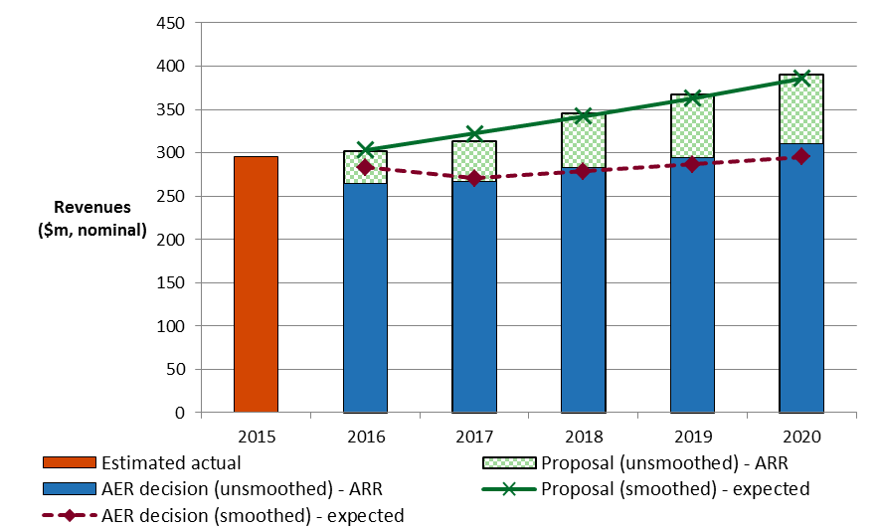

Source: CitiPower, Regulatory proposal, April 2015, Attachment CP 2016-20 PTRM.

AER analysis.

Table 1.1 AER's preliminary decision on CitiPower's revenues for the 2016–20 regulatory control period ($million, nominal)

|  |  |  |  |  |  |  |
| --- | --- | --- | --- | --- | --- | --- |
|  | 2016 | 2017 | 2018 | 2019 | 2020 | Total |
| Return on capital | 108.0 | 113.9 | 120.3 | 125.2 | 129.6 | 597.0 |
| Regulatory depreciation | 57.9 | 56.3 | 59.4 | 62.9 | 68.1 | 304.6 |
| Operating expenditurea | 81.4 | 84.9 | 89.1 | 93.1 | 97.2 | 445.8 |
| Revenue adjustmentsb | 1.4 | –2.9 | 1.0 | –1.5 | –0.1 | –2.2 |
| Net tax allowance | 15.8 | 14.3 | 13.5 | 14.3 | 14.9 | 72.8 |
| Annual revenue requirement (unsmoothed) | 264.5 | 266.5 | 283.3 | 293.9 | 309.7 | 1418.0 |
| **Annual expected revenue (smoothed)** | **282.9** | **270.4** | **278.4** | **286.6** | **295.1** | **1413.4** |
| X factorc | 6.75% | 6.75% | –0.45% | –0.45% | –0.45% | n/a |

Source: AER analysis.

(a) Operating expenditure includes debt raising costs.

(b) Revenue adjustments include efficiency benefit sharing scheme carry-overs, shared asset amounts, 2010   
S-factor scheme close out and demand management innovation allowance (DMIA).

(c) The X factor from 2017 to 2020 will be revised to reflect the annual return on debt update. Under the CPI–X framework, the X factor measures the real rate of change in annual expected revenue from one year to the next. A negative X factor represents a real increase in revenue. Conversely, a positive X factor represents a real decrease in revenue.

## CitiPower's proposal

1. CitiPower proposed a total revenue requirement of $1717.9 million ($ nominal) for the 2016–20 regulatory control period. Table 1.2 shows CitiPower's proposed building block costs, the ARR, expected revenue and X factor for each year of the 2016–20 regulatory control period.

Table 1.2 CitiPower's proposed revenues for the 2016–20 regulatory control period ($million, nominal)

|  |  |  |  |  |  |  |
| --- | --- | --- | --- | --- | --- | --- |
|  | 2016 | 2017 | 2018 | 2019 | 2020 | Total |
| Return on capital | 129.9 | 139.2 | 151.0 | 161.7 | 170.2 | 752.0 |
| Regulatory depreciation | 51.8 | 51.3 | 57.8 | 64.7 | 71.8 | 297.3 |
| Operating expenditurea | 95.9 | 99.9 | 111.0 | 116.9 | 119.9 | 543.5 |
| Revenue adjustmentsb | –2.1 | –2.1 | 0.8 | –2.0 | 0.0 | –5.5 |
| Net tax allowance | 25.9 | 25.5 | 25.4 | 25.6 | 28.2 | 130.6 |
| Annual revenue requirement (unsmoothed) | 301.4 | 313.7 | 345.9 | 366.8 | 390.1 | 1717.9 |
| **Annual expected revenue (smoothed)** | **303.3** | **322.07** | **342.01** | **363.19** | **385.67** | **1716.2** |
| X factor | 0.12% | –3.50% | –3.50% | –3.50% | –3.50% | n/a |

Source: CitiPower, Regulatory proposal, April 2015, p.252, table 13.9.

(a) Operating expenditure includes proposed forecast DMIA and debt raising costs.

(b) Revenue adjustments include efficiency benefit sharing scheme carry-overs and 2010 S-factor scheme close out.

## AER’s assessment approach

We are required to determine the ARR for CitiPower for each year of the 2016–20 regulatory control period.[1]

In this determination we first calculate ARRs for each year of the 2016–20 regulatory control period. To do this we consider the various costs facing the service provider and the trade-offs and interactions between these costs, service quality and across years. This reflects the AER's holistic assessment of the service provider's proposal.

The ARR for each year is the sum of the building block costs. These building block costs are set out in section 1.3.1. The AER's post-tax revenue model (PTRM) brings together these building block costs and calculates the resulting ARRs.

We understand the trade-offs that occur between building block costs and test the sensitivity of these costs to their various driver elements. These trade-offs are discussed in the interrelationships section of the various attachments to this preliminary decision and are reflected in the calculations made in the PTRM developed by the AER.[2] Such understanding allows the AER to exercise judgement in determining the final inputs into the PTRM and the ARRs that result from this modelling.

Having determined the total revenue requirement for the 2016–20 regulatory control period, the ARRs for each regulatory year are smoothed across the 2016–20 regulatory control period. This is to reduce revenue variations between years and to come up with the expected revenue for each year. This is done through the determination of the X factors.[3] The X factor must equalise (in net present value terms) the total expected revenues to be earned by the service provider with the total revenue requirement for the 2016–20 regulatory control period.[4] The X factor must usually minimise, as far as reasonably possible, the variance between the expected revenue and ARR for the last regulatory year of the period.[5]

1. For this preliminary decision, the expected revenue in the last year of the regulatory control period are not required to be as close as reasonably possible to the ARR for that year, due to the transitional provisions.[6] Typically, we would target a divergence of less than 3 per cent between the expected revenue and ARR for the last year of the regulatory control period, if this can promote smoother price changes over the regulatory control period. However, due to the expected true-up for 2016 over the remaining years of the 2016–20 regulatory control period for the substitute decision,[7] we have provided a gradual decrease in smoothed revenues over the first two regulatory years. We have also allowed the divergence in the final year revenues to exceed 3 per cent in this preliminary decision. This helps minimise the prospect of a significant price decrease followed by significant price increases over the 2016–20 regulatory control period. We will review the smoothing for the substitute decision if necessary.

The building block costs (and the elements that drive those costs) used to determine the unsmoothed ARR are set out below.

### The building block costs

1. The efficient costs to be recovered by a service provider can be thought of as being made up of various building block costs. Our preliminary decision assesses each of the building block costs and the elements that drive these costs. The building block costs are approved reflecting trade-offs and interactions between the cost elements, service quality and across years. Table 1.3 shows the building block costs that form the ARR for each year and where discussion on the elements that drive these costs can be found within this preliminary decision.

Table 1.3 Building block costs

|  |  |
| --- | --- |
| Building block costs | Attachments where elements are discussed |
| Return on capital | Regulatory asset base (attachment 2)  Capex (attachment 6)  Rate of return (attachment 3) |
| Regulatory depreciation (return of capital) | Regulatory asset base (attachment 2)  Capex (attachment 6)  Rate of return (attachment 3) |
| Operating expenditure (opex) | Opex (attachment 7) |
| Efficiency benefits/penalties | Efficiency benefit sharing scheme (attachment 9) |
| Estimated cost of corporate tax | Corporate income tax (attachment 8)  Value of imputation credits (attachment 4) |
| Adjustment for shared assets | Annual revenue requirement (attachment 1) |
| Demand management innovation allowance | Demand management incentive scheme (attachment 12) |

## Reasons for preliminary decision

For this preliminary decision, we determine a total revenue requirement of $1418.0 million ($ nominal) for CitiPower over the 2016–20 regulatory control period. This is $300.0 million ($ nominal) or 17.5 per cent below CitiPower's proposal. This reflects the impact of our preliminary decision on the various building block costs. Figure 1.2 shows the difference between CitiPower's proposed ARRs and our preliminary decision.

Figure 1.2 AER's preliminary decision and CitiPower's proposed annual revenue requirement ($million, nominal)

1. 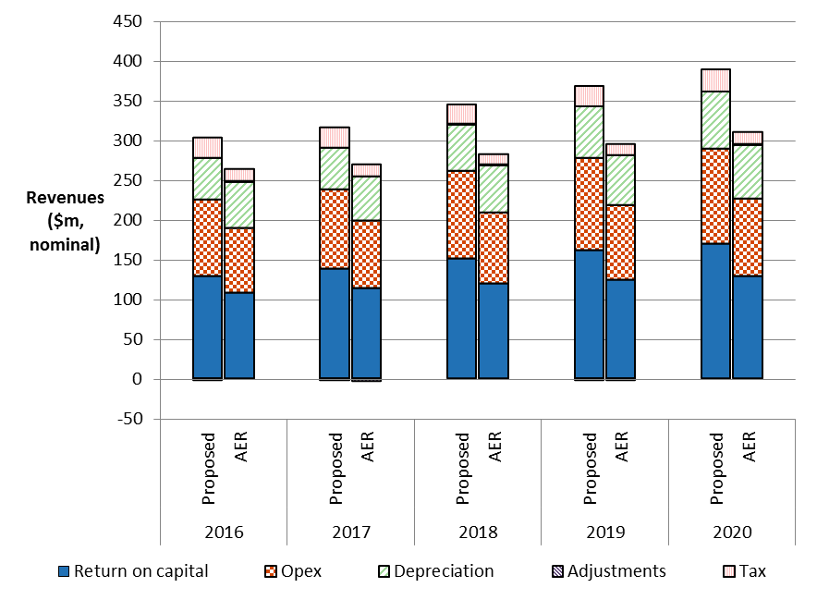

Source: CitiPower, Regulatory proposal, April 2015, p. 252, table 13.9.

AER analysis.

Note: Revenue adjustments include efficiency benefit sharing scheme carry-overs and 2010 S-factor scheme close out. Opex includes debt raising costs.

The most significant changes to CitiPower's proposal include:

* a reduction in the return on capital allowance of 20.6 per cent (attachments 2 and 3)
* a reduction in the capex allowance of 23.1 per cent (attachment 6)
* a reduction in the opex allowance of 18.0 per cent (attachment 7)
* a reduction in the cost of corporate income tax allowance of 44.2 per cent (attachment 8).

### Revenue smoothing

We have taken into account the building block costs determined in this decision, including the adjustment for shared assets, when smoothing the expected revenues for CitiPower over the 2016–20 regulatory control period. We consider that our profile of X factors is reasonable given the requirements of the transitional rules.[8] Due to the expected true-up for 2016 in the substitute decision,[9] we have provided a gradual decrease in expected revenues over the first two regulatory years. We have allowed the difference between smoothed and unsmoothed revenues in the last year of the 2016–20 regulatory control period to diverge more than would be usual. This approach smooths the revenues by allowing for a more gradual path for lower revenues over the 2016–20 regulatory control period.

1. In the present circumstances, based on the X factors we have determined for CitiPower, the difference between the expected revenue and ARR for 2020 is around 4.7 per cent. While we consider this divergence is larger than usual, it avoids the situation where cost changes for the substitute decision and the consequent true-up could result in a large price decrease in 2016 followed by significant price increases for the remaining four years of the regulatory control period. We will review this smoothing for the final decision if necessary.

### Shared assets

1. Service providers, such as CitiPower, may use assets to provide both the standard control services we regulate and other unregulated services. These assets are called 'shared assets'.[10] Of the unregulated revenues a service provider earns from shared assets, 10 per cent will be used to reduce the service provider's prices for standard control services.[11]
2. Shared asset revenue reductions are subject to a materiality threshold. Unregulated use of shared assets is material when a service provider's unregulated revenues from shared assets in a specific regulatory year are expected to be greater than 1 per cent of its total expected revenue for that regulatory year.[12]

CitiPower submitted that its shared asset unregulated revenues are forecast to be just less than 1 per cent of its total expected revenue in each regulatory year of the 2016–20 regulatory control period.[13] We consider CitiPower's 2016 forecast is reasonable, based on CitiPower's reporting of historical shared asset revenue and our assessment of this revenue source for other service providers.[14] However, although CitiPower stated that forecast unregulated revenues would be constant in real terms, it did not appear to index its forecast in line with inflation.[15]

Further, CitiPower's forecast unregulated revenues must now be compared to the regulated revenues we determine, rather than those proposed by CitiPower. Table 1.4 sets out our assessment of CitiPower's forecast shared asset revenues against our preliminary decision smoothed expected revenue (prior to the application of the shared asset revenue adjustment).[16]

1. Table 1.4 AER's preliminary decision on materiality of CitiPower's shared asset revenues for the 2016–20 regulatory control period ($million, nominal)

|  |  |  |  |  |  |  |
| --- | --- | --- | --- | --- | --- | --- |
|  | 2016 | 2017 | 2018 | 2019 | 2020 | Total |
| Forecast unregulated revenue from shared assets | 3.0 | 3.0 | 3.1 | 3.2 | 3.3 | 15.5 |
| Smoothed revenue (prior to shared asset reduction) | 283.1 | 270.7 | 278.7 | 287.0 | 295.5 | 1415.0 |
| Materiality percentage | 1.04% | 1.12% | 1.11% | 1.11% | 1.10% | n/a |
| **Greater than 1 per cent materiality threshold?** | **Yes** | **Yes** | **Yes** | **Yes** | **Yes** | **n/a** |

Source: AER analysis.

Note: The expected (smoothed) revenue in this table is prior to the application of the shared asset revenue reduction, so does not match the figures shown in table 1.1. The smoothing pattern was maintained (equal reductions in 2016 and 2017, then X factors of –0.45 from 2018 to 2020).

The combination of lower smoothed revenue and indexed unregulated shared asset revenue means that 1 per cent materiality threshold is met in every year of the   
2016–20 regulatory control period. Our preliminary decision is therefore to apply a shared asset revenue adjustment equal to 10 per cent of the forecast unregulated revenue, as shown in Table 1.5. The shared asset revenue adjustment is a total reduction of $1.6 million ($ nominal) across the 2016–20 regulatory control period.

1. Table 1.5 AER's preliminary decision on CitiPower's shared asset revenue adjustment ($million, nominal)

|  |  |  |  |  |  |  |
| --- | --- | --- | --- | --- | --- | --- |
|  | 2016 | 2017 | 2018 | 2019 | 2020 | Total |
| CitiPower proposed shared asset revenue adjustment | 0.0 | 0.0 | 0.0 | 0.0 | 0.0 | 0.0 |
| **AER preliminary decision shared asset revenue adjustment** | **–0.3** | **–0.3** | **–0.3** | **–0.3** | **–0.3** | **–1.6** |

Source: AER analysis.

### Indicative average distribution price impact

1. Our preliminary decision on CitiPower's expected revenues ultimately affects the prices consumers pay for electricity. There are several steps required in translating our revenue decision to a price impact.
2. We regulate CitiPower's standard control services under a revenue cap form of control. This means our preliminary decision on CitiPower's expected revenues do not directly translate to price impacts. This is because CitiPower's revenue is fixed under the revenue cap form of control, so changes in the consumption of electricity will affect the prices ultimately charged to consumers. We are not required to establish the distribution prices for CitiPower as part of this determination. However, we will assess CitiPower's annual pricing proposals before the commencement of each regulatory year within the 2016–20 regulatory control period. In each assessment we will administer the pricing requirements set in this distribution determination.
3. For this preliminary decision, we have estimated some indicative average distribution price impacts flowing from our determination on the expected revenues for CitiPower over the 2016–20 regulatory control period. In this section, our estimates only relate to standard control services (that is, the core electricity distribution charges), not alternative control services (such as metering, including advanced metering infrastructure (AMI) charges). These indicative price impacts assume that actual energy consumption across the 2016–20 regulatory control period matches CitiPower's forecast energy consumption, which we have adopted for this preliminary decision.
4. Figure 1.3 shows CitiPower's indicative price path based on the expected revenues established in our preliminary decision compared to its proposed revenue requirement. The indicative price path is estimated using the approved expected revenue and dividing by forecast energy consumption for each year of the 2016–20 regulatory control period. For presentational purposes, the prices are scaled so that the price index begins at 1.00 in 2015. The index provides a simple overall measure of the relative movement in expected distribution prices over the 2016–20 regulatory control period.

Figure .3 AER's preliminary decision and CitiPower's proposed indicative price path (nominal price index)



Source: AER analysis.

Notes: The nominal price index is constructed by dividing expected revenue for standard control services by forecast energy consumption for each year of the regulatory control period, then scaling relative to the base year (2015).

We estimate that our preliminary decision on CitiPower's annual expected revenue will result in a decrease to average distribution charges by about 2.0 per cent per annum over the 2016–20 regulatory control period in nominal terms.[17] This compares to the nominal average increase of approximately 3.3 per cent per annum proposed by CitiPower over the 2016–20 regulatory control period. These high-level estimates reflect the aggregate change across the entire network and do not reflect the particular tariff components for specific end users.

1. Table 1.6 displays the comparison of the revenue and price impacts of CitiPower's proposal and our preliminary decision.

Table .6 Comparison of revenue and price impacts of CitiPower's proposal and the AER's preliminary decision

|  |  |  |  |  |  |  |
| --- | --- | --- | --- | --- | --- | --- |
|  | 2015 | 2016 | 2017 | 2018 | 2019 | 2020 |
| **AER preliminary decision** |  |  |  |  |  |  |
| Revenue ($m, nominal) | 296.0 | 282.9 | 270.4 | 278.4 | 286.6 | 295.1 |
| Price path (nominal index)a | 1.00 | 0.93 | 0.86 | 0.87 | 0.89 | 0.90 |
| Revenue (change %) |  | –4.4% | –4.4% | 3.0% | 3.0% | 3.0% |
| Price path (change %) |  | –7.3% | –6.7% | 1.1% | 1.5% | 1.7% |
| **CitiPower proposal** |  |  |  |  |  |  |
| Revenue ($m, nominal) | 296.0 | 303.3 | 322.1 | 342.0 | 363.2 | 385.7 |
| Price path (nominal index)a | 1.00 | 0.99 | 1.03 | 1.07 | 1.12 | 1.18 |
| Revenue (change %) |  | 2.5% | 6.2% | 6.2% | 6.2% | 6.2% |
| Price path (change %) |  | –0.6% | 3.6% | 4.3% | 4.7% | 4.8% |

Source: AER analysis.

(a) The nominal index is constructed by dividing expected revenue for standard control services by forecast energy consumption for each year of the regulatory control period, then scaling relative to the base year (2015).

1. Distribution charges represent approximately 20.1 per cent on average of CitiPower's typical customer's annual electricity bill.[18] We expect that our preliminary decision, holding all other components of the bill (including metering components) constant, will reduce the average annual electricity bills for residential customers in CitiPower's network. This is because we estimate that our preliminary decision will result in lower distribution charges on average over the 2016–20 regulatory control period compared to CitiPower's proposal as discussed above. We estimate that based on the distribution charges from our preliminary decision passing through to customers, we would expect the average annual electricity bill for residential customers to reduce by $22 (1.5 per cent) and $19 (1.3 per cent) in 2016 and 2017, respectively ($ nominal). This would be followed by increases of about $4 or 0.3 per cent per annum from 2018 to 2020. By comparison, had we accepted CitiPower's proposal, the average annual electricity bill for residential customers would increase by approximately $11 or 0.7 per cent ($ nominal) per annum over the 2016–20 regulatory control period.
2. Our estimate of the potential impact our preliminary decision will have for CitiPower's residential customers is based on the typical annual electricity usage of around 4700 kWh per annum for a residential customer in Victoria.[19] Therefore customers with different usage will experience different changes in their bills. We also note that there are other factors, such as metering costs, transmission network costs, wholesale and retail costs, which affect electricity bills.

Similarly, for an average small business customer in Victoria that uses approximately 12000 kWh of electricity per annum,[20] our preliminary decision for CitiPower is expected to lead to lower average annual electricity bills. We estimate that based on the distribution charges from our preliminary decision passing through to customers, we would expect the average annual electricity bill for small business customers to reduce by $49 (1.5 per cent) and $42 (1.3 per cent) in 2016 and 2017, respectively ($ nominal). This would be followed by increases of about $8 or 0.3 per cent per annum from 2018 to 2020. By comparison, had we accepted CitiPower's proposal, the average annual electricity bill for small business customers would increase by approximately $24 or 0.7 per cent ($ nominal) per annum over the 2016–20 regulatory control period.

1. Table 1.7 shows the estimated annual average impact of our preliminary decision for the 2016–20 regulatory control period and CitiPower's proposal on the average residential and small business customers' annual electricity bills.

Table . Estimated impact of CitiPower's proposal and the AER's preliminary decision on annual electricity bills for the 2016–20 regulatory control period ($ nominal)

|  |  |  |  |  |  |  |
| --- | --- | --- | --- | --- | --- | --- |
|  | 2015 | 2016 | 2017 | 2018 | 2019 | 2020 |
| **AER preliminary decision** |  |  |  |  |  |  |
| Residential annual bill | 1524a | 1502 | 1483 | 1486 | 1490 | 1494 |
| Annual changec |  | –-22 (–1.5%) | –19 (–1.3%) | 3 (0.2%) | 4 (0.3%) | 5 (0.3%) |
| Small business annual bill | 3359b | 3310 | 3268 | 3274 | 3283 | 3293 |
| Annual changec |  | –49 (–1.5%) | –42 (–1.3%) | 6 (0.2%) | 9 (0.3%) | 10 (0.3%) |
| **CitiPower proposal** |  |  |  |  |  |  |
| Residential annual bill | 1524a | 1522 | 1533 | 1547 | 1562 | 1579 |
| Annual changec |  | –2 (–0.1%) | 11 (0.7%) | 13 (0.9%) | 15 (1.0%) | 17 (1.1%) |
| Small business annual bill | 3359b | 3355 | 3379 | 3409 | 3443 | 3480 |
| Annual changec |  | –4 (–0.1%) | 24 (0.7%) | 30 (0.9%) | 34 (1.0%) | 37 (1.1%) |

Source: AER analysis; ESC, Victorian Energy Retailers Comparative Performance Report - Pricing 2013-14, October 2014.

(a) Based on average of standing offers at June 2015 on Switch On comparison tool (postcode 3000) using annual bill with typical consumption of 4690 kWh per year.

(b) Based on average of standing offers at June 2015 on Switch On comparison tool (postcode 3000) using annual bill for typical small business consumption of 12020 kWh per year.

(c) Annual change amounts and percentages are indicative. They are derived by varying the distribution component of 2015 bill amounts in proportion to yearly expected revenue divided by forecast demand. Actual bill impacts will vary depending on electricity consumption and tariff class.

1. NER, cl. 6.3.2(a)(1).
2. There are trade-offs that are not modelled in the PTRM but are reflected in the inputs to the PTRM. For example, service quality is not explicitly modelled in the PTRM, but the trade-offs between service quality and price are reflected in the forecast capex and opex inputs to the model. Other trade-offs are obvious from the calculations in the PTRM. For example, while someone may expect a lower regulatory asset base to also lower revenues, the PTRM shows that this will not occur if the reduction in the regulatory asset base is due solely to an increase in the depreciation rate. In such circumstances, revenues increase as the increased depreciation allowance more than offsets the reduction in the return on capital caused by the lower regulatory asset base.
3. NER, cl. 6.5.9(a).
4. NER, cl. 6.5.9(3)(i). The X factors represent the real revenue path over the 2016–20 regulatory control period under the CPI–X framework.
5. NER, cl. 6.5.9(b)(2).
6. NER, cl. 11.60.3(b).
7. NER, cl. 11.60.4(d)(1).
8. NER, cl. 11.60.3(b).
9. NER, cl. 11.60.4(d)(1).
10. NER, cl. 6.4.4.
11. AER, Shared asset guideline, November 2013.
12. AER, Shared asset guideline, November 2013, p. 8.
13. The proposal values were between 0.95 per cent and 0.75 per cent, though these values do not appear to correctly account for inflation. CitiPower, Regulatory proposal 2016–20, April 2015, p. 250.
14. This includes consideration of this issue for the other Victorian electricity distribution networks, as well as work undertaken during the development of our shared asset guideline in 2013.
15. That is, it appears the shared asset revenue of $2.9m per annum in table 13.7 of CitiPower's regulatory proposal is expressed in $real 2015, but the smoothed revenue figures in this table are expressed in nominal terms.
16. We will reassess the materiality of the forecast shared asset unregulated revenues for our final decision.
17. This amount includes a forecast inflation rate of 2.50 per cent per annum. In real terms we estimate average distribution charges to decline by 4.4 per cent per annum, compared to an increase of 0.8 per cent proposed by CitiPower.
18. CitiPower, Regulatory proposal 2016–20, April 2015, p. 21
19. Based on ESC, Energy Retailers Comparative Performance Report - Pricing 2013-14 -Supplementary Report on Electricity Flexible Prices, December 2014, p. 3.
20. Based on ESC, Energy Retailers Comparative Performance Report - Pricing 2013-14, October 2014, p. 15.