We have made a preliminary decision for Energex, one of two electricity distributors in Queensland. Our preliminary decision allows Energex to recover $6528.1 million ($nominal) from its customers over five years commencing 1 July 2015.

Preliminary decision: Energex (distribution) 2015–20



Overview

The Australian Energy Regulator (AER) regulates the revenues of Energex by setting the annual revenue requirement it may recover from customers.

Our preliminary decision allows Energex to recover $$6528 million ($nominal) from its customers over five years commencing 1 July 2015. If we had accepted Energex’s proposal, it would have recovered $8432.4 million ($ nominal) over the 2015−20 regulatory control period. Our preliminary decision is 22.6 per cent less revenue than Energex’s proposal.

The figure below shows the difference between Energex’s proposed revenue, and what we have allowed for each year of this preliminary decision.

Energex's past total revenue, proposed total revenue and AER preliminary decision revenue allowance ($ million, 2014−15)



The revenue we determine affects the distribution component of a customer’s electricity bill. Distribution charges can make up to about 42 per cent of the bill for one of Energex’s typical residential customers.

Other components in customer bills include the cost of generation, transmission network charges and retailer costs. The AER does not set retail prices.

Within the figures presented in the chart above we have included a number of additional adjustments to the annual revenues to be recovered from electricity customers. These include the costs relating to the Queensland Government's Solar Bonus Scheme and under recoveries. The most significant of these is the Solar Bonus Scheme feed in tariffs (FiT). Neither Energex nor we are able to affect the amount of the costs to be recovered from network charges. However, we are able to smooth the impacts to avoid price fluctuations.

**Estimated price impact**

If the lower distribution charges from our preliminary decision are passed through to customers, we would expect average annual electricity bills for residential customers to reduce by $34 (or 1.8 per cent) in 2015-16, followed by reductions of $16 to $44 over the rest of the period covered by this decision.

For small business customers, we estimate reductions of $53 (or 1.8 per cent) in 2015-16, followed by reductions of $25 to $69 over the rest of the period.

These are only estimates, and are based on the data we have about how much energy customers in Qld use. There are a number of other factors that also affect a customer’s electricity bill, such as the wholesale price of electricity. You can read more about what makes up the energy prices on customers’ bills on our website: www.aer.gov.au/Consumers

**Key elements of our decision**

Our assessment of Energex’s proposed revenue is based on a number of components. These include expenditure to maintain and operate the network and the return to investors on their investment. Together, these determine the revenue Energex may recover from its customers.

Our preliminary decision is to accept Energex’s forecast operating expenditure (opex) and most of its proposed forecast capital expenditure (capex). The component of our preliminary decision that has had the greatest impact on the total revenue allowance is rate of return. It drives most of the revenue gap between our preliminary decision and Energex’s regulatory proposal. We discuss each of these issues below.

**Rate of return**

Significant investment is required to build a distribution network. The return Energex must pay lenders and investors is referred to as the rate of return. Even a small difference in the rate of return can have a big impact on revenues.

Our preliminary decision sets the allowed rate of return (or ‘cost of capital’) at 5.85 per cent for 2015−16. We have not accepted Energex’s proposal for a rate of return of 7.75 per cent.[1]

The investment environment has improved since our previous decision, which was made during the height of uncertainty surrounding the global financial crisis. This improved investment environment translates to lower financing costs necessary to attract efficient investment. We consider that Energex has sought a rate of return that is higher than necessary given the current investment environment.

In our final decision we did not accept the methodology proposed by Energex to set its rate of return. Instead, we have used our methodology developed with extensive consultation during our Better Regulation program in 2013. We consider that our approach provides for a rate of return that better reflects the allowed rate of return objective.

The lower rate of return in this preliminary decision will reduce Energex’s average revenue compared to the past.

Operating expenditure

Opex includes forecast operating, maintenance and other non-capital costs incurred in the provision of distribution network services.

It includes labour and other non-capital costs that Energex is likely to require during the 2015−20 regulatory control period for the efficient operation of its network.

Our preliminary decision is to accept Energex’s proposed opex forecast of $1738.2 million ($2014−15).

**In reaching our preliminary decision we have compared Energex’s opex proposal with our alternative estimate of total opex. While we have reached a different position on specific elements that make up the opex forecast, our preliminary decision is to accept Energex’s forecast of total opex. That is, overall, we are satisfied that Energex’s level of forecast opex reflects costs that a prudent operator—with efficient costs and a realistic expectation of demand and cost inputs—would need to operate its network safely and comply with its obligations and service standards.**

**AER preliminary decision compared to Energex's past and proposed opex ($million, 2014-15)**



**Capital expenditure**

Capex refers to the cost of building new facilities or replacing existing infrastructure. Factors that influence our required level of capex include the age and condition of existing assets.

We must be satisfied that the level of capex proposed by Energex reflects the capex criteria: the costs that a prudent operator—with efficient costs and a realistic expectation of demand and cost inputs—would need to operate its network safely and comply with its obligations and services standards.

We did not accept Energex’s proposed forecast capex of $3239.6 million ($2014−15). We have estimated total forecast capex of $2361.5 million ($2014−15) for Energex’s 2015−20 regulatory control period or 27 per cent lower than Energex’s proposal.

Energex’s forecast capex includes less expenditure on new assets to grow its network than in previous periods, because of slower demand growth. Notwithstanding this reduction, our capex estimate includes lower expenditure on asset replacement, augmentation (or upgrades) of the network and capitalised overheads like information, communications and technology services. We are satisfied that our estimate will allow Energex to comply with its regulatory obligations and requirements and maintain the safety and reliability of its distribution network.

**AER preliminary decision compared to Energex's past and proposed capex ($million, 2014-15)**

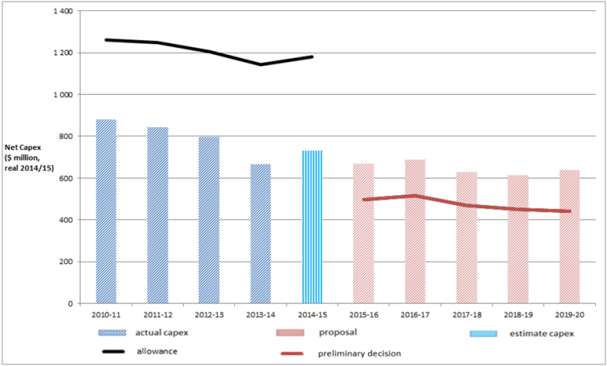

**More information about our consultation process**

Stakeholders may make written submissions on our preliminary decision by 3 July 2015. Energex may submit a revised proposal in response to our preliminary decision also by 3 July 2015. Stakeholders will then have until 24 July 2015 to make submissions on Energex’s revised proposal. Our final decision is due for release by 31 October 2015.

More information on Energex’s proposal, our preliminary decision, and how to make a submission can be found on our website: [www.aer.gov.au](http://www.aer.gov.au).

1. The rate of return that Energex included in its proposal is an indicative value. Its proposal included provision for the AER to adjust this value based on updated information that was not available when Energex submitted its regulatory proposal. More information on the rate of return can be found in our Rate of Return Fact Sheet.