We have made a preliminary decision for Ergon Energy, an electricity distribution network operator in Queensland. Our preliminary decision allows Ergon Energy to recover $6021.5 million ($nominal) from its customers over five years commencing 1 July 2015.

Preliminary decision:

Ergon Energy (distribution) 2015–20



Overview

The Australian Energy Regulator (AER) regulates the revenues of Ergon Energy by setting the annual revenue requirement it may recover from customers.

Our preliminary decision allows Ergon Energy to recover $6021.5 million ($nominal) from its customers over five years commencing 1 July 2015. If we had accepted Ergon Energy’s proposal, it would have recovered $8241.7 million ($ nominal) over the 2015−20 regulatory control period. Our preliminary decision is for 27 per cent less revenue than Ergon Energy’s proposal.

The figure below shows the difference between Ergon Energy’s proposed revenue, and what we have allowed for each year of the preliminary decision.

Ergon Energy's past and proposed total revenue and AER preliminary decision revenue allowance ($ million, 2014–15)

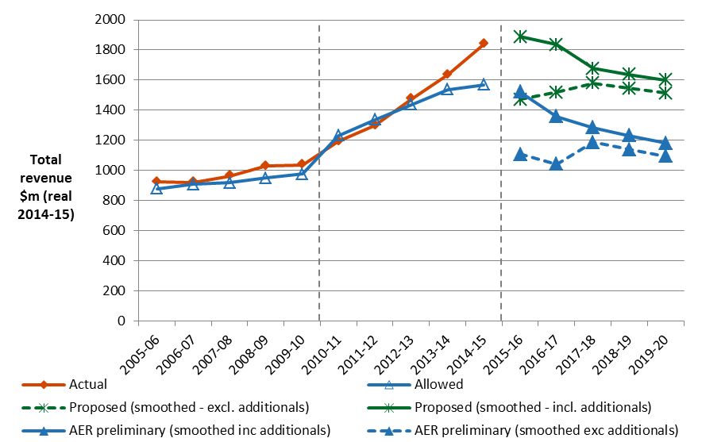

The revenue we determine affects the distribution component of a customer’s electricity bill. Distribution charges may make up to about 42 per cent of the bill for one of Ergon Energy’s typical residential customers. Other components in customer bills include the cost of generation, transmission, network charges and retailer costs. The AER does not set retail prices.

Within the figures presented in the chart above we have included a number of additional adjustments to the annual revenues to be recovered from electricity customers. These include the costs relating to the Queensland Government's Solar Bonus Scheme, capital contributions and under and over recoveries. The most significant of these is the Solar Bonus Scheme feed in tariffs (FiT). Neither Ergon Energy nor we are able to affect the amount of the costs to be recovered from network charges. However, we are able to smooth the impacts to avoid price fluctuations.

A further aspect of our decision for Ergon Energy’s small customers (less than 100 MWh) is that retail electricity prices are subsidised under the Queensland Government’s uniform tariff policy. In the absence of the uniform tariff policy, Ergon Energy’s networks charges would be expected to flow through to all of its customers.

**Estimated bill impact**

The Queensland Government uniform tariff policy means that the bill impact for customers in Ergon Energy area will instead reflect network charges of Energex. Based on our preliminary decision for Energex’s network charges, we would expect average annual electricity bills for residential customers in Ergon Energy’s distribution area to reduce by $34 (or 1.8 per cent) in 2015–16, followed by reductions of $16 to $44 in other years of the period covered by this decision. For small business customers, we estimate a reduction of $53 (or 1.8 per cent) in 2015–16, and followed by reductions of $25 to $69 in other years of the period.

These are only estimates, and are based on the data we have about how much energy customers in Qld use. There are a number of other factors that also affect a customer’s electricity bill, such as the wholesale price of electricity. You can read more about what makes up the energy prices on customers’ bills on our website: www.aer.gov.au/Consumers.

**Key elements of our decision**

Our assessment of Ergon Energy’s proposed revenue is based on a number of components. These include expenditure to maintain and operate the network and the return to shareholders on their investment. Together, these determine the revenue Ergon Energy may recover from its customers.

Two components of our preliminary decision drive most of the difference between Ergon Energy’s proposed revenue and our preliminary decision: rate of return and operating expenditure (opex).

We discuss each of these below.

**Rate of return**

Significant investment is required to build a distribution network. The return Ergon Energy must pay lenders and investors is referred to as the rate of return. Even a small difference in the rate of return can have a big impact on revenues.

Our preliminary decision sets the allowed rate of return (or ‘cost of capital’) at 5.85 per cent for 2015−16. We have not accepted Ergon Energy’s proposed 8.02 per cent.[1]

The investment environment has improved since our previous decision, which was made during the height of uncertainty surrounding the global financial crisis. This improved investment environment translates to lower financing costs necessary to attract efficient investment. We consider that Ergon Energy has sought a rate of return that is higher than necessary given the current investment environment.

In our final decision we did not accept the methodology proposed by Ergon Energy to set its rate of return. Instead, we have used our methodology developed with extensive consultation during our Better Regulation program in 2013. We consider that our approach provides for a rate of return that better reflects the allowed rate of return objective.

The lower rate of return in this decision will reduce Ergon Energy’s average annual requirements compared to the past.

Operating expenditure

Opex includes forecast operating, maintenance and other non-capital costs incurred in the provision of distribution network services.

It includes labour and other non-capital costs that Ergon Energy is likely to require during the 2015−20 regulatory control period for the efficient operation of its network.

Our preliminary decision allows Ergon Energy to recover $1629.9 million ($2014−15) for operating expenditure (opex). This is 10.5 per cent lower than the $1821.1 million Ergon Energy proposed for opex.

**AER preliminary decision compared to Ergon Energy's past and proposed opex ($million, 2014-15)**



**$ million 2013-14**

We must be satisfied that the level of opex proposed by Ergon Energy reflects the opex criteria: the costs that a prudent operator—with efficient costs and a realistic expectation of demand and cost inputs—would need to operate its network safely and comply with its obligations and service standards.

Our evidence, including from benchmarking and detailed review of Ergon Energy’s historical expenditure, shows its costs are above what a prudent and efficient operator would incur in delivering services to Ergon Energy’s customers.

We assessed that Ergon Energy’s distribution services could be provided at a substantially lower cost while still maintaining safety and complying with reliability obligations.

**Capital expenditure**

Capex refers to the cost of building new facilities or replacing existing infrastructure. Factors that influence our required level of capex include the age and condition of existing assets.

We must be satisfied that the level of capex proposed by Ergon Energy reflects the capex criteria: the costs that a prudent operator—with efficient costs and a realistic expectation of demand and cost inputs—would need to operate its network safely and comply with its obligations and service standards.

We have estimated total forecast capex of $2182.0 million ($2014−15) for Ergon Energy’s 2015−20 regulatory control period. This is 36 per cent lower than the $3397.0 million Ergon Energy proposed for capex.

The key difference between our substitute capex forecast and Ergon Energy’s proposal is lower expenditure on replacement capex, non-network capex, expansion of the network and information technology.

**AER preliminary decision compared to Ergon Energy's past and proposed capex ($million, 2014-15)**

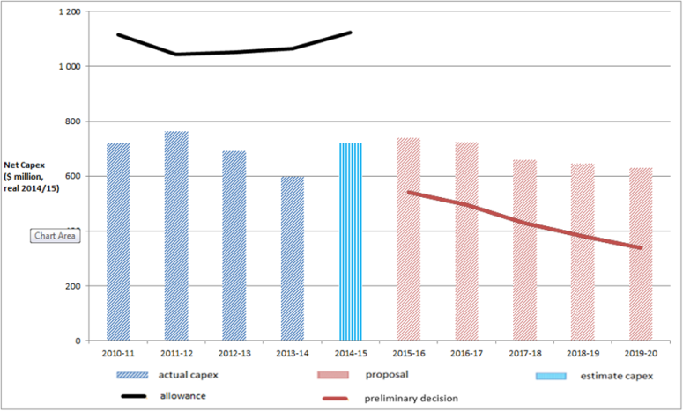

**More information about our consultation process**

Stakeholders may make written submissions on our preliminary decision by 3 July 2015. Ergon Energy may submit a revised proposal in response to our preliminary decision also by 3 July 2015. Stakeholders will then have until 24 July 2015 to make submissions on Ergon Energy’s revised proposal. Our final decision is due for release by 31 October 2015.

More information on Ergon Energy’s proposal, our preliminary decision and how to make a submission is on our website: [www.aer.gov.au](http://www.aer.gov.au).

1. The rate of return that Ergon Energy included in its proposal is an indicative value. Its proposal included provision for the AER to adjust this value based on updated information that was not available when Ergon Energy submitted its proposal. More information on the rate of return can be found in our Rate of Return Fact Sheet.