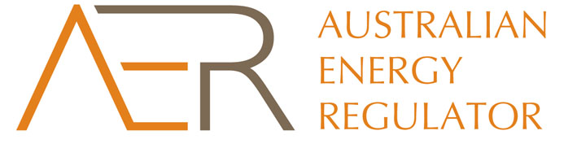

**STATEMENT OF REASONS**

**Aurora Energy’s Tasmanian electricity distribution network**

**Approval of 2014–15 pricing proposal**

The Australian Energy Regulator has approved Aurora Energy’s annual pricing proposal.

The annual pricing proposal outlines the network tariffs and alternative control service charges that will apply from 1 July 2014 to 30 June 2015.

We assessed the annual pricing proposal for compliance with the price control mechanisms set out in Aurora Energy’s 2012–17 distribution determination (distribution determination) and with section 6.18 of the National Electricity Rules (the rules). The average household *retail bill* increase is, all things equal, anticipated to be approximately 1.5 per cent as a consequence of this decision.

The reasons for approving Aurora Energy’s annual pricing proposal are that:

* We are satisfied that the proposed network tariffs have been calculated using the approved revenue requirement (as per the revenue cap formula in section 1.11 of the distribution determination) and based on reasonable quantity forecasts. Furthermore, the proposed network tariffs comply with the relevant pricing principles and side constraints set out in the distribution pricing rules.
* Aurora Energy has correctly applied the approved price control mechanism to calculate the alternative control service price caps in accordance with section 1.12 of the distribution determination. The approved price control mechanism involves escalating current prices by the change in the March quarter CPI on a year on year basis multiplied by an approved X factor.

The approved 2014–15 network tariffs and alternative control service charges can be found in the following documents found on our website:

* Network tariffs – *Network Tariff Approved Price Guide*
* Alternative control service price caps
  + *Metering Services Approved Price Guide*
  + *Public Lighting Tariff Approved Price Guide*
  + *Fee-based Services Approved Price Guide*
  + *Quoted Services Approved Price Guide*