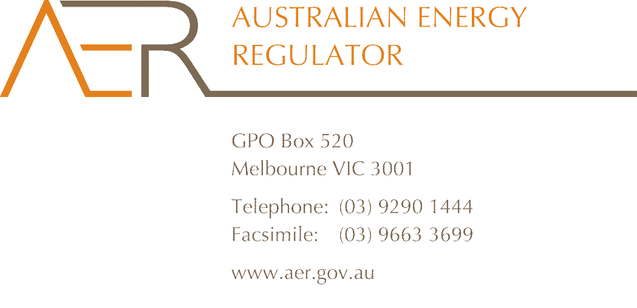

Our Ref: 53717

Your Ref: RRC0001

Contact Officer: Kylie Finnin

Contact Phone: (03) 9658 6445

2 September 2014

Mr John Pierce

Chairman

Australian Energy Market Commission

PO Box A2449

SYDNEY SOUTH NSW 1235

Dear Mr Pierce

**Submission on Draft Rule Determination: National Energy Retail Amendment (Retailer price variations in market retail contracts) Rule 2014**

The Australian Energy Regulator (AER) welcomes the opportunity to provide this submission to the Australian Energy Market Commission’s (AEMC) draft rule determination regarding retailer price variations in market retail contracts.

The AEMC’s draft rule was made in response to a rule change request submitted jointly by the Consumer Action Law Centre (CALC) and the Consumer Utilities Advocacy Centre (CUAC). The rule proposed by CALC/CUAC sought to prohibit energy retailers from varying prices during fixed term or fixed benefit period market retail contracts. CALC and CUAC considered that their proposed rule would result in greater clarity and certainty for customers leading to improved confidence. They also argued that retailers are better placed than customers to manage the risk of changes in costs.

In our submission to the AEMC’s February consultation paper, we emphasised our support for initiatives that build consumer confidence and engagement in energy markets. However, we detailed our concern that prohibiting fixed term, variable price contracts would likely result in reduced choice and higher prices for customers, and that this may not be in the long term interests of consumers. On this basis we did not support the CALC/CUAC proposal and suggested other strategies, such as improving consumer education and the transparency of information in this area, which may more effectively address this issue.

In its draft determination, the AEMC did not make the rule proposed by CALC/CUAC, instead proposing a more preferable rule aimed at improving information disclosure to consumers. The AEMC considered that the key issue raised by the rule change request was that some consumers may be entering contracts unaware that prices may vary. Accordingly, the AEMC’s draft rule is targeted towards enhancing consumer engagement by better informing consumers of key aspects of their market retail contracts at the point of contract entry.

We agree with the AEMC’s discussion of the key issues raised by the rule change request, and support the proposed rule as going some way to address the concerns raised. We also note the findings of the Newgate research—that informed the AEMC’s consideration—indicate consumers have varying appetites for risk, and value having a choice of different retail energy contracts, including both variable and fixed price contracts.

The AEMC’s draft determination also notes that improvements to the AER’s Retail Pricing Information Guideline and Energy Made Easy website could be made to improve consumer understanding of how prices may change and the options available to them. We agree that these improvements could work alongside the draft rule to further support informed decision making by energy consumers and have started considering possible forms these improvements could take.

***Strengthening consumer confidence in retail markets***

As the national energy regulator, we recognise the importance of promoting effective competition in energy markets. We believe that effective competition provides incentives for energy retailers to operate efficiently and to deliver innovation, choice and prices that benefit energy customers. We also recognise that a truly competitive retail energy market relies on confident consumers exercising informed choice. Consumers must be equipped with the tools they need to understand and actively participate in the market, and there must be adequate safeguards in place to promote consumer confidence and awareness.

The National Energy Retail Law (Retail Law) and Rules provide the framework that supports consumer participation in the retail energy market. It contains a number of measures designed to help consumers compare and make informed choices about energy contracts and how they use energy. Under the Retail Law, the AER operates Energy Made Easy ([www.energymadeeasy.gov.au](http://www.energymadeeasy.gov.au)), an energy price comparison website which allows consumers to [compare generally available offers](http://www.energymadeeasy.gov.au/compare-offers) and key details of those offers, such as discounts, incentives, fees, price changes, and other key terms and conditions.

We also have a role in prescribing how retailers present their pricing information to customers, via the Retail Pricing Information Guideline (Guideline). Among other things, the Guideline requires retailers to use a standardised energy price fact sheet to communicate prices and other key product information when they market or advertise pricing information to consumers. Retailers must publish energy price fact sheets on their websites for all generally available standing and market offers, and include them on Energy Made Easy.

In addition to these roles, we promote compliance with the Retail Law and Rules including provisions relating to energy marketing and explicit informed consent. The energy marketing rules contain a number of specific requirements around disclosure to customers before, or as soon as practicable after, formation of a market retail contract. The explicit informed consent provisions require certain matters to be disclosed to customers at the point of entry into a market retail contract. These measures are designed to ensure customers are adequately informed of all relevant matters when making choices about energy contracts or their energy provider.

The AEMC’s draft rule builds on these existing protections, and seeks to address some of the information gaps regarding retailer price variations in market retail contracts identified as part of the proposed rule change. Specifically, the draft determination seeks to amend the Retail Rules to:

* include a new rule that specifically requires retailers to disclose to customers information regarding price variations as part of the existing requirement to obtain a customer’s explicit informed consent; and
* amend the energy marketing rules to clarify that retailers are required to provide information about when they will notify customers of variations to prices, charges and benefits in market retail contracts, as part of existing disclosure requirements.

We consider the draft rule will help to promote transparency and assist customer engagement in retail markets, while also preserving customer choice and not limiting the types of contracts retailers can offer.

***Marketing of market retail contracts***

The AEMC’s draft determination considers the AER’s role in regulating information provided to consumers regarding market retail contracts, including via the Guideline, energy price fact sheets and the Energy Made Easy website. The AEMC also discusses our broader role in overseeing retailer compliance with the Retail Law and Rules.

The AER is currently redeveloping the Energy Made Easy website to improve clarity of information and ease of use. In particular, the improved website will include simplified searching, offer results display and filtering functionality, which will assist in making the website clearer and more accessible to consumers. It is anticipated that the new website will be launched later this year.

In our submission to the AEMC’s consultation paper, we offered to consult on possible changes to the Guideline to give effect to changes to energy price fact sheets and Energy Made Easy, which could clarify and improve information available to customers.

The AEMC supported this proposed initiative, and noted that potential amendments could assist in improving the clarity, quality, accessibility and prioritisation of information, particularly with respect to price variations. This was further supported by the findings of the AEMC’s consumer research, which indicated that consumers would like better information about energy contract options, and for it to be easier for them to compare energy offers.

We have been considering the issues raised as part of this rule change request and possible ways to improve information disclosure to assist customers to shop around, compare offers and access and understand key information when they are signing up to a contract. Without pre‑empting the outcomes of any public consultation process, a review of the Guideline could look to consider:

* limiting use of the term ‘fixed’ both in disclosure documents and on Energy Made Easy so that it could only be used to describe offers that have a fixed price for the term of the contract. Newgate’s research found that a significant minority of customers (21 per cent of residential and 15 per cent of business customers) were unsure of what elements of energy contracts were fixed. Providing additional clarification on the term ‘fixed’ could help to reduce customer confusion;
* prioritising information included in energy price fact sheets so that key details are displayed more clearly and prominently (including, for example information regarding price variations). Behavioural economics suggests that using language on energy price fact sheets that is direct, immediate and personal may assist customers in their decision making.[1] Our consultation on the Guideline could seek views on the value of including the following statements (for example) at the top of energy price fact sheets:
  + *Your price under this contract will not change before…*
  + *We will tell you about price changes by…*
  + *If you leave this contract early, we will charge you an exit fee of…*

Requiring retailers to provide clearer and more prominent information on price variations as part of their marketing and advertising may further reduce customer confusion and raise awareness around these aspects of energy contracts;

* further standardising the format and layout of energy price fact sheets so that information appears in the same location and is described consistently without referring customers to the terms and conditions of contracts. This will improve comparability across energy offers so customers can more easily compare ‘apples with apples’;
* making further changes to Energy Made Easy to allow consumers to filter offers based on whether or not prices under market retail contracts can vary. This may assist in raising awareness among customers of the availability of fixed price offers; and
* requiring energy offer information to be presented more clearly and simply for customers.

The AER is required to consult on proposed amendments to the Guideline in accordance with procedures specified under the Retail Law. Should the AEMC make its draft rule following the conclusion of its consultation process, and if there is support for the AER to undertake a review of the Guideline, the AER anticipates that it could commence consultation in early 2015. This would allow stakeholders the opportunity to comment on proposed changes.

Lastly, the AER will continue to monitor compliance by retailers with the requirements of the Retail Law and Retail Rules. This could involve more targeted reviews of compliance with disclosure requirements relating to market retail contracts, and the explicit informed consent provisions of the Retail Law. We note that requirements relating to explicit informed consent are an area of focus for the AER, given the extent to which non-compliance with these provisions can impact on consumer confidence and participation in the energy retail market. If the AEMC’s draft rule is implemented, the AER could undertake more focused activity to assess businesses compliance with these requirements once they take effect.

We also note the AEMC’s discussion regarding retailers who provide their customers with advance notice of price changes under market retail contracts. While retailers are not obliged to provide advance notice under the Retail Rules,[2] we consider this approach reflects good practice, good customer service and is likely to help promote customer confidence in energy retailers and the market. Advance notification provides customers with the opportunity to switch to another offer or to moderate their energy consumption in response to a price variation before it takes effect, should they wish. We encourage this practice among retailers and support the AEMC’s draft rule which will require retailers to disclose information regarding when a consumer will be notified of a price variation before or shortly after contract entry. This draft rule is a useful starting point and there may be further actions and options worth exploring, as part of these consultation processes, to further assist customers.

Building consumer confidence in energy markets is a strategic priority for the AER, as outlined in our Statement of Intent,[3] and will be an on-going point of focus for our work over the coming period. The issues arising from consideration of this rule change request go to the heart of consumer confidence in the retail energy market and we welcome discussion of issues brought to light by CALC, CUAC and other stakeholders, as part of the consultation on this proposed Retail Rule change. If you would like to discuss any aspect of this submission please contact Sarah Proudfoot, General Manager, Retail Markets Branch, on (03) 9290 6965.

Yours sincerely

Andrew Reeves

Acting Chair

1. Presentation by Dr Paul Harrison, Senior Lecturer and Chair of Consumer Behaviour, Deakin University, AEMC public forum on Retailer price variations in market retail contracts, 19 May 2014.
2. Notice of a variation to tariffs and charges must be given as soon as practicable, and in any event no later than the customer’s next bill; r. 46(3)–(4), National Energy Retail Rules.
3. AER Statement of Intent 2014–15, <http://www.aer.gov.au/node/26301>.