

FINAL DECISION

TasNetworks distribution determination

2017−18 to 2018−19

Attachment 17 – Negotiated services framework and criteria

April 2017

© Commonwealth of Australia 2017

This work is copyright. In addition to any use permitted under the Copyright Act 1968, all material contained within this work is provided under a Creative Commons Attributions 3.0 Australia licence, with the exception of:

* the Commonwealth Coat of Arms
* the ACCC and AER logos
* any illustration, diagram, photograph or graphic over which the Australian Competition and Consumer Commission does not hold copyright, but which may be part of or contained within this publication. The details of the relevant licence conditions are available on the Creative Commons website, as is the full legal code for the CC BY 3.0 AU licence.

Requests and inquiries concerning reproduction and rights should be addressed to the:

Director, Corporate Communications  
Australian Competition and Consumer Commission   
GPO Box 4141, Canberra ACT 2601

or publishing.unit@accc.gov.au.

Inquiries about this publication should be addressed to:

Australian Energy Regulator  
GPO Box 520  
Melbourne Vic 3001

Tel: 1300 585 165

Email: [AERInquiry@aer.gov.au](mailto:AERInquiry@aer.gov.au)

1. Note
2. This attachment forms part of the AER's final decision on TasNetworks' distribution determination for 2017–19. It should be read with all other parts of the final decision.

This final decision consists of an Overview and 8 attachments. As many issues were settled at the draft decision stage or required only minor updates we have not prepared final decision attachments for:

* Regulatory asset base
* Regulatory depreciation
* Capital expenditure
* Operating expenditure
* Corporate income tax
* Capital expenditure sharing scheme
* Service target performance incentive scheme
* Demand management incentive scheme
* Classification of services
* Pass through events
* Connection policy.

1. The AER's final decision on these matters is set out in the Overview. For ease of reference the remaining attachments have been numbered consistently with the attachment numbering in our draft decision.
2. The final decision therefore includes the following documents:
3. Overview
4. Attachment 1 – Annual revenue requirement
5. Attachment 3 – Rate of return
6. Attachment 4 – Value of imputation credits
7. Attachment 9 – Efficiency benefit sharing scheme
8. Attachment 14 – Control mechanisms
9. Attachment 16 – Alternative control services
10. Attachment 17 – Negotiated services framework and criteria
11. Attachment 19 – Tariff structure statement

1. Contents

Note 17-2

Contents 17-3

Shortened forms 17-4

17 Negotiated services framework and criteria 17-6

17.1 Final decision 17-6

17.2 TasNetworks' revised proposal 17-7

17.3 Assessment approach 17-7

17.4 Reasons for final decision 17-7

A TasNetworks' negotiating framework 17-10

1. Shortened forms

| Shortened form | Extended form |
| --- | --- |
| AEMC | Australian Energy Market Commission |
| AEMO | Australian Energy Market Operator |
| AER | Australian Energy Regulator |
| augex | augmentation expenditure |
| capex | capital expenditure |
| CCP | Consumer Challenge Panel |
| CESS | capital expenditure sharing scheme |
| CPI | consumer price index |
| DRP | debt risk premium |
| DMIA | demand management innovation allowance |
| DMIS | demand management incentive scheme |
| distributor | distribution network service provider |
| DUoS | distribution use of system |
| EBSS | efficiency benefit sharing scheme |
| ERP | equity risk premium |
| Expenditure Assessment Guideline | Expenditure Forecast Assessment Guideline for Electricity Distribution |
| F&A | framework and approach |
| MRP | market risk premium |
| NEL | national electricity law |
| NEM | national electricity market |
| NEO | national electricity objective |
| NER | national electricity rules |
| NSP | network service provider |
| opex | operating expenditure |
| PPI | partial performance indicators |
| PTRM | post-tax revenue model |
| RAB | regulatory asset base |
| RBA | Reserve Bank of Australia |
| repex | replacement expenditure |
| RFM | roll forward model |
| RIN | regulatory information notice |
| RPP | revenue and pricing principles |
| SAIDI | system average interruption duration index |
| SAIFI | system average interruption frequency index |
| SLCAPM | Sharpe-Lintner capital asset pricing model |
| STPIS | service target performance incentive scheme |
| WACC | weighted average cost of capital |

# Negotiated services framework and criteria

Our distribution determination imposes control over revenues that a distributor can recover from its provision of direct control services. But we do not determine the terms and conditions of negotiated distribution services. Under the National Electricity Rules (NER), negotiated services are provided under an agreement or as a result of a determination of a commercial arbitrator. These processes are facilitated by:

* a negotiating framework
* negotiated distribution service criteria (NDSC).

A distributor must prepare a negotiating framework that sets out procedures for negotiating the terms and conditions of access to a negotiated distribution service. The NDSC, which we develop in consultation with stakeholders, set out criteria that a distributor must apply in negotiating those terms and conditions, including the prices and access charges for negotiated distribution services. They also contain the criteria that a commercial arbitrator must apply to resolve disputes about such terms and conditions and/or access charges.

This attachment sets out our final decision on TasNetworks negotiating framework for the 2017−18 to 2018−19 regulatory control period.[1] We also specify the negotiated distribution service criteria (NDSC) that are to apply to TasNetworks.[2]

## Final decision

Negotiating framework

Our final decision is to accept TasNetworks' proposed negotiating framework for the 2017−18 to 2018−19 regulatory control period as set out in appendix A.[3] We accepted the same negotiating framework in our draft decision.[4]

Negotiated distribution services criteria

Our final decision is to retain the NDSC that we previously developed and published for TasNetworks in February 2016 for the 2017−18 to 2018−19 regulatory control period.[5] The NDSC give effect to the negotiated distribution service principles.[6]

## TasNetworks' revised proposal

TasNetworks submitted its proposed negotiating framework on 29 February 2016. TasNetworks noted its proposed negotiating framework does not materially depart from its current negotiating framework.[7] We accepted TasNetworks' proposed negotiating framework in our draft decision.[8] Hence TasNetworks did not alter its proposed negotiating framework in its revised regulatory proposal.

## Assessment approach

Negotiating framework

To be approved, a proposed negotiating framework must specify the requirements set out in clause 6.7.5(c) of the NER and not inconsistent with any of the requirements set out in clause 6.7.5(d) of the NER. We examined whether TasNetworks' proposed negotiating framework has met these requirements.

Negotiated distribution services criteria

We consider NDSC that reflects the negotiated distribution service principles would satisfy the NER. Therefore we assessed whether our proposed NDSC reflect the negotiated distribution service principles in clause 6.7.1 of the NER.

## Reasons for final decision

Negotiating framework

Our final decision maintains our draft decision consideration to accept TasNetworks' proposed negotiating framework because it specifies the matters that are set out as minimum requirements in the NER.[9] Our assessment of TasNetworks' negotiating framework was set out in table 17.1 in attachment 17 of our draft decision.

Negotiated distribution services criteria

In February 2016 we published an invitation for submissions on our proposed NDSC for TasNetworks.[10] We did not receive any submissions in response to our proposed NDSC. The NDSC we have decided to apply to TasNetworks for the 2017–19 regulatory control period has the following components:

National Electricity Objective

* 1. The terms and conditions of access for a negotiated distribution service, including the price that is to be charged for the provision of that service and any access charges, should promote the achievement of the national electricity objective.

Criteria for terms and conditions of access

Terms and Conditions of Access

* 1. The terms and conditions of access for a negotiated distribution service must be fair and reasonable and consistent with the safe and reliable operation of the power system in accordance with the NER.
  2. The terms and conditions of access for a negotiated distribution service (including in particular, any exclusions and limitations of liability and indemnities) must not be unreasonably onerous taking into account the allocation of risk between a distributor and any other party, the price for the negotiated distribution service and the costs to a distributor of providing the negotiated distribution service.
  3. The terms and conditions of access for a negotiated distribution service must take into account the need for the service to be provided in a manner that does not adversely affect the safe and reliable operation of the power system in accordance with the NER.

Price of Services

* 1. The price for a negotiated distribution service must reflect the costs that a distributor has incurred or incurs in providing that service, and must be determined in accordance with the principles and policies set out in the relevant Cost Allocation Method.
  2. Subject to criteria 7 and 8, the price for a negotiated distribution service must be at least equal to the cost that would be avoided by not providing that service but no more than the cost of providing it on a stand-alone basis.
  3. If a negotiated distribution service is a shared distribution service that:
     + 1. exceeds any network performance requirements which it is required to meet under any relevant electricity legislation: or
       2. exceeds the network performance requirements set out in schedule 5.1a and 5.1 of the NER,

then the difference between the price for that service and the price for the shared distribution service which meets network performance requirements must reflect a distributor’s incremental cost of providing that service (as appropriate).

* 1. If a negotiated distribution service is the provision of a shared distribution service that does not meet or exceed the network performance requirements, the difference between the price for that service and the price for the shared distribution service which meets, but does not exceed, the network performance requirements should reflect the cost a distributor would avoid by not providing that service (as appropriate).
  2. The price for a negotiated distribution service must be the same for all Distribution Network Users unless there is a material difference in the costs of providing the negotiated distribution service to different Distribution Network Users or classes of Distribution Network Users.
  3. The price for a negotiated distribution service must be subject to adjustment over time to the extent that the assets used to provide that service are subsequently used to provide services to another person, in which case such adjustment must reflect the extent to which the costs of that asset are being recovered through charges to that other person.
  4. The price for a negotiated distribution service must be such as to enable a DNSP to recover the efficient costs of complying with all regulatory obligations or requirements associated with the provision of the negotiated service.

Access Charges

* 1. Any charges must be based on costs reasonably incurred by a distributor in providing distribution network user access, and, in the case of compensation referred to in clauses 5.5(f)(4)(ii) and (iii) of the NER, on the revenue that is likely to be foregone and the costs that are likely to be incurred by a person referred to in those provisions where an event referred to in those provisions occurs (as appropriate).
  2. Any charges must be based on costs reasonably incurred by a distributor in providing network user access to services deemed to be negotiated distribution services by clause 6.24.2(c) of the NER, and, in the case of compensation referred to in clauses 5.4A(h) to (j) of the NER, on the revenue that is likely to be foregone and the costs that are likely to be incurred by a person referred to in those provisions where an event referred to in those provisions occurs (as appropriate).

1. TasNetworks' negotiating framework

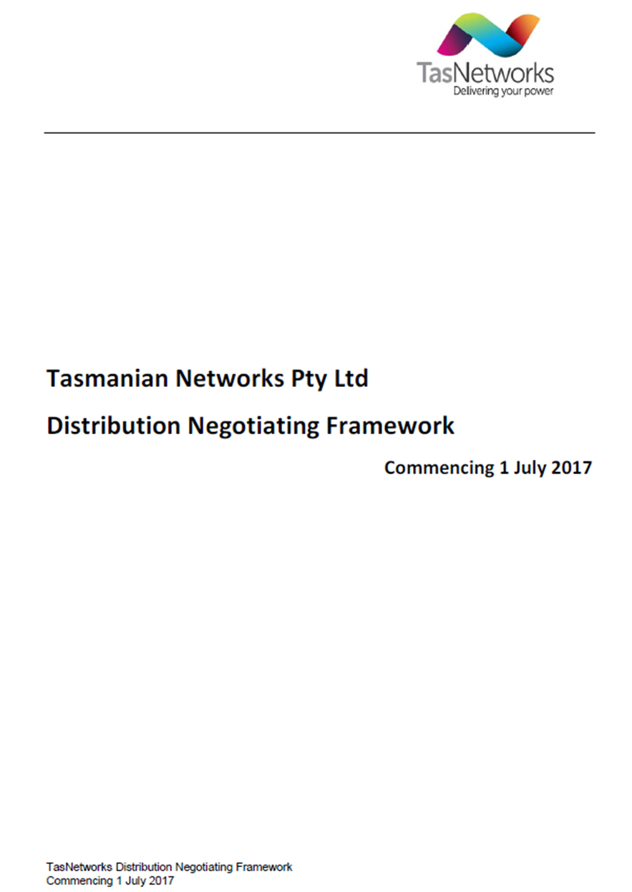

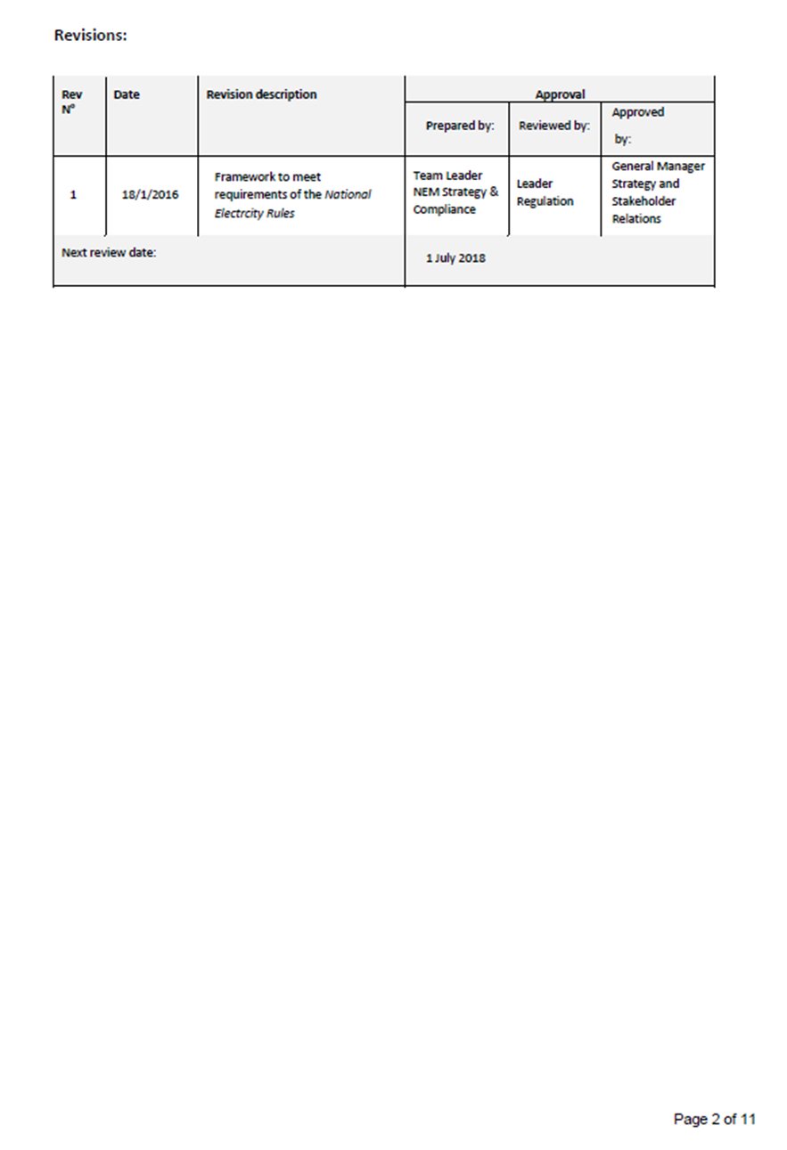

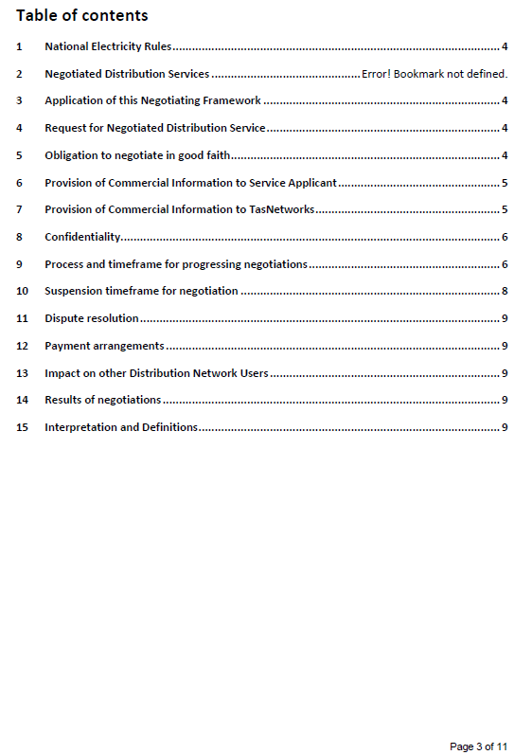

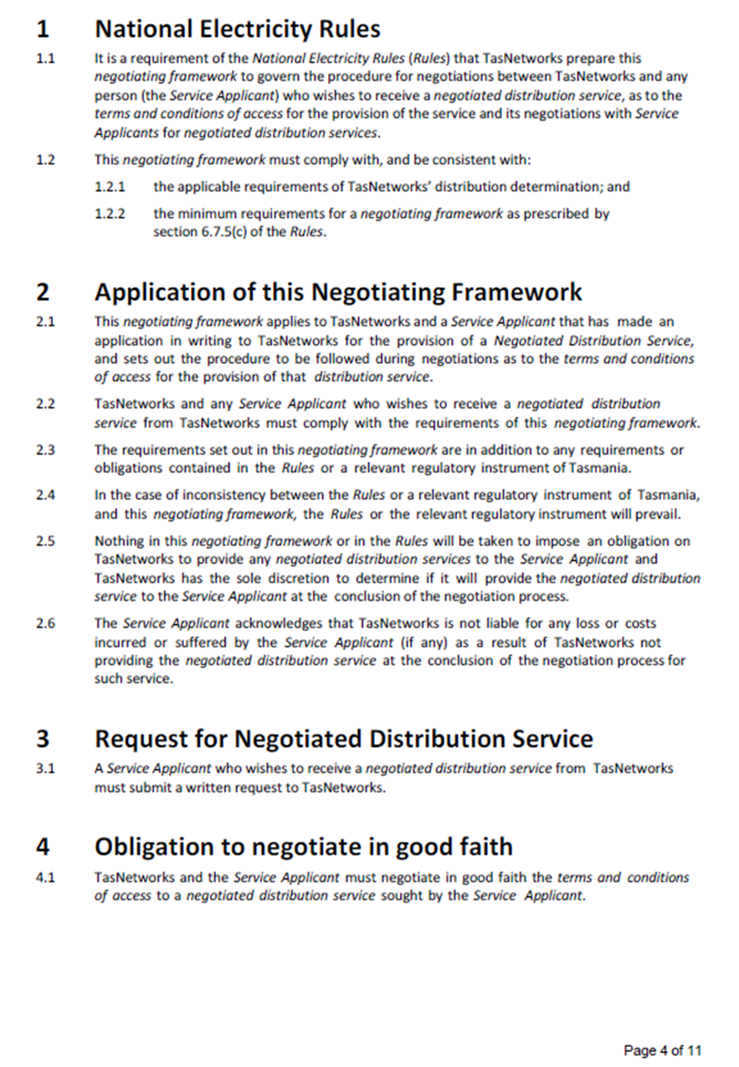

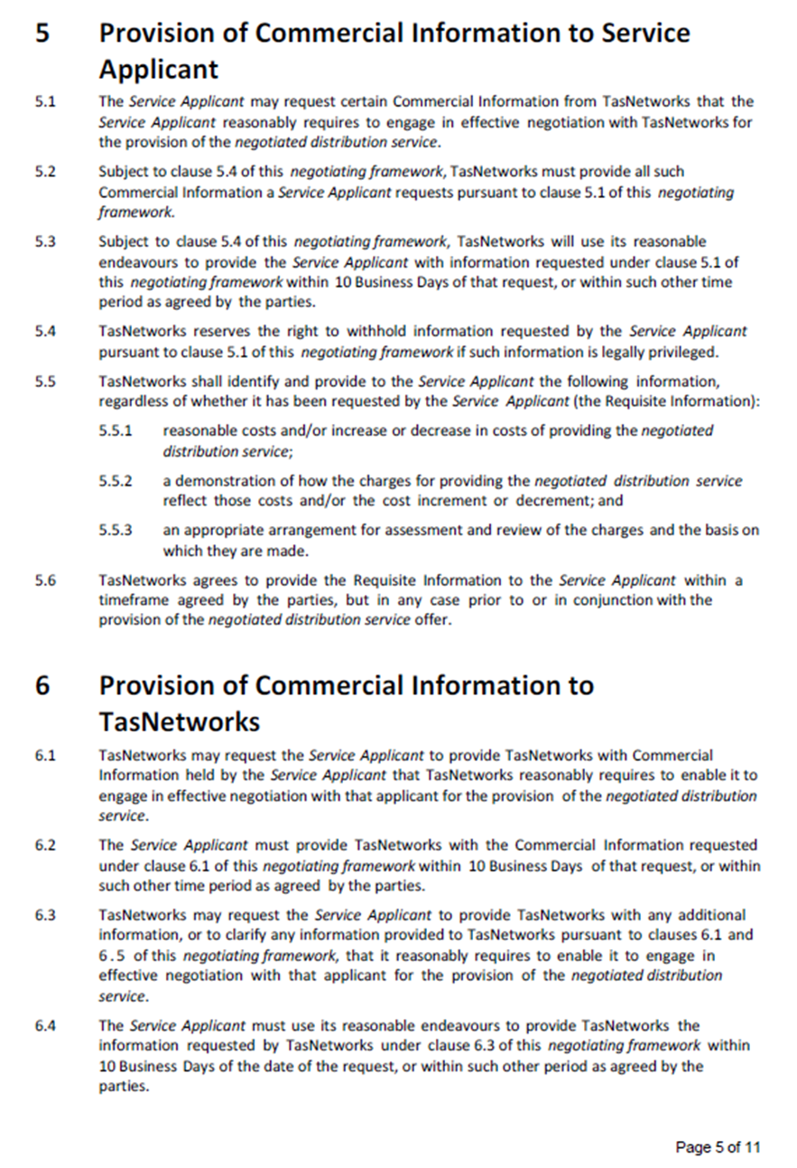

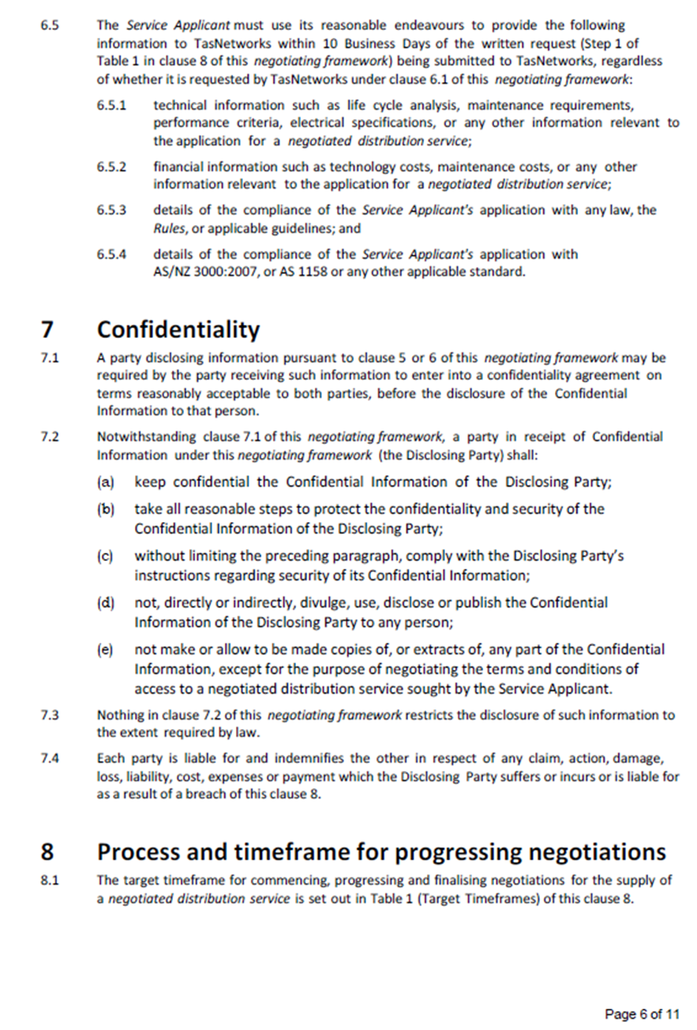

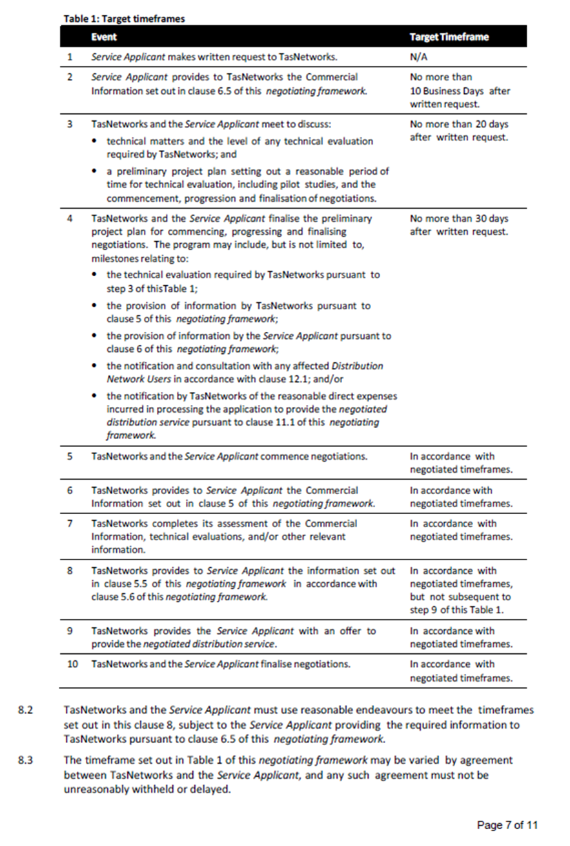

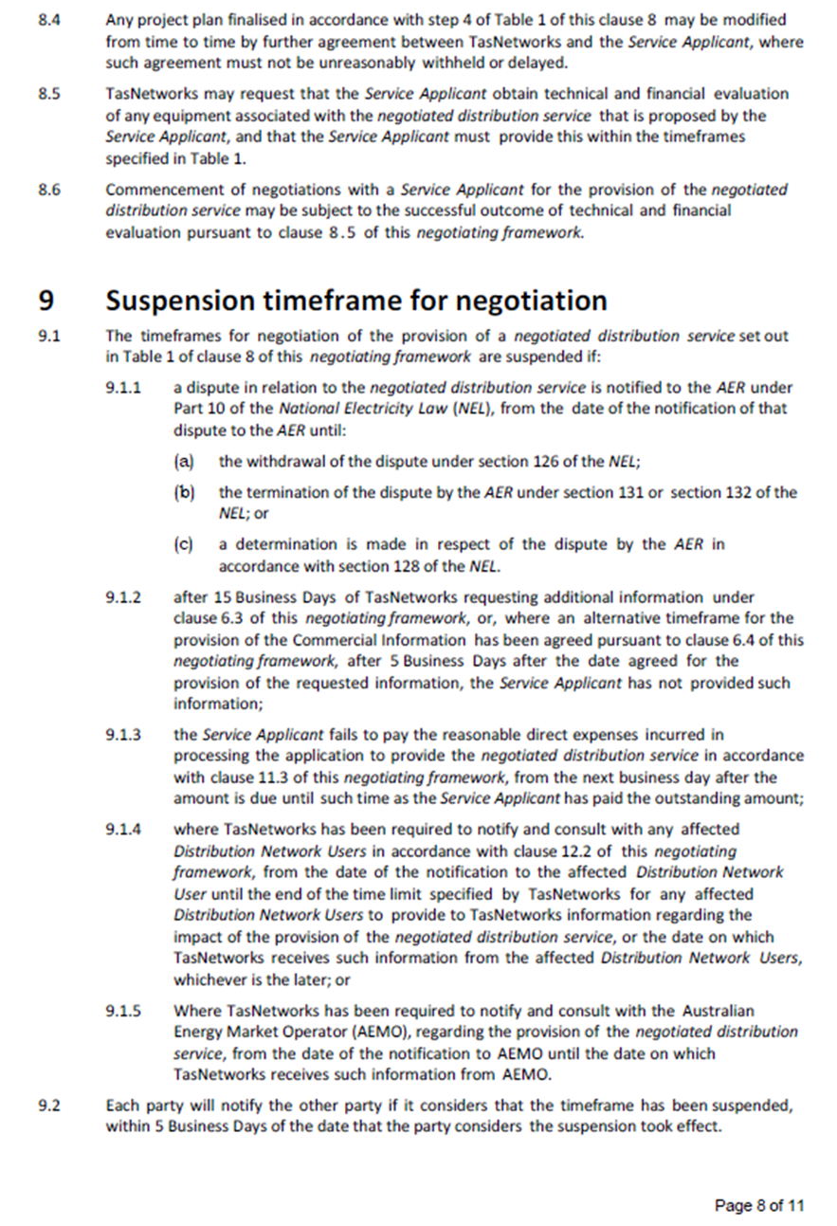

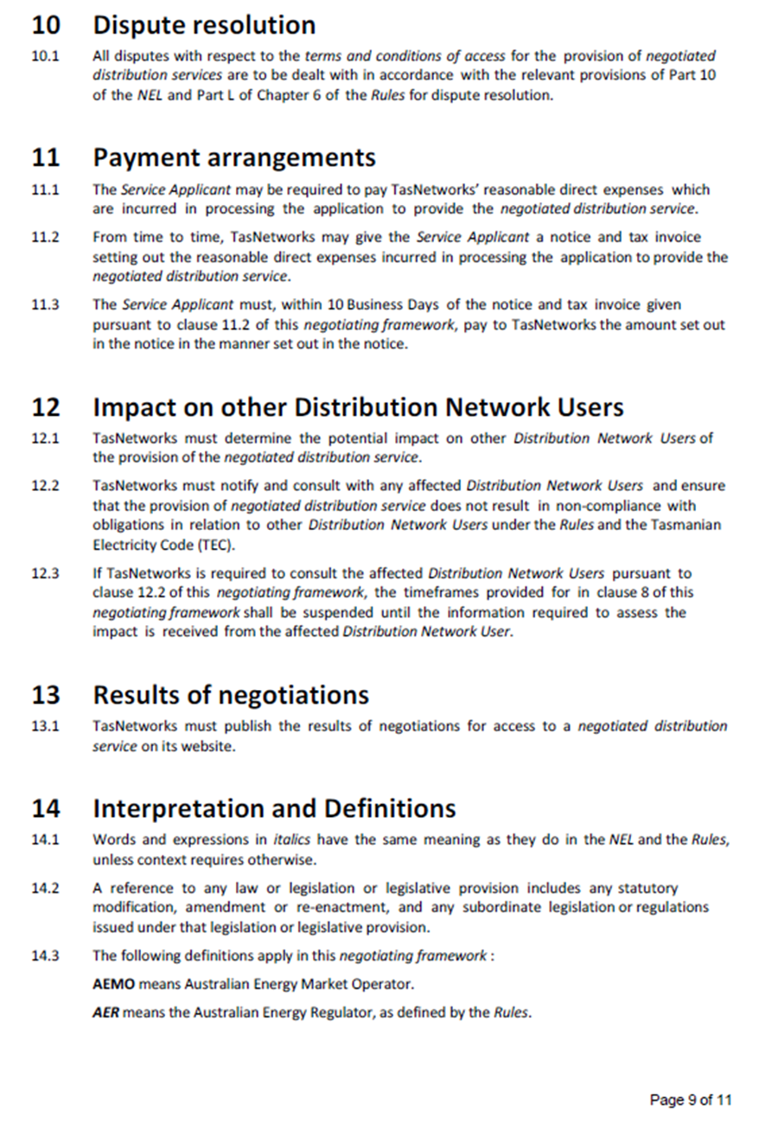

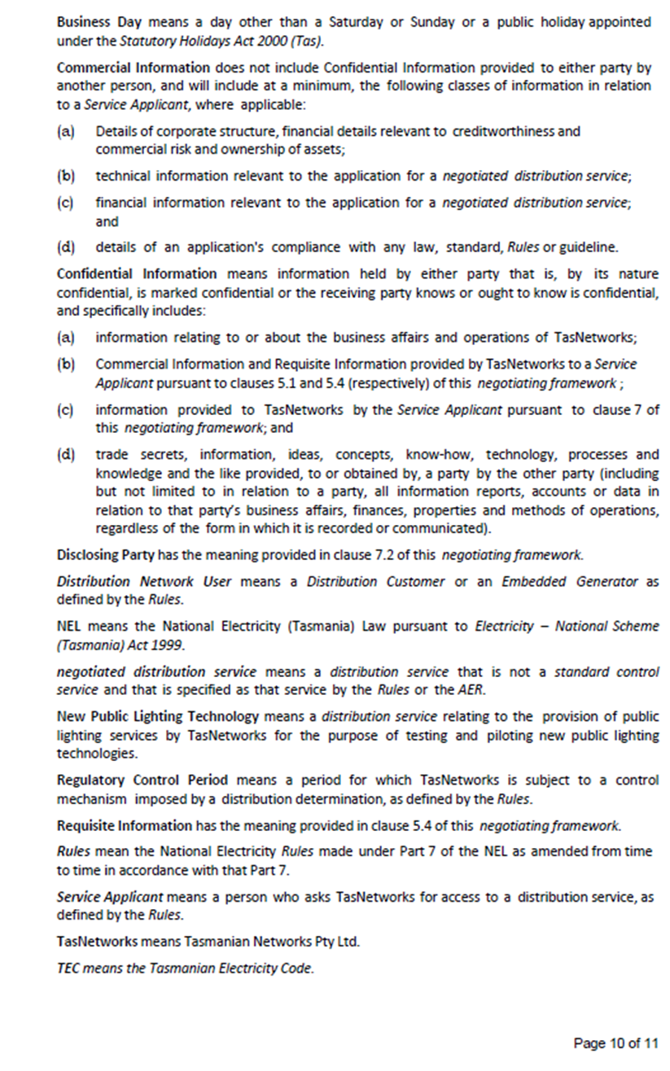



1. NER, cll. 6.7.3, 6.12.1(15).
2. NER, cll. 6.7.4, 6.12.1(16).
3. TasNetworks, Tasmanian Networks Pty Ltd Distribution Negotiating Framework - commencing 1 July 2017, January 2016,
4. AER, Draft decision, TasNetworks distribution determination 2017–18 to 2018–19: Attachment 17—Negotiated services framework and criteria, September 2016.
5. AER, Proposed negotiated distribution service criteria for TasNetworks Regulatory control period 1 July 2017 to 30 June 2019, February 2016.
6. NER, cl. 6.7.1.
7. TasNetworks, Tasmanian Distribution Regulatory Proposal Regulatory Control Period 1 July 2017 to 30 June 2019, January 2016, p.153.
8. AER, Draft decision, TasNetworks distribution determination 2017–18 to 2018–19: Attachment 17—Negotiated services framework and criteria, September 2016.
9. NER, cl. 6.7.5(c).
10. AER, Proposed negotiated distribution service criteria for TasNetworks Regulatory control period 1 July 2017 to 30 June 2019, February 2016.