

FINAL DECISION

TasNetworks distribution determination

2017−18 to 2018−19

Overview

April 2017

© Commonwealth of Australia 2017

This work is copyright. In addition to any use permitted under the Copyright Act 1968, all material contained within this work is provided under a Creative Commons Attributions 3.0 Australia licence, with the exception of:

* the Commonwealth Coat of Arms
* the ACCC and AER logos
* any illustration, diagram, photograph or graphic over which the Australian Competition and Consumer Commission does not hold copyright, but which may be part of or contained within this publication. The details of the relevant licence conditions are available on the Creative Commons website, as is the full legal code for the CC BY 3.0 AU licence.

Requests and inquiries concerning reproduction and rights should be addressed to the:

Director, Corporate Communications  
Australian Competition and Consumer Commission   
GPO Box 4141, Canberra ACT 2601

or publishing.unit@accc.gov.au.

Inquiries about this publication should be addressed to:

Australian Energy Regulator  
GPO Box 520  
Melbourne Vic 3001

Tel: 1300 585 165  
Email: [AERInquiry@aer.gov.au](mailto:AERInquiry@aer.gov.au)

1. Note
2. This Overview forms part of the AER's final decision on TasNetworks' distribution determination for 2017–19. It should be read with all other parts of the final decision.

This final decision consists of an Overview and 8 attachments. As many issues were settled at the draft decision stage or required only minor updates we have not prepared final decision attachments for:

* Regulatory asset base
* Regulatory depreciation
* Capital expenditure
* Operating expenditure
* Corporate income tax
* Capital expenditure sharing scheme
* Service target performance incentive scheme
* Demand management incentive scheme
* Classification of services
* Pass through events
* Connection policy.

1. The AER's final decision on these matters is set out in this Overview. For ease of reference the remaining attachments have been numbered consistently with the attachment numbering in our draft decision.
2. The final decision therefore includes the following documents:
3. Overview
4. Attachment 1 – Annual revenue requirement
5. Attachment 3 – Rate of return
6. Attachment 4 – Value of imputation credits
7. Attachment 9 – Efficiency benefit sharing scheme
8. Attachment 14 – Control mechanisms
9. Attachment 16 – Alternative control services
10. Attachment 17 – Negotiated services framework and criteria
11. Attachment 19 – Tariff structure statement
13. Contents

Note 2

Contents 3

Shortened forms 5

1 Introduction 7

1.1 Structure of the Overview 7

2 Final decision 9

2.1 What is driving allowed revenue? 10

2.2 Key differences between our draft and final decisions 11

2.3 Expected impact of decision on residential electricity bills 13

3 Key elements of our final decision 14

3.1 Regulatory asset base 16

3.2 Rate of return (return on capital) 20

3.3 Value of imputation credits (gamma) 21

3.4 Regulatory depreciation (return of capital) 22

3.5 Capital expenditure 27

3.6 Operating expenditure 28

3.7 Corporate income tax 32

4 Service classification, control mechanisms and incentive schemes 34

4.1 Classification of services 34

4.2 Control mechanisms 36

4.2.1 Standard control services 36

4.2.2 Alternative control services 37

4.3 Incentive schemes 38

4.3.1 Efficiency benefit sharing scheme (EBSS) 38

4.3.2 Capital expenditure sharing scheme (CESS) 39

4.3.3 Service target performance incentive scheme (STPIS) 40

4.3.4 Demand management incentive scheme 42

5 Tariff structure statement 44

6 The regulatory framework 46

6.1 Achieving the NEO to the greatest degree 49

6.2 Interrelationships between constituent components 50

7 Consultation 52

7.1 Consumer engagement 53

7.2 TasNetworks' consumer engagement activities 54

7.3 Consumer submissions 54

7.4 Our view of TasNetworks' consumer engagement 55

A Constituent decisions 56

B List of submissions 60

1. Shortened forms

| Shortened form | Extended form |
| --- | --- |
| AEMC | Australian Energy Market Commission |
| AEMO | Australian Energy Market Operator |
| AER | Australian Energy Regulator |
| augex | augmentation expenditure |
| capex | capital expenditure |
| CCP | Consumer Challenge Panel |
| CESS | capital expenditure sharing scheme |
| CPI | consumer price index |
| DRP | debt risk premium |
| DMIA | demand management innovation allowance |
| DMIS | demand management incentive scheme |
| distributor | distribution network service provider |
| DUoS | distribution use of system |
| EBSS | efficiency benefit sharing scheme |
| ERP | equity risk premium |
| Expenditure Assessment Guideline | Expenditure Forecast Assessment Guideline for Electricity Distribution |
| F&A | framework and approach |
| MRP | market risk premium |
| NEL | national electricity law |
| NEM | national electricity market |
| NEO | national electricity objective |
| NER | national electricity rules |
| NSP | network service provider |
| opex | operating expenditure |
| PPI | partial performance indicators |
| PTRM | post-tax revenue model |
| RAB | regulatory asset base |
| RBA | Reserve Bank of Australia |
| repex | replacement expenditure |
| RFM | roll forward model |
| RIN | regulatory information notice |
| RPP | revenue and pricing principles |
| SAIDI | system average interruption duration index |
| SAIFI | system average interruption frequency index |
| SLCAPM | Sharpe-Lintner capital asset pricing model |
| STPIS | service target performance incentive scheme |
| WACC | weighted average cost of capital |

# Introduction

We, the Australian Energy Regulator (AER), are responsible for the economic regulation of electricity transmission and distribution systems in all Australian states and territories, with the exception of Western Australia. TasNetworks owns and operates Tasmania's electricity distribution network. We regulate the revenues that TasNetworks can recover from its customers.

TasNetworks submitted a revised regulatory proposal for its electricity distribution network on 2 December 2016. TasNetworks' revised proposal sets out the revenue that TasNetworks proposes to recover from electricity consumers through distribution charges for the period 2017–19. The revised proposal was in response to our draft decision which was published on 29 September 2016. This overview, together with its attachments, constitutes our final decision on TasNetworks' regulatory proposal.

TasNetworks' 2017–19 regulatory control period is shorter than the usual five year period. The two year regulatory control period will allow TasNetworks to align the regulatory control periods of its distribution and transmission businesses. The AEMC approved TasNetworks' proposed change in the length of the regulatory control period in its final rule determination issued on 9 April 2015.[1]

The National Electricity Law (NEL) and National Electricity Rules (NER) provide the regulatory framework governing electricity networks. In regulating TasNetworks, we are guided by the National Electricity Objective (NEO), as set out in the NEL. The NEO is:[2]

to promote efficient investment in, and efficient operation and use of, electricity services for the long term interests of consumers of electricity with respect to—

(a) price, quality, safety, reliability and security of supply of electricity; and

(b) the reliability, safety and security of the national electricity system.

## Structure of the Overview

This overview provides a summary of our final decision and its individual components. The remainder is structured as follows:

* Section 2 provides a high level summary of our final decision.
* Section 3 provides a breakdown of our final decision into its key components.
* Section 4 sets out our final decision on the classification of services, control mechanisms and incentive schemes that will apply to TasNetworks for the 2017–19 regulatory control period. These are decisions that we make in addition to the building block revenue determination.
* Section 5 sets out our decision on TasNetworks' tariff structure statement.
* Section 6 explains how we apply the regulatory framework, in particular the NEO, the RPPs and the interrelationships between the constituent components.
* Section 7 outlines our consultation process in reaching this final decision and our view of TasNetworks' consumer engagement undertaken in developing its regulatory proposal.
* Appendix A contains the full list of constituent components that make up TasNetworks' proposal and our final decision on each of them (constituent decisions).
* Appendix B lists the stakeholder submissions received on our draft decision and TasNetworks' revised regulatory proposal.

# Final decision

Our final decision is that TasNetworks can recover $477.3 million ($ nominal, smoothed) from consumers over the 2017–19 regulatory control period. This is a 4.2 per cent increase from TasNetworks' revised proposed revenue allowance of $458.2 million ($ nominal). Our final decision allows TasNetworks to recover 6.9 per cent more from its customers than our September 2016 draft decision of $446.6 million ($nominal).

Our draft and final decisions accepted large parts of TasNetworks' regulatory proposal, including its opex and capex forecasts. The key item of difference between TasNetworks' revised proposal and our final decision is an increase in the allowed rate of return. This increase is reflective of a rise in government bond rates since TasNetworks' submitted its revised proposal to ensure the rate of return reflects prevailing market conditions.

Figure 2.1 compares our final decision on TasNetworks' revenue for 2017–19 to its proposed revenue and to the revenue allowed and recovered during the 2012–17 regulatory control period.

Figure 2.1 TasNetworks' past total revenue, proposed total revenue and AER final decision total revenue allowance ($million, 2016–17)

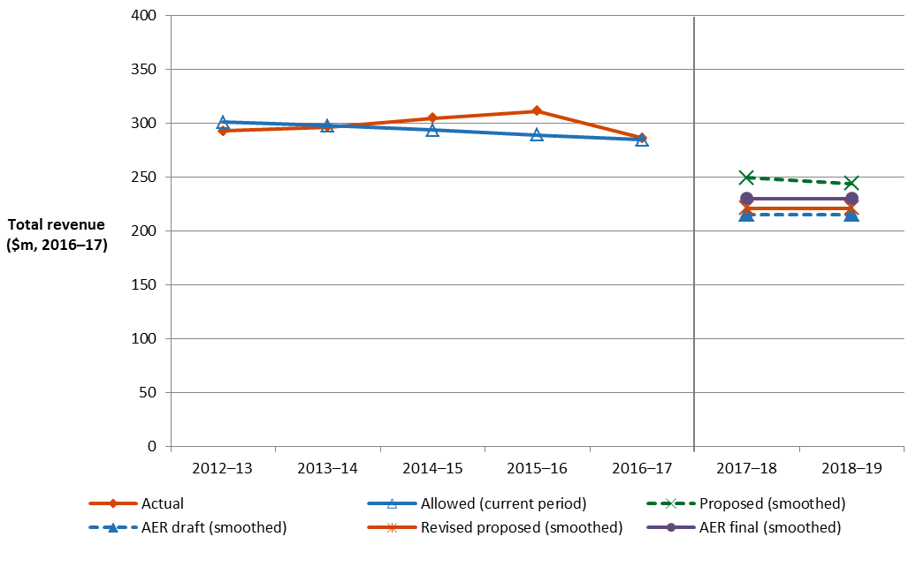

Source: AER analysis.

## What is driving allowed revenue?

Our final decision approves average annual revenues for the 2017–19 regulatory control period that are $63.0 million ($2016–17)—or 21.5 per cent—lower than our previous regulatory decision for Aurora Energy (as the distribution business was then called) for the 2012–17 period, in real dollar terms.[3] Our final decision provides 4.2 per cent ($2016–17) more revenue than TasNetworks set out in its revised regulatory proposal, given some recent modest increases in financing costs.

Figure 2.2 compares the average annual building block revenue from our final decision to that proposed by TasNetworks for the 2017–19 regulatory control period, and to the allowed average amount for the 2012–17 regulatory control period.

Figure 2.2 AER's final decision on constituent components of total revenue ($million, 2016–17)

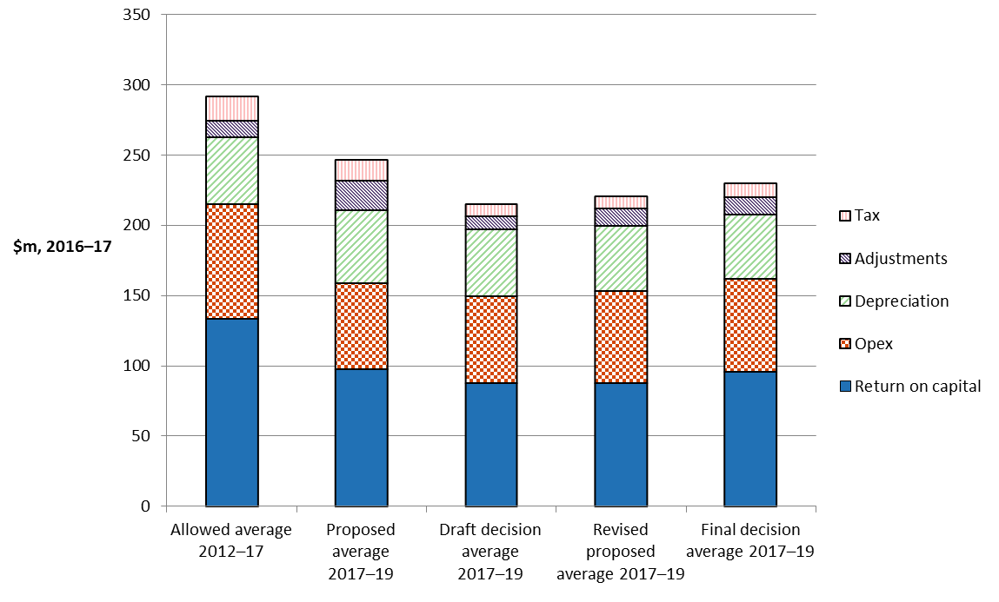

Source: AER analysis.

Figure 2.3 compares our final decision for the 2017–19 regulatory control period with TasNetworks' allowed revenue for the 2012–17 regulatory control period, broken down by the various building block components that make up the forecast revenue allowance. These are annual amounts based on average unsmoothed building block costs over the two relevant regulatory control periods.

Figure 2.3 AER's final decision for 2017–19 and TasNetworks' 2012–17 allowed average annual building block costs ($million, 2016–17)

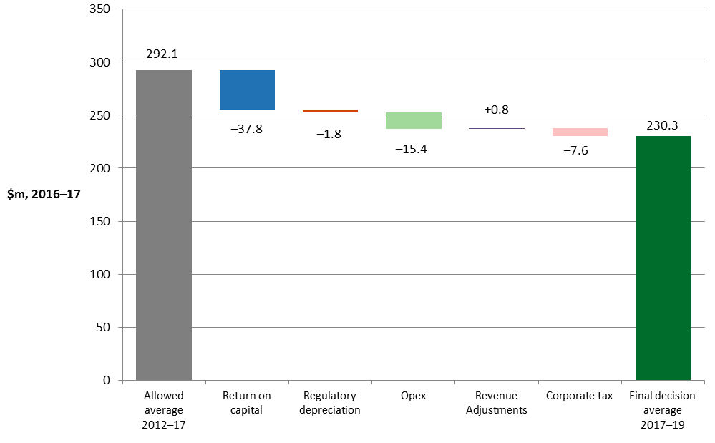

Source: AER analysis.

These figures highlight that the return on capital and opex allowances are the key differences between our final decision for the 2017–19 regulatory control period and TasNetworks' allowed revenue for the 2012–17 regulatory control period.

The reduction in the return on capital is driven by changes in the estimated rates of return on debt and equity. The estimated return on debt and return on equity fell between regulatory periods by 2.9 and 1.3 percentage points respectively. The falls were largely caused by a reduction in the risk free rate and the debt risk premium. However, the equity beta used also fell from 0.8 for the 2012–17 regulatory control period to 0.7 for the 2017–19 regulatory control period reducing the estimated equity risk premium.

TasNetworks' lower opex for the 2017–19 regulatory control period reflects efficiency gains made over the 2012–17 regulatory control period. TasNetworks proposed significant reductions in its opex, largely as a result of the synergies associated with the merger of its transmission and distribution networks in 2014.

## Key differences between our draft and final decisions

Our final decision allows TasNetworks to recover 6.9 per cent more from its customers than our September 2016 draft decision of $446.6 million ($nominal). Figure 2.4 shows the building block components from our final determination that make up the annual building block revenue requirement for TasNetworks, and the corresponding components from its revised proposal and our draft decision.

Figure 2.4 AER's draft and final decisions, and TasNetworks' initial and revised proposed annual revenue requirement ($million, nominal)

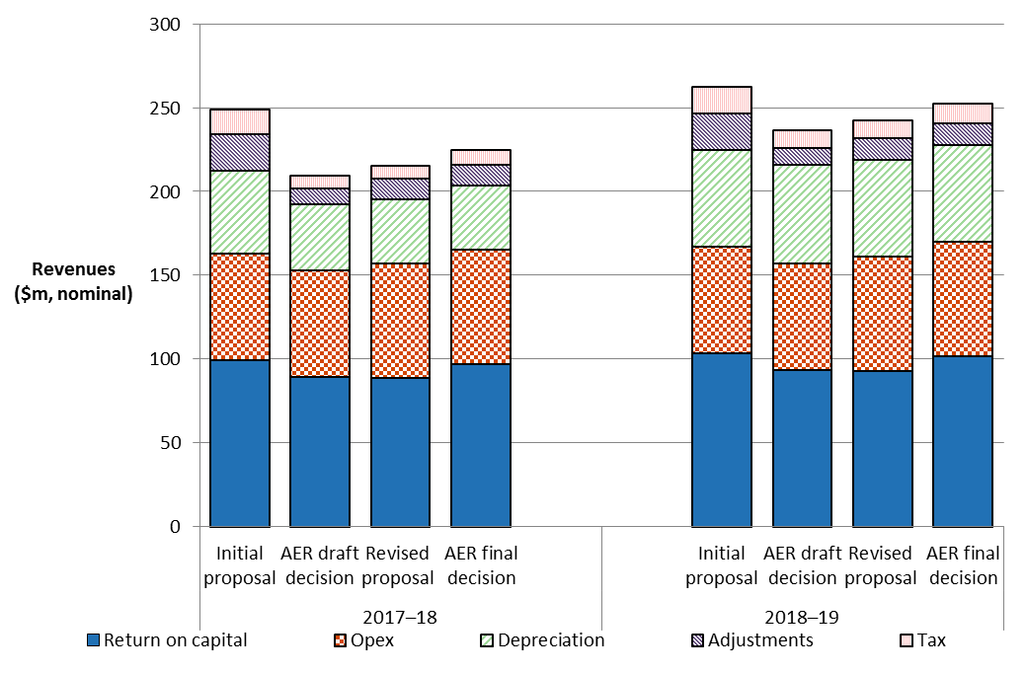

Source: AER analysis

Figure 2.4 shows that the main factor driving the increase in revenue between our draft and final decisions is the return on capital. Our final decision includes a return on capital of $199.1 million ($nominal) which is $16.5 million higher than our draft decision.

In our draft decision we applied a rate of return of 5.48 per cent. While our approach to calculating the rate of return has not changed, our final decision updates the rate of return to reflect data from approved averaging periods for the return on equity and debt. The rate of return of 6.02 per cent approved in this final decision is higher than our draft decision of 5.48 per cent. This is discussed further in section 3.2.

Forecast opex is also a driver of the increase in revenue between our draft and final decisions. Our final decision includes a forecast opex allowance of $136.7 million ($nominal) which is $9.1 million higher than our draft decision opex allowance of $127.6 million ($nominal). We have accepted TasNetworks' revised opex forecast, which takes into account interrelationships between the EBSS and opex. This is discussed further in section 3.6.

## Expected impact of decision on residential electricity bills

1. The annual electricity bill for customers in Tasmania will reflect the combined cost of all of the electricity supply chain components. These components are:

* the cost of purchasing electricity (the wholesale energy generation cost);
* the cost of the poles/towers and wires used to transport the electricity (the transmission and distribution networks), and other infrastructure such as metering cost;
* the cost of environmental policies, including subsidies for renewable energy target; and
* the retailer’s costs and profit margin.

1. Therefore, the electricity bill changes to reflect movements in one or more of the components in the bill. Our final decision on TasNetworks affects the poles and wires (distribution network charges) component of the electricity bill for Tasmanian customers, which represent approximately 41 per cent of an average customer's annual electricity bill.[4] We estimate the expected bill impact by varying the distribution charges in accordance with our final decision, while holding other components of the bill constant.

Based on this approach, we expect that our final decision will result in the distribution component of the average annual electricity bills for residential customers in Tasmania decreasing over the 2017–19 regulatory control period. The distribution component of the average annual residential electricity bill in 2018–19 is expected to reduce by about $110 ($ nominal) below the current, 2016–17 level. We note that this bill impact estimate is indicative only, and individual customers’ actual bills will also depend on their usage patterns and the structure of their chosen retail tariff offering.

1. While our approach isolates the effect of our decision on electricity prices, it does not imply that other components will remain unchanged across the regulatory control period.[5] We note that in its recent electricity price trends report for Tasmania, the AEMC has indicated that wholesale costs are expected to rise, based on the expected trend in Victoria following the closure of Hazelwood power station.[6] However, we expect the decreasing distribution network charges flowing from this final decision will offset some of the increases from other components of the overall bill. Further detail on our final decision impact on overall bills is set out in attachment 1.

# Key elements of our final decision

We use the building block approach to determine TasNetworks' annual revenue requirement. The building block approach consists of five costs that a business is allowed to recover through its revenue allowance.

The building block costs are illustrated in Figure 3.1 and include:

* a return on the regulatory asset base (RAB) (or return on capital)
* depreciation of the RAB (or return of capital)
* forecast opex
* revenue increments or decrements resulting from incentive schemes such as the efficiency benefit sharing scheme (EBSS)
* the estimated cost of corporate income tax.

Figure 3.1 The building block approach for determining total revenue

Return on capital  
(RAB × rate of return on capital)

Regulatory depreciation  
(depreciation net of indexation  
applied to RAB)

Corporate income tax  
(net of value of imputation credits)

**Capital costs**

Operating expenditure  
(opex)

Revenue adjustments  
(increment or decrement)

**Total revenue**

The building block costs are comprised of key elements that we determine through our assessment process. For example, the size of the RAB—and therefore the revenue generated from the return on capital and regulatory depreciation building blocks—is directly affected by our assessment of forecast capex.

This section summarises our final decision on key elements of the building blocks including:

* RAB (section 3.1)
* Rate of return (section 3.2)
* Imputation credits (section 3.3)
* Depreciation allowance (section 3.4)
* Efficient level of capex (section 3.5)
* Efficient level of opex (section 3.6)
* Forecast level of corporate income tax (section 3.6).

Incentive schemes including the EBSS and CESS are covered in section 4.3.

Table 3.1 shows our final decision on TasNetworks' revenues including the building block components.

Table 3.1 AER's final decision on TasNetworks' revenues ($ million, nominal)

|  |  |  |  |  |
| --- | --- | --- | --- | --- |
|  |  | 2017–18 | 2018–19 | Total |
| Return on capital |  | 97.2 | 101.9 | 199.1 |
| Regulatory depreciationa |  | 38.2 | 57.6 | 95.8 |
| Operating expenditureb |  | 68.3 | 68.4 | 136.7 |
| Revenue adjustmentsc |  | 12.5 | 12.8 | 25.4 |
| Net tax allowance |  | 8.9 | 12.2 | 21.0 |
| Annual revenue requirement (unsmoothed) |  | 225.0 | 252.9 | 478.0 |
| **Annual expected revenue (smoothed)** |  | **235.8** | **241.6** | **477.3** |
| X factor |  | n/ad | 0.00%e | n/a |

Source: AER analysis.

(a) Regulatory depreciation is straight-line depreciation net of the inflation indexation on the opening RAB.

(b) Operating expenditure includes debt raising costs.

(c) Revenue adjustments include the efficiency benefit sharing scheme (EBSS) carry-overs and demand management innovation allowance.

(d) TasNetworks is not required to apply an X factor for 2017–18 because we set the expected revenue for 2017–18 in this decision. The expected revenue for 2017–18 is $235.8 million ($nominal). This is around 19.5 per cent lower than the estimated revenue for 2016–17 in real terms, or around 17.6 per cent lower in nominal terms.

(e) The X factor for 2018–19 will be revised to reflect the annual return on debt update. Under the CPI–X framework, the X factor measures the real rate of change in annual expected revenue from one year to the next. A negative X factor represents a real increase in revenue. Conversely, a positive X factor represents a real decrease in revenue.

## Regulatory asset base

The regulatory asset base (RAB) is the value of the assets owned by TasNetworks to provide distribution network services. We use the RAB to determine the return on capital and depreciation (return of capital) building blocks.

We make a decision on TasNetworks' opening RAB value at 1 July 2017 as part of our distribution determination. We also make a decision on TasNetworks' projected RAB for the 2017–19 regulatory control period.[7]

Opening RAB at 1 July 2017

Our final decision is to set TasNetworks' opening RAB at $1615.2 million ($ nominal), as at 1 July 2017. This is 0.4 per cent ($6 million) lower than TasNetworks' revised proposal of $1621.2 million ($ nominal). Our final decision is 0.9 per cent ($14.2 million) lower than our draft decision value for TasNetworks' opening RAB of $1629.4 million ($ nominal).

1. To determine the opening RAB as at 1 July 2017, we have rolled forward the RAB over the 2012–17 regulatory control period to determine a closing RAB value at 30 June 2017. This roll forward includes an adjustment at the end of the 2012–17 regulatory control period to account for the difference between actual 2011–12 capex and the estimate approved at the 2012–17 determination.[8]
2. In our draft decision, we accepted TasNetworks' proposed RAB roll forward approach and updated the 2015–16 inflation value with actual CPI. We noted that we would update the inflation value for 2016–17 at the final decision. We accepted that TasNetworks' actual capex incurred in 2014–15 is prudent and efficient, and included it in the RAB. We noted that we would update the 2015–16 estimated capex with actuals and may also update the 2016–17 estimated capex with a revised estimate in the final decision. TasNetworks' revised proposal updates the approach accepted in our draft decision with updates for 2015–16 capex to reflect its actual incurred capex for that year. TasNetworks did not provide a revised estimate of capex for 2016–17 in its revised proposal.
3. For this final decision, we have updated the inflation value for 2016–17 using the actual March 2017 CPI published by the ABS as it has become available. We have also found that the 2015–16 actual capex in the revised proposal reconcile with the values presented in TasNetworks' annual reporting regulatory information notice (RIN). The financial impact of any difference between actual and estimated capex for 2016–17 will be accounted for at the next reset.[9]
4. We also consider the extent to which our roll forward of the RAB to 1 July 2017 contributes to the achievement of the capital expenditure incentive objective.[10] As discussed in the draft decision, the review period for this distribution determination is limited to 2014–15 capex.[11] Consistent with our draft decision, the overspending requirement for an efficiency review of past capex is not satisfied.[12] Accordingly, the capex incurred in that year is regarded as prudent and efficient, and included in the RAB—this is discussed further in appendix D of capex attachment 6 of the draft decision.
5. For the purposes of this final decision, we have included TasNetworks' actual capex incurred in 2015–16 and estimated capex for 2016–17 in the RAB roll forward to 1 July 2017.[13] At the next reset, the 2015–16 and 2016–17 capex will form part of the review period for whether past capex should be excluded from the RAB for inefficiency reasons.[14] Our RAB roll forward applies the incentive framework approved in the previous distribution determination, which included the use of an actual depreciation approach.[15] As such, we consider that the 2012–17 RAB roll forward contributes to an opening RAB (as at 1 July 2017) that includes capex that reflects prudent and efficient costs, in accordance with the capital expenditure criteria.[16]

Table 3.2 sets out our final decision on the roll forward of TasNetworks' RAB for the 2012–17 regulatory control period.

Table 3.2 AER's final decision on TasNetworks' RAB for the 2012–17 regulatory control period ($ million, nominal)

|  |  |  |  |  |  |
| --- | --- | --- | --- | --- | --- |
|  | 2012–13 | 2013–14 | 2014–15 | 2015–16 | 2016–17a |
| Opening RAB | 1445.2 | 1486.9 | 1539.3 | 1557.0 | 1597.0 |
| Capital expenditureb | 89.3 | 99.8 | 89.2 | 104.9 | 125.4 |
| Inflation indexation on opening RAB | 36.2 | 43.6 | 20.4 | 20.4 | 33.9 |
| Less: straight-line depreciationc | 83.8 | 90.9 | 91.9 | 85.4 | 86.2 |
| Closing RAB | 1486.9 | 1539.3 | 1557.0 | 1597.0 | 1670.1 |
| Difference between estimated and actual 2011­­-12 capex (1 July 2011 to 30 June 2012) |  |  |  |  | –38.0 |
| Return on difference for 2011–12 capex |  |  |  |  | –17.0 |
| **Closing RAB as at 30 June 2017** |  |  |  |  | **1615.2** |

Source: AER analysis.

(a) Based on estimated capex provided by TasNetworks.

(b) Net of disposals and capital contributions, and adjusted for actual CPI.

(c) Adjusted for actual CPI. Based on as-incurred capex.

Forecast closing RAB at 30 June 2019

Once we have determined the opening RAB as at 1 July 2017, we roll forward that RAB over 2017–19 with forecast capex, inflation and depreciation to arrive at a forecast closing value for the RAB at the end of the regulatory control period.

1. We determine a forecast closing RAB value as at 30 June 2019 of $1743.0 million ($ nominal). This is $5.2 million (or 0.3 per cent) lower than the amount of $1748.2 million ($ nominal) in TasNetworks' revised proposal. Our final decision on the forecast closing RAB reflects the amended opening RAB as at 1 July 2017 and rate of return (attachment 3).

Table 3.3 sets out our forecast RAB for TasNetworks in the 2017–19 regulatory control period.

Table 3.3 AER's final decision on TasNetworks' RAB for 2017–19 regulatory control period ($million, nominal)

|  |  |  |
| --- | --- | --- |
|  | 2017–18 | 2018–19 |
| Opening RAB | 1615.2 | 1693.1 |
| Capital expenditurea | 116.1 | 107.5 |
| Inflation indexation on opening RAB | 39.6 | 41.5 |
| Less: straight-line depreciation | 77.7 | 99.1 |
| **Closing RAB** | **1693.1** | **1743.0** |

Source: AER analysis.

(a) Net of forecast disposals and capital contributions. In accordance with the timing assumptions of the post-tax revenue model (PTRM), the capex includes a half-WACC allowance to compensate for the six month period before capex is added to the RAB for revenue modelling.

Figure 3.2 compares our final decision on TasNetworks' forecast RAB to TasNetworks' revised proposal and actual RAB in real dollar terms.

Figure 3.2 TasNetworks' actual RAB, proposed forecast RAB and AER final decision forecast RAB ($ million, 2016–17)

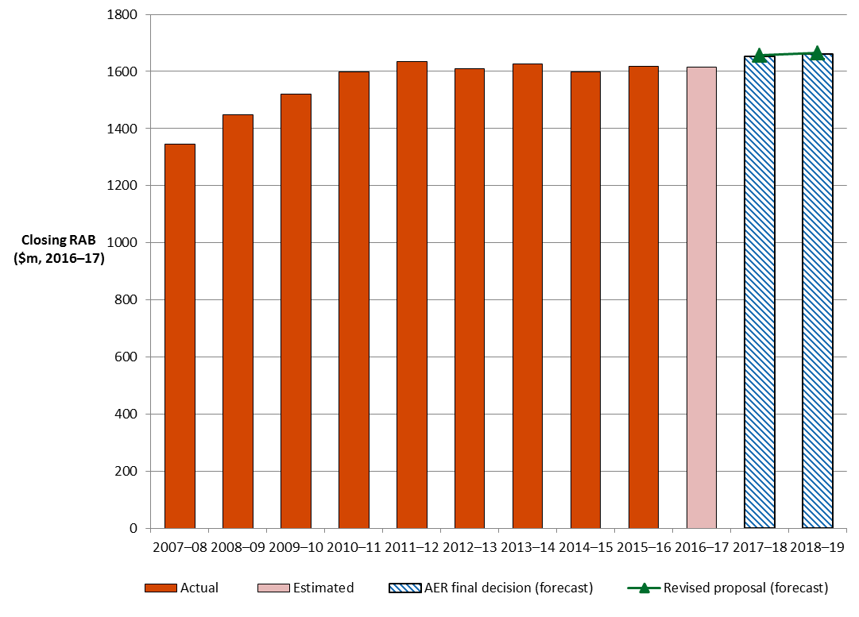

Source: AER analysis.

Application of depreciation approach in RAB roll forward for next reset

When we roll forward TasNetworks’ RAB for the 2017–19 regulatory control period at the next reset we must adjust for depreciation. Our final decision is to roll forward the RAB for the commencement of TasNetworks' 2019–24 regulatory control period using depreciation based on forecast capex (updated for actual inflation). This approach is consistent with our draft decision, TasNetworks' initial proposal and the framework and approach.[17]

## Rate of return (return on capital)

The return on capital is the key difference between our final decision for the 2017–19 regulatory control period and TasNetworks' allowed revenue for the 2012–17 regulatory control period. Both the estimated return on equity and estimated return on debt fell across the periods.

The estimated return on equity fell from 8.7 per cent in the 2012–17 regulatory control period to 7.4 per cent in the 2017–19 regulatory control period. The estimated return on debt fell from 8.0 per cent in the 2012–17 regulatory control period to 5.1 per cent in the 2017–19 regulatory control period.

1. Table 3.4 Final decision on TasNetworks' rate of return (% nominal)

|  |  |  |  |  |
| --- | --- | --- | --- | --- |
|  | Previous allowed return (2012–17) | AER draft decision (2017–18) | AER final decision (2017–18) | Allowed return over 2017–19 regulatory control period |
| Return on equity (nominal post–tax) | 8.69 | 6.5 | 7.4 | Constant (7.4%) |
| Return on debt (nominal pre–tax) | 8.00 | 4.79 | 5.1 | Updated annually |
| Gearing | 60 | 60 | 60 | Constant (60%) |
| Nominal vanilla WACC | 8.28 | 5.48 | 6.02 | Updated annually for return on debt |
| Forecast inflation | 2.6 | 2.45 | 2.45 | Constant (%) |

Source: AER analysis; TasNetworks, Tasmanian Distribution Regulatory Proposal Regulatory Control Period 1 July 2017 to 30 June 2019, 29 January 2016, p. 117; AER, Final Distribution Determination: Aurora Energy Pty Ltd 2012-13 to 2016-17, April 2012, p. 29; AER, Draft Decision TasNetworks distribution determination 2017–18 to 2018–19 Attachment 3 – Rate of return, September 2016; TasNetworks, Tasmanian Distribution Revised Regulatory Proposal Regulatory Control Period 1 July 2017 to 30 June 2019, December 2016, p. 7.

The falls were primarily caused by a reduction in the risk free rate and debt risk premium, which flowed through to the estimated return on debt and return on equity. However, the equity beta used for return on equity estimation also fell from a value of 0.8 for the 2012–17 regulatory control period to 0.7 for the 2017–19 regulatory control period reducing the estimated equity risk premium.

Differences between the draft and final decisions for the 2017–19 regulatory control period were much smaller. The rate of return of 6.02 per cent approved in this final decision is higher than our draft decision of 5.5 per cent. Our approach to calculating the rate of return did not change, but our final decision updates the rate of return to reflect data from approved averaging periods used for estimating the return on equity and return on debt.

1. Further detail on our draft decision in regards to TasNetworks' allowed rate of return is set out in attachment 3.

## Value of imputation credits (gamma)

1. We accept TasNetworks' proposed value of imputation credits (or gamma) of 0.4. We consider that a value for imputation credits of 0.4 will result in equity investors in the benchmark efficient entity receiving an ex ante total return (inclusive of the value of imputation credits) commensurate with the efficient equity financing costs of a benchmark efficient entity.
2. We note TasNetworks' submission that the X-factor definition should be changed to allow for any changes in gamma, following the conclusion of the court proceedings relating to the merit review sought by ActewAGL Distribution, Ausgrid, Endeavour Energy, Essential Energy and Jemena Gas Networks.[18] However, as discussed in attachment 4, we do not consider such an approach is appropriate.
3. In coming to a value of imputation credits of 0.4:

* We adopt a conceptual approach consistent with the Officer framework,[19] which we consider best promotes the objectives and requirements of the NER/NGR. This approach considers the value of imputation credits is a post-tax value before the impact of personal taxes and transaction costs.[20] As such, we view the value of imputation credits as the proportion of company tax returned to investors through the utilisation of imputation credits.[21]
* We consider our conceptual approach allows for the value of imputation credits to be estimated on a consistent basis with the allowed rate of return and allowed revenues under the post-tax framework in the NER/NGR.[22]
* We use the widely accepted approach of estimating the value of imputation credits as the product of two sub-parameters: the 'distribution rate' and the 'utilisation rate'.[23] Our definition of, and estimation approach for, these sub-parameters is set out in Table 3.5.

Table 3.5 Gamma sub-parameters: definition and estimation approach

| 1. Sub-parameter | 1. Definition | 1. Estimation approach |
| --- | --- | --- |
| Distribution rate (or payout ratio) | The proportion of imputation credits generated that is distributed to investors. | Primary reliance placed on the widely accepted cumulative payout ratio approach. Some regard is also given to Lally's estimate for listed equity from financial reports of the 20 largest listed firms. |
| Utilisation rate (or theta) | The utilisation value to investors in the market per dollar of imputation credits distributed. | A range of approaches, with due regard to the merit of each approach:   * equity ownership approach * tax statistics * implied market value studies. |

Source: AER analysis.

1. Overall, the evidence suggests a range of estimates for the value of imputation credits might be reasonable. With regard to the merits of the evidence before us, we choose a value of imputation credits of 0.4 from within a range of 0.3 to 0.5.
2. In considering the evidence on the distribution and utilisation rates, we have broadly maintained the approach set out in the Rate of Return Guideline, but have re-examined the relevant evidence and estimates. This re-examination, and new evidence and advice considered since the Guideline, led us to depart from the 0.5 value of imputation credits we proposed in the Guideline.
3. Further detail on our draft decision in regards to the value of TasNetworks' imputation credits is set out in attachment 4.

## Regulatory depreciation (return of capital)

Depreciation is the allowance provided so capital investors recover their investment over the economic life of the asset (return of capital). In deciding whether to approve the depreciation schedules submitted by TasNetworks, we make determinations on the indexation of the RAB and depreciation building blocks for TasNetworks' 2017–19 regulatory control period.[24] The regulatory depreciation allowance is the net total of the straight-line depreciation less the inflation indexation adjustment of the RAB.

Our final decision is to determine a regulatory depreciation allowance of $95.8 million ($ nominal) for TasNetworks over the 2017–19 regulatory control period. This amount represents a reduction of $0.4 million (or 0.4 per cent) on the $96.2 million ($ nominal) in TasNetworks' revised proposal.[25] It represents a reduction of $2.8 million or 2.9 per cent from the $98.6 million ($ nominal) in our draft decision. In coming to our final decision:

* We confirm our acceptance of TasNetworks' proposed asset classes and its straight-line depreciation method used to calculate the regulatory depreciation allowance.
* We implement straight-line depreciation using the 'year-by-year tracking' approach, which is the same approach used in TasNetworks' revised proposal and our draft decision. In the draft decision, we accepted TasNetworks' proposal to use the year-by-year tracking method for depreciating its existing assets. However, we did not accept TasNetworks' implementation of the approach in its proposed RFM. We established a separate depreciation model for TasNetworks to correctly implement the year-by-year tracking method. In its revised proposal, TasNetworks has adopted the depreciation model we established in the draft decision. We are satisfied the application of the year-by-year tracking method for depreciation purposes meets the requirements of the NER in that it:
* produces depreciation schedules that reflect the nature of the assets and their economic life[26]
* ensures that total depreciation (in real terms) equals the initial value of the assets[27]
* allows the economic lives of existing assets to be consistent with those determined in previous decisions.[28]
* The adoption of year-by-year tracking means it is no longer necessary to explicitly calculate remaining asset lives as at 1 July 2017. However, we do need to decide on the standard asset lives for depreciating new assets. Consistent with the draft decision, we accept TasNetworks' proposed standard asset lives for its existing asset classes. These asset lives are consistent with those approved at the 2012–17 distribution determination and comparable to the standard asset lives used for other distributors.

We confirm our acceptance of TasNetworks' proposal to create a new 'Business management systems' asset class with a standard asset life of 10 years. This asset class will contain asset management IT systems capex incurred from 1 July 2017. Consistent with our draft decision, we consider the proposed standard asset life of 10 years reflects the nature of the assets in this asset class and is comparable with the standard asset life used by other distributors for a similar asset class.

We are therefore satisfied the approved standard asset lives (as set out in table 5.3 of our draft decision regulatory depreciation attachment 5) would lead to a depreciation schedule that reflects the nature of the assets over the economic lives of the asset classes, and that the sum of the real value of the depreciation attributable to the assets is equivalent to the value at which the assets was first included in the RAB for TasNetworks.[29]

* Our final decision on the opening RAB at 1 July 2017 (section 3.1) also affects the forecast regulatory depreciation allowance.[30]

Table 3.6 Table 3.6 sets out our final decision on TasNetworks' regulatory depreciation allowance for 2017–19 regulatory control period.

Table 3.6 AER's final decision on TasNetworks' depreciation allowance for 2017–19 period ($million, nominal)

|  |  |  |  |
| --- | --- | --- | --- |
|  | 2017–18 | 2018–19 | Total |
| Straight-line depreciation | 77.7 | 99.1 | 176.9 |
| Less: inflation indexation on opening RAB | 39.6 | 41.5 | 81.0 |
| **Regulatory depreciation** | **38.2** | **57.6** | **95.8** |

Source: AER analysis.

We received a submission from CCP member David Headberry on our draft decision approving TasNetworks’ standard asset life for the new ‘Business management systems’ asset class and the standard asset lives for existing asset classes in general. Our consideration of these issues are discussed in turn below.

'Business management systems' asset class

The ‘Business management systems’ asset class relates to capex associated with TasNetworks’ business transformation project (the ‘Ajilis’ project) which involves the replacement of a range of legacy systems. This includes key asset management, financial and human resources systems.

In a submission on TasNetworks’ initial proposal, CCP member David Headberry submitted that the proposed standard asset life of 10 years is too short for this asset class. In our draft decision, we accepted the proposed standard asset life of 10 years. We noted that the standard asset life for IT systems assets approved for other distributors for regulatory depreciation purposes is between 5 to 7 years. We considered the nature of the ‘Ajilis’ project and its associated costs meant that the assets will continue to be used by TasNetworks for a longer life than would normally be associated with such type of assets. However, we considered a standard asset life of more than 10 years may not be justified given the short-lived nature of IT assets.

In his submission on the draft decision, Mr Headberry stated that the draft decision to allow TasNetworks’ proposed standard asset life of 10 years is not in consumers’ best interests. He expressed concerns that with the ever increasing amounts of capex across the NEM being committed to upgrade or replace IT systems, consumers see little benefit from the investment.[31] However, he did not provide any evidence that IT systems in the NEM have an economic life of greater than 10 years.

For this final decision, we maintain our view that the standard asset life of 10 years for the ‘Business management systems’ asset class is reasonable. We note that our draft decision approved TasNetworks’ proposed replacement capex associated with the ‘Ajilis’ project because the proposal was well supported by a positive business case. We also note that the proposed asset life of 10 years is consistent with the benefits realisation analysis for this project as presented in the project business case.[32] Therefore, consistent with our draft decision, we consider the proposed standard asset life of 10 years reflects the nature of the assets in this asset class consistent with clause 6.5.5(b)(1) of the NER.

Existing asset classes

Also in his submission on the draft decision, Mr Headberry:[33]

* considered that it is important that the depreciation of the RAB should reflect the actual asset lives rather than a notional expected life of the assets
* expressed concerns with the inconsistency between the asset lives identified in the PTRM depreciation schedule, the Category analysis RIN and the Economic benchmarking RIN
* considered there needs to be better benchmarking of assets between the distributors in the NEM to ensure consumers of some networks are not being disadvantaged.

For this final decision, we will not make any further changes to the proposed standard asset lives for TasNetworks' existing asset classes. Consistent with our draft decision, we consider that the standard asset lives for depreciation purposes should reflect the expected economic life of the assets. While the standard asset lives for depreciation purposes should be generally close to the actual asset life at replacement, it does not necessarily mean that any discrepancy between the two would require changes. This is because the depreciation schedule is a forward looking assumption necessary for new investment. The distributor may adopt the manufacturer's design life or the expected economic life of the assets for depreciation purposes to determine the optimal timing and form of investment. The design life or the expected economic life of the asset may reflect the minimum life that most of the assets are expected to last and therefore are generally shorter than the actual asset lives at replacement.

We note the asset lives in the Category analysis RIN and Economic benchmarking RIN are not directly aligned with the standard asset lives employed in TasNetworks’ PTRM due to different asset classifications used between the three. We also note that the asset categories in the Economic benchmarking RIN is at a much higher level compared to those in the PTRM and the Category analysis RIN. Given the similarity of asset categories in the PTRM and Category analysis RIN, in the draft decision we attempted to map the asset age profile in the Category analysis RIN with the standard asset lives in the PTRM. We found that TasNetworks' standard asset lives in the PTRM broadly align with the average economic lives provided in its Category analysis RIN for similar asset types.

Further, as shown in the draft decision, TasNetworks' weighted average standard asset life is broadly comparable with that of the other distributors, although towards the bottom of the range. However, we do not consider the difference is material, particularly in terms of their impact on overall depreciation. Figure 3.3 shows a comparison of the weighted average standard asset lives of the distributors.

Figure 3.3 TasNetworks' weighted average standard asset lives compared to other distribution service providers' weighted average standard asset lives (years)

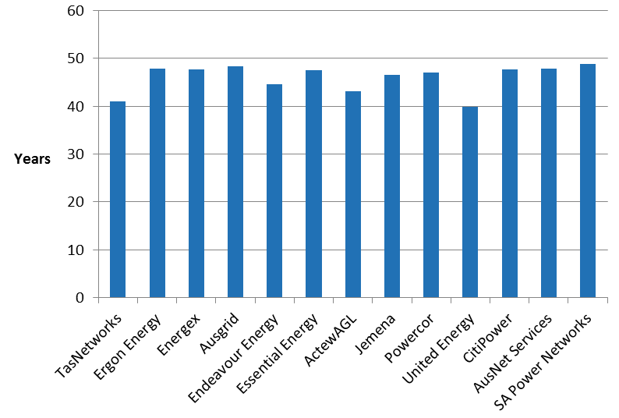

Source: AER analysis.

Note: The opening RAB values for each asset class as set out in the approved PTRMs are used as the weights. Non-depreciable assets such as 'Land' and 'Easements' are excluded from the calculation.

## Capital expenditure

Capital expenditure (capex) refers to the capital expenses incurred in the provision of network services. Forecast capex feeds into the estimates of the return on capital and regulatory depreciation building blocks we use to determine a DNSP's total revenue requirement.

We are satisfied that TasNetworks' proposed total forecast capex of $213.4 million ($2016–17) for the 2017–19 regulatory control period reasonably reflects the capex criteria. This maintains our position from the draft decision. Our reasons for this are set out in attachment 6 to the draft decision.

Table 3.7 shows our decision compared to TasNetworks' forecast.

Table 3.7 AER draft decision on total net capex ($million, 2016–17)

|  |  |  |  |
| --- | --- | --- | --- |
|  | 2017–18 | 2018–19 | Total |
| TasNetworks' proposal | 112.0 | 101.4 | 213.4 |
| AER draft decision | 112.0 | 101.4 | 213.4 |
| Difference | 0 | 0 | 0 |
| Percentage difference (%) | 0 | 0 | 0 |

1. Source: AER analysis

Note: Numbers may not total due to rounding.

Figure 3.4 shows our capex decision compared to TasNetworks' proposal, its past allowances and past actual expenditure.

Figure 3.4 TasNetworks total actual and forecast capex 2008–2019

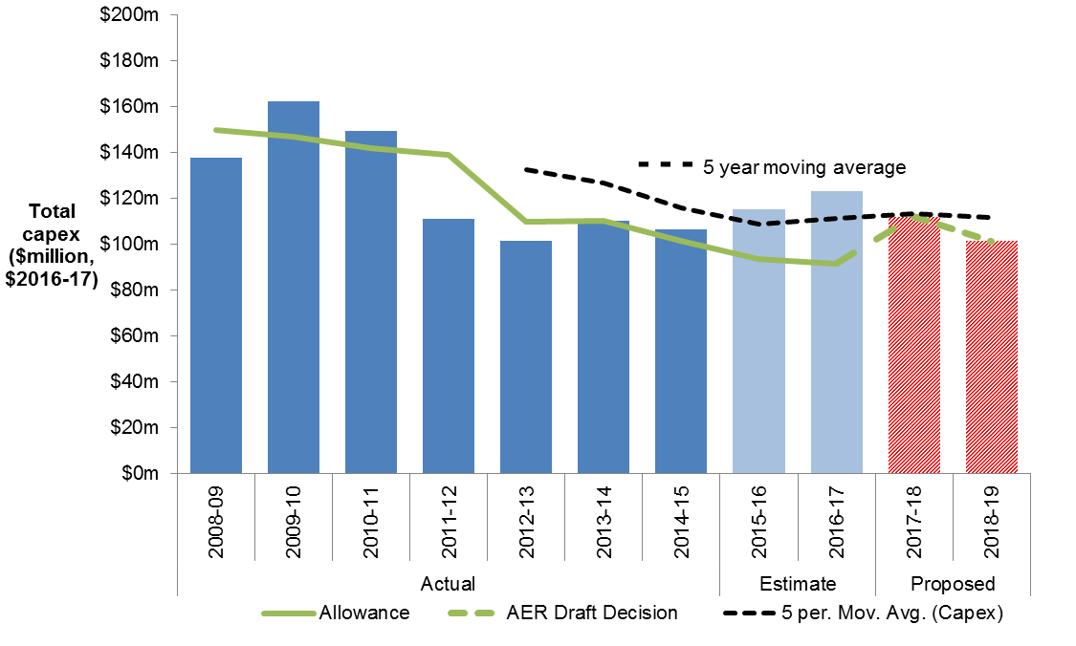

## Operating expenditure

Our final decision is to accept TasNetworks' revised opex proposal of $131.8 million ($2016–17), including debt raising costs. Our final decision is set out in Table 3.8.

Table 3.8 Our final decision on total opex ($million, 2016–17)

|  |  |  |  |
| --- | --- | --- | --- |
|  | 2017–18 | 2018–19 | Total |
| TasNetworks' initial proposal | 62.3 | 60.8 | 123.1 |
| AER draft decision | 62.3 | 60.8 | 123.1 |
| TasNetworks' revised proposal | 66.6 | 65.2 | 131.8 |
| AER final decision | 66.6 | 65.2 | 131.8 |

Source: TasNetworks, Initial and revised PTRMs. AER, Draft and final decision PTRMs.

Note: Includes debt raising costs.

TasNetworks made two key changes to its initial opex forecast:[34]

* it reduced its productivity growth forecast
* it increased its forecast GSL payments to match those we included in the alternative estimate in our draft decision.

The effect of these changes is to increase TasNetworks' total opex forecast by $8.7 million ($2016–17), or 7.1 per cent. We accept this increased proposal because it is still lower than our alternative estimate of efficient costs.

TasNetworks initially proposed total opex of $123.1 million ($2016–17). Our draft decision accepted TasNetworks' initial opex forecast on the basis that it was $17.5 million lower than our alternative estimate of efficient costs.[35]

In its revised proposal, TasNetworks highlighted the interrelationship between forecast opex and the EBSS. TasNetworks explained our draft decision accepted its opex forecast but reduced its EBSS carryover amount by $23.0 million. As a result, TasNetworks revised its opex forecast.[36]

In making our final decision, we considered submissions from David Headberry of the CCP and other stakeholders. In his submission, Mr Headberry questioned the extent to which the EBSS incentivises a network to maximise efficiency and whether the base year opex is efficient. First, he considers TasNetworks’ proposal to make significant opex reductions from current levels, which are ‘even less than the opex the AER would probably have accepted based on its base–step–trend approach’, undermines our assumption that the EBSS drives a network to efficient opex.[37] Second, given we relied on TasNetworks' reported opex in 2014–15 to forecast its opex over the 2017–19 regulatory control period, and that total opex in 2015–16 was lower than 2014–15, Mr Headberry considers this implies the base year opex we used is not the efficient base year.[38]

Consistent with our Expenditure forecast assessment guideline, we prefer to use a revealed cost approach as the starting point for assessing and determining efficient opex forecasts. The ex-ante incentive regime provides an incentive to improve efficiency because network businesses can retain cost savings made during the regulatory control period. However, we also recognise that we must test whether network businesses have responded to the incentive framework in place. That is, we must determine whether or not the network businesses' revealed costs are efficient.[39] For this reason, we assessed the efficiency of TasNetworks’ base year expenditures. We determined it was appropriate for us to rely on its revealed costs.[40]

As shown in figure 3.5 below, TasNetworks' actual opex in 2015–16 was in fact higher than its opex in 2014–15. Mr Headberry’s submission relied on an estimate of opex in 2015–16. Nevertheless, the selection of the base year to forecast total opex has little impact on the business' revenue allowance, given its interaction with the EBSS. Any increase or decrease in opex in one year relative to the forecast will trigger an EBSS penalty or reward paid to the business over the next five years, removing the incentive for the business to inflate its opex in the expected base year. Although using a base year with ‘higher opex’ would typically result in an increased opex forecast, this would be offset by a lower EBSS reward (or a greater penalty).

Additionally, Mr Headberry is concerned that our estimate (based on our base–step–trend analysis) has, at least in part, been a significant influence on TasNetworks deciding to increase its opex allowance in its revised proposal, in that our approach highlighted that TasNetworks’ initial opex forecast was significantly lower than the amount we considered to be acceptable.[41]

We consider that when the EBSS and opex forecast are considered together, in its initial regulatory proposal, TasNetworks may have underestimated the revenue it requires to cover its costs.[42] In effect, TasNetworks chose to pass efficiency gains back to its customers earlier than it is required to under the EBSS. It also miscalculated the EBSS carryovers to which it was entitled. We note that although TasNetworks’ revised opex forecast is higher than its initial forecast, when the opex forecast and proposed EBSS carryover are considered together, TasNetworks’ revised proposal is lower than its initial proposal.

In its submission, the Tasmanian Small Business Council raised the concern that 'the AER’s broad ranging and somewhat asymmetric use of the OEP approach could be limiting the ability of benchmarking to help determine efficient costs.'[43] The Council also raised concerns that our static productivity forecast may reflect inefficiencies such that our ‘alternative estimate’ of efficient opex may be higher than it should be.[44]

Differences in the operating environment for different network businesses make it difficult to use benchmarking to determine an efficient base year opex amount. This is a key reason why we prefer to rely on revealed costs unless benchmarking identifies a material inefficiency. As we stated in our draft decision, we do not expect negative industry productivity trends to continue for the forecast period and we consider zero productivity growth remains the best forecast in the circumstances.[45]

Figure 3.5 compares TasNetworks' forecast opex with its historical opex, historical allowance and our alternative opex forecast.

Figure 3.5 TasNetworks’ actual and forecast opex ($ million, 2016–17)



Source: Aurora 2012–17 - PTRM - Final decision; TasNetworks, Initial revenue proposal, PTRM, TasNetworks, Revised revenue proposal PTRM; TasNetworks (D) RIN responses - Economic Benchmarking -3.2 Operating expenditure and provisions, 2007–08 to 2015–16.

Note: Excludes movement in provisions.

Our opex model provides the calculations for our alternative estimate of efficient opex for TasNetworks, and is available on our website. Our assessment approach and the full reasons for our decision are set out in attachment 7 of our draft decision, which is also available on our website.[46]

## Corporate income tax

We make a decision on the estimated cost of corporate income tax for TasNetworks' 2017–19 regulatory control period as part of our distribution determination.[47] This enables TasNetworks to recover the costs associated with the estimated corporate income tax payable during the regulatory control period.

Our final decision on the estimated cost of corporate income tax is $21.0 million ($ nominal) for TasNetworks over the 2017–19 regulatory control period. This amount represents an increase of $2.5 million (or 13.3 per cent) from the $18.6 million ($ nominal) in TasNetworks' revised proposal. Our final decision represents an increase of $2.3 million (or 12.3 per cent) from the estimated cost of corporate income tax of $18.7 million ($ nominal) in our draft decision.

The increase from the revised proposal reflects our adjustment on the return on capital (sections 3.1 and 3.2) building block which affects revenues, and in turn impacts the tax calculation. The changes affecting revenues are discussed in attachment 1.

For this final decision, we accept TasNetworks' revised opening tax asset base (TAB) value of $1216.3 million ($ nominal) as at 1 July 2017. This is $5.6 million (or 0.5 per cent) lower than the value determined in our draft decision. In our draft decision, we accepted TasNetworks' proposed method to establish the opening TAB as at 1 July 2017, but amended the proposed input relating to the 2011–12 value of shared assets adjustment. TasNetworks' revised proposal has adopted our draft decision to correct this input. The lower revised opening TAB value is due to the updates made to the 2015–16 estimated capex values to reflect actuals—discussed in section 3.1.

We also accept TasNetworks' revised proposed standard tax asset lives. In our draft decision, we accepted TasNetworks' proposed standard tax asset lives for its existing asset classes. However, we did not accept TasNetworks' proposed standard tax asset life of 10 years for the new 'Business management systems' asset class. We instead determined a standard tax asset life of 5 years for the 'Business management systems' asset class to be consistent with the ATO's guide on depreciating these types of assets for tax purposes. TasNetworks' revised proposal has adopted this aspect of our draft decision.

1. Our final decision implements the 'year-by-year tracking' approach for calculating tax depreciation under the straight-line method, which is the same approach used in TasNetworks' revised proposal and our draft decision. In the draft decision, we accepted TasNetworks' proposal to use the year-by-year tracking method for tax depreciation purposes. However, we did not accept TasNetworks' implementation of the approach in its proposed RFM. We established a separate depreciation model for TasNetworks to correctly implement the year-by-year tracking method. In its revised proposal, TasNetworks has adopted the depreciation model we established in the draft decision. We are satisfied the application of the year-by-year tracking method to calculate TasNetworks' tax depreciation of existing assets provides an estimate of the tax depreciation amount for a benchmark efficient service provider as required by the NER.[48] The use of year-by-year tracking means it is no longer necessary to explicitly calculate remaining tax asset lives as at 1 July 2017.[49]
2. Table 3.9 shows our final decision on the estimated cost of corporate income tax allowance for TasNetworks over the 2017–19 regulatory control period.

Table 3.9 AER's final decision on TasNetworks' cost of corporate income tax allowance over the 2017–19 regulatory control period ($million, nominal)

|  |  |  |  |
| --- | --- | --- | --- |
|  | 2017–18 | 2018–19 | Total |
| Tax payable | 14.8 | 20.3 | 35.1 |
| Less: value of imputation credits | 5.9 | 8.1 | 14.0 |
| **Net corporate income tax allowance** | **8.9** | **12.2** | **21.0** |

Source: AER analysis.

# Service classification, control mechanisms and incentive schemes

A range of factors, in addition to the building blocks, affect TasNetworks' revenues. These include service classification, control mechanisms and our approach to services charged to individual customers, and incentive schemes to promote efficiency. This section explains our approach to each of these.

## Classification of services

Service classification is inherently linked to the type of economic regulation, if any, to apply to specific distribution services. Classification is important to customers as it determines which network services are included in basic electricity charges, the basis on which additional services are sold, and those services we will not regulate. Our decision on service classification reflects our assessment of a number of factors, including existing and potential competition to supply these services.

Services are classified as either 'direct control', 'negotiated' or 'unregulated' services.

1. Direct control services are services where we directly control prices by setting a revenue cap or the prices a distributor may charge. These services can be further split by 'standard control' and 'alternative control' services. Our decision on the forms of regulation to apply to standard control and alternative control services is outlined in the following section.
   * Standard control services are services that are central to electricity supply and therefore relied on by most (if not all) customers.
   * Alternative control services are customer specific or customer requested services.
2. Negotiated services are services that require a less prescriptive regulatory approach because the relevant parties have sufficient market power to negotiate the provision of those services. Distributors and customers are able to negotiate prices, and we are available to arbitrate if necessary.
3. Unregulated services are services that are not distribution services, or services that are contestable and therefore do not need to be regulated. We have no role in regulating these services.

Figure 4.1 summarises our final decision on service classification for TasNetworks for the 2017–19 regulatory control period. This decision is consistent with our draft decision.[50]

Our final decision is to reclassify TasNetworks’ basic connection services from standard control to alternative control services, as proposed by TasNetworks. All other service classifications in our final framework and approach[51] remain unchanged. We have made this final decision for the same reasons we explained in our draft decision.

Figure 4.1 AER final decision on 2017–19 service classification for TasNetworks

Stakeholder submissions on the draft decision and revised proposal were limited. David Headberry of the CCP supported the service classification, but submitted there is concern that the reclassification of basic connection services moves costs out of standard control to alternative control services and it is not clear that forecast capex and opex had been adjusted accordingly.[52] TasNetworks responded that it had forecast its RAB, capex and opex consistent with its proposed service classification.[53]

## Control mechanisms

This section sets out our final decision on the control mechanisms to apply to standard control services (section 4.2.1) and alternative control services (section 4.2.2). A control mechanism imposes limits over the prices of direct control services and/or the revenues that a distribution network service provider can recover from customers.

### Standard control services

Our final decision is that TasNetworks' standard control services will be subject to a 'revenue cap' control mechanism over the 2017–19 regulatory control period. This decision is consistent with our final framework and approach[54], TasNetworks' proposal[55] and our draft decision.[56] The final decision revenue cap is as follows:

* The revenue cap formulas are set out in section 14.4.4 in attachment 14 of our final decision:
* The revenue cap for any given regulatory year is the total annual revenue, or TAR, calculated using the formula in figure 14.1 of our final decision
* The side constraints applying to annual price movements for each of TasNetworks' tariff classes must be consistent with the formula in figure 14.2 of our final decision.
* TasNetworks must demonstrate compliance with the revenue cap—in accordance with figure 14.1 of our final decision—by including adjustments for the distribution use of system (DUoS) revenue under or over recovery calculated in accordance with attachment 14 of this final decision.
* TasNetworks must submit as part of its annual pricing proposal a record of:
* revenue recovered from designated pricing proposal charges and associated payments in accordance with appendix B in attachment 14 of our final decision
* any jurisdictional scheme amounts it recovers and associated payments in accordance with appendix C in attachment 14 of our final decision.
* Appendix D in attachment 14 of our final decision specifies the procedures TasNetworks must apply in assigning retail customers to tariff classes or reassigning retail customers from one tariff class to another.

TasNetworks' revised proposal proposed one change to the revenue cap formula as set out in our draft decision. It proposed the X factor definition be amended so that the pending Full Federal Court decision on gamma could be applied to the revenue cap once that decision is made.[57] We do not accept this change to the definition of the X factor for the reasons set out in attachment 3–rate of return.

We also note that our draft decision contained a presentational error in the example calculation of the DUoS unders and overs account. The table incorrectly included adjustments that do not relate to TasNetworks. For the avoidance of doubt, we have corrected this presentational error for our final decision which is set out in appendix A of attachment 14.

### Alternative control services

Our final decision is TasNetworks' alternative control services (ancillary network services, public lighting and metering) will be subject to price cap control mechanisms over the 2017–19 regulatory control period. This decision is consistent with our final framework and approach[58], TasNetworks' proposal[59] and our draft decision.[60]

Under the price cap control mechanisms, we set a schedule of prices for 2017–18 (set out in attachment 16 of our final decision) with prices for 2018–19 determined by applying the following price cap formulas in attachment 16 of our final decision:

* for ancillary reference services the formulas set out in section 16.1.1:
* for fee based services the formula in figure 16.1
* for quoted services the formula in figure 16.2
* for public lighting services the formula set out in section 16.2.1
* for metering services the formula set out in section 16.3.1

TasNetworks did not contest the draft decision price cap control mechanisms.[61] However, it did respond to the aspects of its proposed ancillary network services that were not accepted in our draft decision. Our final decision accepts TasNetworks revised proposal on ancillary network services.

Our consideration of TasNetworks' revised proposal on alternative control services is discussed in attachment 16 of our final decision.

## Incentive schemes

Incentive schemes are a component of incentive–based regulation and complement our approach to assessing efficient costs. The incentive schemes that will apply to TasNetworks are:

* the efficiency benefit sharing scheme (EBSS)
* the capital expenditure sharing scheme (CESS)
* the service target performance incentive scheme (STPIS)
* demand management incentive scheme (DMIS).

Our incentive schemes encourage network businesses to make efficient decisions. They give network businesses an incentive to pursue efficiency improvements in opex and capex, and to share them with consumers. Incentives for opex and capex are balanced with the incentives under our STPIS to maintain or improve service quality. The incentive schemes encourage businesses to make efficient decisions on when and what type of expenditure to incur, and meet service reliability targets.

### Efficiency benefit sharing scheme (EBSS)

The efficiency benefit sharing scheme (EBSS) provides an additional incentive for service providers to pursue efficiency improvements in operating expenditure (opex).

To encourage a service provider to become more efficient, under an ex ante framework, a service provider retains any efficiency gains it makes until the end of the regulatory control period when its opex forecast is reset. The EBSS allows the service provider to retain any efficiency gains it makes for a total of six years, regardless of the year in which the gains are made.[62] This provides a continuous incentive for service providers to pursue efficiency gains over the regulatory control period. It also discourages a service provider from incurring opex in the expected base year to receive a higher opex allowance in the following regulatory control period.

During the 2012–17 regulatory control period, TasNetworks operated under the Electricity distribution network service providers' EBSS released in June 2008.[63]

We have determined an EBSS carryover amount of $23.7 million ($2016–17), from the application of the EBSS during the 2012–17 regulatory control period, will be added to TasNetworks' allowed revenue.[64] This is consistent with TasNetworks' revised proposal.

Our final decision is higher than our draft decision because we:

* updated estimated opex for 2015–16 with actual audited opex
* updated inflation with the most recent actuals available.

Our final decision for the EBSS carryover amounts from the 2012–17 regulatory control period is outlined in Table 4.1.

Table 4.1 AER's final decision on TasNetworks' EBSS carryover amounts ($million, 2016–17)

|  |  |  |  |
| --- | --- | --- | --- |
|  | 2017–18 | 2018–19 | Total |
| TasNetworks' proposal | 20.6 | 20.6 | **41.1** |
| Draft decision | 9.0 | 9.0 | **18.1** |
| TasNetworks' revised proposal | 11.9 | 11.9 | **23.8** |
| Final decision | 11.8 | 11.8 | **23.7** |

Source: TasNetworks, Revised regulatory proposal 2017–19, PTRM; AER analysis. Totals may not add up due to rounding.

Looking forward, our final decision is to apply version two of the EBSS to TasNetworks in the 2017–19 regulatory control period.[65] This is consistent with our draft decision and TasNetworks revised proposal.[66]

Attachment 9 sets out our final decision on the target opex for the EBSS (total opex less excluded categories) that we will use to calculate efficiency gains in the 2017–19 regulatory control period.

### Capital expenditure sharing scheme (CESS)

The CESS provides an incentive for service providers to pursue efficiency improvements in capex. Similar to the EBSS, the CESS provides a network service provider with the same reward for an efficiency saving and the same penalty for an efficiency loss regardless of which year they make the saving or loss.

Under the CESS a service provider retains 30 per cent of the benefit or cost of an underspend or overspend, while consumers retain 70 per cent of the benefit or cost of an underspend or overspend. This means that for a one dollar saving in capex the service provider keeps 30 cents of the benefit while consumers keep 70 cents of the benefit. Conversely, in the case of an overspend, the service provider pays for 30 cents of the cost while consumers bear 70 cents of the cost.

We will apply the CESS as set out in version 1 of the capital expenditure incentives guideline to TasNetworks in the 2017–19 regulatory control period.[67] This is consistent with our draft decision position and the proposed approach we set out in our final F&A.[68]

### Service target performance incentive scheme (STPIS)

The STPIS is intended to balance a business' incentive to reduce expenditure with the need to maintain or improve service quality. It achieves this by providing financial incentives to businesses to maintain and improve service performance where customers are willing to pay for these improvements.

Businesses can only retain their rewards for sustained and continuous improvements to the reliability of supply for customers. Once improvements are made, the benchmark performance targets will be tightened in future years.

TasNetworks has accepted our draft decision on STPIS.[69] For the final decision, we have updated the STPIS targets and incentive rates to include 2015–16 actual performance outcome data and corrected historical performance data, which have been independently verified by TasNetworks' auditor.[70]

The Tasmanian Small Business Council (TSBC) supported our draft decision.[71]

David Headberry of the Consumer Challenge Panel recommended that the targets for reliability under the STPIS should be adjusted to reflect the expected average improvement in reliability from the reliability and congestion capex.[72]

In the draft decision, we clarified that TasNetworks' capex for the current and next regulatory control period does not contain reliability improvement expenditure.[73] Consequently, we have not made adjustments to the targets for reliability improvement capex, which are based on the relevant historical average levels.

Our final decision is to apply the national STPIS to TasNetworks in the 2017–19 regulatory control period. We will not apply the guaranteed service level (GSL) component as TasNetworks is subject to a jurisdictional GSL scheme.[74] This is consistent with our final F&A.[75]

Table 4.2 and Table 4.3 present our final decision on the applicable incentive rates and targets that will be applied to TasNetworks' STPIS for the 2017–19 regulatory period. The incentive rate for the customer service component will be –0.040 per cent per unit of the telephone answering parameter.[76]

The value of customer reliability (VCR) for network segments is outlined in Table 4.4. We have applied this VCR to calculate its incentives rates for 2017–19.

Table 4.2 Final decision—STPIS incentive rates for TasNetworks for the 2017–19 regulatory period

|  |  |  |  |  |  |
| --- | --- | --- | --- | --- | --- |
|  | Critical Infrastructure | High Density Commercial | Urban | High Density Rural | Low Density Rural |
| SAIDI | 0.0031 | 0.0034 | 0.0358 | 0.0091 | 0.0123 |
| SAIFI | 0.2691 | 0.2540 | 2.9206 | 0.9623 | 1.7322 |

Source: AER analysis.

Table 4.3 Final decision—STPIS reliability targets for TasNetworks for the 2017–19 regulatory period

|  | value |
| --- | --- |
| **Critical Infrastructure** |  |
| SAIDI | 27.829 |
| SAIFI | 0.282 |
| **High Density Commercial** |  |
| SAIDI | 25.323 |
| SAIFI | 0.296 |
| **Urban** |  |
| SAIDI | 81.314 |
| SAIFI | 1.026 |
| **High Density Rural** |  |
| SAIDI | 235.292 |
| SAIFI | 2.413 |
| **Low Density Rural** |  |
| SAIDI | 416.130 |
| SAIFI | 3.220 |
| Telephone answering |  |
| **Percentage of calls will be answered within 30 seconds** | 74.78 |

Source: AER analysis.

Table 4.4 Value of customer reliability ($/MWh)

|  |  |  |  |  |  |
| --- | --- | --- | --- | --- | --- |
|  | Critical Infrastructure | High Density Commercial | Urban | High Density Rural | Low Density Rural |
| VCR | 44,399.03 | 43,785.62 | 35,659.75 | 38,146.86 | 40,342.74 |

Source: AER analysis, and AEMO, Value of customer reliability review, final report, September 2014, p. 30.

### Demand management incentive scheme

1. We have determined to continue Part A of the DMIS for TasNetworks in the 2017–19 regulatory control period (that is, the DMIA component). We will not apply Part B of the DMIS to TasNetworks for the 2017–19 regulatory control period because the revenue cap form of control will continue. This is consistent with our proposed approach in our framework and approach for TasNetworks (F&A)[77] and our draft decision.[78]
2. An innovation allowance amount of $0.4 million ($June 2017) per annum will be applied in the 2017–19 regulatory control period (or $0.8 million over the shorter 2 year regulatory period in this case). This represents a small increase from the current regulatory period allowance of $0.38 million ($2009-10) per annum, (or $1.9 million over 5 years).

TasNetworks did not respond to our draft decision on the demand management incentive scheme and we affirm the draft decision.

# Tariff structure statement

A distributor's tariff structure statement must comply with the distribution pricing principles and other applicable requirements in the NER.[79][80] Our final decision approves TasNetworks' revised tariff structure statement.

Our draft decision did not approve TasNetworks' initial tariff structure statement because TasNetworks had not demonstrated reasonable consideration of the impact of the proposed increases in fixed charges on high voltage business customers.[81] We consider the revised tariff structure statement has demonstrated reasonable consideration of this impact. Therefore we are satisfied TasNetworks revised tariff structure statement complies with the distribution pricing principles.

In response to our draft decision, TasNetworks undertook further consultation with its high voltage customers on proposed increases to fixed charges, which was well received by those stakeholders.[82] TasNetworks also demonstrated, on average, the overall network charges for high voltage customers are decreasing, as increases to fixed charge are more than offset by reductions in variable charges. TasNetworks submitted that in light of its further consultation and its analysis of customer impacts, its revised tariff structure statement complies with the distribution pricing principles. We agree with this.

Our draft decision approved all other elements of TasNetworks' initial tariff structure statement. We maintain this view for our final decision.

We approve the introduction of time of use demand tariffs for small and low voltage business customers. Demand based tariffs are more cost reflective compared to existing consumption based tariffs. Demand tariffs better reflect a distributor's forward looking costs which are driven by building network capacity to alleviate network congestion and provide a safe and reliable network during periods of peak demand.

We approve the introduction of the time of use demand tariffs to customers on an opt‑in basis and that legacy tariffs will continue in their current structure for at least the 2017–19 regulatory control period. Both TasNetworks and stakeholders considered this to be a prudent approach, to avoid any sudden price movements for customers.

We approve the proposed time of use demand charging windows for the demand tariffs. The peak demand charging windows reflect times of likely network stress and are also wide enough to aid in avoiding customers shifting load and creating new peaks at other times.

We approve the realignment of specific tariffs to remove long standing subsidies between customer groups. Removing the cross subsidies is a move towards tariffs better reflecting costs and contributes to the achievement of compliance with the distribution pricing principles.

We do note that some stakeholders, such as the Tasmanian Farmers and Graziers Association, were concerned about the removal of these subsidies charges.[83] However, TasNetworks will transition these charges over a period of proximately 12 years, mitigating the impacts on affected customers. Moreover, it is required by the rules to ensure tariffs are cost reflective and the removal of subsidised tariffs helps to achieve this aim.

We encourage TasNetworks to continue working with its customers over coming years to provide information on the impacts of its various tariffs—both existing and new demand time of use varieties—on network bills. This will be important if TasNetworks seeks to move customers more quickly to its new demand tariffs. Furthermore, TasNetworks should continue to seek ways to make its network tariffs more cost reflective with each subsequent tariff structure statement, to ensure continuing compliance with the distribution pricing principles.

# The regulatory framework

The NEO is the central feature of the regulatory framework. The NEO is to:

promote efficient investment in, and efficient operation and use of, electricity services for the long term interests of consumers of electricity with respect to—

(a) price, quality, safety, reliability and security of supply of electricity; and

(b) the reliability, safety and security of the national electricity system.[84]

Energy Ministers have provided us with a substantial body of explanatory material that guides our understanding of the NEO.[85] The long term interests of consumers are not delivered by any one of the NEO's factors in isolation, but rather by balancing them in reaching a regulatory decision.[86]

In general, we consider that we will achieve this balance and, therefore, contribute to the achievement of the NEO, where consumers are provided a reasonable level of safe and reliable service that they value at least cost in the long run.[87] We have also considered the quality and reliability of services provided to consumers. For example, opex allowances have been set so TasNetworks may meet existing and new regulatory requirements. Replacement expenditure (repex) allowances take into account the age and condition of assets. Our capex allowance is based on a contemporary estimate of the value of customer reliability. The STPIS encourages maintenance, and indeed improvement of, service quality.

The nature of decisions under the NER is such that there may be a range of economically efficient decisions, with different implications for the long term interests of consumers.[88] At the same time, however, there are a range of outcomes that are unlikely to advance the NEO, or advance the NEO to the degree that others would.

For example, we do not consider that the NEO would be advanced if allowed revenues encourage overinvestment and result in prices so high that consumers are unwilling or unable to efficiently use the network.[89] This could have significant longer term pricing implications for those consumers who continue to use network services.

Equally, we do not consider the NEO would be advanced if allowed revenues result in prices so low that investors are unwilling to invest as required to adequately maintain the appropriate quality and level of service, and where customers are making more use of the network than is sustainable. This could create longer term problems in the network[90] and could have adverse consequences for safety, security and reliability of the network.

The NEL also includes the revenue and pricing principles (RPP),[91] which support the NEO. As the NEL requires,[92] we have taken the RPPs into account throughout our analysis.

The RPPs are:

A regulated network service provider should be provided with a reasonable opportunity to recover at least the efficient costs the operator incurs in—

– providing direct control network services; and

– complying with a regulatory obligation or requirement or making a regulatory payment.

A regulated network service provider should be provided with effective incentives in order to promote economic efficiency with respect to direct control network services the operator provides. The economic efficiency that should be promoted includes—

– efficient investment in a distribution system or transmission system with which the operator provides direct control network services; and

– the efficient provision of electricity network services; and

– the efficient use of the distribution system or transmission system with which the operator provides direct control network services.

Regard should be had to the regulatory asset base with respect to a distribution system or transmission system adopted—

– in any previous—

– as the case requires, distribution determination or transmission determination; or

– determination or decision under the National Electricity Code or jurisdictional electricity legislation regulating the revenue earned, or prices charged, by a person providing services by means of that distribution system or transmission system; or

– in the Rules.

A price or charge for the provision of a direct control network service should allow for a return commensurate with the regulatory and commercial risks involved in providing the direct control network service to which that price or charge relates.

Regard should be had to the economic costs and risks of the potential for under and over investment by a regulated network service provider in, as the case requires, a distribution system or transmission system with which the operator provides direct control network services.

Regard should be had to the economic costs and risks of the potential for under and over utilisation of a distribution system or transmission system with which a regulated network service provider provides direct control network services.

Consistent with Energy Ministers' views, we set revenue allowances to balance all elements of the NEO and consider each of the RPPs.[93] For example:

* In determining forecast opex and capex that reasonably reflects the opex and capex criteria, we take into account the revenue and pricing principle that should provide TasNetworks with a reasonable opportunity to recover at least efficient costs. (Refer to capex attachment 6 and opex attachment 7 of our draft decision).
* We take into account the economic costs and risks of the potential for under and over investment by a network service provider in our assessment of TasNetworks' forecast capex and opex proposals. (Refer to capex attachment 6 and opex attachment 7 of our draft decision).
* We consider the economic costs and risks of the potential for under and over utilisation of TasNetworks' distribution network in our demand forecasting (Refer to capex attachment 6 of our draft decision).
* Our application of the EBSS, CESS, and STPIS in this final decision provide TasNetworks with effective incentives which we consider will promote economic efficiency with respect to the direct control services that TasNetworks provides throughout the regulatory control period. (Refer to attachment 9 of this final decision and attachments 10 and 11 of our draft decision).
* We have determined TasNetworks' opening RAB taking into account the RAB adopted in the previous distribution determination. (Refer to attachment 2 of our draft decision, regulatory asset base).
* The allowed rate of return objective reflects the revenue and pricing principle in s. 7A(5) of the NEL. We have determined a rate of return that we consider will provide TasNetworks with a return commensurate with the regulatory and commercial risks involved in providing direct control services. (Refer to attachment 3 of this final decision, rate of return).
* Our financing determinations provide the DNSP with a reasonable opportunity to recover at least the efficient costs of accessing debt and capital. (Refer to attachment 3 of this final decision, rate of return).

In some cases, our approach to a particular component (or part thereof) results in an outcome towards the end of the range of options that may be favourable to the businesses. While it can be difficult to quantify the exact revenue impact of these individual decisions, we have identified where we have done so in our attachments. Some of these decisions include:

* selecting at the top of the range for the equity beta
* setting the return on debt by reference to data for a BBB broad band credit rating, when the benchmark is BBB+
* the cash flow timing assumptions in the post-tax revenue model.

We take into account the RPPs when exercising discretion about an appropriate estimate. This requires a recognition that for the long term interests of consumers, the risk of under compensation for, or underinvestment by, a service provider may be less desirable than the risk of overcompensation or overinvestment. However, the AER is also conscious of the risk of introducing an inherent bias towards higher amounts where estimates throughout the different components of the determination are each set too conservatively.[94] The legislative framework recognises the complexity of this task by providing the AER with significant discretion in many aspects of the decision-making process to make judgements on these matters.

Chapter 6 of the NER provides specifically for the economic regulation of DNSPs. It includes rules about the constituent components of our decisions. These are intended to contribute to the achievement of the NEO.[95]

## Achieving the NEO to the greatest degree

Electricity distribution determinations are complex decisions and must be considered as such. In most instances, the provisions of the NER do not point to a single answer, either for our decision as a whole or in respect of particular components. They require us to exercise our regulatory judgement. For example, chapter 6 of the NER requires us to prepare forecasts, which are predictions about unknown future circumstances. As a result, there will likely always be more than one plausible forecast.[96] There is substantial debate amongst stakeholders about the costs we must forecast, with both sides often supported by expert opinion. As a result, for certain components of our decision there may be several plausible answers or several plausible point estimates.

When the constituent components of our decision are considered together, this means there will almost always be several potential, overall decisions. More than one of these may contribute to the achievement of the NEO. Where this is the case, our role is to make an overall decision that we are satisfied contributes to the achievement of the NEO to the greatest degree.[97]

We approach this from a practical perspective, accepting that it is not possible to consider every permutation specifically. Where there are choices to be made among several plausible alternatives each of which would result in an overall decision that contributes to the achievement of the NEO, we have selected what we are satisfied would result in an overall decision that contributes to the achievement of the NEO to the greatest degree. This is our role under the NEO.

In coming to this final decision we considered TasNetworks' regulatory proposal. We have examined each of the building block components of the proposal and the incentive mechanisms that would apply across the 2017–19 regulatory control period. We considered the submissions we received and conducted our own analysis to help us better understand if and how TasNetworks' proposal contributes to the achievement the NEO. We also considered how our constituent decisions relate to each other, the impact that particular constituent decisions have on other constituent components of our decision, and have described these interrelationships in this final decision. We have undertaken an extensive and consultative regulatory review process to ensure we have canvassed stakeholder issues and made as much of this information publicly available as practicable. We have had regard to and weighed up all the information assembled before us in making this final decision.

We are satisfied that among the options before us our final decision on TasNetworks' distribution determination for the 2017–19 regulatory control period contributes to the achieving the NEO to the greatest degree.

## Interrelationships between constituent components

Examining constituent components in isolation ignores the importance of the interrelationships between components of the overall decision, and would not contribute to the achievement of the NEO. As outlined by Energy Ministers, considering the elements in isolation has resulted in regulatory failures in the past.[98] Interrelationships can take various forms, including:

* underlying drivers and context which are likely to affect many constituent components of our decision. For example, forecast demand affects the efficient levels of capex and opex in the regulatory control period (see attachment 6 and 7 to our draft decision).
* direct mathematical links between different components of a decision. For example, the level of gamma has an impact on the appropriate tax allowance; the benchmark efficient entity's debt to equity ratio has a direct effect on the cost of equity, the cost of debt, and the overall vanilla rate of return (see attachments 3 and 4 of this final decision, and attachment 8 to our draft decision).
* trade-offs between different components of revenue. For example, undertaking a particular capex project may affect the need for opex or vice versa (see attachments 6 and 7 to our draft decision).
* trade-offs between forecast and actual regulatory measures. The reasons for one part of a proposal may have impacts on other parts of a proposal. For example, an increase in augmentation to the network means the DNSP has more assets to maintain leading to higher opex requirements (see attachments 6 and 7 to our draft decision).
* the DNSP's approach to managing its network. The DNSP's governance arrangements and its approach to risk management will influence most aspects of the proposal, including capex/opex trade-offs (see attachment 6 to our draft decision).

We have considered interrelationships, including those above, in our analysis of the constituent components of our final decision. These considerations are explored in the relevant attachments.

# Consultation

Stakeholder participation is important to informed decision making under the NEL and NER. It allows us to take a range of views into account when considering how a proposal or decision contributes to the NEO. Effective consultation and engagement provide confidence in our processes and are good regulatory practice. This is reflected in the consultation process set out in the NER, under which we have:

* published TasNetworks' regulatory proposal and supporting material
* published an issues paper identifying preliminary issues with the regulatory proposal
* invited written submissions on the regulatory proposal
* held a public forum on the regulatory proposal
* published a draft decision and reasoning
* published TasNetworks' revised regulatory proposal and supporting material
* invited written submissions on the draft decision and revised regulatory proposal
* published this final determination and reasoning.

We also sought advice from the CCP on TasNetworks' regulatory proposal and revised regulatory proposal. Both the CCP and TasNetworks met with the AER Board to discuss this review.

This process builds on consultation we undertook with a broad range of stakeholders as part of the Better Regulation program. Following changes to the NER in 2012, we spent much of 2013 consulting on and refining our assessment methods and approaches to decision making. We referred to this as our Better Regulation program. The Better Regulation program was designed to be an inclusive process that provided an opportunity for all stakeholders to be engaged and provide their input.[99]

This gives us confidence the approaches set out in our various guidelines, which we have applied in this decision, will result in outcomes that will or are likely to contribute to the achievement of the NEO to the greatest degree. Our Better Regulation guidelines are available on our website[100] and include:

* Expenditure forecast assessment guideline
* Expenditure incentives guideline
* Rate of return guideline
* Consumer engagement guideline for network service providers
* Shared assets guideline
* Confidentiality guideline.

The guidelines provide businesses, investors and consumers predictability and transparency of our approach to regulation under the new rules.

## Consumer engagement

Recent changes to the NER provide further support for consumer involvement in the regulatory process, and enable us to engage more productively with energy consumers and businesses.[101] Chapter 6 of the NER was amended to, among other things, require:

* DNSPs to submit an overview with their proposal which describes how they have engaged with consumers and sought to address any relevant concerns identified by that engagement[102]
* the AER to publish an issues paper after receiving the DNSP's proposal.[103] The purpose of the issues paper is to assist consumer representative groups to focus on the key preliminary issues on which they should engage and comment[104]
* the AER, when determining capex and opex allowances, to have regard to the extent to which the forecast includes expenditure to address the concerns of consumers as identified by the DNSP in the course of its engagement with the consumers.[105]

Our Better Regulation Consumer engagement guideline sets out our expectations of how network businesses should engage with their customers. We expect the network businesses to demonstrate a commitment to ongoing and genuine consumer engagement on issues relevant to consumers. We want to see businesses being more accountable to their consumers.[106] We also understand the businesses may need some time to develop and implement robust and comprehensive engagement strategies and approaches.[107]

As set out in the guideline, we monitor consumer engagement activities through the CCP and our ongoing engagement with stakeholders. We may publicly comment in our decisions on any shortcomings that we identify from an expenditure proposal that reflect weaknesses in consumer engagement.[108]

We have considered the material presented in TasNetworks' proposal (section 7.2), and stakeholder views presented to us in submissions (section 7.3) to form a view of its progress in implementing improved engagement strategies and approaches (section 7.4).

## TasNetworks' consumer engagement activities

As part of preparing its revenue proposal, TasNetworks undertook a range of consumer engagement activities to understand the views of its stakeholders. We set out TasNetworks' consumer engagement activities in the lead up to its initial proposal in our draft decision.[109] In its revised proposal, TasNetworks submitted that it undertook further stakeholder engagement following the submission of its initial revenue proposal.[110]

TasNetworks submitted that it informed key stakeholders of the outcomes of our draft decision. In particular, TasNetworks noted that it engaged directly with customers, interest groups, retailers, and its Pricing Reform Working Group. TasNetworks also continued to engage with customers through its customer engagement plans.[111]

## Consumer submissions

Submissions from the CCP and the Tasmanian Small Business Council (TSBC) have commended TasNetworks on the steps it has taken to engage consumers and consumer advocates on issues associated with its regulatory proposal.[112] The CCP also submitted that TasNetworks provides a good case study of how to apply the AER's Consumer Engagement Guideline effectively.

In its submission the TSBC also acknowledged that TasNetworks is continuing to improve its consumer engagement however it noted that it would welcome additional steps by TasNetworks that show it has been influenced by customer suggestions. The TSBC submitted that its involvement with TasNetworks' Tariff Reform Working Group has sometimes seen important suggestions not acted upon.

## Our view of TasNetworks' consumer engagement

As we noted in our draft decision, we consider that TasNetworks has taken important steps to engage with its customers in a very positive manner. We note that the CCP and the TSBC have also made many positive comments in regards to TasNetworks' consumer engagement.

As noted above, the TSBC has suggested that TasNetworks take additional steps in the future to show how stakeholder feedback has been taken into account in its regulatory processes. As we noted in our draft decision, stakeholder engagement is a relatively new aspect undertaken by network service providers and should continue to improve over time. As such, we expect that TasNetworks will have regard to the suggestions made by the TSBC in developing its consumer engagement program going forward.

1. Constituent decisions
2. Our final decision on TasNetworks' distribution determination includes the following constituent components:[113]

| Constituent decision |
| --- |
| In accordance with clause 6.12.1(1) of the NER, the following classification of services will apply to TasNetworks for the 2017–19 regulatory control period (listed by service group):   * Standard control services include network services, and connection services requiring augmentation * Alternative control services include basic connections, type 5–7 metering services, public lighting services (except new public lighting technology), ancillary network services (fee based and quoted services) * Negotiated distribution services include new public lighting technology * Unregulated services include type 1 to 4 metering services, PAYG metering services provided by Aurora Retail, emergency recoverable works.   Section 4.1 of this Overview discusses classification of services. |
| In accordance with clause 6.12.1(2)(i) of the NER, the AER does not approve the annual revenue requirement set out in TasNetworks' building block proposal. Our final decision on TasNetworks' annual revenue requirement for each year of the 2017–19 regulatory control period is set out in attachment 1 of the final decision. |
| In accordance with clause 6.12.1(2)(ii) of the NER, the AER approves TasNetworks' proposal that the regulatory control period will commence on 1 July 2017. Also in accordance with clause 6.12.1(2)(ii) of the NER, the AER approves TasNetworks' proposal that the length of the regulatory control period will be 2 years from 1 July 2017 to 30 June 2019. |
| In accordance with clause 6.12.1(3)(i), and in accordance with clause 6.5.7(c), the AER accepts TasNetworks' proposed total forecast capital expenditure of $213.4 million ($2016–17). This is discussed in section 3.5 of this Overview. |
| In accordance with clause 6.12.1(4)(i), and in accordance with clause 6.5.6(c), the AER accepts TasNetworks' proposed total forecast operating expenditure inclusive of debt raising costs and exclusive of DMIA of $ 131.8 million ($2016-17). This is discussed in section 3.6 of this Overview. |
| In accordance with clause 6.12.1(4A)(i) the AER determines that there are no contingent projects for the purposes of the distribution determination. |
| TasNetworks did not include any proposed contingent projects in its regulatory proposal for the 2017–19 regulatory control period. Therefore,   * in accordance with clause 6.12.1(4A)(ii), the AER has not made an assessment of whether the capital expenditure proposed in the context of each contingent project reflects the capital expenditure criteria and factors * in accordance with clause 6.12.1(4A)(iii), the AER does not specify any trigger events in relation to contingent projects * in accordance with clause 6.12.1(4A)(iv), the AER does not determine that any proposed contingent project is not a contingent project. |
| In accordance with clause 6.12.1(5) the AER's final decision on the allowed rate of return for the first regulatory year of the regulatory control period in accordance with clause 6.5.2 is to not accept TasNetworks' proposal of 5.48 per cent. Our final decision on the allowed rate of return for the first regulatory year of the regulatory control period is 6.02 per cent as set out in attachment 3 of the final decision. This rate of return will be updated annually because our final decision is to apply a trailing average portfolio approach to estimating debt which incorporates annual updating of the allowed return on debt. |
| In accordance with clause 6.12.1(5A) the AER's final decision is that the return on debt is to be estimated using a methodology referred to in clause 6.5.2(i)(2) which is set out in attachment 3 of the final decision. For the purposes of clause 6.5.2(l), our final decision is that the resulting change to TasNetworks' annual building block revenue requirement is to be effected through:  • the automatic application of the return on debt methodology specified in this section  • using the return on debt averaging periods specified in attachment 3 of the final decision  • implemented using the control formulas specified in attachments 14 and 16 to the final decision, and  • implemented using TasNetworks' final determination post-tax revenue model (PTRM) in accordance with the AER's PTRM handbook. |
| In accordance with clause 6.12.1(5B) the AER's final decision on the value of imputation credits as referred to in clause 6.5.3 is to adopt a value of 0.4. This is discussed in attachment 4 of the final decision. |
| In accordance with clause 6.12.1(6) the AER's final decision on TasNetworks' regulatory asset base as at 1 July 2017 in accordance with clause 6.5.1 and schedule 6.2 is $1615.2 million ($ nominal). This is discussed in section 3.1 of this Overview. |
| In accordance with clause 6.12.1(7) the AER does not accept TasNetworks' proposed corporate income tax of $18.6 million ($ nominal). Our final decision on TasNetworks' corporate income tax is $21.0 million ($ nominal). This is set out in section 3.7 of this Overview. |
| In accordance with clause 6.12.1(8) the AER's final decision is to not approve the depreciation schedules submitted by TasNetworks. Our final decision substitutes alternative depreciation schedules in accordance with clause 6.5.5(b) and this is set out in section 3.4 of this Overview. |
| In accordance with clause 6.12.1(9) the AER makes the following final decisions on how any applicable efficiency benefit sharing scheme, capital expenditure sharing scheme, service target performance incentive scheme, demand management and embedded generation connection incentive scheme or small-scale incentive scheme is to apply:   * The AER's final decision is to apply version two of the EBSS to TasNetworks in the 2017–19 regulatory control period. This is set out in attachment 9 of the final decision. * We will apply the CESS as set out in version 1 of the Capital Expenditure Incentives Guideline to TasNetworks in the 2017–19 regulatory control period. CESS is discussed in section 4.3.2 of this Overview. * We will apply our Service Target Performance Incentive Scheme (STPIS) to TasNetworks for the 2017–19 regulatory control period. * We will apply the System Average Interruption Duration Index (SAIDI) and System Average Interruption Frequency Index (SAIFI) reliability of supply parameters. We will also apply the customer service telephone answering parameter. We will not apply a guaranteed service level scheme as TasNetworks must comply with an existing jurisdictional guaranteed service level scheme. * A beta of 2.5 will be used to calculate the major event day boundary. * Our final decision on the SAIDI and SAIFI incentive rates and performance targets to apply to TasNetworks for the 2017–19 regulatory control period are set out in section 4.3.3 of this Overview. * Our final decision on the customer service incentive rate and performance target are set out in section 4.3.3 of this Overview. * The revenue at risk for TasNetworks will be capped at ±5.0 per cent. Within this there will be a cap of ±0.5 per cent on the telephone answering parameter for performance. * Note: The meaning for year "t" under the price control formula for this determination is different to that in Appendix C of STPIS. Year "t+1" in Appendix C of STPIS is equivalent to year "t" in the price control formula of this final decision. * The AER has determined to continue Part A of the Demand Management Innovation Scheme (DMIS) for TasNetworks in the 2017–19 regulatory control period (that is, the DMIA component). DMIS is discussed in section 4.3.4 of this Overview. |
| In accordance with clause 6.12.1(10) the AER's final decision is that all appropriate amounts, values and inputs are as set out in this determination including attachments. |
| In accordance with clause 6.12.1(11) the AER's final decision on the form of control mechanisms (including the X factor) for standard control services is a revenue cap. The revenue cap for TasNetworks for any given regulatory year is the total annual revenue calculated using the formula in attachment 14 plus any adjustment required to move the DUoS under/over account to zero. This is discussed at attachment 14 of the final decision. |
| In accordance with clause 6.12.1(12) the AER's final decision on the form of the control mechanism for alternative control services is to apply price caps for all services. This is discussed in attachment 16 of the final decision. |
| In accordance with clause 6.12.1(13), to demonstrate compliance with its distribution determination, the AER's final decision is TasNetworks must maintain a DUoS unders and overs account. It must provide information on this account to us in its annual pricing proposal. This is discussed in attachment 14 of the final decision. |
| In accordance with clause 6.12.1(14) the AER has approved the following nominated pass through events to apply to TasNetworks for the 2017–19 regulatory control period in accordance with clause 6.6.1(a1)(5):   * terrorism event * insurance cap event * natural disaster event.   These events have the definitions set out in Attachment 15 of the draft decision. |
| In accordance with clause 6.12.1(14A) the AER's final decision is to approve the tariff structure statement proposed by TasNetworks. This is discussed in attachment 19 of the final decision. |
| In accordance with clause 6.12.1(15) the AER's final decision is to approve TasNetworks' proposed negotiating framework. The negotiating framework that is to apply to TasNetworks is set out in attachment 17 of the final decision. |
| In accordance with clause 6.12.1(16) the AER's final decision is to apply the negotiated distribution services criteria published in February 2016 to TasNetworks. This is set out in attachment 17 of the final decision. |
| In accordance with clause 6.12.1(17) the AER's final decision on the procedures for assigning retail customers to tariff classes for TasNetworks is set out in attachment 14 of the final decision. |
| In accordance with clause 6.12.1(18) the AER's final decision is that the depreciation approach based on forecast capex (forecast depreciation) is to be used to establish the RAB at the commencement of TasNetworks' regulatory control period as at 1 July 2019. This is discussed in section 3.1 of this Overview. |
| In accordance with clause 6.12.1(19) the AER's final decision on how TasNetworks is to report to the AER on its recovery of designated pricing proposal charges is to set this out in its annual pricing proposal. The method to account for the under and over recovery of designated pricing proposal charges is discussed in attachment 14 of the final decision. |
| In accordance with clause 6.12.1(20) the AER's final decision is to require TasNetworks to maintain a jurisdictional scheme unders and overs account. It must provide information on this account to us in its annual pricing proposal as set out in attachment 14 of the final decision. |
| In accordance with clause 6.12.1(21) the AER's final decision is to apply the connection policy as modified by us and published in the draft decision. TasNetworks' revised proposal accepted our draft decision on the connection policy. The reasons for our decision on TasNetworks' connection policy are set out in attachment 18 of our draft decision. |

1. List of submissions

We received 13 submissions in response to our draft decision and TasNetworks' revised regulatory proposal. These are listed below.

|  |  |
| --- | --- |
| Submission from | Date received |
| CCP (Jo De Silva) | 29 November 2016 |
| CCP (David Headberry) | 30 November 2016 |
| Nekon Pty Ltd | 30 November 2016 |
| Alternative Technology Association | 1 December 2016 |
| Tasmanian Renewable Energy Alliance | 1 December 2016 |
| Tasmanian Small Business Council | 1 December 2016 |
| Nekon Pty Limited | 13 December 2016 |
| CCP (David Headberry) | 21 December 2016 |
| CCP (Jo De Silva) | 22 December 2016 |
| Maisch, D. | 22 December 2016 |
| Tasmanian Farmers and Graziers Association | 22 December 2016 |
| Herbst, J. | 23 December 2016 |
| Powe, M. | 24 December 2016 |

1. AEMC, Rule Determination: National Electricity Amendment (Aligning TasNetworks' regulatory control periods) Rule 2015, 9 April 2015.
2. NEL, s. 7.
3. The comparison of the average annual revenues between the 2017–19 and 2012–17 regulatory control periods is based on smoothed revenues. In nominal dollar terms, our final decision average annual revenues for the 2017–19 regulatory control period is about $44.8 million (or 15.8 per cent) less than the average annual revenues approved for the 2012–17 regulatory control period.
4. AEMC, Final report: 2016 Residential Electricity Price Trends, 14 December 2016, p. 160; AER analysis.
5. It also assumes that actual energy demand will equal the forecast in our final decision. Since TasNetworks operates under a revenue cap, changes in demand will also affect annual electricity bills across the 2017–19 regulatory control period.
6. AEMC, Final report: 2016 Residential Electricity Price Trends, 14 December 2016, p. 162.
7. NER, cll. 6.5.1 and S6.2.
8. The end of period adjustment will be positive (negative) if actual capex is higher (lower) than the estimate approved at the 2012–17 determination.
9. NER, cl. S6.2.1(e)(3).
10. NER, cl. 6.12.2(b).
11. AER, Draft decision TasNetworks distribution determination 2017–18 to 2018–19 Attachment 2 – Regulatory asset base, p. 15.
12. TasNetworks' actual capex incurred in 2014–15 is below the forecast allowance set at the previous distribution determination; NER, cl. S6.2.2A(c).
13. NER, cl. S6.2.2A(a1). The NER requires that the last two years of the previous regulatory control period (for the purposes of this decision, the 2012–17 regulatory control period) are excluded from the ex-post assessment of past capex.
14. Here, 'inefficiency' of past capex refers to three specific assessments (labelled the overspending, margin and capitalisation requirements) detailed in NER, cl. S6.2.2A. The details of our ex post assessment approach for capex are set out in AER, Capital expenditure incentive guideline, November 2013, pp. 12–20.
15. AER, Final distribution determination: Aurora Energy 2012–17, April 2012, p. 106.
16. NER, cll. 6.4A(a), 65.7(a), 6.5.7(c) and 6.12.2(b).
17. AER, Draft decision – Attachment 2 – Regulatory asset base, p. 17; TasNetworks, Regulatory proposal, January 2016, p.113; AER, Framework and approach for TasNetworks Distribution for the regulatory control period commencing 1 July 2017, July 2015, p. 17.
18. TasNetworks, Tasmanian Distribution Revised Regulatory Proposal, 2 December 2016, pp. 16-17.
19. The Officer framework is discussed in detail in attachment 3.
20. Post-tax refers to after company tax and before personal tax.
21. This means one dollar of claimed imputation credits has a post (company) tax value of one dollar to investors before personal taxes and personal transaction costs.
22. In finance, the consistency principle requires that the definition of the cash flows in the numerator of a net present value (NPV) calculation must match the definition of the discount rate (or rate of return / cost of capital) in the denominator of the calculation (see Peirson, Brown, Easton, Howard, Pinder, Business Finance, McGraw-Hill, Ed. 10, 2009, p. 427). By maintaining this consistency principle, we provide a benchmark efficient entity with an ex ante total return (inclusive of the value of imputation credits) commensurate with the efficient financing costs of a benchmark efficient entity.
23. These sub-parameters are discussed further in attachment 4.
24. NER, cl. 6.12.1(8).
25. TasNetworks, Revised regulatory proposal, RTN006–PTRM, December 2016.
26. NER, cl. 6.5.5(b)(1).
27. NER, cl. 6.5.5(b)(2).
28. NER, cl. 6.5.5(b)(3).
29. NER, cll. 6.5.5(b)(1)–(2).
30. NER, cl. 6.5.5(a)(1).
31. CCP4 (David Headberry), Response to the AER draft decision and revised proposal to Tasmania's electricity distribution network service provider (TasNetworks - TND) for a revenue reset for the 2017–2019 regulatory period, 25 November 2016, pp. 32–33.
32. TasNetworks, TasNetworks integrated business solution project business case, 29 October 2015, p. 1.
33. CCP4 (David Headberry), Response to the AER draft decision and revised proposal to Tasmania's electricity distribution network service provider (TasNetworks - TND) for a revenue reset for the 2017–2019 regulatory period, 25 November 2016, pp. 33–34.
34. TasNetworks, Distribution revised regulatory proposal 2017-2019, December 2016, p. 13.
35. AER, Draft Decision -TasNetworks distribution determination - Attachment 7 - Operating expenditure, September 2016, p.7-6.
36. TasNetworks, Distribution revised regulatory proposal 2017-2019, December 2016, p. 12.
37. Consumer Challenge Panel Sub Panel 4 (CCP4) – David Headberry, Submission on TasNetworks’ revised proposal, 12 December 2016, p. 11.
38. CCP4 – David Headberry, *Submission on TasNetworks’ revised proposal*, 12 December 2016, p. 12.
39. AER, Expenditure Forecast Assessment Guideline for Electricity Distribution, November 2013, pp. 7–8.
40. AER, Draft Decision -TasNetworks distribution determination - Attachment 7 - Operating expenditure, September 2016, p. 7-14.
41. CCP4 – David Headberry, Submission on TasNetworks’ revised proposal, 12 December 2016, p. 14.
42. Under the NER, we must consider whether the opex forecast is consistent with any relevant incentive scheme (cl. 6.5.6(e)(8)).
43. Tasmanian Small Business Council, Submission on TasNetworks’ draft decision and tariff structure statement, November 2016, p. 14.
44. Tasmanian Small Business Council, Submission on TasNetworks’ draft decision and tariff structure statement, November 2016, p. 14.
45. AER, Draft Decision -TasNetworks distribution determination - Attachment 7 - Operating expenditure, September 2016, p. 16.
46. [www.aer.gov.au/networks-pipelines/determinations-access-arrangements/tasnetworks-formerly-aurora-energy-2017-2019/draft-decision](http://www.aer.gov.au/networks-pipelines/determinations-access-arrangements/tasnetworks-formerly-aurora-energy-2017-2019/draft-decision).
47. NER, cl. 6.4.3(a)(4).
48. NER, cl. 6.5.3.
49. Remaining tax asset lives as at 1 July 2012 and standard tax asset lives are used in the year-by-year tracking method, and these are consistent with our 2012 distribution determination.
50. AER, Draft decision, TasNetworks distribution determination 2017–18 to 2018–19: Attachment 13–Classification of services, September 2016.
51. AER, *Final framework and approach for TasNetworks distribution regulatory control period 2017-19*, 9 July 2015.
52. Consumer Challenge Panel (David Headberry), Response to the AER Draft Decision and Revised Proposal, 12 December 2016, p. 38.
53. TasNetworks, TasNetworks response to questions raised by the AER (IR#021), 15 February 2017, p. 6.
54. AER, Framework and approach for TasNetworks Distribution for the Regulatory control period commencing 1 July 2017, July 2015, p. 14.
55. TasNetworks, AER information request: TasNetworks response to questions raised by the AER, 7 March 2016, p. 4 (TasNetworks, Response to questions raised by the AER, 7 March 2016).
56. AER, Draft decision, TasNetworks distribution determination 2017–18 to 2018–19: Attachment 14–Control mechanisms, September 2016.
57. TasNetworks, Tasmanian distribution revised regulatory proposal–Regulatory control period 1 July 2017 to 30 June 2019, December 2016, pp. 16–17.
58. AER, Framework and approach for TasNetworks Distribution for the Regulatory control period commencing 1 July 2017, July 2015, p. 14.
59. TasNetworks, Alternative control services descriptions paper: Regulatory control period 1 July 2017 to 30 June 2019, January 2016, pp. 6, 8, 19, 34.
60. AER, Draft decision, TasNetworks distribution determination 2017–18 to 2018–19: Attachment 16–Alternative control services, September 2016.
61. TasNetworks, Tasmanian distribution revised regulatory proposal–Regulatory control period 1 July 2017 to 30 June 2019, December 2016, pp. 24–26.
62. The service provider keeps any efficiency gains in the year it makes them. The service provider then keeps those gains for the length of the carryover period. The carryover length is usually five years so the service provider keeps efficiency gains for a total of six years.
63. AER, Electricity distribution network service providers—Efficiency benefit sharing scheme, June 2008.

    AER, Final distribution determination for Aurora Energy 2012–17 - Attachments, April 2012, p. 273.
64. AER, Electricity distribution network service providers—Efficiency benefit sharing scheme, June 2008.
65. AER, Efficiency benefit sharing scheme for electricity network service providers, November 2013.
66. AER, Draft Decision - TasNetworks distribution determination 2017–19 - Attachment 9 – EBSS, September 2016, p. 9-7.
67. AER, Capex incentive guideline, November 2013, pp. 5–9.
68. AER, Framework and approach for TasNetworks Distribution for the Regulatory control period commencing 1 July 2017, July 2015, p. 15; AER, Draft decision, TasNetworks distribution determination 2017–18 to 2018–19, Attachment 10, September 2016.
69. TasNetworks, Distribution Revised Regulatory Proposal 2017 - 2019, December 2016, p. 23.
70. TasNetworks, TasNetworks response to AER Information Request #019, 20 January, 2017, pp. 7-9; TasNetworks, TasNetworks response to AER Information Request #018, GHD Report, 21 December 2016.
71. Tasmanian Small Business Council, Submission on TasNetworks' draft decision and tariff structure statement (TSS) - November 2016, p. 16.
72. CCP4 - David Headberry, Submission on TasNetworks' draft decision and tariff structure statement (TSS) - November 2016, p. 27.
73. AER, TasNetworks distribution draft determination 2017–19, Attachment 11 – STPIS, September 2016, p. 12.
74. OTTER, Guideline - Guaranteed Service Level Scheme, December 2007.
75. AER, Final framework and approach paper for TasNetworks Distribution—Regulatory control period commencing 1 July 2017, July 2015, p. 15.
76. AER, STPIS, November 2009, cl. 5.3.2(a).
77. AER, Framework and approach for TasNetworks Distribution for the Regulatory control period commencing 1 July 2017, July 2015, p. 73.
78. AER, Draft decision, TasNetworks distribution determination 2017–18 to 2018–19: Attachment 12–Demand Management incentive scheme, September 2016, p. 7.
79. NER, cl. 6.18.5.
80. NER, cl. 6.12.3(k).
81. AER, Draft decision, TasNetworks distribution determination 2017–18 to 2018–19: Attachment 19–Tariff structure statement, September 2016, p. 9.
82. TasNetworks, Tariff structure statement: Background and explanation – Regulatory control period 1 July 2017 to 30 June 2019, December 2016, pp. 14–16.
83. Tasmanian Farmers and Graziers Association, Submission on TasNetworks' revised proposal, December 2016, p. 1.
84. NEL, section 7.
85. Hansard, SA House of Assembly, 9 February 2005, pp. 1451–1460; Hansard, SA House of Assembly, 27 September 2007, pp. 963–972; Hansard, SA House of Assembly, 26 September 2013, pp. 7171–7176.
86. Hansard, SA House of Assembly, 26 September 2013, p. 7173.
87. Hansard, SA House of Assembly, 9 February 2005, p. 1452.
88. Re Michael: Ex parte Epic Energy [2002] WASCA 231 at [143].

    Energy Ministers also accept this view – see Hansard, SA House of Assembly, 26 September 2013, p. 7172.

    AEMC, Rule determination, National Electricity Amendment (Economic Regulation of Transmission Services) Rule 2006 No. 18, 16 November 2006, p. 50.
89. NEL, s. 7A(7).
90. NEL, s. 7A(6).
91. NEL, s. 7A.
92. NEL, s. 16(2).
93. Hansard, SA House of Assembly, 27 September 2007, p. 965; Hansard, SA House of Assembly, 26 September 2013, p. 7173.
94. AEMC, Rule determination, National Electricity Amendment (Economic Regulation of Transmission Services) Rule 2006 No. 18, 16 November 2006, p. 52.
95. NEL, s. 88.
96. AEMC, Rule Determination: National Electricity Amendment (Economic Regulation of Transmission Services) Rule 2006, (16 November 2006), 52.
97. NEL, s. 16(1)(d).
98. SCER, Regulation impact statement: Limited merits review of decision-making in the electricity and gas regulatory frameworks, Decision paper, 6 June 2013, p. 6
99. AER, Overview of the Better Regulation reform package, April 2014, pp. 4 & 7–13.
100. [www.aer.gov.au/better-regulation-reform-program](http://www.aer.gov.au/better-regulation-reform-program)
101. AEMC, Rule determination, National Electricity Amendment (Economic Regulation of Network Service Providers), Rule 2012.
102. NER, cl. 6.8.2(c1)(2).
103. NER, cl. 6.9.3(b).
104. AEMC, Rule determination, National Electricity Amendment (Economic Regulation of Network Service Providers), Rule 2012.
105. NER, cll. 6.5.6(e)(5A) and 6.5.7(e)(5A).
106. AER, Better Regulation: Consumer engagement guideline for network service providers, November 2013, p. 5.
107. AER, Better Regulation: Consumer engagement guideline for network service providers, November 2013, p. 12.
108. AER, Better Regulation: Consumer engagement guideline for network service providers, November 2013, p. 12.
109. AER, Draft decision, TasNetworks distribution determination 2017–18 to 2018–19, Overview, September 2016, pp. 48–50.
110. TasNetworks, Tasmanian distribution revised regulatory proposal, Regulatory control period 1 July 2017 to 30 June 2019, December 2016, p. 8.
111. TasNetworks, Tasmanian distribution revised regulatory proposal, Regulatory control period 1 July 2017 to 30 June 2019, December 2016, p. 8.
112. CCP4 (Jo De Silva), Submission to the AER on the draft decision for the TasNetworks distribution determination 2017–19, November 2016, p. 11; CCP4 (David Headberry), Response to the AER draft decision and revised proposal to TasNetworks revenue reset for the 2017–19 regulatory period, November 2016, p. 5; Tasmanian Small Business Council, TasNetworks Distribution - Draft regulatory and TSS determinations, 1 July 2017 to 30 June 2019, November 2016, pp. 18–19.
113. NER, cl. 6.12.1.