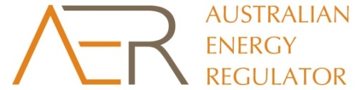

TransGrid electricity transmission — Framework and approach

Information sheet

1. Who is the AER?

The Australian Energy Regulator (AER) is responsible for the economic regulation of electricity transmission and distribution services in Australia's national electricity market. We are an independent statutory authority funded by the Australian Government. Our powers and functions are set out in the National Electricity Law and the National Electricity Rules (NER).

1. What is a Framework and approach?

The framework and approach (F&A) is the first step in the process to determine efficient prices for electricity transmission services. The F&A determines, amongst other things, how the AER will set prices for electricity transmission services and the application of any incentive schemes. The F&A also facilitates early consultation with consumers and other stakeholders and assists electricity businesses to prepare expenditure proposals.

1. Which electricity business does this process affect?

We are taking steps to determine if a new or amended F&A is required for New South Wales’ electricity transmission network service provider, TransGrid. TransGrid designs, constructs, operates and maintains a high voltage electricity transmission network for New South Wales electricity consumers. TransGrid’s next regulatory control period commences on 1 July 2018.

1. Why is a Framework and approach important?

The F&A is important because it provides an opportunity for interested parties to have a say in which incentive schemes should apply to TransGrid to encourage efficient investment and performance and how we should apply our Expenditure Forecast Assessment Guideline when assessing its expenditure proposal. The sort of issue we might consider in an F&A includes:

* Setting out whether incentive schemes will apply, for example, to service quality, improvements in network reliability or capital and operating expenditure. The purpose of incentive schemes is to encourage distribution businesses to manage their business in a safe, reliable manner that serves the long term interests of consumers. The schemes provide distribution businesses with incentives to only incur efficient costs in meeting their service quality targets. Distribution businesses may incur a financial penalty if they fail to meet set targets.

1. What are the next steps?

We are calling for submissions on whether we need to amend or replace the current F&A for TransGrid. Submissions close on 4 December 2015. If we decide to amend or replace the current F&A we will publish an issues/preliminary positions paper in early 2016 and consult on what amendments should be made. If a new F&A is required we will publish it by 31 July 2016.