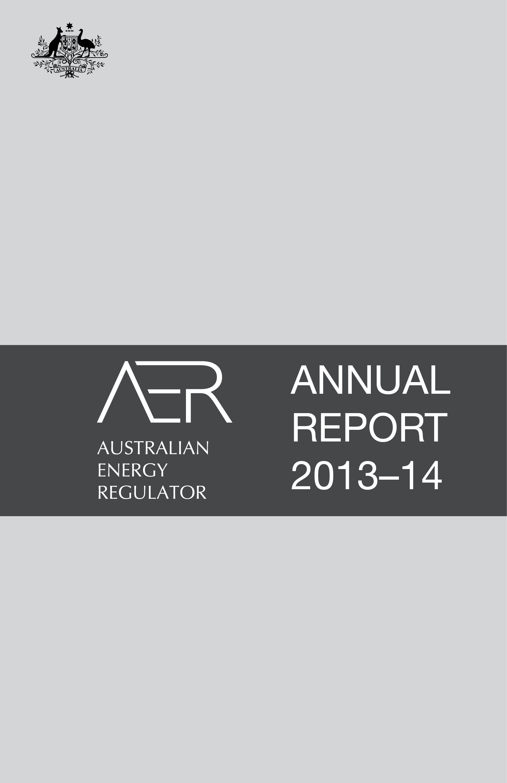
© Commonwealth of Australia 2014
This work is copyright. In addition to any use permitted under the Copyright Act 1968, all material contained within this work is provided under a Creative Commons Attribution 3.0 Australia licence, with the exception of:
• the Commonwealth Coat of Arms
• the ACCC and AER logos
• any illustration, diagram, photograph or graphic over which the Australian Competition and Consumer Commission does not hold copyright, but which may be part of or contained within this publication.
The details of the relevant licence conditions are available on the Creative Commons website, as is the full legal code for the CC BY 3.0 AU licence.
Requests and inquiries concerning reproduction and rights should be addressed to the Director, Corporate Communications, ACCC, GPO Box 3131, Canberra ACT 2601, or publishing.unit@accc.gov.au.
Inquiries about this document should be addressed to:
Australian Energy Regulator
GPO Box 520
Melbourne Vic 3001
Tel: (03) 9290 1444
Fax: (03) 9290 1457
Email: AERInquiry@aer.gov.au

AER reference: 52454; D14/54321
ACCC_09/14_865

Part 4
Stakeholder survey

Stakeholder surveys are a useful tool to seek feedback on our performance. They assist us in identifying what we do well and areas we can improve. The ratings empirically measure how we met some key performance indicators. Surveying a broad range of stakeholders and publishing the results promotes transparency and good governance.

Introduction
The 2014 survey results and commentary overall tell a positive story about the AER’s performance (figure 4.1), indicating stakeholders have confidence in us and our ability to make good decisions—within the boundaries of the regulatory regime. We were rated satisfactory to good against most performance indicators. Further, we received strong positive feedback about our recent initiatives to improve both the way we engage with stakeholders, and how we communicate our processes and decisions.
Figure 4.1: AER’s overall performance, 2014
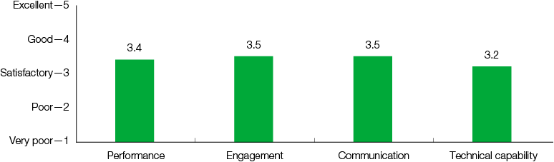
The previous stakeholder survey in 2011 indicated a decline in our performance compared with the 2008 survey. There was also public commentary at the time raising concerns about our performance.
We took the downward trend in the 2011 results and criticism seriously; it helped us understand stakeholders’ expectations of our performance. We identified the following themes:
• There was a perception that stakeholders had reduced confidence in us.
• Some questioned the robustness of our technical analysis, especially given the Australian Competition Tribunal overturned a number of our decisions.
• There were concerns about whether we engage constructively with industry and effectively communicate our decisions.
• Some considered we did not have a good understanding of the key issues facing the industry and, due to resource constraints, we lacked the technical capability to fulfil our role.
The 2014 stakeholder survey is more comprehensive than previous surveys in 2008 and 2011 (the results of which are available on our website). To better understand the above concerns, we added many new performance indicators and clarified the meaning of some existing indicators. We maintained a consistent approach where practicable to allow for performance comparisons over time.
Also, our independent consultant conducted targeted stakeholder interviews for the first time in 2014. We invited stakeholders with a broad perspective of our work and the energy sector more generally, such as industry organisations, to participate in the interviews. We also selected representatives of some businesses we regulate.
The 2014 survey results overall were reasonably consistent across the retail, wholesale and networks areas of the AER (figure 4.2). That said, the results indicated areas where we can improve our performance. In particular, survey participants rated our performance as marginally satisfactory for some indicators, and the commentary highlighted areas we can improve.
Figure 4.2: AER’s overall performance by area, 2014
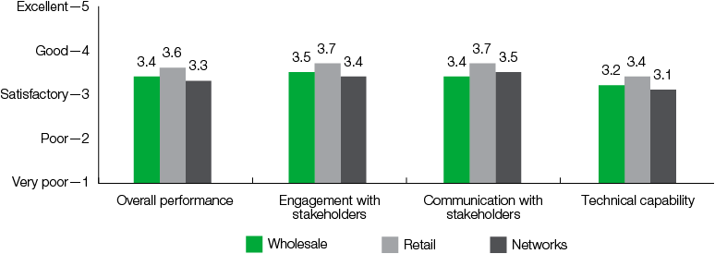
We are committed to continually improving our performance over time. We undertake to learn from the stakeholder feedback by identifying and addressing weaknesses and by building on our successes.

Survey methodology
Buchan Consulting, an independent consultant, conducted our 2014 stakeholder survey and interviews on our behalf.

Changes to the survey
Regular surveys allow us to benchmark our performance over time. While the 2008 and 2011 surveys used the same indicators, the 2014 survey introduced additional performance criteria to help identify any specific concerns. We also clarified the meaning of a number of the existing indicators to encourage objective responses (see appendix 5) and we deleted some previous indicators.
There were also some changes to the survey methodology that affect comparisons between the 2008, 2011 and 2014 results:
• The rating scale was changed from ‘1 to 4’ to ‘1 to 5’ for the 2014 survey. Our expert consultant considered a ‘1 to 5’ rating scale gave respondents a wider, more balanced range to evaluate the AER.
• Where we received multiple responses from the same area of an organisation (i.e., retail, wholesale or networks), the average rating of those respondents was recorded. This gave ratings from each organisation that we surveyed equal weighting so that some organisations are not ‘overrepresented’, which could skew the results to some extent.
• Consultants’ survey ratings were excluded from the overall results and are reported separately (see Consultant views below), given the unique nature of our relationship with them compared with other stakeholders.
To allow comparisons between the 2011 and 2014 survey results, the 2011 data was rescaled, ‘organisation responses’ weighted and consultant responses excluded—consistent with the 2014 survey methodology.

Survey distribution
We invited 290 senior people from a broad range of organisations to participate in the 2014 stakeholder survey including: network businesses, retailers, generators, ombudsman schemes, state regulators, industry and consumer representatives and associations, consultants, government departments and energy Ministers. Stakeholders were asked to complete an online survey.
Sixty per cent of recipients responded to the survey. We are confident a sample size of 173 means the survey results represented a broad range of our stakeholders.
Buchan Consulting also conducted 15 one-on-one qualitative interviews—mostly by phone. The interview questions followed a similar format to the online surveys and covered the same key themes. The AER chose interviewees from a cross section of key stakeholder groups: market institutions, government officials, consumer groups, industry associations and energy businesses.

Survey design
The survey gathered quantitative and qualitative stakeholder feedback on our performance. Participants were asked to identify and provide feedback on the area of our work program most relevant to their role in their organisation in the following categories:
(1) Monitoring compliance and enforcement in energy wholesale markets under National Electricity and Gas Laws (Wholesale Markets)
(2) Monitoring retail energy markets and regulating energy retail and distribution businesses under the National Energy Retail Law (Retail Markets)
(3) Gas and electricity network economic regulation and monitoring enforcement and compliance of network businesses under the National Electricity and Gas Laws (Networks).

Survey structure
The first set of questions in the survey was about the AER’s overall performance. They go to the key capabilities of a good regulatory agency, such as impartiality, transparency and timeliness of decisions.
The survey then sought more specific feedback on three areas of performance, namely engagement, communication and technical capability.
The discussion below follows the survey’s format. That is, first we highlighted our performance results for the higher-level indicators, followed by a more detailed examination of the ratings for the engagement, communications and technical capability performance indicators.

Performance
As the national energy regulator, we must make timely, evidence based, independent decisions. We must also manage risks appropriately, act with integrity and engage effectively with stakeholders. Such criteria reflect our overall performance as a regulator.

Stakeholders have confidence in the AER
The survey indicators relating to trust, independence, leadership and consistency reflect stakeholders’ confidence in the AER. Trust is fostered by communicating honestly and directly and acting respectfully, for example. Independence relates to decisions being made on their merits, in accordance with the regulatory framework and not being inappropriately influenced by political interests, lobby groups or particular market participants.
We performed well against the ‘stakeholder confidence’ indicators (figure 4.3). Survey ratings for ‘trust’ were among the highest across all survey indicators.
Figure 4.3: AER’s performance against stakeholder confidence criteria, 2011–2014
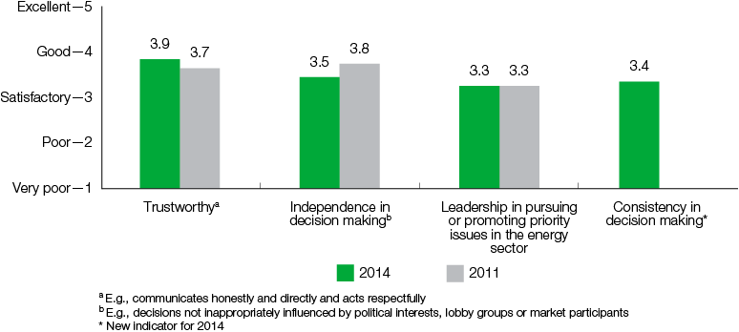
We expect these results reflect our recent initiatives to increase our transparency and ensure stakeholders have an opportunity to contribute to our processes:
• producing our standalone AER annual report, which provides detailed information about our resourcing and comments on our performance against key performance indicators and deliverables
• explaining regulatory processes and decisions at stakeholder workshops and roundtable discussions
• introducing consumer-friendly documents and factsheets to accompany decisions (see Communication).
Ratings for retail and networks were consistently satisfactory to good across the ‘stakeholder confidence’ indicators (figure 4.4).
Figure 4.4: AER’s performance against stakeholder confidence criteria by area, 2014
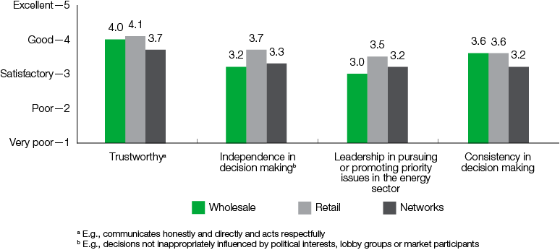
Wholesale’s results varied, receiving scores of satisfactory to good for ‘trust’ and ‘consistent decision making’ but marginally satisfactory scores for ‘leadership in pursuing or promoting priority issues in the sector’ and ‘independence in decision making’. We will consult with our stakeholders to identify and understand underlying concerns about our performance in this area and explore ways to address any perceived weaknesses.

We make decisions in the long term interests of consumers
Our decision making is guided by the national energy objectives to promote efficient investment in, and efficient operation and use of, energy services for the long term interests of consumers of energy with respect to:
• price, quality, safety, reliability and security of supply of energy
• the reliability, safety and security of the national energy systems.
Robust analysis and understanding of the key issues facing the industry helps us make decisions consistent with the long term interests of consumers. Productive partnerships with stakeholders are also an integral part of this and help us to identify the important issues affecting the energy sector.
We received satisfactory results for the ‘decision making’ indicators (figure 4.5).
Figure 4.5: AER’s performance against decision making criteria, 2011–2014
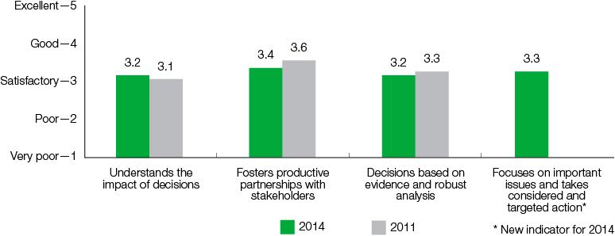
Our retail and wholesale work areas consistently received satisfactory ratings across the ‘decision making’ indicators (figure 4.6).
Figure 4.6: AER’s performance against decision making criteria by area, 2014
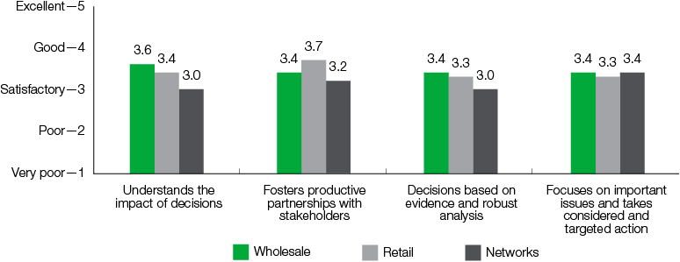
Networks was rated marginally satisfactory for ‘understands the impacts of decisions’, ‘fosters productive partnerships with stakeholders’, and ‘decisions based on evidence and robust analysis’. These results may be partly related to stakeholder concerns about our technical capability, which is discussed in more detail below (Technical capability).
They may also reflect specific concerns about information requirements we impose on the network businesses to assess their regulatory proposals. We request information, for example, to understand how the businesses operate, and to enable us to compare their performance against each other and over time. Several survey participants commented the requirements are excessive and do not reflect an understanding of the resourcing required to meet such obligations.
We consulted extensively about these information requirements, so we only request information that is reasonably required for us to perform our functions under the law. However, we recognise that given the large volume of information requested, more can be done to minimise the compliance costs on the network businesses over time. We commit to periodically reviewing the requirements in close consultation with the businesses.

We are held accountable
We are accountable for our decisions and, ultimately, our performance as a regulator. We must act impartially, with appropriate regard for proper process and within the limits of our authority. We have a duty to explain our decisions and we are exposed to external scrutiny via the Australian Competition Tribunal. We are also subject to the performance and statutory requirements common to all Commonwealth agencies, as well as the COAG Energy Council’s new accountability and performance framework (discussed in part 1).
We performed well against the ‘accountability’ indicators (figure 4.7). Survey ratings for ‘conduct within the legislative framework’ were among the highest across all survey indicators.
One interviewee stated:
Success is being actively engaged with all participants and that their decisions are timely and following the intent of the legislations. At different times, the legislation has different meaning/intent. So regulating is not a set and forget. The AER is really successful in fulfilling that set of criteria; they are active participants in the conversations. They are a player, and the way they engage and ‘play’ sets the way everyone else is involved.
Figure 4.7: AER’s performance against accountability criteria, 2011–2014
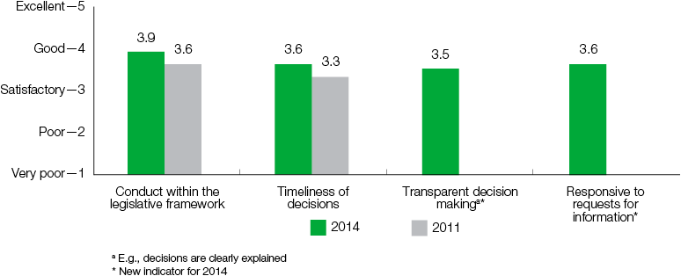
Ratings for our retail, wholesale and networks work areas were consistently satisfactory to good across the ‘accountability’ indicators (figure 4.8).
Figure 4.8: AER’s performance against accountability criteria by area, 2014
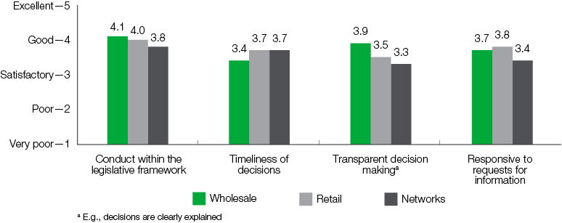

Engagement
The AER has a broad range of stakeholders. It is imperative we meaningfully engage with our stakeholders to remain up to date on market issues and to ensure we account for their views in our decisions. We also need to explain simply how energy market regulation works and to justify our decisions. Regulatory certainty promotes efficient investment and consumer confidence in energy markets. Uncertainty about how regulation is applied can increase the cost of providing energy services by increasing investment risk.
In the 2014 survey we introduced new indicators to get more specific feedback about our engagement practices. We performed well against the ‘engagement’ indicators, particularly ‘opportunity for stakeholder input’ (figure 4.9).
Figure 4.9: AER’s performance against engagement criteria, 2011–2014
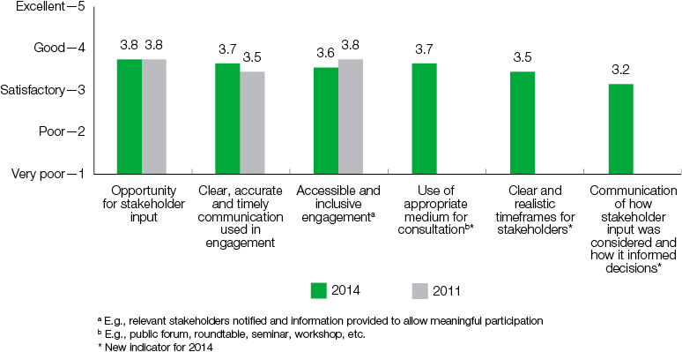
We expect these results reflected our recent initiatives to improve engagement with consumers and the regulated businesses—both in terms of quantity and quality. Our engagement strategy for the Better Regulation guidelines, for example, included public forums and meetings, a submission process and a dedicated forum for consumer representatives—the Consumer Reference Group (CRG). We held over 50 workshops for consumers and the network businesses. There were also a large number of bilateral discussions with investors, network businesses and certain consumer groups.
The engagement was constructive and informed the Better Regulation guidelines. We worked closely with the CRG to inform them of our position and sought feedback from members throughout the development process. We explained the key issues and reasons why each guideline adopted certain approaches, for example. We clearly set out what problem we were trying to solve, and the options we were considering or intending to adopt. CRG members were able to distil key issues and information to constituents for consideration, consult and report back to us.
Another recent initiative is the AER Stakeholder Engagement Framework and, separately, the AER Service Charter. These documents clearly set out what our stakeholders can expect when they contact us or engage with us. The framework commits us to communicate in a timely and clear way, and to be accessible and inclusive, transparent and measurable in our engagement activities. As part of our service charter, we encourage consumers and businesses to share information with us about energy market issues or problems with energy businesses.
Interviewees and survey respondents commented on our improved engagement strategy; for example, one respondent noted:
There has been substantial improvement in the formal mechanism and framework to involve consumers in the process, through things like the Consumer Challenge Panel and Better Regulation, which is a positive step.
That said, a number of stakeholders noted we must be mindful that consumer representatives often have limited time and resources:
Full marks to the Regulator for the right direction and intent. However, don’t bury us with unnecessary information as our resources are too stretched for meaningful engagement
Ratings for retail and wholesale were satisfactory across the engagement indicators (figure 4.10).
Figure 4.10: AER’s performance against engagement criteria by area, 2014
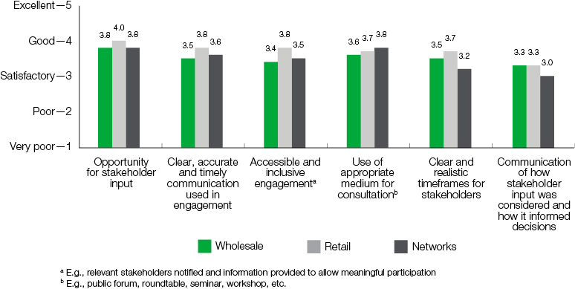
Although networks scored well against most of these criteria, it was rated only marginally satisfactory for ‘communication of how stakeholder input was considered and how it informed decisions’ and ‘clear and realistic timeframes for stakeholders’. The related commentary was mixed. One survey respondent stated:
There could be more transparency in reasons for decisions, and how stakeholder comments have been considered in forming decisions.
By contrast, another interviewee stated:
[The AER’s] engagement has improved. They have improved access, if needed we get access to staff; get a better understanding of their decisions and key issues.
We understand some businesses voiced their frustration that our information requests can lack context, which in their view led to the AER misunderstanding the businesses’ responses. Feedback indicated businesses prefer less formal discussions to clarify the regulatory proposals.
Stakeholders must be confident their input will be valued, understood and accounted for in the decision making process. We endeavour to have an open and consultative relationship with our stakeholders. We want to avoid an approach based solely on documentation exchange. Instead, we prefer to focus more on inquiry, questioning and understanding, although less formal approaches are not always practicable or appropriate. We report against a number of key performance indicators relating to effective engagement (see section 5).

Communication
The energy industry is complex and our decisions are often highly technical. Therefore, we must explain our roles and responsibilities clearly and concisely. Our communications—including our decision documentation and media releases—must be easily accessible to our stakeholders, such as industry and consumers.
In the 2014 survey we introduced new indicators to get more specific feedback about our communications. We performed well against the communication indicators, particularly ‘availability of information on the AER website’ (figure 4.11). Some stakeholders commented positively on our communications:
Generally a positive improvement in external communication, the different material it produces and transparency of its decision making. It has also clearly been an area of focus for the organisation which is credit to the leadership of the AER.
Their reports are well written, well prepared, well structured, well targeted and offer a positive contribution.
Figure 4.11: AER’s performance against communication criteria, 2011–2014
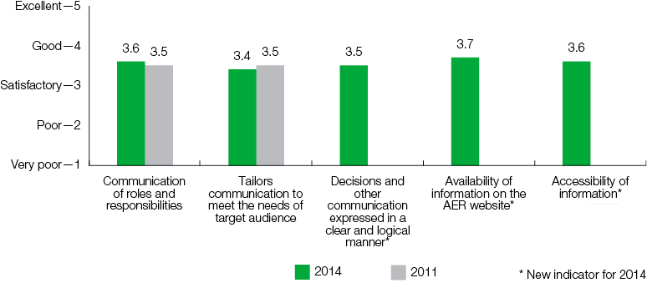
We expect the strong positive results and commentary reflected our recent initiatives to improve publications, to make them accessible to a broader range of stakeholders. We used clear, plain English and keep our documents as concise as possible. We also developed factsheets to accompany each draft and final decision document. They provide a simple, high-level explanation of our decisions and highlight points of interest.
A key focus has been educating stakeholders about our role and their rights and responsibilities under the various pieces of legislation under which we operate. Since the 2011 survey, we gained new responsibilities under the National Energy Retail Law. In the lead up to, and following the Retail Law’s commencement, we consulted extensively with stakeholders to develop the Retail Guidelines. In 2012 we launched the Energy Made Easy price comparator website. Energy Made Easy provides accessible information for residential and small business consumers on the energy market, consumer protections and available energy offers.
We also made it easier for stakeholders to contribute to our often complex processes. While developing the Better Regulation guidelines, for example, we held training sessions for consumer representatives on how a network determination process works. Further, we met with the CRG to explain our position, to ensure stakeholders focused on the most important issues, and to make it easier for them to provide feedback. We also developed a monthly newsletter which we published on our website. The newsletter updated stakeholders on our progress and highlighted upcoming events that may interest them.
Our wholesale markets team engaged regularly with both gas and electricity market participants, often at a detailed technical level, to appreciate the pressure points facing market players and so industry can better understand the matters concerning the AER.
Ratings for our retail, wholesale and networks work areas were consistently satisfactory to good across the ‘accountability’ indicators (figure 4.12).
Figure 4.12: AER’s performance against communication criteria by area, 2014
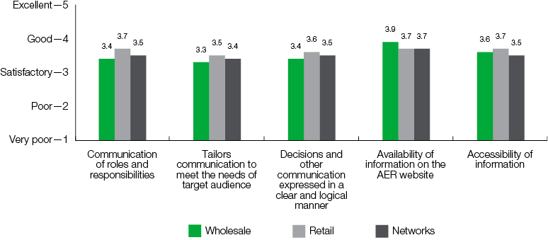
The survey also sought specific feedback on our more significant publications—such as the State of the energy market report. Overall, stakeholders found our publications useful (figure 4.13). The State of the energy market report received positive feedback from readers, with several respondents describing it as a valuable reference. Our factsheets also received strong positive feedback:
The factsheets about the network [decisions] are presented in a really clear format. They clearly explain how [the AER] has arrived at their decision(s) and the impact for customers, so I do think that has been an improvement and I have attended a few of the AER customer council meetings and when they are putting together reports, etc. such as the affordability section that they did recently in their report. They really consulted with that group to make sure that that page captured the consumer concerns around the affordability into their analysis, and what they were actually presenting and communicating in that document.
Figure 4.13: Usefulness of AER communication tools, 2011–2014
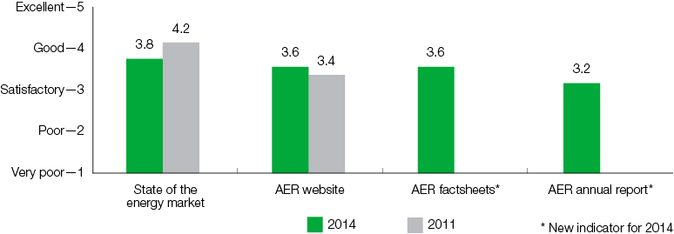
Feedback on our website was mixed. Some stakeholders responded positively to major changes we made to in 2012, while others found it somewhat difficult to navigate. We are committed to ensuring the AER website provides our stakeholders with timely access to information on energy market activity. We will continue trying to make it more accessible and easier for stakeholders to find relevant information. We are also working on enhancements to the Energy Made Easy website. These improvements will enhance accessibility and provide new tools that will assist residential and small business energy consumers, and make it easier for them to compare energy offers.

Technical capability
Regulating energy markets and networks is inherently complex; network price reviews, for example, deal with technical issues on rates of return on investment. Some stakeholders are unfamiliar with economic terms and do not understand the ‘building block approach’ we use to determine how much revenue a business requires to cover its ‘efficient costs’.
Some stakeholders have publicly voiced their concerns about the AER’s technical capability and our ability to fulfil our functions efficiently and effectively, especially in network regulation. The 2014 survey introduced new indicators to get more specific feedback about our technical capability.
Overall, we received satisfactory results for the technical capability performance indicators, although industry experience was rated poor (figure 4.14).
Figure 4.14: AER’s performance against technical capability indicator, 2011–2014
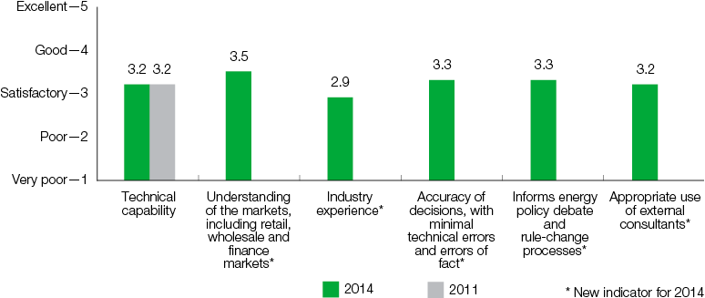
Ratings for our retail work area were consistently satisfactory across the technical capability indicators, although retail was rated as marginally satisfactory for ‘industry experience’ (figure 4.15). This may reflect that the retail branch of the AER is relatively new given the National Energy Retail Law was introduced in Tasmania and the ACT in 2012, and in South Australia and New South Wales in 2013. Our role will continue to evolve as the Retail Law is adopted by the other jurisdictions.
The survey results for wholesale were marginally satisfactory for ‘industry experience’ and ‘informs energy policy debate and rule-change processes’, and the overall indicator for technical capability. These results may reflect, for example, that we have been more targeted in attending workshops on wholesale market issues. We will consult with our stakeholders to identify and understand underlying concerns about our performance in this area and explore ways to address any perceived weaknesses.
Figure 4.15: AER’s performance against technical capability criteria by area, 2014
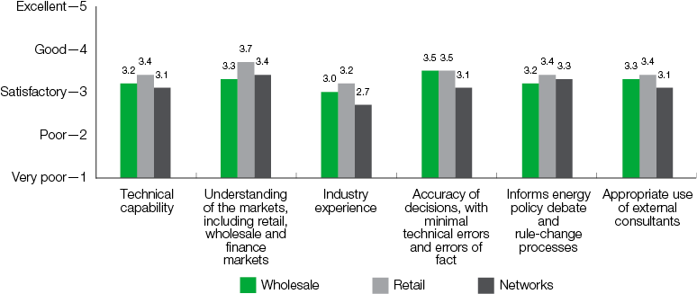
Networks scored poorly for ‘industry experience’, and was rated marginally satisfactory for ‘accuracy of decisions’, ‘use of consultants’ and the overall indicator for technical capability. These views are reflected in interviewee responses:
‘[It is] absolutely critical that the AER can engage with regulated businesses on the more technical, engineering aspects of their proposals. This is one of the areas that we have been most concerned with in the past two years.’
In the past year we significantly improved our in-house technical capability and our information and analytical tools, such as our economic benchmarking capability, which may not be reflected in the 2014 survey results. We appointed four engineering technical advisors to bolster our industry expertise—particularly in electricity networks. They add to the extensive energy and regulatory expertise and experience of the AER Board and staff. AER staff have a broad range of energy and regulatory expertise and experience (in section 6). Some staff joined us from other energy regulators, both state utility regulators and international energy regulators. Others came from consulting firms and the energy sector.
We expect such initiatives will improve stakeholder perceptions of our technical capability over time. For the round of network pricing determinations that started in 2014, the new Technical Advisor Group will be involved the regulatory process, by meeting with the network businesses, and providing specialist industry advice to AER staff and Board members. Moreover, they will develop our expertise through a program of internal capability building, including training staff and advising on improved processes and analytical methodologies. Further, enhancing our internal technical capability means we can seek more targeted assistance from external consultants.

Consultant views
We rely on external advisors, such as legal counsel and expert technical consultants, who examine the more technical aspects of network pricing proposals. It is also true for our stakeholders, especially the businesses we regulate. Our reliance on technical experts is reflected in expenditure on consultants (see part 7).
Consultants consistently rated our performance across all indicators as above satisfactory to good (figure 4.16)
Figure 4.16: AER’s overall performance—Consultants’ views, 2014
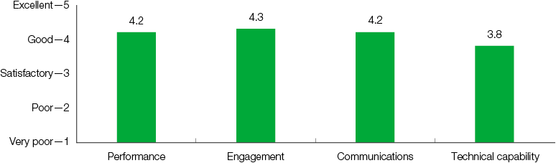

Summary of survey findings
The results of the stakeholder survey and interviews are important to us. They assist us evaluate our performance, to help maintain and drive improvements in the way we operate.
The 2014 survey results and commentary tell an overall positive story about the AER’s performance, indicating stakeholders have confidence in us and our ability to make good decisions—within the boundaries of the regulatory regime. We were rated satisfactory to good against most performance indicators. Further, we received strong positive feedback about our recent initiatives to improve the way we engage with stakeholders, and communicate our processes and decisions.
That said, the results highlight areas where we can improve our performance. In particular, survey participants rated our performance as marginally satisfactory for some indicators, and the commentary highlights areas where we can make improvements.
We endeavour to continually improve our performance over time. We undertake to learn from the stakeholder feedback by identifying and addressing weaknesses in our performance, and by building on our successes.

See at www.aer.gov.au/publications/corporate-documents
In the 2008 and 2011 surveys, respondents could rate the AER ‘poor’ (1), ‘satisfactory’ (2), ‘good’ (3) or ‘excellent’ (4). The options in 2014 were ‘very poor’ (1), ‘poor’ (2), ‘satisfactory’ (3), ‘good’ (4) and ‘excellent’ (5).
Additionally, for the 2014 survey, respondents could select ‘N/A’ if a survey question did not apply to them or if they do not wish to answer the question.
To rescale the results, 2011 ratings of ‘1’ (poor) were converted to ratings of ‘1’ (very poor) and ‘2’ (poor) by applying roughly the same percentage ratio of the ‘very poor’ (30 per cent) and ‘poor’ (70 per cent) ratings observed for the 2014 responses. 2011 survey responses of ‘satisfactory’, ‘good’ and ‘excellent’ were directly comparable with 2014 responses. Buchan Consulting advised these were reasonable assumptions. Unfortunately, the detail of the 2008 survey results was unavailable, so the 2014 survey methodology could not be retrospectively applied to the 2008 results.
Moreover, we report against key performance indicators in this annual report, including indicators relating to transparency and timeliness of decisions, responsiveness to information requests, and avoiding successful challenges and appeals of our decisions (see part 5).

