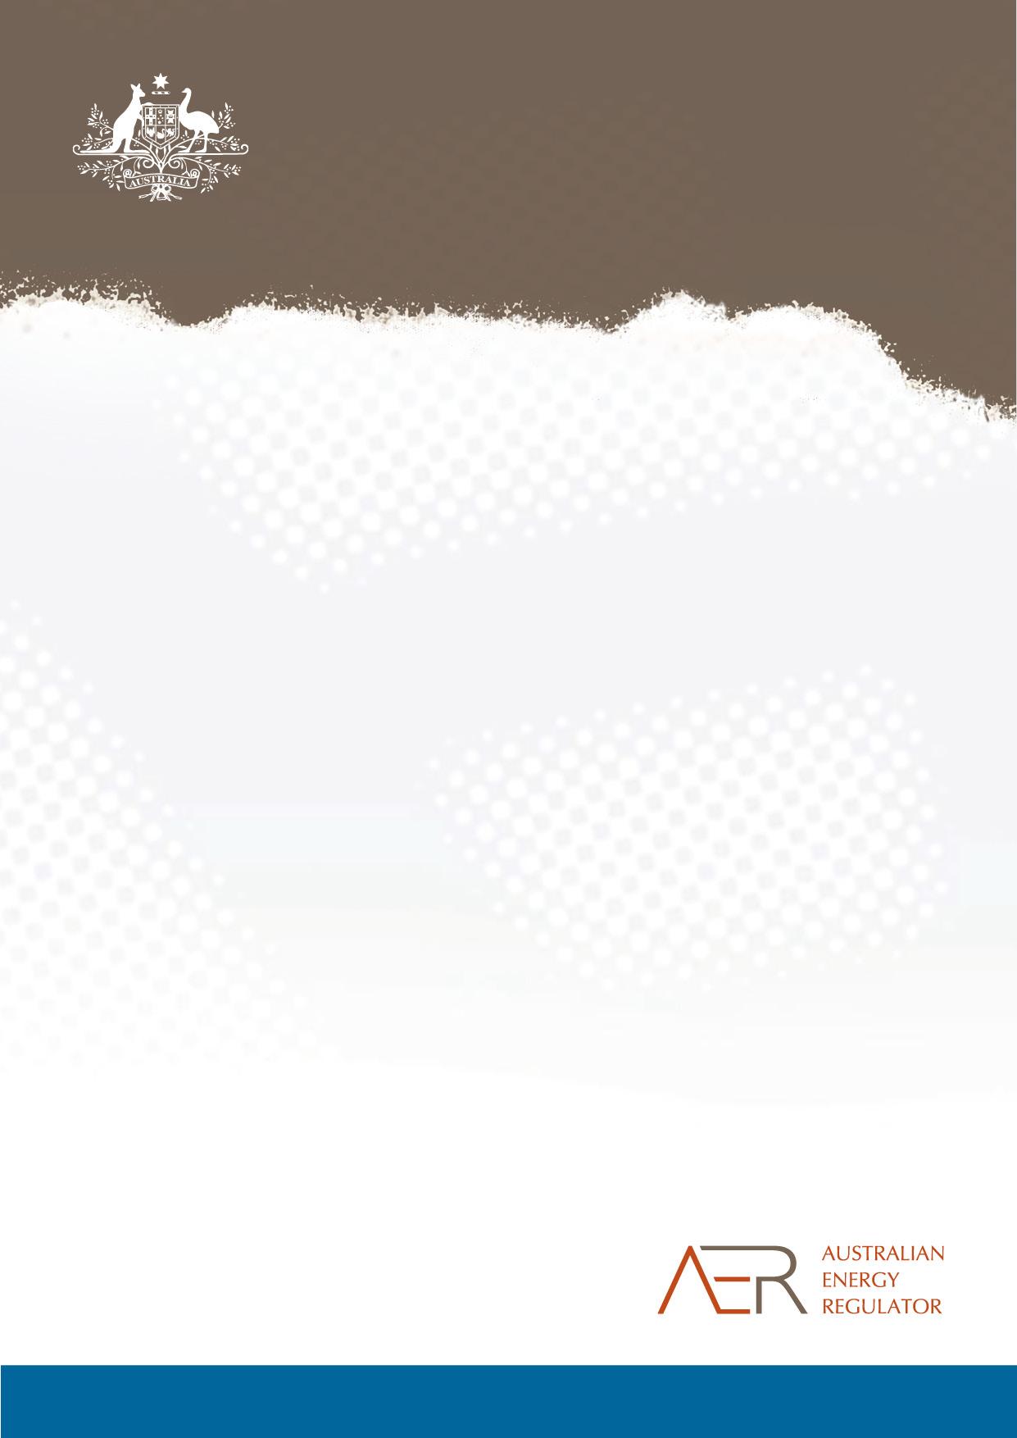

Annual report on the performance of the retail energy market

2014-15

© Commonwealth of Australia 2015

This work is copyright. In addition to any use permitted under the Copyright Act 1968, all material contained within this work is provided under a Creative Commons Attributions 3.0 Australia licence, with the exception of:

* the Commonwealth Coat of Arms
* the ACCC and AER logos
* any illustration, diagram, photograph or graphic over which the Australian Competition and Consumer Commission does not hold copyright, but which may be part of or contained within this publication. The details of the relevant licence conditions are available on the Creative Commons website, as is the full legal code for the CC BY 3.0 AU licence.

Requests and inquiries concerning reproduction and rights should be addressed to the   
Director, Corporate Communications,   
Australian Competition and Consumer Commission,   
GPO Box 4141,   
Canberra ACT 2601   
or publishing.unit@accc.gov.au.

Inquiries about this publication should be addressed to:

Australian Energy Regulator  
GPO Box 520  
Melbourne Vic 3001

Tel: (03) 9290 1444  
Fax: (03) 9290 1457

Email: [AERInquiry@aer.gov.au](mailto:AERInquiry@aer.gov.au)  
AER Reference: 58066

Amendment Record

|  |  |  |
| --- | --- | --- |
| Version | Date | Pages |
| Final | 23/11/2015 | 104 |

Contents

About this report 4

Key findings in 2014-15 7

1 Retail market overview 11

1.1 Retail competition 12

1.2 Standard and market retail contracts 15

1.3 Customer switching rates 17

2 Energy retailer performance 21

2.1 Customer service 22

2.2 Complaints 23

2.3 Energy bill debt 29

2.4 Payment plans 32

2.5 Hardship programs 33

2.6 Disconnections and reconnections 44

2.7 Energy concessions 49

2.8 Security deposits 50

3 Energy affordability 51

3.1 How we report on energy affordability 51

3.2 National comparison 52

3.3 Queensland 54

3.4 New South Wales 59

3.5 Victoria 64

3.6 South Australia 69

3.7 Tasmania 74

3.8 ACT 76

4 Appendices 81

# About this report

The Australian Energy Regulator (AER) is responsible for reporting on energy retailers’ performance under the National Energy Retail Law (Retail Law).[1] Performance reporting enhances transparency and accountability, and provides incentives for businesses to improve performance. It helps identify emerging issues requiring a compliance or enforcement response, and brings transparency and integrity to the market.

This is our third annual retail market performance report and it covers:

* an overview of the retail market
* customer service and complaints
* assistance provided to customers experiencing payment difficulties, including hardship programs
* disconnections and reconnections
* energy affordability
* distribution businesses’ performance against network service standards.

Energy is an essential service, necessary for a reasonable standard of living. Energy is also a big expense for many households. Monitoring and reporting on how energy retailers assist customers experiencing payment difficulties, together with our annual analysis of energy bills for low income households make an important contribution to the national conversation on issues of energy affordability.

This report is structured as follows:

1. Retail market overview: this chapter looks at retailers’ shares in small and large customer markets, the number of customers on standard and market retail contracts in each jurisdiction that has applied the Retail Law [2] and switching rates in all National Electricity Market (NEM) jurisdictions (Chapter 1).
2. Energy retailer performance: this chapter discusses key performance indicators of energy retailers with small customers in jurisdictions that have applied the Retail Law. Indicators include customer service levels, the assistance given to customers experiencing payment difficulties (for example payment plans and hardship programs) and the number of customers disconnected for non-payment (Chapter 2).
3. Energy affordability: this chapter considers how much households in NEM jurisdictions spent on electricity and gas in 2014-15, annual bills as a proportion of household disposable income, and whether energy has become more or less affordable compared with the last two years (Chapter 3).

We are also required to report on:

1. South Australian retailers’ performance against jurisdictional service standards (Appendix 2), and
2. Distribution network service providers’ performance against certain service standards and Guaranteed Service Level schemes[3] (Appendix 3).

Market overview:
- 17 electricity retailers to choose from in NSW, 14 to choose from in South Australia
- 7 gas retailers to choose from in NSW, 5 to choose from in South Australia
- The 'Big 3' retailers supply 91% of households with electricity and 97% of households with gas in NSW
- The 'Big 3' retailers supply 77% of households with electricity and 88% of households with gas in South Australia
- Around 1,000,000 electricity customers and 300,000 gas customers remain on a standard retail contract in NSW
- Aurora Energy supplies 100% of households in Tasmania
- ActewAGL supplies over 95% of households in the ACT

Debt, hardship and disconnections:
- 3.9% of households owe an electricity debt and 4.5% of households owe a gas debt to their energy retailer
- 22% of electricity customers with debt and 11% of gas customers with debt are on hardship programs

Households disconnected for non-payment:
31,979 electricity and 7,555 in NSW
10,179 electricity and 4,575 gas in South Australia
345 electricity and 1,404 gas in the ACT
1,046 electricity in Tasmania

# Key findings in 2014-15

**Customer engagement with the market**

Choice in energy markets provides consumers with more opportunities, and greater incentives, to be actively engaged in finding an energy offer to meet their needs.

Despite the relatively large number of electricity retailers in New South Wales (21) and South Australia (17), both markets are still heavily concentrated with the 'big three' retailers (AGL, EnergyAustralia and Origin Energy) supplying a significant majority of customers (90 per cent and 76 per cent respectively). The smaller markets are even more concentrated: ActewAGL supplies over 95 per cent of ACT households. Tasmanian households are still waiting for a new entrant to compete with monopolist Aurora to provide choice. While the market for gas is smaller in each of these jurisdictions, the big three still dominate the South Australian and New South Wales gas markets, as does ActewAGL in the ACT.

The declining rate of customer switching suggests that energy retailers may be shifting their focus away from customer acquisition and towards customer retention. It is encouraging to see an increasing proportion of customers have moved off standing (or regulated) offers to market retail contracts, which are typically lower priced. In South Australia, 84 per cent of electricity customers and 83 per cent of gas customers are on market retail contracts. It is slightly lower in New South Wales at 69 per cent and 76 per cent respectively. In the ACT and Tasmania, the significant majority of consumers remain on standing offers, although we will look to next year to see the impact of new retailers entering the ACT market, and possibly Tasmania.

Complaints to energy retailers increased in 2014-15, with billing (which includes pricing) the leading cause for concern. In what could be seen as a sign of improved complaint management by retailers, however, energy ombudsman schemes received generally fewer complaints in 2014-15 compared with 2013-14.

**Energy debt and payment difficulties**

The Retail Law provides protections for customers experiencing payment difficulties and it is important that retailers and customers share responsibility for identifying and managing payment difficulties as early as possible.

The proportion of residential and small business customers who were repaying an electricity debt fell between 2014 and 2015 in South Australia, New South Wales, the ACT and Tasmania. However, South Australia has a higher proportion of customers with debt than the other jurisdictions.

The proportion of residential and small business customers who were repaying a gas debt fell between 2014 and 2015 in South Australia and New South Wales but rose in the ACT. The ACT also had the highest proportion of customers with a gas debt.

By subtracting the number of customers on a hardship program from the total number of customers with debt, we find customers that may be on a payment plan or receiving no retailer assistance. Despite having lower debts, these customers are still in financial difficulty and need the right type of assistance. We found that the proportion of residential customers with an electricity debt (but who were not on a hardship program) fell between 2014 and 2015. South Australia had the highest proportion of these customers at over 4 per cent, compared to around 2.7 per cent in New South Wales and the ACT. Average debts were also higher in South Australia. Tasmania had the lowest proportion of customers with an electricity debt (2 per cent, after allowing for the number on hardship programs). This number has decreased from around 3 per cent in the last two years.

The proportion of residential customers with a gas debt (but not on a hardship program) fell to 3% in South Australia and 4% in New South Wales between 2014 and 2015, but increased to around 7% in the ACT.

**Managing payment difficulties through payment plans and hardship programs**

Customers who are experiencing payment difficulties must be able to access timely and appropriate assistance. Retailers must offer different levels of assistance, including a payment plan or hardship program, depending on the severity of the customer’s payment difficulties.

Payment plans are typically the first line of assistance offered to customers that are showing signs of payment difficulties, and are often enough to help customers repay their energy debt. In 2014-15, we observed a small decrease in the number of South Australian and Tasmanian customers being assisted through a payment plan. This may be due to the decrease in the number of customers with an energy debt. There was an increase in 2014-15 in the number of households in New South Wales and the ACT on payment plans.

In addition, the number of customers with an energy debt who entered a hardship program also increased. In South Australia, the number of electricity and gas customers on hardship programs increased by around 2,500 (30 per cent) and 1,200 (43 per cent) respectively. South Australia had the highest proportion of customers on a hardship program (at 1.5 per cent for electricity and 1 per cent for gas). The number of hardship customers in New South Wales was lower, but rose slightly in 2014-15, to 0.74 per cent of electricity customers and 0.36 per cent of gas customers. The number of customers on hardship programs in Tasmania increased by around 700 (65 per cent), to 0.7 per cent of customers, but remained steady in the ACT.

The increase in the number of customers on a hardship program suggests that retailers are now willing to offer this high level of assistance earlier and also that customers are seeking assistance from their retailers when they need it. We expect retailers to offer, and customers to ask for, assistance as soon payment difficulties are identified.

Debt on entry to a hardship program is therefore an important indicator of how readily a retailer identifies, and moves to assist, a customer experiencing severe payment difficulties. Many retailers continue to report a significant number of customers entering hardship programs with high levels of debt. AGL and Origin Energy reported that almost 20 per cent of customers that entered their hardship programs in 2014-15 (around 1,200 each), had electricity debts of over $2,500. We expect that retailers should be identifying customers having trouble and offering assistance before this point and were pleased to see that some retailers, such as Red Energy, are entering a high proportion of customers (up to 86 per cent) with debt below $500 onto a hardship program.

While the number of hardship customers using Centrepay has increased, the proportion of hardship customers using Centrepay has actually fallen. While we would like to see greater use of Centrepay, it is restricted to customers receiving Centrelink payments. Centrepay may be poorly promoted by some retailers, or not favoured by customers. It is also possible that more customers who are not on low incomes and do not have the option of Centrepay are now entering hardship programs.

The declining number of concession customers accessing hardship programs also lends support to the plausibility of this scenario. Concession customers as a proportion of customers on hardship programs for both electricity and gas also decreased in most jurisdictions.

On the other hand, it is encouraging that the proportion of electricity customers successfully repaying their debt on a hardship program increased from 19 per cent in 2013-14 to 24 per cent in 2014-15. However, over this period the rate of exclusion from a hardship program (for not meeting repayments) increased slightly from 54 to 57 per cent. The rates for gas customers are similar, with the "success rate" increasing from 19 per cent to 22 per cent and the exclusion rate also increasing from 54 to 57 per cent.

**Disconnecting customers for non-payment**

Disconnection is serious and should be a last resort for retailers when customers are unable to pay their energy bills. Retailers have to follow a number of steps before they disconnect a customer. Our observation is that for the most part, retailers do this.

Electricity disconnections decreased in Tasmania (by 34 per cent), New South Wales (5 per cent), and South Australia (1 per cent) but increased in the ACT (by 27 per cent). Proportionally, South Australia had the most electricity customers disconnected for non-payment (1.36 per cent), followed by New South Wales (1.06 per cent), Tasmania (0.45 per cent) and the ACT (0.21 per cent).

Gas disconnections for non-payment increased by 49 per cent in New South Wales, 31 per cent in South Australia and 28 per cent in the ACT in 2014-15. Gas disconnections in South Australia have increased to levels similar to 2011-12, however gas disconnections in New South Wales and the ACT are not high compared with previous years. Proportionally, the ACT had the most gas customers disconnected for non-payment (1.2 per cent), followed by South Australia (1.12 per cent) and New South Wales (0.62 per cent).

**Energy affordability**

While our analysis shows modest falls in energy prices and general improvements in energy affordability over the last 12 months (in line with the removal of the carbon tax), growth in energy prices in previous years has outstripped growth in incomes. Energy remains a big expense for many households, and energy debt and disconnection figures also suggest that many households struggle to pay their energy bills.

Following the removal of the carbon tax, electricity bills decreased in most jurisdictions, by between 3.5 per cent in South Australia and 15 per cent in the ACT (for low income households on market offers). The exception was in Queensland, where bills increased by 4 per cent. This was largely due to wholesale energy costs and the costs of feed-in tariffs from the Queensland Solar Bonus Scheme. Gas bills decreased in Victoria and the ACT (by between 4 and 5 per cent), but increased in New South Wales (7 per cent), Queensland and South Australia (both 1 per cent).[4] Reduced network charges will contribute to lower electricity bills in the future. However, electricity bills are also influenced by wholesale and retail costs.

Annual electricity bills remained highest in Tasmania ($1927) and lowest in Victoria ($1188) for low income households. Annual gas bills were highest in the ACT ($1532). Households in Tasmania typically consume the most electricity, and households in the ACT consume the most gas.

Electricity bills again accounted for the smallest share of disposable income in the ACT (3.6 per cent for a low income household). This is due to lower electricity charges and higher incomes relative to other jurisdictions. Low income Tasmanian households spent the highest proportion of their income on electricity at 8.4 per cent (6.4 per cent with a concession) which is not surprising given most households rely on electricity for all their household energy needs (i.e. do not have gas).

Despite low gas prices in Victoria, gas bills made up the greatest proportion of household income (for a low income household) relative to other jurisdictions at 4.8 per cent. This is driven by higher gas consumption. Households in Queensland have low gas consumption, with gas bills representing 2.9 per cent of a low income household's income.

Our analysis showed that customers on standing offers can make considerable savings by switching to a market offer. In jurisdictions where electricity market offers are available, the median market offer was between 5 and 20 per cent cheaper per year than the standing offer. The potential savings were slightly smaller for gas market offers (but still up to 16 per cent).

The range between the cheapest and most expensive market offers was around $400 in some areas of New South Wales and around $200 to $350 in Victoria and South Australia. Potential savings in Queensland and the ACT are less significant, with fewer electricity offers to choose from.

The potential savings on gas are smaller. Compared with the median gas market offer, the cheapest gas market offers were around $100 to $150 per year cheaper in Victoria and the ACT, but only around $20 to $70 cheaper in Queensland, New South Wales and South Australia.

# Retail market overview

This chapter provides an overview of competition in the retail energy markets in New South Wales, South Australia, Australian Capital Territory and Tasmania, with a focus on:

* the number of active retailers selling energy to different types of customers
* the proportion of small customers on standard and market retail contracts
* customers switching between retailers (in all NEM jurisdictions)
* customers using prepayment meters

## Retail competition

In June 2015 the Australian Energy Market Commission (AEMC) released its 2015 Retail Competition Review[5]. It found that:

* competition is providing consumers more opportunities to choose an energy retailer and offer that best meets their needs. Further developments are expected over time as this evolution continues and new technologies are taken up.
* electricity retail competition is effective in New South Wales and South Australia, less effective in the ACT and yet to emerge in Tasmania
* gas retail competition is effective in most of New South Wales and South Australia, and yet to emerge in the ACT.

The report also states that government policies and regulation can influence how quickly a market transitions through competition stages, and that regulation of retail markets has changed over time to promote greater competition.

Figure 1.1 shows the different stages of regulatory reform in retail energy markets of Australia.

Figure 1.1: Stages of energy retail market reform

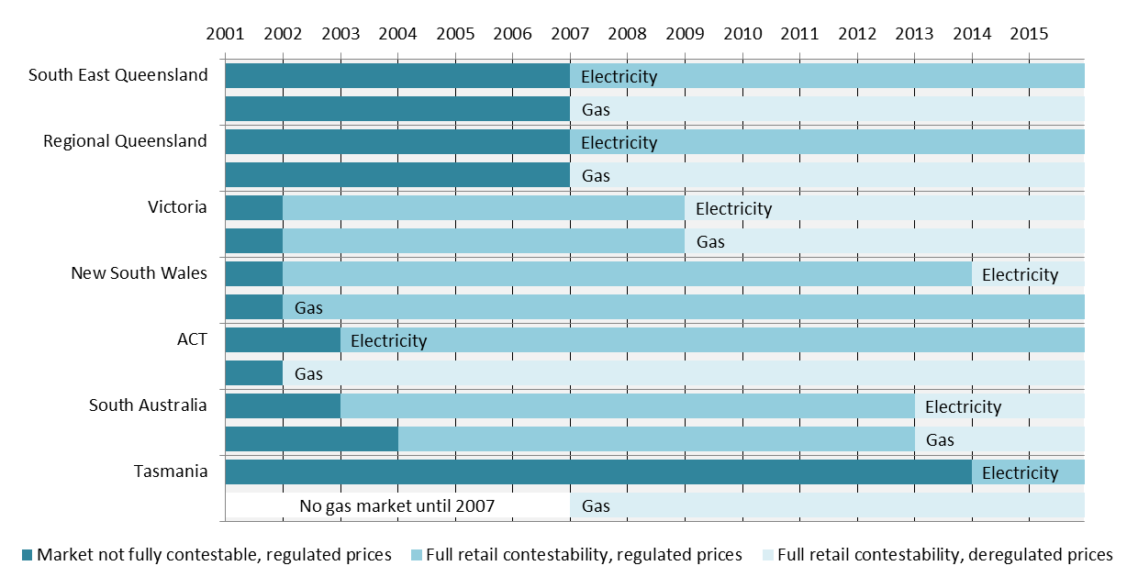

### 

### Electricity

Figure 1.2 shows the market share held by electricity retailers in South Australia, the ACT, Tasmania and New South Wales for residential and small business customers as at 30 June 2015.

Figure 1.2: Retail market share, residential and small business customers – electricity

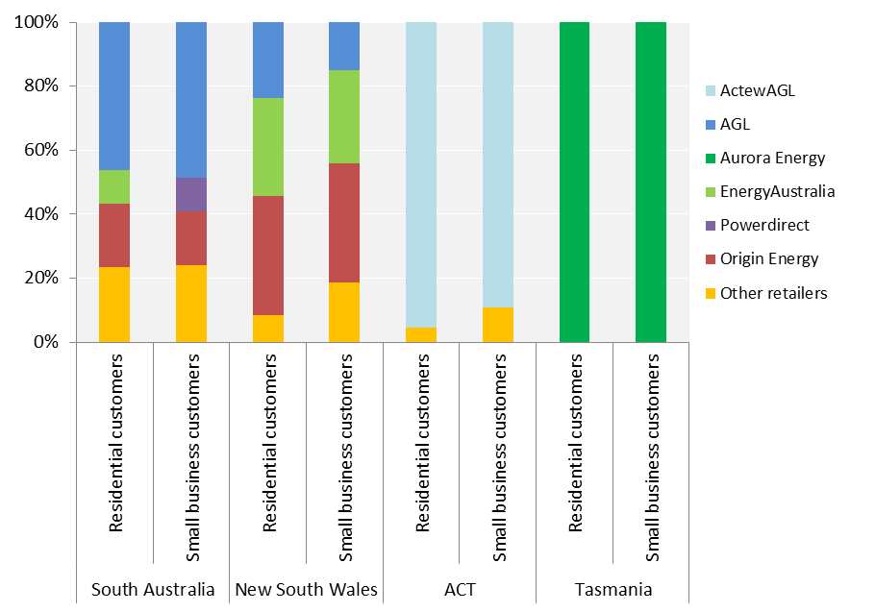

Note: ‘Other retailers’ are those with less than 10 per cent market share in each customer market.

Seventeen retailers supply electricity to small customers in South Australia. 76 per cent of these customers are supplied by the ‘big three’ retailers: AGL (47 per cent), Origin Energy (19 per cent) and EnergyAustralia (10 per cent).

21 retailers supply electricity to small customers in New South Wales. 90 per cent of these customers are supplied by AGL (23 per cent), Origin Energy (37 per cent) and EnergyAustralia (31 per cent). Retailers that entered the market in 2014-15 include Powershop, Next Business Energy and Pooled Energy.

ActewAGL remains the dominant retailer for small customers in the ACT, supplying 95 per cent of small customers. However, there are signs that competition is increasing – with Origin Energy entering the market in September 2014 there are now three retailers selling to residential customers in the ACT.

The Tasmanian Government-owned incumbent, Aurora Energy, sells electricity to all residential customers and almost all small business customers in the state.

### Gas

The availability and uptake of gas varies across jurisdictions. In the ACT, 72 per cent of households are also supplied with gas. 54 per cent of households in South Australia and 41 per cent in New South Wales are supplied with gas. It is estimated that fewer than 5 per cent of households in Tasmania are supplied with gas.[6]

Figure 1.3 shows the market share held by gas retailers in South Australia, the ACT and New South Wales as at 30 June 2015.

Figure 1.3: Retail market share, residential and small business customers – gas

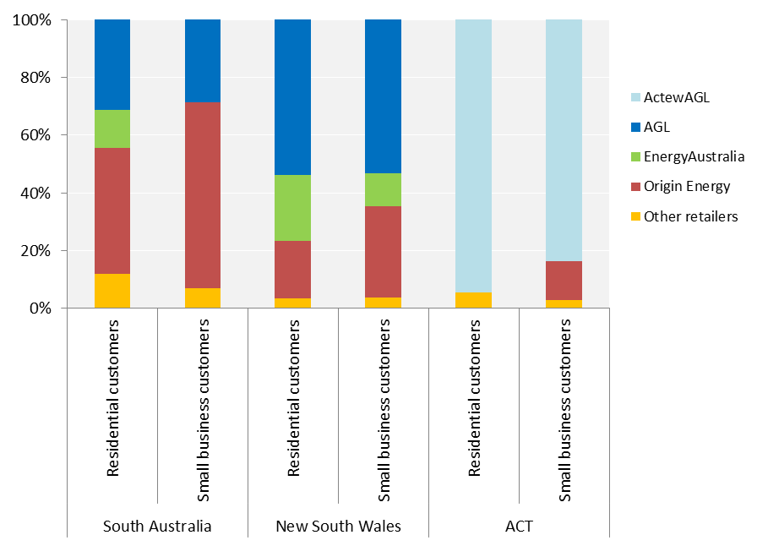

Note: ‘Other retailers’ are those with less than 10 per cent market share in each customer market.

Five retailers supply gas to small customers in South Australia. 88 per cent of customers are supplied by the big three retailers, with 12 per cent supplied by Alinta Energy and Simply Energy.

Seven retailers supply gas to small customers in New South Wales. Despite the number of retailers, the big three retailers collectively supply over 96 per cent of all small customers.

As with the electricity market, ActewAGL is the main retailer of gas for customers in the ACT.

## Standard and market retail contracts

Residential and small business customers can choose between two types of energy contracts.

Standard retail contracts (standing offers) are basic contracts with terms and conditions that cannot be varied by the retailer. In some jurisdictions, these contracts have regulated prices (Figure 1.1). They provide the full suite of protections to customers and do not have a fixed contract term. Standing offer tariffs are generally higher than those offered under market retail contracts.

Market retail contracts have minimum terms and conditions but these vary from contract to contract. Under market contracts retailers can tailor their different energy offers through:

* discounted prices
* non-price incentives
* different billing periods
* different payment options
* fixed term durations
* fees and charges, such as establishment or exit fees.

Market retail contracts also include renewable energy contracts (such as solar power).

Electricity retail price tariffs were deregulated in New South Wales on 1 July 2014, and customers that were on regulated offers at that time were transferred to a ‘transitional tariff’. At the end of June 2015, 69 per cent of electricity customers were on market retail contracts. There remains over one million small electricity customers on standard retail contracts in New South Wales, most of which are customers of the local area retailers[7] Origin Energy (561,000 customers) and EnergyAustralia (396,000 customers).

At the end of June 2015, 76 per cent of gas customers in New South Wales were on market retail contracts. New South Wales gas consumers can choose standard retail contacts with regulated prices. The Independent Pricing and Regulatory Tribunal (IPART) sets the average regulated prices upon request from the New South Wales Government by assessing price proposals from the regulated suppliers for each area of the state. AGL is the regulated supplier for most of New South Wales (including Sydney, Wollongong, Dubbo, Orange, Parkes and parts of the Riverina), and has over two thirds of the 297,000 customers on regulated (standard) contracts.

In South Australia a high proportion of customers are on market retail contracts (84% of electricity customers and 83% of gas customers). The majority of electricity customers that remain on standard contracts are those of the local area retailer AGL (119,000 customers).

In the ACT most small customers are on standard retail contracts (76 per cent of electricity customers and 73 per cent of gas customers), however this number decreased in 2014-15 with Origin Energy’s entry into the retail market.

There is still a lack of choice for small customers in Tasmania, despite the introduction of full retail competition on 1 July 2014. 88 per cent of small customers remain on standard retail contracts with Aurora Energy, at the regulated prices approved by the Tasmanian Economic Regulator. The remaining 12 per cent of customers (around 30,000 residential customers) use prepayment meters (PAYG systems) to purchase electricity, however this number is decreasing as no new PAYG systems are being installed.

Figure 1.4 compares the proportions of customers on standard and market retail contracts in New South Wales, South Australia, the ACT and Tasmania.

Why are some customers still on standard retail contracts?

As mentioned above, the conditions of standard retail contracts (standing offers) cannot be varied by energy retailers, and standing offers are generally higher priced. Therefore the fact that some customers remain on standing offers indicates that competition may simply not be effective in their area. Our previous reports on energy affordability have shown that standing offers have been historically cheaper in some areas, such as in the ACT. Chapter 3 of this report shows the differences in annual energy bills faced by customers on market offers compared to standing offers. Residential customers on standing offers pay up to 20 per cent more each year for electricity and between up to 16 per cent more for gas. Therefore there are cheaper alternatives to standing offers, but customers simply may not know this.

The AEMC's 2015 Competition Review found that in Victoria, South East Queensland and New South Wales, customers on standing offers are more likely to be customers who are older or living in regional areas. In Melbourne and Sydney, higher income areas are more likely to have customers on standing offers, and the reverse applies in many regional areas where lower income areas are more likely to have customers on standing offers.

The findings of the Competition Review identify where there are opportunities to better engage with and target particular customer groups. Older customers and customers with low incomes may not be making a conscious choice to remain on a standing offer. They may also not have access to tools to search for and compare energy offers online using price comparator websites (or knowledge of such websites). It is possible that some assume that by receiving an energy concession, they are receiving the best possible deal. Other customers may be aware of their ability to switch, but may be confused by too much information or perceive the cost to be too high.

Figure 1.4: Small customers on standard and market retail contracts – by jurisdiction

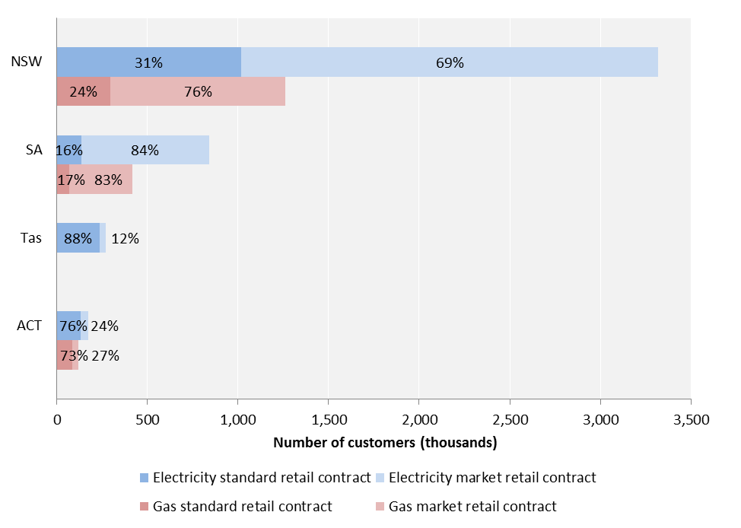

## Customer switching rates

The rate at which customers switch their energy retailer is an indication of customer participation in the retail market. Switching rates do not necessarily indicate the level of competition in a particular market. For example, if customer satisfaction is high there may be less incentive to switch, even in competitive markets. In addition, switching statistics exclude customers that switch between contracts with their current retailer.

Figures 1.5 and 1.6 show the percentage of electricity and gas customers (respectively) that switched retailers over the past five years in Queensland, New South Wales, Victoria and South Australia.[8] Switching rates were flat or declined across these states in 2014-15.

Figure 1.5: Electricity customer switching rates – by jurisdiction

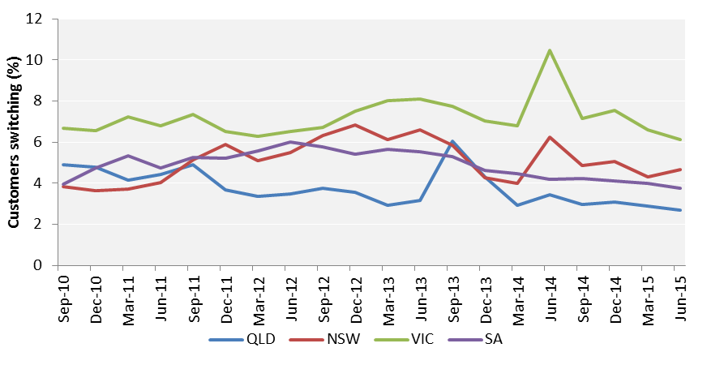

Figure 1.6: Gas customer switching rates – by jurisdiction

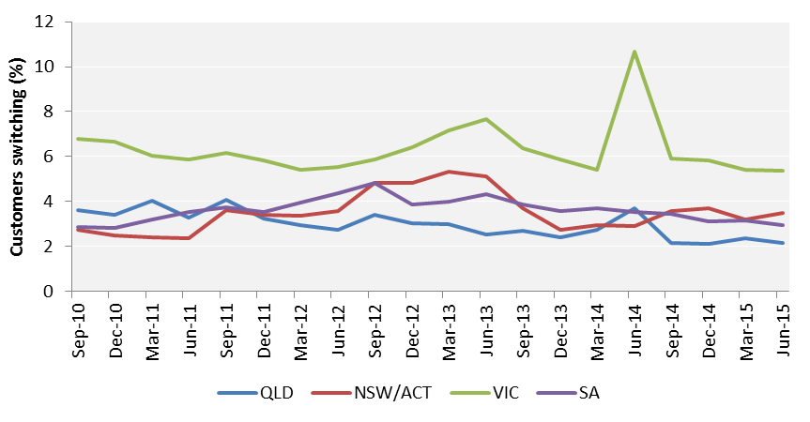

The declining or flat rates of customer switching suggest that energy retailers may be shifting their focus away from customer acquisition and towards customer retention. Origin Energy noted in its submission to the 2015 Competition Review: "As price competition becomes more intense, retailers need to invest to retain customers. Improving customer service is one of the best ways to hold onto existing customers and promote a brand reputation that leads to new acquisitions".

Retailers may also seek to retain customers by offering longer contract terms, with discounts that are conditional on them remaining with the retailer for a period of time. Some retailers have also changed their marketing practices, and ceased door-knocking prospective customers. The 2015 Competition Review found that the average proportion of customers who were approached by retailers reduced across the NEM from 53 to 39 per cent in 2015. However this is unlikely to be the sole driver of lower switching rates, with some research suggesting that most switches are customer-led, rather than being driven by the retailer.[9]

Small customers in Victoria more actively switch between energy retailers compared with customers in other jurisdictions. This is likely due to more choice of products (due to the use of smart meters) and greater awareness of these choices. There is also more competition in the retail gas market, with nine gas retailers available to Victorian households. Our analysis of energy affordability (Chapter 3) also shows that the range in energy bills was generally largest in Victoria, and therefore the potential savings from switching are greatest.

A customer that finds a preferable offer may still have to pay an early exit fee if they choose to switch energy retailers. Exit fees can only be charged in a market retail contract that is a fixed period contract and if the contract is terminated in that fixed period. The amount of the fee must be a reasonable estimate of the costs to the retailer resulting from early termination.[10] Some jurisdictions have separate regulatory requirements governing exit fees. For example, in New South Wales retailers must waive exit fees for hardship and certain other customers experiencing financial difficulty.

Despite the recent increased availability of market contracts without these exit fees, they still may act as a barrier to customer switching. Table 1.1 summarises the range in exit fees across different jurisdictions, and shows that in some areas exit fees can be as high as $187.

Table 1.1: Early exit fees, residential electricity and gas offers

|  |  |  |  |
| --- | --- | --- | --- |
| **Electricity (supply area)** | **Exit fee** | **Gas (supply area)** | **Exit fee** |
| NSW (Ausgrid) | $22-157.50 | NSW (urban) | $50-90 |
| NSW (Endeavour Energy) | $22-157.50 | NSW (rural) | - |
| NSW (Essential Energy) | $22-187 | South Australia (urban) | $50-90 |
| South Australia (SAPN) | $22-157.50 | South Australia (rural) | - |
| ACT (ActewAGL) | $50-90 | ACT (ActewAGL) | $50-90 |
| Tasmania (TasNetworks) | - | Victoria (urban) | $22-157.50 |
| Victoria (CitiPower) | $20-157.50 | Victoria (rural) | $22-157.50 |
| Victoria (other) | $20-157.50 |  |  |

Source: AEMC 2015 Retail Competition Review

Figure 1.7 shows switching rates in the ACT over the last three years for electricity and gas. Historically, switching has been very low, as ActewAGL only competed with EnergyAustralia for electricity and gas. Origin Energy entered the ACT market in September 2014, and has attracted a small but growing share of the market through its market offers. Chapter 3 of this report shows that market offers are now cheaper than standing offers for both electricity and gas in the ACT.

Figure 1.7: Electricity and gas customer switching rates in the ACT

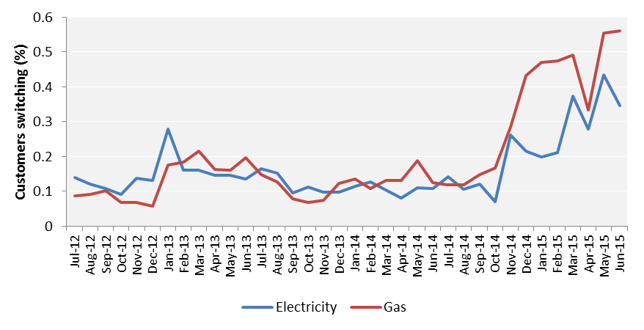

Third retailer enters (Origin Energy)

Two retailers competing (ActewAGL and EnergyAustralia)

# Energy retailer performance

There are a number of reasons why a customer may contact their retailer. For example, customers may contact them to pay their bill, to ask about their bill or a better deal, to ask for payment assistance and sometimes to make a complaint.

Price is important to customers, but so too is good customer service. This chapter discusses the customer experience with energy retailers, including:

* customer service and complaints
* assistance provided to customers with energy debt, such as energy concessions, payment plans and hardship programs
* the disconnection and reconnection of an energy service.

## Customer service

Retailers’ responsiveness to inquiries and complaints is an important measure of customer service. Table 2.1 shows call centre responsiveness, specifically:

* percentage of calls answered within 30 seconds
* average time before a call is answered[11]
* percentage of calls abandoned before being answered.

Table 2.1: Phone calls to retailers in 2014-15, with percentage of calls answered in 30 seconds, average wait time and percentage of calls abandoned before being answered

|  |  |  |  |  |  |  |
| --- | --- | --- | --- | --- | --- | --- |
| **Retailer** | **Calls taken in 30 secs (%)** | | **Average wait time (secs)** | | **Calls abandoned before being answered (%)** | |
| ActewAGL | 71% | ▼7% | 158 | ▲16 | 4% | ▲1% |
| AGL | 87% | ▲2% | 17 | ● | 2% | ● |
| Alinta Energy | 77% | ● | 36 | ▼7 | 2% | ▼1% |
| Aurora Energy | 71% | ▼3% | 46 | ▲12 | 3% | ▲1% |
| Blue NRG | 97% | ▼3% | 30 | N/A | 3% | ▲3% |
| Click Energy | 75% | ▲6% | 50 | ▼7 | 3% | ▼1% |
| CovaU | 93% | ▲6% | 3 | ▼4 | 5% | ▼4% |
| Diamond Energy | 100% | ● | 0 | N/A | 0% | ● |
| EnergyAustralia | 92% | ▲21% | 9 | ▼72 | 2% | ▼4% |
| ERM Power | 94% | ▲12% | 12 | ▼26 | 6% | ▼8% |
| Lumo Energy | 86% | ▲5% | 19 | ▼13 | 1% | ▼1% |
| M2 Energy | 79% | ▲2% | 20 | ▼16 | 3% | ▲1% |
| Momentum Energy | 76% | ▲9% | 109 | ▲59 | 3% | ▲2% |
| Next Business Energy | 92% | N/A | 12 | N/A | 0% | N/A |
| Origin Energy | 59% | ▼10% | 78 | ▲31 | 7% | ▲2% |
| Pacific Hydro Retail | 97% | ▼3% | 4 | N/A | 3% | ▼28% |
| Pooled Energy | 96% | N/A | 8 | N/A | 4% | N/A |
| Powerdirect | 80% | ▲21% | 33 | ▼84 | 2% | ▼5% |
| Powershop | 79% | N/A | 31 | N/A | 3% | N/A |
| QEnergy | 95% | ▼5% | 4 | ▼26 | 5% | ▼3% |
| Red Energy | 79% | ▼5% | 34 | ▲11 | 2% | ▲1% |
| Sanctuary Energy | 90% | ▲4% | 13 | ▼13 | 1% | ▼1% |
| Simply Energy | 92% | ▲1% | 20 | ▲5 | 2% | ▲1% |

Most energy retailers answered at least 80 per cent of calls within 30 seconds, and had average waiting times of less than one minute. EnergyAustralia and Powerdirect significantly improved their performance in the last year. ActewAGL, Momentum Energy and Origin Energy had the longest call waiting times.

The South Australian Government requires retailers selling energy to small customers to meet minimum customer service standards (National Energy Retail (Local Provisions) Regulations.[12]) These are reported in Appendix 2.

## Complaints

Energy retailers must report the number of small customer complaints they receive against the following categories:

* billing – includes complaints about prices, billing errors, payment arrangements, debt recovery practices and disconnections
* energy marketing – includes complaints about sales practices, advertising, contract terms and misleading conduct
* customer transfer – includes complaints about timeliness of transfer, disruption of supply due to transfer and billing problems directly associated with a transfer
* other complaints – includes complaints about customer service, privacy issues, failure to respond to complaints, and health and safety issues.

Figure 2.1 shows the number of residential customer complaints made to energy retailers in each jurisdiction in 2013-14 and 2014-15.

Figure 2.1: Residential customer complaints to retailers in 2013-14 and 2014-15 – by jurisdiction

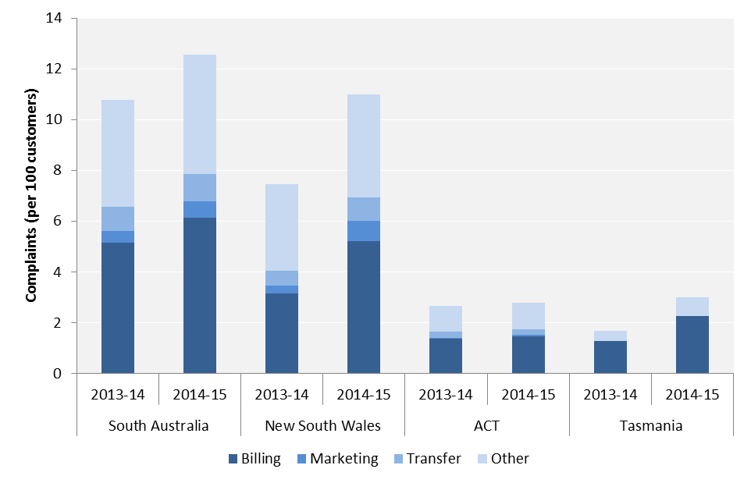

In South Australia over 12 per cent of residential customers complained to their retailer (increase of 17%), and in New South Wales around 11 per cent of customers made complaints (increase of 47%) . Around half of these complaints were for billing issues. Around 3 per cent of customers made complaints to retailers in the ACT and Tasmania.

The overall number of complaints provides an indication of customer satisfaction levels; but it’s important to remember that the nature of some complaints can be outside the control of the energy retailer. For example, complaints about prices due to wholesale and network costs may reflect unfairly on energy retailers. Therefore the manner in which complaints are handled is a more effective measure of retailer performance.

Retailers with effective customer service are generally able to promptly resolve customer complaints when they are made to them. Such complaints often do not need to be escalated or referred elsewhere to be resolved. Customers may contact the energy ombudsman in their state or territory if their complaint is not resolved or dealt with unsatisfactorily by their retailer. Table 2.2 compares the number of complaints made to retailers with those referred to each jurisdictional ombudsman scheme.

Many retailers received fewer complaints in 2014-15, however there were large increases in complaints made to Origin Energy (in South Australia, the ACT and New South Wales), which accounts for the general increase in complaints in each jurisdiction. Ombudsman schemes generally received fewer complaints for investigation in 2014-15 when compared with 2013-14. Ombudsman complaints halved in Tasmania, decreased by 26 per cent in South Australia, decreased in New South Wales and remained steady in the ACT.

Table 2.2: Small customer complaints made to each retailer and the respective ombudsman in 2014-15

|  |  |  |  |  |  |
| --- | --- | --- | --- | --- | --- |
| **Retailer** | **Complaints to retailer** | | **Complaints to ombudsman\*** | | **Ombudsman complaints as % of total complaints** |
| **South Australia** |  | |  | |  |
| AGL | 36 589 | ▼3 584 | 2 154 | ▼348 | 5.9% |
| Alinta Energy | 737 | ▼848 | 377 | ▲84 | 51.2% |
| Diamond Energy | 12 | ▲1 | 2 | ▼1 | 16.7% |
| EnergyAustralia | 6 766 | ▼5 626 | 1 397 | ▼1 616 | 20.6% |
| ERM Power Retail | 16 | ▲16 | 0 | ● | 0.0% |
| Lumo Energy | 1 935 | ▼1 005 | 313 | ▼82 | 16.2% |
| M2 Energy** | 128 | ▲128 | 38 | ▲38 | 29.7% |
| Momentum Energy | 364 | ▼246 | 91 | ▲14 | 25.0% |
| Origin Energy | 48 989 | ▲27 315 | 2 102 | ▼413 | 4.3% |
| Powerdirect | 2 454 | ▼2269 | 282 | ▲69 | 11.5% |
| QEnergy | 8 | ▼13 | 6 | ▼4 | 75.0% |
| Red Energy | 91 | ▼44 | 18 | ▲4 | 19.8% |
| Sanctuary Energy | 55 | ▼6 | 38 | ▲5 | 69.1% |
| Simply Energy | 3 115 | ▲21 | 861 | ▼508 | 27.6% |
| **TOTAL SA** | **101 259** | ▲**13 840** | **7 679** | ▼**2 758** | **7.6%** |
| **ACT** |  | |  |  |  |
| ActewAGL | 3 549 | ▼272 | 959 | ▲36 | 27.0% |
| EnergyAustralia | 269 | ▼265 | 71 | ▼49 | 26.4% |
| Origin Energy | 911 | ▲911 | 15 | ▲15 | 1.6% |
| Powerdirect | 10 | ▲10 | 0 | ● | 0.0% |
| **TOTAL ACT** | **4 739** | ▲**384** | **1 045** | ▲**2** | **22.1%** |
| **Tasmania** |  | |  |  |  |
| **Aurora Energy** | **8 071** | **N/A** | **167** | ▼**167** | **2.1%** |
| **New South Wales** |  | |  |  |  |
| ActewAGL | 842 | ▼96 | 173 | ▼25 | 20.5% |
| AGL | 107 640 | ▲5 001 | 6 509 | ▲797 | 6.0% |
| Blue NRG | 68 | ▲65 | 4 | ▲4 | 5.9% |
| Click Energy | 362 | ▲230 | 273 | ▲100 | 75.4% |
| CovaU | 1 515 | ▲1 512 | 55 | ▲55 | 3.6% |
| Diamond Energy | 24 | ▲10 | 8 | ▲8 | 33.3% |
| EnergyAustralia | 28 825 | ▲921 | 4 849 | ▼2 025 | 16.8% |
| ERM Power Retail | 166 | ▲78 | 4 | ▲4 | 2.4% |
| GoEnergy | 8 | ▲8 | 0 | ● | 0.0% |
| Lumo Energy | 3 087 | ▼745 | 461 | ▼42 | 14.9% |
| M2 Energy | 867 | ▼3 956 | 182 | ▲44 | 21.0% |
| Momentum Energy | 516 | ▼312 | 167 | ▲73 | 32.4% |
| Origin Energy | 206 935 | ▲117 774 | 6 891 | ▼2 340 | 3.3% |
| Pooled Energy | 6 | ▲6 | 0 | ● | 0.0% |
| Powerdirect | 2 559 | ▼1 199 | 372 | ▲124 | 14.5% |
| Powershop | 1 | ▲1 | 0 | ● | 0.0% |
| QEnergy | 129 | ▲31 | 112 | ▲50 | 86.8% |
| Red Energy | 2 361 | ▲410 | 162 | ▼22 | 6.9% |
| Sanctuary Energy | 380 | ▼345 | 262 | ▲29 | 68.9% |
| Simply Energy | 1 332 | ▲615 | 368 | ▲142 | 27.6% |
| **TOTAL NSW** | **357 623** | ▲**120 015** | **20 852** | ▼**3 027** | **5.8%** |

* Excludes matters closed as general enquiries or not escalated/investigated.

** Includes complaints for customers of Dodo Power & Gas and Commander Power & Gas.

Managing customers with payment difficulties: The AER’s hardship review

In January 2015, we released a report on our targeted review of retailers’ hardship policies and practices. The purpose of the review was to help us better understand how retailers identify and assist customers experiencing difficulties paying their energy bills due to financial hardship, and to share examples of good practice across industry.

**Review findings and observations**

The review suggested that concerns about the availability of hardship assistance and payment plan affordability are not symptomatic of widespread non-compliance with the Retail Law and Retail Rules. Rather, they reflect broader issues of energy affordability and energy literacy — that is, consumers’ ability to make informed decisions around selecting an energy offer and understanding their options and rights if they have difficulties paying their bills on time.

While we observed that retailers employ a range of approaches to meeting their obligations to hardship customers, some retailers seem more committed to assisting hardship customers than others (for example better promoting the availability of assistance, staff training to promote more effective engagement with customers, or innovative assistance offerings).

Further, the strong theme highlighted by consumer stakeholders was the importance of respectful practice — how a retailer engages with the customer to listen and validate their experience of financial vulnerability is most important in developing trust and maintaining engagement.

**Early positive outcomes**

We have already seen encouraging progress in response to the review, with many retailers acknowledging the review had prompted them to consider their practices and what they could do better or differently. For example, reviewing and updating their hardship policies and process documentation, identifying and correcting errors in their reporting of hardship performance data, and considering improvements to the quality of information on their websites for consumers experiencing payment difficulties.

We have also developed important insights into how individual retailers approach hardship within their business and how this is evolving across industry. We are in a stronger position to interpret, and where appropriate probe, the picture presented by retailer hardship performance data, which will enable us to respond more swiftly to potential concerns in future.

**Concerns**

Despite the review not revealing widespread non-compliance, our review has given us a point of reference from which to monitor improvements or to act on any systemic issues that become apparent.

Issues of concern generally related to:

* Problems with identifying and assisting customers - for example we observed some retailers reported relatively high levels of customer debt, in conjunction with comparatively low numbers of customers on a payment plan or hardship program; and some retailers reported relatively high levels of debt on entry to a hardship program.
* Disconnection of hardship customers, specifically where the retailer seems unable or slow to stop, a disconnection service order issued against a customer who is being processed for entry onto the hardship program.
* Relatively low numbers of hardship customers using Centrepay, suggesting it is not being well-promoted, or offered to eligible customers.
* Lack of easy to find and easy to read information on a retailer’s website about the availability of assistance
* Lack of additional measures to support a hardship customer, such as helpful advice about energy efficiency
* Incorrect reporting of performance data resulting in a number of performance reports being re-submitted.

The report is available on the AER website ([www.aer.gov.au](http://www.aer.gov.au)).

## Energy bill debt

For the purposes of this report, energy bill debt is an amount owed to a retailer that has been outstanding for 90 days or more.[13] If a customer hasn’t asked their retailer for help, accumulating energy debt should be a signal to a retailer to discuss assistance measures with the customer. This could include a payment plan for more moderate payment difficulties or a hardship program for more chronic and severe difficulties. Energy bill debt is therefore one of several indicators that provide information about the overall affordability of energy and how quickly and effectively retailers are assisting customers.

**Bill smoothing can assist with budgeting**

Bill smoothing can help a customer manage their budget by allowing them to make payments in regular instalments – usually fortnightly or monthly – instead of the more traditional quarterly billing cycle. These instalments are often based on an estimation of a customer’s consumption over any 12 month period.

The Retail Rules do not require a retailer to offer a bill smoothing arrangement to all customers. Instead, the obligations state the retailers may offer bill smoothing arrangements to customers on standard retail contract, only if they comply with the provisions. Retailers can choose to offer these types of arrangement to customers on market contracts.

Retailers are increasingly offering (or even requiring) more frequent payment terms. This can offer benefits to both the customer and the retailer by improving budgeting and more quickly identifying and responding to payment difficulties for debt becomes unmanageable.

Smart meters and related innovations (such as web portals and apps) are also being used by retailers to help customers monitor their actual electricity use, providing real-time feedback on how consumption is translating into cost and allowing customers to take action and prepare for bills.

Figures 2.2 and 2.3 show the number of residential customers with electricity and gas debt in each jurisdiction. These figures also show the proportion of customers repaying their debt through a hardship program, as well as the average levels of debt (for customers on hardship programs and not on hardship programs).

There are differences between jurisdictions in the proportion of residential customers with debt. For example, South Australia has the largest proportion of electricity customers in debt (5.7 per cent of residential customers) and the ACT has the highest proportion of gas customers in debt (7.9 per cent). This reflects differences in prices and consumption, as discussed in Chapter 3.

The number of residential customers with electricity debt has generally decreased in recent years, and the proportion of these customers receiving assistance to repay their debt through a hardship program has increased. The proportion of customers with a gas debt has decreased in New South Wales and South Australia, but increased in the ACT. Fewer customers with a gas debt are on hardship program, relative to electricity customers.

In the case of electricity, the average debt of customers on hardship programs has remained steady or decreased. We have observed it fall significantly in Tasmania over the past three years in line with Aurora’s commitment to strengthening its hardship policies and practices. While the number of customers with electricity debt has generally decreased, in most jurisdictions the average debt (of customers not on hardship programs) has increased. Further, the average debt of gas customers – both on and not on hardship programs – has generally increased.

Figure 2.2: Residential electricity customers repaying debt and average debt – as at 30 June

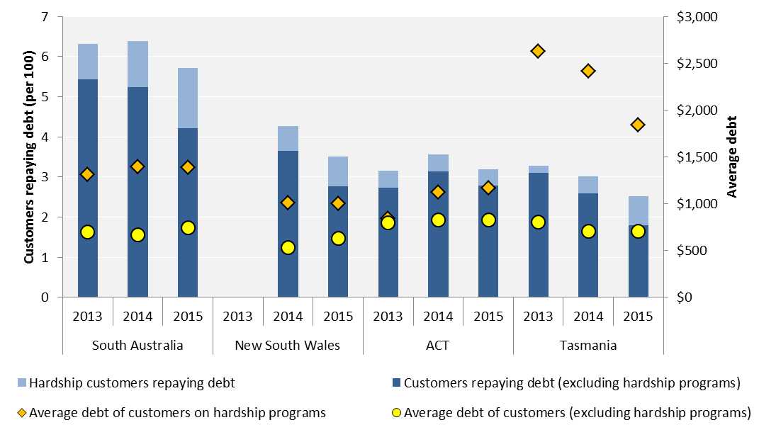

Figure 2.3: Residential gas customers repaying debt and average debt – as at 30 June

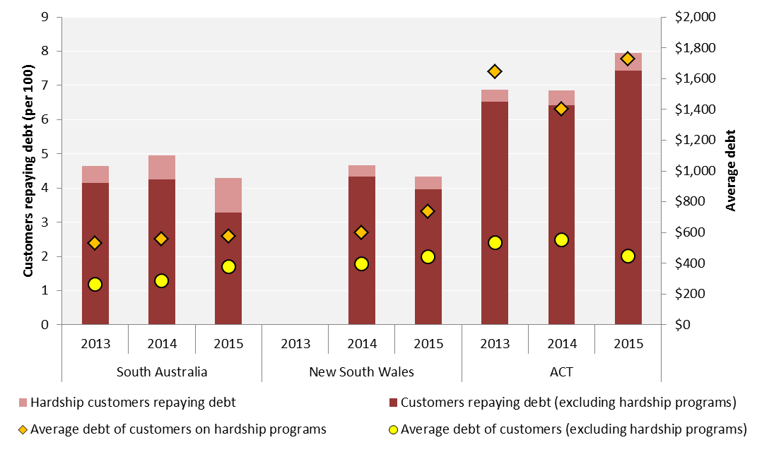

Tables 2.3 and 2.4 show the number of small business customers with electricity and gas debt, along with average debt levels. Generally fewer small businesses held electricity debt in 2015, with the most significant decrease occurring in the ACT. However, average debt levels notably increased in New South Wales and the ACT. Gas debt is most prevalent in the ACT, where almost 11 per cent of small businesses owe an average of around $1500.

Table 2.3: Small business electricity debt (by jurisdiction, as at 30 June)

|  |  |  |  |  |  |  |
| --- | --- | --- | --- | --- | --- | --- |
|  | **Customers in debt** | | | **Average debt** | | |
| **Jurisdiction** | **2013** | **2014** | **2015** | **2013** | **2014** | **2015** |
| South Australia | 6.0% | 3.9% | 3.6% | $1453 | $1594 | $1490 |
| ACT | 4.8% | 6.3% | 3.6% | $803 | $675 | $868 |
| New South Wales | N/A | 3.9% | 3.1% | N/A | $1636 | $1972 |
| Tasmania | 2.6% | 1.4% | 0.8% | $1918 | $1136 | $1138 |

Table 2.4: Small business gas debt (by jurisdiction, as at 30 June)

|  |  |  |  |  |  |  |
| --- | --- | --- | --- | --- | --- | --- |
|  | **Customers in debt** | | | **Average debt** | | |
| **Jurisdiction** | **2013** | **2014** | **2015** | **2013** | **2014** | **2015** |
| South Australia | 4.9% | 3.6% | 3.4% | $1544 | $1571 | $1769 |
| ACT | 9.8% | 9.5% | 10.8% | $2097 | $1537 | $1499 |
| New South Wales | N/A | 7.2% | 6.8% | N/A | $1679 | $2057 |

## Payment plans

The Retail Law requires energy retailers to offer payment plans to customers experiencing payment difficulties. A payment plan is a plan for a residential customer experiencing payment difficulties to pay a retailer by periodic instalments, any overdue amount payable by the customer.[14]

Customers should contact their retailer for assistance when it is required. Retailers should also promptly identify customers that are in debt and help them manage debt through payment plans or hardship programs.

Table 2.5 shows the number of residential customers on a payment plan for each retailer in each jurisdiction, as well as the number of payment plan cancellations that occurred in 2014-15. The number of customers on payment plans increased in New South Wales and the ACT, but decreased in South Australia and Tasmania in 2014-15.

Table 2.5: Customers on payment plans as at 30 June 2015 (change since 2014) and with payment plans cancelled during 2014-15

|  |  |  |  |  |  |  |
| --- | --- | --- | --- | --- | --- | --- |
| **Retailer** | **Customers on payment plans (per 100)** | | | | **Customers with payment plans cancelled (per 100)** | |
|  | **Electricity** | | **Gas** | | **Electricity** | **Gas** |
| **South Australia** |  |  |  |  |  |  |
| AGL | 0.64 | ▼0.20 | 0.29 | ▼0.02 | 2.26 | 1.40 |
| Alinta Energy | 4.50 | ▼2.63 | 2.36 | ▼0.70 | 13.97 | 9.97 |
| Diamond Energy | 2.13 | ▲1.27 | - | - | 0.00 | - |
| EnergyAustralia | 10.19 | ▲0.15 | 8.13 | ▲0.66 | 12.99 | 10.29 |
| Lumo Energy | 3.46 | ▲0.02 | - | - | 0.78 | - |
| M2 Energy | 0.22 | ▲0.22 | - | - | 0.04 | - |
| Momentum Energy | 2.89 | ▼3.52 | - | - | 6.67 | - |
| Origin Energy | 1.29 | ▼3.25 | 0.60 | ▼1.63 | 3.37 | 1.72 |
| Powerdirect | 1.14 | ▼0.15 | - | - | 0.29 | - |
| Red Energy | 4.72 | ▼1.26 | - | - | 5.86 | - |
| Sanctuary Energy | 0.82 | ▲0.36 | - | - | 1.97 | - |
| Simply Energy | 3.10 | ▼0.17 | 2.19 | ▲0.08 | 9.68 | 6.53 |
| **TOTAL SA** | **2.39** | **▼0.82** | **1.69** | **▼0.64** | **4.72** | **3.44** |
| **ACT** |  |  |  |  |  |  |
| ActewAGL | 0.17 | ● | 0.16 | ▲0.04 | 1.93 | 1.32 |
| EnergyAustralia | 13.63 | ▲8.00 | 13.40 | ▲9.64 | 9.02 | 6.57 |
| Origin Energy | 0.05 | ▲0.05 | 0.05 | ▲0.05 | 0.05 | 0.05 |
| **TOTAL ACT** | **0.62** | **▲0.26** | **0.63** | **▲0.37** | **2.14** | **1.49** |
| **Tasmania** |  |  |  |  |  |  |
| Aurora Energy | 1.01 | ▼0.27 | - | - | 1.61 | - |
| **New South Wales** |  |  |  |  |  |  |
| ActewAGL | 0.52 | ▲0.07 | 0.21 | ▲0.02 | 5.03 | 1.71 |
| AGL | 0.42 | ▼0.18 | 0.14 | ▼0.03 | 2.39 | 0.86 |
| Click Energy | 0.36 | ▲0.20 | - | - | 1.08 | - |
| CovaU | 1.14 | ▲1.14 | 0.49 | ▲0.49 | 0.38 | 0.00 |
| Diamond Energy | 1.94 | ▲1.63 | - | - | 0.00 | - |
| EnergyAustralia | 6.51 | ▲4.67 | 5.04 | ▲3.46 | 6.36 | 4.35 |
| Lumo Energy | 3.57 | ▲0.44 | 2.92 | ▲0.20 | 1.04 | 0.74 |
| M2 Energy | 0.16 | ▲0.12 | 0.00 | - | 0.20 | 0.00 |
| Momentum Energy | 0.83 | ▼3.66 | - | - | 6.06 | - |
| Origin Energy | 0.83 | ▼2.33 | 0.98 | ▼1.33 | 2.23 | 1.75 |
| Powerdirect | 1.27 | ▲0.15 | - | - | 0.30 | - |
| QEnergy | 2.47 | ▼0.07 | - | - | 0.00 | - |
| Red Energy | 2.90 | ▼0.78 | - | - | 3.44 | - |
| Sanctuary Energy | 0.61 | ▲0.05 | - | - | 1.60 | - |
| Simply Energy | 4.90 | ▲3.23 | - | - | 12.70 | - |
| **TOTAL NSW** | **2.59** | **▲0.53** | **1.46** | **▲0.57** | **3.61** | **1.84** |

## 

## Hardship programs

A key protection for vulnerable customers is the requirement for energy retailers to develop and maintain a customer hardship policy that sets out their approach to identifying and assisting customers experiencing difficulty paying their energy bills.[15]

Referral to a hardship program is generally the most appropriate form of assistance when a customer’s payment difficulties are overwhelming, such that they cannot meet a payment plan arrangement because they lack the capacity to pay for current and future consumption.

Help under a retailer’s hardship program can include tailored payment plans and further support measures to assist customers to manage their bills on an ongoing basis. As long as a customer is meeting their payments, they can’t be disconnected.

Retailers report annually on:

* the number of customers that each retailer has on hardship programs
* the payment methods used by these customers
* the average level of debt held by customer on hardship programs
* the reasons for customers exiting hardship programs.

### Customers on hardship programs

Table 2.6 shows the number of electricity and gas customers on hardship programs for each retailer in each jurisdiction. More than twice as many electricity customers in South Australia are on hardship programs compared with in New South Wales.

The number of electricity and gas customers on hardship programs in South Australia increased by 30 and 43 per cent respectively. Significantly, over 2.5 per cent of EnergyAustralia's electricity customers (around 2,000) are now on a hardship program. Other significant increases in South Australia were reported by Alinta Energy, M2 Energy, Momentum Energy and Simply Energy.

In New South Wales, the number of electricity customers on hardship programs increased by 20 per cent, to 0.74 per cent of customers. The number of gas customers on hardship programs only increased by 9 per cent, to 0.36 per cent of customers. The significant increases in New South Wales were reported by Simply Energy and Momentum Energy.

In Tasmania, the number of Aurora Energy's customers on hardship programs increased by 65 per cent, to 0.71 per cent of customers. There was little change in the number of customers on hardship programs in the ACT.

Table 2.6: Customers on hardship programs as at 30 June 2015 (change since 2014)

|  |  |  |  |  |
| --- | --- | --- | --- | --- |
| **Retailer** | **Customers on hardship programs (per 100)** | | | |
|  | **Electricity** | | **Gas** | |
| **South Australia** |  |  |  |  |
| AGL | 1.36 | ▲0.22 | 1.35 | ▲0.29 |
| Alinta Energy | 1.52 | ▲1.43 | 1.05 | ▲0.97 |
| EnergyAustralia | 2.53 | ▲1.54 | 1.14 | ▲0.69 |
| Lumo Energy | 0.53 | ▼0.08 | - | - |
| M2 Energy | 1.17 | ▲1.17 | - | - |
| Momentum Energy | 1.96 | ▲0.84 | - | - |
| Origin Energy | 1.48 | ▼0.09 | 0.52 | ▲0.09 |
| Powerdirect | 0.66 | ▲0.16 | - | - |
| Red Energy | 0.74 | ▼0.36 | - | - |
| Simply Energy | 1.95 | ▲0.48 | 2.01 | ▲0.60 |
| **TOTAL SA** | **1.51** | **▲0.34** | **1.00** | **▲0.30** |
| **ACT** |  |  |  |  |
| ActewAGL | 0.38 | ▼0.03 | 0.49 | ▲0.08 |
| EnergyAustralia | 1.81 | ▲0.83 | 1.07 | ▲0.54 |
| **TOTAL ACT** | **0.42** | **▼0.01** | **0.50** | **▲0.09** |
| **Tasmania** |  |  |  |  |
| Aurora Energy | 0.71 | ▲0.28 | - | - |
| **New South Wales** |  |  |  |  |
| ActewAGL | 1.44 | ▼0.09 | 0.78 | ▲0.21 |
| AGL | 0.89 | ▲0.23 | 0.43 | ▲0.14 |
| Click Energy | 0.13 | ▲0.13 | - | - |
| CovaU | 0.07 | ▲0.07 | 0.00 | - |
| Diamond Energy | 0.07 | ▲0.07 | - | - |
| EnergyAustralia | 0.56 | ▲0.17 | 0.16 | ▼0.21 |
| Lumo Energy | 0.36 | ▼0.10 | 0.26 | ▼0.09 |
| M2 Energy | 1.28 | ▲0.15 | 0.00 | - |
| Momentum Energy | 2.05 | ▲1.83 | - | - |
| Origin Energy | 0.77 | ● | 0.35 | ● |
| Powerdirect | 0.49 | ▲0.32 | - | - |
| QEnergy | 1.82 | ▼0.21 | - | - |
| Red Energy | 0.45 | ▼0.31 | - | - |
| Sanctuary Energy | 0.25 | ▲0.25 | - | - |
| Simply Energy | 2.91 | ▲2.63 | - | - |
| **TOTAL NSW** | **0.74** | **▲0.12** | **0.36** | **▲0.03** |

Note: Excludes retailers with zero customers on hardship programs.

Table 2.7 shows the proportion of customers on hardship programs that also receive payment assistance through energy concessions. Only 41 per cent of electricity customers on hardship programs in South Australia receive concessions, whereas 81 per cent in Tasmania receive concessions. Chapter 3 of this report discusses concession eligibility for each jurisdiction.

Table 2.7: Concession customers on hardship programs (change since 2014)

|  |  |  |  |  |
| --- | --- | --- | --- | --- |
| **Jurisdiction** | **Electricity (% of customers on hardship programs)** | | **Gas (% of customers on hardship programs)[16]** | |
| South Australia | 41% | ▼3% | 16% | ▲5% |
| ACT | 58% | ▼2% | 57% | ▼2% |
| New South Wales | 60% | ▼11% | 0% | - |
| Tasmania | 81% | ▲2% | - | - |

### Payment methods of hardship program customers

The Retail Rules require that a payment plan for a hardship customer must be established having regard to the customer’s capacity to pay, any amounts owed by the customer, and the customer’s expected energy consumption over the coming 12 months.[17]

The Retail Law requires retailers to offer flexible payment options (including Centrepay) to hardship customers.[18] Centrepay is a free direct bill-paying service available to customers receiving Centrelink payments. Through Centrepay, customers can pay bills by having a regular amount deducted from their Centrelink payments and transferred electronically to an approved Centrepay business. Centrepay make it easier for customers to budget by having their bills paid in more manageable instalments.

Our 2015 Review of retailers’ hardship policies and practices found relatively low numbers of hardship customers using Centrepay, suggesting it is not being well-promoted, or even offered to eligible customers by retailers. We raised this issue with a number of retailers and indicated our expectation to see this improve.

Table 2.8 shows the payment methods of electricity and gas customers on hardship programs. While the number of hardship customers using Centrepay has increased (not shown), we note that the proportion of hardship customers using Centrepay has actually fallen. While we could still expect to see improvements in these figures, we note that only hardship customers receiving Centrelink payments can pay by Centrepay, so these trends may suggest that there are more middle-income customers entering hardship programs.

As with energy concessions, fewer customers on hardship programs in South Australia use Centrepay to repay energy debt. This may suggest that not only customers with low incomes are accessing hardship programs. The observation supports concerns increasingly voiced by consumer welfare organisations that the demographic of people needing assistance is changing and more middle income families are seeking assistance to pay their energy bills.[19]

Table 2.8: Payment methods of hardship program customers

|  |  |  |  |  |  |  |
| --- | --- | --- | --- | --- | --- | --- |
| **Jurisdiction** | **Payment plan  (non-Centrepay)** | | **Centrepay** | | **Other** | |
| **Electricity** |  | |  | |  | |
| South Australia | 73% | ▲5% | 22% | ▼5% | 5% | ● |
| ACT | 58% | ▲2% | 42% | ▼2% | 0% | ● |
| New South Wales | 72% | ▲8% | 27% | ▼7% | 1% | ▼1% |
| Tasmania | 61% | ▲11% | 39% | ▼11% | 0% | ● |
| **Gas** |  | |  | |  | |
| South Australia | 69% | ▲2% | 23% | ▼2% | 8% | ● |
| ACT | 75% | ▲3% | 25% | ▼3% | 0% | ● |
| New South Wales | 74% | ▲4% | 26% | ▼2% | 0% | ▼2% |

### Debt levels of customers on hardship programs

If a customer enters a hardship program with a low level of debt they have a greater chance of fully repaying their debt, and successfully completing the hardship program. Figures 2.4 and 2.5 show the debt levels of electricity and gas customers that entered hardship programs in 2013-14 and 2014-15.

Over 85 per cent of Red Energy customers and 66 per cent of Lumo Energy customers that entered hardship programs in 2014-15 had less than $500 of electricity debt. By contrast, 48 per cent of customers that entered Aurora Energy’s hardship programs had over $1,500 of electricity debt.

Gas customers generally entered hardship programs with lower levels of debt, with most customers of gas retailers entering hardship programs with less than $500 of debt. ActewAGL and EnergyAustralia reported 30 to 40 per cent of gas customers entering hardship programs with at least $1,500 of debt.

Figure 2.4: Electricity debt levels of customers entering hardship programs in 2013-14 and 2014-15

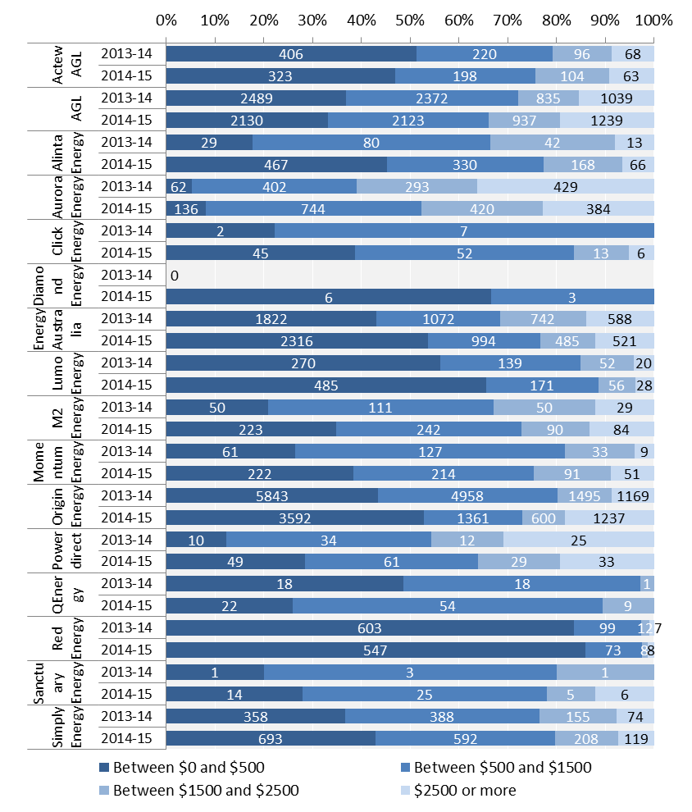

Figure 2.5: Gas debt levels of customers entering hardship programs in 2013-14 and 2014-15

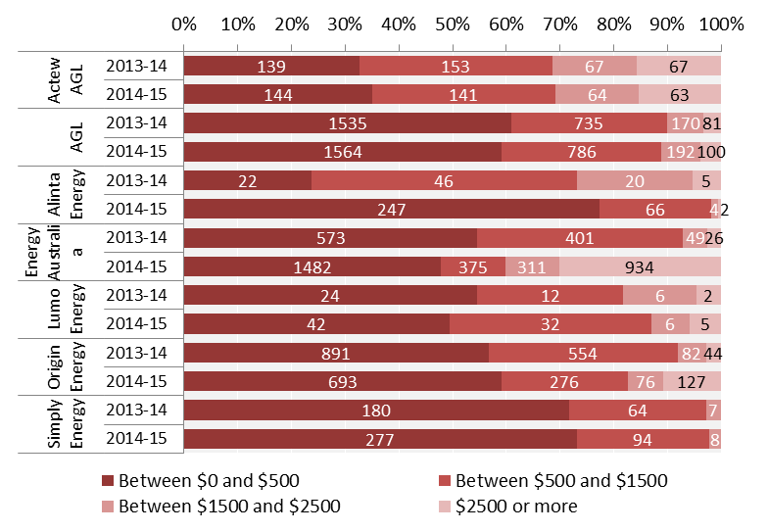

### Customers exiting hardship programs

Retailers report the number of customers exiting their hardship programs for each of the following reasons:

* customer who successfully completed the program or exited with the agreement of the retailer
* customers who transferred, switched or left the retailer, and
* customers who were excluded or removed from the program for failing to meet the requirements.

Figures 2.6 and 2.7 shows the number of electricity and gas customers that exited hardship programs for each retailer in 2013-14 and 2014-15.

The ‘success rate’ of electricity customers exiting hardship programs modestly increased, from 19 per cent in 2013-14 to 24 per cent in 2014-15. However, over this period the rate of exclusion increased from 54 to 57 per cent, as proportionally fewer customers transferred to other retailers.

There is some correlation between low levels of debt on entry to hardship programs and high success rates. As an example, Red Energy’s success rate was among the highest of the second-tier retailers with a significant number of customers exiting hardship programs. Momentum Energy (7 per cent), Alinta Energy (10 per cent) and M2 Energy (11 per cent) had the lowest and declining success rates.

Figure 2.6: Electricity customers exiting hardship programs in 2013-14 and 2014-15

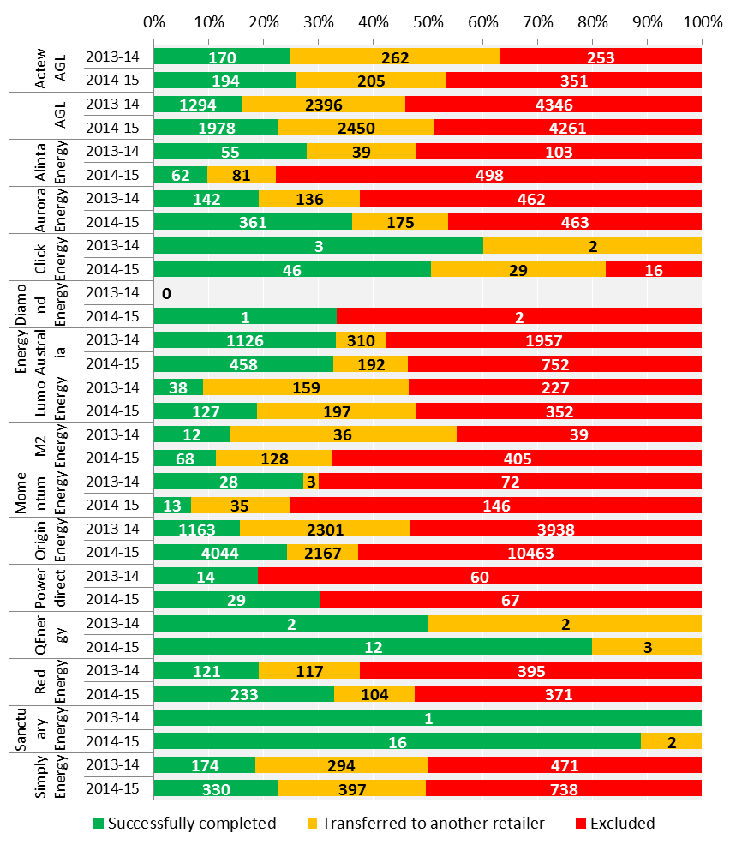

Success rates among gas customers exiting hardship programs also slightly increased, from 19 per cent in 2013-14 to 22 per cent in 2014-15. As with electricity, the rate of exclusion increased from 54 to 57 per cent over this period, as fewer customers transferred to other retailers. Success rates were highest for ActewAGL (38 per cent) and lowest for Alinta Energy (13 per cent) and Origin Energy (16 per cent).

Figure 2.7: Gas customers exiting hardship programs in 2013-14 and 2014-15

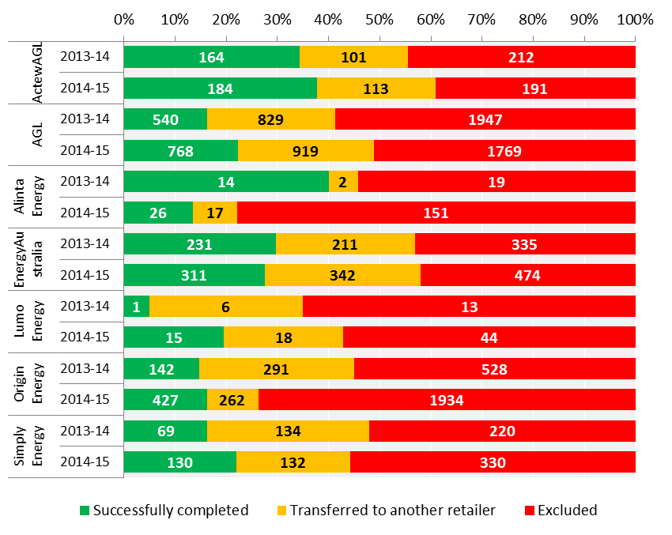

### How do retailers manage customers on hardship programs?

Retailers have reported to us different types of assistance that they may provide under their hardship program. For example, retailers generally found the following methods were successful in helping the customer repay their energy debt:

* early identification of customers with debt
* conducting home energy audits and replacing faulty appliances
* matching customer debt repayments, or providing goodwill credits towards customer accounts
* accepting lower than normal repayments in the short term.

Table 2.9 summarises the abovementioned hardship program indicators for retailers with customers on hardship programs in New South Wales and South Australia.

There do not appear to be strong correlations between success rates, early intervention (low average debt on entry to a hardship program) and the use of Centrepay to repay debt.

We observe different approaches to managing customers in hardship programs. For example, EnergyAustralia reports relatively high hardship success rates among its customers, despite a very small percentage using Centrepay.

Smaller retailers generally have more of their customers in debt on hardship programs, and these customers generally enter hardship programs with less debt.

Origin Energy also has a relatively high proportion of customers in debt on its hardship programs, average debt of its customers on entry to hardship programs is relatively low, and around 40 per cent of its customers use Centrepay to makes repayments on their hardship program.

Alinta Energy, M2 Energy (Dodo Power & Gas) and Momentum Energy all have a relatively high proportion of customers with debt on their hardship programs, but report lower than average use of Centrepay and low success rates.

In summary, it is important not to view these indicators in isolation when assessing the performance of retailers in managing customers on hardship programs. For example, in some cases the success rates reported by retailers may be due to early intervention; however the data suggests that this is not the case for all retailers.

Table 2.9: Hardship program performance indicators – by retailer

|  |  |  |  |  |
| --- | --- | --- | --- | --- |
| **Retailer** | **Customers on hardship programs (as % of customers with debt)** | **Average debt on entry to hardship programs** | **Hardship customers using Centrepay** | **Success rate of hardship programs** |
| **Electricity** |  |  |  |  |
| **ActewAGL** | 26% | $1222 | 47% | 12% |
| **AGL** | 17% | $1641 | 26% | 23% |
| **Alinta Energy** | 30% | $625 | 8% | 10% |
| **EnergyAustralia** | 23% | $1130 | 3% | 33% |
| **Lumo Energy** | 11% | $474 | 8% | 19% |
| **M2 Energy** | 64% | $1636 | 15% | 11% |
| **Momentum Energy** | 44% | $440 | 18% | 7% |
| **Origin Energy** | 32% | $697 | 39% | 24% |
| **Powerdirect** | 9% | $2262 | 29% | 30% |
| **QEnergy** | 27% | $900 | 29% | 80% |
| **Red Energy** | 25% | $192 | 41% | 33% |
| **Simply Energy** | 37% | $981 | 31% | 23% |
| **Gas** |  |  |  |  |
| **ActewAGL** | 9% | $1056 | 25% | 41% |
| **AGL** | 11% | $729 | 23% | 22% |
| **Alinta Energy** | 22% | $295 | 7% | 13% |
| **EnergyAustralia** | 10% | $896 | 9% | 28% |
| **Lumo Energy** | 15% | $423 | 6% | 19% |
| **Origin Energy** | 13% | $463 | 41% | 16% |
| **Simply Energy** | 41% | $335 | 21% | 22% |

## 

## Disconnections and reconnections

Energy is an essential service and disconnection for non-payment of bills should be viewed as a last resort. The number of disconnections may be analysed alongside hardship program and energy debt statistics to provide an indication of how retailers balance their obligations to help customers manage their debt while ensuring that customers continue to receive an energy service.

Figure 2.8 shows the number of residential customers (per 100) disconnected for non-payment in each jurisdiction. It also shows the proportion of customers that were reconnected under the same name and address by their retailer.[20]

Electricity disconnections for non-payment decreased by 5 per cent in New South Wales, 1 per cent in South Australia and 34 per cent in Tasmania. Conversely, disconnections for non-payment increased by 27 per cent in the ACT in 2014-15, but remain relatively low. The decrease in electricity disconnections could be attributed to both increased customer assistance through hardship programs, and more customers able to pay their bills due to decreases in electricity charges (Chapter 3).

In comparison, gas disconnections for non-payment increased in all jurisdictions in 2014-15—by 49 per cent in New South Wales, 31 per cent in South Australia and 28 per cent in the ACT. The rate of gas reconnection decreased from 50 per cent in 2013-14 to 27 per cent in 2014-15.

Figure 2.8: Residential customers disconnected for non-payment in 2013-14 and 2014-15 by jurisdiction

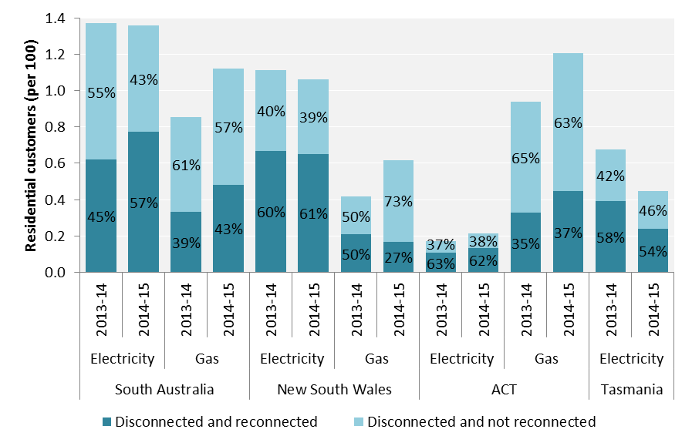

Tables 2.10 and 2.11 show the number of disconnected electricity and gas customers respectively. The tables also show the percentage of disconnected customers that were reconnected as well as the percentage of those reconnections that occurred within seven days.

Proportionally, South Australia had the most electricity customers disconnected for non-payment (1.36 per cent). In South Australia, the largest retailers disconnected slightly more electricity customers in 2014-15 compared with 2013-14, however Alinta Energy disconnected significantly fewer customers compared with 2013-14. In New South Wales, most retailers disconnected more customers in 2014-15 compared with 2013-14, however EnergyAustralia disconnected fewer customers compared with 2013-14.

Most gas retailers across New South Wales, the ACT and South Australia disconnected more customers in 2014-15 compared with 2013-14. The largest proportion of gas customers disconnected for non-payment (1.2 per cent) was in the ACT.

The majority of retailers disconnected fewer than 2 per cent of gas customers in 2014-15. The exceptions were Simply Energy and QEnergy. ActewAGL also disconnected over 2 per cent of its gas customers in New South Wales.

Table 2.10: Residential electricity customers disconnected and reconnected by retailers for non-payment in 2014-15

|  |  |  |  |  |
| --- | --- | --- | --- | --- |
| **Retailer** | **Disconnections (per 100)** | | **Reconnections  (% of disconnections)** | **% of reconnections that occurred within 7 days** |
| **South Australia** |  |  |  |  |
| AGL | 1.23 | ▲0.02 | 43% | 92% |
| Alinta Energy | 1.78 | ▼3.06 | 31% | 90% |
| EnergyAustralia | 0.55 | ▲0.02 | 31% | 75% |
| Lumo Energy | 0.87 | ▼0.36 | 18% | 100% |
| M2 Energy | 0.11 | ▲0.11 | 0% | - |
| Momentum Energy | 1.15 | ▲0.21 | 89% | 38% |
| Origin Energy | 1.75 | ▲0.29 | 94% | 54% |
| Powerdirect | 0.81 | ▲0.13 | 63% | 66% |
| QEnergy | 6.62 | ▲6.62 | 11% | 100% |
| Red Energy | 1.08 | ▼0.06 | 25% | 88% |
| Sanctuary Energy | 0.33 | ▲0.17 | 100% | 100% |
| Simply Energy | 2.39 | ▲0.31 | 57% | 77% |
| **TOTAL SA** | **1.36** | **▼0.01** | **57%** | **72%** |
| **ACT** |  |  |  |  |
| ActewAGL | 0.22 | ▲0.07 | 63% | 89% |
| EnergyAustralia | 0.11 | ▼0.46 | 17% | 100% |
| **TOTAL ACT** | **0.21** | **▲0.04** | **62%** | **89%** |
| **Tasmania** |  |  |  |  |
| Aurora Energy* | 0.45 | ▼0.23 | 54% | 87% |
| **New South Wales** |  |  |  |  |
| ActewAGL | 0.53 | ▲0.21 | 41% | 98% |
| AGL | 1.81 | ▲0.30 | 41% | 96% |
| Click Energy | 0.78 | ▲0.15 | 23% | 95% |
| CovaU | 0.07 | ▲0.07 | 50% | 100% |
| Diamond Energy | 0.13 | ▲0.13 | 100% | 100% |
| EnergyAustralia | 0.27 | ▼0.43 | 55% | 90% |
| Lumo Energy | 1.18 | ▲0.11 | 15% | 100% |
| M2 Energy | 0.63 | ▲0.54 | 24% | 94% |
| Momentum Energy | 1.13 | ▲0.37 | 71% | 41% |
| Origin Energy | 1.20 | ▲0.08 | 87% | 62% |
| Powerdirect | 0.96 | ▲0.58 | 53% | 78% |
| QEnergy | 4.29 | ▲1.85 | 68% | 44% |
| Red Energy | 0.65 | ▼0.38 | 33% | 70% |
| Sanctuary Energy | 0.29 | ▼0.11 | 57% | 100% |
| Simply Energy | 6.28 | ▲6.08 | 50% | 89% |
| **TOTAL NSW** | **1.06** | **▼0.05** | **61%** | **75%** |

* Excludes PAYG customers.

Table 2.11: Residential gas customers disconnected and reconnected by retailers for non-payment in 2014-15

|  |  |  |  |  |
| --- | --- | --- | --- | --- |
| **Retailer** | **Disconnections (per 100)** | | **Reconnections  (% of disconnections)** | **% of reconnections that occurred within 7 days** |
| **South Australia** |  |  |  |  |
| AGL | 1.27 | ▲0.32 | 39% | 84% |
| Alinta Energy | 1.67 | ▼0.47 | 30% | 63% |
| EnergyAustralia | 0.43 | ▲0.35 | 35% | 75% |
| Origin Energy | 0.68 | ▲0.21 | 53% | 76% |
| Simply Energy | 2.62 | ▲0.32 | 36% | 58% |
| **TOTAL SA** | **1.12** | **▲0.27** | **43%** | **75%** |
| **ACT** |  |  |  |  |
| ActewAGL | 1.25 | ▲0.35 | 37% | 77% |
| EnergyAustralia | 0.69 | ▼1.20 | 21% | 67% |
| **TOTAL ACT** | **1.20** | **▲0.27** | **37%** | **77%** |
| **NSW** |  |  |  |  |
| ActewAGL | 2.48 | ▲1.29 | 32% | 64% |
| AGL | 0.72 | ▲0.21 | 25% | 80% |
| EnergyAustralia | 0.14 | ▼0.01 | 22% | 81% |
| Lumo Energy | 0.09 | ▼0.58 | 6% | 100% |
| Origin Energy | 0.75 | ▲0.57 | 32% | 59% |
| **TOTAL NSW** | **0.62** | **▲0.20** | **27%** | **73%** |

Tables 2.12 and 2.13 show the number of residential electricity and gas disconnections in each jurisdiction since 2009-10. Following successive years of increases, electricity disconnections in New South Wales slightly decreased in 2014-15. For the third successive year, over 10,000 electricity customers were disconnected for non-payment of electricity bills in South Australia. Around 32,000 electricity customers were disconnected for non-payment in New South Wales in 2014-15.

Despite the increase in gas disconnections in New South Wales, the number of customers disconnected was well below the peak in 2011-12. Gas disconnections in South Australia increased to levels comparable with 2011-12.

Table 2.12: Residential electricity disconnections for non-payment, 2009-10 to 2014-15

|  |  |  |  |  |
| --- | --- | --- | --- | --- |
|  | **NSW** | **South Australia** | **Tasmania** | **ACT** |
| 2009-10 | 15 835 | 4 748 | 1 396 | 880 |
| 2010-11 | 18 561 | 7 383 | 958 | 402 |
| 2011-12 | 23 207 | 9 893 | 178 | 420 |
| 2012-13 | 24 888 | 10 723 | 1 057 | 73 |
| 2013-14 | 32 940 | 10 148 | 1 555 | 269 |
| 2014-15 | 31 979 | 10 179 | 1 046 | 345 |

Table 2.13: Residential gas disconnections for non-payment, 2009-10 to   
2014-15

|  |  |  |  |
| --- | --- | --- | --- |
|  | **NSW** | **South Australia** | **ACT** |
| 2009-10 | 14 811 | 3 410 | 1 611 |
| 2010-11 | 17 480 | 2 724 | 1 411 |
| 2011-12 | 20 118 | 4 403 | 2 356 |
| 2012-13 | 7 520 | 3 129 | 1 572 |
| 2013-14 | 4 921 | 3 418 | 1 066 |
| 2014-15 | 7 555 | 4 575 | 1 404 |

### Disconnections of customers experiencing financial difficulty

Table 2.14 provides further information about residential customers disconnected in 2014-15.

Table 2.14: Residential customer disconnections, 2014-15

|  |  |  |  |  |
| --- | --- | --- | --- | --- |
| Type of customer disconnected | Electricity (% of disconnections) | | Gas (% of disconnections) | |
| **Customer had been on a payment plan in the previous 12 months** | 25% | ▲6 | 19% | ▲7 |
| **Customer had been disconnected on more than one occasion in the previous 24 months** | 10% | ▲4 | 6% | ▲2 |
| **Customer was receiving an energy concession** | 26% | ▲5 | N/A[21] |  |
| **Customer was on a hardship program** | <1% | ● | <1% | ● |

As discussed earlier in this report, a small number of residential customers in Tasmania use prepayment meters (PAYG) to manage their electricity account. Around half of the customers that use PAYG also receive energy concessions. Table 2.15 shows the number of customers using PAYG (as at the end of June), as well as the number and length of self-disconnections[22] that occurred in each of the last three years.

Table 2.15: Disconnection of customers using prepayment meters in Tasmania

|  |  |  |  |  |
| --- | --- | --- | --- | --- |
|  | **Customers with PAYG** | **PAYG systems capable of detecting and reporting self-disconnections** | **Self-disconnection events** | **Average duration of self-disconnections (mins)** |
| 2012-13 | 33 158 | 4 662 | 1 068 | 225 |
| 2013-14 | 30 640 | 7 194 | 2 069 | 287 |
| 2014-15 | 29 612 | 8 902 | 2 632 | 325 |

## Energy concessions

A concession is a reduction, discount, subsidy, rebate, waiver or exemption provided by the government on the value of goods and services. It may be offered to a household, family or individual, and is generally provided on the basis of low income, special needs of disadvantage or some other category such as age or war service. Energy concessions are provided by state and territory governments.

We use the following indicators to report on energy concessions:

* number of customers in receipt of energy concessions (Table 2.16)
* number of customers in receipt of energy concessions who were disconnected for non-payment (Table 2.14)
* number of customers in receipt of energy concessions who were on a hardship program (Table 2.7).

Table 2.16: Customers receiving energy concessions

|  |  |  |  |  |
| --- | --- | --- | --- | --- |
| **Jurisdiction** | **Customers receiving energy concessions (%)** | | | |
|  | Electricity | | Gas[23] | |
| New South Wales | 29% | ● | 0% |  |
| South Australia | 29% | ● | 26% | ▲1 |
| Tasmania | 38% | - | - |  |
| ACT | 17% | ▲1 | 17% | ▲1 |

Chapter 3 of this report examines energy concessions in greater detail, including concession eligibility and typical savings that customers make with concessions in each jurisdiction.

## Security deposits

Retailers can require small customers to provide security deposits in certain circumstances, for example if the customer owes the retailer money for another account or if the customer has fraudulently acquired energy in the previous two years.[24] Very few retailers hold security deposits—only Aurora Energy and Origin Energy in 2014-15.

Table 2.17: Security deposits held by retailers as at 30 June 2015

|  |  |  |
| --- | --- | --- |
| **Retailer** | **Customers with security deposits** | **Total value of security deposits** |
| Aurora Energy | 92 (small business) | $287 135 |
| Origin Energy | 10 (residential) | $1 760 |

# Energy affordability

## How we report on energy affordability

This chapter provides an overview of the annual cost of electricity and gas around the country[25] for a ‘benchmark household’[26] as at June 2015.

Our state-by-state analysis shows:

* the range in prices of electricity and gas offers generally available to residential customers in each distribution zone
* estimates of annual electricity and gas bills (based on the median standing and market offers for benchmark consumption levels), and
* annual expenditure on electricity and gas bills as a share of disposable income for benchmark low, middle and high income households. For low income households, we also consider the impact of energy concessions.

We have maintained our approach from previous years, as set out in Appendix 7.

We note, however, that due to the release of updated electricity consumption benchmarks and updated ABS income data during 2015 (which we used in this analysis), we have recalculated annual bills from previous years (2013 and 2014) to provide comparisons with the 2015 analysis in this report. This means that estimates of energy bills in this report should not be compared with estimates provided in previous reports.

The latest electricity benchmarking report shows that annual consumption has fallen 12.3 per cent on average. Adjusting for lower consumption levels ensures we do not overstate electricity bills and any potential savings; however our estimates could also potentially understate reductions in recent bills due to decreased consumption.

Unless we state otherwise, any reference to ‘market offer’ and ‘standing offer’ refers to the median market and standing offer respectively. Similarly, any reference to an annual bill or charges refers to an estimated annual bill based on a benchmark household’s consumption level. In our analysis of electricity bills we use two benchmark consumption levels: one for low income households and one for middle and high income (typical) households. Our analysis of gas bills uses only typical consumption levels. ‘Income’ refers to annual disposable income.[27]

## National comparison

Energy bills vary across Australia, as households pay different prices and consume different amounts of energy. The prices in household energy bills cover the costs of wholesale electricity and natural gas, delivering energy through the networks, and retail services (such as call centres and billing). Each of these cost components vary across jurisdictions and distribution zones.

Household consumption of electricity and gas is largely dependent on geographic location. For example, households in Tasmania consume more electricity due to the cooler climate and because few households have gas, and households in the ACT use more gas for heating.

Figure 3.1 shows that a low income household that receives an energy concession, spent between 3 and 6.4 per cent of its income on electricity bills, depending on location (or between 3.6 and 8.4 per cent if they did not receive a concession). Gas bills were a smaller share of income, ranging from 2.6 to 4.4 per cent (or 2.9 to 4.8 per cent without a concession).

Between June 2014 and June 2015, electricity bills decreased by between 3 and 15 per cent in most jurisdictions. The exception was in Queensland, where bills increased by 4 per cent. Gas bills decreased in Victoria and the ACT (by between 4 and 5 per cent), but increased in New South Wales (7 per cent), Queensland and South Australia (both 1 per cent).[28]

This compares with the previous year, where both electricity and gas bills increased in all jurisdictions, with the exception of electricity bills in Tasmania. Although most increases were modest, there were significant increases in electricity bills in Queensland.

The primary reason for the decrease in energy bills was the removal of the carbon tax, which impacted electricity and gas prices from July 2014 and is reflected in the June 2015 energy bills used in this report. Since the removal of the carbon tax, energy bills have also been impacted by changes in wholesale and network prices.

Electricity bills remained highest in Tasmania ($1927 for the standing offer) and lowest in Victoria ($1188 for the median market offer). Electricity bills again accounted for the smallest share of disposable income for low income households in the ACT – 3.6 per cent (or 3 per cent with a concession). This is due to lower electricity charges and higher incomes relative to other jurisdictions.

Despite Victoria having the lowest gas charges, higher levels of gas consumption mean that gas bills represent the greatest proportion of household income relative to other jurisdictions.

Across all jurisdictions where market offers are available, the median market offer was between 5 and 20 per cent cheaper than the standing offer. The potential savings were slightly smaller for gas market offers (up to 16 per cent). The greatest difference between the median market and standing offer was in Victoria.

Compared with the median electricity market offer, the cheapest electricity market offers were around $200 per year cheaper in New South Wales and around $100 to $150 cheaper in Victoria and South Australia, respectively. Potential savings in Queensland ($67) and the ACT ($83) were smaller, but still notable.

The potential savings on gas are smaller than those offered for electricity. Compared with the median gas market offer, the cheapest gas market offers were around $100 to $150 per year cheaper in Victoria and the ACT, but only around $20 to $70 cheaper in Queensland, New South Wales and South Australia. There is less competition in retail gas markets, and this is not expected to improve in the near future due to uncertainty about conditions in the wholesale market.

Energy concessions can significantly improve energy affordability. The potential savings vary in each jurisdiction. For example, with a concession, low income households could save between $200 and $460 on electricity and up to $200 on gas each year.

Tariff structures in retail energy markets typically consist of a fixed charge (daily supply charge) and one or more variable components (energy use charges). Our analysis shows that these daily supply charges make up between 17 and 37 per cent of electricity and gas bills faced by low income households. Although all households pay the same value of daily supply charges, low income households typically consume less energy, and therefore a larger percentage of their bill goes towards these fixed costs when compared with other households.

Figure 3.1: Annual electricity and gas bills, and as a share of benchmark low income household’s disposable income (without concession) – jurisdiction specific ‘low’ consumption levels, June 2013, 2014 and 2015

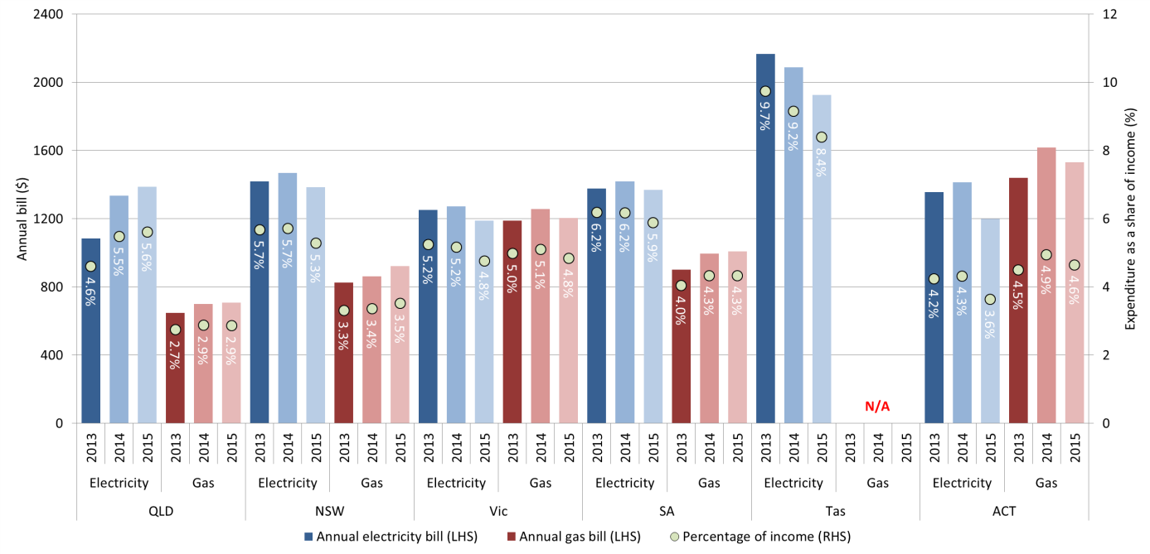

Figure 3.2 directly compares energy charges across jurisdictions, as it applies the same energy consumption levels to all jurisdictions – 6000 kWh of electricity and 24 000 MJ of gas.

Electricity charges were highest in South Australia ($2156), followed by Queensland ($1881) and New South Wales ($1822). Electricity charges were lowest in the ACT ($1265). Queensland ($1077) and South Australia ($1062) had the highest gas bills, and Victoria had the cheapest ($648).

Figure 3.2: Annual electricity and gas bills (6000 kWh and 24 000 MJ pa), June 2013, 2014 and 2015

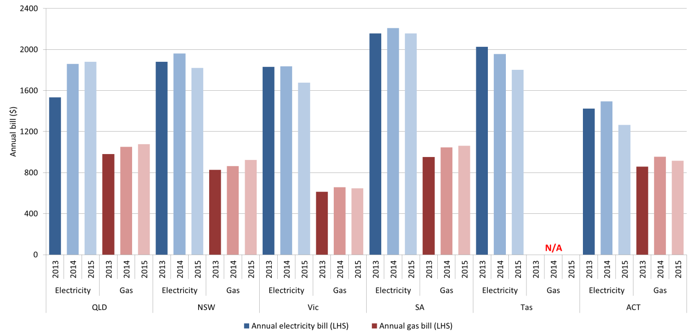

## Queensland

### Energy prices and bills

There are two electricity distribution zones in Queensland:

* Energex covers south east Queensland and
* Ergon Energy, the rest of the state.[29]

The costs of supplying customers in Ergon Energy’s regional and rural areas are much greater than those in south east Queensland, which is serviced by Energex. This is mainly due to the higher transport costs over long distances and fewer customers to share the costs of energy infrastructure. The Queensland Government subsidises Ergon Energy under its uniform tariff policy to ensure that customers in rural areas are not disadvantaged.

The Queensland Competition Authority (QCA) reviews the regulated tariffs (sometimes called notified prices) each year and makes price determinations.

The Queensland Government delayed its plan to commence price deregulation in South East Queensland from 1 July 2015 while the Queensland Productivity Commission undertakes an inquiry into electricity prices. The Queensland Government has announced that retail electricity prices will continue to be regulated in regional Queensland, where competition is limited.

Ergon Energy sells electricity at regulated prices. The standing offer in both the Ergon and Energex zones is the same ($1479) due to the uniform tariff policy.

Households in the Energex zone, however, can choose from a range of market and standing electricity offers from up to eight retailers. Annual electricity bills for these offers ranged from $1320 to $1552. Annual electricity bills for the median market offer were $1387, which was $92 less than the median standing offer (Figure 3.3).

Figure 3.3: Range of generally available electricity offers by distribution zone (4100 kWh) – June 2015

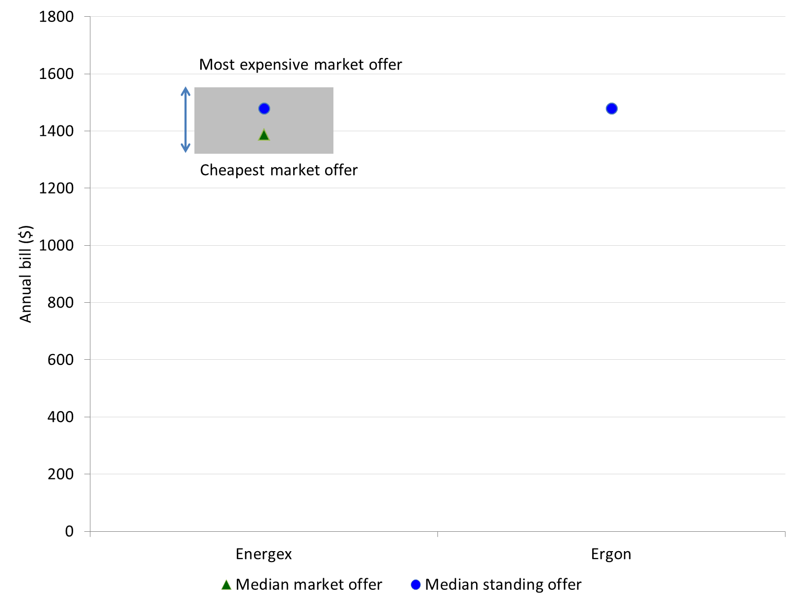

Queensland has four gas distribution zones: Allgas Energy (south Brisbane and the Gold Coast), Australian Gas Networks (AGN) (Brisbane North and Ipswich), AGN (Northern) and AGN (Wide Bay).

The AEMC 2015 Competition Review found that competition in Queensland’s regional retail gas market is not effective, with gas customers in some areas having little to no choice of retailer. The AEMC does not expect these conditions to change, given the small market and tightening demand and supply in the wholesale gas market.[30] The COAG Energy Council has directed the AEMC to review the design, function and roles of facilitated gas markets and gas transportation arrangements on the east coast of Australia.[31]

Figure 3.4 shows the range of annual gas bills across the distribution zones. The median market offer was lowest in AGN (Wide Bay) ($451) and highest in AGN (Northern) ($752).

The range between the cheapest and most expensive market offers in each zone was reasonably narrow (between $21 and $31 across the AGN distribution zones and $47 for Allgas Energy).

Figure 3.4: Range of generally available gas offers by distribution zone (10 000 MJ) – June 2015

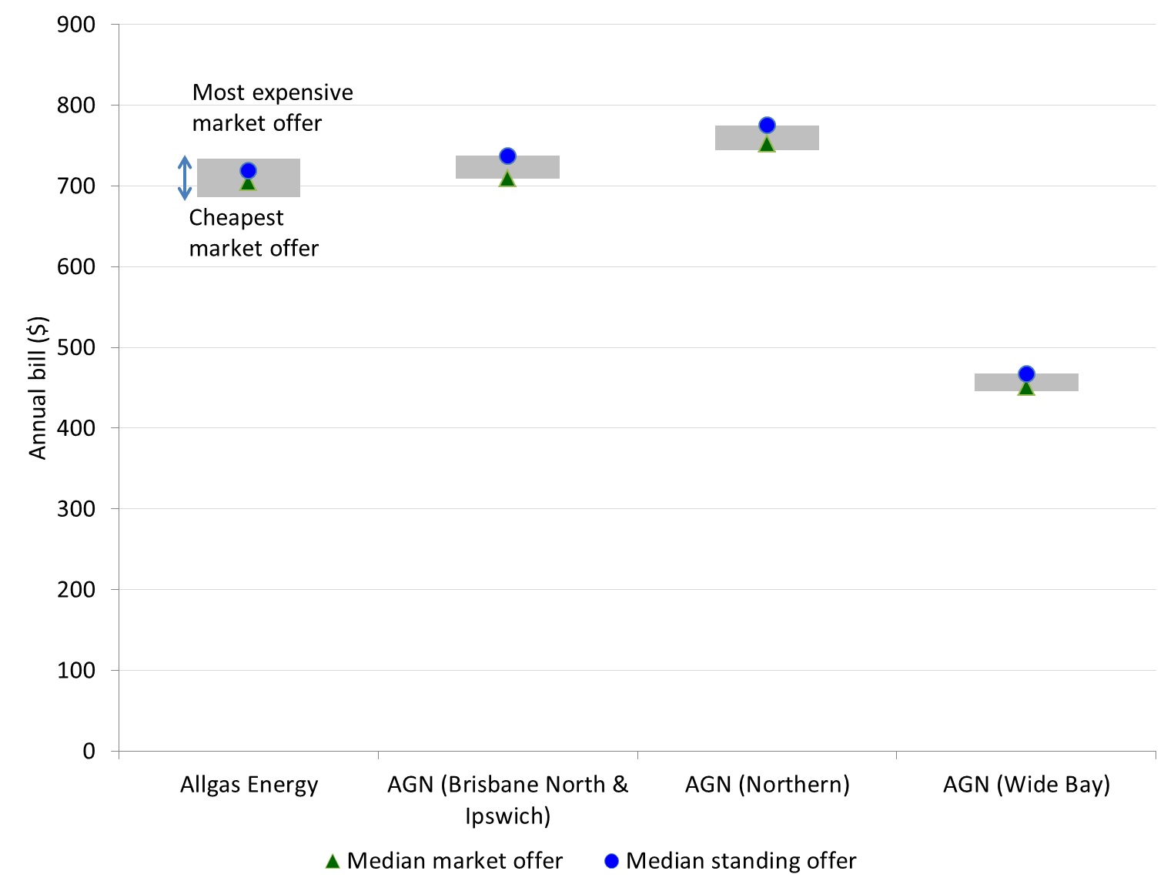

### Energy bills as a percentage of income

Two types of rebate are available to eligible customers in Queensland.[32] In 2014-15, the Electricity Rebate provided up to $321 per year towards electricity bills. The Reticulated Natural Gas Rebate provided around $68 per year. Figure 3.5 shows the impact of these rebates on bills for a benchmark low income household.

Figure 3.5: Annual electricity and gas bills, and as a share of disposable income for a benchmark low income household (4100 kWh and 10 000 MJ)

For a low income household, the annual electricity bill for the median market offer was $1387 ($1066 with a concession). This is 5.6 per cent of annual disposable income, or 4.3 per cent with a concession. The annual electricity bill for the median standing offer was higher than the median market offer, at $1479 ($1158 with a concession). This represents 6 per cent of a benchmark low income household’s annual disposable income, or 4.7 per cent with a concession.
The annual gas bill for the median market offer was $709 ($641 with a concession). This is 2.9 per cent of annual disposable income (2.6 per cent with a concession). The annual gas bill for the median standing offer was 4 per cent greater than the median market offer, at $735 ($667 with a concession). This represents 3 per cent of a benchmark low income household’s annual disposable income (2.7 per cent with a concession). 


For a low income household, the annual electricity bill for the median market offer was $1387 ($1066 with a concession). This is 5.6 per cent of annual disposable income, or 4.3 per cent with a concession. The annual electricity bill for the median standing offer was 7 per cent higher than the median market offer, at $1479 ($1158 with a concession). This represents 6 per cent of a benchmark low income household’s annual disposable income, or 4.7 per cent with a concession.

Annual electricity bills increased by only 4 per cent over the 12 months to June 2015, compared with a 23 per cent increase the previous year. The main factors pushing up electricity prices are wholesale costs, the Solar Bonus Scheme[33] and network charges. The network charges make up around 42 per cent of a Queensland customer's bill. The AER's 2015-20 network determinations for Energex and Ergon are estimated to provide customers with future bill reductions, which will be evident in future reports.

The annual gas bill for the median market offer was $709 ($641 with a concession). This is 2.9 per cent of annual disposable income (2.6 per cent with a concession). The annual gas bill for the median standing offer was 4 per cent greater than the median market offer, at $735 ($667 with a concession). This represents 3 per cent of a benchmark low income household’s annual disposable income (2.7 per cent with a concession).

Annual gas bills for households on market offers increased by 1 per cent over the previous year, and by 4 per cent for households on standing offers.

For a household consuming a typical amount of electricity–5800 kWh in Queensland–annual bills represent 2.6 per cent of a middle income household’s annual disposable income and 1 per cent of a high income household’s annual disposable income.

For a household consuming a typical amount of gas, annual gas bills represent 1 per cent of a middle income household’s annual disposable income and 0.4 per cent of a high income household’s income (table 3.1).

Table 3.1: Summary of annual electricity and gas bills (for the median market offer) and as a share of disposable income – June 2015

|  |  |  |  |
| --- | --- | --- | --- |
| **Income level** | **Annual consumption** | **Annual bill ($)** | **Proportion of annual income (%)** |
| Low income – with concession | Electricity 4100 kWh | 1066 | 4.3 |
| Low income – without concession | Electricity 4100 kWh | 1387 | 5.6 |
| Middle income | Electricity 5800 kWh | 1829 | 2.6 |
| High income | Electricity 5800 kWh | 1829 | 1.0 |
| Low income – with concession | Gas 10 000 MJ | 641 | 2.6 |
| Low income – without concession | Gas 10 000 MJ | 709 | 2.9 |
| Middle income | Gas 10 000 MJ | 709 | 1.0 |
| High income | Gas 10 000 MJ | 709 | 0.4 |

### Composition of energy bills and impact of concessions

Table 3.2 shows the portions of low income household energy bills attributed to daily supply charges and energy use charges, as well as the savings provided by energy concessions.

Daily supply charges for electricity were around $335 per annum in 2015, which represents 24 per cent of a low income household’s annual electricity bill, and 1.4 per cent of its disposable income. Daily supply charges for electricity have increased from $105 per annum (10 per cent of an annual bill) in 2013, however proportionally are similar to other jurisdictions.

Daily supply charges for gas were around $260 per annum, which represents 37 per cent of a low income household’s annual gas bill, and around 1 per cent of its disposable income.

Energy concessions help eligible customers save 23 per cent on electricity and 10 per cent on gas.

Table 3.2: Composition of low income household energy bills (median market offer)

|  |  |  |  |  |
| --- | --- | --- | --- | --- |
| **Fuel type – consumption** | **Year** | **Daily supply charges (%)** | **Energy use charges (%)** | **Saving with concession (%)** |
| Electricity – 4100 kWh | 2013 | 9.7% | 90.3% | 21.2% |
|  | 2014 | 15.1% | 84.9% | 21.2% |
|  | 2015 | 24.1% | 75.9% | 23.1% |
| Gas – 10 000 MJ | 2013 | 46.3% | 53.7% | 10.0% |
|  | 2014 | 42.4% | 57.6% | 9.3% |
|  | 2015 | 36.8% | 63.2% | 9.6% |

## New South Wales

### Energy prices and bills

There are three electricity distribution zones in New South Wales: Ausgrid, Endeavour Energy and Essential Energy. Seventeen retailers had offers generally available to electricity customers in New South Wales.

On 1 July 2014, the New South Wales Government removed price regulation from the retail electricity market. Customers on regulated offers that did not switch to a market contract before 1 July 2014 were automatically moved to a ‘transitional tariff’.

The Essential Energy distribution zone had the highest electricity bills ($2054) and also the greatest range between the cheapest and most expensive offers ($702) (figure 3.6). Essential Energy covers most of regional and rural New South Wales, so typically has fewer customers to pay for a larger area of network infrastructure. The greater network costs are reflected in the final bills to customers.

The Ausgrid and Endeavour Energy distribution zones had similar median market and standing offers (between $1360 and $1390), as well as a similar range between the cheapest and most expensive offers (around $300). Customers on standing offers in these areas could save around $200 a year if they switched to one of the cheapest market offers.

In each distribution zone the median market offer is less than the median standing offer. As at 30 June 2015, 30 per cent of residential customers remained on standing offers.

Figure 3.6: Range of generally available electricity offers by distribution zone (4300 kWh) – June 2015

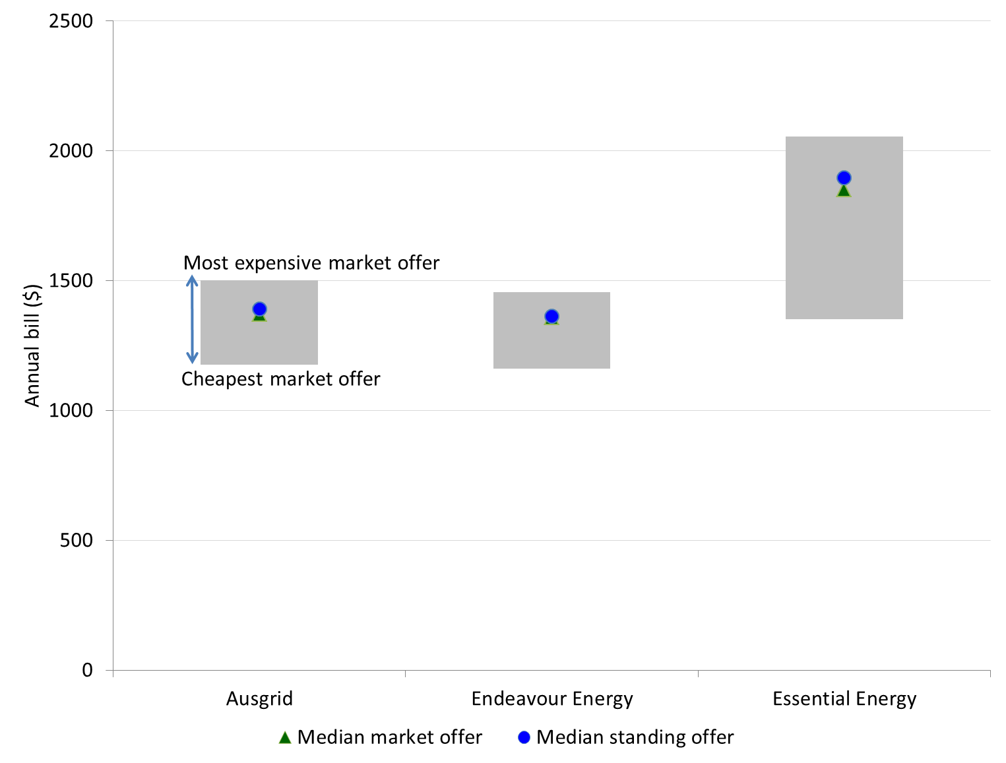

There are four gas distribution zones in New South Wales: Jemena, AGN (Albury), AGN (Wagga Wagga) and ActewAGL Distribution. Six retailers had offers generally available to gas customers in the Jemena distribution zone, but there were only two retailers for AGN (Albury) and ActewAGL, and one retailer for AGN (Wagga Wagga).

Regulated gas prices are determined by the Independent Pricing and Regulatory Tribunal (IPART) under voluntary pricing arrangements with ActewAGL, AGL and Origin Energy.

Figure 3.7 shows the range of annual gas bills across the distribution zones. Gas bills for the median market offer were highest in the Jemena distribution zone ($973), however were still $60 cheaper than the regulated offer ($1033). The median market offer was $791 in the AGN (Wagga Wagga) distribution zone – $65 cheaper than the regulated offer (both from Origin Energy).

Figure 3.7: Range of generally available gas offers by distribution zone (24 000 MJ) – June 2015

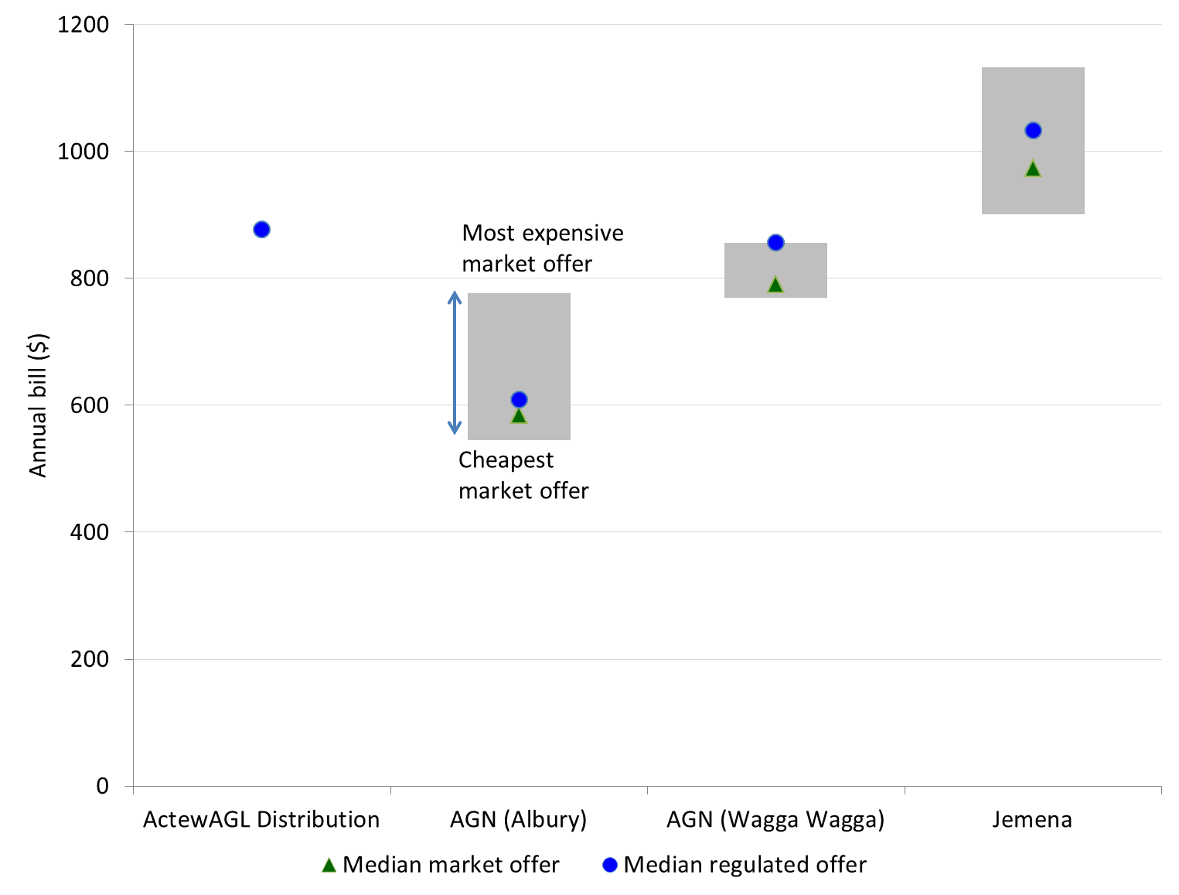

### Energy bills as a percentage of income

The Low Income Household Rebate is the primary energy concession available to eligible customers[34] in New South Wales. It applies only to electricity bills and is capped at $235 (excluding GST) per year.

Some customers are also eligible[35] for the Family Energy Rebate, which is capped at $150 per year. For households eligible for both the Low Income Household Rebate and the Family Energy Rebate, the Family Energy Rebate is capped at $15 per year, making the maximum annual electricity concession available $250. The analysis of annual electricity bills in figure 3.8 includes the maximum value of both concessions. There is no concession available in New South Wales for gas bills.

Figure 3.8: Annual electricity and gas bills, and as a share of disposable income for a benchmark low income household (4300 kWh and 24 000 MJ)

Across New South Wales, the annual bill for customers on the median market offer was $1386 (or $1111 with a concession). Annual bills for the median standing offer were greater, at $1429 (or $1154 with a concession). Low income households on a market offer and receiving an energy concession would spend 4.2 per cent of its income on electricity (or 5.3 per cent if it did not receive a concession). A low income household on the standing offer and receiving a concession would spend 4.4 per cent of its income, or 5.4 per cent without a concession.
Annual gas bills were $923 for a household on the median market offer. The median regulated offer was lower ($867), as some gas distribution zones only had regulated offers or a small number of market offers. For a low income household, gas bills represent 3.5 per cent of income if on the market offer and 3.3 per cent on the regulated offer

Across New South Wales, the annual bill for customers on the median market offer was $1386 (or $1111 with a concession). Annual bills for the median standing offer were greater, at $1429 (or $1154 with a concession). Low income households on a market offer and receiving an energy concession would spend 4.2 per cent of its income on electricity (or 5.3 per cent if it did not receive a concession). A low income household on the standing offer and receiving a concession would spend 4.4 per cent of its income, or 5.4 per cent without a concession.

Electricity bills decreased by 5.5 per cent from June 2014 to June 2015, which was likely due to the removal of the carbon tax. Electricity bills as a proportion of income for low income households decreased from 5.7 per cent in June 2014 to 5.3 per cent in June 2015.

Annual gas bills were $923 for a household on the median market offer. The median regulated offer was lower ($867), as some gas distribution zones only had regulated offers or a small number of market offers. For a low income household, gas bills represent 3.5 per cent of income if on the market offer and 3.3 per cent on the regulated offer. Gas bills increased by 6.9 per cent (market offers) and 4.8 per cent (regulated offers) from June 2014 to June 2015. Wholesale gas prices are attributed as the main driver for these price increases, along with some increases in network costs.

A middle income household consuming a typical amount of energy–5900 kWh in New South Wales–spent 2.4 per cent of its income on electricity (table 3.3). For a high income household, electricity accounted for 0.9 per cent of its income. Middle and high income households spent 1.3 per cent and 0.4 per cent on gas respectively.

Table 3.3: Summary of annual electricity and gas bills (for the median market offer) and as a share of disposable income – June 2015

|  |  |  |  |
| --- | --- | --- | --- |
| **Income level** | **Annual consumption** | **Annual bill ($)** | **Proportion of annual income (%)** |
| Low income – with concession | Electricity 4300 kWh | 1111 | 4.2 |
| Low income – without concession | Electricity 4300 kWh | 1386 | 5.3 |
| Middle income | Electricity 5900 kWh | 1796 | 2.4 |
| High income | Electricity 5900 kWh | 1796 | 0.9 |
| Low income – with concession | Gas 24 000 MJ | 923 | 3.5 |
| Low income – without concession | Gas 24 000 MJ | 923 | 3.5 |
| Middle income | Gas 24 000 MJ | 923 | 1.3 |
| High income | Gas 24 000 MJ | 923 | 0.4 |

### Composition of energy bills and impact of concessions

Table 3.4 shows the portions of low income household energy bills attributed to daily supply charges and energy use charges, as well as the savings provided by energy concessions.

Daily supply charges for electricity were $344 per annum in 2015, which represents 25 per cent of a low income household’s annual electricity bill, and 1.3 per cent of its disposable income. Daily supply charges for electricity decreased by $12 per annum since June 2014.

Daily supply charges for gas were $207 per annum, which represents 22 per cent of a low income household’s annual gas bill, and 0.8 per cent of its disposable income.

The electricity concession helps eligible customers save 20 per cent on electricity; however there is no assistance for gas bills.

Table 3.4: Composition of low income household energy bills (median market offer)

|  |  |  |  |  |
| --- | --- | --- | --- | --- |
| **Fuel type – consumption** | **Year** | **Daily supply charges (%)** | **Energy use charges (%)** | **Saving with concession (%)** |
| Electricity – 4300 kWh | 2013 | 19.0% | 81.0% | 17.6% |
|  | 2014 | 24.2% | 75.8% | 17.0% |
|  | 2015 | 24.8% | 75.2% | 19.8% |
| Gas – 24 000 MJ | 2013 | 19.6% | 80.4% | 0.0% |
|  | 2014 | 24.9% | 75.1% | 0.0% |
|  | 2015 | 22.4% | 77.6% | 0.0% |

## Victoria

### Energy prices and bills

There are five electricity distribution zones in Victoria (Powercor, United Energy, CitiPower, Jemena and AusNet Services). Nineteen retailers had offers generally available to electricity customers in Victoria.

As in previous years, customers in AusNet Services’ distribution – which covers most of the eastern part of Victoria, including some of the eastern suburbs of Melbourne – had the highest electricity bills for the median market ($1315) and median standing offer ($1616).

The AusNet Services zone mainly covers rural Victoria, where a large amount of network infrastructure services a relatively small number of customers. The Jemena and Powercor distribution zones were again the next two most expensive zones, with annual bills for the median market offer of $1209 and $1207 respectively.

In contrast, the CitiPower distribution zone, which is smaller and covers inner Melbourne, had the cheapest possible annual electricity bills ($889 – almost $300 cheaper than the cheapest offer in the AusNet Services zone), as well as the cheapest median market offer ($1032).

Within the NEM, the range in electricity bills (from cheapest to most expensive) across distribution zones was generally greatest in Victoria. In all distribution zones in Victoria, the median market offer was by far cheaper than the median standing offer – by up to $300. A customer still on a standing offer could save around $400 by switching to one of the cheapest market offers.

Figure 3.9: Range of generally available electricity offers by distribution zone (3700 kWh) – June 2015

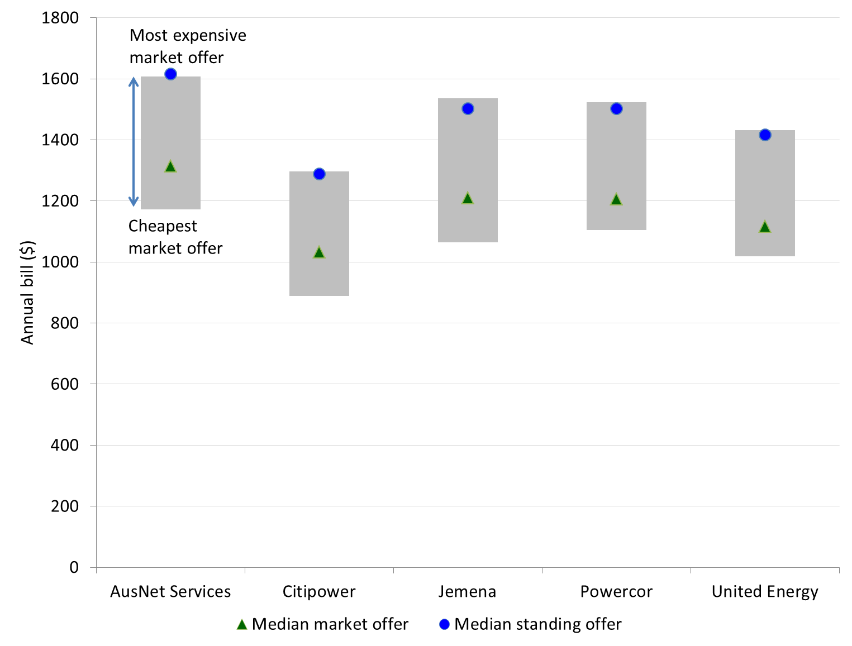

There are eight gas distribution zones in Victoria: Multinet Main 1, Multinet Main 2, AusNet Services Central 1, Ausnet Services Central 2, AusNet Services West, AGN Central 1, AGN Central 2 and AGN North. Nine retailers had offers generally available to gas customers in Victoria.

Across the distribution zones, annual gas bills under the median standing offers were 12 to 15 per cent greater than annual gas bills under the median market offer. In all but one distribution zone the standing offer was the most expensive.

The gas distribution zone with the widest range of market offers was AusNet Services Central 2 ($330) and the narrowest was AGN North ($226).

Figure 3.10: Range of generally available gas offers by distribution zone (63 000 MJ) – June 2015

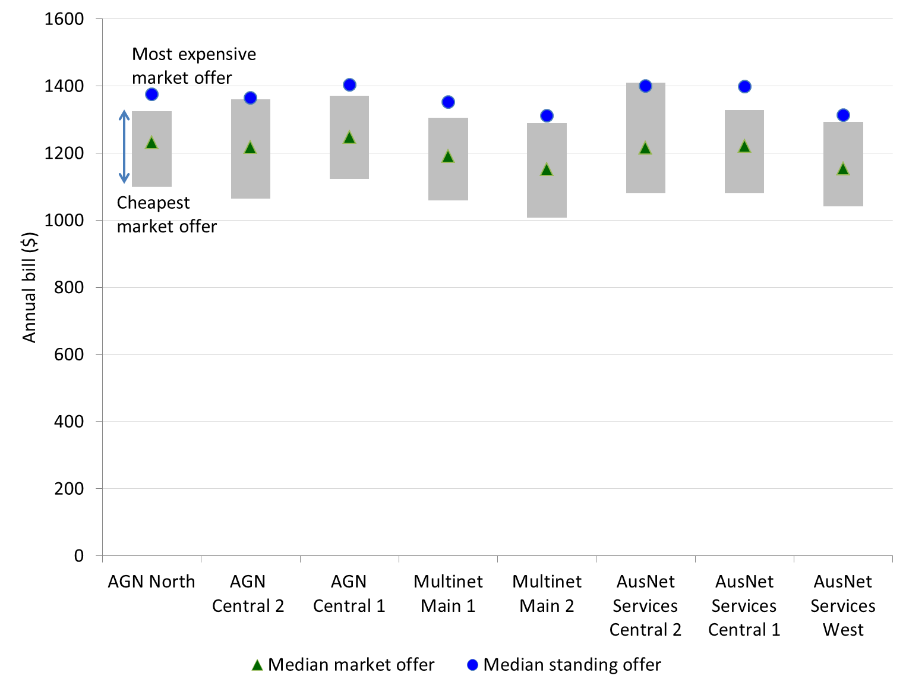

Customers still on standing offers are likely to be able to save money by switching to a market offer that suits their needs. Customers in Victoria can compare energy offers using the Victoria Energy Compare website (<https://compare.switchon.vic.gov.au>).

### Energy bills as a percentage of income

The Victorian Government offers electricity and gas concessions to eligible households.[36] The Annual Electricity Concession provides a 17.5 per cent discount off electricity bills. The discount does not apply to the first $171.60 or automatically to any value above $2763. Concession households with annual electricity bills of more than $2763 can apply for the Excess Electricity Concession to continue to receive the 17.5 per cent concession on electricity consumed above this amount.

The Winter Gas Concession also provides a 17.5 per cent discount off gas bills, but only applies to gas services in the six months between 1 May and 31 October each year. It does not apply to the first $62.40 or automatically to any value above $1462. Concession households with gas bills of more than $1462 during the winter period can apply for the Excess Gas Concession to continue to receive the 17.5 per cent concession. Figure 3.11 shows the impact of these concessions on annual electricity and gas bills.

Figure 3.11: Annual electricity and gas bills, and as a share of disposable income for a benchmark low income household (3700 kWh and 63 000 MJ)

The electricity bill for a household on the median market offer was $1188 (or $1011 with a concession). Electricity bills for the standing offer were higher, at $1479 (or $1250 with a concession). A low income household on the median market offer and receiving an energy concession would spend 4.1 per cent of its disposable income on electricity (or 4.8 per cent without a concession). For the median standing offer, the annual electricity bill would comprise 5 per cent of a low income household’s disposable income (receiving a concession), or 5.9 per cent without a concession.
Annual gas bills for the median market offer were $1206 (or $1106 with a concession), and for the median standing offer were $1368 (or $1254 with a concession). A low income household on the median market offer and receiving an energy concession would spend 4.4 per cent of its disposable income on gas (or 4.8 per cent without a concession). For the median standing offer, the annual gas bill would comprise 5 per cent of a low income household’s disposable income (receiving a concession), or 5.5 per cent without a concession.


The electricity bill for a household on the median market offer was $1188 (or $1011 with a concession). Electricity bills for the standing offer were higher, at $1479 (or $1250 with a concession). A low income household on the median market offer and receiving an energy concession would spend 4.1 per cent of its disposable income on electricity (or 4.8 per cent without a concession). For the median standing offer, the annual electricity bill would comprise 5 per cent of a low income household’s disposable income (receiving a concession), or 5.9 per cent without a concession.

Annual electricity bills for the median market offer decreased by 7 per cent in 2015 when compared to 2014. As a proportion of income, the decrease was from 5.2 per cent to 4.8 per cent. Electricity bills for the standing offer only decreased by 1 per cent over the same period. Annual electricity bills for market offers have decreased to totals below those from June 2013.

Annual gas bills for the median market offer were $1206 (or $1106 with a concession), and for the median standing offer were $1368 (or $1254 with a concession). A low income household on the median market offer and receiving an energy concession would spend 4.4 per cent of its disposable income on gas (or 4.8 per cent without a concession). For the median standing offer, the annual gas bill would comprise 5 per cent of a low income household’s disposable income (receiving a concession), or 5.5 per cent without a concession.

Annual gas bills for the median market offer decreased by 4 per cent from June 2014 to June 2015. Low income households spent 4.8 per cent of their income on gas, compared 5.1 per cent in June 2014 and 5 per cent in June 2013.

A benchmark middle income household consuming a typical amount of electricity – 4900 kWh in Victoria – spent 2 per cent of its disposable income on electricity bills. A high income household consuming the same amount of electricity spend 0.8 per cent of its income. Middle and high income households spent 1.7 per cent and 0.6 per cent of their disposable income respectively on gas.

Table 3.5: Summary of annual electricity and gas bills (for the median market offer) and as a share of disposable income – June 2015

|  |  |  |  |
| --- | --- | --- | --- |
| **Income level** | **Annual consumption** | **Annual bill ($)** | **Proportion of annual income (%)** |
| Low income – with concession | Electricity 3700 kWh | 1011 | 4.1 |
| Low income – without concession | Electricity 3700 kWh | 1188 | 4.8 |
| Middle income | Electricity 4900 kWh | 1436 | 2.0 |
| High income | Electricity 4900 kWh | 1436 | 0.8 |
| Low income – with concession | Gas 63 000 MJ | 1106 | 4.4 |
| Low income – without concession | Gas 63 000 MJ | 1206 | 4.8 |
| Middle income | Gas 63 000 MJ | 1206 | 1.7 |
| High income | Gas 63 000 MJ | 1206 | 0.6 |

### Composition of energy bills and impact of concessions

Table 3.6 shows the portions of low income household energy bills attributed to daily supply charges and energy use charges, as well as the savings provided by energy concessions.

Daily supply charges for electricity were $401 per annum in 2015, which represents 34 per cent of a low income household’s annual electricity bill, and 1.6 per cent of its disposable income. Daily supply charges for electricity did not significantly increase in 2015; however in Victoria they represent the largest portion of annual bills when compared with other jurisdictions.

Daily supply charges for gas were $249 per annum, which represents 21 per cent of a low income household’s annual gas bill, and 1 per cent of its disposable income.

Energy concessions help eligible customers save 15 per cent on electricity and 8 per cent on gas.[37]

Table 3.6: Composition of low income household energy bills (median market offer)

|  |  |  |  |  |
| --- | --- | --- | --- | --- |
| **Fuel type – consumption** | **Year** | **Daily supply charges (%)** | **Energy use charges (%)** | **Saving with concession (%)** |
| Electricity – 3700 kWh | 2013 | 26.6% | 73.4% | 15.1% |
|  | 2014 | 31.3% | 68.7% | 15.1% |
|  | 2015 | 33.7% | 66.3% | 15.0% |
| Gas – 63 000 MJ | 2013 | 17.9% | 82.1% | 8.3% |
|  | 2014 | 18.2% | 81.8% | 8.3% |
|  | 2015 | 20.6% | 79.4% | 8.3% |

## South Australia

### Energy prices and bills

South Australia has one electricity distribution zone (SA Power Networks). Seventeen retailers had offers generally available to electricity customers in South Australia. Figure 3.12 shows the range in generally available electricity offers.

Although it is not quite the most expensive offer, the median standing offer ($1538) was 12 per cent greater than the median market offer ($1370). A customer on a standing offer could save around $300 from their annual bill by switching to one of the cheapest market offers.

Figure 3.12: Range of generally available electricity offers by distribution zone (3700 kWh) – June 2015

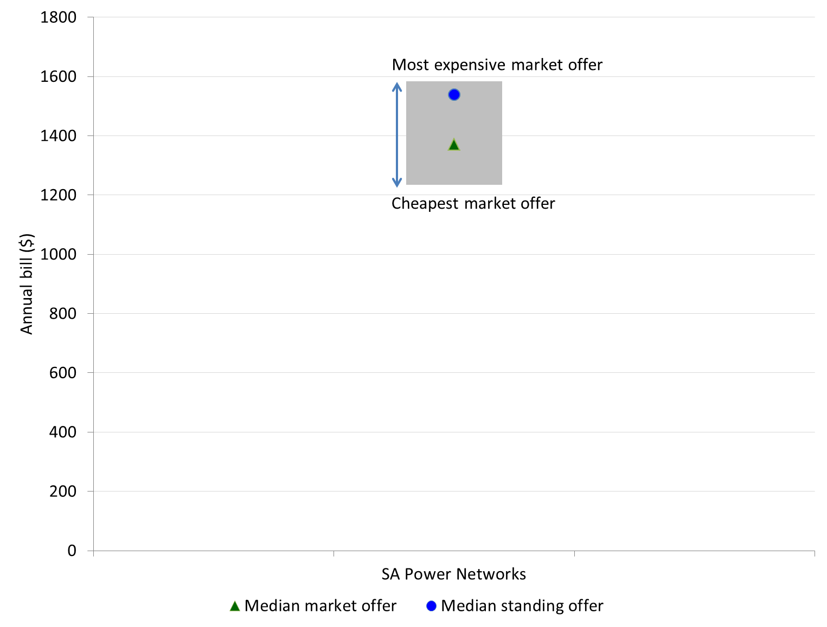

Australian Gas Networks (AGN) is the gas distributor in South Australia. It has five pricing zones: Metro Area, Mount Gambier, Port Pirie, Riverland and Whyalla. Four retailers had offers generally available to gas customers.

In the Mount Gambier, Port Pirie and Whyalla pricing zones, the standing offer was more expensive than any market offer, and Origin Energy market offers were the cheapest. In the Metro and Riverland zones, the median market and standing offers were the same, as was the range in charges of offers ($208). Annual gas bills for median standing offers were 3 to 10 per cent greater than the median market offers.

Figure 3.13: Range of generally available gas offers by distribution zone   
(21 000 MJ) – June 2015

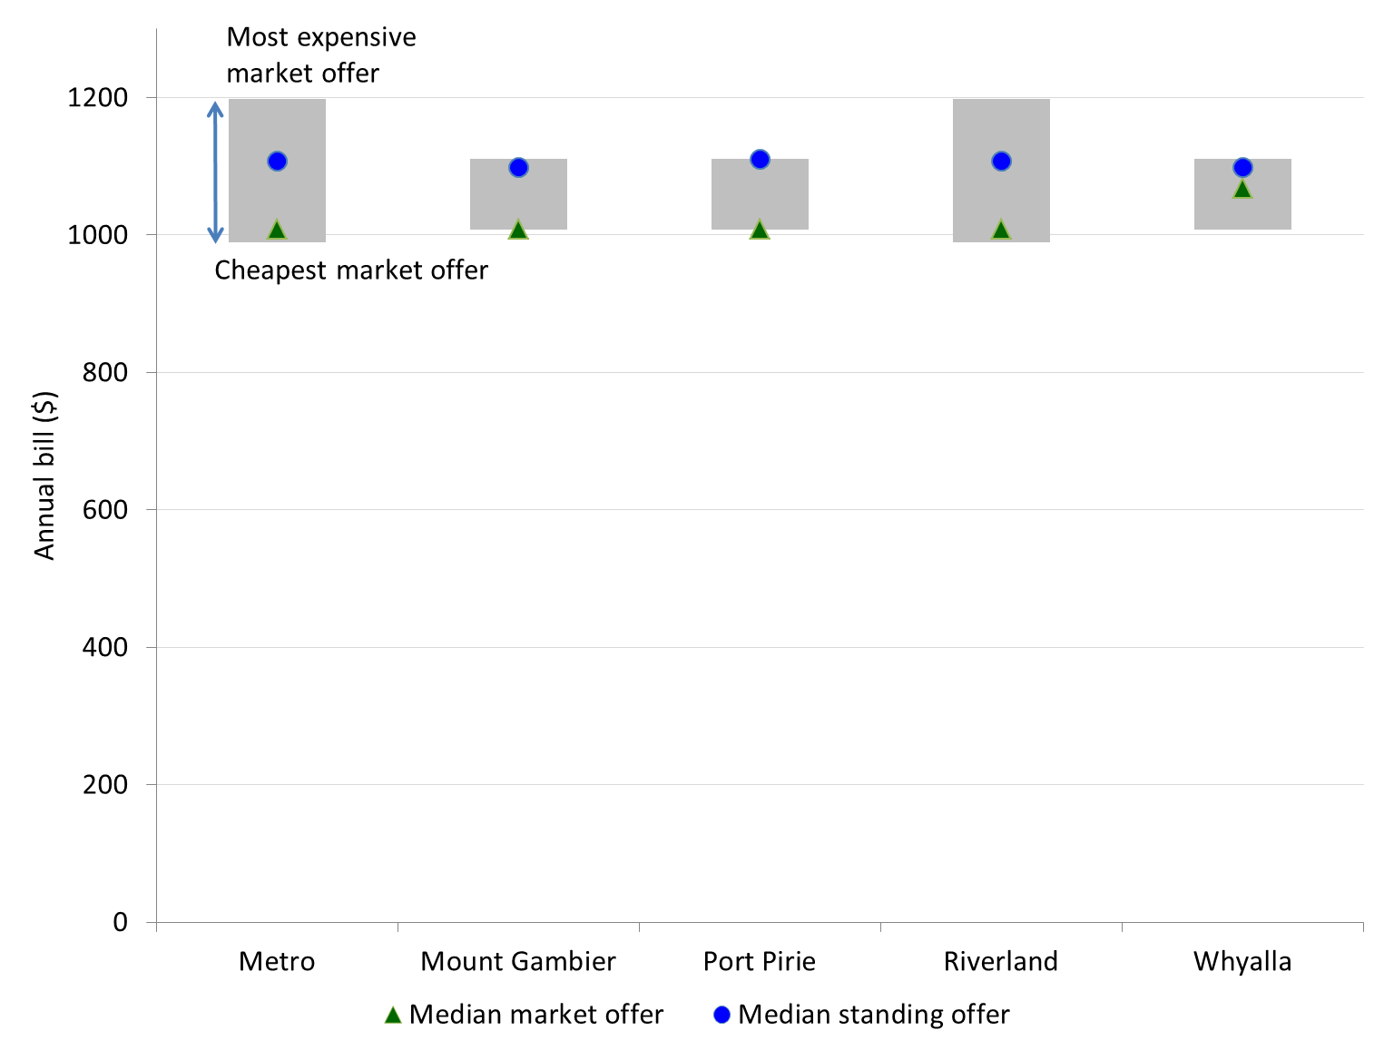

### Energy bills as a percentage of income

Eligible households in South Australia can receive a concession of up to $215 (in total) on their annual household energy (electricity and gas) bills.[38] In our analysis, we applied a concession of $107.50 each to the annual electricity and gas bills of low income households (figure 3.14).

Figure 3.14: Annual electricity and gas bills, and as a share of disposable income for a benchmark low income household (3700 kWh and 21 000 MJ)

The electricity bill for a household on the median market offer was $1370 (or $1263 with a concession). Electricity bills for the standing offer were higher, at $1538 (or $1431 with a concession). A low income household on the median market offer and receiving an energy concession would spend 5.4 per cent of its disposable income on electricity (or 5.9 per cent without a concession). For the median standing offer, the annual electricity bill would comprise 6.1 per cent of a low income household’s disposable income (receiving a concession), or 6.6 per cent without a concession.
Annual gas bills for the median market offer were $1008 (or $901 with a concession), and for the median standing offer were $1110 (or $1003 with a concession). A low income household on the median market offer and receiving an energy concession would spend 3.9 per cent of its disposable income on gas (or 4.3 per cent without a concession). For the median standing offer, the annual gas bill would comprise 4.3 per cent of a low income household’s disposable income (receiving a concession), or 4.8 per cent without a concession.


The electricity bill for a household on the median market offer was $1370 (or $1263 with a concession). Electricity bills for the standing offer were higher, at $1538 (or $1431 with a concession). A low income household on the median market offer and receiving an energy concession would spend 5.4 per cent of its disposable income on electricity (or 5.9 per cent without a concession). For the median standing offer, the annual electricity bill would comprise 6.1 per cent of a low income household’s disposable income (receiving a concession), or 6.6 per cent without a concession.

Annual electricity bills for the median market offer decreased by 3 per cent in 2015 when compared to 2014. As a proportion of income, the decrease was from 6.2 per cent to 5.9 per cent. Electricity bills for the standing offer decreased by less than 1 per cent over the same period. Annual electricity bills for market offers have decreased to totals below those from June 2013.

Annual gas bills for the median market offer were $1008 (or $901 with a concession), and for the median standing offer were $1110 (or $1003 with a concession). A low income household on the median market offer and receiving an energy concession would spend 3.9 per cent of its disposable income on gas (or 4.3 per cent without a concession). For the median standing offer, the annual gas bill would comprise 4.3 per cent of a low income household’s disposable income (receiving a concession), or 4.8 per cent without a concession.

Annual gas bills for the median market offer increased by 1 per cent from June 2014 to June 2015. This follows a 10 per cent increase in the previous year. Low income households spent 4.8 per cent of their income on gas, the same proportion compared with June 2014.

A benchmark middle income household consuming a typical amount of electricity – 5100 kWh in South Australia – spent 3 per cent of its disposable income on electricity bills. A high income household consuming the same amount of electricity spend 1.1 per cent of its income. Middle and high income households spent 1.6 per cent and 0.6 per cent of their disposable income respectively on gas.

Table 3.7: Summary of annual electricity and gas bills (for the median market offer) and as a share of disposable income – June 2015

|  |  |  |  |
| --- | --- | --- | --- |
| **Income level** | **Annual consumption** | **Annual bill ($)** | **Proportion of annual income (%)** |
| Low income – with concession | Electricity 3700 kWh | 1263 | 5.4 |
| Low income – without concession | Electricity 3700 kWh | 1370 | 5.9 |
| Middle income | Electricity 5100 kWh | 1842 | 3.0 |
| High income | Electricity 5100 kWh | 1842 | 1.1 |
| Low income – with concession | Gas 21 000 MJ | 901 | 3.9 |
| Low income – without concession | Gas 21 000 MJ | 1008 | 4.3 |
| Middle income | Gas 21 000 MJ | 1008 | 1.6 |
| High income | Gas 21 000 MJ | 1008 | 0.6 |

### Composition of energy bills and impact of concessions

Table 3.8 shows the portions of low income household energy bills attributed to daily supply charges and energy use charges, as well as the savings provided by energy concessions.

Daily supply charges for electricity were around $276 per annum in 2015, which represents 20 per cent of a low income household’s annual electricity bill and 1.2 per cent of its disposable income. Although annual electricity bills for customers consuming 3700 kWh in South Australia were around $180 greater compared with Victoria, customers in South Australia paid around $125 less in daily supply charges.

Daily supply charges for gas were $260 per annum, which represents 26 per cent of a low income household’s annual gas bill and 1.1 per cent of its disposable income.

In 2014-15 the South Australian Government increased the total electricity and gas concession from $165 to $215. Applied equally to electricity and gas, these concessions provide respective savings of around 8 per cent and 11 per cent.

Table 3.8: Composition of low income household energy bills (median market offer)

|  |  |  |  |  |
| --- | --- | --- | --- | --- |
| **Fuel type – consumption** | **Year** | **Daily supply charges (%)** | **Energy use charges (%)** | **Saving with concession (%)** |
| Electricity – 3700 kWh | 2013 | 19.1% | 80.9% | 6.0% |
|  | 2014 | 18.9% | 81.1% | 5.8% |
|  | 2015 | 20.1% | 79.9% | 7.8% |
| Gas – 24 000 MJ | 2013 | 28.8% | 71.2% | 9.1% |
|  | 2014 | 27.3% | 72.7% | 8.3% |
|  | 2015 | 25.8% | 74.2% | 10.7% |

## Tasmania

### Electricity bills as a percentage of income

The sole electricity distribution zone in Tasmania is TasNetworks.[39] Aurora Energy remains the only electricity retailer available to residential customers.

From 1 July 2014, electricity customers could choose to enter a market retail contract with Aurora Energy, or with a potential new entrant retailer. Customers could also choose to remain on the regulated standard retail contract. As at 30 June 2015, no new retailer had entered the Tasmanian electricity market, and Aurora Energy’s customers remained on standard retail contracts under regulated prices.[40]

Eligible customers in Tasmania can receive a rebate of 125.71 cents per day towards their electricity bills.[41] Figure 3.15 shows the impact of this concession on the annual electricity bills of residential customers on the standing offer.

Figure 3.15: Annual electricity and gas bills, and as a share of disposable income for a benchmark low income household (6500 kWh)

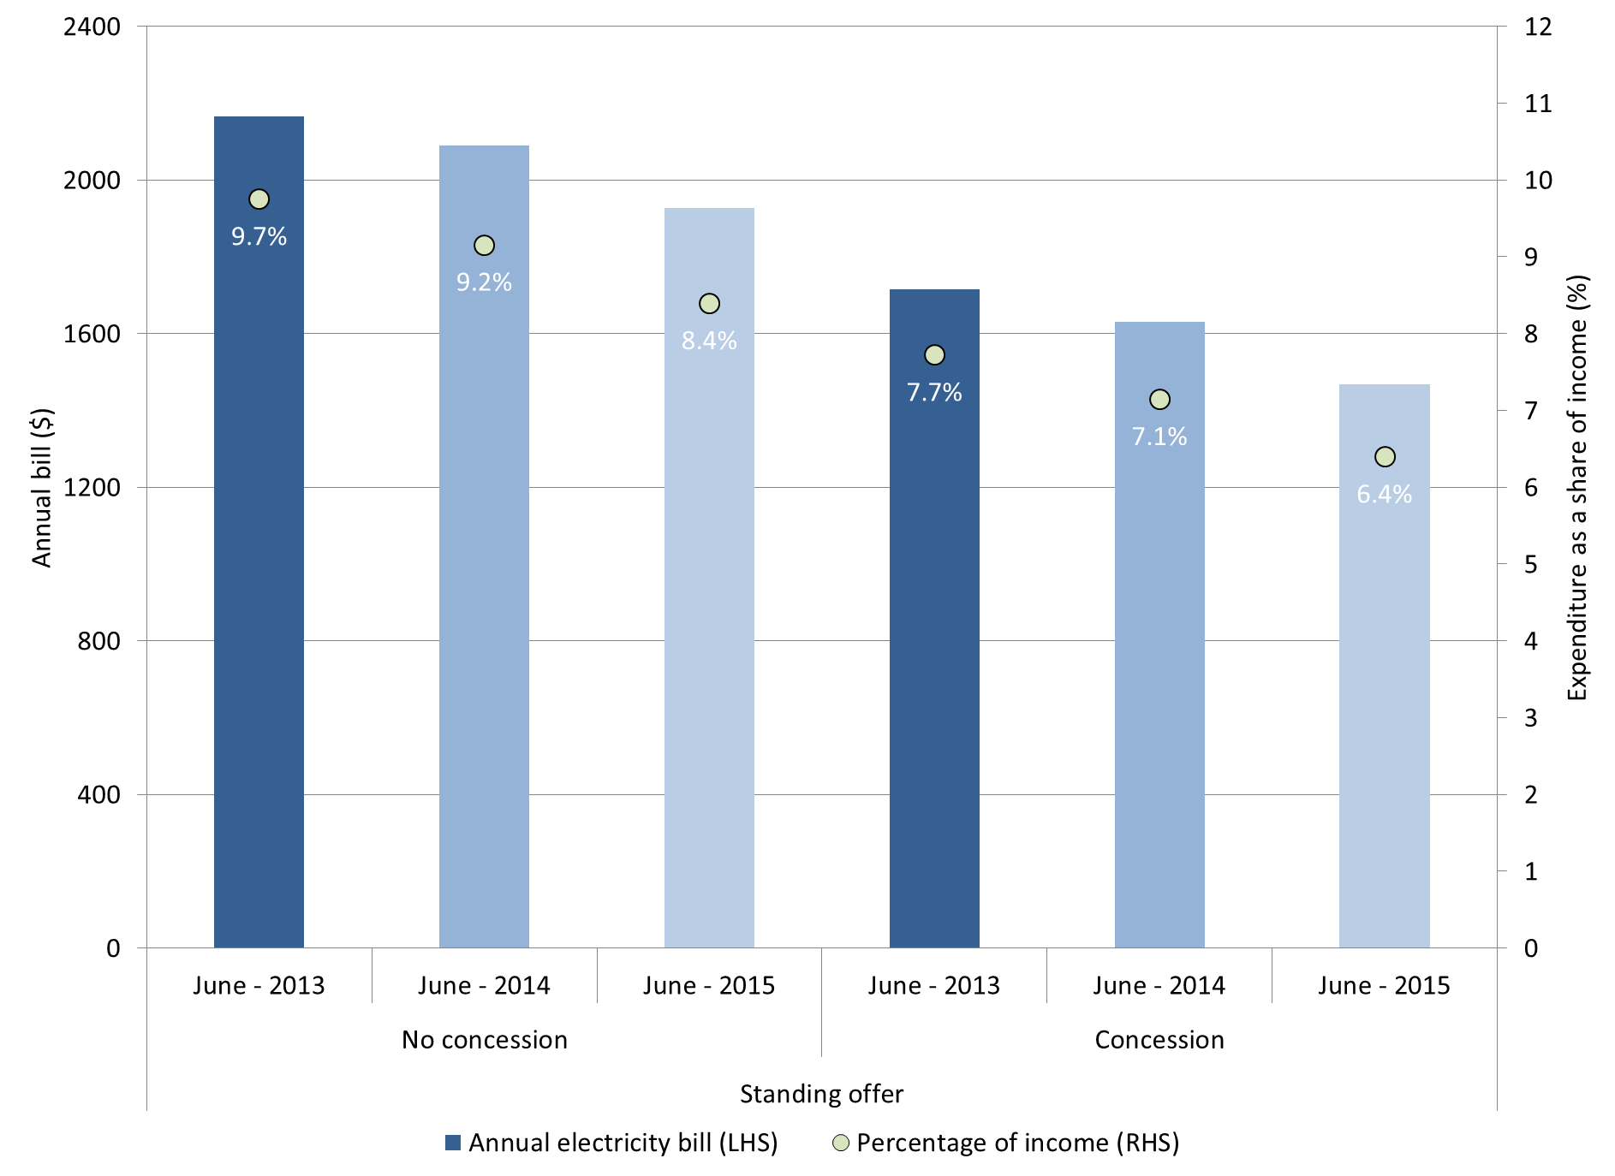

For a low income household receiving the energy concession, the annual electricity bill decreased by 10 per cent in 2015, from $1631 to $1468. Electricity bills represented a relatively high proportion of a low income household’s disposable income, at 6.4 per cent (or 8.4 per cent if it did not receive a concession).

It is not surprising to see that Tasmanian households have higher electricity bills relative to other jurisdictions, as only a small proportion of households are connected to gas and the cooler climate typically demands greater electricity use for heating.

A middle income household consuming 8800 kWh per annum in Tasmania spent 4.3 per cent of its disposable income on electricity bills. This would account for 1.7 per cent of a high income household’s disposable income (table 3.9).

Table 3.9: Summary of annual electricity bills (for the standing offer) and as a share of disposable income – June 2015

|  |  |  |  |
| --- | --- | --- | --- |
| **Income level** | **Annual consumption** | **Annual bill ($)** | **Proportion of annual income (%)** |
| Low income – with concession | Electricity 6500 kWh | 1468 | 6.4 |
| Low income – without concession | Electricity 6500 kWh | 1927 | 8.4 |
| Middle income | Electricity 8800 kWh | 2495 | 4.3 |
| High income | Electricity 8800 kWh | 2495 | 1.7 |

### Composition of energy bills and impact of concessions

Table 3.10 shows the portions of low income household electricity bills attributed to daily supply charges and energy use charges, as well as the savings provided by energy concessions.

Daily supply charges for electricity were $320 per annum in 2015, which represents 17 per cent of a low income household’s annual electricity bill and 1.4 per cent of its disposable income.

Energy concessions help eligible customers save around 24 per cent ($459) on electricity.

Table 3.10: Composition of low income household energy bills (regulated offer)

|  |  |  |  |  |
| --- | --- | --- | --- | --- |
| **Fuel type – consumption** | **Year** | **Daily supply charges (%)** | **Energy use charges (%)** | **Saving with concession (%)** |
| Electricity – 6500 kWh | 2013 | 16.6% | 83.4% | 20.8% |
|  | 2014 | 16.6% | 83.4% | 22.0% |
|  | 2015 | 16.6% | 83.4% | 23.8% |

## ACT

### Energy prices and bills

The ACT has one electricity and one gas distribution zone (both ActewAGL distribution). ActewAGL Retail is the incumbent retailer for energy, water and telecommunications, and supplies around 95 per cent of residential electricity and gas customers. There are two other retailers offering energy contracts to customers in the ACT.

As noted earlier in this report, the entry of Origin Energy into the ACT retail energy market in late 2014 provided households with an additional range of market offers, containing various conditional discounts. Some of ActewAGL’s customers also switched from standing offers to market offers in the 12 months to June 2015.

Figure 3.16 shows the range in generally available electricity and gas offers in the ACT. The cheapest market offer for electricity ($1117) was almost $300 cheaper than the most expensive market offer ($1413) and over $200 cheaper than the median standing offer ($1344). Figure 3.16 also shows a range of $268 between the cheapest ($1397) and most expensive ($1665) gas bills.

Figure 3.16: Range of generally available electricity and gas offers by distribution zone (5600 kWh and 48 000 MJ) – June 2015

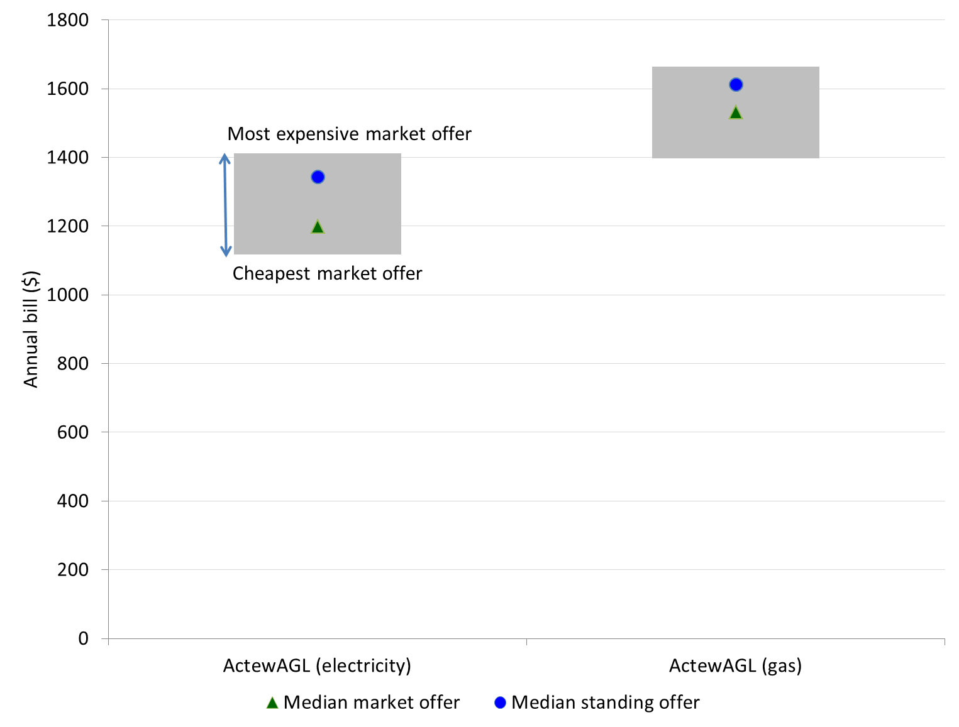

### Electricity and gas bills as a percentage of income

The main energy concession available in the ACT is for both electricity and gas, and is calculated daily, with rates depending on the season.[42] The annual rebate amount in 2014-15 is $338.21. There is also the Utility Concession that can be used towards electricity, gas and water bills, which provided a maximum rebate of $88.25 in 2014-15.

Our analysis assumed that customers eligible for this concession (annual amount of $338.21) applied half towards their electricity bill and half towards their gas bill. Furthermore, we assumed that the utility concession (annual amount of $88.25) was equally divided across a customer’s electricity, gas and water bills. We therefore deducted $198.52 from both the annual electricity and gas bills in our analysis to show the impact of concessions (figure 3.17).

Figure 3.17: Annual electricity and gas bills, and as a share of disposable income for a benchmark low income household (5600 kWh and 48 000 MJ)

The annual electricity bill was $1200 for a low income household on the median market offer (or $1001 with a concession). The annual bill for the median standing offer was greater, at $1344 (or $1146 with a concession). A low income household on the median market offer and receiving an energy concession would spend 3 per cent of its disposable income on electricity (or 3.6 per cent without a concession). For the median standing offer, the annual electricity bill would comprise 3.5 per cent of a low income household’s disposable income (receiving a concession), or 4.1 per cent without a concession.
The annual gas bill was $1532 for a low income household on the median market offer (or $1333 with a concession). This represents 4.6 per cent of disposable income (4 per cent with a concession). 


The annual electricity bill was $1200 for a low income household on the median market offer (or $1001 with a concession). The annual bill for the median standing offer was greater, at $1344 (or $1146 with a concession). A low income household on the median market offer and receiving an energy concession would spend 3 per cent of its disposable income on electricity (or 3.6 per cent without a concession). For the median standing offer, the annual electricity bill would comprise 3.5 per cent of a low income household’s disposable income (receiving a concession), or 4.1 per cent without a concession.

Annual electricity bills for the median market offer decreased by 15 per cent in 2015 when compared to 2014. Electricity bills for the standing offer decreased by 3 per cent over the same period. Annual electricity bills for market offers have decreased to totals below those from June 2013.

The annual gas bill was $1532 for a low income household on the median market offer (or $1333 with a concession). This represents 4.6 per cent of disposable income (4 per cent with a concession).

The median market offer for both electricity and gas was cheaper than the median standing offer, whereas in previous years it was the opposite. This is likely due to the emergence of competition and Origin Energy’s use of conditional discounts.

A middle income household consuming 7500 kWh per annum in the ACT spent 1.5 per cent of its disposable income on electricity. This would account for 0.7 per cent of a high income household’s disposable income (table 3.11).

Table 3.11: Summary of annual electricity and gas bills (for the median market offer) and as a share of disposable income – June 2015

|  |  |  |  |
| --- | --- | --- | --- |
| **Income level** | **Annual consumption** | **Annual bill ($)** | **Proportion of annual income (%)** |
| Low income – with concession | Electricity 5600 kWh | 1001 | 3.0 |
| Low income – without concession | Electricity 5600 kWh | 1200 | 3.6 |
| Middle income | Electricity 7500 kWh | 1481 | 1.5 |
| High income | Electricity 7500 kWh | 1481 | 0.7 |
| Low income – with concession | Gas 48 000 MJ | 1333 | 4.0 |
| Low income – without concession | Gas 48 000 MJ | 1532 | 4.6 |
| Middle income | Gas 48 000 MJ | 1532 | 1.6 |
| High income | Gas 48 000 MJ | 1532 | 0.7 |

### Composition of energy bills and impact of concessions

Table 3.12 shows the portions of low income household energy bills attributed to daily supply charges and energy use charges, as well as the savings provided by energy concessions.

Daily supply charges for electricity were $319 per annum in 2015, which represents 27 per cent of a low income household’s annual electricity bill and around 1 per cent of its disposable income.

Daily supply charges for gas were $268 per annum, which represents 18 per cent of a low income household’s annual gas bill and around 0.8 per cent of its disposable income.

Energy concessions help eligible customers save 17 per cent on electricity and 13 per cent on gas. These concessions increased by 5 per cent in 2014-15.

Table 3.12: Composition of low income household energy bills (median market offer)

|  |  |  |  |  |
| --- | --- | --- | --- | --- |
| **Fuel type – consumption** | **Year** | **Daily supply charges (%)** | **Energy use charges (%)** | **Saving with concession (%)** |
| Electricity – 5600 kWh | 2013 | 29.0% | 71.0% | 12.8% |
|  | 2014 | 19.9% | 80.1% | 13.4% |
|  | 2015 | 26.6% | 73.4% | 16.5% |
| Gas – 24 000 MJ | 2013 | 17.8% | 82.2% | 12.1% |
|  | 2014 | 17.4% | 82.6% | 11.7% |
|  | 2015 | 17.5% | 82.5% | 13.0% |

# Appendices

## Appendix 1: Customer profile of energy retailers

|  |  |  |  |  |
| --- | --- | --- | --- | --- |
|  | **Electricity** | | **Gas** | |
| **Retailer** | **Small customers** | **Large customers** | **Small customers** | **Large customers** |
| **New South Wales** |  |  |  |  |
| ActewAGL | X | X | X | X |
| AGL | X | X | X | X |
| Alinta Energy |  | X |  |  |
| Blue NRG | X | X |  |  |
| Click Energy | X |  |  |  |
| CovaU | X | X | X |  |
| COzero Energy Retail |  | X |  |  |
| Diamond Energy | X |  |  |  |
| EnergyAustralia | X | X | X | X |
| EnergyAustralia Yallourn |  | X |  |  |
| ERM Power Retail | X | X |  |  |
| GoEnergy | X | X |  | X |
| Infigen Energy Markets |  | X |  |  |
| Lumo Energy | X |  | X | X |
| M2 Energy | X |  | X |  |
| Macquarie Bank |  | X |  |  |
| Momentum Energy | X | X |  |  |
| Next Business Energy | X | X |  |  |
| Origin Energy | X | X | X | X |
| Pooled Energy | X |  |  |  |
| Powerdirect | X | X |  |  |
| Powershop | X | X |  |  |
| Progressive Green |  | X |  |  |
| QEnergy | X | X |  |  |
| Red Energy | X | X |  |  |
| Sanctuary Energy | X | X |  |  |
| Simply Energy | X | X |  |  |
| Stanwell |  | X |  |  |
| WINenergy |  | X |  |  |
| **South Australia** |  |  |  |  |
| AGL | X | X | X | X |
| Alinta Energy | X | X | X |  |
| COzero Energy Retail |  | X |  |  |
| Diamond Energy | X |  |  |  |
| EnergyAustralia | X | X | X | X |
| EnergyAustralia Yallourn |  | X |  |  |
| ERM Power Retail | X | X |  |  |
| Lumo Energy | X | X |  |  |
| M2 Energy | X |  |  |  |
| Macquarie Bank |  | X |  |  |
| Momentum Energy | X | X |  |  |
| Origin Energy | X | X | X | X |
| Pacific Hydro | X | X |  |  |
| Powerdirect | X | X |  |  |
| Progressive Green |  | X |  |  |
| QEnergy | X |  |  |  |
| Red Energy | X | X |  |  |
| Sanctuary Energy | X |  |  |  |
| Simply Energy | X | X | X | X |
| WINenergy | X |  |  |  |
| **ACT** |  |  |  |  |
| ActewAGL | X | X | X | X |
| AGL |  | X |  |  |
| Alinta Energy |  | X |  |  |
| EnergyAustralia | X | X | X | X |
| EnergyAustralia Yallourn |  | X |  |  |
| ERM Power Retail | X | X |  |  |
| GoEnergy |  | X |  |  |
| Macquarie Bank |  | X |  |  |
| Momentum Energy | X | X |  |  |
| Origin Energy | X | X | X | X |
| Powerdirect | X | X |  |  |
| Red Energy | X | X |  |  |
| Tasmania |  |  |  |  |
| Aurora Energy | X | X |  |  |
| ERM Power Retail | X | X |  |  |
| Macquarie Bank |  | X |  |  |
| Progressive Green |  | X |  |  |

## Appendix 2: South Australian service standards

Clause 7 of the National Energy Retail (Local Provisions) Regulations imposes minimum service standards on retailers selling energy to small customers in South Australia. The service standards require retailers to use best endeavours to respond to 95 per cent of written enquiries within five business days, and to answer 85 per cent of telephone calls within 30 seconds between 8 am and 6 pm from Monday to Friday.

Retailers must report to the AER on their compliance with these standards and give reasons for any non-compliance as well as information on strategies to improve compliance in the future.

|  |  |  |  |  |  |  |
| --- | --- | --- | --- | --- | --- | --- |
| **Retailer** | **Percentage of written enquiries responded to within five business days** | | | **Percentage of telephone calls answered within 30 seconds** | | |
|  | **2012-13** | **2013-14** | **2014-15** | **2012-13** | **2013-14** | **2014-15** |
| AGL | 80% | 97% | 95% | 89% | 93% | 93% |
| Alinta Energy | 97% | 100% | 98% | 76% | 77% | 77% |
| Diamond Energy | 100% | 100% | 95% | 98% | 100% | 95% |
| EnergyAustralia | 74% | 100% | 95% | 60% | 71% | 93% |
| ERM Power Retail | N/A | 100% | 100% | N/A | 100% | 95% |
| Lumo Energy | 93% | 92% | 99% | 85% | 88% | 92% |
| M2 Energy | N/A | 100% | 88% | N/A | 70% | 79% |
| Momentum Energy | 98% | 100% | 100% | 77% | 72% | 83% |
| Origin Energy | 47% | 97% | 99% | 84% | 93% | 94% |
| Pacific Hydro | N/A | N/A | 100% | N/A | 100% | 97% |
| Powerdirect | 73% | 95% | 95% | 66% | 65% | 85% |
| QEnergy | 40% | 97% | 100% | 87% | 98% | 100% |
| Red Energy | 100% | 100% | 100% | 93% | 96% | 94% |
| Sanctuary Energy | 83% | 100% | 88% | 78% | 77% | 80% |
| Simply Energy | 100% | 78% | 100% | 85% | 93% | 91% |

Alinta Energy, Momentum Energy and Sanctuary Energy have all failed to meet the telephone responsiveness service standard for the last three years. M2 Energy has also failed to meet this standard in the two years it has operated in the South Australian retail energy market.

## Appendix 3: Distribution service standards, associated GSL schemes and small claims compensation regimes

Section 285 of the Retail Law specifies that a retail market performance report must include, amongst other things, a report on the performance of distributors by reference to distributor service standards and associated Guaranteed Service Level (GSL) schemes.[43] The Retail Law defines distributor service standards as service standards imposed on distributors by or under energy laws[44], including, for example, service standards relating to the following:[45]

* the frequency and duration of supply interruptions
* the timely notice of planned interruptions
* the quality of supply (excluding frequency) for electricity (including voltage variations)
* wrongful de-energisation (disconnection)
* timeframes for de-energisation and re-energisation (reconnection)
* being on time for appointments
* response time for fault calls
* the provision of fault information.

A number of service standards are set by the individual jurisdictions and therefore differ between individual states and territories. The following tables summarise distributors’ performance against their respective jurisdictional service standards and GSL schemes.

### Summary of distributor performance

**New South Wales**

* On a pro rata basis, the number of customer complaints received by Essential Energy was the lowest in the state.
* Endeavour Energy had a proportionally high rate of telephone calls compared to the other NSW distributors. This is likely due to heavy storm activity in late 2014, and April 2015.
* Ausgrid reported a low percentage of calls answered within 30 seconds.
* Faulty street light repairs were actioned within the 12 business day window in the majority of cases.
* Ausgrid and Essential Energy reported no instances of connections not being made on time, and Endeavour Energy reported five instances.

**South Australia**

* Overall SAPN reliability levels are relatively good compared to the national averages (taking into account the mix of urban and rural service areas).
* Compensation paid to customers where the duration of supply interruptions exceeded the threshold amount was $2,371,405.
* SAPN reported a high proportion of calls answered within 30 seconds.
* Street light repairs were typically undertaken within the performance targets – particularly in country areas.
* SAPN reported no instances of appointments with customers where a SAPN representative was more than 15 minutes late.

**ACT**

* Overall ActewAGL reliability levels are relatively good compared to the national averages (taking into account the mix of urban and rural service areas).
* ActewAGL reported a relatively low number of complaints compared to the NSW and SA DNSPs.
* There were 298 instances where ActewAGL did not provide at least 4 business days' notice of a planned interruption.

**Tasmania**

* TasNetworks reported receiving 537 customer complaints in 2014-15 - a relatively low number compared to other distributors.
* The number of instances where TasNetworks did not provide sufficient notice of a planned interruption was relatively low at 36 customers for the period.
* TasNetworks reported a total of $3,203,600 in payments for exceeding minimum restorations times.

Table A.1: NSW electricity distributor performance, 2014-15

|  |  |  |  |
| --- | --- | --- | --- |
|  | **Ausgrid** | **Endeavour Energy** | **Essential Energy** |
| **Customers** |  |  |  |
| Total number of customers | 1 679 151 | 933 557 | 824 459 |
| Residential customers | 1 493 892 | 850 139 | 726 970 |
| Small non-residential customers | 172 356 | 78 588 | 93 127 |
| **Complaints** |  |  |  |
| Total complaints received | 4 753[46] | 3 019 | 2 108 |
| Residential (%) | N/A | 94% | 88% |
| Small non-residential (%) | N/A | 6% | 12% |
| **Telephone services** |  |  |  |
| Total calls received | 478 414 | 436 323 | 264 070 |
| Calls answered within 30 seconds (%) | 23% | 74% | 69% |
| Calls abandoned (%) | 9% | 6% | 8% |
| **Promptness of connection** |  |  |  |
| Connections provided for new and existing premises | 225 | 114 201 | 200 466 |
| Connections not provided on or before agreed time | 0 | 5 | 0 |
| Compensation paid for failing to provide connections on time | $0 | $900 | $0 |
| **Faulty street lights** |  |  |  |
| Number of reported street light faults | 11 594 | 22,110 | 6 788 |
| Occasions where repairs not completed on or before agreed date | 604 | 285 | 44 |
| Compensation paid to customers | $7 860 | $4 275 | $660 |
| **Planned interruptions** |  |  |  |
| Number of planned interruptions | 6 202 | 8 512 | 16 071 |
| Occasions where there was insufficient notice of the interruption | 28 | 59 | 232 |
| Occasions where the planned interruption was for longer than the time indicated on the notice | 0[47] | 65 | 1 311 |
|  |  |  |  |

Table A.2: SA electricity distributor performance, 2014-15 (SA Power Networks)

|  |  |
| --- | --- |
| **Customers** |  |
| Total number of customers | 849 954 |
| Residential customers | 751 078 |
| Small non-residential customers | 98 876 |
| Complaints |  |
| Total complaints received | 2 034 |
| **Customer service** |  |
| Total calls received | 475 052 |
| Calls answered within 30 seconds (%) | 91% |
| Calls abandoned (%) | 5% |
| **Promptness of connection** |  |
| New supply addresses connected | 11 901 |
| Connections not provided on or before agreed time | 141 |
| Compensation paid for failing to provide connections on time | $37 620 |
| **Faulty street lights – Adelaide Business Area, Adelaide Metropolitan Area and Major Regional Areas** |  |
| Number of reported street light faults | 26 182 |
| Occasions where repairs not completed on or before agreed date (within five days) | 1 795 |
| Compensation paid to customers | $255 400 |
| **Faulty street lights – Country Areas** |  |
| Number of reported street light faults | 3 867 |
| Occasions where repairs not completed on or before agreed date (within ten days) | 27 |
| Compensation paid to customers | $1 575 |
| **Timeliness of appointments** |  |
| Total number of appointments | 31 973 |
| Total number of appointments with customers where a representative of SAPN is more than 15 minutes late | 0 |
| Compensation paid to customers | $0 |

Table A.3: Duration of supply interruptions, 2014-15 (SA Power Networks)

|  |  |
| --- | --- |
| **System Average Interruption Duration Index (SAIDI)** |  |
| Adelaide Business Area | 10.9 |
| Major Metropolitan Areas | 104.5 |
| Barossa/Mid-North and Yorke Peninsula/Riverland/Murraylands | 279.7 |
| Eastern Hills/Fleurieu Peninsula | 229.0 |
| Upper North and Eyre Peninsula | 353.8 |
| South East | 198.9 |
| Kangaroo Island | 266.4 |
| **SAIDI TOTAL** | 151.9 |
| Percentage contribution of planned interruptions to state-wide SAIDI | 37% |
| Number of customers who experienced a supply interruption greater than 12 hours but less than or equal to 15 hours | 3 477 |
| Compensation paid to customers who experienced a supply interruption greater than 12 hours but less than or equal to 15 hours | $312 930 |
| Number of customers who experienced a supply interruption greater than 15 hours but less than or equal to 18 hours | 2 870 |
| Compensation paid to customers who experienced a supply interruption greater than 15 hours but less than or equal to 18 hours | $401 800 |
| Number of customers who experienced a supply interruption greater than 18 hours but less than or equal to 24 hours | 3 369 |
| Compensation paid to customers who experienced a supply interruption greater than 18 hours but less than or equal to 24 hours | $623 265 |
| Number of customers who experienced a supply interruption greater than 24 hours | 2 793 |
| Compensation paid to customers who experienced a supply interruption greater than 24 hours | $1 033 410 |
| Total amounts paid to customers for duration of supply interruptions exceeding the threshold amount | $2 371 405 |

Table A.4: Frequency of supply interruptions, 2014-15 (SA Power Networks)

|  |  |
| --- | --- |
| **System Average Interruption Frequency Index (SAIFI)** |  |
| Adelaide Business Area | 0.151 |
| Major Metropolitan Areas | 1.121 |
| Barossa/Mid-North and Yorke Peninsula/Riverland/Murraylands | 1.361 |
| Eastern Hills/Fleurieu Peninsula | 1.575 |
| Upper North and Eyre Peninsula | 1.432 |
| South East | 1.667 |
| Kangaroo Island | 3.177 |
| **SAIFI TOTAL** | 1.228 |
| Number of customers with greater than 9 but less than or equal to 12 interruptions | 779 |
| Compensation paid to customers with greater than 9 but less than or equal to 12 interruptions | $70 110 |
| Number of customers with greater than 12 but less than or equal to 15 interruptions | 58 |
| Compensation paid to customers with greater than 12 but less than or equal to 15 interruptions | $8 120 |
| Number of customers with greater than 15 interruptions | 12 |
| Compensation paid to customers with greater than 15 interruptions | $2 220 |
| Total amounts paid to customers for frequency of supply interruptions exceeding the threshold amount | $80 450 |

Table A.5: ACT electricity distributor performance, 2014-15 (ActewAGL)

|  |  |
| --- | --- |
| **Complaints** |  |
| Total complaints received | 507 |
| Complaints responded to within 20 business days | 463 |
| **Planned interruptions** |  |
| Number of planned interruptions | 1479 |
| Instances where notice of at least 4 business days was not provided to customers | 298 |
| Instances where supply was not restored within 12 hours of the initial interruption | 4 |
| Number of customers that received compensation | 46 |
| Compensation paid | $2 567 |
| **Unplanned interruptions** |  |
| Number of unplanned interruptions | 2331 |
| Instances where supply was not restored within 12 hours of the initial interruption | 19 |
| Compensation paid to customers | $0 |
| **System Average Interruption Duration Index (SAIDI)** |  |
| **Overall** | 82.56 |
| Distribution network – planned | 49.69 |
| Distribution network – unplanned | 32.87 |
| Normalised distribution network – unplanned | 32.87 |
| **System Average Interruption Frequency Index (SAIFI)** |  |
| **Overall** | 0.82 |
| Distribution network – planned | 0.22 |
| Distribution network – unplanned | 0.61 |
| Normalised distribution network – unplanned | 0.61 |
| **Customer Average Interruption Duration Index (CAIDI)** |  |
| **Overall** | 100.31 |
| Distribution network – planned | 227.94 |
| Distribution network – unplanned | 54.33 |
| Normalised distribution network – unplanned | 54.33 |

Table A.6: Tasmania electricity distributor performance, 2014-15 (TasNetworks)

|  |  |
| --- | --- |
| **Complaints** |  |
| Total complaints received | 537 |
| **Planned interruptions** |  |
| Number of planned interruptions | 7 630 |
| Number of customers not notified of planned interruptions | 36 |
| Compensation paid to customer not notified of planned interruptions | $1 130 |
| **Faulty street lights** |  |
| Number of reported street light faults | 2 869 |
| Occasions where repairs not completed within 7 days | 338 |
| Compensation paid to customers for repairs not completed within 7 days | $420 |
| **New connections and reconnections** |  |
| New connections | 2 510 |
| New connections completed by scheduled date | 2 195 |
| Compensation paid to customers for late connections | $36 120 |
| Reconnections | 30 348 |
| Reconnections completed by scheduled date | 29 209 |
| Compensation paid to customers for late reconnections | $0 |
| **System Average Interruption Duration Index (SAIDI)** |  |
| Average duration of interruptions | 435 |
| Normalised average duration of interruptions | 219 |
| Number of timely restoration payments made | 27 940 |
| Value of restoration payments made | $3 203 600 |
| **System Average Interruption Frequency Index (SAIFI)** |  |
| Average frequency of interruptions | 2.23 |
| Normalised average frequency of interruptions | 1.67 |
| Number of reliable supply payments made | 2 207 |
| Value of reliable supply payments made | $167 440 |

## Appendix 4: Supplementary tables

Table A.7: Electricity customers - payment plans, hardship programs and disconnections for non-payment

|  |  |  |  |  |  |  |
| --- | --- | --- | --- | --- | --- | --- |
| Retailer | Customers on payment plans | | Customers on hardship programs | | Customers disconnected for non-payment | |
|  | June 2014 | June 2015 | June 2014 | June 2015 | 2013-14 | 2014-15 |
| South Australia |  |  |  |  |  |  |
| **AGL** | 2978 | 2231 | 4036 | 4711 | 4271 | 4274 |
| **Alinta Energy** | 1712 | 1450 | 21 | 490 | 1163 | 575 |
| **Diamond Energy** | 3 | 17 | 0 | 0 | 0 | 0 |
| **EnergyAustralia** | 7969 | 8122 | 786 | 2017 | 423 | 437 |
| **Lumo Energy** | 1452 | 1470 | 259 | 226 | 520 | 371 |
| **M2 Energy** | 0 | 6 | 0 | 32 | - | 3 |
| **Momentum Energy** | 308 | 159 | 54 | 108 | 45 | 63 |
| **Origin Energy** | 6671 | 1909 | 2309 | 2192 | 2145 | 2587 |
| **Powerdirect** | 225 | 208 | 88 | 120 | 119 | 147 |
| **QEnergy** | 0 | 0 | 0 | 0 | 0 | 9 |
| **Red Energy** | 179 | 140 | 33 | 22 | 34 | 32 |
| **Sanctuary Energy** | 3 | 5 | 7 | 0 | 1 | 2 |
| **Simply Energy** | 2244 | 2176 | 1010 | 1371 | 1427 | 1679 |
| ACT |  |  |  |  |  |  |
| **ActewAGL** | 255 | 258 | 624 | 580 | 237 | 339 |
| **EnergyAustralia** | 316 | 739 | 55 | 98 | 32 | 6 |
| **Origin Energy** | 0 | 1 | 0 | 0 | 0 | 0 |
| Tasmania |  |  |  |  |  |  |
| **Aurora Energy** | 2956 | 2376 | 987 | 1663 | 1555 | 1046 |
| New South Wales |  |  |  |  |  |  |
| **ActewAGL** | 124 | 153 | 416 | 420 | 86 | 154 |
| **AGL** | 4300 | 2993 | 4743 | 6293 | 10828 | 12844 |
| **Click Energy** | 25 | 78 | 0 | 27 | 96 | 168 |
| **CovaU** | - | 33 | 0 | 2 | - | 2 |
| **Diamond Energy** | 5 | 58 | 0 | 2 | - | 4 |
| **EnergyAustralia** | 16669 | 60034 | 3517 | 5157 | 6299 | 2478 |
| **Lumo Energy** | 1428 | 1810 | 209 | 183 | 489 | 597 |
| **M2 Energy** | 9 | 36 | 240 | 282 | 20 | 139 |
| **Momentum Energy** | 278 | 68 | 14 | 169 | 47 | 93 |
| **Origin Energy** | 35928 | 9244 | 8714 | 8621 | 12655 | 13400 |
| **Powerdirect** | 162 | 195 | 24 | 75 | 55 | 148 |
| **QEnergy** | 25 | 23 | 20 | 17 | 24 | 40 |
| **Red Energy** | 1685 | 1945 | 347 | 301 | 474 | 437 |
| **Sanctuary Energy** | 29 | 29 | 0 | 12 | 21 | 14 |
| **Simply Energy** | 293 | 1139 | 49 | 676 | 36 | 1461 |

Table A.8: Gas customers - payment plans, hardship programs and disconnections for non-payment

|  |  |  |  |  |  |  |
| --- | --- | --- | --- | --- | --- | --- |
| Retailer | Customers on payment plans | | Customers on hardship programs | | Customers disconnected for non-payment | |
|  | June 2014 | June 2015 | June 2014 | June 2015 | 2013-14 | 2014-15 |
| South Australia |  |  |  |  |  |  |
| **AGL** | 391 | 376 | 1340 | 1723 | 1198 | 1623 |
| **Alinta Energy** | 308 | 345 | 8 | 153 | 215 | 244 |
| **EnergyAustralia** | 3941 | 4357 | 233 | 609 | 42 | 228 |
| **Origin Energy** | 3999 | 1075 | 769 | 931 | 1223 | 1597 |
| **Simply Energy** | 678 | 737 | 451 | 675 | 740 | 883 |
| ACT |  |  |  |  |  |  |
| **ActewAGL** | 131 | 174 | 449 | 542 | 981 | 1375 |
| **EnergyAustralia** | 169 | 561 | 24 | 45 | 85 | 29 |
| **Origin Energy** | 0 | 1 | 0 | 0 | 0 | 0 |
| New South Wales |  |  |  |  |  |  |
| **ActewAGL** | 42 | 46 | 129 | 172 | 265 | 544 |
| **AGL** | 1168 | 905 | 1996 | 2858 | 3465 | 4771 |
| **CovaU** | 0 | 5 | 0 | 0 |  |  |
| **EnergyAustralia** | 3976 | 14022 | 945 | 443 | 379 | 395 |
| **Lumo Energy** | 371 | 530 | 48 | 48 | 92 | 17 |
| **Origin Energy** | 5027 | 2377 | 766 | 854 | 396 | 1828 |

## Appendix 5: Benchmark low income household, annual electricity and gas bills and proportion

|  |  |  |  |  |  |  |  |
| --- | --- | --- | --- | --- | --- | --- | --- |
| Jurisdiction | | Electricity  2014 | Electricity  2015 | Electricity  % change | Gas  2014 | Gas  2015 | Gas  % change |
| Qld | Annual bill ($) | 1335 | 1387 | 3.9 | 702 | 709 | 1.1 |
| Qld | Percentage of income (%) | 5.5 | 5.6 | N/A | 2.9 | 2.9 | N/A |
| NSW | Annual bill ($) | 1468 | 1386 | -5.5 | 863 | 923 | 6.9 |
| NSW | Percentage of income (%) | 5.7 | 5.3 | N/A | 3.4 | 3.5 | N/A |
| Vic | Annual bill ($) | 1274 | 1188 | -6.7 | 1256 | 1206 | -4.0 |
| Vic | Percentage of income (%) | 5.2 | 4.8 | N/A | 5.1 | 4.8 | N/A |
| SA | Annual bill ($) | 1420 | 1370 | -3.5 | 996 | 1008 | 1.2 |
| SA | Percentage of income (%) | 6.2 | 5.9 | N/A | 4.3 | 4.3 | N/A |
| Tas | Annual bill ($) | 2090 | 1927 | -7.8 | N/A | N/A | N/A |
| Tas | Percentage of income (%) | 9.2 | 8.4 | N/A | N/A | N/A | N/A |
| ACT | Annual bill ($) | 1413 | 1200 | -15.1 | 1618 | 1532 | -5.3 |
| ACT | Percentage of income (%) | 4.3 | 3.6 | N/A | 4.9 | 4.6 | N/A |

## Appendix 6: Benchmark low income household, annual electricity and gas bills and proportion

|  |  |  |  |  |  |  |  |
| --- | --- | --- | --- | --- | --- | --- | --- |
| Jurisdiction | | Electricity  2014 | Electricity  2015 | Electricity  % change | Gas  2014 | Gas  2015 | Gas  % change |
| Qld | Annual bill ($) | 1805 | 1829 | 1.3 | 702 | 709 | 1.1 |
| Qld | Percentage of middle income (%) | 2.6 | 2.6 | N/A | 1.0 | 1.0 | N/A |
| Qld | Percentage of high income (%) | 1.0 | 1.0 | N/A | 0.4 | 0.4 | N/A |
| NSW | Annual bill ($) | 1932 | 1796 | -7.0 | 863 | 923 | 6.9 |
| NSW | Percentage of middle income (%) | 2.7 | 2.4 | N/A | 1.2 | 1.3 | N/A |
| NSW | Percentage of high income (%) | 0.9 | 0.9 | N/A | 0.4 | 0.4 | N/A |
| Vic | Annual bill ($) | 1563 | 1436 | -8.1 | 1256 | 1206 | -4.0 |
| Vic | Percentage of middle income (%) | 2.2 | 2.0 | N/A | 1.8 | 1.7 | N/A |
| Vic | Percentage of high income (%) | 0.9 | 0.8 | N/A | 0.7 | 0.6 | N/A |
| SA | Annual bill ($) | 1899 | 1842 | -3.0 | 996 | 1008 | 1.2 |
| SA | Percentage of middle income (%) | 3.2 | 3.0 | N/A | 1.7 | 1.6 | N/A |
| SA | Percentage of high income (%) | 1.2 | 1.1 | N/A | 0.6 | 0.6 | N/A |
| Tas | Annual bill ($) | 2706 | 2495 | -7.8 | N/A | N/A | N/A |
| Tas | Percentage of middle income (%) | 4.7 | 4.3 | N/A | N/A | N/A | N/A |
| Tas | Percentage of high income (%) | 1.9 | 1.7 | N/A | N/A | N/A | N/A |
| ACT | Annual bill ($) | 1787 | 1481 | -17.2 | 1618 | 1532 | -5.3 |
| ACT | Percentage of middle income (%) | 1.9 | 1.5 | N/A | 1.7 | 1.6 | N/A |
| ACT | Percentage of high income (%) | 0.9 | 0.7 | N/A | 0.8 | 0.7 | N/A |

## Appendix 7: Energy affordability methodology

The key elements of our analysis include:

* the estimated annual electricity and gas consumption levels in each state and territory for low, middle and high income households
* the collection of retail electricity and gas offers in each distribution or pricing zone
* the development of estimated annual electricity and gas bills based on our estimated consumption levels and pricing information, and
* the household disposable income data used.

For each jurisdiction, we determined electricity and gas consumption levels for our benchmark low, middle and high income households (see tables A.9 and A.10). A benchmark low income household is a household that uses the average amount of electricity and gas in the relevant state or territory for all households that are the same size as low income households on average. A benchmark middle and high income household is a household that uses the average amount of electricity and gas in the relevant state or territory.

We then calculated annual electricity and gas bills from the energy offer tariffs we collected. Our analysis shows the range in annual bills across generally available offers as well as the median standing and market offer.

We obtained data from the ABS on disposable household incomes for low, middle and high incomes (also tables A.9 and A.10) to estimate the proportion spent on electricity and gas bills (assuming these households were on the median market offer). For our benchmark low income households we have also shown the impact of receiving the energy concession in that jurisdiction.

### Annual electricity and gas consumption levels

To represent the electricity consumption of a benchmark low income household, we took the average number of people in a low income household for each state and territory from the ABS and used electricity consumption benchmark data to determine an average consumption level for that sized household. Our previous reports on energy affordability have used electricity consumption levels obtained from ACIL Tasman’s 2011 Electricity bill benchmarks survey. ACIL Allen updated the benchmarks in 2014, and annual electricity bills in this report are based on the updated consumption benchmarks.[48]

For our benchmark middle and high income households we used typical electricity consumption levels – each state and territory’s ‘average’ household consumption from the electricity consumption benchmark data (a two to three person household). This is higher than for our benchmark low income households which are typically smaller – on average on to two persons.[49]

Available data on gas consumption levels is limited and we have not attempted to estimate a ‘low’ consumption level. Instead, we use an estimate only of ‘typical’ gas consumption, which was formed by various jurisdictional energy regulator reports and St Vincent de Paul’s energy price reports.

These electricity and gas consumption levels are estimates. Furthermore, our low income electricity consumption figures are based on benchmark data for all households (not only low income households) and may not account for low income households using less energy per member of the household than other households.[50]

Annual bills from previous years (June 2013 and June 2014) have been updated to reflect the changes in consumption. Average household sizes for low income households have also slightly changed, and these changes are reflected in historical energy bills. We have used the same gas consumption estimates as those used in the 2013-14 analysis.

### Collection of energy offers

We selected a postcode in each distribution or pricing zone and collected all of the generally available offers in that postcode in June 2013, June 2014 and June 2015. Only single-rate tariffs were considered and any GreenPower-only and solar offers were excluded. Where possible, we collect offer details from our energy price comparison website, Energy Made Easy ([www.energymadeeasy.gov.au](http://www.energymadeeasy.gov.au)). For states and territories that had not commenced the Retail Law by 30 June 2015, we collected tariffs from jurisdictional energy regulators’ price comparison websites or directly from energy retailers’ websites.

### Estimating annual energy bills

Annual electricity and gas bills for each of the offers in the nominated postcode were calculated using the energy consumption levels in tables A.9 and A.10. The estimated bills include key discounts offered by energy retailers (such as discounts for paying on time, paying by direct debit and other cash incentives), but do not include discounts for bundling or dual fuel offers. One-off credits and non-cash incentives are also not included. Seasonal pricing was taken into account when calculating the annual bills; however we assume a consistent level of consumption throughout the year. Annual electricity and gas bills are represented by the median market and standing offers in each jurisdiction. Using the median (rather than a simple average) ensures the analysis is not skewed by a small number of very cheap or very expensive offers.

### Annual household disposable income

Data on disposable income was obtained from the ABS. Disposable household income best represents the remaining income available to households for expenditure on goods and services, including electricity and gas bills.

In previously used ABS data, ‘low income’ households in each state and territory were represented by the second and third income deciles. More recent ABS analysis suggests that this approach may have over-estimated the economic wellbeing of low income households, and unnecessarily excluded some of the most vulnerable households in the lowest income quintile.

This report now uses an adjusted lowest income quintile to represent ‘low income’ households, which is made up of the lowest two deciles, excluding the first and second percentiles. The ‘middle income’ households continue to be represented by the third income quintile and ‘high income’ households are represented by the fifth income quintile. The latest available data from the ABS was for 2013-14 and was adjusted to 2012-13 and 2014-15 dollars using the Consumer Price Index for low income households and the Wage Price Index for middle and high income households (see tables A.9 and A.10).

Table A.9: Benchmark low income households – summary of annual electricity and gas consumption levels

|  |  |  |  |  |
| --- | --- | --- | --- | --- |
| **Jurisdiction** | **Annual electricity consumption (kWh)** | **Annual gas consumption (MJ)** | **Average household size (persons)** | **Annual disposable income ($)** |
| Queensland | 4 100 | 10 000 | 1.46 | 24 704 |
| New South Wales | 4 300 | 24 000 | 1.45 | 26 245 |
| Victoria | 3 700 | 63 000 | 1.45 | 24 927 |
| South Australia | 3 700 | 21 000 | 1.23 | 23 267 |
| Tasmania | 6 500 | N/A | 1.20 | 22 959 |
| ACT | 5 600 | 48 000 | 1.45 | 32 958 |

Table A.10: Benchmark middle and high income households – summary of annual electricity and gas consumption levels

|  |  |  |  |  |  |
| --- | --- | --- | --- | --- | --- |
| **Jurisdiction** | **Annual electricity consumption (kWh)** | **Annual gas consumption (MJ)** | **Average household size (persons)** | **Annual disposable income – middle ($)** | **Annual disposable income – high ($)** |
| Queensland | 5 800 | 10 000 | 2-3 | 70 883 | 188 385 |
| New South Wales | 5 900 | 24 000 | 2-3 | 73 705 | 208 902 |
| Victoria | 4 900 | 63 000 | 2-3 | 71 721 | 186 186 |
| South Australia | 5 100 | 21 000 | 2-3 | 61 640 | 163 290 |
| Tasmania | 8 800 | N/A | 2-3 | 58 446 | 147 953 |
| ACT | 7 500 | 48 000 | 2-3 | 98 363 | 210 392 |

## Appendix 8: Map of electricity distribution zones

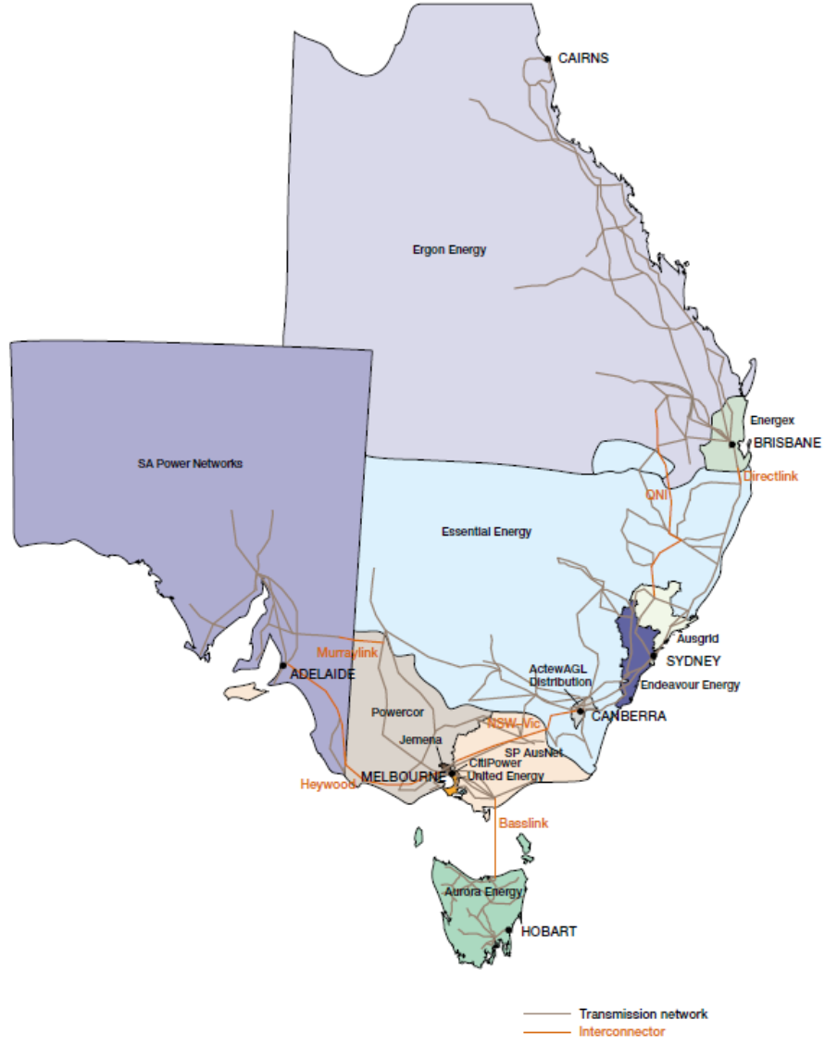

## Appendix 9: Map of gas distribution zones

## 

1. Section 284 of the National Energy Retail Law requires the AER to produce annual reports for retailers and sets out our obligations.
2. .As at 30 June 2015 these were New South Wales, South Australia, Tasmania and the ACT. Future reports will also contain data for Queensland, which commenced the Retail Law on 1 July 2015.
3. In jurisdictions where the Retail Law applies.
4. Changes in annual bills are based on a low income household on the median market offer (standing electricity offer in Tasmania), not receiving an energy concession.
5. Australian Energy Market Commission, 2015 Retail Competition Review,   
   [www.aemc.gov.au/Markets-Reviews-Advice/2015-retail-competition-review](http://www.aemc.gov.au/Markets-Reviews-Advice/2015-retail-competition-review).
6. The gas market in Tasmania is not subject to the Retail Law.
7. Local area retailers are obliged to offer to supply energy in their associated distribution supply areas to customers who create new connections.
8. The Australian Energy Market Operator (AEMO) regularly publishes switching data. An explanation of how AEMO’s switching data is calculated is available at: [www.aemo.com.au](http://www.aemo.com.au).
9. Australian Energy Market Commission, 2015 Retail Competition Review,   
   [www.aemc.gov.au/Markets-Reviews-Advice/2015-retail-competition-review](http://www.aemc.gov.au/Markets-Reviews-Advice/2015-retail-competition-review).
10. National Energy Retail Rules, r.49A.
11. Where the retailer uses an automated or IVR telephone system, the time is measured from when a customer chooses to speak to an operator. In all other cases, the time commences from when the call is received by the switchboard.
12. Under Clause 7 of the National Energy Retail (Local Provisions) Regulations.
13. The Retail Rules require the AER to distinguish between customers experiencing payment difficulties generally and customers on hardship programs.
14. Retailers must only report on arrangements with at least three instalments, and where the customer is paying off arrears (of any overdue amount). Customers using flexible payment arrangements for convenience or budgeting purposes are excluded for the purposes of payment plan reporting.
15. Hardship programs are available to eligible customers, and must include: processes to identify customers who need assistance, flexible payment options including specifically tailored payment plans and Centrepay, advice on concessions and government grants, referrals to financial counselling services, energy efficiency advice and waiving late payment fees. Customers on hardship programs will not be disconnected while they continue to meet agreed payment arrangements.
16. South Australia and ACT customers receiving gas concessions are estimated, as some retailers do not distinguish whether their customers utilise the energy concession (for electricity and gas) specifically for gas.
17. National Energy Retail Rules, r. 72(1)(a).
18. National Energy Retail Law, s. 44(c).
19. Kildonan, 'Two incomes, still short', 2015, www.kildonan.org.au/media-and-publications/news/two-incomes-still-short/.
20. There are a number of reasons why retailers do not reconnect customers, including abandonment of the property, reconnecting with a different retailer, reconnecting in a different name and moving house.
21. Gas concessions are not available in New South Wales, and retailers in South Australia and the ACT do not distinguish whether the energy concession is also applied to gas bills.
22. Self-disconnection means an interruption to the supply of energy because a prepayment meter system has no credit (including emergency credit) available.
23. The proportion of gas customers receiving concessions in South Australia and the ACT is estimated, as not all retailers distinguish whether the total energy concession is applied to gas bills.
24. National Energy Retail Rules, r.40.
25. We consider each jurisdiction that has commenced (or intends to commence) the Retail Law – Queensland, New South Wales, Victoria, South Australia, Tasmania and the ACT. We have not considered energy affordability for customers in Western Australia and the Northern Territory.
26. We use the concept of a ‘benchmark’ household as every household has a different level of consumption and income and it is not possible to account for the individual characteristics of every household.
27. Disposable income is derived by deducting estimates of personal income tax and the Medicare levy from gross income.
28. Changes in annual bills are based on a low income household on the median market offer (standing electricity offer in Tasmania), not receiving an energy concession.
29. Essential Energy’s network in New South Wales also extends into Queensland near Goondiwindi.
30. AEMC Competition Review 2015, p.96.
31. AEMC, East Coast Wholesale Gas Market and Pipeline Frameworks Review, [www.aemc.gov.au/Markets-Reviews-Advice/East-Coast-Wholesale-Gas-Market-and-Pipeline-Frame](http://www.aemc.gov.au/Markets-Reviews-Advice/East-Coast-Wholesale-Gas-Market-and-Pipeline-Frame).
32. Eligibility is restricted to households that have a Commonwealth Pensioner Concession Card, Department of Veterans’ Affairs Gold Card or Queensland Seniors Card. Eligibility is not extended to Centrelink Health Care Cards, unlike in other states and territories.
33. The Queensland Solar Bonus Scheme pays eligible customers for the electricity generated from eligible solar photovoltaic (PV) systems and exported to the Queensland electricity grid.
34. Eligibility is restricted to households that have a Commonwealth Pensioner Concession Card, Health Care Card, or a Department of Veterans’ Affairs Gold Card.
35. Eligibility is restricted to households that receive the Australian Government’s Family Tax Benefit A and/or B.
36. Eligibility is limited to the holder of at least one of the following cards: Pensioner Concession Card, Health Care Card or Department of Veterans’ Affairs Gold Card.
37. The 17.5 per cent electricity concession does not apply to the first $171.60, and the 17.5 per cent winter concession does not apply to the first $62.40. Our analysis assumes constant electricity and gas consumption in each year, however it is likely that customers would consume more gas during winter periods (for heating), and therefore receive a greater part of the 17.5 per cent winter concession available to them.
38. Eligibility is restricted to households that have a Commonwealth Pensioner Concession Card, Health Care Card, or a Department of Veterans’ Affairs Gold Card.
39. TasNetworks commenced operations in 1 July 2014 and was formed by a merger between Aurora’s distribution network and the Transend transmission network.
40. Excludes customers that use prepayment meters.
41. Eligibility is restricted to households that have a Commonwealth Pensioner Concession Card, Health Care Card or a Department of Veterans’ Affairs Gold Card.
42. Eligibility is restricted to households that hold a Centrelink Pensioner Concession Card, a Centrelink Low Income Health Care Card or a Department of Veterans’ Affairs Pensioner Concession Card.
43. National Energy Retail Law, s.285(d).
44. Energy laws are defined to include national energy legislation, jurisdictional energy legislation, the Rules, the NER and the NGR and instruments made under this Law, the Rules, the NER and NGR (including the Retail Market Procedures).
45. National Energy Retail Law, s.2.
46. Complaints to Ausgrid could not be distinguished between residential and non-residential customers as insufficient customer information was supplied.
47. Under Ausgrid’s Deemed Standard Connection Contract planned interruptions are no longer covered by the guaranteed customer service standards, and therefore there is no report on occasions and compensation for this period.
48. The Retail Rules require retailers to provide information to residential customers on their electricity bill regarding how their electricity consumption compares to similar sized households in their local area. ACIL Allen’s 2014 electricity benchmarks show that annual consumption has fallen 12.3 per cent on average from the 2011 survey. Consumption fell most in Queensland and South Australia where the penetration of PV systems is highest. The *electricity bill benchmarks for residential customers 2014* report is available at: [www.aer.gov.au/retail-markets/retail-guidelines/electricity-bill-benchmarks-for-residential-customers-2014](https://www.aer.gov.au/retail-markets/retail-guidelines/electricity-bill-benchmarks-for-residential-customers-2014).
49. Data obtained from the Australian Bureau of Statistics (ABS) shows that low income households are on average one to two person households.
50. ABS Catalogue 4670.0: Household Energy Consumption Survey 2012. Low income households used, on average, less electricity and gas compared to households in the highest income quintile.