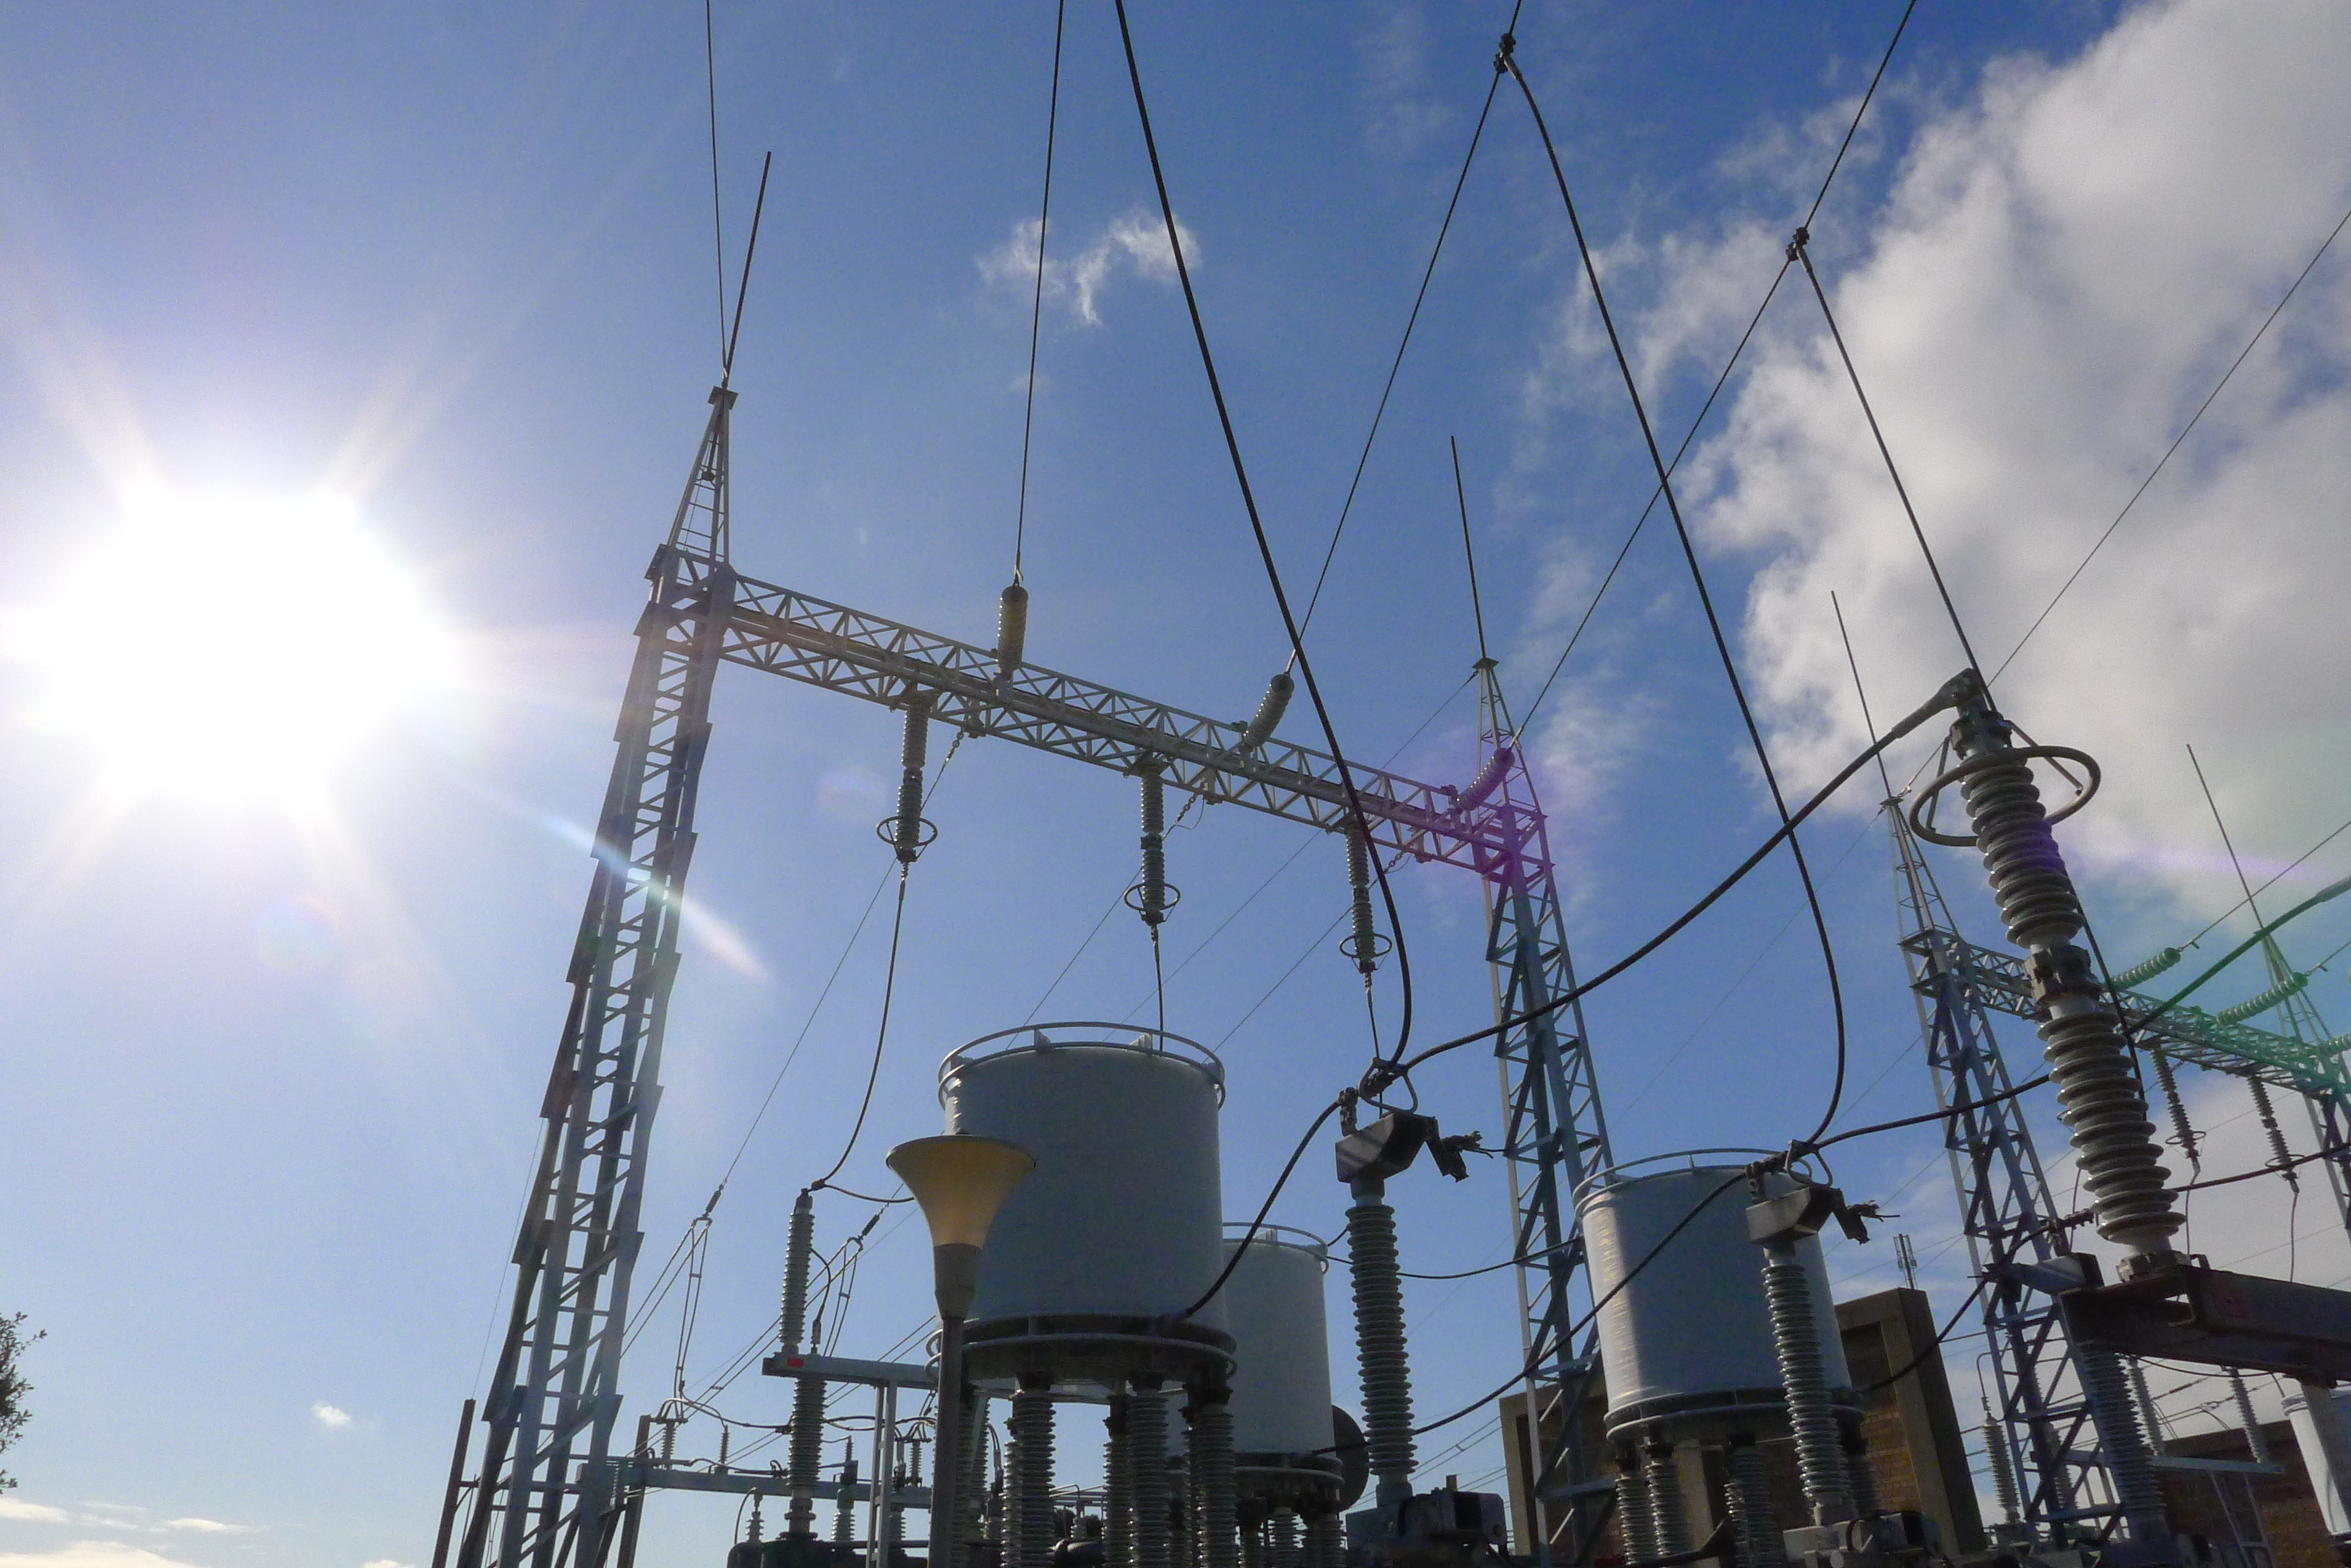

Better Regulation Update - February 2013

Recap

December, January & February
- Better Regulation
Held a nationwide public forum on 18 December and published all forum materials
- Expenditure assessments
Published issues paper and called for submissions; held a roundtable on 12 February
- Rate of return
Published issues paper and called for submissions; held a forum on 5 February
- Consumer reference group
Called for expressions of interest in membership; published list of members; held first meeting on 7 February

Upcoming

February & March
- Expenditure assessments
Submissions on issues paper close COB 15 March; holding category analysis workshops; holding benchmarking workshops
- Rate of return
Holding forum subgroups on 25 and 26 February; publishing further consultation paper
- Service provider consumer engagement
Holding consumer forums on 11 (Sydney), 12 (Melbourne), 13 (Adelaide), and 18 (Brisbane) March.
- Shared assets
Releasing issues paper; holding working group
- Confidentiality
Releasing issues paper; holding working group
This is the AER’s first monthly newsletter to update stakeholders on our progress in the Better Regulation program. Our newsletter highlights the previous month’s events, and the current month’s upcoming events. We will also have a ‘spotlight’ with more information on one of our Better Regulation projects. Our Better Regulation web page also has a complete up-to-date calendar of events.
We started our Better Regulation program in December last year following the Australian Energy Market Commission’s changes to the National Electricity and Gas Rules. A major part of our work is to publish a series of guidelines by 29 November 2013, setting out our revised approach to regulation under the new rules. We will also establish a Consumer Challenge Panel within the AER from 1 July 2013. The panel will provide an independent consumer perspective to challenge the AER and businesses during determinations. We have already set up a consumer reference group to make it easier for consumer representatives to participate in consultation.

Spotlight: Rate of return
The allowed rate of return is how much service providers can earn on their investments. The objective is for the overall rate of return to correspond to the efficient financing costs of a benchmark efficient business.
Under the new rules the AER must determine an overall rate of return to meet the objective at the time we make a determination, rather than a ‘parameter by parameter’ consideration. We will take into account market circumstances, estimation methods, financial models and other relevant information. This is a key part of our aim to ensure that consumers pay no more than necessary for a safe and reliable supply of gas and electricity.
The main issues we will explore during our guideline development are the methods, approaches, theory and practice for estimating return on equity and return on debt, to meet the overall rate of return objective.
We released an issues paper in December last year, and held a forum on 5 February 2013 that was well attended. We are now forming smaller subgroups to discuss detailed issues. To register your interest in our rate of return work you can email rateofreturn@aer.gov.au.
We will publish a further rate of return consultation paper by 29 March 2013, and hold further forums/subgroups in April 2013. This consultation will feed into our draft guidelines which we will publish by 9 August 2013.

