Goo

DRAFT AER Retail Pricing Information Guidelines

April 2015

Version 4.0

© Commonwealth of Australia 2015

This work is copyright. In addition to any use permitted under the Copyright Act 1968, all material contained within this work is provided under a Creative Commons Attributions 3.0 Australia licence, with the exception of:

* the Commonwealth Coat of Arms
* the ACCC and AER logos
* any illustration, diagram, photograph or graphic over which the Australian Competition and Consumer Commission does not hold copyright, but which may be part of or contained within this publication. The details of the relevant licence conditions are available on the Creative Commons website, as is the full legal code for the CC BY 3.0 AU licence.

Requests and inquiries concerning reproduction and rights should be addressed to the   
Director, Corporate Communications,   
Australian Competition and Consumer Commission,   
GPO Box 4141,   
Canberra ACT 2601   
or publishing.unit@accc.gov.au.

Inquiries about this publication should be addressed to:

Australian Energy Regulator  
GPO Box 520  
Melbourne Vic 3001

Tel: (03) 9290 1444  
Fax: (03) 9290 1457

Email: [AERInquiry@aer.gov.au](mailto:AERInquiry@aer.gov.au)  
AER Reference: 51931

Amendment Record

|  |  |  |
| --- | --- | --- |
| Version | Date | Pages |
| 1.0 | September 2011 | 21 |
| 2.0 | January 2012 | 26 |
| 3.0 | June 2012 | 28 |
| 4.0 | April 2015 | 28 |

Contents

1 Overview 5

2 Requirements to produce Energy Price Fact Sheets 8

2.1 Requirement to produce an Energy Price Fact Sheet 8

2.2 Price information requirements 8

2.3 Language requirements 9

2.4 Other information requirements 10

2.4.1 Fees 10

2.4.2 Discounts and incentives 11

2.4.3 Additional information to be provided 12

2.4.4 Solar, GreenPower and other options 12

2.4.5 Metering configurations and tariff type 13

2.4.6 Dual fuel offers 13

2.4.7 Prioritisation of information 13

2.5 Format of Energy Price Fact Sheets 14

3 Publication and distribution of an Energy Price Fact Sheet for generally available offers 16

3.1 The distinction between generally available offers and non-generally available offers 16

3.2 Requirement to publish an Energy Price Fact Sheet on a retailer’s website 16

3.3 Door-to-door sales, in person marketing activities, telemarketing and telephone queries 17

3.4 Mass media and social media 18

4 Provision of information to the AER for Energy Made Easy 19

4.1 Mechanism for the provision of data from retailers to the AER 19

4.1.1 Quality control of data and information submitted 19

4.2 Timeliness of submission of offer data by retailers 20

4.3 Management of offer information 20

4.3.1 Management of existing offers 20

4.4 Generation of Energy Price Fact Sheets via Energy Made Easy 21

4.4.1 Requirement to publish an Energy Price Fact Sheet on a retailer’s website 21

4.4.2 Option to produce hard copies of an Energy Price Fact Sheet generated via Energy Made Easy 21

Glossary 22

Attachment A 25

Attachment B 28

# Overview

The AER may, in accordance with the retail consultation procedure, make and amend the AER Retail Pricing Information Guidelines (Guidelines).[1] The purpose of the Guidelines is to provide guidance to retailers in the presentation of standing offer prices and market offer prices, and thereby assist small customers to consider and compare standing offer prices and market offer prices offered by retailers.[2]

Standing offers are available to small customers for the sale and supply of energy under a standard retail contract.[3] Standing offers protect small customers who are able to choose their energy retailer but have not exercised that choice. Model terms and conditions for standing offer contracts are set out in the National Energy Retail Rules (Retail Rules). In jurisdictions with full retail competition, customers can negotiate the terms and conditions of their contract with their retailer of choice. These contracts are market offers made under a market retail contract. The terms and conditions of these contracts must be consistent with the requirements of the Retail Rules.

The Guidelines may specify any additional matters that the AER considers necessary or convenient to assist customers to consider and compare standing offer prices and market offer prices offered by retailers.[4] Therefore, the Guidelines are not restricted to the presentation of prices alone and include requirements in relation to other aspects of retail offers. The Retail Law requires retailers to:

* present standing and market offer prices in accordance with the Guidelines, including without limitation their presentation when publishing, advertising or notifying the AER of those prices or any variation[5]
* present standing and market offer prices prominently on their websites in accordance with the Guidelines[6] and
* submit to the AER information and data relating to the presentation of standing offers and market offers that are generally available to classes of small customers, in the manner and form (and by the date or dates) specified in the Guidelines.[7]

The Retail Law also requires the AER to develop and make available on a website a price comparator.[8] In response to this obligation, the AER has developed and maintains Energy Made Easy (<http://www.energymadeeasy.gov.au>). The purpose of Energy Made Easy is to assist a small customer to compare the standing offer price available to that customer and market offer prices that are generally available to classes of small customers in this jurisdiction, in accordance with the AER Retail Pricing Information Guidelines.[9] Energy Made Easy may, in addition to the information about the price of the standing offers and market offers listed in the comparator, include other such information as the AER considers will achieve the purpose of a price comparator.[10]

The Guidelines specify the use of a model Energy Price Fact Sheet to present prices and other product information when retailers present or otherwise market or advertise pricing information to customers. It also specifies the required information on offers be provided by retailers to the AER for Energy Made Easy and how that information is to be managed.

**AER enforcement of the Retail Law**

The AER is responsible for monitoring, investigating and enforcing compliance with the obligations under the Retail Law and Retail Rules (National Energy Retail Laws). For detailed discussion on the AER’s performance of this role, see the AER’s Compliance and Enforcement Statement of Approach.[11]

The National Energy Retail Laws give the AER powers to monitor, investigate, enforce and report. In particular, the AER will:

* monitor compliance with obligations under the national energy laws
* investigate and make inquiries regarding breaches or possible breaches of the national energy laws
* take appropriate enforcement action, including:
* issuing infringement notices
* accepting voluntary or court enforceable undertakings
* instituting proceedings in relation to breaches of obligations under national energy laws
* revoking retailer authorisations
* report on compliance with obligations under the National Energy Retail Laws.

Possible enforcement responses to breaches of the Retail Law or Rules can generally be categorised as administrative resolution (such as voluntary undertakings, revisions to internal processes or improved compliance training) or statutory enforcement action. Statutory enforcement action can include issuing infringement notices of $4,000 for a natural person or $20,000 for a body corporate, enforceable undertakings and court proceedings. The AER also has the power, in very limited circumstances, to revoke a retailer authorisation.

The AER aims to exercise its functions and powers in a fair, consistent and transparent manner. The AER and the Australian Competition and Consumer Commission (ACCC) work together by applying a coordinated approach to ensure that misconduct in the energy market is addressed. Businesses that operate under the Retail Law also have obligations under the Australian Consumer Law that apply to their relationships with energy customers. The Australian Consumer Law and the national energy laws operate together, and provide the framework in which businesses are required to operate.

**Definitions and interpretation**

In these Guidelines words and phrases have the meaning given to them in the glossary, or if not defined in the glossary, the Retail Law.

**Processes for revision and version history**

The AER may amend or replace these Guidelines in accordance with the retail consultation procedure set out in the Retail Rules.

# Requirements to produce Energy Price Fact Sheets

## Requirement to produce an Energy Price Fact Sheet

For each standing offer and market offer that a retailer offers to a small customer, a retailer must produce an Energy Price Fact Sheet.

Energy Made Easy will generate an Energy Price Fact Sheet for each offer entered by retailers into the retailer secure area of Energy Made Easy. This Energy Price Fact Sheet may also be saved, exported or printed by the retailer for use in other situations (such as for publishing on the retailer’s own website or for provision to customers by door to door marketers). See section 4.4 for further information.

A retailer may also produce its own Energy Price Fact Sheet for marketing purposes and for publishing on its website. Those Energy Price Fact Sheets must contain the required information and be in the format set out in section 2.2 below.

## Price information requirements

In an Energy Price Fact Sheet, retailers must present the following pricing information:

1. the unit price for electricity and/or gas applicable under the offer in ‘cents per kWh’ and/or ‘cents per MJ’ as appropriate
2. any fixed or standing charge that is in the offer in ‘cents per day’. An offer must identify a fixed or supply charge as a ‘daily supply charge’.

The unit price must be:

1. labelled using the word ‘usage’
2. described to a minimum of two decimal places, and where the values beyond two decimal places are zero, a zero must not be displayed and
3. shown on an Energy Price Fact Sheet as GST inclusive and GST exclusive.

All prices must also be presented as inclusive of any guaranteed discounts and exclusive of any conditional discounts.

All of the above information must be provided in a table format, as set out in section 2.5 of these Guidelines.

Note requirements in clause 2.4 regarding location of the table within the Energy Price Fact Sheet.

A retailer must define the following terms on an Energy Price Fact Sheet using the definitions stipulated below. Retailers must ensure the definition is clear and prominent.

1. Daily supply charge: a charge that applies for supplying electricity/gas[12] to your property for each day of the billing period, regardless of how much electricity/gas you use.
2. kWh: ‘kWh’ stands for kilowatt hour and is the unit of measurement for your electricity usage.
3. MJ: ‘MJ’ stands for megajoule and is the unit of measurement for your gas usage.

## Language requirements

On an Energy Price Fact Sheet, retailers must choose language that is clear and simple and widely understood. Terminology must be consistent, that is, the same word should be used throughout the Energy Price Fact Sheet where the meaning of the term is unchanged.

Table 1 lists the terms that must not be used on an Energy Price Fact Sheet and the acceptable terms that must be used as an alternative.

Table 1

|  |  |
| --- | --- |
| Terms that must not be used | Acceptable terms |
| 'Evergreen' / 'evergreen contract' | Ongoing contract |
| 'Evergreen contract with fixed benefit period' | Ongoing contract with fixed benefit period  (Note: When referring to a ‘fixed benefit period’ as defined in the National Energy Retail Rules, [13] no other term other than ‘fixed benefit period’ may be used.) |
| ‘Fixed term’ or ‘Fixed’ (in relation to contract length) except where the price is also fixed | Contract term, Contract length or ‘[number] month contract’  If there is no contract term: ‘No contract term’ or ‘ongoing contract’ |
| ‘Early termination fee’ or 'Termination fee' | Exit fee |
| ‘Unconditional discount’, ‘Non-conditional discount’, ‘Base discount’ | Guaranteed discount |
| Consumption | Usage |

Where an Energy Price Fact Sheet relates to a fixed term contract, the Energy Price Fact Sheet must specify the arrangements that will take place at the expiry of a fixed term contract if a small customer takes no action.

Where an Energy Price Fact Sheet relates to a market retail contract, the Energy Price Fact Sheet must state the customer’s right under the Retail Rules to cool off, and the length of the cooling off period.

## Other information requirements

### Fees

On an Energy Price Fact Sheet, a retailer must specify the following key fees applicable to an offer in the table format presented in the model Energy Price Fact Sheet at Attachment A to these Guidelines:

* account establishment fees
* annual fees/membership fees
* exit fees
* late payment fees
* disconnection fees
* reconnection fees
* payment processing fees (for example, credit card fees and direct debit fees).

A ‘key fee’ is any fee applying to an offer that will be incurred by:

* all customers or
* a significant portion of customers.

The amount of each fee must be specified in dollars (inclusive of GST) or as a percentage of the bill amount.

If a retailer applies any further fees to an offer that are not key fees, the Energy Price Fact Sheet must include a reference to where a customer can access additional information on these fees (for example, a fee or charge that relates to a special meter read or meter inspection fee is not a key fee).

A retailer must name any fees relating to the disconnection or reconnection of a small customer as ‘disconnection fees’ and ‘reconnection fees’ respectively on an Energy Price Fact Sheet.

A retailer must name any fees relating to the termination or early termination of a contract as ‘exit fees’ on an Energy Price Fact Sheet.

### Discounts and incentives

#### Incentives

An incentive is:

* a non-price benefit or
* any other benefit to the customer, including price benefits, that has a one-off application to the customer’s contract (for example, "first month free" offers).

A retailer must list non-price incentives that form part of the offer on the Energy Price Fact Sheet. This may include such things as vouchers for use in energy retail stores, magazine subscriptions, cinema tickets or tickets to sporting events. If a customer is required to pay the retailer the market value of the incentive when they leave the contract, this must be stated on the Energy Price Fact Sheet.

Any other benefits that have a one-off application must be clearly and simply explained on the Energy Price Fact Sheet.

#### Conditional Discounts

Conditional discounts are discounts that only apply if a customer satisfies certain requirements or conditions (for example, by paying on time).

Examples of conditional discounts include (but are not limited to):

* loyalty discounts
* pay on time discounts
* bundling discounts (discounts available when a customer signs up to both electricity and gas with a retailer)
* direct debit discounts.

Each discount must be named and described clearly and simply using language that is widely understood by the general public.

On each Energy Price Fact Sheet, a retailer must provide information on any conditional discounts that applies to an offer. Information must include:

* the amount and/or percentage of the discount (and for percentage discounts, whether the discount applies to the whole bill or usage charges only)
* how the small customer qualifies for the discount and
* for dual fuel offers, which fuel(s) the discount applies to.

#### Guaranteed discounts

A guaranteed discount is any discount that does not require a particular action or behaviour on the part of the customer. Retailers must not make representations of guaranteed discounts to small customers without stating the tariff to which the discount is being applied. This obligation extends to any marketing or advertising of any offer, including Energy Price Fact Sheets.

On Energy Price Fact Sheets, and wherever else retailers provide pricing information, retailers must display rates including any guaranteed discount(s). Rates exclusive of guaranteed discounts, where such a discount applies, must not be displayed. If a discount is time limited, the retailer must define the time period in which the discount applies, and must also show the rate that will apply upon the expiration of that time limitation.

The Australian Consumer Law prohibits retailers from representing guaranteed discounts in a manner which misleads or deceives consumers.[14] Nothing in these Guidelines affects the operation of the Australian Consumer Law.

### Additional information to be provided

An Energy Price Fact Sheet must include the following information:

1. the distribution area that the offer applies to
2. the cooling off period
3. the length of the contract, as well as the arrangements that will take place at the expiry of the contract or fixed benefit period
4. whether a retailer may vary the prices that apply to an offer, and if the price may vary, how and when small customers will be notified of price variations
5. how and where small customers can access information on the full terms and conditions of the offer
6. a retailer’s contact information, including contact phone number and website details and
7. the availability of Energy Made Easy, using the following words: ‘Energy Made Easy is an independent Australian Government website that allows you to compare all generally available energy offers in your area. Energy Made Easy is available at [www.energymadeeasy.gov.au](http://www.energymadeeasy.gov.au/)’.

The reference to the AER’s price comparator website must be clear and prominent, and must include the Energy Made Easy logo. The logo must be the equivalent size of the retailer’s logo. The text must be in font size 12.

### Solar, GreenPower and other options

A single Energy Price Fact Sheet may include information on additional options that the small customer may select, such as GreenPower options. The information on additional options must be presented in the format outlined in Attachment A.

Retailers must produce a separate Energy Price Fact Sheet if an additional option changes any element of the rest of the offer. For example, if a higher daily supply charge will apply for solar customers.

Where a particular offer has a number of GreenPower options associated with it, a retailer must provide information on each of the associated GreenPower options as one offer.

An Energy Price Fact Sheet must clearly indicate when an offer is available to customers with solar photovoltaic systems. It must also indicate the solar feed-in tariff (or solar feed-in tariffs if there are more than one) available to customers entering into the offer.

Retailers are required to provide a separate Energy Price Fact Sheet if an offer is specifically a GreenPower offer (rather than offering GreenPower as an option).

### Metering configurations and tariff type

The AER recognises that there are a number of household metering configurations that can be used to measure energy usage. The AER also recognises that customer eligibility for an offer could depend upon the metering configuration installed at the premises. Examples of some meter configurations include accumulation meter, controlled load meter and time of use meter.

Energy Price Fact Sheets must state that the offer is subject to the household having the necessary metering system/configuration. This statement does not need to be made if every tariff type offered is available for any metering configuration.

A single Energy Price Fact Sheet may contain information on prices that apply for different metering configurations (that is, one Energy Price Fact Sheet may contain rates for more than one tariff type if the Energy Price Fact Sheet is clear and simple, and it is obvious that only one set of rates will apply to any particular customer). Unit prices for each tariff type must be displayed in separate tables.

For the purposes of Energy Made Easy, where a particular offer has a number of associated metering configurations, a retailer must provide information on the offer and each of the associated metering configurations as separate offers. On Energy Made Easy, each tariff type available with an offer is considered a separate offer.

### Dual fuel offers

For the purpose of these Guidelines, dual fuel refers to offers where prices and/or conditions offered are contingent on customers accepting the supply of both electricity and gas from the retailer.

A retailer must display dual fuel offers on the same Energy Price Fact Sheet and must clearly indicate to customers that the offer is contingent upon the customer accepting the supply of both electricity and gas from the retailer. An offer can be a dual fuel offer even if the customer will enter two separate contracts and receive two separate bills.

### Prioritisation of information

Retailers must display information on Energy Price Fact Sheets in accordance with Table 2.

First priority information must appear first and pricing information must begin within the top half of the first page of an Energy Price Fact Sheet. Information on guaranteed discounts must appear directly below the pricing information.

Second priority information must appear below first priority information.

Third priority information must appear below second priority information.

Table 2: Prioritisation of information

|  |  |
| --- | --- |
| Priority Ranking | Information Type |
| First priority | Retailer name and key offer information  Pricing information (including daily supply charge and kWh/MJ definitions)  Guaranteed discounts  Conditional discounts |
| Second priority | Fees  Contract terms including:   * contract duration * communication of price variations * exit fees |
| Third priority | Add-on options  Energy Made Easy information |

## Format of Energy Price Fact Sheets

The AER has provided a model Energy Price Fact Sheet at Attachment A.

This will be the Energy Price Fact Sheet used on Energy Made Easy. If a retailer does not use the model Energy Price Fact Sheet, the retailer’s Energy Price Fact Sheet must:

1. Title and refer to the document setting out the information required by these Guidelines as an ‘Energy Price Fact Sheet’
2. Include on each Energy Price Fact Sheet for a **generally available offer** a unique reference code as generated by Energy Made Easy[15]
3. Include on each Energy Price Fact Sheet for a **non-generally available offer** a
4. unique reference code as generated by Energy Made Easy; **or**
5. where the retailer is not using Energy Made Easy to generate the Energy Price Fact Sheet, a unique reference code as generated by the retailer.
6. Ensure any shading used complies with the accessibility standards for colour contrast under Web Content Accessibility Guidelines (WCAG) 2.0 AA.
7. Use a minimum 12 point font size.
8. Ensure that left alignment is used. Tables must contain a maximum of 3 columns. Tables may be placed in the centre of the page and must be presented with visible column and row borders.
9. Ensure that the Energy Price Fact Sheet is no longer than two A4 pages (except in the case of dual fuel offers, where a retailer may extend the length of the Energy Price Fact Sheet to three A4 pages).
10. Identify in the product name of the offer that the offer is a standing or regulated offer, if required by the National Energy Retail Laws.
11. Provide written information about offers to ensure that the offer can be understood by a small customer.

# Publication and distribution of an Energy Price Fact Sheet for generally available offers

## The distinction between generally available offers and non-generally available offers

A retailer’s obligations under these Guidelines in relation to an offer often depends on whether that offer is classified as generally available or non-generally available.

A generally available offer is one that is not exclusive to particular customer segments. Therefore, an offer that is available for any residential and/or small business customers in the appropriate distribution zone with the appropriate metering configuration is considered generally available.

‘Special’ or ‘short-term’ offers may meet the definition of generally available offer.

In contrast, a non-generally available offer is one that is only available to a particular person or a particular group of persons—that is, it is not available to residential or small business customers unless they are part of that group. Examples of non‑generally available offers could include:

* family and friends offers
* targeted mail outs
* obsolete offers.

The AER recognises that in some cases it may not be clear whether an offer is a generally available offer or non-generally available offer, and encourages retailers to contact the AER for advice whenever this situation arises.

As stated in section 2.1 of these Guidelines, a retailer must produce an Energy Price Fact Sheet for every offer available to a small customer regardless of whether it is generally available or non-generally available.

## Requirement to publish an Energy Price Fact Sheet on a retailer’s website

**Generally available offers**

A retailer must publish an Energy Price Fact Sheet on its website for each offer that is generally available to small customers. The Energy Price Fact Sheets must be accessible on a retailer’s website. This means that Energy Price Fact Sheets must be placed in a prominent position on the website and be clearly identified as ‘Energy Price Fact Sheets’, both in the document itself and in any page or section titles that a customer uses to navigate the retailer’s website.

Where a retailer includes information or marketing materials on its website about an offer, the retailer must also include, on that same webpage, a clear and prominent link to the relevant Energy Price Fact Sheet. When customers are signing up to an offer through an online sign up process, a retailer must refer to and provide a clear and prominent link to the relevant Energy Price Fact Sheet(s). Customers must be able to access the Energy Price Fact Sheet before beginning an online sign up process.

A retailer must not require a small customer to provide technical or personal information in order to obtain an Energy Price Fact Sheet.

However, a retailer may require a small customer to provide the following information in order to determine if the customer is eligible for the offer or if an offer is applicable:

* the minimum level of information necessary to allow the retailer to determine the customer's distribution zone and/ or
* metering configuration information. A retailer must also provide customers with clear and simple explanations as to how to obtain and enter this information.

**Non-generally available offers**

A retailer is **not** required to publish Energy Price Fact Sheets for non-generally available offers on its website.

A retailer is not required to provide the AER with copies of Energy Price Fact Sheets that are produced for non-generally available offers, including for the purpose of Energy Made Easy. A retailer may choose to upload non-generally available offers to Energy Made Easy for the purpose of generating an Energy Price Fact Sheet; these offers will not be published and will not appear in customers' search results.

A retailer must develop an Energy Price Fact Sheet for each non-generally available offer required by section 2.1 and provide these to small customers in accordance with these Guidelines. These Energy Price Fact Sheets may be the subject of compliance monitoring activity by the AER, including requests at any time for a retailer to provide a particular Energy Price Fact Sheet relating to a non-generally available offer to the AER.

## Door-to-door sales, in person marketing activities, telemarketing and telephone queries

The Australian Consumer Law contains a number of provisions governing unsolicited contact with consumers—for example, **door-to-door and telemarketing sales**. Those provisions include limited hours for contact with consumers, disclosure requirements when making an agreement, cooling off periods and criteria for the form of sales agreements.

The requirements of these Guidelines—for example, the provision of an Energy Price Fact Sheet upon request—exist in addition to the requirements of the Australian Consumer Law, the Retail Rules and the Retail Law.

During any **door-to-door sales or in person marketing activity** to a small customer a retailer, or its agent, must provide an Energy Price Fact Sheet at the time of contact for each generally available offer and non-generally available offer that is being marketed.

An Energy Price Fact Sheet does not need to be provided if the door-to-door sales or other marketing activity ends promptly without any conversation in relation to prices or offers. For example, if the small customer refuses to engage with the retailer, or its agent.

During any **telemarketing activity or telephone queries** that relate directly or indirectly to:

* a retailer marketing generally available offers or non-generally available offers
* a retailer explaining generally available offers or non-generally available offers, where the discussion relates to prices or discounts
* attempting to retain small customers
* attempting to gain small customers
* attempting to offer an additional energy type to small customers (i.e. marketing or discussions relating to bundled offers with small customers that the retailer currently supplies with one fuel)

the retailer must:

* for generally available offers:
* advise each small customer that Energy Price Fact Sheets are available on the retailer’s website or upon request
* at the customer’s request, send (via post or email) the Energy Price Fact Sheet to the small customer within five business days
* for non-generally available offers:
* advise the small customer of the availability of the Energy Price Fact Sheet for the non-generally available offer being made
* at the customer’s request, send (via post or email) the Energy Price Fact Sheet to the small customer within five business days

## Mass media and social media

For any mass media marketing of generally available offers, including (without limitation), magazines, the internet, newspaper or billboards, which references prices, discounts, or the value of existing or potential offers for small customers, a retailer must include the following statement in those advertisements in clear and easily readable text:

* ‘An Energy Price Fact Sheet for this offer is available at [insert retailer website]’ or
* ‘Energy Price Fact Sheets are available at [insert retailer website].’

This requirement extends to the promotion of offers through social media and advertisements on social media.

# Provision of information to the AER for Energy Made Easy

The AER must develop and make available a price comparator website to assist small customers to compare the standing offer prices and market offer prices available to them. This website is the Energy Made Easy website. Retailers must submit to the AER information and data relating to the purposes of a price comparator in the manner and form (including by the date or dates) required by these Guidelines.

## Mechanism for the provision of data from retailers to the AER

Energy Made Easy contains a secure section for retailers to provide to the AER information on each generally available offer that a retailer offers to a small customer.

A retailer must submit data and information to the AER in the manner and form required within the retailer secure area of Energy Made Easy. Within this secure area (accessible to the retailer only), retailers will be able to create new offers, save offers in draft form, preview the offers prior to publication and modify existing offers.

The offer template includes fields, drop down lists and other functions to enable retailers to enter all relevant offer information required by these Guidelines. The offer data information required is listed at Attachment B.

The retailer secure area of Energy Made Easy automatically generates an Energy Price Fact Sheet for each offer created or modified by a retailer in Energy Made Easy.

The Energy Price Fact Sheet for each offer in a user’s search results will be available for viewing and downloading as a PDF file.

Retailers therefore will not have to generate and provide their own separate Energy Price Fact Sheets to the AER for each offer for the purposes of display on Energy Made Easy.

### Quality control of data and information submitted

Retailers are responsible for ensuring that the data and information provided to Energy Made Easy is accurate.

Retailers must ensure that any data and information submitted to the AER for the purposes of Energy Made Easy is reviewed and approved at an appropriate level within the retailers' organisation prior to submission to the AER for publishing (for example, by a regulatory manager or senior manager). This includes approval of the accuracy of Energy Price Fact Sheets generated by Energy Made Easy for publishing on Energy Made Easy. The AER’s publication of an offer on Energy Made Easy is not an approval of the offer’s contents.

Energy Made Easy allows the retailer’s designated administrator to assign offer approval rights of draft offers to appropriate staff within the retailer’s organisation. The designated approver(s) are responsible for approving draft offers for submission to the AER for publication.

## Timeliness of submission of offer data by retailers

A retailer must submit information to the AER on each generally available offer for Energy Made Easy within **two** business days of the offer becoming available to customers. A retailer must also remove obsolete offers from publication on Energy Made Easy within two business days of the offer becoming unavailable to customers.

If Energy Made Easy is unavailable for a period of more than one hour during business hours, the AER will offer a proportionate extension of no less than one business day to the two business day timeframe.

The AER will undertake website maintenance outside of business hours whenever possible. However, where planned maintenance during business hours is unavoidable, the AER will notify retailers in advance.

## Management of offer information

### Management of existing offers

Retailers must ensure that any new or modified offers are submitted in a timely manner, as required in section 4.2. Retailers must also ensure that all their offer information on Energy Made Easy is current and accurately maintained (in addition to maintaining offer information on their own website), including the removal of expired or obsolete offers.

Accordingly, retailers must:

1. ensure that any small customer offers which are not current are not available to be displayed on Energy Made Easy to the customer
2. ensure that any changes to an offer’s details by the retailer are accurately reflected in the information on that offer submitted to the AER
3. ensure that all links to external sources, such as (but not limited to) the retailer’s website and offer terms and conditions are working and current at all times
4. ensure the retailer’s contact details are correct and current at all times and
5. conduct regular and timely reviews of existing offer information for accuracy and relevancy, ensuring that any obsolete offers are deactivated or removed from Energy Made Easy. The review of offer information must be frequent enough to ensure all offers are current and up to date.

In accordance with section 4.2, modifications to existing offers must be made within **two** business days of the modified offer becoming available to small customers.

In accordance with section 4.1.1, any modifications to existing offers must be reviewed and approved at an appropriate level by the retailer prior to submission to the AER.

## Generation of Energy Price Fact Sheets via Energy Made Easy

The Energy Price Fact Sheets generated via Energy Made Easy will include the retailer’s logo (as provided by the retailer).

Energy Made Easy will include functionality for the retailer to save, export and print copies of Energy Price Fact Sheets.

As noted in section 2.1, a retailer may also produce its own Energy Price Fact Sheets (in compliance with the requirements of the Guidelines) for marketing purposes and for publishing on its website.

### Requirement to publish an Energy Price Fact Sheet on a retailer’s website

**Generally available offers**

In accordance with section 3.2, a retailer must publish an Energy Price Fact Sheet on its website for all generally available offers that are available to small customers.

To satisfy this requirement, a retailer can reproduce the Energy Price Fact Sheet generated for that offer via Energy Made Easy for publishing on its website. Should the retailer choose to, it may instead publish its own Energy Price Fact Sheet, in accordance with the Guidelines.

**Non-generally available offers**

In accordance with section 3.2, a retailer is not required to publish Energy Price Fact Sheets for non-generally available offers on its website.

However, should a retailer choose to, it can use Energy Made Easy to generate an Energy Price Fact Sheet for a non-generally available offer. A non-generally available offer entered into Energy Made Easy’s system will not be published on Energy Made Easy. This is to avoid customer confusion about which offers are actually available to that customer when searching Energy Made Easy.

### Option to produce hard copies of an Energy Price Fact Sheet generated via Energy Made Easy

Section 3.3 refers to circumstances in which a retailer may need to provide a hard copy of an Energy Price Fact Sheet to a small customer (for example, during door-to-door sales, in-person marketing activity or telemarketing activity).

Energy Made Easy includes functionality for the retailer to save, export and print copies of the Energy Price Fact Sheets, should the retailer choose to provide an Energy Price Fact Sheet generated via Energy Made Easy to a small customer.

Glossary

**Base level** refers to the level from which a discount is offered. For example, where a retailer has a market offer that provides a 10% discount off their standing offer rates, the standing offer rates are considered the base level.

**Business days** mean a day that is not a Saturday or Sunday; or observed as a public holiday on the same day in each of the participating jurisdictions (except the Commonwealth).

**Contract length** refers to the period of time from commencement until expiry. Specifically, it is the period during which any exit fees are payable. See also 'Contract term' and '[X] month contract'.

**Contract term** refers to the period of time from commencement until expiry. Specifically, it is the period during which any exit fees are payable. See also 'Contract length' and '[number] month contract'.

**Customer** means a person to whom energy is sold for premises by a retailer; or who proposes to purchase energy for premises from a retailer.

**Dual fuel** refers to offers where prices and/or conditions offered are contingent on customers accepting the supply of both electricity and gas from the retailer.

**Energy Price Fact Sheet** means a statement prepared by a retailer that contains information on its standing offer contracts and market offer contracts in the form specified by these Guidelines.

**Exit fee** means any sum of money charged (or any other penalty imposed) on the early termination of a contract before the end of the previously agreed date, including the end of a fixed benefit period. When referring to this type of fee on an Energy Price Fact Sheet, retailers must use the term ‘exit fee’.

**Fixed benefit period** has the meaning given to this term in the National Energy Retail Rules. When a retailer uses this term on an Energy Price Fact Sheet the retailer must state the time period during which the customer will be eligible for the fixed benefit and what happens on the expiry of the fixed benefit period.

**Generally available offer** means an offer that is not exclusive to particular customer segments. Therefore, an offer that is available for any residential and/or small business customers in the appropriate distribution zone with the appropriate metering configuration is considered generally available.

**Guaranteed discount** is any discount that does not require a particular action or behaviour on the part of the customer. The discount is automatic and no conditions are attached.

**Incentive** means:

* a non-price benefit or
* any other benefit to the customer, including price benefits, that has a one-off application to the customer’s contract.

**Key fee** is any fee applying to an offer that will be incurred by:

* all customers or
* a significant portion of customers.

**Market offer** is an offer that is provided to a small customer, for or in connection with the sale and supply of energy, under a market retail contract.[16]

**No contract term** refers to a feature of a contract under which the contract does not have a specific length or end date, and for which the benefits are not fixed.

**Non-generally available offer** means an offer that is only available to a particular person or a particular group of persons—that is, it is not available to residential or small business customers unless they are part of that group. Examples of non‑generally available offers could include:

* family and friends offers
* targeted mail outs
* obsolete offers.

**[number] month contract** refers to the period of time from commencement until expiry. Specifically, it is the period during which any exit fees are payable. When referring to a particular offer, [number] is replaced by the applicable period of time, usually 12, 24 or 36 months. See also 'Contract length' and 'Contract term'.

**Offer** means a standing offer or market offer that a retailer offers to a small customer.

**Ongoing contract** means a contract without a specific contract length or end date.

**Ongoing contract with fixed benefit period** means a contract without a specific contract length or end date (see 'Ongoing contract') that includes a provision for the customer to receive a benefit for a fixed period (see 'Fixed benefit period').

**Regulated offer** has the meaning given in New South Wales energy legislation. Regulated offer prices are regulated by the Independent Pricing and Regulatory Tribunal.

**Retailer** means a person who is the holder of a retailer authorisation.

**Small customer** means a customer who is a residential customer; or who is a business customer who consumes energy at business premises below the upper consumption threshold.

**Standing offer** is an offer that is provided to a small customer, for or in connection with the sale and supply of energy, under a standard retail contract.[17]

**Social media** means websites and applications that enable users to create and share content or participate in social networking.

**Usage** refers to the energy that is consumed at a property.

Attachment A

Explanatory information for consultation

* The redevelopment of Energy Made Easy is currently in progress. As part of the redevelopment, the Energy Price Fact Sheet template is being redesigned. This template will be used for all offers on Energy Made Easy and serves as the model template to guide retailers in the design of their own Energy Price Fact Sheets.
* The template below shows, without any design elements, the proposed structure of the new Energy Made Easy template.
* Sections with a green/dotted border must be presented in table format. For Energy Price Fact Sheets created by the retailer, the style of the table can largely be determined by the retailer subject to any requirements in other sections of the Guidelines.
* Section with a blue/solid border may be shown in a non-table format.
* The template, once it has been fully designed by the Energy Made Easy developers, will be published on the relevant page of the AER website.

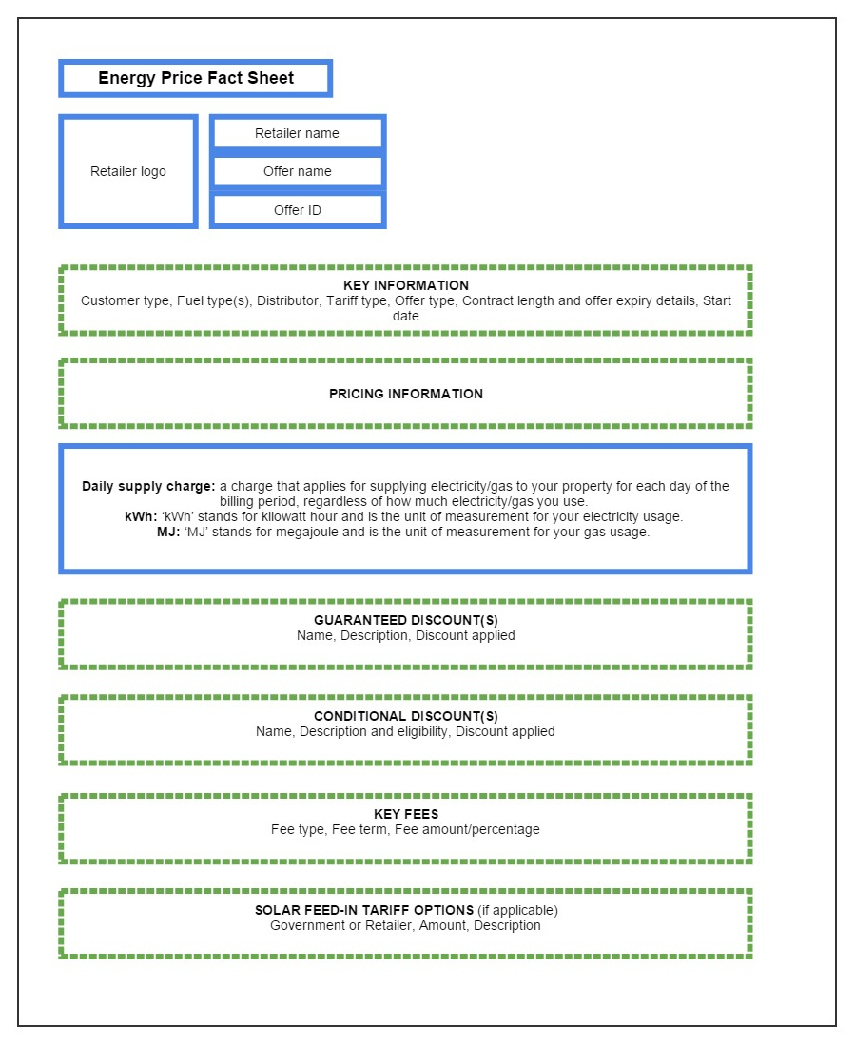

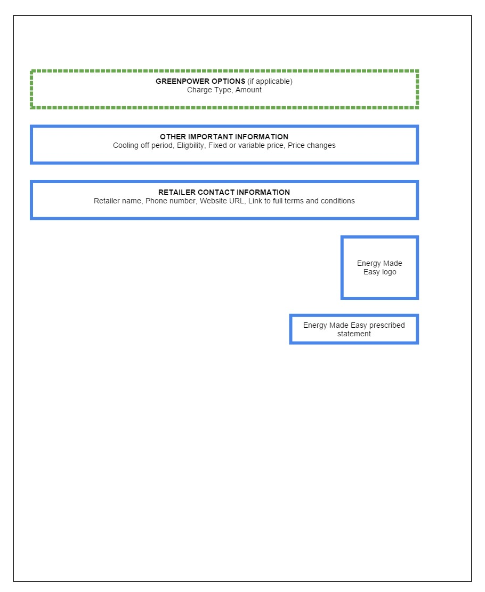

Attachment B

Offer data required to be entered into the price comparator website

Energy Made Easy allows retailers to enter all relevant offer information required by this Retail Pricing Information Guideline, including:

1. The GST exclusive unit price for electricity in ‘cents per kWh’ and for gas in ‘cents per MJ’ in the manner these would apply to customers (specifying any time periods, seasons, usage bands for different tariff rates, etc.)
2. ‘daily supply charge’ in ‘cents per day’
3. ‘key fees’ that are applicable (GST inclusive) and a link to where additional information on these or any further fees can be accessed
4. discounts, where each discount will be separately itemised, appropriately and accurately named and described, including whether it is conditional or guaranteed
5. whether a retailer may vary the prices for the offer, and if prices may vary, the circumstances in which this will occur and the notice that will be provided to the customer
6. a free text field for retailers to include information on incentives that form part of the overall product offering, such as vouchers for use in energy retail stores, or magazine subscriptions, etc
7. the distribution area that the offer applies to
8. contract length, cooling off period and arrangements that will take place at the end of the contract length if the customer takes no action
9. how and where small customers can access information on the full terms and conditions of the offer
10. a retailer’s contact information, including contact phone number and website
11. offer name
12. whether the offer is a dual fuel, electricity or gas offer
13. the metering configuration/s that correspond to the offer
14. whether the offer is available to residential or small business customers
15. release date and expiry date of the offer
16. whether the offer is applicable to customers with solar panel installations, and if so, the feed-in tariff(s) and other relevant information
17. GreenPower options (if applicable) and
18. Whether the offer is a standing, regulated or market offer.

1. National Energy Retail Law s 61(1).
2. National Energy Retail Law s 61(2).
3. National Energy Retail Law s 22(1).
4. National Energy Retail Law s 61(3)(c).
5. National Energy Retail Law ss 24, 37.
6. National Energy Retail Law ss 24, 37.
7. National Energy Retail Law s 63.
8. National Energy Retail Law s 62(2); <http://www.energymadeeasy.gov.au/>.
9. National Energy Retail Law s 62(3).
10. National Energy Retail Law s 62(5).
11. Available on the AER website at: <https://www.aer.gov.au/node/5876>.
12. Use electricity or gas as applicable.
13. National Energy Retail Rules s 45A.
14. *Competition and Consumer Act 2010* (Cth) ss 18, 29.
15. Each offer submitted to Energy Made Easy will have its own unique identification number which will be automatically generated by the price comparator website system. This unique identification number will also be displayed on the Energy Price Fact Sheet generated by Energy Made Easy.
16. A market retail contract is a customer retail contract as referred to in the National Energy Retail Law.
17. A standard retail contract is a customer retail contract that is as defined in the National Energy Retail Law.