

Explanatory statement

Proposed amendment

Electricity transmission and distribution network service providers

Post-tax revenue models (version 3)

3 October 2014

© Commonwealth of Australia 2014

1. This work is copyright. In addition to any use permitted under the Copyright Act 1968, all material contained within this work is provided under a Creative Commons Attribution 3.0 Australia licence, with the exception of:

* the Commonwealth Coat of Arms
* the ACCC and AER logos
* any illustration, diagram, photograph or graphic over which the Australian Competition and Consumer Commission does not hold copyright, but which may be part of or contained within this publication.

The details of the relevant licence conditions are available on the Creative Commons website, as is the full legal code for the CC BY 3.0 AU licence.

Requests and inquiries concerning reproduction and rights should be addressed to the Director, Corporate Communications, ACCC, GPO Box 3131, Canberra ACT 2601, or [publishing.unit@accc.gov.au](mailto:publishing.unit@accc.gov.au)

Inquiries about this decision should be addressed to:

Australian Energy Regulator

GPO Box 520

Melbourne  Vic  3001

Tel: (03) 9290 1444

Fax: (03) 9290 1457

Email: [AERInquiry@aer.gov.au](mailto:AERInquiry@aer.gov.au)

1. AER reference: 55444
2. Request for submissions
3. Interested parties are invited to make written submissions on the proposed amendments to the   
   post-tax revenue model (PTRM) to us, the Australian Energy Regulator (AER), by close of business, 17 November 2014.

We prefer that all submissions sent in an electronic format are in Microsoft Word or other text readable document form. Submissions should be sent electronically to [AERInquiry@aer.gov.au](mailto:AERInquiry@aer.gov.au)

Alternatively, submissions can be sent to:

Mr Warwick Anderson

General Manager – Networks Finance and Reporting Branch

Australian Energy Regulator

GPO Box 3131

Canberra ACT 2601

1. We prefer that all submissions be publicly available to facilitate an informed and transparent consultative process. Submissions will be treated as public documents unless otherwise requested. Parties wishing to submit confidential information are requested to:

* clearly identify the information that is the subject of the confidentiality claim
* provide a non-confidential version of the submission in a form suitable for publication.

1. All non-confidential submissions will be placed on our website at [www.aer.gov.au](http://www.aer.gov.au). For further information regarding our use and disclosure of information provided to us, see the ACCC/AER Information Policy, October 2008 available on our website.

Enquires about this paper, or about lodging submissions, should be directed to Kenny Yap on (02) 6243 1224.

Next steps

1. We will consider and respond to submissions on this explanatory statement. Key dates for our amendment process are set out in table 1.

Table Amendment process

|  |  |
| --- | --- |
| Task | Date |
| AER issues explanatory statement on proposed amendments | 3 October 2014 |
| Stakeholder submissions on proposed amendments close | 17 November 2014 |
| AER issues final decision | Late January 2015 |

Contents

Request for submissions 3

Shortened forms 5

1 Introduction 6

2 NER requirements 7

3 Reasons for the PTRM 8

4 Proposed amendments 9

4.1 Background 10

4.2 Changes to the PTRM 11

4.2.1 Return on equity changes 11

4.2.2 Return on debt changes 12

4.2.3 Return on capital changes 12

4.2.4 Equity raising cost changes 13

4.2.5 X factor recalculation 14

4.2.6 Revenue adjustments 14

4.2.7 Presentation and other minor changes 14

5 Consultation 16

5.1 Initial consultation 16

5.1.1 Future years' return on debt 18

5.2 Key issues for comment 19

Attachment 20

Attachment A: Future years' return on debt – illustrative examples 20

Appendices 26

Appendix A: Post-tax revenue model (transmission) 26

Appendix B: Post-tax revenue model (distribution) 26

Appendix C: Post-tax revenue model handbook (transmission) 26

Appendix D: Post-tax revenue model handbook (distribution) 26

1. Shortened forms

| Shortened form | Extended form |
| --- | --- |
| ABBRR | annual building block revenue requirement |
| ARR | annual revenue requirement |
| AEMC | Australian Energy Market Commission |
| AER | Australian Energy Regulator |
| CPI | consumer price index |
| DNSP | distribution network service provider |
| ERC | equity raising cost |
| MAR | maximum allowed revenue |
| NER | National Electricity Rules |
| NPV | net present value |
| NSP | network service provider (DNSP or TNSP) |
| PTRM | post-tax revenue model |
| RAB | regulatory asset base |
| TAB | tax asset base |
| TNSP | transmission network service provider |
| WACC | weighted average cost of capital |

# Introduction

1. The AER is responsible for the economic regulation of prescribed transmission and direct control distribution services provided by transmission and distribution network service providers (TNSPs and DNSPs) in the National Electricity Market, in accordance with the National Electricity Rules (NER). The NER requires us to prepare and publish post-tax revenue models (PTRMs) for TNSPs and DNSPs.[1] TNSPs and DNSPs can be collectively referred to as network service providers (NSPs).
2. The NER allows us to amend or replace the PTRMs of the NSPs and sets out the requirements in doing so.[2] Table 2 shows the versions of the PTRMs for TNSPs and DNSPs, the key changes to these models and when they were made.

Table **PTRM revisions**

|  |  |  |  |  |
| --- | --- | --- | --- | --- |
| Date | TNSP version | Key changes | DNSP version | Key changes |
| September 2007 | 1 | n/a |  |  |
| June 2008 |  |  | 1 | n/a |
| June 2009 |  |  | 2 | Various non-consequential errors corrected. |
| December 2010 | 2 | Input section modified to allow for the opening regulatory asset base (RAB) to be based on as-commissioned capital expenditure.  Formulae to calculate depreciation adjusted for the RAB roll forward.  Summary tables added. |  |  |

The proposed versions of the PTRMs (which will be labelled version 3 for both TNSPs and DNSPs) will require adjustments to give effect to the AER's new Rate of return guideline.[3] The Rate of return guideline was developed and published in December 2013 following changes to the NER by the Australian Energy Market Commission (AEMC) in November 2012.[4] The most significant change to the PTRMs will be to allow for an annual update for the return on debt. Further background and details of the proposed amendments are discussed in section 4 of this explanatory statement.

1. There are differences between the PTRMs used for TNSPs and DNSPs. However, the proposed amendments discussed in this explanatory statement affect both in largely the same way and are therefore discussed together. Matters that are TNSP or DNSP specific are identified as such.

# NER requirements

1. The NER allows the AER to amend or replace the PTRMs of the NSPs and sets out the consultation procedures the AER must comply with in doing so.[5] When amending the PTRM, the consultation procedures in the NER require us to:[6]

* publish the proposed amended model
* publish an explanatory statement setting out the purpose of the proposed amended model
* invite written submissions on the proposed amended model.

1. Interested parties must be allowed at least 30 business days to make submissions to the AER.[7] Within 80 business days of publishing the proposed amended model the AER must publish its final decision, handbook and model.[8]
2. The NER also sets out the required contents of the PTRM.[9] The required contents are largely similar for the TNSP and DNSPs, although expressions/terminologies differ between the relevant clauses. For example, the TNSP's PTRM is used to calculate the annual building block revenue requirement (ABBRR) and maximum allowed revenue (MAR) for each year of the regulatory control period.[10] The DNSP's PTRM is used to calculate the annual revenue requirement (ARR) and expected revenue for each year of the regulatory control period.[11] Key features of both PTRMs include:

* a methodology that seeks to produce the best estimates of expected inflation
* the timing assumptions and associated discount rates that are to apply in relation to the calculation of the building blocks
* the manner in which the estimated cost of corporate income tax is to be calculated
* a net present value (NPV) calculation that sets the total MAR/expected revenue for the NSP for each year of the regulatory control period equal to the NPV of the ABBRR/ARR for the NSP for each year
* the MAR/expected revenue for the NSP is updated annually using a CPI – X methodology
* the X factors to apply in the regulatory control period.

# Reasons for the PTRM

1. The principal purpose of the PTRM is to calculate the MAR/expected revenue for an NSP in each year of a regulatory control period and resulting X factors as part of a transmission/distribution determination. The X factors are then used in the annual updates to either revenues or prices (depending on the form of control) and annual price approval requirements (in the case of DNSPs).
2. The MAR/expected revenue, calculated using the PTRM, must be determined using the building block approach set out in the NER.[12] The building blocks include:

* an indexation of the RAB
* a return on capital
* a return of capital (depreciation)[13]
* the estimated cost of corporate income tax
* forecast operating expenditure (opex)
* revenue increments or decrements arising from applicable efficiency incentive schemes[14]
* adjustments related to any mechanisms used in the previous regulatory control period and other revenue adjustments such as those related to shared assets.

# Proposed amendments

This section sets out our proposed amendments to the PTRMs for the NSPs and the relevant handbooks. Table 3 and table 4 show which worksheets have been amended, added or removed.[15]

1. The changes bring the structure of the two PTRMs into closer alignment, in particular, through the following amendments:[16]

* The same names are used for equivalent worksheets.
* The Revenue summary worksheet is now included in both PTRMs, and includes content that was previously located on the X factor worksheet of the DNSP PTRM, and across the Revenue summary, Price path (nominal) and Price path (real) worksheets of the TNSP PTRM.
* The DNSP PTRM now includes the Equity raising cost worksheet, which was already in the TNSP PTRM (with an amended label for the worksheet and updated calculations reflecting recent AER decisions).[17]

The specific changes are listed in a temporary Change log worksheet in the proposed amended PTRMs. This detailed log will be deleted from the final version and a summary instead provided in the Intro worksheet to the PTRMs.

Table Changes to the distribution PTRM worksheets

|  |  |  |
| --- | --- | --- |
| Old PTRM worksheets | Status | New PTRM worksheets |
| Intro | Minor changes only | Intro |
| Input | Amended | Input |
| WACC | Amended | WACC |
| Assets | Amended | Assets |
| Analysis | Amended | Analysis |
| Forecast revenues | Amended | Forecast revenues |
| X factor | Amended and renamed | X factors |
|  | Added | Revenue summary |
|  | Added | Equity raising cost |
| Chart 1-Revenues | Minor changes only | Chart 1-Revenues |
| Chart 2-Price path | Minor changes only | Chart 2-Price path |
| Chart 3-Building blocks | Minor changes only | Chart 3-Building blocks |

Table Changes to the transmission PTRM worksheets

|  |  |  |
| --- | --- | --- |
| Old PTRM worksheets | Status | New PTRM worksheets |
| Intro | Minor changes only | Intro |
| Input | Amended | Input |
| WACC | Amended | WACC |
| Assets | Amended | Assets |
| Analysis | Amended | Analysis |
| Smoothing | Amended and renamed | X factors |
| Revenue summary | Amended | Revenue summary |
| Equity raising cost-capex | Amended and renamed | Equity raising cost |
| Price path (nominal) | Removed | Moved to Revenue summary |
| Price path (real) | Removed | Moved to Revenue summary |
| Chart 1-Revenues | Minor changes only | Chart 1-Revenues |
| Chart 2-Price path | Minor changes only | Chart 2-Price path |
| Chart 3-Building blocks | Minor changes only | Chart 3-Building blocks |

The proposed amended PTRMs are at appendices A and B for TNSPs and DNSPs respectively. The proposed amended handbooks are at appendices C and D for TNSPs and DNSPs respectively.

## Background

In November 2012, the AEMC amended the rules that determine how the AER sets the revenues for regulated electricity and gas networks.[18] In particular, the new rules change the way we establish the rate of return on capital, a key determinant of regulated revenues.[19] These rules also introduced the prospect of revenue adjustments (decrement) for shared assets.[20]

In December 2013, we published our Rate of return guideline (guideline), which sets out how we intend to implement the new rules relating to rates of return.[21] This guideline reflects extensive consultation with stakeholders on the changes to the determination of the rate of return within the rules.[22] There are two principal components of the return on capital, also referred to as the weighted average cost of capital (WACC)—the return on equity and the return on debt. The guideline states:

* The return on equity will be determined with regard to a broad range of information that includes different financial models.[23] Previously, the AER set the return on equity using one particular model—the capital asset pricing model (CAPM).
* The return on debt will be estimated using a trailing average portfolio approach, with annual updates within the regulatory control period that reflect changes in debt costs.[24] Previously, the AER used an ‘on-the-day’ approach, which fixed the return on debt at the start of the regulatory control period.[25] The value was therefore adopted for the entirety of the regulatory control period.

In May 2014, we undertook preliminary consultation with various NSPs and industry bodies. We provided example TNSP/DNSP PTRMs that included the most significant changes we propose, as discussed below. Their responses are also discussed below.

## Changes to the PTRM

1. The changes due to the guideline have implications for the return on capital calculations and a number of consequential impacts for other outputs of the PTRM such as the X factors. The changes are discussed in detail below. We have also taken the opportunity to make a few minor presentational changes to improve clarity. These changes are also discussed below.
2. The proposed amendments to the PTRMs were made with the following aims:

* Minimise changes. Wherever possible, we have attempted to make minimal functional changes necessary to bring the guideline approach into effect.
* Applying the guideline. The PTRM seeks to fully implement the AER’s return on capital approach, as set out in the guideline.
* Include user guidance. The PTRM includes various comments and labels to guide the user. This is particularly the case for implementing the new annual return on debt update.
* Minimise WACC modelling in the PTRM. The PTRM is designed to have as inputs the ‘final’ return on equity and return on debt values. This process does not set out the derivation of those values, which is not directly required for the PTRM itself.

1. Guidance on implementing the annual return on debt update is set out in the TNSP/DNSP PTRM handbooks.

### Return on equity changes

The changes specifically related to the return on equity are relatively minor. The return on equity is no longer calculated solely from CAPM components (risk free rate, market risk premium and equity beta), and these component inputs have been removed in the proposed amended PTRMs.

Instead, the user directly enters the overall return on equity input. For simplicity, we have only included the ‘final’ return on equity as input to the PTRM.[26] This value then feeds into the calculation of the overall return on capital and discount rates.[27]

### Return on debt changes

The changes related to the return on debt are more substantial. The user no longer enters a single debt risk premium input (which is then presumed constant across the regulatory control period) and risk free rate.

Instead, the key input is the estimate of the trailing average portfolio return on debt for each year of the regulatory control period.[28] The different annual values for the return on debt will then flow through to all linked building block revenue components. These include:

* Return on capital—the return on debt is a key factor in the return on capital allowance.
* Regulatory depreciation—a change to the return on debt will affect the half WACC adjustment to capital expenditure when we add it to the RAB.[29] This will affect both the return on capital and regulatory depreciation building blocks.
* The cost of corporate income tax—a change to the return on debt will affect the implied estimate of taxable income, largely due to the change in total revenue and the benchmark tax expense offsets, which reflect the deductibility of interest payments from taxable income.

1. The user is also asked to enter the update year when updating the annual return on debt within the regulatory control period. This does not change the underlying calculation of smoothed or unsmoothed revenues, but it does change the presentation of context-sensitive labels and comments that should guide the user.

### Return on capital changes

Given the return on debt changes, the return on capital can now vary from year to year. This gives rise to further consequential changes to the PTRM. There are two ways in which the return on capital affects the outputs of the PTRM:

* 1. The return on capital is an input into several of the revenue building blocks.
  2. The return on capital is the discount rate used in the NPV calculation to equalise smoothed and unsmoothed revenue profiles.

The major changes to the building block revenue calculations are as follows:

* New variables are defined to allow the PTRM to include different real vanilla WACC values for each year of the regulatory control period, which was previously not required. New defined variables ‘rvanilla01’, ‘rvanilla02’, to ‘rvanilla10’ replace the previously single defined ‘rvanilla’ variable used for the half WACC adjustment.[30]
* The allowed return on debt component of the return on capital calculation for each year now refers to the prevailing trailing average portfolio return on debt for that year.
* Previously, the calculation for each year of the regulatory control period referred to a single, constant return on debt as determined in our final decision. Accordingly, the overall return on capital (presented in nominal vanilla WACC form) was determined in the final decision and constant across the regulatory control period.
* Now, under the guideline, the return on debt is updated annually during the regulatory control period. The trailing average will incorporate the most recent return on debt value (as well as the previous nine years of data) and this will change the return on capital building block calculation for that year. However, the smoothed revenue for any year depends on the unsmoothed building blocks across the entire regulatory control period. Hence, the forecast return on debt for later years in the regulatory control period will be a material consideration during the annual update.
* In the PTRM, the trailing average return on debt calculated at the most recent annual update is assumed to apply for the remainder of the regulatory control period. We considered whether the trailing average for later years (the years after the year of the annual update) should stay as in the final decision or revert to some other calculated value. However, we consider the up-to-date trailing average to be the most reasonable proxy for these later years too, until they are updated in subsequent years.[31]
* The PTRM calculates straight-line depreciation using the initial value of capital expenditure added to the RAB. This includes half a year of the WACC, in line with the PTRM’s timing assumption. These calculations now refer to the newly defined ‘rvanillaXX’ variable for the prevailing WACC in the year in which the capital expenditure is added to the RAB. Previously, all calculations referred to a single, constant real vanilla WACC value as determined in our final decision.

The major change to the NPV calculations is that the discount rate applied to each year when calculating the NPV is the cumulative discount rate for all relevant years, even when the individual year has a different return on capital. Hence, the X factors worksheet accommodates the use of different return on capital for each year.

### Equity raising cost changes

1. Another consequential change due to the return on debt changes is that the benchmark equity raising cost (ERC) will also need to be updated annually. The current version of the TNSP PTRM contains an Equity raising cost–capex worksheet. We propose to amend this worksheet (and rename it) to allow the ERC to be updated annually.

The process of calculating ERC is iterative because the required ERC amount depends on the smoothed total revenue (which is known as the MAR for transmission, and expected revenue for distribution), and the smoothed total revenue in turn depends on the required ERC. Hence, the smoothing process—calculating the X factors that equate the NPV of smoothed and unsmoothed total revenue—needs to jointly resolve the ERC and X factors. The new PTRM achieves this via amended macros which refer to the integrated Equity raising cost worksheet. The user interface (buttons on the X factors worksheet which directly call the required macros) remains the same.

In addition, an Equity raising cost worksheet has been added to the DNSP PTRM to allow for this annual update. ERC was previously calculated through separate modelling for the DNSPs. This change therefore streamlines the model for the DNSPs too.

### X factor recalculation

With the annual return on debt update in the PTRM, the X factor will also need to be updated annually. The building block revenues will be updated and the revenues resmoothed to determine revised X factors from year 2 onwards of a regulatory control period. We gave consideration to having a separate factor to account for the incremental change in revenues each year as a result of the return on debt update. However, we consider it simpler to recalculate the X factor. This also simplifies the control equations. Accordingly, the X factors worksheets in the TNSP/DNSP PTRMs respectively include revised X factor calculation buttons with built in macros.

We propose that the updated X factors be determined such that the entire impact of the annual return on debt update is realised in the year to which the change relates.[32]

Updating the X factors is discussed in further detail in the PTRM handbooks.

### Revenue adjustments

1. There can be other revenue adjustments besides the standard building block components on occasion. To pick up these potential revenues adjustments as provided for in the NER, extra input sections have been added to the PTRM.
2. The possible types of revenue adjustments include those which may arise from the following matters.

* The NER changes in November 2012 allow for customers to potentially share in the non-regulated revenues a NSP earns from use of shared assets.
* Under a revenue cap, the DNSPs have scope to include any balance in their unders/overs accounts at the end of the regulatory control period in the building block assessment for the next regulatory control period.
* In future, revenue adjustments in relation to the capital expenditure sharing scheme will also need to be added to the PTRM. Revenue adjustments in relation to the efficiency benefit sharing scheme are already factored into the PTRM and are entered through the operating expenditure input section.

1. The revenue adjustments can have differing impacts in terms of the tax allowance. Therefore the new input sections have been broken down by their impact on tax. For example, any DNSP revenue adjustment for under/over recovery of revenues under a revenue cap would not require a tax allowance as that would have been factored in at the last reset. However, other revenue adjustments may increase/decrease tax liabilities.

### Presentation and other minor changes

There are a few minor presentational and other minor operational changes. These include:

* Smoothing worksheet in the TNSP PTRM has been re-labelled as X factors worksheet to be consistent with the DNSP PTRM.
* The DNSP PTRM now includes the same 'default smoothing' option as the TNSP PTRM (accessed via a button which calls a macro). The 'default smoothing' approach is to set year 1 smoothed revenue equal to year 1 unsmoothed revenue, and then determine the same X factor rate for all remaining years of the regulatory control period so that the NPV of unsmoothed and smoothed revenues equate.
* The PTRMs can now accommodate regulatory control periods between 2 to 10 years in length.[33] Previously the DNSP PTRM assumed the use of a 5 year period, while the TNSP PTRM allowed the user to enter the length of the regulatory period (up to 10 years) but periods other than 5 years caused some summary and display errors.
* There are indicative price impacts included, consistently calculated across the two PTRMs. For revenue caps, these prices are based on the smoothed revenues divided by forecast MWh to determine a simple dollar per MWh price per annum. There are additional forms of control (weighted average price cap and revenue yield cap) available to DNSPs but not TNSPs so there are additional indicative price impacts shown in the DNSP PTRM.
* The PTRMs can now handle tax rate changes from year to year within the regulatory control period. Previously, only the TNSP PTRM allowed this function.
* Additional content-sensitive cautions and warnings have been added to the PTRMs. Based on cell input, these will inform the user of potential concerns. In particular, these have been designed to aid the user when implementing the annual return on debt update, since this is a new process that entails some complexity.

# Consultation

1. This section summarises the first steps in the consultation process already undertaken, and identifies key issues for comment on our proposed TNSP/DNSP PTRMs.

## Initial consultation

In May 2014 we undertook consultation with 19 service providers and industry bodies, sending them example TNSP/DNSP PTRMs with some initial changes, particularly in accommodating the changes to the return on equity and return on debt. The Energy Networks Association (ENA) provided a response, with six NSPs also responding with comments.[34] Two NSPs responded by noting the ENA's comments.[35]

This initial consultation identified one particular issue—the approach to forecasting future years' return on debt—where an approach needs to be adopted for operation of the PTRM. This issue is discussed separately in section 5.1.1. The other main issues raised by interested parties were as follows:

* Several NSPs suggested recalculating the X factors for all remaining years in the regulatory control period, such that the impact from the return on debt update may be spread over two or more years depending on the size of the adjustment. We recognise that this may have some appeal. For example, if the adjustment was greater than two per cent, the adjustment could be spread over two or more years. However, we do not currently propose to adopt this suggestion given the risk of a cumulative impact over time.[36] Any cumulative impact may also be heightened by other annual adjustments to the control mechanism, such as pass throughs or revenue under/over adjustments. Accordingly, we consider the impact should take full effect in the year the update is made and therefore only one X factor will be updated annually.[37]
* The ENA raised the issue of a lag in the updating approach between when the return on debt is observed and when the change is applied to prices. Overall, we consider that the proposed PTRM could handle a lag to the X factor change and that this matter may be considered as part of the final decision for the relevant NSP. Further, we consider that this issue is not about the PTRM itself, but rather a matter for determining the appropriate input for each year.
* Our intention is that for each annual update, which occurs as close as is practical to the commencement of the relevant year, the return on debt for that year is updated, and so too is the X factor for that year.[38] For example, just before the start of year 2, the PTRM is updated with the year 2 trailing average portfolio return on debt, the new X factor for year 2 is calculated, and then end-user prices for year 2 are published. Since this process occurs just before the start of year 2, the return on debt for year 2 must be set with regard to debt market observations from an averaging period in year 1.[39] However, the averaging period must end some three or four months prior to the end of that year to allow time for the pricing implementation. This averaging period is treated as a proxy for the return on debt in year 2.[40]
* If the averaging period was to extend right up to the end of the preceding year, it would not be possible to include the effect of that year's annual return on debt update in the pricing implementation for that year. Instead, under this approach, the return on debt for that year is updated, and the X factor for the following year is updated in response. For example, just before the start of year 3, the PTRM is updated with the year 2 trailing average portfolio return on debt, the new X factor for year 3 is calculated, and then end-user prices for year 3 are published. In this case, the return on debt for year 2 can be set with regard to debt market observations right up to the last day in year 1.
* Our current preference for the first approach is because it allows for a consistent and continuous practical implementation—both within a regulatory control period, and across multiple regulatory control periods. The first approach to the annual update aligns with the process used in the final decision, where the return on debt for year 1 is set using an averaging period that ends several months before the start of that year. Hence, each return on debt observation is a proxy with a consistent lag (in general terms, three to six months before the start of the relevant year). This type of measurement lag is already present in several other WACC parameters, including the inflation adjustment and the return on equity estimate.[41] The process is continuous across multiple regulatory control periods. Debt market observations from year 5 (final year of a given period) will be used as the best available proxy for the return on debt in year 1 (of the following period). Under the second approach, the adjustment for the return on debt in year 5 would need to be implemented in the first year of the following regulatory control period, but it is unclear how this would occur.
* Jemena Gas Networks (JGN) raised an issue concerning the form of discount rate used when deriving smoothed revenue across the regulatory control period.[42] In the PTRM, the NPV of smoothed revenue (MAR or expected revenue) is constrained to equal the NPV of the unsmoothed building block revenue (ABBRR or ARR).[43] In line with the previous PTRM, our proposed PTRM uses a vanilla WACC for discounting purposes in the NPV equation. However, JGN suggested that a pre-tax WACC should be used instead.[44] Conversion from nominal vanilla WACC to nominal pre-tax WACC would increase the discount rate. It does not change the underlying unsmoothed revenue building blocks, but it may increase or decrease the smoothed revenue requirement for the NSP.[45] At present, we have maintained the use of a nominal vanilla WACC for this aspect of the PTRM, noting that this is consistent with the approach in all previous electricity determinations.
* The NSW electricity DNSPs raised an issue concerning the mathematical implementation of the annual return on debt update under the chosen form of control.[46] Our example PTRM allows the X factors to be changed each year as a result of the annual return on debt update. The NSW DNSPs suggested that the X factors from the final decision could be left unchanged and instead new yearly factors, labelled W factors, would be changed in response to the annual return on debt update.[47] We note that this has the advantage of improving transparency, keeping revenue changes arising from the annual debt update (the W factors) separate from revenue changes determined at the final decision stage (the X factors). However, it would necessarily introduce some additional complexity—for example, all existing price control formulae would need to be rewritten to include the additional factors.[48] The split presentation may also be unhelpful in cases where there is a need to apportion interaction effects between the two factors.[49] On balance, we consider that the changes from the annual debt update should be through revising the X factors and no additional set of factors would be added.

### Future years' return on debt

1. When an annual return on debt update takes place, the portfolio return on debt for that year (and any other earlier years in the regulatory control period) is known. However, the portfolio return on debt for later years within the regulatory control period is unknown. An assumption must be made about future years' return on debt in order to derive the new X factor for the year of the annual update.[50]
2. It is important to remember that these assumptions about future years' return on debt will not change the overall revenue outcome in NPV terms. At the end of the regulatory control period, the total NPV (discounted using the final time varying WACC outcome) of smoothed revenue will be equal under either approach. However, different approaches can lead to a different distribution of revenue within the regulatory control period.
3. The example PTRMs we included in our initial consultation assumed the most recent portfolio return on debt applied to all future years. In response, the ENA suggested applying the portfolio return on debt from the final decision to all future years when undertaking the annual debt update, because leaving this value unchanged would reduce price volatility.
4. We evaluated these two alternative approaches against the following key criteria:

* Does the approach promote the allowed rate of return objective?
* Does the approach minimise volatility within the regulatory control period?
* Is the approach consistent with the return on debt being set in the final decision?

1. On the first criterion, any assumption will not affect overall revenue outcomes at the end of the regulatory control period.[51] Hence, it is only the relative change from year to year within the period that could affect the promotion of the objective, and this is the point emphasised by the second criterion. Assessment of such volatility, however, is difficult since movement that reflects year-to-year changes in in the underlying cost of debt is not volatility per se but rather intentionally provides cost reflectivity. The approach should not 'over adjust' revenue (such that there needs to be reversal in later years); nor should the approach 'under adjust' revenue (such that there needs to be large 'price shocks' in later years).
2. Attachment A sets out in detail how the two approaches perform under different illustrative debt market scenarios. It shows that neither approach is universally superior with regard to the first two criteria above. However, our general conclusion is that our proposed approach (applying the most recent portfolio return on debt to future years) produces changes in real revenue that better align with changes in debt market conditions, and appears to minimise volatility overall.[52] This proposed approach limits the upper magnitude of any single year-on-year change, relative to the alternative approach (applying the final decision portfolio return on debt to future years). This is because the alternative approach effectively defers adjustments from earlier years in the regulatory control period. If the portfolio return on debt moves in one direction across several years the cumulative deferred adjustment can become substantial. This has the potential to cause a large single-year adjustment (price shock) in year 4 or 5 of the regulatory control period.
3. Turning to the third criterion, the approach in our PTRM aligns with the forecasting principle used to set the trailing average portfolio return on debt in our final decision. That is, the most recent estimate is the best forecast for future years. In contrast, the ENA approach would align with the value set in the final decision; but not the principle behind the derivation of this value.
4. On balance, our current position is that using the most up to date trailing average of the return on debt for all remaining years in the regulatory control period is the most appropriate approach. This is because this approach best meets the criteria. In particular, it appears to limit the upper magnitude of possible single-year changes in X factors, even under extreme scenarios.[53]

## Key issues for comment

Our positions in the proposed amended PTRMs reflect our consideration of the issues raised during initial consultation. However, we are open to receiving further submissions on the proposed amendments. In particular, we seek comment on:

* The approach to setting future years' return on debt in an annual update during the regulatory control period:[54]
* Are there other approaches (beyond those described above) we should consider?
* Is there a need to manage any volatility arising from future year's return on debt? If so, how could this be done?
* The form of the discount rate when calculating the NPV of smoothed and unsmoothed revenue:
* What form should the discount rate take – vanilla, pre-tax, or another alternative?

1. Attachment

## Attachment A: Future years' return on debt – illustrative examples

1. Overview

As discussed in section 5.1.1, when performing an annual update, the portfolio return on debt assumed for future years in the regulatory control period (that is, the years after the annual update) have a material impact on the revised X factor. This attachment describes two alternative approaches to setting the future years' return on debt and investigates how they perform under four different debt market scenarios. Each scenario reflects a possible path for the return on debt (in other words, interest rates) across the regulatory control period.

Our general conclusion is that our proposed approach (described below and labelled approach A) produces changes in real revenue that better align with changes in debt market conditions, and appears to minimise volatility overall. The alternative approach (described below and labelled approach B) minimises year-on-year volatility where the directional change in the portfolio return on debt in one year is reversed in the next—that is, fluctuating above and below the final decision value.[55] However, if the change in the portfolio return on debt in later years is in the same direction—that is, there is a trend upward or downward across multiple years—such an approach would make the change in the subsequent years even larger.[56] The largest 'price shock', interpreted as a large single year-on-year change, occurs under this situation when applying the alternative approach (approach B). Our proposed approach (approach A) avoids this cumulative deferral problem and therefore limits the upper magnitude of any single year-on-year change.

It is important to remember that these assumptions about future years' return on debt will not change the overall revenue outcome in NPV terms. At the end of the regulatory control period, the total NPV (discounted using the final time varying WACC outcome) of smoothed revenue will be equal under either approach. However, different approaches can lead to a different distribution of revenue within the regulatory control period, as is shown below.

1. Method

We consider two alternative approaches to setting future years' return on debt:

* Approach A: Assume that the most recent portfolio return on debt applies to all future years. This is the approach implemented by default in the proposed PTRM.[57]
* Approach B: Assume that the final decision portfolio return on debt applies to all future years.[58]

We then consider the impact of applying the two alternative approaches under four different scenarios, each presenting a relatively extreme version of possible return on debt outcomes across the five year regulatory control period:

* Scenario 1: Sudden increase, then gradual decrease.
* Scenario 2: Sudden increase, then rapid decrease.
* Scenario 3: Gradual increase across the regulatory control period.
* Scenario 4: Large fluctuations around starting spot rate.

Hence, there are eight examples (two approaches by four scenarios) described below. In each example we report the annual change in real revenue across the five years of the regulatory control period, and show how this differs from the final decision outcome. The key consideration is the distribution of revenue within the regulatory control period, including the change in revenue from one year to the next.

Starting basis

All the examples start from the same basis, reflecting an illustrative AER final decision made just before the start of the regulatory control period. We use the distribution PTRM, which has sample data already included on the Input worksheet. The form of control is a revenue cap.

1. We assume that for the first year of the regulatory control period, the current (spot) return on debt is 7.50 per cent.[59] The return on debt across the previous nine years has varied year by year between 6.5 per cent and 8.5 per cent, and the ten-year trailing average portfolio return on debt is 7.40 per cent, close to the current spot rate.[60]
2. With these inputs, the final decision sets an X factor of –3.0 per cent for year 1, and X factors of 0 per cent for all other years.[61] Figure 1 illustrates the relationship between debt costs and real revenue change at the final decision stage.

Figure Final decision—return on debt and annual real revenue change

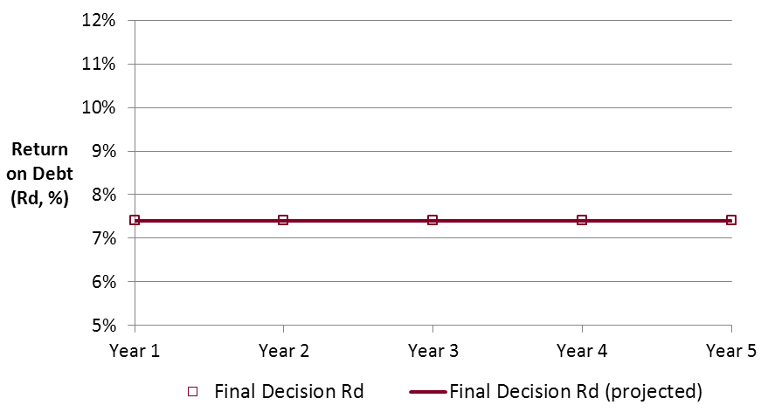 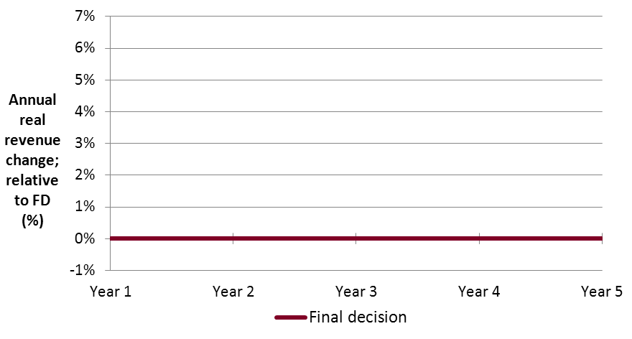

Source: AER analysis.

The left side of figure 1 shows the portfolio return on debt from the final decision (7.4 per cent). The inherent projection in the final decision is that this portfolio return on debt will continue across the regulatory control period. The right side of figure 1 shows the annual real revenue change relative to the final decision (FD) revenue outcome. Obviously, comparing the final decision against itself results in 0 per cent difference for all years.[62] This figure is included to establish the baseline for comparison against outcomes under the four scenarios described next.

Scenario 1: Sudden increase, then gradual decrease.

In year 1 the current (spot) return on debt is 7.5 per cent and the ten-year trailing average portfolio return on debt is 7.4 per cent (as in all scenarios). In year 2, the spot return on debt increases to 12 per cent.[63] The spot rate then gradually decreases from this high point across the remaining years of the regulatory control period, reaching 9 per cent in year five (still substantially above the long run average).

As a result of these changes in spot rates, the ten-year trailing average portfolio return on debt will increase in each of the five years of the regulatory control period. The largest increases in the trailing average portfolio occur in the earlier years of the regulatory control period.

Figure 2 illustrates the relationship between debt costs and real revenue change for scenario 1.

Figure Scenario 1 outcome—return on debt and annual real revenue change

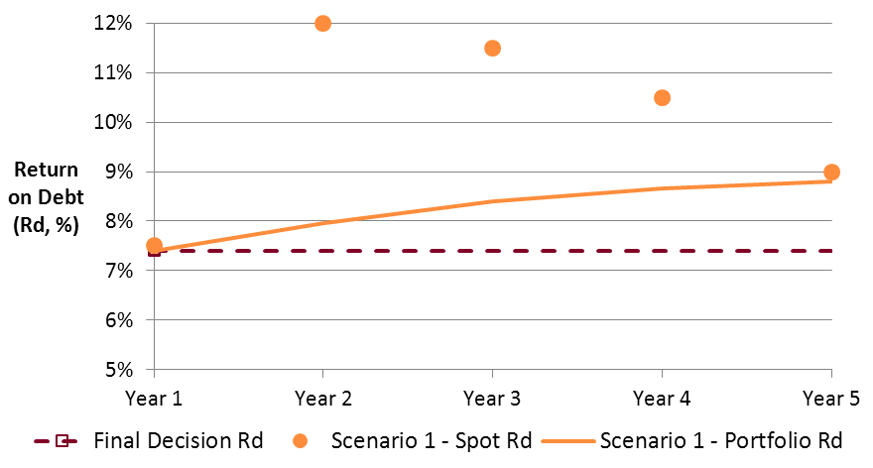 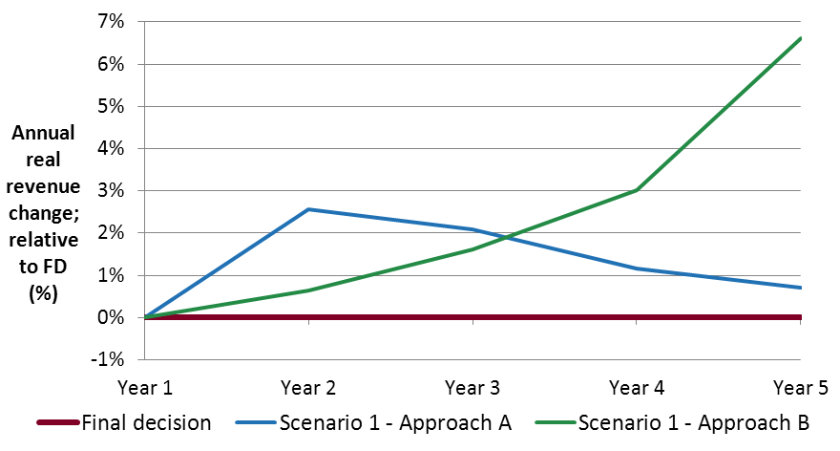

Source: AER analysis.

The left side of figure 2 shows the return on debt outcomes (spot rate as orange markers, and trailing average portfolio as an orange line) across the regulatory control period. The right side of figure 2 shows that in response to the increasing return on debt, the real revenue increases beyond the level set in the final decision under either approach. However, the two approaches differ markedly in their revenue profile:

* Approach A (blue line) has a larger initial increase, coincident with the initial increase in debt costs. Real revenue increases by 2.6 per cent in year 2 and 2.1 per cent in year 3. Adjustments in later years are smaller as a result.
* Approach B (green line) does not include a large increase in response to the initial debt cost shock, and effectively defers adjustments to later years. This eventually causes particularly large changes in year 4 (3.0 per cent) and year 5 (6.6 per cent).

1. In this scenario, the largest annual changes occur at the end of the regulatory control period under approach B, reflecting the cumulative impact of deferred changes earlier in the period.

Scenario 2: Sudden increase, then rapid decrease.

The spot return on debt increases from 7.5 per cent in year 1 to 12 per cent in year 2, which is identical to scenario 1. However, in scenario 3 there is then a rapid decrease in the return on debt, and by year 4 the spot return on debt is back to 7.5 per cent. In year 5 the return on debt is 7 per cent, still commensurate with previous conditions.

As a result of this short lived increase in debt costs, the trailing average portfolio return on debt will increase in years 2 and 3 but then decrease (slightly) in years 4 and 5.

Figure 3 illustrates the relationship between debt costs and real revenue change for scenario 2.

Figure Scenario 2 outcome—return on debt and annual real revenue change

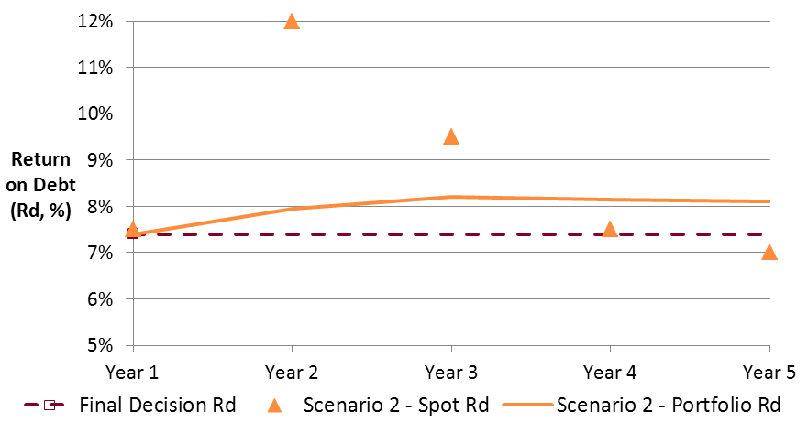 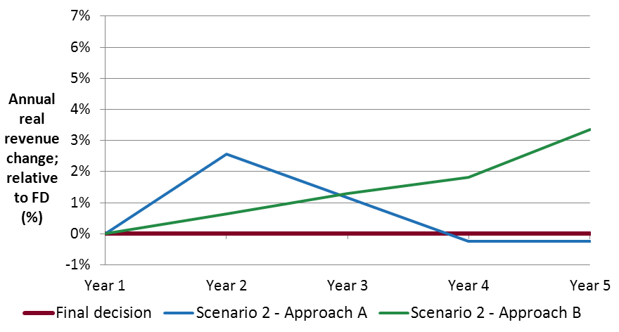

Source: AER analysis.

As before, the left side of figure 3 shows the return on debt outcomes (spot rate and trailing average portfolio in orange) across the regulatory control period. The right side of figure 3 shows that in response to the increasing return on debt, the real revenue increases (relative to the final decision outcome) under either approach—though not as much as in scenario 1:

* Approach A (blue line) has a larger initial increase, coincident with the initial increase in debt costs. Real revenue increases by 2.6 per cent in year 2 and 1.2 per cent in year 3. Adjustments in later years are slightly negative (–0.2 per cent in years 4 and 5). This reflects the slight reductions in the portfolio cost of debt for those years.
* Approach B (green line) does not include a large increase in response to the initial debt cost shock, and effectively defers adjustments to later years as in scenario 1. However, the cumulative effect is not as large and the year 5 change is 3.4 per cent.

Approach A shows slight over-adjustment. The largest single year-on-year change occurs under approach B. Broadly speaking, however, changes under approach A better align with debt market movements (increasing when the return on debt increases, and decreasing when the return on debt decreases).

Scenario 3: Gradual increase across the regulatory control period.

Each year the spot return on debt increases by 1 per cent, climbing from 7.5 per cent in year 1 to 8.5 per cent in year 2 and eventually to 11.5 per cent by year 5.

As a result of the ongoing increase in spot rates, the ten-year trailing average portfolio return on debt will increase in each of the five years of the regulatory control period. The largest increases in the trailing average portfolio occur in the later years of the regulatory control period.

Figure 4 illustrates the relationship between debt costs and real revenue change for scenario 3.

Figure Scenario 3 outcome—return on debt and annual real revenue change

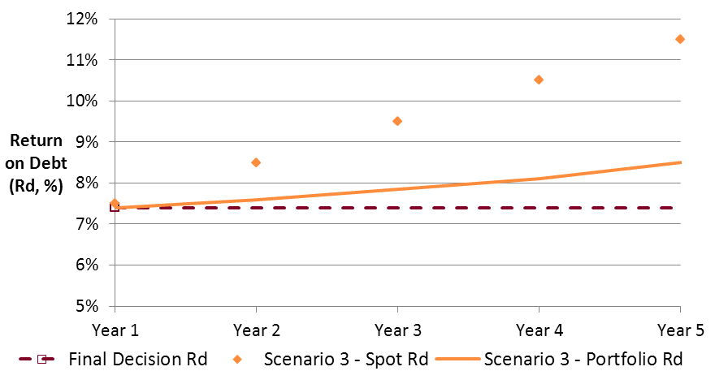 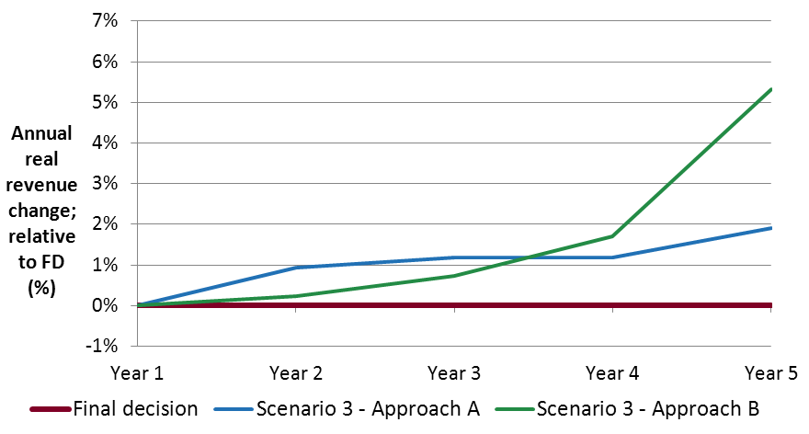

Source: AER analysis.

As before, the left side of figure 4 shows the return on debt outcomes (in orange). The right side of figure 4 shows that in response to the increasing return on debt, the real revenue increases under either approach (relative to the final decision outcome):

* Approach A (blue line) has relatively constant change in real revenue. The increases in each year range between 0.9 per cent (year 2) and 1.9 per cent (year 5).
* Approach B (green line) has the same pattern of deferred changes observed in the earlier scenarios. The increase in year 2 is small, but by year 5 the increase (5.3 per cent) is more than double any other year.

In this scenario, the largest single year change occurs at the end of the regulatory control period under approach B, reflecting the cumulative impact of changes across the period.

Scenario 4: Large fluctuations around the starting spot rate

In year 1 the spot return on debt is 7.5 per cent (as in all scenarios). In this scenario, the spot rate in year 2 is also 7.5 per cent, but then there is a decrease to 5 per cent in year 3. In year 4, debt costs increase to 10 per cent, before another decrease to 5.5 per cent for year 5. Hence, there are large fluctuations above and below the initial spot return on debt.

In year 1, the trailing average portfolio return on debt is 7.4 per cent (as in all scenarios). As a result of these changes in spot rates, the trailing average portfolio return on debt will be 7.5 per cent in years 2 and 4, and 7.3 per cent in year 3 and 5. That is, the return on debt oscillates above and below the starting value.

Note that from year 1 to year 2 in this scenario, the spot rate is unchanged (at 7.5 per cent) but the portfolio return on debt does change (from 7.4 per cent to 7.5 per cent). This occurs because the trailing average no longer includes the spot return on debt from nine years before year 1. This year drops out of the ten year trailing average portfolio, and is replaced by year 2. The return on debt in that year was 6.5 per cent, but the replacement (year 2) return on debt is 7.5 per cent, so the ten year average increases. This illustrates an important point that affects all scenarios—it is the difference between the return on debt exiting the portfolio and the return on debt entering the portfolio that determines the movement in the trailing average.[64]

Figure 5 illustrates the relationship between debt costs and real revenue change for scenario 4.

Figure Scenario 4 outcome—return on debt and annual real revenue change

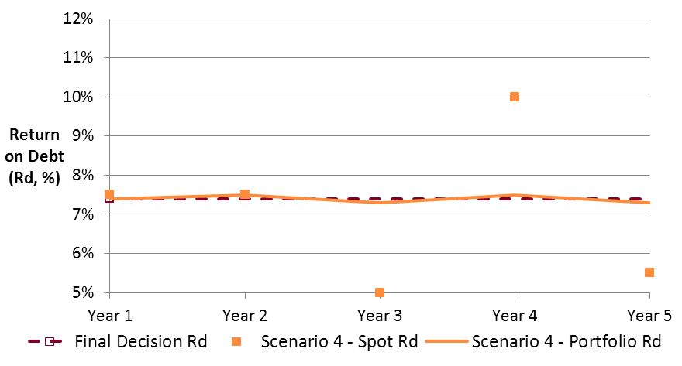 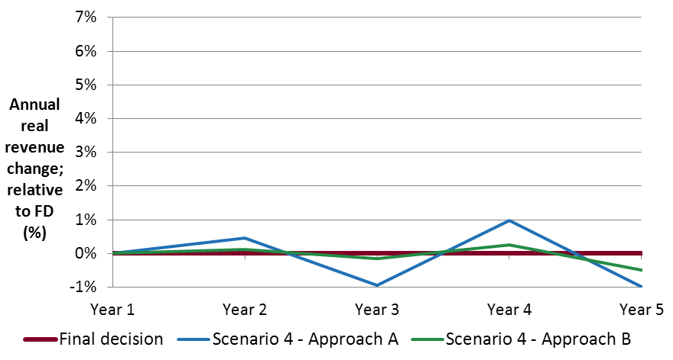

Source: AER analysis.

As before, the left side of figure 5 shows the return on debt outcomes (in orange). Note that although the fluctuations in the spot return on debt (orange markers) are large, they induce only minimal fluctuations in the portfolio return on debt (orange line). The right side of figure 5 shows that in response to the fluctuating return on debt, the real revenue fluctuates under either approach, moving both above and below the final decision outcome:

* Approach A (blue line) has larger changes, positive and negative than approach B. The particular concern is that the change in one year is reversed in the next, noting that this pattern is also evident in debt market outcomes.
* Approach B (green line) has smaller changes, positive and negative, than approach A. Since the portfolio return on debt over the regulatory control period varies around the starting return on debt, the difference between forecast at the final decision and the outcome of the annual update is minimised and changes are very small.

In this scenario approach B appears to minimise volatility.

Additional scenarios

The four scenarios above show relative large movements in the spot return on debt from year to year, relative to real world observed debt market movements. In this sense they are 'extreme' scenarios. Smaller changes in the spot return on debt would produce commensurately smaller changes in real revenue, but the general pattern would not change. The scenarios also illustrate the extent to which a change in the spot return on debt is reflected in the trailing average portfolio return. Since the trailing average includes ten measurements, even a large single year change in the spot return on debt produces a much smaller change in the portfolio return on debt.

The mechanism underlying the annual debt update (and X factor calculation) is symmetrical, so these illustrative scenarios also provide a means to infer the outcomes under 'inverse' scenarios where the movements in the return on debt are the exact opposite of those depicted scenarios in this attachment. For example, the inverse of scenario 1 is a sudden decrease, then gradual increase, in the spot return on debt. In such a situation, the direction of changes in real revenue will reverse, but the magnitude of the changes will be the same.

1. Appendices
2. The appendices include the proposed models and handbooks. As noted above, the proposed models include a Change log worksheet that will be removed from the final version, with only a high level summary of changes in the Intro worksheet. The proposed handbooks currently include highlighted text to indicate where proposed changes were made. This highlighting will be removed for the final decision.

### Appendix A: Post-tax revenue model (transmission)

### Appendix B: Post-tax revenue model (distribution)

### Appendix C: Post-tax revenue model handbook (transmission)

### Appendix D: Post-tax revenue model handbook (distribution)

1. Chapters 6A and 6 of the NER for TNSPs and DNSPs respectively.
2. NER, clauses 6A.5.2(b) and 6.4.1(b), read with the applicable consultation procedures.
3. AER, Better regulation, Rate of return guideline, December 2013.
4. AEMC, Rule determination, National electricity amendment (Economic regulation of network service providers) rule 2012, National gas amendment (Price and revenue regulation of gas services) rule 2012, 29 November 2012.
5. NER, clauses 6A.5.2(b) and 6.4.1(b).
6. NER, clauses 6A.20(b) and 6.16(b).
7. NER, clauses 6A.20(c) and 6.16(c).
8. NER, clauses 6A.20(e) and 6.16(e).
9. NER, clauses 6A.5.3 and 6.4.2.
10. NER, clauses 6A.5.3 and 6A.6.8.
11. NER, clauses 6.4.2 and 6.5.9.
12. NER, clauses 6A.5.4 and 6.4.3.
13. The net total of the indexation of the RAB and depreciation building blocks is referred to as 'regulatory depreciation'.
14. Being any efficiency benefit sharing schemes, capital expenditure sharing schemes, service target performance incentive schemes, or small scale incentive schemes applied to the NSP (and, in the case of DNSPs, any applicable demand management and embedded generation schemes).
15. Minor changes are changes to formatting or labelling which, while noted for completeness, are not consequential to the operation of the PTRM.
16. The DNSP PTRM has a Forecast revenues worksheet that is not in the TNSP PTRM. This is because this worksheet relates to the use of a weighted average price cap control mechanism, and this form of control is not available to TNSPs under the NER.
17. The updated calculations were reflected in the PTRM for the 2012 Powerlink transmission determination. See the discussion of these changes in AER, Final decision: Powerlink transmission determination 2012–13 to 2016–17, April 2012, pp. 145–152. These were also adopted in in the PTRMs for the 2013 ElectraNet transmission determination and the 2014 SP AusNet transmission determination.
18. AEMC, *Rule determination, National electricity amendment (Economic regulation of network service providers) rule 2012, National gas amendment (Price and revenue regulation of gas services) rule 2012*, 29 November 2012.
19. The rate of return on capital is often shortened to just ‘return on capital’. The key changes relating to the return on capital are at NER, clause 6.5.2, 6A.6.2; and NGR, r. 87.
20. NER, clauses 6A.5.5 and 6.4.4.
21. AER, *Better regulation, Rate of return guideline*, December 2013. The new rules required that we develop such a guideline; see NER clauses 6.5.2(m)–(q), 6A.6.2(m)–(q); and NGR, r. 87(13)–(19).
22. AER, *Better regulation, Explanatory statement, Rate of return guideline*, December 2013.
23. AER, *Better regulation, Rate of return guideline*, December 2013, pp. 11–17. There is further explanatory material in AER, Better regulation, Explanatory statement, Rate of return guideline, December 2013, pp. 50–97.
24. AER, *Better regulation, Rate of return guideline*, December 2013, pp. 18–22. There is further explanatory material in AER, Better regulation, Explanatory statement, Rate of return guideline, December 2013, pp. 98–157.
25. Other aspects of the determination of the benchmark return on debt, such as the ten year term and the BBB+ credit rating, remain largely unchanged.
26. The return on equity value is also rounded to one decimal place in accordance with the guideline.
27. The determination of the overall return on equity will necessarily involve separate modelling outside of the PTRM.
28. As with the return on equity, there will be separate modelling to derive the trailing average portfolio return on debt input.
29. This is linked to the capital expenditure timing assumption, and is a well-established element of the PTRM.
30. Similarly, the nominal vanilla WACC for each year is defined using the variables ‘vanilla01, vanilla02, … , vanilla10’. This replaces the previous single ‘vanilla’ variable which was presumed constant across the entire regulatory control period.
31. This issue is discussed in detail in section 5.1.1 below.
32. The process for updating the annual return on debt necessarily entails a number of steps, and use of the PTRM to set the X factor for that year (only) needs to be placed in this context. Hence, any automatic application of a formula for the implementation of the annual return on debt update would need to be explicitly referenced in the final decision for that network. In this way, the process is set down in advance (automatic) and does not require the exercise of judgement within the regulatory control period.
33. The regulatory control period length must be an integer, i.e. whole years only.
34. NSPs with comments of their own included: Energex, TasNetworks, CitiPower, Powercor, SA Power Networks, and Jemena.
35. They were ElectraNet and ActewAGL. Envestra also responded noting that the AER's proposed changes to the PTRM give effect to the Rate of return guideline.
36. The overall effect of delaying (some portion of) an adjustment to later years is that, in the event subsequent adjustments are made in the same direction, the cumulative effect can be much larger than any single-year effect in isolation. Attachment A contains example scenarios which illustrate the consequences of cumulative deferrals in the final years of the regulatory control period.
37. We note that simultaneous adjustment to all future year X factors can be implemented in the proposed PTRM, but this would require manual formula changes.
38. Conceptually, the return on debt should be the rate prevailing at the start of the relevant year, with due regard for the lock-in effect of past debt issuance (reflected in the construction of a trailing portfolio, after accounting for the transition from the previous benchmark).
39. The trailing average portfolio will also include nine other annual debt observations, each offset in exactly the same way.
40. The guideline notes that the averaging period should be 'as close as practical to the commencement of each regulatory year in a regulatory control period'. See AER, Better regulation, Rate of return guideline, December 2013, p. 21.
41. That is, the return on equity is estimated with regard to an averaging period that ends several months before the start of the regulatory control period. The return on equity is not annually updated within a regulatory control period.
42. JGN initially raised this issue as part of its gas access arrangement proposal. See JGN, 2015–20 Access Arrangement information, 30 June 2014, p. 105 (and appendix 12.1).
43. NER, clauses 6.5.9(3), 6A.5.3(c)(1) and 6A.6.8(c).
44. The vanilla WACC is calculated using a pre-tax return on debt and post-tax return on equity.
45. The overall effect depends on the relative profiles of smoothed and unsmoothed revenues across the regulatory control period. If smoothed revenue is more 'front-ended' than unsmoothed revenue (that is, over-recovers in early years of the regulatory control period and under-recovers in later years), then increasing the discount rate (moving from vanilla to pre-tax) decreases the smoothed revenue requirement overall. Conversely, if smoothed revenue is 'back-ended' relative to unsmoothed revenue (that is, under-recovers in early years and then over-recovers in later years), then increasing the discount rate increases the smoothed revenue requirement overall.
46. Ausgrid and Essential Energy initially raised this issue as part of their regulatory proposals. See Ausgrid, Regulatory Proposal, 1 July 2014 to 30 June 2019, May 2014, Attachment 9.02, p. 4; and Essential Energy, Regulatory proposal, 1 July 2014 to 30 June 2019, May 2014, Attachment 9.2, p. 13 (including appendix B to that attachment, the W-factor PTRM).
47. There are already a number of other factors in use across the DNSPs' control mechanism formula. In particular, the label 'D factor' is already used for adjustments in relation to demand management schemes.
48. For example, the standard CPI–X formula might change from ARt=ARt-1×(1+CPI)×(1–X) to ARt=ARt-1×(1+CPI)×(1–X)×(1–W).
49. Where other changes alter revenue within the regulatory control period, the order of resolution would determine whether the interaction effect was presented in the X factor or the W factor.
50. This is because the return on debt for later years will determine the unsmoothed revenue for each of those years, and so in turn the smoothed revenue path across the entire regulatory control period (and the current year).
51. In other words, both approaches are revenue neutral with regard to the final smoothed revenue outcome.
52. This does not imply that our proposed approach always minimises volatility relative to the alternative approach. As shown in scenario 4 of attachment A, our proposed approach will cause greater variation where the portfolio return on of debt is fluctuating (positive and negative) around the starting value.
53. The scenarios are described in more detail in attachment A.
54. Attachment A includes more material relevant to this issue.
55. In contrast, this return on debt scenario produces considerable X factor volatility under approach A (setting the return on debt for later years equal to the most recent year's annual update).
56. In contrast, this return on debt scenario minimises volatility under approach A.
57. The default approach can be overridden by entering the portfolio return on debt for all years in the regulatory control period at each annual debt update.
58. This alternative approach arose from our preliminary consultation with the ENA, as described in section 5.1.
59. The year 1 spot return on debt will be measured during an averaging period that ends prior to the start of year 1, in line with the discussion at section 5.1 on the lag between measurement and application.
60. In our illustrative example, the (spot) return on debt nine years ago was 6.5 per cent; for eight years ago it was 7 per cent, for seven years ago it was 8 per cent, and for five years ago it was 7.5 per cent. These spot return on debt figures matter because as the ten year trailing average portfolio rolls forward they are the individual observations that drop out of the portfolio in subsequent years.
61. Under the CPI–X control formula, a negative X factor means an increase in the real revenue requirement.
62. Since the X factors for years 2 to 5 were 0 per cent in the final decision, there is no real revenue change in those years in any case. The real revenue change in year 1 was +3 per cent (since the X factor for that year was –3.0 per cent), so constructing the graph as a comparison against the final decision outcome nets this figure back to 0 per cent.
63. This is approximately commensurate with the change observed during the global financial crisis.
64. For example, consider a case where the spot return on debt increases from 7.5 per cent last year to 12 per cent this year. Intuitively we expect the portfolio return on debt to increase; but if the return on debt ten years ago (the year dropping out of the ten year average) was higher than 12 per cent, the overall trailing average portfolio return on debt will decrease—despite the recent dramatic increase in (spot) debt costs.