

Explanatory statement

Proposed amendment

Electricity distribution network service providers

Roll forward model (version 2)

31 August 2016

© Commonwealth of Australia 2016

This work is copyright. In addition to any use permitted under the Copyright Act 1968, all material contained within this work is provided under a Creative Commons Attributions 3.0 Australia licence, with the exception of:

* the Commonwealth Coat of Arms
* the ACCC and AER logos
* any illustration, diagram, photograph or graphic over which the Australian Competition and Consumer Commission does not hold copyright, but which may be part of or contained within this publication. The details of the relevant licence conditions are available on the Creative Commons website, as is the full legal code for the CC BY 3.0 AU licence.

Requests and inquiries concerning reproduction and rights should be addressed to the   
Director, Corporate Communications,   
Australian Competition and Consumer Commission,   
GPO Box 4141,   
Canberra ACT 2601   
or publishing.unit@accc.gov.au.

Inquiries about this publication should be addressed to:

Australian Energy Regulator  
GPO Box 520  
Melbourne Vic 3001

Tel: (03) 9290 1444  
Fax: (03) 9290 1457

Email: [AERInquiry@aer.gov.au](mailto:AERInquiry@aer.gov.au)  
AER Reference: 58930

Contents

Shortened forms iv

1 Introduction 1

1.1 What does the RFM do? 1

1.2 Why are we publishing a proposed amended RFM? 2

1.3 Why are we updating the RFM? 3

1.4 What are the key issues for consultation? 3

2 Proposed amendments 5

2.1 Forecast or actual depreciation in RAB roll forward 5

2.2 Remaining asset lives 6

2.3 End of period adjustments 7

2.4 Annual WACC updates 8

2.5 Input worksheet for AER data management system 8

2.6 Presentational and other functional improvements 8

3 Consultation 10

3.1 Actual inflation in the RFM 10

Attachment A: Inflation diagrams 20

Attachment B: Monte Carlo simulation 26

Appendices 29

Appendix A: Roll forward model (distribution) 29

Appendix B: Roll forward model handbook (distribution) 29

Shortened forms

|  |  |
| --- | --- |
| Shortened form | Extended form |
| AER | Australian Energy Regulator |
| Capex | capital expenditure |
| CESS | capital expenditure sharing scheme |
| CPI | consumer price index |
| DMS | data management system |
| DNSP | distribution network service provider |
| NEM | National Electricity Market |
| NER | National Electricity Rules |
| NPV | net present value |
| PTRM | post-tax revenue model |
| RAB | regulatory asset base |
| RFM | roll forward model |
| TAB | tax asset base |
| TNSP | transmission network service provider |
| WACC | weighted average cost of capital |
| WARL | weighted average remaining lives |

# Introduction

The Australian Energy Regulator (AER) is responsible for the economic regulation of direct control services provided by distribution network service providers (DNSPs) in the National Electricity Market (NEM), in accordance with the National Electricity Rules (NER). We make a building block determination for each DNSP that sets out its annual revenue requirement for each regulatory year within a regulatory control period.[1]

The regulatory asset base (RAB) is a key determinant of revenue under the building block approach.[2] We prepare and publish a roll forward model (RFM) for the RAB of DNSPs.[3]

The first (and current) version of the RFM for DNSPs was published in June 2008.[4] To ensure that the RFM remains fit for purpose, we amend or replace the DNSP RFM when necessary.[5] This explanatory statement sets out our proposed amendments to the DNSP RFM and the reasons for these changes. Once finalised, the new RFM will be known as version 2 of the DNSP RFM.

We have also published three versions of the RFM for transmission network service providers (TNSPs); in September 2007, December 2010 and October 2015. The most recent of these TNSP RFMs is labelled version 3. Our proposed amendments to the DNSP RFM will bring it into close alignment with version 3 of the TNSP RFM.

## What does the RFM do?

This RFM establishes the method used to roll forward the RAB—that is, increase or decrease from the previous value:[6]

* from one regulatory control period to the next regulatory control period
* from one regulatory year to the next regulatory year in the same regulatory control period.

The closing RAB value for a regulatory control period as calculated by the RFM becomes the opening RAB to be used for the purposes of making a building block determination for the next regulatory control period.

The RAB values from the RFM are inputs into the PTRM, where they are rolled forward from one regulatory year to the next regulatory year on a forecast indicative basis. They are used in the PTRM as part of the calculation of the annual revenue requirements.

The RFM deals with many aspects of RAB estimation, including:[7]

* establishment of the opening RAB for a regulatory control period
* adjustments for prudent and efficient capex
* the depreciation approach based on forecast or actual capex
* circumstances where other assets may be removed from the RAB
* how the (forecast) roll forward should occur within the regulatory control period.

The roll forward of the RAB from year-to-year will reflect:

* additions for actual capex, net of customer contributions
* reductions for the disposal value of assets
* reductions for depreciation
* indexation for actual inflation
* adjustment for the difference between estimated and actual capex for a previous regulatory control period
* other adjustments for removal or addition of assets made under certain circumstances (such as a change in service classification) in accordance with the NER.

## Why are we publishing a proposed amended RFM?

We want all stakeholders to have opportunity to consider our proposed changes to the RFM and make written comments in response, so we are publishing:[8]

* the proposed amended model
* this explanatory statement, setting out the provision of the NER under which the model is proposed to be prepared, and the reasons for the proposed amended model.

We will accept submissions received on or before Thursday, 13 October 2016.[9] We will consider those submissions before we decide on the final form for the amended model. By 22 December 2016, we will publish:[10]

* a final decision that sets out
* the amended model
* the provision of the NER under which the model is being prepared
* the reasons for the amendment
* a notice of the making of the final decision.

## Why are we updating the RFM?

Version 2 of the DNSP RFM is necessary to provide flexibility to implement recent changes to the regulatory framework.

First, the proposed amendments reflect the AER’s new Capital expenditure incentive guideline, which sets out the use of forecast depreciation (based on forecast capital expenditure) to roll forward the RAB in conjunction with the application of a capital expenditure sharing scheme (CESS).[11] Version 1 of the DNSP RFM used only an actual depreciation approach (based on actual capital expenditure) to roll forward the RAB. Under this approach the depreciation deducted from the RAB depended on the actual capex incurred and rolled into the RAB during the regulatory control period, rather than that forecast at the time of the reset. The actual depreciation approach reflected, in part, the fact that there was no capex incentive scheme. Version 2 of the DNSP RFM has been modified to allow a forecast or actual depreciation approach to be used to roll forward the RAB. The forecast depreciation approach deducts the real forecast depreciation approved at the time of the previous reset from the RAB, and does not adjust for actual capex. This matches what the DNSP received in real depreciation allowed during the regulatory control period.

This policy change also has consequential impacts on the way remaining asset lives are calculated in the RFM. The proposed amendments to the RFM implement our preferred approach to calculating remaining asset lives, known as weighted average remaining lives (WARL).

Second, the proposed amendments reflect the AER’s Rate of return guideline, which allows for an annual update of the return on debt.[12] Version 2 of the DNSP RFM has been modified to accommodate inputs for different annual rates of return.

Version 2 of the DNSP RFM also allows us to make changes to the spreadsheet so that it can be automatically integrated into the AER’s data management system (DMS). The DMS allows us to centrally store and easily retrieve data from all our regulatory processes. These changes do not affect the functionality of the spreadsheet.

Section 2 explains the above changes, and other minor changes, in further detail.

## What are the key issues for consultation?

We are open to receiving submissions from stakeholders on any aspect of the proposed amended RFM. This includes the amendments dealing with:

* Forecast or actual depreciation in the RAB roll forward (section 2.1)
* Remaining asset lives (section 2.2)
* End of period adjustments (section 2.3)
* Annual WACC updates (section 2.4)
* Input worksheet for the AER data management system (section 2.5)
* Presentational and other functional improvements (2.6)

We also seek submissions from stakeholders on another key issue, the treatment of actual inflation in the RFM. This does not appear on the list above because the proposed amended RFM maintains the same treatment as the current RFM—that is, there has been no 'amendment' relating to this specific issue. Nonetheless, this is a substantial matter and section 3.1 explains in some detail our analysis and reasoning. The proposed amended RFM reflects our current assessment of the appropriate treatment of actual inflation in the RFM, but we are open to receiving submissions on this issue. The final amended RFM will reflect our full consideration of all the material we receive.

# Proposed amendments

This section sets out our proposed amendments to the DNSP RFM and the associated handbook. Table 1 shows which worksheets have been amended or added.[13]

The specific changes are listed in a temporary 'Change log' worksheet in the proposed RFM. This detailed log will be deleted from the final version. A summary of changes is provided in the 'Intro' worksheet to the RFM.

Table Changes to the distribution RFM worksheets

|  |  |  |
| --- | --- | --- |
| Old RFM worksheets | Status | New RFM worksheets |
| Intro | Minor changes only | Intro |
| N/a | Added | DMS input |
| Input | Amended | RFM input |
| Adjustment for previous period | Amended | Adjustment for previous period |
| Actual RAB roll forward | Amended | RAB roll forward |
| Total actual RAB roll forward | Amended | Total RAB roll forward |
| Tax value roll forward | Amended | TAB roll forward |
| N/a | Added | RAB remaining lives |
| N/a | Added | TAB remaining lives |
| N/a | Added | PTRM input summary |

The proposed RFM and handbook are at appendices A and B respectively. The changes are now discussed in more detail.

## Forecast or actual depreciation in RAB roll forward

Version 1 of the DNSP RFM calculated depreciation based on actual capex for use in the RAB roll forward. This approach is referred to as an 'actual depreciation' approach. The use of actual depreciation reflected in part that there was no capex incentive schemes applied in the past. Under an actual depreciation approach the DNSP keeps the difference between actual and forecast depreciation over the regulatory control period if it can reduce its actual capex below the amount that was forecast.[14]

However, in recent decisions and based on the development of our Capital expenditure incentive guideline, we applied the CESS and decided that in future a 'forecast depreciation' approach—where the real forecast depreciation amount (based on forecast capex) approved at the last reset for the DNSP—be used to roll forward the RAB.[15] Using the forecast depreciation amount to roll forward the RAB means a service provider does not receive any windfall gain/loss in terms of depreciation from actual capex being different from that forecast.[16] The forecast depreciation subtracted from the RAB therefore reflects the amount that was recovered by the DNSP during the regulatory control period.

Accordingly, we have created a section for recording forecast depreciation inputs in the 'RFM input' worksheet of the proposed RFM. The formulae in the 'RAB roll forward' and 'Total RAB roll forward' worksheets have also been amended to allow either the forecast depreciation approach or actual depreciation approach to be used to roll forward the RAB. The forecast depreciation amounts are entered in real terms, so that actual inflation is applied as part of the RAB roll forward, consistent with other components of the RAB.

The implementation of forecast depreciation in the proposed DNSP RFM aligns with the most recent version of the TNSP RFM (version 3).

## Remaining asset lives

Version 1 of the DNSP RFM took as an input the remaining asset life for each different asset class as at the start of the regulatory control period.[17] These remaining asset lives are used to calculate straight-line depreciation and then the return of capital (depreciation) building block.[18] These inputs remain in the proposed model.

However, the previous version of the DNSP RFM did not calculate the remaining asset lives as at the end of the regulatory control period. These values are needed in order to populate the inputs for the PTRM reflecting the start of the next regulatory control period. In practice, because these calculations were already included in the TNSP RFM, many DNSPs would insert the relevant worksheet from the TNSP RFM into the DNSP RFM.

Accordingly, the proposed RFM now includes calculation of remaining asset lives for RAB and TAB purposes in two new worksheets, 'RAB remaining lives' and 'TAB remaining lives'. These two worksheets are also set up to accommodate the historical capex data needed to track the remaining asset lives year-by-year. There would be no historical capex for the first time the proposed RFM is used as there is no scope to go back further than the remaining asset lives the AER last approved.[19] In subsequent resets, the historical capex from earlier regulatory control periods would have to be recorded as inputs to the RFM. These worksheets align with those in the most recent version of the TNSP RFM (version 3).[20]

The proposed DNSP RFM uses our standard approach, known as weighted average remaining lives (WARL). This approach estimates the remaining life for each asset class by first calculating the remaining asset life for each year of capex within that asset class. When capex is first incurred—that is, when an asset is new—the remaining asset life is equal to the standard asset life. With each passing year, the remaining life will also decrease by one year. The remaining life for the entire asset class is calculated by averaging across all these separately tracked years of capex—that is, averaging across the different aged assets. Instead of being a simple average, the average is weighted with regard to the remaining value of assets in each disaggregated year of capex, as a proportion of total remaining value.[21] This means the final WARL will have regard to the profile of capex across time.

## End of period adjustments

The proposed RFM includes a new input section in the 'RFM input’ worksheet where end of period adjustments are made. This allows additions to or deductions from specific asset classes at the end of a regulatory control period. As an example, if assets were reclassified from standard control services to alternative control services, an end of period deduction could be used to remove the value of the reclassified assets from the relevant asset class in the RFM. Such an adjustment was not possible in the previous version of the RFM, and so an ad-hoc modification to the base template was required on occasion.

To ensure that the adjustment is accurate, the inputs separately record the value of the asset for RAB and TAB purposes, and the associated remaining life in each case (RAB and TAB).[22] The proposed RFM provides for each asset class to have a single remaining asset life for all end of period adjustments.[23] When a new end of period adjustment is made, the RFM calculates the WARL of the end of period adjustment and the residual value (if any) of earlier end of period adjustments. Given the infrequency of these adjustments (at most once per regulatory control period) this provides a reasonable balance between complexity and accuracy.

The treatment of end of period adjustments in the proposed DNSP RFM aligns with the most recent version of the TNSP RFM (version 3).

## Annual WACC updates

The weighted average cost of capital (WACC) is used as an input to the RFM to:

* account for the timing assumption of capex being rolled into the RAB
* calculate the accumulated return on capital associated with the difference between actual and estimated capex used in the previous regulatory control period.

The proposed RFM has been modified so that it can accommodate different annual WACCs over the regulatory control period in the 'RFM input' worksheet. This change is a consequence of changes to the DNSP PTRM (version 3) in January 2015 providing for annual WACC updates during the regulatory control period.[24] Consistent with the changes to the PTRM, the proposed RFM gives effect to the AER's Rate of return guideline, which allows for an annual update for the return on debt.[25]

The treatment of WACC in the proposed DNSP RFM aligns with the most recent version of the TNSP RFM (version 3).

## Input worksheet for AER data management system

We have developed a data management system (DMS) to collect data from regulatory information notices and from the various regulatory models. We have added a new 'DMS input' worksheet to help our system ingest the relevant data from the RFM. This worksheet has no impact on the operation of the RFM. The worksheet previously labelled 'Input' has been renamed 'RFM input' to distinguish the two input worksheets. The DNSP will need to complete both input worksheets when submitting its proposed RFM. The additional information required is minimal (contact details and a few cells identifying the context for the RFM submission).

This worksheet aligns with the most recent version of the TNSP RFM (version 3)

## Presentational and other functional improvements

We have taken the opportunity to improve the presentation and functionality of some calculations in the RFM by making a few minor presentational and operational changes. The changes include:

* adjusting the minimum supported regulatory control period length from five years to two years for displaying RAB roll forward outputs
* removing sections that were made redundant or replicated in other worksheets
* removing the CPI input (in 'Adjustment for previous period' worksheet) for the penultimate year of the previous regulatory control period, as this value is no longer required for use in the RAB roll forward process.

This also includes some updates to the handbook to improve clarity on several issues.

These changes are similar to those made in the most recent version of the TNSP RFM (version 3).

# Consultation

This section highlights one key issue for consultation, the treatment of actual inflation in the RFM. However, we are open to receiving submissions from stakeholders on any aspect of the proposed amendments to the RFM.

## Actual inflation in the RFM

There are a number of alternative approaches to the treatment of actual inflation in the RFM. Our proposed RFM maintains the AER's standard approach, as used in the previous version of the DNSP RFM and in the current TNSP RFM (version 3). We consider that this standard approach (the 'partially-lagged' approach) meets the requirements of the NER.[26] Modelling of inflation impacts across the entire regulatory process shows that it avoids any systematic bias (under-compensation or over-compensation) in total revenue when inflation outcomes differ from forecast. Relative to known alternatives, the partially-lagged approach performs reasonably well at mitigating the magnitude of revenue impacts when inflation outcomes differ from forecast.

We seek stakeholder comments on the treatment of inflation in the proposed RFM, specifically:

* Should the consideration of inflation treatment in the RFM have regard to inflation treatment in the PTRM and pricing process? If so, how?
* What are the appropriate input parameters for the Monte Carlo simulation used to model inflation impacts across the PTRM, annual pricing process and RFM?
* Are there any other inflation approaches that better deal with inflation impacts, and which also meet the requirements of the NER?
* What inflation approach should be applied in the RFM?
* Should DNSPs who have historically used alternative approaches be moved to the approach in the RFM?

Inflation across the entire regulatory process

Before turning to the inflation adjustment applied in the RFM, it is necessary to note the broader context of inflation treatment across all the relevant aspects of the regulatory process.

There are two other key steps that influence revenue outcomes (and end user prices) in conjunction with the RFM: the post-tax revenue model (PTRM) and the annual revenue adjustment process (also called the annual pricing process). At a high level, here is how inflation is dealt with at each step of this process:

1. PTRM. Prior to the commencement of a regulatory control period, the AER makes a final determination using the PTRM. A key input into the PTRM is the inflation forecast, which is constant for all years in the period, and is used to escalate the annual revenue requirements in nominal dollar terms.[27] The PTRM calculates the annual revenue requirements (unsmoothed) in accordance with the NER. Then, a net present value (NPV) calculation determines smoothed revenue using the forecast inflation figure each year under the 'CPI-X' form of control. The CPI–X form of control means that we also establish X factors that smooth expected revenue across the regulatory control period (with the same NPV as unsmoothed).[28] These X factors are a key output from the PTRM.
2. Annual revenue adjustment. This process differs between the first year of the regulatory control period, and subsequent years. The annual revenue for the first year is set prior to its commencement, just after the release of the final decision. The nominal revenue figure from the AER's final determination is used without adjusting for inflation. Just prior to the start of each subsequent year, a new annual revenue adjustment takes place. The new revenue is set using the CPI–X form of control:[29]

This formula says that revenue for the upcoming year will be the previous year's revenue, increased for actual inflation, and then adjusted for the X factor (smoothing). This may be a decrease (positive X factor) or increase (negative X factor). The X factor will be that derived in the PTRM using forecast inflation.[30] However, the CPI figure will now be updated to reflect known inflation outcomes for the previous year and therefore adjusts for any difference between forecast and actual inflation.[31] This process continues iteratively each remaining year of the regulatory control period.

1. RFM. At the end of the regulatory control period, we use the RFM to calculate the value of the closing RAB for use in the following regulatory control period (as the starting RAB). The roll forward needs to adjust for actual inflation outcomes across this period—the issue is determining exactly which inflation treatment should be applied in the RFM.

It is not possible to use a single ‘correct’ inflation outcome across all of these regulatory elements. Using the PTRM, we make a regulatory determination and set the expected revenue (smoothed) in advance using a forecast of expected inflation for the upcoming regulatory control period. Subsequently, at each annual revenue adjustment during the regulatory control period, prior year inflation outcomes are known but the expected inflation for the relevant year must still be forecast. At the next regulatory determination when the RFM is used, inflation outcomes for all years of the previous regulatory control period are known. Overall, the joint effect of the inflation treatment across these three regulatory processes should be to minimise the distortions arising from the difference between inflation forecasts and inflation outcomes (that is, errors in the inflation forecast used to set the expected revenue).

To assist in understanding the impact of inflation across the entire regulatory process, attachment A includes diagrams that illustrate the interactions between the three elements (PTRM, annual revenue adjustments and RFM). These are described in more detail below.

Alternative approaches in the RFM

There are a number of alternative approaches to the treatment of inflation in the RFM. They can be distinguished by the degree of lag applied to the inflation series used to convert nominal values within the RFM. There is always a six month implementation lag to allow for the publication of CPI data and implementation in the annual pricing approval process.[32] We do not consider that this six month lag is contentious.

However, in addition to the implementation lag, there may be an additional year of delay added to some inflation series used to convert some elements within the RFM. By convention, these approaches are labelled with regard to this additional lag (taking the non-contentious implementation lag as a given):

* the ‘partially-lagged’ approach uses inflation lagged by one year for some elements within the RFM, and un-lagged inflation (actual inflation) for others[33]
* the ‘all-lagged’ approach uses inflation lagged by one year for all elements within the RFM[34]
* the ‘un-lagged’ approach uses un-lagged inflation (actual inflation) for all elements within the RFM.[35]

Hence, our proposed RFM maintains the AER's existing approach to inflation indexation in the RFM. More specifically, under our standard partially-lagged approach:

* un-lagged inflation is applied when indexing the opening RAB each year
* one year lagged inflation is applied when converting new capex between real and nominal terms
* un-lagged inflation is applied when moving new capex from mid-year to end-year terms[36]
* one year lagged inflation is applied when converting RAB straight-line depreciation between real and nominal terms.

Attachment A includes three overview diagrams that illustrate the partially-lagged, all-lagged and un-lagged approaches. There is one diagram for each approach, and each diagram shows the major inflation interactions across the three elements (PTRM, annual revenue adjustments and RFM). The diagrams are based on our recent decision for the Victorian electricity DNSPs, in order to provide real-world context.

The proposed RFM applies our standard partially-lagged approach to RAB indexation. This approach is applied in:

* the existing version of the DNSP RFM (version 1)
* all versions of the TNSP RFM (versions 1 to 3)[37]
* most (but not all) recent AER regulatory determinations, the exception being our May 2016 decisions for the Victorian DNSPs.[38]

We consider there are two key questions when evaluating the partially-lagged approach or any alternative approaches:

1. How does the partially-lagged approach (or alternatives) fulfil the NER requirements?
2. What is the overall impact on total revenue of the partially-lagged approach (or alternatives)?

We deal with each in turn.

Legislative requirements

Our treatment of inflation in the RFM must be consistent with the relevant legislation. Clause 6.5.1(e) of the NER sets out requirements for the RFM, and subclause (3) states:

The roll forward of the regulatory asset base from the immediately preceding regulatory control period to the beginning of the first regulatory year of a subsequent regulatory control period entails the value of the first mentioned regulatory asset base being adjusted for actual inflation, consistently with the method used for the indexation of the control mechanism (or control mechanisms) for standard control services during the preceding regulatory control period.

Hence, inflation treatment in the RFM must be consistent with the inflation method used in the annual pricing process. In each regulatory determination, the control mechanism will specify a particular formulation for the annual inflation measure, such as the Australian Bureau of Statistic's Consumer Price Index (CPI), Weighted Average of Eight Capital Cities, All Groups.[39] It will also specify the measurement timing basis, such as 'December–to–December quarter', or the 'average of four quarters ending in December'.[40] It is necessary to precisely specify the inflation metric because there are a number of alternative measurement approaches and they will not align exactly. Hence, we consider that the inflation used in each RFM must align with the relevant inflation metric for that decision.

Recently, several DNSPs have submitted that the consistency requirement in clause 6.5.1(e)(1) of the NER extends beyond the CPI specification to also include the lag applied in the annual pricing process.[41] The pricing control mechanism necessarily uses lagged inflation—that is, when the pricing decision is made, the most recent available CPI measure will be for the year prior to the start of the relevant year. This reading of the rules would suggest that one year lagged inflation should be used within the RFM.

However, the situation is more complicated in the first year of a regulatory control period. Here, the control mechanism directly applies the nominal revenue outcome from the PTRM. The PTRM necessarily uses an inflation forecast, set as a ten year geometric average of expected inflation, because it is set before the commencement of the regulatory control period. Hence, this reading of the rules would suggest that, in the first year of each regulatory control period, consistency with the control mechanism means the inflation forecast from the PTRM is to be used in the RFM.[42] There are further difficulties with this reading because the control mechanism does not use 'actual inflation' in the first year of a regulatory control period. The two requirements of clause 6.5.1(e)(3) of the NER—'actual inflation' and 'consistent with the control mechanism'—would appear be at odds with each other, if the consistency requirement is read to cover this first year of the regulatory control period.

A range of provisions for the treatment of the RAB are set out in schedule 6.2 of the NER.[43] Schedule 6.2.3 deals with the roll forward of the RAB from year to year within a regulatory control period, noting that this occurs in the PTRM (in forecast terms) as well as in the RFM (in historical terms).[44] Clause S6.2.3(c)(4) of the NER states that when rolling forward the value of the regulatory asset base from one year to the next:

The previous value of the regulatory asset base must be increased by an amount necessary to maintain the real value of the regulatory asset base as at the beginning of the later year by adjusting that value for inflation.

This clause suggests that actual inflation (not lagged inflation) should be used within the RFM, since the only inflation index that will maintain the real value of the RAB is actual inflation for that year.[45] Hence, we recognise the tension between the different rule requirements dealing with inflation in the RFM.

We consider that the AER's standard partially-lagged approach meets the requirements of the NER. The inflation inputs in the 'RFM Input' worksheet will be consistent with the relevant measurement basis for inflation from the control mechanism, reflecting clause 6.5.1(e)(3) of the NER. The indexing of the opening RAB each year within the RFM is done using un-lagged inflation, in accordance with clause S6.2.3(c)(4) of the NER.

Assessing overall revenue impact

We consider that the different indexation approaches should be assessed by estimating the overall revenue impact of differences between forecast and actual inflation. This means considering the complex interactions between:

* different regulatory processes (that is, the PTRM, annual pricing adjustments and RFM)
* multiple regulatory control periods (for instance, where lagged series are used and an over-compensation in one period will be offset by under-compensation in the next).

We have developed a spreadsheet that models the key aspects of the PTRM, annual pricing adjustment and RFM across a period of 50 years, split into ten five year regulatory control periods. The model is simplified in that it only models those aspects of the regulatory process directly related to the RAB and inflation.[46] Capex is incurred in years 0 to 10, with the user defining the amount of expenditure incurred and the relevant standard asset lives. The user is also able to set the inflation outcomes each year, and the forecast of inflation made at the beginning of each five year period. The model tracks:

* the return on capital and return of capital set by the PTRM for each regulatory control period, using the relevant forecast inflation
* the annual revenue outcomes year-by-year within each period, updating for inflation outcomes as they become known
* the roll forward of the RAB in the RFM at the end of the period, including inflation adjustments to the opening RAB, new capex, capex timing adjustment, and straight-line depreciation

Within the model, the output RAB from one regulatory control period's RFM will be the input for the PTRM (and RFM) for the following regulatory control period.

Most importantly, the user is able to define exactly which inflation approach will be used in each indexation step within the RFM.[47] For example, the opening RAB can be set to use either one year lagged or un-lagged inflation series when it is indexed each year. Separately, the user can set new capex to use either one year lagged or un-lagged inflation series when it is converted from nominal to real terms each year—and so on for other RFM components. This means the user can set the RFM to be partially-lagged, all-lagged, or un-lagged; and then compare the revenue outcomes under the different approaches. The model simulates the operation of the PTRM, annual pricing process and RFM using these inflation forecasts/outcomes across the life of the assets—that is, until the RAB reaches zero and all capital has been returned. The key output is the net present value of the cash flows spent and received by the service provider across the life of the assets. Ideally, the net present value (NPV) should be zero, which indicates that outward cash flows (capex incurred by the service provider) are exactly equal to inward cash flows (revenue received by the service provider) plus the appropriate return on those funds (the return on capital or weighted average cost of capital, WACC).

Manually setting pertinent inflation outcomes and inflation forecasts (for example, manually setting actual inflation to be below forecast inflation) then provides insight into the revenue outcomes under each approach.

We then implement a Monte Carlo simulation.[48] This requires that we develop a simple probability distribution based on real world observed inflation outcomes. We focus on the three core inflation approaches: partially-lagged, all-lagged, and un-lagged, as described above. The model is set up so that for a given set of inflation inputs, calculations will be done using all three approaches and the NPV separately calculated for each.

For the Monte Carlo simulation, the model is run a large number of times—for example, 5,000 attempts. Each run of the model is a distinct 'scenario', where we generate, using the probability distribution described:

* Inflation outcomes for years 0 to 50
* Inflation forecasts for years 1 to 50, in ten blocks of five years (representing regulatory control periods)

In some scenarios, random chance means that inflation outcomes across the 50 years will be high—and in others, low. Similarly, in some cases forecast inflation across the 10 regulatory control periods will be 'too high' (relative to the inflation outcomes in that scenario); and in others, they will be 'too low'. In most cases, there will be a mixture of high and low inflation outcomes and high and low inflation forecasts. The Monte Carlo simulation allows us to see the overall impact of the inflation approach across the multitude of scenarios.

The results of such a Monte Carlo study are presented below in Table 2. In this particular simulation, we used an initial capex investment (year 0) of $1000, with $100 subsequent capex every year from 1 to 10 ($real year 0). The standard asset life for all capex was 30 years, the real WACC was 5 per cent, and 5000 scenarios were calculated.

Table Results of Monte Carlo simulation (n = 5000) using three alternative approaches to inflation treatment in the RFM ($real year 0)

|  |  |  |  |
| --- | --- | --- | --- |
| Approach | Average NPV (% of initial investment) | Average absolute NPV (% of initial investment) | Average squared NPV |
| Partially-lagged approach | –0.09 (–0.01%) | 4.17 (0.25%) | 27.40 |
| All-lagged approach | 0.33 (0.02%) | 10.24 (0.61%) | 165.74 |
| Un-lagged approach | 0.13 (0.01%) | 2.93 (0.16%) | 13.49 |

Source: AER analysis.

Three different metrics are presented in the table. The first is the average NPV across all scenarios for each approach. Under all three approaches, the NPV is very close to zero:   
–$0.09 for the partially-lagged approach, $0.33 for the all-lagged approach, and $0.13 for the un-lagged approach (all $real year 0). We would expect some minor deviation from zero arising as part of the nature of a Monte Carlo study, so these results suggest there is no systematic bias (under or over compensation) arising from any of the approaches. The table also shows that when compared to the initial investment ($2000 over the years 0 to 10) the average NPV are a very small percentage under all three approaches.[49]

The second (average absolute value NPV) and third (average squared NPV) metrics in the table tell us about the magnitude of deviation from NPV = 0, if we do not allow negative and positive NPVs to offset each other. The pattern of results is similar across both metrics. The partially-lagged and un-lagged approaches perform roughly the same, but the all-lagged approach appears to perform relatively worse. For example, under the partially-lagged approach, the average absolute value NPV is $4.17, which is around 0.25 per cent of the initial investment. In other words, this suggests that the impact of inflation deviations is around $4, either above or below the ideal revenue (which would generate an NPV of $0). This $4 impact is the cumulative effect across the life of assets with initial value of $2000 and just 0.25 per cent of the initial investment (in NPV terms). Further, as demonstrated by the first metric, outcomes of +$4 and –$4 are equally likely (there is no systematic over or under compensation). However, for the all-lagged approach, the revenue impact is roughly doubled to $10, although this still represents a small percentage of the initial investment. For the un-lagged approach, the revenue impact is around $3, which is better than both the partially-lagged approach ($4; noting that this is a small margin of outperformance) and the all-lagged approach (around $10). This pattern of results is also observed using the third metric (squared NPV), with the all-lagged approach resulting in larger departures from the ideal NPV ($0) than either the partially-lagged or un-lagged approaches.

The nature of a Monte Carlo simulation means that it is possible to generate different outcomes, even with the same inputs.[50] Further, there are a range of relevant inputs, such as different initial capex profiles or real WACCs. Extension of the Monte Carlo simulation in this manner may yet reveal new insights into the overall impact of inflation on revenue outcomes.

Nonetheless, after due consideration of the available analysis, we consider that it suggests there is no material advantage in choosing the un-lagged approach over the partially-lagged approach. There may be some suggestion that the partially-lagged or un-lagged approaches should be preferred over all-lagged.[51] As noted above, our recent decisions for the Victorian DNSPs approved their proposal to use the all-lagged approach. Our new analysis suggests that applying this approach may expose the Victorian DNSPs to potentially larger variations in revenue (above or below the expected revenue) from inflation variations than would be the case if we had moved them to the partially-lagged (or un-lagged) approach.[52] However, one of the key reasons we approved the use of the all-lagged approach for the Victorian DNSPs was that they had used this approach across a number of previous regulatory determinations. We consider that regulatory consistency is desirable, and this is one factor supporting the decision to apply the all-lagged approach in that instance.[53] On balance, our current assessment is that the Victorian distributors should be allowed to stay on the all-lagged approach, judging that the benefit of consistency with past treatment outweighs the detriment of potential greater revenue variation. However, we seek submissions on this issue.

For non-Victorian DNSPs, however, regulatory consistency means applying the standard partially-lagged approach, consistent with the previous version of the DNSP RFM. This is also consistent with the latest version (and all earlier versions) of the TNSP RFM. Service providers supported the partially-lagged approach when the RFMs were first developed.[54] When we amended the TNSP RFM last year, we asked for comments on the treatment of inflation from affected stakeholders.[55] We received only one response, which does not suggest that there is a broad consensus for change from the current approach.[56]

Overall, we adopt the partially-lagged approach in the proposed RFM because:

* it meets the requirements of the NER[57]
* it avoids any systematic bias (under-compensation or over-compensation) in total revenue when inflation outcomes differ from forecast
* relative to known alternatives, it appears to perform reasonably well at mitigating the magnitude of revenue impacts when inflation outcomes differ from forecast
* it is the existing standard, so maintains continuity for users of the previous DNSP RFM and promotes regulatory consistency across DNSPs and TNSPs.

Attachment A: Inflation diagrams

This attachment provides three overview diagrams showing the principal inflation adjustments across the PTRM, annual revenue adjustments and RFM.[58] There is one diagram for each of the three key alternative approaches to RFM indexation: partially-lagged, all-lagged and un-lagged.

On each diagram, background shading shows the inflation measure applied in each process, or each year within a process. The intent is that colour matching should make obvious which inflation adjustments are consistent with each other. It also highlights the difficulty in having consistent inflation adjustments across all three processes:

* The PTRM, which is completed in advance of the standard five year regulatory control period, necessarily relies on a forecast of inflation for this entire period (and in fact a ten year inflation forecast, consistent with the term of equity/debt)
* The annual revenue adjustments occur each year within the regulatory control period and use the latest available CPI value. However, this will still be a lagged measure. The exception is the first year of the regulatory control period, which uses the inflation forecast (with ten year term) included in the just-released regulatory decision.
* The RFM is completed at the end of the regulatory control period, and inflation outcomes for all years are known. Given that the PTRM and pricing proposals have no real option on which inflation measures to use, the selection of the optimal inflation measure in the RFM becomes a key consideration for the AER.

To provide real-world context, the diagrams are based on the 2011–15 regulatory control period for the Victorian electricity DNSPs. We chose this example because the RFM inflation approach was an issue considered in our April 2016 decisions for those DNSPs.[59] However, there are several aspects of the 2011–15 Victorian decision RFM that are not indicative of the general regulatory process:

* As is noted earlier, the Victorian DNSPs previously used all-lagged inflation when rolling forward their RABs from 2006 to 2010. For other DNSPs, the status quo is the AER’s partially-lagged approach. The previous inflation approach is not directly depicted on any of the diagrams, since they focus only on the 2011–15 regulatory control period.
* There is not normally a delay in the release of the final decision until after the start of the following regulatory control period. We made our final decision for the Victorian DNSPs' 2016–20 regulatory control period (and therefore the final decision on the RFM for 2011–15) in April 2016 as part of transitional rules that applied to that reset process. The general expectation is that such a decision would be complete in October of the year prior to the commencement of the regulatory control period (for example, October 2015).
* The implementation lag between CPI measurement and regulatory years will be six months for all businesses using the new RFM template, not three months. The diagrams shows that the Victorian DNSPs measured inflation using CPI end September data, for a given regulatory year ending December.[60] Hence, there was a three month implementation lag. This will increase to a six month lag for all resets using the new RFM (including the 2016–2020 Vic DNSPs at their next regulatory determination). For example, CPI calculations will use end June figures for a given regulatory year ending in December.[61] As noted above, the six month implementation lag is not considered contentious.

The net effect of the last two points is that when we completed the final decision on the Victorian DNSP RFM for 2011–15, we had available to us un-lagged (actual) inflation outcomes for all five years in the regulatory control period.[62] The same end outcome will still be achieved in future RFM decisions—that is, we will still have available to us un-lagged (actual) inflation outcomes for all relevant years. The means of achieving this outcome will differ, however—the final decision will be made earlier, but this will be offset by the increase in implementation lag (from three months to six months).

Finally, to clarify two points not specifically related to the Victorian process:

* In all modelling, cash flows are treated as being at year end—31 December for the Victorian DNSPs.
* The RFM recalculates the final year of the previous regulatory period (2010 in the example) principally because we need to true-up actual capex against the estimate used in the previous regulatory decision.[63]

Three diagrams follow on subsequent pages. In each case, the diagram has been rotated (landscape orientation) so as to increase readability. Once rotated, the diagrams should generally be read top-to-bottom reflecting the broad timing of AER regulatory processes:

* The top section shows the relevant years and CPI measures.
* The next section shows the 2011–15 PTRM from our October 2010 decision, where we used a forecast of inflation to set revenues for the full five year period.
* The next section shows the annual revenue adjustments, used to set revenue outcomes (customer prices) each year within the period. For 2011, this decision was made in December 2010 and used the forecast inflation from the PTRM. For 2012 to 2015, the decision is made in December of the preceding year, using lagged inflation outcomes to adjust revenue.
* The bottom section shows the 2011–15 RFM from our April 2016 decision, where we used inflation outcomes to calculate the closing RAB (and so the opening RAB for the 2016–20 regulatory control period). This is where the three approaches differ in their application of lagged or un-lagged inflation to various components within the RFM.

Figure A.1 is an illustrative overview of the partially-lagged approach to RFM inflation, which is the standard approach currently in the AER's RFM template. It shows the application of different inflation measures (lagged and un-lagged) to different components within the RFM.

Figure A. Overview of the partially-lagged approach to RFM inflation

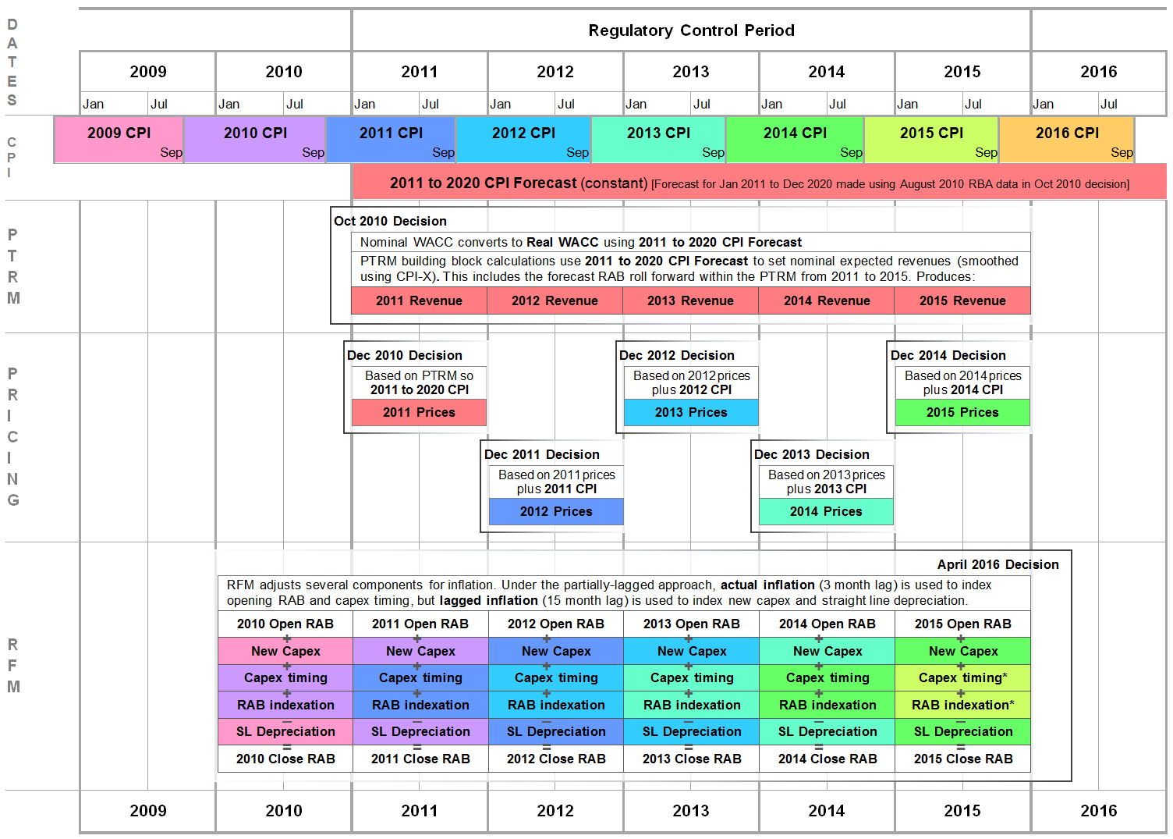

Figure A.2 is an illustrative overview of the all-lagged approach to RFM inflation, which is the approach used for the Victorian DNSPs. The key difference between this approach and the partially-lagged approach (shown in Figure A.1) is the indexation adjustment applied to capex timing and RAB indexation in the RFM.

Figure A. Overview of the all-lagged approach to RFM inflation

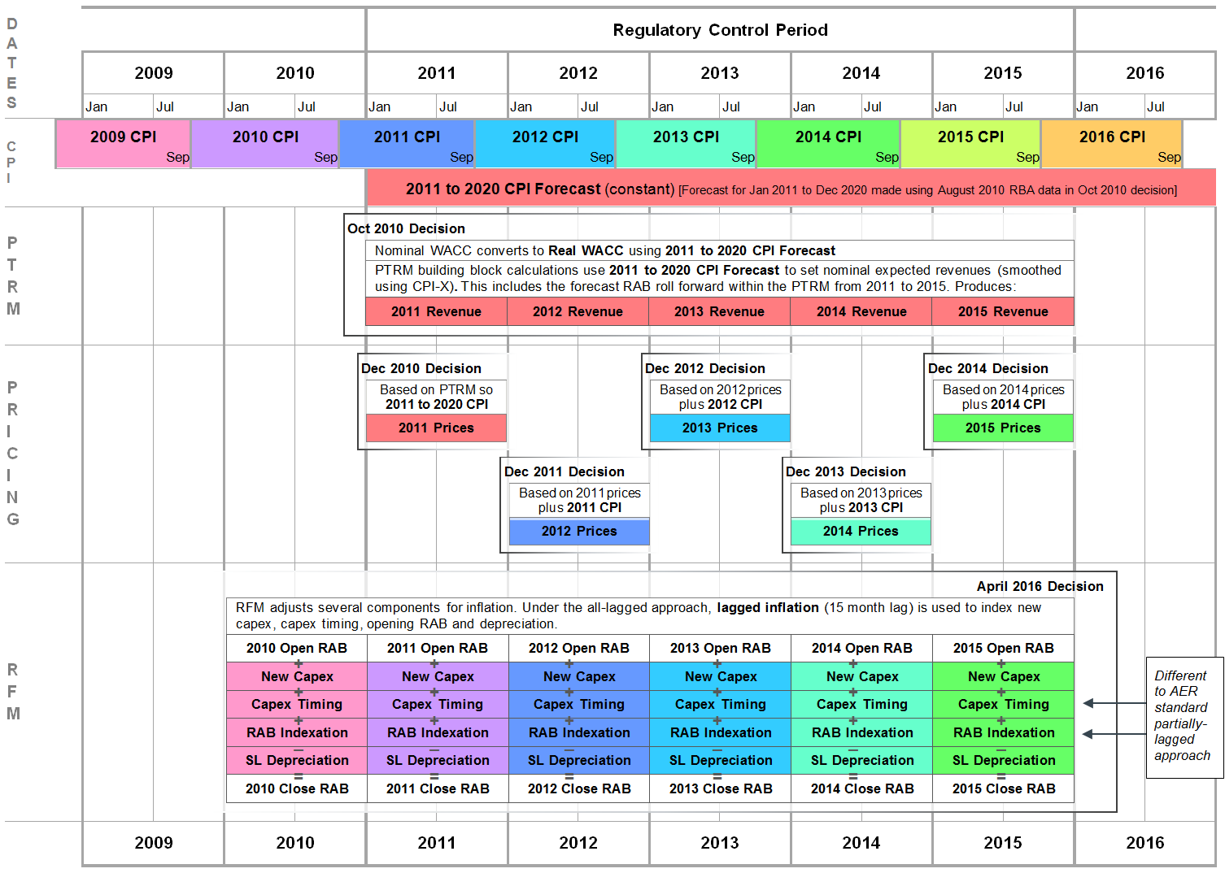

Figure A.3 is an illustrative overview of the un-lagged approach to RFM inflation, which is the other major alternative to the partially-lagged and all-lagged approaches. The key difference between this approach and the partially-lagged approach (shown in Figure A.1) is the indexation adjustment applied to new capex and straight-line depreciation in the RFM.

Figure A. Overview of the un-lagged approach to RFM inflation

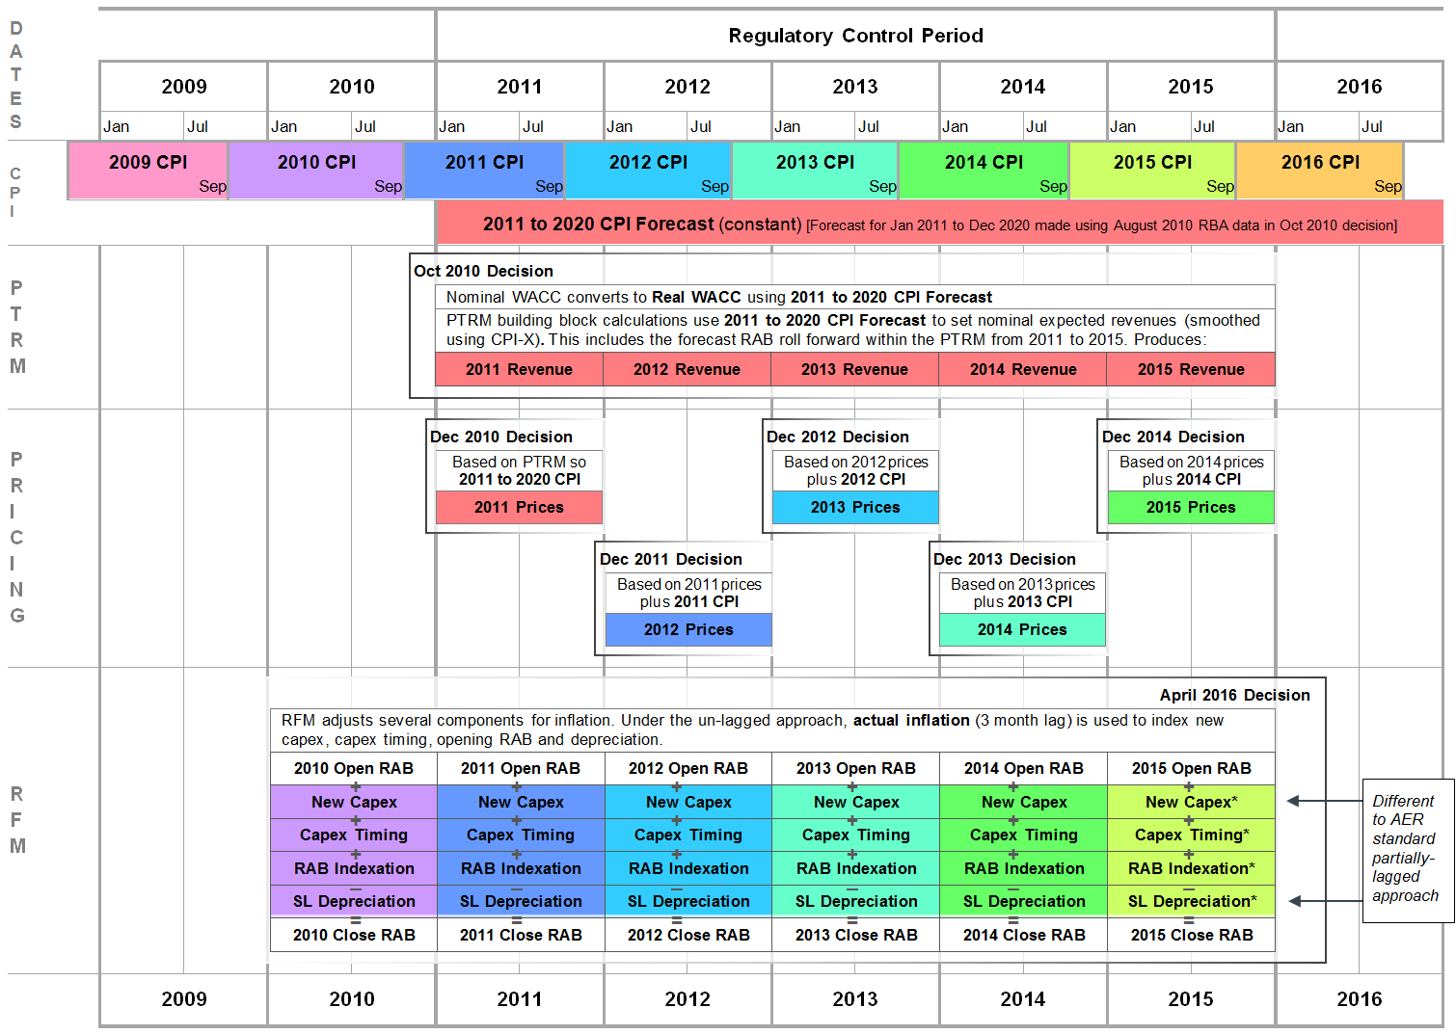

Comparing the all-lagged (Figure A.2) and un-lagged (Figure A.3) approaches shows that each applies a consistent inflation measure within the RFM—that is, on both these diagrams, the four inflation adjustments in the RFM are the same colour each year. However, the inflation adjustments are not the same between these two approaches.

* In the all-lagged approach the indexation aligns with the previous year's CPI measure—for example, in Figure A.2, the inflation applied in 2012 is the same colour as the 2011 CPI outcome. This approach prioritises consistency with the pricing control mechanism (in all years except the first year of the regulatory control period, 2011).
* In the un-lagged approach, the indexation aligns with the same year's CPI measure—for example, Figure A.3, the inflation applied in 2012 is the same colour as the 2012 CPI outcome. This approach prioritises consistency with the actual CPI outcome for the relevant year (as shown at the very top of the diagram).

Attachment B: Monte Carlo simulation

This attachment provides a brief overview of the modelling simulation used to analyse the overall inflation impact of each indexation approach.

We model inflation as a random outcome, based on observed inflation outcomes since the Reserve Bank of Australia (RBA) officially adopted its inflation targeting objective in 1993. Since this time, the RBA has explicitly aimed for inflation between 2 and 3 per cent, and the average yearly inflation outcome has been almost exactly 2.5 per cent, the mid-point of the target range. The maximum observed inflation outcome has been just below 6 per cent, and the minimum has been just below 0 per cent.

This is a small sample from which to extrapolate to future inflation outcomes. We model the population of possible inflation outcomes as a normal distribution with the observed parameters (average of 2.50 per cent, standard deviation of 1.29 per cent).[64] The assumption of a normal distribution appears to be a reasonable simplification for modelling purposes, although we do not rule out the possibility that a more complex method for generating alternative inflation forecasts would generate different results. The inflation outcome in each year is independent of the previous year's inflation figure.[65]

We have excluded the tax, opex and revenue adjustment building blocks, noting that this assumption should have negligible effect on outcomes. We apply a constant real WACC (for example, 5 per cent) across all regulatory control periods. This is a key point in the construction of the model. A nominal WACC, not a real WACC, is the input to the PTRM at the start of each AER final decision. The real WACC (which drives PTRM outcomes) is derived from the nominal WACC by deducting the expected inflation rate.[66] Hence, an overestimate of inflation means the real WACC will be too low (and vice versa). However, the forecast inflation and the nominal WACC are jointly estimated on consistent terms.[67] Directly using the real WACC in the model means we have assumed that this pair of inputs is correctly matched.[68] For example, if forecast inflation is overestimated, but this overestimate of inflation is already included in the nominal rate of return, the real WACC will still be correct. Hence, the construction of the model means we isolate changes in revenue outcomes that reflect the difference between forecast and actual inflation, not errors in the forecast inflation embedded in the WACC.[69]

Capex is incurred in years 0 to 10 (inclusive), and we assume that capex is incurred evenly throughout the year.[70] Each regulatory control period is five years in length, and ten regulatory control periods are modelled. Since capex is incurred up to year 10, this means the maximum standard asset life for capex handled in the model is 40 years.

The inflation forecast for the upcoming regulatory control period is set using the current AER approach, which is the geometric average of annual inflation forecast for the next ten years. When calculating this average, the first two years are the inflation outcomes used by the model with a small error term added (or subtracted), to represent the RBA's short-term forecast. The following eight years are the mid-point of the RBA target inflation band, or 2.5 per cent. The average includes ten years of annual inflation, not five (the length of the regulatory control period) because it matches the horizon for equity investment.

Note that the key inputs remain the same throughout the Monte Carlo simulation—this means the capex profile (expenditure amount and asset lives) as well as the real WACC. The model simulates the operation of the PTRM, annual pricing process and RFM using these inflation forecasts/outcomes across the life of the assets—that is, until the RAB reaches zero and all capital has been returned. The key output is the NPV of the cash flows received by the service provider across the life of the assets.

There are three metrics used to evaluate the performance of different inflation approaches. The first is the average NPV received by the DNSP in each scenario. This metric identifies the net impact of the inflation approach on total revenue. As an average, positive results in some scenarios (over-compensation for the DNSP) will net off against negative results in other scenarios (under-compensation for the DNSP). Hence, this metric identifies any systematic bias in total revenue arising from the indexation approach in the RFM.

The second and third metrics are designed to measure the magnitude of distortion in any one scenario, without netting off negative and positive outcomes. The second metric is the average absolute value of NPV in each scenario; the third is the average square of NPV in each scenario. For example, say that in the first scenario the NPV is 4, and in second scenario the NPV is –2. Under the absolute value metric, the average NPV will be:

$$\frac{abs\left(4\right)+abs\left(-2\right)}{2}=\frac{4+2}{2}=3$$

Under the squared metric, the average NPV will be:

$$\frac{4^{2}+{\left(-2\right)}^{2}}{2}=\frac{16+4}{2}=10$$

Hence, the positive and negative NPVs will not offset each other; but the magnitude of distortion experienced in any particular scenario will be apparent. The absolute value metric has the advantage of being more readily interpreted with regard to NPV outcomes and so leads to an assessment of outcome materiality. The squared metric has the advantage that it more heavily penalises larger NPV distortions, which might be a desirable utility function. These two metrics are not intended to be compared against each other.

Appendices

The appendices include the proposed model and handbook. As noted above, the proposed RFM includes a 'Change log' worksheet that will be removed from the final version, with only a high level summary of changes in the 'Intro' worksheet. The proposed handbook currently includes highlighted text to indicate where proposed changes were made. This highlighting will be removed for the final decision.

Appendix A: Roll forward model (distribution)

Appendix B: Roll forward model handbook (distribution)

1. NER, cl. 6.4.1.
2. NER, cl. 6.4.3.
3. NER, cl. 6.5.1(b).
4. AER, Final decision, Electricity distribution network service providers, Roll forward model, 26 June 2008; available at <http://www.aer.gov.au/networks-pipelines/guidelines-schemes-models-reviews/roll-forward-model-2008>.
5. NER, cl. 6.5.1(c).
6. NER, cl. 6.5.1(e).
7. NER, cl. S6.2.
8. NER, cl. 6.16(b).
9. This is a period of 30 business days. NER, cl. 6.16(c).
10. The period between publication of the proposed amended model and final amended model will be no more than 80 business days. NER, cl. 6.16(e).
11. AER, Better regulation, Capital expenditure incentive guideline, November 2013, pp. 21–22.
12. AER, Better regulation, Rate of return guideline, December 2013, p. 19.
13. Minor changes relate to formatting, labelling or formula updates which, while noted for completeness, are not consequential to the operation of the RFM.
14. The effect is symmetrical, so if actual capex is above forecast capex the DNSP will be worse off by the difference between actual and forecast depreciation.
15. For example, see the discussion on the choice of depreciation approach for the Victorian DNSPs in AER, Final framework and approach for the Victorian electricity distributors, Regulatory control period commencing 1 January 2016, 24 October 2014, pp. 121–126; AER, AER, Preliminary decision, United Energy distribution determination, 2016 to 2020, Attachment 2 – Regulatory asset base, October 2015, pp. 2-17 to 2-18; and AER, Final decision, United Energy distribution determination, 2016 to 2020, Attachment 2 – Regulatory asset base, May 2016, p. 2-13.
16. The tax asset base is rolled forward using depreciation based on actual capex, consistent with the tax framework.
17. For each asset class, the remaining asset life is the time left until the asset is no longer economically viable (or alternatively, when the return of capital is complete). When capex is first incurred—that is, when an asset is new—the remaining asset life is equal to the standard asset life. With each passing year, the remaining life will also decrease by one year. However, since each asset class will generally include capex incurred in many different years—that is, a mixture of assets with different ages—the calculation of average remaining asset life can be complex, and there are a number of different approaches available.
18. The remaining lives also have indirect effects on other building blocks, such as the return on capital and corporate income tax building blocks.
19. See NER cl. 6.5.5(b)(3). Hence, the first application of the proposed RFM at a regulatory determination results in the same WARLs as if the previous version of the TNSP RFM (version 2) were used. The difference will arise in second and subsequent regulatory determinations where the larger set of disaggregated years of capex is preserved for use in the WARL calculation.
20. See AER, Final decision, Amendment, Electricity transmission network service providers, Roll forward model (version 3), 23 October 2015, pp. 7–9.
21. As an example, consider an asset class with two assets, one older (remaining life 5 years) and one newer (remaining life 15 years). The simple average would suggest the remaining life for the whole asset class is 10 years: ½×5+½×15 = 10. However, if we know that the older asset has a remaining value of $10, but the newer asset has a remaining value of $90, the WARL will have regard to the much larger value of the newer asset and calculate the WARL as 14 years: (10/100)×5 + (90/100)×15 = 14.
22. The need to specify a remaining life is linked to the WARL implementation. See AER, Final decision, Amendment, Electricity transmission network service providers, Roll forward model (version 3), 23 October 2015, p. 8.
23. The proposed RFM does not track the remaining asset life of each end of period adjustment separately, as it does for each year of capex,
24. Refer to the explanatory statement for the PTRM amendment for background on this change. See AER, Explanatory statement: Proposed amendment, Electricity transmission and distribution network service providers, Post-tax revenue models (version 3), 3 October 2014, pp. 10–11.
25. AER, Better regulation, Rate of return guideline, December 2013, p. 19.
26. NER, cll. 6.5.1(e)(3) and S6.2.3(c)(4).
27. More specifically, the expected inflation used in the PTRM is estimated as a constant inflation forecast over a 10 year horizon, in order to be consistent with the estimated rate of return on capital. The exact method is specified in the PTRM. See AER, Final decision, Amendment, Electricity transmission and distribution network service providers, Post-tax revenue models, (version 3), 29 January 2015, Appendix B: Distribution PTRM; AER, Draft decision, AusNet Services transmission determination, 2017–18 to 2021–22, Attachment 3 – Rate of return, July 2016, pp. 3-129 to 3-138 (expected inflation is a common issue between distribution and transmission); and AER, Better regulation, Explanatory statement, Rate of return guideline, December 2013, p. 47.
28. NER, cl. 6.2.6(a).
29. This is a simplified representation in order to illustrate the principal inflation interaction. For an example of a complete control mechanism formula and definitions, see AER, Final decision, Untied Energy distribution determination, 2016 to 2020, Attachment 14 – Control mechanisms, May 2016, pp. 14-13 to 14-17.
30. Since we annually update the cost of debt, the X factors can change between final decision and the annual revenue adjustment. However, the inflation estimate in the PTRM (which is a constant inflation forecast) is not updated during the annual return on debt update process.
31. This adjustment is not complete—that is, using lagged actual inflation at this step will not bring about the exact same outcome as would have occurred if actual inflation had been available for use in the initial PTRM. Below we discuss the overall impact of the discrepancy between forecast and actual inflation on final revenue outcomes.
32. In some historical decisions the delay was only three months; but for all decisions under the new DNSP RFM the delay will be six months.
33. We describe the exact treatment for specific RFM elements below.
34. With the six month implementation lag, this means an eighteen month delay in the inflation index.
35. With the six month implementation lag, this means a six month delay in the inflation index.
36. We assume capex is incurred evenly throughout the year, which means capex is spent in the middle of the year on average. However, the RFM (and PTRM) model all cash flows as at the end of each year. To adjust capex values from mid -year to end-year terms, we capitalise (add) six months WACC to new capex, which represents the value of the half a year of delay. This is sometimes labelled the ‘half WACC adjustment’.
37. Model published at: <http://www.aer.gov.au/networks-pipelines/guidelines-schemes-models-reviews/roll-forward-model-transmission-october-2015-amendment>.
38. Our decision to apply the all-lagged approach to the Victorian DNSPs reflected their unique historical circumstances. The all-lagged approach was first applied to them by the relevant state regulator, the Essential Services Commission, and we considered it prudent to maintain this approach in our May 2016 decisions, while noting that our DNSP RFM review was imminent and would provide an appropriate forum to fully evaluate the different approaches. For example, see AER, Final decision, AusNet Services distribution determination 2016 to 2020, Attachment 2 – Regulatory asset base, May 2016, pp. 2-11 to 2-13.
39. This example is from AER, Final decision, United Energy distribution determination 2016 to 2020, Attachment 14 – Control mechanisms, May 2016, p. 14-14.
40. This example is from, AER, Final decision, Ausgrid distribution determination 2015–16 to 2018–19, Attachment 14 – Control mechanisms, April 2015, pp. 14–10 to 14–11 and 14–20.
41. AusNet Services (distribution), Electricity distribution price review 2016–20, Revised regulatory proposal, 6 January 2016, pp. 8-6 to 8-9; CitiPower, Revised regulatory proposal 2016–2020, 6 January 2016, pp. 254–258; Jemena Electricity Networks, 2016–20 Electricity distribution price review regulatory proposal, Revocation and substitution submission, Attachment 5-4 Asset base roll-forward and depreciation, 6 January 2016, pp. 1–6; Powercor, Revised regulatory proposal 2016–2020, 6 January 2016, pp. 248–252; and United Energy, 2016 to 2020 Revised regulatory proposal, 6 January 2016, pp. 72–73.
42. Alternatively, consistency could be achieved by changing the way revenue is set in the first year of a regulatory control period. The nominal total smoothed revenue from the PTRM could have the inflation forecast removed, and then the lagged inflation series (used in the remainder of the regulatory control period) added back in. However, such a change is beyond the scope of this review of the RFM.
43. Note that schedule 6.2 is expressly referenced in NER, cl. 6.5.1(f).
44. That is, within the PTRM we perform a (forecast) roll forward of the RAB as a necessary step when calculating the annual building blocks. While the immediate application of S6.2.3 of the NER is to this roll forward portion of the PTRM (it refers to forecast capex and disposals, rather than actuals), clause S6.2.3(b) of the NER explicitly ties the RFM (and thus the historical roll forward) to the requirements listed in this clause.
45. We note that even 'unlagged' actual inflation has a six month delay, but this appears to be the best available proxy.
46. We provide more technical details on the operation of the model below. We do not consider that these necessary simplifications will have a material effect on our conclusions.
47. Further, the inflation approach used in the annual revenue adjustments can also be configured.
48. More details on the specification of the Monte Carlo simulation are included in attachment B.
49. This calculation is performed in NPV terms; adjusting the initial investment for the time value of money.
50. That is, setting the same user inputs for WACC and capex, but still allowing the generation of random inflation outcomes each scenario.
51. All three approaches show no sign of systematic over compensation or under compensation, which is a more important issue than the magnitude of inflation impacts.
52. Importantly, the analysis does not suggest there will be systematic bias in revenue outcomes.
53. If we were to change a DNSP from one approach to another, we would give careful consideration to the impact of the change and whether an adjustment might be needed to avoid a windfall gain or loss.
54. Our first RFM was that for transmission in 2007, and the development of the first DNSP RFM in 2008 followed the TNSP template. A consultant report at the time dealt only implicitly with the indexation of the opening RAB using actual CPI. Nonetheless, the worked examples in that report indicate that the RAB should be indexed using actual CPI and so support the approach in the proposed RFM. NERA, AER’s first proposed post-tax revenue model, roll forward model and efficiency benefit sharing scheme, Report for Electricity Transmission Network Owners Forum, 1 May 2007, pp. 5–7.
55. AER, Explanatory statement, Proposed amendment, Electricity transmission network service providers, Roll forward model (version 3), July 2015, p. 10.
56. That submission advocated the all-lagged approach. See AusNet Services, Proposed amendments to the electricity transmission roll forward model (RFM), 17 August 2015, p. 2.
57. NER, cll. 6.5.1(e)(3) and S6.2.3(c)(4).
58. As the diagrams are intended to illustrate the key points, they are not intended to be accurate in all details.
59. The Victorian DNSPs operate on a calendar year instead of a financial year basis, which also simplifies the discussion.
60. Though not included on the diagram for simplicity, the inflation metric for the Victorian DNSPs was the ABS' Consumer Price Index, Weighted Average of Eight Capital Cities, All Groups.
61. For other processes where the regulatory year aligns with the financial year, CPI will be calculated using end December figures for a regulatory year ending in June.
62. We also had available lagged inflation figures, which are of course available one year earlier.
63. NER, cl. S6.2.1(e)(2).
64. We consider this a reasonable approach, but note that there are grounds for considering that the distribution of inflation outcomes is not normally distributed.
65. One alternative interpretation of inflation outcomes is that inflation for a given year is not independent of previous years. For example, it might be modelled as random movement using the previous year's inflation as a starting point for the probability distribution.
66. More precisely, instead of subtracting we use the Fisher equation: (1+nominal WACC)/(1+inflation)=(1+real WACC).
67. As noted above, this is why forecast inflation in the PTRM is a constant inflation rate with a 10 year horizon.
68. Another way of expressing this point is that the model assumes away any errors in the initial WACC at the start of each regulatory control period.
69. Similarly, the model makes no allowance for the annual return on debt update. This is equivalent to assuming that there is no change in the cost of the debt portfolio in real terms.
70. Consistent with the application of the PTRM, annual pricing process and RFM, mid-year capex is then moved to end-year terms so as to be consistent with the end-of-year cash flow modelling.