

Proposed amendment

Electricity distribution network service providers

Post-tax revenue model handbook

October 2014

© Commonwealth of Australia 2014

This work is copyright. In addition to any use permitted under the Copyright Act 1968, all material contained within this work is provided under a Creative Commons Attribution 3.0 Australia licence, with the exception of:

* the Commonwealth Coat of Arms
* the ACCC and AER logos
* any illustration, diagram, photograph or graphic over which the Australian Competition and Consumer Commission does not hold copyright, but which may be part of or contained within this publication.

The details of the relevant licence conditions are available on the Creative Commons website, as is the full legal code for the CC BY 3.0 AU licence.

Requests and inquiries concerning reproduction and rights should be addressed to the Director, Corporate Communications, ACCC, GPO Box 3131, Canberra ACT 2601, or [publishing.unit@accc.gov.au](mailto:publishing.unit@accc.gov.au).

1. Inquiries about this decision should be addressed to:

Australian Energy Regulator

GPO Box 520

Melbourne Vic 3001

Tel: (03) 9290 1444

Fax: (03) 9290 1457

Email: [AERInquiry@aer.gov.au](mailto:AERInquiry@aer.gov.au)

1. AER reference: 55444

Amendment record

|  |  |  |  |
| --- | --- | --- | --- |
| Handbook version | Model version | Date | Pages |
| 1 | 1, 2 | 26 June 2008 | 22 |
| 2 | 3 | October 2014 (draft) | 36 |

1. Contents

Contents 3

Shortened forms 5

1 Nature and authority 6

1.1 Introduction 6

1.2 Authority 6

1.3 Role of the model 6

1.4 Confidentiality 6

1.5 Process for revision 6

1.6 Version history and effective date 6

2 The model 7

2.1 Input sheet 7

2.1.1 Opening regulatory asset base and opening tax asset base 10

2.1.2 Forecast real capital expenditure—as-incurred 11

2.1.3 Forecast real asset disposals—as-incurred 12

2.1.4 Forecast real customer contributions—as-incurred 12

2.1.5 Forecast net real capital expenditure—as-incurred 12

2.1.6 Forecast real operating and maintenance expenditure 12

2.1.7 Revenue adjustments from previous regulatory control period 12

2.1.8 Revenue adjustments from shared assets 12

2.1.9 Expected taxation rate 13

2.1.10 Cost of capital 13

2.1.11 Debt and equity raising costs—transaction costs 13

2.1.12 Price/revenue constraint for the current regulatory year 13

2.1.13 Energy delivered forecast 14

2.1.14 Current prices by tariff component 14

2.1.15 Forecast sales quantities by tariff component 14

2.2 WACC sheet 14

2.3 Assets sheet 15

2.3.1 Rolling forward the RAB and depreciation 16

2.4 Analysis sheet 17

2.4.1 Building block approach to deriving cash flows 19

2.4.2 Taxation and related costs and benefits 20

2.4.3 Cash flow analysis 20

2.5 Forecast revenues sheet 22

2.6 X factors sheet 23

2.7 Revenue summary sheet 27

2.8 Equity raising cost sheet 29

2.9 Chart 1—Revenue sheet 31

2.10 Chart 2—Price path sheet 32

2.11 Chart 3—Building blocks sheet 34

3 Process for annual return on debt update 35

3.1 Setting X factors for the final decision before the start of the regulatory control period 35

3.2 Updating X factors to incorporate the annual update to the trailing average portfolio return on debt 36

1. Shortened forms

|  |  |
| --- | --- |
|  |  |
| ARR | annual revenue requirement |
| AER | Australian Energy Regulator |
| ATO | Australian Tax Office |
| capex | capital expenditure |
| CPI | consumer price index |
| DNSP | distribution network service provider |
| IRR | internal rate of return |
| NEL | National Electricity Law |
| NER | National Electricity Rules |
| NPV | net present value |
| opex | operating expenditure |
| PTRM | post-tax revenue model |
| PV | present value |
| RAB | regulatory asset base |
| RFM | roll forward model |
| TAB | tax asset base |
| WACC | weighted average cost of capital |
| WAPC | weighted average price cap |

# Nature and authority

## Introduction

1. This handbook sets out the Australian Energy Regulator’s (AER) post-tax revenue model (PTRM) to be used as part of the building block determinations for standard control services of electricity distribution network service providers (DNSPs). The PTRM is a series of Microsoft Excel spreadsheets developed in accordance with clause 6.4.1 of the National Electricity Rules (NER).

## Authority

1. Clause 6.4.1(a)(c) of the NER requires the AER to develop and publish the PTRM, in accordance with the distribution consultation procedures.

## Role of the model

1. DNSPs are required to submit a completed PTRM to the AER as part of their regulatory proposals. However, the AER recognises that there may be a need for some flexibility in applying the PTRM in order to account for the particular circumstances a DNSP may face. A number of elements of the PTRM where this may be the case have been identified in this handbook. A DNSP will need to propose and justify a departure from any element of the PTRM for the purposes of addressing its specific circumstances as part of its regulatory proposal, which will be considered and assessed by the AER on a case-by-case basis in making its distribution determination.
2. The PTRM is used by the AER to determine the DNSP’s annual revenue requirements (ARR) using the building block approach as specified in clause 6.4.3 of the NER. The PTRM’s purpose is to perform calculations of building block revenue requirements to derive X factors that form part of the control mechanisms for direct control services under clause 6.2.6 of the NER. The PTRM has not been developed with respect to alternative direct control services. Where a DNSP intends to propose multiple control mechanisms, it should consult with the AER on how the PTRM will apply.

## Confidentiality

1. The AER’s obligations regarding confidentiality and the disclosure of information provided to it by a DNSP are governed by the Competition and Consumer Act 2010 (Cth), the National Electricity Law (NEL) and the NER.

## Process for revision

1. The AER may amend or replace the PTRM from time to time in accordance with clause 6.4.1(b) of the NER and the distribution consultation procedures in clause 6.16 of the NER. The AER will publish a revised version of this handbook to accompany each new version of the PTRM it amends or replaces in the future.

## Version history and effective date

1. A version number and an effective date of issue will identify each version of this handbook.

# The model

1. The PTRM is a set of Microsoft Excel spreadsheets that perform iterative calculations to derive the ARR, expected revenue and X factors for each regulatory year of the regulatory control period from a given set of inputs.[1] The PTRM allows the user to vary the inputs to assess their impact on output data such as the ARR, X factors and other derived parameters.
2. The PTRM is configured:

* to perform the interim calculations automatically whenever an input is recorded
* to perform revenue smoothing calculations and equity raising cost updates manually via buttons that will trigger built in macros.

## Input sheet

1. The Input sheet provides for key input variables to be entered in the PTRM. These are automatically linked to corresponding cells in the relevant sheets. Values should be entered into each cell that has light blue shading. This sheet comprises of the following sections:

* opening regulatory asset base (RAB) and opening tax asset base (TAB)
* forecast real capital expenditure (capex)—as incurred
* forecast real asset disposals—as-incurred
* forecast real customer contributions—as incurred
* forecast real net capex—as incurred
* forecast operating expenditure (opex)
* revenue adjustments from previous regulatory control period
* revenue adjustments from other use of standard control services assets
* expected taxation rate
* cost of capital
* debt and equity raising costs—transaction costs
* price/revenue constraint for the current year
* energy delivered forecast
* current prices by tariff component
* current and forecast quantities by tariff component.

1. Some inputs may need to be specified outside of the Input sheet to capture a specific situation (e.g. tax loss carried forward in the Analysis sheet or selection of X factors in the X factors sheet). These cells are also marked with light blue shading and are addressed when they arise.
2. Figure 1, Figure 2 and Figure 3 provide examples of the Input sheet.

Figure Input sheet–first screenshot

1. 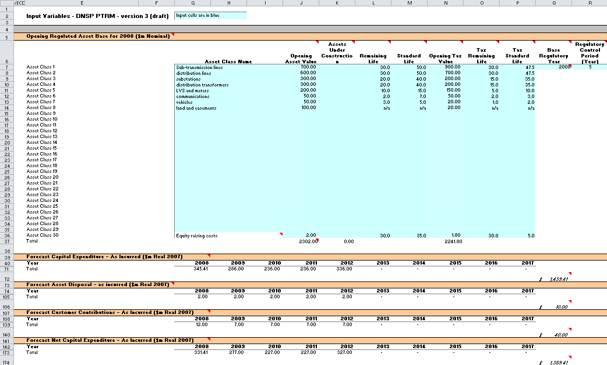

Figure Input sheet–second screenshot

1. 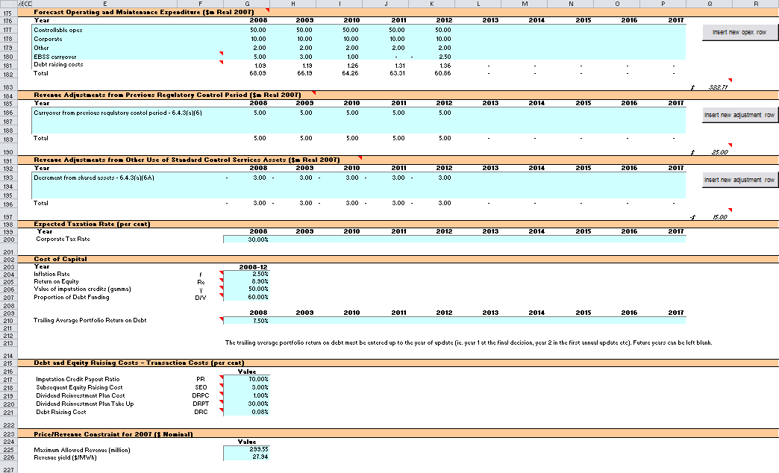

Figure Input sheet–third screenshot

1. 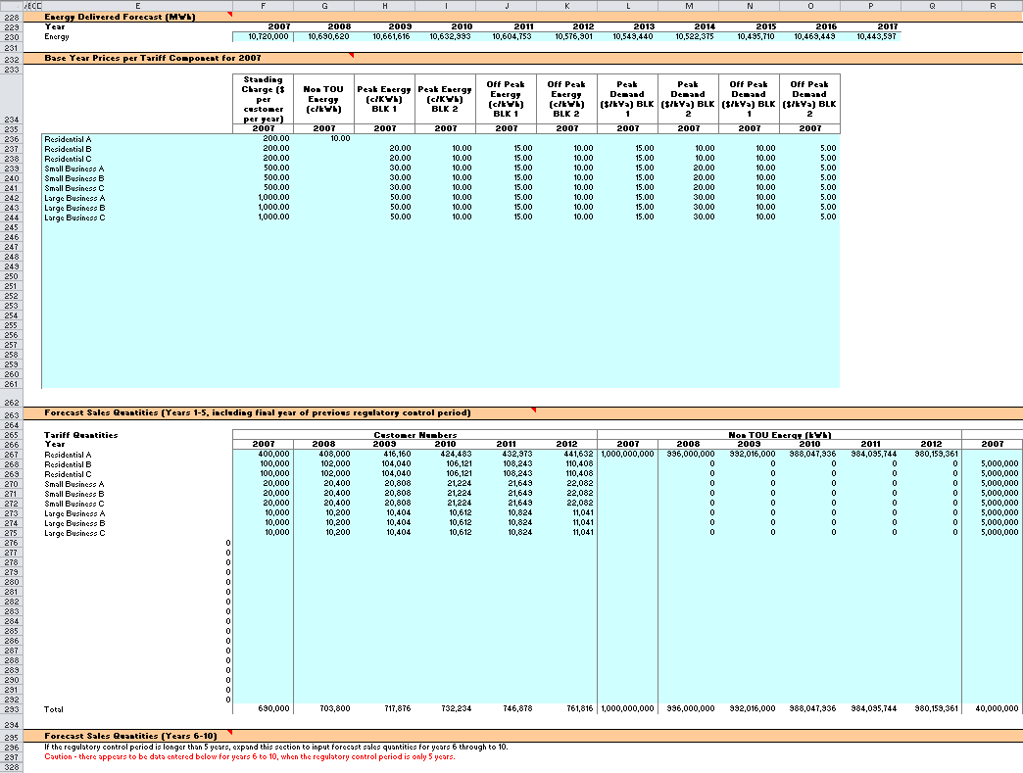
2. The PTRM can accommodate input data for up to a 10-year regulatory control period. Input cells outside of the relevant regulatory control period should be left blank.
3. The PTRM is configured to use the straight-line method as the default position for calculating depreciation for regulatory and tax purposes. After consultation with the AER, DNSPs may propose that depreciation profiles other than the straight-line method be accommodated within the PTRM as part of pre-lodgement discussions and subject to satisfying the requirements at clause 6.5.5(b) and 6.5.3 of the NER respectively.

### Opening regulatory asset base and opening tax asset base

1. The opening RAB is the value of assets on which a return will be earned. The opening TAB is used to calculate depreciation for tax purposes. The Input sheet requires a value for the opening RAB (broken into asset classes in rows 7 to 36) and opening TAB at the start of the first regulatory year of the next regulatory control period. The RAB and TAB will differ each regulatory year to reflect forecast capex, asset disposals, customer contributions and regulatory depreciation (for the RAB) or tax depreciation (for the TAB).
2. The recorded input values are linked to the Assets sheet, which also calculates depreciation for the next regulatory control period. Notes have also been included for various cells with specific comments and explanations about the relevance of the inputs.

Asset class name

1. The asset classes/names are recorded in column G. It is important that the asset classes recorded in the RAB section match the asset classes for which capex, disposals and capital contributions are reported in other input sections. This allows the PTRM to model depreciation consistently across the asset classes.
2. The PTRM is configured to accommodate up to 30 asset classes.[2] The number of asset classes used in the PTRM will vary between businesses.[3] However, for each business the asset classes used in the PTRM must be consistent with that used in the AER’s roll forward model (RFM). This allows the closing RAB values determined in the RFM to be used as inputs to the opening RAB values in the PTRM. RAB values by asset class derived from the RFM may be aggregated or disaggregated when forming inputs for the PTRM where this demonstrably improves the accuracy or administrative convenience of asset calculations.

Opening asset value

1. The opening asset values for each asset class are recorded in column J and are manually sourced from the closing asset value for each asset class as determined in the RFM.

Assets under construction

1. The value of assets under construction for each asset class, where relevant, is recorded in column K.[4] The total value of assets under construction as at the start of the first regulatory year of the next regulatory control period (cell K37) is rolled into the opening RAB value (cell J37).

Average remaining life

1. The average remaining life of the asset classes is recorded in column L, based on the economic life of the assets.[5]

Standard life

1. The standard life of the asset classes is recorded in column M and measures how long the infrastructure would physically last had it just been built.

Opening tax value

1. The opening tax values for each asset class are sourced from the closing tax asset values which have been determined in the RFM and are recorded in column N. Assets valued for tax purposes should include the value of contributed assets.

Average tax remaining life

1. The average tax remaining lives of each asset class for taxation purposes are recorded in column O based on the tax lives specified by the Australian Tax Office (ATO) for the category of assets and commissioning dates.

Tax standard life

1. The tax standard lives of each asset class are recorded in column P.

Base regulatory year

1. The regulatory year for the start of the next regulatory control period is recorded in cell Q7.

Length of regulatory control year

1. The number of years in the next regulatory control period is recorded in cell R7.

### Forecast real capital expenditure—as-incurred

1. Forecast capex values for the next regulatory control period are recorded for each regulatory year in rows 41 to 70[6] (by asset class).[7] Capex is rolled into the RAB when spending is incurred. These inputs must be reported in real terms based on start of year one dollar terms.

### Forecast real asset disposals—as-incurred

1. Forecast asset disposal (as-incurred) values are recorded for the regulatory year in which the disposal is expected to take place, in rows 75 to 104 (by asset class). These inputs must be reported in real terms based on start of year one dollar terms.

### Forecast real customer contributions—as-incurred

1. Forecast customer contributions (as-incurred) values are recorded for the regulatory year in which the contribution is expected to be made, in rows 109 to 138 (by asset class). These inputs must be reported in real terms based on start of year one dollar terms.

### Forecast net real capital expenditure—as-incurred

1. This section on forecast net capex does not require inputs to be recorded. For each asset class, forecast net capex is calculated based on the recorded forecast capex less forecast asset disposals and forecast customer contributions. Forecast net capex (as-incurred) values are displayed in rows 143 to 172 and form part of the roll forward of projecting the RAB in the Assets sheet. These inputs are assumed to be in real terms based on start of year one dollar terms.

### Forecast real operating and maintenance expenditure

1. Opex typically includes items such as wages and salaries, leasing costs, costs associated with maintaining assets, input costs and other service contract expenses paid to third parties. The forecast opex values for each year are recorded in rows 177 to 180, including any carryover amounts determined according to the efficiency benefit sharing scheme developed by the AER. Row 181 displays benchmark debt raising cost and does not require inputs to be recorded because the calculation is formula-driven, and is based on the practice of treating the allowance as an opex line item. Additional opex inputs can be recorded by adding rows to this section—click on the button labelled 'Insert new opex row'.
2. These inputs must be reported in real terms based on start of year one dollar terms.
3. The forecast total opex values (row 182) are linked to the Analysis sheet to calculate the ARR.

### Revenue adjustments from previous regulatory control period

1. Any additional revenue adjustments arising from the previous regulatory control period are recorded in rows 186 to 188.[8] These are linked to the total building block revenue calculations in the Analysis sheet.

### Revenue adjustments from shared assets

1. Any revenue (decrement) adjustments arising from the shared use of standard control services assets are recorded in rows 193 to 195.[9] These are linked to the intermediate building block revenue calculations in the Analysis sheet and affect the tax calculations.

### Expected taxation rate

1. The expected corporate tax rates are recorded for each year in row 200. The tax rates are linked to the WACC sheet to calculate the average tax rate and to the Analysis sheet to estimate the tax payable, as part of calculating the ARR.

### Cost of capital

1. The cost of capital section (rows 204 to 207 and row 210) records the following parameters:

* inflation rate[10]
* return on equity
* gamma—value of imputation (franking) credits
* proportion of debt funding
* trailing average portfolio return on debt for each year of the regulatory control period.

1. Each of these parameters is linked to the WACC sheet to calculate the weighted average cost of capital (WACC). The approach or method for determining each parameter is specified in clause 6.5.2 of the NER or the AER Rate of return guideline.[11] Rows 211 to 212 contain content driven help which will display cautions or guidance based on input to this sheet and the X factors sheet.

### Debt and equity raising costs—transaction costs

1. The debt and equity raising costs section (rows 217 to 221) records the following parameters:

* imputation credit payout ratio
* subsequent equity raising cost
* dividend reinvestment plan cost
* dividend reinvestment plan take up
* debt raising cost.

1. The values for the imputation credit payout ratio, equity raising and dividend reinvestment costs, and the dividend reinvestment take up are linked to the Equity raising cost sheet to calculate the allowance for benchmark equity raising costs associated with capex. The debt raising cost value represents the unit allowance and is linked to row 181 of the **Input** sheet to calculate the overall benchmark debt raising costs to be included in the opex allowance.

### Price/revenue constraint for the current regulatory year

1. Cells G225 and G226 record current values of total revenue and revenue yield for DNSPs subject to these forms of control and may not be required depending on the form of control mechanism determined by the AER. These values are linked to the X factors sheet and are used for projecting smoothed expected revenues based on the ARR.

### Energy delivered forecast

1. Row 230 records total forecast energy delivered. Energy delivered forecasts may be obtained from the most recent Australian Energy Market Operator’s National electricity forecasting report, a DNSP’s annual planning report or other relevant industry sources. These data are used in calculating the price constraint under a revenue yield form of control in the X factors sheet. They are also used in the Revenue summary sheet to calculate the average price impact.

### Current prices by tariff component

1. Prices by tariff component for the final regulatory year of the current regulatory control period are recorded in rows 236 to 261. These data are used in the PTRM’s calculation of a weighted average price cap (WAPC) and may not be required depending on the form of control mechanism determined by the AER. Where used, this section of the model and its dependent calculations in the Forecast revenues sheet may need to be amended to incorporate the components and tariff structures of each DNSP.

### Forecast sales quantities by tariff component

1. Forecast quantities relative to each tariff component for the next regulatory control period are recorded in rows 267 to 292 (years 1 to 5) and rows 301 to 326 (years 6 to 10). These data are used in the PTRM’s calculation for the WAPC and may not be required depending on the form of control mechanism determined by the AER. As for pricing data discussed above, this section of the model and its dependent calculations may need to be amended to suit each DNSP. Where quantities are not available or appropriate for the entire regulatory year (e.g. customer numbers) they will need to be approximated using a method agreed to by the AER.

## WACC sheet

1. The WACC sheet determines for each regulatory year of the next regulatory control period the required return on equity, return on debt and the WACC using the relevant cost of capital parameters from the Input sheet. Some of these will be constant across the regulatory control period, the return on debt (and therefore the overall WACC) may now vary year-by year.
2. The effective tax rates derived from the cash-flow analysis are also reported in the WACC sheet, including various measures of the WACC calculated from the forecast cash-flows in the Analysis sheet. The nominal pre-tax return on debt (row 15) and the nominal post-tax cost of equity (row 12) are multiplied by the debt and equity components of the RAB to determine the return on capital building block.[12]
3. In addition, there is a button labelled 'Set Te and Td' which is linked to a macro that should be pressed after all inputs have been finalised for establishing the ARR at the start of the next regulatory control period. This will copy the cash-flow derived effective tax rates for equity and debt from the Analysis sheet to the appropriate location in the WACC sheet (cells G28 and G29). The cash-flow derived rates shown in column R are designed as checks to ensure certain parameters are internally consistent with those derived by formula at the time of the final decision. Because the cash-flow derived rates are based on the use of a constant WACC, there is no need to press the 'Set Te and Td' button again as part of the annual return on debt update process during the regulatory control period. This process is discussed further in chapter 3.
4. Figure 4 provides an example of the WACC sheet.

Figure WACC sheet

1. 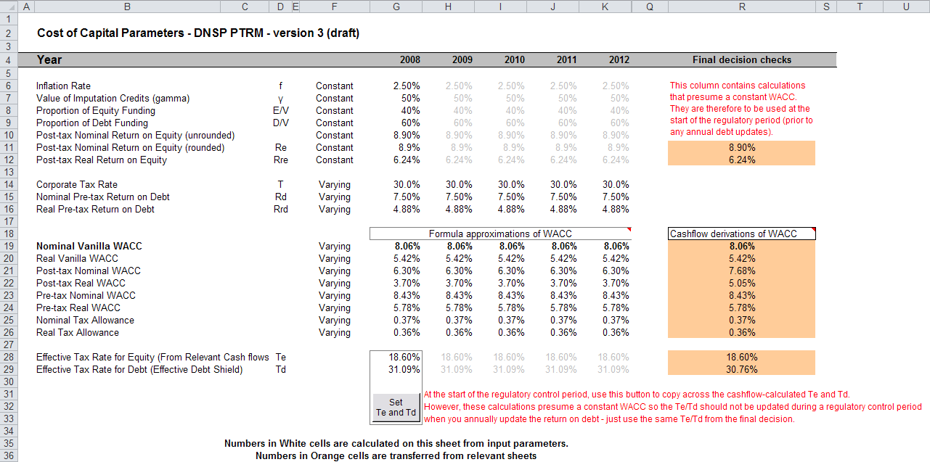

## Assets sheet

1. The Assets sheet calculates the value of the RAB for each regulatory year over the next regulatory control period in real (start of year one) and nominal dollar terms. It also calculates both regulatory and tax depreciation. The Assets sheet displays 55 years of data to allow estimation of the effective tax rate.
2. Figure 5 provides an example of the Assets sheet.

Figure Assets sheet

1. 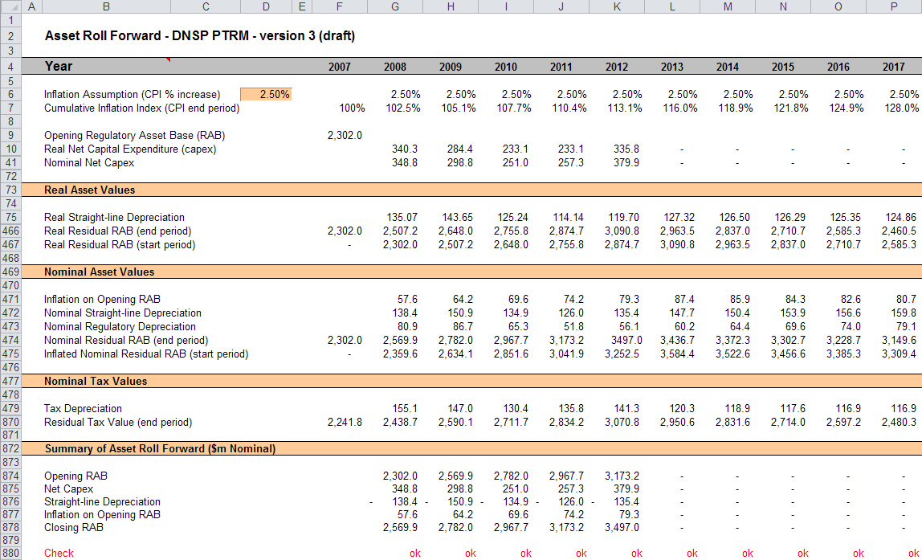

### Rolling forward the RAB and depreciation

1. For consistency, depreciation in a period must equal the difference between the asset value at the start and end of the period. Further, as depreciation is intended to represent the return of capital over the life of the asset, accumulated depreciation should not exceed the initial actual capital cost of the infrastructure.
2. The opening RAB (cell F9) and real forecast net capex values (rows 10 to 40) displayed in this sheet are sourced from the Input sheet. Nominal forecast net capex values are displayed in rows 41 to 71. The modelling of capex in the PTRM is based on a full as-incurred approach. Under this approach the return on capital and the return of capital are calculated based on as-incurred forecast net capex.
3. Capex is assumed to be incurred evenly throughout the regulatory year and therefore a timing assumption is adopted that on average places capex half-way through the year. However, the PTRM calculates the return on capital based on the opening RAB for each regulatory year and capex is not added to the RAB until the end of the regulatory year in which the expenditure on the asset is incurred. To address this timing difference of modelling the real capex, a half-real vanilla WACC is provided (capitalised and recovered over the life of the assets) to compensate for the six-month period before capex is included in the RAB.[13] This is calculated using the specific half-real vanilla WACC applying to the year in which the expenditure is incurred.
4. Real asset values are displayed in rows 75 to 467. Real straight-line depreciation is calculated in rows 75 to 465. It uses the opening RAB, forecast capex values and asset lives from the Input sheet. The individual depreciation profiles for each asset class can be viewed by expanding rows 76 to 465. The roll forward of the closing RAB in real dollar terms (start of year one) for each regulatory year is calculated in row 466.
5. Nominal asset values are displayed in rows 471 and 475. To compensate the DNSP for inflation, the residual value of the RAB at the end of each regulatory year is adjusted upwards for the amount of expected inflation in that regulatory year. This adjustment is calculated in row 471. The change in the nominal value of the RAB from regulatory year to year is calculated by adjusting the closing RAB (row 474) for forecast net capex and the regulatory depreciation allowance. Regulatory depreciation (row 473) is calculated as the nominal straight-line depreciation (row 472), less the inflation adjustment on the opening RAB (row 471).
6. Depreciation for tax purposes and the tax asset value over time is calculated in rows 479 to 870 and is based on the tax asset values, capex values and tax asset lives from the Input sheet. Capex recognised for tax purposes is net of disposals but includes the value of customer contributions. The individual tax depreciation profiles for each asset class can be viewed by expanding rows 480 to 869. Tax depreciation is calculated separately because asset values and asset lives for tax purposes generally differ from those for regulatory purposes.
7. A summary of the roll forward of the RAB is set out in rows 874 to 878.

## Analysis sheet

1. The Analysis sheet itemises the basic costs, or building blocks, of the DNSP, which are then added together to calculate the ARR. In other words, the Analysis sheet is where the data from the Input sheet is combined with the calculations in the Assets and WACC sheets to estimate a DNSP’s revenue requirement. The Analysis sheet displays 55 years of data so that the effective tax rate can be estimated.
2. The Analysis sheet also includes an analysis of the forecast cash flows. This analysis provides rate of return measures estimated from forecast revenues and costs, including: expected pre and post-tax returns on equity, effective tax rates, the effective cost of debt and selected measures of the WACC.
3. Figure 6 and Figure 7 provide an example of the Analysis sheet.

Figure Analysis sheet–first screenshot

1. 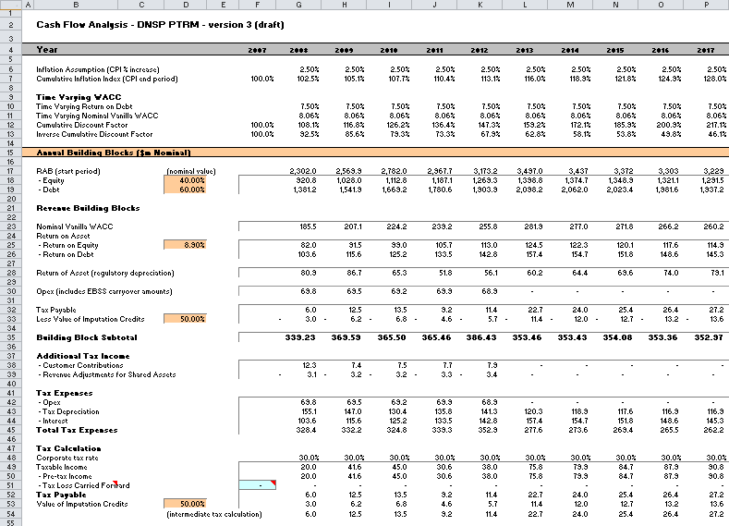

Figure Analysis sheet–second screenshot

1. 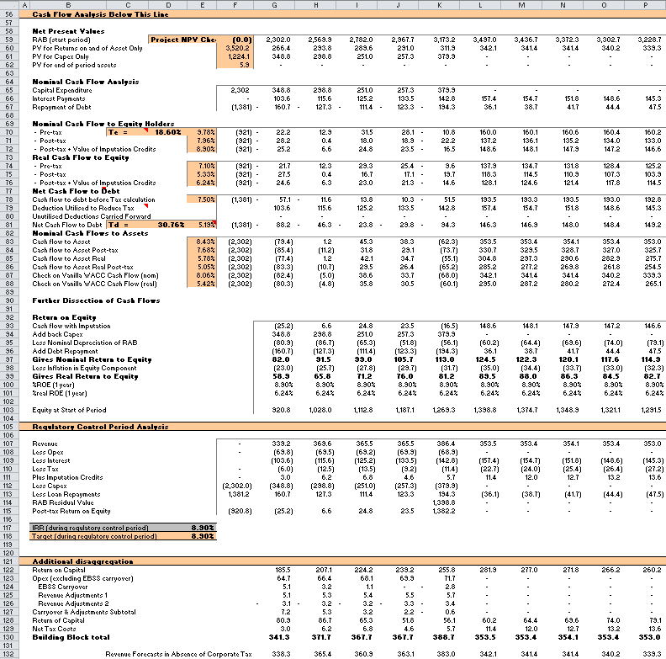

### Building block approach to deriving cash flows

1. Clause 6.4.3 requires the AER to apply the building block approach to assess the revenues required by a DNSP to recover the full cost of providing the regulated distribution (standard control) service. The revenue requirement includes a commercial return on its investment.
2. The key building blocks are:

* the return on capital (row 23) comprising:
* the post-tax return on equity (row 25)
* the return on debt (or the interest payments incurred) required to service borrowings (row 26)
* the regulatory depreciation or return of capital (row 28 )
* opex including carry-over amounts (row 30)
* net tax liabilities payable—the figure is net in the sense that it is the annual tax payable by the DNSP (row 32) less the value of imputation credits available to investing shareholders (row 33).

1. The costs are determined for each regulatory year of the next regulatory control period to derive the building block subtotal (row 35). There is an additional adjustment to reflect the taxation implications of additional revenues from customer contributions (row 38) and revenue adjustments for shared assets (row 39). Because the costs can fluctuate from year to year, the ARR (which includes the additional revenue adjustment for shared assets) is smoothed over the next regulatory control period to give the expected revenue (see section 2.6).
2. As a result of the PTRM’s particular timing assumptions, i.e. all cash flows with the exception of capex are assumed to occur at the end of each regulatory year, there is no need to provide DNSPs an allowance for working capital in the modelling.[14]

### Taxation and related costs and benefits

1. Tax is payable on revenue less tax costs recognised by the ATO. Tax-deductible costs include interest or debt servicing, depreciation allowances and opex (rows 42 to 42).

Spreadsheet calculations

1. Tax payable by the DNSP for each regulatory year is calculated in rows 35 to 54, in three steps:
   1. Pre-tax income (row 50) is calculated as the building block subtotal plus the additional tax income (rows 38 and 39) less the estimated total tax expense (row 45).
   2. Tax loss carried forward is calculated (row 51).
   3. Taxable income (row 49) is then the sum of the above.
2. The tax costs (rows 44 to 44) used in calculating the pre-tax income for the regulatory year are the same as those in the building blocks (rows 26 and 30) with the exception of depreciation. In the case of the revenue building blocks, regulatory depreciation (row 29) is calculated based on the economic life of the asset (see rows 75 to 465 and 471 to 473 of the Assets sheet). Tax depreciation is generally based on a much shorter tax life or calculated in a different way (see rows 479 to 869 of the Assets sheet).
3. The tax payable is recognised as a building block cost and added to the revenue building blocks (row 35). Offsetting this tax cost is the benefit shareholders receive from imputation credits (gamma). This offsetting benefit is equal to gamma multiplied by the tax payable and is recorded in rows 33 and 53.

### Cash flow analysis

1. Calculations in the cash flow analysis section provide a comprehensive check on the validity of revenue determinations to ensure that the outcomes are consistent with the assumptions forming the basis of the building block approach. The Analysis sheet is designed to check the desired rate of return on equity that can be expected from the regulated revenue stream.

Net present values

1. The total returns on and of capital (comprising the RAB and capex) is calculated in row 60. The present value (PV) for these cash flows at the start of the first regulatory year of the next regulatory control period is calculated in cell F60. The PV for capex is calculated in cell F61 and the PV of the end of period assets is calculated in cell F62. The sum of the PV of the returns on and of the RAB and capex, less the residual value of assets is calculated in cell F59. This project net present value (NPV) for the RAB check cell should be equal to zero, which indicates that the asset is receiving the correct returns.

Net cash flows available to equity holders

1. Net nominal pre-tax cash flows to equity holders (row 70) are represented by nominal revenues less:

* opex
* capex
* interest payments
* any repayment of debt in the period.

1. Net nominal post-tax cash flow to equity holders (row 71) is obtained by further deducting the tax expense of the business. Row 72 adds back the value of imputation credits to calculate the net post-tax benefits available to equity holders in a period.
2. The internal rate of return (IRR) of the net cash flows over the life of the assets is calculated in column E. The key IRR is the net post-tax returns to equity holders inclusive of imputation credits (re). The determined re should be validated by the estimated cash flows (row 72).
3. The corresponding real cash flows and the respective IRRs are calculated in rows 74 to 76.
4. The difference in the IRR applying to pre-tax and post-tax cash flows to equity allows the effective rate of tax (Te = 1 – rpost/rpre) to be calculated (cell D70). This can then be used as an input to the formula-based WACC calculations.
5. It is important to note that the formula-based WACC calculations will only provide an approximation of the actual WACC outcomes implied by the cash flow calculations. In practice, Te is generally below the corporate tax rate for assets that can be depreciated at a faster rate for tax purposes.

Net cash flows necessary to service debt and the effective debt shield

1. The cost of debt is reduced by the value of the ‘debt shield’ (row 78) in calculating tax liabilities. Where the interest expense in a regulatory year reduces taxable income by a corresponding amount, the net cost of debt for investors is reduced by the corporate tax rate.
2. However, where the taxable income is so low that the full interest deduction is not required to reduce tax liabilities to zero, the value of the debt shield benefit is deferred to the following regulatory year. This effect is analysed in rows 78 to 81. That part of interest expense used to defer tax is calculated in each regulatory year (row 79) and the unused part carried forward is embodied in the tax loss carried forward calculation (row 80). This allows the net cost to the firm of paying debt holders, after taking account of the tax concession, to be calculated.
3. The IRR calculation (cell E81) represents the effective cost of debt, which is generally well below the nominal cost of debt based on the current interest rates.

Nominal cash flows to assets and calculation of WACC estimates

1. The cash flows to the different sources of capital (debt and equity) have been presented above, but the cash flows to the assets as a whole are of interest since these aggregate numbers characterise the nature of the regulated business.
2. The IRRs from these cash flows are the WACC estimates expected from the application of the regulatory framework and have greater validity than any formula based approximations. They are summarised in the WACC sheet along with the formula-based approximations. It should be noted that the WACC outcomes are calculated for reporting purposes only. They are not required for setting revenues since the modelling already provides the requisite revenue forecasts.

Regulatory control period analysis

1. Rows 107 to 115 provide an additional analysis of the cash flow to equity holders over a regulatory control period.
2. The purpose of this section is to confirm that the desired re target remains throughout the regulatory control period. Rows 107 to 115 are essentially an expansion of the calculations used to derive row 72—that is, cash flow to equity holders inclusive of the value of imputation credits.

Additional disaggregation

1. Rows 122 to 132 provide additional breakdown of revenue by components in accordance with the categories listed in the NER. These values are referred to in the X factors, Revenue summary and Chart 3–Building blocks sheets.

## Forecast revenues sheet

1. The Forecast revenues sheet is relevant to the calculation of X factors under the WAPC control mechanism. Prices are sourced from the Input sheet and escalated by forecast changes of the inflation rate and X factors from the X factors sheet to derive notional prices for each year of the regulatory control period. These prices are multiplied by the forecast quantity data from the Input sheet to derive a notional forecast smoothed revenue amount in row 7, which is intended to equal (in NPV terms) the building block requirement in the X factors sheet.
2. The calculations in this sheet are automated and do not require inputs. The display of forecast, quantities and revenues has been split into two sections—years 1 to 5, and years 6 to 10. The grouping controls can be used to hide all columns relating to years 6 to 10 (for instance, if the regulatory control period is only 5 years long). This sheet is, however, based on a generic tariff structure and will require amendment by each DNSP to suit its own tariff schedules. DNSPs using the PTRM for forms of control other than a WAPC will not be required to use the Forecast revenues sheet. Pricing data in this sheet has no relationship with the information to be provided by DNSPs to the AER under clause 6.8.2(c)(4) or Part I of the NER.
3. Figure 8 and Figure 9 provide an example of the Forecast revenues sheet.

Figure Forecast revenues sheet–first screenshot

1. 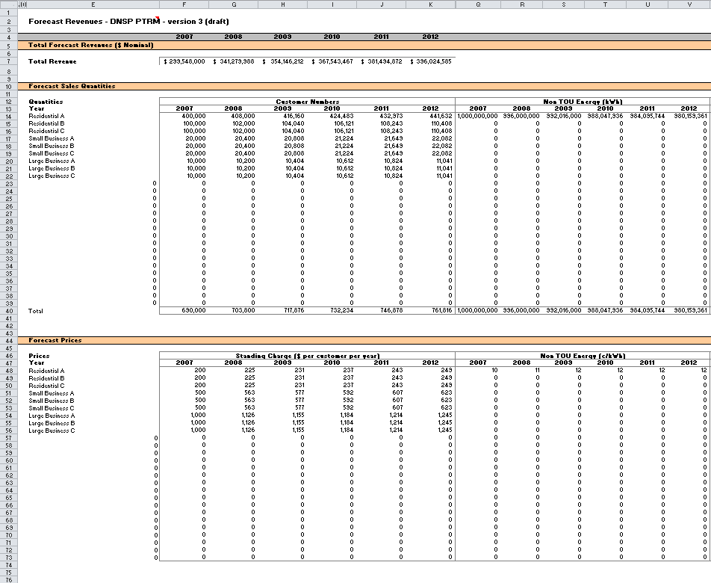

Figure Forecast revenues sheet–second screenshot

1. 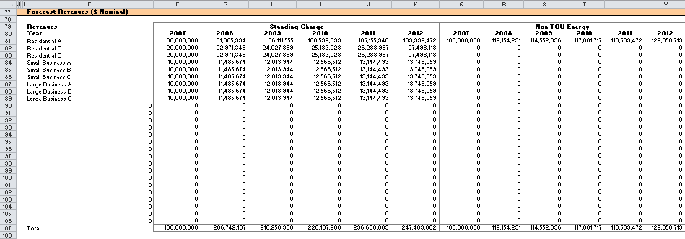

## X factors sheet

1. The X factors sheet reflects the requirements of clause 6.2.6 and 6.5.9 regarding the setting of X factors, namely, that they are to comprise part of the CPI–X constraint on direct control services, and that they must be set such that the following conditions are met:

* the ARR and forecast expected revenues are to be equal in NPV terms
* the value of expected revenue and the ARR in the final regulatory year of the period must be as close as reasonably possible.[15]

1. DNSPs must propose X factors in submitting a completed PTRM with its building block proposal in accordance with clause S6.1.3(6) of the NER. The AER will assess this in accordance with the provisions listed above, but may also consider other relevant factors such as price stability, cash-flow adequacy and longer term pricing goals.
2. The PTRM provides for X factor calculations (usually called 'smoothing') under three basic forms of control, namely a WAPC, revenue cap and revenue yield cap. Through these calculations the X factor is simply a price or revenue adjustment mechanism. It does not relate to actual productivity improvements in the operations of a DNSP. However, this does not mean that the AER ignores productivity improvements when assessing a DNSP’s building block proposal. Instead, the AER includes any expectation of productivity gains directly into the forecasts of costs.
3. When smoothing across the regulatory control period, it is necessary to iteratively update equity raising costs as well. This is because the estimate of equity raising costs is dependent on the smoothed revenue (expected revenue) profile, but in turn the expected revenue is dependent on the estimate of equity raising costs. Hence, there are a number of macros built into the PTRM which jointly smooth revenues while iteratively updating equity raising costs. It is possible to stop the automatic updating of equity raising costs using the drop down menu in cell H16.
4. Across each of the three forms of control (WAPC, revenue cap or revenue yield cap) there are two basic types of smoothing operation:

* Select the 'Apply default smoothing' button that changes all X factors. This default path first entails setting the expected revenue (calculated using the relevant form of control) for the first year equal to the ARR for that year (this will show as a change to the X factor in year 1, sometimes referred to as P0). Next, the macro calculates the single (constant) X factor which can be applied to all remaining years of the next regulatory control period so that the NPVs of smoothed revenue (expected revenue) and unsmoothed revenue (ARR) across the entire period are equal. Equity raising costs will be updated as well.
* Alternatively, it might be necessary (including during the annual debt update) to adjust the X factor for a specific year only. This type of smoothing changes just one X factor so that the NPVs of smoothed revenue (expected revenue) and unsmoothed revenue (ARR) across the regulatory control period are equal.

1. In both cases, equity raising costs will be iteratively updated while smoothing (unless this default option is turned off, as noted above).
2. The WACC (row 7), values of forecast inflation rates (row 10) and building block annual revenue requirements (rows 30 to 35) are sourced from other sections of the model and are used for the calculations in all three forms of control. All NPV calculations in this sheet now reflect the time varying WACC (row 7) which arises as a result of the return on debt (potentially) varying each year. The cumulative discount rate is calculated in row 8. When the return on debt is updated within the regulatory control period, these discount rates will change as a result, and so too will the NPV of the ARR and expected revenue.[16]
3. The process for annually updating the return on debt is described further in chapter 3. There is a drop down menu in cell F21 which allows the user to input the year of the annual return on debt update. This drop down menu will not affect underlying calculations, but instead drives the presentation of content-sensitive help in this sheet (and in the Input sheet). Rows 23 to 26, 51, 67 and 87, will display caution notes/guidance based on logical tests of the PTRM.

X factors under a price cap

1. Under the WAPC form of control, row 47 provides the inputs for the profile of X factors. These are used along with the expected inflation rate to escalate prices in the Forecast revenues sheet and derive the forecast smoothed expected revenues which are listed in row 44. Revenue can be smoothed using the buttons at rows 49 to 50, either by applying the default smoothing approach (changing all X factors as described above) or changing a single specific year's X factor. Smoothing operations will equate the NPV of the forecast expected revenue (cell R44) and the NPV of the ARR (cell R39).
2. The difference between the values of the ARR and forecast expected revenue for the final year of the regulatory control period is listed in cells R41 (nominal dollars) and R42 (percentage of unsmoothed revenue).

X factors under a revenue cap

1. Under the revenue cap form of control, row 63 provides the inputs for the profile of X factors. These are used, along with the expected inflation rate, to derive the nominal smoothed expected revenue for each regulatory year of the regulatory control period in row 60. The value of the expected revenue is escalated directly by CPI–X. Revenue can be smoothed using the buttons at rows 65 to 66, either by applying the default smoothing approach (changing all X factors as described above) or changing a single specific year's X factor. Smoothing operations will equate the NPV of the forecast expected revenue (cell R60) and the NPV of the ARR (cell R55).
2. The difference between the values of the ARR and forecast expected revenue for the final year of the regulatory control period is listed in cells R57 (nominal dollars) and R58 (percentage of unsmoothed revenue).

X factors under a revenue yield

1. Under the revenue yield form of control, row 83 provides the inputs for the profile of X factors. These are used, along with the expected inflation rate, to derive a nominal revenue yield value for each regulatory year of the regulatory control period in row 78. The value of the revenue yield is multiplied by the forecast energy throughput to derive a nominal smoothed expected revenue for each regulatory year of the regulatory control period in row 80. Revenue can be smoothed using the buttons at row 85 to 86, either by applying the default smoothing approach (changing all X factors as described above) or changing a single specific year's X factor. Smoothing operations will equate the NPV of the forecast expected revenue (cell R80) and the NPV of the ARR (cell 71).
2. The difference between the values of the ARR and the forecast expected revenue is listed in cells R73 (nominal dollars) and R74 (percentage of unsmoothed revenue).
3. Figure 10 and Figure 11 provide examples of the X factors sheet.

Figure X factors sheet–first screenshot

1. 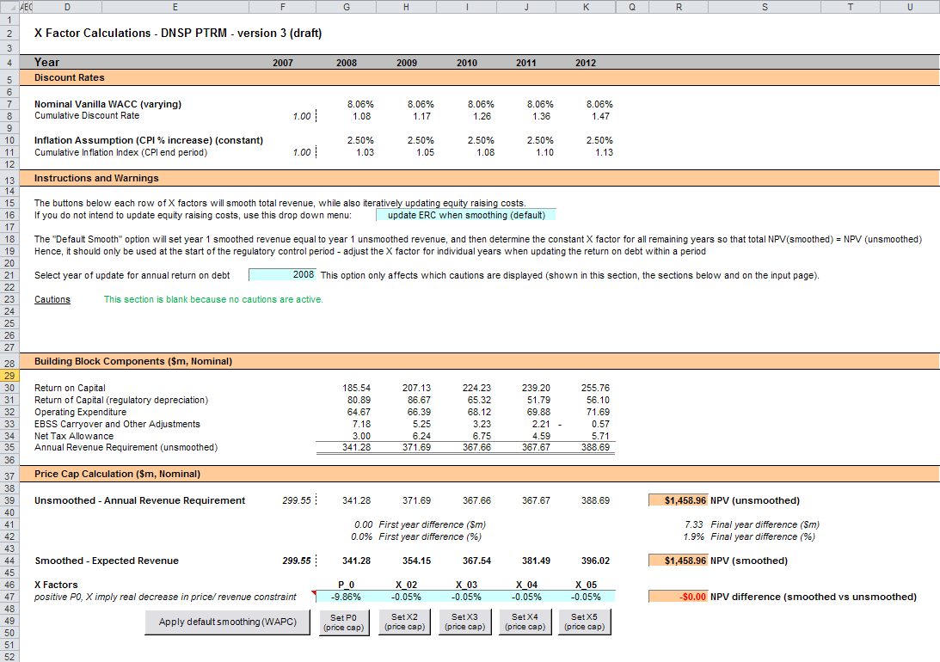

Figure X factors sheet–second screenshot

1. 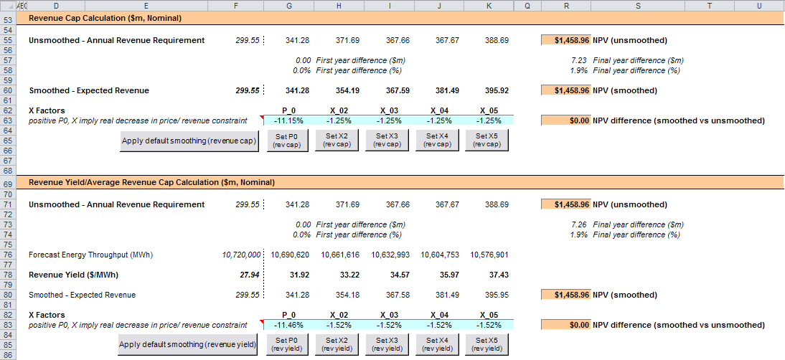

## Revenue summary sheet

1. The Revenue summary sheet outlines the various building blocks, the unsmoothed forecast revenues (or the ARR) and smoothed expected revenues for the next regulatory control period:

* rows 7 to 12 display the building blocks in nominal dollar terms
* rows 17 to 26 display a summary of smoothed revenue amounts in nominal dollar terms and X factors for the three forms of control
* rows 30 to 35 display the building blocks in real dollar terms (start of year one)
* rows 40 to 49 display a summary of smoothed revenue amounts in real dollar terms (start of year one) and X factors for the three forms of control

1. The Price Path Analysis section presents summary values for the forecast price path, which in broad terms is the forecast revenue divided by forecast demand:

* rows 53 and 78 display the DNSP’s forecast energy for the regulatory control period
* rows 56 to 74 use the expected revenues for the three forms of control to calculate indicative revenue and price paths in nominal dollar terms
* rows 81 to 99 use the expected revenues for the three forms of control and calculate indicative revenue and price paths in real dollar terms (start of year one).

1. The price path analysis differs slightly based on the form of control:

* Under a WAPC, the expected revenue in each year reflects the tariff breakdown (forecast quantities x prices) sourced from the Forecast revenues sheet. The starting point for the WAPC price path is an indicative price calculated as total revenue divided by forecast total energy demand.[17] To calculate the price path, this starting value is escalated each year of the regulatory control period using the CPI–X pricing formula. Hence, the X factors will align with the real change in this price path (row 85).
* Under a revenue cap, the expected revenue is directly targeted by the form of control and so the X factors will align with the real change in revenue (row 89). The expected revenue is divided by forecast total energy demand to produce the indicative price path. This also illustrates the extent to which the revenue cap will adjust prices in response to changes in (forecast) demand.
* Under a revenue yield cap, the revenue yield is directly targeted by the form of control and so the X factors will align with the real change in the price path (row 99). Hence, the price path is not just illustrative in this case, and is used to then derive the expected revenue (reversing the operation undertaken in the two other forms of control).

Under each form of control, calculations show the percentage change year-on-year (in both nominal and real terms) and the average yearly change across the regulatory control period.[18]

Figure 12 and Figure 13 provide examples of the Revenue summary sheet.

Figure Revenue summary sheet–first screenshot

1. 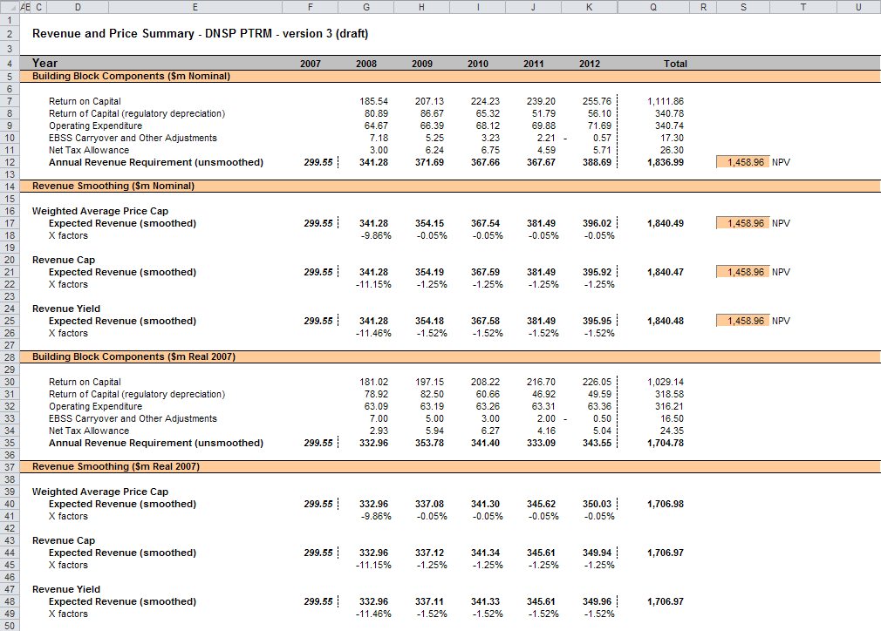

Figure Revenue summary sheet–second screenshot

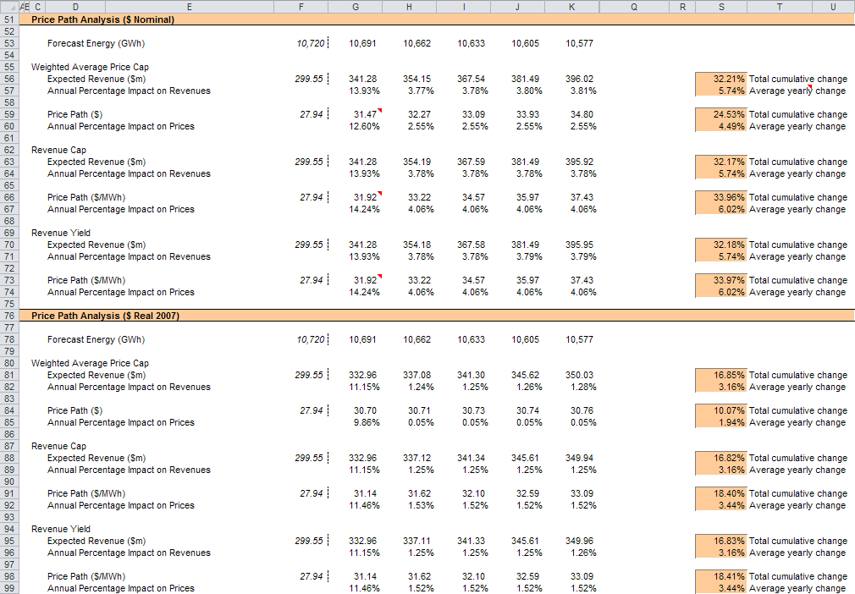

## Equity raising cost sheet

1. In raising new equity capital a business may incur costs such as legal fees, brokerage fees, marketing costs and other transaction costs. These are upfront expenses, with little or no ongoing costs over the life of the equity. While the majority of the equity a firm will raise is typically obtained at its inception, there may be points in the life of a firm—for example, during significant capital expansions—where it chooses additional external equity funding (instead of debt or internal funding) as a source of equity capital, and accordingly may incur equity raising costs.
2. The benchmark cash flow analysis applied by the AER to determine the extent to which equity raising associated with capex is required has been discussed in detail in previous electricity determinations.[19] Broadly, the analysis uses the PTRM cash flows to calculate the amount of retained earnings (taking account of cash flows such as revenue, opex, interest payment, tax payment dividends, and dividend reinvestment plans). The amount of retained earnings is deducted from the equity component of forecast capex (while maintaining the benchmark level of gearing) to determine any external equity requirement. The Equity raising cost sheet sets out the benchmark cash flow analysis.
3. The opening RAB and capex values (rows 7 and 8) are sourced from the Assets sheet. Based on this information the capex rate is calculated and displayed in row 9. The capex rate indicates the proportion of the capex relative to the opening RAB but does not affect the calculation of equity raising costs by itself.
4. The tax payable values (row 13) are sourced from the Analysis sheet and are used in combination with parameters (such as the corporate tax rate and imputation credit payout ratio) from the Input sheet to calculate the dividends payable (row 14). A proportion of dividends that are paid out to investors are assumed to be reinvested in the business. The amount of dividends reinvested by investors is displayed at row 16 and is used in the benchmark cash flow analysis to determine retained cash flows.
5. The drop down menu in row 19 allows the selection of the form of control so that the smoothed revenue cash flows are sourced from the correct section of the X factors sheet. This drop down menu may be automatically updated when running a smoothing macro using the buttons in the **X factors** sheet. If the drop down option to 'update ERC when smoothing (default)' in the **X factors** sheet (cell H16) is selected, then running a smoothing macro will set the drop down menu in the Equity raising cost sheet (cell G19) to the relevant form of control (based on which smoothing button was pressed).[20]
6. The benchmark cash flow analysis set out in rows 21 to 36 are undertaken in nominal dollar terms and is used to determine the equity raising costs as follows:

* The revenues (row 21) sourced from the X factors sheet less expenses such as opex, interest payments, tax payable and other revenue adjustments (rows 22 to 25) sourced from the Analysis sheet provides the internal cash flow (row 26).
* The internal cash flow less dividends paid out to shareholders (row 27) provides the retained cash flow (row 28).
* The capex funding requirement (row 32) is sourced from row 8, adjusted to remove the gross-up for the WACC provided in the PTRM to account for the assumed timing of the incurrence of capex, which is not relevant for financing purposes. The debt component (row 33) represents the increase in debt funding and is sourced from the Analysis sheet, whereby to maintain the benchmark level of gearing, the level of debt must equal 60 per cent of the RAB rather than capex. The residual of capex funding requirement less the increase in debt funding gives the equity component (row 34), which represents the amount of capex that must be funded through retained earnings and then new equity.
* The equity component less retained cash flow (row 35), where it is insufficient, indicates the additional equity requirement (row 36).[21]

1. Rows 40 to 42 display the equity component, retained cash flow and additional equity requirement in real dollar terms (based on start of year one) by converting the nominal dollar equivalents set out in rows 34 to 36. Dividend reinvestment, also in real dollar terms, is displayed in row 44 by converting the nominal dollar equivalent as set out in row 15.
2. If the total equity requirement over the next regulatory control period is above zero, cell Q48 calculates the total dividend reinvestment plan requirement based on the total amount set out at Q44. The total external equity requirement over the next regulatory control period is calculated at cell Q49 by taking the difference between the total equity requirement and the total dividend reinvestment. Cell Q50 displays the sum of the total dividend reinvestment plan requirement and the total external equity requirement. This is the total equity requirement.
3. Based on the total amount of dividends reinvested (cell Q48) and the external equity requirement (cell Q49) the cost for each of these component (sourced from the Input sheet) is calculated in cells Q52 and Q53 respectively. The sum of these components provides the total equity raising costs in real dollar terms (start of year one) and is displayed at cell Q54. A positive value for the total equity raising costs over the next regulatory control period indicates that the calculated benchmark equity raising costs should be allowed and recovered by the DNSPs.
4. The equity raising cost calculations must be performed iteratively because they are both an input to and an output from the building block calculation.[22] In other words, a change in the equity raising cost will change the ARR and expected revenue, which in turn changes the equity raising cost. Further, the equity raising cost calculation depends on both unsmoothed building block components (for instance, the outgoing cash flows each year) and the smoothed total revenue (for instance, the available revenue each year). Accordingly, changes to the smoothed revenue profile (the expected revenue) can change the required equity raising cost, starting the cycle again.
5. By default, the smoothing macros in the X factors sheet perform these iterative calculations for equity raising costs at the same time. However, this function can be disabled using the drop-down menu in cell H16 of the X factors sheet.
6. Figure 14 provides an example of the Equity raising costs sheet.

Figure Equity raising cost sheet

1. 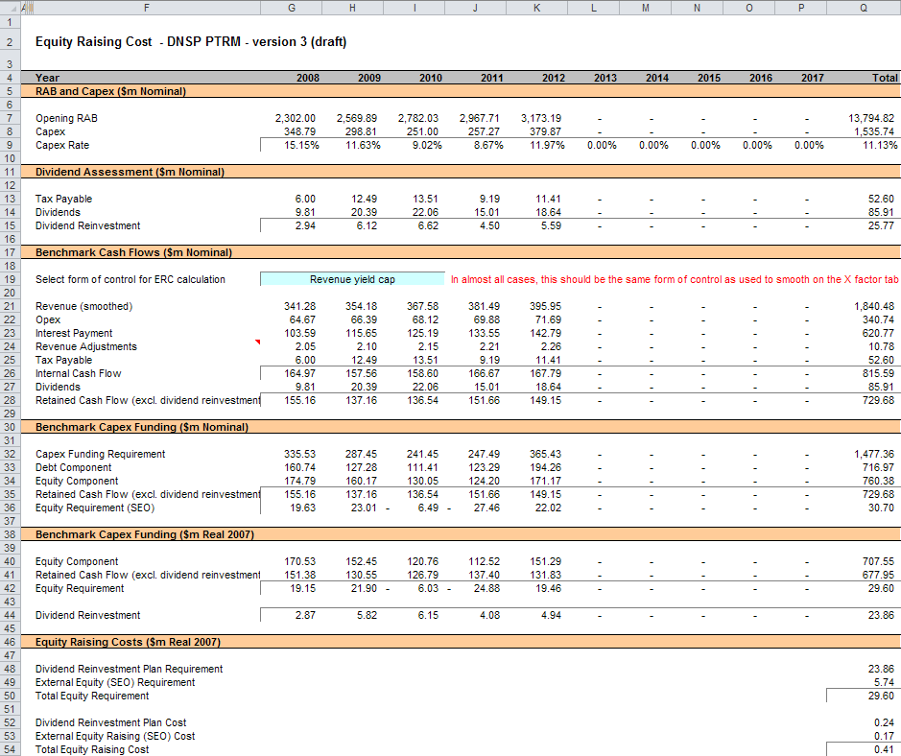

## Chart 1—Revenue sheet

1. The Chart 1–Revenue sheet displays charts for each form of control that incorporates the:

* nominal and real ARR
* nominal and real forecast expected revenues derived under the three forms of control

1. This information is sourced from the Revenue summary sheet.
2. Figure 15 provides an example of the Chart 1–Revenue sheet.

Figure Chart 1—Revenue sheet

1. 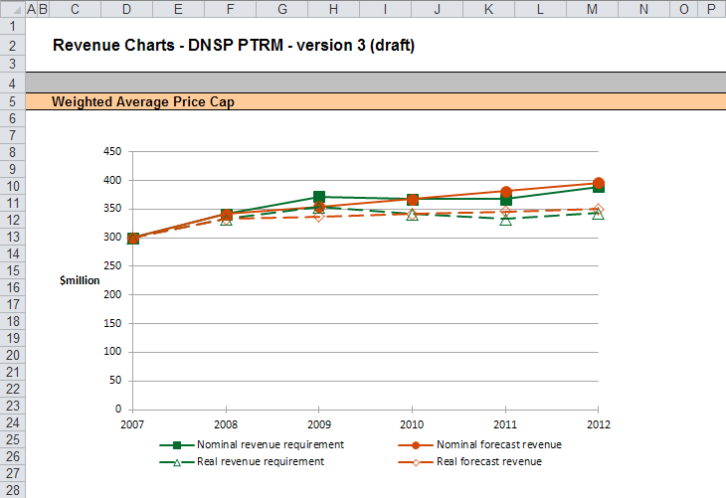

Note: This screenshot only shows an example chart for the weighted average price cap form of control. However, the Chart 1—Revenue sheet also includes similar charts for the revenue cap and revenue yield forms of control.

## Chart 2—Price path sheet

1. The Chart 2–Price path sheet displays charts for each form of control that incorporate the value of average prices (approximated by total revenues divided by total energy demand forecast, or the revenue yield value) in nominal and real dollar terms (start of year one). This information is sourced from the Revenue summary sheet.
2. Figure 16 provides an example of the Chart 2–Price path sheet.

Figure Chart 2–Price path sheet

1. 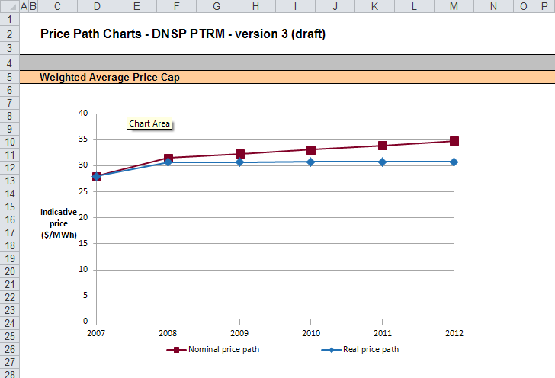

Note: This screenshot only shows an example chart for the weighted average price cap form of control. However, the Chart 2—Price path sheet also includes similar charts for the revenue cap and revenue yield forms of control.

## Chart 3—Building blocks sheet

1. The Chart 3–Building blocks sheet displays the various building block cost components making up the ARR:

* return on capital
* regulatory depreciation
* opex (excluding any carry-over amounts)
* net tax costs
* carry-over and other revenue adjustments.

1. This information is sourced from the Analysis sheet.
2. Figure 17 provides an example of the Chart 3–Building blocks sheet.

Figure Chart 3–Building blocks sheet

1. 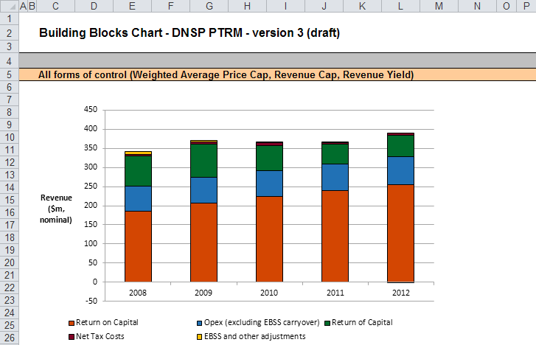

# Process for annual return on debt update

This section sets out the process to set X factors at the time of the final decision, and the default process for annual updates of the return on debt. Some aspects of this approach will be guided by policy decisions to be made during individual determinations. However, following the process set out below will likely result in the basis for calculations that is consistent with the requirements of clauses 6.5.2(h)–(l) of the NER.

## Setting X factors for the final decision before the start of the regulatory control period

* 1. Complete all inputs to the Input sheet. This requires a trailing average portfolio return on debt value only in G210.[23] By default, the PTRM approach adopts the most recent trailing average portfolio return on debt that is entered, where there is no further forecast values entered for other years in the regulatory control period. Accordingly, it is not necessary to enter the return on debt for later years in the regulatory control period at this stage.[24]
  2. In the X factors sheet, ensure that the equity raising cost update option (cell H16) is set to ‘update ERC when smoothing (default)’. This will ensure the equity raising cost calculations are iteratively updated as part of setting the X factors.[25]
  3. In the X factors sheet, check that cell F21 is set to the first year of the next regulatory control period. This will ensure the correct checks and warnings operate for the model.
  4. In the X factors sheet, apply revenue smoothing in the section relating to the chosen form of control:
     1. If applying the default X factor path (year 1 ARR = year 1 expected revenue; X2=X3=X4=X5; NPV(ARR) = NPV(expected revenue)), press the button labelled 'Apply default smoothing (…)' where ‘(…)’ describes the relevant form of control (either WAPC, revenue cap or revenue yield).
     2. If applying an alternative smoothing path, in the section relating to your chosen form of control (WAPC, revenue cap or revenue yield), manually enter values for all X factors except one. Then press the relevant button to calculate the final remaining X factor (so that NPV(ARR) = NPV(expected revenue)). This final X factor can be any of the X factors in the regulatory control period (including the first year, which is labelled as 'P0' by convention instead of 'X1'). These buttons are located under the relevant X factors and are also labelled with the relevant form of control.
     3. In either case, it is necessary to consider the resulting difference between the final year ARR and expected revenue for the chosen form of control (shown in cells R41 and R42 for the WAPC; in cells R57 and R58 for the revenue cap; and cells R73 and R74 for the revenue yield). If this difference would not meet the requirements of NER clause 6.5.9(b)(2), return to step (b) and manually adjust one or more X factors again (ensuring that the final X factor adjustment uses the relevant button so as to jointly smooth the revenue and equity raising cost calculations).
  5. In the WACC sheet, press the 'Set Te and Td' button to copy the cash-flow derived effective tax rates for equity and debt from the Analysis sheet to the appropriate cells in the WACC sheet.

## Updating X factors to incorporate the annual update to the trailing average portfolio return on debt

* 1. In the X factors sheet, select the relevant year of update in cell F21.
  2. In the Input sheet (row 210), enter the trailing average portfolio return on debt values up to and including the relevant year of update, consistent with that selected in cell F21 of the X factors sheet.[26] Caution notes will appear in rows 211 to 212 of the Input sheet to show which inputs are necessary. No other inputs should be changed.
  3. In the X factors sheet, ensure the equity raising cost update option (cell H16) is set to 'update ERC when smoothing (default)'.
  4. In the X factors sheet, apply smoothing to recalculate the X factor by using the button for the relevant year as identified in step 1 and for the relevant form of control. The correct year for update will be identified by a caution note in the rows (rows 51, 67 and 87) under the smoothing X factor buttons for the three forms of control. Only the relevant form of control should be used. It is important that the X factors for past years in the regulatory control period are not altered, since these X factors reflect the revenue (and price) outcomes from those years. Further, the default approach is that only the X factor for the year of update should be altered (rather than multiple X factors, for this year and remaining years within the regulatory control period).[27] This means that the impact of increases/decrease in that year's return on debt will be fully reflected in price changes in that year. For example, under a revenue cap form of control, to re-smooth for a return on debt update in year 2 the button labelled 'Set X2 (rev cap)' would be used, and all other X factors as determined during the final decision process would remain unaltered.

1. The set of Microsoft Excel spreadsheets which constitute the PTRM were created in Microsoft Excel 2007. The AER recommends this or a later version of Microsoft Excel be used in applying these spreadsheets.
2. The PTRM can be expanded to accommodate additional asset classes, when necessary.
3. The 30th asset class is designed to be used only with the 'Equity raising costs' asset class. Several defined name ranges use this asset class to implement the iterative equity raising cost update when smoothing total revenue.
4. Inputs for assets under construction will only be relevant for any DNSPs that previously recognised capex on an as-commissioned basis.
5. Generally these can be derived based on the weighted average remaining life of all individual assets in the class.
6. Row 70 (asset class 30) is designed to be used for equity raising costs only.
7. The button at the left of row 71 may be pressed to display/hide rows 41 to 70 (asset classes 1 to 30).
8. There is also a button which allows new rows to be inserted.
9. There is also a button which allows new rows to be inserted.
10. Clause 6.4.2(b)(1) of the NER requires the AER to specify in the PTRM a methodology that is likely to result in the best estimate of expected inflation. The AER uses an approach that calculates the geometric average based on the inflation forecasts for two years sourced from the latest available Reserve Bank of Australia’s (RBA’s) Statement of monetary policy and the mid-point of the RBA’s target inflation band for eight years (see AER, Final decision, TransGrid transmission determination 2009–10 to 2013–14, 28 April 2009, pp. 60–64).
11. AER, Better regulation: Rate of return guideline, December 2013.
12. See rows 24 to 27 in the Analysis sheet, which calculate the return on capital and provide a breakdown of the return on equity and return on debt.
13. The half-real vanilla WACC is calculated as the square root of (1 + real vanilla WACC) – 1 to account for the compounding effect on an annual rate.
14. The timing of the capex cash flow is assumed to be mid-year.
15. The AER in its regulatory determinations has considered a divergence of up to 3 per cent between the expected revenue and ARR for the final year of the regulatory control period to be reasonable if this can achieve smoother price changes for customers over the regulatory control period.
16. This is not the only change that flows from a change to the return on debt – the return on capital and return of capital building blocks will change, and therefore so will the tax building block.
17. This preserves comparability with the other two forms of control.
18. The average yearly change is calculated as the geometric mean (not the arithmetic mean), and therefore reflects the cumulative impact of year-on-year percentage changes across the regulatory control period. In other words, the value shown in column S (where labelled 'Average yearly change') is the percentage change that, if applied to every year in the regulatory control period, would arrive at the total cumulative change across the period.
19. AER, *Final decision, Powerlink transmission determination 2012–13 to 2016–17*, April 2012, pp. 145–147.
20. If the drop down menu to 'do NOT update ERC when smoothing' (X factors sheet, cell H16) is selected, then running a smoothing button will not change the equity raising cost form of control (Equity raising cost sheet, cell G20). This means that the form of control used to smooth the X factors and the form of control used to iteratively determine equity raising cost may not align.
21. Where there is sufficient retained cash flow to cover the equity component of capex, the amounts shown in row 36 would be negative.
22. This does not mean that the calculation method for the entire workbook needs to be set to manual or iterative (under Options -> Formulas -> Calculation options). The implementation in the PTRM is such that direct values are entered in the Input sheet, so there is no circular reference, and the iterative updates are managed via macros when smoothing. Hence, the calculation option can be left as automatic, without iteration.
23. Also, the year-by-year tax rates (row 200) only require the first year (cell G200) to be entered; the PTRM will apply this tax rate to later years where there is no explicit tax rate entered.
24. The PTRM will use the return on debt for a given year if entered, so if forecasts were entered for later years in the regulatory control period (and these values differ from the year 1 return on debt), this will be reflected in the building block calculations. However, this is not intended to be the default operation of the PTRM. If a DNSP was to propose (at the time of making the final decision) return on debt forecasts for year 2 onwards this would need to be assessed as part of an individual determination.
25. The ‘do NOT update ERC when smoothing’ option can be selected for certain analysis that seeks to isolate the impact of equity raising cost from the revenue requirement.
26. By default, the PTRM will use the most recent return on debt value as the forecast for later years (where the return on debt is not yet known). Hence, at each annual update the forecast for the remaining years in the regulatory control period will be updated.
27. If a DNSP was to propose an alternative approach (for instance, where multiple X factors were changed in response to a given year's annual return on debt update) this would need to be assessed as part of an individual determination and approved as part of the final decision.