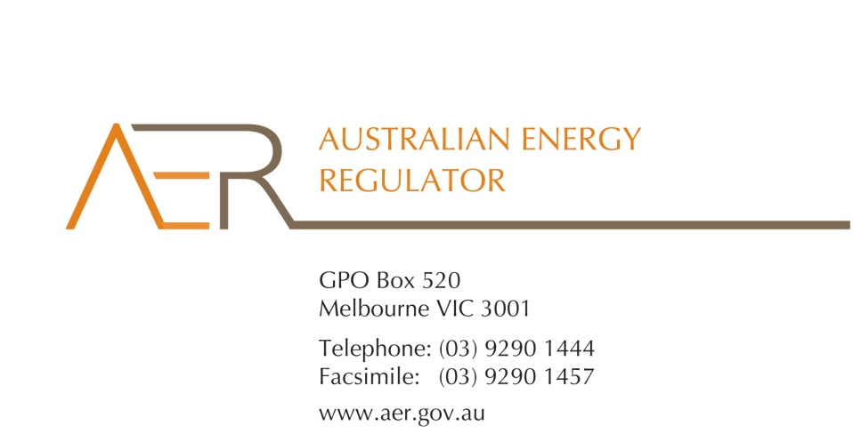

Our reference: 54998 - D14/82831

Contact Officer: Anthony Bell

Contact Phone: 03 9290 6914

26 June 2014

The Honourable Bruce Billson MP

Minister for Small Business

Parliament House

CANBERRA ACT 2600

Dear Minister

**Australian Energy Regulator’s Statement of Intent**

Thank you for providing the Government’s Statement of Expectations for the Australian Energy Regulator (AER) on 26 March 2014.

I am pleased to provide you with the AER’s Statement of Intent. Our Statement of Intent sets out how we will contribute to the Government’s deregulation agenda by ensuring regulatory best practice in our decision making and communication practices. It also emphasises the importance of transparency, accountability and maintaining constructive relationship with Government and other stakeholders.

The Statement of Expectations and the Statement of Intent have been published on the AER website and are available at [www.aer.gov.au/publications/corporate-documents](http://www.aer.gov.au/publications/corporate-documents).

Yours sincerely

Andrew Reeves

Chair

Australian Energy Regulator

AER Statement of Intent

The Government’s vision is for the Australian Energy Regulator (AER) to be a high performing and consultative agency that administers a principles-based regulatory framework in a way that promotes the long term interests of consumers and minimises compliance costs.

In this context, the Government has issued a Statement of Expectations for the AER, which outlines the Government’s expectations of our role and responsibilities, our relationship with the Government, issues of transparency and accountability, and operational matters. The Statement of Expectations is available on the AER website at: [www.aer.gov.au/publications/corporate-documents](http://www.aer.gov.au/publications/corporate-documents)

This Statement of Intent responds to the Government’s Statement of Expectations for the AER.

**Our role**

The AER is an independent body responsible for energy network regulation, wholesale energy markets surveillance and non-price retail market regulation. We are also responsible for enforcing the national gas and electricity laws as set by the member state and territory governments. Another independent body, the Australian Energy Market Commission, makes rules that govern the national electricity and gas markets, which the AER must then enforce.

In undertaking our various roles, we are guided by objectives set out in the electricity and gas laws. The objective of the National Electricity and Gas Laws is to promote efficient investment in, and efficient operation and use of, energy services for the long term interests of consumers of energy with respect to:

* price, quality, safety, reliability and security of supply of energy
* the reliability, safety and security of the national energy systems.

## The Government’s deregulation agenda

We will act in accordance with regulatory best practice in our decision-making, policies, processes and communication practices to maximise efficiency, effectiveness and transparency, and minimise compliance costs. This includes complying with the Government’s enhanced Regulatory Impact Analysis requirements for all regulatory proposals. We will consider the impacts of regulation on business and the community. Working closely with the Office of Best Practice Regulation, we will cost proposals before they are introduced using the Regulatory Burden Measurement Framework.

We will regularly review our policies and procedures to identify opportunities to reduce compliance costs on business. Energy consumers should pay no more than necessary for the safe delivery of reliable electricity and gas network services. Minimising compliance costs for energy businesses is in the long term interests of consumers.

To assist network businesses prepare their regulatory proposals, we have developed a range of guidelines that clarify their obligations and reduce regulatory burden. We also undertake a ‘framework and approach’ process that clearly and transparently sets out how we will apply aspects of the regulatory framework. The process provides an opportunity for the businesses, community and other interested parties to have a say on which services should be regulated, and how prices for those regulated services are determined. Levels of regulation for services are determined in accordance with the degree of market power businesses can exercise. Where there are options for competition, regulation may be limited or removed altogether.

Price and revenue regulation requires access to up-to-date and comprehensive information about businesses’ operations. In imposing information requirements on the businesses (through ‘Regulatory Information Notices’),[1] we are mindful of legislative requirements on us to minimise compliance costs.[2] We undertake significant consultation on the information requirements, including draft decisions and workshops. We will also periodically review the requirements, incorporating stakeholder feedback, to avoid unnecessary requests for information and remove any duplication.

We will continue to review and update our website to make it more user-friendly and accessible, and provide timely information on our decision processes and other activities. Further, we will look for opportunities to utilise our website to reduce administrative-type burdens. For example, we have recently created online ‘exemption registration’ forms that will substantially reduce the amount of time spent by stakeholders to complete registration processes.

We adopt a risk based approach to monitoring and enforcing compliance, based on the likely impact of a breach on participants, end users and other stakeholders, and the probability that a breach may occur.

Given the magnitude of obligations in the national energy laws, we undertake a risk assessment of each requirement under the legislation to assist us to prioritise and target our monitoring and compliance activities. This is consistent with our recently revised Compliance and Enforcement Statement of Approach.[3]

We have discretion in deciding whether to take enforcement action and the nature of that action. We strive for a proportionate response to breaches. Ideally, energy businesses should resolve compliance issues through agreed outcomes, without us needing to exercise statutory enforcement powers or seek financial penalties. We assess each case on its merits. In determining an appropriate enforcement response we consider all relevant circumstances.

## Transparency and Accountability

We endeavour to have an open and consultative relationship with the businesses that we regulate. Increased engagement can inform our decision making process to help achieve outcomes that are in the long term interests of consumers. We want to avoid an approach based solely on an iterative ‘documentation exchange’. Instead, we want to focus more on inquiry, questioning and understanding.

Our Stakeholder Engagement Framework sets out the principles that will guide our public engagement with energy businesses, the community and other stakeholders affected by our activities. It commits us to communicate in a timely and clear way, and to be accessible and inclusive, transparent and measurable in our engagement activities.[4]

## Relationship with the Government

We will work with Treasury, the Department of Industry, the COAG Energy Council, jurisdictional government departments, the Australian Energy Market Commission (AEMC) and the Australian Energy Market Operator (AEMO) to identify possible improvements to the energy regulatory framework. We will make submissions on and help with energy policy matters relating to our functions, particularly where we have specialist expertise and knowledge.

Indeed, we regularly comment on major policy matters—such as the Department of Industry’s Energy White Paper process—and contribute to reviews, including rule change proposals that are being assessed by the AEMC. The Government and regulatory agencies often ask for our input into both the reform agenda and risks in the regulatory frameworks we administer. Our regulatory expertise allows us to provide some unique perspectives to inform the public policy debate.

Further, we are working with the COAG Energy Council to strengthen governance arrangements. We are required to develop an annual Statement of Intent in response to the COAG Energy Council’s Statement of Expectations.[5] As part of the COAG Energy Council framework, we must also report against key performance indicators. This new reporting framework is consistent with the Government’s objectives under the deregulation agenda.

1. We require, for example, the energy network businesses to submit RIN data to assist us in assessing their regulatory proposals and making a determination. The information we ask for goes to how the businesses operate and enables us to compare the businesses’ performance against each other and over time.
2. Under section 28F(1) of the National Electricity Law we must be satisfied that serving regulator information notices (RINs) to collect information is reasonably required for the AER to perform its functions under the National Electricity Rules and Law. In satisfying ourselves of this, we have regard to the factors listed in section 28F(2), namely why the information is required and the likely costs incurred by an efficient business in complying with the RIN or alternative approaches to obtaining the information.
3. See at: <http://www.aer.gov.au/node/5876>
4. The Stakeholder Engagement Framework is available on our website at: <http://www.aer.gov.au/node/21247>
5. The COAG Energy Council’s Statement of Expectations is available on the AER website at: [www.aer.gov.au/publications/corporate-documents](http://www.aer.gov.au/publications/corporate-documents). The COAG Energy Council was formerly the Standing Council on Energy and Resources (or SCER).