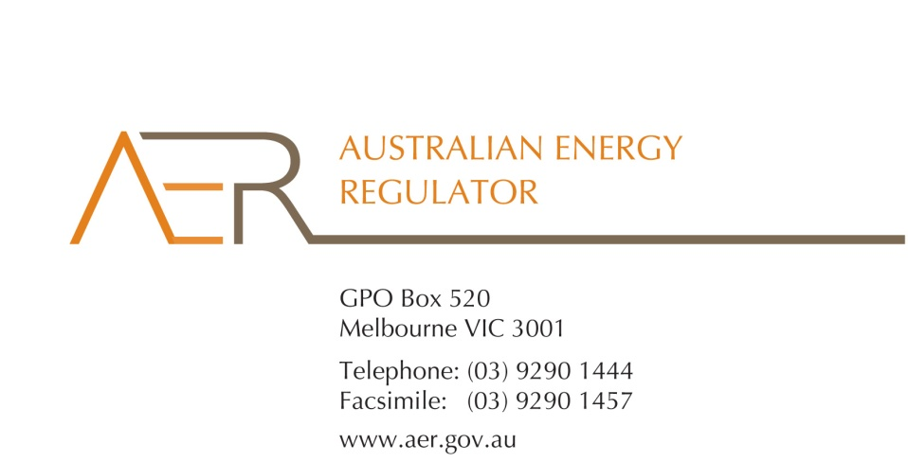

Our Ref: 48619
Your Ref:
Contact Officer: Michelle Groves
Contact Phone: (03) 9290 1423
7 June 2012
Prof. George Yarrow, Hon. Michael Egan and Dr John Tamblyn
Members
Review of Limited Merits Review Regime Secretariat
C/o Energy and Environment Division
Department of Resources, Energy and Tourism
GPO Box 1564
CANBERRA ACT 2601
By email: LMR.Secretariat@ret.gov.au
Dear Members
Submission to the Expert Panel’s Interim Stage One Report and Consultation Papers
The AER welcomes the opportunity to participate in the Expert Panel’s review of the Limited Merits Review (LMR) regime under the National Electricity Law and the National Gas Law.
Our enclosed submission responds to the Expert Panel’s Interim Stage One Report and its Consultation Papers of 30 March 2012 and 27 April 2012. It sets out our key concerns in the LMR regime and some changes for the Expert Panel to consider. It also sets out responses to some of the questions posed in the Consultation Papers.
Should you have any questions, please feel free to contact Michelle Groves on (03) 9290 1423 or me on (03) 9290 1419.
Yours sincerely
Andrew Reeves
Chair

