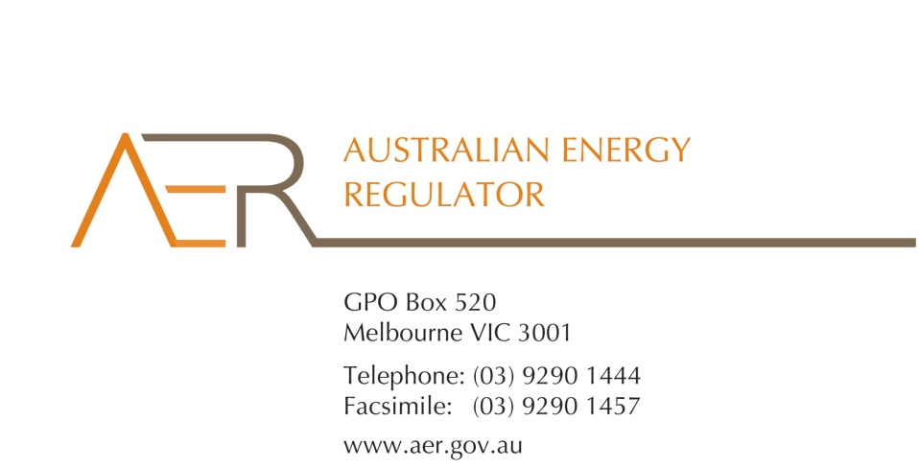

Our Ref: 61110

Your Ref:

Contact Officer: Jacqui Thorpe

Contact Phone: 03 9290 1994

19 December 2016

Mr John Pierce

Chairman

Australian Energy Market Commission

PO Box A2449

SYDNEY SOUTH NSW 1235

Dear Mr Pierce

Re: Submission on National Electricity Amendment (Improving the Accuracy of Transfers) Rule 2016

The Australian Energy Regulator (AER) welcomes the opportunity to comment on the Australian Energy Market Commission's (AEMC) draft rule determination to improve the accuracy of customer transfers. We support broadening the rule from transfers in error to address all transfers without explicit informed consent as this ensures consistency with other provisions in the National Energy Retail Law (Retail Law) and National Energy Retail Rules.

Customers through no fault of their own can find themselves transferred to a new retailer without their consent and can experience considerable difficulty returning to their original retailer. Placing clear obligations on retailers to resolve transfers without explicit informed consent improves transparency and provides a clear path for resolution. We also welcome placing the onus on a new retailer to prove that there is explicit informed consent for any transfer as this underscores the importance of this key protection under the Retail Law.

In particular we consider the draft rule also benefits consumers by:

* placing clear obligations on both the new and original retailer to resolve all transfers without explicit informed consent;
* requiring a retailer to maintain and, if needed, produce a record of a customer’s consent for twelve months; and
* clarifying the legal status of these transfers, including that if there is no record of consent then the transfer is void.

This last point is a particularly important outcome as it returns the customer to the original retailer on the same contract as if the transfer had not taken place. Voiding the transfer ensures that the customer is not penalised when transferred without their explicit informed consent.

We also support the requirement that a retailer will be prohibited from de-energising a customer who transferred to that retailer within the last 12 months unless the retailer has a record of the customer's explicit informed consent to the transfer. This can be the most serious and egregious outcome of transfer without explicit informed consent and we welcome the prohibition on this type of disconnection.

Finally, clear obligations on retailers to resolve transfers without explicit informed consent will support a smoother resolution process, improve transparency and enhance the customer experience. Importantly, this in turn will support and encourage customer participation in the retail energy market.

Thank you for the opportunity to comment on this important consumer issue and if you wish to discuss this further please contact Jacqui Thorpe on (03) 9290 1994.

Yours sincerely

Paula W. Conboy

Chair