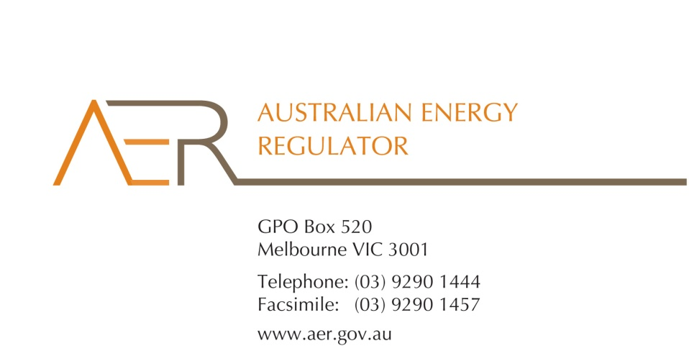

Our Ref: 48619

28 August 2012
Prof. George Yarrow, Hon. Michael Egan and Dr John Tamblyn
Members
Review of Limited Merits Review Regime Secretariat
C/o Energy and Environment Division
Department of Resources, Energy and Tourism
GPO Box 1564
CANBERRA ACT 2601
By email: LMR.Secretariat@ret.gov.au
Dear Members
Submission to the Expert Panel’s Stage Two Assessment
The AER welcomes the opportunity to participate in the Expert Panel’s review of the Limited Merits Review regime under the National Electricity Law and the National Gas Law.
Our enclosed submission sets out the recommendations that we consider should form part of any advice to the Standing Committee on Energy and Resources in Stage Two of this review.
Should you have any questions, please feel free to contact Michelle Groves on (03) 9290 1423 or me on (03) 9290 1419.
Yours sincerely
Andrew Reeves
Chair

