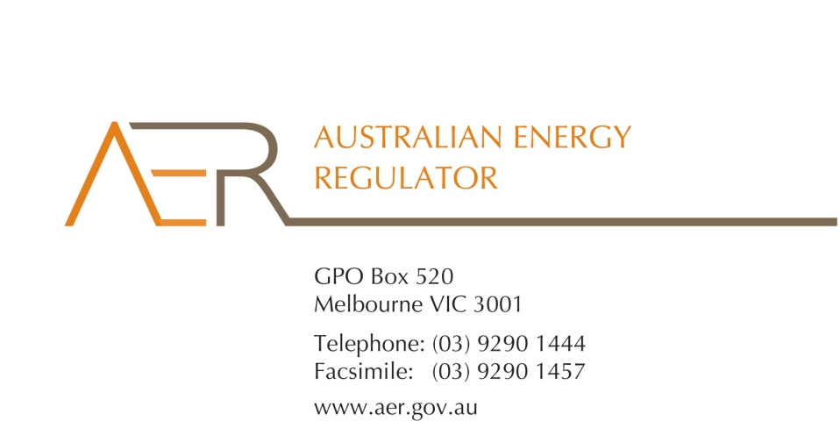

Our Ref: 59026

Your Ref: RRC0006

Contact Officer: Liam Hedge

Contact Phone: 03 9290 6917

28 January 2016

Mr John Pierce

Chairman

Australian Energy Market Commission

PO Box A2449

SYDNEY SOUTH NSW 1235

Dear Mr Pierce

Re: Submission on National Energy Retail Amendment (Meter Read and Billing Frequency) Rule 2016

The Australian Energy Regulator (AER) welcomes the opportunity to respond to the Australian Energy Market Commission's (AEMC) consultation paper on a proposal to amend the billing and meter reading provisions under the National Energy Retail Rules (Retail Rules).

The rule change proposed by Ergon Energy seeks to amend Retail Rules 24 and 21(1)(c) to require retailers to use their ‘best endeavours’ to issue bills to a small customer at least once every three months. Ergon Energy has also suggested that a maximum timeframe of up to 120 calendar days for retailers to issue a bill could be implemented as a safeguard for customers. Ergon Energy argues that these changes would align the billing frequency obligations on retailers with the obligations on Metering Data Providers and improve customer experience.

We do not support the changes proposed. We consider the current rules that allow retailers to issue a bill every three months when meter data is provided, and to estimate a bill when it is not, operate effectively. In particular, we are concerned that Ergon Energy’s proposals could unnecessarily lessen the frequency with which energy bills are issued to some customers. Further, we are concerned that the provisions would be more difficult to enforce, possibly resulting in lower levels of compliance.

The AER’s role in retail energy markets is to protect the interests of over 6.5 million household and small business energy consumers by administering the National Energy Retail Law and Rules. It is important that energy customers can participate actively and confidently in retail energy markets. We promote this goal by, among other things, working with energy businesses to ensure they have proper systems and procedures in place to comply with their obligations under the Retail Law and Rules.

***Current billing and meter reading provisions in the Retail Rules***

Division 4 Part 2 of the Retail Rules sets out the obligations on retailers when billing customers. It prescribes the frequency with which retailers must issue bills to customers (at least once every three months) and that retailers must use data from the customer’s meter as the basis for calculating bills. These provisions aim to ensure that customers receive accurate, regular and timely bills. These protections are important and they assist customers to understand their energy consumption patterns and the costs they incur by consuming energy (especially as customers are typically billed in arrears having already used the energy). Accurate, regular and timely bills can also assist customers in managing and budgeting for their energy costs. The Retail Rules permit retailers and customers to agree to a different, recurrent billing cycle where the retailer obtains the consent of the customer.

The Retail Rules also allow retailers to issue estimated bills to customers in the event that metering data is not available. The rules set out requirements on retailers when calculating estimated bills and for recovering either overcharged or uncharged amounts that may result from estimated bills.

These arrangements have been in effect since July 2012 and in our view are working well. We are not aware of broader or industry-wide concerns with the operation of these provisions. Similarly, delayed and estimated bills do not appear to be generating significant, or increasing, levels of complaints to energy ombudsman schemes that might indicate a rule change in this area is warranted.

Ergon Energy, in its rule change request, states that “[e]nquiries to the AER have established a strict interpretation should be applied that three months [referred to in Rule 24] is equivalent to no more than 92 days”. We disagree with this view and not do consider this an accurate reflection of the response provided to Ergon Energy on this matter. Ergon Energy approached the AER during its preparations for the commencement of the Retail Law and Rules in Queensland. Ergon Energy advised that in order to identify a breach of Rule 24 in a timely and efficient manner that it was developing an automated breach detection process. It proposed to use 92 days as a static reference to enable it to identify breaches of this obligation and sought advice from the AER as to whether this approach was appropriate. We advised Ergon Energy that this proposal would be appropriate for managing the reporting of this obligation. We recognise that the use of automated systems by retailers to identify breaches can be efficient and can avoid lengthy and manual processes which may delay the reporting of breaches to the AER. For these reasons, the AER will work with businesses to identify a pragmatic approach to reporting breaches of obligations as is the case in this instance.

In its rule change request, Ergon Energy notes that over 80 per cent of its bills are issued by 92 days, with 95 per cent issued by 95 days and over 99 per cent issued by 100 days. Ergon Energy advises that it has generally delayed issuing a bill to customers until metering data is received, rather than issuing an estimated bill. Ergon Energy argues that, under the current arrangements, retailers are not permitted to issue an estimated bill without customer consent if it still expects to receive an actual meter reading. We do not agree with this view. We consider that Rules 24 and 21, when read together, permit a retailer to issue a bill based on an estimate of the customer’s consumption where metering data has not been provided. Ergon Energy also identifies that estimated bills are a cause for complaint within their business, accounting for 15 per cent of its complaints.

We support the AEMC’s assessment framework to consider whether the rule change proposed will enhance the consumer experience and if the solution is proportional to the issue that it is designed to address. We agree with the AEMC that there is likely to be a point in which it is preferable for customers to receive an estimated bill than a significantly delayed bill (which in our view is 120 days). We also support the AEMC’s view that as more advanced meters are rolled out nationally delays in retailers receiving metering data on which to base a bill will become less of an issue.

***AER’s approach to compliance with billing obligations***

The reporting framework prescribed in the AER’s *Compliance Procedures and Guidelines*[1] (Guidelines) provides us with considerable data on the levels of retailer and distributor compliance with their obligations in the Retail Law and Rules. The data reported can highlight issues with how the rules operate in practice as well as their effectiveness in protecting customers.

Rules 21 and 24 are civil penalty provisions, reflecting the importance policy makers have placed on customers receiving a regular bill (including when based on an estimate, if necessary). Our experience shows that while minimal delays in issuing bills is not likely to cause problems for customers, longer delays (and therefore higher bills) can result in detriment by putting a customer under additional financial pressure and, in some instances, at risk of hardship. To date, the AER’s compliance work regarding Rule 24 has focussed on systemic and significant delays in retailers issuing bills to customers for these reasons.

In our experience, retailers are generally compliant with Rules 21(1) and 24. We have received reports of breaches to Rule 21(1) over the past three years and have observed a steady decrease in the number of customers affected by reported breaches of rule 24.

While the majority of reported breaches of rule 24 are attributed to delays in retailers receiving metering data, other typical causes of breaches of rule 24 include retailers suspending billing activities whilst investigating customer complaints, natural disasters, or because of system/IT issues. Our observations are that whilst a relatively high number of customers are affected by reported non-compliance with rule 24, for the most part, any delays experienced by affected customers are minimal (no reduction in the number of bills a customer would receive annually or significant lengthening of time between bills). These breaches have not typically resulted in consumer detriment or raise significant compliance concerns.

We are also aware that some retailers have made a business decision not to issue estimated bills to customers at all, preferring to wait until actual meter read data has been received and to issue the bill late. In this case, where bills are not issued at least every three months a breach is reported to the AER. The AER then actively monitors the number of customers who are issued a late bill and the average length of the delay.

Our analysis of reported data suggests that significant billing delays—where customers have not received a bill for several months—are typically caused by system or IT issues, rather than the non-provision of metering data. When these significant delays have occurred, we have worked with retailers to facilitate a resolution so customers can receive their bills as quickly as possible. In our experience most retailers have systems in place to remediate affected customers should this occur. Such initiatives include advising customers in advance their next bill may be late and providing customers with information about payment plans. Feedback received to date has indicated that this approach has been constructive and effective in reducing the number of customers affected by delayed bills and therefore breaches reported.

Recognising the importance of billing provisions in providing safeguards to energy customers, the AER completed its Small Customer Billing Review[2] in 2014. This compliance review found no substantive issues with the manner and form of bills issued by retailers. Since then we have undertaken further compliance work, issuing our *Compliance Check – billing obligations*[3] in April 2015. This provides guidance to retailers on billing obligations including the importance of complying with the overcharging and undercharging provisions of the Retail Rules when estimated bills are issued.

While the AER has not taken formal enforcement action for breaches of the billing provision, we continue to work with businesses to enhance compliance aiming to ensure an appropriate balance is struck between consumers being provided with accurate and regular bills.

The AER considers that Rules 21 and 24 in their current form provide important consumer protections and are operating effectively across the market. In administering these provisions, we work constructively with businesses when breaches occur to monitor and address any potential customer detriment and compliance issues without the need to amend the Rules.

##### Specific concerns around the proposed amendments to Rule 24

We are of the view that the proposal to amend Rule 24 to require retailers to only use their ‘best endeavours’ to issue bills at least once every three months, with a maximum delay of 120 calendar days (or four months) between bills, represents a significant change. We consider this would weaken the protections afforded to customers under the current rule. It could result in a significant delay between bills, with some customers only receiving three bills per year instead of four. In these instances, the average bill received by customers could be up to 33 per cent higher, adding stress to household budgets which may impact customers in vulnerable situations disproportionately.

It is also generally accepted that more frequent billing benefits customers and is easier to manage. The Energy Retailers Association of Australia recently noted in its energy affordability working group[4] that “more frequent billing allows customers to both manage their bills and increase their awareness of energy use and behaviour”. This is a view we support.

Our experience is that significantly delayed electricity bills can be a source of financial hardship for consumers, in part due to consumers already paying for their energy in arrears and not having easy access to information on their liability to their retailer. The requirement under rule 24 is intended to protect customers and ensure they receive at least a quarterly bill as well as to provide certainty about when they will receive a bill. This in turn assists customers with budgeting and managing their expenses as well as understanding their energy use in a timely manner.

In particular, we do not support the changes proposed by Ergon Energy to a move to a 'best endeavours' obligation under rule 24. Our experience suggests that a ‘best endeavours’ clause, being subjective in nature, is more difficult to enforce and this may encourage lower levels of compliance by some retailers. This change would significantly undermine the certainty of customers receiving a bill at least once every three months and would require the AER to take a broad approach to assessing the context and scope of conduct which may constitute ‘best endeavours’. A ‘best endeavours’ test would increase the factors that need to be taken into consideration by the AER, thereby raising the costs of monitoring compliance and investigating breaches. We would not consider such a change to be in the long term interests of consumers.

##### Rule 21(1)(c) proposed amendments

Ergon Energy proposes Rule 21(1)(c) be amended to clarify that a retailer is able to issue a bill based on a customer's estimated consumption when metering data has not been received.

The AER considers that Rule 20 and 21, when read together, permits retailers to issue bills based on estimated consumption when metering data has not been provided with sufficient time for the retailer to meet their obligations under Rule 24. We therefore do not consider an amendment to 21(1)(c) necessary. We are also concerned that the changes proposed do not clarify retailers’ obligations under rule 21.

##### Conclusion

The AEMC outlines three possible solutions to the issue identified by Ergon Energy:

1. allowing retailers to delay issuing a bill until a meter read has been provided, subject to a maximum time limit (Ergon’s proposed solution);
2. recommending to AEMO that it amend its Service Level Procedure: Metering Data Provider Services to require meters to be read more frequently so that bills are more likely to be issued on the basis of actual consumption at least once every three months; or
3. maintaining the current arrangements in which some small customers may receive estimated bills.

The AER supports option 3. We consider the current arrangements in the Retail Rules provide an appropriate framework for issuing regular (at least three monthly) bills to customers and that this is an important safeguard for customers to assist in managing their energy bills, budgets and in understanding their energy use. We also effectively administer these provisions and work constructively with businesses when breaches occur to monitor and address any potential customer detriment without the need to amend the Rules, or incur the additional costs that may be associated with option 2.

We are concerned that the proposed changes to rule 21 and 24, under option 1, would result in a weakening of consumer protections in this area and that this would not be in the long term interests of consumers. The changes as proposed could result in some customers experiencing longer delays in receiving their bills (with potentially customers only receiving three, instead of four, bills a year). The changes would also make these obligations more difficult for the AER to enforce and may encourage poorer billing practices by retailers. This in turn could undermine consumer confidence in the retail energy market. Finally, we consider the changes as proposed do not provide additional clarity to the rules in question and add unnecessary complexity to the drafting.

If the AEMC would like to discuss any of the issues raised in this submission please contact Liam Hedge on (03) 9290 6917.

Yours sincerely

Paula W. Conboy

Chair

1. Version 3, 2014: <http://www.aer.gov.au/system/files/Compliance%20procedures%20and%20guidelines%20-%20Version%203%20-%20September%202014_0.pdf>
2. <http://www.aer.gov.au/system/files/Small%20customer%20billing%20review%202014.pdf>
3. <http://www.aer.gov.au/system/files/Compliance%20Check%202015-02%20-%20billing_0.pdf>
4. Energy Retailers Association of Australia, Energy affordability working group update, December 2015.