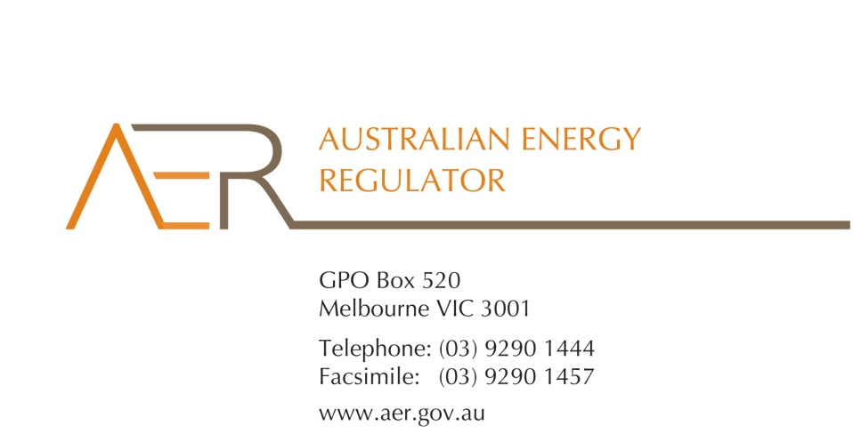

Contact Officer: Anthony Bell

Contact Phone: (03) 9290 6914

12 February 2014

*By email:* [*EWP@industry.gov.au*](mailto:EWP@industry.gov.au)

Dear Energy White Paper Taskforce

## Submission to the Energy White Paper issues paper

The Australian Energy Regulator (AER) welcomes the opportunity to provide this submission to the Department of Industry’s issues paper to inform the preparation of the Energy White Paper. Our comments on energy policy are based on our experience as the economic regulator of the National Energy Market. We regulate prices charged for using energy networks to transport energy to customers, monitor wholesale electricity and gas markets, and regulate retail energy markets in the ACT, South Australia, Tasmania (electricity only) and New South Wales.

We understand that the Energy White Paper will set out the Australian Government’s position on energy policy. Significant progress has been made on a broad package of Government reforms to the energy sector in recent years. The purpose of these reforms is ultimately to improve the living standards of the Australian community by lowering energy prices, improving energy efficiency and reducing energy production emissions. The Energy White Paper will contribute to this broader package of reforms by setting out an integrated, coherent and longer-term whole-of-Government position on energy policy.

The Government’s review is timely given the major transformations that are underway in the electricity sector in particular. We are now seeing the challenges of integrating small customers into the electricity market. The uptake of smart meters and devices bring with them opportunities for innovation and competition. The full benefits of these developments will only be achieved if the appropriate regulatory arrangements are in place.

To this end, the Power of Choice reforms recommended by the Australian Energy Market Commission (AEMC), and endorsed by the Standing Council on Energy and Resources (SCER), should remain a priority for the Government. In particular, we support reforms to the way by which network prices are set and structured to ensure the regulatory arrangements are robust to future changes in technology. Further, we support the introduction of contestability into any services where competition is viable, such as advanced metering services.

It should also be noted that we are currently in the process of implementing significant reforms to network regulation. As noted by the Government in the issues paper, there were important reforms to the National Electricity and Gas Rules in late November 2012 that address cost-of-living pressures on consumers.[1] Also, reforms to the limited merits review regime raise the hurdle for network businesses to appeal our decisions. These network reforms will be tested during our upcoming network pricing decisions.[2] Finally, the Power of Choice reforms and a review of the national frameworks for network reliability are still being progressed by the AEMC.

## The transformation of the energy sector

The electricity industry in Australia has undergone a number of transformations in the past two decades, and we are on the cusp of a further fundamental shift in the way electricity is produced and consumed.

Twenty years ago electricity was primarily generated at large industrial-scale generating plants and transported to consumers via the transmission and distribution networks. The large generators were typically closely integrated into the operation of the transmission and distribution networks, as well as retailing. Electricity consumers, on the other hand, were treated as essentially passive—they were able to consume as much as they desired at a fixed price.

With the establishment of the National Electricity Market, Australia introduced competition into the generation and retailing of electricity. The operation of generation and transmission is now coordinated through market mechanisms. This required a substantial change in the way the electricity industry was organised and operated.

As part of these reforms, a number of new institutions were developed to operate and oversee the market process, to coordinate operation and investment in the transmission networks, and to regulate the prices of the transmission and distribution networks. Such reforms have proven effective at delivering a reliable, stable supply of electricity, and on-going investment in a competitive, efficient generation sector. Although network prices have risen significantly in recent years, partly due to deficiencies in the electricity rules and reliability settings, recent changes strengthen the regulatory framework (as noted above), and provide for a more balanced assessment of the need to allow for ongoing efficient investment to ensure a reliable energy supply, with the need to minimise costs to consumers.

Looking forward, technological change and pressure for decarbonisation of the energy sector is leading to another major change in the sector. There is increasing interest in small-scale local generation, such as rooftop solar PV, small-scale wind-generation, and local storage of electricity. We may see a significant increase in the take-up of electric vehicles in the future, which has the potential to change the way electricity is stored and consumed. Further, the IT and communication revolutions have opened up the scope for a host of new devices and appliances, allowing small-scale consumers for the first time to respond to local electricity market conditions. A new wave of reforms is required to take advantage of these opportunities.

## Transition to the smart electricity grid of the future

New challenges have emerged in the energy sector. We have seen rapid growth in the penetration of air-conditioning units, which increase demand at peak times and drive up the need for network investments. Over a million households have installed roof-top solar PV, reducing the demand for network services even though, in most instances, the networks can deliver power to these customers more cheaply than it can be produced from solar generation. These problems may be further compounded as customers invest in smart appliances and battery storage, which could substantially shift the amount customers withdraw from or inject into the network from one moment to the next. Facilitating efficient decisions of this kind will require reforms to energy pricing and other regulatory arrangements (as discussed below).

In recent years, with improvements in IT and communications, it has become feasible to allow small customers to be more closely integrated into the electricity market. All customers are potentially generators or consumers, depending on their preferences and local market conditions. Many commentators use the word ‘prosumers’ to reflect the fact that consumers of electricity are also often producers of electricity, and may switch from net consumption to net production according to changes in the wholesale price.

Ideally, these ‘prosumers’ would be willing and able to directly or indirectly respond to local market conditions, so that they make efficient decisions as to the best time to, for example, use their electric dryer and dishwasher or, possibly in the future, charge and discharge their electric vehicles. They would also make efficient decisions about when to install an air-conditioning unit, or when to invest in energy-efficient appliances. To achieve efficiency in these decisions—that is, when to produce or consume electricity, and the kinds of production and consumption assets they purchase—end-customers must be more integrated into the wholesale market and face the efficient costs that are relevant to their decisions. This requires reforms to network pricing, among other things.

The increasing use of so-called smart devices and local generation facilities by even the smallest customers fundamentally changes the way we should think about the electric power system and the services it provides. From a paradigm of one-way managed electricity supply, the electricity industry is transforming to a new paradigm in which the industry exists to provide a platform for the two-way trade of electricity, with all customers large and small, able to be integrated with and respond to local market conditions.

These challenges bring with them new opportunities for consumers. There are several potential benefits from the increasing penetration of small scale generation and smart devices, and the integration of these customers into the wholesale electricity market. The integration of even small customers into the electricity market:

* facilitates the integration of small-scale variable renewable generation (such as solar PV, wind, and wave generation), thereby reducing the economic cost of achieving reductions in greenhouse gas emissions
* increases the resilience of the electricity network by increasing the range of production and consumption responses to supply, demand, and network shocks
* increases the utilisation of the network by reducing the need to build network capacity to cater for a relatively small number of peak periods per year, thereby reducing the need for costly network augmentations.
* allows customers options and choices when it comes to managing their electricity consumption, rewarding customers for reducing local consumption at times when it is most costly to supply that customer, and rewarding customers for increasing their local production at times when that production is most valuable to the local area
* helps customers make efficient decisions regarding investment in appliances, energy efficiency, and local generation and storage, ensuring that energy efficiency and generation technologies can compete on a level playing field, and preventing unnecessary waste and stranding of existing assets.

Perhaps the most significant benefit from increasing the integration of small customers into the electricity market is that it will lead to a range of entirely new services. In fact it may lead to a host of new services that are not yet known and that will deliver real value to consumers.

Integrating small customers into the wholesale market is a major shift in thinking. It will require a change in the sophistication with which small customers approach their electricity consumption. Of course, some customers will not wish to change. It will be important that customers see and expect to receive clear benefits from any change, which will require extensive consultation. Carefully managing this process to gain social acceptance is an essential part of the transition to a smart electricity grid.

It is noted that we support the introduction of contestability into any services where competition is viable. Broadly speaking we should not close out options by assigning ownership or control of specific devices or services to particular parties. For example, demand management, metering and local generation and storage are not monopoly activities. However, extension of the functions of the network businesses into these areas, in competition with others, raises concerns about whether there will be a ‘level playing field’. There is also the risk of relying on network businesses to consider and promote alternatives to network investment—alternatives that are not core to their business and may not involve investment in assets.

## Power of choice reforms remain a priority

The AEMC’s 2012 Power of Choice review recognised that the Australian energy sector is going through a period of change and faces a number of major challenges. The review set out a package of integrated reforms that aim to support the market conditions necessary to facilitate efficient demand-side participation in the National Electricity Market as the next step of significant reforms to this sector. The AEMC recommended a number of important reforms to manage the transformation of the energy sector, namely:

building consumer awareness, education and engagement

* engaging with consumers—provision of energy management services to residential and small business consumers
* consumer information—access to electricity consumption data
* enabling technology (ie metering and metering services)
* demand-side participation in wholesale electricity and ancillary services markets
* efficient and flexible pricing options for consumers
* distribution network incentives
* distributed generation
* energy efficiency measures and polices that impact or seek to integrate with the NEM.[3]

It is noted that these recommendations have been accepted by the SCER and are now at varying stages of progress through rule changes or other actions by jurisdictional authorities. Some recommendations will require ongoing work programs by relevant market bodies to consider details of implementation. The scope of the reform program requires leadership in implementing the agreed changes to the market and regulatory arrangements. As noted by the AEMC, the reforms should be implemented in a timely manner and be supported by an effective consumer awareness and education strategy.[4]

Given we are still in the early stages of implementation of these reforms, however, it is important that the Power of Choice rule changes remain a high priority for the Government. We consider there is the potential for significant benefits from improvements to pricing, demand-side management and advanced metering, to name three key areas. These reforms will be significant in enabling the transformation of the industry towards a smart grid future (as discussed above), by reducing market distortions, lowering overall costs to consumers—by empowering them to manage their energy use and save on energy costs by shifting their consumption away from peak times—and integrating small customers into the electricity market.

As a priority, we consider reforms to the way distribution businesses set and structure network prices are required. First, cost-reflective pricing is an efficient way of responding to rising peak demand.[5] Second, as long as customers face tariffs that do not reflect local network congestion, they will not face the correct incentives for investment in and use of local generation and smart devices.

## Concluding comments

The energy sector is on the cusp of a transformation, offering both new challenges and opportunities for electricity consumers. From a paradigm of the one-way delivery of electric power to the location of the customer, we are seeing a shift to a new paradigm in which the primary service provided by the electric power industry is a platform for the trade of electricity by all customers—large and small. This environment creates even greater urgency for a system of pricing that moves toward cost-reflectivity. It is also important that the regulatory settings encourage and reward efficient innovation, adopt open systems to allow participation by multiple agents in activities that are not strictly monopoly activities and, most importantly, be open and communicate with customers and community about the issues, needs and benefits of reform.

The electricity industry of the future will likely look quite different to the electricity industry of today. The Government’s White Paper process offers the opportunity to set the course for the industry over the next 10–15 years or so. We encourage the Panel to take up this challenge of setting out a vision for the industry and a set of principles to be followed as we transition to the smart electricity grid of the future.

If you would like to discuss any aspect of this submission, please contact Anthony Bell, Director, Regulatory Strategy and Coordination, on (03) 9290 6914. We welcome the opportunity to participate in the Energy White Paper process and intend to make a further submission to the Green Paper.

Yours sincerely

  
  
Andrew Reeves

Chairman

Australian Energy Regulator

1. We initiated our Better Regulation program in November 2012 to develop our approach to regulation under the new Rules. In late 2013, we published our final guidelines covering a number of aspects, including how we assess network expenditure proposals, encourage efficient spending by businesses, calculate the allowed return on assets, and engage consumers in the regulatory process. In short, we are improving both how energy network businesses are regulated and consumer engagement in our regulatory processes.
2. Our Better Regulation guidelines will apply to network businesses at their next determination. Electricity network prices will first begin to be affected by our new approach in New South Wales and the ACT with determinations for businesses in these jurisdictions commencing in early 2014. Following New South Wales and the ACT, we will implement the Better Regulation reforms in Queensland, South Australia and then Victoria. All energy networks will be subject to the new approach by 2018.
3. AEMC, *Power of Choice review*, final report, implementation plan, p. 2.
4. ibid, p. 2.
5. Network and generation capacity is based on meeting peak, not average demand. Peak demand growth has been a key driver of investment in generation and network capacity in the last five years. For example, in New South Wales, peak demand events occurring for less than 40 hours per year (or less than 1 per cent of the time) account for around 25 per cent of retail electricity bills, as estimated by the Productivity Commission in its 2013 into Electricity Network Regulatory Frameworks (p. 16).