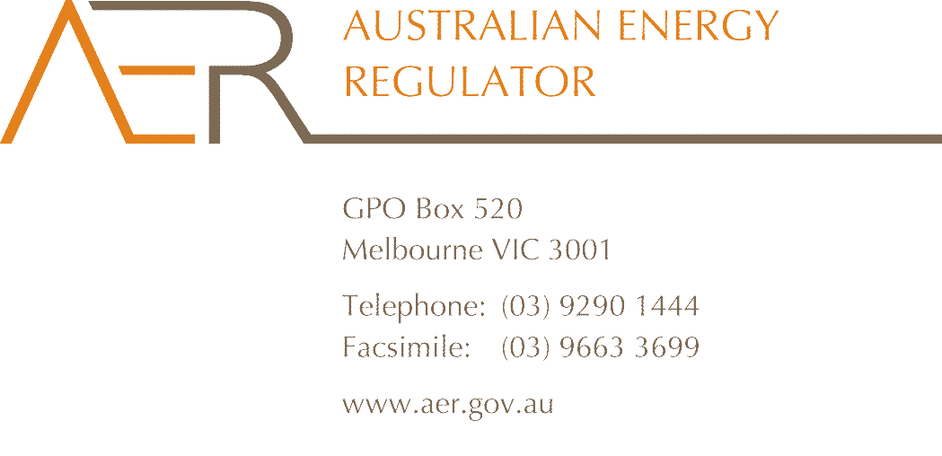

Our Ref: 43491

Your Ref: EMO0024

Contact Officer: Fiona Walker

Contact Phone: (03) 9290 1440

25 September 2014

Mr John Pierce

Chairman

Australian Energy Market Commission

PO Box A2449

SYDNEY SOUTH NSW 1235

Dear Mr Pierce

**Submission on NEM Financial Market Resilience Second Interim Report**

The Australian Energy Regulator (AER) welcomes the opportunity to comment on the draft recommendations set out in the Australian Energy Market Commission’s (AEMC) National Electricity Market Financial Market Resilience Second Interim Report.

The AER generally supports the proposed amendments to the RoLR regime, credit support requirements, and amendments to the suspension provisions. Changes to the RoLR regime such as delaying the designation of RoLRs will make the RoLR regime more effective in managing retailer failures of any size, and should be addressed as a matter of priority. The AER considers that these changes can proceed independently of the proposed work program on stability arrangements.

The AER agrees that addressing large retailer failures through the RoLR regime would result in unacceptably high market concentration, and that large retailer failures need to be managed outside the RoLR regime. The AER therefore supports further exploration of stability arrangements in the form of a special external administration regime.

The AER has set out its considerations on the draft recommendations in Chapters 6, 7, 8 and 9 of the second interim report below.

The AER would be pleased to provide further assistance to the Commission on this important area of work. If you would like to discuss any aspect of this submission please contact Peter Adams, General Manager, Wholesale Markets, on (03) 9290 1465.

Yours sincerely

Andrew Reeves

Chairman

Australian Energy Regulator

The AER sets out its considerations on the draft recommendations below:

**Chapter 6 - Responding to a large participant failure**

AEMC Recommendation:*Relevant market bodies provide advice through a ‘NEM Resilience Council’, to assess and advise government on which participants meet the classification of a ‘SIMP’, escalate instances where a SIMP may be imminently facing financial distress and prepare advice on the best course of action. All decisions on the management of and response to a SIMP failure to be made at a single decision-making point, including decisions regarding suspension and revocation of retailer authorisations.*

The AER agrees that a separate framework is required for responding to the failure of a SIMP, and that a single decision-maker, that is responsible for intergovernmental co-ordination, may be appropriate in such a situation.

The events and circumstances that would be appropriate triggers to initiate the consideration of the NEM Resilience Council could be based on the events, circumstances and matters that are set out in sections 130(1) and 130(2) of the National Energy Retail Law. That is, any event, circumstance or matter that may or will affect, or give rise to some risk of affecting, continuity of the sale of energy to a SIMP’s customers, and including the specific events listed in subsection 130(2)(a) to (d) of the Retail Law:

* The events and circumstances that constitute a RoLR event
* Any material default by the SIMP in the provision of required credit support to a distributor
* Any material default by the SIMP in the payment of network charges
* Any other material default by the SIMP with respect to its obligations under energy laws with respect to the payment of money, the provision of securities or otherwise of a financial nature.

**Chapter 7 – Stability Arrangements**

AEMC Recommendation: *Stability arrangements would apply when a SIMP fails, which would involve a form of special external administration or management. The AEMC recommends that the COAG Energy Council commission energy departments, in consultation with Commonwealth, State and Territory Treasuries, to form a working group to develop the detailed design of stability arrangements for the NEM*

The AER agrees that both the retail and generation activities of a vertically integrated energy business should be considered as part of any stability arrangements, and supports the formation of a working group to develop the detailed design of stability arrangements for the NEM.

Any stability arrangement should preserve incentives for compliance by the entity under special external administration or management. A participant operating in the market under external administration should be subject to requirements to report regularly to market institutions on matters such as resourcing, technical capability and the expected duration of the stability arrangements.

**Chapter 8 – Changes to existing arrangements – the RoLR scheme**

AEMC Recommendation: *Changes to the RoLR scheme to reduce the impact of increased cash flow and additional credit support challenges faced by a RoLR, providing the RoLR greater certainty that it can quickly recovery its costs*

The AER agrees with the AEMC that this recommendation will reduce the financial uncertainty faced by designated RoLR(s) following the failure of a large retailer, and may increase the number of retailers willing to submit expressions of interest to act as additional RoLRs. The recommendation should also assist RoLRs to borrow funds to cover their short-term costs of being a RoLR.

As the AER has noted in its previous submissions, there is a tension between providing certainty of cost recovery and limiting cost recovery to only reasonable costs. The proposed changes to the RoLR scheme have the potential to increase the cost to customers of smaller ROLR events, where there is no risk to the financial resilience of the NEM. For this reason, the AER considers that any changes to the cost recovery principles in s. 166(7) of the Retail Law should distinguish between smaller and larger RoLR events. The current cost recovery principles in s. 166(7) arrangements are an appropriate balance for smaller retailer failures, and should continue to apply to smaller RoLR events. Additional principles should be incorporated in the Retail Law to provide increased certainty of cost recovery of reasonable costs for designated RoLRs in larger retailer failures.

The AER notes the proposal for the AER to consider making an interim determination on RoLR cost recovery within a short period of an application where RoLR costs are substantial, and that Frontier Economics suggests that a “short period” might consist of two weeks. As it would not be feasible to conduct any meaningful analysis or consultation within a two week period, it would be preferable to develop a formulaic approach to determining what a RoLR can recover on an interim basis, or alternatively to extend the period that the AER has to consider an application.

AEMC Recommendation: *Delayed designation of RoLRs, to increase the potential for the AER to appoint multiple RoLRs*

The AER supports the extension of time to appoint the designated RoLRs, and considers that amendments to give effect to this recommendation should be progressed as a matter of priority. This will increase the effectiveness of the RoLR scheme by facilitating the AER’s appointment of multiple RoLRs, at least to the extent that multiple additional RoLRs are registered with the AER. It will also increase the potential for the AER to appoint additional RoLRs that have made a non-firm expression of interest in being a ROLR. If this recommendation is adopted, the AER will consider measures to minimise any communication and event management issues that may arise for customers and market participants, such as establishing the AER’s RoLR hotline early to provide advice on when RoLRs will be appointed. The current RoLR notice provisions in the Retail Law may need to be reviewed, to enable the AER to issue a RoLR notice without specifying designated RoLRs.

AEMC Recommendation: *Limiting the extent to which the RoLR arrangements apply to very large customers, who will have the opportunity to negotiate their own back-up retailer should a RoLR event occur*

The AER supports further consideration on the feasibility of limiting the application of RoLR arrangements to very large customers. Consideration should be given to whether these customers should be required to notify AEMO in writing of their backup retailer prior to any RoLR event. From an event management perspective, communicating with even a relatively small number of individual customers in the immediate aftermath of a RoLR event will introduce a complexity to the management of the RoLR event. Both the AER and AEMO have a number of responsibilities to manage immediately following a RoLR event, and would not be well placed at that time to initiate communications with individual customers.

AEMC Recommendation: *Delaying any additional credit support requirements the ROLR may be required to provide to DNSPs as a consequence of acquiring ROLR customers*

While we support some degree of risk sharing across the market in a RoLR event, and therefore support delaying additional credit support requirements to DNSPs in a RoLR event, consideration needs to be given to the combined effect of delayed credit support and distributor payment determinations. There is potential for the delaying of additional credit support requirements that the RoLR may be required to provide to DNSPs to occur at the same time as the AER makes an interim cost recovery determination, which would be recouped from distributors through distributor payment determinations. The combined effect of these two measures on distributors should be considered.

AEMC Recommendation: *Continued efforts by AEMO and AER to improve information and systems to enable the smooth transfer of customers.*

The AER supports any measures to ensure that standardised, up-to-date customer data is available, and would support an extension of the current gas customer information update arrangements to the NEM, to facilitate the smooth transfer of customers. While the main responsibility for the NEM RoLR Processes rests with AEMO and industry, the AER supports work to continuously improve the accuracy and transferability of customer information.

**Chapter 9 – Market suspension under the National Electricity Rules**

AEMC Recommendation: *Clarify the National Electricity Rules to allow the possibility of not suspending a participant, or parts of its activities, from the market when it is under external administration. This should only occur provided a number of conditions are met.*

The AER supports rule changes to clarify the market suspension provisions in the Rules, including changes that would allow the potential for the generation arm of a business to continue to participate in the market when the retail arm is subject to RoLR.

The AER considers that, given the difficulties with taking enforcement action against entities that are in external administration, it would be appropriate to ensure that a participant operating in the market under external administration is subject to conditions such as requirements to report regularly to market institutions on matters such as resourcing, technical capability and the expected duration of external administration. The framework should allow for the participant to be suspended for a broader range of reasons than those set out in the payment default procedure in rule 3.15.21 of the NER, such as significant non-compliance. This would ensure that the participant in external administration remains incentivised to comply with the market rules.

If the NER are clarified to allow for a retail entity that is under external administration to continue to participate in the market in certain circumstances, the interaction between the NER, the definition of “RoLR event” in the Retail Law, and the AER’s discretion to issue a RoLR notice will need to be considered. The framework should not require the AER to decide whether or not to issue a RoLR notice if a decision has already been taken to allow a retail entity under external administration to continue to participate in the NEM.