

SP AusNet

Transmission determination

2014–15 to 2016–17

January 2014

2. © Commonwealth of Australia 2014

This work is copyright. Apart from any use permitted by the Copyright Act 1968, no part may be reproduced without permission of the Australian Competition and Consumer Commission. Requests and inquiries concerning reproduction and rights should be addressed to the Director Publishing, Australian Competition and Consumer Commission, GPO Box 3131, Canberra ACT 2601.

Inquiries about this document should be addressed to:

1. Australian Energy Regulator
2. GPO Box 520
3. Melbourne Vic 3001
4. Tel: (03) 9290 1444
5. Fax: (03) 9290 1457
6. Email: [AERInquiry@aer.gov.au](mailto:AERInquiry@aer.gov.au)

AER reference: 50377

Contents

Contents ii

Shortened forms iii

Summary 1

1 Revenue 3

2 Negotiating framework 11

3 Negotiated transmission service criteria 20

4 Pricing methodology 22

1. Shortened forms

|  |  |
| --- | --- |
| 1. Shortened form | 1. Extended form |
| 1. AER | 1. Australian Energy Regulator |
| 1. capex | 1. capital expenditure |
| 1. CPI | 1. consumer price index |
| 1. DRP | 1. debt risk premium |
| 1. EBSS | 1. efficiency benefit sharing scheme |
| 1. MAR | 1. maximum allowed revenue |
| 1. MRP | 1. market risk premium |
| 1. NER | 1. National Electricity Rules |
| 1. NTSC | 1. negotiated transmission service criteria |
| 1. opex | 1. operating expenditure |
| 1. PTRM | 1. post tax revenue model |
| 1. RAB | 1. regulatory asset base |
| 1. STPIS | 1. service target performance incentive scheme |
| 1. TNSP | 1. transmission network service provider |
| 1. WACC | 1. weighted average cost of capital |

2. Summary

Clause 6A.13.4 of the National Electricity Rules (NER) requires the Australian Energy Regulator (AER) to make a transmission determination in relation to its final decision for SP AusNet. In accordance with clause 6A.2.2 of the NER, this transmission determination consists of:

* a revenue determination for SP AusNet in respect of the provision of prescribed transmission services
* a determination relating to SP AusNet’s negotiating framework
* a determination that specifies the negotiated transmission service criteria that apply to SP AusNet
* a determination that specifies the pricing methodology that applies to SP AusNet.

Revenue determination

In accordance with clause 6A.4.2(a) of the NER, the AER has determined a revenue determination specifying the following matters applicable to SP AusNet for the 2014–17 regulatory control period:

* the method for calculating the total revenue cap and the amount of the estimated total revenue cap
* annual building block revenue requirement for each regulatory year of the regulatory control period
* the method of calculating the maximum allowed revenue (MAR) for each regulatory year of the regulatory control period
* the method for indexation of the regulatory asset base (RAB)
* performance incentive scheme parameter values
* efficiency benefit sharing scheme parameter values
* commencement and length of regulatory control period
* other amounts, values and inputs used by the AER.

Negotiating framework

The NER requires certain transmission services (negotiated transmission services) to be provided on terms and conditions of access that are negotiated between the transmission network service provider (TNSP) and the service applicant.[1] Each TNSP is required to prepare a negotiating framework, which sets out the procedure to be followed during negotiations. The negotiating framework must comply with and be consistent with:

* the applicable requirements of a transmission determination applying to the provider
* the minimum requirements for a negotiating framework, which are set out in clause 6A.9.5(c).

The document at part 2 of this transmission determination is the negotiating framework that the AER has determined will apply to SP AusNet for the 2014–17 regulatory control period.

SP AusNet may seek to amend or replace its negotiating framework at the time it submits its revenue proposal for the regulatory control period commencing 1 April 2017, by submitting a new proposed negotiating framework in accordance with the NER as in force at that time.

Negotiated transmission service criteria

Clause 6A.9.4 requires the AER to set out the criteria that apply to a TNSP in negotiating the provision of negotiated transmission services, specifically:

* the terms and conditions of access for negotiated transmission services, including the prices that are to be charged
* access charges that are negotiated by the provider during that regulatory control period.

The criteria must also be applied by a commercial arbitrator to resolve disputes about negotiated transmission services, specifically:

* the terms and conditions of access for the negotiated transmission service, including the price that is to be charged for the provision of that service by the TNSP
* access charges that are to be paid to, or by, the TNSP.

The AER has determined that the negotiated transmission service criteria at part 3 of this transmission determination will apply to SP AusNet for the 2014–17 regulatory control period.

Pricing methodology

The NER requires each TNSP to prepare a proposed pricing methodology. The pricing methodology must give effect to and be consistent with the pricing principles for prescribed transmission services, which are set out in rule 6A.23. It must also comply with the requirements of the AER’s pricing methodology guidelines.

The document at part 4 of this transmission determination is the pricing methodology that the AER has determined will apply to SP AusNet for the 2014–17 regulatory control period.

# Revenue

Introduction

The AER is required to calculate the amount of revenue that SP AusNet requires each year of the regulatory control period in accordance with a building block approach.[2] This is referred to as the *annual building block revenue requirement*. The annual building block revenue is then used to calculate the expected *maximum allowed revenue* (MAR) for each year of the 2014–17 regulatory control period. The annual MAR that SP AusNet may earn from providing prescribed transmission services is subject to adjustments to account for factors such as inflation, approved pass through costs and annual performance rewards or penalties.

Method for calculating total revenue cap

1. The AER determines an estimated total MAR of $1600 million ($ nominal) for SP AusNet for the 2014–17 regulatory control period as shown in Table 1.1. The estimated total MAR is also known as the total revenue cap.  It is the sum of the expected MAR for each regulatory year.[3]

Table 1.1 AER final determination on SP AusNet’s annual expected maximum allowed revenue ($ million, nominal)

|  |  |  |  |  |
| --- | --- | --- | --- | --- |
|  | 2014–15 | 2015–16 | 2016–17 | Total |
| Expected MAR (smoothed) | 538.1 | 533.4 | 528.8 | 1600.3 |

Source: AER analysis.

1. The AER determines the annual expected MAR by smoothing the annual building block revenue requirement as set out below.

SP AusNet’s annual building block revenue requirement

1. The AER determines the annual building block revenue requirements for SP AusNet as shown in   
   table 1.2

Table 1.2 AER final determination on SP AusNet’s annual building block revenue requirement ($ million, nominal)

|  |  |  |  |  |
| --- | --- | --- | --- | --- |
|  | 2014–15 | 2015–16 | 2016–17 | Total |
| 1. Return on capital | 226.5 | 233.0 | 242.0 | 701.4 |
| 1. Regulatory depreciation | 75.1 | 81.0 | 86.6 | 242.7 |
| 1. Operating expenditure | 189.7 | 199.2 | 202.2 | 591.1 |
| 1. Efficiency benefit sharing scheme (carryover amounts) | 18.4 | 16.1 | 4.9 | 39.4 |
| 1. Net tax allowance | 9.5 | 9.3 | 9.8 | 28.6 |
| 1. Annual building block revenue requirement (unsmoothed) | 519.0 | 538.7 | 545.4 | 1603.1 |

Source: AER analysis.

Method of calculating SP AusNet’s maximum allowed revenue

1. The AER uses a forecast inflation rate in its post-tax revenue model (PTRM) to calculate the expected MAR (as shown in Table 1.1) in nominal dollar terms. Therefore, the calculation of the actual annual MAR will require an adjustment for actual inflation. The MAR is also subject to adjustments for revenue increment or decrement determined in accordance with the AER’s service target performance incentive scheme (STPIS) and any approved pass through amounts. This section sets out the method of this annual adjustment process.
2. The AER has determined that the method of calculating SP AusNet’s MAR for each year of the   
   2014–17 regulatory control period will be the sum of its allowed revenue (AR) for that year and adjustments arising from the AER’s STPIS and any approved pass through amounts.
3. The AER determines SP AusNet’s AR for 2014–15 is $538.1 million. The 2014–15 AR value may be adjusted for any service standards incentive rewards or penalties carried over from the 2008–14 regulatory control period, as determined in accordance with the AER’s 2008 revenue cap decision for SP AusNet.
4. SP AusNet’s AR for subsequent years of the 2014–17 regulatory control period requires an annual adjustment based on the previous year’s AR and is calculated using the CPI–X methodology:
6. AR*t* = AR*t-1* × (1 + ∆CPI) × (1 – X*t*)
7. where:
8. AR = the allowed revenue
9. t = time period/financial year (for t = 2, 3)
10. ∆CPI = the annual percentage change in the ABS Consumer price index (CPI) all groups, weighted average of eight capital cities from September in year t – 2 to September in year t – 1[4]
11. X = the smoothing factor of 3.24 per cent.
12. The MAR is determined annually by adding to (or deducting from) the AR:

* the service target performance incentive scheme revenue increment (or revenue decrement)[5]
* any approved pass through amounts.[6]

1. Table 1.3 sets out the timing of the annual calculation of the AR and performance incentive:
2. MARt = allowed revenue + performance incentive + pass through
3. = ARt + + Pt
4. where:
5. MAR = the maximum allowed revenue
6. AR = the allowed revenue
7. S = the revenue increment or decrement determined in accordance with the service target performance incentive scheme
8. P = the pass through amount that the AER has determined in accordance with clauses 6A.7.2 and 6A.7.3 of the NER
9. t = time period/financial year (for t = 2, 3)
10. ct = time period/calendar year (for ct = 2, 3).
11. Under the NER, a TNSP must also adjust the MAR for under or over recovery amounts.[7]

Table 1.3 Timing of annual calculation of annual revenue and performance incentive

|  |  |  |  |
| --- | --- | --- | --- |
| 1. t | 1. Allowed revenue (financial year) | 1. ct | 1. Performance incentive (calendar year) |
| 1. 2 | 1. 1 April 2015–31 March 2016 | 1. 2 | 1. 1 January 2014–31 December 2014 |
| 1. 3 | 1. 1 April 2016–31 March 2017 | 1. 3 | 1. 1 January 2015–31 December 2015 |

Method for indexation of the regulatory asset base

1. The AER has determined that the method for indexing SP AusNet’s RAB for each year of the 2014–17 regulatory control period will be the same as that used to escalate its AR for that relevant year—that is, to apply the annual percentage change in the most recently published Australian Bureau of Statistics’ (ABS) CPI all groups, weighted average of eight capital cities. For SP AusNet, this will be the September quarter CPI. This method will be used to roll forward SP AusNet’s RAB for the purposes of the AER’s transmission revenue determination for the regulatory control period commencing on 1 April 2017.

Performance incentive scheme parameters

1. The AER has determined the values for the performance targets, caps, collars and weightings for each of the parameters for the service component of the service target performance incentive scheme (STPIS) applicable to SP AusNet for the 2014–17 regulatory control period.[8] These are shown in table 1.4.

Table 1.4 SP AusNet service component performance targets, caps, collars and weightings to apply for the 2014–17 regulatory control period

|  |  |  |  |  |
| --- | --- | --- | --- | --- |
| 1. Service component parameters | Collar | Target | Cap | Weightings  (per cent of MAR) |
| 1. Average circuit outage rate (%) |  |  |  |  |
| 1. Line outage – fault | 42.0 | 25.9 | 14.8 | 0.2 |
| 1. Transformer outage – fault | 31.7 | 16.1 | 7.4 | 0.2 |
| 1. Reactive plant – fault | 46.4 | 35.1 | 2.5 | 0.1 |
| Line outage – forced | 17.7 | 14.9 | 12.3 | 0.0 |
| Transformer outage – forced | 17.6 | 12.0 | 6.2 | 0.0 |
| Reactive plant – forced | 32.7 | 15.4 | 6.2 | 0.0 |
| 1. Loss of supply event frequency parameter |  |  |  |  |
| 1. >0.05 system minutes (number of events per annum) | 6 | 2 | 0 | 0.15 |
| 1. >0.3 system minutes (number of events per annum) | 2 | 1 | 0 | 0.15 |
| 1. Average outage duration parameter |  |  |  |  |
| 1. Average outage duration (minutes) | 293.5 | 98.0 | 5 | 0.2 |
| 1. Proper operation of equipment |  |  |  |  |
| 1. Failure of protection system | n/a | n/a | n/a | 0.0 |
| 1. Material failure of SCADA | 2 | 1 | 0 | 0.0 |
| 1. Incorrect operational isolation of primary or secondary equipment | n/a | n/a | n/a | 0.0 |
| 1. Total service component weighting |  |  |  | 1.0 |

n/a: Not applicable.

Source: AER analysis.

1. The AER has determined that the market impact component parameter values will be calculated in accordance with section four and appendices C and F of the STPIS.[9] That is, the performance target will be set equal to the average performance over a rolling three calendar year period, while performance will be measured as the average performance over a two calendar year period.
2. The AER has determined that the priority projects and improvement targets shown in Table 1.5 will apply to SP AusNet during the 2014–17 regulatory control period.

Table 1.5 SP AusNet priority projects and improvement targets under the network capability component of the STPIS to apply for the 2014–17 regulatory control period

|  |  |  |  |
| --- | --- | --- | --- |
| 1. Rank | 1. Project circuit/injection point | 1. Description | 1. Improvement target |
| 1. 1 | 220kV switchyards at HTS, KTS, MLTS, ROTS, RTS, RWTS, SVTS, TTS and WMTS | Assess fault level at nominated terminal stations | Provision of report detailing the fault level capability of the equipment, structures and earth grid at the nine specified terminal stations. |
| 1. 2 | Altona TS | Protection setting change | ATS B4 220/66 kV transformer capability 174MVA. |
| 1. 3 | Templestowe TS | Replace 66kV interplant connections, review and uprate equipment ratings in RADAR | TSTS 220/66 kV B1 transformer rating 187 MVA and limited by 66 kV busbar rating of 181 MVA  TSTS 220/66 kV B3 transformer rating 192 MVA and limited by 66 kV busbar rating of 181 MVA  TSTS 220/66 kV B2 transformer capability of 175 MVA. |
| 1. 4 | Both Dederang –Murray 330kV lines | Installation of an emergency control scheme | Fully functioning emergency control scheme provided for the loss of both Dederang–Murray 330kV lines. |
| 1. 5 | Both Dederang–South Morang 330kV lines | Installation of an emergency control scheme | Fully functioning emergency control scheme provided for the loss of both DDTS–SMTS 330 kV lines, or both the DDTS–SMTS 330 kV lines together with 220 kV EPS–MBTS 1 & 2 lines, or both DDTS–SMTS 330 kV lines together with 220 kV EPS–TTS line. |
| 1. 6 | Rowville–East Rowville No 1 & 2 and Rowville–Springvale No 2 220kV circuits | Replacement of two 220kV isolators, protection setting changes | ROTS–ERTS No 1 & 2 220 kV circuits capability limited by circuit rating of 800 MVA.  Rating of isolators between ROTS No 1 220 kV bus and ROTS–SVTS No 2 line increased to 800 MVA or higher. |
| 1. 7 | Eleven 220 kV and 330 kV circuits | Increase instrumentation range on 11 circuits | Increase instrumentation range of the 11 circuits as set out on p. 13 of NCIPAP. |
| 1. 8 | Rowville–Malvern No 1 & 2 220kV circuits | Install a wind monitoring scheme | Implement dynamic rating for both ROTS–MTS 220 kV circuits. The scheme will be designed to achieve ratings of ROTS–MTS circuits under favourable ambient conditions as 234 MVA for system normal operation and 267 MVA under contingent conditions provided pre–contingency loading is less than 60% of 234 MVA. |
| 1. 9 | Moorabool–Mortlake–Heywood–Portland Aluminium customer substation No 2 500 kV circuit | Implement inter–trip control schemes | Fully functional APD inter–trip control scheme provided for this circuit to prevent potential overvoltage at APD 500 kV bus during a prior outage of plant connected at APD. |
| 1. 10 | Hazelwood–Loy Yang No 1, 2 and 3 500 kV circuits | Dynamic line model development and implementation | Hazelwood–Loy Yang No 1, 2 and 3 500 kV circuit capability implemented in the thermal line model based on ambient temperatures. |
| 1. 11 | Moorabool–Mortlake No 2 and Moorabool–Tarrone 500 kV circuits | Review and uprate protection settings in TRESIS | Moorabool–Mortlake No 2 500 kV circuit capability at 2858 MVA  Moorabool–Tarrone No 1 500 kV circuit capability at 2858 MVA. |
| 1. 12 | Keilor–Sydenham No 1 and Keilor–South Morang No 1 500 kV circuits | Review and uprate equipment ratings in RADAR | Keilor–Sydenham No 1 500 kV circuit secondary plant limit 2078 MVA  Keilor–South Morang No 1 500 kV circuit secondary plant limit 2078 MVA. |
| 1. 13 | Geelong TS | Review and uprate equipment ratings in RADAR | GTS 220/66 kV B2 transformer rating 169 MVA  GTS 220/66 kV B4 transformer rating 177 MVA. |
| 1. 14 | Ringwood TS | Review and uprate equipment ratings in RADAR | RWTS 220/66 kV B2 transformer rating 185 MVA and limited by 66 kV busbar rating of 181 MVA  RWTS 220/66 kV B3 transformer rating 190 MVA and limited by 66 kV busbar rating of 181 MVA |

Source: AER analysis; SP AusNet, Revised Appendix 6B: Network Capability Incentive Parameter Action Plan (NCIPAP) 2014–17, 20 December 2013; AEMO, AEMO endorsement of SP AusNet Network Capability Incentive Parameter Action Plan (NCIPAP) 2014–17 (with additional projects and quantified net benefits), 20 December 2013.

Efficiency benefit sharing scheme parameters

1. The AER has determined the values for the efficiency benefit sharing scheme (EBSS) parameters that are to apply to SP AusNet in the 2014–17 regulatory control period, subject to adjustments required by the EBSS. These values are set out in table 1.6.

Table 1.6 AER forecast opex for the EBSS target ($ million, 2013–14)

|  |  |  |  |  |
| --- | --- | --- | --- | --- |
|  | 2014–15 | 2015–16 | 2016–17 | Total |
| Forecast opex for the EBSS target | 78.7 | 80.8 | 81.6 | 241.1 |

Source: AER analysis.

Note: Forecast opex for the EBSS target excludes the categories listed below. Dollars are in end of year terms consistent with our final decision post-tax revenue model.

1. The AER will not adjust the forecast opex used to calculate the EBSS carryover amounts for changes in demand over the 2014–17 regulatory control period.
2. The AER will exclude the following cost categories from the EBSS for calculating EBSS carryovers:

* easement land tax
* self-insurance
* rebates made under the Availability Incentive Scheme
* debt raising costs
* the cost of priority projects approved under the network capability component of the STPIS.

1. The AER will also adjust actual opex for the 2014–17 regulatory control period to reverse any movements in provisions, consistent with the approach used to forecast opex for the period.
2. The length of the carryover period for efficiency gains (or losses) realised in 2014–17 will be the same as the length of the regulatory control period commencing in 2017.

Commencement and length of regulatory control period

1. The regulatory control period will be three years, commencing on 1 April 2014 and ending on   
   31 March 2017.

Other amounts, values and inputs

1. The AER has also determined the following values that could not be determined before the submission of the revenue proposal or were required to be estimated, approved or otherwise determined by the AER but are not so estimated, approved or otherwise determined before the submission of the revenue proposal. These are shown in table 1.7.

Table 1.7 Other amounts, values and inputs (per cent)

|  |  |
| --- | --- |
| 1. Parameter | Value |
| 1. Nominal risk free rate | 4.31% |
| 1. Inflation forecast | 2.45% |
| 1. Debt risk premium | 2.48% |
| 1. Effective tax rate | 22.75% |
| 1. Cost of equity | 9.51% |
| 1. Cost of debt | 6.79% |
| 1. Nominal vanilla WACC | 7.87% |

Source: AER analysis.

# Negotiating framework

1. 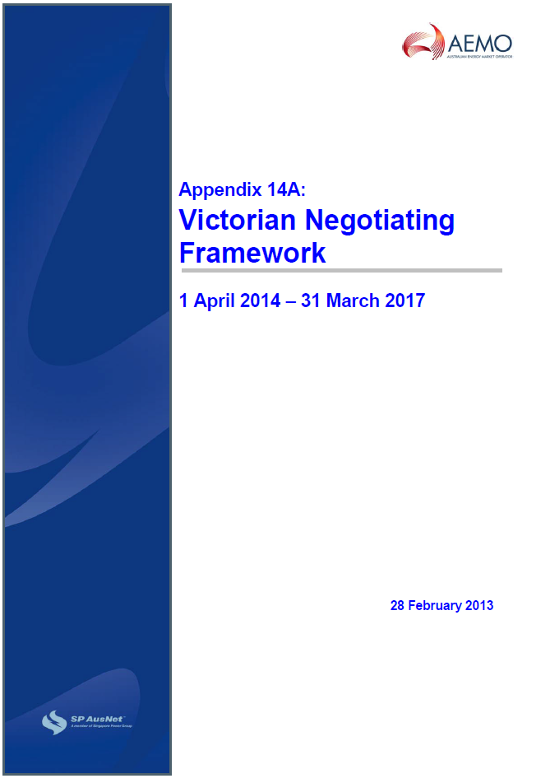
2. 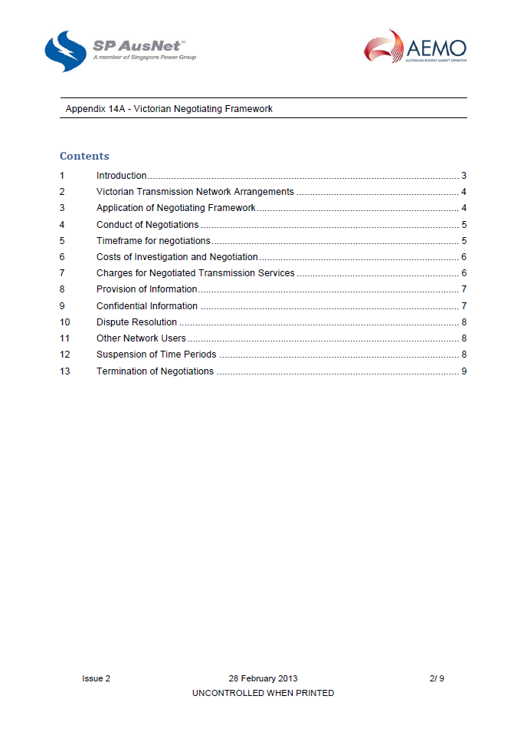

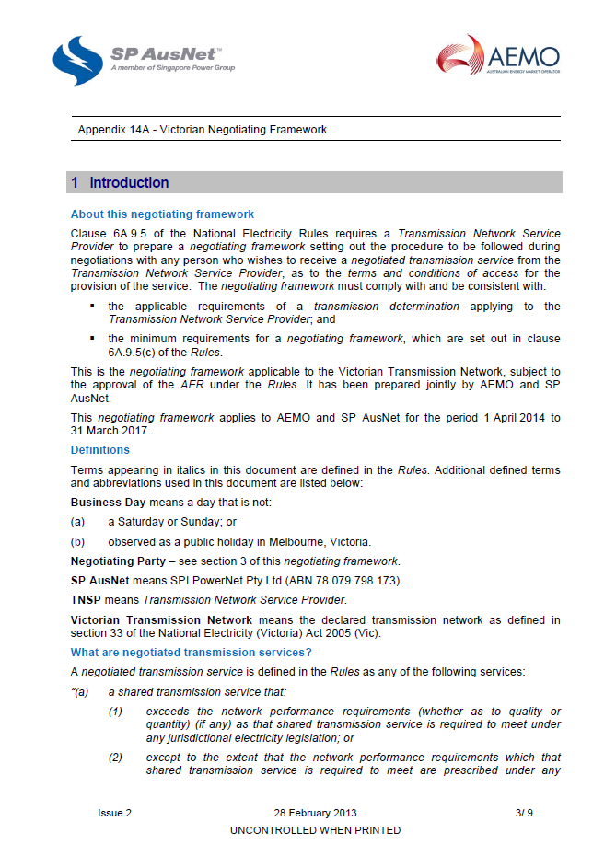

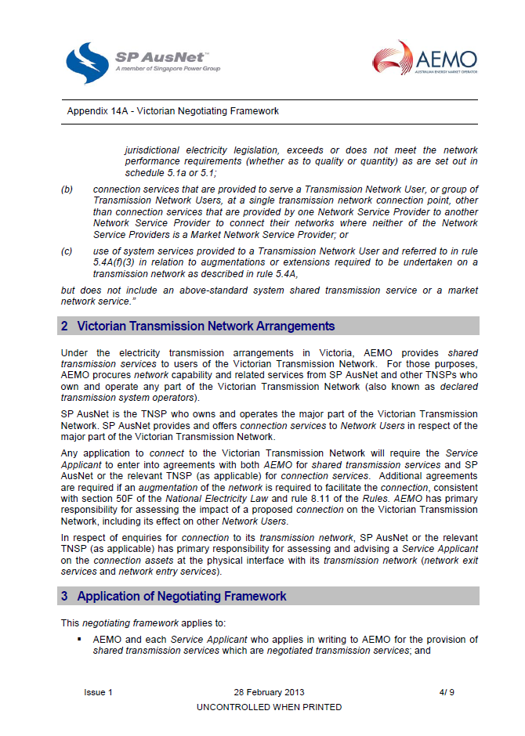

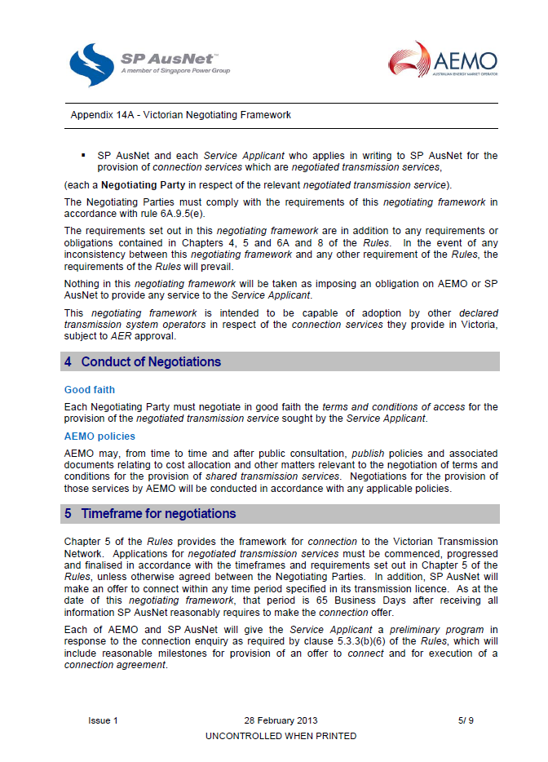

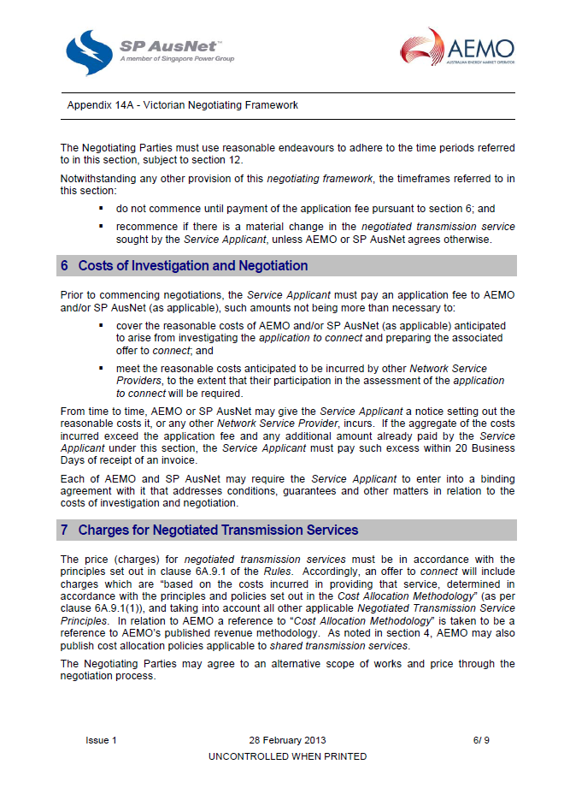

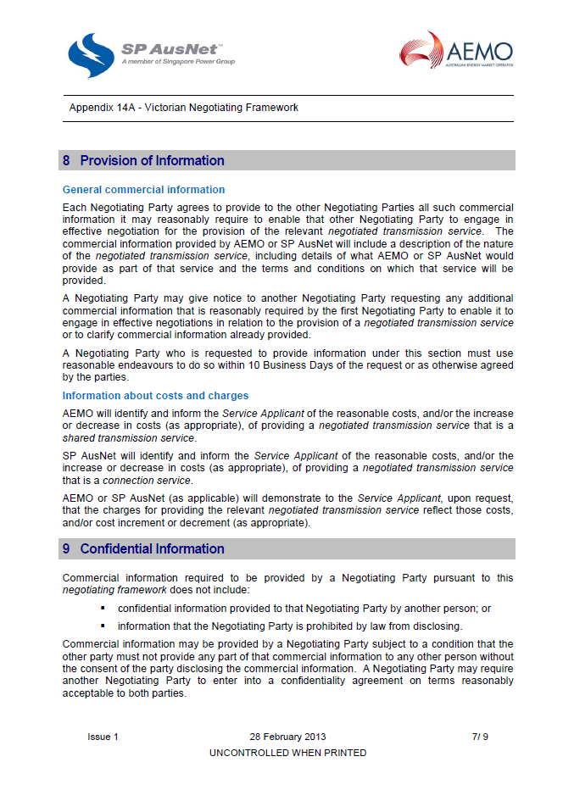

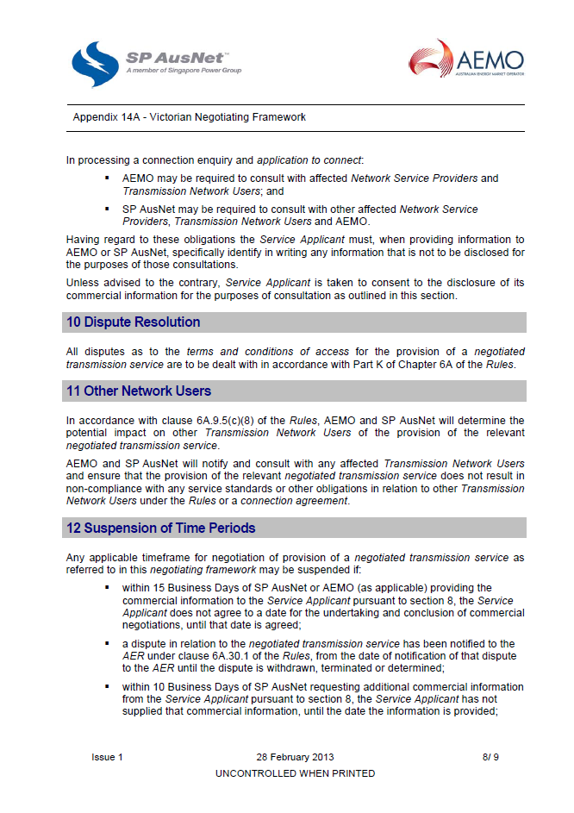

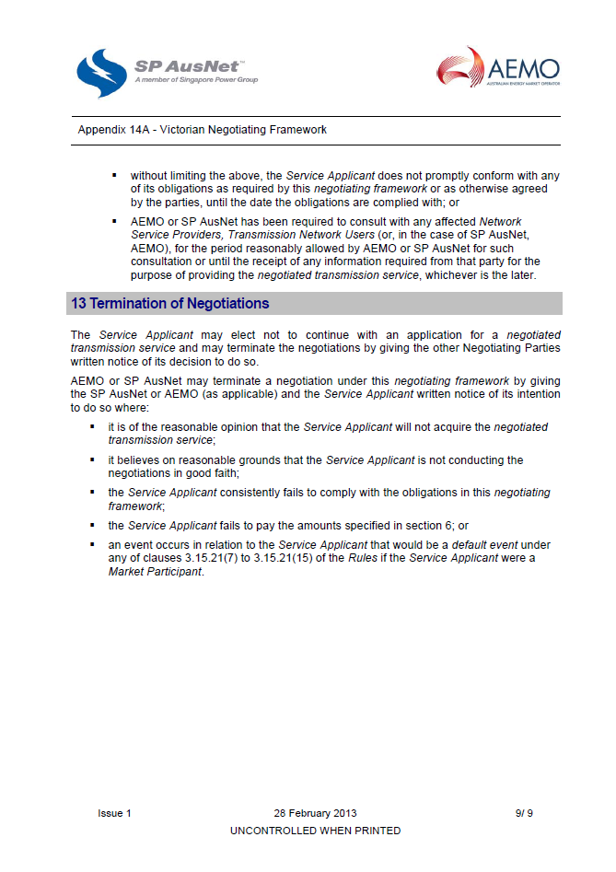

# Negotiated transmission service criteria

## National Electricity Objective

* 1. The terms and conditions of access for a negotiated transmission service, including the price that is to be charged for the provision of that service and any access charges, should promote the achievement of the national electricity objective.

## Criteria for terms and conditions of access

Terms and conditions of access

* 1. The terms and conditions of access for a negotiated transmission service must be fair, reasonable, and consistent with the safe and reliable operation of the power system in accordance with the NER.
  2. The terms and conditions of access for negotiated transmission services, particularly any exclusions and limitations of liability and indemnities, must not be unreasonably onerous. Relevant considerations include the allocation of risk between the TNSP and the other party, the price for the negotiated transmission service and the cost to the TNSP of providing the negotiated service.
  3. The terms and conditions of access for a negotiated transmission service must take into account the need for the service to be provided in a manner that does not adversely affect the safe and reliable operation of the power system in accordance with the NER.

Price of services

* 1. The price of a negotiated transmission service must reflect the cost that the TNSP has incurred or incurs in providing that service, and must be determined in accordance with the principles and policies set out in the Cost Allocation Methodology.
  2. Subject to criteria 7 and 8, the price for a negotiated transmission service must be at least equal to the avoided cost of providing that service but no more than the cost of providing it on a stand alone basis.
  3. If the negotiated transmission service is a shared transmission service that:
     + 1. exceeds any network performance requirements which it is required to meet under any relevant electricity legislation; or
       2. exceeds the network performance requirements set out in schedule 5.1a and 5.1 of the NER

then the difference between the price for that service and the price for the shared transmission service which meets network performance requirements must reflect the TNSP’s incremental cost of providing that service (as appropriate).

* 1. For shared transmission services, the difference in price between a negotiated transmission service that does not meet or exceed network performance requirements and a service that meets those requirements should reflect the TNSP’s avoided costs. Schedule 5.1a and 5.1 of the NER or any relevant electricity legislation must be considered in determining whether any network service performance requirements have not been met or exceeded.
  2. The price for a negotiated transmission service must be the same for all Transmission Network Users. The exception is if there is a material difference in the costs of providing the negotiated transmission service to different Transmission Network Users or classes of Transmission Network Users.
  3. The price for a negotiated transmission service must be subject to adjustment over time to the extent that the assets used to provide that service are subsequently used to provide services to another person. In such cases the adjustment must reflect the extent to which the costs of that asset are being recovered through charges to that other person.
  4. The price for a negotiated transmission service must be such as to enable the TNSP to recover the efficient costs of complying with all regulatory obligations associated with the provision of the negotiated transmission service.

## Criteria for access charges

Access charges

1. Any access charges must be based on the costs reasonably incurred by the TNSP in providing transmission network user access. This includes the compensation for foregone revenue referred to in clause 5.4A(h) to (j) of the NER and the costs that are likely to be incurred by a person referred to in clause 5.4A(h).

# Pricing methodology

1. 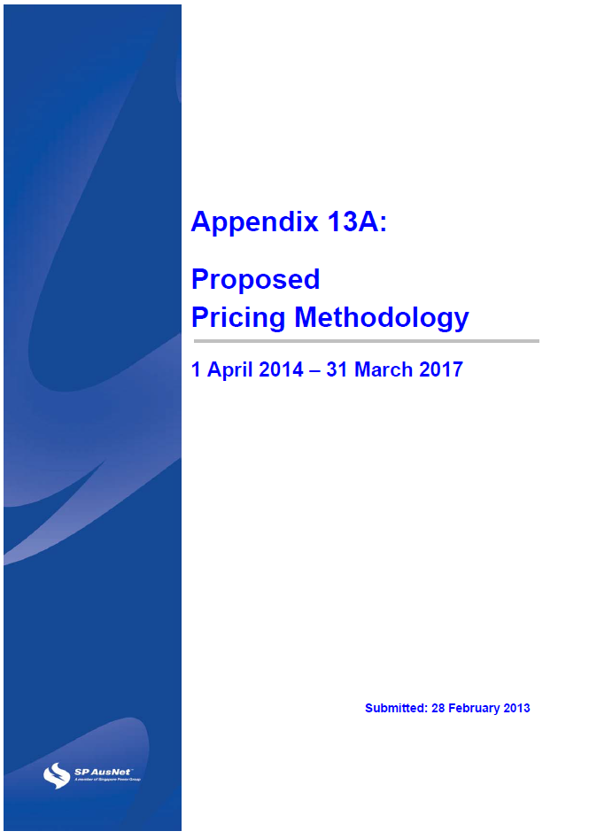
2. 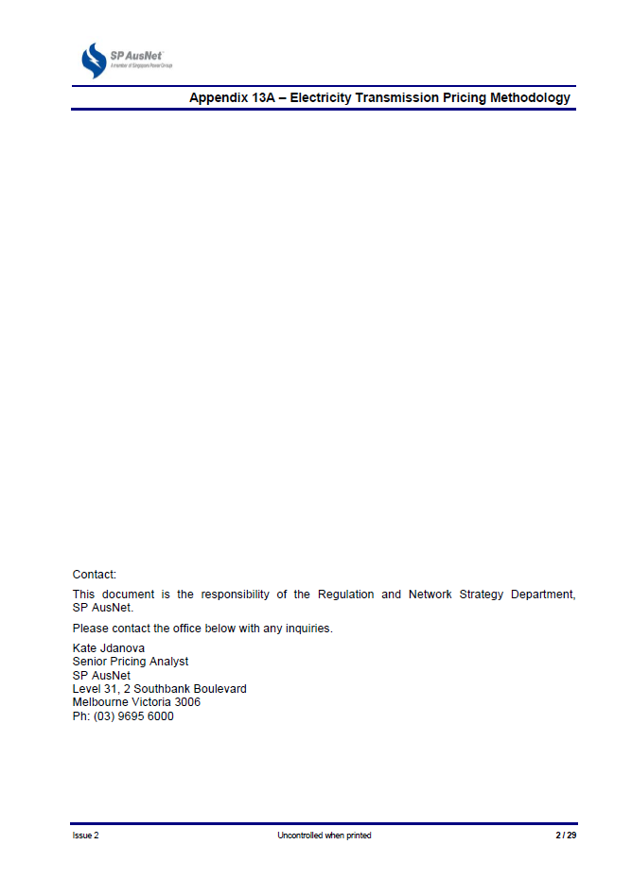

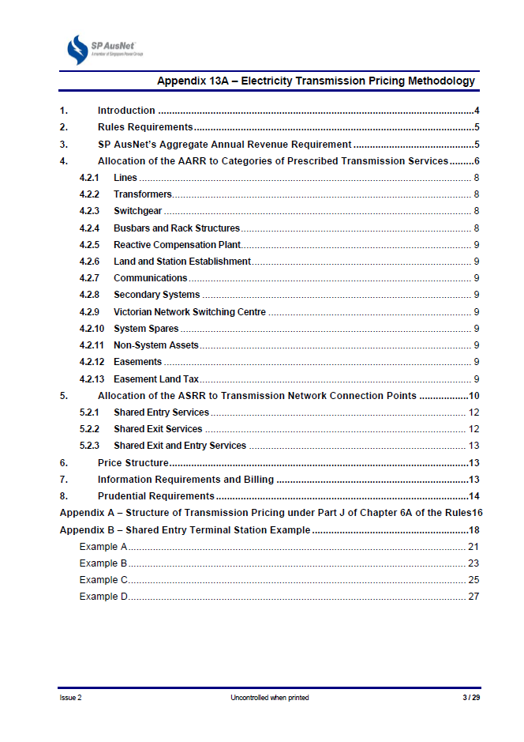

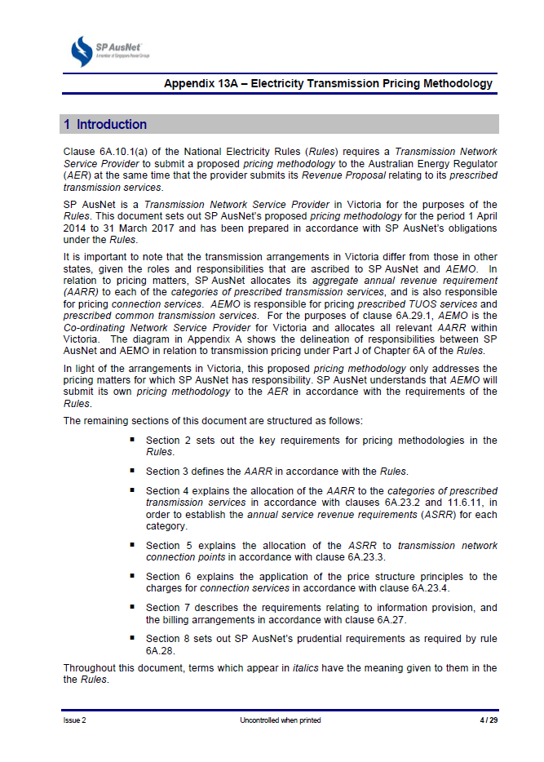

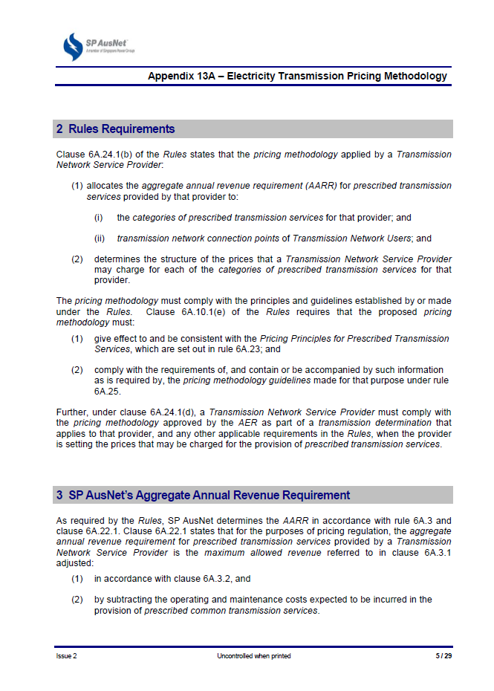

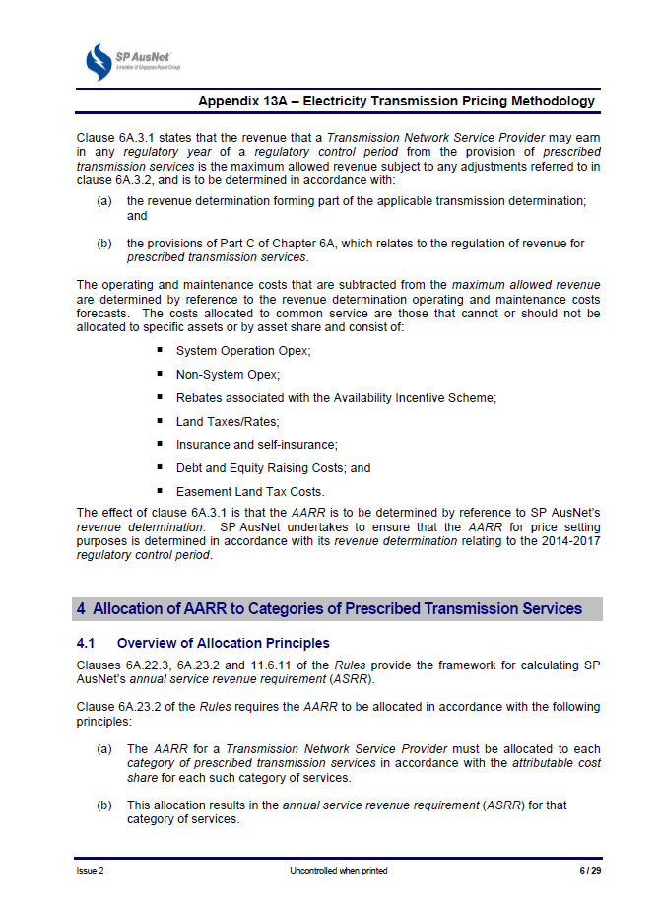

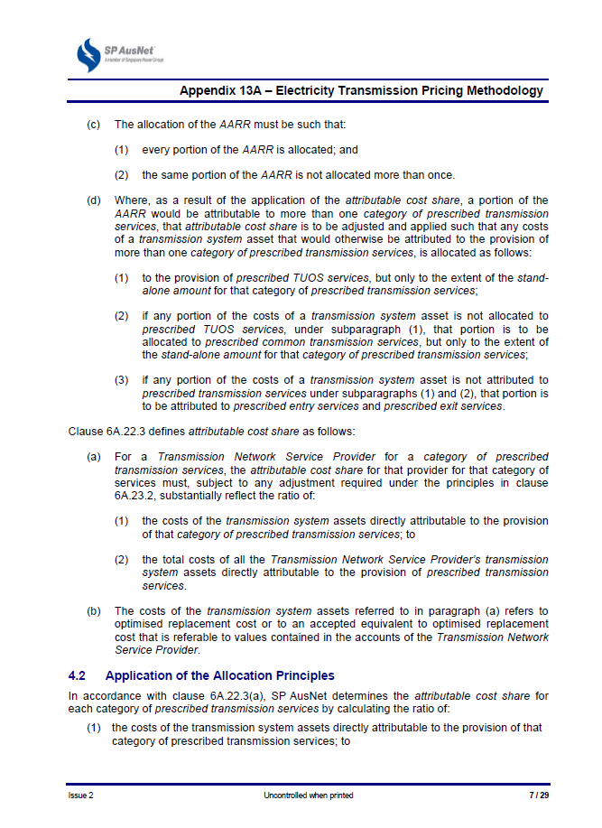

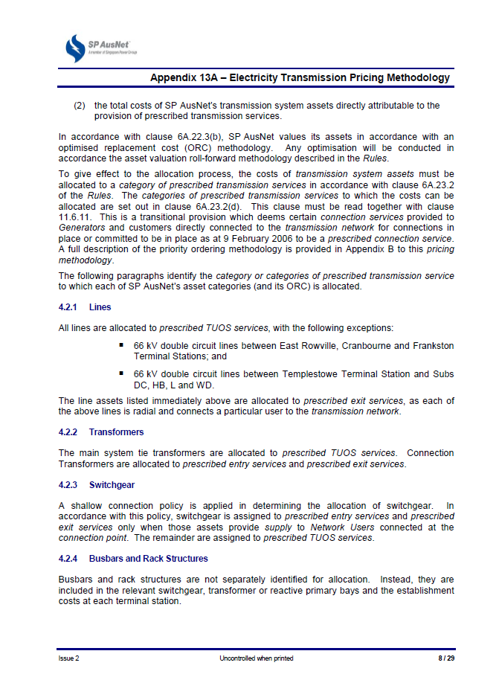

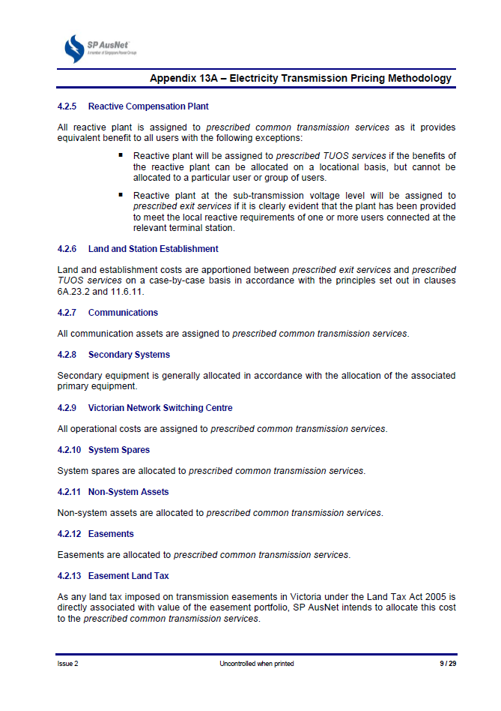

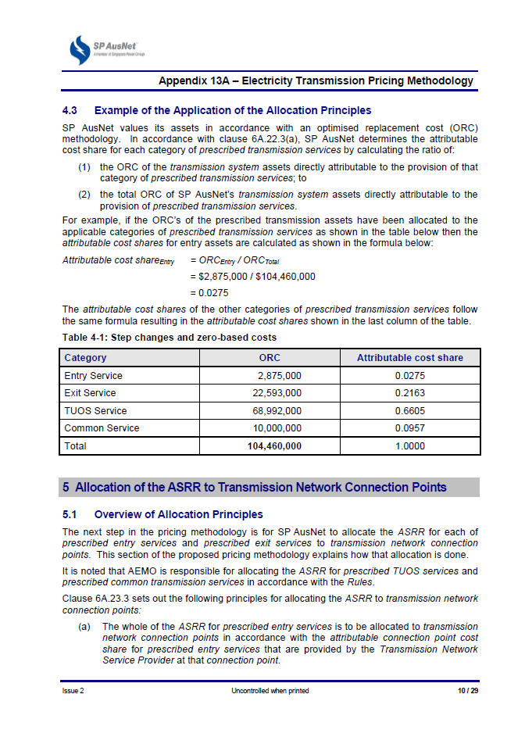

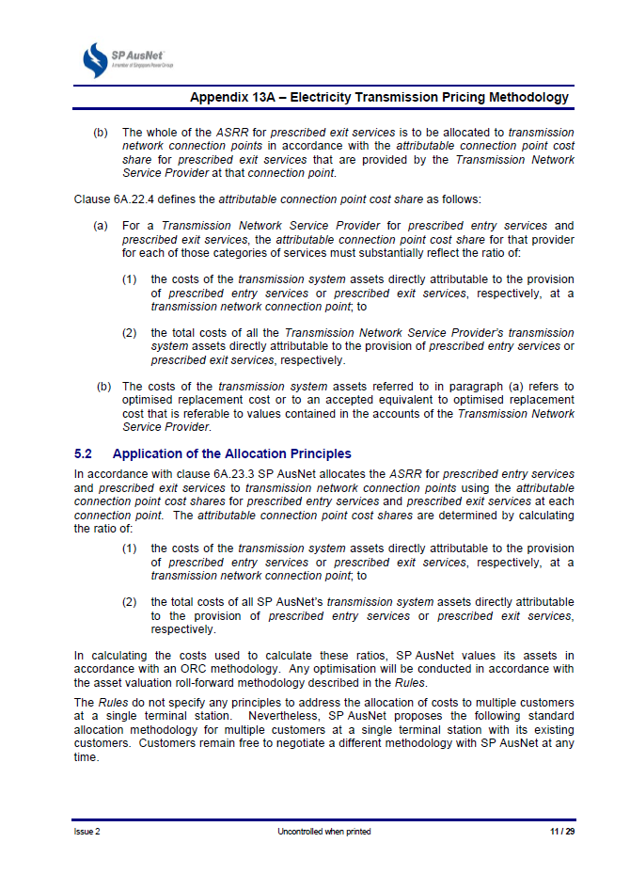

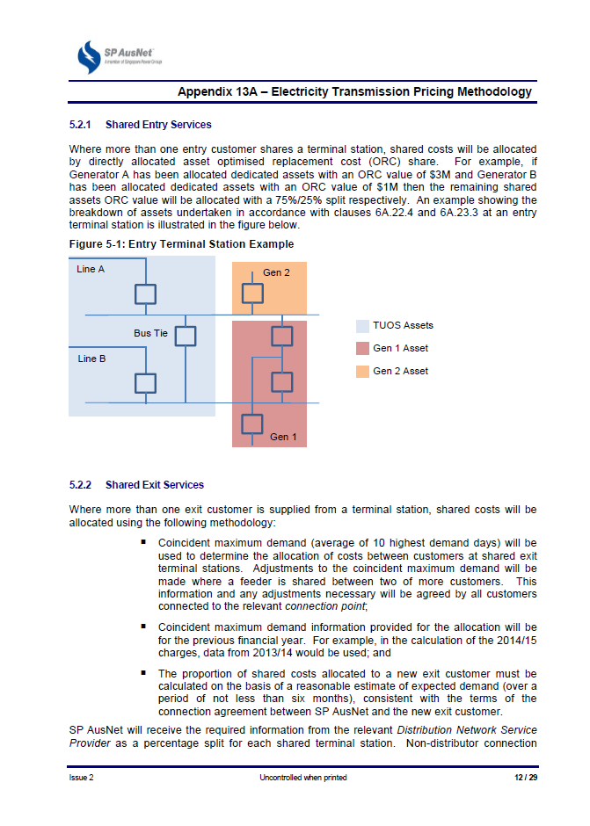

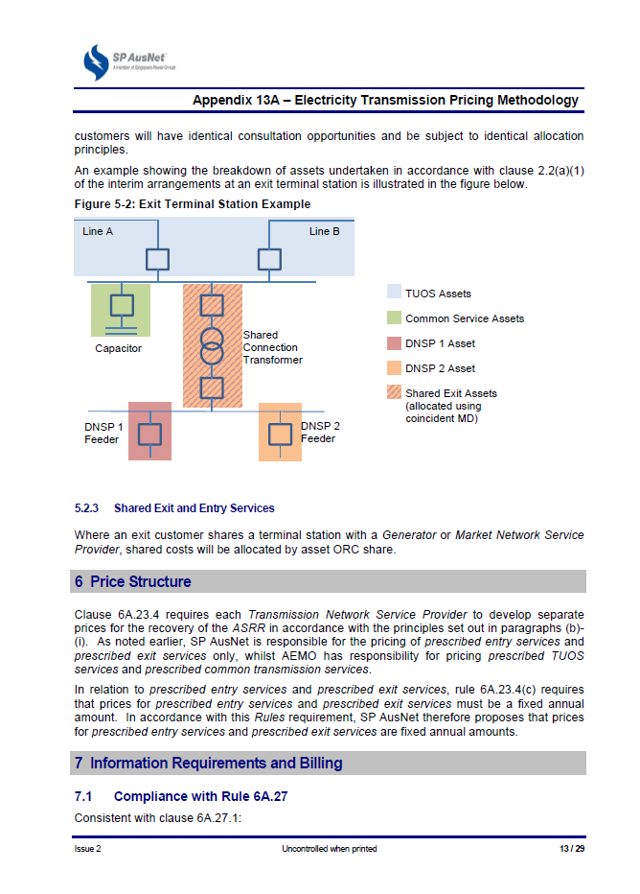

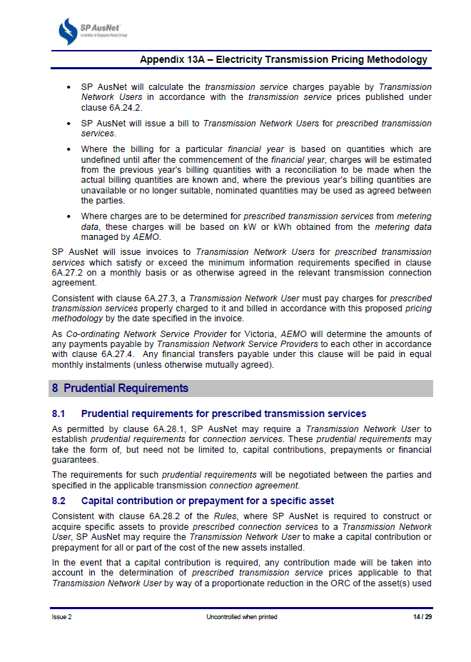

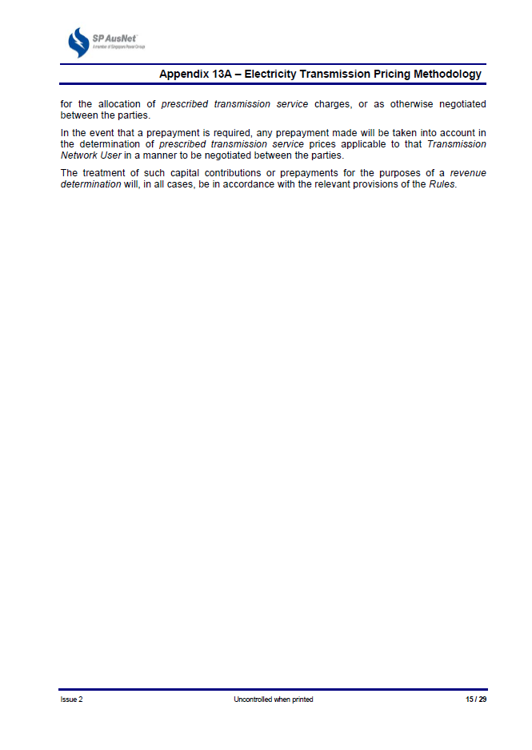

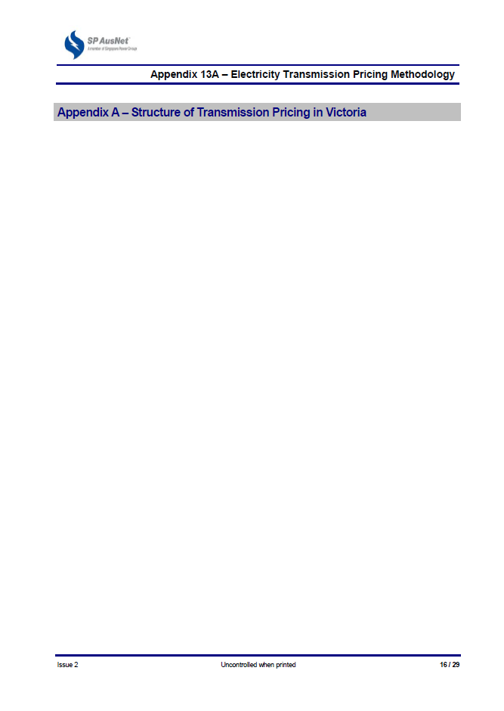

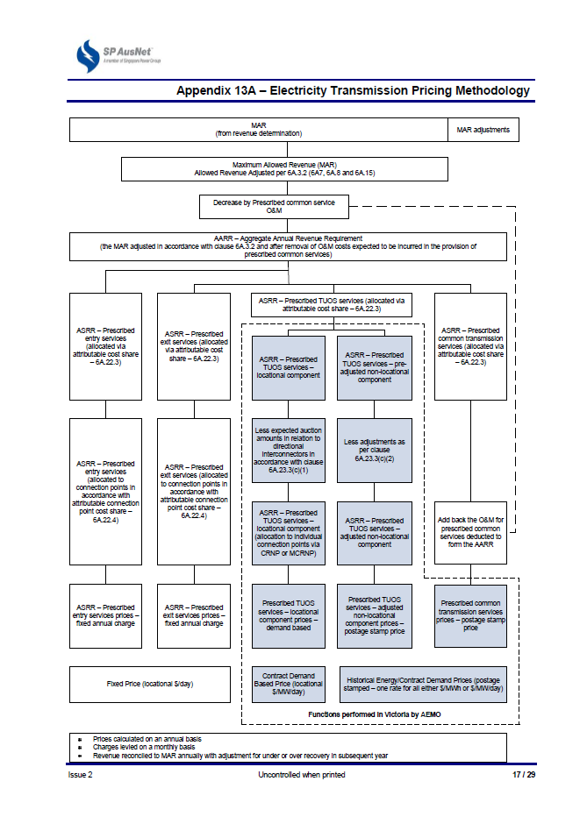

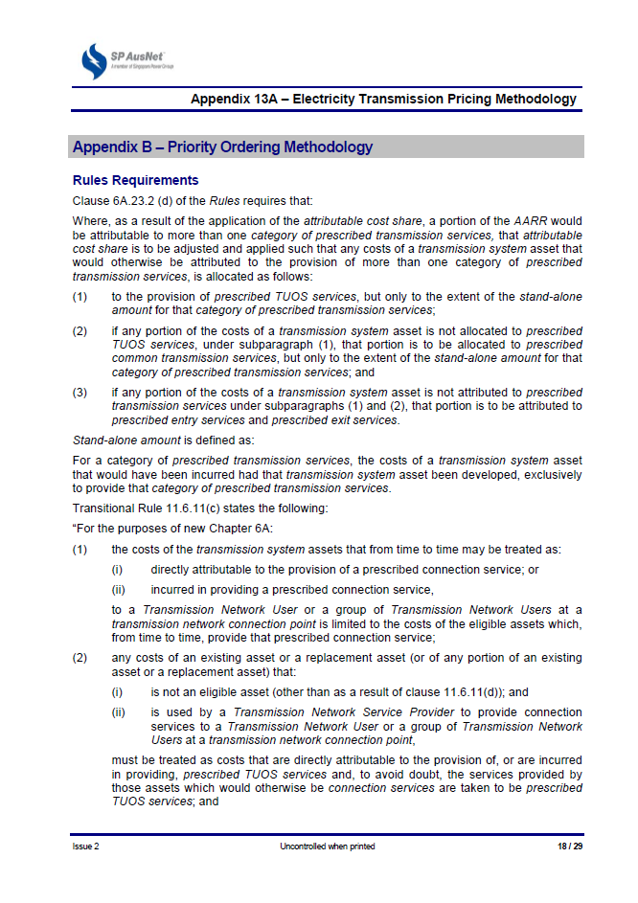

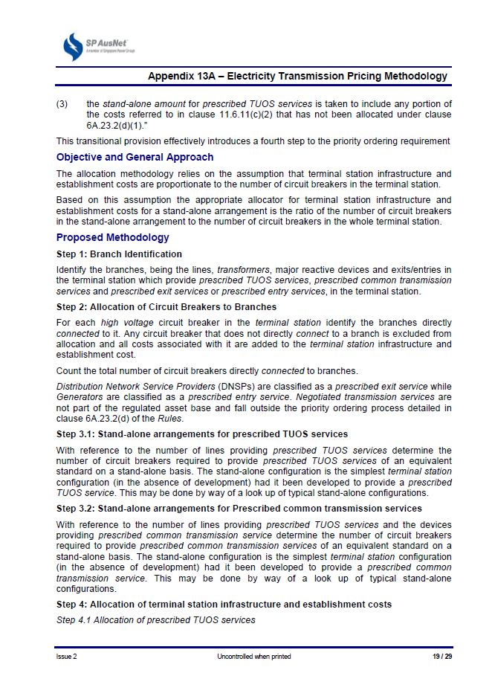

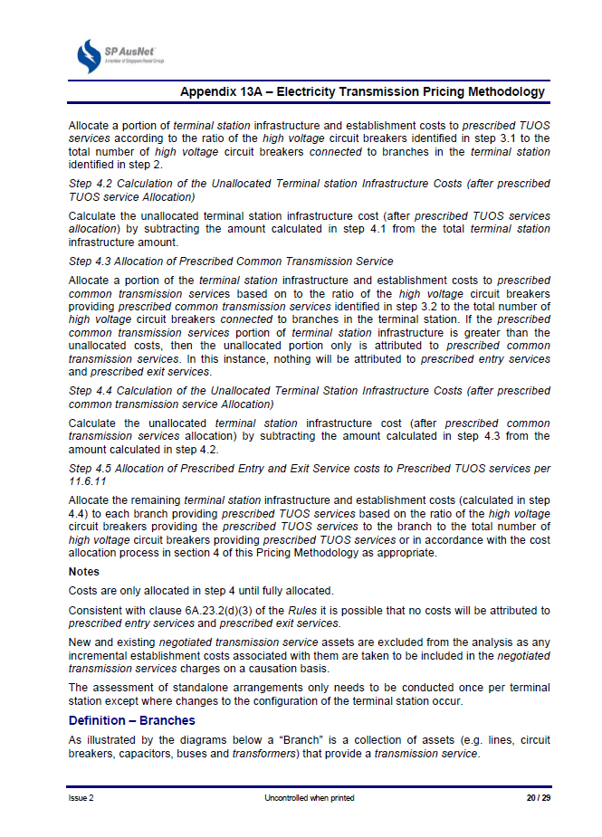

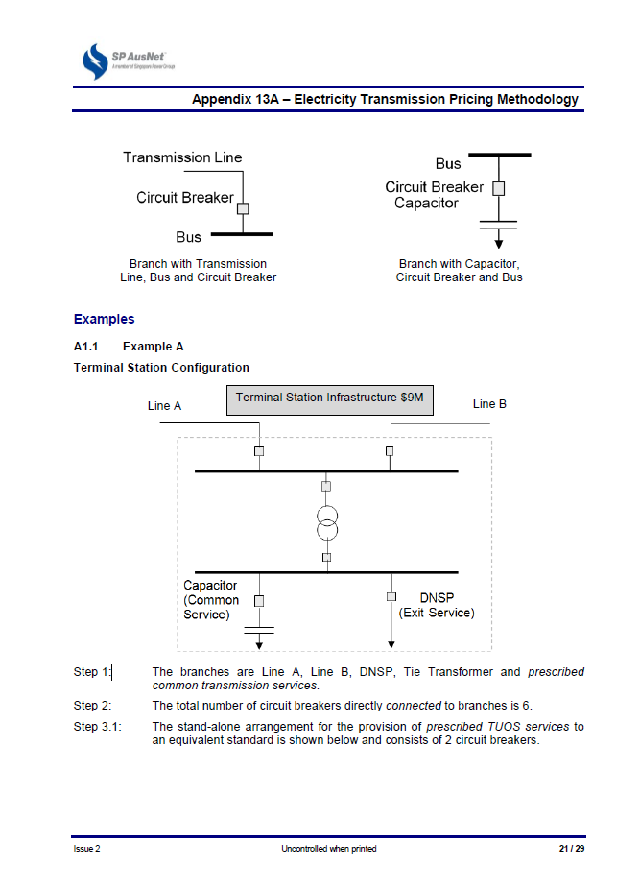

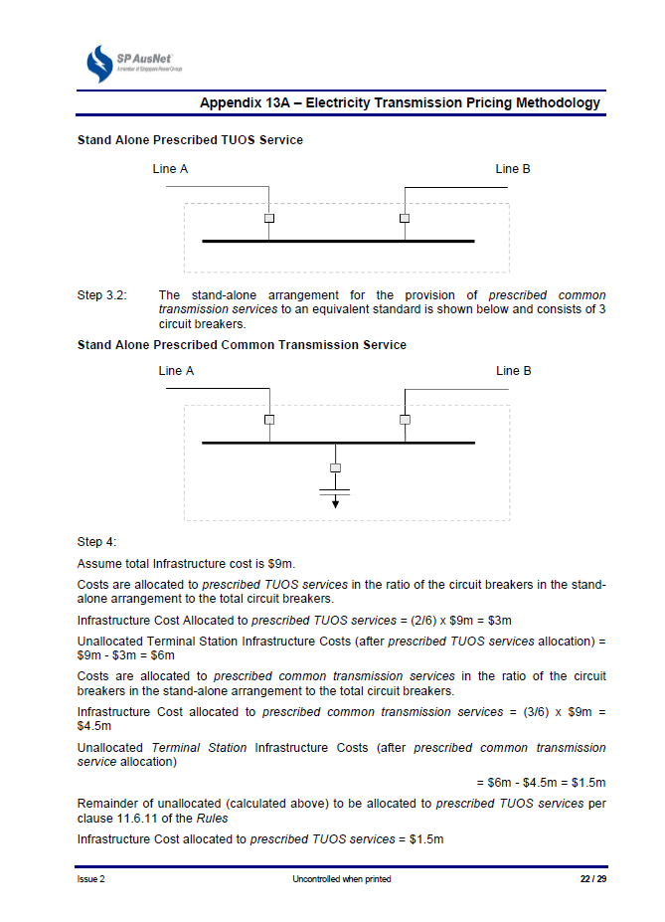

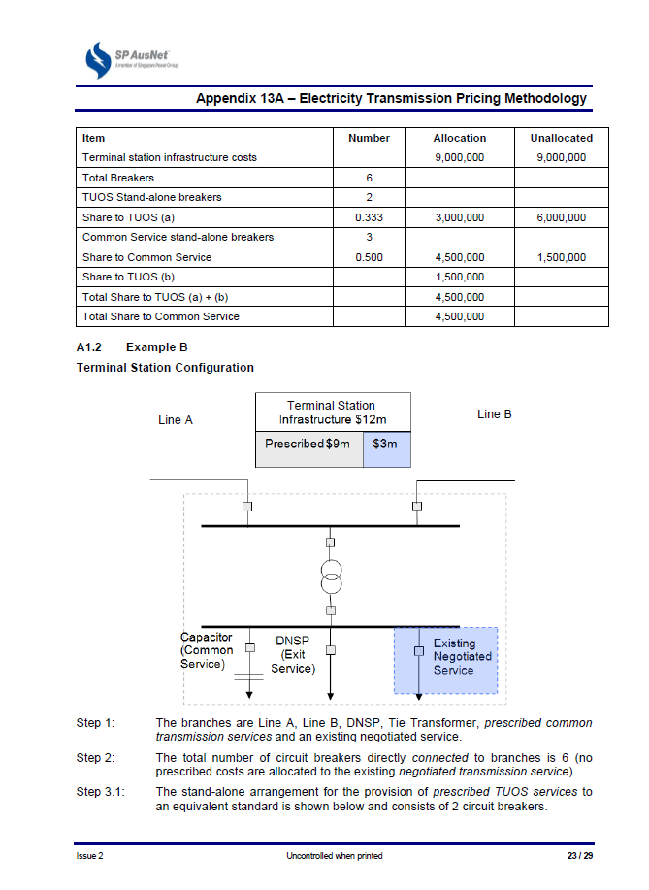

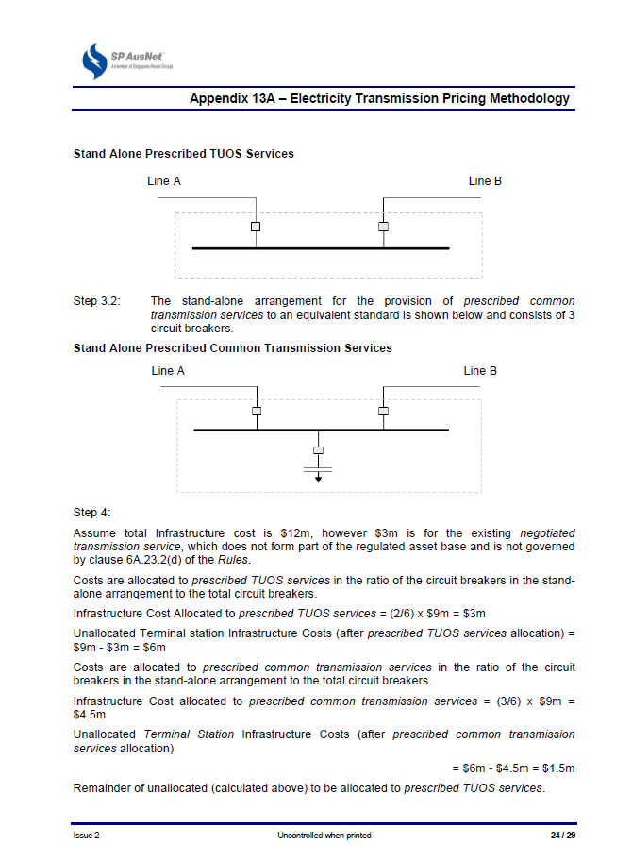

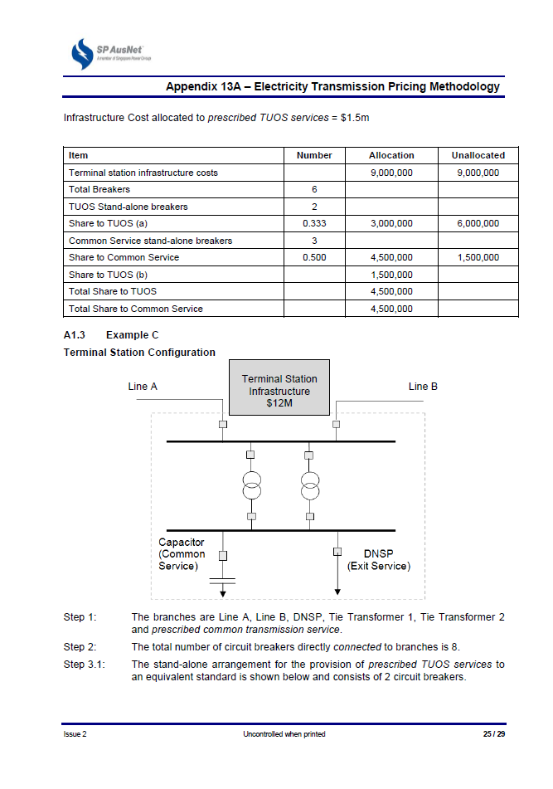

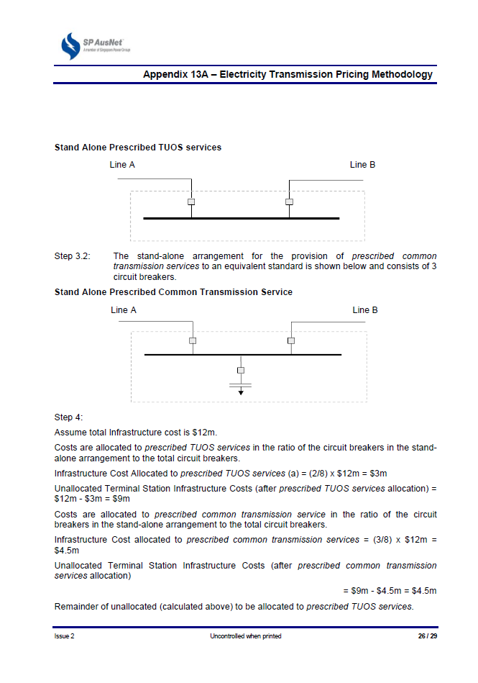

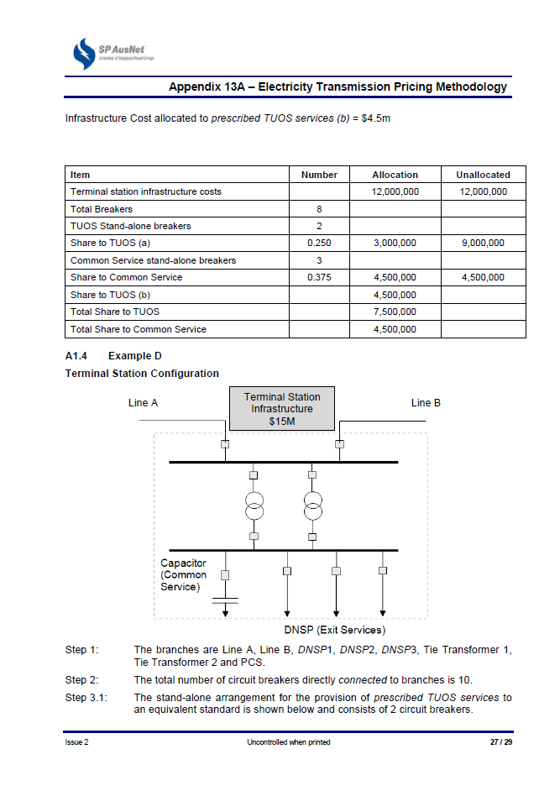

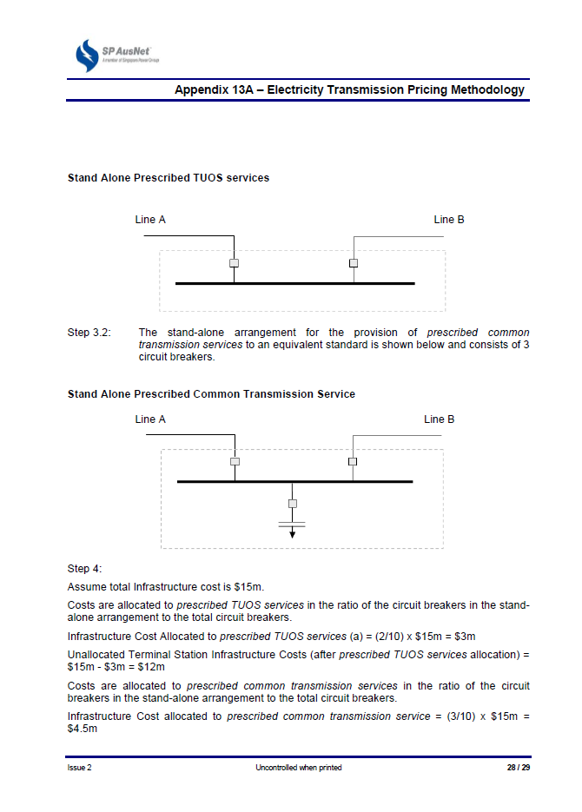

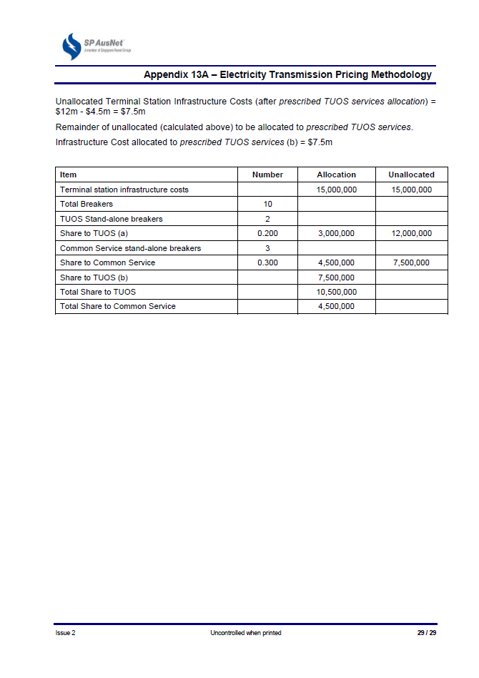

1. NER, clause 6A.9.5(a).
2. NER, clause 6A.5.4.
3. NER, clause 6A.5.3.
4. In the 2008–14 transmission determination, the CPI required for the annual MAR adjustment process reflects the December quarter CPI, which is typically published by the ABS in late January of the following year. For this transmission determination we require SP AusNet to use the September quarter CPI for the annual MAR adjustment for the 2014–17 regulatory control period. The same set of CPI will be used for the RAB roll forward at the next reset for SP AusNet (31 January 2017). This change will ensure the release of the September quarter CPI is available (typically towards the end of October) for use well before the publication date of the AER's final decision at the next reset.
5. NER, clauses 6A.7.4 and 6A.7.3.
6. NER, clauses 6A.7.2 and 6A.7.3.
7. NER, clauses 6A.23.3(c)(2)(iii) and 6A.24.4(c).
8. AER, *Final – Service target performance incentive scheme*, December 2012.
9. AER, *Final – Service target performance incentive scheme*, December 2012.