3 January 2013

Mr Sebastian Roberts

General Manager  
2012 Victorian Gas Access Arrangement Review  
Australian Energy Regulator

Email VicGAAR@accc.gov.au

**AGL Submission — GasNet AA 2013-2017 Draft Decision**

Dear Mr Roberts,

AGL Energy Limited (“**AGL**”) lodges this submission in relation to the AER’s Draft Decision on the revisions to the access arrangement for the Victorian Transmission System (“**VTS**”) proposed by APA. AGL is an active Market Participant in Victoria, being both a shipper and an incumbent user (licensed retailer), and therefore has a very keen interest in the outcome of this consultation.

The review of the gas access arrangement for the VTS for the period 2013-2017 has consisted thus far of APA’s AA Proposal (March 2012), the AER’s Draft Decision (September 2012), and APA’s AA Revised Proposal (November 2012). The AER has invited submissions by 7 January 2013 ahead of issuing a Final Decision in March 2013.

AGL is generally supportive of the AER’s amendments to APA’s initial proposal, as set out in the Draft Decision. There are, however, two issues that AGL would like to raise in this submission. The first is our support for APA’s view that AMDQ CC is not a pipeline service. The second major issue is AGL’s continuing concern (similar concerns were expressed in our first submission of 18 June 2012) about the level of capex that is being proposed for augmentation of the South West Pipeline (“**SWP**”) in an environment where there is unused capacity and where gas supply from the Otways is expected to wind down in the near future.

**AMDQ Credit Certificates**

AGL fully agrees with the position put by APA GasNet in their revised November submission that AMDQ CC is not a pipeline service in the sense that forward haulage or back haul are recognised pipeline services. The AER’s assessment that AMDQ CC is a service likely to be sought by a significant part of the market also needs to be heavily qualified — it will only be sought by that part of the market that has injection rights to the South West Pipeline.

Gas haulage in the VTS context is market carriage — market dispatch is in price merit order and transmission charges are based on usage, not on contractual MDQ. The market rules (NGR, Part 19) however do recognise AMDQ credit certificates (AMDQ CC), which give priority to holders in the event of a pipeline constraint and may provide relief from certain market uplift charges levied by AEMO as the market operator. Participants acquire AMDQ CC through a periodic auction process conducted by APA GasNet.  Bids submitted by market participants can be thought of as consisting of two parts: pre-paid haulage over the stipulated term of X years (which happens to be the reserve set by APA GasNet) plus any premium that a participant is prepared to pay on top of that minimum or reserve to secure that right.

AGL’s view is very much that AMDQ CC are not haulage rights but an additional product or attribute that confers certain market benefits to holders and is better characterised as an insurance product.  In the absence of constraints, market dispatch is always based on price (and not on rights).  Therefore the premium participants are prepared to pay is reflective of how they value this insurance product which sees their gas dispatched ahead of others in the event of a constraint.

AGL fully agrees with APA GasNet and their rationale that AMDQ CC is not an ancillary service either, if it is not to be regarded as a pipeline service. To the extent that gas dispatch is in price merit order, purchase of AMDQ CC is not a prerequisite to participate in the Victorian gas market.

Neither does AGL see AMDQ CC as a rebateable service, as is advanced by some market participants who suggest that APA GasNet is double dipping on a regulated forward haul service, and that the premium paid by them (on AMDQ CC) should be refunded.  This line of argument is not logical or sustainable in AGL’s view — you want something, you pay over the odds, and then subsequently argue that the premium should be refunded.  But in the meantime you possess these certificates, which do have value. And any value conferred or realised is held by the certificate holder and not socialised.

AGL does not believe that AMDQ CC represents a pipeline service for the reasons outlined above and therefore does not warrant a reference tariff as is being suggested by AER. AGL’s view is very much that the only requirements to be imposed on GasNet by the AER are around the transparency and visibility of the tender process run by APA for the sale of AMDQ CC.

**Capex 2013-2017**

The key financial parameters of the evolving VTS Access Arrangement are set out in Table 1 below. This table reflects the APA Proposal (March 2012), AER’s Draft Decision (September 2012), and APA’s Revised Proposal (November 2012) as well as the total revenue requirement associated with each version.

**Table 1. – Victorian Gas Transmission AA Financials**

|  |  |  |  |  |
| --- | --- | --- | --- | --- |
| **Key Financial**  **Overview** | **Historical**  **AA 2008-2012** | **APA Proposal**  **March 2012** | **AER Draft Decision**  **September 2012** | **APA Revised Proposal**  **November 2012** |
| Total Revenue |  | $766.0m | $464.4m | $624.5m |
| Capex | $160.4m | $340.8m | $153.8m | $185.4m |
| WACC | 10.55% | 9.06% | 7.16% | 8.09% |
| Regulatory Depreciation |  | $157.5m | $56.2m | $136.3m |
| Opex |  | $182.2m | $140.6m | $164.9m |

The corresponding favourable impact on the indicative reference tariff flowing from the AER’s Draft Decision is presented in Figure 1, which is a graph produced by the AER. APA’s revised proposal of November 2012 would have the effect of raising and shifting the green line which reflects the AER’s Draft Decision.

**Figure 1. Indicative reference tariff paths**

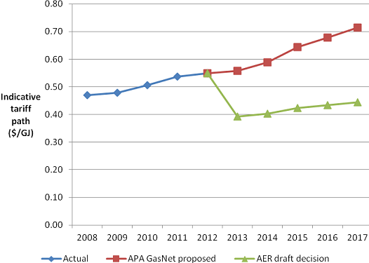

*[Source: Access arrangement draft decision APA GasNet Australia (Operations) Pty Ltd, Australian Energy Regulator, September 2012*]

As we will establish further on in our submission, APA GasNet are requesting sizeable capex for the Gas to Culcairn project, which is claimed to have the additional benefits of system security for Victoria. AGL will argue that the main benefit appears to be an expansion of the winter export capacity out of Culcairn into NSW. We do not agree with the Victorian gas customer base being asked to fund this through higher Victorian transmission tariffs.

AGL notes that $83.2m of the proposed Capital Expenditure in the APA Revised Proposal for the 2013-2017 period is attributable to the Gas to Culcairn Project, without transparency of its justification or the potential impact on reference tariffs. APA’s justification of the Gas to Culcairn Project relies on the criterion of rule 79(2)(b), that the project has achieved a positive net present value and the expenditure is thus seen to be conforming for the purpose of its inclusion in the Capital Base. The NPV analysis supporting the APA justification of the Gas to Culcairn Project has not been made publicly available. Further it is noted that rule 79(2)(b) requires the net present value of the project to be positive, i.e. that the present value of the incremental revenue generated exceeds the present value of the capital expenditure.

In AGL’s view, the capital expenditure of this project should therefore be justified without change to the base reference tariff incurred by network users and only where this investment results in incremental gas flows. It is difficult to see what substantial incremental revenues are generated by the Gas to Culcairn Project that are not already deliverable through greater utilisation of the existing network. AGL notes that the Victorian Gas System demand has not increased materially across the previous 5-year reset period (2008-2012) and that the system has displayed sufficient adequacy from both an energy and capacity perspective (see our Attachment 2 for extracts from AEMO’s 2012 Victorian Annual Planning Report which support our observations that there is no pipeline constraint within Victoria).

The proposed extensions and augmentations which comprise the Gas to Culcairn Project only extend the operating envelope on the South West Pipeline during peak system demand periods. As displayed in Attachment 3, the graphs that AGL has generated from publicly available Gas Bulletin Board data show the SWP has only exceeded 320TJ/d of gas flows for less than 1% of the time between 2008-2012 — and it needs to be remembered that the official capacity of SWP is 353TJ. Even though there has not been material demand growth or full network utilisation, APA has proposed to extend this network by 61TJ/d on the basis that there is a positive NPV. It is difficult to see how a positive NPV is possible on either an energy or capacity basis, given that the expansion is likely to be used less that 1% of the time.

What is also relevant in this context is the discussion currently taking place at the GWCF, the AEMO-run consultative forum for the Victorian wholesale gas market, to introduce Portfolio Trading Rights (“**PRT**”) into the market. PRT will allow the assignment of rights associated with AMDQ or AMDQ CC from one market participant to another for some specified period of time. A recent review of the transmission arrangements by a sub-working group of the GWCF recommended such a facility on the grounds that it might encourage fuller utilisation of the Longford to Dandenong Pipeline (up to a level of 990TJ per day, which is the sum of Tariff V and D AMDQ) as well as efficiencies at other injection points.

A further point to note is that the existing fields in the Otway Basin have finite lives, as shown below in a table that sets out 2P reserves and contrasts that with present production levels to derive remaining lives. Whilst this is a rough and crude guide, the outlook on economic life that emerges from this analysis is not one that would support any upgrade to the South West Pipeline. Assets that would feature in an augmentation would have a minimum life of 30 years for compressors and 50+ years in the case of cathodically protected coated steel piping.

**Table 2. - Projected Remaining Life of Otway Basin**

|  |  |  |  |  |
| --- | --- | --- | --- | --- |
| **Field** | **2P Reserves in PJ (Nov 12)** | **Annual Production (PJ)** | **Years to End of Life** | |
| Thylacine/Geographe | 467 | 48.6 | 9.6 | |
| Minerva | 143 | 23.8 | 6.0 | |
| Casino* | 221 | 32.0 | 6.9 | |
|  | | | | |

*Henry Field (163PJ 2P Reserves) production tied into Casino as per Santos statement on 26th February 2010.

*[Source: EnergyQuest’s Energy Quarterly for November 2012 Report, 21 November 2012]*

It seems the main contribution of the Gas to Culcairn project is to expand the winter export capacity out of Culcairn by 30TJ/d, enabling gas flows from Victoria to NSW across the year. AGL notes that this is not for the benefit of the Victorian customer base and therefore should not be recoverable against their fees. AEMO’s published operational procedures for Culcairn make it clear that northbound flows will stop being supported via the operation of compressors at Euroa and Wollert when achievement of Victorian gas demand is under threat. If the system operator is known to behave thus, why is the system owner persisting with this proposal?

Further, it is unclear that the Gas to Culcairn Project is the most efficient alternative for transporting additional gas to NSW. An expansion of the Eastern Gas Pipeline may well prove to be more effective.

Should you require any further information in relation to AGL’s submission, please contact me on (03) 8633 6239.

Yours sincerely,

G M Foley

Manager Gas Market Development

**Attachment 2 - Historical demand forecast**

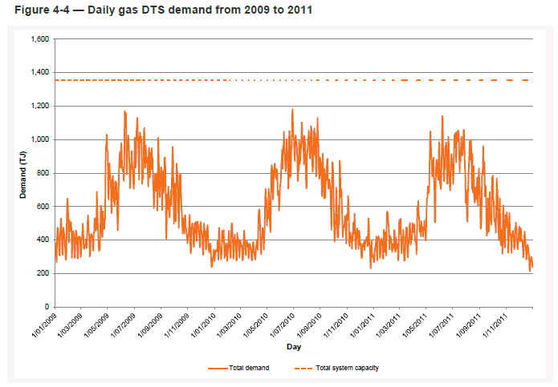

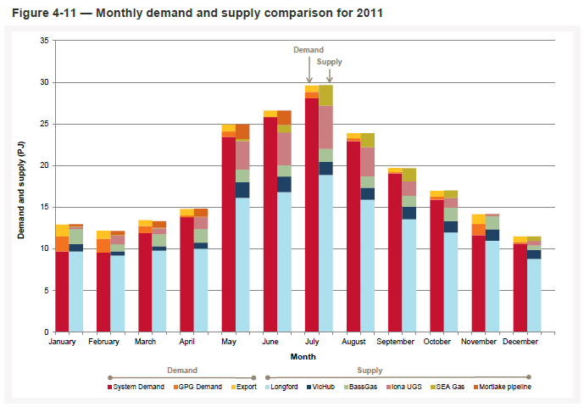

*[Source: Victorian Annual Planning Report 2012, Australian Energy Market Operator]*

**Attachment 3 - Historical Network utilisation  (SWP / Culcairn)**

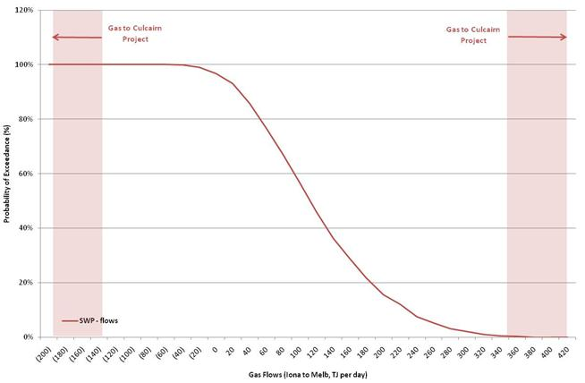

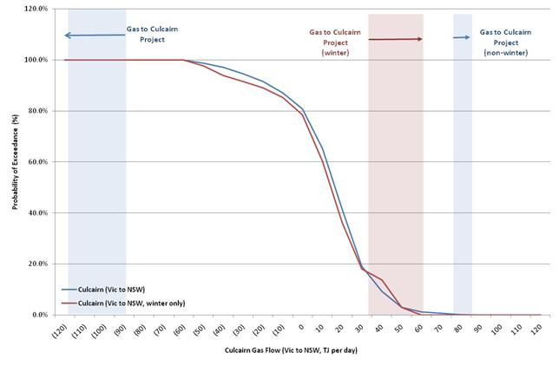

*[Source: Gas Bulletin Board (June 2008 – November 2012)]*