

**Application to Consolidate the Access Arrangements for the Victorian and Albury Gas Distribution** **Networks**

Prepared by

Australian Gas Networks

November 2015

Table of Contents

1 Overview 1

2 NGR Requirements 2

3 Nature of the Pipelines and Pipeline Services 3

4 Stakeholder Consultation and Impact on Customers 6

5 Proposed Approach to Consolidation 7

6 Benefits of Consolidation 7

6.1 Reduced Administrative Costs 7

6.2 Increased Certainty to Support Efficient Investment 8

7 Summary 8

Attachment 1: Stakeholder Consultation – Log of Meetings 9

Attachment 2: Stakeholder Consultation – Presentation 10

Attachment 3: Stakeholder Consultation – AGN Retailer Reference Group Meeting Minutes 11

Attachment 4: Stakeholder Consultation –AGN Victoria Albury Reference Group Meeting Minutes 12

# Overview

Australian Gas Networks Limited (AGN) submits this application to consolidate the access arrangements for the Victorian and Albury natural gas distribution networks into a single access arrangement. The Victorian and Albury networks are currently subject to full regulation under the National Gas Law (NGL) and National Gas Rules (NGR), which requires the AER to approve the price and non-price terms of access to the networks. This form of regulation will continue if consolidation is approved.

AGN owns and operates the Albury and Victorian gas distribution networks. These two networks are interconnected, reflecting that the Albury network is fed from the Northern zone of the Victoria network. Though for regulatory purposes the networks are currently considered separate, they are both managed and operated in the same way. Figure 1.1 shows the area covered by AGN’s Victorian and Albury networks.

Figure 1.1: Area covered by agn’s victorian and albury networks

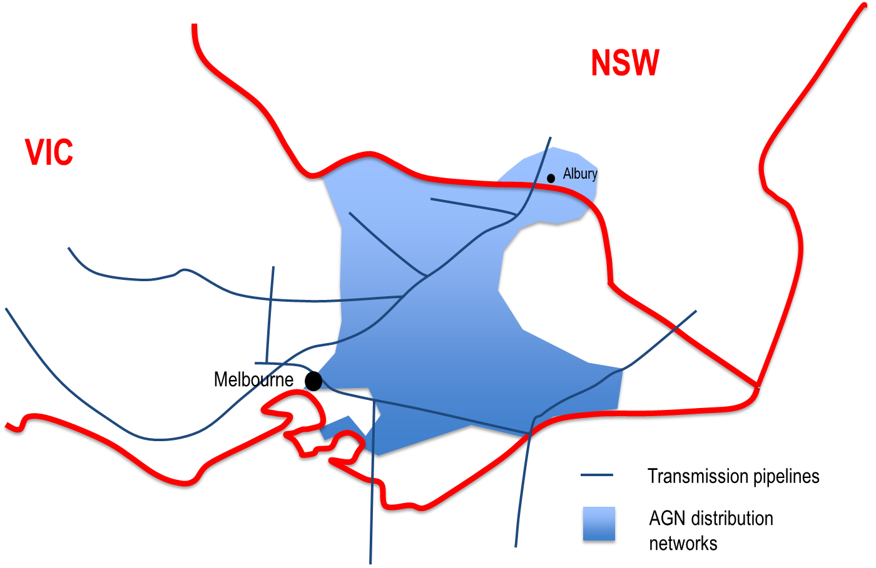

AGN currently provides services to customers in the Victorian and Albury networks under terms and conditions and prices that are outlined in two separate access arrangements. Both access arrangements offer access seekers the same services and terms and conditions. Both the Victorian and Albury access arrangement revisions commencement date has been nominated as 1 January 2018.

Rather than continue the current process of developing and administering two access arrangements, AGN is proposing to submit a single (or consolidated) access arrangement, which essentially combines the regulated asset base (RAB) of both networks and requires AGN to submit a single Regulatory Information Notice (RIN)[1] to the AER. Consolidating these access arrangements is a logical administrative step because:

* both networks are managed and operated in the same way;
* they operate under the same Victorian market rules;
* they provide the same reference services;
* they provide effectively the same terms and conditions of access;
* the access arrangement reviews are due to be submitted to the AER at the same time (1 January 2017); and
* the AER reviewed the two access arrangements at the same time when they were last reviewed in 2012, as did the Essential Services Commission of Victoria (ESCV) prior to that.

AGN expects consolidating the access arrangements will have no impact on customers (or stakeholders more generally) because:

* there will be no change to the operation of the network;
* there will be no change in the regulatory obligations imposed on the business;
* there will be no change to the nature of any services provided;
* there will be no change to the terms and conditions governing access to the networks directly attributable to consolidation;
* there will be no change to tariff structures and the tariff setting process directly attributable to consolidation; and
* stakeholders will be able to participate in and influence the regulatory review process in a more efficient manner (i.e. by avoiding the need to prepare separate submissions for the Albury and Victorian review processes).

Combining the access arrangements is essentially an administrative exercise. The main benefit will be to reduce the administrative burden for the AER, AGN and stakeholders making submissions into the regulatory review process. This should also lead to lower costs. Formally treating the network services under a single access arrangement also provides greater regulatory certainty, which promotes more efficient investment in and use of the networks.

Therefore, pursuant to section 53(2) of the National Gas Rules (NGR), AGN is seeking that the AER issue a direction to consolidate the access arrangements for the Victorian and Albury natural gas distribution networks.

# NGR Requirements

The NGR provides for the separation or consolidation of access arrangements as follows:

***53 Access arrangement proposal for division or consolidation of access arrangements***

(1) The AER may, by notice to a service provider for a covered pipeline, direct the service provider to submit separate access arrangement proposals for different parts of the covered pipeline.

(2) If pipeline services provided, or to be provided, by a service provider are (or are to be) provided by means of 2 or more covered pipelines, the AER may, by notice to the service provider, direct the service provider to submit a consolidated access arrangement proposal for all the relevant covered pipelines.

Example: The AER might direct the submission of a consolidated access arrangement proposal for 2 or more covered transmission pipelines, 2 or more covered distribution pipelines or a combination of covered transmission and covered distribution pipelines.

(3) The AER may give a direction under this rule either on its own initiative or on application by the service provider.

(4) In deciding whether to give a direction under this rule, the AER must have regard to:

(a) the nature of the pipeline or pipelines; and

(b) the nature of the pipeline services provided or to be provided by means of the pipeline or pipelines; and

(c) any other matter the AER considers relevant.

(5) Before the AER gives the direction, it must consult on the proposed terms of the direction with the service provider and any other persons with whom it considers consultation appropriate.

(6) A service provider must comply with a direction under this rule.

Note: This subrule is classified as a civil penalty provision under the National Gas (South Australian) Regulations. See clause 6 and Schedule 3 of the National Gas (South Australian) Regulations.

(7) A direction under this rule may be subject to such conditions as the AER thinks fit and includes in the direction.

AGN submits this application pursuant to NGR 53(3).

Another key consideration is the National Gas Objective (NGO), which is set out in section 23 of the National Gas Law (NGL). The NGO is:

“… to promote efficient investment in, and efficient operation and use of, natural gas services for the long term interests of consumers of natural gas with respect to price, quality, safety, reliability and security of supply of natural gas.”

# Nature of the Pipelines and Pipeline Services

The Victorian and Albury natural gas distribution networks are interconnected, lying either side of the Victorian and New South Wales borders. Figure 3.1 shows how the Victorian network is separated into four tariff zones while there is a single zone in the Albury network.

Figure 3.1: Victorian and Albury network zones

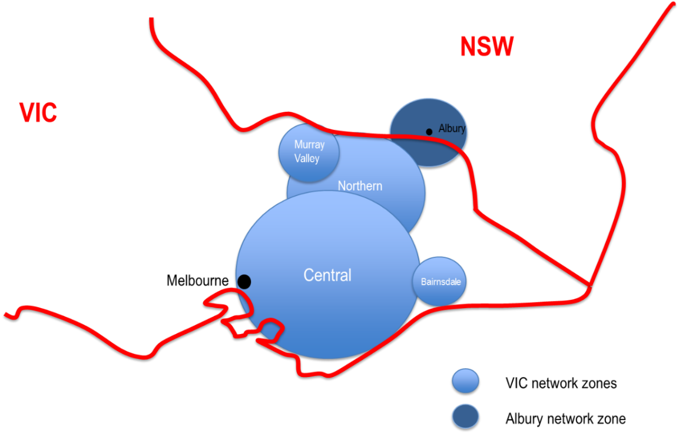

Despite being in New South Wales, Albury operates under the same market rules as Victoria, and as such, retail market dynamics are dictated by Victorian market characteristics. The reference tariffs that apply in the Albury and Victorian access arrangements (and zones within Victoria) are identical in structure. Movement in tariffs over time are subject to the same regulatory review process, which will continue to be the case following consolidation.

The Albury network is managed and operated by the Victorian business and to all intents and purposes is already treated as a fifth ‘zone’ of the Victorian network. AGN’s proposal to consolidate the access arrangements simply formalises this arrangement (see Figure 3.2).

Figure 3.2: Proposed change to access arrangment coverage

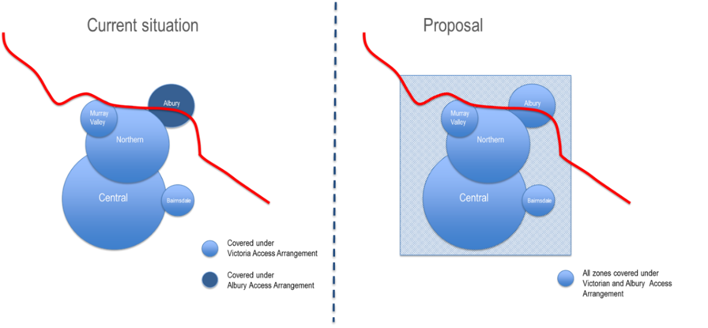

The Albury network serves the city of Albury and its surrounds, extending to Jindera to the north of Albury. It contains around 400 kilometres of mains and delivers gas to nearly 22,000 customers.[2] For the calendar year 2014, Albury represents 1% (or $6 million) of total revenue and 1% of total RAB ($36 million) for AGN. Table 3.1 summarises the market characteristics of the Albury network (and the Victorian zones).

The Victorian network serves the central business district, northern, outer eastern and southern areas of Melbourne, Mornington Peninsula, rural communities in northern, eastern and north-eastern Victoria and south-eastern rural townships in the Gippsland. The network comprises more than 10,000 kilometres of mains delivering gas to around 613,000 customers. For the calendar year 2014, Victoria represented approximately 36% ($180 million) of total revenue and 42% ($1,300 million) of total RAB for AGN (see Table 3.1).

table 3.1: Market CHARACTERISTICS OF THE VICTORIA AND ALBURY NETWORK ZONES 2014 DATA

|  |  |  |  |  |  |
| --- | --- | --- | --- | --- | --- |
|  | Bairnsdale | Central | Northern | Murray Valley | Albury |
| **Total customer numbers** | **3,431** | **520,801** | **73,571** | **7,433** | **21,165** |
| Residential | 3,331 | 501,389 | 70,194 | 7,103 | 20,194 |
| Commercial | 92 | 19,410 | 3,186 | 324 | 920 |
| Tariff D | 8 | 2 | 190 | 6 | 50 |
| **Total consumption (TJ)** | **250** | **40,924** | **8,896** | **1,214** | **2,545** |
| Residential (TJ) | 91 | 23,138 | 3,083 | 241 | 832 |
| Commercial (TJ) | 76 | 6,152 | 764 | 59 | 272 |
| Tariff D (TJ) | 82 | 11,635 | 5,049 | 914 | 1,441 |
| Average consumption per residential customer (GJ) | 27.5 | 46.1 | 43.9 | 33.9 | 41.2 |
| Average consumption per commecrial customer (GJ) | 823.7 | 317.0 | 239.7 | 183.5 | 295.3 |
| Revenue ($m) | 1.4 | 158.7 | 19.7 | 1.9 | 5.9 |
| Retailers operating in market | 10 | 10 | 10 | 10 | 4 |

Table 3.2 summarises the physical characteristics of the Victoria and Albury zones.

table 3.2: Physical CHARACTERISTICS OF THE VICTORIA AND ALBURY NETWORK ZONES 2014 DATA

|  |  |  |  |  |  |
| --- | --- | --- | --- | --- | --- |
|  | Bairnsdale | Central | Northern | Murray Valley | Albury |
| **Total km** | **156** | **8,252** | **1,630** | **199** | **396** |
| Low Pressure <7kPa | - | 574 | 11 | - | - |
| Medium Pressure 7-210kPa | - | 90 | - | - | - |
| High Pressure 210-1050kPa | 156 | 7,587 | 1,618 | 199 | 396 |

Table 3.3 summarises the reference tariffs under the access arrangements by tariff class for the Victorian and Albury networks. Each of the pipeline services provided in Victoria and Albury are the same, and are defines as follows:

Table 3.3: REFERENCE services of the victoriA and albury networks 2014

|  |  |  |
| --- | --- | --- |
| Victoria | Albury | Description |
| Tariff V- Volume Haulage Service | Tariff V- Volume Haulage Service | Provision of gas delivery services for customers using less than 10TJ per annum |
| Tarrif D Demand Haulage Service | Tarrif D Demand Haulage Service | Provision of gas delivery services for customers using greater than 10TJ per annum |
| Meter and Gas Installation Test  Disconnection  Reconnection  Meter Removal  Meter Reinstallation  Special Meter Read | Meter and Gas Installation Test  Disconnection  Reconnection  Meter Removal  Meter Reinstallation  Special Meter Read | On site testing to check measurement accuracy of meter  Disconnection by installation of locks or plugs on a meter  Reconnection by removal of locks or plugs on a meter  Removal of a meter at a premises  Reinstallation of a meter at a premises  Read of meter in addition to the scheduled meter reading |

# Stakeholder Consultation and Impact on Customers

During November 2015 AGN engaged with stakeholders on our proposal to submit an application to the AER to consolidate the Victorian and Albury access arrangements (see Attachment 1 for a detailed log of stakeholder meetings and Attachment 2 for the presentation provided during these engagements). More specifically, AGN met with the following stakeholders:

* New South Wales Energy Department;
* Victorian Department of Economic Development;
* Australian Energy Regulatory (AER);
* Independent Pricing and Regulatory Tribunal (IPART);
* AGN Retailer Reference Group;
* Public Interest Advocacy Centre (PIAC); and
* The AGN Victorian and Albury Reference Group[3]; and
* The AGN Victorian and Albury Retailer Reference Groups[4].

As part of this engagement, AGN sought feedback from stakeholders on a range of matters, including:

* concerns/issues stakeholders may have had in respect of consolidation;
* matters in existence which in the view of stakeholders would necessitate the continuance of two separate access arrangements; and
* general feedback on AGN’s proposal

The stakeholder feedback in respect of the consolidation of the Victorian and Albury Access Arrangements is summarised below:

* consolidation is a logical administrative step for AGN to take;
* consolidation would appear to be consistent with the key focus areas of Governments, including to reduce red-tape, reduce energy prices and to promote retail competition (particularly in the regions in the case of New South Wales);
* there is in principal support for consolidation if separate RABs, and expenditure information more generally, is retained for the each of the Albury and Victorian networks; and
* there is in principal support for consolidation if the approach to cost allocation between the two networks remains unchanged.

AGN considers that stakeholders understood the reasons for consolidating the Victorian and Albury Access Arrangements and are supportive of this application. Importantly, not one of the above stakeholder groups identified any reason as to why the AER should not make a direction to consolidate the access arrangements. AGN also accepts the suggestion to maintain certain information for Albury and Victoria, particularly in regards to the RAB.

# Proposed Approach to Consolidation

There is a strong case for consolidating the Victorian and Albury access arrangements. As noted above, this application has strong stakeholder support and is a logical administrative step given the similarities between the two networks and the way the review processes have been undertaken in the past. Subject to the AER issuing a direction to consolidate the access arrangements, AGN proposes the following approach:

* AGN will submit one consolidated access arrangement proposal to the AER on 1 January 2017;
* AGN will combine the Albury RAB with the Victoria RAB for the purposes of the access arrangement proposal, however AGN will continue to maintain separate RABs for the two networks;
* tariffs in Albury will be subject to the same regulatory review process (and will be considered and calculated in the same way as the reference tariffs for other zones of the consolidated Victorian and Albury access arrangement);
* movements in tariffs for all zones will be considered together and costs will continue to be allocated in line with the applicable allocation method approved by the AER as part of the access arrangement review process;
* in response to a stakeholder request AGN commits to holding a consumer engagement workshop in Albury irrespective of the AER’s decision in respect of consolidation; and
* in light of feedback received from some stakeholders, AGN will maintain a separate RAB for the Albury and Victorian networks.

Adopting this approach to consolidation will minimise the administrative burden for the AER, AGN and stakeholders more generally, which will maximise the available cost savings from consolidation.

# Benefits of Consolidation

AGN considers adopting the above approach to consolidation will deliver the following benefits:

* reduced administrative costs; and
* increased certainty to support efficient investment.

These benefits are discussed below.

## Reduced Administrative Costs

Consolidating the Victorian and Albury access arrangements is a logical administrative exercise for both the AER and AGN. It removes the administrative burden and associated costs of preparing and reviewing two access arrangement proposals at the same time, making for a more efficient regulatory review process. Consolidation would also appear to be consistent with the objectives of Governments to reduce unnecessary regulatory costs in order to promote economic efficiency.

Efficiencies will be maximised if Albury is effectively treated as a fifth zone of the Victoria network, with a consolidated RAB and the requirement to only produce one RIN. AGN will however continue to collect information on the Albury network separately, as it is important to retain specific network data for regulatory and asset management purposes. AGN will continue to maintain a separate RAB for both networks.

AGN incurred approximately $4 million for the most recent Victorian and Albury access arrangement reviews. The review costs attributed to each network can range from 50% (i.e. an equal share) to one based on customer numbers, which allocation would imply a cost of around $0.2 million for Albury. AGN expects its own cost savings to be more in-line with the lower bound estimate. It is reasonable to expect a similar order of cost savings, on aggregate, for other stakeholders (including the AER).

The lower regulatory costs from consolidating the Albury and Victorian access arrangements will be passed through to consumers through lower operating expenditure that is used to set reference tariffs. AGN submits that, by lowering prices to consumers, this application to consolidate access arrangements better promotes the achievement of the National Gas Objective.

## 6.2 Increased Certainty to Support Efficient Investment

Both networks will be reviewed under one access arrangement, assessed at the same time and operated under the same terms and conditions. Consolidation not only formalises the current approach but it also removes the potential for a different regulatory treatment of Albury, which might otherwise prompt changes to the operation and treatment of the network in a way that increases costs. Greater certainty allows for more efficient investment.

# Summary

In summary, AGN considers consolidation of the access arrangements for the Victorian and Albury natural gas distribution networks to be a prudent and relatively straightforward administrative exercise that better promotes the achievement of the NGO. This reflects that consolidating access arrangements, by reducing the regulatory costs imposed on AGN and stakeholders, is expected to be in “*the long term interests of consumers of natural gas with respect to price*”.

Consolidating access arrangements on its own will not change the regulatory obligations imposed on the business, the operation of the Victorian and Albury networks, the services and the tariffs that apply to those networks and the level of regulatory oversight applied to the networks (as both will continue to be subject to full regulation pursuant to the NGL). This application for consolidation is largely an administrative exercise aimed at lowering regulatory costs.

# Attachment 1: Stakeholder Consultation – Log of Meetings

Log OF STAKEHOLDER MEETINGS

|  |  |  |  |  |  |
| --- | --- | --- | --- | --- | --- |
| Date | Organisation | Organisation Representative(s) | AGN Representative(s) | Meeting Material | Meeting Minutes |
| 4 November 15 | NSW Department of Industry | Katharine Hole | Ben Wilson Craig de Laine | Refer Attachment 2 | No minutes circulated |
| 4 November 15 | IPART | John Smith | Ben Wilson Craig de Laine | Refer Attachment 2 | No minutes circulated |
| 10 November 15 | AER | Sebastian Roberts  Lynley Jorgensen  Anthony Bell | Craig de Laine Peter Bucki Will Chivell | Refer Attachment 2 | No minutes circulated |
| 10 November 15 | AGN Victorian Retailer Reference Group[5] | Patrick Whish-Wilson (AGL)  Paul Mullan (Alinta Energy)  Sallie-Ann Proctor (Lumo Energy)  Lillian Patterson (Origin Energy)  David Curtain (Simply Energy) | Craig de Laine  Peter Bucki  Kristin Raman  Will Chivell | Refer Attachment 2 | Refer Attachment 3 |
| 12 November 15 | Victorian Department of Energy | Raif Sarcich | Peter Bucki | Refer Attachment 2 | No minutes circulated |
| 13 November 15 | Public Industry Advocacy Centre | Oliver Derum  Kristal Diamond | Peter Bucki | Refer Attachment 2 | No minutes circulated |
| 18 November 15 | AGN Victoria Albury Reference Group | Ben Martin Hobbs (Consumer Utilities Advocacy Centre)  Jon Onley (Australian Industry Group)  Ken Gardner (Master Plumbers Association) | Craig de Laine  Kristin Raman  Anna Mitchell | Refer Attachment 2 | Refer Attachment 4 |

# Attachment 2: Stakeholder Consultation – Presentation

# Attachment 3: Stakeholder Consultation – AGN Retailer Reference Group Meeting Minutes

# Attachment 4: Stakeholder Consultation – AGN Victoria Albury Reference Group Meeting Minutes

1. As noted later in this paper, AGN proposes to maintain a separate RAB for the Albury and Victorian networks.
2. Corowa, Mulwala and Howlong are also supplied via custody transfer stations in Victoria, from Rutherglen, Yarrawonga and Chiltern respectively. These form part of the unregulated Murray Valley (New South Wales) network. No change is being proposed to the unregulated status of this network. There are approximately 4,000 customers in the Murray Valley network.
3. The members of which are: The Consumer Utilities Advocacy Centre, St Vincent de Paul Society, Australian Industry Group, Master Plumbers Association, NORTH Link and COTA Victoria.
4. The members of which are: AGL, Alinta Energy, Energy Australia, Lumo Energy, Origin Energy and Simply Energy.
5. Note: Whilst EnergyAustralia were unable to attend the Retailer Reference Group meeting, they were provided the meeting minutes, meeting materials and were offered a separate one-on-one meeting. EnergyAustralia advised this meeting was not required as the meeting materials were clear and consolidation seemed like an appropriate approach.